Victoria's Investment Prospectus RENEWABLE HYDROGEN
Table of Contents
Acknowledgement of Country 2
Welcome to Victoria's renewable energy sector 3
Why invest in Victoria’s renewable hydrogen sector? 5
Government support for your renewable hydrogen project 6
Victoria’s world leading renewable hydrogen ecosystem 8
Victoria’s new Renewable Energy Zones 10
Access to Victoria's world-class renewable energy talent 12
Our innovative approach leads the way 14
Applications for renewable hydrogen across key sectors 16
Key Victorian Government entities 18
Publication information 20

Acknowledgement of Country
We acknowledge and respect Victorian Traditional Owners as the original custodians of Victoria’s land and waters, their unique ability to care for Country and deep spiritual connection to it.
We honour Elders past and present whose knowledge and wisdom have ensured the continuation of culture and traditional practices.
We are committed to genuinely partner, and meaningfully engage, with Victoria’s Traditional Owners and Aboriginal communities to support the protection of Country, the maintenance of spiritual and cultural practices and their broader aspirations in the 21st century and beyond.

Traditional Owners at the centre of decision-making processes
Strong and mutually beneficial partnerships with Traditional Owners and First Peoples are imperative to the electricity transition’s success and integral to ensuring the goals and objectives of self-determination set out in the Victorian Government’s Self Determination Reform Framework and the Department of Energy, Environment and Climate Action’s (DEECA) Pupangarli Marnmarnepu ‘Owning Our Future’ Aboriginal Self-Determination Reform Strategy 2020–2025.
For more information, visit:
deeca.vic.gov.au/aboriginalselfdetermination/self-determination-reform-strategy

Welcome to Victoria's renewable energy sector
At the centre of Australia’s electricity network, the state of Victoria is leading the way to a renewable energy future
We estimate that Victoria will need 25 GW of new generation and storage capacity by 2035. Our legislated renewable energy generation, energy storage and emissions reduction targets provide a clear market signal, supported by government programs to drive investment.
The renewable energy sector is at the heart of our economy, identified as a priority growth industry backed by streamlined approval processes, well-developed supply chains, world‑class research and development capabilities and a highly skilled workforce.

A renewable hydrogen sector positioned for growth
Victoria offers a unique ecosystem for renewable hydrogen investment, combining access to sustainable carbon sources with 4 strategically located deepwater ports, Australia’s second busiest airport, and significant underground storage capacity.
These advantages ensure Victoria is well positioned to host large-scale renewable hydrogen projects for applications such as heavy transport, industrial decarbonisation and electricity resilience, creating compelling opportunities for investors.
Figure 1: Legislated renewable energy targets
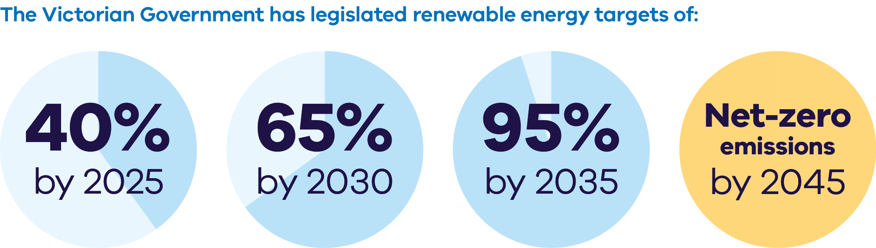
The Victorian Government has legislated renewable energy targets of:
- 40% by 2025
- 65% by 2030
- 95% by 2035
Net-zero emissions by 2045
Figure 2: Energy storage capacity and Offshore wind energy targets from 2025-2045
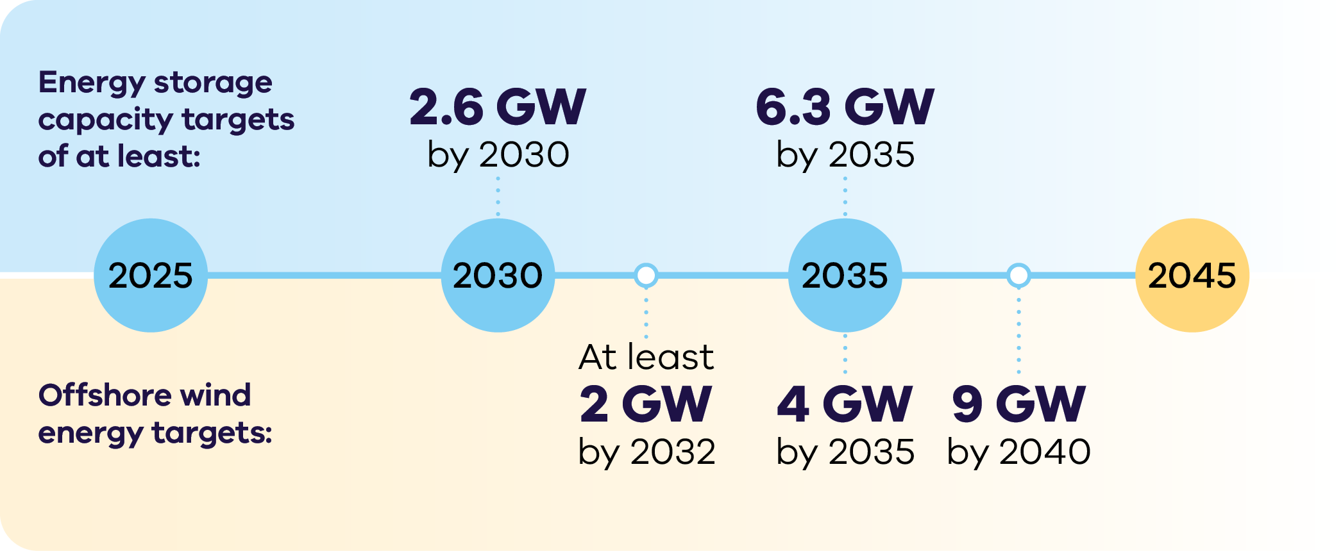

Energy storage capacity targets
of at least:
- 2.6 GW by 2030
6.3 GW by 2035
Offshore wind energy targets:
- At least 2 GW by 2032
- 4 GW by 2035
9 GW by 204

Why invest in Victoria’s renewable hydrogen sector?

Access to key inputs
Victoria has a ready supply of sustainable sources of water and carbon (key inputs to produce green methanol), including from the Green Forestry Triangle in South‑west Victoria.

Underground renewable hydrogen storage potential
Victoria has significant potential for underground renewable hydrogen storage, particularly in the utilisation of large, depleted gas fields present in Western Victoria. Underground hydrogen could provide long-duration energy storage that supports Victoria’s electricity network.

Leadership in renewable hydrogen for transport
Victoria leads in the development of renewable hydrogen for heavy road transport, with Australia’s largest hydrogen refuelling project and the first public service station to offer renewable hydrogen to commercial trucks and transport now in operation.

World-class education
Victoria has established a strong reputation in renewable hydrogen research and development, with several innovative renewable hydrogen centres run by world-class universities.

Home to leading manufacturers
Victoria is home to state-of-the-art electrolyser technology development, as well as fuel cell generator and hydrogen bus component manufacturing.

Major transport hubs creating demand
Victoria has 4 deepwater ports and 2 major airports which can provide critical sources of demand for renewable fuel.

Government support for your renewable hydrogen project
The Australian Government is investing $25 billion to transform the nation into a renewable energy superpower. This funding can be leveraged to support Victorian renewable hydrogen projects, and includes:
- $6.7 billion production tax incentive for renewable hydrogen
- $2 billion for early-mover renewable hydrogen projects as part of the Hydrogen Headstart program (bringing total investment to $4 billion)
- $1.7 billion to promote net-zero innovation, including for low carbon liquid fuels
- $134 million to fast-track approval processes for renewable energy projects
A fast-tracked and expanded Guarantee of Origin scheme ($11.4 million).
For more information, visit: treasury.gov.au/publication/p2024-526942
The Victorian Government can connect you with the Australian Government’s specialist investment vehicles, including the:
- Clean Energy Finance Corporation (CEFC): Australia’s ‘Green Bank’, with access to $30.5 billion in investment capital
- Australian Renewable Energy Agency (ARENA): Provides financial assistance for research, development, demonstration, commercialisation and deployment of renewable energy technologies
- National Reconstruction Fund Corporation: A $15 billion national investment fund designed to diversify and transform Australia's industry and economy.

National Hydrogen Strategy
The 2024 National Hydrogen Strategy is a framework to guide Australia’s production, use and export of hydrogen. This will position Australia to become a global hydrogen leader. The strategy has a strong focus on renewable hydrogen over other production pathways. Key initiatives include:
- 2050 production targets (15 million tonnes per year, with a stretch target of 30 million tonnes) and export targets
- Identifying priority end uses, including green metals, ammonia, long haul transport (heavy road transport, shipping, and aviation), and power generation and grid support
Continued development of Hydrogen Hubs as an important building block towards a large-scale hydrogen industry.
For more information, visit:
dcceew.gov.au/energy/publications/australias-national-hydrogen-strategy

Renewable Hydrogen Industry Development Plan
Released in 2021, the Victorian Government’s Renewable Hydrogen Industry Development Plan outl~ines the actions Victoria will take to develop the renewable hydrogen sector. The plan focuses on driving innovation, building skills and capacity through pilots, trials and demonstrations and supporting business cases to reduce greenhouse gas emissions across our industrial, energy and transport sectors.
For more information, visit: energy.vic.gov.au/renewable-energy/renewable-hydrogen

Victoria’s world leading renewable hydrogen ecosystem
Our competitive advantages, strategic investments and ambitious renewable energy targets create a unique opportunity for a renewable hydrogen market to thrive.

Priority development region
South-west Victoria is primed for renewable hydrogen development, with access to the Green Forestry Triangle, depleted underground gas fields, two deepwater ports, connections to Geelong’s industrial centre, the Geelong oil refinery and Avalon airport.

Sustainable carbon
One of Australia’s major forest regions The Green Triangle spans the border between Victoria and South Australia and is a premier location for growing and processing wood fibre.

Water
Victoria has access to adequate sustainable water sources to support a large-scale renewable hydrogen industry. Sustainable water sources such as recycled water, desalinated water and stormwater should be used for renewable hydrogen production.

Electrolyser manufacturing
Victoria is home to several innovative electrolyser technology companies targeting high efficiency renewable hydrogen production including Cavendish Renewable Technology, SungreenH2 and Hadean.

Renewable Energy
Victoria has access to various and plentiful renewable energy sources including solar, onshore wind and planned offshore wind development zones.
Figure 3: Map of Victoria’s renewable hydrogen ecosystem.
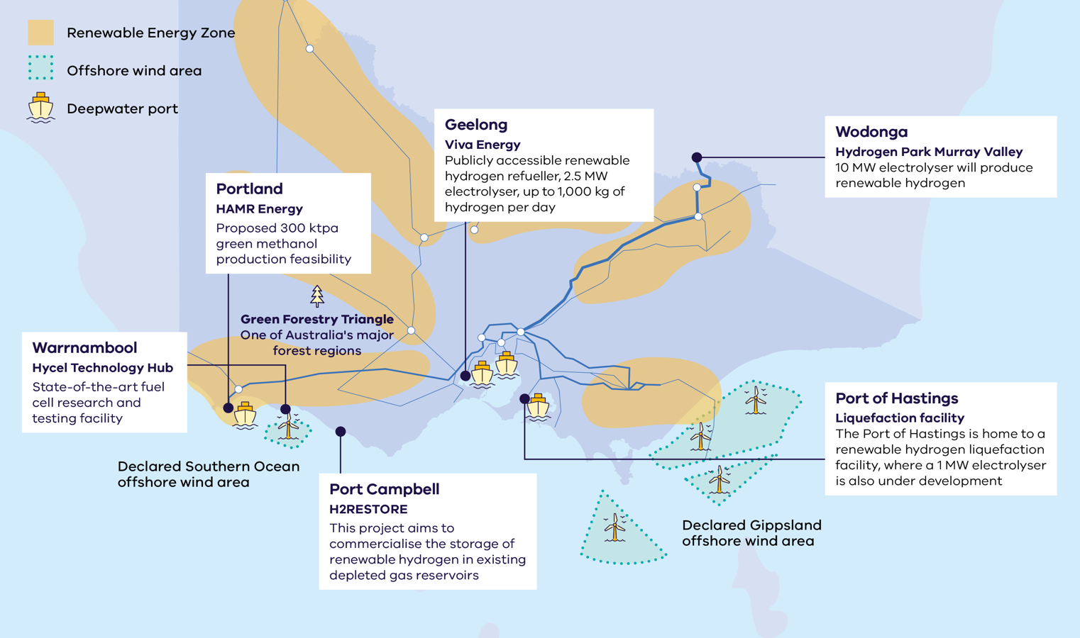

Victoria’s new Renewable Energy Zones
The Victorian Transmission Plan is a new long-term strategic plan for transmission and renewable energy zone development in Victoria.
This plan will ensure we build the right amount of energy infrastructure in the right places at the right time to support the transition to renewable energy.
The plan sets out 6 proposed onshore renewable energy zones: South West, Central Highlands, Western, North West, Central North and Gippsland.
These are the areas identified as most suitable to host new renewable energy generation, such as wind turbines, solar farms, and battery storage.
It also sets out the transmission projects that need to be built over the next 15 years to enable Victoria’s energy transition, providing a long-term pipeline of strategic investment opportunities.
The 2025 Victorian Transmission Plan was released in August 2025.
For more information, visit:
energy.vic.gov.au/renewable-energy/vicgrid/the-victorian-transmission-plan

Figure 4: The 6 proposed onshore renewable energy zones
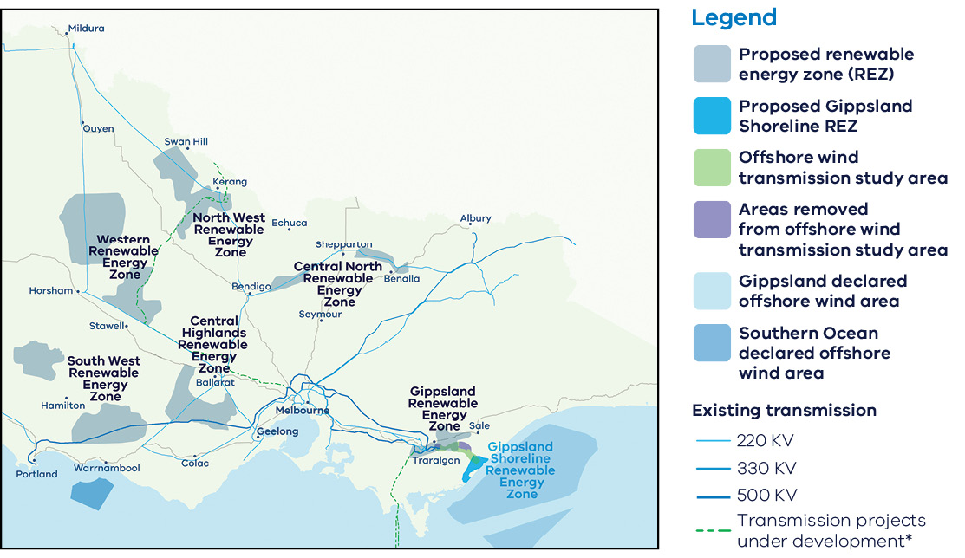

Access to Victoria's world-class renewable energy talent
Our growing, highly skilled workforce drives project delivery and fosters industry growth. To meet the needs of the sector, the Victorian Government has committed to significant new energy skills and workforce initiatives.
- Delivering the Victorian Energy Jobs Plan, which seeks to support Victoria’s once-in-a-generation energy transition by setting out actions to mobilise the workforce and grow investment confidence. The Plan identifies key opportunities to support Victoria’s energy workforce, which is projected to increase from 41,000 full time equivalent (FTE) to 67,000 FTE in 2040, a 62% increase.
- Delivering the Women in Energy Strategy, which seeks to drive significant change for women in energy through Victoria’s energy transition, including addressing barriers to increasing the number of women in the energy workforce. The Strategy aligns with the Victorian Energy Jobs Plan as well as Our Equal State, which seeks to increase participation by women, economic equity, inclusive and safe workplaces, and education opportunities.
- Supporting the establishment of the National Training Centre in New Energy Skills based in Melbourne, in partnership with the Australian Government, to train and reskill key workforces needed for the energy transition across Australia.
Developing and supporting new energy training pathways through the $7 million for new Vocational Education and Training (VET) qualifications in renewable energy and utilising the $50 million TAFE Clean Energy Fund.

World-class education and training
Victoria has a globally renowned education and training system, including:
- 2 global ‘Top 40’ universities1
- 8 universities, including 4 dual-sector universities (offering both tertiary and vocational education)
- 12 independent technical and further education (TAFE) institutions under a single TAFE network
- a diverse talent pool with strong growth across the broad range of occupations relevant to the renewable energy sector.

Our innovative approach leads the way
Victoria’s renewable hydrogen research and innovation capabilities are demonstrated through leading hubs, including:

Deakin University’s Hycel Hydrogen Technology Hub
The Hycel Technology Hub is a purpose-built research, commercialisation and training facility designed to support the hydrogen fuel cell industry to innovate and scale.
For more information, visit: deakin.edu.au/hycel

Victorian Hydrogen Hub
Led by Swinburne, in partnership with CSIRO and Germany’s ARENA2036, the Victorian Hydrogen Hub brings together researchers, industry partners and business to drive the implementation of the renewable hydrogen economy.
For more information, visit:
swinburne.edu.au/research/platforms-initiatives/victorian-hydrogen-hub

Case study: HAMR Energy’s Portland Renewable Fuels Project
HAMR’s flagship development, the Portland Renewable Fuels project, is a world scale renewable methanol development in Portland, Victoria, with a target capacity of 300 ktpa.
This innovative renewable fuels project utilises biomass and renewable hydrogen to produce low carbon methanol. Leveraging locally sourced biomass and nearby onshore wind resources, the project aims to create a sustainable, low-carbon methanol that can be transported to local and international customers via the Port of Portland or road and rail. The methanol will be used to support the decarbonisation of hard to abate sectors including aviation, shipping and chemicals.
When completed, the project’s decarbonisation benefits will be equivalent to taking 80,000 cars off the road. The Victorian Government is supporting the Portland Renewable Fuels Project with $500,000 for a feasibility study through its Portland Diversification Fund.
For more information, visit: hamrenergy.com/portland-renewable-fuels

Case study: Hydrogen Park Murray Valley
Australian Gas Infrastructure Group (AGIG) has begun construction of a 10 MW electrolyser co-located with North East Water’s wastewater treatment plant in Wodonga, Northern Victoria.
The Victorian Government is providing $12.3 million to the Hydrogen Park Murray Valley project. The project is also supported by $36.1 million in ARENA funding and financing from the CEFC.
The Hydrogen Park Murray Valley project is under development and, once complete, its 10MW electrolyser will be the largest electrolyser operating on the Eastern seaboard. The hydrogen produced by the facility can be used in several sectors including transport, with the facility having potential as a refueller for heavy road vehicles, as the hydrogen market develops.
For more information, visit: agig.com.au/hydrogen-park-murray-valley

Applications for renewable hydrogen across key sectors

Transport and freight
Victoria’s access to green carbon, existing refining capacity and key sources of demand give it the potential to be a major player in green methanol and other future fuels, including sustainable aviation fuel.
International shipping companies and airlines bound by international mandates for sustainable fuels will increasingly need sources of sustainable fuel along key travel corridors – creating new demand markets in Victoria.
Victoria is home to 4 deepwater commercial ports, through which over 4000 ships are processed annually, providing significant opportunities for green methanol or green ammonia investment.
Melbourne hosts Australia’s second busiest airport, representing 28% of Australia’s international air freight and using approximately 3.5 billion litres of jet fuel per year.
Victoria has also started decarbonising its freight corridors – see the next page for a case study.

Underground storage
In March 2024, the Australian Renewable Energy Agency (ARENA) agreed to contribute $2m to Lochard Energy’s 18-month $6.3m feasibility study for H2RESTORE. Lochard has undertaken a feasibility study investigating the commercial and technical viability of storing renewable hydrogen underground in existing gas reservoirs in southwest Victoria. Lochard Energy funded the remaining $4.3m.
For more information, visit: lochardenergy.com.au/our-projects/h2restore

Industry
Renewable hydrogen is likely to play a critical but targeted long-term role in decarbonising Victoria’s diverse manufacturing sector, which includes food and beverages, textiles, paper, petroleum refining, cement, lime, mineral and metal production.
To support industrial gas users to transition away from fossil gas, approximately 40–60 PJ per annum of renewable gas, including renewable hydrogen and biomethane, will likely be required.

Case study: Viva Energy Hub
The 2.5 MW Viva Hub electrolyser can generate up to 1000 kg per day of renewable hydrogen for use by a diverse fleet of hydrogen vehicles. It is Australia’s first commercially scaled public renewable hydrogen refuelling station. The Viva Energy Hub services a fleet of heavy fuel cell electric vehicles across multiple industry partners including Toll Group, ComfortDelGro Corporation Australia, Cleanaway and Barwon Water – showcasing the use of hydrogen to power transport operations such as road freight, public transport, municipal waste management, water treatment and general fleet. The project received a $34 million grant from ARENA as part of their Advancing Renewables program and the Victorian Government contributed $1 million to the project via the Renewable Hydrogen Commercialisation Pathways Fund.
For more information, visit: vivaenergy.com.au/energy-hub

Key Victorian Government entities
We can help facilitate connections with key Victorian Government entities and industry members across our renewable energy sector.

Department of Energy, Environment and Climate Action (DEECA)
DEECA works with industry and the community to develop Victoria's secure and sustainable energy future.
For information on Victoria’s energy policy landscape and facilitated connections across the Victorian Government and renewable energy sector, contact the Business and Industry Engagement team at: BIE@deeca.vic.gov.au
For more information, visit: energy.vic.gov.au/industry/investment-opportunities

Contact a local Victorian Government Trade and Investment Office to help you:
- navigate investment opportunities in Victoria’s new energy technology sector
- set up a briefing with energy specialists
- arrange inbound market visits
introduce you to the Victorian Government’s Energy Business and Industry Engagement team and Invest Victoria.
For more information, visit: global.vic.gov.au/meet-our-global-team/all-office-locations

Fast-tracked planning approvals
The Victorian Government Development Facilitation Program fast-tracks the planning permit approval process for large renewable energy facilities and utility installations. This provides certainty to investors by removing the risk of delay by third-party appeals.
For more information, visit: planning.vic.gov.au/planning-approvals/planning-enquiries-and-requests/development-facilitation-program
Furthermore, the Australian Government is providing $168 million to better prioritise approval decisions for renewable energy projects of national significance, and support faster decisions on environment, cultural heritage and planning approvals.

Invest Victoria
Invest Victoria is the Victorian Government’s investment attraction agency. Services include:
- market regulatory information
- statutory approvals coordination
- site location services
- identification of infrastructure and utility requirements
advocacy within government.
The Investment Coordinator-General role and function also sits within Invest Victoria, working across agencies to ensure approvals deadlines are met and helping to reduce delays.
For more information, visit: invest.vic.gov.au

Publication information

Acknowledgements
We acknowledge and respect Victorian Traditional Owners as the original custodians of Victoria’s land and waters, their unique ability to care for Country and deep spiritual connection to it.
We honour Elders past and present whose knowledge and wisdom has ensured the continuation of culture and traditional practices.
DEECA is committed to genuinely partnering with Victorian Traditional Owners and Victoria’s Aboriginal community to progress their aspirations.

Copyright
© The State of Victoria Department of Energy, Environment and Climate Action, September 2025.

Creative Commons
This work is licensed under a Creative Commons Attribution 4.0 International licence, visit the Creative Commons website (http://creativecommons.org/licenses/by/4.0/).
You are free to re-use the work under that licence, on the condition that you credit the State of Victoria as author. The licence does not apply to any images, photographs or branding, including the Victorian Coat of Arms, and the Victorian Government and Department logos.
ISBN 978-1-76176-611-4 (Print)
ISBN 978-1-76176-612-1 (pdf/online/MS word))

Disclaimer
This publication may be of assistance to you but the State of Victoria and its employees do not guarantee that the publication is without flaw of any kind or is wholly appropriate for your particular purposes and therefore disclaims all liability for any error, loss or other consequence which may arise from you relying on any information in this publication.

Accessibility
To receive this document in an alternative format, phone the Customer Service Centre on 136 186, email customer.service@delwp.vic.gov.au, or contact National Relay Service on 133 677. Available at DEECA website (www.deeca.vic.gov.au).
End of document.

Cheaper, cleaner, renewable: our plan for Victoria's electricity future, http://energy.vic.gov.au/renewable-energy/victorias-electricity-future. Note this figure will be updated following the release of the draft AEMO 2026 Integrated System Plan in December 2025
Manufacturing Statement, djsir.vic.gov.au/made-in-victoria/manufacturing-statement
QS World University Rankings, June 2025, topuniversities.com/world-university-rankings

