$250 Power Saving Bonus Program
Suggested Newsletter text

Claim your $250 Power Saving Bonus with Victorian Energy Compare
We’re helping Victorian households with a payment of $250 to ease cost of living pressures.
All Victorian households are eligible for the $250 Power Saving Bonus, and we would like as many people as possible to know about it.
The process is simple:
- Visit Victorian Energy Compare via compare.energy.vic.gov.au
- Compare your energy offer
- Get $250 in your pocket
The Victorian Energy Compare website is the only free and independent online energy price comparison service available to Victorian energy consumers.
Over the last twelve months, user data shows that seven out of every ten users were able to save money by switching energy offers, with typical annual savings for those users of $330 on energy bills in the first year alone.
To be eligible for the new $250 Power Saving Bonus, Victorian households will need to:
- Have a recent residential electricity bill and be the account holder for that bill
- Visit the Victorian Energy Compare website or engage with an energy affordability service through one of our participating community outreach partners.
Only one payment is available per household.
Victorians who received the $50 Power Saving Bonus and/or the $250 Power Saving Bonus for concession recipients and meet the eligibility requirements of the new $250 Bonus, are eligible to apply for another $250 payment.
If you have difficulty with online submissions, further support is available by calling 1800 000 832.

Community Outreach
To support eligible Victorians to access the $250 Power Saving Bonus, the Victorian Government has partnered with a range of organisations who specialise in providing support to the Victorian community.
Targeted and tailored support will be available for consumers until 30 June 2023 and will delivered by the following organisations who provide valuable assistance to Victorians:
- Good Shepherd
- Neighbourhood Houses Victoria
- The Consumer Action Law Centre
- The Ethnic Communities’ Council of Victoria
- The Brotherhood of St Laurence
- State Trustees

Suggested social media content

Twitter
Claim your $250 Power Saving Bonus by comparing your household energy offer on the Victorian Energy Compare website.
Over the last twelve months, 7 out of 10 people were able to save money by switching to a better offer.
Available for all Victorian households.
Visit compare.energy.vic.gov.au for more information or call 1800 000 832.

Facebook
Claim your $250 Power Saving Bonus by comparing your household energy offer on the Victorian Energy Compare website.
The process is simple:
- Visit Victorian Energy Compare via compare.energy.vic.gov.au
- Compare your energy offer
- Get $250 in your pocket
Over the last twelve months, 7 out of 10 people were able to save money by switching to a better offer.
Available for all Victorian households.
What are you waiting for?
Need support with your application? You can call our helpline on 1800 000 832 or request support from our community outreach partners:
- Good Shepherd
- Neighbourhood Houses Victoria
- The Consumer Action Law Centre
- The Ethnic Communities’ Council of Victoria
- The Brotherhood of St Laurence
- State Trustees
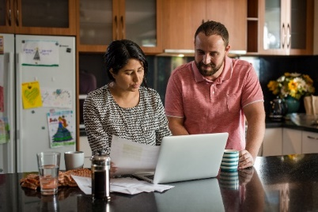

Click here to download the high-resolution version of these images

