1.5 – Safe work practices using elevated work platforms
VEU Insulation Program – Technical Guidance Series




This is part of a series developed with WorkSafe to help installers in our program to work safely while installing insulation.
Use this sheet and others in this series to plan safe series of work while installing insulation.

Series 1 – Working Safely at Heights
1.1 | Working safely at heights during rooftop insulation installations
1.2 | Edge protection – working at height
1.3 | Manual handling of heavy and bulky items
1.4 | Working safely with ladders
1.5 | Safe work practices using elevate work platforms  (this sheet)
1.6 | Falls through skylights, fragile roofs, voids and penetrations.

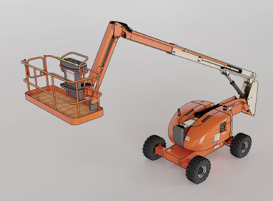
Self-propelled boom lift

Elevated Work Platforms
There are numerous hazards associated with EWP use that can pose a risk to the health and safety of employees and the public. Use of EWPs during installations of rooftop insulation requires effective hazard identification taking into account the unique features of each EWP type.
Rolls of insulation are large and unwieldy and must be handled with care to protect employees undertaking the installations.
For rooftop insulation installations in residential premises, EWPs may be a suitable way of conveying rolls of insulation onto the roof, thus reducing the risks associated with manual handling tasks and reducing exposure to fall risks.
Note: Ladders should not be used to carry materials that prevent the worker from maintaining three points of contact. Insulation rolls must be lifted using a mechanical aid or other safe method.
Follow this four-step risk management process to ensure hazards are identified, risks are assessed and controlled, and that employers fulfil their duty to monitor, review and revise controls when required.
Figure 1: The four-step risk management process

Step 1: Identify hazards – common EWP hazards
There are numerous hazards associated with EWP use that can pose a risk to the health and safety of employees and the public. Use of EWPs during installations of rooftop insulation on residential premises requires effective hazard identification taking into account the unique features of each EWP type. Common hazards related to the use of EWPs during rooftop insulation installations can include:
- uneven or unstable ground
- concealed voids, basements or pits
- working at heights
- crushing injuries
- overhead conductors, structures and vegetation
- traffic and pedestrians
- wind loading
- mechanical failure of the machine
- transport, unloading and manoeuvring.
Employers must so far as reasonably practicable consult with their employees (including any HSRs and independent contractors) when identifying or assessing hazards or risks to health and safety.
For more information and practical guidance for duty holders about complying with their duties under the Occupational Health and Safety (OHS) Act 2004 see Elevating Work Platforms industry standard on the WorkSafe website.

Step 2: Assess risks – plan your use of EWPs
Plan your use of EWPs and assess the risks based on identified hazards.
Take into account the likelihood, nature and severity of consequences and document your systems of work in a safe work method statement (SWMS) when required. Employers and self-employed persons must provide their workers with a SWMS before undertaking high-risk construction work (HRCW). HRCW includes work where there is a risk of a person falling more than 2 metres. Employees undertaking HRCW must be informed and consulted in determining risk controls during the SWMS preparation process. Ensure the SWMS is prepared before the work commences and ensure that the work is performed in accordance with the SWMS.
Additional factors to take into consideration may include:
- no go zones
- side force limitations
- wind speed and prevailing weather conditions
- weight of operators, tools and materials in relation to the rated capacity of the EWP
- plant to be operated in accordance with manufacturers recommendations.
If it is planned to enter or leave the platform of an EWP when it is in an elevated position (e.g., gaining access to the roof of a building), a safer alternative method needs to be considered. For more information, please visit AS 2550.10.
See the WorkSafe website for more information on when and how to complete a SWMS for construction activities: worksafe.vic.gov.au/resources/safe-work-method-statements-swms

Step 3: Control risks – safe use of elevating work platforms
Employers must eliminate any risk associated with the use of an EWP, so far as is reasonably practicable. Where this cannot be achieved the hierarchy of control must be used to reduce risks, so far as is reasonably practicable.
Ensure the selection of the EWP is the right type for the specific task and determine if any attachments are required to complete the task. Some work practices to be avoided while using EWPs are:
- travelling with a raised platform
- exceeding the safe working load (SWL) of the EWP platform
- using indoor rated EWPs outdoors
- working over footpaths, work areas or publicly accessible areas without adequate controls
- working above or beneath other EWPs
- allowing excessive material, debris and equipment on the platform
- placing outrigger footplates on a slope.
Where there is a risk of crushing against a fixed structure, an effective operator protective device needs to be fitted, so far as is reasonably practicable. These devices are commonly known as secondary guarding and may include, but are not limited to:
- physical barriers attached to the platform, which reduce the likelihood of employees being crushed against structures
- pressure sensing devices positioned over the control panel, which detect pending crush incidents and prevent further hazardous movements
- proximity sensing devices which prevent an EWP’s platform from manoeuvring into high-risk areas near fixed structures.
Remember that the requirement to consult with employees and independent contractors improves Occupational Health and Safety (OHS) outcomes due to their direct participation in identification of hazards and risks, and evaluation and adoption of new risk control measures and concepts.
Direct participation also gives a sense of ownership that translates to improved uptake of control measures when implemented.

Operating EWPs near overhead assets
The use of EWPs around overhead electrical assets introduces risks that require knowledge of, and compliance with the No Go Zone (NGZ) requirements.
See the next page for diagrams of No-Go Zone requirements around powerlines and transmission towers.
It is critical that EWP operators understand and comply with the NGZ requirements around overhead distribution and transmission assets and understand the various requirements associated with each level of obligation.
In conjunction with NGZ requirements, the role of electrical spotters, when they are required, and their licensing requirements should be understood. Spotters must:
- be registered with Energy Safe Victoria
- hold current first aid and cardiopulmonary resuscitation (CPR) qualifications
- only spot for plant that they themselves hold competency for, noting that a person with a Dogman or Rigger class spotters registration card may act as a spotter for any type of plant
- only observe operation of one item of plant at any one time
- not undertake any other task while observing plant operating in the Spotter Zone
- understand and make allowance for sag and sway of overhead conductors.
There are inherent dangers of overhead conductor contact associated with tracking plant around a site. Maintain awareness at all times to avoid plant strike and understand your obligations to seek permitting with the relevant Distribution Network Service Provider (DNSP) if plant or equipment could encroach into the NGZ.
Further information:
For more information on No Go Zones see the Energy Safe Victoria website: energysafe.vic.gov.au/industry-guidance/electrical/electrical-network-infrastructure/working-around-powerlines
To find out more about electrical spotters see the Energy Safe website: energysafe.vic.gov.au/licensing/electrical-licences/licence-types/spotters-registration
For more information on working with powered mobile plant near overhead assets see the WorkSafe website: worksafe.vic.gov.au/resources/using-powered-mobile-plant-near-overhead-assets-guidebook

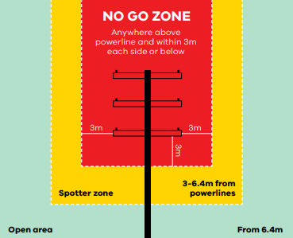
Figure 2: NGZ around distribution poles

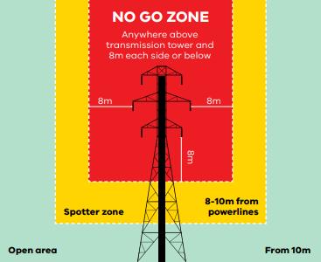
Figure 3: NGZ around transmission towers

Step 4: Review and revise controls
Managing the risk of working with EWPs is an ongoing process. Under regulation 121 of the Occupational Health and Safety Regulations 2017 (OHS Regulations) employers have a duty to monitor, review and, if necessary, revise control measures or any associated systems of work:
- before the plant is deployed at a workplace
- prior to making any alteration to the plant or its associated systems of work, including a change in location
- if new or additional information about hazards or risks relating to the plant or its associated systems of work become available
- after any notifiable incident
- if, for any reason, the risk control measures do not adequately control the risks
- at the request of a Health and Safety Representative (HSR).
Your actions shouldn't stop at Step 4. You should repeat this process often to make sure your management of risk is working.

© The State of Victoria Department of Energy, Environment and Climate Action, April 2026.
ISBN 978-1-76176-828-6 (pdf/online/MS word
Disclaimer
This publication may be of assistance to you but the State of Victoria and its employees do not guarantee that the publication is without flaw of any kind or is wholly appropriate for your particular purposes and therefore disclaims all liability for any error, loss or other consequence which may arise from you relying on any information in this publication.
Accessibility
To receive this publication in an alternative format, please contact the Victorian Energy Upgrades team at energy.upgrades@deeca.vic.gov.au. This document is also available on the internet at energy.vic.gov.au/victorian-energy-upgrades.

