Victoria's Investment Prospectus BIOENERGY
Table of Contents
Victoria is investing in world-class bioenergy innovation 1
Welcome to Victoria's renewable energy sector 2
Why invest in Victoria’s bioenergy sector? 5
Biomass opportunities for biomethane 7
Investment opportunity for biomethane and other renewable fuels for industry 8
Policies and guidelines driving circular economy investment 9
Access to Victoria's world-class renewable energy talent 11
Bioenergy in action 13
Renewable fuels made from biological sources can access
traditional fossil fuel markets 15
Key Victorian Government entities 17
Publication information 20

Victoria is investing in world-class bioenergy innovation

Acknowledgement of Country
We acknowledge and respect Victorian Traditional Owners as the original custodians of Victoria’s land and waters, their unique ability to care for Country and deep spiritual connection to it.
We honour Elders past and present whose knowledge and wisdom have ensured the continuation of culture and traditional practices.
We are committed to genuinely partner, and meaningfully engage, with Victoria’s Traditional Owners and Aboriginal communities to support the protection of Country, the maintenance of spiritual and cultural practices and their broader aspirations in the 21st century and beyond.

Traditional Owners at the centre of decision-making processes
Strong and mutually beneficial partnerships with Traditional Owners and First Peoples are imperative to the electricity transition’s success and integral to ensuring the goals and objectives of self-determination set out in the Victorian Government’s Self Determination Reform Framework and the Department of Energy, Environment and Climate Action’s (DEECA) Pupangarli Marnmarnepu ‘Owning Our Future’ Aboriginal Self-Determination Reform Strategy 2020–2025.
For more information, visit:
deeca.vic.gov.au/aboriginalselfdetermination/self-determination-reform-strategy

Welcome to Victoria's renewable energy sector
At the centre of Australia’s electricity network, the state of Victoria is leading the way to a renewable energy future
We estimate that Victoria will need 25 GW of new generation and storage capacity by 2035. Our legislated renewable energy generation, energy storage and emissions reduction targets provide a clear market signal, supported by government programs to drive investment.
The renewable energy sector is at the heart of our economy, identified as a priority growth industry backed by streamlined approval processes, well-developed supply chains, world‑class research and development capabilities and a highly skilled workforce.

A bioenergy sector positioned for growth
Victoria’s bioenergy sector is primed for investment, with significant renewable gas opportunities emerging as part of Victoria's transition to a sustainable and net‑zero future.
As Australia’s largest food and fibre producing state, there are significant opportunities in Victoria's regions to leverage agricultural waste as biomass. Proponents can also access the Viva Refinery, infrastructure including 4 deepwater ports, a 24-hour airport and Australia’s busiest combined regional passenger and freight rail network – creating sources of demand and export infrastructure for biomethane and renewable fuels.
Figure 1: Legislated renewable energy targets
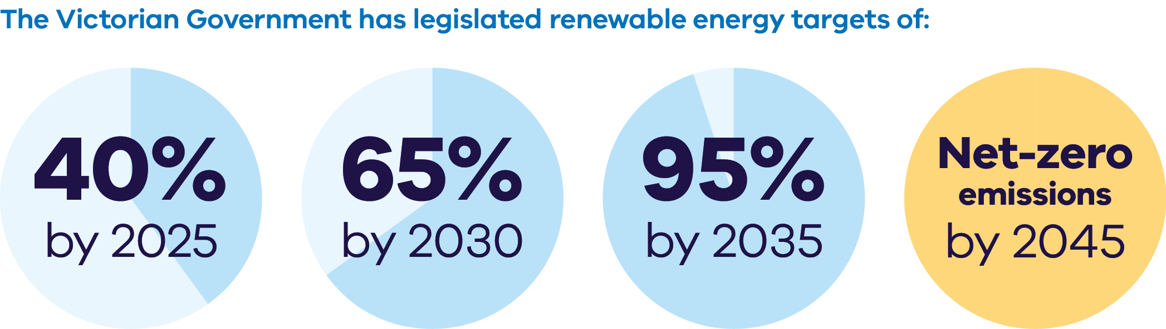
The Victorian Government has legislated renewable energy targets of:
- 40% by 2025
- 65% by 2030
- 95% by 2035
Net-zero emissions by 2045
Figure 2: Energy storage capacity and Offshore wind energy targets from 2025-2045
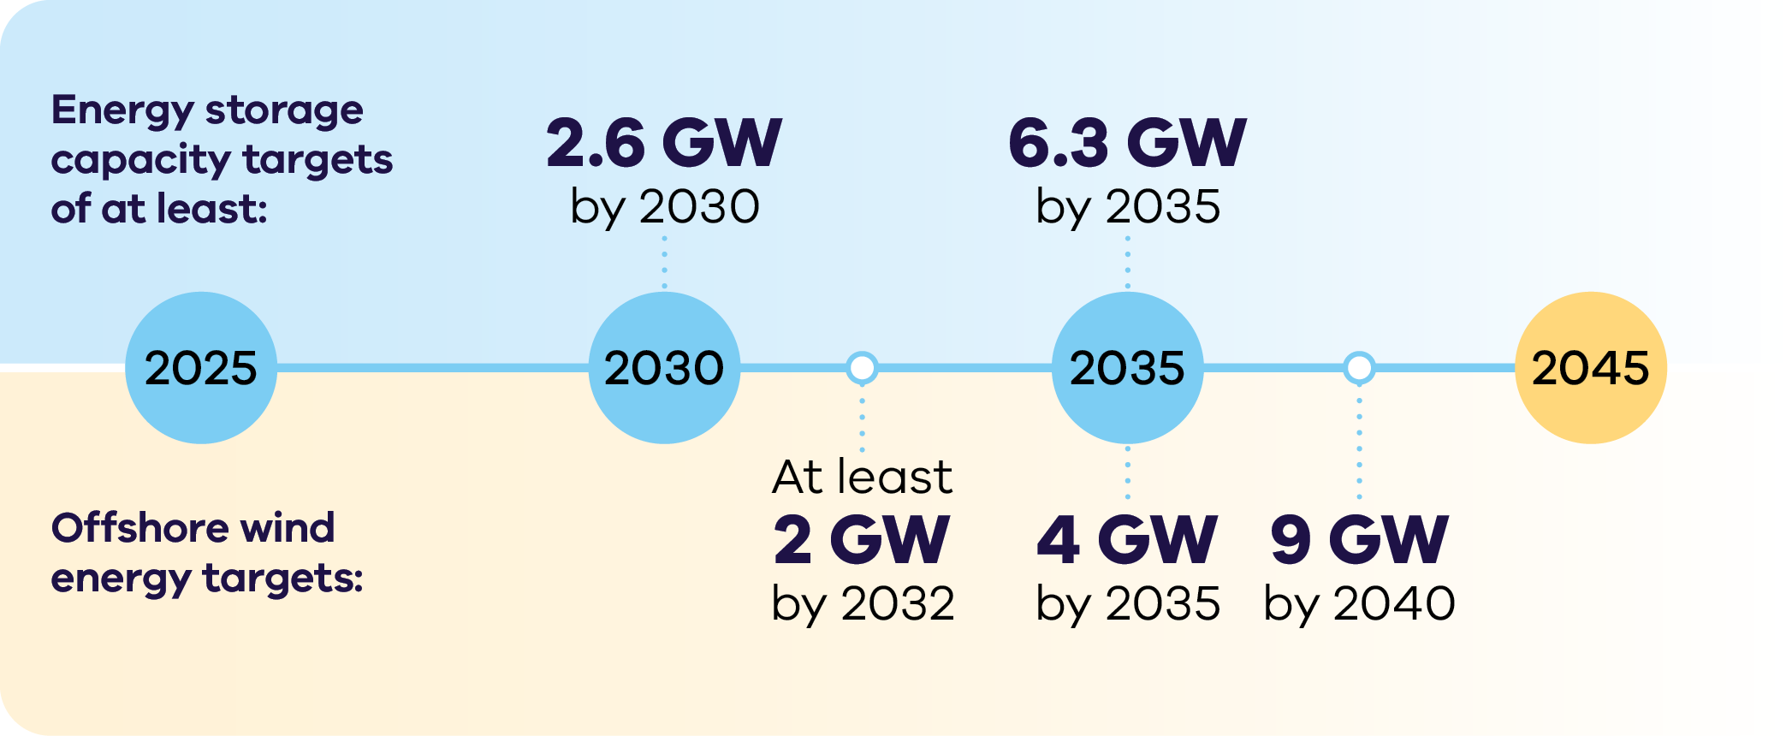

Energy storage capacity targets
of at least:
- 2.6 GW by 2030
6.3 GW by 2035
Offshore wind energy targets:
- At least 2 GW by 2032
- 4 GW by 2035
9 GW by 204

Why invest in Victoria’s bioenergy sector?

Emerging markets for renewable gas
An emerging renewable gas market, backed by schemes like GreenPower Renewable Gas Certification, has the potential to drive new investment and decarbonise parts of Victoria's industrial and gas-powered generation sectors, where electrification is not commercially or technically feasible.

Access to biomass resources across the state
Our diverse commercial, agricultural, water and industrial sectors have biowaste streams that are ripe for development. For example, the Green Forestry Triangle region in South-west Victoria provides access to renewable carbon sources to support renewable fuel projects.

Clear guidelines driving investment
Environmental Protection Authority (EPA) Victoria’s digestate and organics guidelines provide clear information for managing bioenergy waste outputs, boosting investor confidence in bioenergy.

Strong ecosystem for investment in waste to energy
Victoria is leading the way nationally by creating a target to halve the volume of organic waste going to landfill by 2030, creating strong opportunities for bioenergy and new waste to energy infrastructure.

Emerging demand for biomethane and renewable fuels
Victoria’s freight infrastructure includes 4 deepwater ports, a 24-hour airport and Australia’s busiest combined regional passenger and freight rail network – creating sources of demand and export infrastructure for biomethane and renewable fuels.

Advanced manufacturing and supply chain capacity
Victoria’s strong manufacturing sector and established supply chains are well‑positioned to support bioenergy project development.

Defining Bioenergy
Bioenergy is a form of renewable energy generated from the conversion of biomass into heat, electricity, biogas and liquid fuels. Biomass is organic matter derived from forestry, agriculture or waste streams available on a renewable basis.

Biomass opportunities for biomethane
As Australia’s largest food and fibre producing state, there are significant opportunities in Victoria's regions to leverage agricultural waste as biomass.
Victoria’s theoretical biogas potential is estimated to be 80.6 PJ per year.
This represents 37% of the 214 PJ of gas currently consumed annually in Victoria.

High Recoverable Potential
Figure 3: Regions of Victoria and their recoverable potential for biogas
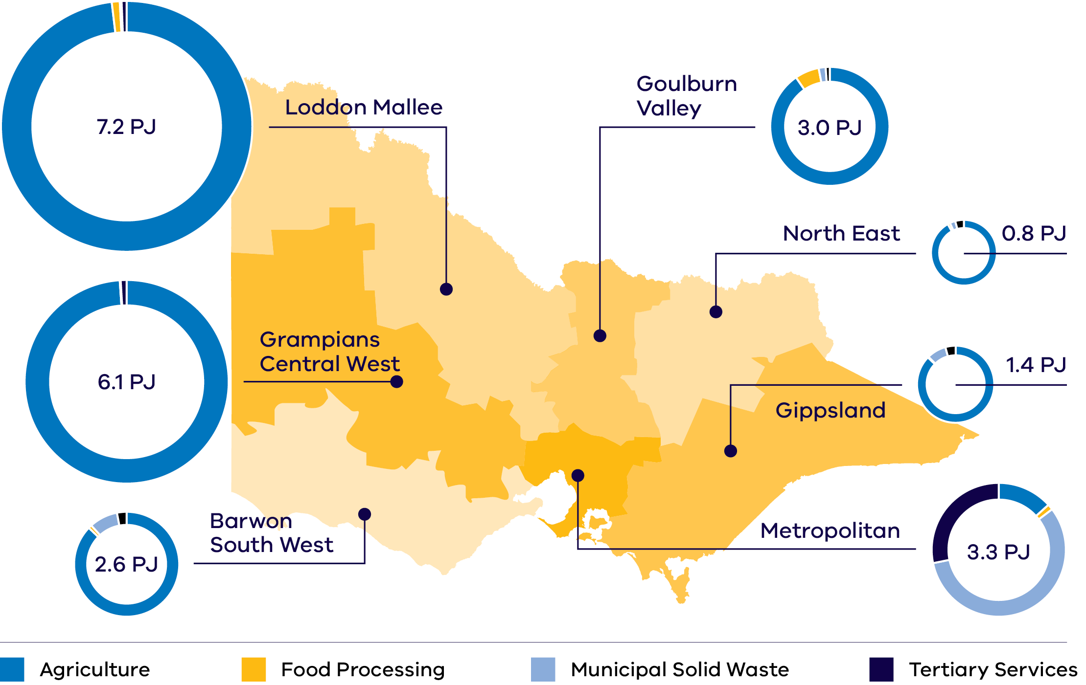

Investment opportunity for biomethane and other renewable fuels for industry
Victoria has substantial recoverable feedstock that could support bioenergy production, and contribute to a growing renewable gas industry.
A substantial portion of Victoria’s industrial processing and gas-powered generation relies on fossil gas in applications that are currently harder to electrify. This includes sectors requiring high-temperature heat (above 200°C), such as heavy manufacturing. It also includes parts of the chemical industry where fossil gas is used as a feedstock and cannot be replaced by electricity. These hard-to-abate areas present a compelling investment opportunity. Biomethane stands out as the most promising renewable gas solution, offering a scalable, commercially viable pathway aligned with the state’s net-zero goals and industrial transition.
The Victorian Government can connect you with the Australian Government’s specialist investment vehicles, including:
- Clean Energy Finance Corporation: Australia’s ‘Green Bank’, with access to $32 billion in investment capital from the Australian Government
- Australian Renewable Energy Agency: Provides financial assistance for research, development, demonstration, commercialisation and deployment of renewable energy technologies
- National Reconstruction Fund Corporation: A $15 billion national investment fund designed to diversify and transform Australia's industry and economy.

Policies and guidelines driving circular economy investment
Both the Victorian Government and the Australian Governments are committed to getting your project through planning approvals as quickly as possible.

Key circular economy policies
Our circular economy plan, Recycling Victoria: A new economy, outlines a commitment to:
- cut waste generation by 15% per capita over the next 10 years, and
halve food and organic waste going to landfill.
For more information, visit: vic.gov.au/victorias-plan-circular-economy
The Victorian Recycling Infrastructure Plan outlines infrastructure needs and gaps, to drive innovation and potential investment where it is needed most.
For more information, visit: vic.gov.au/victorian-recycling-infrastructure-plan
The Recycling Victoria Data Hub provides data, intelligence and insights for use by Victoria's waste, recycling and resource recovery sector, businesses, government and the community.
For more information, visit: vic.gov.au/recycling-victoria-data-hub

Updated Environmental Protection Authority (EPA) guidelines provide regulatory clarity
EPA Victoria’s digestate regulatory instruments and guidelines enhance the investment case for bioenergy by simplifying requirements and providing clear standards for managing digestate, a waste output of anaerobic digestion.
These updates provide regulatory clarity, reduce regulatory burden, and promote the safe, beneficial use of digestate in agriculture. For investors, this means a more streamlined and secure environment for developing and expanding bioenergy projects in Victoria.
In addition, the EPA updated the guidance around their organic waste processing facilities, which sets clearer expectations for risk management, site planning, and output material handling. This provides the bioenergy sector with greater certainty around compliance, environmental protection, and investment planning.
For more information, visit: epa.vic.gov.au/operating-organics-processing-facilities
The Waste, Recycling and Resource Recovery Investment Prospectus outlines investment opportunities in the waste, recycling and resource recovery sector, and how Recycling Victoria can support investment.
For more information, visit: vic.gov.au/victorian-recycling-infrastructure-plan

Access to Victoria's world-class renewable energy talent
Our growing, highly skilled workforce drives project delivery and fosters industry growth. To meet the needs of the sector, the Victorian Government has committed to significant new energy skills and workforce initiatives.
- Delivering the Victorian Energy Jobs Plan, which seeks to support Victoria’s once-in-a-generation energy transition by setting out actions to mobilise the workforce and grow investment confidence. The Plan identifies key opportunities to support Victoria’s energy workforce, which is projected to increase from 41,000 full time equivalent (FTE) to 67,000 FTE in 2040, a 62% increase.
- Delivering the Women in Energy Strategy, which seeks to drive significant change for women in energy through Victoria’s energy transition, including addressing barriers to increasing the number of women in the energy workforce. The Strategy aligns with the Victorian Energy Jobs Plan as well as Our Equal State, which seeks to increase participation by women, economic equity, inclusive and safe workplaces, and education opportunities.
- Supporting the establishment of the National Training Centre in New Energy Skills based in Melbourne, in partnership with the Australian Government, to train and reskill key workforces needed for the energy transition across Australia.
Developing and supporting new energy training pathways through the $7 million for new Vocational Education and Training (VET) qualifications in renewable energy and utilising the $50 million TAFE Clean Energy Fund.

World-class education and training
Victoria has a globally renowned education and training system, including:
- 2 global ‘Top 40’ universities1
- 8 universities, including 4 dual-sector universities (offering both tertiary and vocational education)
- 12 independent technical and further education (TAFE) institutions under a single TAFE network
- a diverse talent pool with strong growth across the broad range of occupations relevant to the renewable energy sector.

Bioenergy in action

Case study: Melton bioenergy facility
Greater Western Water (one of Victoria’s 18 water corporations) has built a waste to energy facility at its Melton Recycled Water Plant. The first facility of its type in the region, the $3.3 million co-digestion project was made possible by securing more than $800,000 through Sustainability Victoria’s original $2.3 million Waste to Energy Infrastructure Fund.
The facility will receive up to 5,000 kilolitres of liquid organic waste each year from local businesses and support the Victorian Government’s goal to halve the amount of organic material going to landfill by 2030. This waste is then treated through an anaerobic digester where it is converted into biogas. Renewable energy produced from the biogas and existing on-site solar array will provide up to 100% of the plant’s energy needs during the day and is expected to reduce Greater Western Water’s greenhouse gas emissions by 900 tonnes per year.
For more information, visit:
sustainability.vic.gov.au/news/news-articles/harnessing-the-power-of-organic-waste

Case study: Pavilion Farms Circular Farming
Pavilion Farms, a large broiler chicken growing operation in Victoria, is working towards 100% sustainable circular farming, with organic fertiliser production, responsible re-use of 100% of its waste, renewable energy generation, bird welfare, lowering greenhouse gas emissions and providing local jobs part of its operational and growth strategy.
Awarded $9.31 million through Round 2 of the Energy Innovation Fund, Pavilion farms is installing an anaerobic digestion plant which will use chicken litter as its primary feedstock to produce biogas and granulated organic, pathogen free and sustainable fertiliser.
The power generated will be used to run the chicken farms and anaerobic digestion plant, with approximately 18 GW/h hours per annum being sold to local Victorian food producers as baseload renewable power.
Projects like Pavilion Biogas are helping us support the commercialisation of innovative, emerging renewable energy technologies in Victoria.
For more information, visit: pavilionbiogas.com.au/home-alnding

Renewable fuels made from biological sources can access traditional fossil fuel markets
Renewable fuels are vital for reducing emissions in Victoria’s hard‑to‑abate sectors as we work toward net-zero emissions by 2045. Biodiesel, renewable diesel, and sustainable aviation fuel (SAF) offer immediate and long-term solutions.

Investment Opportunity
Victoria offers unique opportunities for investment into renewable fuels due to its:
- Hard-to-electrify sectors (freight, aviation, shipping) driving demand for renewable fuels
- High levels of imported fuels (~90% of liquid fuels Australia-wide)
- Rising renewable fuel demand from freight, public transport, and agriculture
- ~47 million GJ of potential waste-derived feedstocks across Victoria’s regions, some of which are suited to renewable fuel processing
- Untapped production opportunity at existing facilities
- Established critical infrastructure, including the Viva Refinery, deepwater ports, busy airport and freight corridors.

Case study: Just Biodiesel
Just Biodiesel is a key contributor to Victoria’s commitment to renewable fuels, specialising in biodiesel production. The company operates a state-of-the-art biodiesel manufacturing facility located in Barnawartha, Victoria. This facility was constructed in 2006 for $70 million. The feedstock for making biodiesel is a combination of tallow and used cooking oil (UCO). The tallow is sourced from regional rendering facilities, and the UCO is collected from restaurants across the country. Just Biodiesel supplies biofuel to Viva Energy and Refuelling Solutions that is blended with mineral diesel at a ratio of around 5%. This blend is currently used in various sectors, showcasing the practical application of biodiesel in reducing carbon emissions.
For more information, visit: justbiodiesel.com.au

Key Victorian Government entities
We can help facilitate connections with key Victorian Government entities and industry members across our renewable energy sector.

Department of Energy, Environment and Climate Action (DEECA)
DEECA works with industry and the community to develop Victoria's secure and sustainable energy future.
For information on Victoria’s energy policy landscape and facilitated connections across the Victorian Government and renewable energy sector, contact the Business and Industry Engagement team at: BIE@deeca.vic.gov.au
For more information, visit: energy.vic.gov.au/industry/investment-opportunities

VicGrid
VicGrid coordinates the planning and development of Victorian Renewable Energy Zones (REZs). It also oversees the $480 million REZ fund that will be used to strengthen the grid and develop each REZ.
For more information, visit: energy.vic.gov.au/renewable-energy/renewable-energy-zones

Sustainability Victoria
Sustainability Victoria empowers Victorians to live sustainably by taking action on climate change and using our precious resources wisely – to deliver a sustainable future for us all.
For more information, visit: sustainability.vic.gov.au

Invest Victoria
Invest Victoria is the Victorian Government’s investment attraction agency. Services include:
- market regulatory information
- statutory approvals coordination
- site location services
- identification of infrastructure and utility requirements
advocacy within government.
The Investment Coordinator-General role and function also sits within Invest Victoria, working across agencies to ensure approvals deadlines are met and helping to reduce delays.
For more information, visit: invest.vic.gov.au

Recycling Victoria
Recycling Victoria is a regulator for the waste sector and sits within DEECA. Recycling Victoria is also responsible for administration of the Victorian Waste to Energy Scheme.
For more information, visit: vic.gov.au/about-recycling-victoria

Environment Protection Authority Victoria
The EPA is the state's independent environmental regulator. They protect the health of Victoria’s community and environment from pollution and waste.
For more information, visit: epa.vic.gov.au

Victorian Water Corporations
Victoria’s 18 water corporations provide water supply and sewage services. They also undertake projects to actualise their biomethane and other renewable fuels production potential, to contribute to the state's decarbonisation and renewable energy targets.
For more information, visit:
water.vic.gov.au/about-us/how-we-work-with-water-corporations

Contact a local Victorian Government Trade and Investment Office to help you:
- navigate investment opportunities in Victoria’s new energy technology sector
- set up a briefing with energy specialists
- arrange inbound market visits
introduce you to the Victorian Government’s Energy Business and Industry Engagement team and Invest Victoria.
For more information, visit: global.vic.gov.au/meet-our-global-team/all-office-locations

Publication information

Acknowledgements
We acknowledge and respect Victorian Traditional Owners as the original custodians of Victoria’s land and waters, their unique ability to care for Country and deep spiritual connection to it.
We honour Elders past and present whose knowledge and wisdom has ensured the continuation of culture and traditional practices.
DEECA is committed to genuinely partnering with Victorian Traditional Owners and Victoria’s Aboriginal community to progress their aspirations.

Copyright
© The State of Victoria Department of Energy, Environment and Climate Action, September 2025.

Creative Commons
This work is licensed under a Creative Commons Attribution 4.0 International licence, visit the Creative Commons website (http://creativecommons.org/licenses/by/4.0/).
You are free to re-use the work under that licence, on the condition that you credit the State of Victoria as author. The licence does not apply to any images, photographs or branding, including the Victorian Coat of Arms, and the Victorian Government and Department logos.
ISBN 978-1-76176-603-9 (Print)
ISBN 978-1-76176-604-6 (pdf/online/MS word))

Disclaimer
This publication may be of assistance to you but the State of Victoria and its employees do not guarantee that the publication is without flaw of any kind or is wholly appropriate for your particular purposes and therefore disclaims all liability for any error, loss or other consequence which may arise from you relying on any information in this publication.

Accessibility
To receive this document in an alternative format, phone the Customer Service Centre on 136 186, email customer.service@delwp.vic.gov.au, or contact National Relay Service on 133 677. Available at DEECA website (www.deeca.vic.gov.au).
End of document.

Cheaper, cleaner, renewable: our plan for Victoria's electricity future, http://energy.vic.gov.au/renewable-energy/victorias-electricity-future. Note this figure will be updated following the release of the draft AEMO 2026 Integrated System Plan in December 2025
Manufacturing Statement, djsir.vic.gov.au/made-in-victoria/manufacturing-statement
Report Energy Assessment of Victorian biogas potential assets https://assets.sustainability.vic.gov.au/susvic/Report-Energy-Assessment-of-Victorian-biogas-potential.pdf
QS World University Rankings, June 2025, topuniversities.com/world-university-rankings

