Harnessing
Victoria's
distributed
energy
resources

Acknowledgement
We acknowledge and respect Victorian Traditional Owners as the original custodians of Victoria's land and waters, their unique ability to care for Country and
deep spiritual connection to it. We honour Elders past and present whose knowledge and wisdom has ensured the continuation of culture and traditional practices.
We are committed to genuinely partner, and meaningfully engage, with Victoria's Traditional Owners and Aboriginal communities to support the protection
of Country, the maintenance of spiritual and cultural practices and their broader aspirations in the 21st century and beyond.

© The State of Victoria Department of Environment, Land, Water and Planning, 2022.
This work is licensed under a Creative Commons Attribution 4.0 International licence. You are free to re-use the work under that licence, on the condition that you credit the State of Victoria as author. The licence does not apply to any images, photographs or branding, including the Victorian Coat of Arms, the Victorian Government logo and the Department of Environment, Land, Water and Planning (DELWP) logo. To view a copy of this licence, visit creativecommons.org/licenses/by/4.0/
ISBN 978-1-76105-866-0
Disclaimer
This publication may be of assistance to you but the State of Victoria and its employees do not guarantee that the publication is without flaw of any kind or is wholly appropriate for your particular purposes and therefore disclaims all liability for any error, loss or other consequence which may arise from you relying on any information
in this publication.
This instrument has been made to give effect to the requirements in Division 1 of Part 5 of the Climate Change Act 2017.

Accessibility
If you would like to receive this publication in an alternative format, please telephone the DELWP Customer Service Centre
on 136 186, or email customer.service@delwp.vic.gov.au, or via the National Relay Service on 133 677, www.relayservice.com.au This document is also available on the internet at www.delwp.vic.gov.au
People power is
revolutionising energy
Hundreds of thousands of Victorians are embracing the use of distributed energy resources (DER) – seizing the opportunity to generate, store, manage or sell their own energy. It is, quite literally, putting power in people’s hands.
That’s why, by 2025, solar panels on homes and businesses are projected to deliver up to 60% of our energy demand at times. That’s why, within the next decade, the energy in small-scale batteries is expected to increase 8-fold. That’s why electric vehicle use is projected to increase by more than 1600% by the mid-2030s.
To enable this change, the Victorian Government is revolutionising the energy system. We’re investing a record $1.6 billion to create renewable energy hubs, improve grid infrastructure and decarbonise the energy sector. We’re helping 778,500 households install solar panels, batteries and solar hot water systems through our $1.3 billion Solar Homes Program. And we’re delivering 15,000 rebates for solar panels to small businesses though our Solar for Business Program.
These reforms are transformational.
They will accelerate the shift to DER – helping householders and businesses save money through control of their own energy. They will make our electricity supply more affordable and reliable – whilst creating more than 5,500 jobs.
And they will help Victoria meet its legislated renewable energy targets of 40% by 2025, 50% by 2030, and net-zero emissions by 2050.
Harnessing Victoria’s distributed energy resources highlights our continued leadership in the energy transition – and that we are placing energy affordability, sustainability and reliability for all Victorians at the heart of everything we do.

The Hon. Lily D’Ambrosio MP
Minister for Energy, Environment and Climate Change
Minister for Solar Homes
Contents
People power is revolutionising energy 3
Distributed energy resources 5
Harnessing Victoria's distributed energy resources 6
Vision 8
Principles 9
Objectives 10
Helping all householders access the benefits of DER 11
Driving innovations through place-based initiatives 13
Future proofing consumer protections for our transforming energy system 16
Supporting business and jobs to harness the opportunities of DER 18
Transforming our public and private buildings 20
Preparing our grid for DER integration and consumer access to markets 22
Supporting our energy transition 23

Distributed energy resources
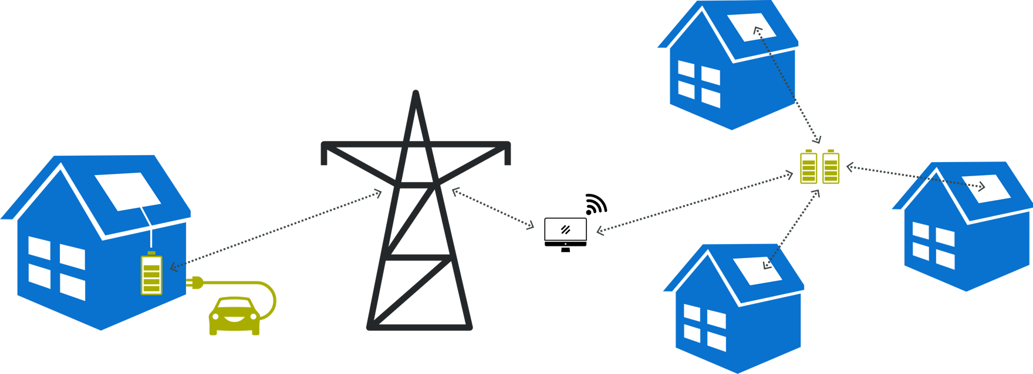
What are distributed energy
resources (DER)
DER are resources owned by consumers
to generate, store, manage or sell energy.
They include solar panels, home
or neighbourhood batteries, electric
vehicles (EVs) and smart energy devices
(such as controllable air conditioners).
New DER communication capabilities
are enabling consumers to generate and
sell new energy services to households,
the community and the electricity industry.
Harnessing Victoria's distributed energy resources
Challenges and opportunities
Integrating DER into our electricity grid enables Victorians to harness the full benefits of solar photovoltaic (PV), batteries and EV growth. The more integrated distributed
energy resources we have, the lower our emissions and electricity prices; and the greater our energy security and consumer market participation.
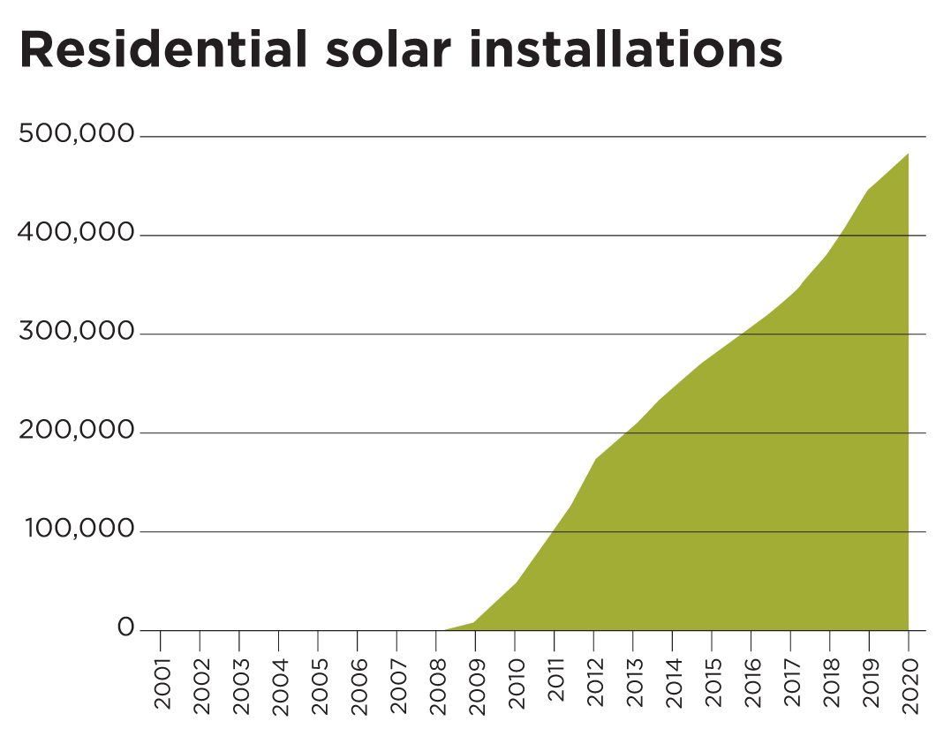
We will continue to address the challenges we face when we connect DER to the old electricity system, a system with infrastructure, markets and regulation
designed for a few coal generators, absent of small-scale renewables and consumer market participation.

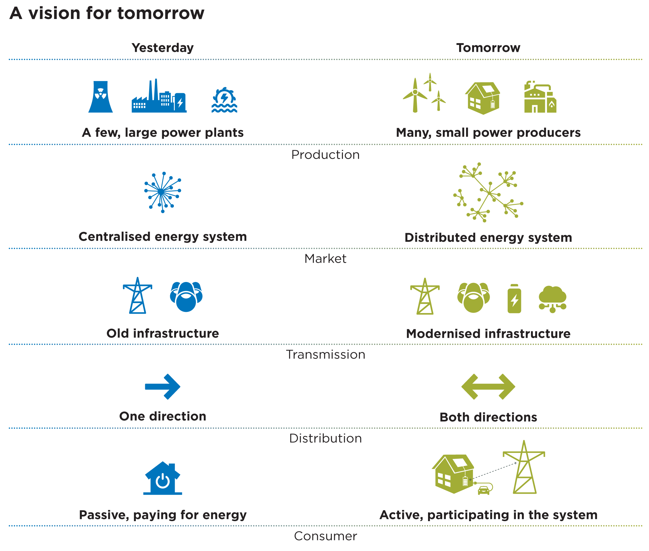
We will smooth the path for a DER dominant
future that puts consumers at the centre
of our energy transition.
We will focus on optimising DER
opportunities for households and small
businesses to complement other
government policies and programs that
drive renewables at different scales and
across different sectors including:
- Victoria’s Renewable Energy Roadmap
- Renewable Energy Zones
- Victoria’s Big Battery
- A range of other energy innovations:
Vision
To deliver reliable, sustainable and affordable energy services, and a zero-emissions,
climate ready economy and community.
DER continues
to deliver significant emission reductions
and economic
growth in Victoria
Household PV contributes to
11%
of Victoria’s
electricity
generation
by 2025
ER enhances
the affordability, reliability and
safety of Victoria’s energy system
A total of
740 MWh
of distributed battery storage
in Victoria
by 2025

DER enhances
the affordability, reliability and
safety of Victoria’s energy system
A total of
740 MWH
of distributed battery storage
in Victoria
by 2025

The benefits
of DER are shared fairly across
Victorian households and small businesses
ALL
new solar customers
can export
solar to the
grid by 2025
ll Victorians
can participate
actively in the
DER energy market
1 in 3
households
have solar PV
in Victoria
by 2025

All Victorians
can participate
actively in the
DER energy market
1 in 3
households
have solar PV
in Victoria
by 2025

Principles
The objectives and actions are underpinned by 6 principles:
Consumer-driven design
Technology, regulation and markets are only part of the energy transition – household, community and business practices shape their participation in a DER marketplace and we will continue to work hard to bring all consumer voices into all our decision making.
Clear governance, roles and responsibilities
We will work with national regulators, state compliance bodies, industry and consumers to coordinate and promote transparent oversight of the DER market as it accelerates. This means those closest to a DER issue have sight of the data, and the licence to intervene at the right time and the right place.
Enabling innovation
We know our energy future needs new solutions, not old approaches designed for an old system. Our policy and programs are designed with this future in mind, to accelerate innovation in our technology, regulation, business models and consumer insights.
Collaborating with industry
Industry are incubators of innovation. We will collaborate with industry (distributors, retailers, product developers, aggregators, installers) on our policy and programs to smooth the path for DER innovation and new business models. We understand that without this collaboration, policy can stifle rather than support DER innovation and growth.
Equity and access
Victorian households, communities and businesses are diverse in a multitude of ways – in their social practices, housing, health, language, income and energy
literacy. We will consider this diversity in our communications, subsidies, legislation and market design to ensure the accessibility of our programs. This includes applying contemporary definitions of consumer vulnerability that include transient and longstanding drivers of vulnerability.
Resilience to shocks and change
Natural hazards and disasters can strike at any time, and distributed energy systems must be planned with these risks in mind. Our DER policy and programs acknowledge the deep uncertainty nested in our physical, social and economic systems by embedding an adaptive and risk management approach into everything we do.
Objectives
Government investment is focused on 6 objectives to prepare us for a DER dominant future:
- Helping all householders access the benefits of DER
- Driving innovations through place-based initiatives
- Future proofing consumer protections for our transforming energy system
- Supporting business and jobs to harness the opportunities of DER
- Transforming our public and private buildings
- Preparing our grid for DER integration and consumer access to markets
Helping all householders access the benefits of DER
Renters, community housing tenants, homeowners and rental providers are receiving Victorian Government subsidies to generate, store, manage and sell energy. This financial support puts households at the centre of the energy transition helping them to access to the latest technology in solar, electric vehicles and temperature control.
Solar Homes Program
The $1.3 billion Solar Homes Program will support 778,500 households over 10 years to install solar panels, solar hot water systems or batteries at home, helping households reduce emissions and save on their energy bills.
Recent studies show that some Solar Homes customers have saved an average of $1,073 on their previous year’s energy bill through installing solar panels. Eligible rental providers and community housing providers can apply for solar rebates helping Victorians who don’t own their own property access the benefits of renewable energy.
ZEV Subsidy Program
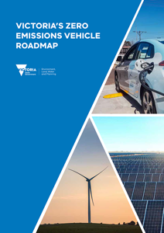
The Victorian Government’s $100 million Zero Emissions Vehicle (ZEV) Roadmap will accelerate the uptake of EVs in Victoria and prepare Victoria for the transition
to ZEVs. The Roadmap’s $46 million ZEV Subsidy Program increases the affordability of ZEVs for Victorians in combination with a $19 million investment
into charging infrastructure across the State.
Access Victoria's zero emissions vehicle roadmap here
Victorian Energy Upgrades
The Victorian Energy Upgrades (VEU) program is expanding the technologies available so Victorians can get the most out of their DER products. VEU provides incentives for consumers to install real-time electricity monitoring systems and will soon include other technology such as smart thermostats for heating and cooling appliances, and smart EV chargers. These technologies help consumers use appliances when solar is the most productive or when electricity is cheap - taking the effort out of household energy efficiency and lowering energy bills.
VEU delivered energy efficiency upgrades to more than 245,000 homes and 10,000 businesses in 2021 saving the equivalent of 6.3 million tons of greenhouse gas emissions. Between 2022 and 2025 the program is projected to deliver 1.3 billion dollars in Victorian energy bill savings.
Victorian Energy Compare
The Victorian Energy Compare website shows Victorians how to combine their DER with the cheapest electricity pricing in the market. Every household is different, whether it uses lots of energy in the day or at night, have solar or don’t, VEC will help Victorians find the best deal. The VEC’s Solar Calculator also helps business and households find the best solar system for them by taking their electricity use data to estimate the annual savings and payback period.

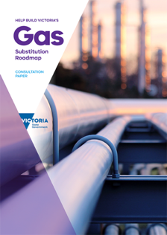
Decarbonisation of the grid means that many households can reduce emissions and bills by switching
from gas appliances to electric. Find out more

Driving innovations through place-based initiatives
Communities are leading innovation in Victoria’s energy transition. The Victorian Government supports this innovation through place-based pilots and programs. We will continue to listen and learn on how we can best facilitate increased community participation in the energy transition. Insights from community programs will shape our policy now and into the future.
Neighbourhood Battery Initiative
The Victorian Government’s $10.92 million Neighbourhood Battery Initiative (NBI) is trialling new energy storage models to maximise benefits for Victorian communities and the electricity system. Neighbourhood batteries are larger than household batteries and connect directly to the electricity grid – known as ‘in front of the meter’.
These ‘shared’ batteries support the integration of more solar into our energy system, expand Victorian’s access to energy storage and inform future policy on distributed energy resources. This program puts communities at the centre by asking them critical questions to inform consumer protections, system functionality, and device communications (Victorian Neighbourhood Battery Initiative Consultation | Engage Victoria) and by evaluating the community experience of every project.

Community power hubs​
Community power hubs (CPH) are allocating $3.37 million for renewable energy projects. After a successful pilot in 2017, the hubs bring together local stakeholders to realise the economic and employment benefits of renewable energy. CPH support certified not-for-profit organisations, community groups or social enterprise to establish, operate or deliver the project.
Seven CPHs have been funded to work with communities across the state to develop new projects and 16 implementation-ready projects will be funded. CPH and NBI increases opportunities for people sometimes excluded from owning DER (such as low-income households and apartment dwellers) by providing a shared DER asset to use and invest in.

The Victorian Government is facilitating innovation through regulatory sandboxing. This will allow new business models, products and services to operate under relaxed regulatory requirements on a time-limited basis with appropriate safeguards in place.
From June 2022, the Victorian Essential Services Commission will be able to grant a trial waiver to projects that are genuinely innovative in the electricity sector.

Microgrid Program and Microgrid Demonstration Initiative
The NBI and CPH complement the Microgrid Program and the Microgrid Demonstration Initiative (MDI). Microgrids provide resilient energy infrastructure to communities and households during extreme weather events. In Mallacoota, Omeo and Corryong the Microgrid Program will deliver back-up power if they become isolated from the grid.
The $10 million MDI, launched in December 2017, has supported the development and implementation of various innovative microgrid projects. During the 2019–20 bushfire, the Totally Renewable Yackandandah Microgrid provided power for fire pumps and local homes. Other projects funded under the MDI include the Euroa Microgrid, the Monash University Microgrid Electricity Market Operator, the Origin Energy Virtual Power Plant, and the Birchip Cropping Group Microgrid Demonstration.
Solar Victoria Virtual Power Plant pilot program
This pilot program is an expansion of the Solar Homes battery rebate. Its ‘aggregation’ option helps households understand and participate in battery aggregation, such as virtual power plant projects. Projects have been assessed on the strength of their consumer protections putting community benefits at the centre of this exciting new funding stream. Various operational and business models will be tested to maximise the insights on the role of batteries in Victoria’s transitioning electricity system. The pilot program will provide up to 2,000 households with access to higher battery rebates.

Microgrids provide resilient energy infrastructure to communities during extreme weather events
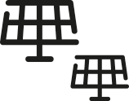

The Traditional Owner Renewable Energy Program
The $1.1 million Traditional Owner Renewable Energy Program (TOREP) launched in late November 2020, supports Victoria’s 11 Registered Aboriginal Parties (RAPs) with grants of up to $100,000 for renewable energy projects. TOREP will capture the feedback and experiences of RAPs on how they choose to participate in the DER market and advance their small-scale renewable energy projects and capabilities.
All RAPs that applied for TOREP were successful and their renewable energy projects will be completed by June 2022. These projects are primarily solar PV and battery storage systems to provide clean power to various RAP buildings and other infrastructure.
TOREP is an example of enabling self-determination within the renewable energy sector for Traditional Owners and Aboriginal Victorians and responds DELWP’s Pupangarli Marnmarnepu ‘Owning Our Future’ Aboriginal Self-Determination Reform Strategy 2020-25. The program provides varied tangible and intangible cultural, environmental, economic and sustainability outcomes. It is a community level example of how RAPs can contribute to lowering emissions for a cleaner future for all Victorians.

Future proofing consumer protections for our transforming energy system
The Victorian Government is working with partners to ensure that every part of the DER
customer journey has protections in place to reflect the diversity of Victorians and the changing energy system.
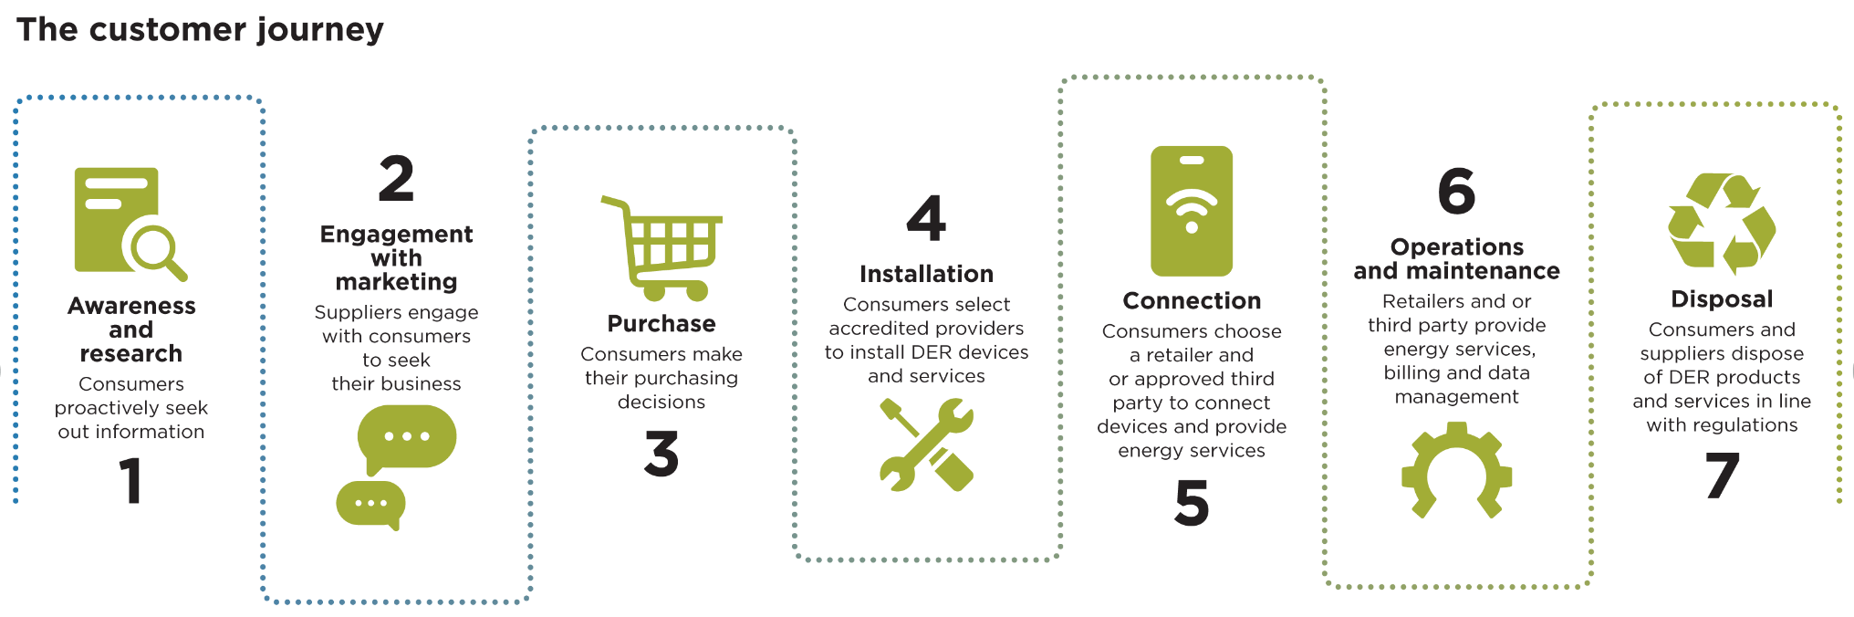

Energy fairness reforms
The Victorian Government’s Energy Fairness reforms prohibit energy retailers and their agents from unsolicited high-pressure sales tactics to residential customers, such as door-to-door selling or cold-calling. These reforms will remove pressure for consumers to sign up to expensive DER products and services that they don't understand and avoid subsequent financial stress. Door-to-door sales of solar products have also been banned under the Solar Homes Program since 1 September 2021.
Solar Homes audits
Audits of Solar Homes installations are driving continuous improvement in the solar industry. Continued participation of businesses in the Solar Homes Program is based on audit findings and action ensuring ongoing delivery of high standards in the program. The audits are complemented by a compulsory Certificate of Electrical Safety (CES) prior to grid connection for every installation.
Codes of conduct
Since 1 July 2019, retailers participating the Solar Homes Program must be signatories to the Clean Energy Council’s Solar Retailer Code of Conduct to meet the highest safety and quality standards and consumer protections. Signatories to the Code must comply with standards covering advertising, contract documentation, finance and payments, design and installation, and complaints.
Similarly, DELWP is introducing a Code of Conduct for the Victorian Energy Upgrade program to establish protections for participating gas and electricity consumers from 1 July 2022. By mandating industry Code of Conducts, the Victorian Government boosts delivery standards and positive consumer outcomes in its programs and across the DER industry.
VEU consumer protections
We are talking to consumers and stakeholders about how to best deliver consumer protections in the VEU program. The consultation paper (https://engage.vic.gov.au/victorian-energy-efficiency-target-act-review) covered a range of emergent issues associated with the latest DER including data
privacy and access, product performance, sales and contracts. We heard from stakeholders that stronger protections, better communications
and third-party compliance are priority issues.
Working with partners
We will continue work with partners to address what we heard in our consultations and ensure consumer protections keep pace with our rapidly transforming energy system. The Energy and Water Ombudsman of Victoria (EWOV), the Essential Services Commission (ESC) and the consumer groups Energy Consumers Australia (ECA) and the Consumer Action Law Centre (CALC) play critical roles in driving consumer outcomes in the energy market. With our partners we are continuing to progress action in:
- Dispute resolution services for DER products and services
- Accessible and useful information on DER product function and performance
- Consumer data access and privacy
- Compliance with product and service standards
Supporting business
and jobs to harness the opportunities of DER
Businesses are accessing new energy infrastructure and skills to harness the economic benefits
of our transforming energy system.
Solar for Business Program
The Solar for Business Program is offering solar PV rebates to 15,000 small businesses over three years, helping businesses lower their energy costs and contributing to Victoria’s economic recovery. The VEU program also provides subsidies for medium-scale solar panels (more than 100kW) creating financial incentives for businesses
to generate and use energy on site.
New Energy Jobs Fund
The New Energy Jobs Fund (NEJF) provides $20 million to support Victorian-based projects that create long-term jobs in new energy technologies. The fifth round of the NEJF provided $1 million in grants to help regional communities deliver innovative renewable energy projects.
Work Safely in the Solar Industry training program
Solar Victoria is investing $11 million to provide skills and safety training for Victoria’s solar and heating, ventilation and air conditioning (HVAC) workforces. This includes a fully subsidised, solar-specific safety training course, Work Safely in the Solar Industry, mandatory for all on-site workers carrying out Solar Homes and Solar for Business installations from 1 July 2021.
Clean Economy Skills and Jobs Taskforce
The Clean Economy Skills and Jobs Taskforce provides expert advice to Government on the Clean Energy Workforce Development Strategy. Together they will target the Victorian Governments’ skills and training investment to our energy future – DER with sophisticated communications and market democratisation. This investment is delivered in part via the Clean Economy Workforce Capacity Building Fund, providing $6 million in grants for teaching professional development, curriculum, learning resources and platforms.
Zero Net Carbon Homes
Sustainability Victoria’s Zero Net Carbon Homes provided capacity development to enable builders to develop, market and sell sustainably designed homes. Solar panels, energy efficient design and fixed appliances in each home reduces running costs, increases comfort, and curbs carbon emissions. The design of each home supplies enough renewable energy for a households’ estimated energy use.

The New Energy Job Fund provides $20 million to support Victorian-based projects
that create long-term jobs in new energy technologies
Transforming our public
and private buildings
The Victorian Government is increasing DER in our public and private buildings.
We know transforming our buildings will support energy security, emission reductions,
cost reductions and economic growth.
DER ready building regulations
Victoria is working with other jurisdictions on changes to the National Construction Code (NCC) to promote onsite renewables, electric vehicle chargers and DER friendly temperature control. This work is supported by amendments to the Plumbing Regulations 2018 to enable electrification; and policy development to create DER ready precincts and electricity infrastructure.
Solar on Public Buildings
Volunteer Committees of Management have been benefiting from the $9.2 million ‘Solar on Public Buildings program by the installation of solar PV on sport, recreation
and community buildings.
The 3-year program will provide cost savings, improve the electrical safety and energy efficiency for up to 300 public land sites and energy security for emergency management sites.
Volunteer committees are set to save over $1 million per year following the installation of solar PV systems. Accessing DER has supported the viability of local meeting
places and engaged communities all over Victoria on the benefits of DER and local energy management.

Greener Government Buildings Program
The Greener Government Buildings program is delivering solar panels to health and education buildings across Victoria. After the successful school pilot delivered energy upgrades to 42 schools in 2019, another 171 government schools across Victoria will receive solar systems under the program.
In the health sector the $13.5 million Regional Health Solar Program has installed 8,329 kilowatt-peak of solar on 61 health facilities. The Greener Government
Buildings program is also delivering around 1,000 kilowatt-peak of solar in large hospitals and the first Australian public hospital Peninsula Health, to install a battery.

After the successful school pilot delivered energy upgrades to 42 schools in 2019, another 171 government schools
across Victoria will receive solar systems under the program

Preparing our grid for DER integration and consumer
access to markets
The Victorian government is driving innovation and reform in a range of national and state processes and programs to strengthen the DER readiness of our grid and maximise consumer participation.
Modernising our grid and technology standards
We will continue to work with the Australian Energy Regulator and Victorian electricity distribution businesses on: solar export limits; transparent DER infrastructure investment; and DER appropriate electricity pricing. This includes pricing to support solar self-consumption; electric vehicle ownership; and battery storage benefits.
The Victorian Government is also a strong advocate for network innovation. We work closely with distribution businesses and support the use of innovation funding to optimise DER consumer outcomes. AusNet Services has used innovation funding to develop Project EDGE, a collaboration with AEMO and Mondo to provide households
with compensation for new DER services. Another example is the smart Electric Vehicle Charging Trial, where 3 Victorian distribution businesses (Jemena, AusNet Services and United Energy) are helping prepare our grid for an electric vehicle future.
We will continue to use the Solar Homes Program to elevate DER technical standards. From July 2019, Solar Homes mandated that solar inverters provide grid support and from July 2021, that they are capable of 2-way communications. Also, since July 2019, Solar Homes battery installations have been virtual power plant ready – enabling owners to sell energy services back to Victoria’s grid and contribute to its transformation.

Want to understand more about electricity pricing? Find out more Victorian Energy Saver or from Victorian Energy Compare
Supporting our energy transition
The Victorian Government has a suite of instrumental policy and programs to drive our
DER dominant future. We invite Victorians to co create our DER policy through our consultation papers to be released in 2022.

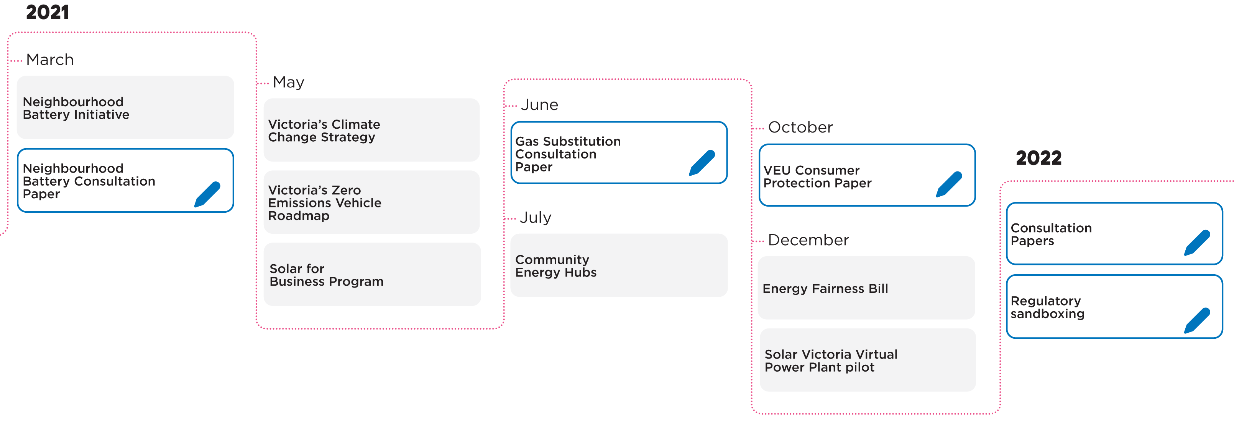

https://www.solar.vic.gov.au/solar-homes-program-reporting
Bill savings locked in but are projected out into the future, 1 tonne C02 = 934kWh, 2022 electricity pricing stays close to May 2021 average. Victorian electricity price of 20.96c/kWh, calculation based on electricity savings only.

