Victoria's Renewable Energy Investment Prospectus
Table of Contents
Victoria, one of the world’s most exciting energy markets 3
Minister’s Foreword 4
Our legislated targets are driving investment 6
Victorian Government initiatives drive sector growth 8
A trusted location for your next energy investment 10
Fast-tracking planning approvals 13
VicGrid – shaping Victoria’s future grid 15
Victoria’s new Renewable Energy Zones 17
Powering Victoria’s renewable energy future 19
Investing in a net-zero Future Made in Australia 21
A leader in manufacturing and recycling 23
Capacity Investment Scheme 25
Access to Victoria’s world-class renewable energy talent 26
Globally significant critical mineral deposits 28
The heart of Australia’s National Electricity Market 30
Dive into Victoria’s renewable energy subsectors 33
Bioenergy 34
Digital energy and innovation 36
Energy storage 38
Renewable hydrogen 41
Solar 44
Onshore Wind 46
Offshore Wind 48
Zero emissions vehicles 51
Subsector packs 53
Key Victorian Government entities 54
For international investors 57
Publication information 59

Victoria, one of the world’s most exciting energy markets

The Victorian Government has committed to a target of:
Net-zero greenhouse gas emissions by 2045

Acknowledgement of Country
We acknowledge and respect Victorian Traditional Owners as the original custodians of Victoria’s land and waters, their unique ability to care for Country and deep spiritual connection to it.
We honour Elders past and present whose knowledge and wisdom have ensured the continuation of culture and traditional practices.
We are committed to genuinely partner, and meaningfully engage, with Victoria’s Traditional Owners and Aboriginal communities to support the protection of Country, the maintenance of spiritual and cultural practices and their broader aspirations in the 21st century and beyond.

Traditional Owners at the centre of decision-making processes
Strong and mutually beneficial partnerships with Traditional Owners and First Peoples are imperative to the electricity transition’s success and integral to ensuring the goals and objectives of self-determination set out in the Victorian Government’s Self Determination Reform Framework and the Department of Energy, Environment and Climate Action’s (DEECA) Pupangarli Marnmarnepu ‘Owning Our Future’ Aboriginal Self-Determination Reform Strategy 2020–2025.
For more information, visit:
deeca.vic.gov.au/aboriginalselfdetermination/self-determination-reform-strategy

Minister’s Foreword
On behalf of the Victorian Government, I am proud to welcome you to our Renewable Energy Investment Prospectus.
With abundant renewable resources to harness, sophisticated supply chain capabilities and strong economic credentials, Victoria is one of the fastest-growing destinations for renewable energy investment in the Southern Hemisphere.
We have legislated our targets of 95% renewable energy by 2035 and net-zero emissions by 2045, placing us at the forefront of the global energy transition and giving the private sector the confidence to invest.
Our pipeline of renewable energy and storage projects, combined with increased investment and uptake in energy efficient technologies, means we are on track to achieving our target of 40% renewable electricity by 2025.
We are building Australia’s first offshore wind industry and have legislated offshore wind generation capacity targets to demonstrate our commitment to the sector – including the first target of at least 2 GW of by 2032. Located off the coast of Victoria, this industry will create thousands of jobs while prioritising the protection of our unique wildlife and biodiversity.
Through VicGrid’s Victorian Transmission Plan, we have identified areas that are the most suitable to host new renewable energy and storage projects. These proposed Renewable Energy Zones are primed for development, investment and ready to create the next wave of renewable energy projects.
We recognise that realising our renewable energy future depends on swift investment and a skilled workforce. That is why the Development Facilitation Program has unlocked almost $5 billion worth of investment across 18 projects – accelerating progress and unlocking new opportunities across Victoria.
The challenge ahead is significant, but so too are the opportunities. We are ready to work with industry to ensure every Victorian is connected to clean, safe and reliable energy.
Whether you are looking to invest, partner or innovate – Victoria is the place for you.
The Hon. Lily D’Ambrosio MP
Minister for Climate Action
Minister for Energy and Resources
Minister for the State Electricity Commission

Our legislated targets are driving investment

Victoria's changing energy market is creating investment opportunities
Victoria’s energy market is in transition, shifting from its historic fuel source of brown coal to a more diversified, renewable mix. The Victorian Government has entered into agreements with the owners of 2 of the largest coal-fired generators, that will see these assets close in 2028 and 2035.
This creates unprecedented opportunities for investment, as Victoria will need an estimated $35 billion of additional investment to provide 25 GW of new renewable energy and storage capacity by 2035.
Our transition to renewable energy is supported by strong targets set by the Victorian Government, creating significant opportunities for investors.

Victoria’s Electricity Future
The Victorian Government has released its vision for Victoria’s future electricity system.
Cheaper, cleaner, renewable: our plan for Victoria’s Electricity Future is a 4-pillar plan to enable the renewables big build, empower households and businesses to lower energy bills, manage the transition away from fossil fuels and create jobs, skills and supply chains.
Figure 1: Legislated renewable energy targets
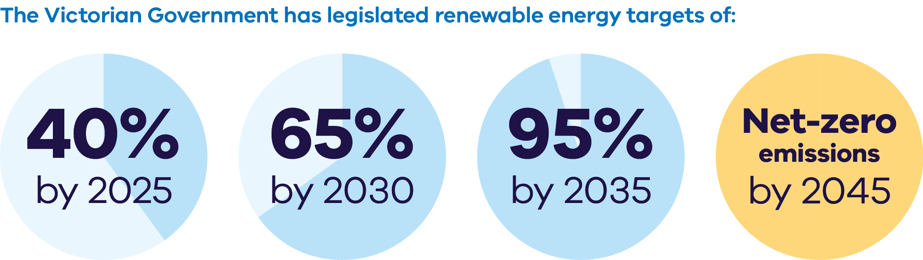
The Victorian Government has legislated renewable energy targets of:
- 40% by 2025
- 65% by 2030
- 95% by 2035
Net-zero emissions by 2045
Figure 2: Energy storage capacity and Offshore wind energy targets from 2025-2045
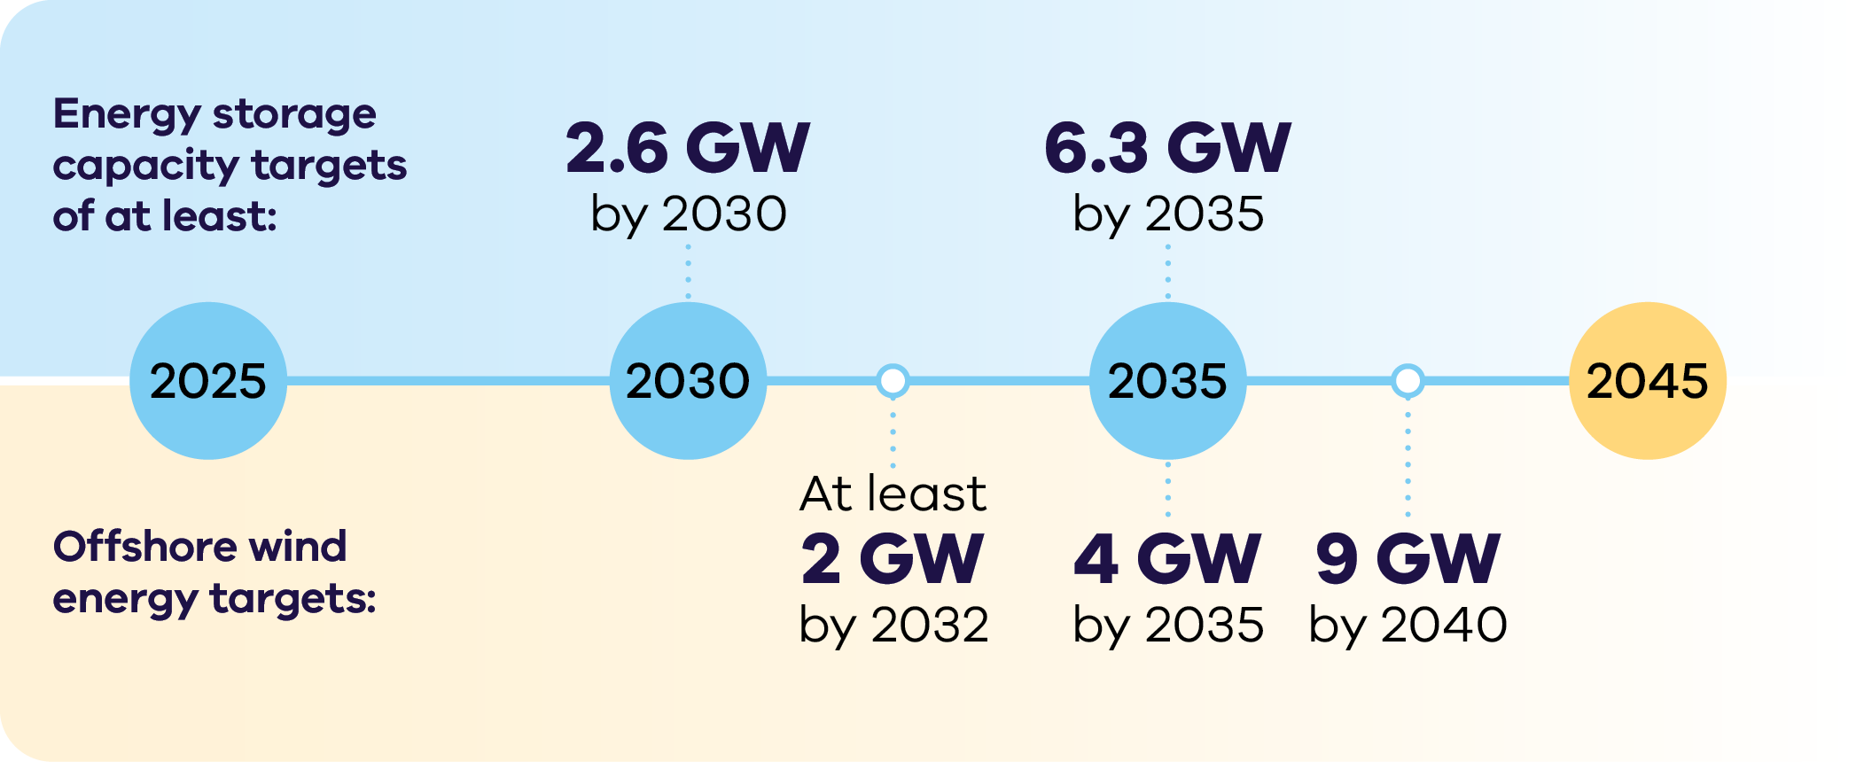
Energy storage capacity targets of at least:
- 2.6 GW by 2030
6.3 GW by 2035
Offshore wind energy targets:
- At least 2 GW by 2032
- 4 GW by 2035
9 GW by 2040
For more information, visit: energy.vic.gov.au/renewable-energy/victorias-electricity-future

Victorian Government initiatives drive sector growth
The Victorian Government has committed almost $4 billion to support the energy transition over the last few years. This government support makes it easier for investors to join the state’s growing renewable energy sector. (Note: The $4 billion committed includes funding announced in the 2020–21, 2021–22, 2022–23, 2023–24, 2024–25 and 2025–26 Victorian Budgets, all figures are in $A. Funding for the Solar Homes program is over 2018–2028. Batteries are no longer supported under the Solar Homes program.)
Recent initiatives include:

Network stability
$480 million for transmission upgrades to unlock new renewable energy investment, supporting regional economic growth and jobs.

SEC
$1 billion towards delivering 4.5 GW of power through renewable energy and storage projects over the next 10 years, delivered by the SEC, a government-owned energy company.

Solar and batteries
$1.3 billion provided through the Solar Homes Program for rebates and no-interest loans to accelerate the uptake of rooftop solar PV, batteries, heat pumps and solar hot water systems for eligible homes.

Victorian Renewable Energy Target auctions
$2 billion of investment leveraged by the Victorian Renewable Energy Target auctions (VRET1 and VRET2), by awarding long-term support agreements that provide investment certainty.

Innovation
$108 million to support the commercialisation of innovative, emerging renewable energy technologies in Victoria, including offshore wind, renewable hydrogen, bioenergy and battery energy storage systems.

Energy efficiency
$580 million in energy efficiency and electrification upgrades unlocked through the Victorian Energy Upgrades (VEU) program in 2024–25.

A trusted location for your next energy investment
Figure 3: Melbourne, Australia
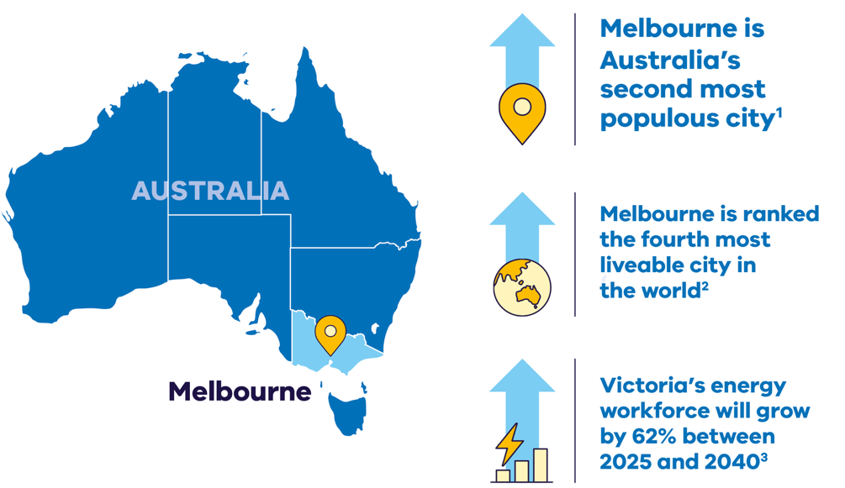
- Melbourne is Australia’s second most populous city.
- Melbourne is ranked the fourth most liveable city in the world.
- Victoria’s energy workforce will grow by 62% between 2025 and 2040.

Verifiable, ethical business practices
- Our transparent and auditable local supply chains ensure alignment with responsible sourcing principles
- Proximity to Australia’s critical minerals and an extensive local supply network reduces Victoria’s manufacturing carbon footprint.

Stable and trusted
- Australia has a stable political environment and is a global leader in the protection of property rights, including IP rights
- Victoria’s environmental, social and governance (ESG) benefits are underpinned by a fair legal system, strong governance and an agile public service with the ability to formulate and implement sound policies.

A strong economy
- Victoria’s economy has experienced strong growth and is was 11.5% larger in 2023–24 in real terms compared to 2018–19, before the pandemic4
- Since 2014, Victoria has achieved the highest jobs growth in Australia6, with employment growth rising by 20% since 2020.,

Leading the way to economy wide net‑zero
- The Victorian Government has set strong targets of 95% renewable electricity generation by 2035 and net-zero emissions by 2045
- With almost $28 billion of national funding committed towards a greener Future Made in Australia and a Net Zero Fund for industrial decarbonisation, there are strong opportunities for Victorian businesses to become part of national renewable energy supply chains.

World class skilled workforce
- Victoria is home to 2 universities ranked in the world’s top 40 and 6 within the global top 3006
- Victoria has strong vocational education and training options and is utilising the $50 million TAFE Clean Energy Fund to support training for renewable energy jobs.⁴
- The Victorian Government has also committed $7 million to develop new energy training pathways through VET qualifications to ensure workforce skills and future capacity align with evolving industry requirements.⁴

Globally connected
- Victoria provides access to domestic and international goods, services and
markets via its:
- 4 major seaports
- 24/7 curfew free international airport
- extensive road and rail networks.
- Victoria is home to the fastest growing export sector in Australia, growing more than $10 billion in 2023–2024.⁵

Fast-tracking planning approvals
The Victorian and Australian Governments are committed to getting your project through planning approvals as quickly as possible.

Fast-tracked planning approvals
The Victorian Government Development Facilitation Program fast-tracks the planning permit approval process for renewable energy facilities and utility installations. This provides certainty to investors by removing the risk of delay by third-party appeals.
For more information, visit: planning.vic.gov.au/planning-approvals/planning-enquiries-and-requests/development-facilitation-program
Furthermore, the Australian Government is providing $168 million to better prioritise approval decisions for renewable energy projects of national significance, and support faster decisions on environment, cultural heritage and planning approvals.

New tools and guidance to better manage biodiversity impacts of renewable energy projects
The Victorian Government has delivered a suite of new tools and guidance designed to facilitate critical renewable energy development while protecting Victoria's unique biodiversity.
On 29 May 2025, the new Handbook for the development of renewable energy in Victoria was published. This handbook outlines a risk-based approach to identify, assess and manage the biodiversity impacts of renewable energy projects.
For more information, visit: environment.vic.gov.au/home/managing-impacts-of-renewable-energy-on-environment
The Habitat Value map and the Marine Biodiversity Values map have also been released, which combine information on thousands of species to show the relative biodiversity value of habitats in Victoria. These maps can assist with prioritising areas for protection, avoiding areas of high biodiversity value in development footprints and designing infrastructure that minimises impacts.
For more information, visit:
environment.vic.gov.au/biodiversity/habitat-value
marineandcoasts.vic.gov.au/marine-and-coastal-knowledge/MBV
The Victorian Government has also released outcomes of research projects designed to address some of the most urgent questions facing developers and decision-makers about biodiversity impacts from onshore renewable energy.
For more information, visit:
ari.vic.gov.au/research/strategic-projects-for-policy/science-for-renewable-energy-policy

VicGrid – shaping Victoria’s future grid
VicGrid is changing the way renewable energy zones are planned and developed, and delivering the infrastructure Victoria needs to unlock more renewable energy resources.

VicGrid’s flagship projects
VicGrid is working on flagship projects that will not only unlock significant new generation and storage, but present strong investment opportunities.
This includes:
- Investing $480 million in a portfolio of projects across the state to strengthen and modernise Victoria’s grid
- Leading the development of Gippsland offshore wind transmission infrastructure
- Working with the Australian Energy Market Operator (AEMO) to deliver crucial new transmission projects including the Victoria to New South Wales Interconnector West (VNI West) and the Western Renewables Link (WRL)
- Investing in the Marinus Link interconnector between Victoria and Tasmania to enhance energy reliability and affordability.

Sharing benefits with local communities
The Victorian Government encourages investors and project developers to take a strong consumer engagement and benefit-sharing approach, as set out in the draft Renewable Energy Zone (REZ) Community Benefits Plan. A cornerstone of this plan is the REZ Community Energy Fund, which creates opportunities to invest in local energy outcomes and to create other benefits for communities in those regions.
In May 2024 VicGrid carried out consultation on the draft REZ Community Benefits Plan. VicGrid is assessing the feedback it received, which will inform the final plan, expected to be released in late 2025.
For more information, visit: engage.vic.gov.au/vtif-rez-community-benefits

Victoria’s new Renewable Energy Zones
The Victorian Transmission Plan is a new long-term strategic plan for transmission and renewable energy zone development in Victoria.
This plan will ensure we build the right amount of energy infrastructure in the right places at the right time to support the transition to renewable energy.
The plan sets out 6 proposed onshore renewable energy zones: South West, Central Highlands, Western, North West, Central North and Gippsland.
Figure 4: The 6 proposed onshore renewable energy zones
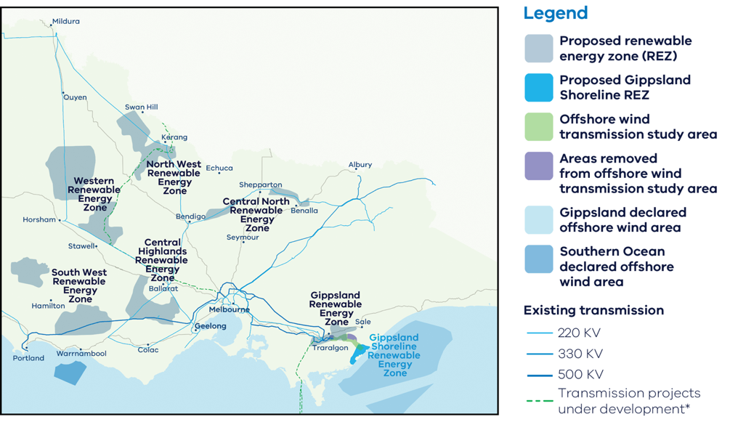
These are the areas identified as most suitable to host new renewable energy generation, such as wind turbines, solar farms, and battery storage.
It also sets out the transmission projects that need to be built over the next 15 years to enable Victoria’s energy transition, providing a long-term pipeline of strategic investment opportunities.
The 2025 Victorian Transmission Plan was released in August 2025.
For more information, visit: energy.vic.gov.au/renewable-energy/vicgrid/the-victorian-transmission-plan

Powering Victoria’s renewable energy future

What is SEC?
SEC is a government-owned renewable energy company that:
- invests in renewable energy and storage projects that accelerate the energy transition and deliver sustainable returns
- retails to government and commercial and industrial businesses
- supports households to go all-electric to reduce their energy bills and emissions
- supports the growth of the renewable energy workforce our energy transition requires.

How SEC invests:
SEC is investing an initial $1 billion towards delivering 4.5 GW of new renewable energy generation and storage. Its work will ensure Victorian households and businesses continue to have the power they need as we transition to renewable energy.
SEC’s investments include opportunities in renewable generation and storage. Utility-scale storage can address critical system gaps and help catalyse investment in large wind and solar generation to replace ageing coal assets.
The organisation will also continue to explore emerging technologies, including long duration energy storage opportunities, that accelerate the sector's maturity by enabling high levels of renewable power generation in the power grid. SEC’s investment focus is on achieving sustainable returns while delivering broader benefits to the Victorian public and enabling the market.
Find more information, visit: secvictoria.com.au

SEC’s initial investments
SEC has already made two major investments in renewable generation and storage projects, representing 819 MW of capacity:
- Melbourne Renewable Energy Hub in Plumpton, which SEC is developing together with Equis Australia. With 600 MW of capacity, it is one of the world’s biggest battery projects. Once operational in late 2025, the hub will deliver 1.6 GWh of energy storage – enough to power around 200,000 homes during peak evening consumption.
- SEC Renewable Energy Park in Horsham, a wholly-owned 119 MW solar farm and a 100 MW, two-hour battery storage system capable of generating around 242,000 MWh of renewable energy a year – enough to power around 51,000 homes.

Investing in a net-zero Future Made in Australia
The Australian Government is investing over $25 billion to transform the nation into a renewable energy superpower. As the country’s leading manufacturing state, Victoria can be central to these ambitions.
(Note: The investment of $25 billion includes funding announced in the 2024-25 and 2025-26 Federal Budgets.)
The Australian Government’s Future Made in Australia initiative has been designed to maximise the economic and industrial benefits of the net zero transition. It is focused on facilitating private sector investment and building a stronger, more diversified and more resilient economy powered by renewable energy.
Key initiatives include:
- $7 billion production tax incentive for the processing and refining of critical minerals
- $6.7 billion production tax incentive for renewable hydrogen
- $2 billion for early-mover renewable hydrogen projects as part of the Hydrogen Headstart program (bringing total investment to $4 billion)
- $2 billion green aluminium production credit to position Australian aluminium as some of the greenest in the world.
- $1.7 billion to promote net-zero innovation, including for green metals and low-carbon fuels
- $1 billion Green Iron Investment Fund to setup new facilities and supply chains
- $1.5 billion to strengthen battery and solar panel supply chains through production incentives
- $134 million to fast-track approval processes
For more information, visit: treasury.gov.au/policy-topics/future-made-australia
The Victorian Government can connect you with the Australian Government’s specialist investment vehicles, including:
- Clean Energy Finance Corporation: Australia’s ‘Green Bank’, with access to $30.5 billion in investment capital from the Australian Government and the financing arm of Rewiring the Nation, a program that invests to modernise Australia’s electricity grid
- Australian Renewable Energy Agency: Provides financial assistance for research, development, demonstration, commercialisation and deployment of renewable energy technologies
- National Reconstruction Fund Corporation: A $15 billion national investment fund designed to diversify and transform Australia's industry and economy.

A leader in manufacturing and recycling
Victoria is primed to be a global leader for low carbon production, leveraging our existing resource endowments, nation-leading manufacturing base, and low carbon research and innovation capabilities to expand our clean energy export potential.

Nation-leading manufacturing base
- Home to a $39 billion manufacturing sector that supports more than 275 000 jobs, and exports goods over $11 billion
- A long history in automotive, aerospace, defence, metal, food and fibre, medical technologies, chemical and general manufacturing, Victoria has a nation-leading manufacturing base that provides the foundation for capturing clean energy export opportunities.

Resource endowments
- Establishing a seamless critical minerals ‘mine to manufacture’ supply chain, with some of the largest global reserves of ilmenite, rutile, and zircon – plus substantial reserves of antimony and gold
- Leveraging our world-class solar and wind resources as a low-cost and reliable renewable energy source for production – preparing Victorian industry for low carbon and zero emissions metals production
- Victoria has access to a growing volume of decommissioned renewable energy components, creating a valuable stream of materials for repurposing or recycling. This presents strong investment potential - both in expanding existing recycling infrastructure and establishing new facilities - aligned with Victoria’s commitment to a circular economy.

Research and innovation capabilities
- World-class universities and purpose-built research and innovation centres, such as Deakin University’s Battery Research and Innovation Hub
- A highly skilled workforce, including one of Australia’s largest pools of manufacturing engineers and the largest number of tech graduates in the nation
- Home to more than 3,500 start-ups, with the whole ecosystem worth $132 billion.

Energy Innovation Fund
The Energy Innovation Fund (EIF) supports the commercialisation of innovative, emerging renewable energy technologies required to meet the net-zero emissions by 2045 target. Round 3 of the EIF was launched in June 2025 with $10 million in grants available to support industrial electrification in Victoria, with a specific focus on the food and beverage processing and manufacturing sector.
For more information, visit: energy.vic.gov.au/grants/energy-innovation-fund

Capacity Investment Scheme
The Capacity Investment Scheme (CIS) provides a national framework to underwrite 23 GW of renewable capacity and 9 GW of clean dispatchable capacity by 2030.
The Australian Government will provide revenue underwriting for successful CIS tender projects, with an agreed revenue ‘floor’ and ‘ceiling.’ This will offer investors a long-term revenue safety net that decreases their financial risks and encourages more investment when and where it is needed.
Competitive tenders for renewable energy and storage will be held approximately every 6 months. The Victorian Government and Australian Government have entered a bilateral Renewable Energy Transformation Agreement (RETA) which secures target allocations for Victorian projects in these tenders for at least 11 TWh of renewable energy and 1.7 GW of 4-hour equivalent storage.
Table 1: Schedule for target Victorian allocations in the CIS
CIS Tenders in Calendar Year | Cumulative  generation allocation  (GW / TWh) | Cumulative  storage allocation  (GW / GWh)
2024 | 2.8 / 6.2 | 1.0 / 4.0
2025 | 3.8 / 8.0 | 1.5 / 6.0
2026 | 5.0 / 11.0 | 1.7 / 6.8
For more information, visit: dcceew.gov.au/energy/renewable/capacity-investment-scheme

Access to Victoria’s world-class renewable energy talent
Our growing, highly skilled workforce drives project delivery and fosters industry growth. To meet the needs of the sector, the Victorian Government has committed to significant new energy skills and workforce initiatives.
- Delivering the Victorian Energy Jobs Plan, which seeks to support Victoria’s once-in-a-generation energy transition by setting out actions to mobilise the workforce and grow investment confidence. The Plan identifies key opportunities to support Victoria’s energy workforce, which is projected to increase from 41,000 full time equivalent (FTE) to 67,000 FTE in 2040, a 62% increase.
- Delivering the Women in Energy Strategy, which seeks to drive significant change for women in energy through Victoria’s energy transition, including addressing barriers to increasing the number of women in the energy workforce. The Strategy aligns with the Victorian Energy Jobs Plan as well as Our Equal State, which seeks to increase participation by women, economic equity, inclusive and safe workplaces, and education opportunities.
- Supporting the establishment of the National Training Centre in New Energy Skills based in Melbourne, in partnership with the Australian Government, to train and reskill key workforces needed for the energy transition across Australia.
- Developing and supporting new energy training pathways through the $7 million for new Vocational Education and Training (VET) qualifications in renewable energy and utilising the $50 million TAFE Clean Energy Fund.

World-class education and training
Victoria has a globally renowned education and training system, including:
- 2 global ‘Top 40’ universities
- 8 universities, including 4 dual-sector universities (offering both tertiary and vocational education)
- 12 independent technical and further education (TAFE) institutions under a single TAFE network
- a diverse talent pool with strong growth across the broad range of occupations relevant to the renewable energy sector.

Globally significant critical mineral deposits
The energy transition presents significant opportunities to invest in Victoria’s critical minerals sector – from mining to manufacturing.

Valuable resources
Regional Victoria has significant mineral sand deposits containing titanium, zirconium, and rare earth elements (REEs), as well as other resources like antimony, copper, high-purity alumina, and silica.
Heavy mineral sand deposits in the Murray Basin of North-west Victoria have some of the largest resources of ilmenite, rutile and zircon in the world, with:
- 22% of Australia’s ilmenite (~7% of global economically demonstrated resource)
- 51% of Australia’s rutile (~32% of global economically demonstrated resource)
39% of Australia’s zircon (~27% of global economically demonstrated resource).
These deposits could support downstream processing and metallisation of titanium and/or REEs:
- REEs are found in monazite and xenotime in Victoria’s mineral sand deposits
- Titanium is found in ilmenite and rutile
- Zirconium is found in zircon.

Victoria’s potential mining-to-manufacturing opportunities
- Permanent magnet manufacture: REEs
- Wind turbines from the Wimmera: REEs and copper
- Modern battery components: Lithium and antimony
- Solar panel components: Silicon, titanium and antimony
- Hydrogen electrolysers: Zircon and titanium

Victoria’s Critical Mineral Roadmap
The Victorian Government’s Critical Mineral Roadmap creates the foundations for a coordinated and integrated approach to foster this new industry – tailored to Victoria.
For more information, visit: resources.vic.gov.au/critical-minerals

The heart of Australia’s National Electricity Market
Victoria is located at the very centre of Australia’s National Electricity Market (NEM), linking the state to major load centres and critical infrastructure to unlock demand for energy generation and storage projects.

The National Electricity Market
The National Electricity Market (NEM) is one of the world’s largest interconnected power systems, stretching 5,000 km along Australia’s East and South-east seaboard with 40,000 km of transmission lines and cables. It services almost 90% of Australia’s population, generating over 200 TWh of electricity annually.1 Key features of the NEM include:
- A wholesale 5-minute spot market to trade electricity between generators and retailers
- Over 54 GW total system generation capacity
- Facilitated $17.7 billion in trade (2023–24 FY)
- 5 interconnected states that function as pricing regions
- $20,300/MWh spot price market cap (2025–26FY).

Investment Opportunities
Victoria’s fully competitive, privatised electricity market creates many opportunities for investors. This includes the spot and contract markets for companies that specialise in buying and selling electricity, with opportunities to leverage market fluctuations and participate in existing and emerging grid services markets.
For more information, visit: energy.vic.gov.au/electricity/about-the- electricity-sector

Australian Energy Market Operator
AEMO manages the electricity and gas systems and markets across Australia, ensuring Australians have access to affordable, secure and reliable energy.
AEMO produces trusted publications and reports relating to our energy systems, which can support investment decisions.
For more information, visit: aemo.com.au/library

Other regulating bodies
Australian Energy Market Commission is the rule maker for Australian electricity and gas markets. For more information, visit: aemc.gov.au
Australian Energy Regulator regulates energy networks and the wholesale and retail markets in Australia to ensure they are secure, reliable and affordable for consumers.
For more information, visit: aer.gov.au
Figure 5: Victoria's (VIC) high voltage interconnections with South Australia (SA), New South Wales (NSW) and Tasmania (TAS)
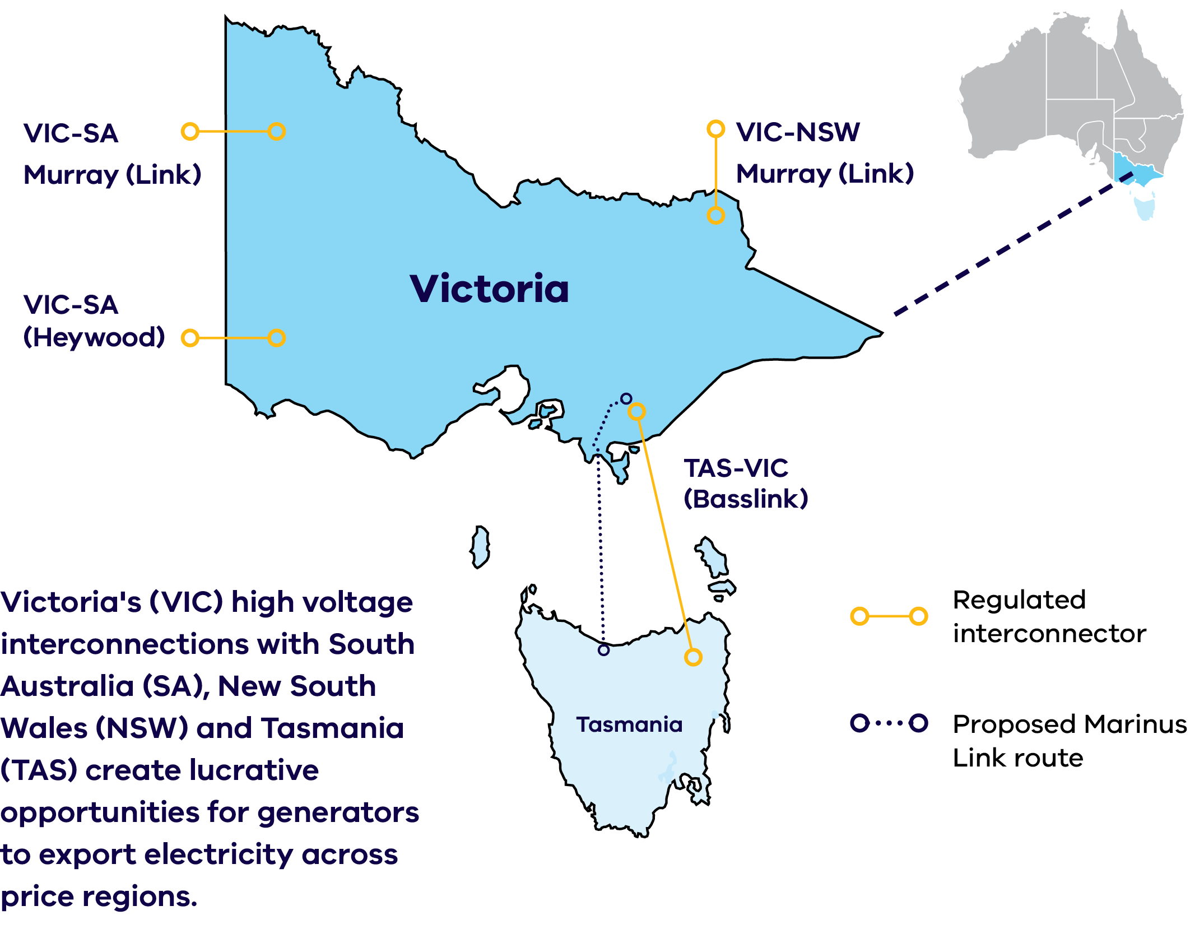
Victoria's (VIC) high voltage interconnections with South Australia (SA), New South Wales (NSW) and Tasmania (TAS) create lucrative opportunities for generators to export electricity across price regions.

Dive into Victoria’s renewable energy subsectors
To achieve our ambitious renewable energy targets, including 95% renewable electricity generation by 2035, Victoria will need to rapidly deploy a variety of technologies across 7 key subsectors. Each of these subsectors has a targeted Investment Prospectus pack, summarised over the coming pages. Read on to learn more about Victoria’s exciting opportunities in:
- Bioenergy
- Digital energy and innovation
- Energy storage
- Renewable hydrogen
- Solar
- Wind – Onshore, Offshore
- Zero emissions vehicles.

Bioenergy
As Australia’s largest food and fibre producing state, there are significant opportunities in Victoria's regions to leverage agricultural waste as biomass.
Victoria’s theoretical biogas potential is estimated to be 80.6 PJ per year. This represents 37% of the 214 PJ of gas currently consumed annually in Victoria.

High Recoverable Potential
Figure 6: Regions of Victoria and their recoverable potential for biogas
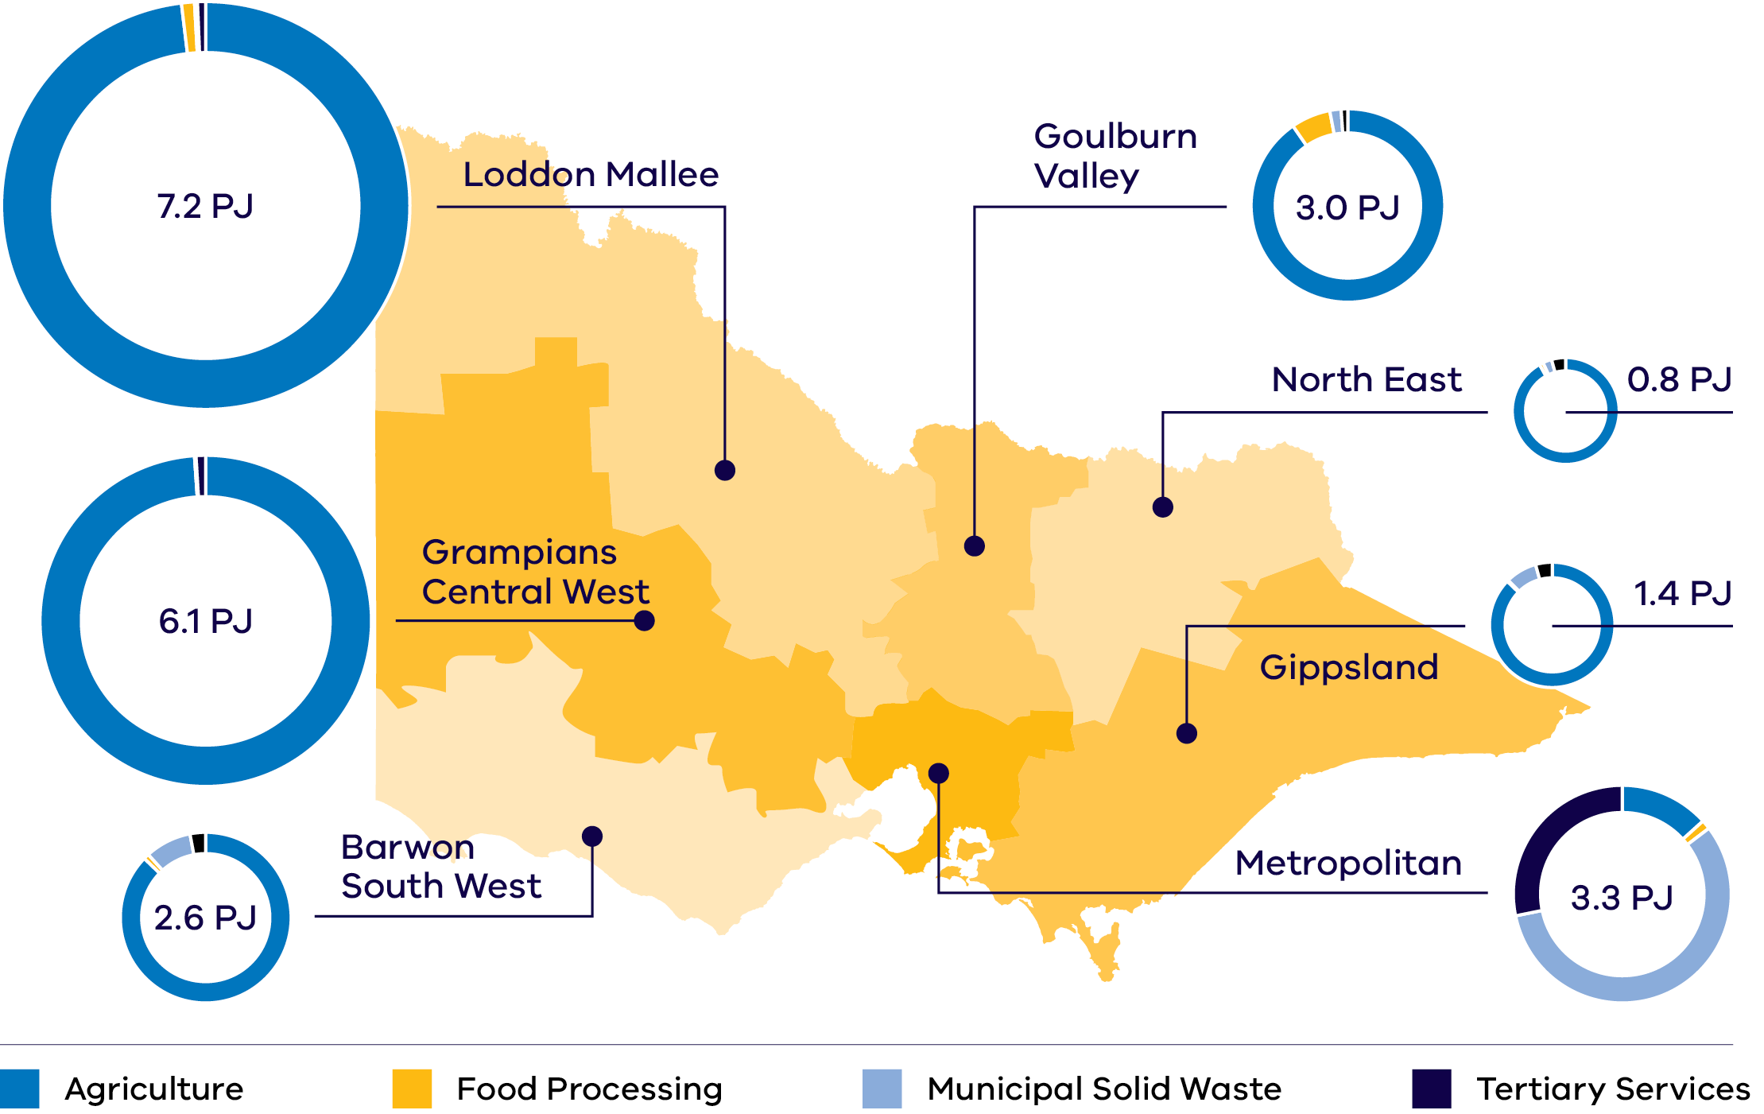

Government support for bioenergy projects
$9.31 million was awarded to Pavilion Farms through Round 2 of the Energy Innovation Fund for an anaerobic digestion plant which will use chicken litter as its primary feedstock to produce biogas and granulated organic, pathogen free and sustainable fertilizer.

For more information
For more information on bioenergy opportunities in Victoria visit: energy.vic.gov.au/industry/investment-opportunities

Digital energy and innovation
Victoria has the most extensive penetration of smart meters in Australia (over 99%), making the state the ideal location to pilot new smart grid technologies, services and business models.

World class energy data
Victoria is the only state in Australia with a fully digitised energy system, thanks to the roll-out of over 2.5 million smart meters to residential and small business electricity customers (over 99% coverage).
This makes Victoria the ideal place to develop and test new digital energy innovations, with smart meters:
- enabling near real-time remote monitoring of customer electricity flows, and
- allowing digital energy businesses to provide customers with new product offerings and greater insight into their energy use.

Smart meter coverage around Australia
- Victoria – above 99%
- Rest of Australia – less than 30%

The increasing role of Distributed Energy Resources (DER)
The drive to integrate increasing DER creates opportunities to introduce technologies and services to the Victorian market, including:
- next generation smart inverter technologies
- advanced control and coordination of batteries
- smart household energy management systems and smart appliances
smart solar electric hot water systems and heat pumps.

Investment Opportunity
Victoria’s growing digital and digital energy sectors are creating a wealth of investment opportunities. The following statistics show the pace and scale of growth:
- Australia's growing digital technologies sector is expanding at a rate 4 times faster than the rest of the economy, having grown 26% to $167 billion since 2020 and expected to reach $244 billion by 20311
- Victoria's digital technology sector generated $34 million in revenue and $3 billion in exports annually
Melbourne is home to more than half of Australia’s top 20 technology companies.

For more information
For more information on digital energy opportunities in Victoria visit: energy.vic.gov.au/industry/investment-opportunities

Energy storage
Victoria are Australia’s biggest developer of battery and energy storage projects. Both short and long duration energy storage are critical to enabling the energy transition.
Energy storage will play a key role in Victoria’s renewable energy transition in providing reliable, affordable and zero-emissions energy as Victoria’s coal generators are replaced with new renewable capacity.

Victoria’s Energy Storage Targets
Victoria has legislated energy storage targets of:
- at least 2.6 GW of energy storage capacity by 2030
- at least 6.3 GW by 2035.
The energy storage targets will include short, medium and long duration energy storage systems.
For more information about the storage targets, visit: energy.vic.gov.au/renewable-energy/victorian-renewable-energy-and-storage-targets

Cheaper Homes Batteries Program
The Australian Government’s Cheaper Home Batteries Program incentivises the rapid uptake of batteries across Australia.
The program will provide around a 30% discount on the upfront cost of installing eligible small-scale battery systems (5 kW–100 kW). The discount will be based on the battery’s usable capacity and will gradually decrease until 2030. The program is also investigating options to reduce waste from solar PV.

Neighbourhood batteries
The Victorian Government has committed more than $37 million to fund the installation of 100 neighbourhood batteries across Victoria.
The 100 Neighbourhood Batteries Program provides grants to install neighbourhood batteries (20 kW–5 MW) to improve energy reliability and provide energy storage capacity for locally generated solar power. This is expected to increase access to renewable energy and help lower energy bills.

Investment Opportunity
The Victorian market provides significant opportunities for investment across many aspects of the storage industry, including:
- Battery manufacturing and assembly utilising our existing manufacturing capability and skilled workforce
- Battery recycling and remanufacturing
- Deploying energy storage technologies to generate revenue through lucrative energy arbitrage and ancillary services markets.

Manufacturing Opportunity
Victoria is estimated to need up to:
- 1,350 utility-scale battery packs by 20351
- 212,000 distributed battery packs by 2035.
Initial Victorian demand for batteries creates a foundation for providing OEMs with long-term pipeline certainty.

For more information
For more information on energy storage opportunities in Victoria visit: energy.vic.gov.au/industry/investment-opportunities

Renewable hydrogen
The Victorian Government is investing in a range of opportunities relating to renewable hydrogen, which could support the transition to a low-carbon energy system.

The Victorian Renewable Hydrogen Industry Development Plan
Released in 2021, the Victorian Government’s Renewable Hydrogen Industry Development Plan outlines the actions Victoria will take to develop the hydrogen sector. The plan focuses on driving innovation, building skills and capacity through pilots, trials and demonstrations and supporting business cases to reduce greenhouse gas emissions across our industrial, energy and transport sectors.
For more information, visit: energy.vic.gov.au/renewable-energy/renewable-hydrogen

National Hydrogen Strategy
The 2024 National Hydrogen Strategy is a framework to guide Australia’s production, use and export of hydrogen, aiming to position Australia as a global hydrogen leader. The strategy has a strong focus on renewable hydrogen over other production pathways.
For more information, visit:
dcceew.gov.au/energy/publications/australias-national-hydrogen-strategy

Hydrogen Production Tax Incentive
In its 2024–25 budget, the Australian Government announced $6.7 billion for a Hydrogen Production Tax Incentive. This initiative will provide a tax credit of $2 per kilogram of renewable hydrogen produced for facilities that reach Final Investment Decision by 2030. The incentive will be available to projects from 2027–28 for up to 10 years.

Hydrogen Headstart Round 2
Building on the $2 billion Round 1 of the program, a further $2 billion was announced in the 2024–25 Australian Government budget to support early mover large-scale renewable hydrogen projects to bridge the green premium.
Read the Victorian Renewable Hydrogen Industry Development Plan here: energy.vic.gov.au/renewable-hydrogen/industry-development-plan

Viva Energy Hub
The 2.5 MW electrolyser can generate up to 1000 kg per day of renewable hydrogen for use by a diverse fleet of hydrogen vehicles. It is Australia’s first commercially scaled public renewable hydrogen refuelling station. The Viva Energy Hub services a fleet of heavy fuel cell electric vehicles across several industry partners including Toll Group, ComfortDelGro Corporation Australia, Cleanaway and Barwon Water – showcasing the use of hydrogen to power transport operations such as road freight, public transport, municipal waste management, water treatment and general fleet. The project received a $34 million grant from ARENA as part of their Advancing Renewables Program and $1 million from the Victorian Government via the Renewable Hydrogen Commercialisation Pathways Fund.
For more information, visit: vivaenergy.com.au/energy-hub

For more information
For more information on hydrogen opportunities in Victoria visit: energy.vic.gov.au/industry/investment-opportunities

Solar
North-west Victoria receives especially high irradiation levels similar to Spain, with Southern Victoria boasting better solar resources than most of Western Europe.
North-west Victoria receives an exceptional amount of solar energy, with irradiation levels exceeding 1,900 kWh/m² annually. Additionally, Victoria exhibits high solar irradiation levels between 1,500–1,900 kWh/m² annually in the Northern and North-west regions.
Victoria’s corresponding proposed Renewable Energy Zones capture this abundance of solar radiation, supported by the Victorian Government’s strong policy settings and transmission planning.
Figure 7: Solar Irradiation in Victoria
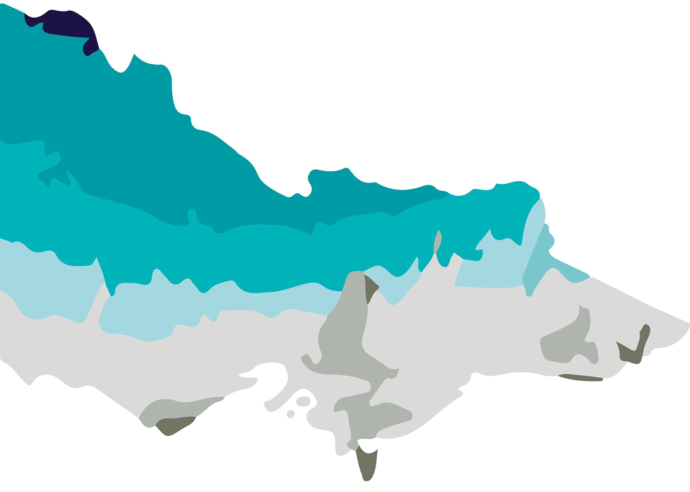
Table 2: Snapshot of the sector (as of September 2025)
No. of solar farms | Combined capacity
52 operating | 1,578 MW
4 under construction | 580 MW
Total | 2,158 MW

Manufacturing Opportunity
Victoria is estimated to need up to 4.7 million utility PV solar panels and 15.7 million rooftop solar panels by 2035.2 Initial Victorian demand for panels creates a foundation for providing original equipment manufacturers (OEMs) with long-term pipeline certainty.

For more information
For more information on Victoria's Solar sector visit:
energy.vic.gov.au/industry/investment-opportunities

Onshore Wind
Victoria boasts excellent wind resources, with an average wind speed of 8.4 m/s in Western Victoria and 7.2 m/s in the southwest.
Victoria has been a location of choice for wind developers since the early 2000s. Our state’s wind resource is among the best in the world.
Victoria’s southern coastline, which lies in the path of the strong westerly wind belt between 35˚ and 60˚ latitudes, boasts high average wind speeds exceeding 8 m/s in many areas.
Figure 8: Victoria’s average yearly wind speed (Source: GeoVic, Resources Victoria)
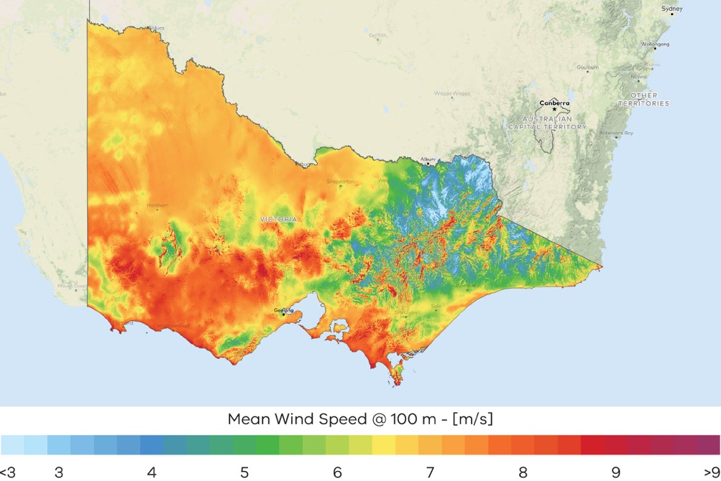
Table 3: Snapshot of the sector (as of September 2025)
No. of wind farms | Combined capacity
43 operating | 5,475 MW
1 under construction | 576 MW
9 granted development approval | 1,199 MW
Total | 7,251 MW

Manufacturing Opportunity
Victoria is estimated to need an additional 1,100 onshore wind turbines by 2035.2 Initial Victorian demand for turbines creates a foundation for providing original equipment manufacturers with long-term pipeline certainty.

For more information
For more information on Victoria's Wind sector visit:
energy.vic.gov.au/industry/investment-opportunities

Offshore Wind
A key pillar in Victoria’s renewable energy future.
Victoria is perfectly positioned to lead the nation in establishing a thriving new offshore wind industry, with:
- a world-class offshore wind resource close to our transmission backbone
- a skilled regional workforce
- a track record of delivering renewable energy projects, and
- an enabling legislative environment.

Progress towards industry establishment
The Australian Government has declared an area of the Bass Strait off Gippsland, Victoria, as Australia’s ﬁrst and largest offshore wind zone, at approximately 15,000 km2.
It has also declared an offshore wind zone off the coast of South-west Victoria, spanning an area of approximately 1,030 km2.
Following an Australian Government process, there are 11 feasibility licences held in the Gippsland declared area and one feasibility licence in the Southern Ocean declared area.
In May 2024, Victoria enacted the Energy and Public Land Legislation Amendment (Enabling Offshore Wind Energy) Act 2024 (Vic). This enables developers who hold feasibility licences to undertake feasibility studies on Victorian public land and in public waters.
In December 2024, VicGrid commenced a procurement process to engage a delivery partner to design, build and operate the transmission line to connect offshore wind to the grid in Gippsland.
In March 2025, the Victorian Government opened a Registration of Interest (ROI) process to enable feasibility licence holders to access the information needed to inform a Request for Proposal (RFP) auction stage for the first 2 GW of offshore wind energy.
A RFP launch is subject to a future government decision.

Investment Opportunity
The market provides significant opportunities for investment in the offshore wind industry:
- Offshore wind is a key pillar in Victoria’s renewable energy future with legislated targets of at least 2 GW by 2032, 4 GW by 2035 and 9 GW by 2040
- The strength and consistency of wind speeds are high by Australian and international standards
- Victoria’s first mover advantage in Australia presents opportunities for manufacturing that may extend to other jurisdictions over time.

Manufacturing Opportunity
Victoria is estimated to need up to 267 offshore wind turbines by 2035.
Initial Victorian demand for turbines creates a foundation for providing original equipment manufacturers (OEMs) with long-term pipeline certainty.

Offshore Wind Energy Victoria (OWEV) was established to coordinate and drive the development of Victoria’s offshore wind sector and is the gateway of industry, stakeholder and community engagement.

Offshore Wind Energy Implementation Statements provide industry and stakeholder guidance for how the Victorian Government is developing offshore wind energy.
Implementation Statement 4 was released in April 2025 and provides updates on:
- Procurement
- Transmission
- Ports
- Legislation and regulatory frameworks
- Workforce and industry development
- Protecting the environment
- Traditional Owner partnerships
- Industry, stakeholder and community engagement.
OWEV is a division within the Energy group of the Victorian Government’s Department of Energy, Environment and Climate Action (DEECA).

Zero emissions vehicles
The Victorian Government has released a Zero Emissions Vehicle (ZEV) Roadmap that will support Victoria’s transport sector to become ZEV-ready, enabling a pathway to economy wide net-zero greenhouse gas emissions by 2045. This includes a commitment for half of all light vehicle sales in Victoria to be ZEVs by 2030 – creating demand for around 3.4 million ZEVs by 2045.

Victoria’s ZEV Targets
- Aim for 50% of all light vehicles sold from 2030 to be ZEVs
- Replace 400 vehicles in the Victorian Government Fleet with new ZEVs by 2024
New public transport buses will be zero emissions buses in accordance with Victoria's Zero Emission Bus Transition Plan.
The transition to ZEVs will play a critical role in achieving Victoria’s target of economy- wide net-zero emissions by 2045. Key Victorian Government policies and initiatives to support this transition include:
- $19 million to accelerate the roll-out of electric vehicle (EV) charging infrastructure across regional Victoria and support the charging of EV fleets
- $20 million for a ZEV public transport bus trial – and a target for all public transport bus purchases to be ZEVs from July 2025
- $10 million to replace 400 vehicles in the Victorian Government Fleet with ZEVs
- $5 million to establish a Commercial Sector Zero Emissions Vehicle Innovation Fund.

Investment Opportunity
The Victorian market provides significant opportunities for investment across many aspects of the ZEV supply chain, including:
- component manufacturing
- vehicle, truck and bus manufacturing
- battery supply chain and recycling
- charging infrastructure
- software engineering for managed demand
- vehicle to grid energy management systems.

Manufacturing Opportunities
Preliminary estimates suggest Victoria could need up to:
- 115,000 public EV chargers by 2035
- 3,600 utility-scale battery packs by 2035
Around 820,000 distributed battery packs by 2035.
There are 4,500 diesel buses in the Victorian fleet that will be replaced with a Zero Emission Vehicles from 2025.
Victoria’s Zero Emissions Vehicle Roadmap is focused on actions that will be taken in this decade to address key barriers to uptake of zero emissions vehicle technologies, while also leveraging the opportunities associated with this major technology transition.
For more information visit: energy.vic.gov.au/renewable-energy/zero-emissions-vehicles

For more information
For more information on ZEV opportunities in Victoria visit: energy.vic.gov.au/industry/investment-opportunities

Subsector packs
Figure 9: Renewable Energy subsector packs
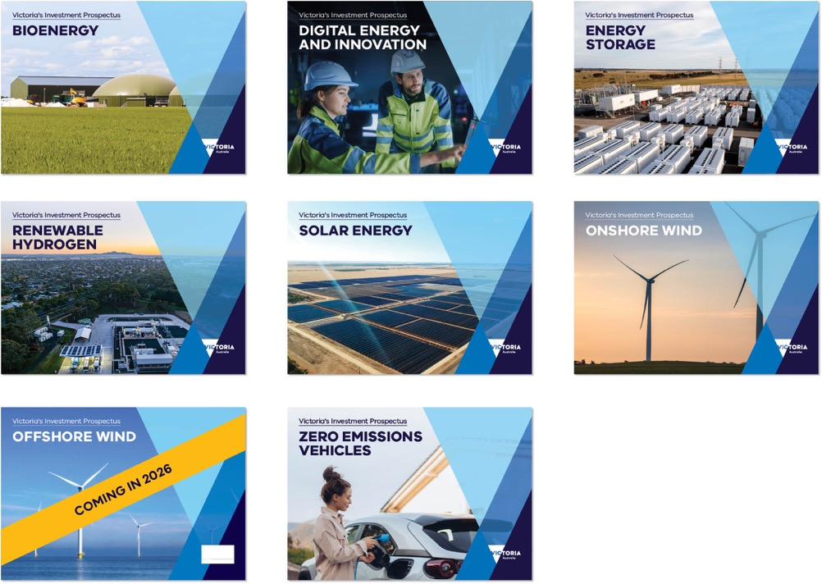
Renewable Energy subsector packs include:

- Bioenergy
- Digital energy and innovation
- Energy storage
- Renewable hydrogen
- Solar
- Wind – Onshore, Offshore
- Zero emissions vehicles.
To access the Renewable Energy subsector packs, please visit: energy.vic.gov.au/industry/investment-opportunities

Key Victorian Government entities
We can help facilitate connections with key Victorian Government entities and industry members across our renewable energy sector.

Department of Energy, Environment and Climate Action (DEECA)
DEECA works with industry and the community to develop Victoria's secure and sustainable energy future.
For information on Victoria’s energy policy landscape and facilitated connections across the Victorian Government and renewable energy sector, contact the Business and Industry Engagement team at: BIE@deeca.vic.gov.au
For more information, visit: energy.vic.gov.au/industry/investment-opportunities

SEC
SEC is a Victorian Government-owned renewable energy company. It is partnering with the private sector to deliver 4.5 GW of new renewable energy and storage projects with an initial investment of $1 billion.
For more information, visit: secvictoria.com.au

Breakthrough Victoria
Breakthrough Victoria launched in 2021 and is a private investment company providing patient capital and investment that impact Victoria’s economy and wellbeing.
For more information, visit: breakthroughvictoria.com

Invest Victoria
Invest Victoria is the Victorian Government’s investment attraction agency. Services include:
- market regulatory information
- statutory approvals coordination
- site location services
- identification of infrastructure and utility requirements
advocacy within government.
The Investment Coordinator-General role and function also sits within Invest Victoria, working across agencies to ensure approvals deadlines are met and helping to reduce delays.
For more information, visit: invest.vic.gov.au

Offshore Wind Energy Victoria
Offshore Wind Energy Victoria (OWEV) was established as the single point of entry for industry and community engagement on offshore wind.
For more information, visit: energy.vic.gov.au/renewable-energy/offshore-wind-energy

Solar Victoria
Solar Victoria is responsible for the delivery of the Victorian Government’s $1.3 billion Solar Homes Program – one of the most ambitious and transformative renewable energy programs in Australia.
For more information, visit: solar.vic.gov.au

Sustainability Victoria
Sustainability Victoria empowers Victorians to live sustainably by taking action on climate change and using our precious resources wisely – to deliver a sustainable future for us all.
For more information, visit: sustainability.vic.gov.au

VicGrid
VicGrid coordinates the planning and development of Victorian Renewable Energy Zones (REZs). It also oversees the $480 million REZ fund that will be used to strengthen the grid and develop each REZ.
For more information, visit: energy.vic.gov.au/renewable-energy/renewable-energy-zones

For international investors
Contact a local Victorian Government Trade and Investment Office to help you:
- navigate investment opportunities in Victoria’s new energy technology sector
- set up a briefing with energy specialists
- arrange inbound market visits
introduce you to the Victorian Government’s Energy Business and Industry Engagement team and Invest Victoria.
For more information, visit: global.vic.gov.au/meet-our-global-team/all-office-locations

Figure 10: Victorian Government Trade and Investment office locations
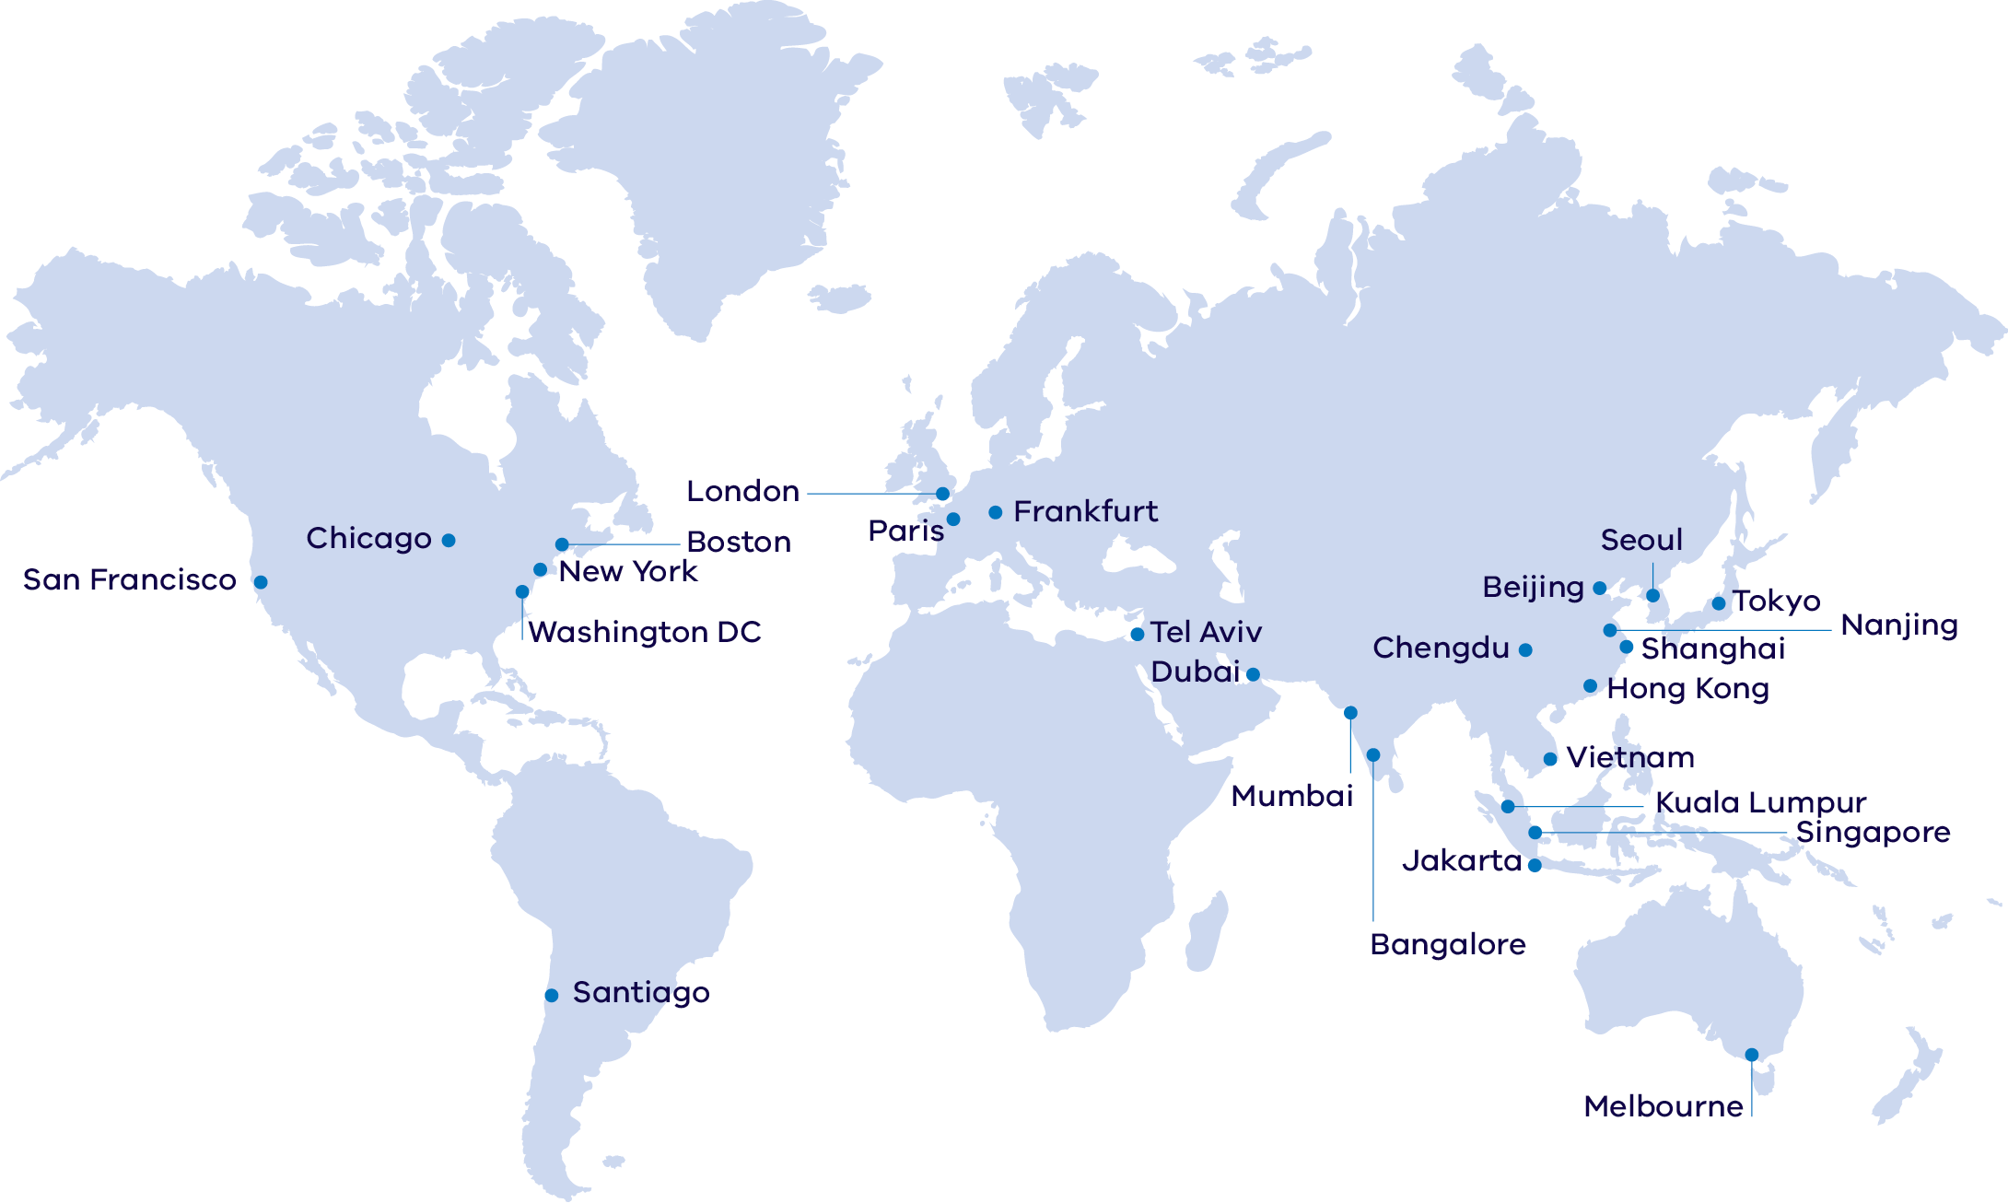

Publication information

Acknowledgements
We acknowledge and respect Victorian Traditional Owners as the original custodians of Victoria’s land and waters, their unique ability to care for Country and deep spiritual connection to it.
We honour Elders past and present whose knowledge and wisdom has ensured the continuation of culture and traditional practices.
DEECA is committed to genuinely partnering with Victorian Traditional Owners and Victoria’s Aboriginal community to progress their aspirations.

Copyright
© The State of Victoria Department of Energy, Environment and Climate Action, September 2025.

Creative Commons
This work is licensed under a Creative Commons Attribution 4.0 International licence, visit the Creative Commons website (http://creativecommons.org/licenses/by/4.0/).
You are free to re-use the work under that licence, on the condition that you credit the State of Victoria as author. The licence does not apply to any images, photographs or branding, including the Victorian Coat of Arms, and the Victorian Government and Department logos.
ISBN 978-1-76176-601-5 (Print)
ISBN 978-1-76176-602-2 (pdf/online/MS word))

Disclaimer
This publication may be of assistance to you but the State of Victoria and its employees do not guarantee that the publication is without flaw of any kind or is wholly appropriate for your particular purposes and therefore disclaims all liability for any error, loss or other consequence which may arise from you relying on any information in this publication.

Accessibility
To receive this document in an alternative format, phone the Customer Service Centre on 136 186, email customer.service@delwp.vic.gov.au, or contact National Relay Service on 133 677. Available at DEECA website (www.deeca.vic.gov.au).
End of document.

Note this figure will be updated following release of the draft AEMO 2026 Integrated System Plan in December 2025
Australian Bureau of Statistics, March 2025, abs.gov.au/statistics/people/population/regional-population/latest-release
Economist Intelligence, August 2025, eiu.com/n/campaigns/global-liveability-index-2025-confirmation/
Victorian Energy Jobs Plan, August 2025
Economic Growth Statement, August 2025, vic.gov.au/sites/default/files/2024-12/Economic-Growth-Statement.pdf
Victorian Budget 2025–26, May 2025, budget.vic.gov.au/growing-economy
Economic Growth Statement, Victoria: Open for Business, 2024, vic.gov.au/economic-growth-statement
LaunchVic, 2025, launchvic.org/our-ecosystem
QS World University Rankings, June 2025, http://topuniversities.com/world-university-rankings
Report Energy Assessment of Victorian biogas potential assets. https://assets.sustainability.vic.gov.au/susvic/Report-Energy-Assessment-of-Victorian-biogas-potential.pdf
LaunchVic, 2023, Scaling Up: Growing the Economic Opportunity for Victoria's start-up ecosystem, launchvic.org/impactreport
Breakthrough Victoria, 2025, breakthroughvictoria.com/growth-sectors/digital-technologies
Estimates are based on internal forecasts and modelling conducted by the Department of Energy, Environment and Climate Action and are subject to change.
Internal register figures from the Department of Energy, Environment and Climate Action, September 2025
Internal register figures from the Department of Energy, Environment and Climate Action, September 2025
Indicative estimates based on modelling conducted by Accenture (2023) for the Department of Energy, Environment and Climate Action and are subject to change.

