1.3 – Manual handling of heavy and bulky items
VEU Insulation Program – Technical Guidance Series




This is part of a series developed with WorkSafe to help installers in our program to work safely while installing insulation.
Use this sheet and others in this series to plan safe series of work while installing insulation.

Series 1 – Working Safely at Heights
1.1 | Working safely at heights during rooftop insulation installations
1.2 | Edge protection – working at heights
1.3 | Manual handling of heavy and bulky items  (this sheet)
1.4 | Working safely with ladders
1.5 | Safe work practices using elevated work platforms
1.6 | Falls through skylights, fragile roofs, voids and penetrations

What is hazardous manual handling?
Manual handling is work such as manually lifting, lowering, pushing, pulling, carrying, moving or holding heavy and bulky items.
During rooftop insulation installations, injuries can occur while undertaking manual handling that often involves:
- repeated, sustained or high force
- sustained awkward postures
- repetitive movements
- loads that are unstable, unbalanced or hard to hold.

Potential for injuries
Employees who manually handle insulation, tools and other materials required as part of a rooftop retrofit insulation installation can be injured by:
- strain from manual handling
- overbalancing, tripping and falling from a roof or ladder
- being struck by falling objects while manual handling.
A key injury resulting from manual handling is musculoskeletal disorders (MSDs) which include:
- sprains and strains
- back injuries
- hernias
- chronic pain
- cuts and broken bones
Employers are required to control the risks of MSDs associated with hazardous manual handling, so far as is reasonably practicable.
A risk assessment should be carried out prior to handling heavy and bulky items. This should identify any manual handling tasks related to the installation of rooftop insulation that may pose a hazard.
Figure 1: The four-step risk management process

Step 1: Identify hazards – what manual handling work can be hazardous
Not all manual handling work is hazardous. Employers have a duty to identify, so far as is reasonably practicable, and in consultation with employees, any work that involves hazardous manual handling. Hazard identification is the first step in assessing workplace tasks to determine if they pose an MSD risk to employees.
During the installation of rooftop insulation employees may perform hazardous manual handling tasks that can lead to MSDs. These include:
- lifting insulation bundles or other heavy items above shoulder height which may present risk factors for strains, sprains and back injuries
- working overhead to install and secure insulation to ceiling cavities and roof structures, which involve awkward postures, repetitive or sustained forces and exposure to vibration from using power tools (e.g. staple guns or drills)
- manual handling of heavy or bulky insulation materials onto a roof or into ceiling spaces during the installation process, which may lead to insulation slips, trips and falls.
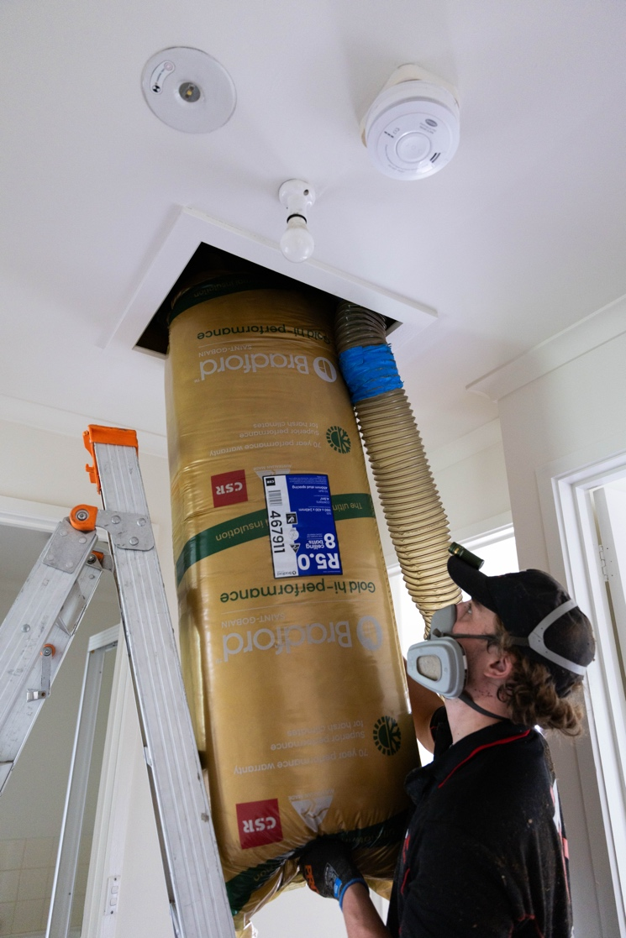

Step 2: Assess risks – when does manual handling become more hazardous?
Once the hazards have been identified, and in consultation with employees, assess the MSD risk posed to employees undertaking manual handling tasks.
Forces, postures, movements, and vibration can interact to increase the risk of injury. For example, it takes more bending and twisting of the back to pick up insulation bundles from the floor than from a bench at mid-thigh height. The more sustained the task, the greater the risk of injury. Environmental factors like heat, cold and lighting levels can also increase the risk of injury.
Work-related stress can also be a factor in the development of MSDs. For example, high pressure and a perceived lack of support can contribute to poor outcomes in managing and treating MSDs.
All of these factors can be exacerbated by an employee's physical condition and attributes, age, and the existence of any prior injuries.
See the WorkSafe website for more information on when and how to complete a SWMS for construction activities: www.worksafe.vic.gov.au/safe-work-method-statements-swms

Step 3: Control risks – how can you control the risk of MSD?
To control the risk of MSD, set out specified risk control measures and commit to using them when undertaking hazardous manual handling.
The hierarchy of control is the best risk management tool for controlling risks in the workplace. Chapter 3, Part 3.1, of the Occupational Health and Safety Regulations 2017 (OHS Regulations) stipulates an employer's duties with respect to hazardous manual handling and includes the specific hierarchy for controlling MSD risk.
Employers must apply the highest level of control so far as is reasonably practicable before applying lower order controls to reduce remaining risk. In some cases, it will be necessary to use a combination of risk control measures to effectively control risk.
For more information see the WorkSafe Hazardous Manual Handling Compliance Code: worksafe.vic.gov.au/resources/compliance-code-hazardous-manual-handling
Table 1: Hierarchy of control for controlling the risk of MSD associated with hazardous manual handling
Level | Description | Example
1 | Eliminate risk of MSD | Remove any activity that carries the risk of MSD
2 | Reduce the risk of MSD by introducing changes to the workplace or work | Create changes to:  - workplace layout, environment, or systems of work  - devices used in hazardous manual handling  Also consider mechanical aids
3 | Reduce the risk of MSD through providing information, instruction and training | Ensure appropriate provision, use and understanding of information, training and instruction.

Step 4: Review and revise controls
Control measures are more effective where there is regular review of work procedures to make sure they are working as planned. An employer must review and, if needed, revise them:
- before changes are made to a thing, process or system of work that involves manual handling
- when new information about hazardous manual handling becomes available including new and improved control methodology or equipment
- if an injury is reported or a notifiable incident occurs
- if for any reason, the risk control measures fail to adequately control the risk
- if a Health and Safety Representative requests a review and/or revision of a control.
Your actions shouldn't stop at Step 4. You should repeat this process often to make sure your management of risk is working.

© The State of Victoria Department of Energy, Environment and Climate Action April 2026.
ISBN 978-1-76176-827-9 (pdf/online/MS word)
Disclaimer
This publication may be of assistance to you but the State of Victoria and its employees do not guarantee that the publication is without flaw of any kind or is wholly appropriate for your particular purposes and therefore disclaims all liability for any error, loss or other consequence which may arise from you relying on any information in this publication.
Accessibility
To receive this publication in an alternative format, please contact the Victorian Energy Upgrades team at energy.upgrades@deeca.vic.gov.au. This document is also available on the internet at energy.vic.gov.au/victorian-energy-upgrades.

