Victoria's Investment Prospectus ZERO EMISSIONS VEHICLES
Table of Contents
Acknowledgement of Country 2
Welcome to Victoria's renewable energy sector 3
Why invest in Victoria’s Zero Emissions Vehicle (ZEV) sector? 5
An ideal location for your next Asia Pacific battery and ZEV manufacturing facility 6
Access to Victoria's world-class renewable energy talent 8
Powering Victoria’s renewable energy future 10
Strong supply chain and manufacturing capability 11
A ZEV industry on the move 14
A heavy vehicle investment opportunity 15
Key Victorian Government entities 17
Publication information 19

Acknowledgement of Country
We acknowledge and respect Victorian Traditional Owners as the original custodians of Victoria’s land and waters, their unique ability to care for Country and deep spiritual connection to it.
We honour Elders past and present whose knowledge and wisdom have ensured the continuation of culture and traditional practices.
We are committed to genuinely partner, and meaningfully engage, with Victoria’s Traditional Owners and Aboriginal communities to support the protection of Country, the maintenance of spiritual and cultural practices and their broader aspirations in the 21st century and beyond.

Traditional Owners at the centre of decision-making processes
Strong and mutually beneficial partnerships with Traditional Owners and First Peoples are imperative to the electricity transition’s success and integral to ensuring the goals and objectives of self-determination set out in the Victorian Government’s Self Determination Reform Framework and the Department of Energy, Environment and Climate Action’s (DEECA) Pupangarli Marnmarnepu ‘Owning Our Future’ Aboriginal Self-Determination Reform Strategy 2020–2025.
For more information, visit:
deeca.vic.gov.au/aboriginalselfdetermination/self-determination-reform-strategy

Welcome to Victoria's renewable energy sector
At the centre of Australia’s electricity network, the state of Victoria is leading the way to a renewable energy future
We estimate that Victoria will need 25 GW of new generation and storage capacity by 2035. Our legislated renewable energy generation, energy storage and emissions reduction targets provide a clear market signal, supported by government programs to drive investment.
The renewable energy sector is at the heart of our economy, identified as a priority growth industry backed by streamlined approval processes, well-developed supply chains, world‑class research and development capabilities and a highly skilled workforce.

A ZEV sector positioned for growth
Victoria’s Zero Emissions Vehicle (ZEV) sector is primed for investment. We have a strong track record in advanced manufacturing and innovation, a world-class education and training sector and holistic investment support structures to facilitate your project.
Our legislated renewable energy targets are backed by key government initiatives to drive growth in the ZEV sector, such as the Zero Emissions Vehicle Roadmap, targets for state-wide ZEV uptake, and the national New Vehicle Efficiency Standard.
Figure 1: Legislated renewable energy targets
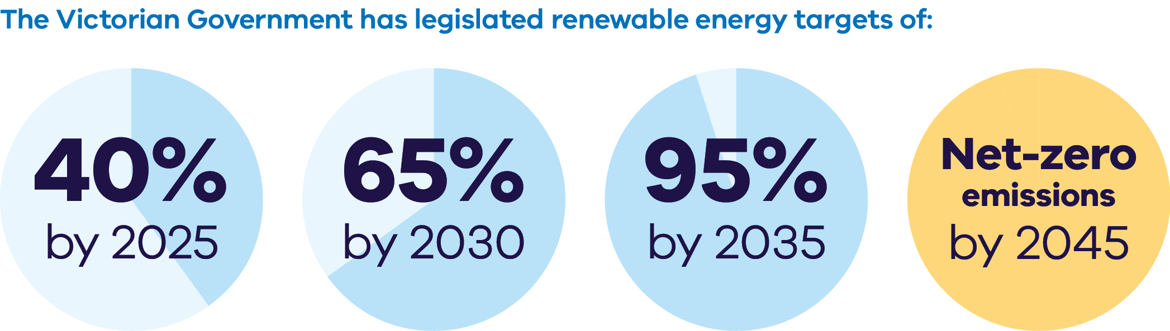
The Victorian Government has legislated renewable energy targets of:
- 40% by 2025
- 65% by 2030
- 95% by 2035
Net-zero emissions by 2045
Figure 2: Energy storage capacity and Offshore wind energy targets from 2025-2045
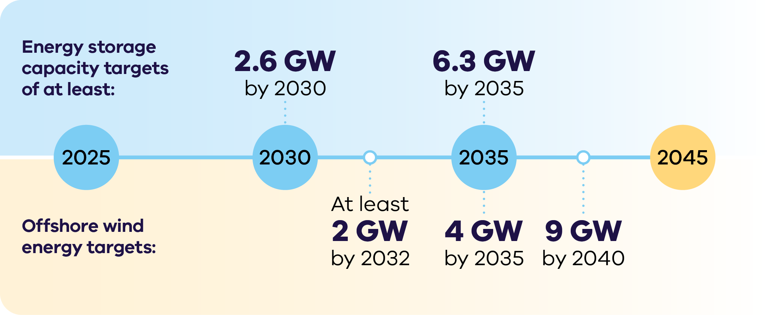

Energy storage capacity targets
of at least:
- 2.6 GW by 2030
6.3 GW by 2035
Offshore wind energy targets:
- At least 2 GW by 2032
- 4 GW by 2035
9 GW by 204

Why invest in Victoria’s Zero Emissions Vehicle (ZEV) sector?

Government initiatives driving demand
The Victorian Government has set strong ZEV targets – by 2030 we are aiming for half of all light vehicle sales in Victoria to be ZEVs.

Leading the way in heavy and long‑haul transport
With several hydrogen refuelling stations built or in the pipeline and trials underway for multiple vehicle types (e.g. buses, waste trucks and freight vehicles), there are significant opportunities for further investment in renewable hydrogen for heavy and long-haul transport.

Demand for zero emissions buses
There are 4,500 diesel buses in the Victorian fleet that are in the process of being replaced, plus new public transport buses will be zero emissions buses in accordance with Victoria's Zero Emission Bus Transition Plan.

ZEV manufacturing
Access the skilled workforce, existing supply chains and critical minerals required to manufacture batteries and ZEVs at scale.

World-class research and development
Partner with Victorian universities that are pioneering world-leading research and development.

Integrating ZEVs into the grid
Victoria is projected to need 115,000 public electric chargers by 2035. With approximately 600 public charging stations currently across Victoria, strong demand exists to scale up production and deployment of grid integration technologies.

Government policy and funding is accelerating the uptake of ZEVs
The Victorian Government released the Zero Emissions Vehicle Roadmap in 2021 to support Victoria’s transport sector to become ZEV-ready. We are working with the Australian Government and other jurisdictions to implement the National Electric Vehicle Strategy to further reduce barriers to electric vehicle uptake and improve charging infrastructure.
The transition to ZEVs will play a critical role in achieving Victoria’s target of economy-wide net-zero emissions by 2045.
Key Victorian Government policies and initiatives to support this transition include:
- $19 million to accelerate the roll-out of electric vehicle (EV) charging infrastructure across regional Victoria and support the charging of EV fleets
- $20 million for a ZEV public transport bus trial – and a commitment for new public transport buses will be zero emissions buses in accordance with Victoria's Zero Emission Bus Transition Plan
- $10 million to replace 400 vehicles in the Victorian Government Fleet with ZEVs and introduction of a ‘ZEV first’ policy for new Victorian Government fleet purchases
$5 million to establish a Commercial Sector Zero Emissions Vehicle Innovation Fund.
Victoria’s Zero Emissions Vehicle Roadmap is focused on actions addressing key barriers to the uptake of ZEV technologies, with a continued Victorian Government focus on enabling the deployment of accessible EV charging infrastructure across the state.
For more information, visit: energy.vic.gov.au/renewable-energy/zero-emission-vehicles
The Victorian Government can connect you with the Australian Government’s specialist investment vehicles, including the:
- Clean Energy Finance Corporation: Australia’s ‘Green Bank’, with access to $30.5 billion in investment capital from the Australian Government
- Australian Renewable Energy Agency: Provides financial assistance for research, development, demonstration, commercialisation and deployment of renewable technologies
- National Reconstruction Fund Corporation: A $15 billion national investment fund designed to diversify and transform Australia's industry and economy.

New Vehicle Efficiency Standard
Australia’s New Vehicle Efficiency Standard sets CO2 targets for car companies based on the vehicles they produce. Car companies must meet or beat the CO2 targets set for them, which incentivises the production of more efficient, lower emissions vehicles.
For more information, visit:
infrastructure.gov.au/infrastructure-transport-vehicles/vehicles/new-vehicle-efficiency-standard

An ideal location for your next Asia Pacific battery and ZEV manufacturing facility
Our advanced manufacturing capability, skilled workforce, world-leading battery research and access to Australia's rich source of critical minerals make Victoria the ideal place to establish your battery and ZEV manufacturing operations.
Figure 3: Forecast demand for energy storage and electric vehicles in Australia's
National Electricity Market (GWh)1
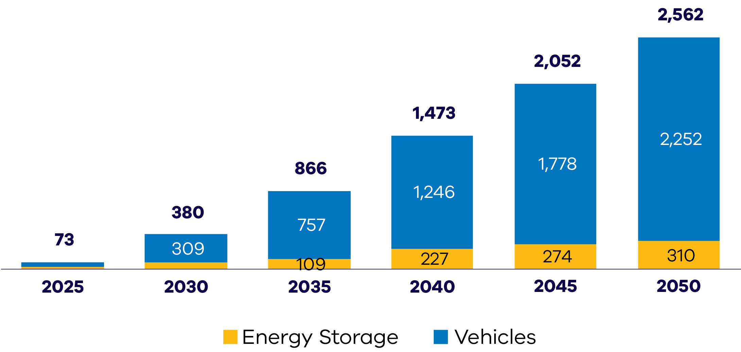

Manufacturing Opportunity
The Victorian market provides significant opportunities for investment across many aspects of the ZEV supply chain, including:
- component manufacturing
- vehicle, truck and bus manufacturing
- battery supply chain and recycling
- charging infrastructure.

Mining to manufacturing opportunities
Australia is home to some of the largest recoverable critical mineral deposits on earth, including high-quality cobalt, lithium, manganese, rare-earth elements, tungsten and vanadium.
There is the option to refine critical minerals near their source or co‑locate a refinery with manufacturing in Victoria.
The North-west region of Victoria hosts globally significant deposits of mineral sands, including rare-earth elements in high demand as inputs to the permanent magnets utilised in electric vehicles and wind turbines.
Victoria has:
- 22% of Australia’s ilmenite (~7% of global economically demonstrated resource)
- 51% of Australia’s rutile (~32% of global economically demonstrated resource)
- 39% of Australia’s zircon (~27% of global economically demonstrated resource).

Victoria’s Critical Mineral Roadmap
The Victorian Government has released its Critical Mineral Roadmap, which creates the foundations for a coordinated and integrated approach to foster this new industry – tailored to Victoria.
For more information, visit: resources.vic.gov.au/critical-minerals

Access to Victoria's world-class renewable energy talent
Our growing, highly skilled workforce drives project delivery and fosters industry growth. To meet the needs of the sector, the Victorian Government has committed to significant new energy skills and workforce initiatives.
- Delivering the Victorian Energy Jobs Plan, which seeks to support Victoria’s once-in-a-generation energy transition by setting out actions to mobilise the workforce and grow investment confidence. The Plan identifies key opportunities to support Victoria’s energy workforce, which is projected to increase from 41,000 full time equivalent (FTE) to 67,000 FTE in 2040, a 62% increase.
- Delivering the Women in Energy Strategy, which seeks to drive significant change for women in energy through Victoria’s energy transition, including addressing barriers to increasing the number of women in the energy workforce. The Strategy aligns with the Victorian Energy Jobs Plan as well as Our Equal State, which seeks to increase participation by women, economic equity, inclusive and safe workplaces, and education opportunities.
- Supporting the establishment of the National Training Centre in New Energy Skills based in Melbourne, in partnership with the Australian Government, to train and reskill key workforces needed for the energy transition across Australia.
Developing and supporting new energy training pathways through the $7 million for new Vocational Education and Training (VET) qualifications in renewable energy and utilising the $50 million TAFE Clean Energy Fund.

World-class education and training
Victoria has a globally renowned education and training system, including:
- 2 global ‘Top 40’ universities1
- 8 universities, including 4 dual-sector universities (offering both tertiary and vocational education)
- 12 independent technical and further education (TAFE) institutions under a single TAFE network
- a diverse talent pool with strong growth across the broad range of occupations relevant to the renewable energy sector.

Powering Victoria’s renewable energy future

What is SEC?
SEC is a government-owned renewable energy company that:
- invests in renewable energy and storage projects that accelerate the energy transition and deliver sustainable returns
- retails to government and commercial and industrial businesses
- supports households to go all-electric to reduce their energy bills and emissions
- supports the growth of the renewable energy workforce our energy transition requires.

How SEC invests:
SEC is investing an initial $1 billion towards delivering 4.5 GW of new renewable energy generation and storage. Its work will ensure Victorian households and businesses continue to have the power they need as we transition to renewable energy.
SEC’s investments include opportunities in renewable generation and storage. Utility-scale storage can address critical system gaps and help catalyse investment in large wind and solar generation to replace ageing coal assets.
The organisation will also continue to explore emerging technologies, including long duration energy storage opportunities, that accelerate the sector's maturity by enabling high levels of renewable power generation in the power grid. SEC’s investment focus is on achieving sustainable returns while delivering broader benefits to the Victorian public and enabling the market.
Find more information, visit: secvictoria.com.au

Strong supply chain and manufacturing capability
Companies looking to diversify or expand their ZEV manufacturing capabilities can leverage Victoria’s strong existing design, manufacturing, engineering and recycling capabilities.

Bosch

Overview
Bosch maintains a strong engineering presence in Victoria through its research and manufacturing hub in Clayton and proving grounds in Anglesea.

Key products
- Global Centre of Competence for Trailer Safety
- Automotive component engineering
- Automotive and motorsport parts
- Personalised, automated, connected, and electrified mobility solutions

Rectifier Technologies

Overview
Rectifier Technologies is a leading innovator in power electronics, dedicated to driving progress in electric mobility and emerging new energy solutions through high-efficiency power conversion technologies.

Key products
- High Power Rectifier Modules
- EV Charger Modules
- Active Power Factor Correction (PFC) Rectifier Modules
- Powershelves
- Battery Chargers and Power Systems

Premcar

Overview
Premcar is a trusted partner to various world-leading OEM carmakers, providing new-car engineering and development as well as vehicle assembly and secondary manufacturing services.

Key products
- Chassis system design and tuning
- Body/trim concept design and manufacturing

Envirostream

Overview
Envirostream is Australia’s leading recycler of end-of-life lithium-ion batteries. As Australia’s first licensed recycler of mixed batteries, they deal with most of the major global battery brands and participants in the battery value chain.

Key products
- Steel
- Copper
- Aluminium
- Mixed metal compound

Manufacturing Opportunities
Preliminary estimates suggest Victoria could need up to:
- 115,000 public EV chargers by 2035
- 1,350 utility-scale battery packs by 2035
- Around 210,000 distributed battery packs by 20351
- Initial Victorian demand for chargers and EV batteries creates a foundation for providing OEMs with long-term pipeline certainty.

Case study: Bortana
Based in regional Victoria, Bortana is the first and only Australian company to manufacture and deploy battery electric vehicles tailored for use in hard rock underground mines. With a goal to create safe, durable and reliable zero emissions vehicles, Bortana has custom designed and purpose-built its product to meet Australian and international industry standards. The 100% electric vehicles come with a 10-year expected lifespan, multiple charging options, and modular battery configurations. Bortana’s vehicles are manufactured onsite in Bendigo, giving Victoria sovereign manufacturing capability and bringing economic growth and jobs to the region. Following 2 years of successful prototype testing in field trials across Australia, the vehicles are ready for scaled deployment to meet zero emissions targets.
For more information, visit: safescape.com/vehicles/bortana-ev

A ZEV industry on the move

Case study: Nissan HQ and electric car centre
Nissan Australia has established its national headquarters and technical training centre in Mulgrave, in Melbourne’s South-east. The facility was developed and equipped with Nissan’s new and emerging electrified technologies in mind, providing crucial training and support to Nissan service technicians nationwide. This builds on Nissan’s Victorian electric vehicle presence, with its sister company, Nissan Casting Australia, producing electric vehicle components for Nissan products sold worldwide.
For more information, visit: nissan.com.au

Case study: Barwon Water H-Drive Truck
Barwon Water Group is now operating the first fully registered, type approved hydrogen fuel cell prime mover in Australia. The Taurus prime mover, from HDrive International, is among the first wave of vehicles to use Viva Energy’s new commercial hydrogen refuelling station in Geelong.
The vehicle will collect and transport organic waste from Barwon Water’s treatment plants before the waste is converted into products for the agriculture sector.
As the first of its type in a Victorian Government agency, the prime mover will provide valuable insights into the cost of ownership, its reliability and general points of difference to a diesel-fuelled vehicle.
For more information, visit:
barwonwater.vic.gov.au/about-us/major-projects/renewable-hydrogen

A heavy vehicle investment opportunity
The Victorian Government is preparing its roads for battery electric trucks as Victorian industry positions itself as a leader in electric truck manufacturing and deployment.

Electrifying Australia’s heavy vehicles
Australia’s heavy vehicles, including its truck fleet of over 600,000 rigid and articulated trucks, are responsible for the production of a quarter of Australia’s total transport emissions. The Australian Renewable Energy Agency (ARENA) has committed almost $28.6 million to Australian logistics companies Linfox and Toll to lower the upfront costs of battery electric trucks (BETs) and support progress toward zero emissions targets.

Legislative changes in Victoria are paving the way for BETs
Victoria has led the way by permanently allowing certain electric heavy vehicles with a 7.5 tonne steer axle weight on the road network and is working to expand this access even further.
A Low or Zero Emission Heavy Vehicle (LZEHV) Access Map is available for Volvo Group’s FM or FH Semi-Trailers (7.5t steer, 44.0t GCM). It provides the truck operators with a pre-approved access route for their eco-friendly truck on specific Victorian roads, making it easier to use a more environmentally friendly heavy vehicle in Victoria.
For more information, visit: maps.nhvr.gov.au

Case study: JET Charge
In a first of its kind in the world, in February 2024, when major storms in Melbourne triggered the disconnection of Loy Yang coal power station and two wind farms, 16 electric vehicles, plugged in at properties, responded within seconds, rapidly discharging short bursts of electricity into the grid to stabilise it. Those 16 vehicles were part of a fleet of 51 installed with vehicle to grid (V2G) chargers as part of the Realising Electric Vehicle-to-grid Services (REVS) project.
Melbourne-based JET Charge, Australia’s leading EV charging infrastructure company and leaders in V2G technology, coordinated the market certification for the first and only V2G charger sold in the Australian market and developed in-house the proprietary control system technology that enabled the vehicles to discharge power from EVs into the grid.
In total, the 16 vehicles provided 107 kW of support to the grid. With almost 100,000 EVs sold in Australia in 2023, and that number rapidly rising, the potential of EVs to support the grid during national emergencies serves as a beacon for the potential of electric vehicles to change the way that Victorians live and move.
For more information, visit: jetcharge.com.au

Key Victorian Government entities
We can help facilitate connections with key Victorian Government entities and industry members across our renewable energy sector.

Department of Energy, Environment and Climate Action (DEECA)
DEECA works with industry and the community to develop Victoria's secure and sustainable energy future.
For information on Victoria’s energy policy landscape and facilitated connections across the Victorian Government and renewable energy sector, contact the Business and Industry Engagement team at: BIE@deeca.vic.gov.au
For more information, visit: energy.vic.gov.au/industry/investment-opportunities

Breakthrough Victoria
Breakthrough Victoria launched in 2021 is a private investment company providing patient capital and investment that impact Victoria’s economy and wellbeing.
For more information, visit: breakthroughvictoria.com

Invest Victoria
Invest Victoria is the Victorian Government’s investment attraction agency. Services include:
- market regulatory information
- statutory approvals coordination
- site location services
- identification of infrastructure and utility requirements
advocacy within government.
The Investment Coordinator-General role and function also sits within Invest Victoria, working across agencies to ensure approvals deadlines are met and helping to reduce delays.
For more information, visit: invest.vic.gov.au

Sustainability Victoria
Sustainability Victoria empowers Victorians to live sustainably by taking action on climate change and using our precious resources wisely – to deliver a sustainable future for us all.
For more information, visit: sustainability.vic.gov.au

Contact a local Victorian Government Trade and Investment Office to help you:
- navigate investment opportunities in Victoria’s new energy technology sector
- set up a briefing with energy specialists
- arrange inbound market visits
introduce you to the Victorian Government’s Energy Business and Industry Engagement team and Invest Victoria.
For more information, visit: global.vic.gov.au/meet-our-global-team/all-office-locations

Publication information

Acknowledgements
We acknowledge and respect Victorian Traditional Owners as the original custodians of Victoria’s land and waters, their unique ability to care for Country and deep spiritual connection to it.
We honour Elders past and present whose knowledge and wisdom has ensured the continuation of culture and traditional practices.
DEECA is committed to genuinely partnering with Victorian Traditional Owners and Victoria’s Aboriginal community to progress their aspirations.

Copyright
© The State of Victoria Department of Energy, Environment and Climate Action, September 2025.

Creative Commons
This work is licensed under a Creative Commons Attribution 4.0 International licence, visit the Creative Commons website (http://creativecommons.org/licenses/by/4.0/).
You are free to re-use the work under that licence, on the condition that you credit the State of Victoria as author. The licence does not apply to any images, photographs or branding, including the Victorian Coat of Arms, and the Victorian Government and Department logos.
ISBN 978-1-76176-615-2 (Print)
ISBN 978-1-76176-616-9 (pdf/online/MS word))

Disclaimer
This publication may be of assistance to you but the State of Victoria and its employees do not guarantee that the publication is without flaw of any kind or is wholly appropriate for your particular purposes and therefore disclaims all liability for any error, loss or other consequence which may arise from you relying on any information in this publication.

Accessibility
To receive this document in an alternative format, phone the Customer Service Centre on 136 186, email customer.service@delwp.vic.gov.au, or contact National Relay Service on 133 677. Available at DEECA website (www.deeca.vic.gov.au).
End of document.

Cheaper, cleaner, renewable: our plan for Victoria's electricity future, http://energy.vic.gov.au/renewable-energy/victorias-electricity-future. Note this figure will be updated following the release of the draft AEMO 2026 Integrated System Plan in December 2025
Manufacturing Statement, djsir.vic.gov.au/made-in-victoria/manufacturing-statement
Estimates are based on internal forecasts and modelling conducted by the Department of Energy, Environment and Climate Action and are subject to change.
Source: AEMO ISP’s ‘Step Change’ scenario which is considered to be the most likely of the scenarios modelled by AEMO
QS World University Rankings, June 2025, topuniversities.com/world-university-rankings
Estimates are based on internal forecasts and modelling conducted by the Department of Energy, Environment and Climate Action and are subject to change.

