Victoria's Investment Prospectus ENERGY
STORAGE
Table of Contents
Victoria, one of the world’s most exciting energy markets 2
Welcome to Victoria's renewable energy sector 3
Why invest in Victoria’s energy storage sector? 5
Government policies supporting your project 6
Victoria’s new Renewable Energy Zones 9
Access to Victoria's world-class renewable energy talent 11
Powering Victoria’s renewable energy future 13
Energy storage research and development 15
An ideal gateway for your next Asia Pacific battery manufacturing facility 17
Microgrids and opportunities for short duration storage 20
Key Victorian Government entities 22
Publication information 24

Victoria, one of the world’s most exciting energy markets

Acknowledgement of Country
We acknowledge and respect Victorian Traditional Owners as the original custodians of Victoria’s land and waters, their unique ability to care for Country and deep spiritual connection to it.
We honour Elders past and present whose knowledge and wisdom have ensured the continuation of culture and traditional practices.
We are committed to genuinely partner, and meaningfully engage, with Victoria’s Traditional Owners and Aboriginal communities to support the protection of Country, the maintenance of spiritual and cultural practices and their broader aspirations in the 21st century and beyond.

Traditional Owners at the centre of decision-making processes
Strong and mutually beneficial partnerships with Traditional Owners and First Peoples are imperative to the electricity transition’s success and integral to ensuring the goals and objectives of self-determination set out in the Victorian Government’s Self Determination Reform Framework and the Department of Energy, Environment and Climate Action’s (DEECA) Pupangarli Marnmarnepu ‘Owning Our Future’ Aboriginal Self-Determination Reform Strategy 2020–2025.
For more information, visit:
deeca.vic.gov.au/aboriginalselfdetermination/self-determination-reform-strategy

Welcome to Victoria's renewable energy sector
At the centre of Australia’s electricity network, the state of Victoria is leading the way to a renewable energy future
We estimate that Victoria will need 25 GW of new generation and storage capacity by 2035. Our legislated renewable energy generation, energy storage and emissions reduction targets provide a clear market signal, supported by government programs to drive investment.
The renewable energy sector is at the heart of our economy, identified as a priority growth industry backed by streamlined approval processes, well-developed supply chains, world‑class research and development capabilities and a highly skilled workforce.

An energy storage sector positioned for growth
Victoria’s energy storage sector is primed for investment. We have a strong track record in manufacturing and innovation, a world-class education and training sector and holistic investment support structures to facilitate your project.
Our legislated energy storage targets are backed by key government initiatives, such as the Victorian Renewable Energy Auction Scheme contracts, Solar Victoria’s interest-free loans for home batteries, Neighbourhood Batteries program and SEC’s Melbourne Renewable Energy Hub.
Figure 1: Legislated renewable energy targets
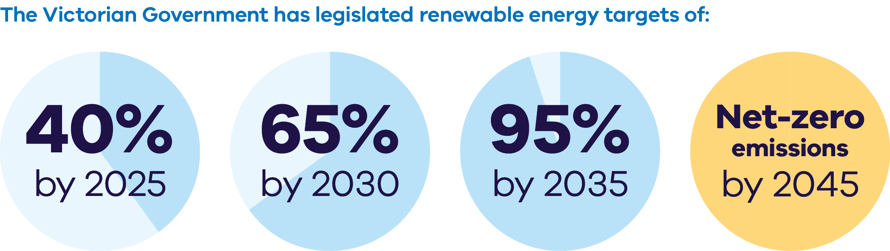
The Victorian Government has legislated renewable energy targets of:
- 40% by 2025
- 65% by 2030
- 95% by 2035
Net-zero emissions by 2045
Figure 2: Energy storage capacity and Offshore wind energy targets from 2025-2045
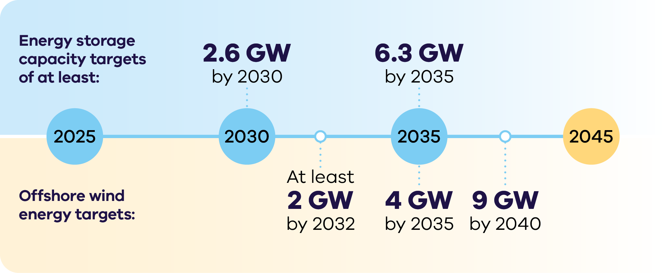

Energy storage capacity targets
of at least:
- 2.6 GW by 2030
6.3 GW by 2035
Offshore wind energy targets:
- At least 2 GW by 2032
- 4 GW by 2035
9 GW by 204

Why invest in Victoria’s energy storage sector?

Exciting revenue opportunities
Energy storage operators can capture proven market opportunities including energy arbitrage, ancillary services and a System Integrity Protection Scheme (SIPS).

Abundant opportunities for new storage developments
Victoria’s established supply chains and skilled workforce are perfectly placed to support your storage project. With 740 MW of existing storage capacity and 2,028 MW under construction as of June 2025, there are still significant opportunities for investment to help meet Victoria’s ambitious storage targets.

Battery manufacturing
The national Battery Breakthrough Program provides $523 million in production-linked incentives to support manufacturers in developing critical battery manufacturing capabilities in Australia.

Short, medium and long-duration investment opportunities
Victoria welcomes investment in a range of energy storage technologies, including short, medium and long duration storage. As planned coal generation closures occur, delivering long duration storage into Victoria presents a significant opportunity for developers.

Emerging storage technologies
The Australian Government’s Future Made in Australia Innovation Fund supports innovation, commercialisation, pilot and demonstration projects. It may help unlock opportunities for deploying innovative storage technologies in Victoria.

Ready to deliver
Victoria’s advanced manufacturing capabilities, resilient supply chain and highly skilled workforce are primed to deliver new energy storage projects.

Government policies supporting your project
The Victorian and Australian governments are making it easier to navigate planning approvals.
The Victorian Government Development Facilitation Program fast-tracks the planning permit approval process for renewable energy facilities and utility installations.
Victoria also released updated guidance for managing biodiversity impacts of renewable energy projects.
For more information, visit: planning.vic.gov.au/planning-approvals/planning-enquiries-and-requests/development-facilitation-program and environment.vic.gov.au/home/managing-impacts-of-renewable-energy-on-environment
In December 2024, as part of the Economic Growth Statement, the Victorian Government announced the following key reforms:
- faster Environmental Effects Statement processes, providing investors with an answer in 18 months or less
- enhanced public engagement with a more focused approach
- targeted assessments and developer support to encourage investment
appointment of an Investment Coordinator‑General.
For more information, visit: vic.gov.au/economic-growth-statement

Underwriting new renewable energy capacity
The Capacity Investment Scheme (CIS) provides a national framework to underwrite 26 GW of renewable capacity and 14 GW of clean dispatchable capacity by 2030.
Competitive tenders for renewable energy and storage will be held approximately every 6 months. Target allocations for Victorian projects are for at least 11 TWh of renewable energy and 1.7 GW of 4-hour equivalent storage. Victoria expects onshore wind to play a strong role in delivering this capacity.
For more information, visit: dcceew.gov.au/energy/renewable/capacity-investment-scheme
Table 1: Schedule for target Victorian allocations in the CIS
CIS Tenders in Calendar Year | Cumulative generation allocation  (GW / TWh) | Cumulative storage allocation  (GW / GWh)
2024 | 2.8 / 6.2 | 1.0 / 4.0
2025 | 3.8 / 8.0 | 1.5 / 6.0
2026 | 5.0 / 11.0 | 1.7 / 6.8

Future Made in Australia
The Australian Government is investing $25 billion to maximise the economic and industrial benefits of the net-zero transition. Key initiatives include incentives for critical minerals, renewable hydrogen, batteries and solar panels, and innovation in green metals and low-carbon fuels.
For more information, visit: treasury.gov.au/publication/p2024-526942
The Victorian Government can connect you with the Australian Government’s specialist investm;ent vehicles, including the:
- Clean Energy Finance Corporation: Australia’s ‘Green Bank’, with access to $30.5 billion in investment capital from the Australian Government
- Australian Renewable Energy Agency: provides financial assistance for research, development, demonstration, commercialisation and deployment of renewable energy technologies
- National Reconstruction Fund Corporation: $15 billion national investment fund designed to diversify and transform Australia's industry and economy.

Victoria’s new Renewable Energy Zones
The Victorian Transmission Plan is a new long-term strategic plan for transmission and renewable energy zone development in Victoria.
This plan will ensure we build the right amount of energy infrastructure in the right places at the right time to support the transition to renewable energy.
The plan sets out 6 proposed onshore renewable energy zones: South West, Central Highlands, Western, North West, Central North and Gippsland.
Figure 1: The 6 proposed onshore renewable energy zones
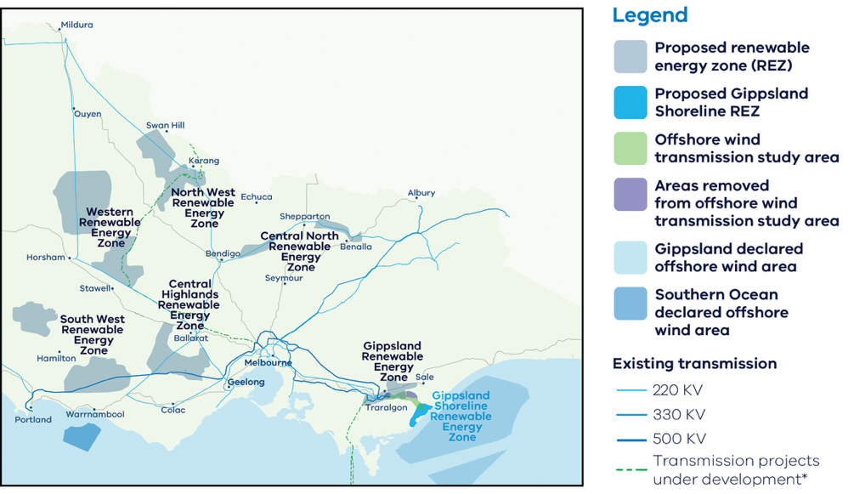
These are the areas identified as most suitable to host new renewable energy generation, such as wind turbines, solar farms, and battery storage.
It also sets out the transmission projects that need to be built over the next 15 years to enable Victoria’s energy transition, providing a long-term pipeline of strategic investment opportunities.
The 2025 Victorian Transmission Plan was released in August 2025.
For more information, visit: energy.vic.gov.au/renewable-energy/vicgrid/the-victorian-transmission-plan

Access to Victoria's world-class renewable energy talent
Our growing, highly skilled workforce drives project delivery and fosters industry growth. To meet the needs of the sector, the Victorian Government has committed to significant new energy skills and workforce initiatives.
- Delivering the Victorian Energy Jobs Plan, which seeks to support Victoria’s once-in-a-generation energy transition by setting out actions to mobilise the workforce and grow investment confidence. The Plan identifies key opportunities to support Victoria’s energy workforce, which is projected to increase from 41,000 full time equivalent (FTE) to 67,000 FTE in 2040, a 62% increase.
- Delivering the Women in Energy Strategy, which seeks to drive significant change for women in energy through Victoria’s energy transition, including addressing barriers to increasing the number of women in the energy workforce. The Strategy aligns with the Victorian Energy Jobs Plan as well as Our Equal State, which seeks to increase participation by women, economic equity, inclusive and safe workplaces, and education opportunities.
- Supporting the establishment of the National Training Centre in New Energy Skills based in Melbourne, in partnership with the Australian Government, to train and reskill key workforces needed for the energy transition across Australia.
Developing and supporting new energy training pathways through the $7 million for new Vocational Education and Training (VET) qualifications in renewable energy and utilising the $50 million TAFE Clean Energy Fund.

World-class education and training
Victoria has a globally renowned education and training system, including:
- 2 global ‘Top 40’ universities1
- 8 universities, including 4 dual-sector universities (offering both tertiary and vocational education)
- 12 independent technical and further education (TAFE) institutions under a single TAFE network
- a diverse talent pool with strong growth across the broad range of occupations relevant to the renewable energy sector.

Powering Victoria’s renewable energy future

What is SEC?
SEC is a government-owned renewable energy company that:
- invests in renewable energy and storage projects that accelerate the energy transition and deliver sustainable returns
- retails to government and commercial and industrial businesses
- supports households to go all-electric to reduce their energy bills and emissions
- supports the growth of the renewable energy workforce our energy transition requires.

How SEC invests:
SEC is investing an initial $1 billion towards delivering 4.5 GW of new renewable energy generation and storage. Its work will ensure Victorian households and businesses continue to have the power they need as we transition to renewable energy.
SEC’s investments include opportunities in renewable generation and storage. Utility-scale storage can address critical system gaps and help catalyse investment in large wind and solar generation to replace ageing coal assets.
The organisation will also continue to explore emerging technologies, including long duration energy storage opportunities, that accelerate the sector's maturity by enabling high levels of renewable power generation in the power grid. SEC’s investment focus is on achieving sustainable returns while delivering broader benefits to the Victorian public and enabling the market.
Find more information, visit: secvictoria.com.au

Case study: The Melbourne Renewable Energy Hub
SEC has made a major investment in the Melbourne Renewable Energy Hub in Plumpton, which is being developed with Equis Australia. With 600 MW of capacity, it is one of the world’s biggest battery projects. Once operational in late 2025, the hub will deliver 1.6 GW hours of energy storage – enough to power around 200,000 homes during peak evening consumption.

Investment Opportunity
Victoria will require significant new investment in energy storage of all durations to meet its legislated storage targets of at least 2.6 GW by 2030 and at least 6.3 GW by 2035. These targets translate to approximately an additional 25 GW of large and small-scale generation and storage capacity from 2024 to 2035. Storage will include a mix of short, medium and longer durations to manage both intra-day mismatches between renewable supply and demand and occasional periods of multi-day or seasonal shortfalls.

Energy storage research and development
Victoria is looking to attract investment in a range of energy storage technologies and has strong research and development capabilities across its universities to support technology development.
The state's world-class research organisations are delivering cutting-edge innovation across the full spectrum of established and emerging energy storage solutions.
This includes the following leading centres:
- Deakin University's Battery Research and Innovation Hub
- Commonwealth Scientific and Industrial Research Organisation (CSIRO)
- RMIT's Centre for Advanced Materials and Industrial Chemistry
- The University of Melbourne's Melbourne Energy Institute
- Monash University's Monash Energy Institute.

Case study: Battery Research and Innovation Hub
Deakin University's Battery Research and Innovation Hub is a unique, world-class research and innovation centre focused on advanced battery prototyping and the commercialisation of energy storage technologies.
The specialised facility was developed with $10.3 million in co‑funding by the Victorian Government and Deakin. It includes a dedicated research innovation laboratory for new battery design and development, prototyping, and a cell and systems test facility for multiple battery types and sizes.
Research can be tailored to meet specific industry needs and consumer demands as batteries continue to evolve from small personal use items to powering our modes of transport and electricity supply.
For more information, visit: batteryhub.deakin.edu.au

An ideal gateway for your next Asia Pacific battery manufacturing facility
Our advanced manufacturing capability, skilled workforce, world-leading battery research and access to Australia's rich critical minerals deposits make Victoria the ideal place to establish your manufacturing operations, from mining to recycling.

Mining to manufacturing opportunities
Australia is home to some of the largest recoverable critical mineral deposits on earth, including high-quality cobalt, lithium, manganese, rare-earth elements, tungsten and vanadium.
There is the option to refine critical minerals near their source or co-locate a refinery with manufacturing in Victoria.
The North-west region of Victoria hosts globally significant deposits of mineral sands, including rare-earth elements in high demand as inputs to the permanent magnets utilised in electric vehicles and wind turbines.
Victoria has:
- 22% of Australia’s ilmenite (~7% of global economically demonstrated resource)
- 51% of Australia’s rutile (~32% of global economically demonstrated resource)
- 39% of Australia’s zircon (~27% of global economically demonstrated resource).

Victoria’s Critical Mineral Roadmap
The Victorian Government has released its Critical Mineral Roadmap, which creates the foundations for a coordinated and integrated approach to foster this new industry – tailored to Victoria.
For more information, visit: resources.vic.gov.au/critical-minerals

Manufacturing Opportunities
Preliminary estimates suggest Victoria could need up to:
- 1,350 utility-scale battery packs by 2035
- Around 212,000 distributed battery packs by 20351
Initial Victorian demand for batteries creates a foundation for providing original equipment manufacturers with long-term pipeline certainty.

Case study: Envirostream
Envirostream is Australia’s leading recycler of end-of-life lithium‑ion batteries. As Australia’s first licenced recycler of mixed batteries, they deal with most of the major global battery brands and participants in the battery value chain. Its processes recover around 95% of the materials in a spent battery.
For more information, visit: liviumcorp.com/battery-recycling

Case study: Hazelwood Battery Energy Storage System
The Hazelwood Battery Energy Storage System (BESS) in the Latrobe Valley is Australia’s first utility-scale energy storage system to be commissioned on the site of a retired coal-fired power plant.
Jointly funded and developed by ENGIE and Eku Energy, the 150 MW/150 MWh system has the capacity to store the equivalent energy of 30,000 residential rooftop solar systems, which it can then discharge to help meet peak demand.
With access to 1,600 MW of network transmission capacity on site, the Hazelwood BESS will play a critical role in increasing renewable energy capacity in Victoria while delivering essential system services to the grid.
For more information, visit: ekuenergy.com/projects/hazelwood-bess

Microgrids and opportunities for short duration storage
The Victorian and Australian Governments are delivering innovative solutions that will reduce reliance on the electricity network and share renewable power – boosting demand for investment in energy storage.
Victoria has seen a rapid rise in distributed and consumer energy resources (such as home solar and batteries) and the innovative control systems that complement them.
Home battery systems, microgrids and virtual power plants are expected to play an increasing role in Victoria’s energy landscape, creating opportunities for market entrants and investors.

Cheaper Homes Batteries Program
The Australian Government’s Cheaper Home Batteries Program incentivises the rapid uptake of batteries across Australia.
The program will provide around a 30% discount on the upfront cost of installing eligible small-scale battery systems (5 kW–100 kW) in 2025. The discount will be based on the battery’s usable capacity and will gradually decrease until 2030. The program is also investigating options to reduce waste from solar panels.
For more information, visit: dcceew.gov.au/energy/programs/cheaper-home-batteries

Neighbourhood Batteries
The Victorian Government has committed to fund the installation of 100 neighbourhood batteries across Victoria.
The 100 Neighbourhood Batteries Program provides grants to install neighbourhood batteries (20 kW–5 MW) to improve energy reliability, resilience and provide storage capacity for locally generated solar power. This is expected to increase access to renewable energy and help lower energy bills.
For more information, visit: energy.vic.gov.au/100-neighbourhood-batteries

Case study: Corryong Islandable Microgrid
In 2024, the Victorian and Australian Governments allocated $10 million to a $28.6 million construction of the Corryong Islandable Microgrid. Once complete the microgrid will be able to power more than 900 local households and businesses for up to 5 days.
The Corryong Microgrid will use a centralised 4.98 MW battery, 3 KVA diesel generator and advanced switching technology to operate independently of the grid during power outages helping the isolated community keep their power on when the grid goes down.
The microgrid is expected to be operating in summer 2026.
For more information, visit:
engage.vic.gov.au/project/community-microgrids/page/community-microgrids-corryong

Key Victorian Government entities
We can help facilitate connections with key Victorian Government entities and industry members across our renewable energy sector.

Department of Energy, Environment and Climate Action (DEECA)
DEECA works with industry and the community to develop Victoria's secure and sustainable energy future.
For information on Victoria’s energy policy landscape and facilitated connections across the Victorian Government and renewable energy sector, contact the Business and Industry Engagement team at: BIE@deeca.vic.gov.au
For more information, visit: energy.vic.gov.au/industry/investment-opportunities

Invest Victoria
Invest Victoria is the Victorian Government’s investment attraction agency. Services include:
- market regulatory information
- statutory approvals coordination
- site location services
- identification of infrastructure and utility requirements
advocacy within government.
The Investment Coordinator-General role and function also sits within Invest Victoria, working across agencies to ensure approvals deadlines are met and helping to reduce delays.
For more information, visit: invest.vic.gov.au

VicGrid
VicGrid coordinates the planning and development of Victorian Renewable Energy Zones (REZs). It also oversees the $480 million REZ fund that will be used to strengthen the grid and develop each REZ.
For more information, visit: energy.vic.gov.au/renewable-energy/renewable-energy-zones

Solar Victoria
Solar Victoria is responsible for the delivery of the Victorian Government’s $1.3 billion Solar Homes Program – one of the most ambitious and transformative renewable energy programs in Australia.
For more information, visit: solar.vic.gov.au

SEC
SEC is a Victorian Government-owned renewable energy company. It is partnering with the private sector to deliver 4.5 GW of new renewable energy and storage projects with an initial investment of $1 billion.
For more information, visit: secvictoria.com.au

Contact a local Victorian Government Trade and Investment Office to help you:
- navigate investment opportunities in Victoria’s new energy technology sector
- set up a briefing with energy specialists
- arrange inbound market visits
introduce you to the Victorian Government’s Energy Business and Industry Engagement team and Invest Victoria.
For more information, visit: global.vic.gov.au/meet-our-global-team/all-office-locations

Publication information

Acknowledgements
We acknowledge and respect Victorian Traditional Owners as the original custodians of Victoria’s land and waters, their unique ability to care for Country and deep spiritual connection to it.
We honour Elders past and present whose knowledge and wisdom has ensured the continuation of culture and traditional practices.
DEECA is committed to genuinely partnering with Victorian Traditional Owners and Victoria’s Aboriginal community to progress their aspirations.

Copyright
© The State of Victoria Department of Energy, Environment and Climate Action, September 2025.

Creative Commons
This work is licensed under a Creative Commons Attribution 4.0 International licence, visit the Creative Commons website (http://creativecommons.org/licenses/by/4.0/).
You are free to re-use the work under that licence, on the condition that you credit the State of Victoria as author. The licence does not apply to any images, photographs or branding, including the Victorian Coat of Arms, and the Victorian Government and Department logos.
ISBN 978-1-76176-607-7 (Print)
ISBN 978-1-76176-608-4 (pdf/online/MS word))

Disclaimer
This publication may be of assistance to you but the State of Victoria and its employees do not guarantee that the publication is without flaw of any kind or is wholly appropriate for your particular purposes and therefore disclaims all liability for any error, loss or other consequence which may arise from you relying on any information in this publication.

Accessibility
To receive this document in an alternative format, phone the Customer Service Centre on 136 186, email customer.service@delwp.vic.gov.au, or contact National Relay Service on 133 677. Available at DEECA website (www.deeca.vic.gov.au).
End of document.

Cheaper, cleaner, renewable: our plan for Victoria's electricity future, http://energy.vic.gov.au/renewable-energy/victorias-electricity-future. Note this figure will be updated following the release of the draft AEMO 2026 Integrated System Plan in December 2025
Manufacturing Statement, djsir.vic.gov.au/made-in-victoria/manufacturing-statement
QS World University Rankings, June 2025, topuniversities.com/world-university-rankings

