Victoria's Investment Prospectus SOLAR ENERGY
Table of Contents
Victoria, one of the world’s most exciting energy markets 2
Welcome to Victoria's renewable energy sector 3
Why invest in Victoria’s large-scale solar sector? 5
Victoria has excellent solar resources 6
Victoria’s new Renewable Energy Zones 8
Powering Victoria’s renewable energy future 10
Government policies supporting your project 11
Access to Victoria's world-class renewable energy talent 14
Co-locate with energy storage to maximise output 16
Established supply chains support a thriving solar industry 19
Key Victorian Government entities 21
Publication information 23

Victoria, one of the world’s most exciting energy markets

Acknowledgement of Country
We acknowledge and respect Victorian Traditional Owners as the original custodians of Victoria’s land and waters, their unique ability to care for Country and deep spiritual connection to it.
We honour Elders past and present whose knowledge and wisdom have ensured the continuation of culture and traditional practices.
We are committed to genuinely partner, and meaningfully engage, with Victoria’s Traditional Owners and Aboriginal communities to support the protection of Country, the maintenance of spiritual and cultural practices and their broader aspirations in the 21st century and beyond.

Traditional Owners at the centre of decision-making processes
Strong and mutually beneficial partnerships with Traditional Owners and First Peoples are imperative to the electricity transition’s success and integral to ensuring the goals and objectives of self-determination set out in the Victorian Government’s Self Determination Reform Framework and the Department of Energy, Environment and Climate Action’s (DEECA) Pupangarli Marnmarnepu ‘Owning Our Future’ Aboriginal Self-Determination Reform Strategy 2020–2025.
For more information, visit:
deeca.vic.gov.au/aboriginalselfdetermination/self-determination-reform-strategy

Welcome to Victoria's renewable energy sector
At the centre of Australia’s electricity network, the state of Victoria is leading the way to a renewable energy future
We estimate that Victoria will need 25 GW of new generation and storage capacity by 2035. Our legislated renewable energy generation, energy storage and emissions reduction targets provide a clear market signal, supported by government programs to drive investment.
The renewable energy sector is at the heart of our economy, identified as a priority growth industry backed by streamlined approval processes, well-developed supply chains, world‑class research and development capabilities and a highly skilled workforce.

A solar energy sector positioned for growth
Victoria’s solar energy sector is primed for investment, with solar energy to play a critical role in achieving the state’s renewable energy targets. Victoria has excellent solar irradiation levels across the state, setting this sector up for continued growth.
Strategic Victorian Government initiatives support investment in solar, including the Victorian Renewable Energy Auction Scheme, Solar Victoria’s $1.3 billion Solar Homes Program, and SEC investing to deliver 4.5 GW of new renewable energy generation and storage.
Figure 1: Legislated renewable energy targets
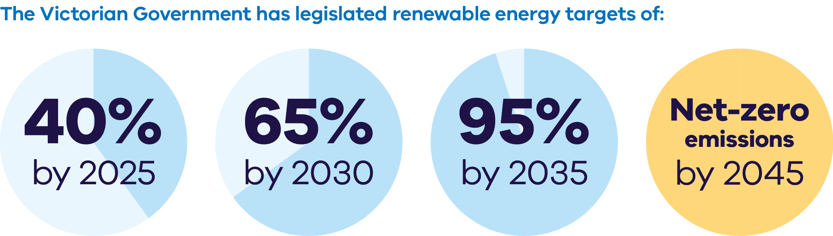
The Victorian Government has legislated renewable energy targets of:
- 40% by 2025
- 65% by 2030
- 95% by 2035
Net-zero emissions by 2045
Figure 2: Energy storage capacity and Offshore wind energy targets from 2025-2045
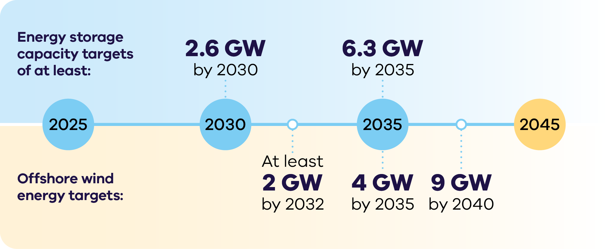

Energy storage capacity targets
of at least:
- 2.6 GW by 2030
6.3 GW by 2035
Offshore wind energy targets:
- At least 2 GW by 2032
- 4 GW by 2035
9 GW by 204

Why invest in Victoria’s
large-scale solar sector?

Targets fuelling investment
Victoria has legislated ambitious renewable energy, storage and emission reduction targets, which will drive investment in solar.

Supporting advanced solar manufacturing
The Australian Government has committed to support innovative manufacturing across the solar panel supply chain, including production subsidies and grants through the Solar Sunshot program.

Excellent solar resources
Victoria has solar irradiation levels on par with Spain, with North-west Victoria exceeding 1,900 kWh/m² annually.

An attractive market for generators
Victoria has a fully competitive, transparent and privatised energy market, positioned at the heart of Australia’s National Electricity Market.

Network upgrades unlocking access to resources
Planned near-term upgrades to Victoria’s transmission network will unlock even more of Victoria’s solar resources.

Planning reforms to derisk your investments
The Victorian Government expanded the Development Facilitation Program to fast-track planning approvals for large renewable energy facilities such as solar farms.

Victoria has excellent solar resources
North-west Victoria receives especially high irradiation levels similar to Spain, with Southern Victoria boasting better solar resources than most of Western Europe.
North-west Victoria receives an exceptional amount of solar energy, with irradiation levels exceeding 1,900 kWh/m² annually. Additionally, Victoria exhibits high solar irradiation levels between 1,500–1,900 kWh/m² annually in the Northern and North-west regions.
Victoria’s corresponding proposed Renewable Energy Zones capture this abundance of solar radiation, supported by the Victorian Government’s strong policy settings and transmission planning.
Table 1: Snapshot of the sector (as of September 2025)
No. of solar farms | Combined capacity
52 operating | 1,578 MW
4 under construction | 580 MW
Total | 2,158 MW
Figure 3: Solar Irradiation in Victoria
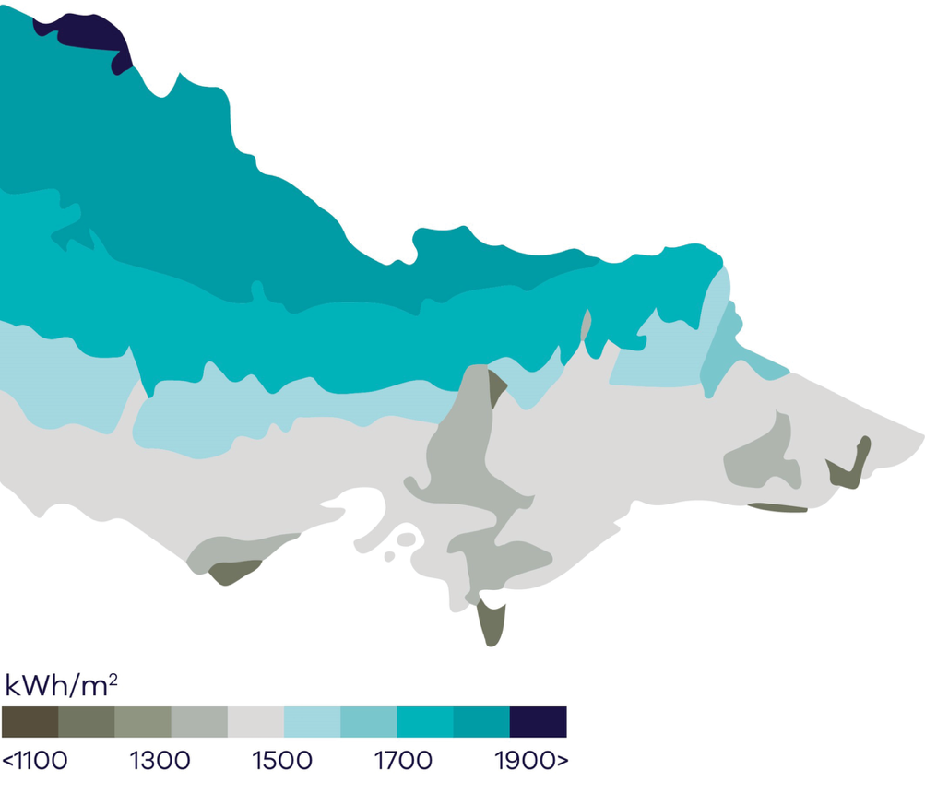

Victoria’s new Renewable Energy Zones
The Victorian Transmission Plan is a new long-term strategic plan for transmission and renewable energy zone development in Victoria.
This plan will ensure we build the right amount of energy infrastructure in the right places at the right time to support the transition to renewable energy.
The plan sets out 6 proposed onshore renewable energy zones: South West, Central Highlands, Western, North West, Central North and Gippsland.
These are the areas identified as most suitable to host new renewable energy generation, such as wind turbines, solar farms, and battery storage.
It also sets out the transmission projects that need to be built over the next 15 years to enable Victoria’s energy transition, providing a long-term pipeline of strategic investment opportunities.
The 2025 Victorian Transmission Plan was released in August 2025.
For more information, visit:
energy.vic.gov.au/renewable-energy/vicgrid/the-victorian-transmission-plan

Figure 4: The 6 proposed onshore renewable energy zones
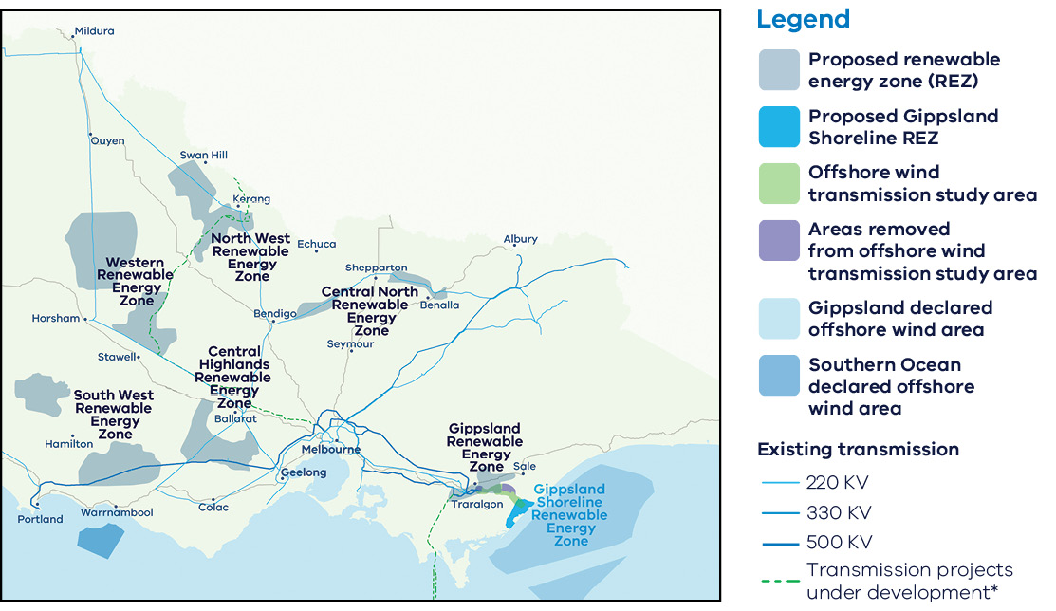

Powering Victoria’s renewable energy future

What is SEC?
SEC is a government-owned renewable energy company that:
- invests in renewable energy and storage projects that accelerate the energy transition and deliver sustainable returns
- retails to government and commercial and industrial businesses
- supports households to go all-electric to reduce their energy bills and emissions
- supports the growth of the renewable energy workforce our energy transition requires.

How SEC invests:
SEC is investing an initial $1 billion towards delivering 4.5 GW of new renewable energy generation and storage. Its work will ensure Victorian households and businesses continue to have the power they need as we transition to renewable energy.
SEC’s investments include opportunities in renewable generation and storage. Utility-scale storage can address critical system gaps and help catalyse investment in large wind and solar generation to replace ageing coal assets.
The organisation will also continue to explore emerging technologies, including long duration energy storage opportunities, that accelerate the sector's maturity by enabling high levels of renewable power generation in the power grid. SEC’s investment focus is on achieving sustainable returns while delivering broader benefits to the Victorian public and enabling the market.
Find more information, visit: secvictoria.com.au

Government policies supporting your project
The Victorian and Australian governments are making it easier to navigate planning approvals.
The Victorian Government Development Facilitation Program fast-tracks the planning permit approval process for renewable energy facilities and utility installations.
Victoria also released updated guidance for managing biodiversity impacts of renewable energy projects.
For more information, visit: planning.vic.gov.au/planning-approvals/planning-enquiries-and-requests/development-facilitation-program and environment.vic.gov.au/home/managing-impacts-of-renewable-energy-on-environment
In December 2024, as part of the Economic Growth Statement, the Victorian Government announced the following key reforms:
- faster Environmental Effects Statement processes, providing investors with an answer in 18 months or less
- enhanced public engagement with a more focused approach
- targeted assessments and developer support to encourage investment
appointment of an Investment Coordinator‑General.
For more information, visit: vic.gov.au/economic-growth-statement

Underwriting new renewable energy capacity
The Capacity Investment Scheme (CIS) provides a national framework to underwrite 26 GW of renewable capacity and 14 GW of clean dispatchable capacity by 2030.
Competitive tenders for renewable energy and storage will be held approximately every 6 months. Target allocations for Victorian projects are for at least 11 TWh of renewable energy and 1.7 GW of 4-hour equivalent storage. Victoria expects onshore wind to play a strong role in delivering this capacity.
For more information, visit: dcceew.gov.au/energy/renewable/capacity-investment-scheme
Table 2: Schedule for target Victorian allocations in the CIS
CIS Tenders in Calendar Year | Cumulative generation allocation  (GW / TWh) | Cumulative storage allocation  (GW / GWh)
2024 | 2.8 / 6.2 | 1.0 / 4.0
2025 | 3.8 / 8.0 | 1.5 / 6.0
2026 | 5.0 / 11.0 | 1.7 / 6.8

Future Made in Australia
The Australian Government is investing $25 billion to maximise the economic and industrial benefits of the net-zero transition. Key initiatives include incentives for critical minerals, renewable hydrogen, batteries and solar panels, and innovation in green metals and low-carbon fuels.
For more information, visit: treasury.gov.au/publication/p2024-526942
The Victorian Government can connect you with the Australian Government’s specialist investment vehicles, including the:
- Clean Energy Finance Corporation: Australia’s ‘Green Bank’, with access to $30.5 billion in investment capital from the Australian Government
- Australian Renewable Energy Agency: provides financial assistance for research, development, demonstration, commercialisation and deployment of renewable energy technologies
- National Reconstruction Fund Corporation: $15 billion national investment fund designed to diversify and transform Australia's industry and economy.

Access to Victoria's world-class renewable energy talent
Our growing, highly skilled workforce drives project delivery and fosters industry growth. To meet the needs of the sector, the Victorian Government has committed to significant new energy skills and workforce initiatives.
- Delivering the Victorian Energy Jobs Plan, which seeks to support Victoria’s once-in-a-generation energy transition by setting out actions to mobilise the workforce and grow investment confidence. The Plan identifies key opportunities to support Victoria’s energy workforce, which is projected to increase from 41,000 full time equivalent (FTE) to 67,000 FTE in 2040, a 62% increase.
- Delivering the Women in Energy Strategy, which seeks to drive significant change for women in energy through Victoria’s energy transition, including addressing barriers to increasing the number of women in the energy workforce. The Strategy aligns with the Victorian Energy Jobs Plan as well as Our Equal State, which seeks to increase participation by women, economic equity, inclusive and safe workplaces, and education opportunities.
- Supporting the establishment of the National Training Centre in New Energy Skills based in Melbourne, in partnership with the Australian Government, to train and reskill key workforces needed for the energy transition across Australia.
Developing and supporting new energy training pathways through the $7 million for new Vocational Education and Training (VET) qualifications in renewable energy and utilising the $50 million TAFE Clean Energy Fund.

World-class education and training
Victoria has a globally renowned education and training system, including:
- 2 global ‘Top 40’ universities1
- 8 universities, including 4 dual-sector universities (offering both tertiary and vocational education)
- 12 independent technical and further education (TAFE) institutions under a single TAFE network
- a diverse talent pool with strong growth across the broad range of occupations relevant to the renewable energy sector.

Co-locate with energy storage to maximise output
Pairing solar generation with storage assets can boost revenue, reduce costs and provide the potential to leverage existing development sites.

Victoria’s energy storage targets
Victoria has legislated energy storage targets of:
- at least 2.6 GW of energy storage capacity by 2030
at least 6.3 GW by 2035.
These energy storage targets will include short, medium and long-duration energy storage systems.
For more information, visit:
energy.vic.gov.au/renewable-energy/victorian-renewable-energy-and-storage-targets
For more information on energy storage opportunities in Victoria visit: energy.vic.gov.au/industry/investment-opportunities

Case study: Gannawarra Energy Storage System
The Gannawarra Energy Storage System is located at the Gannawarra Solar Farm in Wandella, Victoria. The 25 MW/50 MWh battery is jointly owned by Edify Energy and Wirsol Energy and operated by Energy Australia.
This battery is used to smooth the output of the 60 MW Gannawarra Solar Farm, allowing the combined solar and battery system to provide power when there is insufficient sun. The Gannawarra project is one of the largest integrated solar farm and battery projects in Australia.
For more information, visit: edifyenergy.com/project/gannawarra-energy-storage

Case study: SEC Renewable Energy Park – Horsham
SEC Renewable Energy Park is a large-scale solar farm and renewable energy storage project near Horsham. Construction of the 100% publicly owned project began in February 2025 and SEC is working with developer OX2 to build the energy park in two stages, starting with a 119 MW solar farm comprising more than 212,000 PV solar panels.
SEC’s $370 million investment allowed work on the solar farm to begin immediately while supporting the addition of a 100 MW two-hour battery energy storage system (BESS) – making it one of Australia’s first integrated solar and BESS projects with a single connection point. Once operational in 2027, the facility will be capable of generating around 242,000 MWh of renewable energy a year – enough renewable energy to power around 51,000 homes.
For more information, visit: secvictoria.com.au/investments/sec-renewable-energy-park

Case study: Cohuna Solar Plant
Cohuna Solar Farm, owned by Potentia Energy, is a utility scale solar farm using highly efficient bi-facial PV modules.
The Cohuna Solar Farm was awarded, through a competitive tender process, a 15-year support agreement with the Victorian Government. In this way, the Cohuna Solar Farm is directly contributing towards achieving the Victorian Government’s Victorian Renewable Energy Target of 65% by 2030.
Potentia is at the forefront of integrating innovative technologies into renewable energy plants and partnered with Agriculture Victoria for use of the site for research and development activities related to agrivoltaic practices, intending to accelerate the understanding of opportunities for complementary energy and agricultural production across Australia.
For more information, visit: potentiaenergy.com.au/project/cohuna-solar-farm

Established supply chains support a thriving solar industry
Victoria’s solar manufacturing and supply chain capabilities have been growing progressively since the early 2010s, meaning that local businesses are well-equipped to contribute to project development across the entire supply chain.
Victoria is also home to a wide range of specialist manufacturing, research and development facilities keeping the state at the cutting edge of Australian manufacturing innovation.
The Australian Government has committed to supporting innovative manufacturing facilities in Australia across the solar PV supply chain, including production subsidies and grants through the Solar Sunshot program.
For more information, visit: arena.gov.au/funding/solar-sunshot

Manufacturing Opportunity
Victoria is estimated to need up to 5.8 million utility PV solar panels and 23 million distributed PV solar panels by 2035.1 Initial Victorian demand for panels creates a foundation for providing original equipment manufacturers (OEMs) with long-term pipeline certainty.

Mining to manufacturing opportunities
Australia is home to some of the largest recoverable critical mineral deposits on earth, including high-quality cobalt, lithium, manganese, rare-earth elements, tungsten and vanadium.
There is the option to refine critical minerals near their source or co-locate a refinery with manufacturing in Victoria.
The North-west region of Victoria hosts globally significant deposits of mineral sands, including rare-earth elements in high demand as inputs to the permanent magnets utilised in electric vehicles and wind turbines.
Victoria has:
- 22% of Australia’s ilmenite (~7% of global economically demonstrated resource)
- 51% of Australia’s rutile (~32% of global economically demonstrated resource)
39% of Australia’s zircon (~27% of global economically demonstrated resource).

Victoria’s Critical Mineral Roadmap
The Victorian Government has released its Critical Mineral Roadmap, which creates the foundations for a coordinated and integrated approach to foster this new industry – tailored to Victoria.
For more information, visit: resources.vic.gov.au/critical-minerals

Key Victorian Government entities
We can help facilitate connections with key Victorian Government entities and industry members across our renewable energy sector.

Department of Energy, Environment and Climate Action (DEECA)
DEECA works with industry and the community to develop Victoria's secure and sustainable energy future.
For information on Victoria’s energy policy landscape and facilitated connections across the Victorian Government and renewable energy sector, contact the Business and Industry Engagement team at: BIE@deeca.vic.gov.au
For more information, visit: energy.vic.gov.au/industry/investment-opportunities

SEC
SEC is a Victorian Government-owned renewable energy company. It is partnering with the private sector to deliver 4.5 GW of new renewable energy and storage projects with an initial investment of $1 billion.
For more information, visit: secvictoria.com.au

Invest Victoria
Invest Victoria is the Victorian Government’s investment attraction agency. Services include:
- market regulatory information
- statutory approvals coordination
- site location services
- identification of infrastructure and utility requirements
advocacy within government.
The Investment Coordinator-General role and function also sits within Invest Victoria, working across agencies to ensure approvals deadlines are met and helping to reduce delays.
For more information, visit: invest.vic.gov.au

Solar Victoria
Solar Victoria is responsible for the delivery of the Victorian Government’s $1.3 billion Solar Homes Program – one of the most ambitious and transformative renewable energy programs in Australia.
For more information, visit: solar.vic.gov.au

VicGrid
VicGrid coordinates the planning and development of Victorian Renewable Energy Zones (REZs). It also oversees the $480 million REZ fund that will be used to strengthen the grid and develop each REZ.
For more information, visit: energy.vic.gov.au/renewable-energy/renewable-energy-zones

Contact a local Victorian Government Trade and Investment Office to help you:
- navigate investment opportunities in Victoria’s new energy technology sector
- set up a briefing with energy specialists
- arrange inbound market visits
introduce you to the Victorian Government’s Energy Business and Industry Engagement team and Invest Victoria.
For more information, visit: global.vic.gov.au/meet-our-global-team/all-office-locations

Publication information

Acknowledgements
We acknowledge and respect Victorian Traditional Owners as the original custodians of Victoria’s land and waters, their unique ability to care for Country and deep spiritual connection to it.
We honour Elders past and present whose knowledge and wisdom has ensured the continuation of culture and traditional practices.
DEECA is committed to genuinely partnering with Victorian Traditional Owners and Victoria’s Aboriginal community to progress their aspirations.

Copyright
© The State of Victoria Department of Energy, Environment and Climate Action, September 2025.

Creative Commons
This work is licensed under a Creative Commons Attribution 4.0 International licence, visit the Creative Commons website (http://creativecommons.org/licenses/by/4.0/).
You are free to re-use the work under that licence, on the condition that you credit the State of Victoria as author. The licence does not apply to any images, photographs or branding, including the Victorian Coat of Arms, and the Victorian Government and Department logos.
ISBN 978-1-76176-613-8 (Print)
ISBN 978-1-76176-614-5 (pdf/online/MS word))

Disclaimer
This publication may be of assistance to you but the State of Victoria and its employees do not guarantee that the publication is without flaw of any kind or is wholly appropriate for your particular purposes and therefore disclaims all liability for any error, loss or other consequence which may arise from you relying on any information in this publication.

Accessibility
To receive this document in an alternative format, phone the Customer Service Centre on 136 186, email customer.service@delwp.vic.gov.au, or contact National Relay Service on 133 677. Available at DEECA website (www.deeca.vic.gov.au).
End of document.

Cheaper, cleaner, renewable: our plan for Victoria's electricity future, http://energy.vic.gov.au/renewable-energy/victorias-electricity-future. Note this figure will be updated following the release of the draft AEMO 2026 Integrated System Plan in December 2025
Manufacturing Statement, djsir.vic.gov.au/made-in-victoria/manufacturing-statement
Internal register figures from the Department of Energy, Environment and Climate Action, September 2025
QS World University Rankings, June 2025, topuniversities.com/world-university-rankings

