Victoria's Investment Prospectus DIGITAL ENERGY AND INNOVATION
Table of Contents
Victoria is investing in world-class bioenergy innovation 2
Welcome to Victoria's renewable energy sector 3
Why invest in Victoria’s digital energy and innovation sectors? 5
Our digital energy future is backed by data 6
Investment opportunities and government funds 8
Access to Victoria's world-class renewable energy talent 9
Exceptional research and development capabilities 11
Powering Victoria’s renewable energy future 12
Key Victorian Government entities 15
Publication information 18

Acknowledgement of Country
We acknowledge and respect Victorian Traditional Owners as the original custodians of Victoria’s land and waters, their unique ability to care for Country and deep spiritual connection to it.
We honour Elders past and present whose knowledge and wisdom have ensured the continuation of culture and traditional practices.
We are committed to genuinely partner, and meaningfully engage, with Victoria’s Traditional Owners and Aboriginal communities to support the protection of Country, the maintenance of spiritual and cultural practices and their broader aspirations in the 21st century and beyond.

Traditional Owners at the centre of decision-making processes
Strong and mutually beneficial partnerships with Traditional Owners and First Peoples are imperative to the electricity transition’s success and integral to ensuring the goals and objectives of self-determination set out in the Victorian Government’s Self Determination Reform Framework and the Department of Energy, Environment and Climate Action’s (DEECA) Pupangarli Marnmarnepu ‘Owning Our Future’ Aboriginal Self-Determination Reform Strategy 2020–2025.
For more information, visit:
deeca.vic.gov.au/aboriginalselfdetermination/self-determination-reform-strategy

Welcome to Victoria's renewable energy sector
At the centre of Australia’s electricity network, the state of Victoria is leading the way to a renewable energy future
We estimate that Victoria will need 25 GW of new generation and storage capacity by 2035. Our legislated renewable energy generation, energy storage and emissions reduction targets provide a clear market signal, supported by government programs to drive investment.
The renewable energy sector is at the heart of our economy, identified as a priority growth industry backed by streamlined approval processes, well-developed supply chains, world‑class research and development capabilities and a highly skilled workforce.

A digital and innovation sector positioned for growth
Victoria leads Australia’s electricity system digitisation and digitalisation, with near-comprehensive smart meters installed across the state. Rich data sources, open data initiatives, local innovation capabilities and world-class research and development hubs make Victoria a prime destination to create, develop and invest in digital and innovative energy products.
Key government initiatives in this area are boosting growth, including Breakthrough Victoria, LaunchVic, and small-scale renewable technologies programs for households and neighbourhoods such as Solar Victoria’s rebates.
Figure 1: Legislated renewable energy targets
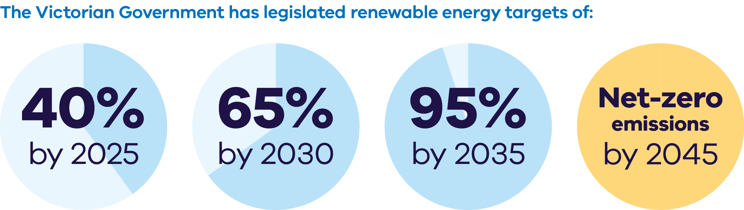
The Victorian Government has legislated renewable energy targets of:
- 40% by 2025
- 65% by 2030
- 95% by 2035
Net-zero emissions by 2045
Figure 2: Energy storage capacity and Offshore wind energy targets from 2025-2045
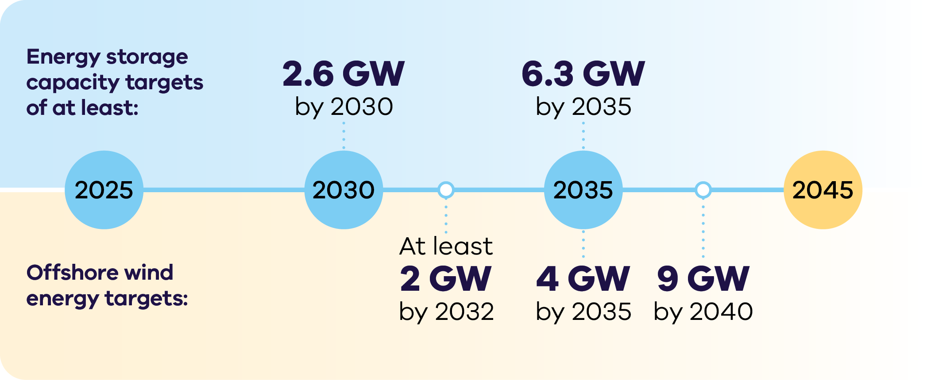

Energy storage capacity targets
of at least:
- 2.6 GW by 2030
6.3 GW by 2035
Offshore wind energy targets:
- At least 2 GW by 2032
- 4 GW by 2035
9 GW by 204

Why invest in Victoria’s digital energy and innovation sectors?

Some of the world’s richest energy data
Victoria’s near 100% smart meter penetration is among the highest in the world. Rich data made accessible through reforms such as the Consumer Data Right (CDR) make Victoria the ideal location to innovate, test and grow digital energy solutions.

Government underwriting investment
Breakthrough Victoria’s providing patient capital and investment to build on Victoria’s track record for innovation. It has committed over $60 million to companies driving the clean energy transition, emissions reduction, and the circular economy.

Fast-growing startup ecosystem
Victoria’s startup ecosystem (including startups, scaleups and unicorns) is valued at $143 billion; it is one of the world’s fastest growing ecosystems, home to more than 3,800 start-ups.

National funding boosting local capabilities
National investment in innovation is available to support Victorian initiatives, including the $1.7 billion Future Made in Australia Innovation Fund.

Extensive pipeline of digital talent
Victoria has the fastest growing digital technology sector in Australia, with over 259,000 tech professionals.

Advanced research and development capabilities
Our world-class universities produce cutting-edge research to innovate and commercialise energy products, including through leading research centres.

Our digital energy future is backed by data
Victoria is the ideal location to test, develop and deploy new digital solutions, thanks to our world-class energy data and access initiatives.

What makes Victoria's digital energy and innovation subsector different?
Victoria is the only state in Australia with a fully digitised energy system, thanks to the roll-out of over 3.2 million smart meters to residential and small business electricity customers (over 99% coverage).
This makes Victoria the ideal place to develop and test new digital energy innovations, with smart meters:
- enabling near real-time remote monitoring of customer electricity flows
- allowing digital energy businesses to provide customers with new product offerings and greater insight into their energy use.

Smart meter coverage around Australia
- Victoria – above 99%
- Rest of Australia – less than 30%

Open data initiatives
Through DataVic, Victorian Government agencies have published over 5,694 datasets under open licence.
For more information, visit: data.vic.gov.au
The Digital Twin Victoria platform adds interactive 3D and real-time data visualisation, making state-wide spatial data more accessible for innovators, businesses and investors.
For more information, visit:
land.vic.gov.au/maps-and-spatial/digital-twin-victoria/dtv-platform

Investment opportunities and government funds

Investment Opportunity
Victoria’s growing digital and digital energy sectors are creating a wealth of investment opportunities. The following statistics show the pace and scale of growth:
Australia's growing digital technologies sector is expanding at a rate 4 times faster than the rest of the economy, having grown 26% to $167 billion since 2020 and expected to reach $244 billion by 2031
Melbourne is home to more than half of Australia’s top 20 technology companies.
We can connect you with the Australian and Victorian governments’ specialist investment vehicles, including:
- Clean Energy Finance Corporation: Australia’s ‘Green Bank’, with access to $30.5 billion in investment capital from the Australian Government
- Australian Renewable Energy Agency: Provides financial assistance for research, development, demonstration, commercialisation and deployment of renewable energy technologies
- Breakthrough Victoria: was launched in 2021 to be a private investment company for Victoria, providing patient capital and investment that impacts the State’s economy and wellbeing.

Access to Victoria's world-class renewable energy talent
Our growing, highly skilled workforce drives project delivery and fosters industry growth. To meet the needs of the sector, the Victorian Government has committed to significant new energy skills and workforce initiatives.
- Delivering the Victorian Energy Jobs Plan, which seeks to support Victoria’s once-in-a-generation energy transition by setting out actions to mobilise the workforce and grow investment confidence. The Plan identifies key opportunities to support Victoria’s energy workforce, which is projected to increase from 41,000 full time equivalent (FTE) to 67,000 FTE in 2040, a 62% increase.
- Delivering the Women in Energy Strategy, which seeks to drive significant change for women in energy through Victoria’s energy transition, including addressing barriers to increasing the number of women in the energy workforce. The Strategy aligns with the Victorian Energy Jobs Plan as well as Our Equal State, which seeks to increase participation by women, economic equity, inclusive and safe workplaces, and education opportunities.
- Supporting the establishment of the National Training Centre in New Energy Skills based in Melbourne, in partnership with the Australian Government, to train and reskill key workforces needed for the energy transition across Australia.
Developing and supporting new energy training pathways through the $7 million for new Vocational Education and Training (VET) qualifications in renewable energy and utilising the $50 million TAFE Clean Energy Fund.

World-class education and training
Victoria has a globally renowned education and training system, including:
- 2 global ‘Top 40’ universities1
- 8 universities, including 4 dual-sector universities (offering both tertiary and vocational education)
- 12 independent technical and further education (TAFE) institutions under a single TAFE network
- a diverse talent pool with strong growth across the broad range of occupations relevant to the renewable energy sector.

Exceptional research and development capabilities
Victoria boasts a thriving energy research and development sector, with some of the world’s top research centres and facilities, including 2 universities in the world’s top 40 and 6 within the top 300.

Siemens Swinburne Energy Transition Hub
Swinburne University of Technology is home to the Siemens Swinburne Energy Transition Hub, a research and development centre dedicated to accelerating the transition towards a sustainable energy sector, with a focus on achieving net zero targets and promoting the uptake of renewable energy sources.
For more information, visit:
swinburne.edu.au/research/platforms-initiatives/siemens-swinburne-energy-transition-hub

Deakin Digital Design and Engineering Centre (3DEC)
3DEC was established in 2017 by integrating existing multi-disciplinary design and engineering R&D in civil, mechanical, electronics, environmental, renewable energy and electrical engineering disciplines to advance industries that are vital for Australia’s social, economic and environmental future including the sustainable energy infrastructure industry.
For more information, visit: deakin.edu.au/3dec

Powering Victoria’s renewable energy future

What is SEC?
SEC is a government-owned renewable energy company that:
- invests in renewable energy and storage projects that accelerate the energy transition and deliver sustainable returns
- retails to government and commercial and industrial businesses
- supports households to go all-electric to reduce their energy bills and emissions
- supports the growth of the renewable energy workforce our energy transition requires.

How SEC invests:
SEC is investing an initial $1 billion towards delivering 4.5 GW of new renewable energy generation and storage. Its work will ensure Victorian households and businesses continue to have the power they need as we transition to renewable energy.
SEC’s investments include opportunities in renewable generation and storage. Utility-scale storage can address critical system gaps and help catalyse investment in large wind and solar generation to replace ageing coal assets.
The organisation will also continue to explore emerging technologies, including long duration energy storage opportunities, that accelerate the sector's maturity by enabling high levels of renewable power generation in the power grid. SEC’s investment focus is on achieving sustainable returns while delivering broader benefits to the Victorian public and enabling the market.
Find more information, visit: secvictoria.com.au

Case study: Amber Electric
Amber Electric (Amber) is an innovative energy company giving households access to the real-time wholesale price of electricity and the technology to automate their home batteries and electric vehicles. This allows households to unlock more value from their assets while accelerating the energy transition.
Founded in December 2017 with the goal of using new technologies to benefit customers and build a more sustainable world, Amber is backed by Australia’s leading venture capitalists, impact-focused investors and individuals.
Through smart meters, Amber customers can see their detailed electricity usage data in the Amber app, allowing them to shift energy use and be rewarded for using power at cheaper and greener times.
In February 2024 Victorian Government-backed investment fund, Breakthrough Victoria, announced an equity investment of $4.5m. Since this investment, Amber has grown its customer base to over 43,000 and hired over 40 people taking their total team size to greater than 140.
For more information, visit: amber.com.au

Case study: HAL Systems and CivVic Labs Digital Energy Challenge
HAL Systems is an early-stage climate technology start-up focused on improving energy efficiency in commercial buildings through advanced predictive climate control technology.
Founded with the mission to reduce CO2 emissions and operational costs in commercial properties, HAL Systems utilises real-time weather forecasts to optimise heating, ventilation, and air conditioning systems. This innovative solution ensures a balance between energy savings and occupant comfort, making it a valuable tool for building owners pursuing their sustainability goals.
For more information, visit: halsystems.com.au

Key Victorian Government entities
We can help facilitate connections with key Victorian Government entities and industry members across our renewable energy sector.

Department of Energy, Environment and Climate Action (DEECA)
DEECA works with industry and the community to develop Victoria's secure and sustainable energy future.
For information on Victoria’s energy policy landscape and facilitated connections across the Victorian Government and renewable energy sector, contact the Business and Industry Engagement team at: BIE@deeca.vic.gov.au
For more information, visit: energy.vic.gov.au/industry/investment-opportunities

Solar Victoria
Solar Victoria is responsible for the delivery of the Victorian Government’s $1.3 billion Solar Homes Program – one of the most ambitious and transformative renewable energy programs in Australia.
For more information, visit: solar.vic.gov.au

SEC
SEC is a Victorian Government-owned renewable energy company. It is partnering with the private sector to deliver 4.5 GW of new renewable energy and storage projects with an initial investment of $1 billion.
For more information, visit: secvictoria.com.au

Launch Vic
LaunchVic is Victoria’s startup agency, fuelling the growth of Victoria’s startup sector by helping startups grow and scale and develop the private early-stage investment landscape.
For more information, visit: launchvic.org

Breakthrough Victoria
Breakthrough Victoria launched in 2021 and is a private investment company providing patient capital and investment that impact Victoria’s economy and wellbeing.
For more information, visit: breakthroughvictoria.com

Invest Victoria
Invest Victoria is the Victorian Government’s investment attraction agency. Services include:
- market regulatory information
- statutory approvals coordination
- site location services
- identification of infrastructure and utility requirements
advocacy within government.
The Investment Coordinator-General role and function also sits within Invest Victoria, working across agencies to ensure approvals deadlines are met and helping to reduce delays.
For more information, visit: invest.vic.gov.au

Contact a local Victorian Government Trade and Investment Office to help you:
- navigate investment opportunities in Victoria’s new energy technology sector
- set up a briefing with energy specialists
- arrange inbound market visits
introduce you to the Victorian Government’s Energy Business and Industry Engagement team and Invest Victoria.
For more information, visit: global.vic.gov.au/meet-our-global-team/all-office-locations

Publication information

Acknowledgements
We acknowledge and respect Victorian Traditional Owners as the original custodians of Victoria’s land and waters, their unique ability to care for Country and deep spiritual connection to it.
We honour Elders past and present whose knowledge and wisdom has ensured the continuation of culture and traditional practices.
DEECA is committed to genuinely partnering with Victorian Traditional Owners and Victoria’s Aboriginal community to progress their aspirations.

Copyright
© The State of Victoria Department of Energy, Environment and Climate Action, September 2025.

Creative Commons
This work is licensed under a Creative Commons Attribution 4.0 International licence, visit the Creative Commons website (http://creativecommons.org/licenses/by/4.0/).
You are free to re-use the work under that licence, on the condition that you credit the State of Victoria as author. The licence does not apply to any images, photographs or branding, including the Victorian Coat of Arms, and the Victorian Government and Department logos.
ISBN 978-1-76176-605-3 (Print)
ISBN 978-1-76176-606-0 (pdf/online/MS word))

Disclaimer
This publication may be of assistance to you but the State of Victoria and its employees do not guarantee that the publication is without flaw of any kind or is wholly appropriate for your particular purposes and therefore disclaims all liability for any error, loss or other consequence which may arise from you relying on any information in this publication.

Accessibility
To receive this document in an alternative format, phone the Customer Service Centre on 136 186, email customer.service@delwp.vic.gov.au, or contact National Relay Service on 133 677. Available at DEECA website (www.deeca.vic.gov.au).
End of document.

Cheaper, cleaner, renewable: our plan for Victoria's electricity future, http://energy.vic.gov.au/renewable-energy/victorias-electricity-future. Note this figure will be updated following the release of the draft AEMO 2026 Integrated System Plan in December 2025
Manufacturing Statement, djsir.vic.gov.au/made-in-victoria/manufacturing-statement
launchvic.org/our-ecosystem
techcouncil.com.au/wp-content/uploads/2022/03/2022-Tech-Jobs-Opportunity-report.pdf
aemc.gov.au/news-centre/media-releases/aemc-finalises-landmark-reform-accelerate-smart-meter-rollout
Deloitte analysis conducted for the Department of Energy, Environment and Climate Action
http://breakthroughvictoria.com/growth-sectors/digital-technologies
QS World University Rankings, June 2025, topuniversities.com/world-university-rankings
QS World University Rankings, June 2025, topuniversities.com/world-university-rankings

