Gas Substitution Roadmap Update 2025

Our plan is working, but there is more to do

Victoria State Government

Accessibility
If you would like to receive this publication in an alternative format, please telephone DEECA Customer Service Centre on 136 186, or email customer.service@delwp.vic.gov.au, or via the National Relay Service on 133 677, www.relayservice.com.au. This document is also available on the internet at www.deeca.vic.gov.au.

Minister’s foreword 3
Executive summary 4
1 Introduction 5
The Gas Substitution Roadmap is cutting costs for Victorian families 5
Four years of nation-leading policy action 6
2 How we are supporting families 10
Making it easier to electrify your existing home 14
Accelerating the uptake of efficient, electric hot water systems 18
Energy efficiency in social housing 20
3 How we are supporting business 22
Industrial decarbonisation opportunities for food and beverage sector 23
Industry Diversification Program for appliance manufacturers 23
New VEU commercial and industrial solar photovoltaic activity 24
Large Energy Users Electrification Support program 24
Renewable gas for industrial applications 25
Optimising the gas distribution network 26
4 Growing the new energy workforce 26
Victorian Energy Jobs Plan and Women in Energy Strategy 26
National training centre in new energy skills 26
Workforce training for electrification 27
Solar Victoria Insulation Training and Accreditation update 27
5 Securing Victoria’s gas supply 28
6 Transitioning the Victorian Government’s own gas use 29
Electrification of Victorian Government buildings 30
Next steps 31

Traditional Owners acknowledgement
We acknowledge and respect Victorian Traditional Owners as the original custodians of Victoria’s land and waters, their unique ability to care for Country and deep spiritual connection to it. We honour Elders past and present whose knowledge and wisdom has ensured the continuation of culture and traditional practices.
We are committed to genuinely partner, and meaningfully engage, with Victoria’s Traditional Owners and Aboriginal communities to support the protection of Country, the maintenance of spiritual and cultural practices and their broader aspirations in the 21st century and beyond.

Minister’s foreword
Victorian families and businesses have been central to Victoria’s move away from fossil gas, commencing with the inaugural Gas Substitution Roadmap in 2022.

The Hon. Lily D’Ambrosio MP
- Minister for Climate Action
- Minister for Energy and Resources
- Minister for the State Electricity Commission
The considered and practical actions that the Victorian Government has taken as part of the Gas Substitution Roadmap are already cutting costs for Victorian families and businesses.
More than 156,000 gas appliances have been upgraded to efficient electric alternatives through both the Victorian Energy Upgrades (VEU) and Solar Victoria programs since 2023. Over 327,000 households have installed solar panels through the Solar Homes program since its launch in 2018.
This support unlocks bill savings for Victorian families from day one and progresses the decarbonisation of our energy system.
Businesses are already capturing discounts and realising bill savings. Through the VEU, 180,000 businesses have accessed discounted appliances, slashing energy usage and costs, while boosting competitiveness to grow Victoria’s economy.
These figures will grow, as further Victorian Government support comes online. This support is headlined by the introduction of solar photovoltaic (PV) activity to the VEU program for commercial and industrial users, as well as Round 3 of the $10 million Energy Innovation Fund. These programs will support Victoria’s food manufacturing sector to invest in cutting-edge electric technology.
We know that not every business can readily electrify – underscoring the need for a thriving renewable gas sector to decarbonise high-heat industry and achieve Victoria’s legislated emission reduction targets.
At the same time, the Victorian Government is establishing the conditions to ensure sufficient gas supplies to meet our state’s ongoing needs. The Gas Security Statement lays out the new investment in exploration and production that is underway to ensure there is sufficient gas in the system to meet our needs.
Along with essential gas market reform at the Commonwealth level, these actions will ensure that the east coast gas market, including Victoria, will avoid projected gas shortfalls from 2029.
The Victorian Government has long advocated for further measures that will improve reliability of supply, such as a national domestic gas reservation, to ensure the needs of domestic consumers are prioritised. We welcome the announcement by the Commonwealth Government that an east coast gas reservation policy will be introduced, and look forward to continuing to engage with the Commonwealth Government on measures to deliver energy security and affordability.
The Victorian Government understands that different parts of the economy have different opportunities and barriers to electrification. This is why we took the logical decision to require most commercial buildings to be all‑electric, but exempted industrial buildings and farms as these types of buildings have unique needs that can only be met by fossil gas for the foreseeable future.
As we progress, the Victorian Government will continue to identify common-sense actions to protect consumers and provide certainty for industry to ensure a fit-for-purpose gas market.
To this end, in 2026, the Victorian Government will continue the Gas Substitution Roadmap agenda by:
- Reforming the VEU program by implementing recommendations from the Strategic Review in legislation, which will:
  - Give families and businesses more ways to reduce the up-front costs for efficient electric appliances and bills.
  - Boost consumer awareness and protections by making discounts more transparent.
  - Strengthen consumer protections by providing trusted independent dispute resolution.
- Examining the frameworks which govern electricity supply upgrades and explore any improvement opportunities.
- Finalising requirements for gas distribution businesses to process gas connection abolishment requests in certain circumstances, saving households and businesses time and money.
These actions continue with the Victorian Government’s transparent and pragmatic approach to moving Victoria away from gas, slashing bills for families and businesses while meeting our legislated emission reduction targets.

Executive summary
Victoria’s actions are slashing bills for families while providing certainty for industry.
Four years after the inaugural Gas Substitution Roadmap, Victoria continues to lead the nation through the gradual move away from expensive fossil gas. Since then, we’ve started reducing Victoria’s dependence on fossil gas through common sense reforms that have cut energy bills and boosted certainty for business.
Our efforts to build the all-electric homes of the future are already delivering cost-of-living relief for Victorian families. The proportion of new homes being built all‑electric is accelerating, while over 156,000 gas appliances have been replaced by efficient electric appliances in existing homes, supported by discounts thanks to the Victorian Energy Upgrades (VEU) and Solar Victoria programs. These programs are supported by the SEC’s electrification pilots, which will expand into a full service one-stop shop in 2026.
The Victorian Government is laser-focused on ensuring all Victorians benefit from a fair and equitable transition away from fossil gas, exemplified by the $209.4 million Energy Efficiency in Social Housing Program (EESHP). Jointly delivered by the Department of Energy, Environment and Climate Action and Homes Victoria, EESHP will deliver energy efficiency upgrades in 23,600 social housing homes by June 2027.
These investments are complimented by the phase-in of Minimum Energy Efficiency Standards in Rental Homes from 2027.
Victorian businesses are being closely supported to strengthen Victorian industry’s competitive advantage. This is headlined by Round 3 of the $10 million Energy Innovation Fund and the $9.5 million Industry Diversification Fund. These programs will kickstart investment in industrial electrification technology and support repositioning of Victoria’s gas appliance sector respectively.
Victoria’s gas substitution agenda is reducing gas demand, freeing up more low-cost gas for industrial users with limited alternatives. The shift is led by new Building Electrification Regulations that will require end-of-life gas hot-water systems to be replaced with efficient electric alternatives. These reforms, combined with wider electrification initiatives, are expected to save 44 PJ of gas annually by 2035, equal to 85 per cent of 2025 industrial gas demand. This effectively unlocks a new source of low-cost, bulk Victorian supply reserved for Victorian industry.
The 2025 Gas Substitution Roadmap builds on these achievements, with common sense decisions that will make getting off gas cheaper and easier.

1 Introduction
Our long-term journey away from gas has begun.

The Gas Substitution Roadmap is cutting costs for Victorian families
As we identified in the inaugural Gas Substitution Roadmap, gas prices remain high, meaning Victorians are paying too much to heat their home and water. The supply scenario is improving, with the Gas Security Statement laying out a set of actions that will avoid projected structural shortfalls for the east coast gas market emerging from 2029.

Gas retail prices continue to rise
While Victoria continues to have some of the lowest gas prices in the country, prices have been steadily rising over the past five years. In 2024-25, gas prices were approximately 51 per cent higher for households and 67 per cent higher for small businesses than they were in 2020-21. Compared to 2023-24, household gas prices have increased by nearly 10 per cent, demonstrating that the upward trend in gas prices is persisting (Results reflect representative bills based on a residential consumer using 54,400MJ annually and small businesses using 500,000MJ annually. Calculation uses median market offer available in each financial year. Essential Services Commission, Victorian retail energy offers 2024-25).

Gas supplies are in decline
The Australian Energy Market Operator (AEMO) forecasts that Victoria’s fossil gas production will decrease by approximately 37 per cent from 2025 to 2029, as Victoria’s remaining resources decline (Derived from aemo.com.au).

Cutting gas use is critical to meeting greenhouse gas emissions targets
Fossil gas (used mainly in our buildings) contributes approximately 15 per cent of Victoria’s greenhouse gas emissions (Derived from Australia’s National Greenhouse Accounts 2023 data). As Victoria moves towards its target of 95 per cent renewable electricity by 2035, switching from gas to electricity will reduce greenhouse gas emissions.

Four years of nation-leading policy action
With the release of the inaugural Gas Substitution Roadmap in 2022, Victoria became the first state in Australia to lay out the path to moving away from fossil gas. Since then, dozens of commitments have been delivered.

2023

$31 million Business Recovery Energy Efficiency Fund
BREEF program concludes in July 2023, reducing greenhouse gas emissions by 25,000 tonnes per year, providing $13 million in financial benefits to business, providing 90 jobs during delivery and another 40 ongoing roles.

$8 million Waste to Energy Fund: Bioenergy
$8 million in grants to 24 recipients for a range of innovative projects to expand bioenergy generation.

$1 billion new SEC established
$1 billion investment to accelerate renewable energy transition, support households to switch to electric, and build Victoria’s renewable energy workforce.

All‑electric new public and Victorian Government buildings
The Victorian Government commits to build all new public and government-owned buildings that are yet to reach design stage as all‑electric.

Cap on gas disconnections
Following Victoria’s strong advocacy, the Australian Energy Regulator capped the fee for gas service abolishment at $220 (excluding GST), making it easier to disconnect and eliminate ongoing daily supply charges (Cap subject to indexation).

Renewable Gas Consultation Paper
Released.

Fossil gas residential appliance VEU incentives phased out, and new electrification incentives included
Incentives for fossil gas residential appliances phased out of the Victorian Energy Upgrades program, and new electrification incentives included.

Electric heat pump water heater installation easier
Amendments to Plumbing Regulations 2018 to enable installing efficient electric heat pump water heaters in new homes

Security and reliability of gas
Victoria initiates significant regulatory reforms of the east coast gas market to boost security and reliability of gas supply

2023–2027

Energy Efficiency in Social Housing Program
Delivering more than 50,000 energy efficiency and electrification upgrades across 23,600 homes in Victoria’s social housing portfolio, with total investment of $209.4 million.

2024

New homes all‑electric
All new homes requiring a planning permit required to be all‑electric.

7-star standard begins
Strengthened national efficiency standards for new homes, including an increase to 7-star and introduction of a whole-of-home energy budget comes into effect.

Solar for Apartments program begins
Program providing funding of up to $2,800 per apartment to install solar panels.

Gas connection inducements banned
Victorian gas distribution businesses prohibited from offering inducements to connect residential buildings to gas or purchase and install gas appliances.

Heat pump water heaters in VEU and Solar Homes
New requirements for heat pump water heaters approved for use in VEU and Solar Homes programs to use low global warming potential refrigerants (R32 or below).

High pressure sales banned
High pressure sales tactics like telemarketing and door-knocking banned in Victoria’s flagship programs – Solar Homes and the VEU.

Rental homes Energy Efficiency Standards consulted
Proposed Energy Efficiency Standards for Rental Homes released for public consultation.

SEC Electric Home Planner launched
To help Victorians understand their home energy use and switch to all‑electric, piloting a new digital platform to remove guesswork and simplify the process.

Victorian Large Energy User Electrification Support launched
Funding feasibility assessments for electrification in large commercial and industrial sites consuming 10–100 TJ of gas per year.

Incentives for efficient electric induction cooktop
Included in Victorian Energy Upgrades program.

2024–2025

SEC One-stop shop pilots launched
A free service offering tailored plans for households to reduce their energy bill with energy efficient electric appliances.

2024–2026

Victorian Energy Upgrades strategic review
To ensure the program is fit for purpose for the future and supports electrification of homes and businesses at scale.

2025

Victorian Energy Upgrades extended
VEU program legislated end-date extended to 2045 to align with Victoria’s net-zero emissions target, and providing long-term certainty for investment.

New VEU targets set
Targets of 4.4 million Victorian Energy Efficiency Certificates in 2026 and 4.6 million Victorian Energy Efficiency Certificates in 2027 are set.

Ceiling insulation to be re‑introduced under VEU
VEU discounts for ceiling insulation due to be available from 2026 in a staged rollout.

Expanded Minimum Energy Efficiency Standards for rental homes announced
Covering ceiling insulation, efficient shower heads, draught-proofing, cooling and end-of-life electrification of gas heating and hot water introduced, to be phased in from 1 March 2027.

Building Electrification regulations announced
New regulations introduced for all new homes to be built as all‑electric from 1 January 2027. From 1 March 2027, a gas hot water system must be replaced with an electric alternative at end-of-life.

Victoria’s Gas Security Statement released
Outlining Victoria’s strategy to ensure long‑term, reliable and affordable gas supply to support industry needs while transitioning towards net zero emissions.

$10 million Energy Innovation Fund launched
Round 3 of the Energy Innovation Fund (EIF) launched to provide grants for industrial electrification projects in food and beverage processing and manufacturing.

$9.5 million Industry Diversification Program launched
Supporting Victorian gas appliance manufacturers to expand into electric appliances, supporting the growth of a local, electric appliance manufacturing sector.

Energy Retail Code changes announced
Requiring retailers to offer better deals and cap unfair fees; putting $258 back into the pockets of Victorians each year by toughening Victoria’s energy retail consumer protections.

2026

Victorian Energy Jobs Plan and Women in Energy Strategy
Under development and scheduled for release in 2026.

Community Housing exemption from compliance with rental efficiency standards to be reviewed
Regulatory Impact Statement to assess energy performance of current community housing stock, determine path to compliance.

Expansion of the SEC One-stop shop
SEC is developing solutions to help more Victorian households switch to electric appliances, and reduce energy bills and emissions.

2026–2030

Whole of Victorian Government Emissions Reduction Pledge
Whole of Victorian Government Emissions Reduction Pledge includes a commitment to consider options to replace fossil gas-fired assets with efficient electric assets at end-of-life in existing Victorian Government buildings.

2027–2030

New Building Electrification and Minimum Energy Efficiency Standards in Rental Properties Regulations commence
New building electrification regulations and expanded rental efficiency standards begin to come into effect in stages from 1 January, with full compliance by 1 July 2030.

2 How we are supporting families
Nation-leading electrification reforms have cut costs for every household, and will continue as more reforms are phased-in.
Victorians are using less gas, buying more efficient electric appliances, and saving on their energy bills as a result. This is tangible progress.
Victoria’s total gas consumption has been declining since 2020, with residential and commercial gas use falling by over 23 PJ (or approximately 22 per cent) between 2020 and 2024. More Victorian households are buying and installing efficient electric appliances, driven by the VEU and Solar Homes programs (See Figure 1 Victorian gas use trends and voluntary electrification) delivering savings of $990 on energy bills for new homes without solar to $2,230 for existing homes with solar.
Analysis of data provided by Victorian Gas Distributors to the Australian Energy Regulator shows that the average annual gas usage per home (of all “active” connections) has fallen by over 24 per cent since 2020 (See Figure 2 Annual gas use of the average residential customer). For those Victorian homes with solar that have fully electrified, this is delivering real annual bill savings of around $2,230 per year to Victorian families.
We’re also seeing continued growth in all‑electric new residential construction. The Council Alliance for Sustainable Built Environment (CASBE) has seen new Victorian residential approvals that selected “no gas supplied” rise from 17 per cent of developments in July 2023 to more than 90 per cent of developments by mid-2025 (See Figure 3 BESS trends in new all-electric Victorian residential builds). This means that more Victorian families are living in homes and paying no gas bill at all. A typical new all‑electric home with solar will save around $1,230 on their energy bills annually compared to an equivalent dual-fuel home.

Figure 1 Victorian gas use trends by sector, 2020 – 2024;
Voluntary electrification of gas space heating and hot water appliances through VEU and Solar Victoria programs, 2023 – 2025 year to date
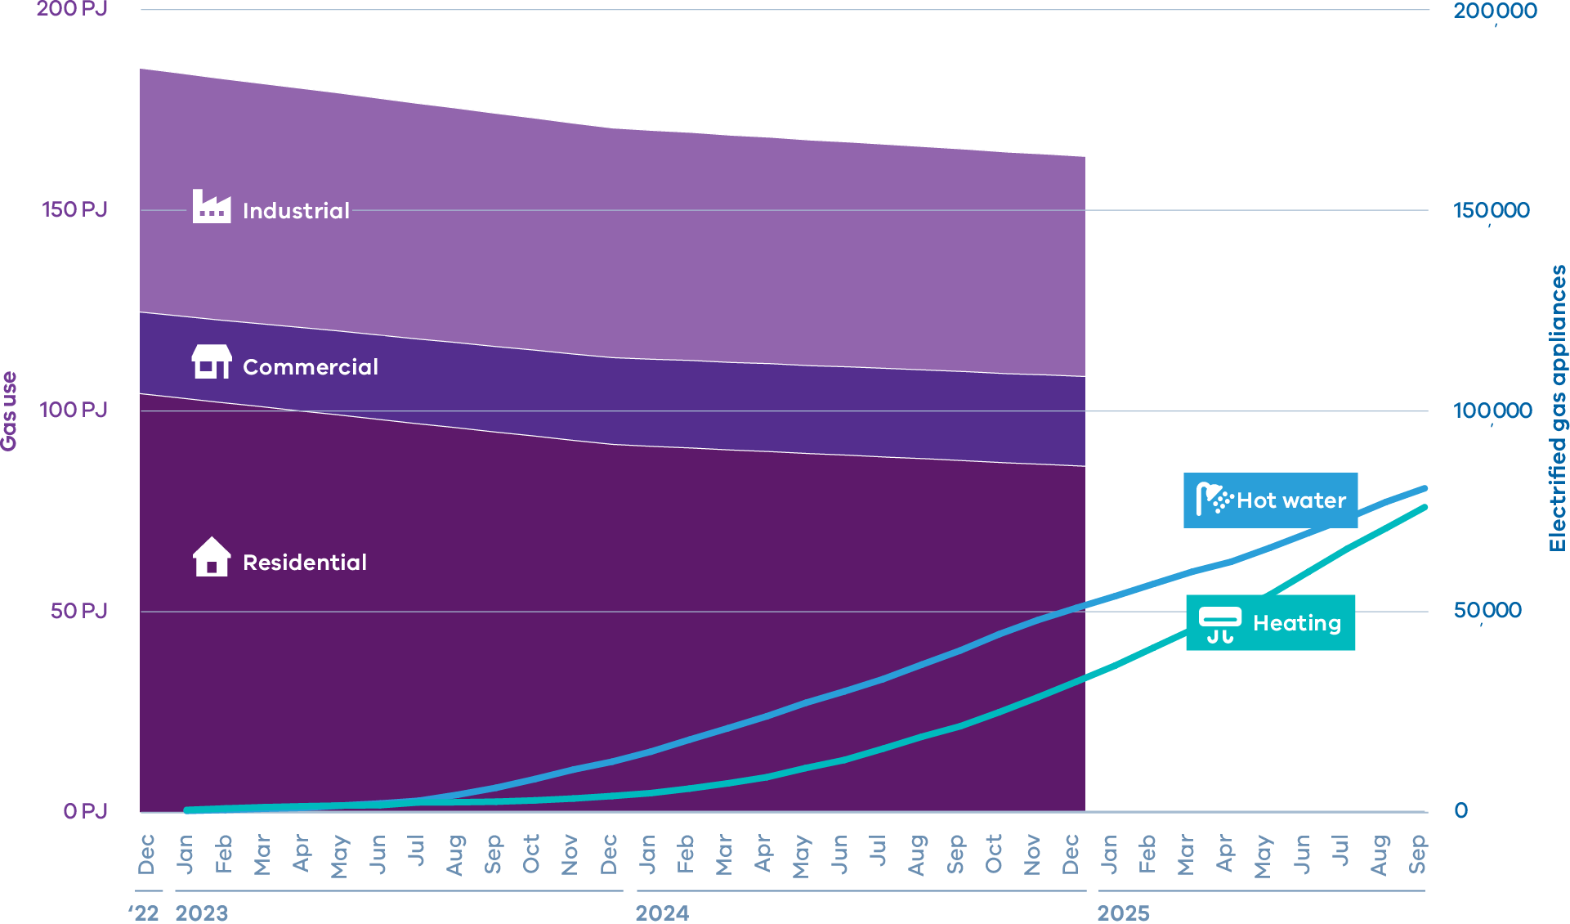
- AEMO Gas Forecasting Data Portal data for Gas Statement of Opportunities (GSOO) 2025 Publication and Australian Energy Update 2025
- Electrification data for VEU program and Solar Homes program reporting to end of September 2025

Figure 2 Annual gas use of the average residential customer, 2011 – 2024
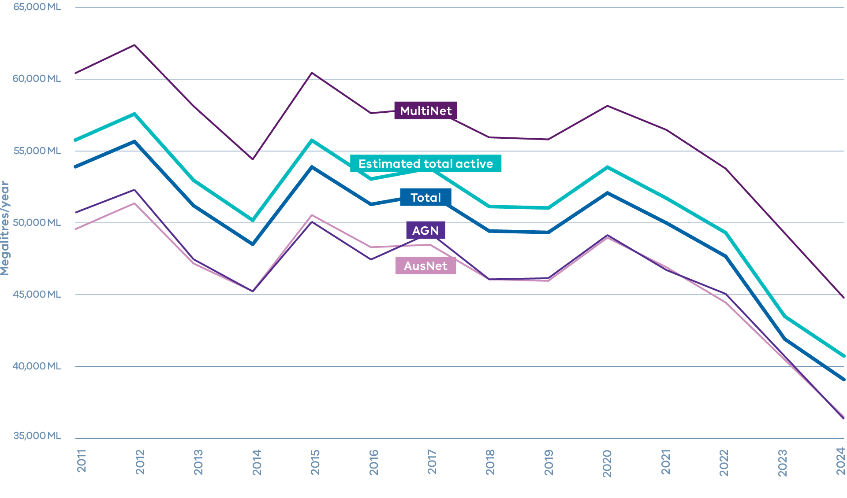
Analysis of Regulatory Information Notice (RIN) responses provided by Victorian gas distributors to the Australian Energy Regulator

Figure 3 Built Environment Sustainability Scorecard trends in new all‑electric Victorian residential builds, 2023 – 2025
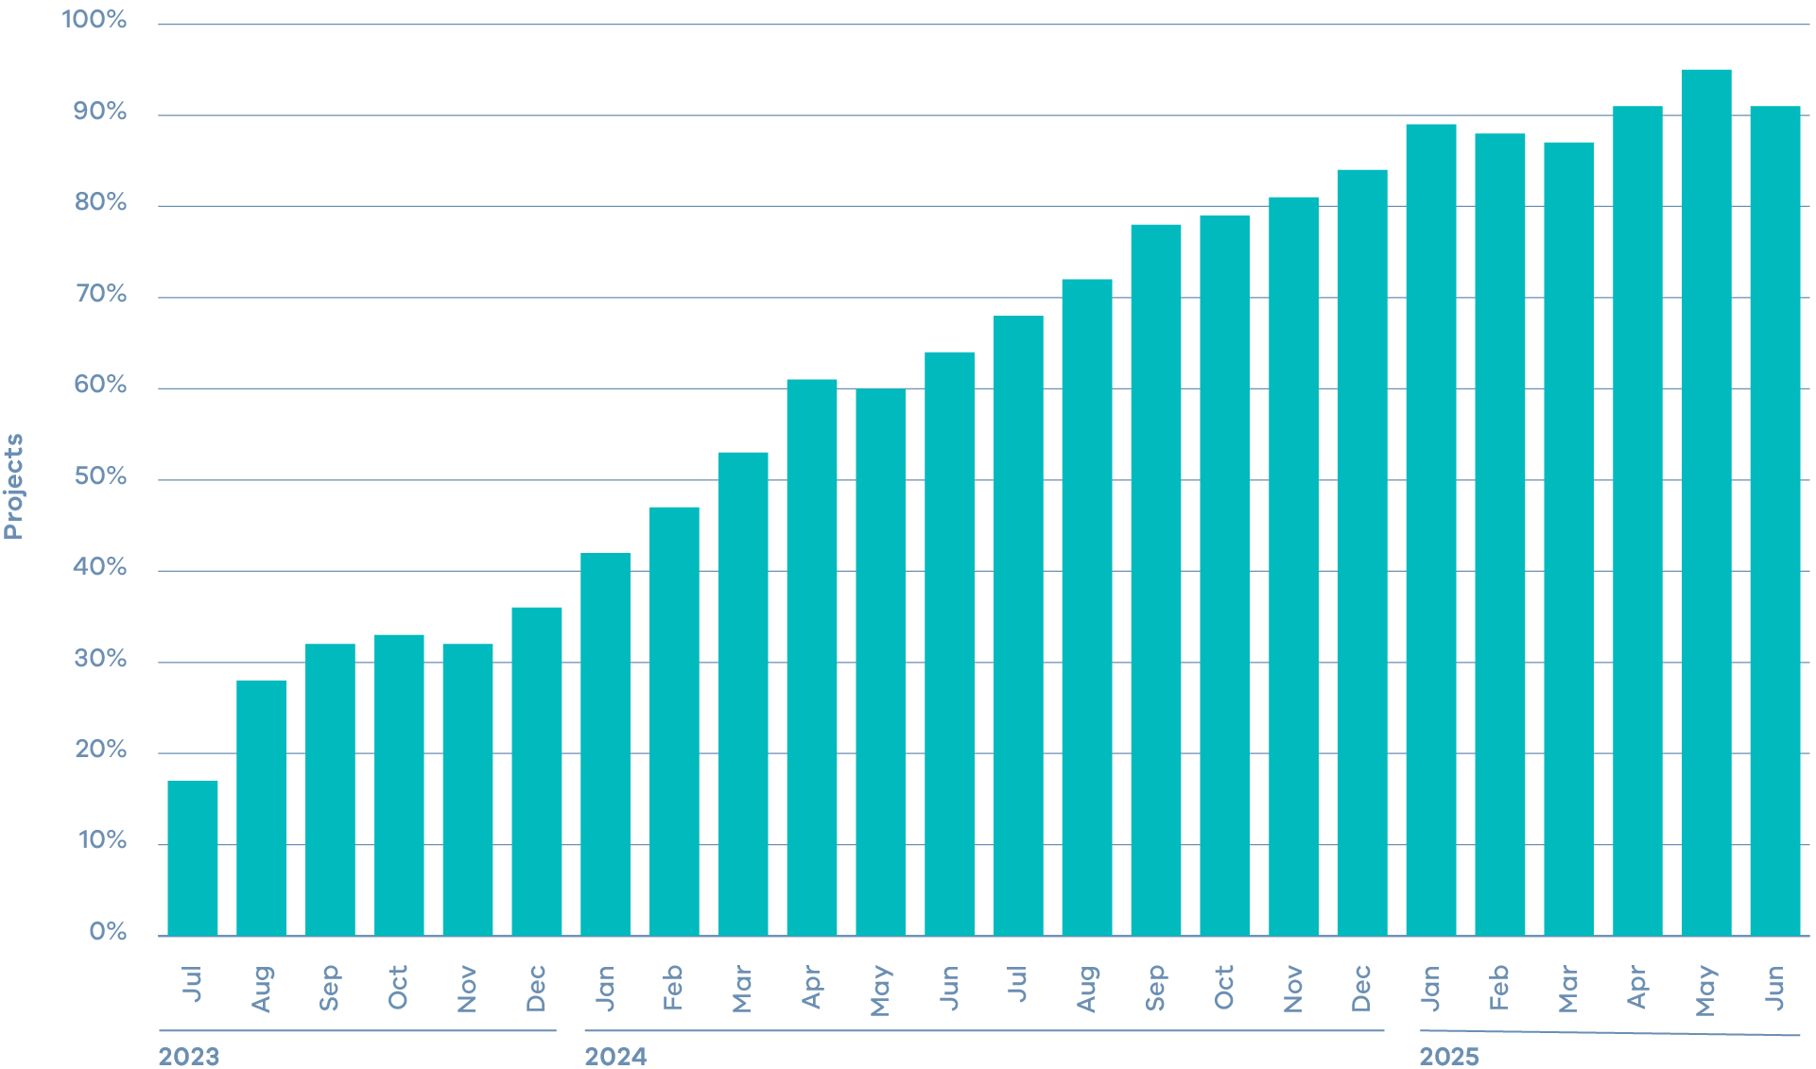
Provided by CASBE, based on new residential dwellings data submitted through the Built Environment Sustainability Scorecard (BESS) tool. Projects in BESS are dynamic and are revised by users in BESS throughout the planning permit process of a project, sometimes over several years. Only the latest version of a project is included in BESS data

Making it easier to electrify your existing home
The Victorian Government understands that for busy Victorian families, navigating the energy sector can be a complex and daunting experience. That’s why there are a range of supports on offer to simplify these interactions, on top of the financial incentives in place through the VEU and Solar Homes programs.

1 Plan to electrify your home
Make a plan to switch your home to electric using SEC electric home planner
Residential Efficiency Scorecard will rate how efficient your home is and provide tailored advice for efficiency improvements – the best way to make sure your efficiency dollar goes further

2 Start with efficiency
Insulation, draught-proofing, and efficient lighting and appliances reduce energy use and make it easier and cheaper to keep homes warm in winter and cool in summer

3 Electrify hot water
When replacing your hot water system, consider installing an efficient electric heat pump
- Up to $560 discount for heat pump hot water systems from VEU
- Up to $1,400 rebate for eligible locally made hot water systems, or $1,000 for other eligible hot water products through Solar Homes

4 Electrify heating
When replacing your heating system, consider installing a reverse‑cycle air conditioner and get bonus cooling
- Up to $5,530 discount for reverse‑cycle air conditioning system from VEU

5 Switch to induction cooking
If cooking is your last gas appliance, you can save around $360 a year in supply charges by disconnecting altogether
- $140 discount for induction cooktop from VEU

6 Go solar
Installing solar can cut your bills even further, helping to pay off investments in efficiency and electrification even sooner
- Up to $1,400 in rebates for installing solar PV systems, and an interest-free loan of up to $1,400 through Solar Homes

7 Battery storage
Households with solar can cut bills and emissions further by installing a battery to store solar generated during the day for use at night with Solar Homes program
These steps highlight the actions that Victorian households can take to ensure they’re using their energy as efficiently as possible. These actions save households money right away. More significant actions, like replacing appliances, make most sense at end‑of‑life or as part of renovation projects.

New VEU program targets and electrification upgrades
The VEU program is a key pillar of the Victorian Government’s gas substitution agenda.
In the first two years following the introduction of electrification upgrade discounts in May 2023, more than 73,000 households and businesses have upgraded from costly and inefficient gas heating to efficient electric systems, slashing energy bills (See Figure 4 Proportion and location of different heaters replaced through VEU). Another 62,000 households have switched from inefficient gas water heating to cheaper heat pump water heaters through the VEU Program (See Figure 5 Proportion of different hot water systems replaced through VEU)
From early 2026, ceiling insulation will be reintroduced into the VEU program via a staged rollout, with the first stage targeting social and community housing. In the second half of 2026, this will be expanded to all Victorian households. This common-sense reform will cut the cost of ceiling insulation for the almost 60 percent of homes in Victoria who have no ceiling insulation or are under-insulated. The discount will reduce the install cost by up to $1,500 based on current VEEC prices, while reducing heating costs by approximately $400 a year (premier.vic.gov.au).
The program will include an insulation safety and quality assurance regime, including audits and oversight requirements prioritising safety above all. This will ensure that only high-quality products (including Australian-made insulation) are used and installed by well-trained installers.

Figure 4 Proportion and location of different heaters replaced through VEU to April 2025
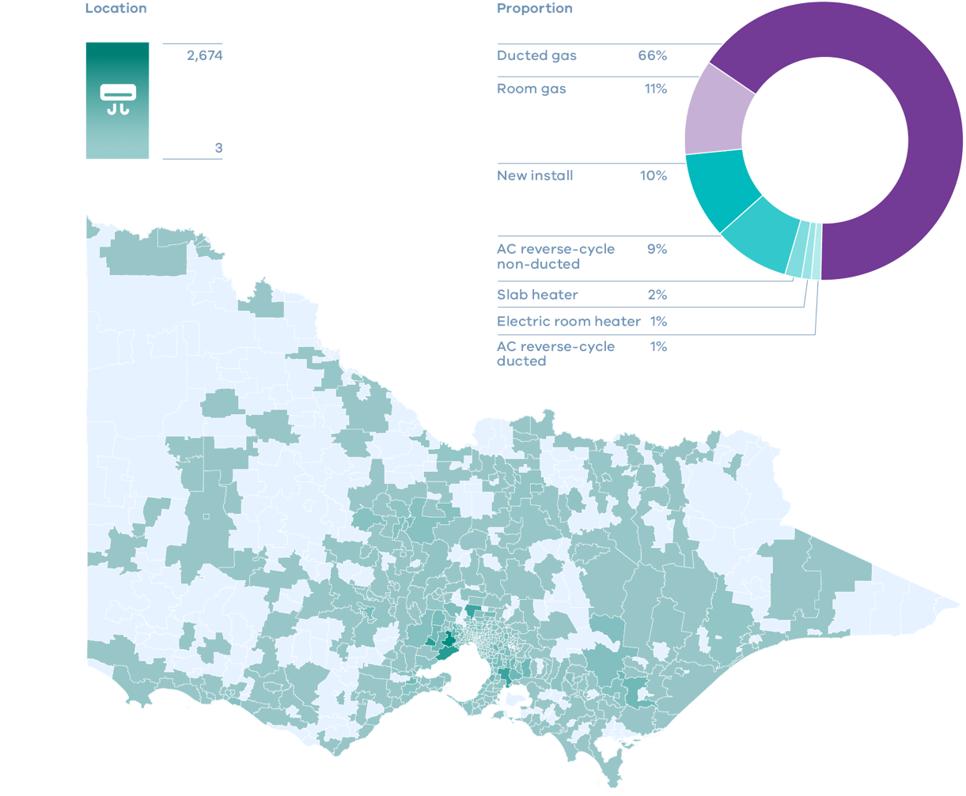

Figure 5 Proportion of different hot water systems replaced through VEU to April 2025
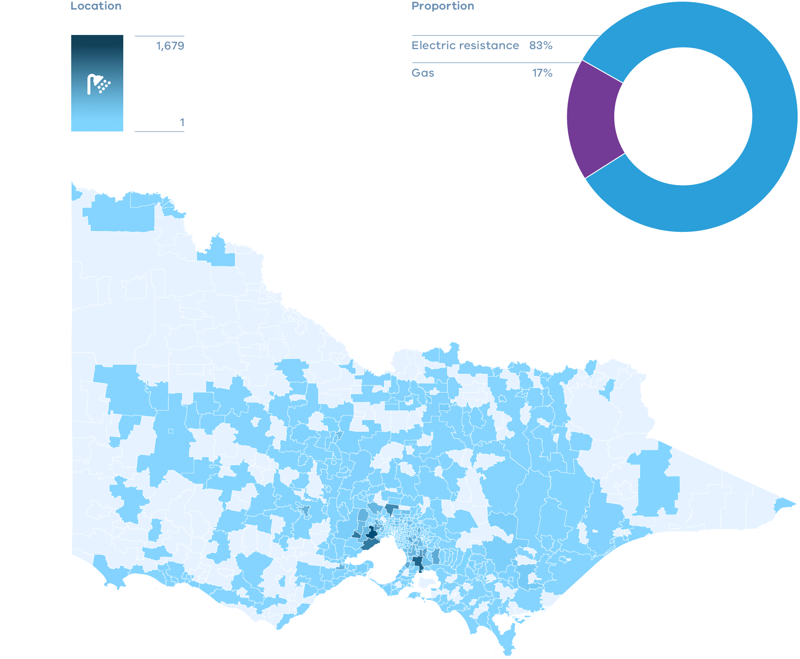

Solar Homes
The Solar Homes program continues to support the uptake of renewable energy across Victoria.
Since the program began in 2018 more than:
- 320,000 households received a rebate to install rooftop solar
- 75,000 households supported to install energy-efficient hot water
- 21,000 households supported to install a home battery
- 7,000 rental providers installed a solar system on their rental property through Solar For Rentals Program
The Victorian Government is also ensuring apartment residents share in the benefits of the renewable energy, with the Victorian and Commonwealth Governments each allocating $8.05 million to delivering round 3 of the Solar for Apartments program. This joint $16.1 million investment is expected to deliver average annual bill savings of around $500 per household on their electricity bills.
Since the program’s launch in February last year, more than 3,200 families living in apartments, units and townhouses have installed rooftop solar. Around half of the current uptake has been for rental apartments, providing critical cost of living relief to Victorian renters (premier.vic.gov.au).
In 2025-26, the Solar Homes Program will provide up to 47,700 solar PV system rebates for owner occupier and rental households, and a further $29.7 million for 27,000 rebates for installing efficient electric and solar hot water systems in their homes.
The Victorian Government continues to stay focused on supporting local manufacturing and jobs – introducing a new local content incentive as part of the Hot Water Rebate. Households installing an eligible hot water system that is locally made will receive an extra rebate of $400 on top of the maximum $1,000.

SEC One-stop shop
For many Victorian households, the decision to reduce energy bills by installing solar panels or replacing gas appliances is straightforward. For some households where it is more complex, the SEC is building a One-stop shop to provide assistance and support for Victorians to electrify their home. This will promote how Victorians can go more electric, connect with SEC‑endorsed installers, and access information about rebates and indicative bill savings.
From early 2026, the SEC’s one-stop shop will offer:

Consumer portal
Tailored advice on going all- or more-electric, guidance on upfront costs and bill savings

Appliance suggestion and comparison
Suggestions for appliances, and options to compare indicative prices and discounts

Installer marketplace
Connecting Victorians with local installers for tailored assessment and quotes

Rebates and financing

Simplified information on rebates and financing
More than 18,000 Victorians used SEC’s online platform during its pilot phase. In early 2026, the SEC’s new One-stop shop will be a free online tool providing tailored advice on switching to efficient electric appliances, including indicative appliance costs, potential bill savings, rebates, potential return on investment and emissions reduction estimate.

Accelerating the uptake of efficient, electric hot water systems
In June 2025, the Victorian Government delivered world-leading reforms that permanently slash energy bills for Victorian families. These were the introduction of new Building Electrification Regulations for residential and many commercial buildings, and Minimum Energy Efficiency Standards for Rental Homes (premier.vic.gov.au).
These reforms followed extensive public consultation – with a Building Electrification Regulatory Impact Statement (RIS) released in December 2024, and the Minimum Energy Efficiency Standards (MEES) RIS (engage.vic.gov.au/project/new-minimum-standards-for-rental-properties-and-rooming-houses/update/665) released in June 2024.

All new homes and most commercial buildings to be all‑electric
The Victorian Government is building the homes of the future. Since 1 January 2024, new homes requiring a planning permit have been required to be constructed as all‑electric. Building on that foundation, the Victorian Government announced in June 2025 that from 1 January 2027, this would be extended to all new homes.
From 1 January 2027, most new commercial buildings must also be built all‑electric. This doesn’t apply to some buildings, such as factories or farms.

Electrifying hot water appliances in existing homes
From 1 March 2027 when a gas hot water system reaches the end of its life, it must be replaced with an efficient electric alternative. Efficient electric hot water systems cut energy bills by up to $400 a year, or $590 with solar. To support this transition, households may be eligible for discounts of up to $1,400 available through the Solar Victoria program, in addition to up to $560 from VEU and $800 in Federal Small scale Technology Certificates (STCs).
A range of exemptions from the regulations are available where compliance is not feasible. For example, if a household must upgrade a switchboard for non‑safety reasons, if hot water is supplied by a centralised system, or if installation would require an electrical supply capacity upgrade.

Minimum Energy Efficiency Standards for Rental Homes
The Victorian Government has also delivered on its commitment to improve Minimum Energy Efficiency Standards for Rental Homes, building on minimum standards introduced in 2021. The new standards will lower energy bills and make rentals more comfortable to live in.
Rental providers should also benefit, with recent data indicating that energy efficient homes for sale in Melbourne are fetching up to $197,000 and $95,000 more than non-energy efficient houses and units respectively (Domain, Sustainability in Property 2025 at 29/07/2025)
Exemptions are available for rental homes where compliance with the standards is not possible or reasonable, such as where ceiling space is common property and heating or hot water is supplied by a centralised system.

What this means for rental providers
The standards are designed to improve rental homes while keeping costs manageable for rental providers. The standards also commence at different times to help spread expenses over time.

From 1 March 2027
- At the start of a new lease (or conversion to periodic lease):
  - Insulation must be installed to an R 5.0 rating by an accredited installer where no insulation is present
  - 4-star Water Efficiency Labelling and Standards (WELS) efficient shower head/s must be installed
  - Efficient electric cooling must be installed in the main living area
- Heating and hot water systems that reach end of life must be replaced with efficient electric systems (heat pump or reverse cycle air‑conditioner)

From 1 July 2027
At the start of a new lease (or conversion to a periodic lease), external doors, windows and wall vents must have draught-proofing installed

From 1 July 2030
Efficient electric cooling must be installed in the living area of all rental homes irrespective of whether a new lease has been entered into

Energy efficiency in social housing
The Victorian Government is making living in social housing more comfortable and cheaper through new funding and strengthened energy efficiency standards.
Through the Energy Efficiency in Social Housing Program (EESHP), the Victorian and Commonwealth Governments will deliver more than 50,000 energy efficiency upgrades across 23,600 homes in Victoria’s social housing portfolio by June 2027 with a total investment of $209.4 million.
The program will boost the energy performance of social housing properties, by delivering multiple upgrades in each property including replacement of existing gas appliances with efficient electric alternatives.
As of 30 June 2025, the Energy Efficiency in Social Housing Program delivered 21,576 upgrades and electrified 474 homes. In March 2025, increased funding of $51.4 million was secured, including $25.7 million from Commonwealth, helping more social housing renters get modern, electric, cleaner energy efficient appliances. A new head contractor was appointed in June 2025 to deliver the upgrades to public housing properties.

Energy efficiency and electrification upgrades for community housing
The regulations introducing efficiency standards for rental homes currently include an exemption for community housing providers in response to concerns from the sector regarding the costs of compliance. Community Housing Organisations (CHOs) have limited capacity to fund the efficiency upgrades required to achieve compliance due to the rent-capped operating model that supports provision of affordable rents for tenants experiencing various forms of disadvantage.
A new Community Housing Upgrades Stream of EESHP will provide funding to CHOs to undertake energy efficiency and electrification upgrades in their portfolio. Round 1 of the Community Housing Upgrades Stream was launched in 2025 with subsequent funding rounds to be delivered in 2026.
The Victorian Government is also working with the sector to undertake an audit of the energy performance of properties across the sector, to inform a Regulatory Impact Statement to determine if the current rental standards exemption should be removed.

Consumer protections and energy affordability framework
In September 2025, the Victorian Government took more decisive action to protect consumers from energy retailers, saving them around $258 every year (Essential Services Commission). These reforms ensured that Victoria’s energy consumer protections remain the nation’s strongest, and include:
- Customers with energy bill debt over $1,000 and older than three months will automatically be switched to the retailer’s best available offer. This change will benefit approximately 75,000 electricity and 60,000 gas customers, delivering total savings of $27.8 million each year.
- The minimum debt threshold before disconnection can be pursued has been raised from $300 to $1,000.
- Fees for services such as paying bills at the post office or late payments will be capped, and direct debit-only offers will be banned.
- Retailers will need to verify more frequently the customer eligibility for energy concessions, ensuring eligible households get their entitlements
The Essential Services Commission will begin stage 2 of its review of the Energy Retail Code of Practice in early 2026. The scope of this review will be informed by the issues raised in its June 2024 issues paper.
These reforms build on Victoria’s nation-leading consumer protections system, headlined by the Victorian Default Offer (VDO). In addition to the safety net provided by the VDO, the Victorian Government also offers a range of concessions, benefits, and energy bill relief grants for eligible low-income Victorians experiencing unexpected hardship. This includes a free Energy Assistance Program to support consumers having trouble paying energy bills. For immediate energy bill relief, Victorians with an eligible concession card can also apply for the current $100 Power Saving Bonus on the Victorian Energy Compare website (premier.vic.gov.au).

Understanding gas and electricity network connections
The Victorian Government knows that navigating the energy market can be a confusing and challenging experience for busy Victorian families and businesses. This makes it difficult for Victorians to make the right decisions when it comes to electrification. Our focus is to assist Victorians exploring this process.
Electrical supply capacity is a common barrier faced by families or businesses to go all or more electric. The processes used by local electrical distribution networks to assess supply capacity at the premises or on the network is inconsistent, and can lead to unpredictable, opaque, and sometimes excessive costs. While most homes will not need to increase their supply, action is needed to protect the minority who will.
This is why we will examine how electricity distribution businesses assess electrical capacity to determine if upgrades are required and their costs. We’re focused on improving transparency and clarity to households and businesses looking to electrify or connect to the network for the first time.
This includes reviewing the frameworks which govern these processes, such as the National Electricity Rules, the National Electricity (Victoria) Act 2005 and Electricity Industry Act 2000, and investigating opportunities to make it as simple, consistent, and transparent as possible. This will ultimately save families and businesses time and money. The Victorian Government will also investigate opportunities to upskill tradespeople to ensure consumers are provided with accurate advice.
The Victorian Government is also closely monitoring the Australian Energy Market Commission’s consultation on six rule change proposals to ensure the regulatory framework for gas distribution networks is fit-for-purpose in the context of declining gas demand. These proposals include changes to how gas connections and disconnections are regulated and paid for, criteria for approving capital expenditure, the use of accelerated depreciation and new planning requirements. The Victorian Government’s assessment of any rule changes will be driven by maintaining safe and reliable networks for all Victorians.
Finally, the Victorian Government will finalise reforms in progress to require gas distribution businesses to publish detailed, local consumption data. This will improve our understanding of how fossil gas consumption is evolving and support evidence-based decisions about the future of gas networks.

3 How we are supporting business
Reducing household gas demand unlocks low-cost supply for Victorian industry, protecting Victorian jobs.
Victoria’s manufacturing sector plays an important role in our economy. Victoria is home to more than 23,000 manufacturing firms, employing more than 260,000 people and providing 30 per cent of the nation’s manufacturing output (Made In Victoria 2030). Manufacturing also plays a key role in driving economic growth and prosperity across regional Victoria.
Industrial processes are a major source of energy use and emissions. The industrial sector accounts for 31 per cent of gas use in Victoria or approximately 55 PJ a year. (AEMO Gas Forecasting Data Portal data for Gas Statement of Opportunities (GSOO) 2025). Reducing emissions in the industrial sector will be required to meet Victoria’s 2035 and 2045 net zero targets.
Electrification is an opportunity for some industrial users, particularly in sectors such as food and beverage manufacturing, to slash costs and emissions. Low heat industrial processes make up around a quarter of industrial gas use in the state, using around 15 PJ a year. Electrification and energy efficiency upgrades are the most viable technology to reduce emissions in these applications. (Victorian Government. Gas Substitution Roadmap Update, page 26).
Industrial sectors with high temperature requirements, such as steel-making and brick manufacturing, account for around three quarters of Victoria’s industrial gas use. For these sectors, electrification poses a challenge as viable electric alternatives are not yet available. Renewable gases like biomethane and renewable hydrogen offer long-term opportunities here.
The Victorian Government has been progressing reforms that support industry to decarbonise their gas use and benefit from gas substitution. Capitalising on opportunities to electrify where possible will cut energy costs for businesses while boosting our competitiveness.

Industrial decarbonisation opportunities for food and beverage sector
There are commercially feasible technologies to significantly reduce gas usage in Victorian industry.
Nowhere is this more apparent than in Victoria’s food and beverage manufacturing sector, one of the state’s most gas-intensive industries.
To drive wider uptake and de-risk innovative investment in this sector, the Victorian Government is investing $10 million in industrial electrification projects through Round 3 of the Energy Innovation Fund. Applications for this program closed in December 2025.

Industry Diversification Program for appliance manufacturers
There is an opportunity for Victoria’s legacy gas appliance manufacturers to capitalise on the rapidly increasing demand for efficient electric appliances.
The Victorian Government recognises the need for industry support, establishing the $9.5 million Industry Diversification Program to support gas appliance manufacturers and their supply chains to diversify their operations. This will also support existing businesses to ride the wave of the expansion of electric appliance manufacturing and help the gas appliance manufacturing supply chain upgrade their facilities and reskill their workforce. Applications for this program opened in December 2025.
This support comes off the back of increased discounts for locally made electric hot water systems through Solar Victoria. Households installing an eligible hot water system that is locally made will receive a rebate of up to $1,400. As Victorian households and businesses transition towards an electrified future, it is essential that our manufacturing sector can meet the growing demand for electric appliances.

New VEU commercial and industrial solar photovoltaic activity
In September 2025, the Victorian Government announced that for the first time, commercial and industrial businesses would be eligible to access discounted solar PV under the VEU program.
This highlights the Victorian Government’s focus to continually identify opportunities to cut upfront and running costs for Victorian businesses, slashing gas use and boosting competitiveness.
The discount will wipe up to $25,000 off the upfront cost of installing a 100 kilowatt system and up to $34,300 off a 200 kilowatt solar system, with discounts available for systems from 30 kilowatt up to 200 kilowatts.
Businesses are also eligible for Commonwealth Government rebates on solar systems in the 30-to-200-kilowatt size range. Combined with the VEU discount, businesses can get up to 30 per cent off the cost of the installation.

Large Energy Users Electrification Support program
Victorian manufacturers are looking to upgrade the way they work, switching from gas to electric technologies to reduce energy bills and stay competitive.
Launched in May 2024, the Large Energy User Electrification Support program assisted Victorian industrial and commercial businesses to develop feasibility studies for electrification and energy efficiency upgrades across their operations.
The $1.58 million Large Energy User Electrification Support program provided grants of up to $60,000 for eligible businesses to conduct electrification feasibility assessments.
The program closed in February 2025 and identified:
- $5.7 million in potential annual energy savings.
- Over 600 terajoules of potential industrial fossil gas usage reduction annually.
These studies supported businesses to identify opportunities to replace gas systems for boiling, heating, ventilation, and air-conditioning with modern, efficient electric alternatives.
The VEU program’s Project-Based Activities (PBA), which provide incentives for large and custom energy efficiency projects, have also been updated to support electrification upgrades for commercial and industrial businesses. These changes include streamlining reporting requirements for participants, and creation of specified measurement methods that reduce complexity, duration and costs for projects, allowing businesses to achieve emissions and energy bill savings sooner.
PBAs continue to support bespoke upgrades for businesses and provide a critical pathway enabling sites with complex energy efficiency upgrades to access VEU incentives. Businesses can use insights from their feasibility studies to inform and develop a PBA with incentives reducing upfront costs and improving access to reduced operational costs.

MainStream Aquaculture
The Victorian Government provided a $19,000 grant to MainStream Aquaculture to undertake an electrification feasibility study.
MainStream Aquaculture is a global aquaculture business based in Werribee, specialising in breeding and growing barramundi fish. The site consists of a main grow hall housing eight 600 kilolitre (kL) grow pools and two 650 kilowatt (kW) natural gas boilers. The feasibility study proposed two solutions including replacement of the two boilers with a 550kW water-to-water heat pump.
This project could save 10 terajoules (TJ) of gas per year (a 70 per cent reduction in on-site gas usage). It could also attract VEU incentives of up to $281,250 and result in up to $113,000 in annual energy savings allowing a simple payback period of five years.

Renewable gas for industrial applications
Scaling up a thriving Victorian renewable gas sector is essential for Victoria to meet the legislated target of net-zero emissions by 2045.
While electrification is the most cost-effective way to reduce fossil gas use in buildings and low-temperature industrial processes, it is not yet technically or commercially viable for high-heat industrial applications, chemical feedstocks, and gas-powered electricity generation.
For these applications, renewable gases – such as biomethane and renewable hydrogen – will play a targeted but critical role in decarbonising industrial applications and support Victoria’s commitment to be net zero by 2045.
In December 2024, the Victorian Government released the Renewable Gas Directions Paper to seek feedback on a potential model for a Victorian renewable gas scheme.
The Directions Paper received strong stakeholder engagement – with submissions from almost 100 different organisations and excellent attendance at public forums and stakeholder meetings. The Victorian Government’s response to this process will be finalised in 2026.
Concurrently, the Victorian Government continues to advocate for the establishment of a national renewable gas scheme. This advocacy catalysed a policy development process through the Energy and Climate Change Ministerial Council (ECMC). These discussions recognise that while grants are important for early momentum, long-term growth requires enduring policy mechanisms. Victoria strongly supports a national mechanism that will ensure renewable gases can decarbonise industrial energy use.

Optimising the gas distribution network
The Victorian Government is taking steps to drive transparency in the gas market by making local consumption data from gas distribution businesses be publicly available.
This will improve our understanding of how gas consumption is evolving both locally and across the state to support evidence-based decisions about the future of gas networks.

4 Growing the new energy workforce
The Victorian Government is investing in training tradespeople to meet the demand for 67,000 new jobs by 2040.
Victoria’s workforce is an essential input into the energy transition. Transitioning millions of homes and businesses requires a skilled workforce and reliable supply of electric appliances. This highlights the need for training pathways that deliver future-ready skills, with Victoria’s TAFE network at its core.

Victorian Energy Jobs Plan and Women in Energy Strategy
We’re working on the Victorian Energy Jobs Plan and Women in Energy Strategy, which are scheduled for release in 2026.
The Victorian Energy Jobs Plan seeks to support Victoria’s energy transition by mobilising the workforce and growing investor confidence. The Women in Energy Strategy aims to support women’s full and equitable participation in the renewable energy transition.

National training centre in new energy skills
The Victorian Government is investing $10 million to deliver a dedicated training centre to reskill plumbers and gas fitters to thrive in an electrified Victoria in partnership with the Commonwealth Government and the Plumbing Industry Climate Action Centre (PICAC).
The facility will be based in Melbourne’s western suburbs. The centre will upskill 2,000 tradespeople including plumbers, gas and refrigeration workers, and train 200 apprentices each year. The training would include best practice for energy upgrade technologies like heat pumps, demand for which is being driven by falling prices and increasing consumer awareness, strongly supported by the Victorian Energy Upgrades and Solar Victoria programs.

Workforce training for electrification
Solar Victoria has been allocated $5 million over three years (financial years 2026 to 2028) to extend the electrification skilling and training program under the Solar Homes program.
The training will grow workforce capacity and skills to meet the higher consumer demand for electrical appliances.
This builds on earlier efforts, with more than 7,500 workers already trained through Victorian Government-funded programs including:
- 5,000 electricians
- 1,200+ plumbers
- 3,000+ building practitioners and trades (Vic Energy Source Newsletter, LinkedIn)
For the first year of delivery (financial year 2025–2026), $950,000 has been allocated to delivering heat pump design and installation training to up to 1,000 plumbers and fourth year apprentices.
Delivery of heat pump training will be delivered through training partners, via a public and competitive grants process. The grant launched in August 2025, with delivery underway from November 2025 to May 2026.

Solar Victoria Insulation Training and Accreditation update
Early this year, the Victorian Government committed $12 million to introduce a new ceiling insulation upgrade activity under the VEU program.
The Victorian Government is investing in training through registered training providers and the Energy Efficiency Council’s (EEC) Insulation Installer Certification to uplift and expand the Victorian insulation retrofit workforce. This will ensure that installers participating in the program have the necessary skills to deliver safe and high-quality insulation installations. Free training and other subsidies are now available for insulation installers who wish to attain the EEC Certification and participate in the program.
A staged rollout of the ceiling insulation upgrade activity under the VEU program will commence from early 2026.

5 Securing Victoria’s gas supply
Victoria’s gas substitution agenda is preserving low-cost gas for Victorian industry, while slashing energy bills for families.
The Gas Security Statement outlines decisive Victorian Government actions to prevent forecast fossil gas shortfalls and ensure reliable supply for both industrial sector and gas-powered electricity generation.
The Gas Security Statement outlines how the Victorian Government is ensuring that we have sufficient gas supplies to meet our state’s needs. Approximately $2 billion worth of investment across a range of projects has been announced in 2024 and 2025, including:
- New production from Esso and Woodside’s Gippsland Basin Joint Venture and Beach Energy.
- Exploration campaigns from ConocoPhilips, 3D Energi, Korean National Oil Corporation (KNOC), Amplitude Energy, ADZ Energy and Lakes Blue Energy.
- Progress in storage and large infrastructure plays through Golden Beach, Lochard Energy, Viva Energy, and Vopak.
The Victorian Government has made a positive assessment to Viva Energy’s proposed Liquified Natural Gas (LNG) import terminal in Corio Bay as part of the Environmental Effects Statement (EES) process administered by the Minister for Planning.
Alongside these actions to increase Victoria’s gas supply, Victoria’s reforms to reduce gas usage are expected to reduce fossil gas use by 44 PJ annually by 2035 (equivalent to around 85 per cent of Victoria’s industrial demand in 2024).
This effectively represents a new source of the lowest cost gas in the country for Victorian industrial users, boosting Victoria’s competitiveness and supporting manufacturing jobs.
The forecast for shortfalls facing the east coast gas market is a national problem requiring a national solution. The Victorian Government has advocated strongly to the Commonwealth Government and Energy Ministers for a national approach. As a result, Energy Ministers are working through options on expanded powers for AEMO to address east coast gas supply issues. This will empower AEMO with a new national role to fill any residual gap through a new bulk supply source such as an LNG re-gasification terminal or domestic supplies available through pipelines and storage infrastructure.
These actions, combined with reforms to the east coast gas market through the Energy and Climate Change Ministerial Council (ECMC), will help alleviate forecast gas shortfalls (See Figure 6 Forecast of Victorian gas supply and demand).
The Victorian Government has long advocated for further measures that will improve reliability of supply, such as a national domestic gas reservation, to ensure the needs of domestic consumers are prioritised. We welcome the announcement by the Commonwealth Government that an east coast gas reservation policy will be introduced, and look forward to continuing to engage with the Commonwealth Government on measures to deliver energy security and affordability.

Figure 6 Forecast of Victorian gas supply and demand, 2025 – 2035
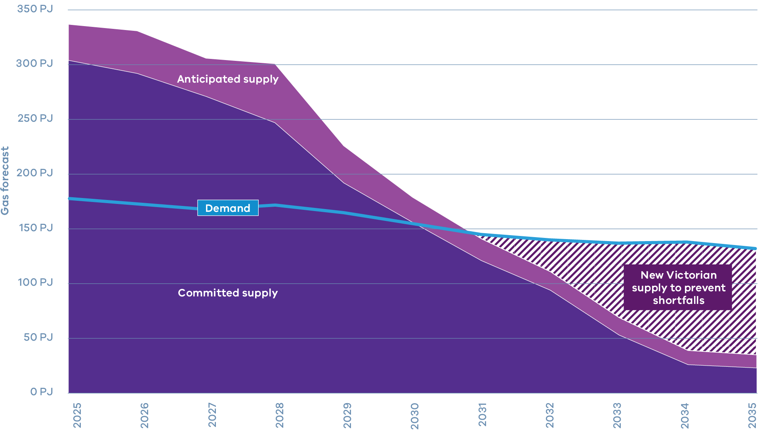
AEMO GSOO 2025 Report figures, tables, and online gas forecasting tool (Step Change scenario)

Wombat Project by Lakes Blue Energy
Lakes Blue Energy continues to appraise the Wombat gas field and recently drilled the Wombat-5 well in Victoria’s Gippsland Basin. It is aimed at determining the commercial viability of developing this new source of natural gas.
The Wombat gas field is strategically located near the existing pipeline infrastructure, enabling efficient integration of fossil gas supply into the state’s energy network. Current predictions indicate that it could supply up to 20 PJ of fossil gas each year, supporting energy reliability and affordability.

6 Transitioning the Victorian Government’s own gas use
The Victorian Government is phasing out fossil gas use in government-owned and leased buildings across the state.
The SEC is powering large Victorian Government buildings, including the MCG and the new Metro Tunnel, with 100 per cent renewable electricity. This means that government’s own energy use is decarbonising, as we use less gas and more renewables.
The Victorian Government is committed to reducing its fossil gas consumption. Key actions here include improving energy performance through modern sustainable design standards for new facilities, and targeted energy efficiency upgrades in existing sites such as schools, hospitals, and office buildings.
The government accounts for around three per cent of Victoria’s total gas consumption with major users including hospitals, schools, sporting facilities and office buildings.

Electrification of Victorian Government buildings
Energy efficiency in government buildings is improving significantly. All new Victorian Government buildings have been built as all-electric since July 2023. From 2025, all new government office buildings and tenancy fit-outs are required to meet a minimum 6-star energy performance rating. All large government sites are using 100 per cent renewable electricity from the SEC (See Section 2 How we are supporting families). Where it makes economic sense, government buildings will electrify gas appliances when they reach end‑of‑life.
Further actions to support the move away from gas in existing government buildings and to inform broader electrification pathways for commercial buildings across Victoria are being developed under the 2026-30 Whole of Victorian Government Emissions Reduction Pledge.
The Victorian Government is progressing a range of building electrification and energy efficiency projects to support its transition away from fossil fuels.
- The government is establishing a Government Buildings Electrification Study to demonstrate the benefits of electrification and options for different types of buildings.
- Through the Greener Government Buildings Program, energy efficiency upgrades are being delivered across hospitals, schools, and office buildings via a $60 million revolving fund, with approximately $15 million available for investment each year.
- For government leases, preference is being given to those buildings that have higher energy-ratings and Green Lease Schedule.
- The $50 million TAFE Clean Energy Fund is supporting the development of all‑electric training facilities to prepare Victoria’s net zero workforce.
- From 1 July 2025, SEC has commenced retailing Victorian Government operations for the first time in 30 years, providing low-cost renewable electricity to public schools, hospitals, police stations, and more.

Next steps
We’re making common-sense, practical decisions to guide the next steps of the Gas Substitution Roadmap. These decisions reflect the Victorian Government’s continued focus on providing cost-of-living relief by lowering energy bills for Victorian families and businesses.

Barriers and actions

Improving efficient electric appliance accessibility for households and businesses
- Completing the VEU Strategic Review
- Streamlining the process to include new discounted products and improve transparency
- Strengthening consumer protections

High costs for upgrading single phase electrical supply
The Victorian Government will examine the frameworks which govern electricity supply upgrades and explore any improvement opportunities

Consumer protections
The Essential Services Commission will commence Stage 2 of the Energy Retail Code of Practice Review in early 2026. Stage 2 will build upon the important improvements implemented in Stage 1.

Supporting our tradies to install electric appliances
The Victorian Government will develop clear guidance materials for licensed tradespeople to safely and efficiently comply with new building electrification regulations

Victoria State Government
ISBN 978-1-76176-690-9 (PDF/ONLINE/MS WORD)
© The State of Victoria Department of Energy, Environment and Climate Action 2025
This work is licensed under a Creative Commons Attribution 4.0 International licence, visit creativecommons.org/licenses/by/4.0/
You are free to re-use the work under that licence, on the condition that you credit the State of Victoria as author. The licence does not apply to any images, photographs or branding, including the Victorian Coat of Arms, and the Victorian Government and Department logos.

Disclaimer
This publication may be of assistance to you but the State of Victoria and its employees do not guarantee that the publication is without flaw of any kind or is wholly appropriate for your particular purposes and therefore disclaims all liability for any error, loss or other consequence which may arise from you relying on any information in this publication.

