Demand Management Solutions for Business
Most of us are familiar with the idea of being more energy efficient, but as our energy system changes, we need to consider not just how much electricity we use but also when we use it. A business that can be flexible about how much power it draws and when, can reduce its operating costs, environmental impacts and even create revenue.

What is demand and demand management?
Demand management is used in situations where it is cheaper or easier than alternative ways to balance electricity supply and demand, such as building new power stations, altering electricity networks or investing in large-scale storage.

As the Victorian energy system increases the share of renewable energy and moves from gas to electric appliances and equipment, it will be important to keep electricity supply and demand in balance to keep the energy system reliable and secure.

Options for managing your business’ demand can vary in terms of the technologies used (and who manages it), the type of energy company involved, and payment arrangements. Businesses can choose what best suits their situation.

What are the benefits of managing demand?
There are many benefits to demand management. They include:
- Reduced operating costs – by better managing electricity demand, not only can you reduce total electricity usage (i.e. kWh consumed and therefore dollars spent) but you can also reduce any demand charges.
- Revenue creation – retailers, networks and third parties may pay you for participating in some forms of demand response – this is particularly true for larger energy users.
- Improved grid stability – by helping to balance electricity demand and supply you are keeping the energy supply reliable and secure for all energy consumers.
- Supporting Victoria’s shift to a zero emissions future by adapting energy use to accommodate more renewable energy supply in the electricity grid.

How you can manage your electricity demand
There are different ways your business can manage its electricity demand. The following table gives examples of some of these. The options you use will depend on your site and circumstances – your electricity retailer, an energy consultant or demand response aggregator can advise on what might best suit your site.

Option | Examples
Make ongoing changes to how you use electricity (‘shaping’) | - Upgrading your equipment so it’s more energy efficient, such as upgrading pipes with insulation/lagging to better preserve heat within the pipe, upgrading heating, ventilation and air conditioning systems.  - Power factor correction (i.e., equipment that automatically adjusts the quality of power at a site). | 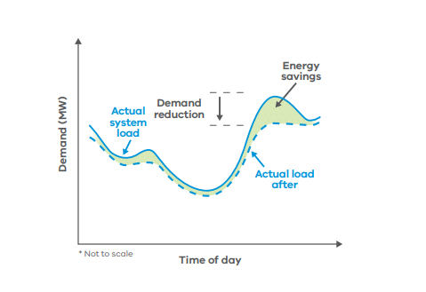
Change when you use electricity (‘shifting’) | - Operating your equipment, on timers, outside of peak demand periods.  - Rescheduling any energy intensive processes to occur at off peak times. | 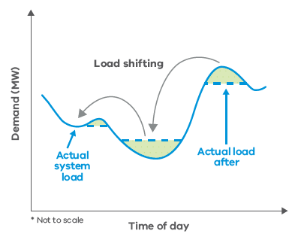
Increase your electricity use at key times (‘surging’) | - Increasing your production when there is cheap, extra power available from the grid.  - Charging your electric vehicle fleet during the middle of the day. | 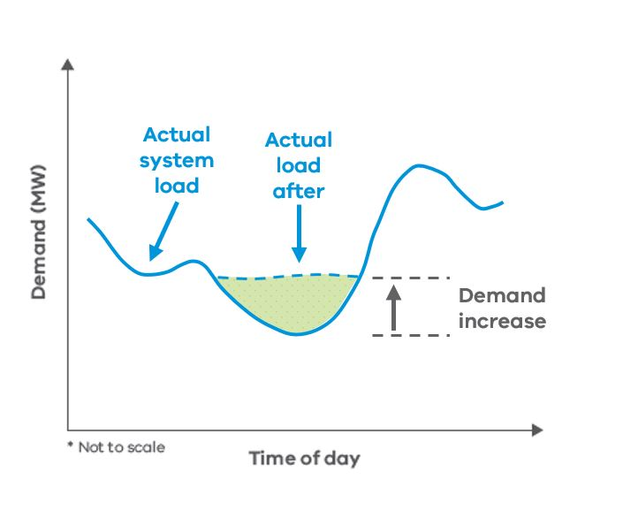
Rapidly adjust demand to keep the energy system stable (‘shimmying’) | - Allowing the operator to rapidly change your load over a period of seconds to minutes.  - Only suits certain types of equipment. | 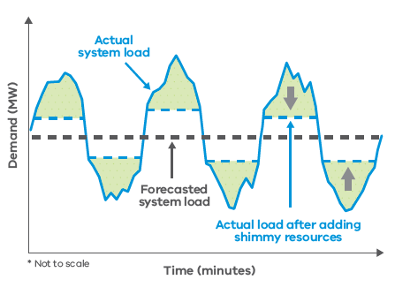
Reduce your demand for electricity at critical times (‘shedding’) | Working with your retailer, network or a third party to:  - schedule maintenance or staff training when there may be electricity shortages, instead of operating production lines/machinery at these times  - temporarily avoid using grid power using on-site batteries or generators. | 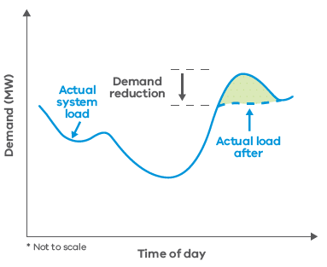

How can my business get involved in demand management?
Demand management opportunities suitable for your business depend on the nature of your energy use and activities:
- Taking action can be as simple as checking when your energy retailer’s peak period is (don’t assume you know it – they have changed and will likely continue to change) and turning equipment off manually before then or setting timers/programs to do it automatically.
- For more complex opportunities, an energy assessor, specialist retailer or demand response aggregator can advise your business to manage demand, alongside onsite generation and retail options.
- If your business spends more than $50,000 a year on electricity, you can be billed for demand charges. A broker can help you understand how to reduce these charges.
Check out the Energy Efficiency Council’s database of independent energy service providers at https://www.eec.org.au/for-energy-users/overview#/find-a-provider to find someone who may be able to help your business.
For inspiration, see the following case studies of demand management projects implemented as part of the Victorian Government’s Business Recovery Energy Efficiency Fund (BREEF). The table starts with simpler projects that may be suitable for most sites, to more complex projects better suited to larger energy users.

Business | Project description | Relevant to…
Quality Packaging Services | Reverse Osmosis Water Controller  This staff-led project involved installing a probe to monitor the water level in a large tank and a timer to ensure that the water pump only operates during times of peak solar production (from the site's existing solar panels).  The project reduced electricity and water use and operating costs.  This kind of project would work well for any programmable equipment. Timers and programs can be adjusted to ensure equipment (including hot water heaters or heating, ventilation and air conditioning systems) operate outside of peak periods or at times when on site solar power is being generated or grid power is cheaper. | - All industries.  - Energy users of any size.
Valley Pack | Unloading Area Upgrade  With funding from BREEF, Valley Pack installed rapid roller shutter doors on its cool rooms to reduce cold air loss or hot air ingress when transferring products. The project also involved civil upgrades to the unloading area, allowing trucks to be unloaded with forklifts outside of the refrigerated areas.  The project has resulted in significant reductions in electricity use, particularly in the warmer months. During the first full moth of operation, energy savings significantly exceeded expectations - with a reduction of 33,000 kWh.  This project is a good example of demand management as it involves saving energy use at a time when the grid is often under the greatest pressure (summer) and addresses significant peaks in site demand caused by the cooling systems having to ramp up for short periods. | - Industries that require cold storage, including agriculture, food processing and retail (food).  - Energy users of any size.
Breathe Fresh | 600 kVAr Power Factor Correction Unit  This project involved the supply and installation of a 600 kVAr Power Factor Correction (PFC) Unit at the primary production facility of Breathe Fresh Australia. Through a 20% reduction in peak demand, Breathe Fresh has achieved bill savings of over $20,000/year  Power factor correction is a good option for sites with large inductive loads such as electric motors, fluorescent lighting, ventilation, refrigeration and air conditioning. A power factor correction unit is relatively easy to install, looks like a large cabinet and reduces the maximum amount of power required at a site at any given time. | - All industries.  - Moderate-large energy users.
Sims Group Australia | Brooklyn Site 22 kV Metering Panel  The project involved upgrading the site's electricity monitoring equipment to have electricity demand displayed to the Shredder Plant Operator, so that they can control the site activity to maintain electricity demand below a predetermined level. This allowed the business to avoid incurring peak demand penalties from their retailer.  In addition to contributing towards grid reliability the project has saved Sims over $50,000 in the first year of operation.  This project involved installing equipment to guide behaviour change – that is, equipment giving better data on energy demand to enable the employees to take action. If your site incurs demand charges when you exceed a demand limit, this kind of project may suit you. | - All industries.  - Larger energy users.
MtM | MtM Demand Response  This project is working to maximise the benefits of MtM's large on-site solar system through the installation of a battery and demand management system.  The nature of MtM's operations mean that energy demand can fluctuate to high levels for short periods of time - this kind of load is difficult for the electricity grid to accommodate and results in high demand charges. By installing a 300 kWp/731.5 kWh battery system and accompanying demand management system, MtM can maximise the use of its large on-site solar and earn revenue by exporting power to the grid during peak times.  In some areas restrictions are in place that prevent solar systems from being connected to the grid, as the network is unable to accommodate any more local generation during peak solar production times. A battery and demand management system can rectify this as the battery charges during peak generation periods and can be used on site and/or discharged to the grid during times of peak demand to save money and/or generate revenue. | - All industries.  - Sites with solar systems.  - Moderate-large energy users.
GPT Funds Management | Chirnside Shopping Centre Battery Installation & Demand Management Project  Partnering with Shell Energy, this project saw GPT installing a 1 megawatt / 2 megawatt hour battery at the Chirnside Park Shopping Centre. The battery has been commissioned and integrated with the Shopping Centre’s building management system to optimise cost and energy savings.  Reducing peak demand can contribute to grid stability, but importantly for GPT and the business owners located within Chirnside Park Shopping Centre, this will also lower energy costs through a reduction in demand and network charges.  The project has successfully created over 500 kVA in demand response capabilities and reduced costs by $50,000/year primarily through network savings. Further financial benefit is expected through further development of non-network revenue streams.  The project supports GPT's Net Zero by 2030 target and GPT will apply the lessons learnt from this project to future battery initiatives.  Large-scale battery installation can be an expensive activity but depending on the nature of your operations, there is significant potential to reduce costs and generate revenue. Specialist energy consultants can assess and model how a battery can be best sized to suit your operations and maximise financial benefits while ensuring appropriate safety measures have been implemented. | - Large energy users.

