# Energy Resilience Solutions Program

Loch Sport Community Centre - Case Study

[deeca.vic.gov.au](https://delwpvicgovau.sharepoint.com/Users/fionadurante/Downloads/deeca.vic.gov.au)

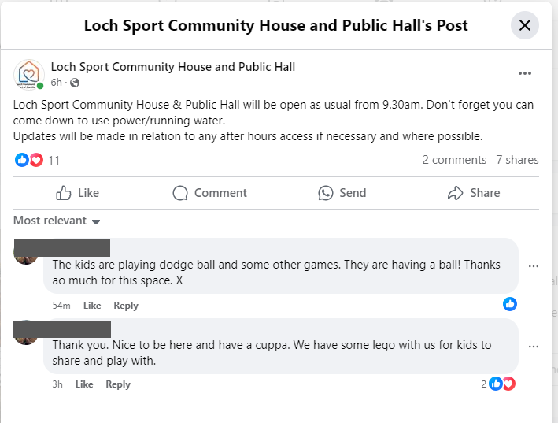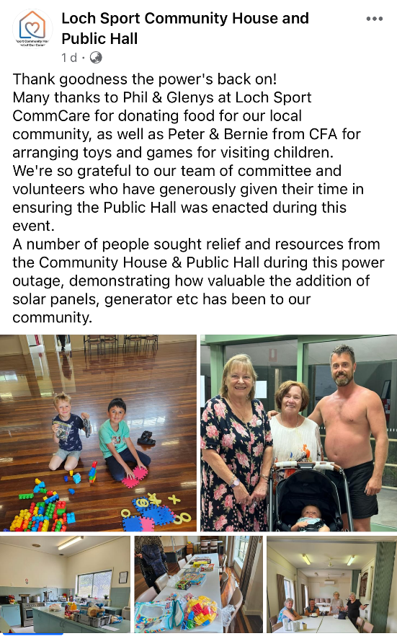

## A cuppa and community connection – energy resilience in Loch Sport

In October 2021, storms hit the small town of Loch Sport leaving its 2400 residents without electricity, running water and heating for over four days. Two years later, in December 2023, an energy back-up system was installed at the Community Centre. Establishing a community site that could provide phone charging, hot meals and hot running water during power outages

In the first year, the Loch Sport Community Centre system has been activated twice. In one instance, around 50 residents arrived at the centre to charge their phones, access information, access running water, use the toilets and cook or heat meals.

‘During a fire, we had one lady here actually crying and saying she was just so grateful because she was just so frightened, and she didn't know where to go,’ said Loch Sport Community House and Public Hall Manager, Rachel Mulder.

*Facebook posts:*

*Loch Sport Community Centre*

*2 Sept 2024 (left) 15 Feb 2024 (right)*

*Gunaikurnai Country*

Beyond access to power and water, the Community Centre has also provided an important space for social connection and inclusion during challenging times.   
  
It has provided a meeting space for residents to have a chat, feel safe and have a hot drink together.

*‘I probably hadn't anticipated the level of need for community to support each other in that time. That's actually been a really, really big thing,’ said Manager, Rachel Mulder.*

Loch Sport was one of 24 towns that received funding from the Victorian Government’s Energy Resilience Solutions (ERS) Program, with electricity distribution network AusNet Services identifying the community centre as a key hub. Loch Sport Community Centre is an ideal place for the ERS because it can technically, logistically, and socially support the needs of the community during a power outage.

*‘…one of the things that was a driver was that there was an organisation operating here five days...it’s a lovely big building with a big kitchen and rooms…I think the premises made a lot of sense that if you had to pull in a lot of community members for a variety of reasons, that this would be an ideal spot,’ Manager Rachel Mulder said.*

While initially some community members were unsure about the site selection, sentiment has changed now that the town has experienced power outages and made use of the facilities.

Residents highlighted it provided a central back-up powered meeting space for residents to have a chat, feel safe and have a hot drink together. One attendee posted on social media describing how she was having a cuppa while her children played sport and used the Lego provided.

*The kids are playing dodge ball and some other games. They are having a ball! Thanks so much for this space. (Zita, Facebook user).*

As a result of the community connections, facilitated by these power outage events, some residents have expressed a desire to use the centre more often for catchups, coffee and other social gatherings outside of outage periods.

What’s more, for the site manager, the system, which includes 6.4kW of solar, a 28kWh battery and a 17kVA diesel generator, has been easy to maintain thanks to thorough handover and manuals, as well as seamless operation during power outage activations.

‘There’s not even been a glitch or a blip… The generator is the last thing to kick in during a power outage and it just all clicks straight over. Wow, it's an incredible system,’ Manager Rachel Mulder said.

Into the future, the Manager has plans to expand the services available. While the site currently offers running water during a power outage, there are not yet showers available. The Centre has been inspired by their new energy resilience capacity and are now seeking further grants to enhance the comfort and safety of the Centre. As well as training to support the mental wellbeing of their community during and after power outage events. 

#### Who was involved

The Loch Sport Community Centre energy back-up system was funded by the Victorian Government’s Energy Resilience Solutions Program, designed by AusNet and Mondo and installed by RACV Solar. Wellington Shire and the Centre’s Committee of Management also supported the project as owner and operator of the site and energy back-up system.

#### Community Hubs with energy back-up system further information

Please visit the Victorian Government Community hubs with energy back-up systems website: <https://www.energy.vic.gov.au/about-energy/safety/community-hubs-energy-backup-systems>



We acknowledge Victorian Traditional Owners and their Elders past and present as the original custodians of Victoria’s land and waters and commit to genuinely partnering with them and Victoria’s Aboriginal community to progress their aspirations.

© The State of Victoria Department of Energy, Environment and Climate Action March 2025.

Creative Commons

This work is licensed under a Creative Commons Attribution 4.0 International licence, visit the [Creative Commons website](http://creativecommons.org/licenses/by/4.0/) (<http://creativecommons.org/licenses/by/4.0/>).

You are free to re-use the work under that licence, on the condition that you credit the State of Victoria as author. The licence does not apply to any images, photographs or branding, including the Victorian Coat of Arms, and the Victorian Government and Department logos.  
**ISBN** 978-1-76176-220-8 **(pdf/online/MS word)**

Disclaimer

This publication may be of assistance to you but the State of Victoria and its employees do not guarantee that the publication is without flaw of any kind or is wholly appropriate for your particular purposes and therefore disclaims all liability for any error, loss or other consequence which may arise from you relying on any information in this publication.

Accessibility

To receive this document in an alternative format, phone the Customer Service Centre on 136 186, email [customer.service@delwp.vic.gov.au](mailto:customer.service@delwp.vic.gov.au), or contact National Relay Service on 133 677. Available at [DEECA website](http://www.deeca.vic.gov.au/) (www.deeca.vic.gov.au).