|  |
| --- |
| Business Recovery Energy Efficiency Fund – Program Outcomes |
|  |

The Victorian Government’s Business Recovery Energy Efficiency Fund (BREEF) has successfully supported business to deliver over 100 energy management projects – reducing emissions, cutting costs and creating employment.

Background

Launched in December 2020, the $31 million BREEF program provided grants to Victorian businesses to deliver energy management activities during the COVID-19 pandemic.

The objectives of the program were to:

* increase energy productivity and reduce energy costs for Victoria’s businesses
* accelerate the uptake of innovative energy efficiency and demand management technologies in the Victorian industrial and commercial sectors and participation in demand-side opportunities
* create jobs through the implementation of equipment, systems and process upgrades that manage energy costs, supporting new sustainable employment.

By funding these initiatives during the pandemic, the program aimed to maintain the momentum of business in cutting greenhouse gas emissions.

Results

BREEF supported the implementation of a variety of energy initiatives in a range of different workplace types as shown in Figures 1 and 2.

Combined the completed projects have achieved:

* Electricity reductions of over 21,000 MWh/year (that’s enough to power over 4,500 Victorian homes!)
* Gas savings of over 70 TJ/year
* Greenhouse gas emission reductions of nearly 25,000 tonnes/year
* Over $13 million/year in financial benefits to business
* Over 90 full-time equivalent (FTE) jobs during the 12-month implementation period, with the creation of over 40 ongoing FTE roles through business growth and expansion
* Demand response capabilities of over   
  4,500 kW.

Figure BREEF Projects by Workplace Type

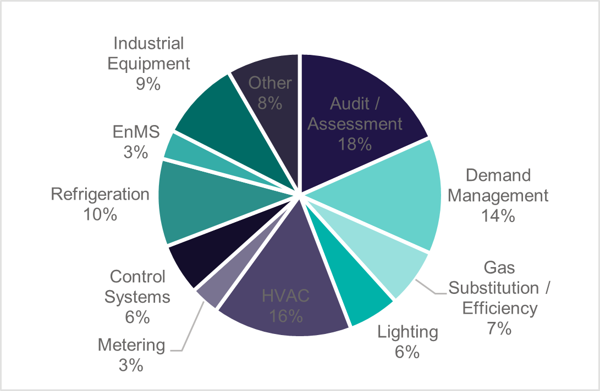

Figure BREEF Initiatives by Project Type

In addition to the savings already realised many BREEF projects identified, scoped and developed business cases for future initiatives which could achieve additional savings in the order of:

* Over 14,000 MWh/year in electricity reductions
* Nearly 300 TJ/year in gas savings
* Over 30,000 tonnes/year of greenhouse gas emissions
* Nearly $2.5 million/year in financial benefits to business.

Case Studies

#### Furphy Foundry goes 100% electric

Located in Shepparton, Furphy Foundry is a regional manufacturer with a commitment to sustainability. Demonstrating this commitment, Furphy Foundry installed a 110 kW solar system on site, and with funding from BREEF replaced their gas furnace with an electric unit.

The installation of the electric furnace has eliminated the use of gas at the site. Due to the installation of the solar system, electricity use has also dropped despite the introduction of the electric furnace but the key benefit to the business has been improved efficiency in manufacturing.

The new furnace means greater output with molten aluminium available on hand all day, greater efficiency in material use and less maintenance and non-productive duties.

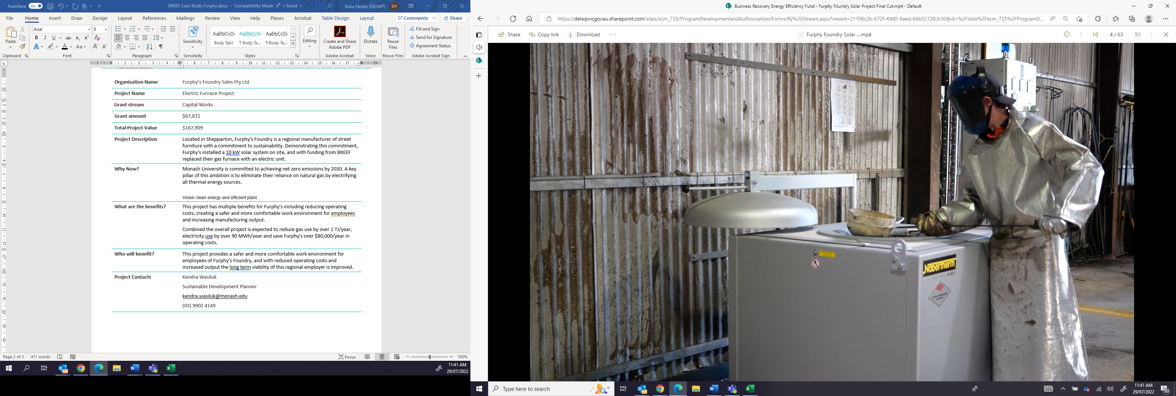

Figure Furphy's New Electric Furnace

|  |
| --- |
| *The project has exceeded the intended outcomes with Furphy's eliminating gas use on site while improving our manufacturing processes. The project was an important step towards our goals of becoming carbon neutral. We have been able to develop a new casting facility which will be implemented in Q4 of 2023.”* *– Chris Earles, General Manager, Furphy Foundry* |

#### Saving energy and reducing waste at Fulton Hogan

Fulton Hogan is a major Australian construction company with over 7,000 employees. With a commitment to improving sustainability performance, Fulton Hogan identified an opportunity to increase the volume of recycled materials used in their asphalt production at Lara by installing a specially designed Reclaimed Asphalt Pavement (RAP) Warming Dryer Drum.

Figure Fulton Hogan’s New RAP Warming Dryer Drum Ready for Installation

The completion of the project has enabled Fulton Hogan to supply three local projects with high specification recycled product in the 12 months following the completion of the project. Without this project a lower volume of recycled materials would have been supplied, or material would need to be trucked in from further away.

Energy productivity improvements are estimated to have reduced site electricity use by over   
200 MWh/year and gas by nearly 5 TJ/year. Financial savings just from the use of the cheaper recycled aggregate totalled more than $2 million in the first   
12 months. Greenhouse gas emission reductions are estimated at over 460 tonnes/year. Fulton Hogan have been able to take on an additional two staff members as a direct result of the project, with all staff benefiting from improved safety at the site through access and layout improvements.

#### Not a Trace expands business through energy efficiency

Not a Trace completed an upgrade of their heating, ventilation and air conditioning (HVAC) systems in an excellent demonstration of how good energy management can deliver great business outcomes.

The upgrade has enabled the company to introduce a new product line due to improved climate control within the factory. This led to the employment of an addition 20 FTE staff and significant additional revenue for the new product streams.

|  |
| --- |
| *“The key outcome of this project was that it provided an opportunity to grow the capability and hence financial viability of the business. The project enabled Not a Trace to undertake new customer contracts that it would previously not been equipped to undertake.*  *This was a project that our business could not proceed with on its own under the prevailing pandemic circumstances and whilst the financial assistance enabled the project, it was the on-going flexibility and support of the team at BREEF (real people, really listening!) that saw the project through to its successful completion.”* **– Susan Broderick, CFO, Not a Trace** |

#### Helping Monash University achieve a net zero future

Monash University is committed to achieving net zero emissions by 2030. A key pillar of their strategy to do this is to eliminate their reliance on natural gas by electrifying all thermal energy sources.

In 2022, Monash University completed a project to electrify existing end of life natural gas boilers used to provide domestic hot water to three buildings at their Clayton Campus and one building at their Frankston Campus. The boilers were replaced with high efficiency heat pump technology.

With Monash University purchasing 100% Green Power, this project eliminated greenhouse gas emissions associated with hot water heating at these buildings and reduced operation and maintenance costs of these assets by 48%.

The project served to demonstrate large-scale implementation of domestic hot water electrification and the feasibility of the technology for more complex buildings. Supported by the successful outcomes of the BREEF funded works, Monash University has commenced construction of six additional systems at its Clayton Campus.

#### Yarra Valley Water improves demand response capacity

With funding from BREEF Yarra Valley Water (YVW) delivered an electrification and demand management project at their Mitcham head office including:

* creation of a site-wide demand management system linked to the existing building management system
* introduction of highly efficient heat pumps to replace aging domestic hot water systems to create additional demand response capacity
* extension and upgrade of existing electric vehicle charging infrastructure.

In addition to creating over 360 kW of demand response capacity, YVW identified the project has contributed to a 375 MWh/year reduction in energy use and 156 GJ/year reduction in gas use. Combined financial savings to date are estimated at over $160,000/year.

|  |
| --- |
| *“By providing operational examples of demand management, alternative electrified technologies in traditionally fossil fuel applications, and a convenient and exciting electric vehicle experience we have engaged and energised stakeholders to enable the office, company and industry transition to a zero emissions future.”* **– Paris Pollock, Senior Engineer, Yarra Valley Water** |

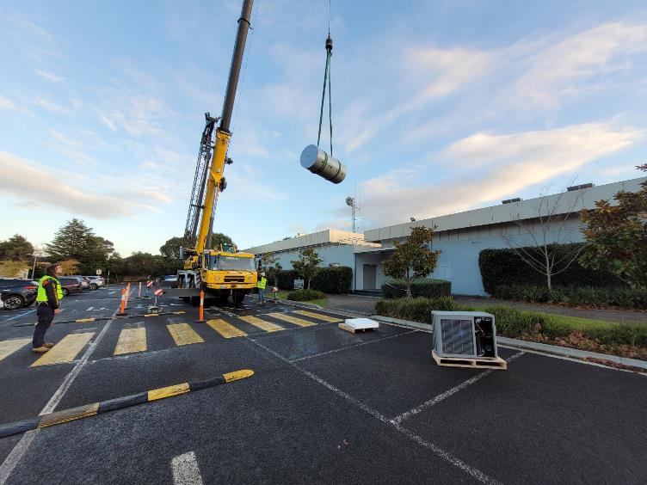

Figure New Electric Hot Water Units Being Installed at YVW's Mitcham Office

#### Improving energy productivity at Victorian dairies

BREEF funded several dairies across the state to implement energy projects including electrifying irrigation systems, battery installations and upgrading chilling equipment.

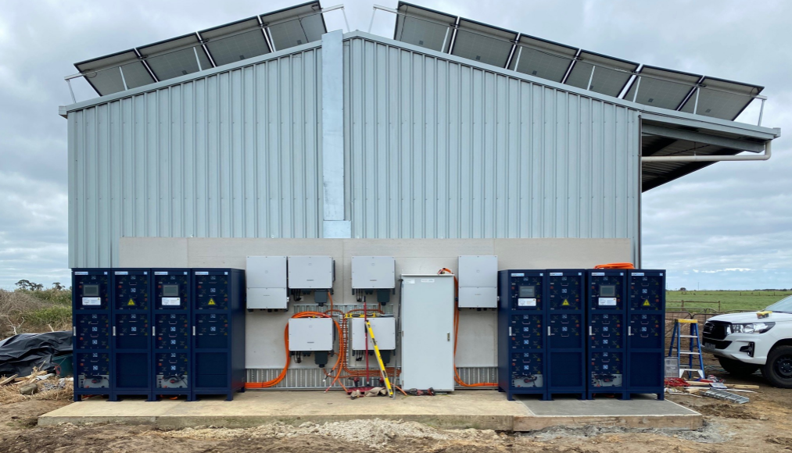

Figure New Batteries at Nikep Dairy in Simpson

Benefits experienced by dairy farmers included:

* A 10% reduction in energy use per litre of milk produced by L Weston and J Boyle dairies in Gippsland
* TMB Farms reduced electricity use by nearly 9% while increasing milk production by 6%
* L&H&J McRae have been able to grow their own fodder through the introduction of an irrigation system powered by on site solar. This has reduced costs associated with the purchase of fodder from offsite and increased milk production and revenue.

Combined the dairy projects implemented under BREEF demonstrated that batteries and upgraded chilling systems can be used to reduce demand at peak times leading to more secure energy supply. They can also eliminate the need for diesel-based back-up systems.

|  |
| --- |
| *“A key objective of this project was to increase our milk production, while increasing compliance with milk cooling standards – since the project was completed, we have consistently met the milk cooling standards while increasing milk production and reducing energy use. Not only does this make our business more economically viable in an environment of rapidly increasing energy costs, it makes us more environmentally viable, by helping control our environmental footprint, which is very important to us in agriculture.”* **– Louise Murray, Director, TMB Farms** |

Looking to improve energy management in your business?

All business has potential to benefit from improved energy management. As demonstrated through BREEF– well-designed and delivered energy management initiatives don’t only save on energy use and costs but can significantly enhance business outcomes.

#### Understanding your energy use

A great first place to start in improving your energy management is an energy audit. An energy audit involves using an energy specialist to review your energy use and identify opportunities for improvement. You can find a list of energy auditors on Sustainability Victoria’s [website](https://www.sustainability.vic.gov.au/energy-efficiency-and-reducing-emissions/in-a-business/find-an-energy-auditor).

To get the most out of your energy audit consider incorporating the following into the scope:

* The order that any improvement opportunities should be implemented. For example, improving energy efficiency can reduce the size (and cost) of any potential solar or battery systems
* Opportunities to eliminate gas as part of major equipment upgrades (critical if your business is looking to achieve net zero emissions without purchasing offsets)
* Demand management opportunities.

Energy audits should be done around once every five years as operations change, equipment ages or becomes redundant and new technologies develop.

For larger businesses, an energy audit can be done as part of an Energy Management System (EnMS). An EnMS is a system (like a quality, safety or environmental management system) for the regular review and continuous improvement of energy management within a business. The Commonwealth Government has guidance on EnMS on their [website](https://www.energy.gov.au/business/energy-management-business/large-energy-users/establish-energy-management-system).

#### Improving energy efficiency

If your business is looking to progress an energy efficiency project support may be available through the Victorian Energy Upgrades (VEU) program. VEU provides businesses with discounts on a wide-range of energy-efficient products to help cut power bills and reduce greenhouse gas emissions.

To access discounted products and services through the VEU program, you need to work with an accredited provider.

Approved products and accredited providers can be found on the Essential Services Commission [website](https://www.esc.vic.gov.au/victorian-energy-upgrades/energy-saving-information-consumers/find-accredited-provider) where you can search based on the type of product/upgrade and region.

#### Demand management

Demand management involves modifying how much electricity is used at different times to ensure supply and demand are balanced.

Businesses who effectively manage demand can reduce costs by reducing overall demand or shifting demand to times when electricity prices are cheaper.

If you are interested in demand management speak to your retailer to see if they have any programs or services available.

#### Gas substitution

Gas substitution is the removal of equipment and processes that consume natural gas and replacing them with alternatives. This can include electrification (e.g. replacing a gas hot water unit with an electric heat pump) or the use of alternative fuels such as biogas or hydrogen (in the future).

Gas substitution projects are becoming more and more economically viable as technology develops and gas prices increase. Many gas substitution technologies are supported through the VEU.

More information on gas substitution can be found on DEECA’s [website](https://www.energy.vic.gov.au/renewable-energy/victorias-gas-substitution-roadmap).

#### Getting a better deal on energy

Options available for negotiating a better deal on your energy pricing depends on how much energy you use.

Small businesses using similar amounts of energy to a household (no more than 40 MWh/year of electricity, or 1,000 GJ/year of gas) can compare energy offers using the Victorian Energy Compare [website](https://compare.energy.vic.gov.au/). After providing information on your energy use, this service will let you know if there is a better energy deal out there and provide you with an easy link to switch providers.

For larger energy users you may be able to negotiate an individual contract with your energy retailer. Options for doing this include direct negotiation with an energy provider, engaging an energy broker, group purchasing or a power purchase agreement. More information can be found on DEECA’s [website](https://www.energy.vic.gov.au/for-businesses/buying-energy).

|  |  |
| --- | --- |
| © The State of Victoria Department of Energy, Environment and Climate Action 2023  Creative Commons BYThis work is licensed under a Creative Commons Attribution 4.0 International licence. You are free to re-use the work under that licence, on the condition that you credit the State of Victoria as author. The licence does not apply to any images, photographs or branding, including the Victorian Coat of Arms, the Victorian Government logo and the Department of Energy, Environment and Climate Change (DEECA) logo. To view a copy of this licence, visit http://creativecommons.org/licenses/by/4.0/  ISBN 978-1-76136-337-5  Disclaimer  This publication may be of assistance to you, but the State of Victoria and its employees do not guarantee that the publication is without flaw of any kind or is wholly appropriate for your particular purposes and therefore disclaims all liability for any error, loss or other consequence which may arise from you relying on any information in this publication. | Accessibility  If you would like to receive this publication in an alternative format, please telephone the DEECA Customer Service Centre on 136186, email [customer.service@delwp.vic.gov.au](mailto:customer.service@delwp.vic.gov.au) or via the National Relay Service on 133 677 [www.relayservice.com.au](http://www.relayservice.com.au). This document is also available on the internet at [www.deeca.vic.gov.au](http://www.deeca.vic.gov.au). |