# Embracing electricity to cut your bills at home

The Victorian Government’s Gas Substitution Roadmap is helping our State navigate the path to net zero emissions while cutting energy bills.

The Roadmap outlines how we will use energy efficiency, electrification, hydrogen and biomethane to drive down bills and cut carbon emissions.

It will also ensure that Victorians have access to an affordable, secure, reliable, and safe supply of energy.

Running your home on electricity will save you money and reduce your carbon emissions. When major gas appliances, such as gas heating or hot water systems, reach the end of their life, it’s a great time to consider upgrading them with an efficient electric option.

Whole-of-house gas heating systems and evaporative cooling systems can be replaced with a reverse cycle heating and cooling system. Gas hot water systems can be replaced with heat pump hot water systems, which are highly efficient, and can heat water for free from solar panels. Incentives are available through the Victorian Energy Upgrades (VEU) program to support households to undertake these upgrades. Gas cooktops can be replaced with modern induction cooktops - which are safer, faster and easier to clean.

Converting an existing home with solar panels from gas to electricity can save around $2,000 a year on energy bills. This is in addition to around $740 of savings per year from an existing 6.6 kW solar system.

Renovations are another excellent time to consider switching to efficient, electric appliances. Many renovations focus on living spaces – those areas that are most used and require the most energy for heating and cooling. They also often have older appliances, which are due for replacement.

Renovations should also focus on improving the efficiency of the building to further reduce energy bills and emissions. The [Victorian Residential Efficiency Scorecard](https://www.homescorecard.gov.au/) (https://www.homescorecard.gov.au/) can help.

For more information on the Gas Substitution Roadmap, please visit energy.vic.gov.au/gas/victorias-gas-substitution-roadmap

## Example: Costs of converting an existing solar home from dual-fuel to all-electric (with multi-split heating/cooling)

### Duel-fuel:

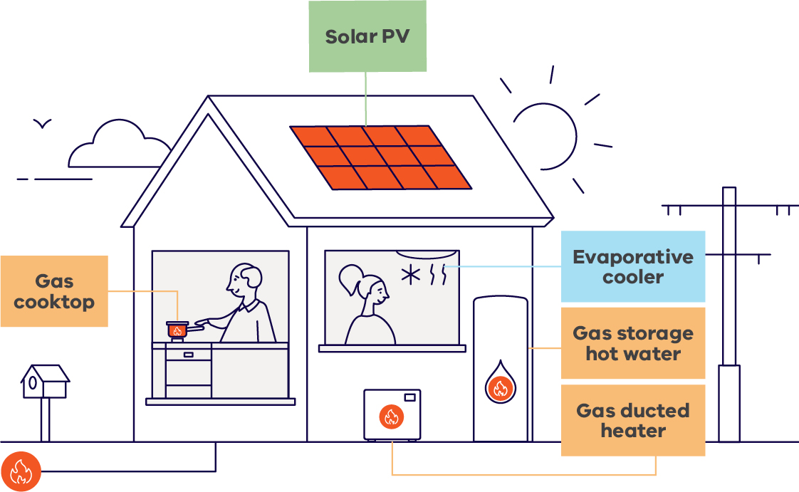

|  |  |
| --- | --- |
| **Appliance and install costs (Does not include site-specific upgrade costs (eg. duct modifications)** | |
| Heating and cooling | $10.2k**  **Heating and cooling costs for dual-fuel and all-electric are estimated for an average existing home size (DEECA Housing Stock Model). New homes are typically larger (Australian Bureau of Statistics) and require bigger, more expensive heating and cooling systems. |
| Hot water | $2k |
| Cooktop (inc. fixed charge) | $1.9k |
| Solar | Existing |
| **Total (appliance + installation)** | **$14.1k** |

|  |  |
| --- | --- |
| **Bill costs** | |
| Electricity bill | $890 |
| Gas bill | $2,530 |
| **Annual energy bill** | **$3,420** |

### All-electric:

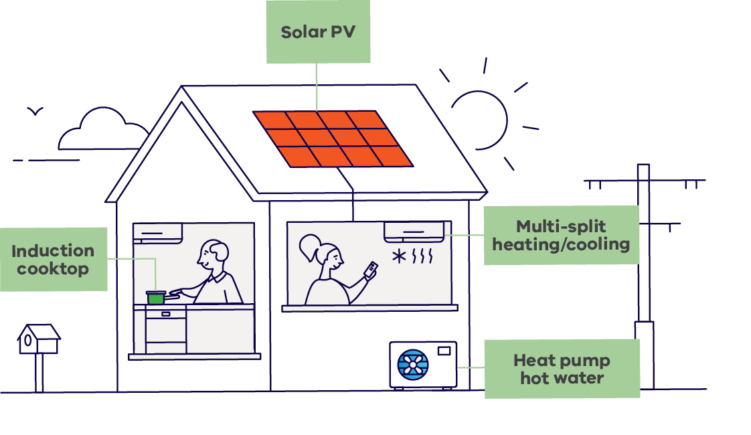

|  |  |  |
| --- | --- | --- |
|  | **Total appliance and install costs**  (Does not include site-specific upgrade costs (eg. switchboard upgrade)) | **Costs after incentives and rebates**  (Includes potential Solar Homes rebates, VEU discounts and small-scale technology certificates (STCs) where applicable) |
| Heating and cooling | $8.5k | $2.9k |
| Hot water | $4.2k | $1.9k |
| Cooktop | $2.3k | $2.2k |
| Solar | Existing | Existing |
| Gas capping and  abolishment costs | $0.5k | $0.5k |
| **Total (appliance + installation)** | **$15.5k** | **$7.5k** |

|  |  |
| --- | --- |
| **Bill savings** (Average annual savings, 2024 dollars) | |
| Heating and cooling | $1,010 saving |
| Hot water | $330 saving |
| Additional solar savings | $330 saving |
| Cooktop (inc. fixed charge) | $350 saving |
| **Total savings** | **$2,020 saving** |

#### For more information, visit the following:

https://www.energy.vic.gov.au/households/save-with-all-electric-home

https://www.energy.vic.gov.au/for-households/victorian-energy-upgrades-for-households

www.energy.vic.gov.au/renewable-energy/victorias-gas-substitution-roadmap

https://www.solar.vic.gov.au/

https://www.secvictoria.com.au/powerup

# Publication information

## Acknowledgement of Traditional Owners

We acknowledge Victorian Traditional Owners and their Elders past and present as the original custodians of Victoria’s land and waters and commit to genuinely partnering with them and Victoria’s Aboriginal community to progress their aspirations.

## Copyright

© The State of Victoria Department of Energy, Environment and Climate Action,   
December 2024.

**ISBN** 978-1-76136-386-3 **(pdf/online/MS word)**

## Disclaimer

This publication may be of assistance to you but the State of Victoria and its employees do not guarantee that the publication is without flaw of any kind or is wholly appropriate for your particular purposes and therefore disclaims all liability for any error, loss or other consequence which may arise from you relying on any information in this publication.

## Accessibility

To receive this document in an alternative format, phone the Customer Service Centre on 136 186, email customer.service@delwp.vic.gov.au, or contact National Relay Service on 133 677. Available at DEECA website (www.deeca.vic.gov.au).

**End of document.**