Overview of values, uses and activities in Gippsland’s marine environment



© The State of Victoria Department of Energy, Environment and Climate Action June 2024.

Creative Commons

This work is licensed under a Creative Commons Attribution 4.0 International licence, visit the [Creative Commons website](http://creativecommons.org/licenses/by/4.0/) (<http://creativecommons.org/licenses/by/4.0/>).

You are free to re-use the work under that licence, on the condition that you credit the State of Victoria as author. The licence does not apply to any images, photographs or branding, including the Victorian Coat of Arms, and the Victorian Government and Department logos.

**ISBN** 978-1-76136-767-0 (**pdf/online/MS word**)

Disclaimer

This publication may be of assistance to you but the State of Victoria and its employees do not guarantee that the publication is without flaw of any kind or is wholly appropriate for your particular purposes and therefore disclaims all liability for any error, loss or other consequence which may arise from you relying on any information in this publication.

Accessibility

To receive this document in an alternative format, phone the Customer Service Centre on 136 186, email [customer.service@delwp.vic.gov.au](mailto:customer.service@delwp.vic.gov.au), or contact National Relay Service on 133 677. Available at [DEECA website](http://www.deeca.vic.gov.au/) (www.deeca.vic.gov.au).

Contents

1 Overview 3

1.1 Purpose 3

1.2 Policy context 3

1.2.1 Victoria’s marine planning areas 4

1.2.2 MSP Guidelines 4

1.3 Victoria’s Offshore Wind Program 5

2 Gippsland marine environment 6

2.1 Rightsholders and stakeholders 6

2.1.1 Rightsholders 7

2.1.2 Stakeholders 7

2.2 Traditional Owner cultural values and uses 7

3 Marine and coastal environment 9

3.1 Coastal Processes 9

3.2 Oceanographic characteristics and climate 9

3.3 Landforms and seabed 9

3.4 Sediment compartments 10

3.5 Habitats 10

3.6 Biogeographic units 11

3.7 Conservation and protected areas 11

3.8 Biodiversity and species distributions 13

3.9 Threats and pressures 14

4 Human values and uses/activities 16

4.1 Economic, social, and cultural values 16

4.2 Recreation, leisure, and tourism 17

4.3 Extraction of living resources 17

4.4 Marine transport 18

4.5 Coastal infrastructure and management activities 19

4.6 Energy generation 19

4.7 Defence and national security 19

4.8 Research 20

4.9 Waste management activities 20

4.10 Extraction and disposal of non-living resources 20

5 Identified data needs to aid strategic planning 21

5.1 Traditional Owner cultural values and uses 21

5.2 Marine and coastal environment 21

5.3 Threats and pressures 22

5.4 Economic, social, and cultural values 22

5.5 Human uses/activities 23

Appendix 1: Legislation, plans, strategies, and guidelines 24

Commonwealth 24

Statewide 24

Acts 24

Regulations 24

International Agreements 24

Policies, strategies, and assessments 25

Regional 25

Local 25

Appendix 2: Tools glossary 26

Appendix 3: Species within the area (MBV map) 27

Appendix 4: NESP priority datasets 31

List of tables

Table 1. Habitats within the Gippsland area. 11

Table 2. FFG Act and EPBC Act listed species of high priority for data improvement. 22

Table 3. Identified data needs on human uses/activities. 23

List of figures

Figure 1. Victoria's marine planning areas. 4

Figure 2. Gippsland area. 6

Figure 3. Publicly available data on shipwrecks and dive site locations in the area and adjacent Commonwealth waters.. 12

Figure 4. MBV first iteration map for the area. 14

Figure 5. Example of publicly available data on marine protection areas and vessel hotspots (2017-2022) in the area and adjacent Commonwealth waters 18

# 1 Overview

Strategic planning, including Marine Spatial Planning (MSP), plays an important role in informing the location, type, design, and timing of offshore wind infrastructure construction to effectively avoid, minimise and offset impacts on biodiversity and environmental values1. In addition, as use of the marine environment continues to grow and change, there is finite space available to accommodate all uses/activities (for example, some uses may only be able to occur in certain areas, with some unable to share a footprint with others). Strategic planning enables efficiencies across engagement, provides transparency of existing or likely values and conflicts, and supports sharing of collected data (where processes are in place). Strategic planning can therefore deliver positive outcomes and minimise risks for industry, community, and the environment.

## 1.1 Purpose

This document provides a high-level synthesis of available information on values and uses/activities within or relevant to the marine environment of Gippsland (refer to location information in Section 2). The information has been compiled to support offshore wind project developers who are pursuing environmental assessments or planning for feasibility activities relating to proposed offshore wind farm infrastructure. The information within can also aid any future strategic planning occurring within the area.

This document is not intended to outline the requirements of current regulatory frameworks and is not an exhaustive list of data required under planning and permitting processes. It is not legal advice and is not intended to provide an exhaustive list of all available data or additional data that may be needed or identified as needed, nor is the document to be attached to submissions as part of the *Environment Effects Act 1978* assessment process.

Not all information outlined in this document may be complete, current, fit for purpose or directly relevant to offshore wind farm projects. This document should be read in conjunction with existing legislation, policies and plans that provide direction for planning, management and decision making in the marine and coastal environment (see Appendix 1), Offshore Wind Energy Implementation Statement 3, Victoria's Marine Planning Areas, and MSP Guidelines. At the time of release of this document, there has been no commitment to undertake a MSP process in the area.

## 1.2 Policy context

Planning for offshore wind development in Victoria will be guided by the current approval process including the *Environment Protection and Biodiversity Conservation Act 1999*, *Environment Effects Act 1978* and the *Marine and Coastal Act 2018*. The Victorian Government is working in collaboration with the Australian Government to identify future opportunities to align and coordinate environmental and regulatory approvals processes to help facilitate offshore wind development.

Victoria’s *Marine and Coastal Act 2018* (MAC Act) sets the objectives and guiding principles for the planning and management of the State’s marine and coastal environment. Under the MAC Act, the Marine and Coastal Policy 2020 (the MAC Policy), which includes a Marine Spatial Planning Framework (MSP Framework), details the policies for achieving these objectives.

The MSP Framework provides guidance and a process for achieving integrated and coordinated planning and management of the marine environment and sets out Victoria’s approach to MSP. Implementation Statement 3[1] notes that elements of marine spatial planning can support planning for offshore wind development in Victoria, including through strategic planning to achieve ecological, economic, and social objectives.

The MSP Framework consists of two parts:

* Part A provides an overarching structure and policies to guide planning, management and decision making in the marine environment.
* Part B sets out the process to initiate and undertake MSP in Victoria.

Implementation of the MSP Framework is being led by the Department of Energy, Environment and Climate Action (DECCA), and has commenced through the development of MSP Guidelines[2], determination of marine planning areas[3], partnerships with Traditional Owners and engagement with stakeholders.

### 1.2.1 Victoria’s marine planning areas

Implementation of Part B of the MSP Framework commenced via a statewide ‘first-pass’ approach that divided Victoria’s marine environment into 8 marine planning areas (Figure 1)[4]. In determining the boundaries and size of the marine planning areas several factors were considered, including the Victorian Environmental Assessment Council’s Assessment of the Values of Victoria’s Marine Environment Atlas (2019)[5].The boundaries of the marine planning areas are indicative, with refinement to occur as part of undertaking an MSP process. The landward and seaward boundaries of the marine planning areas are demarcated according to the ‘marine environment’ definition in the MAC Act.

A marine planning area is the area to which a marine plan and its identified management actions (developed and agreed through the completion of an MSP process) will apply. Given the dynamic and interconnected nature of marine ecosystems, it is essential to consider interactions and connectivity across the land, sea and catchment interface (including Commonwealth waters). Whilst a marine plan applies to an entire marine planning area, there may be locations that require a more intensive focus when undertaking an MSP process (for example, due to the intensity of uses/activities differing across the marine planning area).

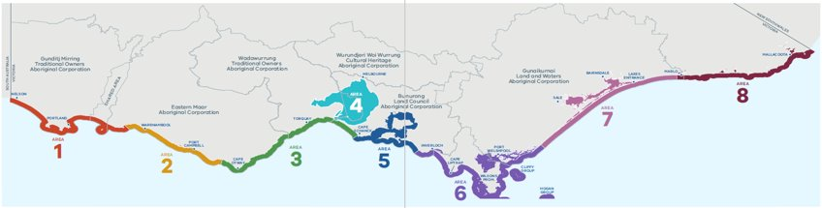

Figure 1. Victoria's marine planning areas.

### 1.2.2 MSP Guidelines

The MSP Guidelines[6] outline detailed instructions on how to undertake an MSP process in Victoria. Specifically, they:

* enable Traditional Owners to partner in marine planning and management
* guide the preparation, implementation, evaluation, and improvement of strategic plans for the marine environment
* support marine sectors, marine users, and the community to participate in marine planning and management.

The MSP Guidelines are designed to be used to undertake an MSP process once approval has been granted by the lead Minister. The key steps in the MSP Guidelines reflect those in the MSP Framework. Tasks outlined in each step may not occur sequentially, as the information gained during one step may highlight the need to revisit a preceding step.

At this stage, there has been no commitment to undertake a full MSP process, however the steps identified in the MSP Guidelines have been drawn on in identifying available information on values and uses/activities within or relevant to the marine environment of Gippsland. This information has been collated to assist offshore wind project developers as they progress to the next stage of feasibility testing and approvals, and to provide a synthesis of useful background information for any future strategic planning exercise.

## 1.3 Victoria’s Offshore Wind Program

Offshore Wind Energy Implementation Statements are published by the Victorian Government to support and guide industry, stakeholders, and the Victorian community on the development of the offshore wind sector.

The Victorian Government has set offshore wind energy targets of at least 2 gigawatts (GW) by 2032, 4 GW by 2035 and 9 GW by 2040. These targets have been legislated in the C*limate Change and Energy Legislation Amendments (Renewable Energy and Storage Targets) Act 2024*.

Implementation Statement 3[7], released in December 2023, includes announcements and updates on the following:

* The Victorian Government’s procurement approach for the first tranche of offshore wind energy
* The establishment of ports and transmission
* Policy, workforce, and industry development
* Legislation and regulatory reform
* Environment
* Traditional Owner partnerships
* Industry and community engagement.

Offshore Wind Energy Victoria has also published regulatory information resources to support industry[8].

**Why offshore wind?**

The Victorian Government recognises that reaching Victoria’s net-zero emissions goals by 2045 and 95 per cent renewable energy generation by 2035 will require an unprecedented amount of new renewable energy generation capacity. As Victoria’s ageing and increasingly unreliable coal-fired power stations retire, our electricity system needs to evolve. In recent years, Victoria’s renewable energy transition has accelerated with market changes including Energy Australia’s announcement that the Yallourn power station will close in 2028 and AGL’s announcement that the Loy Yang A power station will close in 2035.

Offshore wind energy is key to this once-in-a-generation renewable energy transition, delivering clean and affordable power, creating new jobs and developing a thriving Victorian renewable energy supply chain.

Victoria is establishing a thriving offshore wind sector – paving the way for our state to host the first offshore wind energy projects in Australia. The Victorian Government understands that there can be risks and potential impacts of offshore wind development and will continue its commitment to protecting the environment through the development of offshore wind projects before, during, and after operations commence. Victoria will ensure that renewable energy objectives are aligned with our environmental values, through strict and robust environmental assessments and management.

# 2 Gippsland marine environment

The information in this document covers the entirety of marine planning areas 6 and 7[9], extending from Wilsons Promontory in the west to Lakes Entrance in the east (Figure 2). The focus is on Victoria’s marine environment, however adjacent marine and terrestrial areas, and neighbouring Commonwealth waters, are discussed where information is known.

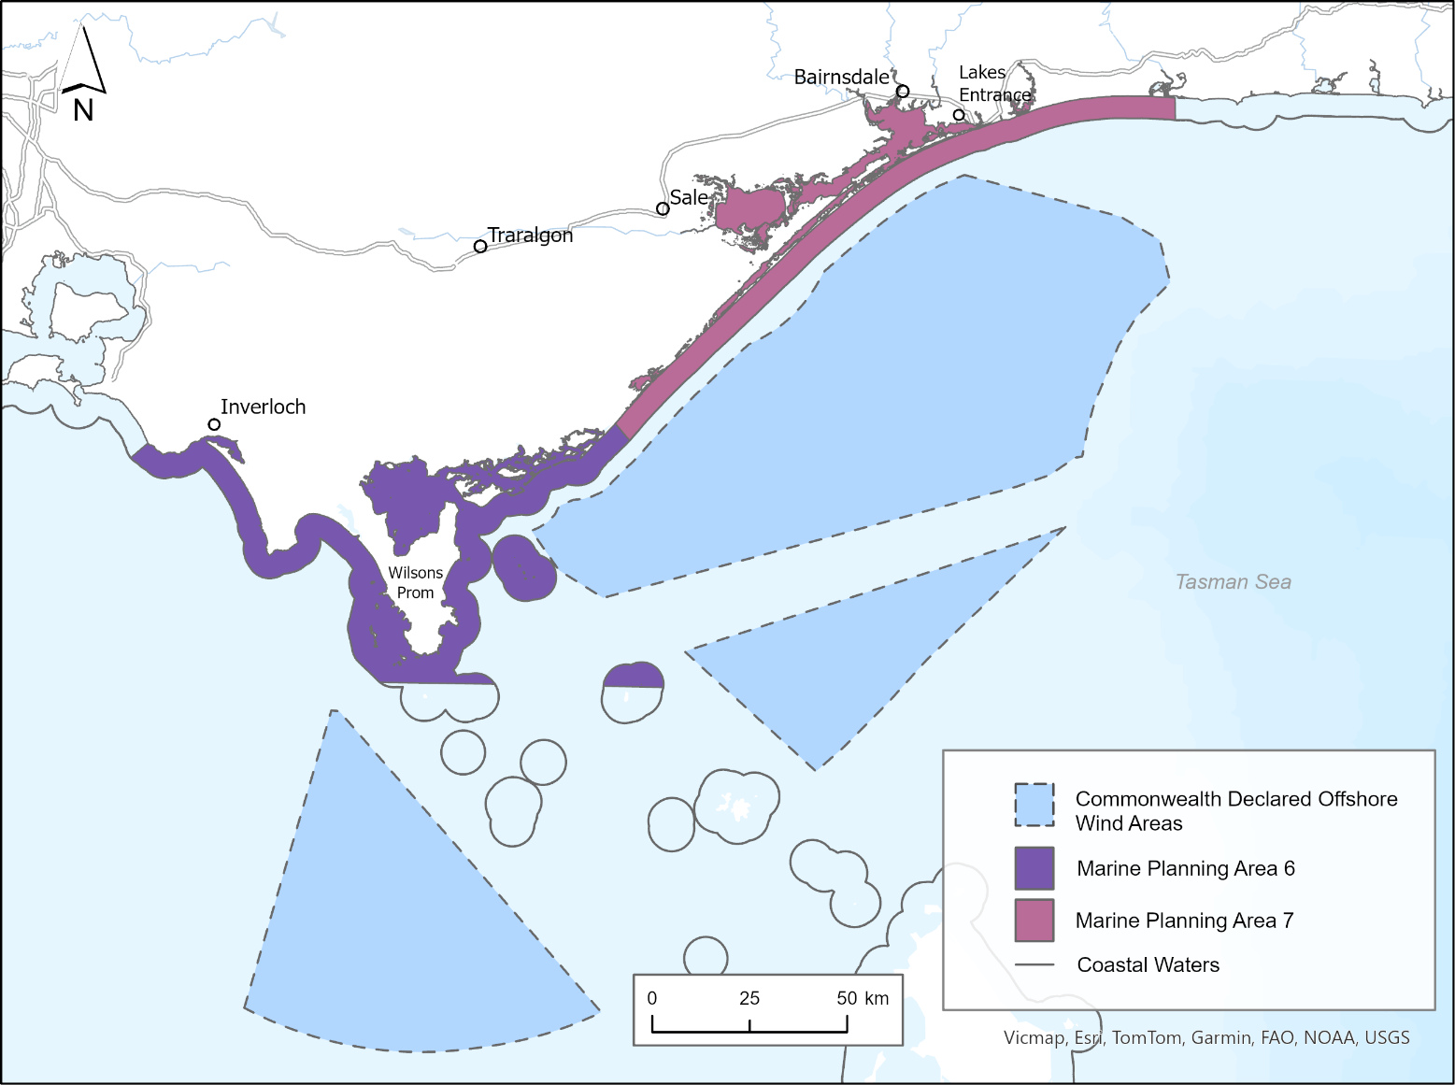

Figure 2. Gippsland area.

Victoria’s ‘marine environment’ is defined in the MAC Act as extending from the high-water mark for 3 nautical miles, or 5.5 km, to the edge of the State’s jurisdiction. It includes all bays, inlets, estuaries, and the Gippsland Lakes. This extends to a depth of 200m below the seabed, and includes the biodiversity associated with both land and water.

## 2.1 Rightsholders and stakeholders

As outlined in the MSP Guidelines[10], Marine Spatial Planning (MSP) is a participatory approach, therefore it is important to identify, contact and partner with rightsholders, and identify and engage stakeholders when conducting strategic planning. For instance, Traditional Owners request when being engaged the concept of free, prior, and informed consent be followed. There should also be a clear understanding of the resources and availability of Traditional Owners to engage from the start, with Traditional Owners self-determining their role. A collaborative approach to marine planning and development allows for proactive identification and reduction of conflicts between uses, and between uses and the environment.

The MSP Guidelines highlight the importance of partnering with rightsholders as well as considerations for identifying stakeholders. They list examples of those with existing rights by legislation, permit or licence, and suggests engagement and communication approaches (see Step 1 of the MSP Guidelines).[11]

### 2.1.1 Rightsholders

The importance of Sea Country must be recognised and integrated into marine planning and management through a self-determined approach. Registered Aboriginal Parties (RAPs) (under the *Aboriginal Heritage Act 2006*) and Registered Native Title Body Corporates (under the *Native Title Act 1993*) have responsibilities for managing and protecting Aboriginal cultural heritage on Country. In areas where there is no legally recognised RAP, the local Traditional Owner group and/or the Aboriginal Heritage Council should be contacted.

The Traditional Owner groups within marine planning areas 6 and 7 are:

* Bunurong Land Council Aboriginal Corporation
* Gunaikurnai Land and Waters Aboriginal Corporation (Prescribed Body Corporate under the *Native Title Act 1993)*
* Boonwurrung Land and Sea Council (not a recognised RAP).

Please note - Gunaikurnai Land and Waters Aboriginal Corporation request that offshore wind project developers engage directly.

Note: while the above listed Traditional Owner groups exist within marine planning areas 6 and 7, only Sea Country managed by the Gunaikurnai Land and Waters Aboriginal Corporation is within the Commonwealth declared offshore wind areas.

### 2.1.2 Stakeholders

Stakeholders with interests in marine planning areas 6 and 7 include those with existing rights by legislation, permit or licence, marine user groups, industry, non-government groups and peak bodies, researchers, and planners and managers from local, regional, state, and national levels of government.

## 2.2 Traditional Owner cultural values and uses[12]

Sea Country is part of the interconnected cultural landscape that includes land and waters. A cultural landscape includes Traditional Owner cultural values and uses for Sea Country, which are deeply held spiritual, cultural, social, economic, environmental, of land and water form, place-based, practice-based, wellbeing, future use, identity connections, and any others as determined by Traditional Owners.

Marine planning areas 6 and 7 are linked to very high settlement patterns, evidenced by having one of the highest recorded incidences of Aboriginal tangible cultural heritage sites in Victoria, including middens with shellfish remains, charcoal, scorched pebble, burial grounds, scar trees, artefact scatters and massacre sites.

Key areas of interest in marine planning areas 6 and 7 include, but are not limited to:

* The coastal waters of Gippsland are subject to a Sea Country Indigenous Protected Area consultation process, which spans from Nanjet, east of Wilsons Promontory, to Mallacoota.
* Significant intangible cultural heritage associated with the area, including but not limited to elements such as song, dance, stories, places and living bio-cultural values, such as culturally significant plants and animals.
* Many cultural heritage sites including ancestral remains, shell middens, artefact scatters found through cultural heritage surveys, and many areas yet to be surveyed.
* Numerous archaeological sites include occupation sites at Morgan Creek, near Point Smythe, at Ten Mile Creek, Five Mile Creek and near Bell Point.
* Caves, shelter places and burial grounds throughout Mitchell River where human remains have been found.
* Islands off Yiruk (Wilsons Promontory) are especially significant – White Rock (Seal Group) and Rabbit Island.
* Burnt Bridge Reserve in Lake Tyers, a popular gathering place and ochre site, and tangible cultural heritage including scar trees, artefact scatters, birthing places, and burial sites.
* Cultural places and objects, including in areas that are submerged due to sea level rise since the last glacial period.
* The waterways, lakes system and open ocean were the maritime routes for the Gunaikurnai ancestors.
* The unregistered area is of interest to the Gunaikurnai Land and Waters Aboriginal Corporation and Gunaikurnai people. Cultural places and objects in the area show evidence of the Gunaikurnai people living there and using the natural resources at least 6,500 years ago.
* Cultural significance of the Wilsons Promontory and surrounding areas (land and sea) make it a very valuable place to the Gunaikurnai People.
* Recent surveys by Gunaikurnai Land and Waters Aboriginal Corporation in the Corner Inlet and Nooramunga Marine Park area identified that of the 47 sites surveyed, 36 were at extreme risk of inundation by 2024.
* The towns of Lakes Entrance, Metung and Paynesville which were developed on the camping grounds of the Gunaikurnai ancestors.

# 3 Marine and coastal environment

Gippsland’s marine environment is home to a rich diversity of species, most of which are found only in the waters of south-eastern Australia. This section provides examples of known available data on the physical and environmental characteristics of Gippsland’s marine and coastal environment, including biounits, landforms, habitats, sediment compartments and conservation areas, and the biodiversity they enable, including listed species.

Data on Victorian and adjacent Commonwealth waters is available through [DataVic](https://www.data.vic.gov.au/) (viewable via [CoastKit](https://www.marineandcoasts.vic.gov.au/marine-and-coastal-knowledge/coastkit)), the Commonwealth funded National Environmental Science Program (NESP) via the [Australian Ocean Data Network (AODN)](https://imos.org.au/facilities/aodn), [data.gov.au](https://data.gov.au/home), and Geoscience Australia’s online map-based tool (NationalMap) (see Appendix 2 for a list of data sources). The Commonwealth Department of Climate Change, Energy, the Environment and Water (DCCEEW) has also released guidance on key environmental values for consideration when developing offshore renewable energy projects in Commonwealth waters.[13]

Offshore wind project developers should note that not all data outlined may be complete, current, fit for purpose, available to access, or directly relevant to offshore wind farm projects, and is being provided solely as an initial high-level synthesis. Therefore, in addition to the data that is referenced in this document, offshore wind project developers will need to consider what further data they will require for assessment processes, with a strategic and collaborative (where appropriate) approach to data gathering being highly beneficial.

## 3.1 Coastal Processes

The Victorian Government coordinates the [Victorian Coastal Monitoring Program (VCMP)](https://www.marineandcoasts.vic.gov.au/marine-and-coastal-knowledge/victorian-coastal-monitoring-program) to ensure data is used to inform coastal hazard management and adaptation planning. The statewide program aims to:

* increase understanding of how coastlines change over time
* assist with managing coasts in the present
* provide knowledge to ensure coasts are resilient in the future.

Examples of available data collated as part of this program includes:

* ‘VCMP Sites’ data at three locations (Inverloch, Walkerville, and Seaspray) - shoreline trends and time series based on VCMP drone surveys, aerial imagery, and satellite imagery ([Digital Earth Australia](https://www.dea.ga.gov.au/))
* ‘VCMP Coastal Erosion Indicators’ at three locations (Inverloch, Walkerville, and Seaspray)
* wave climate data through wave buoys at Inverloch, Wilsons Promontory and Lakes Entrance (managed by Gippsland Ports) – used to calibrate a 40-year hindcast wave model and a longshore sediment transport model.

## 3.2 Oceanographic characteristics and climate

Examples of available data and information include, oceanographic conditions, meteorological conditions, physical chemistry (e.g., salinity, oxygen, temperature) and hydrology (e.g., wave climate upwelling). This data and information can be accessed via the [AODN](https://imos.org.au/facilities/aodn).

## 3.3 Landforms and seabed

Examples of available data and information on landforms and the seabed includes:

* coastal topography and bathymetry (including the Victorian Coastal Digital Elevation Model)
* geological sites and geomorphology (including data available at [Geoscience Australia](https://www.ga.gov.au/) repository)
* submarine canyons (via the [Geoscience Australia](https://www.ga.gov.au/) repository)
* marine geology and sediments (via the [Geoscience Australia](https://www.ga.gov.au/) repository).

## 3.4 Sediment compartments

As part of the National Classification of Coastal Sediment Compartments, the coastline of Gippsland has been mapped based on landforms and patterns of sediment (sand and other beach material) movement[14].

The primary sediment compartments, based on large landforms and offshore processes, within marine planning areas 6 and 7 are:

* + Port Phillip
  + Wilsons Promontory
  + Ninety Mile Beach.

The secondary sediment compartments, which link to information on sediment movement and coastal types, within marine planning areas 6 and 7 are:

* + Cape Woolamai – Cape Paterson
  + Venus Bay
  + Waratah Bay
  + Wilsons Promontory (southwest)
  + Wilsons Promontory (east)
  + Corner Inlet
  + Gippsland Lakes
  + Snowy River.

### 

## 3.5 Habitats

DEECA has developed a [statewide marine habitat map](https://www.marineandcoasts.vic.gov.au/marine-and-coastal-knowledge/statewide-marine-habitat-map)[15] from available habitat observations recorded in Victoria’s waters, combined with predictive modelling and mapping techniques that synthesise existing information. DEECA adopts the Combined Biotope Classification Scheme (CBiCS) [16] which comprises six hierarchical levels, from CBiCS level 1 (major environment type) to level 6 (sub-biotope). The map represents 24 distinct habitats classified to habitat complex (CBiCS level 3) across the State, encompassing a range of species, some of which may be unique, rare, or threatened with extinction. Within the Gippsland marine environment there are 20 distinct habitats (Table 1), further information on habitat descriptions can be found in the Feature Activity Sensitivity Tool (FeAST) Guidelines[17].

Table 1. Habitats within the Gippsland area.

|  |  |
| --- | --- |
| **Habitat complex** | **Biotic code** |
| High energy littoral rock | ba1.1 |
| Moderate energy littoral rock | ba1.2 |
| Littoral sand | ba2.2 |
| Littoral mud | ba2.3 |
| Saltmarsh and reedbeds | ba2.5 |
| Mangrove | ba2.6 |
| High energy infralittoral rock | ba3.1 |
| Moderate energy infralittoral rock | ba3.2 |
| Low energy infralittoral rock | ba3.3 |
| High energy open coast circalittoral rock | ba4.1 |
| **Habitat complex** | **Biotic code** |
| Tide-swept channels of circalittoral rock | ba4.2 |
| Sublittoral coarse sediment | ba5.1 |
| Sublittoral sand and muddy sand | ba5.2 |
| Sublittoral mud | ba5.3 |
| Sublittoral mixed sediments | ba5.4 |
| Sublittoral rhodolith beds | ba5.5 |
| Sublittoral biogenic reefs | ba5.6 |
| Sublittoral seaweed on sediment | ba5.7 |
| Sublittoral seagrass beds | ba5.8 |
| Non-reef sediment epibenthos | ba5.b |

## 3.6 Biogeographic units

The Integrated Marine and Coastal Regionalisation of Australia (IMCRA)[18] is a biographic regionalisation of the oceanic waters of Australia’s exclusive economic zone. Within marine planning areas 6 and 7, the IMCRA provincial bioregions are:

* + Bass Strait Shelf Province
  + Southeast Shelf Transition.

Statewide mapping, undertaken in 2018, of Victoria’s marine environment resulted in delineation of the IMCRA bioregions into biogeographic units[19]. Referred to as biounits, these are a means of describing, mapping, and monitoring biological communities, abiotic structural habitat components and ecosystem types. Biounits are characterised by dominant physiographical settings including oceanography and geomorphology (processes).

The biounits within marine planning areas 6 and 7 are:

* + Bunurong
  + Cape Liptrap
  + Wilsons Prom West
  + Wilsons Prom East
  + Cliffy Group
  + Hogan Group North
  + Corner Inlet
  + Nooramunga
  + Ninety Mile Beach
  + Gippsland Lakes.

## 3.7 Conservation and protected areas

Within marine planning areas 6 and 7, ecologically and biologically significant areas include:

* + Marine National Parks (Bunurong, Wilsons Promontory, Corner Inlet, Ninety Mile Beach)
  + Marine and Coastal Parks (Yallock-Bulluk, Shallow Inlet, Wilsons Promontory, Corner Inlet, Nooramunga, Gippsland Lakes)
  + Ramsar sites (Corner Inlet, Gippsland Lakes)
  + Little Snake Island, Sunday Island, Saint Margaret Island, Snake Island, Clonmel Island, Box Bank, Dream Island, Rabbit Island, Cliffy Group and Hogan Group
  + Jack Smith Lake and Lake Tyers, Latrobe River, Avon River, Mitchell River, Nicholson River, Tambo River
  + Beagle Marine Park (Commonwealth jurisdiction)
  + Numerous shipwreck sites (see Figure 4)
  + Victorian Marine Asset Areas[20].

It should be noted that the above list may be extended or otherwise altered through conservation initiatives.

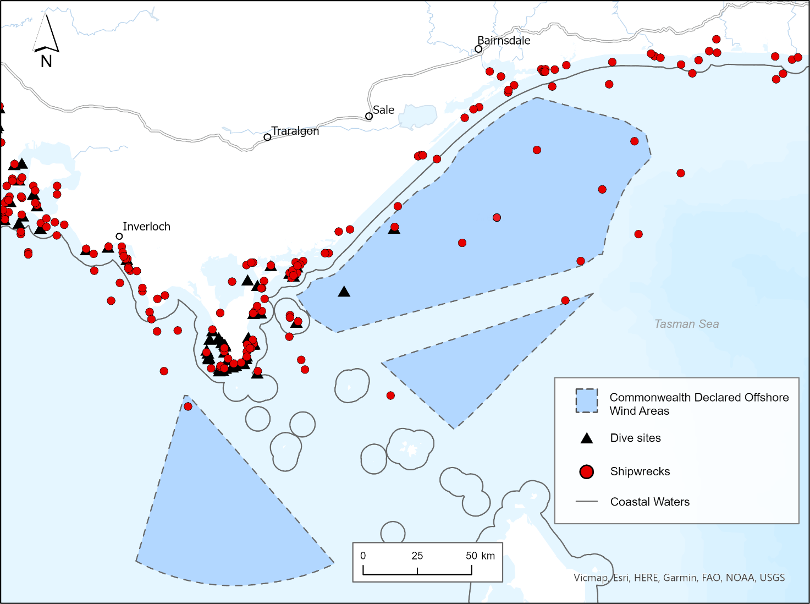

Figure 3. Publicly available data on shipwrecks and dive site locations in the area and adjacent Commonwealth waters. Note: Figures are provided for illustrative purposes, with spatial data available via [DataVic](https://www.data.vic.gov.au/) for download and viewable via [CoastKit](https://www.marineandcoasts.vic.gov.au/marine-and-coastal-knowledge/coastkit).

## 3.8 Biodiversity and species distributions

DEECA has developed a statewide Marine Biodiversity Values (MBV) map and corresponding technical report[21] that provides a spatially explicit view of the relative biodiversity importance of Victoria’s marine environment. The map will be continuously updated (subject to resourcing) as additional data/knowledge becomes available. The MBV map has been developed to highlight statewide biodiversity areas of value, not specifically tailored to any particular activity, use or development. Additional consideration is required around the likelihood of conflicts and impacts from offshore wind infrastructure and development activities on key biodiversity values and/or species of concern.

As of June 2024, 263 listed and key marine and coastal biodiversity features occurring statewide have been included in the MBV map. Within marine planning areas 6 and 7, 144 species[22] with available data have been identified, including 51 species listed under the *Flora and Fauna Guarantee Act 1988* (FFG Act), 121 species listed under the *Environment Protection and Biodiversity Conservation Act 1999* (EPBC Act), and 41 species listed under both (Appendix 3).

The MBV map highlights areas with low to high biodiversity values, ranked from 0 to 100. High priority biodiversity areas (shown as yellow in Figure 3) are areas considered valuable to protect, conserve or avoid. Areas with lower biodiversity value (shown as dark purple in Figure 3) indicate:

* areas where not enough information has been collated to understand the biodiversity in that location
* inland areas that may not be particularly valuable for marine and coastal species but are important for terrestrial species, or
* areas where habitats tend to be more homogonous (e.g., open sandy areas) and so support fewer species.

There are three broad areas with high biodiversity value (Figure 3): Wilsons Promontory, Corner Inlet and Nooramunga, and the Gippsland Lakes.

* Wilsons Promontory supports sponge gardens, kelp forests, fish, sharks and rays, conservation-listed communities, and species, as well as endemic or rare species. It is a key habitat for White Shark (*Carcharodon carcharias*) populations.
* The Corner Inlet and Nooramunga area supports large seagrass meadows, conservation listed species, productive mudflats, mangroves, and coastal saltmarsh. The area is also a Ramsar listed wetland providing habitat and foraging areas for many migratory shorebirds.
* Gippsland Lakes is a Ramsar listed wetland that includes extensive seagrass beds, saltmarsh vegetation, waterbird and fish habitats, and is the only known location of the FFG listed Burrunan Dolphin (*Tursiops australis*) within the area.

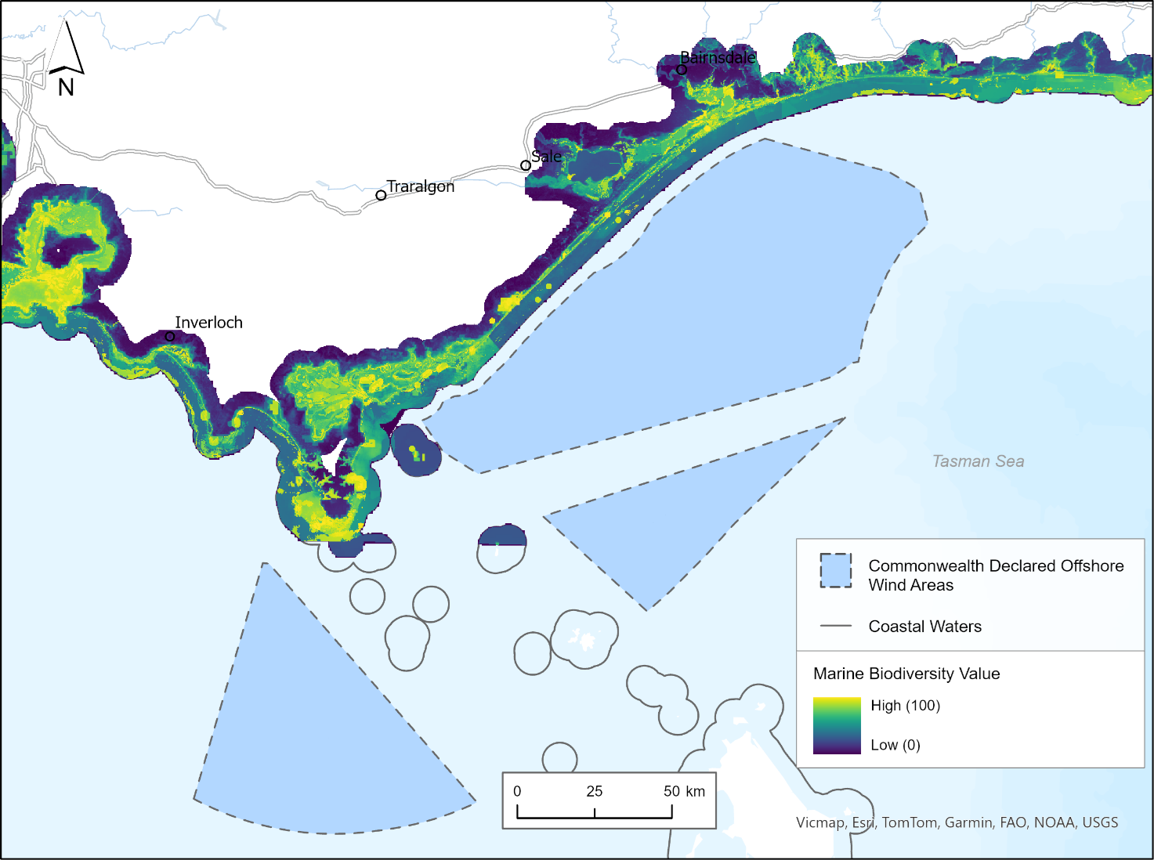

Figure 4. MBV first iteration map for the area. Note: Figures are provided for illustrative purposes, with spatial data available via [DataVic](https://www.data.vic.gov.au/) for download and viewable via [CoastKit](https://www.marineandcoasts.vic.gov.au/marine-and-coastal-knowledge/coastkit).

A [NESP project](https://www.nespmarinecoastal.edu.au/project/3-21/) is also underway to identify priority datasets of relevance to the Commonwealth offshore wind declaration area and pathways for their use in guiding decision-making. The focus of the NESP project is on a priority subset of species identified by DCCEEW and the National Offshore Petroleum Safety and Environmental Management Authority (NOPSEMA) (Appendix 4)[23]. Three specific pilot projects within Commonwealth waters off the Gippsland coast are also being examined in more detail: Migration paths and patterns for Orange Bellied Parrot (*Neophema chrysogaster*) and Swift Parrot (*Lathamus discolor*), baseline surveys for threatened seabirds (Albatross), and baseline surveys for Blue Whale (*Balaenoptera musculus*)and Southern Right Whale (*Eubalaena australis*). Information on these species is a priority.

## 3.9 Threats and pressures

When conducting strategic planning, it is important to consider the main pressures on the area of interest, and whether there are any threats to environmental, cultural, social, or economic values within the area. Threats to values can include climate change impacts, changes to marine habitats/species through stressors, degradation/deterioration of the built or natural environment, marine pollutants, and disturbances associated with human uses/activities. Thresholds, limits, and resilience of environmental indicators to threats and pressures should also be considered.

Examples of available data that can help assessing threats and pressures when conducting strategic planning within marine planning areas 6 and 7 are:

* Inundation hazard and risk projections
* Cliff hazard and risk projections
* Erosion vulnerability hazard and risk projections
* Historical occurrence of invasive species and pests
* Climate change predictions (e.g., ocean temperatures, ocean acidification)
* Density of foreshore use and infrastructure (e.g., residential, and commercial dwellings, population density).

In addition, DEECA has developed the [Features Activity Sensitivity Tool (FeAST)](https://www.marineandcoasts.vic.gov.au/marine-and-coastal-knowledge/feature-activity-sensitivity-tool), a statewide marine sensitivity and risk assessment tool hosted on [CoastKit](https://www.marineandcoasts.vic.gov.au/marine-and-coastal-knowledge/coastkit). This tool quantifies the nature and scale of potential impacts on the marine environment resulting from anthropogenic uses/activities. FeAST has been developed as an initial desktop-based risk assessment to support users to evaluate environmental features that could be impacted by a proposed project.

# 4 Human values and uses/activities

This section details examples of known data and information on human values and uses/activities. The focus is on the best available data, referred to as ‘Examples of available data’.

Data and information categories are based on a review of international strategic planning processes and further detailed within the Victoria's marine planning areas document[24]. Information in this section is current as of June 2024, and may change as new data becomes available. In addition, not all data outlined may be complete, current, fit for purpose, available to access, or directly relevant to offshore wind farm projects. Information is being provided solely as an initial high-level synthesis to support offshore wind project developers to undertake best-practice feasibility activities, including planning and development of offshore wind farm infrastructure. In addition to the data that is referenced in this document,offshore wind project developers will need to consider what further data they will require for assessment processes, with a strategic approach to data gathering being highly beneficial.

Custodians of available datasets within the Victorian Government include, but are not limited to, Department of Energy, Environment and Climate Action[25], Department of Transport and Planning[26],[27], Department of Jobs, Skills, Industry and Regions, Department of Premier and Cabinet[28], Victorian Fisheries Authority (including Better Boating Victoria), and Parks Victoria. Commonwealth agencies, and local and regional government agencies may also hold additional datasets. Additional data on Victorian and adjacent Commonwealth waters is available through [DataVic](https://www.data.vic.gov.au/) (viewable via CoastKit), [data.gov.au](https://data.gov.au/home) and Geoscience Australia’s online map-based tool ([NationalMap](https://www.nationalmap.gov.au/)). Consideration for how data is best expressed (e.g., geographically, temporally) will depend on the data being displayed and the nature of the proposed activities.

## 4.1 Economic, social, and cultural values

Economic, social, and cultural values are important to consider. These include the monetary value and use of marine resources, and intangible values placed by individuals, communities and/or wider society on the natural environment. Beliefs, traditions, and habits are also included in this category. Limited information on these values exists, however the following are applicable:

* + degree of economic and social reliance on resources
  + economic value of the ecosystem and services
  + places of community benefit
  + places of cultural importance
  + relationship between offshore development and onshore communities and economies
  + sense of place
  + key species
  + diversity of local livelihoods.

## 4.2 Recreation, leisure, and tourism

This category focusses on recreational and leisure pursuits and has been separated into 4 sub-categories; shore-based activities (includes beach activities, biking, walking/hiking, camping, hang gliding, horse riding, dog walking/beach access), diving (includes both scuba and free/snorkel), surface-water activities (including recreational fishing, boating use, sailing, kayaking, kite surfing, wind surfing, swimming, personal water craft, sporting events), wildlife viewing/sightseeing (includes photography, wildlife and sightseeing).

|  |  |
| --- | --- |
| Icon of a swimmer | **Examples of available data** |
| **Shore-based activities** | * Coastal/beach activities (hiking tracks, camping sites, caravan parks, life-saving clubs) * Beach facilities * Designated dog on/off leash beaches and foreshores * Beaches and foreshore areas allowing horse riding * Piers and jetties allowing recreational fishing |
| **Diving** | * Dive sites (refer to Figure 4) * Free/snorkel locations * Shellfish reef restoration sites |
| **Surface water activities** | * Surf breaks * Marine tours * Marine waters where recreational fishing is allowed |

## 4.3 Extraction of living resources

This category focusses on both commercial and recreational fishing.

|  |  |
| --- | --- |
| Icon of a fishing rod with a fish | **Examples of available data** |
| **Commercial fishing** | * Aquaculture leases * Catch and effort data of Victorian fisheries (abalone, bait, bays and inlet species, eel, giant crab, multi-species ocean species, octopus, pipi, rock lobster, scallop, sea urchin, wrasse) * Management areas, exclusion zones, fishery zones * Catch and effort data of Commonwealth managed fisheries |
| **Recreational fishing** | * Artificial fishing reefs * Fisheries Reserves * Fishery zones * Boating behaviour studies |

## 

## 4.4 Marine transport

This category focusses on vessel movements or relating to the support of transport activities (including vessel moorings and maritime navigation aids).

|  |  |
| --- | --- |
| Icon of a ship | **Examples of available data** |
| **Marine transport** | * Vessel moorings/anchorages * Maritime navigation aids * Shipping channels * Waterway zones and rules - Vessel Operating and Zoning Rules (VOZR) * Marine safety incidents * Live vessel positions * Vessel hot spots 2017-2022 (Figure 5) * Ferry routes |

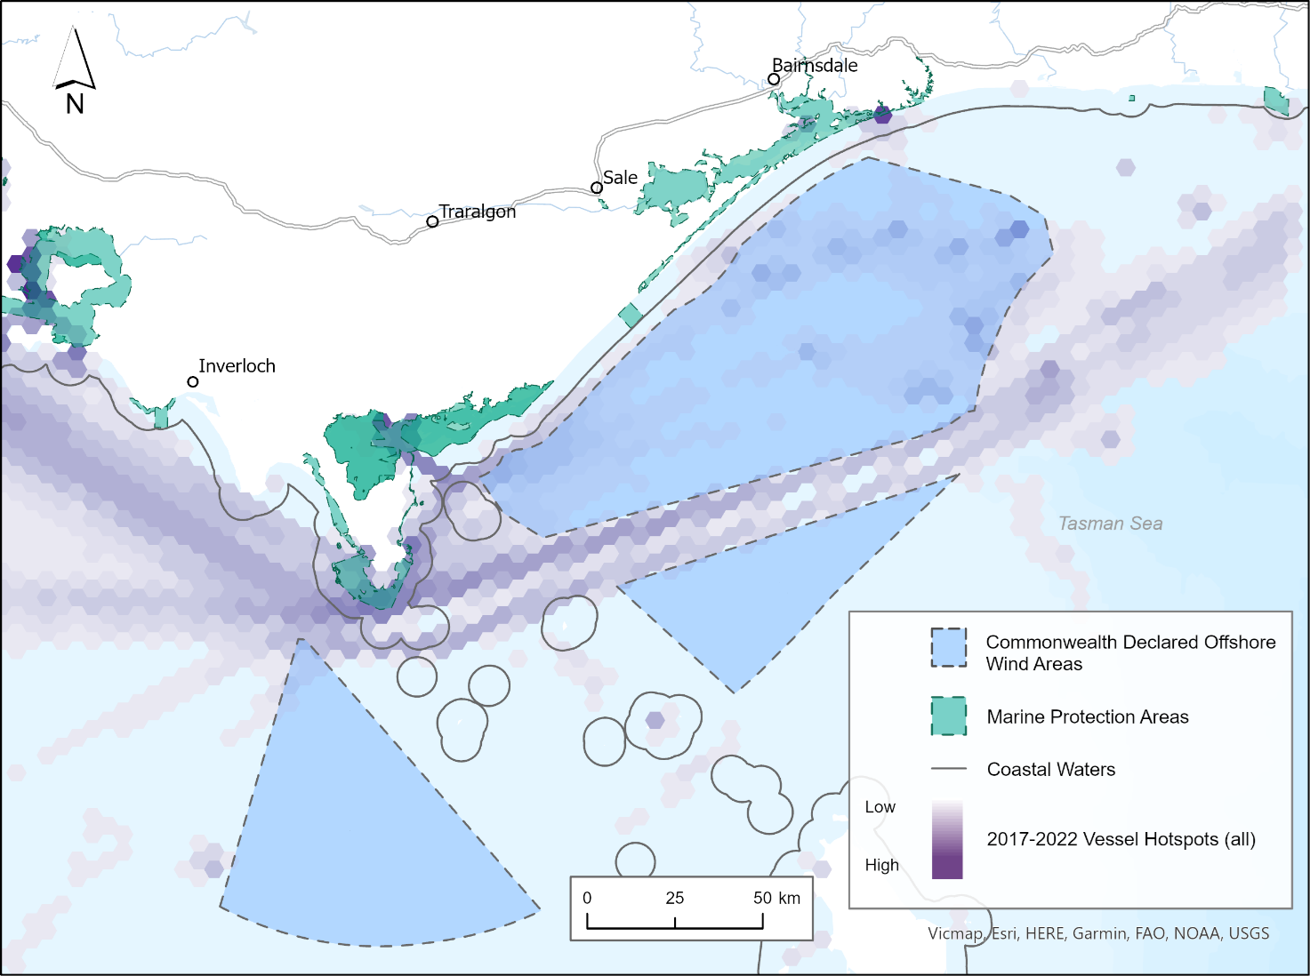

Figure 5. Example of publicly available data on marine protection areas and vessel hotspots (2017-2022) in the area and adjacent Commonwealth waters. Note: Vessel hotspots include all vessels with Automatic Identification System monitoring. The main transport route for vessels is excluded from Commonwealth Declared Offshore Wind Areas. Figures are provided for illustrative purposes, with spatial data available via [DataVic](https://www.data.vic.gov.au) for download and viewable via [CoastKit](https://www.marineandcoasts.vic.gov.au/marine-and-coastal-knowledge/coastkit).

## 4.5 Coastal infrastructure and management activities

This category focusses on development and management of coastal infrastructure such as ports and harbours, jetties, and boat ramps, as well as management activities such as marine search and rescue.

|  |  |
| --- | --- |
| Icon of a boat on a boat ramp | **Examples of available data** |
| **Coastal infrastructure and management activities** | * Port facilities * Marinas, wharfs, breakwaters, harbours, jetties, boat ramps * Coastal protection structures and assets * Coastal and marine management plans * Marine search and rescue locations |

## 4.6 Energy generation

This category focusses on the development, operation, maintenance, and decommissioning of structures and wider developments which generate energy or are related to energy generation (including anticipated development).

|  |  |
| --- | --- |
| Icon of a wind turbine | **Examples of available data** |
| **Renewables** | * Commonwealth declared offshore wind energy zones |
| **Oil and gas** | * Oil and gas platforms/facilities * Oil and gas pipelines * Petroleum wells * Offshore petroleum acreage releases * Offshore greenhouse gas acreage releases * Current titles, permits and licences |

## 4.7 Defence and national security

This category focusses on infrastructure and activities associated with defence and national security (including Commonwealth defence areas and prohibited areas).

|  |  |
| --- | --- |
| Icon of a plane | **Examples of available data** |
| **Defence and national security** | * Defence prohibited areas * Defence aviation area regulations * Airspace information |

## 

## 4.8 Research

This category focusses on activities relating to the investigation and study of the marine environment for scientific and exploratory purposes (including seismic surveys).

|  |  |
| --- | --- |
| Icon of a microscope | **Examples of available data** |
| **Research** | * Victorian Coastal Monitoring Program survey locations and sites * Research areas and sites (historical and published field studies) * Current exploratory activities (including seismic survey locations) |

## 4.9 Waste management activities

This category focusses on activities relating to the discharge of waste (for example, sewage and industrial wastewater discharge).

|  |  |
| --- | --- |
| Icon of a outflow pipe | **Examples of available data** |
| **Waste management activities** | * Historical sea dumping locations * Sewage and industrial wastewater discharge locations |

## 4.10 Extraction and disposal of non-living resources

This category focusses on extraction and disposal of non-living resources (including dredging).

|  |  |
| --- | --- |
| Icon of a spade | **Examples of available data** |
| **Extraction and disposal of non-living resources** | * Dredging operations * Dredge spoil discharge sites |

# 5 Identified data needs to aid strategic planning

This section highlights some additional data which is needed to assist future strategic planning in the Gippsland area.

Data needs were identified through an initial synthesis, utilising information from the MSP Guidelines[29], Victoria’s marine planning areas[30], conversations with rightsholders, as well as advice by Victorian government agencies and departments. The data needs identified are not exhaustive and over time these needs may change or be subject to priorities. Relevant data needs could potentially be filled by government, researchers, or industry, including offshore wind project proponents. When filling data needs, a strategic approach should be adopted. The information below is current as of June 2024.

As detailed in the MSP Guidelines[31], it is important to examine adjacent marine and terrestrial areas when undertaking strategic planning. This includes neighbouring Commonwealth waters and where resources, uses/activities, processes and/or values connect with or impact the area of interest. The extent of adjacent marine and terrestrial areas requiring consideration will depend on the characteristics of the area and activities proposed.

Additionally, the MSP Guidelines[32] recommend that once all available data has been collected, a data gap analysis is undertaken to identify data that is missing or in poor quality, and what the consequences of this could be. Another important part of the gap analysis includes an assessment of data quality (e.g., format, spatial coverage of study area, resolution, uncertainty, previous data processing), whereby available data may need to be improved or excluded upon further application. The initial data needs identified in this section can act as a starting point for any future gap analysis.

## 5.1 Traditional Owner cultural values and uses

Traditional Owner cultural values and uses, and the representation of these values as geographic information is essential to strategic planning. Traditional Owners must be fully funded to support capacity building to self-determine their roles, appropriate protocols, and processes for Indigenous Data Sovereignty and how it is embedded, and how cultural landscapes and values, and Traditional Owner rights and objectives for Country, are reflected in the process and resulting outputs.

## 5.2 Marine and coastal environment

According to data underpinning the MBV map, there are 18 FFG Act and EPBC Act listed biodiversity features of high priority for data improvement[33] within marine planning areas 6 and 7 (Table 2). It should be noted that this list is not specific to species with high conflict potential with offshore wind infrastructure or development activities. This information is current as of June 2024, with additional species data needs likely to be identified as further information (such as Traditional Owner cultural values and socio-economic values) becomes available. Note, whilst further data on the species listed in Table 2 is a priority, information on all species known to occur within marine planning areas 6 and 7 is of value.

Table 2. FFG Act and EPBC Act listed species of high priority for data improvement.

|  |  |  |  |
| --- | --- | --- | --- |
| **Common name** | **Scientific name** | **FFG Act status** | **EPBC Act listed (✔)** |
| Black-tailed godwit | *Limosa limosa* | Critically Endangered | **✔** |
| Burrunan dolphin | *Tursiops australis* | Critically Endangered | **✔** |
| Common Bent-winged Bat | *Miniopterus schreibersii* | Critically Endangered |  |
| Curlew Sandpiper | *Calidris ferruginea* | Critically Endangered | **✔** |
| Eastern Curlew | *Numenius madagascariensis* | Critically Endangered | **✔** |
| Fairy tern | *Sternula nereis* | Critically Endangered | **✔** |
| Great Knot | *Calidris tenuirostris* | Critically Endangered | **✔** |
| Grey Nurse Shark | *Carcharias taurus* | Critically Endangered | **✔** |
| Leatherback Turtle | *Dermochelys coriacea* | Critically Endangered | **✔** |
| Loggerhead sea turtle | *Caretta caretta* |  | **✔** |
| Northern royal albatross | *Diomedea sanfordi* |  | **✔** |
| Shy Albatross | *Thalassarche cauta* | Endangered | **✔** |
| Southern Right Whale | *Eubalaena australis* | Endangered | **✔** |
| Swift Parrot | *Lathamus discolor* | Critically Endangered | **✔** |
| Wandering Albatross | *Diomedea exulans* | Critically Endangered | **✔** |
| White faced storm petrel | *Pelagodroma marina* | Endangered | **✔** |
| White Shark (great) | *Carcharodon carcharias* | Endangered | **✔** |
| Wood sandpiper | *Tringa glareola* | Endangered | **✔** |

5.3 Threats and pressures

Threats, pressures, and trends of environmental indicators in response to human activities (direct or cumulative) and climate change, are important when assessing and analysing current and future characteristics of an area. Identified data needs that would help assess threats and pressures to support strategic planning include, but are not limited to:

* coastal hazard and risk projections for the open coast
* understanding of coastal change via in-depth monitoring at sentinel sites
* the ecology, sources and spatial distribution of invasive species and pests
* sources and levels of marine pollution (i.e., light, micro- and macroplastics, chemicals)
* status and trends of environmental indicators
* cumulative impacts
* species response to pressures and threats (with distribution and migration understanding above).

Additional data needs may become apparent as available data identified in Section 3.9 is investigated.

## 5.4 Economic, social, and cultural values

Data on economic, social, and cultural values and the representation of these values as geographic information is an important identified data need. Obtaining and mapping data relating to these values can support the identification of areas with high economic, emotional, cultural, or social value. Data on these values can also support social licence and may avoid late-stage conflicts and/or approval delays.

Methods to assess economic values often include cost benefit analysis, cost effectiveness analysis and environmental economic accounting. The representation of data on social and cultural values often involves proxy indicators, such as employment, to measure social impacts of human activity. Other options for data collection include stakeholder driven activities such as participatory mapping, questionnaires and/or interviews.

## 5.5 Human uses/activities

To understand existing and potential areas of spatial conflict, and cross-sectoral risks and dependencies, it is important to consider human uses/activities occurring within an area. Identified data needs on uses/activities from Section 4 have been outlined in Table 3 below. The data needs identified are not exhaustive and over time these needs may change or be subject to priorities.

Table 3. Identified data needs on human uses/activities.

|  |  |
| --- | --- |
| **Use/activity category** | **Identified data need** |
| Recreation, leisure, and tourism | Shore-based beach use intensity and frequency (spatial and temporal) |
| Recreation, leisure, and tourism | Additional dive sites/locations |
| Recreation, leisure, and tourism | Recreational usage (swimming, personal watercraft areas, sailing, kayaking, wind/kitesurfing locations) |
| Recreation, leisure, and tourism | Sporting events |
| Recreation, leisure, and tourism | Tourism boat/charter locations |
| Recreation, leisure, and tourism | Wildlife watching, photography and sightseeing locations, use, intensity, and frequency |
| Energy generation | Proposed renewable energy infrastructure locations, size, and density |
| Research | Current scientific research areas and sites |
| Research | Historical exploratory activities’ location, duration, timing, and intensity (including seismic surveys) |
| Waste management activities | Unmonitored discharge sites |

What’s next?

As the offshore wind energy industry continues to grow, the Victorian Government is committed to supporting offshore wind project developers. The Victorian Government will continue to engage with rightsholders and key stakeholders to understand more about what offshore wind developers are seeking and communicate the key pieces of information that Government can provide. This is to assist in pursuing environmental assessments, planning for feasibility activities, or aiding any future strategic planning.

# Appendix 1: Legislation, plans, strategies, and guidelines

The following list identifies some of the key legislation, plans, guidance documents, assessments and international agreements that may guide or impact planning and decision making in the marine environment, or that may set out requirements additional to those required under the *Marine and Coastal Act 2018*. This list is not exhaustive and may change as new policies and legislation are enacted or existing ones are updated. This list should be used as a guide only.

## Commonwealth

*Aboriginal and Torres Strait Islander Heritage Protection Act 1984 (Cth)*

*Australian Maritime Safety Authority Act 1990 (Cth)*

*Biosecurity Act 2015 (Cth)*

*Environmental Protection and Biodiversity Conservation Act 1999 (Cth)*

*Fisheries Management Act 1991 (Cth)*

*Maritime Transport and Offshore Facilities Security Act 2003 (Cth)*

*Native Title Act 1993 (Cth)*

*Offshore Energy Infrastructure Act 2021 (Cth)*

*Underwater Cultural Heritage Act 2018 (Cth)*

*Underwater Cultural Heritage (Consequential and Transitional Provisions) Act 2018 (Cth)*

## Statewide

### Acts

*Aboriginal Heritage Act 2006*

*Catchment and Land Protection Act 1994*

*Climate Change Act 2017*

*Crown Land (Reserves) Act 1978*

*Emergency Management Act 2013*

*Environment Effects Act 1978*

*Environment Protection Act 1970* and *Environment Protection Act 2017*

*Fisheries Act 1995*

*Flora and Fauna Guarantee Act 1988*

*Geothermal Energy Resources Act 2005*

*Heritage Act 2017*

*Land Act 1958*

*Marine Safety Act 2010*

*Mineral Resources (Sustainable Development) Act 1990*

*National Parks Act 1975*

*Offshore Petroleum and Greenhouse Gas Storage Act 2010*

*Petroleum Act 1998*

*Planning and Environment Act 1987*

*Pipelines Act 2005*

*Pollution of Waters by Oil and Noxious Substances Act 1986*

*Port Management Act 1995*

*Traditional Owner Settlement Act 2010*

*Transport Integration Act 2010*

*Water Act 1989*

*Wildlife Act 1975*

### Regulations

Aboriginal Heritage Regulations 2018

Environment Protection (Ships’ Ballast Water) Regulations 2017

Environment Protection Regulations 2021

Fisheries (Fees, Royalties and Levies) Regulations 2017

Fisheries Regulations 2019

Marine Safety Regulations 2012

National Parks Regulations 2013

Pollution of Waters by Oil and Noxious Substances Regulations 2022

Port Management (Local Ports) Regulations 2015

### International Agreements

Agreement on the Conservation of Albatrosses and Petrels 2004 (ACAP)

China-Australian Migratory Bird Agreement 1988

Convention on the Conservation of Migratory Species of Wild Animals 1983 (Bonn Convention)

Convention on Wetlands of International Importance especially as Waterfowl Habitat 1971 (Ramsar Convention)

International Convention for the Control and Management of Ships’ Ballast Water and Sediments 2004

Japan-Australia Migratory Bird Agreement 1981

Republic of Korea-Australia Migratory Bird Agreement 1986

### Policies, strategies, and assessments

Climate Change Adaptation Action Plans – Built Environment, Education and Training, Health and Human Services, Natural Environment, Primary Production, Transport, Water Cycle (*Climate Change Act 2017*)

Coastcare Strategy 2020-25

Environment Reference Standard (Environmental Protection Authority, 2017)

Fisheries Management Plans

Gunaikurnai Whole-of-Country Plan (Gunaikurnai Land and Waters Aboriginal Corporation, 2015)

Invasive Plants and Animals Policy Framework

Licensing System for Tour Operators and Activity Providers on Public Land in Victoria (Department of Environment, Land, Water and Planning, 2018)

Managing Country Together Framework 2018 (Parks Victoria, 2018)

Planning Policy Framework (including State, regional and local policies (municipal planning schemes))

Protecting Victoria’s Environment – Biodiversity 2037 (Department of Environment, Land, Water and Planning, 2017)

Recreational Boating Facilities Framework (Central Coastal Board, 2014)

Sites of Geological and Geomorphological Significance

South-east Commonwealth Marine Reserves Network management plan 2013-23 (Director of National Parks, 2013)

State Environment Protection Policies (Environmental Protection Authority)

State of the Marine and Coastal Environment Reports

State Maritime Emergencies (non-search and rescue) Plan (Emergency Management Victoria, 2016)

Victorian Aquaculture Strategy 2017 – 2022 (Department of Economic Development, Jobs, Transport and Resources, 2017)

Victorian Cetacean Emergency Plan (Department of Environment, Land, Water and Planning, 2015)

Victorian Commercial Ports Strategy (Department of Transport, 2022)

Victorian Fisheries Authority Strategic Plan 2019 – 2024

Victorian Marine Pollution Contingency Plan 1997

Victorian Offshore Wind Policy Directions Paper (Department of Environment, Land, Water and Planning, 2021)

Victorian Recreational Boating Strategy 2021 – 2030 (Department of Transport, 2021)

Victorian Traditional Owner Cultural Landscapes Strategy (Federation of Victorian Traditional Owners, 2021)

Water for Victoria – Water Plan (Department of Environment, Land, Water and Planning, 2016)

## Regional

Conservation Action Plans

Environmental Management Plans (*Marine and Coastal Act 2018*)

Estuary Management Plans

Gippsland Regional Growth Plan (Department of Transport, Planning and Local Infrastructure, 2014)

Management Plans under the *Fisheries Act 1995*, *National Parks Act 1975* and *Coastal Management Act 1995*

Port of Hastings 2018 Port Development Strategy (Port of Hastings Development Authority, 2018)

Ports Safety and Environment Management Plans, Department of Transport

Ramsar management plans

Regional and Strategic Partnership products (*Marine and Coastal Act 2018*)

Regional Catchment Strategies

Regional Climate Change Adaptation Strategies

## Local

Coastal and Marine Management Plans (*Marine and Coastal Act 2018*)

Coastal hazard risk management and adaptation planning completed as part of Victoria’s Resilient Coast – Adapting for 2100+

# Appendix 2: Tools glossary

The data sources and tools identified below are mentioned in this document, however this is not an exhaustive list of all sources and tools available.

|  |  |
| --- | --- |
| **Tool/ source** | **Details** |
| [Australian Ocean Data Network (AODN)](https://imos.org.au/facilities/aodn) | Interoperable online network of marine and climate data resources. |
| [CoastKit](https://www.marineandcoasts.vic.gov.au/marine-and-coastal-knowledge/coastkit) | Knowledge management system and interactive web-mapping portal to centralise marine and coastal data stored on DataVic. |
| [DataVic](https://www.data.vic.gov.au/) | Platform that provides access to Victorian Government open data. |
| [Data.gov.au](https://data.gov.au/home) | Central source of Australian open government data published by federal, state and local government agencies. |
| [Digital Earth Australia](https://www.dea.ga.gov.au/) | Program of Geoscience Australia creating free and open satellite data products. |
| [Features Activity Sensitivity Tool (FeAST)](https://www.marineandcoasts.vic.gov.au/marine-and-coastal-knowledge/feature-activity-sensitivity-tool) | Marine sensitivity and risk assessment tool for proposed developments and activities in Victoria’s marine and coastal areas, hosted on CoastKit. |
| [Geoscience Australia](https://www.ga.gov.au/) | Australian Government agency housing a repository for Earth science data and knowledge. |
| [NationalMap](https://www.nationalmap.gov.au/) | Online map-based tool that allows easy access to location-based data from Australian government agencies. |

# Appendix 3: Species within the area (MBV map)

It should be noted that the information below on the Marine Biodiversity Values (MBV) map is current as of June 2024. Information may change as new data becomes available.

|  |  |  |  |
| --- | --- | --- | --- |
| **Common name** | **Scientific name** | **FFG Act**  **status** | **EPBC Act listed (✔)** |
| Aldinga Pipefish | *Histiogamphelus cristatus* |  | **✔** |
| Australasian Bittern | *Botaurus poiciloptilus* | Critically Endangered | **✔** |
| Australian Fur Seal | *Arctocephalus pusillus doriferus* |  | **✔** |
| Australian Grass-wrack | *Heterozostera nigricaulis* | Endangered |  |
| Australian Grayling | *Prototroctes maraena* | Endangered | **✔** |
| Australian Gull-billed Tern | *Gelochelidon macrotarsa* | Endangered |  |
| Australian Long-nosed Pipefish | *Vanacampus poecilolaemus* |  | **✔** |
| Australian Mudfish | *Neochanna cleaveri* | Endangered |  |
| Australian Painted-snipe | *Rostratula australis* | Critically Endangered | **✔** |
| Bar-tailed Godwit | *Limosa lapponica* | Vulnerable | **✔** |
| Bigbelly Seahorse | *Hippocampus abdominalis* |  | **✔** |
| Black Bream | *Acanthopagrus butcheri* |  |  |
| Black-browed Albatross | *Thalassarche melanophris* |  | **✔** |
| Black-faced Cormorant | *Phalacrocorax fuscescens* |  | **✔** |
| Black-lip Abalone | *Haliotis rubra* |  |  |
| Blue Petrel | *Halobaena caerulea* |  | **✔** |
| Blue Warehou | *Seriolella brama* | Conservation Dependent | **✔** |
| Blue-winged Parrot | *Neophema chrysostoma* |  | **✔** |
| Broad-billed Sandpiper | *Limicola falcinellus* |  | **✔** |
| Broadnose Sevengill Shark | *Notorynchus cepedianus* |  |  |
| Brown algae | *Ecklonia radiata* |  |  |
| Brown algae | *Phyllospora comosa* |  |  |
| Brown Skua | *Catharacta skua* |  | **✔** |
| Brushtail Pipefish | *Leptoichthys fistularius* |  | **✔** |
| Bryde's Whale | *Balaenoptera edeni* |  | **✔** |
| Bullneck Seahorse | *Hippocampus minotaur* |  | **✔** |
| Burrunan dolphin | *Tursiops australis* | Critically Endangered |  |
| Campbell Albatross | *Thalassarche impavida* |  | **✔** |
| Caspian Tern | *Hydroprogne caspia* | Vulnerable | **✔** |
| Chatham Albatross | *Thalassarche eremita* |  | **✔** |
| Common Bent-winged Bat | *Miniopterus schreibersii* | Critically Endangered |  |
| Common Bottle-nosed dolphin | *Tursiops truncatus* |  | **✔** |
| Common Diving-Petrel | *Pelecanoides urinatrix* |  | **✔** |
| Common Greenshank | *Tringa nebularia* | Endangered | **✔** |
| Common Minke Whale | *Balaenoptera acutorostrata* |  | **✔** |
| Common Sandpiper | *Actitis hypoleucos* | Vulnerable | **✔** |
| Common Seadragon | *Phyllopteryx taeniolatus* |  | **✔** |
| Crested Pipefish | *Histiogamphelus briggsii* |  | **✔** |
| Crested Tern | *Thalasseus bergii* |  |  |
| Curlew Sandpiper | *Calidris ferruginea* | Critically Endangered | **✔** |
| Deepbody Pipefish | *Kaupus costatus* |  | **✔** |
| Double-banded Plover | *Charadrius bicinctus* |  | **✔** |
| Draughtboard Shark | *Cephaloscyllium laticeps* |  |  |
| Eastern Bent-winged Bat | *Miniopterus fuliginosus* | Critically Endangered |  |
| Eastern Cattle Egret | *Bubulcus coromandus* |  | **✔** |
| Eastern Curlew | *Numenius madagascariensis* | Critically Endangered | **✔** |
| Eastern Horseshoe Bat | *Rhinolophus megaphyllus megaphyllus* | Endangered |  |
| Eastern Osprey | *Pandion cristatus* |  | **✔** |
| Eastern Yellow Wagtail | *Motacilla tschutschensis* |  | **✔** |
| Fairy Prion | *Pachyptila turtur* |  | **✔** |
| Fairy Tern | *Sternula nereis* | Critically Endangered | **✔** |
| Fin Whale | *Balaenoptera physalus* |  | **✔** |
| Flesh-footed Shearwater | *Ardenna carneipes* |  | **✔** |
| Fork-tailed Swift | *Apus pacificus* |  | **✔** |
| Great Knot | *Calidris tenuirostris* | Critically Endangered | **✔** |
| Great White Shark | *Carcharodon carcharias* | Endangered | **✔** |
| Greater Sand Plover | *Charadrius leschenaultii* | Vulnerable | **✔** |
| Green Turtle | *Chelonia mydas* |  | **✔** |
| Green-lip Abalone | *Haliotis laevigata* |  |  |
| Grey Mangrove | *Avicennia marina subsp. australasica* | Endangered |  |
| Grey Nurse Shark | *Carcharias taurus* | Critically Endangered | **✔** |
| Grey Plover | *Pluvialis squatarola* | Vulnerable | **✔** |
| Grey-tailed Tattler | *Tringa brevipes* | Critically Endangered | **✔** |
| Gummy Shark | *Mustelus antarcticus* |  |  |
| Hairy Pipefish | *Urocampus carinirostris* |  | **✔** |
| Half-banded Pipefish | *Mitotichthys semistriatus* |  | **✔** |
| Hawksbill Turtle | *Eretmochelys imbricata* |  | **✔** |
| Hooded Plover | *Thinornis cucullatus* | Vulnerable | **✔** |
| Javelin Pipefish | *Lissocampus runa* |  | **✔** |
| Killer Whale | *Orcinus orca* |  | **✔** |
| King George Whiting | *Sillaginodes punctatus* |  |  |
| Knifesnout Pipefish | *Hypselognathus rostratus* |  | **✔** |
| Latham's Snipe | *Gallinago hardwickii* |  | **✔** |
| Leatherback Turtle | *Dermochelys coriacea* | Critically Endangered | **✔** |
| Lesser Sand Plover | *Charadrius mongolus* | Endangered | **✔** |
| Little Curlew | *Numenius minutus* |  | **✔** |
| Little Egret | *Egretta garzetta* | Endangered |  |
| Little Penguin | *Eudyptula minor* |  | **✔** |
| Little Tern | *Sternula albifrons* | Critically Endangered | **✔** |
| Loggerhead Turtle | *Caretta caretta* |  | **✔** |
| Long-nosed Fur Seal | *Arctophoca forsteri* | Vulnerable | **✔** |
| Magpie Goose | *Anseranas semipalmata* | Vulnerable | **✔** |
| Marsh Sandpiper | *Tringa stagnatilis* | Endangered | **✔** |
| Mollison's Pipefish | *Mitotichthys mollisoni* |  | **✔** |
| Mother-of-Pearl Pipefish | *Vanacampus margaritifer* |  | **✔** |
| New Zealand Wandering Albatross | *Diomedea antipodensis* |  | **✔** |
| Northern Royal Albatross | *Diomedea sanfordi* |  | **✔** |
| Oceanic Whitetip Shark | *Carcharhinus longimanus* |  | **✔** |
| Oriental Plover | *Charadrius veredus* |  | **✔** |
| Pacific Golden Plover | *Pluvialis fulva* | Vulnerable | **✔** |
| Pacific Gull | *Larus pacificus* |  | **✔** |
| Pectoral Sandpiper | *Calidris melanotos* |  | **✔** |
| Pied Oystercatcher | *Haematopus longirostris* |  |  |
| Plumed Egret | *Ardea intermedia plumifera* | Critically Endangered | **✔** |
| Porbeagle | *Lamna nasus* |  |  |
| Port Phillip Pipefish | *Vanacampus phillipi* |  | **✔** |
| Pugnose Pipefish | *Pugnaso curtirostris* |  | **✔** |
| Pygmy Right Whale | *Caperea marginata* |  | **✔** |
| Rainbow Bee-eater | *Merops ornatus* |  | **✔** |
| Red Knot | *Calidris canutus* | Endangered | **✔** |
| Red Pipefish | *Notiocampus ruber* |  | **✔** |
| Red-capped Plover | *Charadrius ruficapillus* |  | **✔** |
| Red-necked Avocet | *Recurvirostra novaehollandiae* |  | **✔** |
| Red-necked Stint | *Calidris ruficollis* |  | **✔** |
| Ringback Pipefish | *Stipecampus cristatus* |  | **✔** |
| Risso's Dolphin | *Grampus griseus* |  | **✔** |
| Ruddy Turnstone | *Arenaria interpres* | Endangered | **✔** |
| Ruff | *Calidris pugnax* |  | **✔** |
| Rufous Fantail | *Rhipidura rufifrons* |  | **✔** |
| Salvin's Albatross | *Thalassarche salvini* |  | **✔** |
| Sanderling | *Calidris alba* |  | **✔** |
| Satin Flycatcher | *Myiagra cyanoleuca* |  | **✔** |
| Sawtooth Pipefish | *Maroubra perserrata* |  | **✔** |
| School Shark | *Galeorhinus galeus* |  |  |
| Sea Water-mat | *Althenia marina* | Critically Endangered |  |
| Sea-Spiders | *fam. Hymenosomatidae gen. Halicarcinus* |  |  |
| Sharp-tailed Sandpiper | *Calidris acuminata* |  | **✔** |
| Short-beaked Common Dolphin | *Delphinus delphis* |  | **✔** |
| Shorthead Seahorse | *Hippocampus breviceps* |  | **✔** |
| Short-tailed Shearwater | *Ardenna tenuirostris* |  | **✔** |
| Shy Albatross | *Thalassarche cauta* | Endangered | **✔** |
| Silver Gull | *Chroicocephalus novaehollandiae* |  | **✔** |
| Smooth Pipefish | *Lissocampus caudalis* |  | **✔** |
| Smooth Stingray | *Dasyatis brevicaudata* |  |  |
| Snapper | *Chrysophrys auratus* |  |  |
| Soft-plumaged Petrel | *Pterodroma mollis* |  | **✔** |
| Sooty Oystercatcher | *Haematopus fuliginosus* |  |  |
| Sooty Shearwater | *Ardenna grisea* |  | **✔** |
| Sooty Tern | *Onychoprion fuscatus* |  |  |
| Southern Bent-winged Bat | *Miniopterus orianae bassanii* | Critically Endangered | **✔** |
| Southern Bluefin Tuna | *Thunnus maccoyii* | Conservation Dependent | **✔** |
| Southern Humpback Whale | *Megaptera novaeangliae australis* | Critically Endangered | **✔** |
| Southern Right Whale | *Eubalaena australis* | Endangered | **✔** |
| Southern Sand Flathead | *Platycephalus bassensis* |  |  |
| Spiny Pipehorse | *Solegnathus spinosissimus* |  | **✔** |
| Spotted Pipefish | *Stigmatopora argus* |  | **✔** |
| Swift Parrot | *Lathamus discolor* | Critically Endangered | **✔** |
| Terek Sandpiper | *Xenus cinereus* | Endangered | **✔** |
| Thresher Shark | *Alopias vulpinus* |  |  |
| Trawl Pipefish | *Kimblaeus bassensis* |  | **✔** |
| Tucker's Pipefish | *Mitotichthys tuckeri* |  | **✔** |
| Upside-down Pipefish | *Heraldia nocturna* |  | **✔** |
| Wandering Albatross | *Diomedea exulans* | Critically Endangered | **✔** |
| Whale Shark | *Rhincodon typus* |  | **✔** |
| Whimbrel | *Numenius phaeopus* | Endangered | **✔** |
| Whiskered Tern | *Chlidonias hybrida* |  |  |
| White winged black tern | *Chlidonias leucopterus* |  |  |
| White-bellied Sea-Eagle | *Haliaeetus leucogaster* | Endangered | **✔** |
| White-capped Albatross | *Thalassarche steadi* |  | **✔** |
| White-faced Storm-Petrel | *Pelagodroma marina* | Endangered | **✔** |
| White-throated Needletail | *Hirundapus caudacutus* | Vulnerable | **✔** |
| Widebody Pipefish | *Stigmatopora nigra* |  | **✔** |
| Wood Sandpiper | *Tringa glareola* | Endangered | **✔** |
| Yellow-bellied Sheathtail Bat | *Saccolaimus flaviventris* | Vulnerable |  |

# Appendix 4: NESP priority datasets[34]

It should be noted that the information below on the National Environmental Science Program (NESP) is current as of June 2024. Information may change as new data becomes available.

|  |  |
| --- | --- |
| **Common name** | **Scientific name** |
| **Birds, shorebirds, and seabirds** |  |
| Amsterdam Albatross | *Diomedea amsterdamensis* |
| Australian Gould's Petrel | *Pterodroma leucoptera leucoptera* |
| Curlew Sandpiper | *Calidris ferruginea* |
| Far Eastern Curlew | *Numenius madagascariensis* |
| Grey-headed Albatross | *Thalassarche chrysostoma* |
| Mongolian Lesser Sand Plover | *Charadrius mongolus mongolus* |
| New Siberian Islands Red Knot | *Calidris canutus piersmai* |
| North-eastern Siberian Red Knot | *Calidris canutus rogersi* |
| Northern Royal Albatross | *Diomedea sanfordi* |
| Orange-bellied Parrot | *Neophema chrysogaster* |
| Swift Parrot | *Lathamus discolor* |
| Shy Albatross | *Thalassarche cauta* |
| Southern Giant-Petrel | *Macronectes giganteus* |
| Tasmanian Wedge-tailed Eagle | *Aquila audax fleayi* |
| Yakutian Bar-tailed Godwit | *Limosa lapponica menzbieri* |
| **Cetaceans** |  |
| Blue whale | *Balaenoptera musculus sp.* |
| Southern right whale | *Eubalaena australis* |
| Humpback whale | *Megaptera novaeangliae* |

[**energy.vic.gov.au/offshore-wind-energy**](https://www.energy.vic.gov.au/offshore-wind-energy)



1. The State of Victoria Department of Energy, Environment and Climate Change (DEECA) (2023) Offshore Wind Energy Victoria Implementation Statement 3
2. The State of Victoria Department of Energy, Environment and Climate Action (DEECA) (2023) Marine Spatial Planning Guidelines.
3. The State of Victoria Department of Energy, Environment and Climate Action (DEECA) (2023) Victoria’s Marine Planning Areas.
4. Ibid.
5. Victorian Environmental Assessment Council (VEAC) (2019) Assessment of the Values of Victoria’s Marine Environment – Atlas, Melbourne. The VEAC is a statutory body established to conduct investigations, assessments and provide advice as requested by the Victorian Government on environment and natural land matters.
6. The State of Victoria Department of Energy, Environment and Climate Action (DEECA) (2023) Marine Spatial Planning Guidelines.
7. Ibid.
8. <https://www.energy.vic.gov.au/renewable-energy/offshore-wind-energy/regulatory-information>
9. The State of Victoria Department of Energy, Environment and Climate Action (DEECA) (2023) Victoria’s Marine Planning Areas.
10. The State of Victoria Department of Energy, Environment and Climate Action (DEECA) (2023) Marine Spatial Planning Guidelines.
11. Ibid.
12. The State of Victoria Department of Energy, Environment and Climate Action (DEECA) (2023) Victoria’s Marine Planning Areas. *Note: Section 2.2 is an excerpt from this document which was written in partnership with Traditional Owners.*
13. Department of Climate Change, Energy, the Environment and Water (2023). Guidance - Key Environmental Factors for Offshore Windfarm Environmental Impact Assessment under the *Environment Protection and Biodiversity Conservation Act 1999*.
14. Thom, B.G., Eliot, I., Eliot, M., Harvey, N., Rissik, D., Sharples, C., Short, A.D. and Woodroffe, C.D. (2018). National sediment compartment framework for Australian coastal management. Ocean & Coastal Management, 154:103-120.
15. Mazor, T., Watermeyer, K., Hobley, T., Grinter, V., Holden, R., MacDonald, K. and Ferns, L. (2023). Statewide marine habitat map. Habitat complex modelling method (CBiCS Level 3). The State of Victoria Department of Energy, Environment and Climate Action (DECCA).
16. Edmunds, M., Flynn A., Ferns, L. (2021) Combined Biotope Classification Scheme (CBiCS). A New Marine Ecological Classification Scheme to Meet New Challenges. The State of Victoria Department of Environment, Land, Water and Planning.
17. The State of Victoria Department of Energy, Environment and Climate Action (DECCA) (2023). Feature Activity Sensitivity Tool (FeAST) Guidelines.
18. The Commonwealth of Australia (2006). A Guide to the Integrated Marine and Coastal Regionalisation of Australia Version 4.0. Department of the Environment and Heritage, Canberra, Australia.
19. Edmunds, M. and Flynn, A. (2018). Victorian marine biogeographical settings, Australian Marine Ecology Report No. 559. Report to the Department of Environment, Land, Water and Planning, Melbourne.
20. Kent, J. and Jenkins, G.P. (2012) Ecological descriptions of the significant marine environmental assets of Victoria: Interim Report. Fisheries Victoria Technical Report No. 177. Department of Primary Industries, Queenscliff, Victoria, Australia.
21. DEECA (2024), Marine Biodiversity Values (MBV) Map, Marine Knowledge, Biodiversity Division, The State of Victoria Department of Energy, Environment and Climate Action.
22. To note: Of the 311 biodiversity features analysed statewide, only 263 had the minimum data requirements to be assessed in the marine planning area, therefore this sample may not be representative of the entire area.
23. [Project 3.21 - Marine and Coastal Hub (nespmarinecoastal.edu.au)](https://www.nespmarinecoastal.edu.au/project/3-21/)
24. The State of Victoria Department of Energy, Environment and Climate Action (DEECA) (2023) Victoria’s Marine Planning Areas.
25. [Coastkit@delwp.vic.gov.au](mailto:Coastkit@delwp.vic.gov.au), [Contact DataVic | data.vic.gov.au](https://www.data.vic.gov.au/contact-us)
26. Planning data/information | Justin Madex (Manager Spatial Services), justin.madex@delwp.vic.gov.au
27. Transport data/information | Dr Sheelan Vaez (Manager of Network Data and Systems), sheelan.sheikheslamivaez@roads.vic.gov.au
28. [vahr@dpc.vic.gov.au](mailto:vahr@dpc.vic.gov.au), Heritage Services (FPSR) | <https://www.firstpeoplesrelations.vic.gov.au/aboriginal-cultural-heritage>
29. The State of Victoria Department of Energy, Environment and Climate Action (DEECA) (2023) Marine Spatial Planning Guidelines
30. The State of Victoria Department of Energy, Environment and Climate Action (DEECA) (2023) Victoria’s Marine Planning Areas.
31. The State of Victoria Department of Energy, Environment and Climate Action (DEECA) (2023) Marine Spatial Planning Guidelines.
32. Ibid.
33. DEECA (2024), Marine Biodiversity Values (MBV) Map, Marine Knowledge, Biodiversity Division, The State of Victoria Department of Energy, Environment and Climate Action.
34. [Project 3.21 - Marine and Coastal Hub (nespmarinecoastal.edu.au)](https://www.nespmarinecoastal.edu.au/project/3-21/)