Choosing the right size reverse cycle air conditioner
Think carefully about what your household needs from a new reverse cycle air conditioning system. Every household is unique, and this impacts what size is appropriate.
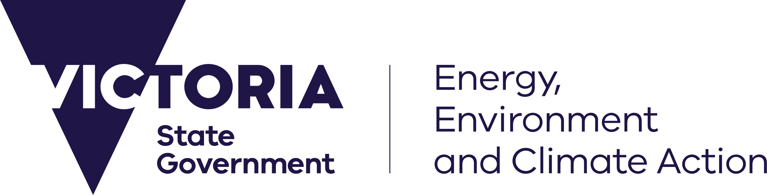
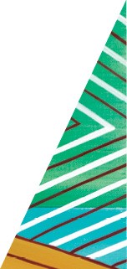
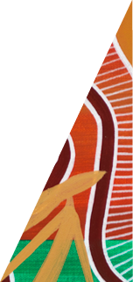
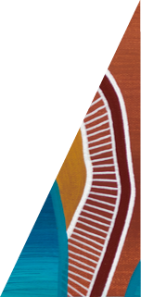
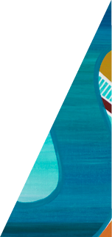
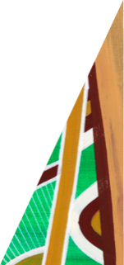
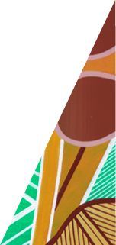
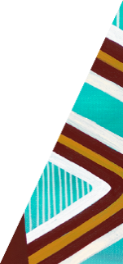
The guidance below has been developed to assist you in selecting the right size reverse cycle air conditioner to heat and cool your home.
deeca.vic.gov.au

A system that is too small may not be able to properly heat or cool your home
A system that is too large will cost more to buy and may cost more to run
The Victorian Energy Upgrades (VEU) program offers incentives for households to upgrade to reverse cycle air conditioners that can heat and cool. Only products meeting VEU program requirements can be installed. We recommend discussing sizing with your installer.
If the system you intend to install is smaller than the size recommended in this fact sheet, you may not experience the heating and cooling you want.

Types of reverse cycle air conditioners available
- Single-Split – one outdoor unit connected to one indoor unit, suitable for a single room or open plan area.
- Multi-split – one outdoor unit connected to multiple indoor units, suitable for multiple rooms or whole-of-home.
- Ducted – one central outdoor unit connected to multiple indoor rooms through ducts and vents, suitable for whole-of-home.
There is a range of systems eligible under the VEU program. Not all products are of the same quality or suitability for all households.
Remember to do your research on products and warranties as they vary between manufacturers.
Important considerations before choosing your new system
Before investing in a new system, consider the efficiency of your home. An efficient home will be easier and cheaper to heat and cool.
- Are there draughts in your home?
- Do you have standard or high ceilings?
- Are your roof, walls, and floors insulated?
- Does your room have many single glazed windows?
- How much sun or shade does your room receive?
- How is your home constructed? E.g., brick or weatherboard?
All these factors impact the amount of heating and cooling your house may need.

Which rooms need heating and cooling?
When considering a new reverse cycle air conditioner, discuss the rooms you want heated and cooled with your installer.
Ask yourself the following questions:
- What rooms do you heat or cool the most?
- What are the hottest and coldest rooms in your home?
We recommend your new system covers primary living spaces such as living rooms, lounges and open plan living areas. Also consider what rooms are covered by your existing heating or cooling.

Recommended size for your reverse cycle air conditioner
Disclaimer: Sizing any heating and cooling system should account for several factors and not only the room size in square meters. We recommend that sizing and installation is always conducted by a fully qualified technician.
The ‘size’ of a reverse cycle air conditioner refers to its heating and cooling output. Products list size in kilowatts (kW). An important factor to consider when sizing your new system is the size of the space you want to heat or cool.
The table below provides a guide to the system size you may need for a particular room size.
Table 1: Recommended size for single-split or multi-split air conditioning
Room size | Example room | Recommended heating output
Small (up to 20m²) | Bedroom, study | 2.5 to 3 kW
Medium (21-40m²) | Bedroom with ensuite, small lounge | 3 to 5 kW
Large (41-60m²) | Lounge, large kitchen | 5 to 8 kW
Very large (More than 60m²) | Open plan areas, large lounges | +8 kW

Recommended size for ducted systems
Ducted systems offer an effective way to heat and cool your entire home, however, they can be more expensive to install and run.
If you choose a ducted system, the right size can depend on several factors and should be discussed with your installer.
We recommend providing 1.1 to 1.4kW of heating output for every 10m2 of your home covered by a ducted system, depending on the individual characteristics of your home.
Zoning – We recommend zones for your ducted system. Zones allow more control over which areas of your home to heat and cool.
Ducting – Speak to your installer to ensure your new ducting is appropriately insulated and correctly sized for your heating and cooling needs.

Other considerations
Product star rating
- Reverse cycle air conditioners are star rated for both heating and cooling. The more stars a product has, the less energy it uses.
- A higher star rating for heating is the goal as Victorians typically use more energy for heating.
Noise and system placement
- Speak to your installer about noise and system placement.
- Consider the impact of noise from the indoor and outdoor components on your household and neighbours.
- Outdoor components require good air circulation to work efficiently.
Climate
- Speak to your installer about models and sizes best suited to your location.
- The amount of energy you need to heat and cool your house depends on your local climate.
Solar
- All VEU reverse cycle air conditioners are electric and can make use of electricity generated from a solar PV system.

More information about heating and cooling upgrades, sizing, and other upgrades on offer under the VEU program are available on our website:
https://www.energy.vic.gov.au/for-households/victorian-energy-upgrades-for-households/heating-and-cooling
If you have a complaint, please call
(03) 9032 1310 or email veu@esc.vic.gov.au

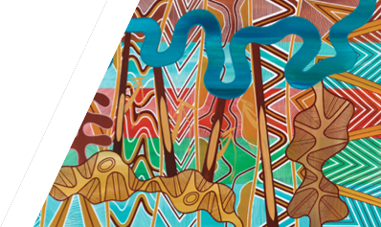
We acknowledge Victorian Traditional Owners and their Elders past and present as the original custodians of Victoria’s land and waters and commit to genuinely partnering with them and Victoria’s Aboriginal community to progress their aspirations.
© The State of Victoria Department of Energy, Environment and Climate Action 2023.
Creative Commons
This work is licensed under a Creative Commons Attribution 4.0 International licence, visit the Creative Commons website (http://creativecommons.org/licenses/by/4.0/).
You are free to re-use the work under that licence, on the condition that you credit the State of Victoria as author. The licence does not apply to any images, photographs or branding, including the Victorian Coat of Arms, and the Victorian Government and Department logos.
ISBN 978-1-76136-275-0
Disclaimer
This publication may be of assistance to you but the State of Victoria and its employees do not guarantee that the publication is without flaw of any kind or is wholly appropriate for your particular purposes and therefore disclaims all liability for any error, loss or other consequence which may arise from you relying on any information in this publication.
Accessibility
To receive this document in an alternative format, phone the Customer Service Centre on 136 186, email customer.service@delwp.vic.gov.au, or contact National Relay Service on 133 677. Available at DEECA website (www.deeca.vic.gov.au).

