Sparking Change
  - The Women in Energy Strategy
Driving significant change for women in energy through Victoria’s energy transition
Table of Contents
Publication information 4
Minister Forewords 6
Minister for Energy and Resources 6
Minister for Women and Girls 8
Acknowledgement of Country 10
Women and the Victorian energy workforce 12
Overview 13
Introduction 14
The Women in Energy Strategy 17
Women in Energy Strategy framework 20
Our approach 22
Victoria’s renewable energy transition and workforce needs 26
The Victorian Energy Jobs Plan 27
The energy sector in the Victorian Energy Jobs Plan 30
Future opportunities for women in Victoria’s energy workforce 34
Focus area 1: Attracting women to the energy sector 36
Women in the energy workforce 36
Opportunities to engage women 39
Meeting the challenge 48
Focus area 2: Ensuring women can access and complete education and training 51
Challenges in building capability 51
Opportunities for change 56
Meeting the challenge 60
Focus area 3: Ensuring women can enter and thrive in the workforce 64
Barriers to gaining employment 64
Regional and rural barriers 65
Barriers to advancement and retention 66
Opportunities to affect workplace change 71
Women in Energy and Manufacturing funding program 80
Meeting the challenge 87
Oversight and monitoring 91
Endnotes 92

Publication information

Acknowledgement of Victorian Traditional Owners
We acknowledge and respect Victorian Traditional Owners as the original custodians of Victoria’s land and waters, their unique ability to care for Country and deep spiritual connection to it.
We honour Elders past and present whose knowledge and wisdom has ensured the continuation of culture and traditional practices.
DEECA is committed to genuinely partnering with Victorian Traditional Owners and Victoria’s Aboriginal community to progress their aspirations.

Copyright
© The State of Victoria Department of Energy, Environment and Climate Action, May 2026.

Creative Commons
This work is licensed under a Creative Commons Attribution 4.0 International licence, visit the Creative Commons website.
You are free to re-use the work under that licence, on the condition that you credit the State of Victoria as author. The licence does not apply to any images, photographs or branding, including the Victorian Coat of Arms, and the Victorian Government and Department logos.
ISBN 978-1-76176-873-6 (print)
ISBN 978-1-76176-874-3 (pdf/online/MS word)

Disclaimer
This publication may be of assistance to you but the State of Victoria and its employees do not guarantee that the publication is without flaw of any kind or is wholly appropriate for your particular purposes and therefore disclaims all liability for any error, loss or other consequence which may arise from you relying on any information in this publication.

Accessibility
To receive this document in an alternative format, phone the Customer Service Centre on 136 186, email customer.service@delwp.vic.gov.au, or contact National Relay Service on 133 677 or visit http://www.accesshub.gov.au/. Available at DEECA website (www.deeca.vic.gov.au).

Minister Forewords

Minister for Energy and Resources
Victoria’s energy transition is one of the most significant economic and industrial shifts of our time. As we move towards a cleaner, more sustainable future, we have an unprecedented opportunity to ensure that women share in the benefits of this transformation. The transition to renewable energy will create thousands of jobs across the state, and we must take deliberate action to ensure that women, particularly those in regional areas and from diverse backgrounds, share equitably in these opportunities.
The energy sector has long been male-dominated, contributing to gender pay gaps and limited career pathways for women. This Strategy is about changing that. The Victorian Women in Energy Strategy recognises that the shift to renewable energy is not just about technology – it is about people. If we are to meet the workforce needs of the energy transition, we must tap into the full potential of our community, ensuring that women and girls see a future for themselves in this growing industry.
This means tackling the barriers that have historically limited women’s participation, including access to training, career pathways, and leadership roles. It also means supporting First Nations women and regional women to ensure that the benefits of the renewable energy boom are felt across the state. Education and training providers play a key role in building this diverse workforce, ensuring that students – regardless of gender – are equipped with the skills needed for the future energy workforce.
The Victorian Energy Jobs Plan provides projections of energy workforce demand and identifies potential opportunities across a broad range of occupations as the energy industry changes and grows. It provides a framework for coordination across government, the energy industry and the education and training sector to develop the workforce we need for the energy transition. Through initiatives like the National Training Centre in New Energy Skills, we are creating pathways that will connect women with new and emerging opportunities in renewable energy, from large-scale energy generation and decentralised electricity grids to household renewables and energy efficiency solutions. These initiatives, alongside the efforts of government, industry, unions, and education providers, will help break down gender segregation in the energy sector and ensure that women are leading across many aspects of the energy transition – not just participating in it.
Victoria has already made significant progress in advancing gender equality, but there is still more work to do. By embedding gender equity in every stage of the energy transition, we can create a sector that is fairer, more diverse, and better positioned to meet the challenges of the future. The Victorian Government is committed to leading the way, ensuring that as we build a cleaner energy system, we also build a more inclusive workforce.
Together, we have a once-in-a-generation opportunity to reshape our energy sector and set the right foundations for the future. By taking action now, we can ensure that the jobs, skills, and opportunities of tomorrow are open to all Victorians – especially women.
The Hon. Lily D’Ambrosio MP
Minister for Energy and Resources
Minister for the State Electricity Commission

Minister for Women and Girls
Victoria leads the nation when it comes to clean energy – resulting in a huge demand for skilled workers in the sector. Yet the well-paid, interesting jobs available are largely dominated by men. On top of that, we know that women often feel less satisfied in their careers in energy. This Women in Energy Strategy presents the genuine opportunity to bring together our nation-leading work on gender equality with the bold technological and workforce transformation in the energy sector. The energy transition is an enormous opportunity to improve the experience of women working in industries and jobs largely occupied by men.
The size and scale of the energy transition is driving demand for workers and skills across many energy sectors and professions. For a successful energy transition, we must upskill, train and educate Victoria’s energy workforce, encouraging and supporting those who may not have otherwise joined the sector. Promoting gender equality and enabling women’s full participation will also address the need for more skilled workers to support Victoria’s energy transition.
This strategy clearly sets out the challenge for government, the energy sector and educational institutions and the role we can all play in ensuring women are attracted to the sector, can access and complete required education, and have opportunities to work and succeed in the energy sector.
In August 2023, the Victorian Government launched Our equal state: Victoria’s gender equality strategy and action plan 2023–2027. Our equal state is Victoria’s second gender equality strategy, following the conclusion of Safe and Strong 2016–2021. It is also Victoria’s first State Gender Equality Action Plan, as required under the Gender Equality Act 2020.
Improving gender equality in the energy sector is one of the actions in Our equal state. It also supports us to reduce the economic strain felt by women as we continue to implement the recommendations handed down by the Inquiry into economic equity for Victorian women. Sparking change is one of a number of targeted strategies from the Victorian Government to boost women’s participation in male-dominated industries, including the Women in Transport Strategy, Building Equitable Futures Strategy for Women in Construction and Making it equal: Victoria’s women in manufacturing strategy.
Our equal state takes a life-stage and intersectional approach to advancing gender equality in Victoria. It recognises gender gaps exist at all stages of life and that gender inequality is compounded by intersecting attributes, such as living regionally or having a culturally or linguistically diverse background. Further research on intersectionality is also needed to ensure greater workforce participation for all women and gender-diverse people.
I am excited to work in partnership with the energy sector to support a cleaner, renewable future where women share equally in the economic opportunities it provides – and take their place in leading the transformation of our State.
Gabrielle Williams MP
Minister for Women and Girls

Acknowledgement of Country
The Victorian Government acknowledge and respect Victorian Traditional Owners as the original custodians of Victoria’s land and waters, their unique ability to care for Country and deep spiritual connection to it.
The Victorian Government honour Elders past and present whose knowledge and wisdom have ensured the continuation of culture and traditional practices.
The Victorian Government is committed to enabling the self-determining rights of First Peoples and their decisions to participate in Victoria’s energy transition and our growing energy workforce.

Terminology
Traditional Owner is an Aboriginal and/or Torres Strait Islander person who has traditional connections to an identified geographical area of Country.
A Traditional Owner Corporation is an incorporated group that represents the interests of Traditional Owners in a particular area. In Victoria they may hold rights under the Native Title Act 1993 (Cth), Aboriginal Heritage Act 2006 (Vic) or Traditional Owner Settlement Act 2010 (Vic) on behalf of the Traditional Owners they represent, or they may have no formal agreements in place.
For the Women in Energy Strategy, the terms ‘First Peoples’ and ‘First Nations’ are used to refer to all Traditional Owners and other Aboriginal and Torres Strait Islanders living in Victoria. This acknowledges that Aboriginal and Torres Strait Islanders from other parts of Australia move to Victoria for study and employment opportunities.
Other terms such as ‘Koori’ and ‘Indigenous’ are retained where they refer to names of programs, initiatives, publication titles and in reference to published data.
Gender refers to a person’s own concept of who they are and how they interact with other people. A person’s gender may or may not exclusively correspond with their assigned sex at birth. While many people understand their gender as being a man or a woman, others understand gender as a combination of these or neither. Our gender equity approach includes trans and gender-diverse people and we recognise that gender inequality can be experienced in different ways.

Women and the Victorian energy workforce
The Victorian energy sector is growing.
The workforce will increase by 53% from 45,000 FTE workers in 2026 to 68,000 FTE workers in 2040.
Women’s representation is low and uneven across the top occupations needed for the energy sector.
In 2026, women make up 26% of the occupations needed in Victoria’s energy workforce:
- 73% of Clerical and Administrative Workers
- 1% of Airconditioning and Refrigeration Mechanics
- 2% of Electricians
- 1% of Plumbers
13% of Engineering Professionals
Victoria can grow its skilled workforce and create an energy sector where women can participate fully and equitably.
Please note, the percentage of women in each occupation relates only to sectors with available occupation data (see Endnote 1). Further, the percentage of women in each occupation measures all workers in Victoria, including the energy sector and other sectors.

Overview
As the energy transition accelerates, we face both a skills challenge and a significant opportunity to ensure women, including those from regional and diverse backgrounds, share in the transition’s benefits.
The Women in Energy Strategy calls on government, industry, and education and training providers to work together to ensure women’s full and equitable participation in the work and training opportunities in Victoria’s growing renewable energy sector.

Introduction
Victoria’s once-in-a-generation renewable energy transition presents a prime opportunity to attract women to the energy sector
The way we use, store, generate and move energy in Victoria is rapidly changing. If the Victorian Government and community, industry, and education and training sectors act now, the renewable energy transition can serve as a catalyst to reshape energy workforce culture and drive significant change for women in the energy sector.
The scale and speed of the energy transition will require a large increase in workers across the energy sector and in many occupations. Importantly, workforce forecasts and stakeholder engagement indicate the current workforce must expand significantly to meet future demand which, if not met, could impact the energy transition and our renewable energy targets. The size of Victoria’s energy workforce needs to grow. Around 68,000 FTE workers will be needed in 2040, an increase of 53% from the 2026 level.
The energy workforce is highly skilled, with most roles requiring post-secondary qualifications. By 2040, approximately 48% of workers will need vocational education and training (VET) at the Certificate IV to associate degree level, while 40% will require a bachelor degree or higher qualification.
These qualifications support occupations that span a diverse range of technical, trades-based and professional roles, including electricians, plumbers, metal fitters and machinists, architectural, building and surveying technicians, electrical engineers, environmental scientists, architects and landscape designers.
Building workforce capacity and capability in the energy sector presents a valuable opportunity to attract underrepresented groups, particularly women. Currently in Victoria, women make up only 26% of workers in the occupations required for the energy sector workforce. In addition to being underrepresented, women face challenges such as pay inequity, occupational gender segregation, and specific barriers to participation – such as discrimination due to cultural background or age, lack of suitable facilities or flexible work options.

Benefits of an inclusive and gender balanced energy workforce
- A greater pool of talent to draw on, meaning more skilled workers to fill industry vacancies
- Better organisational performance resulting from a diverse workforce
- A sustainable workforce with less staff turnover as a result of a more inclusive workplace culture
- Enhanced visibility of women working in careers that are male-dominated
A just and fair transition that produces benefits all women will share in

What the Women in Energy Strategy means for our partners

Victorian community
Enhance the community and individuals’ understanding of the:
- Opportunities for women to work in the energy industry
- Actions being taken to enhance education and employment pathways for women
Ways to challenge entrenched stereotypes to enable women to thrive in a currently male-dominated industry.

Energy Industry
Enhance employment pathways and education offerings for women through:
- Clear expectations on developing diverse and equitable workplaces
- Opportunities for linking with education and training institutions
Boosting the visibility of women in the industry, energy industry pathways and leadership opportunities.

Education and training sector
Improve education offerings and workforce skills for women through:
- Clear expectations on improving flexibility, culture and accessibility
- Opportunities to work with industry to develop new courses and enhance continuous learning opportunities
- Supporting promotion of energy industry career pathways to women and girls.

Governments
Drive improvements for women in the energy sector through:
- Supporting coordination between the community, the education and training sector and industry
- Leading as an employer and through procurement and funding
- Opportunities to align promotion of the energy industry to women.

The Women in Energy Strategy
The Women in Energy Strategy is designed to support the full and equitable participation of women in the jobs and training opportunities emerging from Victoria’s renewable energy transition. It focuses on delivering outcome-oriented actions to address barriers and promote inclusion.
It calls on the energy industry, education and training sector, governments, and other stakeholders to work together to address the following problems:
- the need for more skilled workers to support Victoria’s renewable energy transition
- women not sharing equitably in the opportunities in the energy sector
the energy sector missing out on the benefits of a diverse workforce.
Resolving these challenges is complex, and includes structural and cultural barriers that can deter or prevent women from pursuing a career in the energy sector. This Strategy focuses on addressing bias in career choice, making improvements to women’s participation levels as the sector transitions, and tackling fundamental barriers in the workplace. It recognises that changes to the system rather than individuals will sustain progress, as well as acknowledging the important role of government in driving improvements for women in the sector. Barriers may be faced across key stages of the energy career pathway: attraction, education and training, and entering and thriving in the workplace.
Addressing barriers at these key stages will enable women to share in the benefits of the growing energy workforce and open up opportunities for both women and the broader Victorian community. Alignment with the Victorian Government’s gender equality strategy
The Women in Energy Strategy is part of a broader work program to achieve gender equality in Victoria, through Our equal state: Victoria’s gender equality strategy and action plan, alongside Victoria’s Gender Equality Act 2020. This Act requires the Victorian public sector, local councils and universities to take action to make workplaces more equitable for women, and to consider strategies to enhance gender equity through their policies, programs and services. Although Victoria’s Gender Equality Act 2020 does not extend to the private sector,
where most energy jobs exist, it does apply to Victorian Government energy agencies (such as Energy Safe Victoria, the Essential Services Commission, Solar Victoria, Vic Grid and the Department of Energy, Environment and Climate Action) and sets a benchmark for the wider sector to aim for.
Developing the Women in Energy Strategy is an action under Our equal state. Additionally, the Women in Energy Strategy has been prepared in response to recommendation 19 of the Inquiry into economic equity for Victorian women, which recommends that new strategies are implemented to attract, recruit and retain women in majority-men industries. It also builds on the success of other Victorian Government strategies that aim to increase women’s participation in male-dominated industries, including:
- the Women in Transport Strategy 2021–2024
- the Building Equitable Futures Strategy 2024–32: Women in Construction
- Making it equal: Victoria’s women in manufacturing strategy.

The Victorian Energy Jobs Plan
The Women in Energy Strategy is closely aligned to the Victorian Energy Jobs Plan to help ensure women can share equitably in the opportunities as the sector and its workforce develops.
The Victorian Energy Jobs Plan seeks to support Victoria’s energy transition by mobilising the workforce and growing investment confidence. It aims to support the development of a skilled and diverse workforce capable of meeting the evolving demands of the energy sector. The Plan contains detailed information on the workforce needed for the energy transition and the projections for jobs and training needed.
The two initiatives are complementary and were developed in parallel, with all actions in the Women in Energy Strategy contained in the Victorian Energy Jobs Plan. This integration ensures gender considerations are embedded across the Plan’s initiatives, enabling consistent and coordinated implementation and monitoring.
The Victorian Energy Jobs Plan and Women in Energy Strategy align with the Victorian Government’s Clean Economy Workforce Development Strategy 2023–33, Cheaper, Cleaner, Renewable: Our Plan for Victoria’s Electricity Future, Economic Growth Statement – Victoria: Open for Business, and the Victorian Skills Plan.

Women in Energy Strategy framework
The Women in Energy Strategy brings together the energy sector’s workforce needs and gender equality policy, highlighting actions across the focus areas of attraction, education and the workplace.
Diagram 1: Women in Energy Strategy framework
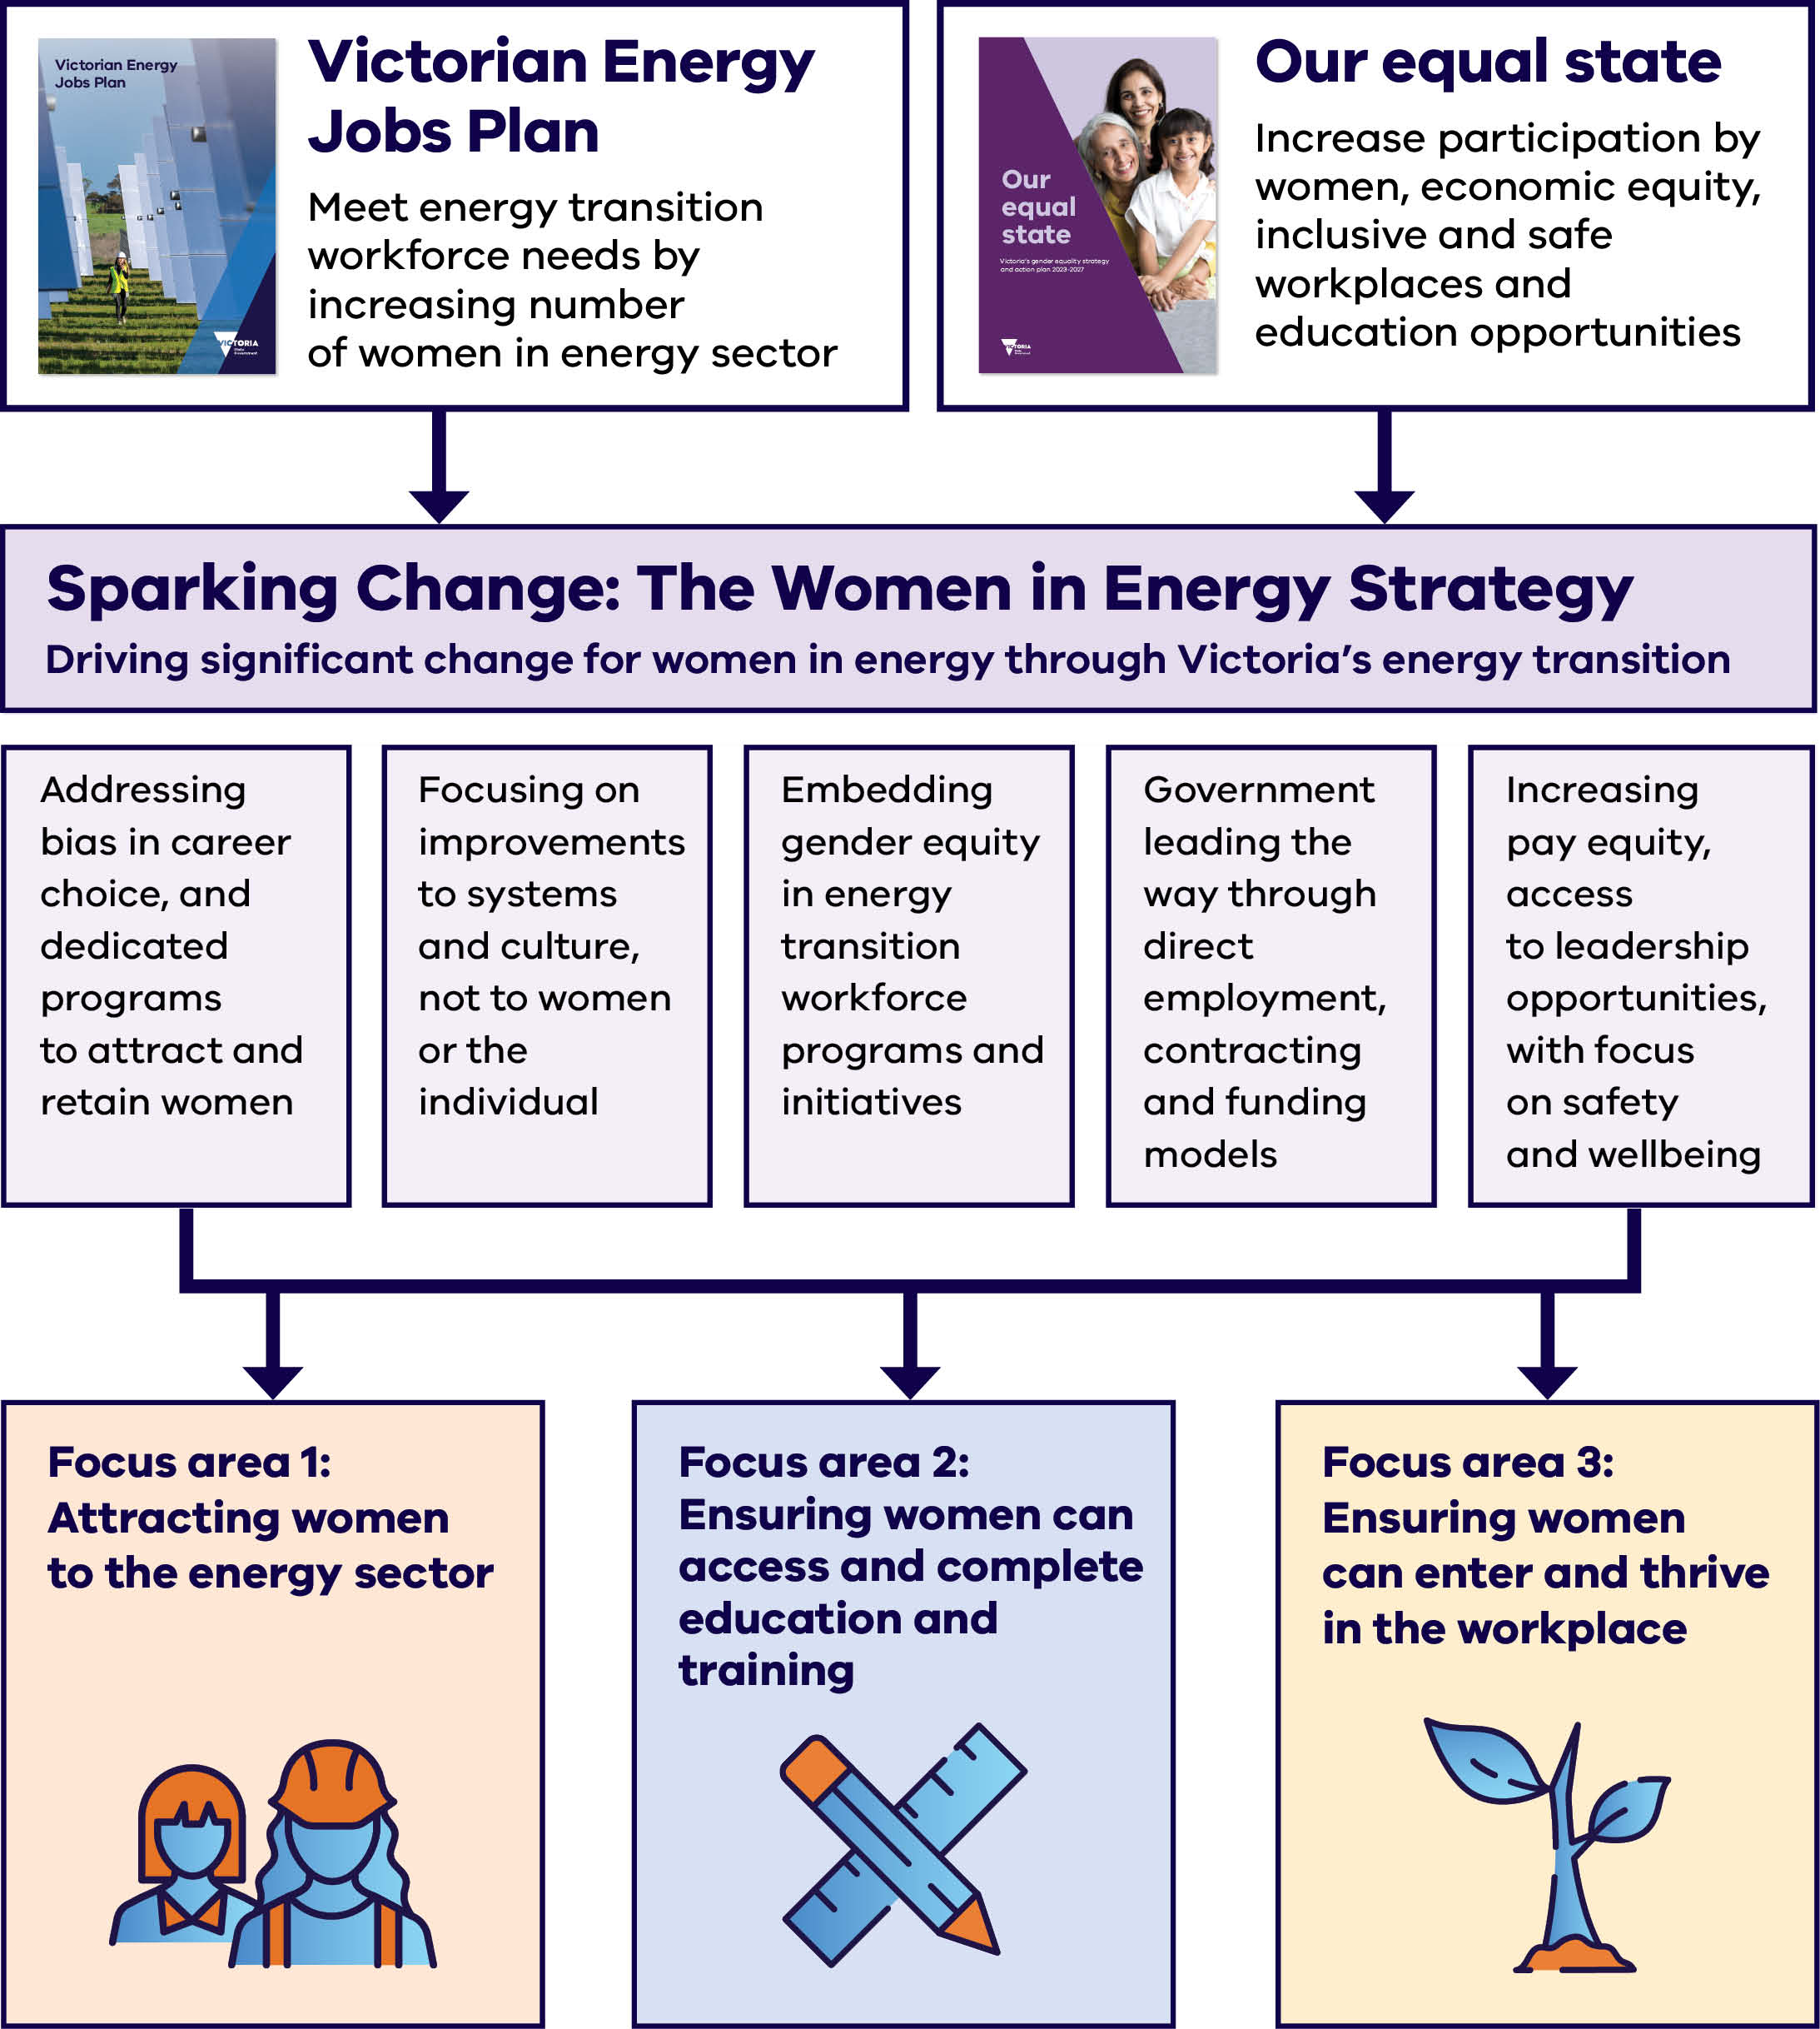
The Women in Energy Strategy framework detailed in Diagram 1 shows how two Victorian strategies come together in the Women in Energy Strategy, which is delivered through five approaches and three focus areas.
The framework draws on two Victorian strategies:
- Victorian Energy Jobs Plan – meet energy transition workforce needs by increasing the number of women in the energy sector.
Our equal state (Victoria’s gender equality strategy and action plan 2023–2027) – increase participation by women, economic equity, inclusive and safe workplaces, and education opportunities.
These come together in Sparking Change: The Women in Energy Strategy, which drives significant change for women in energy through Victoria’s energy transition. The Strategy’s approach focuses on:
- Addressing bias in career choice, and dedicated programs to attract and retain women.
- Focusing on improvements to systems and culture, not to women or the individual.
- Embedding gender equity in energy transition workforce programs and initiatives.
- Government leading the way through direct employment, contracting and funding models.
Increasing pay equity and access to leadership opportunities, with a focus on safety and wellbeing.
The Strategy is delivered through three focus areas:
- Focus area 1: Attracting women to the energy sector.
- Focus area 2: Ensuring women can access and complete education and training.
Focus area 3: Ensuring women can enter and thrive in the workplace.

Our approach
The Women in Energy Strategy has been informed by extensive consultation, research, data modelling, and analysis. The engagement process ensured stakeholder and rightsholder views and ideas informed the work, through direct engagement and a consultation paper.
The Victorian Government took a comprehensive approach, engaging across the energy industry as well as the education and training sectors. This Strategy has also drawn on consultation undertaken for the Making it equal: Victoria’s women in manufacturing strategy.
What we heard
Prominent themes we heard through engagement for the Women in Energy Strategy included the need to:
- Raise awareness of renewable energy careers and education pathways
- Increase workforce participation of underrepresented groups, including women and First Peoples
- Increase availability of skilled, high‑quality trainers
- Intervene throughout the entire career pathway, including attraction, recruitment, retention and advancement, to increase women’s participation
- Increase efforts to improve gender equality outcomes focusing on structural change.
Workforce projections reflected in this Strategy, and in greater detail in the Victorian Energy Jobs Plan, offer valuable insights into the future energy sector workforce, including its size, composition, skills, and occupational requirements. The Victorian Government partnered with the RACE for 2030 Cooperative Research Centre and the University of Technology Sydney (UTS) to develop workforce projections, establishing a new baseline of information for Victoria with an outlook to 2040. The workforce projections have been developed by the Institute for Sustainable Futures at UTS and are an input into the Victorian Energy Jobs Plan, along with other data and analysis.
The data insights in this Strategy are a snapshot in time, setting the groundwork for an improved understanding of Victoria’s energy workforce and new data products to be developed over coming years.
Drawing on this evidence base, three focus areas vital for driving women’s full and equal participation in the renewable energy transition were identified.

Focus areas
- Attracting women to the energy sector
- Ensuring women can access and complete energy-related education and training
- Ensuring women can thrive within the energy workforce
These focus areas were used to identify eight aligned outcomes, with associated actions that will drive their achievement. These actions will be measured through progress reports. The close alignment of the Women in Energy Strategy with the Victorian Energy Jobs Plan reflects the importance of embedding gender equity in development of the workforce to drive significant change.
Attracting women to, and retaining them in, the energy workforce, will require coordination and collaboration between education and training providers, the energy industry, and the Victorian Government.

Focus on structural barriers
Women’s participation in the energy sector is influenced by both cultural and structural factors.
Structural barriers are created by systems, policies (e.g. the amount of flexibility in work location and hours) and organisational structures, while cultural barriers arise from differing values, beliefs or norms. This Strategy is primarily focused on redressing structural and cultural barriers in preference to changing individual community members or their approach to overcoming challenges.
The Victorian Government recognises it can make a substantive impact to women’s participation by focusing on structural barriers within its control, to affect positive culture change. Addressing these barriers will help enable more women to enter the energy workforce and take on leadership roles.

Gender equity or equality?
In this Strategy gender equality refers to an outcome or ‘end state’ where women, men and gender-diverse people are equal in status, rights and access to opportunities.
Gender equity is the process to achieve gender equality. It recognises that different genders have different needs and may face unique challenges. By addressing these specific needs and challenges, gender equity aims to remove barriers and create more balanced access to opportunities for all genders.
This Strategy takes a gender equity approach, recognising that pre-existing gender disparities within the energy sector must be addressed and the specific challenges and needs of women should inform targeted interventions and training.

People experience inequality in different ways
Gender inequality can be compounded by intersecting forms of discrimination and disadvantage. This may include a person’s ethnicity, age, disability, sexual orientation, gender identity, race, religion or other attributes.
An intersectional approach recognises that the causes of disadvantage or discrimination do not exist independently but intersect and overlap with gender inequality. This can magnify and increase the complexity of actions required to address the inequality.
The Victorian Government recognises and celebrates diversity and acknowledges the importance of addressing compounding barriers and issues that perpetuate inequality.
Through the implementation of this Strategy, the Victorian Government seeks to better understand the impact of intersectionality.

Gender norms and stereotypes
This Strategy is set in the context of broader Victorian society, where gender social norms – the often-unwritten rules and expectations about how people should behave based on their gender – are still prevalent. Gender stereotypes refer to simplified and often exaggerated beliefs about characteristics attributed to a specific gender.
Gender norms and stereotypes can impact the way individuals are viewed within broader society and the workplace, the career that they choose, and whether they choose (or can choose) to relocate for work, or have breaks in their working life. This Strategy aims to consider the unique and diverse experiences of women, including women who are burdened with greater caring and household labour responsibilities and require flexibility in the workplace.
Targeted interventions that aim to address structural and cultural barriers are a vital starting point for changing beliefs about women and their capabilities, both within the energy sector and broader society.

Victoria’s renewable energy transition and workforce needs
The Victorian Government has set ambitious renewable energy targets, supporting an overarching target of economy-wide net zero emissions by 2045.
Victoria’s future energy workforce needs – including how many workers, which occupations and skills are needed, and where in Victoria activity will be located – have been developed and mapped as workforce projections for the next 15 years within the Victorian Energy Jobs Plan.

The Victorian Energy Jobs Plan
The Victorian Energy Jobs Plan sets out a detailed view of the workforce needed for the Victorian renewable energy transition.
Victoria has already made substantial progress towards its renewable energy and storage targets. These targets include 95% renewable energy, at least 6.3 gigawatts (GW) of energy storage capacity by 2035 and at least 9 gigawatts (GW) of offshore wind by 2040. These targets support an overarching target of economy-wide net zero emissions by 2045.
The rapid growth of the renewable energy sector in Victoria has significantly increased the demand for workers. The expansion of renewable energy generation, transmission, distribution and storage infrastructure, as well as the planned increase in the use of efficient electric appliances and roll-out of zero emissions vehicle (ZEV) infrastructure, has coincided with a tight labour market and historically high employment levels.
The insights and analysis on the Victorian energy sector and its changing workforce provides a strong base on which opportunities and challenges for women entering and staying in the energy sector can be identified. Workforce projections for Victoria’s energy sector show the breadth of energy activities and jobs. These projections include analysis of occupations, education categories and workforce demographics.
See the Victorian Energy Jobs Plan for more information on the workforce needed for Victoria’s energy transition
energy.vic.gov.au/renewable-energy/our‑energy-workforce

There are opportunities for women across the energy sector
The Victorian Energy Jobs Plan sets out demand for workers across Victoria’s energy sector between 2026 and 2040 by sector, activity, occupation and location, highlighting projected job opportunities across Victoria.
The Plan provides workforce projections and analysis of sectors, as shown in Figure 2. It includes electricity generation, electricity networks, utility‑scale energy storage, enabling functions like energy retail, distributed energy resources like rooftop solar and distributed batteries, zero emissions vehicles infrastructure, and energy efficiency across residential, commercial, industrial, and agricultural settings.
With each sector projected to experience increased workforce demand through to 2040, there are potential job opportunities for women across the energy workforce.
The circular economy, manufacturing, supply chains, and some technologies that are still emerging or maturing in Victoria are not the focus of modelling undertaken for the Victorian Energy Jobs Plan and Women in Energy Strategy. However, they remain significant areas of interest, since they represent potential areas of job growth and opportunity in the future.

Demand for workers is projected to increase for a wide range of occupations
Technicians and trades workers, including electricians, plumbers, and airconditioning and refrigeration mechanics, are projected to continue to be the most in-demand occupations in the modelled energy sector between 2026 and 2040. This is followed by professionals, including engineers, information and organisation professionals, and business and systems analysts, and programmers, as well as managers such as ICT managers, business administrative managers, and construction, distribution and production managers.
Figure 1: Workforce projected for the energy sector by ANZSCO major groups between 2026 and 2040
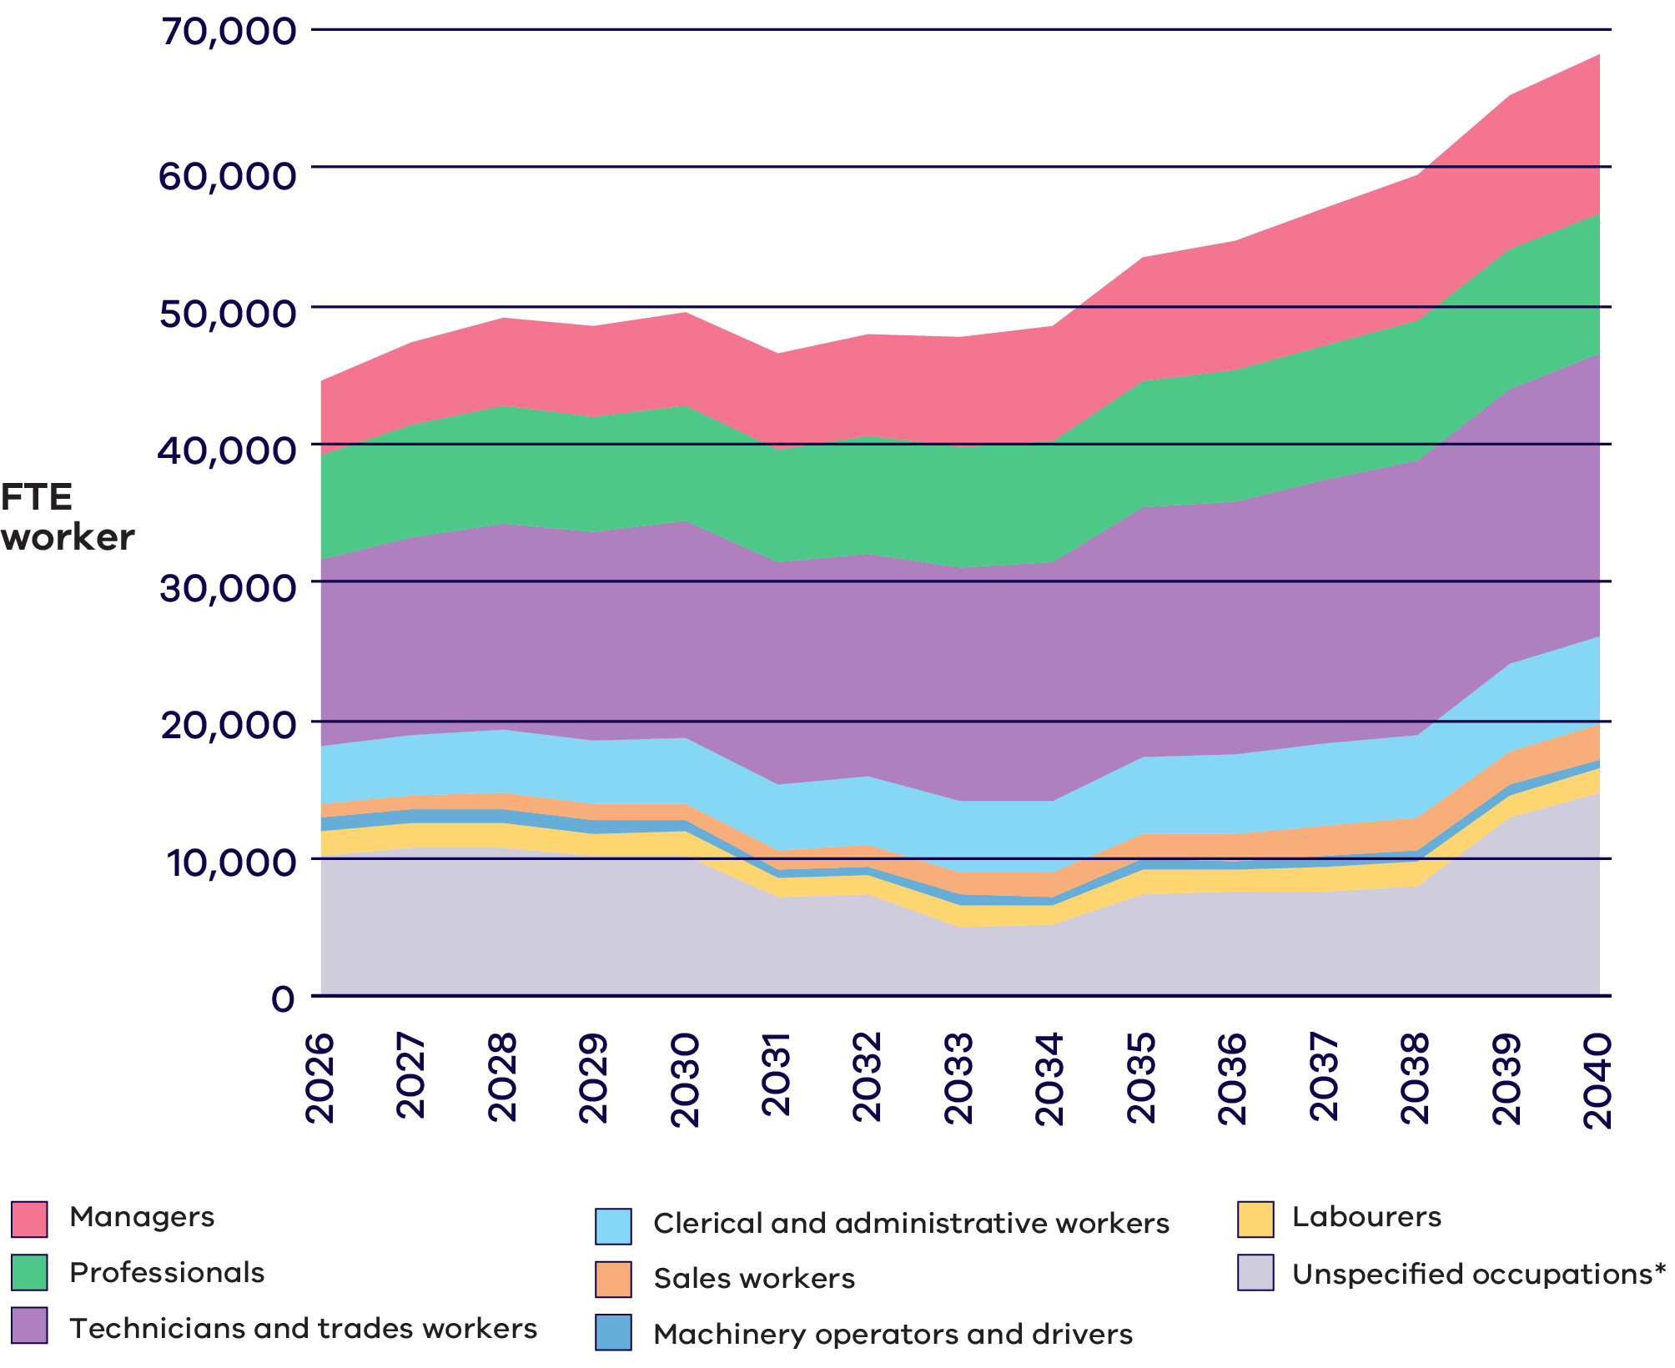
*Note: The energy sector workforce in Figure 1 includes all the energy sectors that comprise the Victorian energy sector. Occupational information is available for 53,300 FTE of the 68,100 FTE workers projected for 2040. ‘Unspecified occupations’ includes the remaining 14,800 FTE workers that could not be allocated to a specific ANZSCO major group due to limitations in the available occupational data, including residential energy efficiency, commercial, industrial, agricultural and forestry electrification and energy efficiency, hydrogen vehicle refuelling infrastructure and construction of gas powered generation workforces that cannot currently be disaggregated by ANZSCO classification.

The energy sector in the Victorian Energy Jobs Plan
Figure 2: Energy sectors included in the Victorian Energy Jobs Plan and potential careers
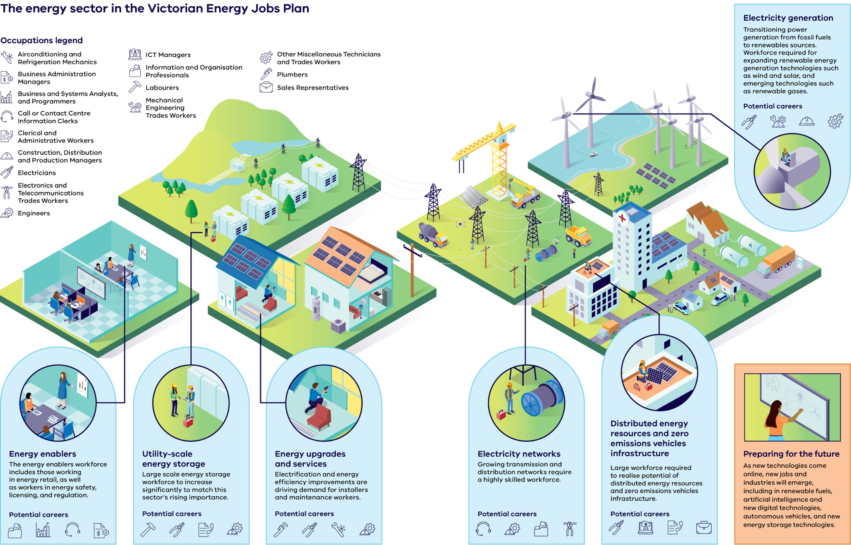
Energy sectors in the Victorian Energy Jobs Plan and example workforce needs as shown in Figure 2
Energy sector | Description | Potential careers
Electricity generation | Transitioning power generation from fossil fuels to renewable sources. Workforce required for expanding renewable energy generation technologies such as wind and solar, and emerging technologies such as renewable gases. | - Electricians  - Mechanical Engineering Trades Workers  - Construction, Distribution and Production Managers  - Other Miscellaneous Technicians and Trades Workers
Energy enablers | The energy enablers workforce includes those working in energy retail, as well as workers in energy safety, licensing and regulation. | - Labourers  - Electricians  - Clerical and administrative workers  - Engineers
Utility-scale energy storage | Large-scale energy storage workforce to increase significantly to match this sector’s rising importance. | - Plumbers  - Electricians  - Airconditioning and refrigeration mechanics  - Engineers
Energy upgrades and services | Electrification and energy efficiency improvements are driving demand for installers and maintenance workers. | - Plumbers  - Electricians  - Airconditioning and refrigeration mechanics  - Engineers
Electricity networks | Growing transmission and distribution networks require a highly skilled workforce. | - Call or Contact Centre / Information Clerks  - Engineers  - Information and Organisation Professionals  - Electronics and Telecommunications Trades Workers
Distributed energy resources and zero emissions vehicles infrastructure | Large workforce required to realise the potential of distributed energy resources and zero emissions vehicles infrastructure. | - Electricians  - ICT Managers  - Clerical and administrative workers  - Sales Representatives
Preparing for the future | As new technologies come online, new jobs and industries will emerge, including in renewable fuels, artificial intelligence and new digital technologies, autonomous vehicles, and new energy storage technologies. | - Emerging roles across engineering, ICT, trades and operations

Occupations represented in the Victorian Energy Jobs Plan energy sector overview:
- Airconditioning and Refrigeration Mechanics
- Business Administration Managers
- Business and Systems Analysts, and Programmers
- Call or Contact Centre Information Clerks
- Clerical and Administrative Workers
- Construction, Distribution and Production Managers
- Electricians
- Electronics and Telecommunications Trades Workers
- Engineers
- ICT Managers
- Information and Organisation Professionals
- Labourers
- Mechanical Engineering Trades Workers
- Other Miscellaneous Technicians and Trades Workers
- Plumbers
- Sales Representatives

Future opportunities for women in Victoria’s energy workforce
Women represent approximately 26% of the workforce in energy-related occupations across Victoria. There is both a significant need and strong benefit to increasing women’s representation in these occupations. Victoria’s energy sector workforce is projected to grow from about 45,000 FTE workers in 2026 to over 68,000 FTE workers in 2040, an increase of 53%.
Energy sector workers will come from across the economy, including transitioning workers, skilled migrants and students. The energy sector encompasses a wide range of roles requiring diverse skills, experience, and qualifications.
Between 2026 and 2040, managers, professionals, and technicians and trades workers will be the types of roles most required in the energy workforce.
Most energy roles will need post‑secondary qualifications. About 48% will require a Certificate IV (or a Certificate III with at least two years of on‑the‑job training) to an associate degree qualification and 40% will need a bachelor degree or higher qualification. Together, almost nine out of ten jobs will need education beyond school. Early, coordinated education planning is essential to prevent skills shortages. Supporting more women to take up post‑secondary study is also critical. Strengthening these pathways now will benefit women and the sector by building a more diverse, capable workforce.
Opportunities will also arise for women in regional areas, with an estimated 37% of energy sector jobs between 2026 and 2040 to be for regional projects and activities, and hence compounding barriers for women outside metropolitan areas must be considered to fully engage women in the transition.
In-demand roles in Victoria’s energy sector – such as electricians, plumbers, engineers, Information and Communications Technology (ICT) managers, sales representatives, administration staff, call centre clerks, and airconditioning and refrigeration mechanics – vary widely in gender representation. Some have low participation by women, others much higher, highlighting the need for tailored workforce strategies across different occupations.
The gender make-up of these occupations provides insight into the opportunities for increasing the number of women in the energy sector. There is a broader pattern across the workforce, sustained by gender stereotypes and unequal burden of care, where women are overrepresented in jobs that are lower paid, insecure and have limited scope to progress into more senior roles. This is reflected in women making up the majority of call centre and administrative workers in Victoria, some of the lowest paid jobs in the industry. As demand for workers grows, more women will become part of the energy sector. However, if the industry attracts women only to these roles, it will do little to address job segregation between men and women or indeed gender pay differences.
Electricians are the most in‑demand occupation in Victoria’s energy sector, followed by plumbers, but women represent only 2% and 1% of these workforces.

Focus area 1: Attracting women to the energy sector
The energy sector workforce is set to grow by 53% between 2026 and 2040.
To attract women, the energy industry needs to overcome stereotyped approaches, issues of general inequality and provide more information on the industry and opportunities.

Women in the energy workforce

Low and segregated participation of women in the energy sector
Victoria, like the rest of Australia, has significant gender imbalances in many jobs and industries. Women remain underrepresented in sectors like construction, manufacturing and the traditional energy sector.
This gender segregation by industry and occupation is estimated to account for 24% of the national gender pay gap and equates to around AU$232 million in national earnings per week. Recent research into economic equality observed that as gender segregation increases, occupational shortages tend to get worse. This is particularly evident in occupations that remain almost completely male‑dominated.
The energy workforce has a comparatively lower proportion of women, First Peoples, people of culturally and linguistically diverse backgrounds, and people with a disability. Compared with the broader Victorian workforce, workers in occupations found in the energy sector are more likely to be male, less likely to be born overseas and earn almost 20% more income.
This trend is evident in the energy workforce, where women remain underrepresented in technical roles and are, on average, paid less than men in comparable positions.

Challenges to attracting women to the industry

The impact of gender stereotypes on industry attraction
The stereotype that energy sector jobs are more suitable for men must be countered by efforts to promote the industry and its suitability to women.
Where an occupation or industry workforce is predominantly made up of men, this is enough to reinforce stereotypes that women are not suitable for that work. This can be a significant factor for women when making decisions about what education to undertake or which industry to work in.
The majority of clerical and administrative workers are women, and despite being in high demand, they are amongst the lowest paid energy occupations.
Stakeholder feedback suggests that a lack of visibility of women working in the sector discourages women and girls from considering energy as a career option. The lack of visible role models reaffirms pre-existing gender stereotypes, making it even less likely that girls and women will see careers for themselves in the energy sector.

Low awareness of opportunities
Beyond the impact of stereotypes, many people are simply not aware of the types of work and careers that are available. This is often due to the fast changing nature of the renewable energy sector.
There is evidence to suggest that despite being passionate about climate action, many young people are not aware of roles available in the climate industry or pathways into climate jobs. This barrier is not specific to women; nevertheless, it is another factor that may contribute to low workforce participation.

Gender equity in the energy workforce
The energy sector can improve across a number of measures on gender equity nationally, ranging from the gender pay gap, women’s participation in the energy sector and key occupations, and representation in governance roles.
26% proportion of women in occupations needed in the energy sector
- In the electricity supply sector, women are paid on average 20.8% less than men.
- 25% of governing body members in the electricity supply sector are women compared with 36% for all industries.
- 6% of technicians and trade workers are women in the electricity supply sector, compared to 18% across all industries.
- 36% of professionals are women in the electricity supply sector, compared to 56% across all industries.
- In Victoria, only 2% of electricians and 13% of engineering professionals are female.
- Based on median earnings, women employed as electricians earn $13,700 less than men in the same role.
- Based on median earnings, women employed as airconditioning and refrigeration mechanics earn $21,380 less than men in the same role.

Opportunities to engage women
Victoria’s transition to 95% renewable energy by 2035 will reshape the sector rapidly, creating clear opportunities to better engage women as the workforce grows. This period of change allows industry and government to address long‑standing structural and cultural barriers, including persistent gender norms and stereotypes, that have limited women’s participation. Ensuring women can share equitably in the opportunities created by the transition will be essential to building a more inclusive and resilient energy workforce.

Raising awareness about a career in energy
For women to participate fully in the energy sector, girls and women must be exposed to the opportunities presented by a career in energy, and awareness raising about careers should start early. Stakeholder feedback has been clear that targeting those in influential roles, such as teachers, career educators and parents, is just as important as directly challenging gender bias in individual career choices.
Peers are a major influence for school-aged girls, and can shape perceptions of career options. Building awareness of the broad range of careers in energy should start at school, with some stakeholders suggesting this should begin even earlier, and continue into university and training, as women begin to select specialisations, and undertake internships and work experience.
Career guidance materials promoting careers in energy for girls and women can contribute to building awareness and interest in the sector while they are students. Resources must be regularly updated to keep pace with the evolving skills and occupations needed in the sector.

Mid-career attraction
Victoria’s renewable energy transition presents a strong opportunity to attract women from outside the sector – broadening the talent pool and bringing greater diversity to the energy workforce. Attracting more women from other industries would provide immediate benefits by addressing skills shortages and increasing the number of women in senior and technical roles, inspiring female students and others to join the industry.
Workers from related sectors, such as manufacturing and mining, gas, and existing coal and forestry industries, need clearer insight into how their skills can be transferable. Recruitment campaigns should target mid-career professionals, highlighting available benefits and opportunities, and accessible development and education pathways for transition.
The recruitment of women to the energy sector with technical or leadership backgrounds is important – particularly where the proportion of women is low. However, the energy sector will also need women with a broad range of skills including law, compliance, business, customer service and sustainability.
To help attract women in the energy sector from other states and countries, especially for identified skill shortages, there needs to be clear pathways for recognising qualifications from different jurisdictions.

Influences on education and career choices across life stages
Women and girls experience a range of influences on education and career decisions across different life stages. This graphic shows a range of education options through a woman’s working life as she moves between different sectors, takes career breaks, considers teaching or continues to work in semi-retirement.
Diagram 2: A range of education options through a woman’s working life as she moves between different sectors
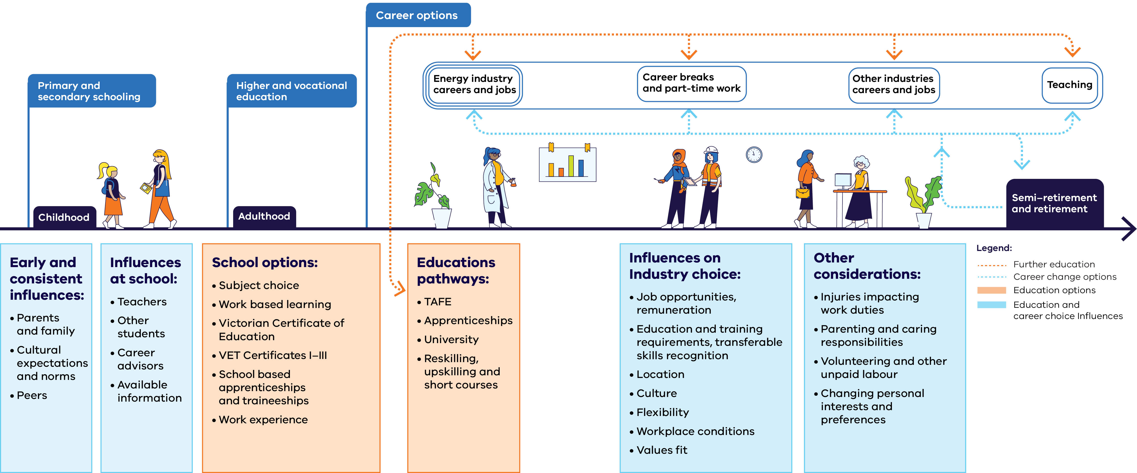

A range of education options through a woman’s working life as she moves between different sectors
The following is a text alternative for Diagram 2. It shows the education options and influences a woman may experience across her working life, arranged along a timeline from childhood through to semi-retirement and retirement.
The timeline moves through the following life stages:
- Childhood – primary and secondary schooling.
- Adulthood – higher and vocational education.
- Career options – energy industry careers and jobs; career breaks and part-time work; other industries careers and jobs; and teaching. Women may move between these options throughout their working life.
Semi-retirement and retirement.
Throughout these stages, further education pathways can lead into any of the career options, and career change options allow women to move between energy industry roles, other industries, career breaks or part-time work, and teaching.
Early and consistent influences:
- Parents and family.
- Cultural expectations and norms.
Peers.
Influences at school:
- Teachers.
- Other students.
- Career advisors.
Available information.
School options:
- Subject choice.
- Work based learning.
- Victorian Certificate of Education.
- VET Certificates I–III.
- School based apprenticeships and traineeships.
Work experience.
Education pathways (further education):
- TAFE.
- Apprenticeships.
- University.
Reskilling, upskilling and short courses.
Influences on industry choice:
- Job opportunities and remuneration.
- Education and training requirements, and transferable skills recognition.
- Location.
- Culture.
- Flexibility.
- Workplace conditions.
Values fit.
Other considerations:
- Injuries impacting work duties.
- Parenting and caring responsibilities.
- Volunteering and other unpaid labour.
Changing personal interests and preferences.
Attracting women to plumbing
The PPTEU and RAW Group Training Organisation (GTO) ‘Women in Plumbing’ program is a successful initiative helping to address the underrepresentation of women in the plumbing sector.
Developed in 2022 and launched in 2023, the program leverages existing family connections to the trade, recognising that intergenerational pathways common amongst male plumbers have been largely absent for women. RAW GTO recruits women through member networks via social media, with the union specifically asking members to consider ‘daughters, nieces, partners, family friends’ who might be interested in plumbing careers.
Twenty-three women are currently completing apprenticeships through the program, receiving training at the Plumbing Industry Climate Action Centre (PICAC) while gaining on-site experience with host employers. In 2026 it is anticipated that program numbers will increase by ten.
Additionally, three program participants are on track to qualify in June 2026.
The program achieved a 90.4% retention rate for female apprentices, with its success attributed to the effectiveness of wraparound support models combining formal training, supportive host employers, and dedicated GTO assistance. Participant case studies showed that leveraging existing industry connections while providing structured support can overcome traditional barriers. Women in the program emphasised the importance of working with other female apprentices to build connections and create pathways for future apprentices. Critically, the program helps drive up workplace safety for women. As a result of comprehensive mentoring models, tailored and ongoing supports, and careful employer selection, participants are reporting respectful treatment on male-dominated sites.

Opportunities to attract women across a range of energy occupations
The breadth of occupations that will be in most demand in the energy sector in 2040 are shown in Figure 3. Of these, the fastest growing jobs from 2026 and 2040 will be ICT managers, sales representatives and electricians, alongside clerical and administrative workers.
These top ten energy sector jobs include occupations with very low proportions of women and occupations where women make up the majority of workers. With such a range of workforce participation rates, different strategies to attract and retain women will be required for each of these occupations.
Figure 3: The top jobs in the energy sector in 2040
Rank | Occupation
1 | Electricians
2 | ICT Managers
3 | Plumbers
4 | Clerical and Administrative Workers
5 | Engineers
6 | Airconditioning and Refrigeration Mechanics
7 | Sales Representatives
8 | Information and Organisation Professionals
9 | Business Administration Managers
10 | Call or Contact Centre Information Clerks

Industry profile: Danielle King, Green Moves
Danielle King began her career as one of the few female software engineers in Australia, where she consistently challenged the status quo in male-dominated fields. She later relocated to London, working in technology roles across the finance and banking sectors before deciding to return to Melbourne in the early 2000s in search of work with greater purpose and balance.
On her return Danielle transitioned into the emerging energy efficiency and sustainability sector, applying her technical background to climate and resource challenges. She retrained in home energy efficiency (now recognised as the Certificate IV in Home Energy Efficiency and Sustainability), completed a Diploma in Sustainability and Carbon Accounting, and attained a Certificate IV in Training and Assessment. This combination of skills and qualifications led her to establish Green Moves Australia, a successful and purpose-driven sustainability consultancy, and to educate on sustainability topics at Swinburne University and other institutions.
​Danielle is intentional about ensuring Green Moves remains aligned with its core values and “walks the talk” in all aspects of its operations. The organisation offers flexible working arrangements, including remote work and adaptable hours, which has contributed to attracting a highly skilled team, the majority of whom are women.
She believes that long-term success in the sustainability sector requires a commitment to ongoing learning. Technology, policy, regulations and market expectations are evolving rapidly, meaning every engagement offers an opportunity to deepen understanding and improve outcomes.
“To succeed in this sector, you need to listen, learn, and share your knowledge. The technology and regulatory landscape are constantly evolving, so every day is an opportunity to grow. Our work isn’t just about helping businesses operate more sustainably or assisting households to reduce energy use – it’s about guiding people towards more sustainable decisions. Every project offers new insights, and that’s what keeps this work so rewarding.”

Meeting the challenge
To attract more people – especially women – to the energy sector, we need to raise awareness of career paths, provide clear information on roles and qualifications, and support people to transition from other industries.
Coordinated action across all levels of government, industry, and the training and education sector is needed to align campaigns that promote energy careers, highlight entry pathways for women, and showcase women in technical and leadership roles. This would build on an inspiring energy transition narrative, and showcase impactful and desirable careers.
See the Victorian Energy Jobs Plan for the full suite of actions to mobilise the workforce for Victoria’s energy transition.
energy.vic.gov.au/renewable-energy/our‑energy-workforce
Credentials and career opportunities in the energy sector need to be actively promoted through schools and further education – especially in regional areas. These should be backed up with targeted programs to give female students and women direct practical experience in the sector. Science, technology, engineering and mathematics (STEM) programs that already aim to attract women to male-dominated occupations and industries should specifically incorporate the energy sector. The role of influencers, such as parents, teachers and peers in school settings, should also be considered.
Skills recognition across industries and jurisdictions is critical to making sure workers can shift industries and roles throughout their careers. To increase the proportion of women at their mid career stage in the energy sector, as well as boosting the proportion of women in more senior roles, pathways must be clear for skilled women from other industries to upskill or retrain to join the renewable workforce.

Outcomes
To attract more women to the renewable energy sector, outcomes and underlying actions were developed in tandem with the Victorian Energy Jobs Plan. Relevant outcomes for women include:
- More women are aware of and attracted to energy sector roles and careers
Existing and transitioning female workers are supported by targeted incentives and improved skills recognition
These outcomes are supported by targeted Victorian Government initiatives outlined below. Achieving lasting change will depend on sustained collaboration between government, industry, and the education and training sector.

Initiatives underway:
- Providing free career, jobs and training advice, including energy workforce and education pathways information, through Skills and Jobs Centres located across Victoria.
Raising awareness and interest in renewable energy sector careers and promoting renewable energy workforce pathways to students, incorporating aspects and considering programs that appeal to female students through the SEC’s education program.
- Promoting pathways into renewable energy for groups including First Peoples, women, and transitioning workers, including from existing power and forestry industries, through Skills and Jobs Centres.
- Providing female secondary students with a valuable introduction to energy careers and workplaces by delivering 10,000 work experience placements for in-demand industries including renewable energy.
Increasing school students’ understanding of renewable electricity, through the Resource Smart Schools program.

Initiatives commencing:
Facilitating support for workers impacted by the net zero transition in the Latrobe and broader Gippsland region to gain new opportunities, including careers in renewable energy, by working with the Australian Government’s Net Zero Economy Authority and Department of Employment and Workplace Relations on initiatives including the Regional Workforce Transition Plan and Transitioning Workforce Fund.

The call to action
To achieve these outcomes, industry, education and training providers and all levels of government need to work together to:
- Promote careers and pathways in the energy sector by explaining the energy transition and showcasing opportunities in Victoria’s new energy workforce, as well as highlighting women in the sector and the climate change credentials of the sector
- Empower women to make informed career choices by developing and promoting resources which set out the specific jobs, careers, qualifications, and education pathways for the new energy workforce
- Reduce barriers for women currently working in the energy industry, as well as other industries, to move within and transition to the energy workforce by developing transition plans and investing in incentives, training and support programs.

Focus area 2: Ensuring women can access and complete education and training
Most jobs in Victoria’s energy sector require vocational or higher education qualifications, making access to training critical – especially for women from other industries or professions.
Addressing barriers to education – such as structural challenges and gender stereotypes – is key to enabling more women to access training, complete their studies, and enter the energy sector with the skills needed for success.

Challenges in building capability

Education and training barriers
The vast majority of energy sector roles require VET or higher education qualifications. Therefore, identifying and reducing barriers to women enrolling in and completing these courses is critical for increasing the number of women in the sector and the proportion of women in male‑dominated occupations.
It is common for an industry’s culture to be reflective of its education environment where, for example, students and educators may not accept that women can work in trades or other technical occupations. Where men make up the majority of students in a course, there can be an appreciable effect on women’s perception of the industry itself. For example, in a survey of school-aged girls, the behaviour of their male peers was cited as a major reason for not choosing STEM subjects or male-dominated vocational streams.
It has been identified that women are more likely to successfully complete courses when they are within a supportive and inclusive environment. Fostering such an environment requires trainers to actively manage themselves and the classroom to ensure that unsafe attitudes and behaviours do not prevail.
The quality and consistent approach of trainers is critical to ensuring that the quality of education women receive is high and that the education environments they are in foster acceptance of women and other underrepresented groups.
By 2040, most of the energy workforce will require VET or higher education qualifications.
Energy workforce education requirements by 2040
Education category | Share of workforce
Bachelor degree or higher | 12%
Certificate IV (Or Certificate III with at least 2 years of on-the-job training) to associate degree | 40%
High school and Certificate I, II, III | 48%

Inflexible delivery options and financial obstacles
For female mature-aged students seeking to change occupations or upskill, the cost and flexibility in delivery format are critical elements that impact whether they choose to undertake further education. Financial barriers include the opportunity cost in lost or reduced wages – for example, taking on an apprenticeship at a mature age or simply the cost of the course.
Partial or full subsidisation of courses helps to mitigate barriers to access. Victoria’s Free TAFE program removes a substantial financial barrier for students. Women constitute around 60% of applicants to the program across a range of industries. However, the opportunities for women to undertake further education may be limited by inflexible delivery formats that do not take into account caring responsibilities (predominantly undertaken by women) or the need to continue paid work. This flexibility includes time commitment, scheduling and location. For regional women, in particular, limited access to childcare services is another barrier to completing education and training opportunities.
To support women entering the energy industry, the education and training sector must better cater for women who are considering a career or occupation change by providing a good learning environment and offering targeted support and flexibility.
Free TAFE program
The Victorian Government is covering the cost of tuition fees for 80 Technical and Further Education (TAFE) qualifications, and pre-apprenticeship and short courses, including critical workforce needs such as housing and renewable energy.
Students who have completed any Free TAFE program can also access the Certificate IV in Training and Assessment (TAE) under Free TAFE. This is to encourage and support industry-qualified people to pursue a career in VET training. People who already have a VET qualification or degree may also be eligible.

Industry profile: Sue Sizer, Head of Industry Education and Guidance, Energy Safe Victoria
Sue Sizer was the original State Electricity Commission’s (SEC) first female and youngest electrical inspector, after training as an electrical apprentice. She was also a teacher at trade school for a decade before returning to government at Energy Safe Victoria (ESV). Sue is currently Head of Industry Education and Guidance for Energy Safe Victoria.
As a teacher at trade school, the vast majority of Sue’s students were young men.
“When you walk into a class of male electrician students, as a female the first thing you’ve got to do is establish your credibility – that you know your stuff. When you get the respect of the boys, then the girls see there are pathways for them too.”
Having a supportive and approachable teacher is important for student experience, as students could come to Sue to discuss a range of issues impacting their study. Sue reflected that students may have felt more comfortable talking to a female teacher about, for instance, being up all night with a crying baby (both men and women) and needing to move an exam.
On leaving her teaching role, Sue joined Energy Safe Victoria, undertaking compliance investigations and education which drew on both her technical and teaching skills. Sue completed her Bachelor and Master’s in adult education, before creating a team at Energy Safe Victoria which develops targeted guidance for industry education (a team which she now heads). Sue believes Energy Safe Victoria’s culture is actively encouraging and supportive of female employees, with many women in senior roles, including the CEO.

Barriers to apprenticeships
Apprenticeship commencement rates for women are low in key occupations critical to Victoria’s renewable energy transition. There are also gendered concerns about the experiences of women apprentices in male-dominated workplaces.
The cost of hiring mature-aged apprentices can be another barrier for women. Women commence trade apprenticeships and traineeships at an average age of 27, compared to an average commencement age of 23 for male apprentices. This means they are more likely to face difficulty finding work, as employers can be reluctant to pay the higher hourly rate for mature-aged apprentices and trainees of any gender.
Similarly, as mature-aged women have often transitioned out of a previous career, apprentice wages can be relatively low, putting pressure on those managing family and financial responsibilities.
Older women can face extra challenges to gaining employment as an apprentice, as they may be overlooked for opportunities in favour of both men and younger women.

Case Study: Paving the way for a rewarding career in a high demand industry
Solar Victoria engaged Plumbing Apprenticeships Victoria through Master Plumbers to attract and support six women as mechanical services plumbing apprentices and airconditioning and refrigeration mechanic apprentices.
Solar Victoria also delivered electrical apprenticeships for women through group training organisations, Apprenticeships Group Australia (AGA) and AiGroup. In total, 32 electrical apprentices were employed over the life of the initiative.
More skilled tradespeople are needed to meet a surge in consumer demand for more energy efficient technology in their homes – and partnering with the plumbing industry has made it easier to attract and retain these women in the industry. An independent evaluation of Solar Victoria’s Training and Workforce Development Program found a clear need for these initiatives and found that the program achieved its intended objectives, including supporting workforce growth, capability and diversity, helping to address a skilled worker shortage whilst promoting gender diversity in the clean energy sector. The evaluation also found that supported apprentices were satisfied or highly satisfied with the program, increasing their skills, improving workforce practices, and developing an improved understanding of working safely.
To reduce financial barriers for female apprentices, partnerships were supported with incentives for the first two years of their apprenticeship, including a tool allowance when they started and fully funded accredited training. Host employers benefited from a 50% discount on hire costs, and assistance with administration.

Opportunities for change

Building industry and education links
Victoria’s energy transition is reshaping workforce needs, making strong connections between industry and the training and education sector essential to ensure skills and qualifications keep pace with evolving demands. Through these links, knowledge and expertise can be shared and pathways to employment for students and the available workforce for employers become clearer.
As existing courses are adapted or new courses developed for the transitioning energy sector, the location and flexibility in delivery should be considered and a culture that supports diversity pursued as a priority.
Additionally, networks between education and industry are crucial to work experience opportunities for students during and at the completion of their course. This is particularly important for women in an industry where employment is often obtained through existing and informal networks that women may not be a part of.

Attracting more teachers and trainers
Attracting enough quality teachers and trainers with the skills and experience in emerging renewable energy technology is critical to meeting the workforce needs of the energy transition and supportive education environments. The rate of change in the industry is significant, and stakeholders report that there is often a small pool of qualified people with competing offers for their time.
Current shortages of VET Trainers for TAFEs, schools and registered training organisations need to be addressed in ways that attract and retain high-quality teachers – a critical element for women and other underrepresented groups completing education. Addressing challenges around salaries, conditions and pathways into the profession, in partnership with industry, could increase teacher and trainer numbers. There are also opportunities to encourage women and others in industry roles into teaching positions. This includes women who have caring or other responsibilities which make work ‘out in the field’ difficult as well as women who have retired from the industry.
Greater flexibility in teaching roles, such as teaching fellowships and secondments, as well as the ability to teach under supervision without full educational qualifications, could aid in supporting skilled workers to more easily transition to becoming skilled educators.

The number of women studying trades is increasing
Across the Victorian economy, women remain underrepresented among trades needed in the energy sector which means women and girls often have limited role models and opportunities to enter training and apprenticeships in these occupations. This further perpetuates gender stereotypes about the industry not being for women.
Despite this, the indicators are positive, with female enrolments in Certificate III courses for plumbers and electricians significantly increasing in recent years. These courses must be undertaken with work experience to complete trade apprenticeships.
In Victoria female enrolments in these courses have more than doubled over the four years to 2023 (Figure 4). With increasing overall numbers of students, the proportion of women has also increased, and this is mirrored across Australia.
This presents opportunities for education and training providers to better support these students to stay engaged and complete their courses – so these enrolments translate to more women workers.
Figure 4: Increasing female enrolments in Certificate III courses for plumbers and electricians in Victoria.
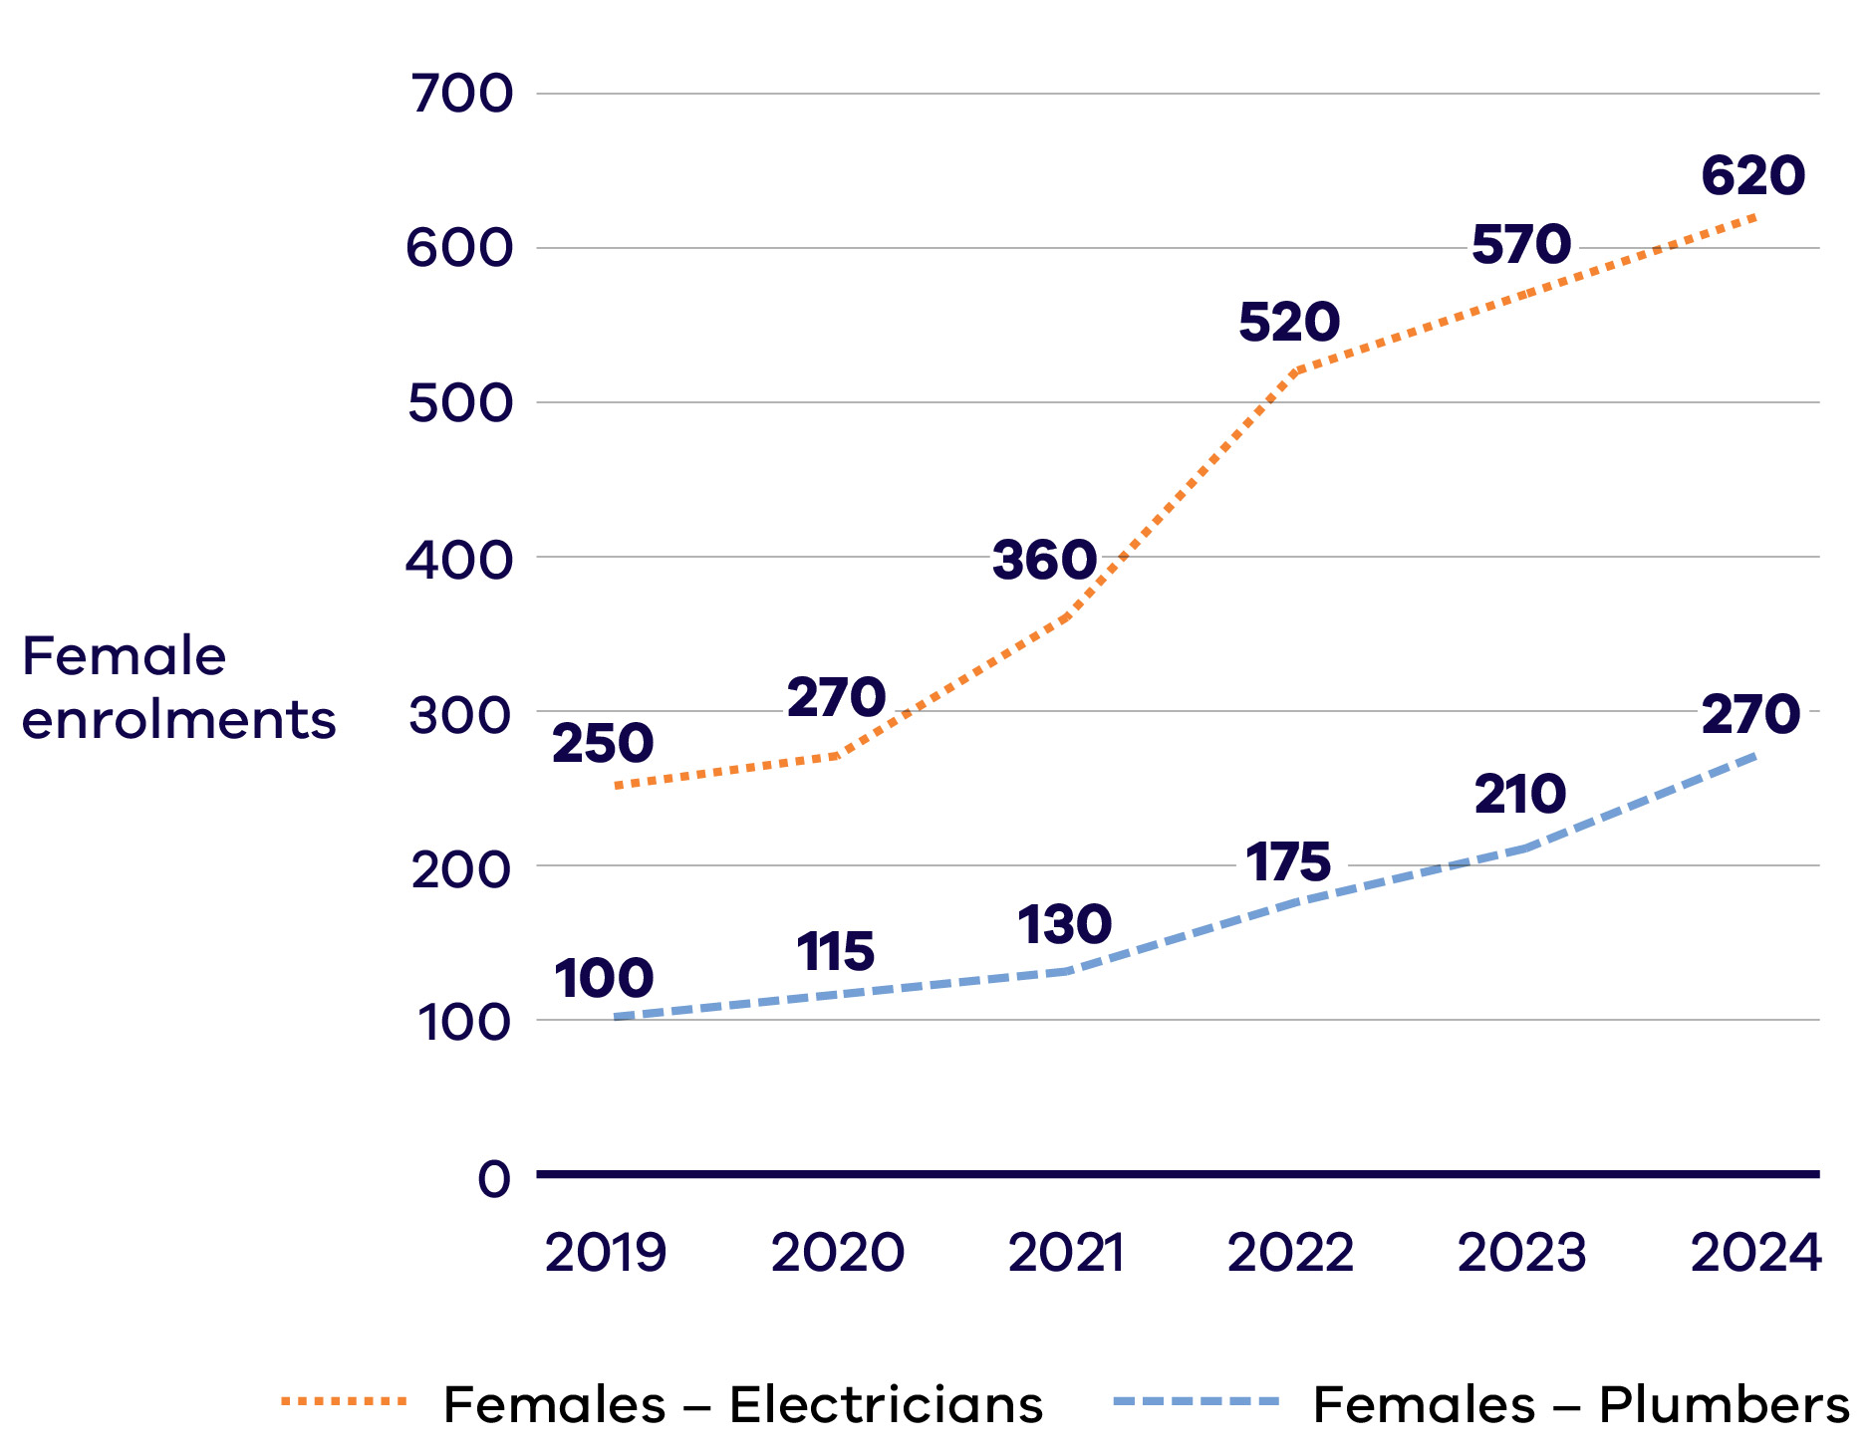
The following table is a text alternative for Figure 4. It shows female enrolments in Certificate III courses for electricians and plumbers in Victoria, by year.
Female enrolments in Certificate III courses for electricians and plumbers in Victoria
Year | Female enrolments – Electricians | Female enrolments – Plumbers
2019 | 250 | 100
2020 | 270 | 115
2021 | 360 | 130
2022 | 520 | 175
2023 | 570 | 210
2024 | 620 | 270
National Training Centre in New Energy Skills
The National Training Centre in New Energy Skills (the Centre) will be established in Melbourne’s west, bolstering Victoria’s reputation as Australia’s leader in new energy education and training. The Victorian Government is committing $10 million to establish the Centre, with $20 million being contributed by the Australian Government and $10 million by the Plumbing Industry Climate Action Centre (PICAC) for a total of $40 million in co-funding.
Delivery of the Centre will be led by PICAC, and will prioritise training for tradespeople and apprentices in installing and maintaining new and energy efficient technologies – such as heat pumps.
Once established, the Centre will have capacity to train and upskill over 2,000 tradespeople and apprentices each year across new energy occupations, including but not limited to plumbers, gasfitters, electricians and refrigeration workers.

Meeting the challenge
Connecting education pathways with workplaces, attracting more quality teachers and offering inclusive education formats are all critical to women undertaking and completing energy sector qualifications.
Embedding a culture of inclusivity and safety in education can support women and other underrepresented groups to access and complete education and training. In the development of the National Training Centre in New Energy Skills, and the Victorian Renewable Energy TAFE Centre of Excellence, the location and delivery flexibility will be considered, and fostering a culture that supports diversity will be a priority.
An important contributor to creating a welcoming classroom environment for women is increasing the quality and number of teachers, through improved remuneration, conditions and flexibility, and opportunities for advancement and continuous learning.
Supporting apprentices and providing them assistance through training and work placements is vital to meeting the demand for trade workers in the energy sector and enabling more women to enter these occupations. The initiatives being implemented by Apprenticeships Victoria, will help more apprentices to overcome difficulties and complete their studies and work placements.
Increasing opportunities for school students, including female students, to consider and engage with trades and STEM careers, through initiatives such as Vic Tech Schools, can help avoid financial or other barriers that become more prominent after high school.
Stronger links between education and industry is vital to developing the energy workforce. It can help align education outcomes with the skills needed and expand continuous learning opportunities for employees. Cooperation between the education sector and industry can also assist female apprentices and students, who cannot access informal industry networks, to secure employment.
These links can extend to strategies encouraging experienced industry workers to contribute as part‑time trainers, or subject matter experts, in the education sector. Having women as trainers may also further normalise women within the energy workforce and create alternative career paths to retain women in the sector.
See the Victorian Energy Jobs Plan for the full suite of actions to mobilise the workforce for Victoria’s energy transition.
energy.vic.gov.au/renewable-energy/our‑energy-workforce

Outcomes
To address the barriers to education for women and capitalise on the opportunities to make education and the workplace more conducive to their needs, outcomes have been identified that will be driven by underlying actions. These include:
- People actively seek teaching roles in the energy sector
- Female students and apprentices engage with study and complete qualifications
Education pathways from school to the energy workforce are clear and connected
These outcomes are supported by targeted Victorian Government initiatives outlined below. Achieving lasting change will depend on sustained collaboration between government, industry, and the education and training sector.

Initiatives underway:
- Providing apprentices and trainees with free information and support through the Apprentice Helpdesk and confidential short-term counselling and coaching for a broad range of health and wellbeing matters through the Apprentice Employee Assistance Program.
- Providing apprentices with free and confidential support and advice through Apprenticeship Support Officers (ASOs) located across Victoria.
- Addressing diverse students’ needs, by continuing to implement existing education delivery mandates such as the Equal Opportunity Act and Disability Discrimination Act.
- Encouraging industry professionals to transition into teaching roles by covering tuition fees for teaching qualifications, such as the Certificate IV in Training and Assessment, under Victoria’s Free TAFE program.
- Supporting a responsive, high-quality training workforce through the provision of professional development supports including a Clean Economy e-learn and opportunities for research fellowships in clean energy through the International Specialised Skills Institute.
- Encouraging more school students, including female students, to consider careers in essential trades and STEM careers, including through Victoria’s Tech Schools.
Expanding student pathways into clean energy related roles, by delivering a Renewable Energy VCE VET program containing qualifications including a Certificate II and Certificate III in Renewable Energy.

Initiatives commencing:
- Identifying critical workforce needs and delivering specialist training programs to prepare workers for renewable energy careers by establishing the Victorian Renewable Energy TAFE Centre of Excellence – with Victorian and Australian Government co-funding.
- Training thousands of tradespeople to install and maintain new and energy efficient technologies by establishing the National Training Centre in New Energy Skills – a joint initiative between the Australian Government, Victoria and the Plumbing Industry Climate Action Centre.
Supporting existing TAFE teachers in the energy sector to remain in the VET workforce and access higher-level teaching roles by covering tuition fees for higher teaching qualifications, such as the Diploma of Vocational Education and Training and the Graduate Certificate of Adult Vocational Education and Training.

The call to action
To achieve these outcomes, industry, education and training providers and all levels of government need to work together to:
- Encourage teaching in the energy sector by creating clear pathways into well-remunerated teaching roles and increasing flexibility for skilled workers to take on teaching positions
- Enhance learning outcomes and career prospects for women by strengthening links between the energy sector and education and employment institutions, while also identifying and addressing gaps in education pathways into an energy career
- Address barriers for women to complete their studies by investing in student and apprenticeship financial assistance and support models, and by improving conditions and safeguards for apprentices and trainees
- Support women to complete their studies by ensuring education and training delivery methods are accessible and content meets diverse needs.

Focus area 3: Ensuring women can enter and thrive in the workforce
Women in the energy sector are less likely than in other industries to hold professional or leadership roles, and more likely to encounter unsafe workplaces or inadequate facilities.
Improving workplace experiences – through safe and inclusive cultures, equal pay, career progression, and supportive conditions – is essential to attracting and retaining the skilled and diverse workforce needed for Victoria’s energy transition.

Barriers to gaining employment
Similar industries, such as manufacturing or construction, have found that despite being qualified and enjoying their work, women in trades often struggle to find employment or transition to roles that better suit their needs and interests.
Stakeholders’ feedback suggests that filling roles through word-of-mouth networking is common across the energy industry, which disadvantages people without existing networks: in this case, women.
Lack of recognition of overseas qualifications, skills, and work experience is a major barrier for migrant women, making them more likely to work in low-paid, low-skilled and insecure jobs.
Older women can face additional challenges to obtaining the work experience needed to support their trade qualifications, as they can be overlooked for opportunities in favour of both men and younger women.
When mid-career women consider a new occupation or career, their decisions are often informed by their lived experiences and broader personal responsibilities. Although societal expectations are shifting, women frequently assume primary caregiving roles for both children and family members.
Accessing new work opportunities often depends on the flexibility and supportiveness of workplace culture. Flexible and supportive environments enable women to manage their caregiving responsibilities while continuing to advance in their careers.
However, availability of flexible conditions can be limited in the energy sector. For example, nationally in clean energy generation and distribution, part‑time work is uncommon, with only 11% and 9% of workers employed part-time, respectively.

Regional and rural barriers
Many aspects of the energy transition are expected to be in regional and rural areas and, if managed correctly, these can bring significant local benefits and employment opportunities.
For women in rural areas, there are compounding barriers to employment. These include reduced access to childcare, distance to schooling, reduced networking connections, and in some cases, more entrenched views on what work is suitable for women.
37% of all Victorian energy jobs between 2026 and 2040 are to be in regional areas.
For women in these areas to fully benefit from the energy transition, these compounding challenges need to be better understood and should be considered when planning initiatives to support them.

Industry profile: Zoe Valente, Electrician – Central Spark
Zoe is a newly qualified electrician working for Central Spark in Castlemaine on solar, batteries and off-grid installations for residential and some commercial applications.
Zoe reflects that her career choice was “the best decision I’ve ever made”.
Having started IT studies at university and working in retail for a period, Zoe took the time to fully investigate her future career options. An apprenticeship in electrotechnology meant that she could learn while earning a good wage in a technical and hands-on occupation.
Now as an electrician working with a supportive employer and colleagues, Zoe has not been deterred by being one of the few women in her TAFE classes or on the job site. Being one of only two women, Zoe recalls that the class environment was really blokey. She noticed early on that some in the industry would only address her male colleagues and be surprised that she was qualified. Her pragmatic advice to others is “don’t put up with behaviours and comments you don’t have to.”
Throughout her apprenticeship and now as a fully qualified electrician, Zoe has enjoyed the practical and varied work: “I’m continually learning and the work is super interesting.”

Barriers to advancement and retention
Inflexible work arrangements and poor workplace culture are major factors affecting women’s participation, retention, wellbeing and advancement in majority-men workforces.
Workplace culture and wellbeing issues cost the Victorian economy billions of dollars every year, with untold cost to workers’ quality of life. Poor workplace culture contributes to high rates of turnover, absenteeism, stress and burnout-related leave for employees of all genders.
Women of culturally and linguistically diverse backgrounds
Women from culturally and linguistically diverse (CALD) backgrounds face compounding barriers at work. For example, while information on the energy sector is limited, several Australian-based studies into the experience of CALD women show that there are pervasive views in Australian workplaces that CALD women are less likely to have the attributes that are suited to leadership roles. This manifests as women from diverse backgrounds stereotyped and overrepresented in technical or junior roles without access to progression into leadership.
When compared to other industries, women in the energy sector are currently more likely to face unsafe workplaces, lack of acceptance, and inadequate equipment.
A 2022 Electrical Trades Union (ETU) survey found that women in electrical trades were eight to ten times less likely than men to have access to proper or permanent bathrooms, affecting their health, safety, hygiene, and wellbeing.
Sexism, sexual harassment, and discrimination have been identified as major barriers preventing women from entering and staying in sectors with poor workplace culture.
The Electricity, Gas, Water and Waste Services industry group has the third highest rate of workplace sexual harassment in Australia. In 2022, almost three quarters (71%) of women and 30% of men working in these sectors had experienced sexual harassment in the last five years. Reports have found that over one-third of women surveyed aged 25 to 35 years intend to leave their STEM profession within the next five years. The main reasons women cited for wanting to leave their STEM profession (for women both with and without children) were:
- poor work conditions and pay
- lack of career advancement
poor workplace culture.

A better understanding of the energy workforce is needed
To effectively inform energy planning and improvements to gender equity and participation, more detailed understanding of occupation demand and energy specific workforce data is required.
In the past, workforce modelling and forecasting for the Victorian energy sector has been limited by the data available. The data has lacked specificity on occupations, skills, demographics, and locations. It could also be unreliable, based on long gaps between publications and limited sample sizes.
While Victoria can take a lead, coordination at the Commonwealth level provides greater scale and confidence. Increased data and understanding of Victoria’s energy sector workforce needs will be most advantageous if coordinated nationally, establishing a solid foundation for collaboration between industry and the education sector to align training requirements with skill gaps.
For gender equity programs and initiatives to improve the proportion of, and equality for, women in the sector, a better understanding of the gender breakdown across industry sectors and occupations, and other demographics is required. Factors such as age, cultural background, location, First Peoples background, and disability can all impact the complexity of barriers. Further information on pay equity and gender occupation segregation will inform the progress of the industry in becoming more gender-diverse. This data can inform interventions and ensure that they are better targeted and designed.

Victorian energy workforce demographics
Table 1 sets out the characteristics of Victoria’s workforce in 2026, compared to the estimated energy sector workforce.
Table 1: Energy workforce demographics in 2026
Characteristic | Estimated  energy  workforce* | All of  Victoria’s workforce
Median age | 40.2 | 40.8
Female | 25.6% | 48.2%
Female – Melbourne | 25.6% | 47.9%
Female – rest of Victoria | 26.4% | 52.2%
First Nations | 0.7% | 0.7%
Born overseas | 29.0% | 34.0%
Married/de-facto | 64.4% | 60.8%
Average annual total personal income (all sources)*# | $102,000 | $84,000
Highest level of education
Postgraduate | 9.5% | 10.7%
Undergraduate | 23.0% | 25.9%
Diploma/Advanced Diploma | 11.9% | 16.0%
Certificate (I–IV) | 33.4% | 17.9%
High school | 22.2% | 29.5%
Location
Melbourne | 79.8% | 77.4%
Ballarat and Geelong | 7.1% | 7.5%
Bendigo and Shepparton | 3.8% | 4.3%
Hume and Latrobe – Gippsland | 6.4% | 6.7%
Victoria North West, Warrnambool and South West | 3.0% | 4.1%

Important notes relating to Table 1
*Note 1: The column titled ‘Estimated energy workforce’ in Table 1 reflects all occupations that comprise the energy sector workforce, where available. It includes occupations in energy generation (excluding construction of gas powered generation), energy networks, utility-scale energy storage, energy enablers, distributed energy resources, zero-emissions vehicle (ZEV) infrastructure (electric vehicle charging infrastructure only, excluding hydrogen vehicle refuelling infrastructure), and energy upgrades and services (residential electrification and services only, excluding residential energy efficiency and commercial, industrial, agricultural and forestry electrification and energy efficiency).
#Note 2: The row ‘Average annual total personal income (all sources)’ in Table 1 is a weighted average that uses the midpoints of income ranges reported in census data. Reported averages are higher than the median personal income (e.g. for the Victorian workforce the average is $72,000 and the median is $62,000).

Opportunities to affect workplace change
Improving work health and safety, along with transparent processes and positive workplace culture, benefits all employees. These changes also support greater inclusion for women, First Peoples, new migrants, and people from diverse cultural backgrounds.
Further barriers to women’s participation and equal treatment can often be found in energy workplaces, such as rigid hiring practices, a lack of flexible work arrangements and ineffective safety and diversity approaches.
Change must be brought directly to energy workplaces to improve both the participation and experience of women. Increased participation and equity in opportunities and pay for women will drive and underpin the success of any actions to attract them to the sector.
Resulting changes in culture will likely influence corresponding improvements for training courses and other energy education.

Policy and procedural change
The objective of making improvements in policies and procedures is to create an equitable workplace culture supported by a diverse and effective leadership. The reduction or removal of structural barriers in the workplace can be aided by the development of procedures and policies focused on supporting the needs of women.

Recruitment and working conditions
Energy workplace recruitment practices must be transparent and based on fairness to offset the practice of hiring through established informal networks, which advantage men. This need for transparency and formal approaches should extend to both remuneration review and promotion decisions to reduce bias. Businesses should apply procedures for monitoring and apply pay equity principles.
Workplaces can be more inclusive and supportive for women through offering flexibility in hours and location, which provides greater ability to work around other commitments, such as caring responsibilities.
These options support people of all genders to balance their responsibilities outside of work and encourages better sharing of care and other unpaid work between men and women.
A culture that supports flexibility does more than offer access to flexible work options. It recognises the productivity benefits of attracting a broader range of talent to the industry and makes sure that use of these work options does not disadvantage or undermine career advancement.

Safety in the workplace
To ensure workplaces are inclusive and supportive, women must be mentally and physically safe at work. In the energy sector, basic infrastructure is often absent for women, including suitable bathroom facilities or equipment and personal protective equipment (PPE) that is suitable and safe for a range of women’s body shapes. Safety and wellbeing policies and procedures are essential for women in male-dominated workplaces, particularly as the workforce diversifies. Improving workplace environments so individuals feel their cultural identities are welcomed and respected will be fundamental to attracting women from various backgrounds. Robust and informed dispute resolution and reporting approaches that support the effective management of harassment, assault and bullying are critical.
Pay Equality Toolkit
The Pay Equality Toolkit is a set of resources for small and medium enterprises in Victoria to help them achieve equal pay. The toolkit includes:
- information on equal pay concepts
- a progress self-assessment tool, the Pay Equality Compass
- templates and guidance for creating things like audits and action plans, including a sample equal pay policy, a model for handling complaints, and advice on how to conduct a gender pay audit.

Industry profile: Carina Steinbakk, Senior Project Manager, AGL
Growing up in Norway, Carina studied energy and environmental engineering before migrating to Australia for her first job in western Queensland’s oil and gas industry. She quickly pursued her career goal of working in renewable energy by transitioning into a role delivering large-scale battery projects with Origin Energy. As a Senior Project Manager with AGL, she is now leading the development of major battery projects around Australia.
“I was drawn to engineering as I’m very curious and enjoy solving problems. My father has worked in Norway’s oil and gas industry for over 40 years and we would have discussions around the role of renewable energy. I was determined to prove it could be done, even though I have learned through experience both fossil fuels and renewables will play a part. So we were both right!
When I first arrived in Australia I was working in remote and regional sites with very few women. The work was challenging, with long days and quite rough conditions – sometimes there wouldn’t even be a toilet onsite. As a site engineer you’d be challenged to prove yourself from day one, from sweeping the lease to running the equipment, and I was determined here too, to be the best lease sweeper and never back down.
“In past roles, I’ve been asked how the field could be made more women-friendly. It’s such a silly question. We want the same things as anyone – equality, good pay, work-life balance.”
I’ve found AGL to have a very collaborative and open culture so far. You can ask questions, and it feels safe. My advice for other women who want to get into the industry is to know what you want and be motivated to go for it, because it may not be easy, and you’ll need to stay focused. You’ll face misconceptions and meet a few dinosaurs along the way. On the tough days I’d say talk to people and lean on support services. Engineering is a tough, fast-paced industry, and we’re asked to solve hard problems every day. But it’s worth it because it’s so much fun. There’s always something new to work on and we get to ensure our projects are making a sustainable impact. I feel like I’m working on the forefront of tomorrow every day.”

Supporting diversity
Increasing women’s representation in the workforce and in leadership roles has many benefits. Evidence shows that gender diversity improves organisations. Collaboration is improved by having more women in a group and profitability performance is better in companies with higher representation of women. In leadership, there is research to show women demonstrate more ‘transformational’ leadership styles, inspiring people to achieve an organisation’s mission.
There is a direct link between a critical mass of women in leadership and improved employee satisfaction, reduced turnover and greater organisational performance and innovation.
This shows that increasing the representation of women in the workforce expands the talent pool to address the rising demand for skills and is likely to result in improved organisational performance for companies in the energy sector.

Understanding the experiences of intersectionality for First Nations women
Understanding how gender and First Peoples’ identities intersect is essential to improving workplace experiences and outcomes in the energy sector. Despite this importance, available research remains limited, and current data shows that First Peoples represent only 0.8% of the national clean energy workforce, compared with 3.3% of the total population.
In 2023, the Victorian Government commissioned research into the intersectionality of gender and First Peoples’ experiences in the public sector. Interviews uncovered specific issues for women such as the burden of cultural load, where women were expected to educate their non-Indigenous work colleagues on their cultural history and issues.
This work is often undervalued, and some felt it could impede career progression. The findings also highlighted that proactive recruitment of First Peoples is concentrated in junior positions and, where women did experience unfair treatment, they were less likely than men to have access to appropriate support.

Women’s networks, mentoring and leadership development
A key principle of this strategy is that systems must change, not the individual. Therefore, this strategy seeks to address the structural barriers to women’s participation and progression in the energy sector.
Mentoring, leadership development and networks alone are not sufficient for creating
long-term improvements and, in some circumstances, may exacerbate the divide between genders.
However, mentoring, leadership development and networking support are often visible and central points of action for gender equality. These initiatives are recognised as important supports for women currently in the sector and in attracting women to join the sector.
Networking with other women in the sector can improve workplace outcomes for individuals by enabling the sharing of experiences and creation of opportunities that would be unavailable to women through traditional networks. Mentoring has similar value, as individuals benefit through sharing difficulties and tailored guidance.
Leadership development for women in the sector can increase the number and enable the success of women in leadership positions. If the development and training translate to leadership opportunities, this will lead to three important outcomes:
- Women will be better able to see themselves in leadership
- The prominence of women in leadership roles will challenge traditional perceptions that the energy sector is a sector for men
A more diverse leadership team is likely to support greater diversity and inclusion in the workplace through lived experience influencing policy and procedures.
The Australian Government’s Gender Economic Equality Study found that regardless of which pay gap measure or benchmark is used, First Nations females have the highest gender pay gaps in Australia.

Fostering diverse and inclusive workplaces in the energy sector
Key factors that contribute to workplace inclusivity and supporting a diverse workforce are represented in Diagram 3, emphasising the critical roles of organisational leadership and a supportive workplace culture.
Diagram 3: Key factors that contribute to workplace inclusivity and supporting a diverse workforce
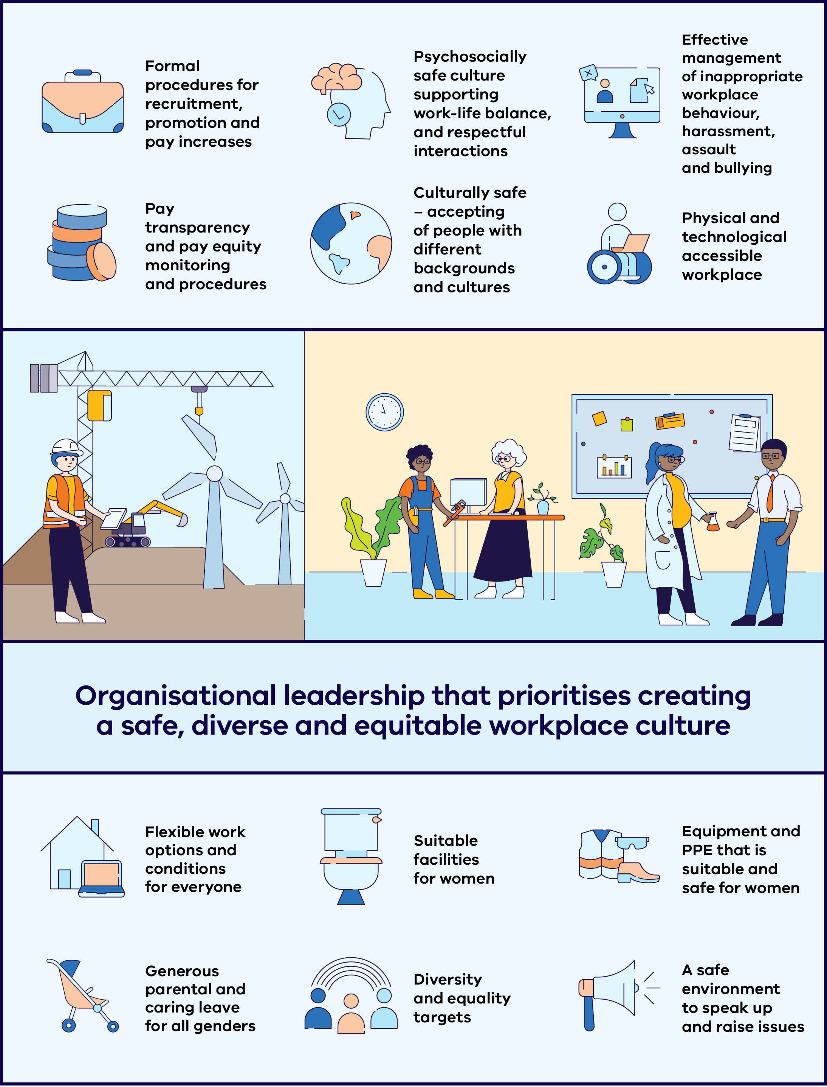
Diagram 3 shows that Organisational leadership that prioritises creating a safe, diverse and equitable workplace culture is central to the following key factors that contribute to workplace inclusivity and supporting a diverse workforce:
- Formal procedures for recruitment, promotion and pay increases
- Pay transparency and pay equity monitoring and procedures
- Psychosocially safe culture supporting work-life balance, and respectful interactions
- Culturally safe – accepting of people with different backgrounds and cultures
- Effective management of inappropriate workplace behaviour, harassment, assault and bullying
- Physical and technological accessible workplace
- Flexible work options and conditions for everyone
- Generous parental and caring leave for all genders
- Suitable facilities for women
- Diversity and equality targets
- Equipment and PPE that is suitable and safe for women
A safe environment to speak up and raise issues

Women in Energy and Manufacturing funding program
This grant program was designed to boost women’s participation and equity in Victorian energy and manufacturing industries, especially in majority-men trade and leadership roles, and create culture change to ensure women can also thrive and progress in these sectors.

Showcasing Women in Victoria’s Energy Transition
Clean Energy Council’s ‘Women Powering Change’ project created videos and other content that profiled women working in renewable energy for a widespread social media campaign. The campaign presented women in diverse careers and discussed their career pathways to the renewable energy industry, encouraging women and young girls to see themselves thriving in the sector. The campaign directed viewers to learn more about opportunities for rewarding careers in the sector and generated over one million impressions.
For further information and to hear the stories of six incredible women working in the Victorian energy transition go to: Clean Energy Council – Women Powering Change.

Solar in Schools
Led by Australian Women in Solar Energy (AWISE), this initiative delivered a range of presentations and Q&A sessions on working in solar energy to school-aged girls, prioritising schools in regional locations. AWISE also visited school careers expos, developed case studies about women working in the solar energy sector, and delivered a series of networking events.
The initiative found two key insights: that students have limited knowledge of the energy transition, and are most engaged when they can ask direct questions to someone working in the energy industry. The mix of individual school visits and career expos was key to connect with school careers educators and provide students with several industry touchpoints.

Women Onsite project “Try a Trade”
The Women Onsite project led by the Victorian Trades Hall Council promoted manufacturing and clean energy jobs and skilled trades to women through events, training and supports. Women Onsite focused on removing structural barriers to entry through hands-on, practical Try a Trade events, industry information, careers guidance, direct support to purchase tools and workwear, and understanding rights at work workshops.
The project supports women’s economic equity by improving access to secure, well-paid apprenticeships, while funding through this grants program supported accountability for workplace safety, culture and diversity through the WorkSafe-approved Safe Respectful Workplace Training to energy and manufacturing employers and TAFEs.

Grant project snapshots
Other initiatives funded through this grants program focused on working with energy businesses and women across Victoria to support inclusion, showcase women working in the industry and improve workplaces.
- NECA Education and Careers ‘Women and their Trade (WaTT)’ and ‘WaTT EDGE’ projects fostered more inclusive training environments by educating teachers on gender equality, supporting women to become educators and providing leadership support to women electrical apprentices.
- The National Association of Women in Operations (NAWO) mentoring program, provided a virtual forum for mentees to learn from experienced leaders across the energy and manufacturing industries, grow knowledge and build networks. Mentees reported feeling empowered to make informed decisions on their career development, increased self-confidence and professional networks.
- The Australian Workers’ Union’s Job Ready and Ready for Advancement project, which supported women into trade-based roles and sought to understand the challenges for women entering and thriving in the manufacturing and energy industries.
- AIG’s ‘Apprentice to Leader’ Program supported the advancement of women in energy by providing female apprentices and workers with peer-to-peer and leader mentoring, and leadership workshops.
- Gippsland Women’s Health’s ‘Towards Gender Mainstreaming in Renewable Energy in Gippsland’ project provided mentoring to women in Gippsland working in the energy sector and developed a handbook to support organisations to implement gender equitable policies and procedures.
- Women’s Health Grampians ‘See What You Can Be / Act on Site in the Wimmera’ project delivered a whole-of-workplace culture change program in the Wimmera, prioritising recruitment policies, procedures and wraparound supports for women, raising the visibility of women working in trades, and training careers staff to ensure inclusive career advice.
- Whittlesea Community Connections project, ‘Redefining Women’s Work in Hume and Whittlesea’ project provided hands-on skill building opportunities, networking and tailored career support for women who face compounding barriers, particularly culturally and racially marginalised women, to explore career opportunities in the energy and manufacturing sectors.

The role of the Victorian Government in creating change

The government as an employer
The Victorian Government is a direct employer of people working in and with the energy sector. This includes the Department of Energy, Environment and Climate Action, the SEC, VicGrid and Solar Victoria. Many staff move between the private energy industry and government, as their skills are required in both.
As a major employer of women in the energy sector, the Department of Energy, Environment and Climate Action, along with the Commonwealth Government and agencies in other states, has committed to the ‘Equal by 30’ campaign. The campaign is a public commitment by organisations, both public and private, to work towards equal pay, equal leadership, and equal opportunities for women in the clean energy sector by 2030. It requires signatories to take concrete actions to accelerate the participation of women in the clean energy sector.
Equal by 30 is a global campaign that aims to achieve gender equality in the clean energy sector by 2030.
The state also requires all defined entities under Victoria’s Gender Equality Act 2020 to measure and publicly report on their progress towards workplace gender equality and promote gender-equal outcomes across its public-facing policies, programs and services. Some areas of the Victorian Government have already implemented programs in their workplaces that support First Nations women to feel safe, valued and able to fully participate in their human and cultural rights.

The government as influencer
The Victorian Government has several levers to influence the industry to improve its performance in terms of gender balance, remuneration and occupational gender segregation, particularly where targeted initiatives would benefit the sector as a whole.
This can be done through cooperative groups and forums such as industry or ministerial roundtables made up of large employers, unions, employer groups and government representatives. These forums enable industry-wide issues to be discussed, government to test policies and strategies, and for actions to be better informed.
Building Women’s Careers Program
The Commonwealth Government has invested over $60 million over four years for the Building Women’s Careers Program. This includes grant funding for both large-scale partnership projects, and smaller, place-based partnerships, to advance structural and cultural change to improve women’s access to and experience in the male-dominated industries and sectors of construction, clean energy, advanced manufacturing and digital and technology. In March 2025, funding was granted to 20 partnership projects across industry and community organisations, including nine in the clean energy sector.
For more information visit Building Women’s Careers Program – Department of Employment and Workplace Relations, Australian Government.

Grants, social procurement and other government levers
Governments can activate a range of policy levers to support and encourage improvements in industries, education and the broader community. Direct grants, social procurement settings, and gender‑equality requirements embedded in government‑funded projects or in planning approvals for energy developments can all improve gender equality outcomes.
Social procurement is an example of a practical lever to embed gender‑equity expectations across the energy sector. By building equity criteria into tender evaluation, contractual obligations, and supplier reporting, governments can reward and accelerate best‑practice workplace equality approaches. In practice, this may involve large employers choosing to adopt initiatives such as the ‘Equal by 30’ campaign, or investigating the use of mandates or targets where resistance or specific barriers persist.
The Victorian and the Commonwealth Governments have provided direct grants to support initiatives under the Women in Energy and Manufacturing Funding Program (featured on pages 80–86) and the Building Women’s Careers Program (on page 84) respectively. These and similar grant programs provide organisations with the opportunity to trial new innovations, gather evidence for best practice, and connect with industry and gender equality stakeholders. While these projects advance gender equality goals over the funded period, dedicated and continued effort is required from all stakeholders to embed lasting change.

Creating jobs for women through SEC investments
SEC is a government-owned renewable energy company, focused on accelerating Victoria’s renewable energy transition by working to deliver renewable, affordable, reliable energy for all Victorians.
SEC partnered with Equis to deliver the Melbourne Renewable Energy Hub, one of the world’s biggest batteries, in Melbourne’s west. The Hub provides enough capacity to power 200,000 homes during the evening peak.
The Hub created work and training opportunities for more than 1,200 people, including over 70 apprentices, cadets and trainees. The project’s workforce included many Victorians who are underrepresented in the wider energy sector, including First Peoples and women, demonstrating SEC’s commitment to help build a more diverse energy workforce. Women in trade roles worked more than double the target hours during the Hub’s construction phase, with First Peoples employed on the project working almost double the target hours.

Meeting the challenge
By deepening workforce insights and enhancing workplace conditions, the energy sector can seize critical opportunities to improve the representation and experience of women.
As the energy sector grows and emerging technologies and industries scale-up, there is an opportunity to build a positive culture. This includes creating a workforce that reflects community diversity, is accessible, flexible and provides employees with consistent opportunities to learn and develop in their careers. At the same time, improved workforce data availability can provide insights into progress on workforce gender equality and assist in identifying gaps.
See the Victorian Energy Jobs Plan for the full suite of actions to mobilise the workforce for Victoria’s energy transition.
energy.vic.gov.au/renewable-energy/our‑energy-workforce
The energy industry stands to gain an advantage by addressing the concerns of women and diverse groups, and by recognising emerging trends in the future of work, such as the growing demand for flexibility.
Implementing systemic change through clear policies and procedures that support flexible working hours, locations and leave policies can enable employees with family or other responsibilities to contribute meaningfully and effectively.
Further, embedding a culture that acknowledges and supports the responsibilities women often carry, reduces barriers to career progression and leadership. Promoting flexibility and a positive workplace culture will also help attract a more diverse workforce, and enable the energy sector to draw on a wider pool of talent.
Normalising women’s participation across all roles, including those currently dominated by men, and ensuring women in leadership is common and accepted will create a more inclusive and equitable industry.
To more effectively address these challenges, the Victorian Government, the energy industry and the education sector need clearer insight into the energy workforce’s size and composition. This will better inform responses targeted at the needs of regional communities, as well as underrepresented groups such as First Peoples, women and people with disabilities.

Outcomes
To ensure that women can thrive in the workplace, several levers can be used to enable actions that will lead to the following outcomes:
- The energy workforce is accessible for all and represents the diversity of our community
- Employers retain female workers by fostering positive and flexible workplace cultures that support career development
Data and mapping provide a clear picture of energy workforce and skills needs.
These outcomes are supported by targeted Victorian Government initiatives outlined below. Achieving lasting change will depend on sustained collaboration between government, industry, and the education and training sector.

Initiatives underway:
- Leading by example as an employer of the energy workforce through flexible and equitable conditions, including committing to the ‘Equal by 30’ campaign.
- Delivering social and sustainable outcomes benefitting the Victorian community by continuing to shape government procurement activity through the Victorian Government’s Social Procurement Framework.
- Improving understanding of gender and other energy workforce diversity measures by collaborating with Race for 2030 Cooperative Research Centre and the Institute for Sustainable Futures at the University of Sydney to undertake energy sector workforce projections, conducting research and analysis, and exploring opportunities to link existing workforce skills and training data products.
- Leveraging SEC investments and activities to support workforce training and create entry-level opportunities, including apprenticeships and traineeships.
Role-modelling industry standards for diversity and inclusion, by providing job opportunities for underrepresented groups, including women and First Peoples through the SEC.

Initiatives commencing:
- Improving access to energy workforce-specific data and analysis by reviewing the Victorian Energy Jobs Plan regularly to ensure it continues to meet the needs of the changing energy sector.
Assisting women apprentices to find supportive employers and encouraging the provision of hygiene facilities, uniforms, and support for women by establishing a ‘gender equity employer list’ through a voluntary pledge for employers as a response to the Apprenticeship Taskforce’s recommendation.

The call to action
To achieve these outcomes, industry, education and training providers and all levels of government need to work together to:
- Reduce barriers to employment for women, First Peoples, people with a disability, LGBTIQA+ and culturally and linguistically diverse people by encouraging the development of supportive and equitable workforce conditions
- Increase diversity, particularly in leadership, governance, trade, technical and regionally based roles by continuing to support and invest in programs for women and other underrepresented groups that better enable them to enter and progress within the energy workforce
- Make workplaces safer and more welcoming for all people by working with energy industry employers to improve safety in workplaces and access to continuous learning opportunities
- Support government, industry investors, education providers and communities to make informed decisions by improving access to consistent energy workforce-specific data and analysis.

Oversight and monitoring
The Women in Energy Strategy actions and outcomes are shared with the Victorian Energy Jobs Plan.
- Progress under the Women in Energy Strategy will be considered as part of reporting under Action 57 of Our equal state: Victoria’s gender equality strategy and action plan 2023–27.
- The Our equal state Reference Group has been set up to give advice on the implementation of Our equal state (Action 99). This group may be used to provide advice on implementation elements of the Strategy.
- The actions and outcomes in the Women in Energy Strategy and the Victorian Energy Jobs Plan provide a consolidated overview of what government is doing to support jobs, skills and training for the energy sector. A governance framework will be developed to report on the progress and outcomes of implementation.

Endnotes

This reflects the weighted average of the proportion of women in all occupations by the Australia and New Zealand Standard Classification of Occupations (ANZSCO) that comprise the energy sector workforce, where data are available. Occupational information by ANZSCO for the energy sector workforce is available for energy generation (excluding construction of gas powered generation), energy networks, utility-scale energy storage, energy enablers, distributed energy resources, selected zero-emissions vehicle (ZEV) infrastructure (electric vehicle charging infrastructure only, excluding hydrogen vehicle refuelling infrastructure), and selected energy upgrades and services (residential electrification and services only, excluding residential energy efficiency and commercial, industrial, agricultural and forestry electrification and energy efficiency). Occupational information is available for 53,300 FTE of the 68,100 FTE workers projected for 2040.
Department of Energy, Environment and Climate Action, Victorian Energy Jobs Plan, Victorian Government, 2026.
Throughout this document, locations are classified using Australian Bureau of Statistics (ABS) Statistical Area Level 4 (SA4) regions. Locations indicate where energy sector projects and activities may be located; however, job locations may differ. Regional areas include Ballarat, Bendigo, Geelong, Hume, Latrobe-Gippsland, North West, Shepparton, Warrnambool and South West. Metropolitan areas include Melbourne – Inner, Melbourne – Inner East, Melbourne – Inner South, Melbourne – North East, Melbourne – North West, Melbourne – Outer East, Melbourne – South East, Melbourne – West, and Mornington Peninsula. The energy sector workforce that is able to be projected by location includes of energy generation (excluding construction of gas powered generation), energy networks, utility-scale energy storage, energy enablers, distributed energy resources, selected zero-emissions vehicle (ZEV) infrastructure (electric vehicle charging infrastructure only, excluding hydrogen vehicle refuelling infrastructure), and selected energy upgrades and services (residential electrification and services only, excluding residential energy efficiency and commercial, industrial, agricultural and forestry electrification and energy efficiency). Locational information is available for 53,300 FTE of the 68,100 FTE workers projected for 2040.
KPMG, She’s Price(d)less: The economics of the gender pay gap, KPMG, 2026, accessed 9 February 2026.
Jobs and Skills Australia ‘New Perspectives on Old Problems: Gendered Jobs, Work and Pay’, Australian Government, 2026, accessed 11 February 2026
Year13, What do Gen Z think about climate careers, unpublished survey results, 2023.
Workplace Gender Equality Agency, Industry data explorer – 2024–25, Australian Government, 2025, accessed 15 February 2026.
Workplace Gender Equality Agency, Industry data explorer – 2024–25, Australian Government, 2025, accessed 15 February 2026.
Workplace Gender Equality Agency, Industry data explorer – 2024–25, Australian Government, 2025, accessed 15 February 2026.
Workplace Gender Equality Agency, Industry data explorer – 2024–25, Australian Government, 2025, accessed 15 February 2026.
Victorian Skills Authority, Employment Projections Dashboard 2024, Victorian Government, 2025, accessed 9 February 2026.
Jobs and Skills Australia, Occupational Gender Pay Gap Dashboard, 2025, Australian Government, accessed 11 February 2026.
Jobs and Skills Australia, Occupational Gender Pay Gap Dashboard, 2025, Australian Government, accessed 11 February 2026.
RMIT, Career pathways of women in construction: Boots on the ground, Victorian Government, 2022, accessed 11 February 2026.
The top ten jobs in the energy sector in 2040 reflect all occupations comprising the energy sector workforce, by ANZSCO occupation name where available. This includes occupations in energy generation (excluding construction of gas powered generation), energy networks, utility-scale energy storage, energy enablers, distributed energy resources, zero-emissions vehicle (ZEV) infrastructure (electric vehicle charging infrastructure only, excluding hydrogen vehicle refuelling infrastructure), and energy upgrades and services (residential electrification and services only, excluding residential energy efficiency and commercial, industrial, agricultural and forestry electrification and energy efficiency).
Engineers include occupations classified under ANZSCO codes 233, 2332, 2333, 2334 and 2335.
RMIT, Career pathways of women in construction: Boots on the ground, Victorian Government, 2022, accessed 11 February 2026.
RMIT, Career pathways of women in construction: Boots on the ground, Victorian Government, 2022, accessed 11 February 2026.
The education categories are based on the Australia and New Zealand Standard Classification of Occupations (ANZSCO) skill levels. ANZSCO’s five skill levels have been aggregated into three broad education categories. Bachelor degree or higher, or at least 5 years of relevant experience, is retained unchanged. Certificate IV to associate degree* combines ‘AQF Certificate IV’ and ‘AQF Associate Degree, Advanced Diploma or Diploma’. High school and Certificate I, II, III combines ‘Compulsory Secondary Education’ and ‘AQF Certificate I, II and III’.
RMIT, Career pathways of women in construction: Boots on the ground, Victorian Government, 2022, accessed 11 February 2026.
National Centre for Vocational Education Research (NCVER), Total VET students and courses 2024: Data Builder, 2025, accessed 4 March 2026.
National Centre for Vocational Education Research (NCVER), Total VET students and courses 2024: Data Builder, 2025, accessed 4 March 2026.
RMIT, Career pathways of women in construction: Boots on the ground, Victorian Government, 2022, accessed 9 February 2026.
Jobs and Skills Australia, The Clean Energy Generation: Workforce needs for a net zero economy, Australian Government, 2023, accessed 12 February 2026.
D Crook and A Tessler, The Cost of Doing Nothing Report, BIS Oxford Economics for the Construction Industry Culture Taskforce, 2021, accessed 12 February 2026.
D Crook and A Tessler, The Cost of Doing Nothing Report, BIS Oxford Economics for the Construction Industry Culture Taskforce, 2021, accessed 12 February 2026.
MindTribes, Levelling the Playing Field: 5 Years of Advocacy for Culturally Diverse Women & Women of Colour, 2023, accessed 26 February 2026.
MindTribes, Levelling the Playing Field: 5 Years of Advocacy for Culturally Diverse Women & Women of Colour, 2023, accessed 26 February 2026.
Monash University, ‘Women from diverse backgrounds still face leadership barriers: study’, 19 September 2023, accessed 25 February 2026.
Australian Human Rights Commission, Time for respect: Fifth national survey on sexual harassment in Australian workplaces, 2022, accessed 26 February 2026.
Australian Human Rights Commission, Time for respect: Fifth national survey on sexual harassment in Australian workplaces, 2022, accessed 26 February 2026.
Professionals Australia, Women staying in the STEM workforce – an economic imperative for Australia: Professionals Australia’s Women in the STEM Professions Survey Report, 2021, accessed 22 January 2026.
A Novotney, ‘Women leaders make work better. Here’s the science behind how to promote them’, American Psychological Association, 23 March 2023, accessed 25 February 2026.
M Emerson, ‘Why Gender Equity in the Workplace is Good for Business’, Harvard Division of Continuing Education, 27 March 2020, accessed 21 March 2025.
A Novotney, ‘Women leaders make work better. Here’s the science behind how to promote them’, American Psychological Association, 23 March 2023, accessed 25 February 2026.
T Chamorro-Premuzic, ‘The Business Case for Women in Leadership’, Forbes, 2 March 2022, accessed 17 February 2026.
Clean Energy Council (CEC), Clean Energy Australia Report 2023, 2023, accessed 26 February 2026.
D Bargaillie, B Carlson and M Day, Make Us Count: Understanding Aboriginal women’s experiences in Victorian public sector workplaces, Griffith and Macquarie Universities, 2023.
Jobs and Skills Australia ‘New Perspectives on Old Problems: Gendered Jobs, Work and Pay’, Australian Government, 2026, accessed 11 February 2026. End of document.

