Energy Efficiency for Rental Properties in Victoria

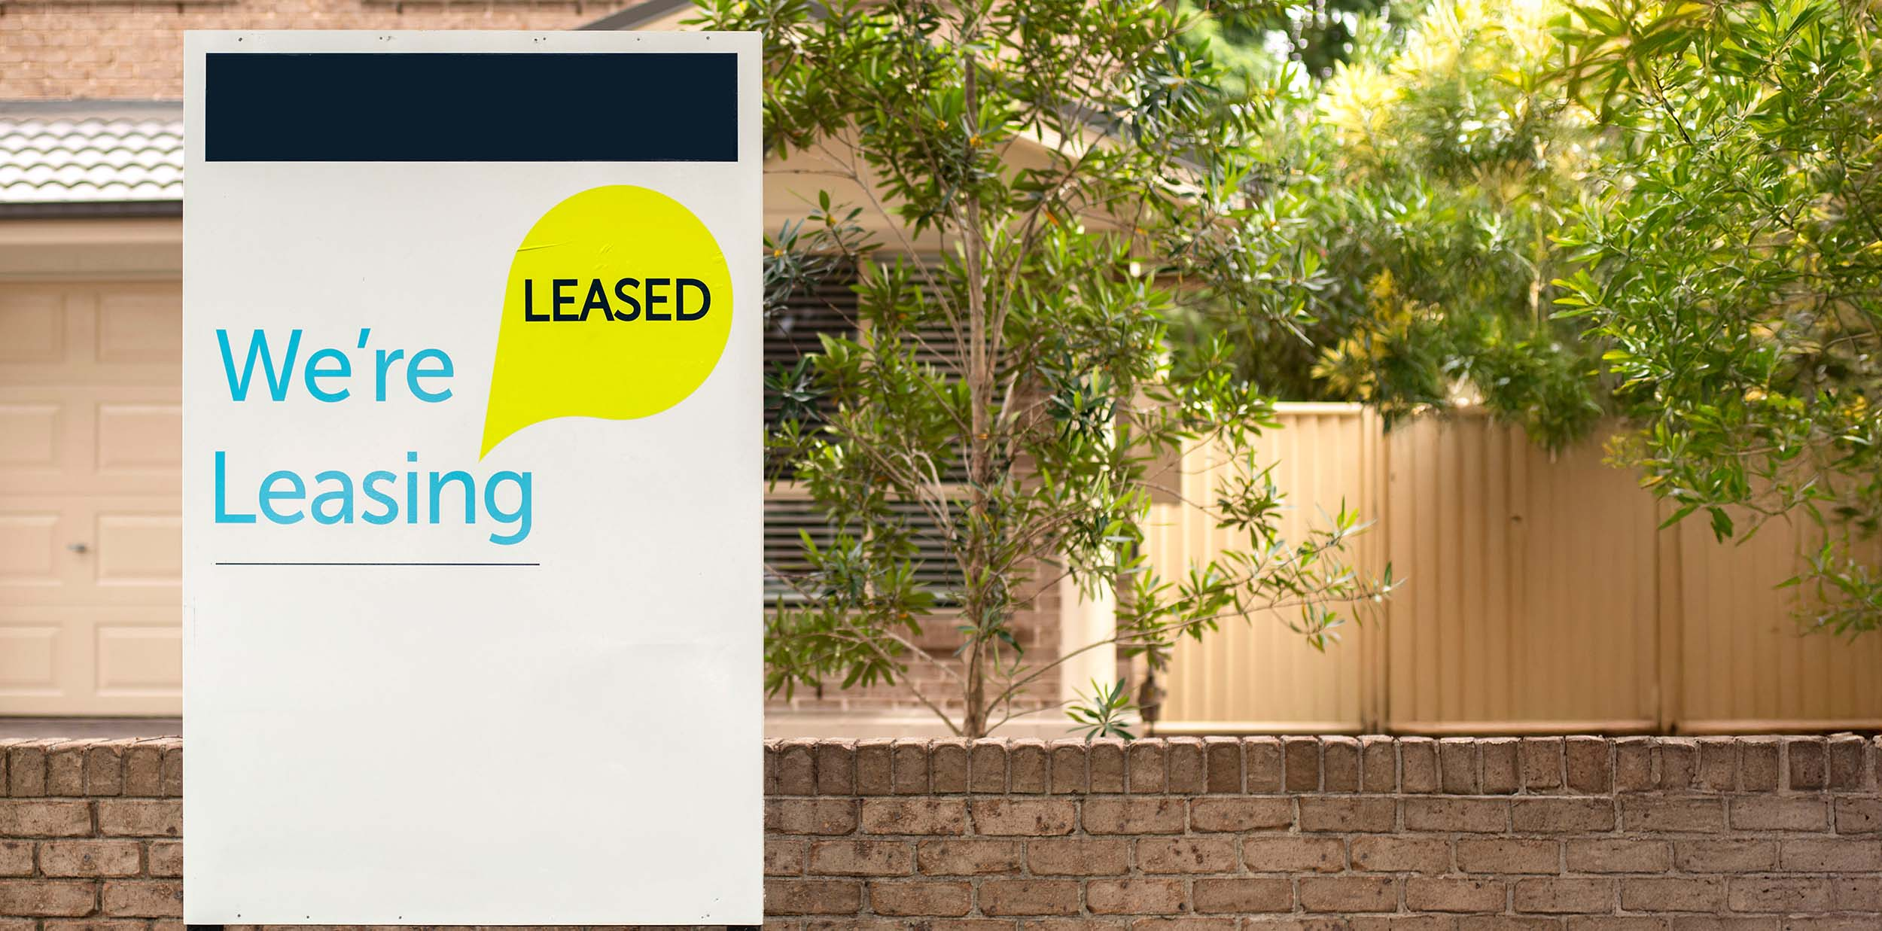

# Investments in energy efficiency and electrification increases dwelling values

* Global evidence shows energy efficiency upgrades raise property values and premiums when leased.
* A 2011–2016 University of Melbourne study of Australian Capital Territory (ACT) property transactions found 5 and 6-star energy homes had sale premiums of 2 and 2.4%, compared to 3-star properties. This translates to a $15,000 to $18,000 premium for homes in the Melbourne market.
* Further efficiency upgrades led to even higher prices, with 7-star properties attracting sale premiums of up to 9.4%.
* Rental properties with 5 and 6-star energy ratings leased at a 3.5 and 3.6% premium, compared to 3-star properties.
* [Domain Sustainability in Property Report 2022](https://www.domain.com.au/research/domain-sustainability-in-property-report-1147058/) found that in the ACT, a higher energy-efficiency rating (EER) relates to a higher price per square metre for houses. The report observed a consistent increase in price with higher EER across the ACT.
* More than half of Domain advertisements in 2022 included keywords related to energy efficiency.

# The Victorian Government will improve minimum energy efficiency standards for rental properties in 2025

Rental homes in Victoria must have a fixed heater in the main living area with at least a   
2-star energy rating.

The December 2023 Gas Substitution Roadmap Update committed to new energy efficiency standards for rental homes. [A Regulatory Impact Statement and draft Regulations](https://engage.vic.gov.au/new-minimum-standards-for-rental-properties-and-rooming-houses) were released for public comment in June 2024. The Government is currently considering feedback.

Proposed new standards include ceiling insulation, draught sealing, hot water, cooling and a revised heating standard, as well as a heating standard for rooming houses.

**For more information about Victoria's rental standards see** <https://www.consumer.vic.gov.au/>

**Check** <https://calculator.energyrating.gov.au/> **to see if your heater meets the 2-star standard**

# The Victorian Government supports rental providers to invest in energy efficiency and electrification

Discounts are available for energy efficiency upgrades through the [Victorian Energy Upgrades (VEU) program](https://www.energy.vic.gov.au/victorian-energy-upgrades/about-the-veu-program), including replacing a gas heater with a reverse cycle air conditioner or switching a gas hot water heater with a heat pump. VEU offers home energy rating assessments for targeted recommendations on improving energy efficiency.

[Solar for Rentals](https://www.solar.vic.gov.au/) offers eligible landlords a rebate of up to $1,400 for the installation of solar panels (PV), slashing the upfront costs of solar while raising the value and appeal of their property.

Eligible rental providers can apply for an interest-free loan of up to $1,400 to further reduce the upfront cost of the solar panel system.

[Victorian Energy Compare](https://compare.energy.vic.gov.au/) helps customers find the lowest price energy offer.

Figure : An all-electric home

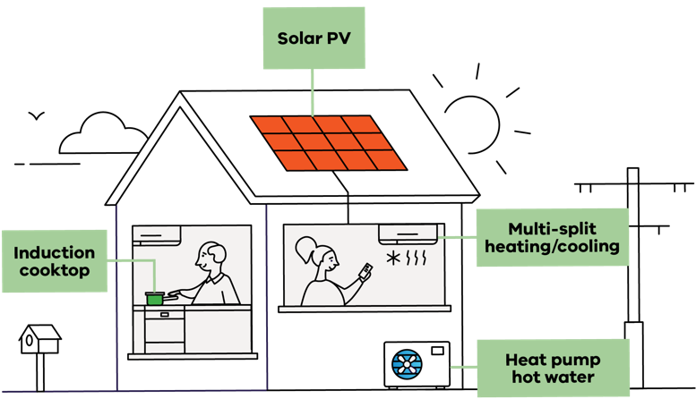

# New energy efficiency standards are not expected to impact rental supply

* Australian Housing and Urban Research Institute research suggests that changes to increased minimum standards do not significantly influence landlords leaving the market.
* In 2022, [Analysis by REA Group’s PropTrack](https://www.realestate.com.au/news/victorian-rental-minimum-standards-market-impact-one-year-on-and-whats-to-come/) found new standards have not led to an increase in rents and sales by landlords, according to data released one year later.

[**energy.vic.gov.au**](http://energy.vic.gov.au/)

# Publication information

## Acknowledgement of Traditional Owners

We acknowledge Victorian Traditional Owners and their Elders past and present as the original custodians of Victoria’s land and waters and commit to genuinely partnering with them and Victoria’s Aboriginal community to progress their aspirations.

## Copyright

© The State of Victoria Department of Energy, Environment and Climate Action, 2024. Updated December 2024.

I**SBN** 978-1-76136-669-7 **(Print)**

**ISBN** 978-1-76176-036-5 **(pdf/online/MS word)**

## Creative Commons

This work is licensed under a Creative Commons Attribution 4.0 International licence, visit the [Creative Commons website](http://creativecommons.org/licenses/by/4.0/) (<http://creativecommons.org/licenses/by/4.0/>).

You are free to re-use the work under that licence, on the condition that you credit the State of Victoria as author. The licence does not apply to any images, photographs or branding, including the Victorian Coat of Arms, and the Victorian Government and Department logos.

## Disclaimer

This publication may be of assistance to you but the State of Victoria and its employees do not guarantee that the publication is without flaw of any kind or is wholly appropriate for your particular purposes and therefore disclaims all liability for any error, loss or other consequence which may arise from you relying on any information in this publication.

## Accessibility

To receive this document in an alternative format, phone the Customer Service Centre on 136 186, email customer.service@delwp.vic.gov.au, or contact National Relay Service on 133 677. Available at DEECA website (www.deeca.vic.gov.au).

**End of document.**