Gas Substitution Roadmap Update

Victoria’s Electrification Pathway

Victoria State Government

Accessibility
If you would like to receive this publication in an alternative format, please telephone DEECA Customer Service Centre on 136 186, or email customer.service@delwp.vic.gov.au, or via the National Relay Service on 133 677, www.relayservice.com.au. This document is also available on the internet at www.deeca.vic.gov.au

Traditional Owner acknowledgement
We acknowledge and respect Victorian Traditional Owners as the original custodians of Victoria’s land and waters, their unique ability to care for Country and deep spiritual connection to it.
We honour Elders past and present whose knowledge and wisdom has ensured the continuation of culture and traditional practices.
We are committed to genuinely partner, and meaningfully engage, with Victoria’s traditional Owners and Aboriginal communities to support the protection of Country, the maintenance of spiritual and cultural practices and their broader aspirations in the 21st century and beyond.

Contents
Minister’s foreword 6
Rapid electrification is critical to lowering bills and emissions, and maintaining reliability 6
Executive summary 8
Gas Substitution Roadmap Update at a glance 16
1 Introduction 16
2 Driving electrification of homes and businesses 36
3 Supporting businesses and households to transition 53
4 Working with industry through the transition 57
5 Maintaining reliable, affordable gas supply 72
6 Preparing the future workforce 79
7 National partnerships and regulatory reform in the transition 84
8 Transitioning the Government’s own gas use 87
9 Next steps 89
Glossary 89

Minister’s foreword

The Hon. Lily D’Ambrosio MP
Minister for Energy and Resources
Minister for Climate Action
Minister for the State Electricity Commission

Rapid electrification is critical to lowering bills and emissions, and maintaining reliability
A little over a year ago, the release of the Gas Substitution Roadmap signalled the Victorian Government’s commitment to transition away from gas towards renewable energy to deliver cheaper bills for households and businesses.
This Update to the Roadmap delivers on the Government’s promise to report on progress towards a just and equitable transition that ensures energy affordability, reliability, security and safety for all Victorians.
Gas in Victoria was historically a source of cheap and abundant energy – this is no longer the case. This is being driven by falling supply from Bass Strait combined with tighter links between domestic prices and global gas markets, as private companies continue exporting Australian gas overseas. These elevated prices highlight the bill savings available to Victorian households and businesses from going all-electric – while supporting the state to meet our nation-leading emission reduction targets of 45–50 per cent by 2030, 75–80 per cent by 2035 and net zero by 2045.
Victoria’s Gas Substitution Roadmap identified these trends and set Victoria on a path to transition away from our high reliance on fossil gas and towards a future powered by reliable, affordable renewable energy. The Roadmap identified electrification as the most cost-effective decarbonisation pathway for most of Victoria’s gas use – especially in our homes and businesses. Similarly, the Roadmap recognised that renewable gases such as biomethane and renewable hydrogen will be needed for a range of industrial uses that can’t readily electrify.
The Roadmap also committed to ensuring a robust regulatory framework was in place to support a gas market that works fairly and transparently for all Victorians.
During 2023 this Government has taken significant steps to assist Victorians on their electrification journey to ensure they are protected from high gas bills now and in the future. The key policy actions delivered since the release of the Roadmap in 2022 include:
- The Victorian Energy Upgrades program has expanded to offer incentives of up to $3,600 to install a wider range of efficient electric appliances such as heat pumps and reverse cycle air conditioners, while previous incentives for gas appliances have been phased out.
- Stronger 7-star efficiency standards that will make new homes more affordable, comfortable and healthier to live in have been agreed nationally, coming into effect in Victoria from May 2024 (allowing time for industry transition).
- From 1 January 2024, new homes requiring a planning permit will be all-electric, locking in lower energy bills and lower emissions for decades to come.
- Fees for disconnecting from the gas network and eliminating ongoing daily supply charges are now capped at $220, making it even more affordable to go all‑electric.
- Progress is being made to develop Victoria’s renewable gas sector with the release of a Consultation Paper in September 2023 seeking feedback on policy options to scale up biomethane and renewable hydrogen production to meet future needs.
Rapid electrification is the central force propelling Victoria’s decarbonisation journey. The Allan Labor Government is committed to ensuring Victorians are not locked into higher than necessary energy bills and is highly focused on assisting Victorians to switch to efficient electric appliances.
Key policy actions supporting the electrification of Victoria’s homes and businesses to be delivered over the next stage of Victoria’s decarbonisation journey include:
- The SEC exploring options for a trusted ‘one stop shop’ to assist Victorians to navigate the home electrification process, with pilot household solutions starting from 2024.
- Investigating options to progressively electrify all new and existing residential and most commercial buildings (including through a regulatory impact statement and public consultation).
- The same regulatory impact statement will consider the costs and benefits of requiring existing gas appliances in homes and relevant commercial buildings be replaced with electric appliances when the current appliance reaches end-of-life.
- Expanding minimum standards to cover ceiling insulation, draught-sealing, hot water and cooling following public consultation on implementation options in early 2024 to continue protecting renters from higher energy bills and the health risks of inefficient homes.
- Expanding the Victorian Energy Upgrades to include incentives for upgrades to efficient electric cooktops, enabling all Victorians to fully electrify their homes through Victorian Energy Upgrades.
The Victorian Government is also focused on scaling up biomethane and renewable hydrogen production across the state, to reliably power Victoria’s manufacturing and industrial sectors while establishing new industries and job opportunities.
A policy directions paper will be released in 2024 reflecting stakeholder input to the Renewable Gas Consultation Paper released in September 2023 and outlining next steps for driving the expansion of this critical sector.
While this Update continues our firm commitment to gas substitution, the Government is taking a responsible and balanced approach to ensuring adequate supply to meet demand by considering options for sourcing short-term, transitional supply.
The Allan Labor Government is acutely aware of how important affordable, reliable, renewable and secure energy is to a smooth Victorian energy transition. Scaling up our efforts to electrify is the quickest and cheapest way to get there – and to maintain Victoria’s prosperity in the decades to come.

Executive summary
Victoria is the largest user of fossil gas in Australia, with two million households and businesses connected to the reticulated gas network. Despite the important role fossil gas has played in the Victorian economy for decades, Victoria’s gas sector faces significant challenges heading into the future and we need to progressively phase out use of the fuel starting with those users that already have cost effective alternatives available.
While historically gas has been less expensive than electricity, that is no longer the case. A range of international and domestic factors have led to unprecedented gas price rises in recent years resulting in significant cost of living pressures being experienced by Victorians and Australians.
Since the beginning of overseas gas exports from Queensland Liquefied Natural Gas (LNG) plants in 2015, domestic fossil gas prices have been increasingly linked to the international market, leaving Victoria more exposed to spikes in global gas prices. Concurrently, production from Victoria’s historically plentiful gas fields in Gippsland Basin in the Bass Strait is declining, placing additional upwards pressure on prices and bringing a challenging supply and demand situation in coming years. The combination of these international and domestic factors means gas prices are highly likely to remain higher than the historical average for the foreseeable future, as shown in the forward short-term LNG netback prices that suggest a sustained and structural increase in global and domestic gas prices. (Australian Competition and Consumer Commission, LNG netback price series, 16 November 2023 (Accessed 24/11/23) accc.gov.au/inquiries-and-consultations/gas-inquiry-2017-30/lng-netback-price-series)
Gas consumers have felt these pressures in recent years, with families and businesses facing sharp increases in retail prices over 2022 which have continued into 2023. For example, in the past 18 months, the median market offers in the Multinet Gas distribution zone increased by about 34 per cent for homes and 57 per cent for small businesses.
There is a clear benefit for residential and commercial users of fossil gas to transition to efficient electric alternatives when upgrading or replacing appliances. Residents of a new, all-electric detached home (without solar) can save around $1,000 per year on reduced energy bills, with savings increasing to more than $2,200 a year with solar installed. For commercial users, savings can range from $1,500 to $9,000 a year.
The Victorian Government is currently providing a range of incentives and assistance to support households and businesses to electrify, while the SEC will explore options to establish a ‘one stop shop’, commencing a pilot home electrification scheme to simplify the sometimes complex process of going all‑electric.
Reducing fossil gas consumption is critical to achieving Victoria’s world-leading emission reduction targets. Fossil gas had historically been a lower emissions energy source than electricity, which was once overwhelmingly generated by brown coal.
Switching from gas to electricity, particularly to efficient electric space heating and hot water, offers significant and cost-effective emission reduction opportunities.
Victoria’s Gas Substitution Roadmap (the Roadmap) released in July 2022 identified these challenges and set out the case for Victoria to focus in the short-term on reducing its reliance on fossil gas, by switching to electricity where practical, and reducing fossil fuel use in line with achieving net zero greenhouse gas emissions, which the Victorian Government has now committed to doing by 2045.
The Roadmap outlined a pathway for Victoria to reduce its reliance on fossil gas while maintaining reliable supply and keeping downward pressure on prices, relying on:
- Investment in energy efficiency and electrification to replace gas where electric alternatives are readily available, particularly in residential and commercial buildings, and removal of barriers to all‑electric homes.
- Development of renewable gases (biomethane and hydrogen) for remaining, largely industrial gas uses where electrification is likely not a feasible option.
- Decisive action to maintain reliability and affordability of gas supply through the transition.
Victoria continues to be a net exporter of fossil gas to the east coast, supplying all of Tasmania’s needs, around half New South Wales’ gas needs, and supporting South Australia. In 2022, Victoria produced 300 petajoules (PJ) of fossil gas, most of which was consumed locally (214PJ), while about a third (86PJ) was exported to support the energy requirements of other Australian states.

Rapid electrification a key priority
The majority of Victoria’s fossil gas is used for space heating and hot water in residential and commercial buildings. Electrification and energy efficiency offer the most immediate and cheapest opportunities for reducing gas consumption for these uses, while helping to ease cost of living pressures and reliability risks.
Moving decisively to electrify these uses offers significant opportunities to reduce gas consumption in the short-term, helping to maintain reliability of supply for gas uses across the economy where electrification options are less readily available, such as industrial applications.
This in turn will put downward pressure on prices, while renewable alternatives are developed exclusively for these ‘harder to electrify’ uses.
Residential, commercial and industrial gas demand – and therefore emissions contribution – has remained relatively consistent over the last decade. Reducing emissions from the fossil gas sector will become more challenging and more costly if the transition is delayed or the pace of action does not accelerate. This is because delayed progress will require Victoria to take more significant action in a shorter timeframe to meet our emission reduction targets.
This Update delivers on the Government’s pledge to report on its progress in implementing key policy changes promised in the Roadmap, and outlines new work to maintain momentum towards a net zero emissions energy system that drives down the cost of energy bills for households and businesses.

Key commitments in the Roadmap have now been delivered
- Victorian Energy Upgrades scheme expanded to include new incentives for switching to efficient electric appliances from May 2023
- Incentives for fossil gas residential appliances phased out of Victorian Energy Upgrades scheme from June 2023
- Victoria Planning Provisions amended in August 2022 to remove the requirement for new housing developments to be connected to gas
- Stronger energy efficiency standards in the National Construction Code (NCC) adopted in Victoria in May 2023 and mandatory from 1 May 2024. 85 per cent of homes designed and built through Sustainability Victoria’s 7‑Star Homes Program went all-electric to meet the new energy budget for heating, cooling, hot water and other fixed appliances.
- Plumbing Regulations amended in November 2023 to remove a barrier to installing efficient electric heat pump water heaters in new homes.
In working to reduce gas consumption across the economy, a critical first step is to limit the continued growth in demand. To help avoid locking in additional gas use, the Government is taking action to change incentives and ensure Victorians can see the benefits of electrification.
In November 2023 a notice of intent to prevent the offering of inducements for consumers to retain or initiate new gas connections, or for installation of gas appliances, was initiated by the Minister for Energy and Resources, while `abolishment’ fees to permanently disconnect from the gas network have been capped at $220 (plus GST) (Includes disconnection and gas service abolishment (permanent disconnection of an existing home from gas supply in the street and removal of the gas meter)).
A significant step in limiting the continued growth of the gas network was announced in July 2023; from 1 January 2024, new dwellings, apartment buildings and residential subdivisions requiring a planning permit will be all-electric.
Victoria’s Housing Statement released on 20 September 2023 announced new planning exemptions for a small secondary dwelling (granny flat). These small secondary dwellings are also required to be all-electric. All new government buildings that have not yet reached design stage will also be built as all‑electric.
The Government has removed incentives for residential gas appliances from the Victorian Energy Upgrades scheme and added new incentives for those switching to efficient electric appliances. New Victorian Energy Upgrades electrification discounts came into effect in mid-2023. Already, there are hundreds of rebated models of heat pump water heaters and space heaters available for families to choose from, with more being added every month.
To build on these improvements, in 2024 the Victorian Energy Upgrades program will be expanded to include induction cooktops, so that the scheme includes all the major gas appliances households commonly use.
The Victorian Government will work with suppliers and retailers of induction cooktops to determine the best way to bring these products into the scheme quickly, with the aim of having discounts for some models available for consumers in the second half of the year.
Induction cooktops are more energy efficient than gas cooktops, and although the difference can be modest, the cooktop is often the last gas appliance in a house, and removing it allows the home to be fully disconnected from gas. This means the annual gas network connection charges will be permanently avoided, as well as lower cost of energy for cooking on-going, saving around $350 to $400 annually on fixed network charges. Importantly, this will significantly reduce the risk of Victorian children developing respiratory conditions such as asthma (Climate Council, (2021). Kicking The Habit: How gas is harming our health, (Accessed 24 November 2023) climatecouncil.org.au/resources/gas-habit-how-gas-harming-health).
And after a three year national process, Victoria ensured strengthened 7-star energy performance standards for new homes as agreed by States and Territories in August 2022. These higher standards were adopted in May 2023 and become mandatory May 2024, replacing Victoria’s 6-star standard that included requirements encouraging the installation of gas-boosted solar water heaters in new homes.
In November 2023, Victoria amended the Plumbing Regulations 2018 to remove standards that required gas boosting of solar water heaters and prohibited connection of heat pump water heaters to mains electricity in new homes with reticulated gas available for connection.
This year, the Government brought back the SEC. The SEC’s Strategic Plan 2023–2035 named supporting the switch to all-electric households as one of the SEC’s three priorities over the next ten years.
This will be driven by the SEC exploring options for a trusted ‘one stop shop’ for Victorians, taking the guesswork out of the electrification process and supporting Victorians to get off polluting and expensive fossil gas. With pilot household solutions launching in 2024, the SEC, alongside the Victorian Energy Upgrades program and Solar Homes, will be critical tools in implementing the vision outlined in this Roadmap Update.
This work has set a solid foundation for Victoria’s move towards electrification where that is the most fitting substitution option, particularly in residential and commercial buildings. This Roadmap Update charts a path forward, announcing further action to proactively drive large-scale electrification to reduce energy bills, cut emissions and manage the risk of potential gas supply challenges.
By moving towards electrification at a rapid pace for new government buildings, we’ll create the stable policy environment that stakeholders have called for to encourage investment in new technology, workforce skills and training. It will also give households and businesses the certainty they need to make informed investment decisions, and encourage them to take advantage of electrification incentives and support.

Next steps
Key electrification work in this Update includes:
- The Government will undertake a regulatory impact statement to investigate options to progressively electrify all new residential and most commercial buildings where appropriate electric appliance options are readily available. The regulatory impact statement will be released for public feedback in 2024.
- The same regulatory impact statement will consider the costs and benefits of requiring existing gas appliances in homes and relevant commercial buildings be replaced with electric appliances when the current appliance reaches end-of-life. Options to be explored in the consultation will include the timing of any new requirement and the need for exemptions for some fossil gas users, such as agriculture and hospitality settings. Some categories of gas users will be excluded entirely from consideration, such as industrial and manufacturing sectors where fossil gas is used directly as a feedstock, or where cost-effective electric appliance alternatives are not currently available (such as high heat processes).
- Minimum energy efficiency standards for rented homes will be expanded to cover ceiling insulation, draught sealing, hot water and cooling. Options for implementation will be tested through public consultation on draft regulations and a regulatory impact statement in early 2024.
- Building on the successful expansion of the Victorian Energy Upgrades program to include space heating and water heating electrification activities announced in early 2023, the program will be expanded in 2024 to also include rebates for upgrades to efficient electric cooktops, enabling all Victorians to fully electrify their homes through Victorian Energy Upgrades.
- Recognising how important it is to limit reliance on fossil gas, the Government announced in July 2023 that all new government buildings and facilities will be built as all-electric.
- Agencies are encouraged to consider opportunities to build all-electric and remove gas when undertaking construction activities at existing buildings and sites with requirements to include an electrification option in business cases for government construction projects.

Developing Victoria’s renewable gas sector
While rapid electrification is a key priority in the short to medium term, it is recognised that not all gas uses, particularly many industrial and manufacturing applications, are suitable for replacement with electricity. Decarbonisation of these gas uses will rely on renewable alternatives such as biomethane and renewable hydrogen being available at scale.
The Government has continued work to develop the renewable gas sector to meet the needs of ‘harder to electrify’ uses across the economy. Delivering on another Roadmap action, the Government released the Renewable Gas Consultation Paper on 11 September 2023, seeking stakeholder feedback on an effective framework to grow the sector in Victoria.
In general terms, most stakeholders supported the need for a renewable gas target with accompanying policy to ensure target delivery, although a range of views were expressed regarding an appropriate target level and timeframe. About 70 per cent of stakeholders supported the prioritisation of renewable gas use for industrial users.
The Department of Energy, Environment and Climate Action (DEECA) is currently considering all stakeholder submissions with a view to releasing a policy directions paper in mid-2024.

Responsible and balanced approach to maintaining adequate fossil gas supplies
The Victorian Government’s approach to maintaining adequate fossil gas supplies has already involved a range of measures in partnership with the Commonwealth Government and other States and Territories. These actions include regulatory reforms to ensure the effective utilisation of existing gas storage assets, and contribution to the development of a second stage of east coast gas reliability and supply adequacy regulatory reforms.
The Dandenong Liquefied Natural Gas (DLNG) storage facility remains at high levels leading into this summer – as a direct result of the Victorian Government-initiated rule change to allow the Australian Energy Market Operator (AEMO) to act as a supplier and buyer of last resort.
This regulatory reform, combined with action to electrify fossil gas use across the economy and develop renewable gas alternatives, will progressively reduce demand and help manage any future supply challenges should they arise. However, these measures alone cannot affect demand sufficiently in the timeframes available to avoid the Australian Energy Market Operator’s (AEMO) projected peak-day gas supply constraints which could occur as early as 2026 unless additional supply is made available to the east coast gas market.
Victoria is taking a responsible and balanced approach to sourcing sufficient transitional supply to meet consumer needs in challenging national and international gas market conditions.
Australia’s east coast gas market is interconnected, both physically and as a market – meaning changes to supply and demand in one state can positively or negatively affect their neighbours. There has been a range of infrastructure and supply investments across the east coast, and the Government is considering the impact of those changes in assessing what more needs to be done locally to ensure stable gas supplies in coming years. A number of market-led gas supply proposals are currently under development across the east coast of Australia.
The Government supports actions that ensure secure and reliable supply will continue to be available to Victorian consumers, businesses and industry over the coming years while the transition away from fossil gas usage gathers momentum. It recognises that this transition will take time and that new infrastructure to secure supply capacity is required in the interim, and is committed to ensuring that Government processes are conducted in a timely and efficient manner to support positive outcomes for all Victorians.
As the Government delivers the actions of this Roadmap Update and progresses the next stage of the fossil gas sector transition, we will continue to engage with industry and Victorians to ensure milestones are met, including annual updates to the Roadmap – with the next release planned for 2024.

Supporting present and future Victorian workers to thrive through the energy transition
While the Victorian Government is clearly signalling a strong commitment to electrification, the transition of Victoria’s gas sector will take many years to complete.
Many gas appliances operating today will continue to require servicing and support for years to come, meaning there will continue to be a market for gas appliances and gas sector workers in Victoria for the foreseeable future. The electrification transition will be staged and careful to allow consumers and industry time to adjust.
During this process the Government will work with manufacturers and suppliers of both gas and efficient electric appliances to identify and capitalise on the business opportunities created by the expected future growth in demand for electric heat pump space and water heaters.
Government is also working closely with business, unions, and industry to ensure Victoria has enough skilled electricians, plumbers and other trades to meet the higher demand driven by the transition, as well as support for re-training and upskilling workers in impacted sectors that may experience a long-term decline in demand.
The labour force impacts of the energy transition are already observable in Victoria, with demand for electricians accelerating rapidly and forecast to continue over the short, medium and long term.
The Victorian Government also expects increased demand for specialist roles in the burgeoning renewable gas sector. Recognising the need to plan for the present and the future, the Victorian Government is administering a range of training programs to upskill existing workers with less certain long-term employment prospects, as well as train the next generation of skilled workers to deliver the energy transition.
These workforce issues will be explored in more detail in future updates to the Gas Substitution Roadmap, including the next update in 2024.
Further information on the Victorian Government’s approach to ensuring Victorian workers benefit from the energy transition can be found in Section 6 Preparing the future workforce.

Gas Substitution Roadmap Update at a glance

Priorities for policy and reform and opportunities for Victoria
- $10 million Residential Electrification Grants: Helping new home builders install solar, heat pumps or solar hot water during construction
- $1.3 billion Solar Homes: Helping more than 260,000 Victorians install solar panels, hot water systems and batteries
- 2.4million+ tonnes emissions saved
- Deliver more all‑electric precincts: New homes requiring a planning permit submitted after 1 January 2024 will be all-electric
- Transition Government’s own gas use: All new government buildings and facilities will be built as all-electric
- All‑electric, efficient homes: Options for phasing out gas use in residential and commercial buildings to be explored in 2024. SEC to pilot first household electrification offering in 2024
- Industrial users: Continue to assist industry to adopt renewable gases and take advantage of opportunities in the clean energy economy
- Build skills and capability: Work with unions, employers and other stakeholders to deliver skills and training to build the electrification workforce
- Help Victorians cut energy bills: Continue to assist Victorians in energy hardship and make it easy to improve efficiency and electrify
- Support Victorians to participate in the transition: Rebates of up to $4,000 to replace existing gas heating systems and up to $720 to replace existing gas hot water through the Victorian Energy Upgrades program, with eligible households also able to access an additional $1,000 for hot water replacements through the Solar Homes program
- Unlock renewable gases to service hard-to-abate sectors: Releasing a policy directions paper in mid-2024
- Maintain gas reliability throughout transition: Additional interim gas supply infrastructure to address unavoidable short-term supply risks will be progressed

1 Introduction
Fossil gas has played an important role in powering Victoria’s energy system and economy for many years.
However recent price increases, declining supply and the ongoing transition of Victoria’s electricity to renewable energy means it is no longer the cheap, abundant and low emissions energy source it once was.

Fossil gas today and into the future
Fossil gas has played an important role in powering Victoria’s energy system and economy for many years. Gas is used across the Victorian economy – in our homes and businesses, as well as in the manufacturing, chemical and agricultural industries. Victoria’s gas use also supports a range of businesses and trades that manufacture, supply and install gas equipment in homes and businesses.
Victoria’s proximity to large Commonwealth offshore gas fields has meant that we have historically processed and consumed the highest volumes of gas in Australia at the lowest cost. We have also processed and fed this once abundant resource into critical applications in neighbouring states including South Australia, New South Wales and Tasmania. Over the period from 2014 to 2019, Victorian processing facilities supplied on average 150PJ per year to neighbouring states (Victorian Gas Planning Report, AEMO, March 2019 aemo.com.au/-/media/files/gas/national_planning_and_forecasting/vgpr/2019/2019-victorian-gas-planning-report.pdf).
Victoria’s high reliance on gas has been driven by fossil gas’ historical status as a cheap and abundant energy source. It was also lower emissions compared to electricity generated overwhelmingly from brown coal which historically provided a high proportion of Victoria’s electricity needs.
However, as shown in Figure 1, gas prices are expected to remain high into the future driven by domestic and international factors and Victoria’s electricity supply is increasingly powered by renewable energy, with the state achieving its 2020 target of 25 per cent renewable energy, and we’re currently on track to meet the 2025 target of 40 per cent, and then onto 65 per cent by 2030 and 95 per cent by 2035.

Figure 1 Victorian renewable electricity generation share
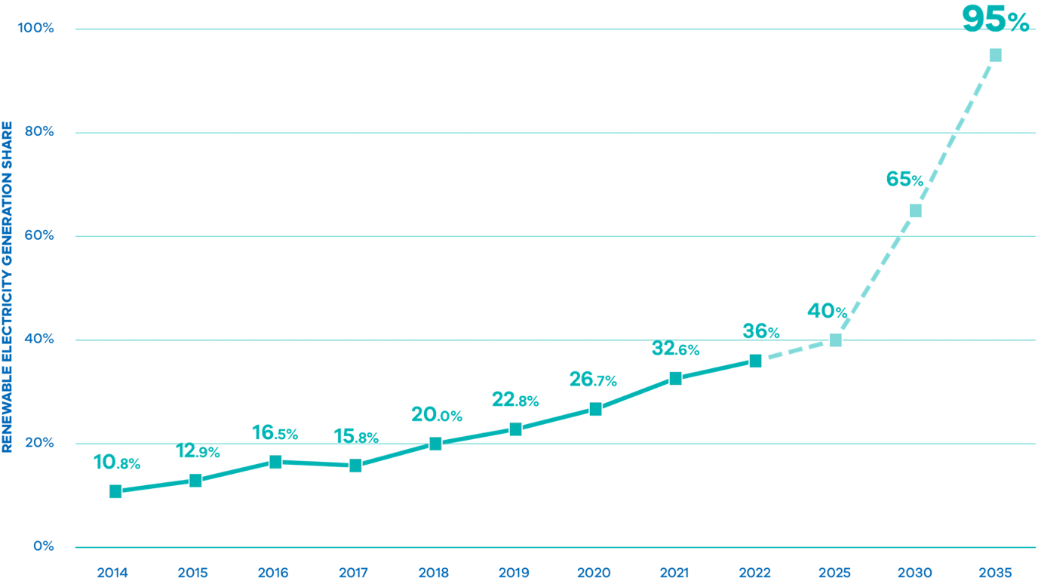

Source: Compiled using VRET Progress Report 2022/23, Victorian electricity sector renewable energy transition – energy market modelling (DELWP 2022) and NEM Review, Metered generation (as generated), Australian Government, DCCEEW
Figure 2 highlights the urgent and ambitious action to cut Victorian fossil gas consumption. The trajectory of Victoria’s fossil gas consumption combined with reduced gas supply will probably result in significant tightness in Victorian gas supply by the second half of this decade. This would likely drive rapid and sharp rises in gas prices, impacting Victorian household budgets and industry competitiveness. These impacts necessitate ambitious policy to shield Victorians from the risk of higher energy bills.
Around two million Victorian homes and businesses are connected to the reticulated gas network, with more than 60 per cent of total consumption going to heating and hot water in our homes and businesses. Approximately 30 per cent is used in industry and manufacturing for high heat applications or as a chemical feedstock. The remainder is used to provide gas powered generation (GPG) of electricity, which currently plays a critical but limited role in the energy system by responding quickly to supply additional electricity during times of peak demand.
Even as Victoria electrifies and renewable gases develop, a steady supply of fossil gas will still be needed to heat homes for those who cannot readily electrify, or to support commercial and industrial operations that do not yet have feasible alternatives. Ultimately remaining gas users will be serviced by renewable gas (biomethane or renewable hydrogen).
Victoria’s Gas Substitution Roadmap, released in July 2022 identified these challenges and set out the case for Victoria to reduce its reliance on fossil gas. In the time since the Roadmap was released, the challenges facing Victoria’s fossil gas sector – and the risks of continued high reliance on gas for essential energy uses – have only intensified. See Figure 3.

Figure 2 Victorian historical and forecast gas production, consumption and export 2014–2027
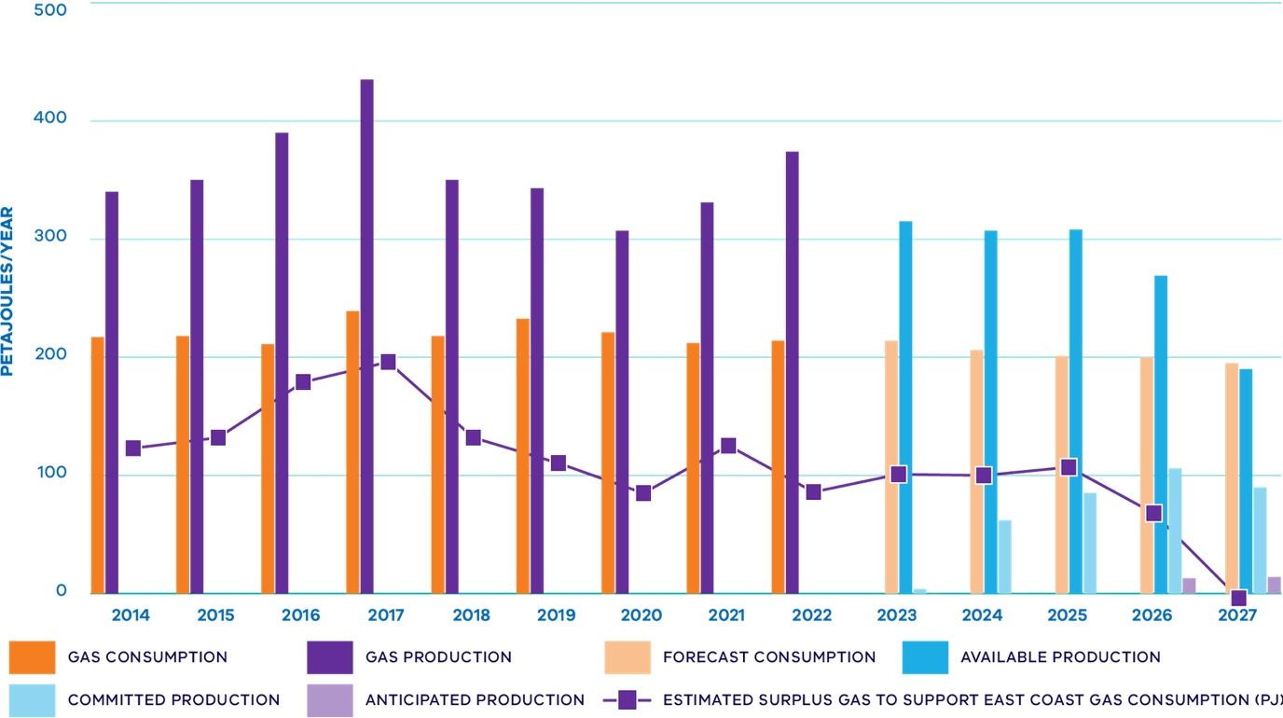

Source: Based on data from Victorian Gas Planning Reports and Gas Statement of Opportunities 2019 to 2023, AEMO

Figure 3 Eastern Australian gas demand by state and end-use PJ/a
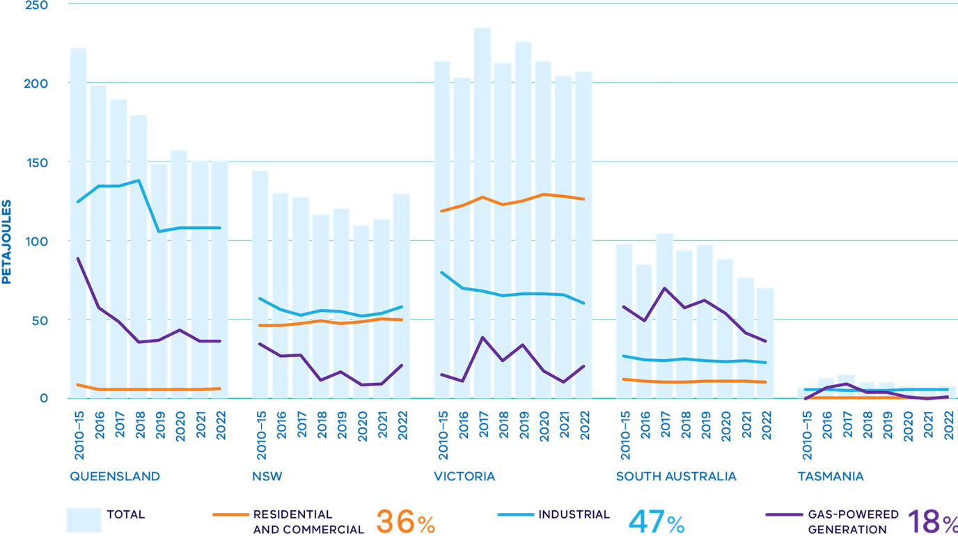

Source: State of the Energy Market 2023, Australian Energy Regulator aer.gov.au/publications/reports/performance/state-energy-market-2023

Fossil gas prices likely to remain high as supply declines
Fossil gas has traditionally been cheap and abundant in Australia, but since the commencement of overseas gas exports from Queensland Liquefied Natural Gas (LNG) plants in 2015, fossil gas prices have been linked to the international market. Following several years of unprecedented high gas prices, Australia also experienced its worst energy crisis this century in mid-2022.
This was initially driven by rising international coal and gas prices, high international demand and significant global volatility resulting from the ongoing war in Ukraine. This in turn increased demand for Australian gas exports with flow-on effects for domestic supply and prices.
At the same time, extensive flooding along much of eastern Australia constrained coal supply and coal-fired electricity output, driving up the need for high cost gas-powered electricity generation (GPG) and putting further upward pressure on domestic wholesale prices.
This trend of higher fossil gas prices will continue and likely worsen due to the tightening supply situation and across the southern states.
The link to international prices is here to stay, meaning it is expected that we will never see a sustained return to pre-2015 pricing levels (See Figure 4). The resulting elevated and volatile wholesale gas and electricity prices across the eastern seaboard prompted National Cabinet to agree to an Energy Price Relief Plan in December 2022, which included setting a 12-month emergency cap on gas prices. Although Victoria’s energy price increases have been less than in other states in eastern Australia, the wholesale price rises of 2022 are continuing to feed into increased retail prices for Australian customers during 2023. This is continuing to add to energy affordability pressures for Victorian households and businesses.

Figure 4 Gas market prices 2023 $/GJ
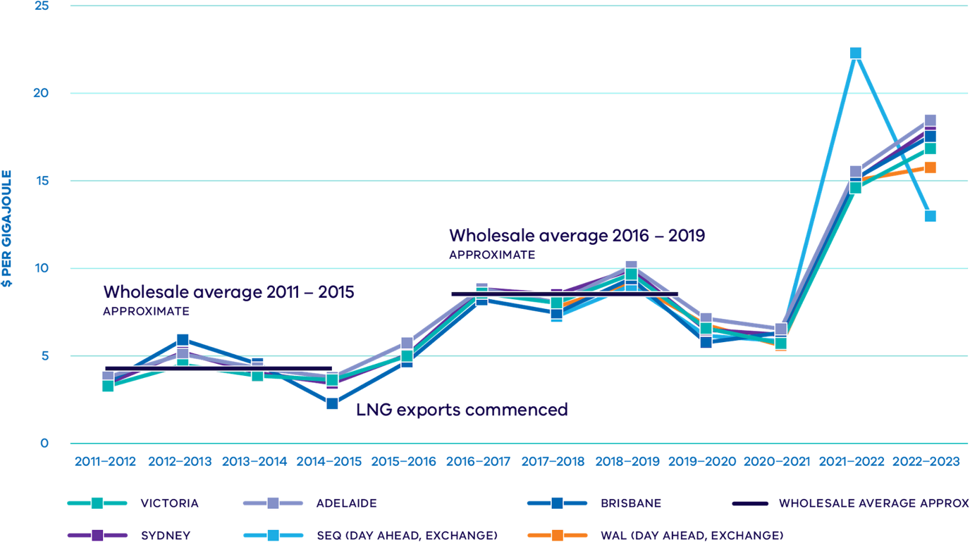

Source: Gas Market Prices, Australian Energy Regulator. July 2023 (Accessed 2/11/23) aer.gov.au/wholesale-markets/wholesale-statistics/gas-market-prices
Our high dependence on fossil gas is a legacy of our proximity to once-plentiful reserves in the Gippsland Basins in Bass Strait. However, forecasts from both AEMO and the Australian Competition and Consumer Commission (ACCC) show that supply is declining significantly and will continue to do so over this decade. Victoria, which has historically played a key role in supplying gas to other east coast states could be experiencing a much tighter local supply and demand balance than has historically been the case on high demand days as early as 2026. This is being driven by the rapid decline in supply from the Gippsland Basin combined with a lack of new supply in northern states to manage domestic supply constraints due to high volumes of exported LNG. This challenge is exacerbated by infrastructure bottlenecks such as the bidirectional South West Queensland Pipeline that connects Victoria, New South Wales, and Queensland operating at full capacity.
In the absence of significant reductions in demand, declining gas supply will likely continue to drive prices even higher and remain elevated into the foreseeable future, further adding to cost of living pressures being experienced by Victorians and Australians. While additional supply capacity for the southern gas market is required, reducing our reliance on fossil gas and moving to more cost-effective electric appliances will be critical to saving consumers money and ensuring gas dependent consumers can access the supply they need.

Electrification delivers cost of living relief to Victorians
As gas prices continue to rise, reducing fossil gas consumption offers opportunities for households and business to reduce energy bills.
While many Victorians have already been responding to rising gas and electricity prices and climate impacts by investing in electrification, solar and efficiency, many more feel locked out by the complexity of changing to new appliances, upfront costs and other barriers.
Low-income households typically spend a higher proportion of their disposable income on energy bills (~6.4 per cent compared with 1.5 per cent for high income households, ACOSS, BSL, ANU, 2019, Energy Prices as a share of disposable income, Australian Council for Social Service, Brotherhood of St Laurence, Australian National University (Accessed 2/11/23) acoss.org.au/wp-content/uploads/2019/06/ACOSS-briefing-note_energy-prices-as-share-of-disposable-income.pdf), leaving them with less of a buffer and more exposed to financial stress when prices rise. Programs available to support low-income households and households experiencing energy hardship include:

Energy concessions program
Provides a 17.5 per cent discount on gas and electricity bills for eligible concession card holders

Utility relief grants scheme
Provides up to $650 per utility every two years to low‑income Victorians experiencing unexpected hardship to pay utility bills

Comprehensive payment difficulty framework
Under which electricity and gas retailers offer tailored assistance to residential customers experiencing difficulty paying their energy bills

Energy Assistance Program
Provides tailored one-on-one support for eligible customers to access all assistance
The Government will continue to explore options to support low-income households and households experiencing energy hardship to electrify and improve the efficiency of their homes, making the transition fairer and ensuring no-one is left behind.
At the same time, the transition will require an evolution of the reticulated transmission and distribution network over time to ensure it continues to meet the needs of future gas users and the Victorian economy.
Those who are unable to electrify will be more exposed to increasing network costs as fossil gas use across the sector reduces – further highlighting the importance of government initiatives to support low-income household electrification, alongside consumer protections against any unfair or predatory behaviour by suppliers. Careful consideration will need to be given to how this transition is managed to ensure ongoing costs of network operation are shared fairly and affordably between users.
Having taken action already to prevent gas networks from charging unfair costs to consumers that have made the decision to discontinue their gas supply, the Government will now consider making a regulatory change to prevent gas distribution companies from offering inducements to Victorian consumers to lock them into using the network for longer than is in their financial interest.
These inducements, typically involving cash rebates for purchasing a gas appliance or connecting to the network, have the potential to expose Victorians to higher energy costs for the life of those assets. As Victorian households electrify, fixed network costs will increase for remaining (and decreasing) gas network connections.
Ultimately, that will have a negative effect on low-income households and renters who are less able to electrify, subjecting them to increasing network costs and higher variable charges. These risks will be considered as the Victorian Government considers the optimal future use-cases for the Victorian gas networks.
This issue will be canvassed further in future updates to the Gas Substitution Roadmap as the Government consults with industry and broader community stakeholders. The Victorian Government also recognises that there are some instances where energy users have no alternative to gas appliances, such as for emergency repairs or certain hardship matters, and any regulatory change will accommodate these scenarios as much as is practicable.
The Government also notes that the Essential Services Commission is currently reviewing the Gas Distribution Service Code of Practice (GDSCoP). There are potential opportunities to align the GDSCoP with the Gas Substitution Roadmap and other Victorian electrification policies.

We need to cut gas consumption to meet our emissions targets
The Victorian Government is taking ambitious climate action. Meeting Victoria’s targets to halve emissions from 2005 levels by 2030, reduce emissions 75 to 80 per cent below 2005 levels by 2035 and to reach net zero by 2045 will require action to cut emissions across the whole economy.
With the gas sector contributing around 17 per cent of Victoria’s net emissions, it will need to play its part within economy-wide decarbonisation.
Historically, fossil gas represented a lower emissions source of energy than electricity, primarily due to Victoria’s heavy reliance on brown coal electricity generation. This is changing rapidly as wind and solar play an increasing role in Victoria’s electricity mix, and as old brown coal power stations retire (See Figure 5). Victoria will generate 95 per cent of its electricity from renewable sources by 2035 and is on track to meet this target, with renewable sources currently accounting for 38 per cent of Victoria’s electricity generation.
The AEMO Integrated System Plan (ISP) released in 2022 identified its Step Change scenario as the most likely pathway for decarbonising Australia’s energy sector. Since revised as the Orchestrated Step Change, this scenario is centred around achieving a scale of energy transformation that supports Australia’s contribution to limiting global temperature rise to below 2ºC and targeting 1.8ºC. See Figure 6. In this scenario, electrification is high with decarbonisation of manufacturing and other industrial activities, as well as consumers switching from fossil gas to electricity to heat their homes (AEMO Integrated System Plan 2022 (Accessed 27/11/23) aemo.com.au/-/media/files/major-publications/isp/2022/2022-documents/2022-integrated-system-plan-isp.pdf).

Figure 5 Victoria’s changing electricity generation mix AEMO Step Change
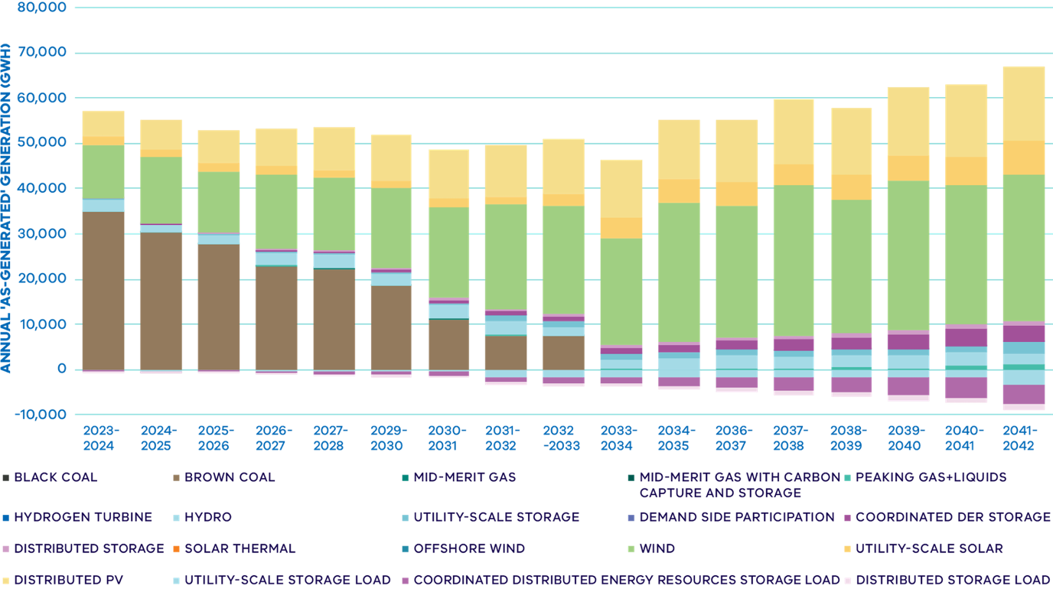

Source: AEMO Integrated System Plan 2022 – Step Change Databook – Summary - Victoria (Accessed 2/11/23)

Figure 6 Achieving AEMO’s Step Change Scenario in Victoria
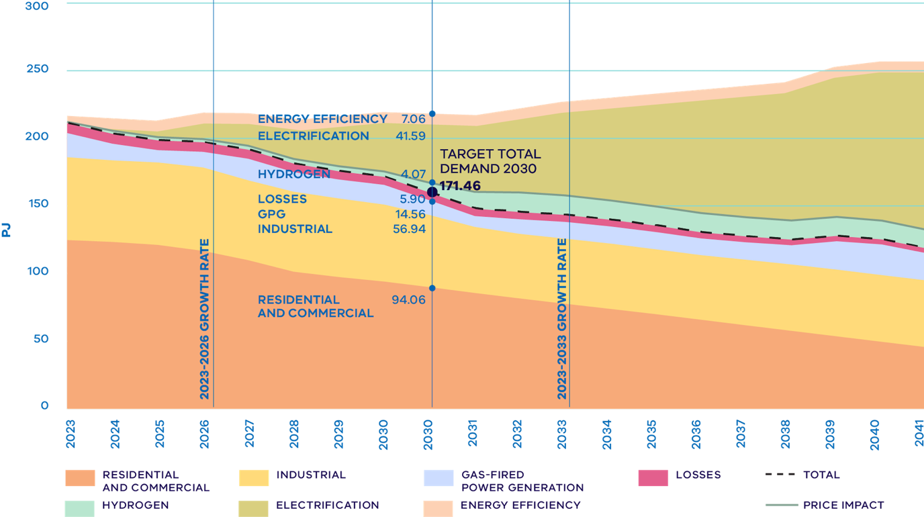

Source: Gas Statement of Opportunities Interactive Tool, AEMO March 2023, National Electricity Forecasting aemo.com.au

All‑electric homes reduce emissions immediately
In a decarbonising grid, switching from gas to electricity and reducing demand through efficiency offers the cheapest opportunities for reducing emissions from buildings (Grattan Institute (2023), Getting off gas – Why, how and who should pay (Accessed 2/11/23) grattan.edu.au/report/getting-off-gas; Australian Sustainable Built Environment Council (2022) Unlocking the pathway: why electrification is the key to net zero buildings (Accessed 2/11/23) asbec.asn.au/publications).
The high efficiency of many electric appliances – like reverse cycle air conditioners and heat pump water heaters – complements this cleaner grid, meaning that switching to efficient electric appliances reduces emissions both now and over the coming decades.
Government analysis shows that emissions from a new all‑electric home are 16 per cent lower than an equivalent new dual-fuel (gas and electric) home (See Figure 7), saving 900kg of carbon-dioxide equivalent (CO2-e) a year.
Over 10 years, the emissions gap between an all‑electric and dual-fuel home would widen to 29 per cent, as the proportion of renewable energy powering Victoria’s electricity supply continues to grow.
A range of independent organisations have published their own research this year which confirms that household electrification is the best choice for lower prices and lower emissions; this includes modelling by the Grattan Institute and Institute for Energy Economics and Financial Analysis (IEEFA).
For example, IEEFA estimated that Victorians could collectively save $931 million annually in energy costs if electric appliances replaced all household appliances at end-of-life (Institute for Energy Economics and Financial Analysis (2023) Managing the transition to al-electric homes (Accessed 2/11/23) ieefa.org/resources/managing-transition-all-electric-homes). These costs do not consider substantial gas distribution network upgrades, as well as the cost to households of upgrading to hydrogen‑compatible appliances.
Achieving AEMO’s Orchestrated Step Change scenario requires Victoria to reduce fossil gas consumption by 44PJ by 2030 – roughly equivalent to electrifying 880,000 homes. Meeting this target would require approximately 500 homes to switch to all‑electric each day between now and 2030. This represents a very significant increase on current rates of electrification and is indicative of the scale of action likely to be required to achieve Victoria’s 2030 interim emissions reduction target. These statistics highlight the importance of requiring new dwellings that require a planning permit to be all-electric. Without this requirement, this challenge would be even greater as Victoria aims to construct 800,000 new dwellings in the next decade.

Figure 7 Comparison of emissions from dual-fuel and all‑electric homes
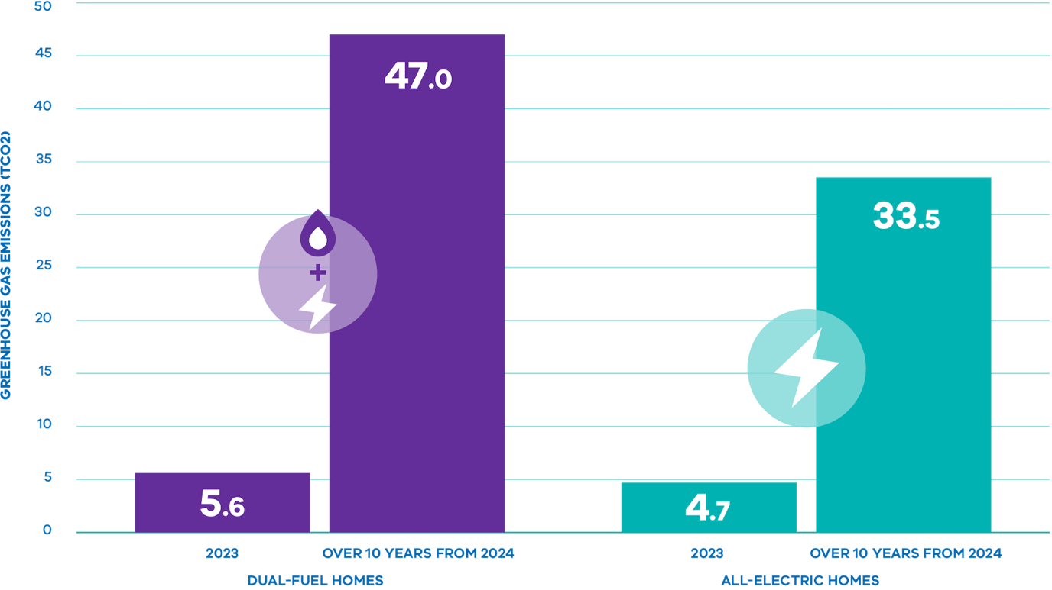

Source: New all‑electric homes emission forecast fact-sheet, Victoria’s Gas Substitution Roadmap (Accessed 2/11/23) energy.vic.gov.au/renewable-energy/victorias-gas-substitution-roadmap

Electrification and efficiency will spearhead action to cut bills and emissions
The Roadmap released in July 2022 identified these significant affordability, reliability and emissions challenges facing Victoria’s gas sector – and outlined a decarbonisation pathway for Victoria’s gas sector relying on:
- Investment in energy efficiency and electrification to replace gas where electric alternatives are readily available.
- Development of renewable gases (biomethane and renewable hydrogen) for remaining (largely industrial) gas uses where electrification is not a feasible option.
- Decisive action to maintain reliability of gas supply through the transition.
Electrification and energy efficiency continue to offer the most immediate, least-cost opportunities for reducing gas consumption across the Victorian economy – helping to ease cost of living pressures and reliability risks as well as reducing emissions (See Figure 8).
The majority of Victoria’s fossil gas is used for space heating and hot water in residential and commercial buildings, as well as low temperature industrial applications such as food and beverage processing.

Figure 8 Roadmap logic remains the same

Challenges
- Gas is becoming scarcer - increasing risk to reliability
- Gas is becoming more expensive - exposing consumers to higher bills
- Climate change action requires emissions reductions from all sectors

Actions
- Drive energy efficiency and electrification
- Regulatory reform for all-electric homes
- Support take up of alternative gases such as hydrogen and biomethane
- Maintain gas reliability through infrastructure and market reform
- Build skills and capability

Outcomes
- Reduce energy bills for households and businesses
- Free up gas for industry and improve access to affordable, reliable supply
- More energy efficient buildings
- Reduce emissions
- Support clean energy jobs
Efficient, modern electric technology – such as heat pump water heaters, reverse cycle air conditioners (RCAC) and induction cooktops – is mature, cost-effective and readily available now. Moving decisively to electrify these uses offers significant opportunities to reduce gas consumption in the short-term, while delivering immediate energy bill savings for consumers. Improving a building’s thermal efficiency (e.g. through insulation and draught sealing) alongside electrification delivers additional low-cost emissions abatement and energy bill savings, as well as health, well-being and climate resilience benefits.
Despite electrification offering significant energy bill savings for households and business, a lack of relevant factual information, complexity and preferences for gas for certain uses such as cooking, can prevent investment in electric alternatives. The SEC will explore options for trusted ‘one stop shops’ to take the guesswork out of the electrification process, supporting Victorians to go all-electric and get off polluting and expensive fossil gas.
Further proactive work is needed to overcome these barriers to action if Victoria is to achieve the ambitious levels of electrification needed to address affordability, reliability and emissions challenges, and ensure no-one is left behind in the transition.
Reducing demand in the short-term through electrification will also help maintain reliability of supply for gas uses across the economy where electrification options are less readily available (See Figure 9).
This will provide time to expand the supply of renewable gas (like biomethane and renewable hydrogen) for industrial uses where electrification is not technically feasible or cost‑effective.
Given Victoria’s current high reliance on fossil gas across the economy, a protracted supply gap would have severe economic and social impacts. In parallel with our nation-leading work to transition to renewable energy, the Government is also taking action to develop interim supply solutions to bridge projected short-term supply challenges.

Figure 9 Estimated fossil gas use by sub-sector and favoured technology substitute
 |  | VIC Fossil Gas Use
Sector |  | % | Approx PJ | Key uses |  | Expected Substitution Technology
Buildings | Residential | 50 | 105 | Space heating, 71%  Water heating 27%  Cooking 3% |  | Electrification and energy efficiency
 | Commercial | 10 | 21 | Space heating, 60%  Water heating 30%  Cooking 10%
Industrial | Low heat <95ºC | 29 | 15 | Food and beverage manufacturing  Dairy |  | Electrification and energy efficiency
 | High heat >95ºC |  | 45 | Steel-making  Bricks |  | Electrification and renewable gas
 | Feedstock (raw material) | 1 | 2 | Fertiliser manufacture |  | Biomethane
Gas-powered generation (GPG) |  | 10 | 21 | Electricity generation |  | Other technologies under consideration

Source: AEMO Gas Statement of Opportunities 2022, Industrial Low/High Heat proportion estimated by DEECA

Renewable gases’ most efficient use is in hard to abate industrial settings, not the household
There is extensive and rigorous research from dozens of independent studies around the world that concludes renewable hydrogen or biomethane should not be used for residential applications, such as space heating, hot water heating, and cooking.
(National Infrastructure Commission, (2023). Second National Infrastructure Assessment, (Accessed 24/11/24) nic.org.uk/studies-reports/national-infrastructure-assessment/second-nia; Rosenow, J, 2022, Is heating homes with hydrogen all but a pipe dream? An evidence review, Joule, Volume 6, Issue 10, 2022, Pages 2225-2228; IRENA (2022), Global hydrogen trade to meet the 1.5°C climate goal: Part II – Technology review of hydrogen carriers, International Renewable Energy Agency, Abu Dhabi)
This is driven by the uncompetitive cost of renewable gases to power homes, and the added supply chain strain from developing the necessary infrastructure to pipe renewable gases into domestic settings.
Higher renewable gas production costs mean using renewable gas to power homes would increase bills of dual-fuel compared to all-electric homes. For example, IEEFA research recently concluded that running electric appliances at home is four times cheaper than using biomethane, and more than ten times cheaper than using hydrogen due to their high relative efficiencies.
The same research also found that using renewable hydrogen to power home appliances would be almost three times more expensive than fossil gas (IEEFA, (2023). ‘Renewable gas’ campaigns leave Victorian gas distribution networks and consumers at risk).
However, there are energy users for whom renewable hydrogen or biomethane are the only technically feasible decarbonisation pathway. These include users with high temperature heat requirements (greater than 500°C) such as smelters, chemical plants and some manufacturing facilities. Creating unnecessary demand for renewable gas consumption will drive up prices for those users that have no alternative, risking Victoria’s industrial competitiveness.

Managing grid impacts of rapid electrification
Peak electricity usage in Victoria currently occurs during the summer months with a load of up to 10GW, while winter peak load is currently about 8GW. As most household gas is used for heating, electrification is anticipated to have the largest impact on winter peak loads.
However, the current gap of approximately 2GW between summer and winter is sufficient to provide for household electrification without the need for significant additional network investment. Maintaining a strong focus on improving the thermal performance of all buildings will also minimise the energy consumption of buildings.
As household electrification activities will not require significant new generation capacity, electrification of space heating, water heating and cooking are expected to have a negligible impact on electricity prices. A typical home can fully electrify cooking, space and water heating without upgrading the power supply to three phase (although some owners may choose to do this).
Nevertheless, as Victorian population grows and uptake of Zero Emissions Vehicles (ZEV) increases, the electrical transmission and distribution networks will continue to be expanded and strengthened. There are opportunities to support the network to ensure ongoing integration of electric equipment over the longer term.
In addition, the deployment of distributed energy resources, such as household and neighbourhood storage will be critical to providing local network support that can help to manage changing supply and demand patterns. The Victorian Government has invested $10.92 million in the Neighbourhood Battery Initiative which has funded community-scale batteries to investigate business models and feasibility of this emerging asset class. Based on the success of this trial, the Government will provide a further $42 million to install an additional 100 neighbourhood batteries in Victoria.
ZEVs will also play an important role in providing local storage and grid support as Victorians continue their rapid uptake. Managed well, ZEVs can support the grid through the use of smart charging and vehicle-to-grid technology.
The Government will continue to work with electricity distribution businesses to ensure the electricity grid is ready for the future.

Partnerships and engagement continue to guide policy action
Since the first Roadmap was released, the Government has continued to engage with more than 425 key stakeholders across the energy, manufacturing, business, building and construction sectors, installing trades, local government, environment and consumer groups to inform policy direction and implementation.
Extensive engagement has taken the form of regular, ongoing engagement with specific groups as well as targeted consultation with a range of stakeholders to consider their feedback on key policy reforms.
This ongoing engagement has emphasised that the broad themes that informed the Roadmap remain relevant:
- Reliability and affordability of both gas and electricity supply is highly valued
- Electrification is the best option for households and most commercial buildings to substitute reticulated fossil gas
- Electrification leads to lower energy costs and lower greenhouse gas emissions immediately and on an on-going basis
- Industrial gas users will face technical and economic challenges transitioning away from fossil gas use and will not be required to transition unless and until options are cost-effective and readily available, which they currently are not
- Existing skills should be leveraged to support electrification and industry development
- Consumers need to be supported through the transition, with initiatives to support culturally and linguistically diverse communities, renters and low-income households
- The transition will require ongoing engagement across all representative groups
- Clear government planning, goals and phased implementation can help reduce uncertainty.
This Roadmap Update continues to align with stakeholder feedback, representing an appropriate response to Victoria’s significant gas reliability and climate challenges while balancing the diverse interests and concerns of key stakeholders.

Roadmap policy direction welcomed
Stakeholder feedback since the Roadmap was released in 2022 has been broadly supportive of the overall policy direction (and subsequent policy announcements) (In particular, the July 2023 announcement that new homes requiring a planning permit would be required to be all‑electric from 1 January 2024; See New Victorian homes to go all-electric from 2024 that emphasises energy efficiency and electrification to reduce Victoria’s high reliance on fossil gas (See Figure 10).
While several stakeholders have urged more ambitious action to ease cost of living pressures for consumers and reduce emissions, others have raised concerns about potential impacts on jobs and business and the need to ensure the costs of transition are shared fairly.
As noted in the Roadmap, the transition will create both challenges and opportunities for key sectors such as installing trades (plumbers and electricians), the construction industry and network operators.
In regular ongoing engagement, Government has heard clearly from stakeholders that while policy certainty is welcomed, the mechanisms for policy implementation should be consulted on, and the complexities of transition will need to be closely managed.
- “But gas is yesterday’s fuel. Ultimately we need to get all Victorian homes off gas, and using efficient appliances powered by clean electricity.” Victorian Council of Social Service. Media statement 1 February 2023 vcoss.org.au/budget/2023/02/gas-price-surge
- “The Victorian Government’s decision to end new residential gas connections next year is a turning point for our energy systems. A clear decision on the future of gas at least provides some certainty. But we mustn’t underestimate the impact on appliance supply chains, and we also need to ensure that gas users continue to enjoy secure supply.” AiG. Media release 28 July 2023 aigroup.com.au/news/media-centre/2023/gas-connection-ban-a-big-call-more-to-do-to-make-it-workable
- “While there is likely to be some debate about this policy, it is the right call for Victorian families. Going all‑electric means healthier homes, lower bills and a big step towards a net zero community.” Energy Efficiency Council. Media release 28 July 2023 eec.org.au/news/eec-news/article/media-release-all-electric-new-homes-all-good-for-victorian-families
- “We look forward to the (government) updating its Gas Substitution Roadmap later this year, which must include a clear plan for helping the two million Victorian homes already connected to gas to be retrofitted with efficient electric appliances.” Environment Victoria. Media release 28 July 2023 environmentvictoria.org.au/2023/07/28/victoria-takes-necessary-bold-action-to-end-new-gas-connections
- “Electrification is the fastest, cheapest way to decarbonise the way we heat our buildings, and (this policy) provides industry with the certainty it needs to deliver zero-carbon-ready buildings that can contribute to Victoria’s ambitious emissions reduction targets.“ Property Council of Australia. Media release 28 July 2023 propertycouncil.com.au/media-releases/property-council-welcomes-push-to-electrify-victorian-homes
- “To meet our legislated net zero targets, we need buildings to be healthy, all‑electric and powered by renewables. Large parts of the property sector are already driving the change, and now we’re seeing governments join us on this important transition.” Green Building Council of Australia. Media release 28 July 2023 new.gbca.org.au/news/gbca-media-releases/victoria-paves-the-way-for-healthier-all-electric-homes
- “The decarbonisation of Victoria’s energy system….is a complex issue with many moving parts… Energy Networks Australia is keen to work collaboratively with the State Government and other stakeholders to ensure that the policy is fully understood and the transition to renewable energy is smooth, fair, and minimises unintended consequences for energy customers.” Energy Networks Australia. Media release 28 July 2023 energynetworks.com.au/news/media-releases/2023-media-releases/industry-calls-for-policy-consultation

Our responsibilities for engagement and partnerships with First Peoples
The Victorian Government is committed to work in partnership with Traditional Owners as distinct rights holders to Country and Sea Country. They are our partners who have rights that must be upheld as laid out under the Charter of Human Rights and Responsibilities Act 2006, the Traditional Owner Settlement Act 2010 (Vic), Aboriginal Heritage Act 2006 (Vic) and Native Title Act 1993.
The Government acknowledges that Traditional Owners have legal rights and cultural responsibility that will be recognised and supported.
The Victorian Government will work with and enable self-determination and drive sustainable outcomes for First Peoples and will ensure that First Peoples, who may be potentially affected by the Gas Substitution Roadmap, are at the centre of decision-making processes around issues and opportunities that directly affect them. This will be achieved through a separate engagement and partnership approach to Traditional Owners.
The Victorian Government honours Traditional Owners, who never ceded their sovereignty and their spiritual and intrinsic connection to Country and Sea Country, the sacredness and importance of protecting cultural heritage and cultural values since time immemorial.
Strong and mutually beneficial partnerships with Traditional Owners are imperative to the energy transition’s success and integral to ensuring the goals and objectives of self-determination as set out in the Victorian Government’s Self Determination Reform Framework and DEECA’s Pupangarli Marnmarnepu Owning Our Future Aboriginal Self-Determination Reform Strategy 2020-2025.

Figure 10 Alignment of Roadmap actions to stakeholder feedback

Maintaining the reliability, affordability and safety of fossil gas supply

Feedback
- Potential challenge of inconsistent gas blends and the need for controls
- Reliability of supply continues to be highly valued including by industrial customers
- There is a need to appropriately balance reliability and affordability

Actions and outcomes
- Energy efficiency and electrification can free up gas for industrial users
- Maintain reliability by supporting infrastructure investment and making market and regulatory reforms

Updated actions and outcomes
- Decisive action to electrify buildings will help maintain reliability of supply for industrial users
- Additional interim supply to address supply challenges during the transition will be progressed

Transitioning to more sustainable gaseous fuels with minimal disruption to end-users

Feedback
- Transitioning away from gas is not possible for every user
- Consumers need to be supported in the transition

Actions and outcomes
- Actions free up gas for industrial users
- Develop renewable gases – building on hydrogen projects and preparing the market for take up at scale

Updated actions and outcomes
- Stakeholder consultation will shape design of a renewable gas scheme to drive production and take-up of biomethane and renewable hydrogen at scale

Maintaining electricity reliability in light of new sources of demand

Feedback
- Electricity system security was a key concern in light of increased electrification
- Electric vehicles and other decarbonisation impacts have to be considered

Actions and outcomes
- Improve energy efficiency, to manage demand
- Work closely with the market on demand and supply projections and to support timely infrastructure investment

Updated actions and outcomes
- Continue to prioritise efficiency as part of building electrification upgrades
- Work with market operators to manage implications of the energy transition for the gas network

Supporting Victoria’s workforce, industry and the institutions that support them

Feedback
- Opportunity to leverage and transition existing skills to support industry development
- Requirement to act now to ensure there is not a skills shortage or major job impacts

Actions and outcomes
- Build skills and capability, through Clean Economy Workforce Skills Initiative, and provide support to upskill to install electric and renewable technologies

Updated actions and outcomes
- Deliver training to upskill Victoria’s workforce to meet the needs of the energy transformation.
- Victorian Energy Jobs Plan will be released in 2024

Managing uncertainty in the transition

Feedback
- The transition will require ongoing engagement across all representative groups
- Clear government planning and goals, with the implementation of a phased approach can help reduce uncertainty

Actions and outcomes
- Roadmap identifies priorities, advances all technologies, and guides a considered and ordered transition

Updated actions and outcomes
- Update signals clear policy direction, encouraging investment in skills and training, supply chain development and industry transition needed for the energy system transformation

Transitioning the Victorian economy efficiently and equitably

Feedback
- Opportunity to expand existing support programs to facilitate an equitable transition
- Reform regulation to enable the transition by improving minimum standards (e.g. of appliances; for rental accommodation)

Actions and outcomes
- Incentives for efficient electric appliances target vulnerable consumers
- Actions, including regulatory reform for all‑electric homes, enhance consumer choice
- Training and upskilling for workers

Updated actions and outcomes
- Regulatory reform to drive electrification helps consumers avoid being locked into high gas bills
- Incentives targeted to support electrification
- Continuing action to expand efficiency standards for rental homes

2 Driving electrification of homes and businesses
Residential, commercial and public buildings are long-term assets that will be in use for decades. They are also where Victorians spend most of their time – and their energy performance has a huge impact on quality of life, health and wellbeing, work productivity and living costs.

Protecting Victorians against high fossil gas costs and health risks
Energy affordability is a key priority for the Victorian Government. As gas prices continue to rise, switching from gas to efficient electric appliances reduces Victorian households’ and businesses’ exposure to rising gas prices, saving money on energy bills. Encouraging residential and commercial building owners to electrify will also take pressure off declining gas supplies, further reducing upward pressure on prices.
Whole-of-house gas heating systems and evaporative cooling systems can be replaced with a reverse cycle heating and cooling system. Gas hot water systems can be replaced with heat pump hot water systems, which are highly efficient and can heat water for free if you also have solar panels. Gas cooktops can be replaced with modern induction cooktops which are safer, faster and easier to clean.
In this context, the Government is taking action to ensure households are not inadvertently being locked into higher than necessary energy bills by investing in new gas connections or appliances, and that fees are affordable for households who choose to disconnect from the gas network.
The Government is also helping households with high energy bills today through a range of financial assistance and consumer protection measures boosted by the establishment of the SEC’s trusted ‘one stop shop’ to cut through the complexity of going all-electric, piloting household solutions in 2024. At the same time, Government programs such as Victorian Energy Upgrades and Solar Homes are helping households to upgrade their homes and cut bills permanently (Section 3 Supporting businesses and households to transition)
Avoiding a gas connection itself is a significant saving, as consumers pay a fixed daily charge for the maintenance of gas pipeline infrastructure to their homes and businesses. Fixed daily charges vary but are generally between $350 and $400 per year (DEECA review of retail gas prices on Victorian Energy Compare website, July 2023 compare.energy.vic.gov.au). Furthermore, as the efficiency of some electric appliances is significantly higher than their equivalent gas appliance, an all‑electric household’s exposure to higher electricity prices is also reduced. For example, a multi-split air conditioning system replacing a gas ducted heating system is up to five times more efficient in delivering the same amount of heat into a building. Electrification benefits increase even further where solar panels are installed.
Residents of a new, all‑electric detached home (without solar) will spend around $2,600 a year on energy bills, compared with around $3,600 per year for a dual-fuel (electric and gas) home. That means going all‑electric puts around $1,000 per year back in the pockets of new-home owners. And those savings can increase to more than $2,200 a year with solar installed.
Converting an existing home with solar panels from dual-fuel to all-electric can save around $1,700 per year on energy bills, in addition to the approximately $1,000 of savings per year generated by the solar system (Assuming a 6.6 kW solar PV system).
All‑electric homes are also healthier to live in, as the health risks of cooking with gas have become increasingly evident in recent years.
A 2013 global study found that children living in a home with a gas stove had a 42 per cent increased risk of having asthma during the studied period, and a 24 per cent greater chance of being diagnosed with asthma at some point in life (Linet al. (2013) ‘Meta-analysis of the effects of indoor nitrogen dioxide and gas cooking’. International Journal of Epidemiology, Volume 42, Issue 6, December 2013).
These findings were supported in a 2018 study from the University of Queensland and in a 2022 article in the Australian Journal of General Practice. The former found that approximately 12 per cent of cases of childhood asthma were due to harmful particles released by indoor gas cooktops (Knibbs, L.D., Woldeyohannes, S., Marks, G.B. and Cowie, C.T. (2018), Damp housing, gas stoves, and the burden of childhood asthma in Australia. Medical Journal of Australia, 208: 299-302.). The latter found that “there is no ongoing need for new houses to have a connection to gas supply” and that electrifying households will have “substantial health benefits” through reduced incidence of asthma (Ben Ewald, George Crisp, Marion Carey. (2022), Health risks from indoor gas appliances, Australian Journal of General Practice, Vol 51, No. 12, 935‑938).

Cooking with electricity in the revamped Victorian Energy Upgrades program
The Victorian Energy Upgrades program is taking the next step to accelerate the electrification of households by adding efficient induction cooktops to the program in 2024. Victorian Energy Upgrades is the Government’s flagship energy efficiency program, helping Victorian households and businesses to reduce their power bills and greenhouse gas emissions by providing discounts on energy efficient electric appliances.
In 2024 the VEU program will be expanded to include induction cooktops, so that the scheme includes all the major gas appliances households commonly use. The Victorian Government will work with suppliers and retailers of induction cooktops to determine the best way to bring these products into the scheme quickly, with the aim of having discounts for some models available for consumers in the second half of the year.
There are many benefits to choosing an efficient induction cooktop over gas alternatives. Induction cooktops are around three times more efficient than gas cooktops, driving down bills and emissions. Induction cooktops are also far healthier, avoiding emissions of harmful contaminants that cause respiratory illnesses and symptoms. Induction cooktops are favoured by a rapidly growing range of professional chefs for a reason – they heat more precisely, cooking more quickly and providing greater temperature control. Induction cooktops also promote cooler kitchens, as the cooktop surface only heats when a pan is present, containing the heat in the pan and not in the surrounding air environment. Finally, they are easier to clean, requiring a simple wipe down.
While cooktops account for just 1.5 per cent of a typical household’s gas consumption, they are commonly the key to saving hundreds on energy bills. When the gas cooktop is the final gas appliance in the home, installing an induction cooktop would allow the household to permanently abolish their connection to the gas network at a fee of $220, less than the average annual fixed charge that consumers pay to maintain a gas connection.
With cooktops typically the final gas appliance in the home, this step will allow households to permanently abolish their fossil gas connections, saving around $350 to $400 annually on fixed network chargers. Importantly, this will significantly reduce the risk of Victorian children developing respiratory conditions such as asthma. The addition of induction cooktops to Victorian Energy Upgrades is an important step to support Victorians to make this change.

Victorian Government actions

Investigate a ban on gas companies from offering inducements to install gas appliances
In November 2023 the Minister for Energy and Resources provided Gas Distribution Network Service Providers (DNSPs) with a Notice of Intent to impose a Ministerial Licence condition on a class of licences under section 40A of the Gas Industry Act 2001 to prevent the offering of rebates, cashbacks or other incentives for connecting to gas or installing gas appliances which lock Victorians into higher energy costs for longer. The Minister is currently considering the responses from DNSPs.

Capping the cost of disconnecting from the gas network
On 1 July 2023, the Australian Energy Regulator (AER) capped the fee for gas service abolishment (which involves permanent disconnection of an existing home from gas supply in the street and removal of the gas meter) at $220 (excluding GST). This is the fee that a gas distributor can charge a gas retailer for this service. The final charge on a household’s retail gas bill may differ slightly. Abolishing a gas connection also eliminates ongoing daily supply charges.

Building for the future
Designing and constructing a new building to high efficiency standards with all‑electric appliances is much cheaper and easier than retrofitting to improve performance later.
It makes even more sense to build multi-storey buildings such as apartments or office towers that have centralised heating and hot water systems as all‑electric, as they can be more difficult and expensive to retrofit particularly if there are building design limitations. Constructing a new building as all‑electric avoids occupants being inadvertently locked into decades of unnecessarily high gas bills (and supply charges) and avoids the cost of building new gas mains and reticulating infrastructure in new subdivisions.
Recent analysis of development approvals data from 35 councils across Victoria shows that the number of residential and commercial developments committing to build without a gas connection has risen dramatically just in the last few years (see Figure 11). This is encouraging and a positive sign that more developers and home-owners are recognising the benefits of going all‑electric.

Figure 11 Developments committing to build without a gas connection 2019-2023
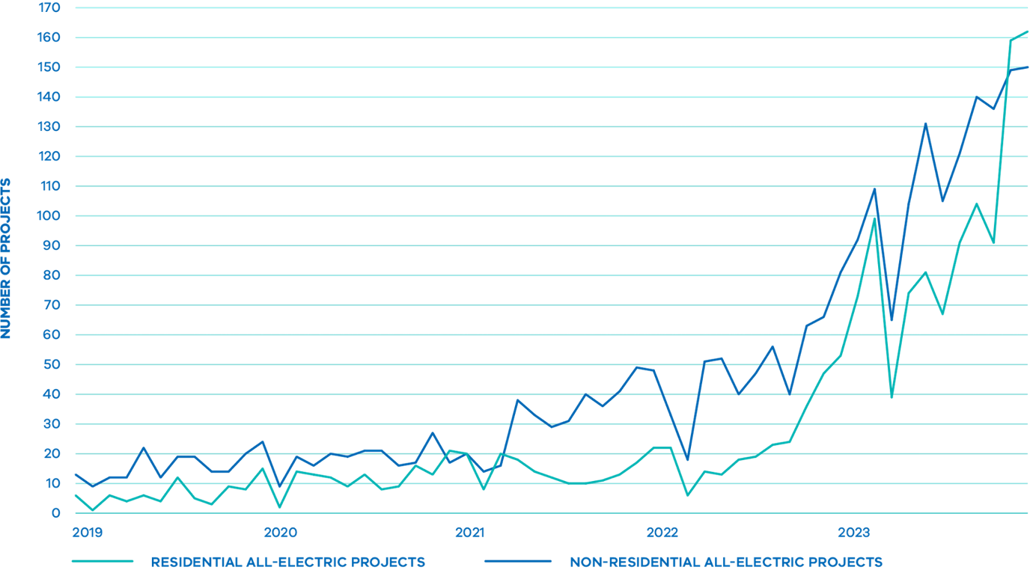

Source: Extract of Built Environment Sustainability Scorecard data from 35 Victorian councils from 2019 to August 2023 cleaned, aggregated and provided upon request for the purposes of the Gas Substitution Roadmap bess.net.au

Victorian Government Actions

Removing barriers to electrification in the planning system
- The Victoria Planning Provisions (VPP) and all planning schemes were changed in August 2022 to remove requirements for developments to be connected to reticulated gas and to amend requirements for referral of connection decisions to gas distribution companies.
- On 28 July 2023 the Government announced that new homes requiring a planning permit will be required to be all‑electric from 1 January 2024. This will apply to new planning permit applications submitted from 1 January 2024 for new homes and apartments in both greenfield and infill sites, as well as all new public and social housing delivered by Homes Victoria.
- Solar Victoria is delivering the $10 million Residential Electrification Grants program to support the uptake of new all‑electric homes, developments and precincts.

Stronger efficiency standards for new homes will be implemented in 2024
- Stronger energy efficiency standards in the National Construction Code adopted in Victoria in May 2023 and mandatory from 1 May 2024. 85 per cent of homes designed and built through Sustainability Victoria’s 7 Star Homes Program went all-electric to meet the new energy budget for heating, cooling, hot water and other fixed appliances.
- Victoria’s Plumbing Regulations were amended in November 2023 to remove a barrier to installing efficient electric heat pump water heaters in new homes.
Research commissioned by the Australian Gas Infrastructure Group (AGIG), APA Group and Jemena published in 2023 showed that for new builds it would generally be lower cost to electrify (Boston Consulting Group 2023, The role of gas infrastructure in Australia’s energy transition, June 2023). Separate, independent research conducted by the Grattan Institute found all‑electric dwellings are cheaper to run and better for people’s health and concluded gas connections to new homes should be prohibited (Grattan Institute 2023, Getting off gas. Why, how and who should pay? grattan.edu.au/report/getting-off-gas).
However, of the more than 50,000 new homes built in Victoria each year approximately 40,000 are still connecting to the gas network. This is adding to residential gas demand as well as continuing to expand the gas network infrastructure that supplies gas to homes and businesses. This challenge will only grow as Victoria aims to build 800,000 new dwellings over the next decade, as outlined in Victoria’s Housing Statement.
Allowing the network to continue to expand risks unnecessary investment in expensive, long-lived gas infrastructure, with costs ultimately passed on to consumers. A critical first step in managing an orderly transition to renewable energy is to limit the continued expansion of the reticulated gas network.
On 28 July 2023, the Government took an important first step in announcing that from 1 January 2024, new dwellings, apartment buildings and residential subdivisions that require a planning permit will no longer be connected to the reticulated gas network.
This change to be implemented through changes to the Victoria Planning Provisions will apply to homes and apartments in new subdivisions, as well as knock-down/rebuild new homes in existing suburbs and towns.
This change will ensure that new home buyers secure cost of living relief through lower energy bills for the life of their home. Signalling this clear direction will also provide the manufacturing sector and installing trades with the confidence to invest in the new jobs, innovation, skills and training needed to support the scale of residential electrification required.
Building a new home as all-electric need not cost any more than building a dual-fuel home, and in many cases can be cheaper upfront if reverse-cycle air-conditioners (RCAC) are used for both heating and cooling (see Figure 12).
All‑electric subdivisions can also recoup important infrastructure savings as gas supply pipes do not need to be laid across the estate.
The following table compares the indicative whole-of-home installation costs associated with building a new home as either dual-fuel or all‑electric.
The Victoria Planning Provision amendments are anticipated to affect approximately 14,500 residential planning permits per year. Because there can be a time lag of up to two years between the issuing of a planning permit and commencing construction (for multi-stage subdivision the time lag can be up to ten years), only a small proportion of new homes built after 1 January will initially be captured by this change, but the proportion will increase over time.
This decision complements the introduction of new energy performance standards for new homes under the National Construction Code that will come into effect in Victoria from 1 May 2024. These strengthened standards will require an increase in efficiency from 6 to 7 stars and introduce a new ‘whole-of-home’ energy budget to manage energy use from major appliances. They will increase the bill-saving and emissions benefits of an all‑electric home (See Figure 13).
To support the wider uptake of all‑electric homes, developments and precincts, Solar Victoria will deliver the $10 million Residential Electrification Grants program. Through an Expression of Interest (EOI) process, the program will target providers that can, through co-investment and innovation, leverage Solar Victoria funding to implement renewable energy technology solutions. These may include orchestration and load shifting, the development of all‑electric residential precincts or banks allocating ‘green’ home loans. This program will allocate funding to approved providers in bulk enabling them to install systems for a minimum of 50 homes as part of a single scheme, project or development. Providers will then pass the rebate savings on as a benefit to the homeowner.

Figure 12 Product and installation costs for dual-fuel versus all‑electric homes Class 1, detached homes
Home type | Detached | Detached | Detached | Detached
Appliance mix | Dual-fuel | Dual-fuel | All-electric | All-electric
Space heating type  Total installed cost | Gas ducted $5,770 | Gas ducted $5,770 | Ducted RCAC $12,520 | Multi-split RCAC $12,110
Space cooling type  Total installed cost | Evaporative $6,640 | Multi-split RCAC $12,110 | Ducted RCAC included in ducted RCAC cost above | Multi-split RCAC Included in multi-split RCAC cost above
Water heating type  Total installed cost | Gas instant $2,430 | Gas SHW $4,390 | Heat pump $4,530 | Heat pump $4,530
Cooktop type  Total installed cost | Gas $1,220 | Gas $1,220 | Induction $1,750 | Induction $1,750
Total appliances installed cost | $16,060 | $23,490 | $18,800 | $18,390
Cost of supporting gas equipment i.e. Gas pipework | $3,090 | $3,090 | N/A | N/A
Cost of electricity connection to home | $510 | $510 | $510 | $510
Cost of supporting internal wiring | $0 | $0 | $1,360 | $940
Total cost for home type | $19,660 | $27,090 | $20,670 | $19,840

Source: Reverse cycle air conditioning

New Victorian homes to go all‑electric from 2024
In July 2023, the Government announced that from 1 January 2024 new dwellings, apartment buildings and residential subdivisions that require a planning permit will not be permitted to connect to the reticulated gas network.
This new policy will impact the construction of new dwellings that require a planning permit, including knock-down/rebuild projects. The new policy will not impact:
- New dwellings that do not require a planning permit
- Existing homes that have an existing gas connection
- Renovations and extensions to existing dwellings
- LPG use in homes that are not connected to the gas network, or in other applications such as barbecues
- Planning permit applications that are lodged prior to 1 January 2024

Figure 13 Costs of a new dual-fuel home vs a new all‑electric home

Dual-fuel
- Gas cooktop
- Gas ducted heater
- Gas storage water
- Evaporative cooler

Appliance and install costs
Cooling and heating | $12,400
Hot water | $2,400
Cooktop (inc. fixed charge) | $1,200
Total | $16,000
Gas pipework installation cost | $1,300 - $5,000
Total cost (appliance + installation) | $17,300 - $21,000

Bill costs
Electricity bill | $1,880
Gas bill | $1,730
Annual energy bill | $3,610

All-electric
- Induction cooktop
- Solar PV
- Multi-split heating/cooling
- Heat pump hot water

Appliance and install costs
Cooling and heating | $12,100
Hot water | $4,500
Cooktop (inc fixed charge) | $1,800
Total (appliances) | $18,400

Bill savings
Heating/cooling | $480 saving
Hot water | $170 saving
Cooktop (inc fixed charge | $370 saving
Total savings | $1,020 saving
Annual energy bill | $2,590

Solar
Solar installation cost (6.6 kW) | $4,630
Solar saving | $1,230 saving
Annual energy bill (with solar) | $1,360

Source: Save money and the environment with your new all‑electric home fact-sheet, Victorian Gas Substitution Roadmap at energy.vic.gov.au/renewable-energy/victorias-gas-substitution-roadmap
The Government will build on the planning reforms already announced, by exploring options to phase out new gas connections to other building classes including through a regulatory impact statement. Further amendments to the Victoria Planning Provisions to phase out gas connections to buildings such as offices, retail premises (including food and drink premises), some education facilities and other accommodation (such as residential aged care facilities and rooming houses) will also be investigated.
The Government understands the diverse nature of non-residential building classes and those differences will be considered. Industrial and manufacturing facilities will not be included in this process.

Next steps
- The Government will undertake a regulatory impact statement to investigate options to progressively electrify all new residential and most commercial buildings where appropriate electric appliance options are readily available. The regulatory impact statement will be released for public feedback soon.
The same regulatory impact statement will consider the costs and benefits of requiring existing gas appliances in homes and relevant commercial buildings be replaced with electric appliances when the current appliance reaches end-of-life.
- Victoria’s Housing Statement released on 20 September 2023 announced new planning exemptions for a small secondary dwelling (granny flat). These small secondary dwellings are also required to be all-electric.
- Solar Victoria will deliver a $16 million co-funded Commonwealth-Victorian Government Solar for Apartments program which will provide funding for solar photovoltaic (PV) to apartment buildings at scale. This will enable customers to start the journey to electrification by boosting up front affordability and allowing energy savings to flow immediately once solar PV systems have been installed.
- Building on the successful expansion of the Victorian Energy Upgrades program to include space heating and water heating electrification activities announced in early 2023, the Victorian Energy Upgrades program will be expanded to include induction cooktops, so that the scheme includes all the major gas appliances households commonly use, enabling all Victorians to fully electrify their homes through Victorian Energy Upgrades.
- Victoria is continuing to engage with the next update of the National Construction Code (due for implementation in 2025), a key focus of which is strengthened energy performance standards for new commercial (non-residential) buildings. Objectives for stronger standards for new and refurbished commercial buildings include:
  - Reducing greenhouse gas emissions
  - Making buildings more resilient to heatwaves
  - Reducing building running costs
  - Assisting with the decarbonisation of the electricity grid
Mandatory solar PV, provision of electric vehicle charging infrastructure, and all‑electric net zero building options will also be tested.
The Australian Building Codes Board will engage with industry on key proposals in early 2024 via a consultation regulatory impact statement, and the Victorian Government will provide guidance on meeting the new standards in time for commencement in May 2025.

Electrification is gaining pace around the world
In taking action to phase out gas use in buildings, Victoria is joining many cities and countries around the world that are enacting pro-electrification policies and regulations:

Australia
- The ACT introduced a regulation to prevent new gas connections in the Territory, from 8 December 2023.
- The 2022 New South Wales Sustainable Buildings State Environmental Planning Policy (SEPP) requires certain non-residential developments to be all‑electric or capable of converting to operate without fossil fuels by 2035.

United States of America
- New York City and more than 60 Californian cities and counties including Los Angeles and San Francisco have adopted gas-free buildings commitments or electrification building codes.

Europe
- Belgium has a ban on fossil heating systems in new builds from 2025 in Flanders.
- Netherlands has had a ban on new fossil gas connections since 2018.
- France has a de-facto ban on gas boilers in new homes from 2022, due to introduction of emissions limits.
- Germany has a de-facto ban on new fossil-powered heating systems via a requirement of 65 per cent renewables input from 2024.
- In Austria the sale of new gas boilers and repair of old ones are banned from 2023.
- Denmark has had a ban on new gas boilers since 2013 and has a plan to move 50 per cent of households using gas heating to district heating by 2028.
- Norway has had a ban on installation of new gas boilers since 2017.

Electrifying existing buildings
The Government has already taken an important first step by announcing that from 1 January 2024, new residential buildings requiring a planning permit will no longer be allowed to connect to the reticulated gas network.
This signals the Government’s clear intent to limit the continued growth in fossil gas consumption and continued expansion of the network, on a pathway towards reducing Victoria’s overall reliance on fossil gas.
However, the more substantive challenge lies in reducing gas demand by electrifying gas use in Victoria’s 2 million existing residential and commercial buildings. Victorian households and businesses are making decisions every day that will not only influence their future energy bills, but also whether Victoria meets its emissions reduction targets.
These decisions occur when a major appliance breaks down and needs to be replaced, when a major renovation is being undertaken or when rooftop solar is being installed.
The Government is continuing to assist Victorian households to improve energy efficiency and switch to efficient electric appliances through a range of programs including the Residential Efficiency Scorecard, comprehensive online information and advice through Solar Victoria and Sustainability Victoria, as well as financial assistance provided through Solar Homes and the Victorian Energy Upgrades program (see Section 3 Supporting businesses and households to transition).
The Scorecard is Australia’s only home energy efficiency rating and advice program for existing homes.
- Snapshot of your home’s energy performance and comfort
- Trusted energy efficiency rating system
- Expert advice tailored to your needs
- A clear path forward
- Ensure your energy upgrade dollars are well spent
- Verified impact of energy upgrades
- Cheaper to run, greener, more comfortable home
Discover how Scorecard can help: www.homescorecard.gov.au

Victorian Government actions
- The $1.3 billion Solar Homes program has supported Victorian households to install over 300,000 solar photovoltaic (PV) systems, efficient electric hot water and solar battery systems, helping them save on their annual energy bills and reduce emissions.
- Key reforms to the Victorian Energy Upgrades program to support electrification have been delivered.
  - Established new incentives for the replacement of inefficient gas water heaters and space heating with efficient electric alternatives commenced on 31 May 2023
  - Removed incentives to replace existing gas water and space heaters with new gas hot water and space heaters on 30 June 2023
  - Inclusion of Residential Efficiency Scorecard assessments in the scheme, making it more affordable for Victorians to get independent, rigorous advice about upgrade opportunities for their home
More and more Victorians are recognising the benefits of efficient electric appliances. While encouraging, current trends towards electrification are not sufficient to put Victoria on track to meet emissions targets or manage gas supply challenges.
Reducing gas consumption consistent with meeting AEMO’s Orchestrated Step Change scenario will require highly ambitious rates of electrification of Victoria’s buildings – equivalent to around 880,000 homes (or approximately 1.76 million gas appliances) (Assuming each home has gas hot water and gas heating) electrifying by 2030 or more than 500 homes (or 1,000 gas appliances) per day.
Currently, around 80,000 gas heaters and around 186,000 gas water heaters are installed in Victoria each year, the majority of which are replacements in existing homes (2021 Residential Baseline Study for Australia and New Zealand for 2000-2040, EnergyConsult for DCCEEW on behalf of the national Equipment Energy Efficiency Program, November 2022 (Accessed 2/11/23) energyrating.gov.au/industry-information/publications/report-2021-residential-baseline-study-australia-and-new-zealand-2000-20 40).
This equates to more than half a million gas heaters and nearly one million gas hot water systems replaced between now and 2030 (Sustainability Victoria analysis based on SV’s 2015 Victorian Residential Energy End-Use Model) – or around 1.5 million opportunities to install an efficient electric heat pump unit instead, saving between $170 and $250 annually when replacing an old gas storage or instant water heater with a heat pump water heater (Embracing electricity to cut your bills at home’, Victoria’s Gas Substitution Roadmap energy.vic.gov.au/renewable-energy/victorias-gas-substitution-roadmap).
However, consumer surveys conducted for the Roadmap, as well as many other studies, indicate that complex, outdated and inaccurate information and a historical preference for gas for certain uses such as cooking, can prevent investment in electric alternatives. This is particularly so in emergency situations such as replacing essential appliances such as hot water or heating, where decisions need to be made quickly often based on existing information (Brotherhood of St Laurence (2017) Home Energy Efficiency Upgrade Program final report (Accessed 2/11/23) bsl.org.au/research/publications/home-energy-efficiency-upgrade-program-final-report). Many households also face language, cultural or other barriers to accessing relevant information, while low-income households and those experiencing energy hardship can struggle to afford the upfront costs of electrification, even if it will save money on energy bills into the future (ACOSS, BSL and TCI (2017) Empowering disadvantaged households to access affordable, clean energy, Australian Council for Social Service, Brotherhood of St Laurence and The Climate Institute (Accessed 30/10/23) acoss.org.au/wp-content/uploads/2017/07/ACOSS_BSL_TCI_Empowering-households.pdf).
Infrastructure Victoria’s 2022 analysis of the future of gas in a net zero economy highlighted the importance of independent information in influencing consumer attitudes and behaviour change, noting that consumers “value simple, practical and accessible information on energy efficiency from an independent trusted source, including clarity on different technologies and how they can save money and make a positive impact.” (Towards 2050: Gas Infrastructure in a net zero emissions economy – Final report, Infrastructure Victoria, July 2022 (Accessed 2/11/23) infrastructurevictoria.com.au/report/towards-2050-gas-infrastructure-in-a-net-zero-emissions-economy) Ensuring low-income households and those experiencing energy hardship can easily access relevant services is particularly important (Enabling electrification: Addressing the barriers to moving off gas faced by lower-income households, ARC Centre of Excellence for Children and Families over the Life Course & Brotherhood of St Laurence, July 2023. (Accessed 2/11/23)).
As a result, many Victorian households typically opt for ‘like for like’ replacement of their existing gas appliances – meaning they are inadvertently missing out on significant energy bills savings, while Victoria is missing out on the wider economic and emissions reduction benefits of electrification.
More than 2.5 million air conditioning units are already installed in Victorian homes. The majority are used only for cooling although many are also “reverse cycle” – meaning they can heat. Switching to using these existing units for winter heating instead of gas could deliver immediate reductions in gas demand, saving money on household energy bills as well as reducing emissions.
There is a clear need for proactive moves to ensure all Victorians benefit from electrification, and to avoid the economic and social risks of gas supply tightness and climate change. On top of action to limit the continued growth of new gas connections, the Government will also review the use of gas in existing buildings.
Sending a clear signal that Victoria is moving away from gas in residential and commercial buildings will stop households and businesses inadvertently investing in equipment that will lock them into higher energy bills and higher emissions for decades.
Clear direction will create the stable policy environment that is needed to encourage investment in new technology, workforce skills and training, while assisting households and business to make informed investment decisions and take advantage of electrification incentives and assistance.
In 2024, the Government will explore options, including through a regulatory impact statement, to phase-out gas in existing residential and many commercial buildings through further amendments to building and planning regulations. The same regulatory impact statement will consider the costs and benefits of requiring existing gas appliances in homes and relevant commercial buildings be replaced with electric appliances when the current appliance reaches end‑of‑life.
The Government is also continuing to ensure renters, who have less control over the energy performance of their homes, are not locked into unnecessary costs. Victoria was the first jurisdiction in Australia to introduce minimum energy efficiency standards for rented homes, commencing with a heating standard in March 2021. The Government is now moving to expand these standards to cover ceiling insulation, draught sealing, hot water, and cooling.
Expanded minimum energy efficiency standards will support rental affordability by addressing key drivers for energy use and costs in approximately 500,000 rented homes while also improving the worst performing rental properties, benefiting renters through lower energy bills and improved thermal comfort (with associated health benefits). Modelling carried out by DEECA indicates that new standards for ceiling insulation would save renters around $387 per year, a draught sealing standard $37, hot water $205 and cooling $153 a year.
These standards will also improve health outcomes and ensure rented homes are more resilient to the changing climate. Options for the new standards will be tested through a regulatory impact statement and public consultation process during early 2024.

Next steps
- Explore options, including through a regulatory impact statement, to phase out gas in existing residential and many commercial buildings through further amendments to building and planning regulations.
The same regulatory impact statement will consider the costs and benefits of requiring existing gas appliances in homes and relevant commercial buildings be replaced with electric appliances when the current appliance reaches end of life.
- Continue to drive improvements in the energy performance of rental homes.
  - Expand minimum energy efficiency standards for rented homes to cover ceiling insulation, draught sealing, hot water and cooling.
  - Options for the new standards will be tested through a regulatory impact statement and public consultation process during late 2023 and early 2024.
- Continue to progress to introduce a mandatory disclosure scheme. The disclosure of energy efficiency information at key decision points such as purchase, lease or renovation helps householders decide how to improve the energy performance of their home.
  - The Commonwealth Government is leading on the development of a National Disclosure Framework in collaboration with States and Territories.
  - A draft framework was released in 2022 and is now due for completion by the end of 2023. When finalised, the framework will help inform future disclosure policy in Victoria.
- Support Victorian households and businesses to electrify by setting the energy saving targets for the Victorian Energy Upgrades program for 2026 to 2030 by May 2025 following public consultation in 2024. These targets will set the level of ambition of the Victorian Energy Upgrades program out to 2030.
- The SEC Consumer Energy Solutions function will provide affordable, accessible solutions that can help all Victorians enjoy the benefits of an energy efficient and all-electric home.

What about LPG?
The Victorian Government recognises that many Victorians current use Liquefied Petroleum Gas (LPG or ‘bottled’ gas) in their outdoor barbecues. Some Victorians, particularly in regional areas where connection to the reticulated gas network is not available, also rely on bottled gas for home heating, cooking and hot water.
Over time, bottled gas may also transition to renewable alternatives. In Europe Bio-LPG is increasingly being made available for purchase in cylinders for a range of off-grid leisure activities as well as industrial heating. In partnership with SHV Energy, Circle K in Sweden since mid-2020 has provided 100 per cent Bio-LPG cylinders across all its stores.
In Australia, several pilot operations will soon produce Bio-LPG as a by-product of up to 10 per cent of the manufacture of biodiesel or Sustainable Aviation Fuel (SAF). One example is the Oceania Biofuels Project Queensland which is an Australian first $500 million biodiesel and SAF refinery proposing to use locally sourced tallow, canola and used cooking oil to produce 350 million litres of SAF and biodiesel per year. Household LPG use represents a very small proportion of Victoria’s total gas use (around 1 per cent)
Some Victorians may prefer to continue to use LPG instead of efficient electric alternatives, particularly for relatively small consumption uses such as barbecues. However, LPG is higher cost than fossil gas and this may make its ongoing use for home heating prohibitive for most people.
The Government will consult closely with the LPG industry to monitor the development of this potentially significant transition and consider the sector in more detail in future roadmap updates.

Helping business to improve efficiency and electrify
Victorian businesses use fossil gas in diverse ways ranging from heating and hot water in office buildings, to high heat applications in a range of manufacturing and industrial processes.
Where businesses use gas in similar ways to households – for heating, hot water and cooking – efficiency and electrification offers similar cost-effective opportunities for reducing gas consumption, cutting emissions and lowering energy bills. However, readily available residential electric technology may be less suitable for commercial building classes such as multi-storey office buildings that have centralised heating, ventilation and cooling (HVAC) and/or hot water systems.
These buildings can often need tailored electrification retrofit solutions to overcome design, space or other constraints. In addition, businesses that rent their premises in an office building or shopping mall may have less control over decisions affecting the systems that power their business.
The Government is continuing to provide support and assistance for Victorian businesses across the economy to improve energy efficiency and reduce gas use. The Government is also actively developing renewable alternatives for use by manufacturing and industrial applications that cannot be easily electrified (see Section 4 Working with industry through the transition.

Victorian Government actions
- Victorian manufacturers are benefiting from nearly $20 million provided in the 2022-23 Budget to invest in renewable energy and low carbon component manufacturing and to help their workers transition into highly skilled, digital jobs.
  - Low Carbon Manufacturing Grant Program – Business Readiness Stream assisted 10 Victorian small to medium enterprises to access business services, advice, or expertise.
  - Low Carbon Manufacturing Grant Program – Business Growth Stream assisted nine Victorian manufacturers to capitalise on opportunities to produce products or components that support the transition to decarbonisation and net zero emissions. The successful projects will retain 162 and create 26 new jobs.
- The Victorian Government’s five-year, $60 million investment via the Agriculture Energy Investment Plan (AEIP) supported Victorian farmers to improve on-farm energy efficiency and incorporate renewable energy into farming systems to make Victoria’s agriculture industries resilient and internationally competitive. The AEIP included free on-farm energy assessment, grants, research and demonstration of energy technology and efficiency on-farm and identified education and skills opportunities for the sector.
While funding for the program concluded in June 2023, ongoing policy, research and industry development support will continue to underpin farmers’ energy transition. This support will help to reduce risk, maximise opportunities for emissions reductions and ensure affordable, secure and reliable energy is available for agricultural products.
- The $31 million Business Recovery Energy Efficiency Fund (BREEF) program concluded in July 2023, delivering 108 energy management projects in energy efficiency upgrades – reducing greenhouse gas emissions by 25,000 tonnes a year, providing $13 million in financial benefits to business, providing 90 jobs during delivery and another 40 ongoing roles.

3 Supporting businesses and households to transition
The Victorian Government is committed to supporting households and businesses to overcome barriers to electrification and ensure the choices made today benefit consumers now and into the future.

Making it easier to electrify and improve efficiency
In the current economic climate where energy prices are rising at the same time as inflation and interest rates, a broader range of households are experiencing energy hardship and struggling to pay their energy bills.
However, upfront costs can be a barrier to households and businesses investing in electrification and efficiency upgrades, even if the upgrade would pay for itself in energy bills savings in a short period of time. At the same time, the complexity of the modern energy market and technology can create confusion, while many people, particularly vulnerable households, the elderly or people from culturally and linguistically diverse backgrounds also face cultural, language or education barriers to accessing information (Energy Consumers Australia 2020, Power Shift Final Report energyconsumersaustralia.com.au/wp-content/uploads/Power-Shift-Final-Report-February-2020.pdf).
The Victorian Government is supporting households and businesses to navigate this complex landscape to ensure that the choices that are made today benefit consumers now and into the future. This will be driven by flagship electrification initiatives (See Figure 14), including the SEC exploring options for a trusted `one stop shop’ via a pilot program to be launched in 2024, the revamped Victorian Energy Upgrades scheme, and Solar Homes.
Taken together, these programs aim to provide Victorians with a full suite of supports to enable more households to go all-electric. By providing reliable and trusted information, the SEC will help Victorians cut through the noise and make well-informed decisions to go all-electric, slashing their bills and emissions in doing so.
In 2024, the revamped and expanded Victorian Energy Upgrades will provide discounts for efficient electric induction cooktops, giving Victorian households access to all the discounted appliances they need to go all-electric. Through Solar Homes, eligible Victorian households can boost their savings through rebates and loans of up to $1,400 to install solar panel systems, and loans of up to $8,800 to install solar battery systems.

Figure 14 Electrification incentives available for Victorian households
 |  |  |  |  | Victorian Energy Upgrades Discount Approx
Decommissioning | Property type | Installing | Appliance and installation Cost | VEECs | Assuming $70 certificate price | % of product price | Revised price
Space heating
Room gas | Single room | Single-split reverse cycle air conditioner (6 kW unit) | $1,800–$4,000 | 15 | $1,050 | 25–60% | $750–$2,950
Ducted gas | Detached home | Ducted reverse cycle air conditioner (1 x 15 kW unit) | $10,135–$16,670 | 50 | $3,500 | 20–35% | $6,635–$13,170
Ducted gas | Townhouse and apartment | Multi-split reverse cycle air conditioner (1x10 kW unit) | $6,840–$9,670 | 40 | $2,800 | 30–40% | $4,040–$6,870
Ducted gas | Detached home | Multi-split reverse cycle air conditioner (19kW unit) | $8,500–$13,650 | 80 | $5,600 | 40–65% | $2,900–$8,050
Ducted gas | Detached home | 4 x Single split reverse cycle air conditioner | $7,200–$10,000 | Total 36  - 1 x 8kW living room, 30  - 3 x 3kW bedrooms 2+2+2 | $2,520 | 25–35% | $4,680–$7,480
Hot water
Instant gas or gas storage | Detached home and townhouse | Heat pump hot water system (Eg 280L unit) | $2,100–$6,300 | 5–9 | $350–$630 | 10–15%, average | $1,750–$5,670
Instant gas or gas storage | Detached home and townhouse | Electric-boosted solar hot water system | $3,400–$7,600 | 5–11 | $350–$770 | 10% average | $3,050–$6,830

Victorian Government actions
- Solar Homes continues to assist Victorian homes to electrify. Over the first five years since commencing in 2018, the $1.3 billion Solar Homes Program has assisted thousands of Victorian households to install over 300,000 solar PV systems, efficient electric hot water and solar battery systems, helping them save on their annual energy bills and reduce emissions. The program has assisted more than:
  - 11,100 households to install an energy efficient hot water system
  - 27,200 households to install a split system air conditioner
  - 241,100 households to install a solar PV system, generating over 4,773,000MWh of electricity and abating approximately 2.4Mt of GHG emissions.
  - 16,000 households to install a battery system, with 456 of those enrolled into a virtual power plant with a cumulative capacity of 182MWh
- The Victorian Energy Upgrades program will support more households and businesses to go all-electric by expanding the discounted product offering to include induction cooktops, and a wider range of hot water and space heating heat pumps.
- Residential Efficiency Scorecard assessments are now available at discounted rates through the Victorian Energy Upgrades program. The Scorecard is Australia’s only home energy efficiency rating and advice program for existing homes. It is an innovative program that offers:
  - A star rating for the home, just like a washing machine
  - Support to households when transitioning to electric-only
  - A clear pathway to upgrading the home
  - All while reducing energy costs and emissions and improving comfort and health outcomes.
The Residential Efficiency Scorecard is a Victorian Government success story that has been adopted and funded by all States, Territories, and the Commonwealth.

Accessing affordable energy through the transition
As well as taking decisive action to reduce Victorians’ exposure to high gas prices in the long-term, the Government also has a range of supports in place to assist households and businesses to reduce their current high energy costs.
The energy concessions program which provides a 17.5 per cent discount off gas and electricity bills for eligible concession card holders
The utility relief grant scheme which provides up to $650 per utility every two years to low‑income Victorians experiencing unexpected hardship to pay utility bills
The comprehensive Payment Difficulty Framework under which retailers must offer tailored assistance to residential customers with arrears
Small businesses as well as households can use Victorian Energy Compare to compare their offer to others in the market and ensure they are on the lowest-price offer available
Retailers must give written notice to households and small businesses of price rises with clear advice about whether the customer is on the retailer’s best offer
The Energy Assistance Program helps Victorians experiencing energy hardship to navigate the energy market and ensure households are accessing eligible supports and are on the best retail offer.

Next steps
- The Victorian Energy Upgrades program is continuing to provide businesses with discounts to reduce their gas use by installing new equipment such as efficient electric water heaters and space heaters. Businesses can also access financial incentives for bespoke ‘project-based’ energy efficiency, electrification and fuel switching activities that cut emissions. These projects have the potential to achieve significant reductions in gas consumption for businesses. Work is underway to streamline project-based activity requirements and to further encourage renewable energy investment through these projects.
- SEC ‘one stop shop’ solutions for supporting the switch to all‑electric households will help remove some of the barriers to Victorians reducing their energy costs and emissions.

4 Working with industry through the transition
The Victorian Government is continuing to take action to ensure renewable alternatives are available to support the long-term transition of Victoria’s industrial gas users and create long‑term jobs through new career pathways.

Unlocking renewable alternatives for industrial gas users
Gas is used across Victoria’s industrial sector in a diverse range of applications ranging from medium temperature steam-raising (in the food and beverages sectors), to high temperature applications in metals, glass, ceramics and brick production, and as a chemical feedstock in fertiliser production.
Gas also plays an important role in Victoria’s electricity system by assisting with ‘firming’ or ‘peaking’ electricity generation – turning on quickly to maintain reliability of supply during periods of high demand or lower supply from other sources.
While electrification and energy efficiency are key to decarbonising buildings and lower temperature industrial uses, at present these are not technically feasible or cost-effective options for all industrial gas uses, particularly high-heat applications.

Victorian Government actions
- A Renewable Gas Consultation Paper was released on 11 September 2023 seeking feedback on potential policy design to support the deployment of renewable gas in Victoria.
- Victoria is leading the way in building the foundations for a thriving hydrogen economy, as outlined in the Renewable Hydrogen Industry Development Plan, as well as preparing for the supply and take-up of renewable gases at scale:
  - $10 million for the Hume Hydrogen Highway initiative to deliver at least four refuelling stations and 25 hydrogen-powered trucks along Victoria’s busiest freight corridor – the Hume Highway between Melbourne and Sydney.
  - Continue to work with Victoria’s hydrogen technology clusters, which the Victorian Government initially helped seed fund, supporting renewable hydrogen industry collaboration and partnerships across the state.
  - $6.6 million in grant support for projects that will see Victoria produce and use renewable hydrogen in real-world applications through the Renewable Hydrogen Commercialisation Pathways Fund.
  - $600,000 in grants to support eight recipients to develop business cases or feasibility cases to support their transition to renewable hydrogen through the Renewable Hydrogen Business Ready Fund.
  - $12.3 million in funding to support the Hydrogen Park Murray Valley project in Wodonga which includes a 10MW electrolyser which will initially deliver hydrogen to the Albury-Wodonga gas network.
- In August 2023, the Waste to Energy Fund: Bioenergy Fund has awarded $8 million in grants to 24 recipients including water corporations, local government, agribusiness and food processing businesses for a range of innovative projects to expand renewable bioenergy generation in Victoria. The program is due to run until March 2025.
Renewable hydrogen is the highest cost of the four main gas substitution options (electrification, energy efficiency, biomethane and renewable hydrogen) and is likely to offer limited carbon abatement opportunities in the period to 2030. At the same time, a material amount of lower cost biomethane will likely be required this decade for Victoria to meet its 2030 economy-wide emissions reduction target.
Renewable gases such as biomethane and renewable hydrogen will therefore need to play a critical but targeted role in decarbonising Victoria’s harder-to-electrify industrial uses in the medium to long-term. A range of factors affect the suitability of renewable gases such as biomethane and renewable hydrogen to substitute for existing uses of fossil gas across the Victorian economy.
Consideration | Biomethane | Renewable Hydrogen
Cost | Lower cost than hydrogen but more expensive than fossil gas (dependent on future fossil gas price) (Biomethane prices vary due to factors including distance of biomethane production site to end users) | Higher cost than biomethane and fossil gas
 | Avoids cost of waste disposal where organic waste is used as feedstock
Scalability | Scale is limited to available feedstock | Potentially highly scalable in long-term (subject to availability of sustainable water resources as key input)
Short- or long-term option | Short-term, can displace fossil gas and reduce emissions at a lower cost than hydrogen | Required long-term
 | Required long-term
Substitution for fossil gas | Compatible with existing gas appliances and infrastructure (including storage and transmission networks) | Less energy dense than fossil gas – greater volume needed to produce the same amount of energy (Hydrogen requires approximately three times the volume to produce the same energy output as fossil gas)
 |  | Incompatible with older, steel-based distribution and transmission networks beyond an initial blending limit (~10% by volume or 3% by energy)
Decarbonisation benefits | Net zero fuel source if feedstock used is organic waste and residue | Net zero fuel source
 | Maximum decarbonisation limited by available feedstock | Maximum decarbonisation potentially very high
Highest value use | Can be substituted directly for fossil gas as feedstock in industry | Feedstock in chemical industrial processes (eg making ammonia), powering intensive industries that cannot readily electrify (eg steel-making, transport and shipping) and long duration energy storage (While hydrogen can be used as an energy source in other processes, a number of these involve either technical limitations or lower value uses (e.g. for low grade heat in buildings)
 | Provides an economic case for methane capture and combustion, reducing emissions by more than the avoided gas use | Higher cost than electrification and energy efficiency in building applications (space heating, hot water or cooking) or lower temperature industrial heat
Industrial use cases | Water corporations could substitute fossil gas with biomethane (onsite or exported to the grid) | Energy intensive industries such as producing ammonia, green steel, aluminium and other metals
 | Onsite heat and power generation (where biogas is produced on site)
Behind the meter usage | Both biomethane and renewable hydrogen can be generated and utilised onsite (as opposed to delivery via the gas distribution system) as a substitute for some large industrial processes currently reliant on fossil gas
Electrification is the lowest cost option for residential users to decarbonise their fossil gas consumption compared to renewable gases. Analysis shows that biomethane is currently around double the cost of fossil gas, whilst renewable hydrogen is currently around four times the cost of fossil gas (DEECA 2023, Renewable Gas Consultation Paper engage.vic.gov.au/victorias-renewable-gas-consultation-paper).
Compounding the higher up-front price of renewable gas is the fact that an efficient gas heater can only convert one unit of energy into a maximum of one unit of heat, while electric heat pumps (RCACs) produce 3–5 units of heat for the same energy inputm (Grattan Institute 2023 Grattan Institute (2023), Getting off gas – Why, how and who should pay, grattan.edu.au/wp-content/uploads/2023/06/Getting-off-gas-why-how-and-who-should-pay.pdf) meaning residential users will be significantly financially better off if they electrify. The International Energy Agency (IEA) estimates that PV-powered heat pumps require 5-6 times less electricity than a boiler running on green hydrogen to provide the same amount of heating (IEA 2021, Global Hydrogen Review 2021, International Energy Agency at iea.blob.core.windows.net/assets/e57fd1ee-aac7-494d-a351-f2a4024909b4/GlobalHydrogenReview2021.pdf).
Other factors which need to be considered include the availability of appropriate technology. For example, household hydrogen appliances are not currently available, and will not be for many years to come. Ensuring all the safety and health aspects of utilising hydrogen in homes will also be challenging.
The cheapest, simplest, and most logical choice for residential users is to electrify, and this will ensure that valuable renewable gases are reserved for non-substitutable industrial uses.

Developing Victoria’s renewable gas sector
Given the scale of Victoria’s gas substitution challenge and the important role that renewable gases will need to play, current rates of growth in the supply of biomethane and renewable hydrogen will be insufficient to meet Victoria’s emissions reduction targets. Policy intervention is required to provide sufficient investment certainty, scale up renewable gas and direct it to the end-uses that need it most. This will present new opportunities and renewable energy jobs for Victoria through the expansion of the renewable gas industry (Consistent with the recent recommendation from the Grattan Institute that all governments should develop policies to build green gas supply chains for the industrial sector – Grattan Institute 2023).
Biomethane is biogas that has been purified and stripped of carbon dioxide, hydrogen sulphide and water. It is composed of methane and is chemically indistinguishable from fossil gas.
To support development of these options, the Government released a Renewable Gas Consultation Paper in September 2023. The paper sought stakeholder views on the potential design of a policy or policies to best support the efficient and effective deployment of renewable gas in Victoria.
The paper included analysis of cost recovery options of a potential renewable gas scheme, including potential scheme costs and bill impacts if any scheme were to be cost-recovered from energy consumers. It is based on different renewable gas target levels and different combinations of biomethane and renewable hydrogen to meet those targets.

Stakeholder response to Renewable Gas Consultation Paper
The Victorian Government received almost 50 submissions in October 2023 to its Renewable Gas Consultation Paper. Stakeholders engaged thoroughly on the key questions posed in the paper with several raising additional areas for consideration and providing their own detailed analysis.
Most stakeholders supported the need for a renewable gas target with accompanying policy to ensure target delivery. A range of views were expressed regarding an appropriate target level and timeframe. Some stakeholders noted the significant barriers regarding deployment of hydrogen and biomethane that must be overcome to implement any long‑term scheme.
The Victorian Government is currently considering all stakeholder submissions with a view to releasing a policy directions paper in mid-2024
- “Establishment of a Victorian Renewable Gas Target and a Victorian (or Federal) Renewable Gas Certificate/Guarantee Origin is … critical to support financial investment in renewable gas projects.” Melbourne Water.
- “ENA considers the proposed target ranges provided in the Paper as a suitable starting point.” Energy Networks Australia.
- “Brickworks supports an initiative to begin decarbonising the Victorian gas network through the injection and blending of renewable gases in the network. We believe biomethane is the most commercially viable renewable gas in the near term and that Government financial support will be needed to develop biomethane production facilities for Victorian gas consumers.” Brickworks.
- “EDL’s international experience is that government policy support is essential to successfully developing a renewable gas market. EDL considers that a 10 per cent by energy / 14.5 petajoule (PJ) by 2030 Renewable Gas Target and certificate scheme starting in 2025 and with a 20 year scheme duration would provide investment confidence while ensuring that end user impacts are modest.” EDL.
- “VCOSS is concerned that … any mechanism for compensating industry or for building renewable gas infrastructure that is funded through additions to energy bills for residential customers will see low-income households disproportionately subsidising large businesses. Low-income households already pay a larger portion of their income on energy bills, and in the context of a worsening cost of living crisis, this kind of cost recovery mechanism is unfair and regressive.” Victorian Council of Social Service.

Supporting Victoria’s industrial users
Consultation undertaken for the Roadmap indicated that many existing gas users were seeking guidance and support to transition smoothly to renewable alternatives. To assist with providing that guidance, the Government has undertaken a comprehensive analysis of Victorian industrial gas users and assessed likely transition pathways for their operations. This analysis examined the appliances used by each industrial gas user, the applicability of key gas substitution options and their proximity to gas distribution infrastructure and potential renewable gas sources.
This analysis concluded that:
- Less than 1.5 per cent of industrial gas use (0.92PJ per year) can be fully electrified without significant technical and/or economic barriers
- Most industrial gas users (around 80 per cent or 54.5PJ per year) can be partially electrified, but most have higher temperature applications that, due to technical and/or economic barriers, are likely to require biomethane and/or renewable hydrogen
- Around 14 per cent of industrial gas use (accounting for 9.81PJ per year) appears to offer minimal electrification opportunities with a high reliance on high temperatures that can only be served by biomethane and/or renewable hydrogen
- Less than 4 per cent of industrial consumption (2.66PJ per year) is used in processes that cannot accommodate any concentration of renewable hydrogen and will likely have a higher reliance on biomethane, although compatibility will need to be confirmed.
Note this analysis is based on a point-in-time assessment of available technologies and comparative costs, and may be subject to change based on future developments in electrification technologies.
To support industrial gas users to transition away from fossil gas, approximately 40-60PJ per annum of renewable gas will likely be required. The capital costs associated with converting existing equipment to other technologies including electrification or renewable hydrogen are often prohibitive, meaning biomethane may be the simplest and most cost-effective decarbonisation pathway for many industrial users.
The current world leaders in biomethane production including Germany, the United Kingdom, the Netherlands and Denmark established targeted biomethane policies and programs and are now producing between five and 36PJ per year (Mapping the state of play of renewable gases in Europe, Regatrace, June 2019 regatrace.eu/wp-content/uploads/2020/02/regatrace-d6.1.pdf). This demonstrates the challenges in achieving scale in new industries and reinforces the need for Victoria to take steps now to establish this industry.
Victoria’s biogas potential (non-purified gas composed on a range of gases including methane and carbon dioxide) is in the order of between 10 and 25PJ per year (See Figure 15). This is based on an assessment of organic residues from various sectors (but predominantly agriculture) that can be considered available for anaerobic digestion, where there was no higher value competing use and considering capture constraints (The range of recoverable biogas potential was estimated based on low- and high-recovery rate scenarios where non-energy competing uses and capture constraints were considered, along with organic residues that were suitable to anaerobic digestion. Capture constraints accounts for separation of organic residues, concentration of anaerobically digestible material in the waste stream and logistics of recovery.).
Further work will be required to understand the exact long-term potential of biomethane, but current analysis suggests that biomethane could supply up to half of Victoria’s existing industrial fossil gas use. Other renewable sources such as biogas and renewable hydrogen will be required for the remaining applications.
Government has also considered Victoria’s industrial gas users’ proximity to:
- Other industrial users (i.e. geographical clusters)
- Existing sources of biogas (e.g. wastewater treatment plants and landfills)
- The Victorian gas transmission and distribution network.
This analysis concluded that most of Victoria’s industrial gas users are located within 20 kilometres of a potential biogas source – around 70 per cent are within 20 kilometres of a landfill site and around 80 per cent are within 20 kilometres of a wastewater treatment plant (WWTP). Many landfill sites currently use their biogas to generate electricity but could convert to producing biomethane instead to supply industrial demand. Similarly, many WWTPs have the potential to upgrade their biogas to biomethane.
Furthermore, the majority of Victoria’s WWTPs (around 70 per cent) are located near the existing gas network and could be connected to export biomethane into the network. The proximity of biogas sources to both potential end-users and the gas transmission and distribution network, along with biomethane’s lower cost, means it is an excellent renewable gas opportunity for Victoria. The government will continue to work with all stakeholders in 2024 to consider the best policy approach to ensure sufficient supply of renewable gas to meet industrial users’ needs into the future.

Figure 15 Sector breakdown of Victoria’s recoverable biogas potential
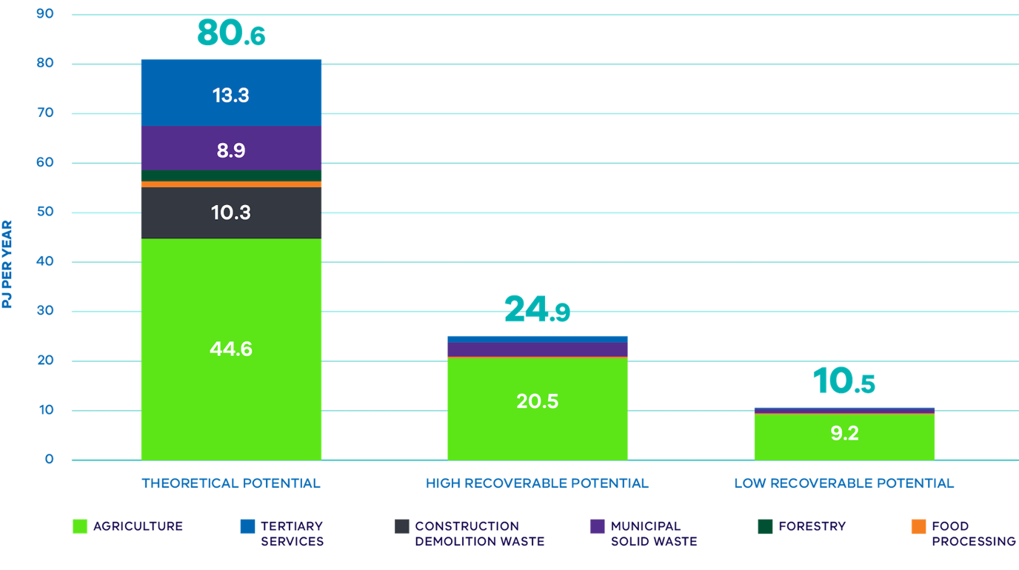

Source: Sustainability Victoria 2021, Assessment of Victoria’s Biogas Potential sustainability.vic.gov.au/research-data-and-insights/research/research-reports/assessment-of-victorias-biogas-potential Victoria’s long-term, theoretical biogas potential is in the order of 80PJ per year, without reference to capture constraints

Denmark A biogas success story
Denmark is a leader in the production of biogas in Europe, with production tripling since 2013. The rapid expansion of the industry over the last decade has come in response to the need for agricultural and organic waste management solutions and a flexible renewable energy source.
The sector’s rapid expansion has been driven by bipartisan government policy support provided through the Energy Agreement signed in 2012. This was followed by a new Energy Agreement signed in 2018 which included $1 billion allocated for biogas and an ambition to increase production to 24PJ (up from 14PJ in 2018). Denmark has set targets to meet 75 per cent of its gas demand by 2030 and 100 per cent by 2034.
The majority of Denmark’s 200+ biogas plants source feedstock from agricultural waste (such as liquid manure, deep litter and energy crops) and household organic waste.
The Danish biogas production model is based on centralised biogas plants around the country, each serving 100 to 250 farms under contract or as owner partners. Ideally, the farms are within 20 to 30 kilometres from the biogas facility (See Figure 16).
The remainder of Denmark’s biogas production comes from wastewater treatment plants, landfills and industrial plants.
Currently, most of Denmark’s biogas is used to produce electricity and heat, although in future it is expected a greater share will be upgraded and delivered to the natural gas grid.

Figure 16 Denmark biomethane use
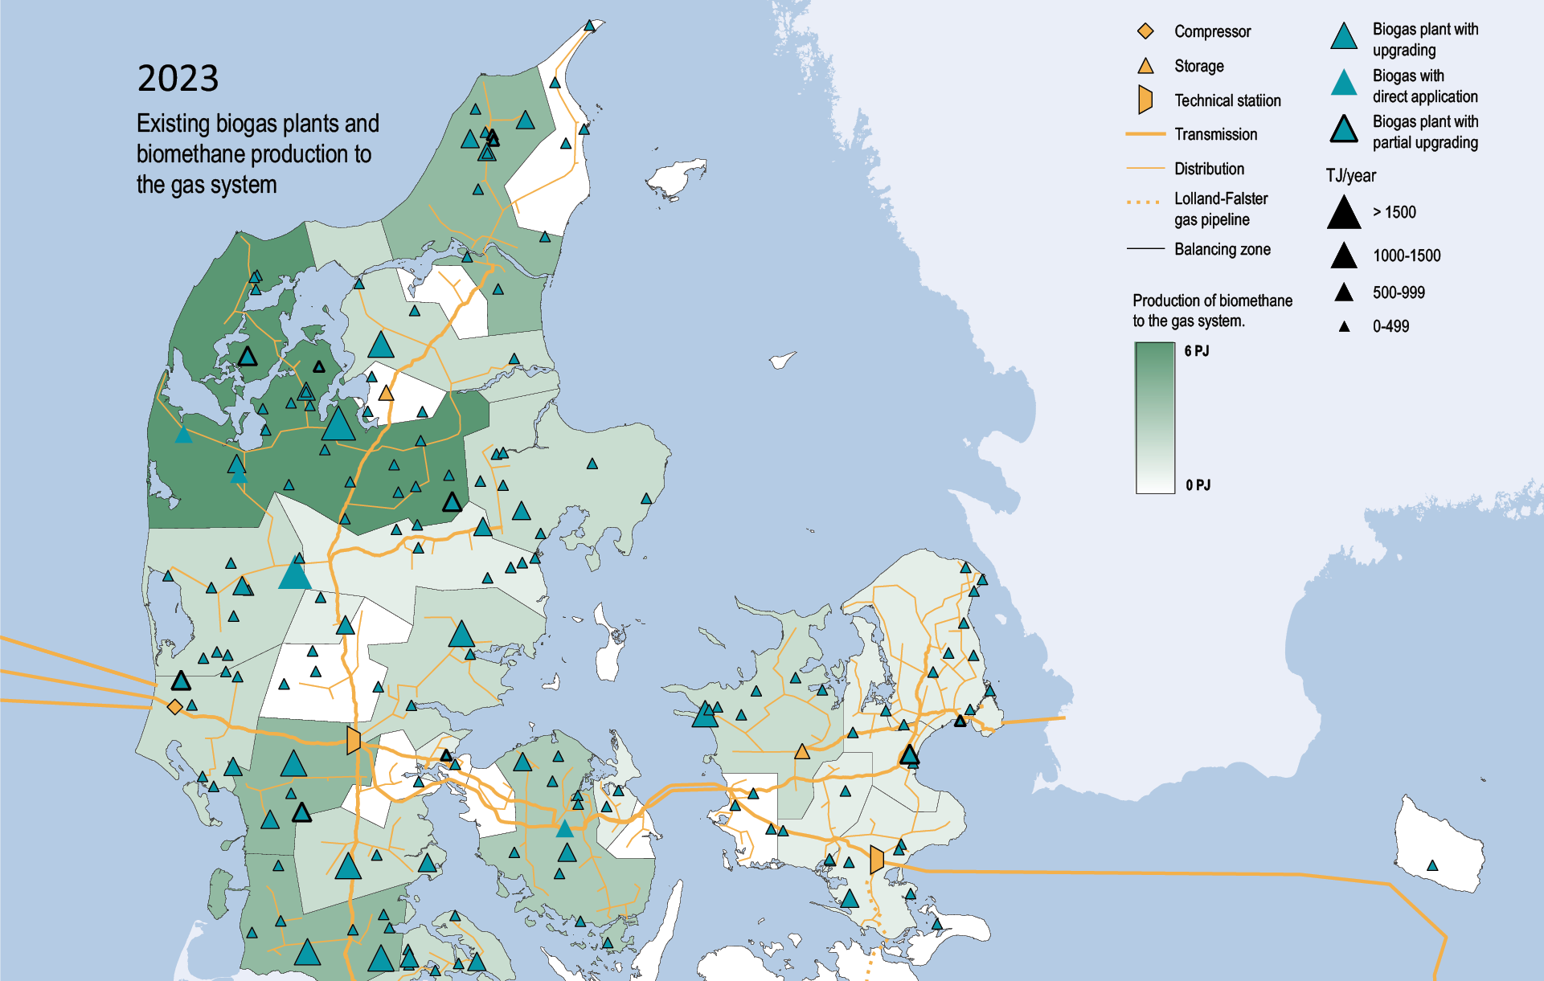
Source: Biogas in Denmark, Danish Energy Agency ens.dk/en/our-responsibilities/bioenergy/biogas-denmark

Enabling new industries
There is abundant opportunity for the development of renewable gas generation facilities – in fact it will be critical to maintaining Victoria’s strong manufacturing base. In a decarbonised gas sector, Victoria will require approximately 40-60PJ of renewable gas production to support industrial users. To put the scale of this production into perspective, this is roughly equivalent to the energy output of one of Victoria’s coal-fired power stations (Assuming power station capacities of Loy Yang A - 2.21GW, Loy Yang B - 1.2GW, Yallourn - 1.48GW, operating 80 per cent of the time).
To meet this increased demand for renewable gas production, Victoria will need to expand its fleet of biomethane production facilities – that use anaerobic digestors to process organic matter such as agricultural waste, wastewater biosolids and food wastes. These anaerobic digestors will require adequate and reliable volumes of organic feedstock to effectively meet energy demand. A potential source of this feedstock could be organic waste collected from Victorian residents by councils and Alpine Resorts Victoria (ARV). Under its circular economy policy, Recycling Victoria: a new economy, the government is working with councils and ARV to roll out a new standardised four-stream household waste and recycling system across Victoria.
The four streams are food organics and garden organics (FOGO), glass, mixed recycling and general rubbish. Aggregations of residential FOGO material could be used as feedstock for anaerobic digesters to produce biomethane.
Furthermore, through exploring the best use of agriculture and forestry residues and other organic waste sources, there are opportunities to reduce reliance on fossil gas while supporting the expansion of Victoria’s renewable gas sector where waste cannot be avoided, minimised, reused or recycled. In addition to biomethane produced from organic waste, Victoria will also explore opportunities for expanding biomethane production through additional processing of emissions from wastewater treatment plants and landfills.
Nevertheless, it is unlikely projected feedstock supplies will be sufficient to generate enough biomethane to replace all existing industrial fossil gas usage. Hence, other forms of renewable gas including biogas and renewable hydrogen will also likely play an important role for targeted uses.
For example, in future there will be periods where wind and solar generation are producing more electricity than Victorians need. This excess renewable energy capacity is ideally placed to produce renewable hydrogen, which can then be stored and used later at times of low wind and solar generation to provide renewable gas-fired electricity generation, in the same way that fossil gas does now.

Next steps
- A new exemption framework is being developed that would allow certain large energy users to opt out of the Victorian Energy Upgrades scheme under certain conditions. This will manage costs for these businesses, while helping them reduce energy use and emissions. A regulatory impact statement seeking feedback on policy design is due to be released soon.
- In mid 2024, the Department of Energy, Environment and Climate Action will aim to publish a policy direction paper in response to submissions to the Victoria’s Renewable Gas Consultation Paper.
- The Government will continue to work with stakeholders to develop an effective policy framework to develop a thriving renewable gas industry in Victoria.
- The Government will continue to monitor local and international developments in the deployment of new technologies supporting decarbonisation of industrial processes.

Malabar Biomethane Injection Plant
Jemena and Sydney Water’s Malabar Plant is the first demonstration project in Australia to produce biomethane and inject it into a gas network.
At this facility, biogas produced from organic wastewater is upgraded to remove impurities and moisture to create high quality biomethane suitable for injection into the natural gas network. The demonstration plant has an initial capacity of 95 terajoules of renewable gas per annum, which is about the consumption of a medium sized manufacturing facility.
The Malabar facility is located in the Malabar Headland National Park, and is one of Sydney Water’s multiple Anaerobic Digestion (AD) plants in NSW which produce biogas from organic waste in waste water. Before the development of the biomethane injection facility, the bulk of the AD biogas output was used for electrical power generation and water heating on site. The balance of biogas that could not be used via site processes was combusted through waste gas burners.
The key infrastructure built on site consists of a biomethane upgrader which removes water, carbon dioxide, and other contaminants from biogas to produce renewable biomethane. The removed contaminants are appropriately managed according to their characteristics, with fluids returned to the Sydney Water drainage system, hazardous gases absorbed via carbon filters and disposed of with the necessary waste classification. A biogas buffer storage biodome also stores the biogas before it is upgraded to biomethane. The biodome is constructed from materials that are flame retardant, abrasion resistant and UV/sun resistant, preventing deterioration of the material over the lifecycle of the equipment.
The project is jointly funded by Jemena and the Australian Renewable Energy Agency (ARENA) which is contributing $5.9 million in grant funding.
The Malabar Biomethane Injection Plant is the first renewable gas facility to be registered under GreenPower’s renewable gas certification pilot scheme.
Source: sydneywatertalk.com.au/malabar-biomethane-project jemena.com.au/future-energy/future-gas/Malabar-Biomethane-Injection-Plant

Ensuring robust supply chains for quality appliances
The Government will play an important role in supporting the establishment of secure, resilient and sustainable renewable energy supply chains that can withstand global supply challenges and rapidly escalating competition for finite resources.
Around the world, renewable energy supply chains are under increasing pressure from rising costs of raw materials, legacy COVID-19 disruptions, the war in Ukraine and the global push to decarbonise.
The Government is working to understand how supply chain challenges could affect legislated climate action targets and the broader energy transition. This includes how we rapidly scale up the sourcing of equipment, critical minerals, materials and components to build the required infrastructure.
The Government continues to consider potential approaches that can complement Commonwealth Government action such as the National Renewable Energy Supply Chain Action Plan.
Victoria’s longstanding status as the largest user of fossil gas in Australia has made it the logical home for businesses manufacturing and supplying gas appliances to homes and businesses. While the Government has clearly signalled a pathway to electrification, the transition of Victoria’s gas sector will take time, meaning there will continue to be a market for gas appliances in Victoria for some years to come. During that time, the Government will work with manufacturers and suppliers of both gas and efficient electric appliances to identify and capitalise on the business opportunities created by the expected future growth in demand for electric heat pump space and water heaters.
However, the projected increased demand is unlikely to be able to be met by local industry alone. Successful electrification on the scale required will depend on robust supply chains at a time when global demand for heat pumps is surging, driven by large-scale incentive programs in Europe and the United States.
Analysis from the International Energy Agency (IEA) shows global sales of heat pumps grew by 11 per cent in 2022 with sales in Germany and Sweden growing by more than 100 per cent and 20 per cent respectively (International Energy Agency (Accessed 2/11/23) iea.org/energy-system/buildings/heat-pumps). Ensuring Victoria has access to this critical technology will be key to our transition success (See Figure 17).

Figure 17 Annual growth in sales of heat pumps in buildings worldwide and in selected markets 2021 – 2022
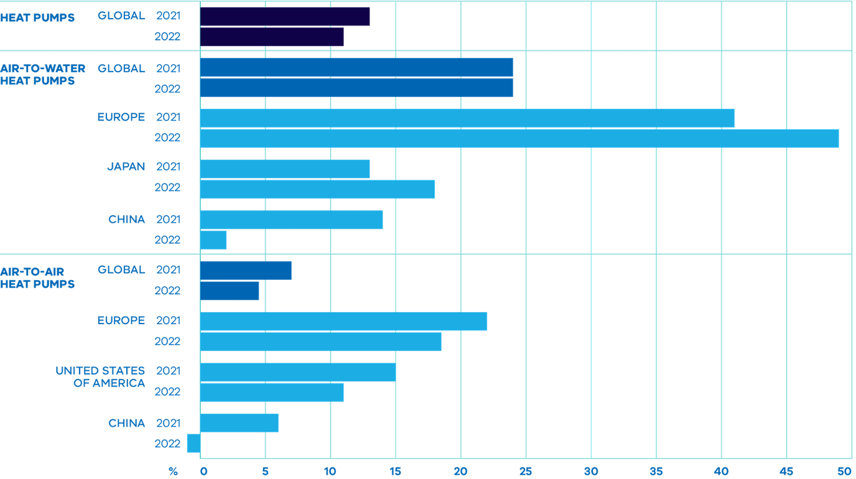

Source: International Energy Agency (Accessed 2/11/23) iea.org/data-and-statistics/charts/annual-growth-in-sales-of-heat-pumps-in-buildings-worldwide-and-in-selected-markets-2021-and-2022

United States Inflation Reduction Act Electrification Rebates High Efficiency Electric Home Rebate Program
The passing of the United States Inflation Reduction Act by Congress in 2022 has unlocked billions of dollars of public investment in assistance for electrification and renewable energy upgrades in American homes.
Just one of these programs, the Electrification Rebates program, is offering USD4.5 billion in rebates to provide point-of-sale consumer discounts to enable low- or moderate-income households across America to electrify their homes.
These rebates cover 100 per cent of electrification project costs (up to USD14,000) for low-income households (who earn less than 80 per cent of their Area Median Income) and 50 per cent of costs for moderate-income households (who earn between 80 and 150 per cent of their Area Median Income)

Source: US Department of Energy (Accessed 2/11/23) energy.gov/lpo/inflation-reduction-act-2022
In Australia, heat pump water and space heating (reverse cycle air conditioning or RCAC) technology is technologically and commercially mature, with many options available off-the-shelf from recognised manufacturers. However, an accelerated and large-scale rollout will depend on successfully managing potential supply chain constraints, such as availability of units and adequately trained installers.
Without clear and transparent policy measures there is a risk that manufacturing, and industry capacity and adaptation will not meet the pace and performance required to service the transition. Long-term policy consistency and regulatory certainty is key to strengthening supply chains, by providing the stable market demand that assists business and industry to plan investment.
To help guide policy direction and investment, the Victorian Government, along with the New South Wales Government is funding the Energy Efficiency Council to develop a Heat Pump Hot Water System (HPHWS) Roadmap to support the decarbonisation of residential water heating across Victoria. The roadmap will highlight actions government, unions, industry and other stakeholders will need to take to ensure sufficient affordable, quality heat pumps are available to meet Victoria’s electrification objectives. Specifically, the roadmap will:
- Map the HPHWS supply chain in Victoria and New South Wales
- Identify supply chain constraints including consideration of workforce issues and opportunities
- Develop a plan of action for dramatically scaling up rollout of efficient electric heat pump water heaters in Victorian homes.
Another key consideration in developing supply chains is to ensure that heat pump appliances are good quality and meet consumers’ needs.
In more than 60,000 heat pump installations undertaken through the Victorian Energy Upgrades program there has been no clear evidence of an issue with failure. Of these Victorian Energy Upgrades installations, more than 20,000 have been installed in cold climates with no clear evidence of consumers running out of hot water during colder months. It is also notable that heat pump penetration in Europe is highest in cold regions such as Norway and Finland, prompting the IEA to conclude that this “undercut(s) the argument that heat pumps are unsuitable for cold climates” (International Energy Agency, 2022, The Future of Heat Pumps, iea.org/reports/the-future-of-heat-pumps (Accessed 2/11/23)). Nevertheless, it is acknowledged that consumer perception can have an important influence on heat pump uptake, and so this is a risk that needs to be managed.
A key gap is the lack of a Minimum Energy Performance Standard (MEPS) for heat pump water heaters, as currently exist for other appliances such as electric water heaters, washing machines, air conditioners or fridges.
The Commonwealth Government Equipment Energy Efficiency (E3) Program has included a project to introduce a MEPS for heat pump water heaters on its 2023-24 work program, which could see a national standard introduced by late 2026 or early 2027. Despite the long implementation timelines, the MEPS framework has the advantage of delivering a single, integrated approach to energy efficiency standards across all Australian jurisdictions and New Zealand – something that many in the industry advocate for to keep compliance costs low. The Government will therefore continue to engage in the E3 process to support work to progress a MEPS for heat pump water heaters as quickly as possible.
In the interim, the Government is also taking action to set quality standards for products installed through its incentives programs, which in turn should have an influence on the wider Victorian market. The Solar Homes Notice to Market 2023-24 includes new mandatory requirements that enhance safety and quality by maintaining rigorous standards, and ensure a level playing field within the industry. These changes include requirements for heat pumps to have a timer and whole-of-product five year warranty, as well as updated mandatory installer requirements to complete specific training and/or mentoring identified by Solar Victoria.
Another important quality consideration relates to the management of refrigerant gases used in heat pump space and water heaters. These gases commonly have a much greater effect than carbon dioxide on global warming – sometimes several thousand times greater per unit of mass. At the same time, using these technologies to decarbonise gas does result in a significant net reduction in emissions.
Modern refrigerant gases have much lower global warming impact than those found in older appliances. This means that the lowest impact refrigerants must be used in any future transition involving electrification, and maintenance and end-of-appliance-life management must also be considered.
The Government recognises this issue must be managed effectively to ensure that electrification reduces emissions as much as possible. The 2020 Industrial Process and Product Use (IPPU) sector emissions reduction pledge sets out plans for Victoria to improve the management of refrigeration and air conditioning (RAC) equipment and refrigerant gases at a state level, while advocating for further national action to reduce emissions from RAC equipment and accelerate the transition to lower-emissions alternatives. From 1 July 2024, heat pump water heaters, approved for use in Victorian Energy Upgrades and Solar Homes programs, will be required to use low global warming potential (R32 or below) refrigerants.

Next steps
- The Victorian Government will have ongoing engagement with the Commonwealth E3 program to support the development of minimum energy performance standards (MEPS) for heat pump water heaters
- The Government will continue to work with Victorian industry to provide targeted guidance on how to reduce leakages of refrigerant gases in industrial settings
- From 1 July 2024, heat pump water heaters, approved for use in Victorian Energy Upgrades and Solar Homes programs, will be required to use low global warming potential (R32 or below) refrigerants.

5 Maintaining reliable, affordable gas supply
Unprecedented rates of electrification of Victorian residential and commercial buildings will be needed to prevent deeper fossil gas supply challenges.

Traditional supply of fossil gas is depleting
As noted earlier, the Australian Energy Market Operator (AEMO) and the Australian Competition and Consumer Commission (ACCC) are forecasting that supply from key gas fields will significantly decline over the next decade.
Southern regions of Australia (Victoria, Tasmania, New South Wales and South Australia) are already facing risks to supply on cold winter days and this situation will persist from winter 2024 onwards. Annual production from the Gippsland Basin is forecast to reduce from 326PJ in 2022 to 130PJ in 2027 (a 54 per cent reduction).
While production levels from the Otway Basin will vary year on year out to 2027 (from 48PJ in 2023, to 73PJ in 2024 and then down to 60PJ in 2027), these volumes will be insufficient to make up for the significant decline in Gippsland supply. Overall system resilience is also declining as plant continues to age and as key infrastructure components approach retirement age. Victoria – which has historically played a key role in supplying gas to other east coast states – could face structural supply constraints in the second half of this decade.
But while supplies are declining, on current trends Victoria’s gas consumption will continue to increase year on year to reach 235PJ in 2042. Continued growth in consumption in a tightening supply environment will not only risk reliability for essential uses, but also put upward pressure on prices further adding to energy affordability challenges.
It is important to note that the AEMO projections of supply constraints assume that the high degree of electrification required under the Orchestrated Step Change scenario (reducing consumption to around 118PJ by 2042) has already occurred. This degree of electrification across the Victorian economy will require unprecedented rates of electrification of Victorian residential and commercial buildings to prevent deeper supply challenges (See Figure 18).

Figure 18 Victorian gas consumption Actual and forecast
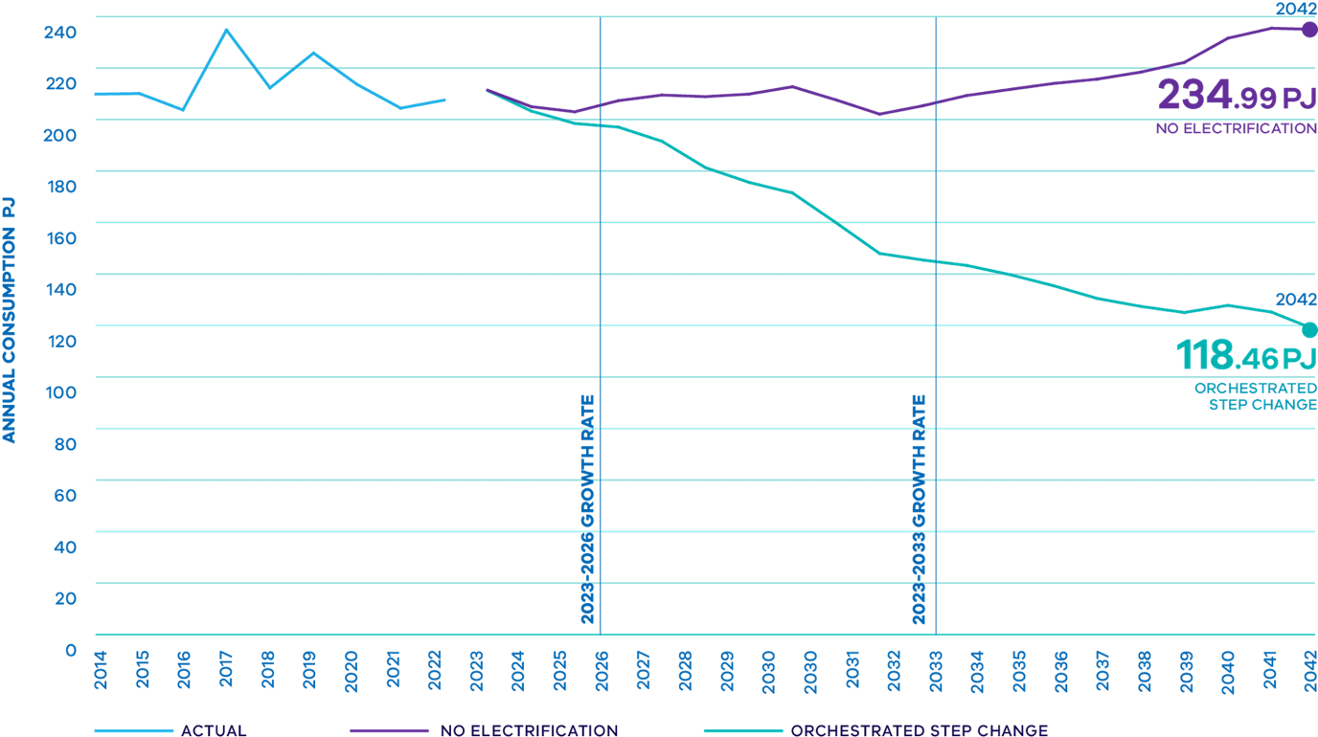

Source: Gas Statement of Opportunities Interactive Tool, AEMO March 2023, National Electricity Forecasting aemo.com.au
AEMO’s supply forecasts also assume infrastructure is available at full capacity. However, as both gas and coal plant continue to age there is reduced redundancy at key infrastructure sites such as the Longford gas plant meaning the actual risk to supply is much greater. These additional risks also need to be addressed to avoid the impacts of both physical supply and associated pricing shocks to the system.
Declining gas supply will also impact availability for gas-fired generation (GPG) of electricity. While alternative grid support solutions such as batteries and other forms of storage are under development, it will take time before these are available at sufficient volume. In the interim, this additional grid support would need to be provided by more emissions-intensive coal-fired power stations, potentially jeopardising their orderly retirement. Uncertain gas supply could therefore not only impact electricity supply but also pose risks to our emissions reduction trajectory.
This increases the importance of using high efficiency electrical appliances (which use much less energy per unit of heat output) to reserve diminishing gas supplies for GPG to maintain reliable electricity supply.
Addressing the significant energy affordability, reliability and emissions risks posed by Victoria’s high reliance on a declining fossil gas resource will require decisive policy action to reduce gas consumption across the economy.
Forecast gas supply constraints pose significant reliability, security and affordability risks for Victoria’s energy system, people and economy (See Figure 19). The greatest economic output impact will be to the manufacturing industry.

Figure 19 Projected annual adequacy in southern regions Orchestrated Step Change (1.8ºC) scenario, with existing, committed and anticipated developments
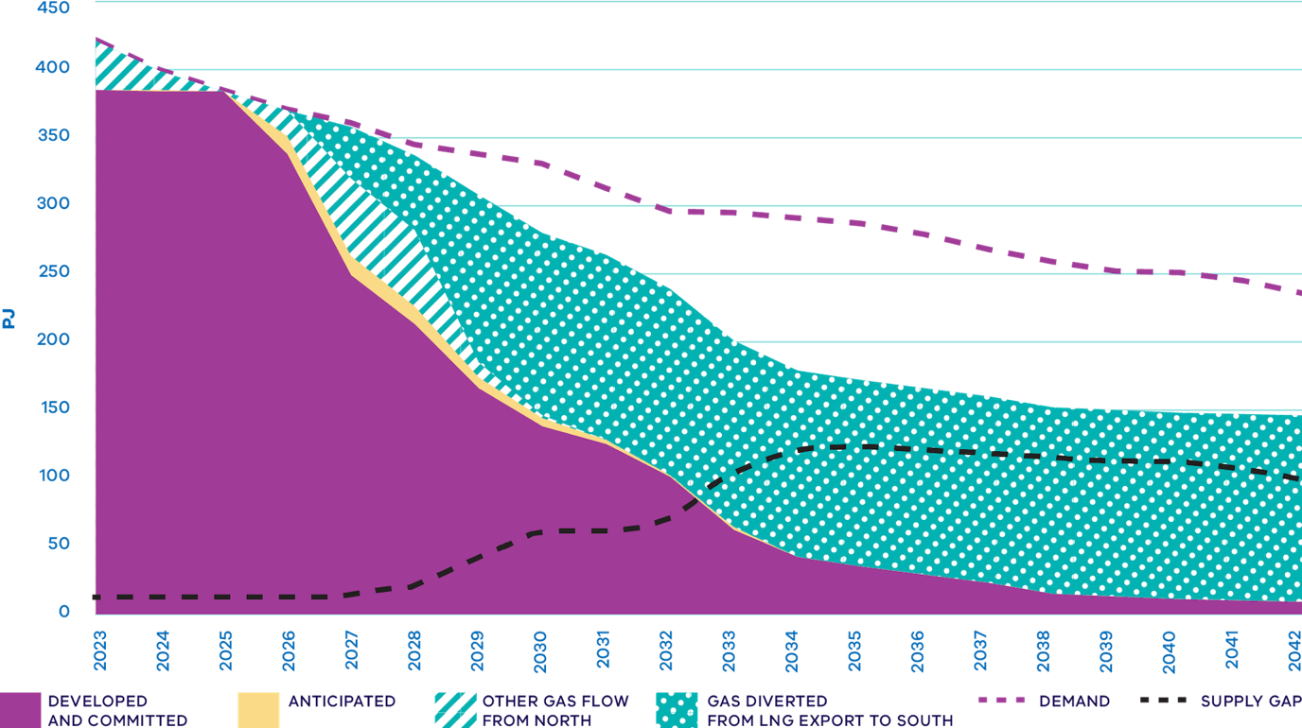

Source: AEMO 2023, Gas Statement of Opportunities, March 2023 (Accessed 2/11/23) aemo.com.au/-/media/files/gas/national_planning_and_forecasting/gsoo/2023/2023-gas-statement-of-opportunities.pdf

Safeguarding reliability and supply through the transition
The Roadmap recognises these serious risks and is taking proportionate and responsible action to ensure ongoing reliable energy supply, focusing on:
- Optimising the effective use of existing gas assets
- Actively engaging in regulatory reform
- Ensuring any investment in additional supply and infrastructure is proportionate to the risks we face and transitional in nature to address supply challenges while the renewables build continues.
Taking this balanced and proportionate response will help mitigate gas supply risks. It will also minimise the risk of locking in long-term stranded assets and associated costs for consumers, while supporting the state’s trajectory to net zero emissions by 2045.

Using existing gas assets effectively
As Victoria decarbonises its gas sector, optimising the use of existing gas assets such as storage will help to minimise overbuild of new assets and reduce the risk of asset stranding. Enhancing the use of existing storage and pipeline capacity aligns with the long-term interests of consumers by providing an appropriate balance between security, reliability, safety, and affordability of supply while still supporting a net zero emissions trajectory.
Victorian storage has played a key role in supporting east coast gas demand over recent years. Indeed, it was heavily depleted during both winter 2021 and 2022 as Victoria shouldered a significant part of the burden in supplying east coast demand. The tightening supply and demand balance will place greater pressure on both seasonal and shallow Victorian storage facilities in coming years. Early depletion of gas storage is a key risk and needs to be carefully managed to avoid adverse outcomes for Victorians.
AEMO and ACCC forecasts show there will be increasingly heavy reliance on seasonal and shallow storage to meet southern east coast gas demand over this decade. Victoria has taken action to ensure that its storage capability can be used as effectively as possible to support reliable supply for all Victorians.

Victorian Government actions
- Victoria successfully argued for an urgent rule change to maximise use of available storage at the Dandenong LNG facility which was delivered in December 2022. This measure was credited as contributing to an improved supply outlook assessment in the 2023 Victorian Gas Planning Report.
- Victoria provided supported regulatory approval of the installation of an extra compressor at the Winchelsea compressor station on the Southwest Pipeline in advance of the 2023 winter to help mitigate peak day supply risks.
- Government support resulted in the infrastructure build for APA Group’s Western Outer Ring Main (WORM) project. This project will improve the reliability of Victoria’s gas transmission system and better support timely refill of the existing Iona Underground Gas Storage facility in western Victoria.
- Victoria initiated the development of a first stage of reforms providing AEMO with enhanced powers to monitor, signal and respond to emerging threats across east coast gas markets. This first stage of reforms, including legislative and regulatory amendments to the national frameworks, was implemented in May 2023.

Dandenong LNG Storage
The Dandenong LNG facility plays a unique and critical role in the Victorian Declared Transmission System (DTS), it is the only facility that can be called upon to address the risk of pipeline pressure incidents and associated safety risks in a timely manner to ensure the safe, secure and reliable supply of gas to end customers.
In mid-2022 the Victorian Government submitted an urgent rule change request to maximise use of available storage at the Dandenong LNG facility. The rule change empowered AEMO to act as both buyer and supplier of last resort for the Dandenong LNG facility, to contract any unused storage capacity at the facility and purchase gas from the Domestic Wholesale Gas Market to fill the tank. The rule change was successfully implemented in late 2022 to support winter demand.

Additional Winchelsea compression
In 2022, the Victorian Government provided written support to the Australian Energy Regulator for an APA Group Southwest Pipeline expansion project to add compression at the existing Winchelsea site. This allowed the project to proceed to Final Investment Decision. This additional compression was successfully installed in mid-2023, increasing peak day capacity on this pipeline allowing for better utilisation of supply from the Port Campbell region on the days when it is most needed.

Western Outer Ring Main
The Western Outer Ring Main (WORM) project provides a link between the east and west of the state to improve the reliability of Victoria’s gas transmission system and better support timely refill of the existing Iona Underground Gas Storage. This will help mitigate the risks with heavy seasonal demand as occurred in both 2021 and 2022 and will help ensure available capacity can be more efficiently refilled each year ahead of the next winter. It will also improve peak day supply on the highest demand days and will help manage the system in event of any unplanned outages of key infrastructure in the east of the state. Most of the infrastructure has been completed following the issuing of a pipeline licence and related approvals by the Government. facility in the west of the state.

East coast grid expansions
Upgrades to key east coast gas transmission pipelines have also occurred outside of Victoria. Stage one of an APA Group east coast grid expansion was completed for winter 2023 through the addition of extra compression on the Southwest Queensland Pipeline and Moomba to Sydney Pipeline. This will be followed by a second stage expansion of the east coast grid targeted to be in place prior to winter 2024. These upgrades which increase southbound pipeline capacity are expected to alleviate some interstate demand for Victorian gas and reduce the risk of Victorian storage being depleted before the end of each winter season. While the expansions do not increase pipeline capacity on the one interconnector that allows gas to flow into Victoria, they are nonetheless an important contribution to alleviating transportation constraints in east coast markets.

Reforming regulatory frameworks
Victorian gas has played a significant role in supporting east coast domestic demand, including during the energy crisis of 2022, while other domestic gas is shipped overseas. However, as supply from legacy fields such as in the Gippsland Basin is rapidly declining, it is not reasonable for Victoria to continue to shoulder this burden. It is important that all parties play their part in supporting east coast supply while the broader transition to renewables is underway.
Victoria also continues to advocate for the effective use of all levers available to the Commonwealth such as the Australian Domestic Gas Security Mechanism (ADGSM) to help alleviate the risks of a domestic gas shortfall. The ADGSM is now informed by quarterly reporting by the ACCC. The mandatory Gas Distribution Service Gas Code of Conduct which came into effect on 11 July 2023 also includes an exemptions framework intended to incentivise producers to commit more gas to the east coast gas market in the short-term and facilitate new investment to meet ongoing demand in the medium term.
Victoria will continue to advocate for the prioritisation of domestic supply for domestic users on fair terms and reasonable prices. This will ensure that any additional gas supply or infrastructure to bridge the remaining gap between supply and demand is proportionate to the problem at hand and is genuinely needed.
Victoria continues to be an active participant in the development of enhanced east coast gas reliability frameworks. On 12 August 2022 and in response to the east coast wide energy crisis, all Energy Ministers agreed to progress a range of regulatory reforms to support more secure, resilient and flexible east coast gas markets using a staged approach.
A second stage of reliability and supply adequacy reforms is now underway. Victoria continues to be a key contributor to this process working closely alongside the Commonwealth and other jurisdictions. A public consultation paper was released on 1 June 2023 seeking feedback on a range of potential reliability mechanisms including:
- An east coast gas reliability standard to ensure any measures taken to support reliable supply, including associated costs, are commensurate with the risk being faced and the value that customers place on avoiding supply interruptions.
- Improved monitoring and communication tools including a Projected Assessment of System Adequacy (PASA) and enhanced threat signalling.
- Targeted reliability and supply adequacy management tools such as administered demand response and a supplier of last resort mechanism.

Transitioning to a fit for the future gas network
Meeting Victoria’s target of net zero emissions by 2045 will require a significant degree of electrification of existing gas uses particularly in residential and commercial buildings, as well as progressive replacement of remaining fossil gas uses (primarily industrial) with renewable alternatives.
Biomethane has the advantage of being able to be injected directly into the existing gas distribution network without any need to modify pipelines. Similarly, users will not need to make any modifications to their equipment to utilise a biomethane-fed network. However, projected biomethane supply may only be able to supply up to half of Victoria’s industrial fossil gas use. Renewable hydrogen will therefore also need to play a targeted role in supplying some uses where alternative lower-cost options are not feasible.
Replacing fossil gas with 100 per cent hydrogen requires further assessment of the installed equipment, material compatibility and operating conditions among other factors to determine the feasibility. A blended renewable hydrogen/biomethane network could be a good compromise. Similarly, co-located behind-the-meter applications could provide suitable alternatives. Further work is required to assess these options.
This significant transition of Victoria’s fossil gas use will require an evolution of the reticulated transmission and distribution network over time to ensure it continues to meet the needs of future gas users and the Victorian economy. Careful consideration will need to be given to how this transition is managed to ensure Victoria’s stringent energy safety and reliability standards are maintained, and the ongoing costs of network operation are shared fairly and affordably between users and networks.
The Government will work closely with all Victorian gas distribution networks as well as with the technical safety regulator, Energy Safe Victoria (ESV), the Essential Services Commission (ESC) and the Australian Energy Regulator to manage the impacts of the transition on network infrastructure.

Next steps
- Victoria will continue to play a key role in the development of a second stage of east coast gas reliability and supply adequacy regulatory reforms, to better manage east coast gas markets and respond to supply threats.
- Victoria will progress development of additional interim gas supply if necessary to avoid short-term supply risks, ensuring statutory approval assessment processes are efficient and timely.
- As gas use changes across Victoria throughout this transition, the Government will work closely with stakeholders to investigate pathways for managing implications of the energy transition for the gas network, while ensuring energy safety and reliability standards are maintained.
- Victoria continues to actively contribute to the development of a second tranche of east coast reliability reforms, including the potential for a gas reliability standard, improved supply adequacy assessments and threat signalling, administered demand response, and a supplier of last resort function.

6 Preparing the future workforce
Victoria’s longstanding reliance on gas to power our homes and businesses has been enabled by a skilled workforce.
The Government is working closely with the plumbing and electrical sectors through unions, training providers, employers and other stakeholders to support a just transition for affected workers – and to reap the benefits of new opportunities for them.

Building capacity for rapid electrification
Victoria’s longstanding reliance on gas to power our homes and businesses has been enabled by a skilled workforce of plumbers, electricians and other trades who install and maintain gas equipment.
The significant shift to electrification signalled in this Roadmap Update creates the dual challenge of ensuring Victoria has enough skilled workers to meet higher demand for some services while managing a long-term decline in demand for others. The Government is working closely with the plumbing and electrical sectors through unions, training providers, employers and other stakeholders to support a just transition for affected workers – and to reap the benefits of new opportunities for them.
Victoria has 33,600 licensed plumbers, of which 20,000 are gas-fitters (Victorian Skills Authority, 2022; Plumbing Industry Climate Action Centre (PICAC) Submission, in Renewable Hydrogen Discussion Paper 2020 (cited in Victorian Renewable Hydrogen Industry Development Plan, 2021)). There will continue to be strong demand for these plumbers over the next 10 to 15 years as Victorian households and businesses progressively replace their gas appliances as they approach end‑of‑life.
The Government is working closely with industry to identify opportunities for assisting plumbers to upskill to take advantage of new opportunities, particularly for electrical work, while ensuring we have enough gas-fitters in the medium term to support an orderly transition away from gas.
The Government will also work with the gas appliance manufacturing sector to identify opportunities for re-training and re-deployment of employees impacted by the declining demand for fossil gas, as well as scope for expanding production of efficient electric appliances to meet new areas of demand.
The Government is also actively considering the role that transitioning workers can have in delivering the large-scale roll-out of efficient electric heat pumps and other appliances across the state.
Conversely, demand for electricians is expected to grow strongly – by more than 10 per cent over the next five years – while all states in Australia are already experiencing shortages of electricians (Jobs and Skills Australia (Accessed 30/10/23) jobsandskills.gov.au). Recent analysis commissioned by Solar Victoria confirms that workforce and skills shortages are resulting in waiting times of several weeks for solar PV or battery installations.
Work is underway on the Victorian Energy Jobs Plan that will identify the skills and training needed to support our renewable energy industries. It will prioritise practical actions to address gaps and workforce shortfalls and position Victoria as a renewable energy workforce leader. It is planned to be released in the second half of 2024. It is still early days in the transition away from fossil gas use, and much work needs to be done to plan for the transition. There will be further consideration of the workforce implications in future updates to the Roadmap.
In June 2023, the Government released the Clean Economy Workforce Development Strategy 2023–2033, which provides a planning and investment framework to support the workforce and create training pathways to meet industry’s growing demand for skills.
Victoria’s transition to a clean economy is expected to create 10,000 jobs each year from now until 2030 and transform more than 500,000 existing jobs through new skills training. Targeted training and skills programs will address the increased skills demand in key sectors including manufacturing, engineering, electricity, and construction.
As part of bringing back the SEC, the SEC Centre of Training Excellence will be established to engage with schools, training providers (including TAFEs) and industry to support the attraction, training and retention of a skilled renewable energy workforce.
As part of Solar Victoria’s $11 million training and workforce development program, a new training program delivering specialised skills in designing and installing energy efficient heat pumps and solar hot water systems was launched in March 2023. Working in partnership with the Plumbing Industry Climate Action Centre (PICAC), Solar Victoria will deliver solar hot water and heat pump training to 200 plumbers to meet the expected demand for installations and will look to train an additional 1,000 plumbers in 2024.
Addressing forecast skills shortages also provides an opportunity to increase the diversity and inclusivity of our workforce. Historically, Australia’s energy workforce has been overwhelmingly male-dominated and homogenous, with low workforce participation of women, First Nations people, LGBTIQ communities, people living with disability and culturally and linguistically diverse communities.
Analysis from Jobs and Skills Australia shows that occupations with skills shortages where employment opportunities are expected to grow are likely to have significant gender imbalance in their workforce. For example, only around 2 per cent of Australia’s electricians are women (Jobs and Skills Australia, 2023. Australia’s Clean Energy Workforce: Discussion Paper, April 2023 (Accessed 30/10/23)).
Solar Victoria’s Women in Solar program is seeking to address this gap by offering apprenticeships and complementary career and professional development support to encourage more women to work in the renewable energy sector.
Tradespeople such as electricians and plumbers also play an important role in Victoria’s energy sector as providers of trusted advice to households and business about their energy needs and investment options. Ensuring our existing workforce is equipped with up‑to-date factual information about efficient electric technology will be an important part of building the skilled workforce we need to meet our electrification objectives.
Building the capacity of Victoria’s construction sector to design, construct and market efficient all‑electric homes will also be key to the transition. Victoria’s building industry has already moved towards the electrification of new homes, with several major builders and developers offering all‑electric residential estates as standard.
In April 2023, leading volume home builders and developers voiced strong support for electrification at an industry roundtable hosted by the Minister for Energy and Resources to identify opportunities in this market.
Since 2021, Sustainability Victoria has been delivering the $2.19 million 7-Star Homes program to help prepare Victoria’s residential builders for new 7-star efficiency standards that will come into effect under the National Construction Code from 1 May 2024.
Training and resources provided through the program are based on the principle that good home design can reduce the amount of energy required to keep a home comfortable with little or no additional construction cost. While not a specific requirement, around 85 per cent of new homes built through the program have been designed and constructed as all‑electric.

Victorian Government actions
- Since commencing in 2018, the Solar Homes program has supported over 4,000 jobs, including training for women in solar, licensed electrical inspectors, business skills mentoring, and upskilling in solar PV, battery and plumbing installation work.
- Since 2021, Sustainability Victoria’s 7-star industry capability building program has assisted 29 Victorian builders and land developers and built the capability and capacity of the residential construction industry in building energy efficient homes. Over 85 per cent of the homes in the program are all‑electric. Under the program which concluded in October 2023:
  - 1,703 industry professionals from 500 businesses participated in 7-Star Design and Construction training facilitated by the Housing Industry Association and Master Builders Association on behalf of Sustainability Victoria.
  - 72 homes are being built with 69 having undergone as-built verification testing.
- The Victorian Skills Plan for 2023 into 2024 is a continuation of the first plan released in 2022. The Plan provides an updated view of the Victorian labour market, the skilling challenges and opportunities that lie ahead and recommendations to improve post-secondary education and training in Victoria. The Skills Plan Implementation Update provides updates on the work underway on the actions identified in the 2022 plan.
- The Clean Economy Workforce Development Strategy 2023 -2033 was released in June 2023. A ten-year implementation plan is now being developed, built around the strategic priorities outlined in the Strategy, including activities identified through the extensive research undertaken to develop the Strategy. Implementation will be a staged process based on detailed two-year rolling Action Plans, the first of which will begin development from late 2023 with completion anticipated by mid-2024.
- The Victorian Higher Education State Investment Fund is supporting the education sector to build the skills and develop the practices and products we need to grow Victoria’s hydrogen sector, including:
  - $10 million for Swinburne University of Technology’s Victorian Hydrogen Hub.
  - $9 million to support Deakin University’s Hycel Technology Hub.

Creating jobs in renewable gas
Establishing and growing a renewable gas sector in Victoria will also create new jobs and strong demand for skilled trades and professionals. The International Renewable Energy Agency (IRENA) estimates there are 2.4 million jobs in biofuels worldwide, with the vast majority in feedstock operations (IRENA 2022, Renewable Energy and Jobs, Annual Review 2022 (Accessed 2/11/23) irena.org/publications/2022/Sep/Renewable-Energy-and-Jobs-Annual-Review-2022).
While still representing a small proportion of total renewable energy employment worldwide, the biogas sector is growing strongly around the world, particularly in Europe where it forms an important part of strategies for reducing reliance on Russian fossil gas.
The Renewable Gas Consultation Paper released in September 2023 sought feedback on options for developing an efficient and effective policy framework to scale up the sector in Victoria. A key objective is to support industry development to create new employment opportunities for Victorian workers, enhance our manufacturing sovereignty and support the ongoing competitiveness of gas-intensive sectors. It will also help to keep manufacturing and industry in Victoria.
The Government is also driving the expansion of the renewable hydrogen sector in Victoria through the Victorian Renewable Hydrogen Industry Development Plan. The Plan highlights the potential for a hydrogen economy to generate jobs across the supply chain, from production, transport and end uses, to skills and training opportunities, advanced manufacturing and export.

Next steps
- Solar Victoria initiatives to be delivered in 2023-24 to support electrification include:
  - Training to upskill up to 800 plumbers and fourth year apprentices in the design and installation of energy efficient heat pumps and solar hot water systems
  - Training to upskill up to 400 electricians and fourth‑year apprentices in the design and installation of solar PV and battery systems
  - Further research to identify what additional skills gaps might exist and what is trending that could help to grow the sector and identify emerging worthwhile initiatives
  - Placements for up to 20 female solar electrical apprentices and six plumbing or air conditioning and refrigeration mechanic apprentices, using wage subsidies and incentive payments to expand the size and diversity of the solar energy workforce.
- The Victorian Energy Jobs Plan will ensure Victoria’s workforce meets the needs of our energy system transformation, while supporting Victorians to benefit from the education, training and employment opportunities this transformation creates. The Plan will incorporate tangible, practical actions to address gaps, improve linkages and position Victoria to be a leader in energy workforce and skills. The Plan is expected to be released in the second half of 2024.
- The Victorian Skills Authority has an immediate focus on supporting the development of the Victorian Energy Jobs Plan by providing data and insights in response to the Clean Economy Workforce Development Strategy 2023-2033.
- The SEC Centre of Training Excellence will be established to coordinate courses in renewable energy, connecting with TAFEs, registered training organisations, unions and industry.

7 National partnerships and regulatory reform in the transition
The energy transition cannot be delivered by Victoria alone. With its commitment to a 43 per cent fall in emissions by 2030 moving to net zero emissions by 2050, and underpinned by an 82 per cent renewable energy grid by 2030, the Commonwealth Government represents a key partner in delivering a renewable energy future.
Effective partnerships between the Victorian and Commonwealth Governments have delivered important outcomes for Victorians to date. Following advocacy by the Victorian Government, the Australian Energy Regulator capped gas disconnection fees in Victoria in July 2023, making it more affordable for households to go all‑electric.
Victoria is also working closely with the Commonwealth and other jurisdictions to address gas reliability risks and is continuing to actively contribute to progressing a range of regulatory reforms to support more secure, resilient and flexible east coast gas markets.
The Victorian Government will continue to engage with a range of inter-jurisdictional processes where Commonwealth leadership will be key to delivering the decisive policy action needed to meet emissions targets and address energy affordability issues for the nation.
- The National Construction Code triennial update process represents the key opportunity to strengthen minimum mandatory energy performance standards for new buildings across the country. Victoria is actively engaging in the current update process focusing on new commercial (non-residential) buildings, seeking commitment to updated requirements that support electrification of this important asset class.
- Efficiency standards for appliances is another important area of policy reform affecting positive consumer experiences of electrification. The Victorian Government is moving forward to ensure rigorous quality standards are in place in its flagship Victorian Energy Upgrades and Solar Homes programs, which will in turn influence the wider Victorian market.
- Victoria will also have ongoing engagement with the Commonwealth E3 program to support the development of minimum energy performance standards (MEPS) for heat pump water heaters. Delivering these long-awaited standards will be important for developing the robust supply chains needed for the large-scale electrification of homes and businesses.
- The Commonwealth Government is matching the Victorian Government’s investment of $46 million to expand the Victorian Energy Efficiency in Social Housing program to a total of $92 million, reducing energy bills for residents and ensuring they can keep their homes warm in winter and cool in summer. The joint partnership will help electrify and modernise public housing, which could include reverse-cycle air conditioning, hot water heat pumps, electric cook tops and solar PV. The Commonwealth’s contribution is being funded through the $1.7 billion Energy Savings Package in this year’s Federal Budget.
- The Nationwide House Energy Rating Scheme (NatHERS) delivered by the Commonwealth Government provides national, accurate and comparable home energy performance ratings and information to improve the comfort and energy efficiency of Australian homes. The scheme includes tools to rate existing homes such as the Residential Efficiency Scorecard and tools to rate new homes such as FirstRate5 – both of which are owned by the Victorian Government.
- Currently endorsed by NatHERS, the nationally funded Residential Efficiency Scorecard program is expected to be fully accredited and phased into the NatHERS scheme in the coming years. The Residential Efficiency Scorecard rates your home’s energy use and comfort and provides tailored recommendations for improvements. Getting a Scorecard home energy rating from a government-accredited assessor provides the targeted information required to help households to reduce energy bills and/or go all‑electric, or just live in a more comfortable home. Further, a Scorecard assessment provides the finance industry with a way to identify and incentivise energy efficiency and electrification investments.
- Victoria will continue to collaborate with the Commonwealth to ensure more effective national regulation of the east coast gas market so that domestic gas is made available to domestic markets to manage short-term supply risks and protect consumers against high gas prices.
The Commonwealth Government can also play an important role in financing key aspects of the transition, particularly the significant challenge of electrifying and upgrading the efficiency of our housing stock. The Victorian Government welcomes the recent allocation of an additional $1 billion to the Clean Energy Finance Corporation to create the Household Energy Upgrades Fund. While discounted finance is an important part of the suite of measures needed to drive wide-scale uptake of efficiency and electrification measures, it is not always accessible to households already experiencing energy hardship. Victoria has a strong track record in delivering household retrofit programs targeting low income and disadvantaged households (Including the Healthy Homes program and the Energy Efficiency in Social Housing program (EESHP)) and will continue to engage with the Commonwealth to share learnings and ensure retrofit programs reach those most in need.

Green finance
Australia’s banking sector is increasingly incorporating climate change objectives into their management of environmental, social and governance (ESG) risks and the range of products and services they provide.
As of 2019, nine of Australia’s major banks had set a net zero before 2050 target for their operational emissions. Bank Australia has gone further, committing in 2022 to achieving net zero emissions across its operations, and lending and investment portfolio by 2035.
The Australian residential mortgage sector is valued at $1.82 trillion, and Australian banks have amongst the highest proportion of residential mortgage assets in the developed world. Most home loan contracts are in place for up to 30 years, a timeframe during which climate risk exposure will become more pronounced.
Green bond issuance in Australia has reached A$8.3 billion driven by banks and sub-sovereign issuers. Australia was the second largest green bond market in the Asia Pacific region in H1 2018 and 12th globally, larger than more established bond markets such as Japan.
A growing number of Australian financial institutions offer a range of `green’ products including:
- Bank Australia with the support of the Clean Energy Finance Corporation offers a Green Home Loan. The homeowner receives a 0.4 percentage point discount on their home loan rate if their home is either NatHERS 7 star+ (new homes) or can demonstrate ambitious green upgrades in the previous 12 months based on a Residential Scorecard Assessment.
- The Commonwealth Bank offers a Green Loan where customers with an eligible CommBank home loan or investment home loan can borrow from $5,000 to $30,000 to fund the purchase and installation of a range of clean energy products such as solar, batteries, heat pump hot water and switching from gas to electric cooktops.

Figure 20 Growth of green finance in Australia
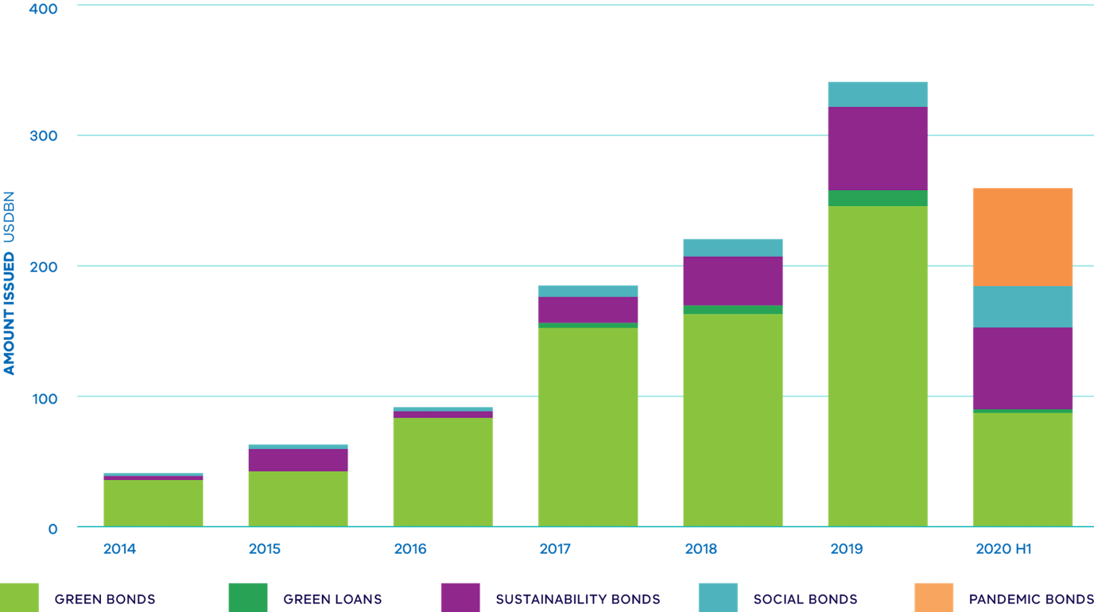

Source: Climate Bonds Initiative 2020, Australian and New Zealand Green Loans Report

8 Transitioning the Government’s own gas use
Replacing gas equipment with efficient electric appliances powered by 100 per cent renewable energy offers a clear pathway to decarbonise government buildings and facilities throughout the state.
The Government accounts for around three per cent of Victoria’s total gas consumption with major users including hospitals, schools, sporting facilities, office buildings and a wide range of other settings. Consumption of fossil gas is currently responsible for approximately seven per cent of government’s operational emissions.
The Victorian Government has already established a range of targets and actions that will significantly reduce emissions from government operations between now and 2030, including for 100 per cent renewable electricity in government operations by 2025, actions to transition government fleet vehicles and public buses to zero emissions, and announced that all new government buildings and facilities are built as all‑electric.
Our work towards 100 per cent renewable electricity will see the largest source of government operational emissions (scope 2 emissions associated with electricity consumption) fall to zero. With the delivery of this commitment in 2025, fossil gas used in buildings and facilities will account for around one-third of government operational emissions. Replacing gas equipment with efficient electric appliances powered by 100 per cent renewable energy offers a clear pathway to decarbonise government buildings and facilities throughout the state.
Recognising how important it is to limit reliance on fossil gas, the Government announced in July 2023 that all new government buildings and facilities will be built as all‑electric.
Agencies are encouraged to consider opportunities to build all-electric and remove gas when undertaking construction activities at existing buildings and sites with requirements to include an electrification option in business cases for government construction projects.
The Government has committed to reducing its own operational emissions, including through the use of 100 per cent renewable electricity by 2025
While contributing directly to emissions reduction, these actions will also have a range of wider community benefits, including more efficient use of public resources, building capability in the market and freeing up fossil gas supply for hard-to-abate sectors of the economy.

Victorian Government actions
- The Government has committed to reducing its own operational emissions, including through the use of 100 per cent renewable electricity by 2025.
- The Government is working to ensure that all Victorians can take part in the transition to more energy efficient and cheaper housing through a range of programs for private and social housing renters.
  - The Big Housing Build program is delivering over 12,000 new social housing properties, with all‑electric specification pursued wherever possible.
  - The Energy Efficiency in Social Housing Program is supporting a range of cost-effective energy efficiency upgrades for public, community and Aboriginal housing properties with a strong emphasis on electrification, including installation of RCAC to replace inefficient gas and electric heaters.

Next steps
- Agencies are encouraged to consider opportunities to build all-electric and remove gas when undertaking construction activities at existing buildings and sites with requirements to include an electrification option in business cases for government construction projects.
- Recognising how important it is to limit reliance on fossil gas, the Government announced in July 2023 that all new government buildings and facilities will be built as all-electric.

9 Next steps
Since the release of the Roadmap in 2022, the Government has taken decisive and responsible first steps in the transition away from fossil gas, commensurate with the significant economic and social risks posed by Victoria’s high reliance on fossil gas.
The Government will continue to deliver on commitments and do what is needed to ensure Victorians have access to sustainable, reliable and affordable energy.
This Roadmap Update demonstrates just how quickly Victoria’s energy system is changing in the transition to our renewable energy future. Victoria is keeping pace through proactive, flexible and forward-thinking policy action, and we must embrace this momentum to ensure that all Victorians benefit from this transition. Policy will continue to be led by current evidence and diverse stakeholder engagement, ensuring that the transition remains open to new technologies, solutions and opportunities as they arise.
We need to embrace the technologies that are available now, while continuing to prepare for what we need in the future. For households and many businesses who use the vast majority of Victoria’s fossil gas, we know that electrification is the most cost-effective pathway to reduce fossil gas use and save money.
For remaining, mostly industrial gas users, we know that renewable gases will be a critical input to their primary functions. A clear path forward will help to protect consumers from rising fossil gas prices or interrupted supply, and ensure that the appropriate planning and investment is made for a smooth and coordinated transition.
The Government will undertake further analysis to explore potential pathways to expand electrification in residential and commercial buildings, and assess policy options to support the uptake of renewable gases. As the Government delivers the actions of this Roadmap Update and progresses the next stage of the fossil gas sector transition, we will continue to engage with industry and Victorians to ensure milestones are met, including regular updates to the Roadmap with the next release planned for 2024.

Glossary

ACCC
Australian Competition and Consumer Commission

ADGSM
Australian Domestic Gas Security Mechanism

AEMC
Australian Market Energy Commission

AEMO
Australian Energy Market Operator

AER
Australian Energy Regulator

ARENA
Australian Renewable Energy Agency

Biogas
Renewable energy source derived from the anaerobic digestion of organic material (biomass) such as industrial and agricultural waste, wastewater treatment sludge or energy crops

Biomethane
With the same chemical composition as methane (the principal component of fossil gas), biomethane is produced by upgrading biogas to remove impurities, which can then be injected into existing gas networks

CCS
Carbon capture and storage

CER
Clean Energy Regulator

Decarbonisation
Reducing or eliminating the amount of carbon released to atmosphere from combustion of fossil fuels such as fossil gas.

DCCEEWW
Department of Climate Change, Energy, the Environment and Water

DEECA
Department of Energy, Environment and Climate Action

DER
Distributed energy resources

DLNG
Dandenong Liquefied Natural Gas facility.

DSP
Demand side participation

DTS
Declared Transmission Service

FOGO
Food organics and garden organics

Fossil gas
Fossil gas is a non-renewable gaseous substance (fossil fuel) found in naturally-occurring underground reservoirs. When first produced, raw fossil gas often includes impurities such as water and carbon dioxide (which must be removed before sale), methane, and other components such as ethane, propane and butane. Sales quality fossil gas is primarily methane.

GDSCoP
Gas Distribution Service Code of Practice

GJ
Gigajoule (unit of measurement for gas): 1 GJ = 1 billion joules

GPG
Gas-fired power generation

GSOO
Gas Statement of Opportunities

GW
Gigawatts

HPHWS
Heat pump hot water system

Hydrogen
The most abundant element in the universe, with a low density and high energy potential

IEA
International Energy Agency

IPPU
Industrial processes and product use

ISP
Integrated System Plan

LNG
Liquefied Natural Gas

LPG
Liquefied Petroleum Gas

MEPS
Minimum Energy Performance Standards

NatHERS
Nationwide Home Energy Rating Scheme

NCC
National Construction Code

PASA
Projected Assessment of System Adequacy

PJ
Petajoule (unit of measurement for gas): 1PJ = 1 million GJ. Victoria consumes ~200PJ of fossil gas each year

PV
Photovoltaic

RCAC
Reverse cycle air conditioner

Renewable Gas
A gas that does not produce any additional emissions at point of usage and can be used as a clean energy source. It is a zero emissions substitute for fossil gas. The two main forms of renewable gas are biomethane and renewable hydrogen.

Renewable hydrogen
Hydrogen produced using renewable energy

SEPP
State Environment Protection Policy

SME
Small to medium enterprise

VEU
Victorian Energy Upgrades program

WORM
Winchelsea Outer Ring Main

WWTP
Wastewater treatment plant

Waste-to-energy
A process for converting waste material into energy, either through high-temperature incineration to power steam turbines, through capturing fugitive gasses at landfill sites or by means of anaerobic digestion (i.e. of organic material).

