Victorian all-electric home emissions forecast

All-Electric and Dual Fuel – December 2024

# Key Messages – Existing Home

Department of Energy, Environment and Climate Action (DEECA) analysis concludes:

* Converting an existing dual-fuel home to all-electric will result in 19% lower GHG emissions in 2025, saving 1.3 t CO2 in the first year.

Figure 1: Emissions in 2025 – Existing home

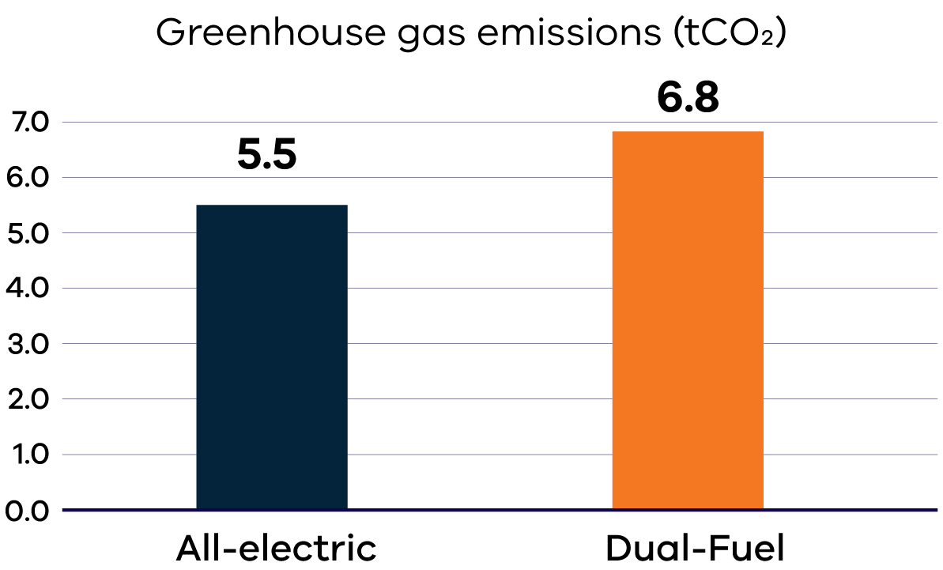

* Over the 10-year period from 2025–2035, an existing all-electric home will have 38% lower GHG emissions than a new dual fuel home, saving 21.5 t CO2.

Figure 2: Emissions over 10 years from 2025 – Existing home

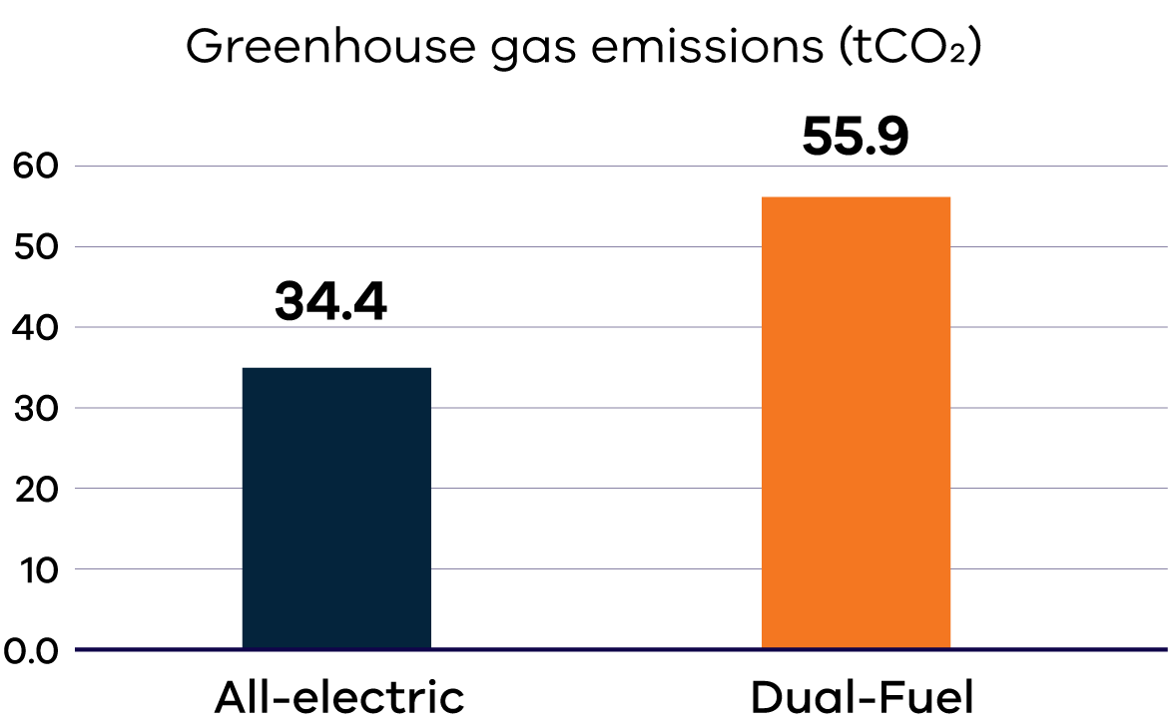

* Electrifying an existing home can deliver greater reductions compared to a new home, as existing homes are typically not as thermally efficient and require higher heating loads. Switching to an efficient electric alternative in an existing home will save more energy and therefore emissions.

# Key Inputs – Existing Home

* Thermal performance of a 3-star building shell
* High efficiency, multi-split air conditioning systems used for space heating (high efficiency conversion of around 450%)

Table 1: Key inputs for an existing home

| Input | Existing home | Emissions Factor 2025 |
| --- | --- | --- |
| Dual Fuel – gas input | 65.2 GJ/yr | 0.056 tC02/GJ |
| Dual Fuel – electricity input | 3.9 MWh | 0.812 tC02/MWh |
| All-electric home input | 6.7 MWh | 0.812 tC02/MWh |

# Key Messages – New Home

Department of Energy, Environment and Climate Action (DEECA) analysis concludes:

* Built today, a new, all-electric home has 6% lower greenhouse gas (GHG) emissions than a new dual fuel home, saving 0.3 t CO2. (**Note:** GHG emissions reductions estimates for a new home were revised using updated energy use assumptions and electricity emissions factors.)

Figure 3: Emissions in 2025 – New home

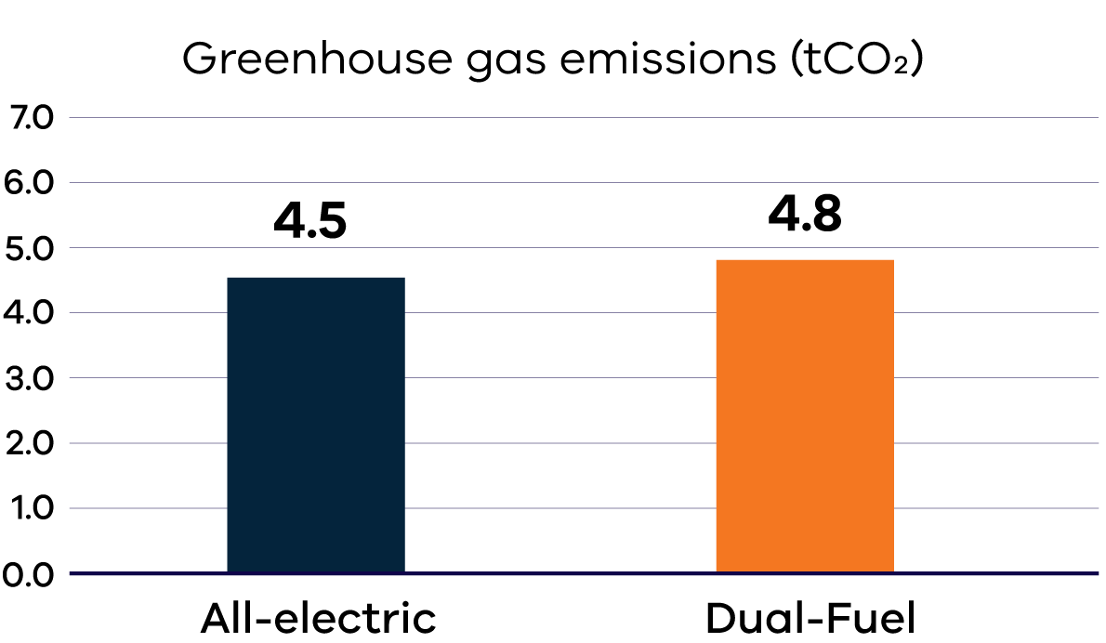

* Over the 10-year period from 2025–2035, a new, all-electric home has 23% lower GHG emissions than a new dual fuel home, saving 8.2 t CO2.

Figure 4: Emissions over 10 years from 2025 – New home

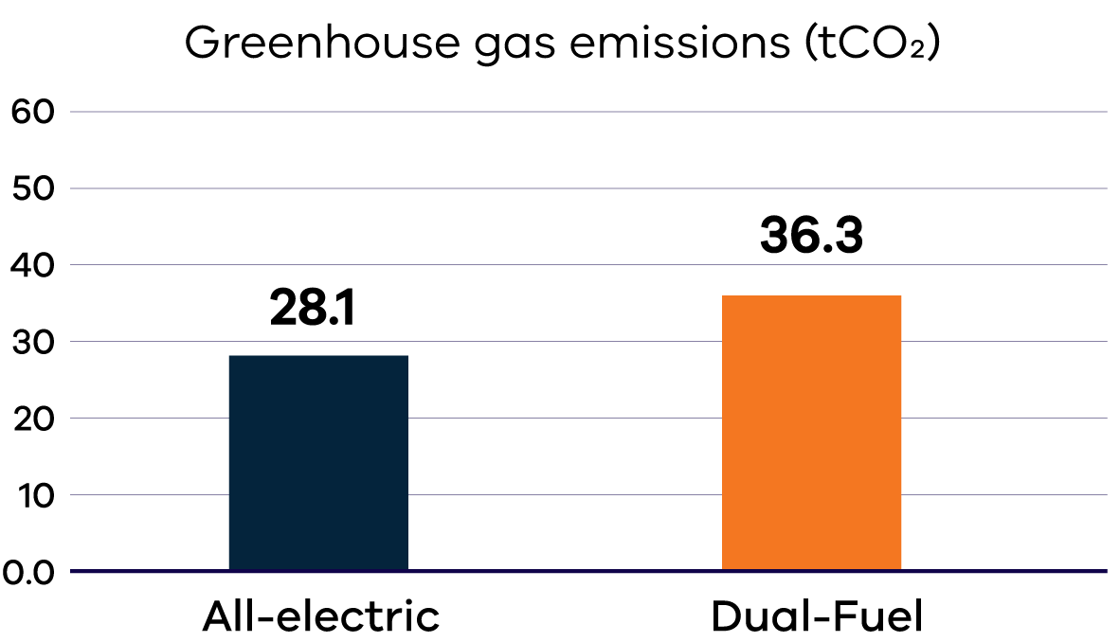

# Key Inputs – New Home

* New home built with 7-star building shell
* High efficiency, multi-split air conditioning systems used for space heating (high efficiency conversion of around 450%)

Table 2: Key inputs for a new home

| Input | New home | Emissions Factor 2025 |
| --- | --- | --- |
| Dual Fuel – gas input | 32.4 GJ/yr | 0.056 tC02/GJ |
| Dual Fuel – electricity input | 3.5 MWh/yr | 0.812 tC02/MWh |
| All-electric home input | 5.4 MWh/yr | 0.812 tC02/MWh |

# GHG emissions factors

* Scope 2 electricity emissions based on AEMO 2024 Step Change scenario and scope 3 from DCCEEW (**Source:** [Australian National Greenhouse Accounts Factors (dcceew.gov.au)](https://www.dcceew.gov.au/sites/default/files/documents/national-greenhouse-accounts-factors-2022.pdf) Table 1)
* Scope 1 and 3 gas emissions from DCCEEW (**Source:** [Australian National Greenhouse Accounts Factors (dcceew.gov.au)](https://www.dcceew.gov.au/sites/default/files/documents/national-greenhouse-accounts-factors-2022.pdf) Table 4 and Table 5. Table 5 notes the following “Scope 3 emission factors do not include fugitive emission leakage but do include the combustion associated with low pressure natural gas distribution pipeline networks.”)

[**energy.vic.gov.au**](http://energy.vic.gov.au/)

# Publication information

## Acknowledgement of Traditional Owners

We acknowledge Victorian Traditional Owners and their Elders past and present as the original custodians of Victoria’s land and waters and commit to genuinely partnering with them and Victoria’s Aboriginal community to progress their aspirations.

## Copyright

© The State of Victoria Department of Energy, Environment and Climate Action,   
December 2024.

**ISBN** 978-1-76176-034-1 **(pdf/online)**

**ISBN** 978-1-76176-035-8 **(print)**

## Creative Commons

This work is licensed under a Creative Commons Attribution 4.0 International licence, visit the [Creative Commons website](http://creativecommons.org/licenses/by/4.0/) (<http://creativecommons.org/licenses/by/4.0/>).

You are free to re-use the work under that licence, on the condition that you credit the State of Victoria as author. The licence does not apply to any images, photographs or branding, including the Victorian Coat of Arms, and the Victorian Government and Department logos.

## Disclaimer

This publication may be of assistance to you but the State of Victoria and its employees do not guarantee that the publication is without flaw of any kind or is wholly appropriate for your particular purposes and therefore disclaims all liability for any error, loss or other consequence which may arise from you relying on any information in this publication.

## Accessibility

To receive this document in an alternative format, phone the Customer Service Centre on 136 186, email customer.service@delwp.vic.gov.au, or contact National Relay Service on 133 677. Available at DEECA website (www.deeca.vic.gov.au).

**End of document.**