Renewable Energy Investment Prospectus: Utility-Scale Electricity Generation and Storage
  - October 2026

Table of Contents
Traditional Owners at the centre for decision-making processes 4
Welcome to Victoria’s renewable energy sector 5
Invest in Victoria’s utility-scale electricity generation and storage sector 7
Victoria is at the heart of Australia’s National Electricity Market 9
Victoria’s world-leading wind resource 12
Victoria’s booming storage market offers a strong investment opportunity 15
Victoria has excellent solar resources 19
Hybrid electricity generation and storage projects 21
Underwriting new renewable energy capacity 24
Access to government co-investment 27
Fast-tracking planning approvals 29
SEC: Investing to accelerate the transition and the market 32
Victoria’s new Renewable Energy Zones 35
VicGrid – Shaping Victoria’s future grid 38
Investing in a Future Made in Australia 39
Manufacturing and recycling opportunities 40
Research and innovation capabilities 43
Access to Victoria’s world-class renewable energy talent 46
A clear pathway to partner with First Peoples 48
Key Victorian Government entities 50
Subsector packs 53
Publication information 54

Traditional Owners at the centre for decision-making processes
Strong and mutually beneficial partnerships with Traditional Owners and First Peoples are imperative to the energy transition’s success and integral to ensuring the goals and objectives of self-determination set out in the Victorian Government’s Self Determination Reform Framework and the Department of Energy, Environment and Climate Action’s (DEECA) Pupangarli Marnmarnepu ‘Owning Our Future’ Aboriginal Self-Determination Reform Strategy 2020–2025.
For more information, visit the Pupangarli Marnmarnepu ‘Owning Our Future’ strategy page.

Acknowledgement of Country
We acknowledge and respect Victorian Traditional Owners as the original custodians of Victoria’s land and waters, their unique ability to care for Country and deep spiritual connection to it.
We honour Elders past and present whose knowledge and wisdom have ensured the continuation of culture and traditional practices.
We are committed to genuinely partner, and meaningfully engage, with Victoria’s Traditional Owners and Aboriginal communities to support the protection of Country, the maintenance of spiritual and cultural practices and their broader aspirations in the 21st century and beyond.

Welcome to Victoria’s renewable energy sector
Our legislated targets and changing energy market are creating investment opportunities.
Victoria’s energy market is rapidly transitioning away from a historic reliance on fossil fuels to a distributed and diversified renewable supply mix as the state’s largest coal-fired generators are set to retire by 2035. At the same time, electricity demand is growing as households, businesses and transport electrify and more data centres are added to the mix. Together, these trends are driving the need for new, reliable and clean energy supply.
The utility-scale electricity generation and storage sector is at the heart of our energy transition, supported by legislated renewable energy generation and storage targets. With excellent resources, strong supply chains, world-class research and development capabilities, and a highly skilled workforce, Victoria is a great destination for your investment.
Table 1: Key renewable energy figures
Figure | Description
27 GW | New renewable generation and storage capacity required by 2035 in Victoria
82% | Australia’s renewable energy target by 2030
9 GW | Targeted offshore wind capacity
Table 2: The Victorian Government’s legislated targets
Year | Renewable electricity generation target | Energy storage target
2020 | 25% renewable electricity generation (achieved) | –
2025 | 40% renewable electricity generation (achieved) | –
2030 | 65% renewable electricity generation | 2.6 GW energy storage capacity
2035 | 95% renewable electricity generation | 6.3 GW energy storage capacity
2045 | Net-zero emissions | –

Invest in Victoria’s utility-scale electricity generation and storage sector

Clear targets
Legislated targets of 95% renewable electricity generation and 6.3 GW of storage by 2035.

World-class wind
Excellent wind resources, with top average wind speeds of 8.4 m/s in western Victoria.

Excellent solar
Solar irradiation levels are world-leading, with north-west Victoria exceeding 1,900 kWh/m² annually.

Transmission investment
Planned transmission upgrades are unlocking more of Victoria’s wind and solar resources.

Faster planning
Streamlined planning approvals through the Development Facilitation Program.

Competitive electricity market
At the centre of Australia’s competitive, transparent and privatised National Electricity Market.

Victoria at a glance
- Victoria is the fastest-growing state in the country with the population expected to reach 10.3 million by 2051.
- Victoria contributes nearly a quarter of Australia’s economic activity.
Melbourne is ranked the world’s 3rd most liveable city and Australia’s most liveable city.

Victoria is at the heart of Australia’s National Electricity Market
Victoria is located at the very centre of Australia’s National Electricity Market (NEM), linking the state to major load centres and critical infrastructure.

The National Electricity Market (NEM)
The NEM is one of the world’s largest interconnected power systems, stretching 5,000 kilometres (km) along Australia’s east and south-east seaboard. It has 5 interconnected states that function as pricing regions. It is a wholesale 5-minute spot market to trade electricity between generators and retailers.

Australian Energy Market Operator (AEMO)
AEMO manages the electricity and gas systems and markets across Australia, ensuring Australians have access to affordable, secure and reliable energy. AEMO produces trusted publications and reports which can support investment decisions.
For more information, visit the AEMO publications library.

Other regulatory bodies
- Australian Energy Market Commission is the rule maker for Australian electricity and gas markets. For more information, visit the Australian Energy Market Commission website.
Australian Energy Regulator regulates energy networks and the wholesale and retail markets in Australia to ensure they are secure, reliable and affordable for consumers. For more information, visit the Australian Energy Regulator website.

Victoria’s connections to the NEM
Figure 1: The National Electricity Market
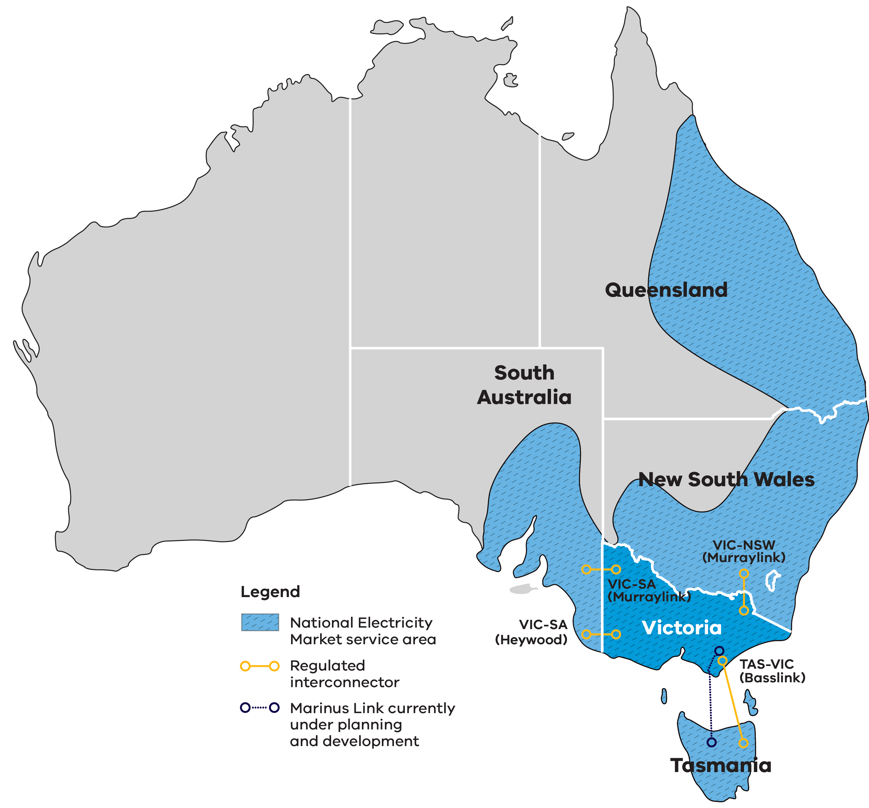
Figure 1 shows the National Electricity Market service area, which covers Queensland, New South Wales, Victoria, South Australia and Tasmania. Victoria sits at the centre of the market and is directly connected to 3 other states by 4 regulated interconnectors:
- VIC-SA (Heywood), connecting Victoria and South Australia
- VIC-SA (Murraylink), connecting Victoria and South Australia
- VIC-NSW (Murraylink), connecting Victoria and New South Wales
TAS-VIC (Basslink), connecting Tasmania and Victoria.
A further interconnector between Victoria and Tasmania, Marinus Link, is currently under planning and development.

Investment opportunities
Victoria’s fully competitive, privatised electricity market creates many opportunities for investors. This includes the spot and contract markets for companies that specialise in buying and selling electricity, with opportunities to leverage market fluctuations and participate in existing and emerging grid services markets.
For more information, visit the Victorian electricity sector overview page.
Table 3: The National Electricity Market at a glance
Measure | Value
Value traded in FY2024–25 | $25 billion
Spot price market cap FY2025–26 | $20,300/MWh
Share of Australia’s population serviced | ~85%
Customers | ~11 million
Transmission lines | 40,000 km
Regulated interconnectors directly connecting Victoria to 3 other states | 4
Electricity supplied each year | ~200 TWh
Total generation | ~99 GW

Victoria’s world-leading wind resource
Victoria boasts excellent wind resources, with an average wind speed of 8.4 m/s in western Victoria and over 9 m/s in many areas along the southern coastline.
Victoria’s onshore wind sector is primed for investment, with wind power set to play a critical role in achieving the state’s renewable energy targets. Victoria’s windspeeds rank among the highest in the world, setting the sector up for continued growth.
Table 4: Victoria’s onshore wind sector at a glance
Status | Projects | Capacity
Currently operating | 44 wind farms | 6 GW
Under construction | 1 wind farm | 205 MW
Required by 2035 | – | 5.1 GW of onshore wind
Figure 2: Victorian wind resource map and indicators
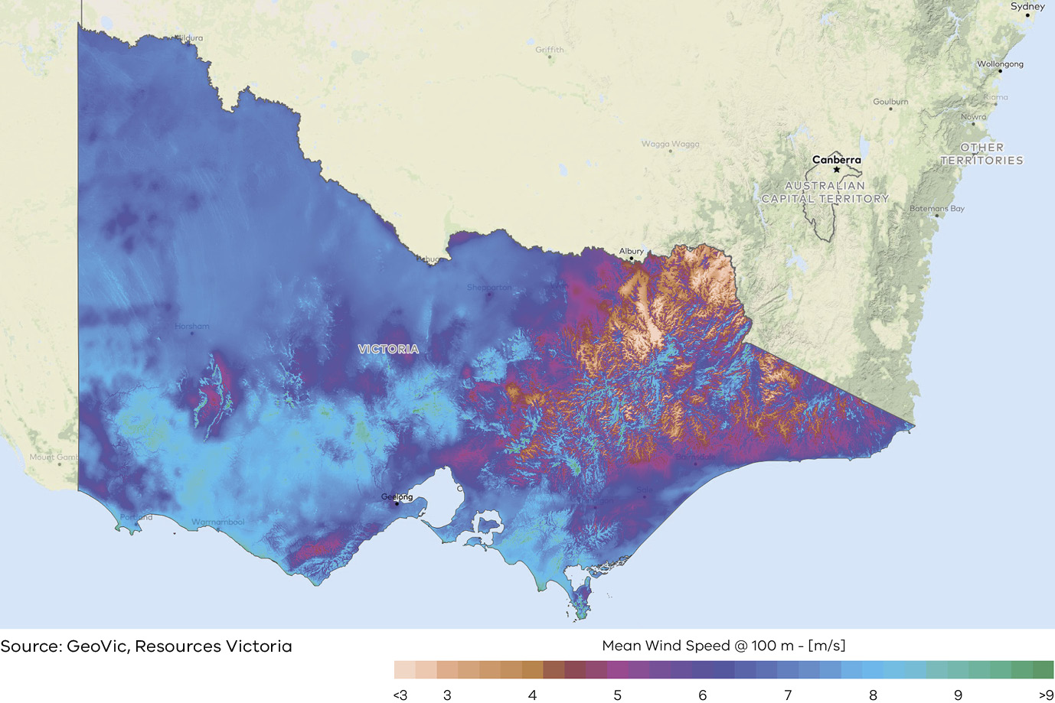
Figure 2 is a heat map of mean wind speed at 100 metres (m) height across Victoria, in metres per second (m/s), on a scale from less than 3 m/s to more than 9 m/s. It shows:
- mean wind speeds of around 7 to 9 m/s across most of western, central and northern Victoria
- the highest wind speeds, above 9 m/s, along parts of the southern coastline and on elevated areas
more variable wind speeds, ranging from below 3 m/s in sheltered valleys to above 9 m/s on ridges, in the north-east alpine region.
Source: GeoVic, Resources Victoria.

Case study: Goldwind Australia

Moorabool Wind Farm
The Moorabool Wind Farm is a 312 MW onshore wind project located near Ballarat in western Victoria, delivering clean energy to power approximately 228,000 homes annually. Owned by BJEI Australia and Nebras Power, the project comprises 104 turbines across 2 sections and was fully commissioned in 2022.
Moorabool Wind Farm represents a significant international investment in Victoria. Developed by Goldwind Australia, construction commenced in 2018 before entering full commercial operation in 2022.
Key facts:
- 312 MW installed generation capacity
- 104 turbines
enough electricity to power 228,000 homes.
For more information, visit the Moorabool Wind Farm website.
“Goldwind’s delivery of the Moorabool Wind Farm highlights Victoria as a prime destination for renewable energy investment, supported by coordinated planning, a skilled workforce, and a strong supply chain.”
Goldwind Australia

Victoria’s booming storage market offers a strong investment opportunity
The market opportunity is growing, with Victorian batteries earning a 10% annual increase in average monthly realised arbitrage in 2025.
Victoria’s utility-scale battery market continues to grow, driven by increasing renewable energy penetration, strong government support, and the planned retirement of coal-fired generation capacity.
Victoria has legislated nation-leading energy storage targets of at least 2.6 GW by 2030 and 6.3 GW by 2035. In the 2025–26 financial year, renewables supplied 45.1% of Victoria’s electricity. As Victoria progresses towards its target of 95% renewable electricity by 2035, increased utility-scale storage will be critical in maintaining grid reliability, firming renewable generation and replacing ageing coal-fired power stations.
More than 2 GW of large-scale battery capacity is already commissioned and 9 additional projects are under construction or approved.

Strong revenue opportunities
Energy storage operators can capture demonstrated market opportunities including energy arbitrage, ancillary services and a System Integrity Protection Scheme (SIPS).
According to analysis by Bloomberg New Energy Finance (BloombergNEF), in 2025 utility-scale batteries in the National Electricity Market earned approximately $360 million in gross arbitrage revenue, with net arbitrage revenue up 70% year on year.
Table 5: Victoria’s utility-scale storage sector at a glance
Status | Projects | Capacity
Currently operating | 26 storage projects | 2 GW
Under construction | 9 storage projects | 1.8 GW
Required by 2035 | – | 5.5 GW of utility storage

Case study: Rangebank BESS
Eku Energy partnered with Shell Energy Australia and Perfection Private to develop the Rangebank battery energy storage system (BESS) which has increased Victoria’s renewable energy hosting capacity while providing essential system services to VicGrid and the National Electricity Market (NEM).
The Rangebank BESS became fully operational in December 2024 and has the storage capacity, of 200 MW, to power the equivalent of 80,000 homes for an hour during peak periods. Under a tolling agreement, Shell Energy Australia has access to the battery’s capacity over the next 20 years.
Together both companies are committed to Victoria with each organisation investing in the state’s infrastructure through upcoming projects.
For more information, visit the Eku Energy Rangebank project page or the Shell Energy Rangebank BESS project page.

Case study: Hazelwood BESS
The Hazelwood Battery Energy Storage System (BESS) in the Latrobe Valley is Australia’s first utility-scale energy storage system to be commissioned on the site of a retired coal-fired power plant.
100% owned by ENGIE, the 150 MW/150 MWh system has the capacity to store the equivalent energy of 30,000 residential rooftop solar systems, which it can then discharge to help meet peak demand.
With access to existing network transmission capacity on site, the Hazelwood BESS will play a critical role in increasing renewable energy capacity in Victoria while delivering essential system services to the grid.
For more information, visit the ENGIE Hazelwood Battery page.
“Victoria is the place to be for investment in the energy transition, with near term coal retirement commitments, strong wind and solar resources and supportive policy deployment.”
Laura Caspari, Chief Renewables Officer, ENGIE AU

Case study: Fotowatio Renewable Ventures Australia (FRV Australia)
Fotowatio Renewable Ventures Australia (FRV Australia) has been awarded $7 million through round 2 of the Energy Innovation Fund (EIF) to install a 100 MW/200 MWh lithium-ion Battery Energy Storage System (BESS) using innovative grid forming inverters, located in Terang, Victoria.
The project will include 38 inverters and 48 battery containers and once complete will connect to the national electricity grid.
Grid forming inverters use voltage and frequency control technology to manage the supply and demand of electricity flowing through the network and keep it performing reliably. This technology is critical as more renewable energy is connected to the grid.
For more information, visit the Terang BESS website.

Victoria has excellent solar resources
North-west Victoria receives high irradiation levels, with southern Victoria boasting better solar resources than most of western Europe.
Victoria’s solar energy sector is primed for investment, with solar energy to play a critical role in achieving the state’s renewable energy targets. Victoria has excellent solar irradiation levels across the state, setting the sector up for continued growth.
North-west Victoria receives an exceptional amount of solar energy, with irradiation levels exceeding 1,900 kWh/m² annually.
Table 6: Victoria’s utility-scale solar sector at a glance
Status | Projects | Capacity
Currently operating | 57 solar farms | 2 GW
Under construction | 3 solar farms | 300 MW
Required by 2035 | – | 2.9 GW of utility solar
Figure 3: Solar irradiation levels in Victoria
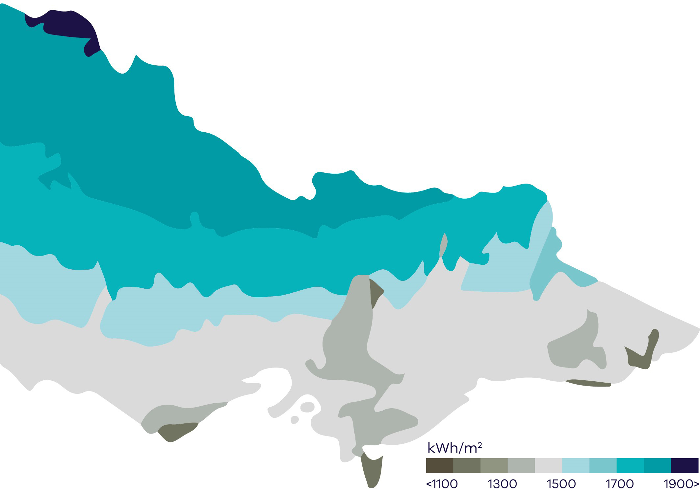
Figure 3 is a map of Victoria shaded by annual solar irradiation in kilowatt hours per square metre (kWh/m²), on a scale from less than 1,100 to more than 1,900 kWh/m². It shows:
- the highest irradiation, above 1,900 kWh/m², in the far north-west corner of the state around Mildura
- high irradiation of about 1,700 to 1,900 kWh/m² across the rest of northern and north-western Victoria
- moderate irradiation of about 1,500 to 1,700 kWh/m² across central and western Victoria
lower irradiation, below 1,500 kWh/m², in southern and eastern Victoria, with the lowest levels in the alpine north-east and parts of the south coast.

Hybrid electricity generation and storage projects
Under current market conditions, solar and wind project economics are boosted with a battery.
Hybrid projects – combining solar or wind energy with battery energy storage systems – represent a strong and growing investment opportunity in Victoria. By co-locating generation and storage, hybrid projects can improve asset utilisation, capture greater wholesale market value, and provide firm, dispatchable renewable energy.

BloombergNEF modelling
BloombergNEF modelling shows that pairing batteries with renewable assets can improve project economics by capturing excess generation and arbitraging price volatility.
Under current market conditions, the revenue-to-capex ratio for a 100 MW generation project paired with a one-hour 200 MW battery in the NEM is:
- 197% for a solar farm
140% for a wind farm.

Case study: Fulham Solar Farm
Octopus Australia is an energy fund manager and developer focused on delivering large-scale solar, wind and battery storage projects across Australia. Backed by global institutional capital, including support from the Clean Energy Finance Corporation and Australian superannuation funds, the company is building integrated renewable energy portfolios designed to deliver reliable, firmed renewable power at scale.
Victoria is a key focus region, with the Fulham Solar Farm and Battery Project representing a significant long-term investment in regional Victoria. Supported by a long-term energy agreement with the Victorian Government’s second Victorian Renewable Energy Target Auction (VRET2), the project adds new renewable generation and storage to the state’s electricity system. The 80 MW solar farm, DC-coupled with 64 MW/128 MWh of battery storage, will generate enough energy to power around 39,000 homes.
It is expected to support more than 230 construction jobs and create opportunities for local contractors and suppliers throughout the life of the project.
For more information, visit the Fulham Solar website.
“Victoria has created a strong platform for renewable investment, and its energy transition depends on delivering integrated projects at scale. Fulham combines large-scale solar generation with battery storage, delivering reliable, low-cost energy while supporting regional jobs and investment in Gippsland.”
Sam Reynolds, Chief Executive Officer, Fulham Solar

Case study: Gannawarra Energy Storage System
The Gannawarra Energy Storage System is located at the Gannawarra Solar Farm in Wandella, Victoria. It was one of the first large-scale battery projects supported by the Victorian Government as part of its $25 million Energy Storage Initiative. The 25 MW/50 MWh battery was developed by Edify Energy and is jointly owned by Revolt Energy and Gentari.
The project is managed by Edify Energy and has an offtake with EnergyAustralia. This battery is used to smooth the output of the 60 MW Gannawarra Solar Farm, allowing the combined solar and battery system to provide power when there is insufficient sun.
For more information, visit the Edify Energy Gannawarra project page or the Gentari Gannawarra Energy Storage System page.

Underwriting new renewable energy capacity
The Australian Government has set a renewable energy target of 82% by 2030. To achieve this goal, it is helping to de-risk projects through long-term revenue underwriting.

Capacity Investment Scheme (CIS)
The Capacity Investment Scheme (CIS) provides a national framework to underwrite 23 GW of renewable capacity and 9 GW of clean dispatchable capacity by 2030.
Competitive tenders for renewable energy and storage will be held approximately every 6 months. The Victorian Government and Australian Government have entered a bilateral Renewable Energy Transformation Agreement (RETA) which secures target allocations for Victorian projects in these tenders for at least 5 GW or 11 TWh of renewable energy and 1.7 GW of 4-hour equivalent storage.
To date in Victoria, the Commonwealth has awarded contracts for 5.9 GW of generation and storage capacity. An additional 2.4 GW of generation capacity is expected to be announced for Victoria from existing CIS tender rounds and future tender rounds commencing over the course of 2026 to meet Victoria’s target allocation.
The final tender round is proposed to open in December 2026 with the indicative date announced in July 2027.
For more information, visit the Capacity Investment Scheme page.
Table 7: Capacity Investment Scheme allocations for Victoria
Capacity | Description
5.9 GW | Generation and storage announced for Victoria through CIS tenders
2.4 GW | Victoria’s minimum remaining capacity allocation

Electricity Service Entry Mechanism (ESEM)
The Electricity Service Entry Mechanism (ESEM) is a proposed long-term investment framework designed to provide ongoing investment certainty following the CIS. State and Territory Energy Ministers (except Queensland) have agreed to target ESEM commencement by the end of 2027.
It aims to support investment by bridging the ‘tenor gap’ – the mismatch between generators’ need for price certainty over a long period (15+ years), compared with market customers’ appetite to enter price hedging over the short-term (for example, up to 3 years). It will do this by awarding hedging contracts through competitive tenders for only the mid to later years (5+) of a project, then sell those contracts to market customers as the hedging period approaches. This ‘recycling’ of contracts, and their fungible nature, is a key innovation on previous underwrite schemes.
The ESEM Administrator is expected to conduct competitive reverse auctions to procure 3 specific services:
- Bulk zero-emissions energy
- Shaping services
- Firming services.
The ESEM is being implemented by the Commonwealth and NEM jurisdictions, with amendments to the National Electricity Law anticipated for Q1 or Q2 2027, and the ESEM being fully operational by Q4 2027.
For more information, visit the NEM wholesale market settings review page.

Access to government co-investment
Australian Government Specialist Investment Vehicles (SIVs) provide debt, equity and grant support to help net-zero projects get off the ground and scale alongside private capital.
The Victorian Government can connect you with the following organisations.

Clean Energy Finance Corporation (CEFC)
The CEFC is Australia’s specialist climate investor, helping cut emissions in the race towards net-zero by 2050. We invest in the latest technologies to generate, store, manage and transmit clean energy. Our discounted asset finance programs help put more Australians on the path to sustainability, in their homes and on the road. CEFC capital is also backing the net-zero transformation of our natural capital, infrastructure, property and resources sectors, while providing critical capital for the emerging climate tech businesses of tomorrow. With access to more than $33 billion from the Australian Government, the CEFC invests with commercial rigour and is governed by an independent board.
For more information, visit the Clean Energy Finance Corporation website.

National Reconstruction Fund Corporation (NRFC)
The NRFC manages a $15 billion sovereign fund that provides financing to grow Australia’s advanced manufacturing base, including a dedicated $5 billion Net Zero Fund for renewable energy technologies, batteries, hydrogen and industrial decarbonisation projects.
For more information, visit the National Reconstruction Fund Corporation website.

Australian Renewable Energy Agency (ARENA)
ARENA accelerates innovation and deployment of renewable energy by funding pre-commercial, renewable solutions. This helps move ideas from concept to market and supports Australia’s emissions reduction. As part of its role, ARENA administers programs like the Future Made in Australia Innovation Fund and Hydrogen Headstart Program.
For more information, visit the Australian Renewable Energy Agency website.

Australia’s Investor Front Door
Australia’s Investor Front Door streamlines the development of major, nationally significant projects by providing coordinated government support for investment and project delivery.
For more information, visit Australia’s Investor Front Door page.

Fast-tracking planning approvals
The Victorian Government is committed to getting your project through planning approvals as quickly as possible.

Dedicated renewable energy planning pathways
Victoria’s Development Facilitation Program (DFP) is an accelerated planning pathway for the delivery of significant economic development, including renewable energy facilities and utility installations. This streamlined planning process provides greater certainty and can reduce assessment timeframes by approximately 9–12 months.

Faster, more focused and consistent environmental assessments in Victoria
Recent reforms have modernised Victoria’s environmental assessment processes. Supporting timely project delivery while maintaining robust environmental assessment and community engagement is a key priority.
This includes new digital streamlined interfaces between proponents and government agencies, and updated guidance, templates and governance arrangements to increase predictability, clarity, transparency and tracking.

Investment Coordinator-General
The Investment Coordinator-General role and function sits within Invest Victoria and works across agencies to ensure approval deadlines are met and reduce delays.

Australian Government funding to fast-track approvals
Victoria works closely with the Australian Government to facilitate projects. In 2024–25, the Australian Government’s Future Made in Australia allocated $134.2 million to better prioritise approvals for renewable energy projects of national significance, and support faster decisions on environment, cultural heritage and planning approvals.
The Australian Government also committed over $70 million from 2026–27 to fast-track approvals in priority areas like energy and critical minerals.
Table 8: Development Facilitation Program achievements since April 2024
Result | Measure
Less than 4 months | Statutory days for approvals
34 | Renewable energy projects approved
More than $14 billion | In investment
Note: figures correct as of August 2026, Department of Transport and Planning.

Better information, tools and guidance to manage biodiversity impacts of renewable energy projects
Victoria has developed tools and guidance to help renewable energy projects manage biodiversity impacts with greater clarity and certainty. Ongoing work focuses on continued improvements to the information and guidance currently available.

Guidance to support faster renewable energy development
Published in May 2025, the Handbook for the development of renewable energy in Victoria outlines a risk-based approach to identifying, assessing and managing biodiversity impacts.
For more information, visit the managing impacts of renewable energy on the environment page.

Biodiversity mapping to support lower-risk project siting
Victoria’s Habitat Value and Marine Biodiversity Values maps can be used to consider the relative value of biodiversity in different areas, to help site and design infrastructure that minimises impacts.
For more information, visit the Habitat Value page and the Marine Biodiversity Values page.

Research to reduce development risk
Victoria continues to undertake and release targeted research to help developers and decision-makers better understand biodiversity impacts for onshore renewable energy development.
For more information, visit the Science for renewable energy policy page.

SEC: Investing to accelerate the transition and the market
SEC’s investment focus is on achieving sustainable returns, while enabling the market and delivering broader benefits to Victorians.
As a Victorian Government-owned renewable energy company, SEC’s investments address system gaps, crowd-in private capital and support a broader market response to the energy transition.
SEC operates across 3 domains:
- Scaled investment in renewable generation and storage projects
- Enabling decarbonisation for businesses and industry
- Driving electrification of households at scale.

Scaled investment in renewable generation and storage projects
SEC is investing to deliver 4.5 GW of renewable energy and storage capacity, with over 1 GW already built or under construction. These investments have helped to add critical storage capacity, strengthen energy security and support regional economic growth, including jobs, training and community benefit-sharing.

Enabling decarbonisation for businesses and industry
SEC provides renewable retail and wholesale electricity solutions to commercial and industrial customers to help businesses reduce costs and emissions.

Driving electrification of households at scale
SEC supports households switch from gas to electric appliances through Easy Electric SEC, a digital platform and SEC-endorsed installer network, reducing energy costs and emissions.

Examples of current projects

Melbourne Renewable Energy Hub
SEC’s first investment, the Melbourne Renewable Energy Hub, was the first financial close of a 4-hour BESS in the NEM. SEC’s $245 million investment helped fast track construction and doubled the storage duration of one of the project’s 3 battery components from 2 to 4 hours. The 600 MW battery provides 1.6 GWh of storage – enough to power 200,000 homes during the evening peak period.

SEC Renewable Energy Park – Horsham
SEC Renewable Energy Park – Horsham is a 100% publicly owned utility-scale renewable energy project in Victoria’s Wimmera region. The project comprises a 119 MW solar farm and a 100 MW/200 MWh battery energy storage system. Once operational in 2027, the facility will be capable of generating around 242,000 megawatt hours of renewable energy a year – enough renewable energy to power around 51,000 homes.

SEC Delburn Wind Farm
The SEC Delburn Wind Farm is creating significant opportunities for local businesses through construction and supply contracts. Once operational in 2028, the project will deliver up to 205 MW of renewable electricity.

SEC Energy Works
SEC Energy Works is a new energy innovation precinct in Victoria’s Latrobe Valley. It will provide a space for SEC to partner with industry to develop a range of new energy infrastructure and storage technologies that our future energy system will require. In partnership with global clean technology company, Energy Dome, SEC’s first project will be a closed-loop, compressed CO₂ long-duration energy storage solution that will be capable of continuously supplying electricity for 10 to 12 hours.

Baranduda Electrical Energy Reserve
The Baranduda Electrical Energy Reserve is a utility-scale battery that will deliver 400 MW of capacity and store 1.86 GWh of energy. Once operational in late 2028, Baranduda will be capable of storing enough energy to power more than 200,000 Victorian homes through the evening peak.

Victoria’s new Renewable Energy Zones
VicGrid is implementing the Victorian Transmission Plan, a long-term strategic plan for transmission and renewable energy zone development in Victoria.
This plan will ensure Victoria builds the right amount of energy infrastructure in the right places at the right time to support the transition to renewable energy.
The Victorian Government has declared 5 renewable energy zones, along with the shoreline renewable energy zone to connect offshore wind projects in Gippsland, that were proposed in the 2025 Victorian Transmission Plan.
The Gippsland Shoreline Renewable Energy Zone is different from other renewable energy zones. It is a defined planning area for offshore wind developers to run underground cables from the shoreline to the electricity grid.
Renewable energy zones are areas identified as most suitable to host new renewable energy generation, such as wind turbines, solar farms, and battery storage.
Renewable energy zones will:
- ensure better coordination of renewable projects and reduce the need for unnecessary transmission lines and other infrastructure
- enable VicGrid to implement clear rules that manage how projects gain access to the grid, including expectations for how developers engage with community
- provide greater certainty about how and where renewables projects should be built
unlock new economic benefits for regional communities and Traditional Owners.
Figure 4: Victoria’s renewable energy zones and transmission network
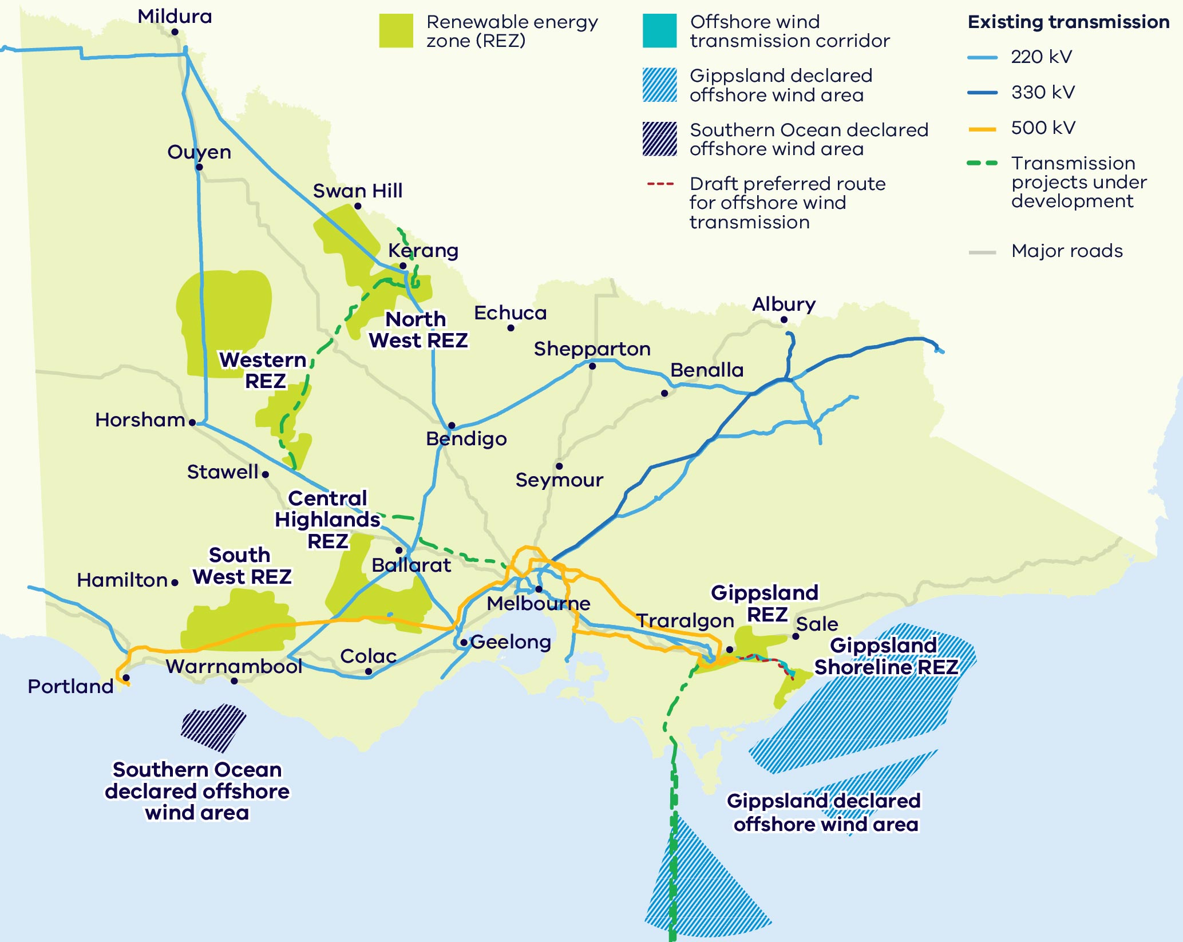
Figure 4 is a map of Victoria’s renewable energy zones (REZ) and transmission network. It shows:
- Western REZ: west of Stawell and north of Horsham, in western Victoria
- North West REZ: around Swan Hill and Kerang, in northern Victoria
- Central Highlands REZ: between Stawell and Ballarat
- South West REZ: between Hamilton and Colac, in south-west Victoria
- Gippsland REZ: around Traralgon and Sale, in eastern Victoria
- Gippsland Shoreline REZ: on the Gippsland coast south of Sale, connecting to the offshore wind transmission corridor
- existing 220 kV, 330 kV and 500 kV transmission lines radiating from Melbourne to regional centres, and transmission projects under development, including links through the Western, North West and Central Highlands REZs
the Southern Ocean declared offshore wind area off Portland and the Gippsland declared offshore wind area off the Gippsland coast, with the draft preferred route for offshore wind transmission.

VicGrid – Shaping Victoria’s future grid
VicGrid is changing the way renewable energy zones are planned and developed, and delivering the infrastructure Victoria needs to unlock more renewable energy resources.

VicGrid’s flagship projects
VicGrid is working on flagship projects that will not only unlock significant new generation and storage, but present strong investment opportunities. Flagship projects include:
- investing $480 million in a portfolio of projects across the state to strengthen and modernise Victoria’s grid
- leading the development of Gippsland offshore wind transmission infrastructure
- working with the Australian Energy Market Operator (AEMO) to deliver crucial new transmission projects including the Victoria to New South Wales Interconnector West (VNI West) and the Western Renewables Link (WRL)
- investing in the Marinus Link interconnector between Victoria and Tasmania to enhance energy reliability and affordability
rebuilding existing transmission lines and delivering new lines identified in the Victorian Transmission Plan.

Investing in a Future Made in Australia
The Australian Government is investing to transform the nation into a renewable energy superpower.
In the 2024–25 Federal budget, $22.7 billion was announced for initiatives that are part of a Future Made in Australia package designed to maximise the economic and industrial benefits of the net-zero transition. It is focused on facilitating private sector investment and building a stronger, more diversified and more resilient economy powered by renewable energy.
For more information, visit the Future Made in Australia page.
Table 9: Future Made in Australia commitments
Funding | Commitment
$1.5 billion | Support for priority areas through the Future Made in Australia Innovation Fund: $250 million for low carbon liquid fuels, $500 million for clean energy technology manufacturing capabilities and $750 million for green metals
Up to $1 billion | To scale domestic solar manufacturing and strengthen solar panel supply chains through production incentives and grants
$3 billion | For early-mover renewable hydrogen projects, under the Hydrogen Headstart program
$13.7 billion | In hydrogen and critical minerals production tax incentives
$2 billion | Green aluminium production credit to position Australian aluminium as some of the greenest in the world
$1 billion | Green Iron Investment Fund to set up new facilities and supply chains

Manufacturing and recycling opportunities
Victoria’s renewable energy transition is driving demand for wind turbines, solar panels and batteries, creating market opportunities for original equipment manufacturers.
Growing Victorian demand for wind turbines, solar panels and batteries provides market opportunities and pipeline certainty for original equipment manufacturers.
Table 10: Additional utility-scale equipment Victoria is estimated to need by 2035
Equipment | Approximate number required
Onshore wind turbines | 800
Utility-scale solar PV panels | 4.3 million
Utility-scale battery packs | 3,300

Manufacturing opportunities
- A $39 billion manufacturing sector that supports more than 275,000 jobs, and exports goods valued at over $11 billion.
- Legislated renewable generation and storage targets create long-term pipeline certainty to manufacture and supply utility-scale battery packs, PV panels, wind turbine components and supporting infrastructure.
- World-class, purpose-built research and innovation centres support battery design and development. Visit the Battery Research and Innovation Hub website.
Critical minerals provide a ‘mine to manufacture’ opportunity, including rare earths essential for permanent magnets used in wind turbines, EV motors and advanced energy technologies. Visit the Resources Victoria critical minerals page.

Recycling opportunities

Significant emerging waste streams
Large future volumes of end-of-life infrastructure, including PV panels, turbines and batteries, presenting a scalable resource recovery opportunity.

High value materials recovery potential
Recoverable critical and strategic materials (for example, lithium, cobalt, copper, aluminium, silicon and silver) that can be recycled and reused in manufacturing supply chains.

Policy and regulatory drivers
Victoria’s circular economy policy and e-waste landfill ban increase demand for recycling solutions, supported by targeted funding and innovation programs to commercialise new technologies.

Case study: Lotus Recycling
Lotus Energy Recycling (LER) was established in 2020 to recover valuable minerals from end-of-life solar panels and support a circular renewable economy. Based in Campbellfield, Melbourne, LER is Australia’s first fully operational solar recycling facility recovering over 97% of material.
LER responsibly recycles solar panels and e-waste, while following strict environmental standards. Current material recovery includes copper, aluminium, glass and silicon while future initiatives focus on sustainable silver extraction and Nano-Silicon production for next-generation lithium-ion batteries through partnerships in Germany and Canada.
For more information, visit the Lotus Energy Recycling website.
“Our decision to establish operations in Victoria was driven by the state’s strong commitment to renewable energy, sustainability, and innovation. By building our recycling facility in Melbourne, we are creating a local circular economy that recaptures valuable materials from end-of-life solar panels and transforms them into the resources needed for the next generation of clean energy technologies.”
Anthony Vippond, Chief Executive Officer, Lotus Recycling

Research and innovation capabilities
Victoria has strong research and development capabilities across its universities and has a leading innovation ecosystem.

World-class research organisations
Victorian universities and research organisations are delivering cutting-edge innovation across the full spectrum of storage and generation technologies. This includes:
- Deakin University’s Battery Research and Innovation Hub (see below)
- Commonwealth Scientific and Industrial Research Organisation (CSIRO). For more information, visit the CSIRO research page.
- RMIT’s Centre for Advanced Materials and Industrial Chemistry (CAMIC). For more information, visit the RMIT CAMIC page.
- The University of Melbourne’s Melbourne Energy Institute. For more information, visit the Melbourne Energy Institute website.
Monash University’s Monash Energy Institute. For more information, visit the Monash Energy Institute website.

Battery Research and Innovation Hub
The Battery Research and Innovation Hub, managed by the Deakin Institute for Frontier Materials, provides world-class equipment for advanced battery prototyping and the commercialisation of energy storage technologies.
The hub includes a research laboratory for new battery design and development, prototyping and a cell and systems test facility for multiple battery types and sizes.
Research can be tailored to meet specific industry needs and consumer demands as batteries continue to evolve from small personal use items to powering our modes of transport and electricity supply.
For more information, visit the Battery Research and Innovation Hub website.

Case study: Solstice AI
Solstice AI provides the intelligence layer for energy systems increasingly affected by variable solar energy. By applying artificial intelligence to satellite imagery, Solstice AI forecasts cloud movement and solar generation with high accuracy, helping solar farms, virtual power plants, energy traders, and network operators manage increasingly volatile energy systems.
Founded in Melbourne in 2022, Solstice AI leveraged technology originally developed in PhD research at the University of Melbourne. With additional support from LaunchVic, the University of Melbourne’s MAP startup accelerator, and Australia’s EnergyLab startup accelerator, the company has grown from an early-stage forecasting concept into a commercial energy technology business working with industry partners across Australia and overseas.
For more information, visit the Solstice AI website.
“Melbourne has been the ideal place to launch our company — combining world-leading solar and battery adoption with world-class research and a vibrant, supportive startup ecosystem.”
Dr Julian de Hoog, Co-founder and Chief Executive Officer, Solstice AI

Fast-growing startup ecosystem
Victoria’s startup ecosystem (including startups, scaleups and unicorns) is valued at $143 billion. It is one of the world’s fastest growing ecosystems, home to more than 4,300 start-ups.

Access to Victoria’s world-class renewable energy talent
Our growing, highly skilled workforce drives project delivery and fosters industry growth.
To meet the needs of the sector, our energy workforce is predicted to grow by 53% to 68,000 between 2026 and 2040. The Victorian Government has committed to significant new skills and workforce initiatives to ensure the workforce is available when and where it’s needed, including:
- investing $5 million in Solar Victoria’s Electrification Skills Program
- investing $25 million toward the $50 million Victorian Renewable Energy technical and further education (TAFE) Centre of Excellence
- releasing regular energy workforce data to support informed decision-making and boost investor confidence
- developing new energy training pathways through the $7 million for new vocational education and training (VET) certificates in renewable energy projects
- simplifying pathways for skilled workers to move to Victoria through improved qualification recognition and Victoria’s Skilled Migration Visa Nomination Program
investing $10 million toward the $40 million National Training Centre in New Energy Skills.

Victorian Energy Jobs Plan
The Victorian Energy Jobs Plan provides a framework for developing the robust, future-ready energy workforce needed to deliver the transition and strengthen investment confidence.
For more information, visit the Victorian Energy Jobs Plan page.

Sparking Change: The Women in Energy Strategy
The Women in Energy Strategy recognises that attracting and retaining more women in the renewable energy workforce provides significant benefit to this growing sector. It aims to drive significant change for women in energy through Victoria’s energy transition.
For more information, visit the Women in Energy Strategy page.

A clear pathway to partner with First Peoples

Victorian Traditional Owners are actively involved in the energy transition
Investments have been made in developing frameworks and localised plans for the energy transition to create clear pathways for development in Victoria.
Traditional Owner Corporations have clearly defined strategies and processes for partnering to achieve best development outcomes in Victoria.

Access to specialist support
DEECA has invested in dedicated First Peoples energy specialists who can help developers and investors:
- understand Traditional Owner priorities and aspirations
- navigate engagement and partnership processes
build strong, long-term relationships that support project success.
For more information, visit the First Peoples energy page.

Clear guidance from Traditional Owners
Many Traditional Owner Corporations have published guidance and planning documents that help proponents:
- identify community priorities and aspirations
- understand preferred engagement and partnership models
align projects with local economic, social and cultural outcomes.

Strong government policy and guidance
Victoria has established strategic policies and guidance to support collaboration with First Peoples throughout the renewable energy development lifecycle, reducing uncertainty and creating stronger foundations for project development, investment confidence and long-term social value.

First Peoples Renewable Energy Strategic Plan
Identifies First Peoples priorities and desired outcomes within Victoria’s renewable transition.
For more information, visit the First Peoples resources page.

Community Engagement and Social Value Guidelines
Clear guidance on engagement pathways and creating social value in renewable development.
For more information, visit the VicGrid news story about driving better community engagement and benefits from renewable energy projects.

Key Victorian Government entities
We can help facilitate connections with key Victorian Government entities and industry members across our renewable energy sector.

Department of Energy, Environment and Climate Action (DEECA)
DEECA works with industry and the community to develop Victoria’s secure and sustainable energy future.
For information on Victoria’s energy policy landscape and facilitated connections across the Victorian Government and renewable energy sector, contact the Business and Industry Engagement team at: BIE@deeca.vic.gov.au
For more information, visit the renewable energy investment opportunities page.

Offshore Wind Energy Victoria
Offshore Wind Energy Victoria (OWEV) has been established as the single point of entry for industry and community engagement on offshore wind.
For more information, visit the Offshore Wind Energy Victoria page.

Solar Victoria
Solar Victoria is responsible for the delivery of the Victorian Government’s $1.3 billion Solar Homes Program – one of the most ambitious and transformative renewable energy programs in Australia.
For more information, visit the Solar Victoria website.

VicGrid
VicGrid coordinates the planning and development of Victorian Renewable Energy Zones (REZs). It is also investing $480 million that will be used to strengthen the grid and develop each REZ.
For more information, visit the renewable energy zones page.

Invest Victoria
Invest Victoria is the Victorian Government’s investment attraction agency. Services include:
- market regulatory information
- statutory approvals coordination
- site location services
- identification of infrastructure and utility requirements
advocacy within government.
For more information, visit the Invest Victoria website.

Investment Coordinator-General
The Investment Coordinator-General role and function also sits within Invest Victoria, working across agencies to ensure approvals deadlines are met and helping to reduce delays.
For more information, visit Victoria’s Investment Coordinator-General page.

Innovation Victoria
Innovation Victoria is the Victorian Government’s single front door for innovation, supporting founders, researchers, entrepreneurs and investors from early idea through to commercialisation and scale. It provides the capability uplift, connections and capital pathways to accelerate the commercialisation from idea to growth, scale and global opportunity.
For more information, visit the Innovation Victoria website.

SEC
SEC is a Victorian Government-owned renewable energy company. It is partnering with the private sector to deliver 4.5 GW of new renewable energy and storage projects with an initial investment of $1 billion.
For more information, visit the SEC website.

Subsector packs
To access the Renewable Energy subsector packs, please visit the renewable energy subsector packs page.
The following subsector packs are available:
- Distributed Energy Resources and EVs
- Offshore Wind
- Utility-Scale Electricity Generation and Storage
- Renewable Fuels and Feedstocks
Renewable Fuels and Feedstocks: Sustainable Aviation Fuel.

Publication information

Copyright
© The State of Victoria Department of Energy, Environment and Climate Action, September 2026.

Creative Commons
This work is licensed under a Creative Commons Attribution 4.0 International licence, visit the Creative Commons website.
You are free to re-use the work under that licence, on the condition that you credit the State of Victoria as author. The licence does not apply to any images, photographs or branding, including the Victorian Coat of Arms, and the Victorian Government and Department logos.
ISBN 978-1-76176-993-1 (print)
ISBN 978-1-76176-994-8 (pdf/online/MS word)

Disclaimer
This publication may be of assistance to you but the State of Victoria and its employees do not guarantee that the publication is without flaw of any kind or is wholly appropriate for your particular purposes and therefore disclaims all liability for any error, loss or other consequence which may arise from you relying on any information in this publication.

Accessibility
To receive this document in an alternative format, phone the Customer Contact Centre on 136 186, email customer.service@deeca.vic.gov.au, or contact National Relay Service on 133 677 or visit the National Relay Service website. This document is available on the DEECA website.
End of document.

Total additional capacity required reflects estimates only, based on AEMO’s 2026 Integrated System Plan (ISP) Generation and Storage Outlook – step change scenario – Optimal Development Path – Victoria (2026 to 2035).
Victoria in Future | Department of Transport and Planning | planning.vic.gov.au/guides-and-resources/Data-spatial-and-insights/discover-and-access-planning-open-data/victoria-in-future
Why invest in Melbourne? | City of Melbourne | melbourne.vic.gov.au/why-invest-melbourne
EIU Global Liveability Index 2026 | Economist Intelligence Unit | eiu.com/n/wp-content/uploads/2026/07/EIU_Liveability-Index-2026.pdf
NEM Factsheet | Australian Energy Market Operator (AEMO)
NEM Factsheet | Australian Energy Market Operator (AEMO)
NEM Factsheet | Australian Energy Market Operator (AEMO)
Our role | Australian Energy Regulator | aer.gov.au/about/aer/our-role
NEM Factsheet | Australian Energy Market Operator (AEMO)
NEM Factsheet | Australian Energy Market Operator (AEMO)
2026 Integrated System Plan (ISP) | AEMO | aemo.com.au/energy-systems/major-publications/integrated-system-plan-isp/2026-integrated-system-plan-isp
Internal register figures from the Department of Energy, Environment and Climate Action, figures correct as of August 2026 and subject to change.
Estimates are based on internal forecasts and modelling by the Department of Energy, Environment and Climate Action and are subject to change.
Arbs and Flows: Australia Energy Storage Update 2026 | BloombergNEF | 2026
Internal register figures from the Department of Energy, Environment and Climate Action, figures correct as of August 2026 and subject to change.
Estimates are based on internal forecasts and modelling by the Department of Energy, Environment and Climate Action and are subject to change.
Internal register figures from the Department of Energy, Environment and Climate Action, figures correct as of August 2026 and subject to change.
Estimates are based on internal forecasts and modelling by the Department of Energy, Environment and Climate Action and are subject to change.
Batteries Supercharge Australia’s Solar and Wind Economics | BloombergNEF | April 2026. Based on NSW pricing data within the National Electricity Market.
Figure correct as of August 2026 | Department of Energy, Environment and Climate Action
Estimates are based on internal forecasts and modelling by the Department of Energy, Environment and Climate Action and are subject to change.
Estimates are based on internal forecasts and modelling by the Department of Energy, Environment and Climate Action and are subject to change.
Economic Growth Statement | Victorian Government | 2024 | vic.gov.au/economic-growth-statement
Start-up ecosystem in Victoria | Invest Victoria | 2026 | invest.vic.gov.au/understand-the-market/know-the-victorian-economy/start-up-ecosystem-in-victoria
Victorian Energy Jobs Plan | Victorian Government | 2026 | energy.vic.gov.au/renewable-energy/our-energy-workforce/victorian-energy-jobs-plan

