Victorian Energy Jobs Plan
Table of Contents
Publication information 3
Minister’s Foreword 5
Acknowledgement of Country 8
Terminology 8
Headline initiatives 9
The Victorian energy workforce 11
A period of transformation and opportunity 11
Workforce demographics 11
Occupational trends 12
Workforce trends 13
Framing the energy workforce 15
Introduction 16
What this Plan will do 20
The energy sector in the Victorian Energy Jobs Plan 27
Victorian energy sector workforce needs 34
Demand for skilled workers is high across Victoria’s economy 34
The Victorian energy workforce 38
Workforce trends over the next 15 years 44
Energy workforce snapshot 52
Energy generation 54
Utility-scale energy storage 60
Energy networks 63
Energy enablers 71
Distributed energy resources and zero emissions vehicles infrastructure 75
Energy upgrades and services 81
Projected regional Victoria energy sector workforces 2026-2040 86
Projected metropolitan Melbourne energy sector workforces 2026-2040 95
Actions for change 97
Focus area 1: Growing and retaining capacity 98
Focus area 2: Building workforce capability 115
Focus area 3: Improving confidence and coordination 140
Towards 2040 and beyond: Empowering a future-ready Victorian
energy workforce 156
Working together 156
A new coordinated position, backed by foundational workforce modelling 156
Building workforce capacity and capability, and driving coordination 156
Implementation 157
Data appendix 158
Endnotes 174

Publication information

Acknowledgement of Victorian Traditional Owners
We acknowledge and respect Victorian Traditional Owners as the original custodians of Victoria’s land and waters, their unique ability to care for Country and deep spiritual connection to it.
We honour Elders past and present whose knowledge and wisdom has ensured the continuation of culture and traditional practices.
DEECA is committed to genuinely partnering with Victorian Traditional Owners and Victoria’s Aboriginal community to progress their aspirations.

Copyright
© The State of Victoria Department of Energy, Environment and Climate Action, May 2026.

Creative Commons
This work is licensed under a Creative Commons Attribution 4.0 International licence, visit the Creative Commons website (http://creativecommons.org/licenses/by/4.0/).
You are free to re-use the work under that licence, on the condition that you credit the State of Victoria as author. The licence does not apply to any images, photographs or branding, including the Victorian Coat of Arms, and the Victorian Government and Department logos.
ISBN 978-1-76176-871-2 (print)
ISBN 978-1-76176-872-9 (pdf)

Disclaimer
This publication may be of assistance to you but the State of Victoria and its employees do not guarantee that the publication is without flaw of any kind or is wholly appropriate for your particular purposes and therefore disclaims all liability for any error, loss or other consequence which may arise from you relying on any information in this publication.

Accessibility
To receive this document in an alternative format, phone the Customer Service Centre on 136 186, email customer.service@delwp.vic.gov.au, or contact National Relay Service on 133 677 or visit http://www.accesshub.gov.au/. Available at DEECA website (www.deeca.vic.gov.au).

Minister’s Foreword
We're pledging 68,000 jobs for Victorian workers by 2040 – because of our ambitious and achievable renewable energy transition.
Our success will depend on one thing above all: people. The force behind every turbine, solar panel, heat pump installation, retail offer, and new electric vehicle (EV) charging station is our workforce. And as our energy system evolves, so too must the skills, capabilities and opportunities available to Victorians.
That’s why I’m proud to present the Victorian Energy Jobs Plan (the Plan) – a plan that sets out Victoria’s future energy workforce, what it will look like and how industry, government, and training providers can work together to support its development. It ensures we have the people needed to deliver the state’s renewable energy future, and that every Victorian can be part of it.
This is a once-in-a-generation transformation. The scale is huge – and the momentum is real. Our energy workforce is expected to grow by around 53% over the next 15 years, from nearly 45,000 full-time equivalent (FTE) workers in 2026 to 68,000 FTE workers by 2040.
These new jobs will span a diverse range of careers – from linesworkers building new transmission infrastructure, electricians and plumbers electrifying our houses, and engineers and information and communication technology (ICT) professionals transforming how we interact with energy.
Our workforce is underpinned by Victoria’s world‑class universities and TAFEs, as well as a range of leading training providers. Their strong industry partnerships and commitment to regional communities are ensuring Victorians are equipped with the skills required for the energy transition.
We know where the opportunities lie. EV charging infrastructure alone is expected to require more than 14,300 FTE workers in 2040. Climate change and extreme weather events mean more operations and maintenance crews are needed to keep our electricity networks working. And new sectors like offshore wind are emerging fast, backed by investment and ready for growth. Much of this work will take place in regional Victoria, bringing long-term benefits right across the state.
This Plan is grounded in leading workforce analysis and shaped by engagement with industry, unions, the education and training sector, regional communities, and First Peoples – whose leadership and self-determination are at the heart of this transition. It’s a practical plan, with new information on where the jobs are, what skills are needed, and how we work together to deliver them.
Victoria already leads in renewable energy and electrification. Now we’re scaling up our workforce – investing in training, forging new partnerships, and opening pathways into energy careers, especially for underrepresented groups. That includes our Women in Energy Strategy, which sits alongside this Plan and seeks to drive lasting change for women across the energy sector. Because our energy future must be inclusive and equitable.
This is a call to action. We need to build faster, train smarter – and work together.
The energy industry, skills and training sector, and government must work in partnership to create the skilled, diverse, job-ready workforce that will power Victoria’s energy future.
The Victorian Government is committed to building an affordable, reliable, and secure energy system – and we’re backing the workforce that will get us there.
Let’s get to work – together.
The Hon. Lily D’Ambrosio MP
Minister for Climate Action
Minister for Energy and Resources
Minister for the State Electricity Commission

Acknowledgement of Country
The Victorian Government acknowledge and respect Victorian Traditional Owners as the original custodians of Victoria’s land and waters, their unique ability to care for Country and deep spiritual connection to it.
The Victorian Government honour Elders past and present whose knowledge and wisdom have ensured the continuation of culture and traditional practices.
The Victorian Government is committed to enabling the self-determining rights of First Peoples and their decisions to participate in Victoria’s energy transition and our growing energy workforce.

Terminology
Traditional Owner is an Aboriginal and/or Torres Strait Islander person who has traditional connections to an identified geographical area of Country.
A Traditional Owner Corporation is an incorporated group that represents the interests of Traditional Owners in a particular area. In Victoria they may hold rights under the Native Title Act 1993 (Cth), Aboriginal Heritage Act 2006 (Vic) or Traditional Owner Settlement Act 2010 (Vic) on behalf of the Traditional Owners they represent, or they may have no formal agreements in place.
For the Victorian Energy Jobs Plan, the terms ‘First Peoples’ and ‘First Nations’ are used to refer to all Traditional Owners and other Aboriginal and Torres Strait Islanders living in Victoria. This acknowledges that Aboriginal and Torres Strait Islanders from other parts of Australia move to Victoria for study and employment opportunities.
Other terms such as ‘First Nations’, ‘Koori’ and ‘Indigenous’ are retained where they refer to names of programs, initiatives, publication titles and in reference to published data.

Headline initiatives
A skilled workforce is essential to delivering Victoria’s energy transition. Under the Victorian Energy Jobs Plan, these initiatives bring industry, education providers, and government together to build skills, support workers, and create clear pathways into energy jobs, enabling projects and accelerating sector growth.
Victorian Energy Jobs Plan initiatives are:
- Investing $10 million toward the $40 million National Training Centre in New Energy Skills
- Developing new energy training pathways through the $7 million for new VET certificates in renewable energy project
Trades and technicians workers in Victoria’s energy workforce are projected to increase by 50% between 2026 and 2040
- Delivering free high-tech STEM programs to students at Victoria’s 16 Tech Schools, including 6 new schools
- Utilising the $50 million TAFE Clean Energy Fund to support training for renewable energy jobs
50% of the energy workforce will need Certificate IV (or Certificate III with at least 2 years of on-the-job training) to associate degree qualifications between 2026 and 2040
- Supporting the Gippsland‑Latrobe workforce transition through a new partnership with the Australian Government
The energy workforce in the Gippsland-Latrobe region is projected to have over 4,600 FTE workers in 2040
- 10,000 work experience placements for secondary students in in-demand industries, including renewable energy
- Releasing regular energy workforce data to support decision making
Victoria’s energy workforce will grow by 53% between 2026 and 2040
- Investing $25 million toward the $50 million Victorian Renewable Energy TAFE Centre of Excellence
- Improving apprentice outcomes by responding to Apprenticeships Taskforce recommendations
Apprenticeship pathways are critical for some top jobs in the energy sector, including electricians, plumbers, and airconditioning and refrigeration mechanics
- Offering subsidised training initiatives and support for workers in electrification through Solar Victoria’s $5 million Electrification Skills Program
The workforce for distributed batteries and rooftop solar is projected to grow by 43%, requiring 6,100 FTE workers in 2040

The Victorian energy workforce

A period of transformation and opportunity
- +53% Energy workforce growth
- As Victoria’s energy sector transitions to renewable energy sources, the workforce is also changing. By 2040, energy-related jobs will increase from 45,000 FTE workers in 2026 to 68,000 FTE workers in 2040.

Workforce demographics
Figure 1: Projected Victorian energy workforce demographics for gender, education, and location
Projected Victorian energy workforce demographics for gender
Gender | Percentage of workforce
Women | 26%
Men | 74%
Projected Victorian energy workforce demographics for education
Education category | Percentage of workforce
Bachelor degree or higher | 40%
Certificate IV (or Certificate III with 2 years of  on-the-job training) to associate degree | 48%
High school and Certificate I, II, III | 12%
Projected Victorian energy workforce demographics for location
Location | Percentage of workforce
Metropolitan | 63%
Regional | 37%

Occupational trends
- Top in-demand occupations
~39% of the energy workforce are projected to be technicians and trades between 2026 and 2040.
- In-demand jobs in 2040
~8,500 FTE workers are projected to be electricians in 2040. Other top jobs include information and communication technology (ICT) managers and plumbers.
- Fastest growing jobs
ICT managers are projected to be the fastest growing occupation. This is followed by sales representatives and electricians.
- Regional workforce
67% increase on average in the energy workforce projected for Ballarat, Bendigo and Geelong to 2040, with most developments in electric vehicle charging infrastructure, distribution, and residential electrification and services.

Workforce trends
Figure 2: Victorian energy workforce projected growth in demand for FTE workers between 2026 and 2040, by energy sector
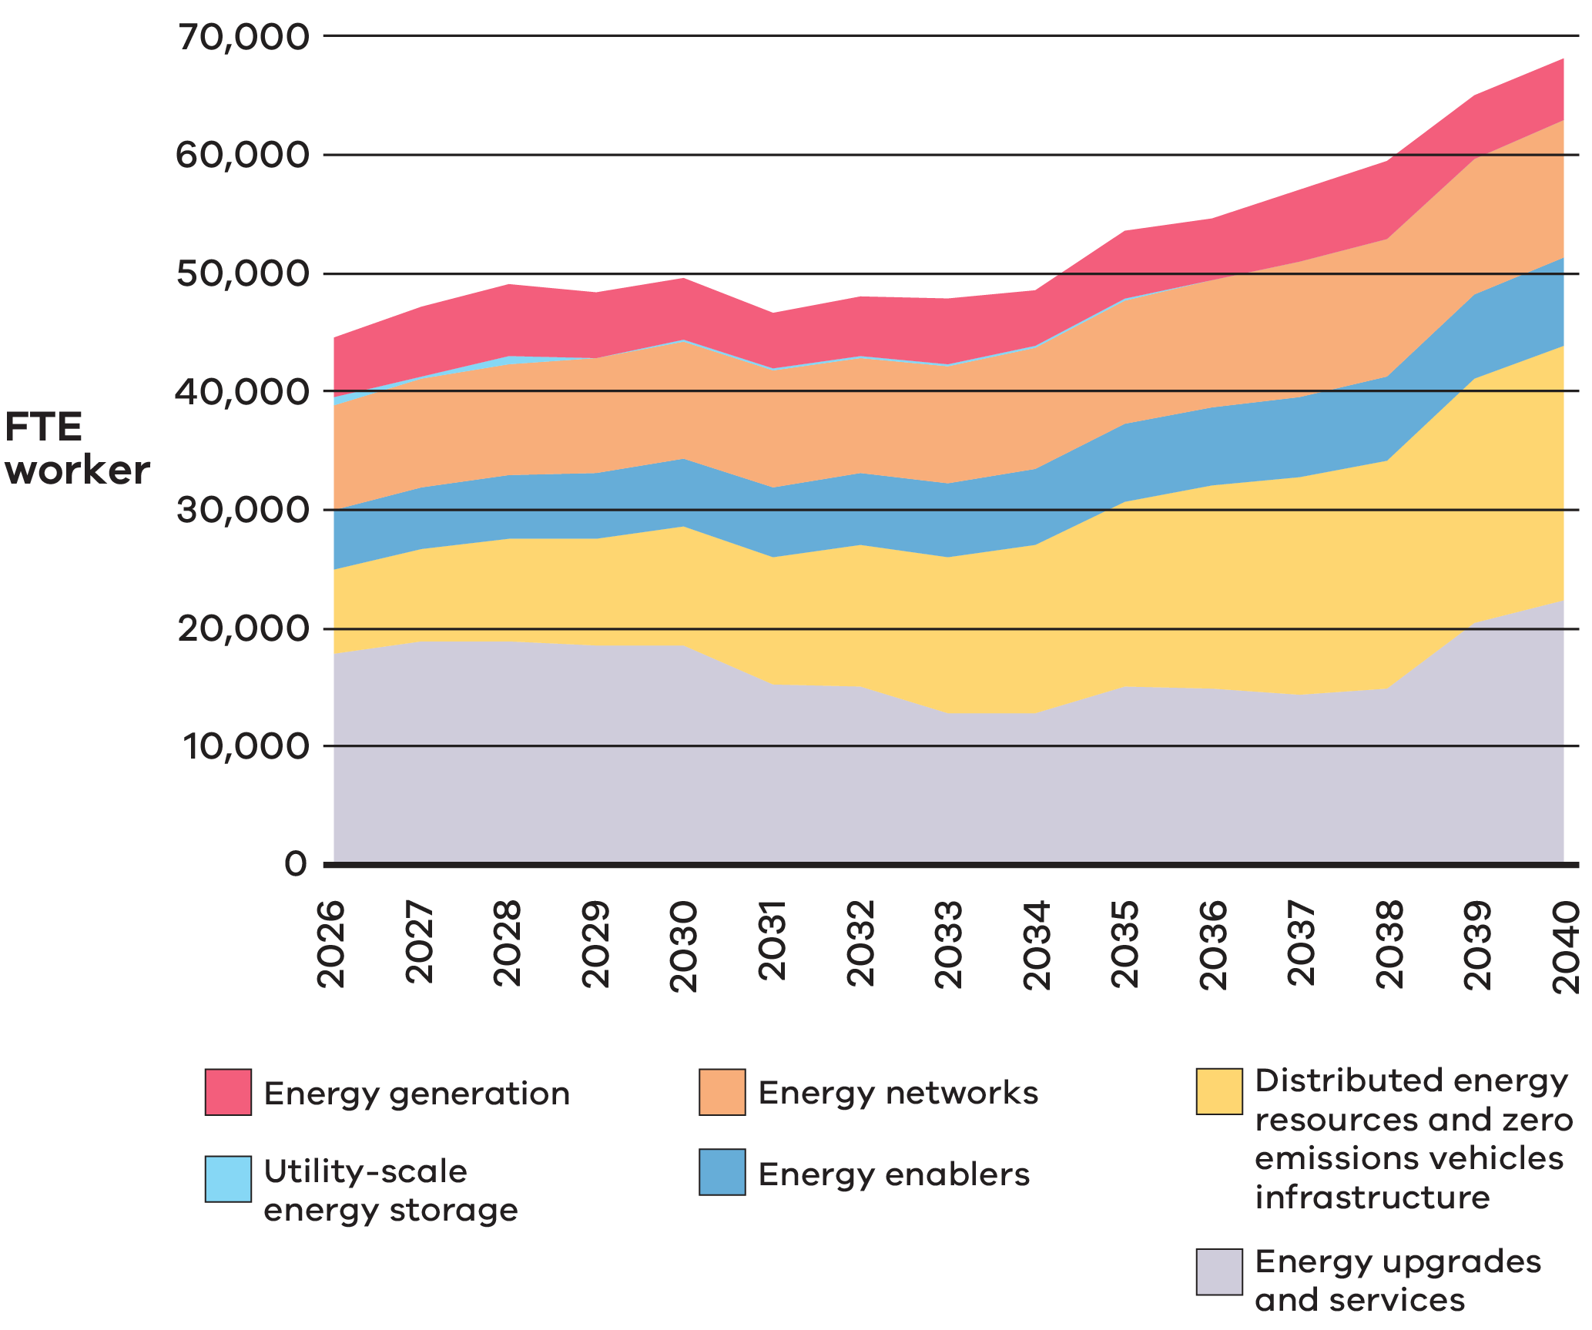
Victorian energy workforce projected growth in demand for FTE workers between 2026 and 2040, by energy sector
Sector | Details of projected growth in sector
Energy generation | Utility-scale solar workforce demand is projected to be highest in 2035, requiring over 1,200 FTE workers.
 | Wind energy jobs are projected grow from 56% to 81% of the energy generation workforce, requiring 4,200 FTE workers in 2040.
Utility-scale  energy storage | Demand for large-scale storage workers is projected to be highest in the mid to late 2020s, then require a consistent workforce.
Energy networks | More workers will be needed to build and maintain power lines and infrastructure, requiring over 11,600 FTE workers in 2040.
Energy enablers | Jobs in energy retail will grow steadily, increasing by nearly 2,000 FTE workers or 42% in 2040.
Distributed energy  resources (DER) and zero emissions vehicles (ZEV) infrastructure | The workforce needed for home battery installations is projected to reach 2,600 FTE workers in 2040, up from 1,000 FTE workers in 2026.
 | Jobs for electric vehicle charging infrastructure are projected grow by more than four times, needing over 14,300 FTE workers by 2040.
Energy upgrades  and services | The biggest share of energy jobs will come from the energy upgrades and services sector, requiring over 22,300 FTE workers in 2040 for activities such as upgrading homes with electric heating, cooling, and cooking.

Framing the energy workforce
Victoria’s energy transition is driving demand for a skilled and adaptable energy workforce.
Over the past decade, Victoria has made world-leading progress on the energy transition. The Victorian Government has set ambitious renewable energy and storage targets, supporting an overarching goal of economy-wide net zero emissions by 2045.
The Victorian Energy Jobs Plan seeks to support Victoria’s energy transition by mobilising the workforce and growing investment confidence. It calls on the energy industry, the education and training sector, and governments to collaborate and tackle energy transition workforce challenges.

Introduction
Victoria is positioned at the forefront of a once-in-a-generation renewable energy transition.
Ageing coal plants are shutting down, while renewable energy sources like wind and solar are being harnessed to provide affordable and reliable alternatives. Fossil gas has played an important role in the Victorian economy for decades; however, the gas sector is facing significant challenges heading into the future. New technologies are advancing, from pilot projects to commercial investments. The way that people use, generate, and move energy is changing.
Supporting this shift requires mobilising a skilled and diverse workforce to meet the sector’s evolving needs. Workforce forecasts and stakeholder engagement indicate significant expansion is necessary to meet future demand, which is crucial for the energy transition and renewable energy targets.
The workforce capacity must grow. Approximately 68,000 FTE workers are needed by 2040, reflecting a job growth rate of 53% by 2040 and a 3% average annual growth rate year on year from 2026.
Between 2026 and 2040, 88% of the energy workforce will require education qualifications of Certificate IV (or Certificate III with at least 2 years of on-the-job training) or higher. By 2040, most of the workforce will continue to require vocational education and training (VET) or higher education qualifications. Specifically, 48% of the workforce will require Certificate IV (or Certificate III with at least two years of on-the-job training) to associate degree qualifications and 40% of the workforce will require a bachelor degree or higher qualification.
Attracting a diverse workforce is crucial to ensuring more people share in employment opportunities. Evolving skills and workforce policies must address future demands, while education and training providers need to focus on critical learning and development programs. Workforce resources must be coordinated across various infrastructure projects and regions to deliver long-term benefits to Victorians and their communities.
This is a complex challenge, made even more so as new energy technologies emerge. The transition will require the strategic and coordinated efforts of education and training providers and the energy industry, in partnership with the Victorian Government.

Victoria’s ambitious energy targets
Over the past decade, Victoria has made world-leading progress on the energy transition. Victoria has often been the first Australian jurisdiction to lead highly complex energy policy reform, from deploying smart meters to delivering energy efficiency programs and legislation.
The Victorian Government has set ambitious renewable energy and storage targets for 2035, including achieving 95% renewable energy and delivering at least 6.3 GW of energy storage capacity, along with a target of at least 9 GW of offshore wind energy by 2040. These targets support an overarching target of economy-wide net zero emissions by 2045, and - alongside other government supports for innovation, efficiency and emerging technologies - promote investment confidence for Victoria (Figure 3).

The Victorian Government has legislated renewable energy targets
Figure 3: Victorian Government legislated renewable energy targets
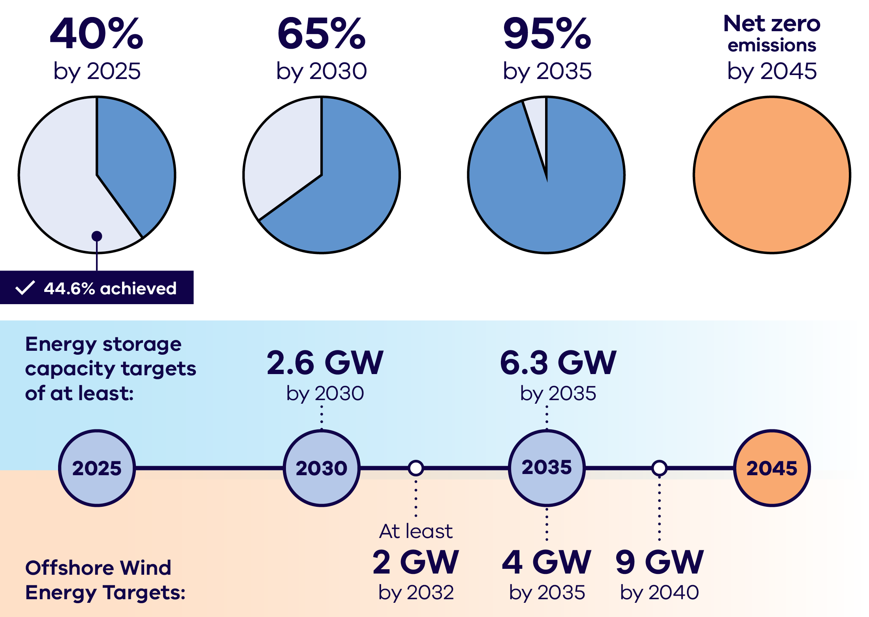
Summary of Victorian renewable energy generation targets shown in Figure 3
Year | Renewable energy share of generation | Status
2025 | 40% | 44.6% achieved
2030 | 65% | Target
2035 | 95% | Target
2045 | Net zero emissions | Target
Victorian energy storage capacity targets shown in Figure 3
Year | Storage capacity target
2030 | At least 2.6 GW
2035 | At least 6.3 GW
Victorian offshore wind energy targets shown in Figure 3
Year | Offshore wind capacity target
2032 | At least 2 GW
2035 | At least 4 GW
2040 | At least 9 GW
Demand for skilled workers will continue to grow, with Victoria’s installed electricity generation capacity projected to more than double by 2040.

Victoria’s Projected Electricity Generation Capacity
Figure 4: Victoria’s projected electricity generation capacity as per the AEMO ISP 2024 step change scenario
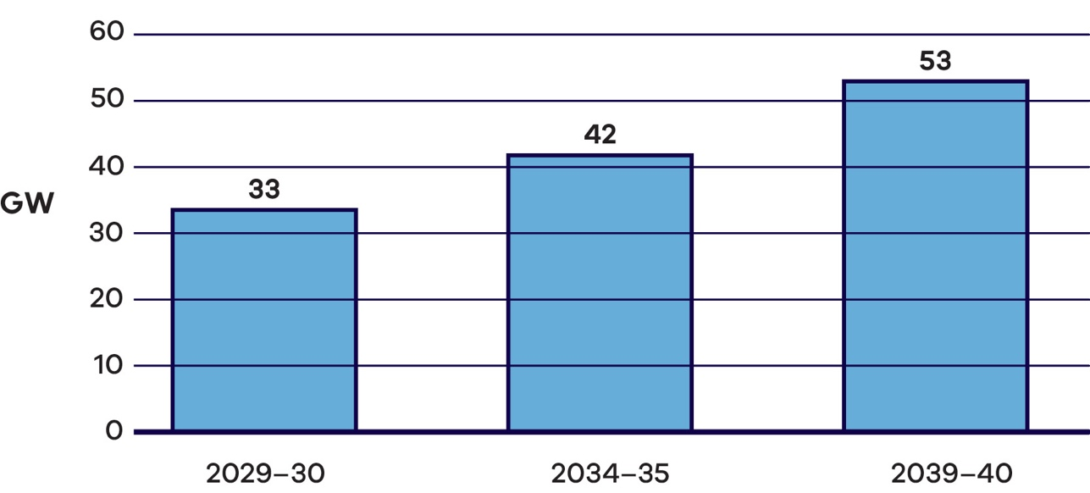
Victoria's projected electricity generation capacity (AEMO ISP 2024 step change scenario)
Year | Installed generation capacity (GW)
2029-30 | 33
2034-35 | 42
2039-40 | 53

What this Plan will do
To coordinate and accelerate the next phase of Victoria’s energy transition, the Victorian Government is establishing a statewide approach to building Victoria’s renewable energy, energy efficiency and electrification workforces. The Victorian Energy Jobs Plan provides a framework for developing the workforce needed to deliver the transition and strengthen investment confidence.
This Plan seeks to support Victoria’s energy transition by mobilising the workforce and growing investment confidence. It calls on the energy industry, the education and training sector, and governments to collaborate and tackle energy transition workforce challenges.
Specifically, this Plan sets out a framework for:
- supporting the development of the workforce required for the energy transition
- increasing visibility and understanding of the current and future Victorian energy workforce
- enabling more people to enter and excel in the energy workforce, including transitioning workers and those currently underrepresented, such as women, First Peoples, and people with disabilities
- identifying how Victoria’s education and training system can support the needs of the renewable energy sector, including its current and future workforce
- improving industry confidence in Victoria’s renewable energy workforce and increasing renewable energy investment in Victoria
- supporting local communities across Victoria to benefit from the energy transition.
The call to action
To address workforce opportunities and challenges of the energy transition, the energy industry, the education and training sector, and governments need to work together.
This Plan outlines the work being undertaken by the Victorian Government and offers clear and specific calls to action throughout to guide all partners in their collective efforts to mobilise the workforce required for Victoria’s energy transition.

Alignment across Victorian Government policies

The Women in Energy Strategy
This Plan has been developed in parallel and will be released with the Women in Energy Strategy. Together, these documents aim to ensure gender-based issues are considered as the energy workforce develops, and women are supported to have equitable access to opportunities.
The two policy documents are complementary, with all initiatives in the Women in Energy Strategy included in this Plan.
The Women in Energy Strategy delivers on a commitment made in the Victorian Government’s Our equal state.

Other policies
This Plan and the Women in Energy Strategy also align with the Victorian Government’s Clean Economy Workforce Development Strategy 2023-33, Cheaper, Cleaner, Renewable: Our Plan for Victoria’s Electricity Future, Economic Growth Statement – Victoria: Open for Business, and the Victorian Skills Plan.

How to navigate this Plan
- Framing the energy workforce – The purpose and scope of this Plan (You are here)
- Victorian energy workforce needs – Projections and analysis of the Victorian energy workforce to 2040
- Focus areas – Actions set out across three focus areas to ensure Victoria has a supply of skilled workers to support the energy transition
- Focus area 1
- Focus area 2
- Focus area 3

Focus areas and outcomes

Focus area 1: Growing and retaining capacity
- More people are aware of and attracted to energy sector roles and careers
- Employers retain workers by fostering positive and flexible workplace cultures that support career development
- Jobs in the energy workforce are accessible for all and represent the diversity of the community
- Existing and transitioning workers are supported by incentives and improved skills recognition

Focus area 2: Building workforce capability
- People actively seek teaching roles in the energy sector
- Students, apprentices and trainees engage with study and complete qualifications
- Education offerings and pathways adapt to evolving skills needs
- Education pathways from school to the energy workforce are clear and connected

Focus area 3: Improving confidence and coordination
- Victoria is the national leader in developing renewable energy skills and workforces
- Public and private investment in the energy workforce is driven by clear, consistent, and coordinated renewable energy policies and workforce strategies
- Publicly available data provides a clear picture of energy workforce and skills needs
- Workforce planning is improved by effective coordination and forward planning of infrastructure projects

How this Plan was developed
This Plan is shaped by consultation, modelling, and new and existing government initiatives.

Consultation
A comprehensive consultation approach was undertaken, engaging with the energy industry, community groups, unions, and the education and training sectors. Direct engagement, in addition to a consultation paper, ensured that stakeholder and rights holder views and ideas were at the forefront throughout the Plan’s development.
What we heard
Prominent themes we heard across all engagement for the Victorian Energy Jobs Plan feedback included the need to:
- Raise awareness of renewable energy careers and education pathways
- Increase workforce participation of underrepresented groups, including women, people with disabilities, and First Peoples
- Ensure education offerings and pathways can adapt to evolving skills needs
- Increase availability of skilled, high-quality trainers
- Improve confidence in the pipeline of renewable energy infrastructure projects.

Modelling
New modelling and data analysis has provided a deeper understanding of the size and composition of the projected future energy sector workforce, including occupations and locations. The Victorian Government partnered with the RACE for 2030 Cooperative Research Centre to develop workforce forecasts, establishing a new baseline of information for Victoria with an outlook to 2040. Further analysis, such as projections of workforce by location and some sectors, was undertaken to complement this research.
The data insights in this Plan provide a foundational understanding of Victoria’s energy transition workforce. This will support the development of new data resources in the coming years.

Actions for change
This Plan sets out a framework for action to support the development of Victoria’s energy workforce. The framework includes three focus areas and twelve targeted outcomes.

Focus areas
- Growing and retaining capacity: ensuring there are enough people seeking, and staying in, jobs in the energy sector to support industry needs.
- Building workforce capability: ensuring that the workforce has the skills and qualifications required to deliver an orderly energy transition.
- Improving confidence and coordination: ensuring demand for energy workers is planned for and coordinated.

What parts of the energy sector are included in this Plan
For this Plan, Victoria’s energy sector includes electricity generation, electricity networks, utility‑scale energy storage, enabling functions like energy retail, distributed energy resources like rooftop solar and distributed batteries, zero emissions vehicles infrastructure, and energy efficiency across residential, commercial, industrial, and agricultural settings (Figure 5).
As Victoria continues to shift toward renewable energy sources, the importance of adjacent industries such as manufacturing, supply chains and recycling will grow. The energy transition may also rely on new or emerging energy technologies in Victoria.
While gas production, pipelines and use, the circular economy, manufacturing and supply chains, and emerging sectors such as renewable fuels and bioenergy are not the focus of this Plan, they remain significant areas of interest, and jobs, in the future. The Victorian Government will continue to explore and monitor these areas.

What this Plan means for our partners

Victorian community
- Jobs – More understanding and certainty on the breadth of job opportunities for individuals to work in the energy sector
- Local communities – More opportunities for local communities to benefit from energy sector jobs and skills development
Coordination – Greater confidence that the energy transition is being planned and coordinated effectively

Energy industry
- Investment – Greater confidence to invest in, and deliver, Victoria’s energy transition
- Workplaces – More certainty on expectations for improving workplace culture, including increasing workforce diversity, equity and inclusion
Linkages – Clearer opportunities for connection between the education and training sector and governments on energy sector workforce development

Education and training sector
- Training needs – More certainty about the breadth of energy transition skills and occupations
- Collaboration – More opportunities for collaborating with industry to identify education and training priorities
Forward planning – Greater confidence to invest in designing and delivering aligned education and training offerings

Governments
- Policy – More certainty on the breadth of energy transition skill and occupation needs
- Coordination – More opportunities to coordinate policy and planning to achieve energy transition targets and commitments
- Investment attraction – Greater confidence to invest in actions and initiatives informed by energy industry and training needs in Victoria

The energy sector in the Victorian Energy Jobs Plan
Figure 5: Energy sectors included in the Victorian Energy Jobs Plan and potential careers
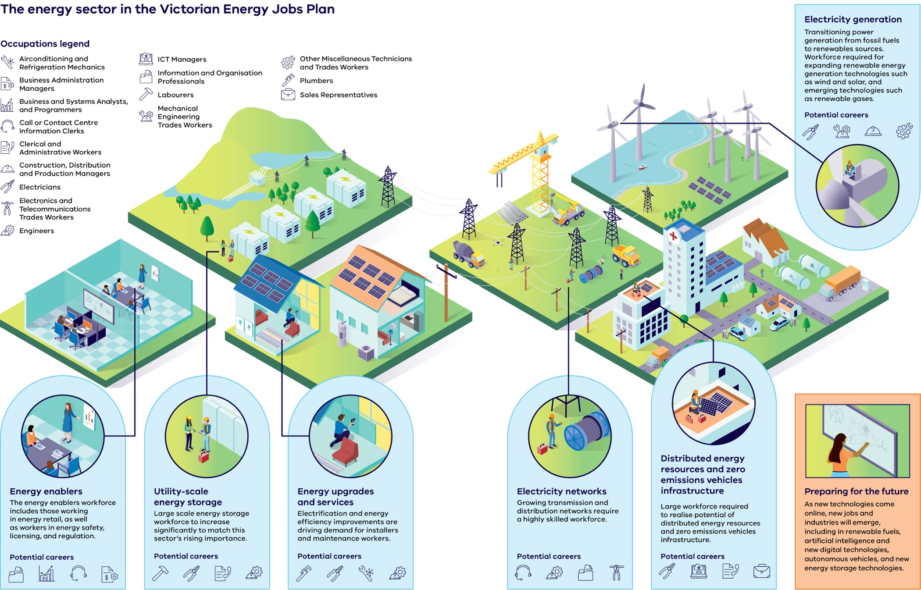
Energy sectors in the Victorian Energy Jobs Plan and example workforce needs as shown in Figure 5
Energy sector | Description | Potential careers
Electricity generation | Transitioning power generation from fossil fuels to renewable sources. Workforce required for expanding renewable energy generation technologies such as wind and solar, and emerging technologies such as renewable gases. | - Electricians  - Mechanical Engineering Trades Workers  - Construction, Distribution and Production Managers  - Other Miscellaneous Technicians and Trades Workers
Energy enablers | The energy enablers workforce includes those working in energy retail, as well as workers in energy safety, licensing and regulation. | - Labourers  - Electricians  - Clerical and administrative workers  - Engineers
Utility-scale energy storage | Large-scale energy storage workforce to increase significantly to match this sector’s rising importance. | - Plumbers  - Electricians  - Airconditioning and refrigeration mechanics  - Engineers
Energy upgrades and services | Electrification and energy efficiency improvements are driving demand for installers and maintenance workers. | - Plumbers  - Electricians  - Airconditioning and refrigeration mechanics  - Engineers
Electricity networks | Growing transmission and distribution networks require a highly skilled workforce. | - Call or Contact Centre / Information Clerks  - Engineers  - Information and Organisation Professionals  - Electronics and Telecommunications Trades Workers
Distributed energy resources and zero emissions vehicles infrastructure | Large workforce required to realise the potential of distributed energy resources and zero emissions vehicles infrastructure. | - Electricians  - ICT Managers  - Clerical and administrative workers  - Sales Representatives
Preparing for the future | As new technologies come online, new jobs and industries will emerge, including in renewable fuels, artificial intelligence and new digital technologies, autonomous vehicles, and new energy storage technologies. | - Emerging roles across engineering, ICT, trades and operations

Occupations represented in the Victorian Energy Jobs Plan energy sector overview:
- Airconditioning and Refrigeration Mechanics
- Business Administration Managers
- Business and Systems Analysts, and Programmers
- Call or Contact Centre Information Clerks
- Clerical and Administrative Workers
- Construction, Distribution and Production Managers
- Electricians
- Electronics and Telecommunications Trades Workers
- Engineers
- ICT Managers
- Information and Organisation Professionals
- Labourers
- Mechanical Engineering Trades Workers
- Other Miscellaneous Technicians and Trades Workers
- Plumbers
- Sales Representatives

The energy transition is already underway
Victoria has already made substantial progress towards transitioning the energy sector. As set out in Cheaper, Cleaner, Renewable: Our Plan for Victoria’s Electricity Future, achievements to date include:
- Accelerating approval pathways for major energy projects and bringing back the SEC, keeping power in the hands of Victorians
- Creating investment certainty to build new energy generation projects by providing long-term contracts through the Victorian Renewable Energy Target auctions
- Delivering a transparent, integrated Gas Substitution Roadmap and updates, which will reduce pressure on declining legacy gas supply sources, assist gas customers to take advantage of highly efficient and cost-effective electric appliances, and enable the uptake of renewable gas technologies
- Empowering consumers to control their energy usage by adopting distributed energy resources, including rooftop solar and batteries, as well as reducing the upfront cost of energy efficient appliances to Victorians through the Victorian Energy Upgrades (VEU) and Solar Homes programs
- Entering Structured Transition Agreements to facilitate the orderly closure of two of Victoria’s three coal-fired generators (Yallourn in 2028 and Loy Yang A in 2035)
Supporting the decarbonisation of industries in which it is difficult to lower emissions
Enabling the roll out of major transmission infrastructure and renewable energy zones through VicGrid.
Creating jobs through SEC investments
SEC is a government-owned renewable energy company, focused on accelerating Victoria’s renewable energy transition by working to deliver renewable, affordable, and reliable energy for all Victorians.
SEC partnered with Equis to deliver the Melbourne Renewable Energy Hub, one of the world’s biggest batteries, in Melbourne’s west. The Hub provides enough capacity to power 200,000 homes during the evening peak.
The Hub created work and training opportunities for more than 1,200 people, including over 70 apprentices, cadets and trainees. The project’s workforce included many Victorians who are underrepresented in the wider energy sector, including women and First Peoples, demonstrating SEC’s commitment to help build a more diverse energy workforce.
SEC is also creating hundreds of jobs in regional Victoria through its investments in two 100% publicly owned projects:
- SEC Renewable Energy Park, a massive solar farm in Victoria’s west near Horsham – as of February 2026, the project has created over 249 FTE Victorian jobs during the construction period
- the SEC Delburn Wind Farm, just south of the Latrobe Valley in Gippsland – expected to create 300+ FTE jobs over the construction period.
Over the past six years, the Victorian Government has invested significantly to support the energy transition.*
- SEC – $1 billion initial investment in the SEC to help drive down power bills and help create new energy jobs.
- Energy innovation – $108 million to support the commercialisation of innovative, emerging renewable energy technologies in Victoria, including offshore wind, renewable hydrogen, bioenergy and battery energy storage systems.
- Network stability – $480 million invested in 12 projects to strengthen and modernise Victoria’s grid to enable more renewable energy to flow to homes and businesses. These projects have the potential to unlock more than 2.3 GW of new renewable energy, which is enough to provide 16% of Victoria’s total annual energy consumption.
- Energy efficiency – $654 million in energy efficiency and electrification upgrades unlocked through the Victorian Energy Upgrades (VEU) program in 2025.
- Victorian Renewable Energy Target auctions – $2 billion of investment leveraged by the Victorian Renewable Energy Target auctions (VRET1 and VRET2) by awarding long-term Support Agreements that provide investment certainty.
- Solar and batteries – $1.3 billion funded through the Solar Homes Program, providing rebates and loans that are accelerating uptake of rooftop solar PV, batteries, heat pumps and solar hot water systems for eligible homes.
*Note: All figures include funding announced in the 2020-21, 2021-22, 2022-23, 2023-24, 2024-25 and 2025-26 Victorian Budgets except for funding for the Solar Homes Program, which is over 2018-2028. As of 2026 the Solar Homes Program has provided over $1 billion in support through its rebates and loans. Batteries are no longer supported under the Solar Homes Program. All figures are in $A.

Victorian energy sector workforce needs
Victoria’s energy workforce is growing and changing to meet the demands of the energy transition.
Changing energy sectors, technologies and consumer behaviour are driving demand and developments to the energy workforce.
A broad range of roles and skills, across metropolitan and regional areas, will be required to support Victoria’s energy transition.

Demand for skilled workers is high across Victoria’s economy
Over the past decade, Victoria’s economy has grown at a faster rate than any other state in Australia. As this growth continues, many sectors in Victoria’s economy are competing to attract skilled workers, such as in construction, manufacturing, and digital technology.
Occupations with higher-order skills, requiring Certificate IV (or Certificate III with at least two years of on-the-job training) to bachelor degree or higher qualifications are central to driving Victoria’s energy transition. Occupations such as technicians and trades workers, professionals, managers and clerical, administrative and sales workers make up the largest shares of the energy workforce.
Top occupations for Victoria’s energy sector are in demand across Victoria’s whole of economy workforce. Key occupations in the energy sector, such as electricians and plumbers, have been identified as in demand across Victoria’s whole of economy workforce since at least 2021.
In 2040, 88% of energy workforce occupations will require higher-order skills
Figure 6: Victoria’s energy sector* education requirements in 2040
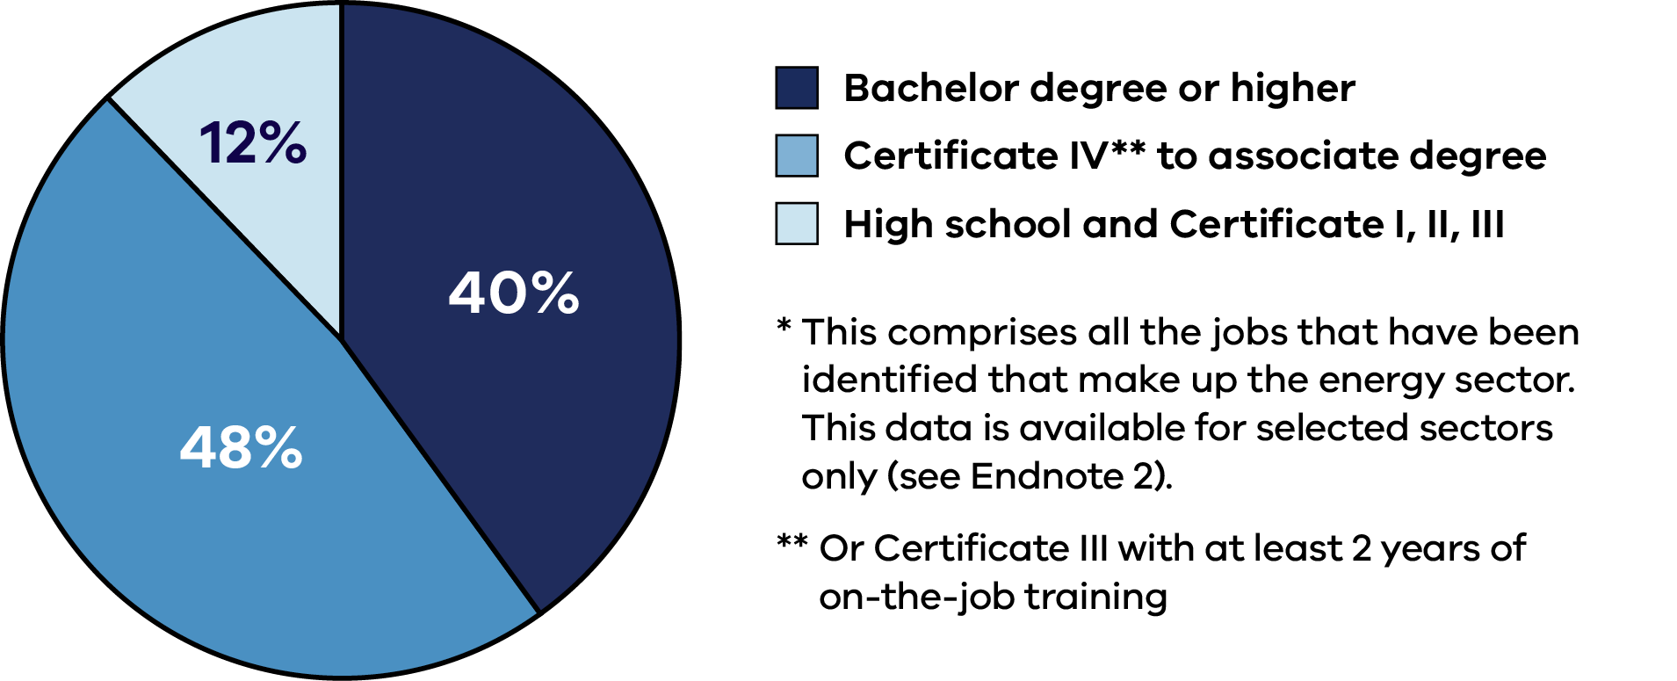
Victoria’s energy sector* education requirements in 2040
Education category | Share of energy sector workforce (2040)
Bachelor degree or higher | 40%
Certificate IV** to associate degree | 48%
High school and Certificate I, II, III | 12%
*Note 1: This comprises all the jobs that have been identified that make up the energy sector. This data is available for selected sectors only (see Endnote 2).
**Note 2: Or Certificate III with at least 2 years of on-the-job training.
Compared to Victoria’s overall workforce, the energy sector requires proportionately more technicians and trades workers
Figure 7: Victoria’s projected energy workforce in 2026 as compared to Victoria’s entire workforce in 2025, by ANZSCO major occupation group
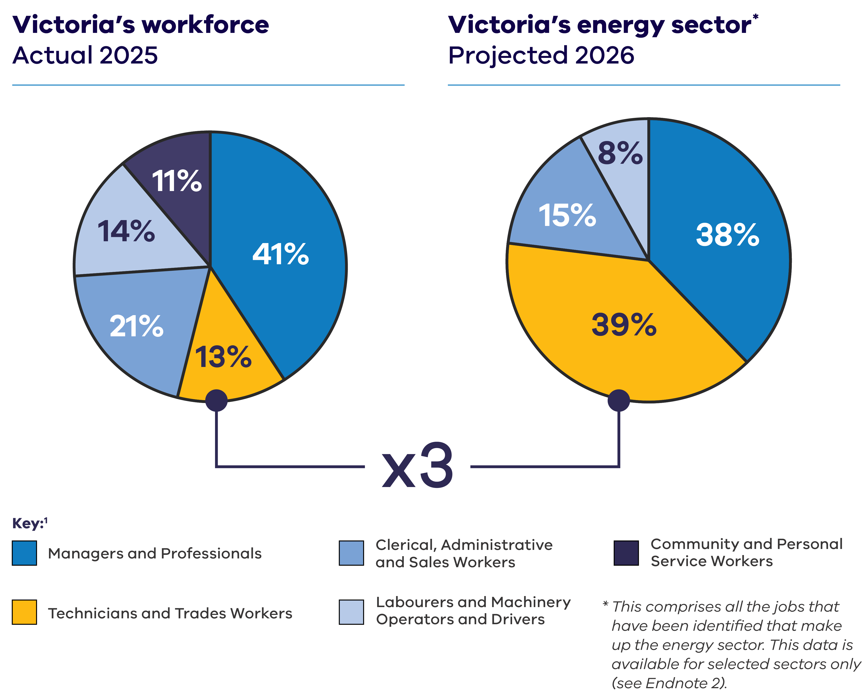
Victoria’s projected energy workforce in 2026 as compared to Victoria’s entire workforce in 2025, by ANZSCO major occupation group (data for Figure 7)
ANZSCO major occupation group | Victoria's workforce – Actual 2025  (%) | Victoria's energy sector* – Projected 2026 (%)
Managers and Professionals | 41 | 38
Technicians and Trades Workers | 13 | 39
Clerical, Administrative and Sales Workers | 21 | 15
Labourers and Machinery Operators and Drivers | 14 | 8
Community and Personal Service Workers | 11 | 0
*Note: This comprises all the jobs that have been identified that make up the energy sector. This data is available for selected sectors only (see Endnote 2).
Figure 8: The projected top 3 jobs for technicians and trades, and managers and professionals in the Victorian energy workforce in 2026
Rank | Top 3 technicians  and trades jobs | Top 3 managers and  professionals’ jobs
1 | Electricians | Engineers
2 | Plumbers | Construction, Distribution and Production Managers
3 | Airconditioning and Refrigeration Mechanics | ICT Managers

The Victorian energy workforce
The rapid growth of Victoria’s renewable energy sector has significantly increased the demand for workers.
The expansion of renewable energy generation, transmission, distribution and storage infrastructure, as well as the planned increase in the use of efficient electric appliances and roll out of zero emissions vehicles (ZEV) infrastructure, has coincided with a tight labour market and historically high employment levels.
For the purposes of this Plan, Victoria’s energy sector has been defined to include electricity generation, networks and utility-scale energy storage, as well as energy enabling functions such as retail, and safety, licensing and regulation, zero emissions vehicles infrastructure, electrification and energy efficiency across residential, commercial, industrial, and agricultural settings.
While not the focus of this Plan, the following areas remain of significant interest for future Victorian Government energy workforce analysis:
- Gas production, pipelines and use
- Circular economy, manufacturing and supply chains (including critical minerals)
- Decommissioning and rehabilitation of existing coal power plants and mines
- Bioenergy, renewable fuels and other emerging energy technologies.

The energy sector in the Victorian Energy Jobs Plan
Figure 9: Energy sectors in the Victorian Energy Jobs Plan
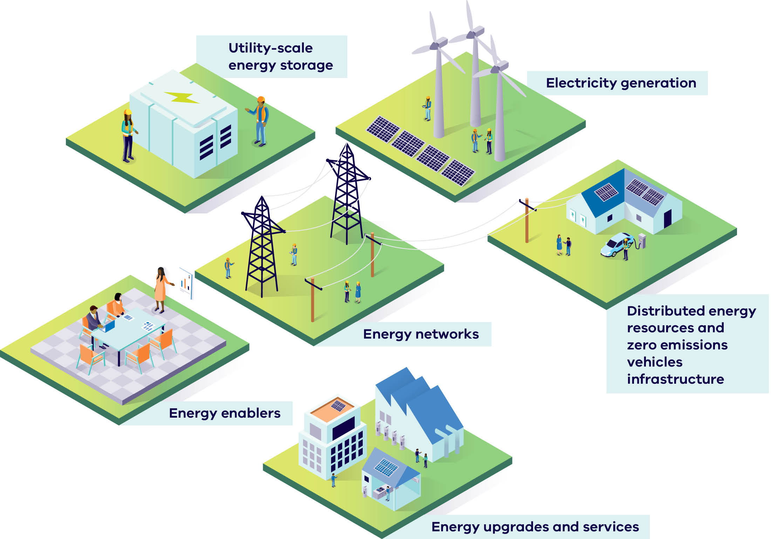
The six energy sectors in the Victorian Energy Jobs Plan shown in Figure 9 are:
- Utility-scale energy storage
- Electricity generation
- Energy networks
- Distributed energy resources and zero emissions vehicles infrastructure
- Energy enablers
- Energy upgrades and services

Today’s energy workforce
Victoria’s current energy workforce consists of approximately 45,000 FTE workers. The workforce includes a wide range of workers across sectors, including energy generation from both renewable sources and fossil fuels, electricity networks, enablers and storage, distributed energy resources, zero emissions vehicles infrastructure and residential heating, cooling and cooking electrification and services (Residential electrification and services) and energy efficiency.
The energy workforce includes a broad range of occupations, offering opportunities for people across many industries and skill sets, from entry level through to highly specialised.
Electricians and plumbers are currently the most in-demand occupations in Victoria’s energy sector (Figure 10). Workforce projections indicate that around 4,400 FTE electricians and around 3,500 FTE plumbers work in the energy sector in 2026, which is 9% and 10% of all electricians and plumbers in Victoria respectively.
Both professions have been defined on the National Skills Priority List as being in ‘persistent shortage’, in demand for the past three years.
Other top occupations range from engineers and clerical and administrative workers, to airconditioning and refrigeration mechanics and ICT managers.
Job titles in this Plan
In this Plan, the names of occupations we use align to the 2022 ANZSCO (Australian and New Zealand Standard Classification of Occupations), a skill-based classification used to categorise all occupations and jobs undertaken for profit in the Australian and New Zealand labour market.
The full ANZSCO classification is available at the Australian Bureau of Statistics website, www.abs.gov.au.
Figure 10: The top jobs in the energy sector in 2026
Rank | Occupation
1 | Electricians
2 | Plumbers
3 | Engineers
4 | Clerical and Administrative Workers
5 | Airconditioning and Refrigeration Mechanics
6 | Construction, Distribution and Production Managers
7 | ICT Managers
8 | Business Administration Managers
9 | Call or Contact Centre Information Clerks
10 | Information and Organisation Professionals

Who is in today’s Victorian energy workforce?
The Victorian energy workforce includes a broad range of workers. Workers represent a range of different ages, genders, backgrounds, education levels, and are located across Victoria.
Notably, in key demographics the energy workforce trails the diversity of the broader Victorian workforce. Table 1 compares the demographics of the workers in occupations found in the Victorian energy workforce to the broader Victorian workforce.
Currently, workers in occupations found in the energy sector are typically male, less likely to be born overseas, and earn around 20% more than the average Victorian worker. They are also more likely to have completed a vocational certificate.
The figures highlight lower participation rates from underrepresented groups, including women, First Peoples, and people born overseas.
Table 1: Energy workforce demographics in 2026
Characteristic | Estimated  energy  workforce* | All of  Victoria’s workforce
Median age | 40.2 | 40.8
Female | 25.6% | 48.2%
Female – Melbourne | 25.6% | 47.9%
Female – rest of Victoria | 26.4% | 52.2%
First Nations | 0.7% | 0.7%
Born overseas | 29.0% | 34.0%
Married/de-facto | 64.4% | 60.8%
Average annual total personal income (all sources)*# | $102,000 | $84,000
Highest level of education
Postgraduate | 9.5% | 10.7%
Undergraduate | 23.0% | 25.9%
Diploma/Advanced Diploma | 11.9% | 16.0%
Certificate (I-IV) | 33.4% | 17.9%
High school | 22.2% | 29.5%
Location
Melbourne | 79.8% | 77.4%
Ballarat and Geelong | 7.1% | 7.5%
Bendigo and Shepparton | 3.8% | 4.3%
Hume and Latrobe – Gippsland | 6.4% | 6.7%
Victoria North West, Warrnambool and South West | 3.0% | 4.1%
*Note 1: The column ‘Estimated energy workforce’ reflects all occupations that comprise the energy sector workforce, where available. It includes occupations in energy generation (excluding construction of gas powered generation), energy networks, utility-scale energy storage, energy enablers, distributed energy resources, zero emissions vehicle (ZEV) infrastructure (electric vehicle charging infrastructure only, excluding hydrogen vehicle refuelling infrastructure), and energy upgrades and services (residential electrification and services only, excluding residential energy efficiency and commercial, industrial, agricultural and forestry electrification and energy efficiency).
#Note 2: The values for ‘Average annual total personal income (all sources)’ is a weighted average that uses the midpoints of income ranges reported in census data. Reported averages are higher than the median personal income (e.g. for the Victorian workforce the average is $72,000 and the median is $62,000).

Workforce trends over the next 15 years
Victoria’s energy workforce is set to grow and change between 2026 and 2040 to meet the needs of the energy transition.

A growing workforce required to meet growing demand for electricity
To meet growing electricity demand and support Victoria’s energy transition, the energy workforce needs to grow. By 2040 it’s projected that Victoria will need approximately 68,000 FTE workers in the energy sector, an increase of 23,000 FTE workers (Figure 11).
In 2035, Victoria’s electricity use will have increased by about 50%, driven by the electrification of homes and businesses, uptake of electric vehicles, and new industrial electricity demand. The scale of new infrastructure required to meet this demand and Victoria’s 2035 renewable energy targets is significant (Figure 12).
The Victorian energy sector will need approximately 23,000 more FTE workers by 2040
Figure 11: Current and projected energy sector workforce for Victoria
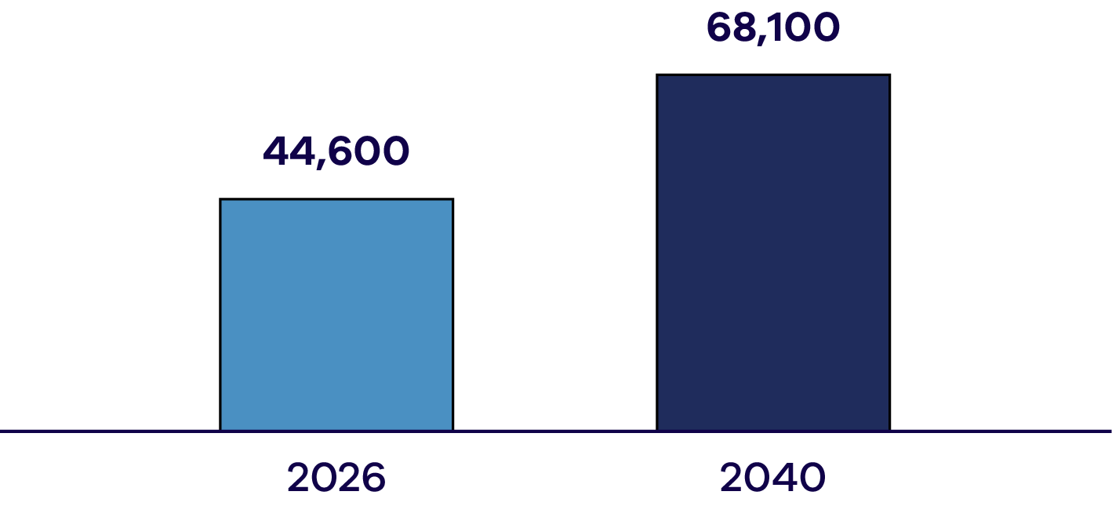
Current and projected energy sector workforce for Victoria (data for Figure 11), in full-time equivalent (FTE) workers
Year | Energy sector workforce (FTE)
2026 | 44,600
2040 | 68,100

Energy generation workforce shifting to renewable energy technologies
Over the next 15 years, demand for workers is projected to grow across renewable energy generation technologies.
The workforce for renewable energy technologies, including wind, utility-scale solar and hydroelectric, is projected to grow from 69% to 92% of the energy generation workforce in 2040. This is driven predominantly by a growing wind energy workforce.

Move to electrification and a more decentralised energy system is increasing demand for workers
As Victoria’s energy system continues to electrify and decentralise, workforces for sectors and activities such as renewable energy generation, energy networks, utility-scale energy storage, distribute energy resources and energy upgrades and services are projected to grow.
Combined, these workforces are projected to increase by 27%, requiring approximately 44,900 FTE workers in 2040.
This aligns with the significant investment required to build and maintain renewable generation infrastructure, transmission and distribution networks, and to install and maintain rooftop solar, distributed batteries and energy efficient appliances.
Figure 12: Approximate levels of new equipment and infrastructure required to meet the 2035 targets
Equipment / infrastructure type | Approximate quantity required
Solar panels on solar farms | 4.7 million
Distributed (rooftop) solar panels | 15.7 million
Onshore wind turbines | 1,100
Offshore wind turbines | 267
Large-scale battery packs | 1,350
Distributed battery packs | 212,000
Figure 13: The top jobs in the energy sector in 2040
Rank | Occupation
1 | Electricians
2 | ICT Managers
3 | Plumbers
4 | Clerical and Administrative Workers
5 | Engineers
6 | Airconditioning and Refrigeration Mechanics
7 | Sales Representatives
8 | Information and Organisation Professionals
9 | Business Administration Managers
10 | Call or Contact Centre Information Clerks

Setting the foundations for stronger energy jobs data
Renewable energy is a fast-evolving sector, for which there has been limited sector-wide economic and jobs modelling.
This Plan delivers preliminary Victorian energy workforce projections, providing new baseline insights across all major renewable energy sectors and establishing a foundation to explore gaps in our current understanding.
The Victorian Government partnered with the RACE for 2030 Cooperative Research Centre (CRC) and the University of Technology Sydney (UTS) to develop workforce forecasts, establishing a new baseline of information for Victoria with an outlook to 2040. The majority of the workforce projections used in this Plan have been developed by the Institute for Sustainable Futures at UTS, with results published by RACE for 2030 CRC.
A key input has been the Australian Energy Market Operator (AEMO)’s Integrated System Plan (ISP), a nationally significant roadmap for transforming Australia’s electricity system. The 2024 ISP Step Change scenario has been a key input to modelling.
Modelling completed for the Victorian Energy Jobs Plan, including workforce projections and additional analysis, provides insights into the changing size of the energy sector workforce, the occupations that will be involved, and where jobs will be located across Victoria.
Beyond the findings in this Plan, there is further work to be done to continue to better understand the energy workforce. This includes better understanding workforces for sectors such as energy efficiency, and in exploring workforce needs for emerging parts of the energy sector, such as renewable gases, that are not yet modelled.

The breadth of job opportunities in the energy workforce will continue
The energy workforce includes a wide range of occupations, with a breadth of job opportunities expected from 2026 to 2040.

In-demand
In-demand jobs range from electricians and airconditioning mechanics, to clerical and administrative workers and business administration workers.

Fastest growing
The fastest growing occupations are projected to be ICT managers, sales representatives, electricians, telecommunications trades workers, along with clerical and administrative workers.
Demand for ICT managers will grow from 1,100 in 2026 to 5,800 FTE workers in 2040, whilst demand for telecommunications trades workers is projected to grow from 200 to 800 FTE workers in 2040.

Specialised
Specialised jobs are also projected to be required throughout the energy sector. For example, in energy networks, electrical distribution trades workers, structural steel construction workers, and construction managers are essential for building and maintaining the transmission infrastructure needed to deliver renewable energy across the grid.
A top energy workforce occupation
Electricians
Electricians are a vital part of Victoria’s skilled workforce, with over 48,000 employed across the economy. Their expertise is essential to the energy transition – enabling rooftop solar, EV charging and electrified heating.
As electrification accelerates, electricians will continue to be the most in-demand profession across the energy sector. To meet broader economic growth and replace retirees – particularly in housing, transport and energy – Victoria will need to train around 14,500 new electricians by 2034.

Increasing demand for occupations requiring higher education and vocational qualifications
Between 2026 and 2040, demand for roles needing higher education qualifications is projected to grow by 66%, while demand for vocationally trained roles is set to rise by 50%.
Key occupations requiring higher education qualifications – such as ICT managers, information and organisation professionals, and business and systems analysts and programmers –are among the fastest growing in the energy sector. The number of ICT managers is expected to increase by 4,700 FTE workers, and information professionals by 600 FTE workers by 2040. These roles are required for activities such as electricity distribution and zero emissions vehicles infrastructure.
Occupations requiring vocational training will also grow, with an extra 4,100 FTE electricians and 600 FTE telecommunications trades workers required by 2040. These roles are required for activities such as zero emissions vehicles infrastructure, residential heating, cooling and cooking, and onshore wind.
A top energy workforce occupation
Information and communication technology managers
Information and communication technology (ICT) managers are essential to Victoria’s energy transition, overseeing the digital systems behind networks, energy services and customer technologies that optimise energy use. Their role supports the integration of renewables and electrification across sectors.
As digital infrastructure expands, Victoria will need to train new ICT managers to meet growing demand – ensuring the workforce can support both the transition and broader economic needs.

Workers will be required across Victoria, with a large regional component
Between 2026 and 2040, demand for workers is spread across Victoria, with 37% of jobs projected to be in regional Victoria. For regional areas, demand is driven particularly for workers in energy generation, distributed energy resources, electric vehicle charging infrastructure and energy networks.
Energy storage technology – regional battery workforce
Workforces for neighbourhood batteries are needed in many locations across Victoria, including in regional areas. Totally Renewable Yackandandah (TRY) is a community-focused volunteer organisation in North East Victoria. TRY worked with Indigo Power and Indigo Shire Council to install a 60 kW solar system with a 200 kWh battery at Yackandandah Sports Park. The battery will support local sports clubs, save on costs, and provide backup energy during emergencies.
Neighbourhood batteries, along with utility-scale batteries and household batteries, are in high demand. Jobs for electricians and maintenance technicians are expected to increase in Victoria.

Energy workforce snapshot
More information in the Data Appendix
Energy workforce snapshot
Energy sector | Activities | Workforce size 2026 | Annual sector growth  (2026-2040) | Workforce size share  2026-2040 | Top jobs
There are 6 key energy sectors that make up the Victorian energy sector… | Each sector includes the following activities… | In 2026, energy upgrades and services and energy networks make up the largest proportion of the energy workforce. | Between 2026 and 2040, each sector is expected to grow at an average annual rate of... | On average, DER, ZEV infrastructure and energy upgrades and services will make up the largest proportion of the energy workforce... | In the next 15 years, the top jobs required in each energy sector will be…
Energy  generation | Wind (onshore); Wind (offshore); Utility-scale solar; Hydroelectric; Gas-powered generation; Coal | 11% of energy workforce (5,100 FTE workers in 2026) | 1% growth per year | 10% of energy workforce | - Electricians  - Mechanical Engineering Trades Workers  - Construction, Distribution and Production Managers  - Other Miscellaneous Technicians and Trades Workers  - Engineers
Utility-scale  energy storage | Utility-scale batteries; Pumped hydroelectric | 2% of energy workforce (700 FTE workers in 2026) | 4% growth per year | Less than 1% of energy workforce | - Labourers  - Electricians  - Clerical and Administrative Workers  - Engineers  - Managers; Machinery Operators and Drivers; Construction Managers
Energy  networks | Electricity transmission networks; Electricity distribution networks | 20% of energy workforce (8,800 FTE workers in 2026) | 2% growth per year | 20% of energy workforce | - Call or Contact Centre Information Clerks  - Engineers  - Information and Organisation Professionals  - Electronics and Telecommunications Trades Workers  - Professionals
Energy  enablers | Energy retail; Safety, licensing and regulation | 11% of energy workforce (5,100 FTE workers in 2026) | 3% growth per year | 12% of energy workforce | - Information and Organisation Professionals  - Business and Systems Analysts, and Programmers  - Call or Contact Centre Information Clerks  - Business Administration Managers  - Advertising, Public Relations and Sales Managers
Distributed energy resources and zero emissions vehicles infrastructure | Rooftop solar; Distributed batteries; Zero emissions vehicles infrastructure | 16% of energy workforce (7,000 FTE workers in 2026) | 8% growth per year | 26% of energy workforce | - Electricians  - ICT Managers  - Clerical and Administrative Workers  - Sales Representatives  - Other Miscellaneous Labourers
Energy upgrades and services | Residential electrification and services (Residential heating, cooling and cooking electrification and services); Energy efficiency; Electrification | 40% of energy workforce (17,900 FTE workers in 2026) | 2% growth per year | 32% of energy workforce | Residential electrification and services  - Plumbers  - Electricians  - Airconditioning and Refrigeration Mechanics  - Engineers  - Sales, Marketing and Public Relations Professionals

Energy generation
- Wind (onshore)
- Wind (offshore)
- Utility-scale solar
- Hydroelectric
- Gas-powered generation
Coal
Victoria’s energy generation mix is rapidly shifting toward renewable energy technologies. Solar photovoltaics (PV) installations are increasing significantly. Onshore wind generation is now well-developed, and offshore wind generation is set to grow. Hydroelectric infrastructure continues to generate renewable energy.
A strong pipeline of renewable energy projects, either under construction or in planning, ensures Victoria stays on track to meet its renewable energy targets.
Victoria currently has in operation 42 onshore wind and 52 solar farms with a combined capacity of more than 6.2 GW. A further four solar farms and nine wind farms are under construction or approved for construction. Victoria also has a number of hydroelectric projects in operation.

Workforce demand: Energy generation

Projections
The energy generation workforce is a large part of the energy sector workforce, on average making up 10% of the overall energy workforce between 2026 and 2040, with an average 5,500 FTE workers each year.
Employment demand increases with the development and construction phases of renewable energy projects in the late 2020s and at points in the mid-to-late 2030s. As these construction phases conclude, workers for energy generation operations and maintenance workforces will be in consistent demand.
The workforce in onshore wind is expected to be largest in the late 2020s, from about 2,800 FTE workers in 2026 to 4,300 FTE workers in 2028. The offshore wind workforce will also see significant growth, particularly during construction phases, with the largest projected workforce for offshore wind in 2038, at around 2,400 FTE workers.
Wind energy jobs are projected to grow from 56% to 81% of the energy generation workforce, requiring 4,200 FTE workers by 2040.
The utility-scale solar workforce is projected to be largest in 2035, reaching 1,200 FTE workers.
The hydroelectric workforce will remain steady over the period, requiring approximately 300 FTE workers yearly between 2026 and 2040.
The energy generation workforce will make up 10% of the entire energy workforce between 2026 and 2040
Figure 14: Workforce projected for the energy generation sector between 2026 and 2040*
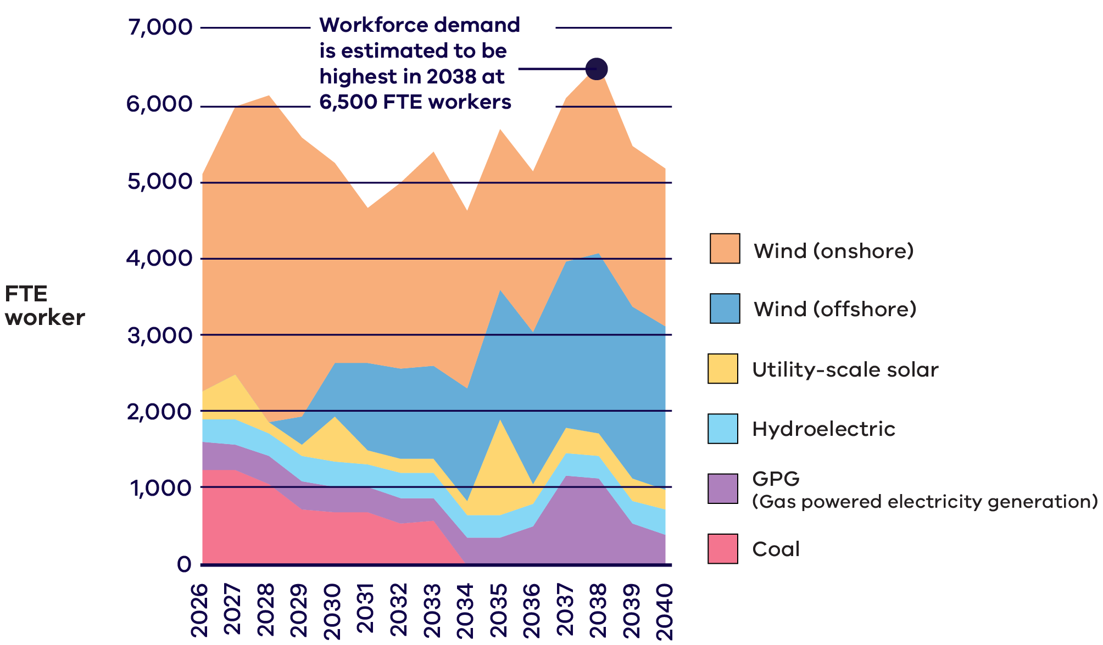
*Note: The workforce projected for the energy generation workforce reflects the 2024 ISP Step Change scenario.

Jobs

Wind
The majority of occupations in onshore wind will be in construction, and operations and maintenance with high demand for electricians, mechanical engineering trades workers, construction, distribution and production managers and engineers. Offshore wind will follow a similar pattern, with high demand for technicians and trades workers, as well as professionals and managers.

Utility-scale solar
In 2035, the year projected to need the highest number of workers for utility-scale solar, the most in-demand occupations will include electricians, building and plumbing labourers and clerical and administrative workers.

Hydroelectric
Top jobs in the hydroelectric workforce include engineers, clerical and administrative workers and business administration managers, working in operations and maintenance.

Education
Nearly all roles will require a post‑secondary qualification, with 59% requiring Certificate IV (or Certificate III with at least two years of on‑the‑job training) to associate degree qualifications, and a further 34% requiring a bachelor degree or higher qualification (Figure 15).
The majority of roles in energy generation will require Certificate IV (or Certificate III with at least 2 years of on-the-job training) to associate degree
Figure 15: Education categories for the energy generation workforce between 2026 and 2040
Education category | Share of workforce
Bachelor degree or higher | 34%
Certificate IV (Or Certificate III with at least 2 years of on-the-job training) to associate degree | 59%
High school and Certificate I, II, III | 7%

Top jobs required in the energy generation workforce
Figure 16: Top jobs in the energy generation workforce, ranked by 2026-2040 average FTE worker, with five‑year averages
Rank | Job title | 2026-2030  Average  FTE | 2031-2035  Average  FTE | 2036-2040  Average  FTE
1 | Electricians | 970 | 1,046 | 1,018
2 | Mechanical Engineering Trades Workers | 486 | 529 | 519
3 | Construction, Distribution and Production Managers | 506 | 373 | 335
4 | Other Miscellaneous Technicians and Trades Workers  (Note: All ‘Other Miscellaneous Technicians and Trades Workers’ in the Victorian energy workforce are in the offshore wind workforce.) | 31 | 342 | 724
5 | Engineers | 446 | 304 | 302
More information in the Data Appendix

The energy generation workforce in regional Victoria
Between 2026 and 2040, most generation of jobs will be located in regional areas.
Most offshore wind workforce opportunities will be located in Latrobe Valley-Gippsland, while other sectors will be spread out across regions.
Figure 17: Victorian generation workforce opportunities by region – Australian Bureau of Statistics (ABS) Statistical Area Level 4 (SA4)
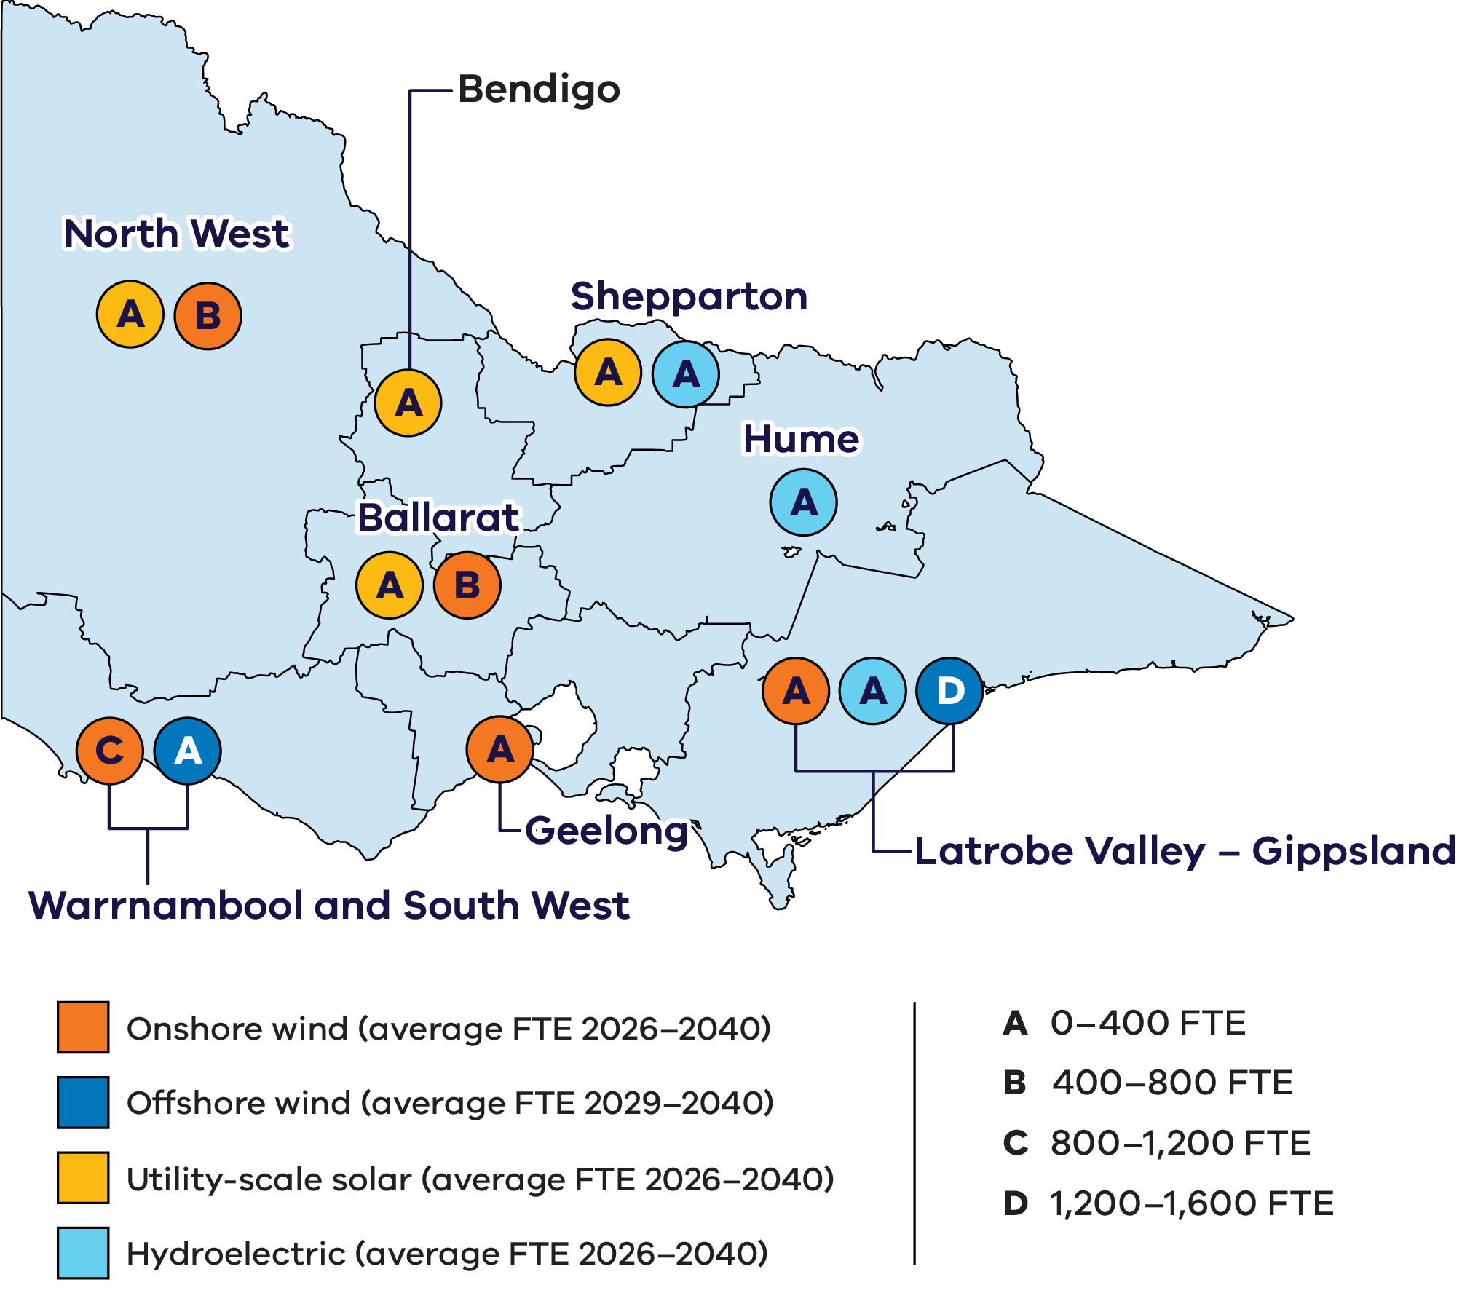
The map in Figure 17 shows the potential location of project activity. Jobs, such as managerial and professional roles, may be located in Melbourne.

Utility-scale energy storage
- Utility-scale batteries
Pumped hydroelectric
Energy storage plays a critical role in supporting increased renewable energy generation by balancing supply and demand, maintaining grid stability, and reducing reliance on fossil fuels. Short, medium and long duration storage systems are required in locations across Victoria to ensure grid reliability and to meet Victoria’s legislated storage targets. Utility-scale batteries will play a growing role in Victoria’s energy system. Further storage technologies, such as pumped hydroelectric, may come online to provide further storage support, and emerging technologies such as renewable hydrogen and compressed air for long duration storage have a potential role to play in the future.

Workforce demand: Utility‑scale energy storage

Projections
The utility-scale energy storage workforce is to be made up predominantly of utility-scale battery workers, with a small number of pumped hydroelectric energy storage workers, as projected in line with the Australian Energy Market Operator’s (AEMO) 2024 Integrated System Plan under the step change scenario.
New utility-scale energy storage infrastructure is required to meet Victoria’s energy storage targets, with construction of utility-scale batteries projected to be largely concentrated between 2026 and 2028. The utility-scale battery construction workforce will be at its highest during this time, averaging 500 FTE workers each year.
Further construction of utility-scale battery projects and a small number of pumped hydroelectric energy storage projects is projected between 2032 and 2035.
Demand for utility-scale energy battery operations and maintenance workers is projected to require an average of 80 FTE workers annually between 2026 and 2040 (Figure 18).
Highest construction workforce demand will be in the mid to late 2020s
Figure 18: Workforce projected for the utility-scale batteries sector between 2026 and 2040
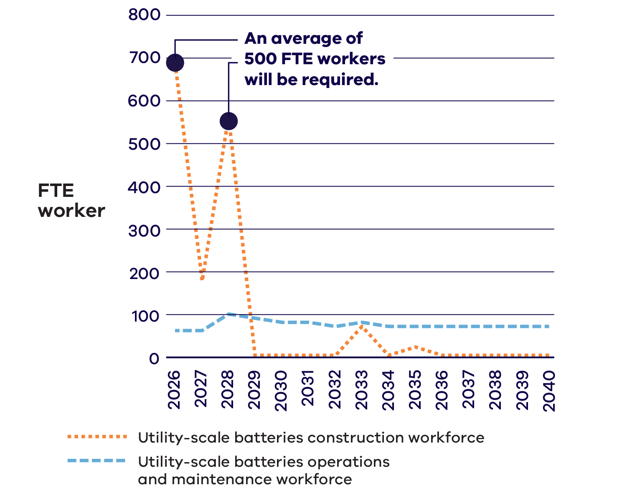

Jobs and education
The utility-scale energy storage workforce is projected to be heavily represented by trades, with 48% of jobs projected to require Certificate IV (or Certificate III with at least two years of on-the-job training) to associate degree qualifications. A further 26% of jobs are projected to require a bachelor degree or higher qualification (Figure 19).
Labourers and electricians are projected to be the most in-demand jobs, particularly between 2026 and 2030, which reflects the expected construction of new energy storage infrastructure (Figure 20). Other significant roles include clerical and administrative workers, engineers, and machinery operators and drivers.
Roles in utility-scale energy storage will require all levels of education, with a significant proportion requiring Certificate IV (or Certificate III with at least 2 years of on-the-job training) to associate degree.
Figure 19: Education categories for the utility-scale energy storage workforce between 2026 and 2040
Education category | Share of workforce
Bachelor degree or higher | 26%
Certificate IV (Or Certificate III with at least 2 years of on-the-job training) to associate degree | 48%
High school and Certificate I, II, III | 26%

Top jobs required in the utility-scale energy storage workforce
Figure 20: Top jobs required in the utility-scale energy storage workforce, ranked by 2026-2040 average FTE worker, with five‑year averages
Rank | Job title | 2026-2030  Average  FTE | 2031-2035  Average  FTE | 2036-2040  Average  FTE
1 | Labourers | 88 | 23 | 17
2 | Electricians | 62 | 17 | 12
3 | Clerical and Administrative Workers | 33 | 10 | <10
4 | Engineers | 22 | <10 | <10
5 | Managers | 26 | <10 | <10
5 | Machinery Operators and Drivers | 26 | <10 | <10
5 | Construction Managers | 26 | <10 | <10
More information in the Data Appendix

Energy networks
- Electricity transmission networks
Electricity distribution networks
As Victoria’s energy system transitions to renewable generation, transmission and distribution networks are being modernised and expanded to connect new renewable and storage projects, support electrification and growing communities, and maintain a reliable and affordable electricity system. Transmission development is being guided through coordinated planning by VicGrid and AEMO, alongside ongoing upgrades to distribution networks. Together, these investments are expected to drive steady growth in the energy networks workforce between 2026 and 2040, reaching over 11,600 FTE workers by 2040.

Workforce demand: Electricity transmission networks
Parts of Victoria’s transmission infrastructure are decades-old, with much of it dating back to the mid-20th century. There are 6,000 kilometres of high‑voltage electrical transmission lines feeding electricity into an extensive distribution network of low-voltage power poles, wires, and meters.
The Victorian Government is investing significantly into new transmission infrastructure projects and network improvements to ensure that renewable energy resources can connect to our electricity grid. Modernising the electricity grid by constructing and upgrading transmission networks will require highly specialised workforces, often in regional and remote locations.
What we heard
Industry feedback about transmission networks workforces
Australia needs more experienced transmission line workers to construct the planned national pipeline of projects.
Companies have reported difficulties in finding skilled transmission line workers locally, especially those with construction experience. Infrastructure construction firms reported competing internationally to attract workers from other countries, including sourcing talent from the Philippines and New Zealand.

Projections
The transmission network construction workforce is projected to be largest in the mid-to-late 2020s, with an average of 800 FTE workers needed between 2026 and 2030 (Figure 21). Workforce needs are projected to evolve in the 2030s as project phases and construction activity levels change and projects are completed.
An increased demand for workers in transmission network operations and maintenance is projected, with a steady growth in workforce size from 800 FTE workers in 2026 to over 1,100 by 2031 (Figure 21).
New transmission infrastructure to drive demand for construction and operation and maintenance workers
Figure 21: Workforce projected for the electricity transmission networks sector between 2026 and 2040
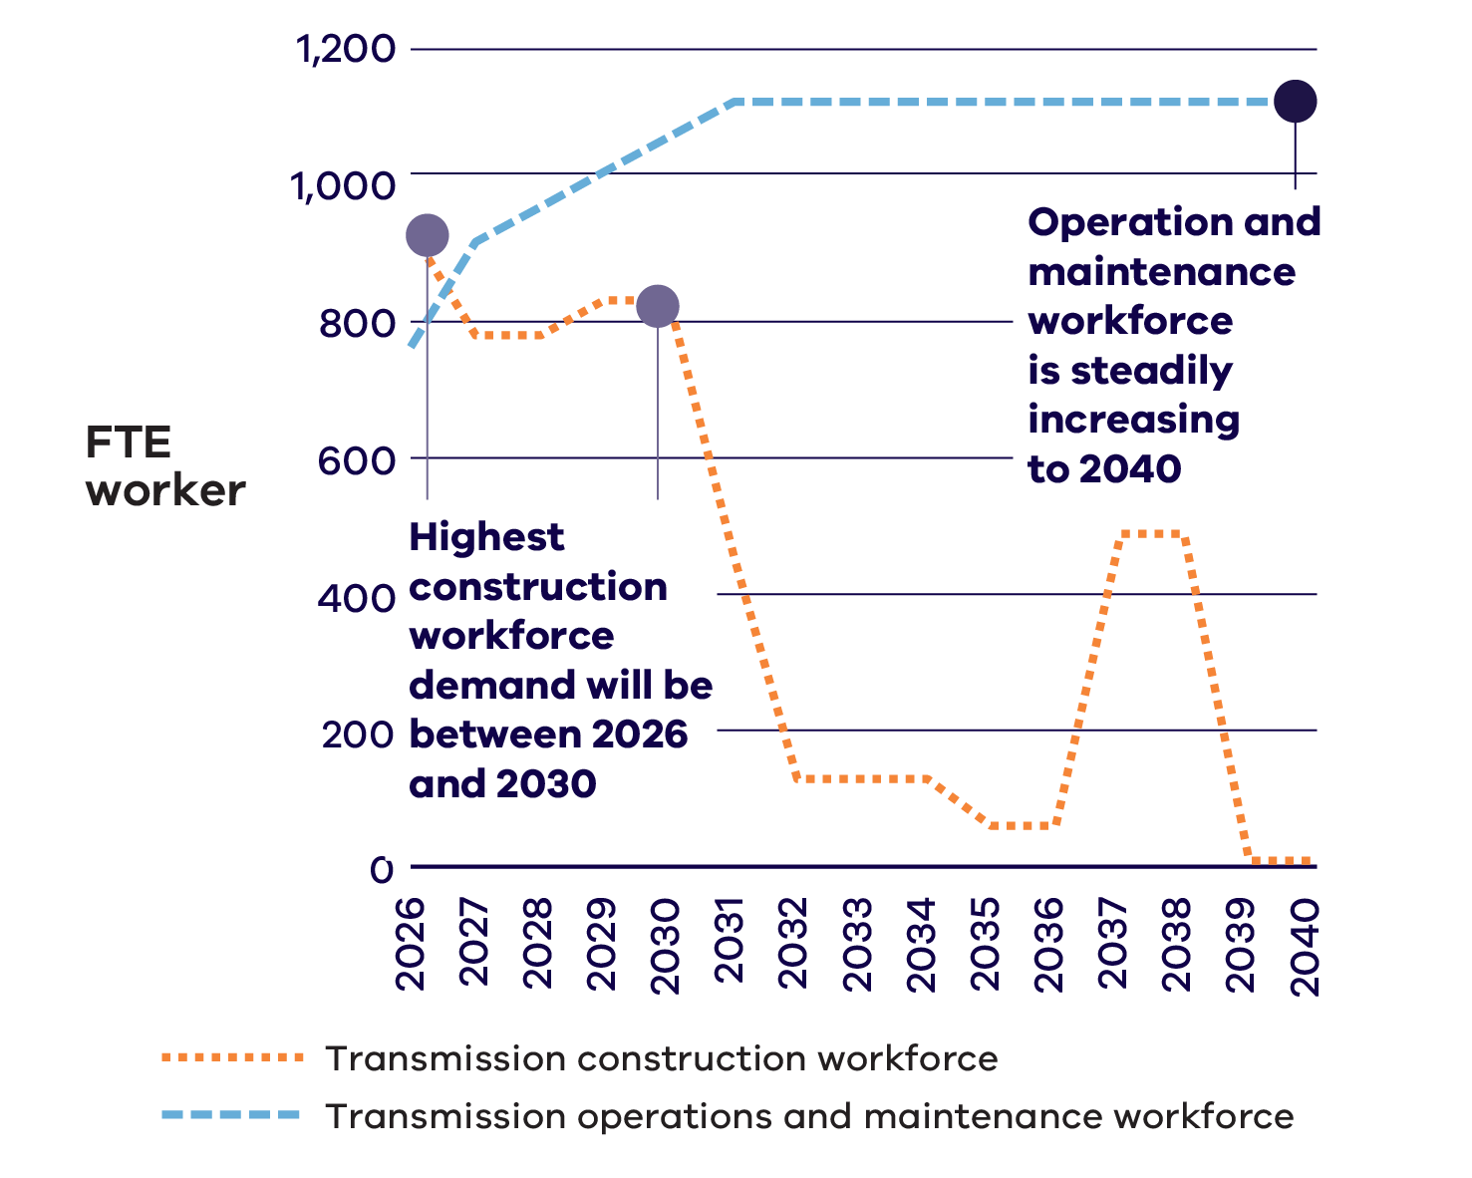

Jobs and education

Electricity transmission networks construction workforce
Most roles in the transmission construction workforce (55%) are projected to require Certificate IV (or Certificate III with at least two years of on‑the‑job training) to associate degree qualifications (Figure 22).
The majority of roles in transmission construction will require Certificate IV (Or Certificate III with at least 2 years of on-the-job training) associate degree
Figure 22: Education categories for the electricity transmission networks construction workforce between 2026 and 2040
Education category | Share of workforce
Bachelor degree or higher | 22%
Certificate IV (Or Certificate III with at least 2 years of on-the-job training) to associate degree | 55%
High school and Certificate I, II, III | 23%
Top jobs include electricians, electrical distribution trades workers, engineers, and structural steel construction workers (Figure 23).

Top jobs required in the electricity transmission network construction workforce
Figure 23: Top jobs required in the electricity transmission networks construction workforce, ranked by 2026 FTE worker, with 2026-2040 average FTE worker
Rank | Job title | Peak year (2026) | 2026-2040  Average  FTE
1 | Electricians | 126 | 39
2 | Electrical Distribution Trades Workers | 121 | 71
3 | Engineers | 109 | 42
4 | Structural Steel Construction Workers | 107 | 55
5 | Construction, Distribution and Production Managers | 68 | 26

Electricity transmission networks operation and maintenance workforce
The projected transmission operation and maintenance workforce has more occupations requiring Certificate IV (or Certificate III with at least two years of on-the-job training) to associate degree qualifications at 46% and a further 43% of this workforce requiring a bachelor degree or higher qualification (Figure 24).
Top jobs include professionals, technicians and trades workers and labourers.
Most of the roles in transmission operation and maintenance will require post-secondary qualifications.
Figure 24: Education categories for the electricity transmission networks operation and maintenance workforce between 2026 and 2040
Education category | Share of workforce
Bachelor degree or higher | 43%
Certificate IV (Or Certificate III with at least 2 years of on-the-job training) to associate degree | 46%
High school and Certificate I, II, III | 11%
Education requirements are based on limited occupational data for the electricity transmission networks operation and maintenance workforce, as occupational information is only available by ANZSCO major occupational groups.

Workforce demand: Electricity distribution networks
Victoria’s electricity distribution networks are growing and modernising to support decarbonisation, rooftop solar, electric vehicles and new technologies, and a growing population. A skilled, adaptable workforce is needed to support distribution networks.

Projections
The distribution networks workforce is projected to steadily increase from 2026 to 2040 (Figure 25). It will account for about 17% of the total energy workforce each year on average during this period.
Demand for distribution networks workforce is to increase steadily to 2040
Figure 25: Workforce projected for the electricity distribution networks sector between 2026 and 2040
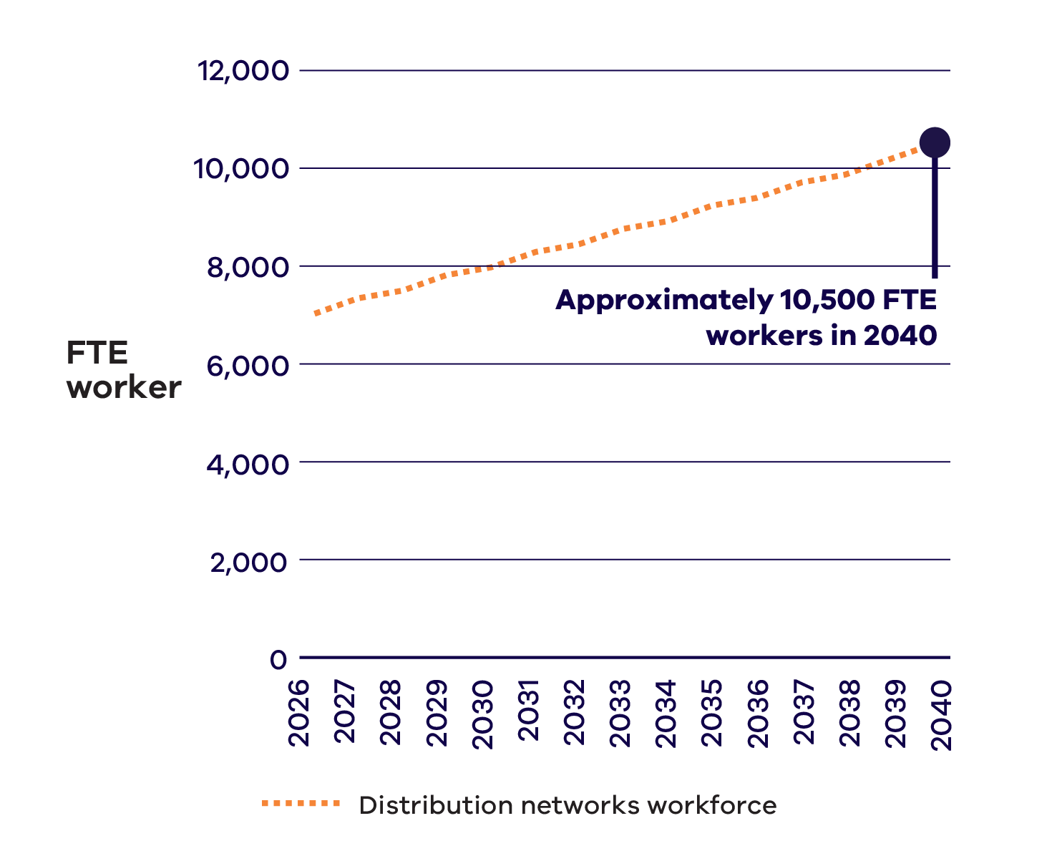
Top jobs in the distribution workforce include call or contact centre information clerks, information and organisation professionals and engineers (Figure 26).
Distribution Network Service Providers (electricity distribution businesses) reported through the Victorian Energy Jobs Plan Consultation Paper consultations that there is high demand for occupations including engineers, control room operators, linesworkers, cable jointers, substation workers, and stakeholder engagement professionals.
Top jobs required in the electricity distribution networks workforce
Figure 26: Top jobs in the electricity distribution networks workforce between 2026 and 2040
Rank | Job title | 2026-2040  Average  FTE
1 | Call or Contact Centre Information Clerks | 759
2 | Information and Organisation Professionals | 691
3 | Engineers | 683
4 | Electronics and Telecommunications Trades Workers | 654
5 | Business and Systems Analysts, and Programmers | 458
What we heard
Industry workforces in electricity distribution networks
“Every year we are still seeing quite a large increase in terms of our capital works program. Melbourne, in particular, is really expanding at a phenomenal rate, and we need to provide the electrical infrastructure as the backbone that supports that.”
Distribution Network Service Provider

Education
The distribution workforce is highly qualified, with 84% requiring qualifications of either a bachelor degree or higher, or Certificate IV (or Certificate III with at least two years of on-the-job training) to associate degree (Figure 27).
The majority of roles in distribution will require a bachelor degree or higher
Figure 27: Education categories for the distribution networks workforce between 2026 and 2040
Education category | Share of workforce
Bachelor degree or higher | 52%
Certificate IV (Or Certificate III with at least 2 years of on-the-job training) to associate degree | 32%
High school and Certificate I, II, III | 16%
Severe weather driving demand for energy networks workers
Severe weather episodes causing damage to essential services infrastructure are now occurring in Victoria nearly every year and are expected to continue.
Both transmission and distribution workforces are being challenged to ensure they have enough field services workers available to safely repair and restore the networks after major outage events.
More information in the Data Appendix.

Energy enablers
- Energy retail
Safety, licensing and regulation
Energy enablers include energy retail, which sells electricity to household and business customers, as well as safety, licensing and regulation which supports the secure, reliable and safe operation of the energy system. Together, they enable consumers to purchase electricity and make sure the energy system and installation of appliances is regulated and safe.

Workforce demand: Energy retail
Energy retail workforces primarily work in businesses that facilitate the sale and supply of electricity and other energy services to residential and business customers. Victoria currently has over 35 energy retailers and collectively, energy retailers play a critical role in Victoria’s energy transition by enabling households and businesses to access, manage and benefit from clean energy technologies - such as solar, batteries and electric vehicles.
The energy retail workforce helps households and businesses actively participate in the energy transition by designing and managing energy products, supporting customers using new technologies such as solar, batteries and electric vehicles, operating digital platforms and data, and ensuring retail services are fair, reliable and accessible.
Workers in energy retail are increasingly involved with managing rooftop solar exports, integrating home batteries and electric vehicle charging, enabling smart meter services, and providing tools that help consumers reduce costs and emissions.

Projections
The energy retail workforce is projected to grow steadily between 2026 and 2040 (Figure 28).

Jobs
Common jobs in energy retail include information and organisation professionals, business and systems analysts, and call or contact centre information clerks (Figure 30).
The energy retail workforce typically supports customer service, data analysis, systems optimisation, stakeholder engagement, and marketing and delivery of renewable energy products and services.
Energy retail workforce to increase steadily to 2040
Figure 28: Workforce projected for the energy retail sector between 2026 and 2040
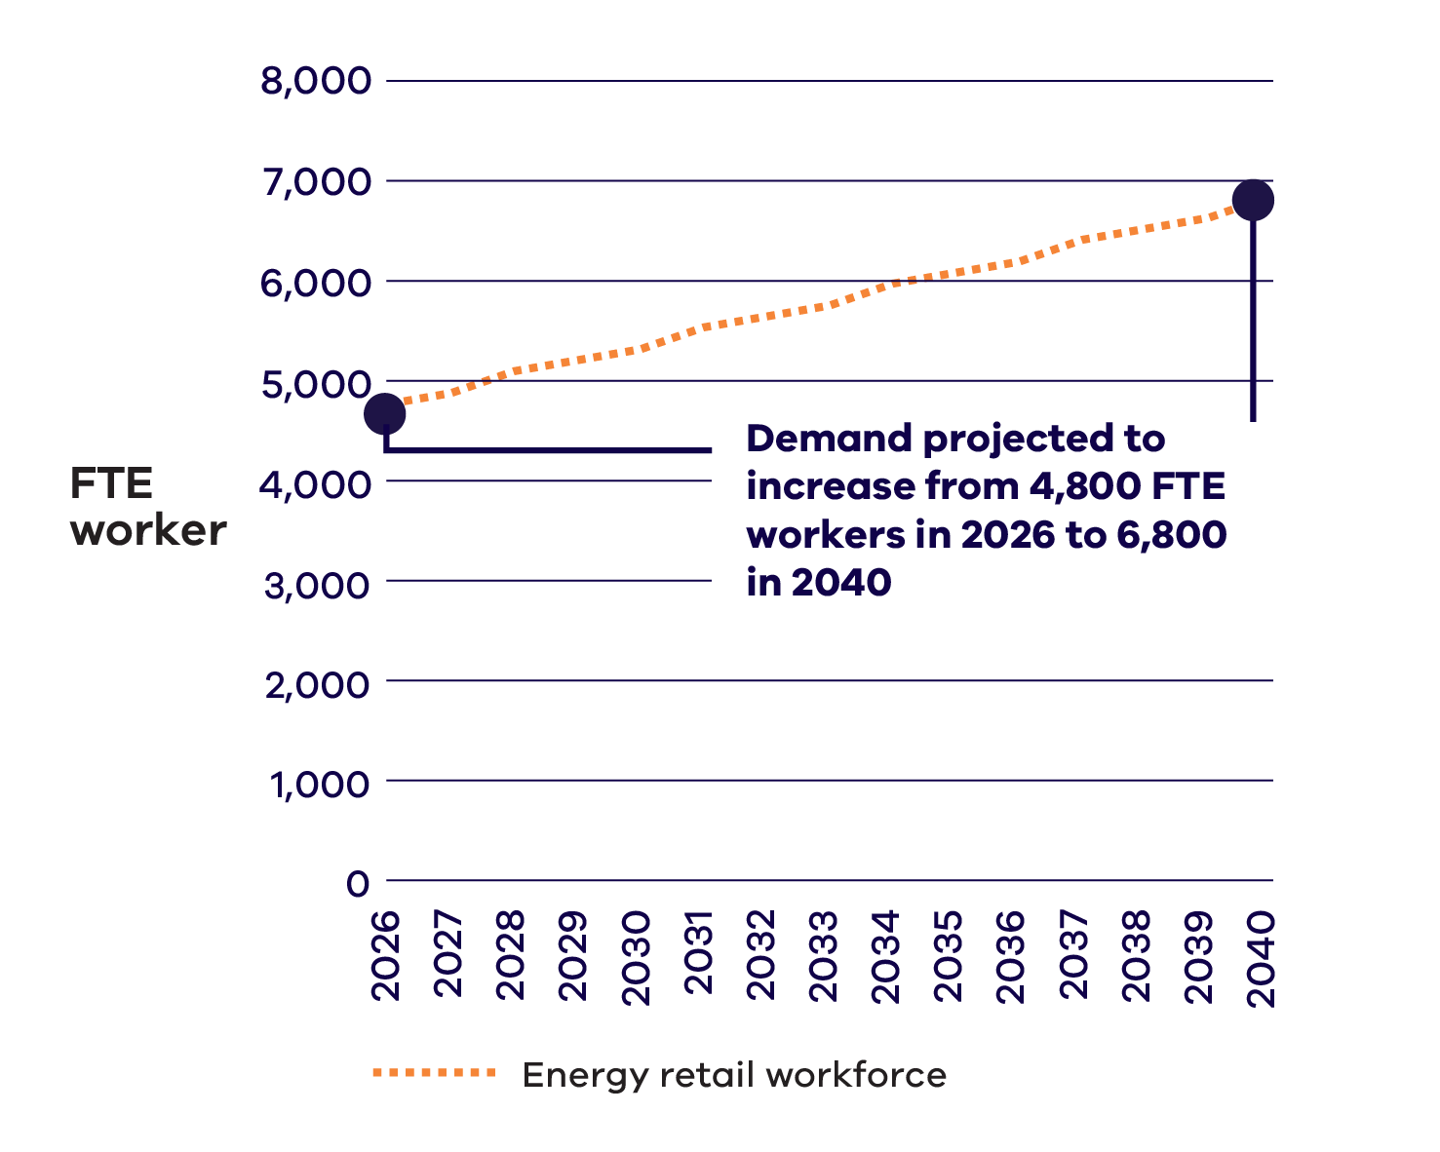
On average, 11% of the energy workforce will work in energy retail between 2026 and 2040.

Workforce demand: Energy safety, licensing and regulation
Energy safety, licensing and compliance are essential to protect consumers and ensure the reliability, security and safety of the energy system.
Like many industries, regulation of the energy industry is performed by a range of Victorian and Commonwealth regulators – both industry-specific and general regulators.
A key employer in the energy safety and licensing sector is Energy Safe Victoria. As the state’s independent energy safety regulator, Energy Safe Victoria oversees the regulatory safety frameworks for electricity, gas, and pipelines. Its primary responsibility is to ensure that Victoria’s gas and electricity industries operate safely and in line with community expectations.

Jobs
The workforce in energy safety, licensing and regulation requires specialists such as legislators, along with clerical and administrative workers, electrotechnology and telecommunications trades workers, chief executives, and general managers. The energy safety, licensing and regulation workforce ensures that energy installations meet safety standards, qualified practitioners are licensed, and oversee regulatory frameworks that enable safe and compliant deployment of new energy technologies across the state.

Energy enablers education
The majority of the energy enablers workforce comprises workers who have completed higher education.
Between 2026 and 2040, 60% of the energy enablers workforce will need a bachelor degree or higher qualification (Figure 29). The top jobs that require a bachelor degree or higher qualification are information and organisation professionals, business and systems analysts, and programmers and business administration managers.
The majority of roles in energy enablers will require a bachelor degree or higher
Figure 29: Education categories for the energy enablers workforce between 2026 and 2040
Education category | Share of workforce
Bachelor degree or higher | 60%
Certificate IV (Or Certificate III with at least 2 years of on-the-job training) to associate degree | 29%
High school and Certificate I, II, III | 11%

Top jobs required in the energy enablers workforce
Figure 30: Top jobs required in the energy enablers workforce, ranked by 2026-2040 average FTE worker, with five‑year averages
Rank | Job title | 2026-2030  Average  FTE | 2031-2035  Average  FTE | 2036-2040  Average  FTE
1 | Information and Organisation Professionals | 512 | 598 | 685
2 | Business and Systems Analysts, and Programmers | 416 | 486 | 557
3 | Call or Contact Centre Information Clerks | 416 | 416 | 416
4 | Business Administration Managers | 286 | 338 | 391
5 | Advertising, Public Relations and Sales Managers | 250 | 295 | 341
More information in the Data Appendix.

Distributed energy resources and zero emissions vehicles infrastructure
Distributed energy resources
- Rooftop solar
- Distributed batteries
Zero emissions vehicles infrastructure
Distributed energy resources and zero emissions vehicles (ZEV) infrastructure are changing the way consumers engage with the energy system.
With distributed energy resources, consumers are no longer just energy users – they are becoming active players in the energy system and use distributed energy resources to generate, store, manage and sell their energy. This includes solar panels, home batteries, and controllable air conditioners.
ZEV infrastructure, including for electric vehicle charging and hydrogen vehicle refuelling infrastructure, are changing how we live and commute.
The take up of distributed energy resources and ZEV is reshaping the energy market and driving demand for new skills and jobs.

Workforce demand: Distributed energy resources
Installations of rooftop solar and battery storage in households and commercial buildings are expected to drive an increased demand for workers as consumers continue to install, maintain and upgrade distributed energy resources.
In 2025, solar panels on homes and businesses will deliver up to 60% of Victoria’s energy demand at certain times. Launched in 2018, the Victorian Government’s 10-year Solar Homes Program aims to support the installation of up to 783,000 rooftop solar, battery and hot water systems through rebates and interest-free loans, assisting Victorian households to reduce their energy bills and emissions.
Within the next decade, the energy storage capacity in small-scale batteries will increase tenfold. The role of distributed batteries is expected to increase over time as more households and businesses install batteries.
The distributed batteries workforce is projected to grow by almost 3 times, reaching approximately 2,600 FTE workers in 2040.

Projections
For rooftop solar, an average of approximately 3,300 FTE workers will be needed each year until 2040 to meet projected demand (Figure 31).
For distributed batteries, the workforce is expected to increase significantly from around 1,000 FTE workers in 2026 to over approximately 2,600 workers by 2040 (Figure 31).
The distributed energy resources workforce is set to grow
Figure 31: Workforce projected for the distributed energy resources sector between 2026 and 2040
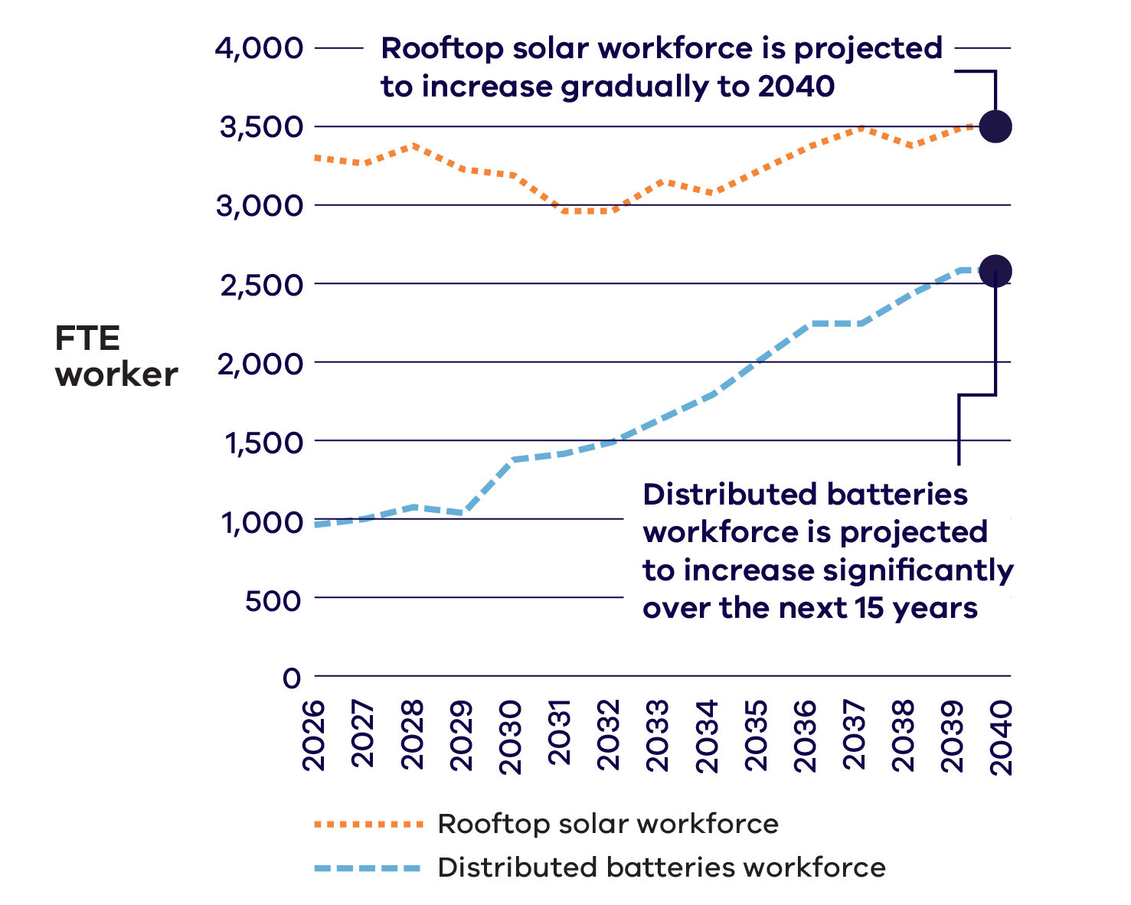

Jobs
The rooftop solar and distributed batteries workforces require occupations such as electricians, business, human resource and marketing professionals, and building and plumbing labourers (Figure 32).
Top jobs required in the distributed energy resources workforce
Figure 32: Top jobs in the distributed energy resources workforce between 2026 and 2040
Rank | Job title | 2026-2040  Average  FTE
1 | Electricians | 891
2 | Business, Human Resource and Marketing Professionals | 569
3 | Other Miscellaneous Labourers | 565
4 | Building and Plumbing Labourers | 497
5 | Clerical and Administrative Workers | 400

Education
A significant proportion of workers in rooftop solar and distributed batteries (39%) will require a bachelor degree or higher qualification (Figure 33).
Other occupations requiring a bachelor degree or higher qualification include accountants; sales, marketing and public relations professionals; and chief executives and general managers.
Jobs in utility-scale energy storage require a wide range of qualifications, with a significant proportion to require a bachelor degree or higher
Figure 33: Education categories for the rooftop solar and distributed batteries workforces between 2026 and 2040
Education category | Share of workforce
Bachelor degree or higher | 39%
Certificate IV (Or Certificate III with at least 2 years of on-the-job training) to associate degree | 32%
High school and Certificate I, II, III | 29%

Workforce demand: Zero emissions vehicles infrastructure
ZEV infrastructure includes electric vehicle charging and renewable hydrogen vehicle refuelling infrastructure, with electric vehicle charging infrastructure expected to make up the majority of the sector.
By 2030, the Victorian Government aims for half of all light vehicle sales to be ZEV. By the mid-2030s, electric vehicle use could increase by over 1,600%.

Projections
The need for electric vehicle charging infrastructure is growing, driven by increasing demand for electric vehicles, creating jobs in installation, operations and maintenance. The electric vehicle charging infrastructure workforce is projected to increase significantly from around 2,600 FTE workers in 2026 to over 14,300 FTE workers by 2040 (Figure 34). This is a four times increase in the workforce from 2026 and will support over 3.5 million electric vehicles.
The workforce for electric vehicle charging infrastructure is projected to grow significantly
Figure 34: Workforce projected for the electric vehicle charging infrastructure sector between 2026 and 2040
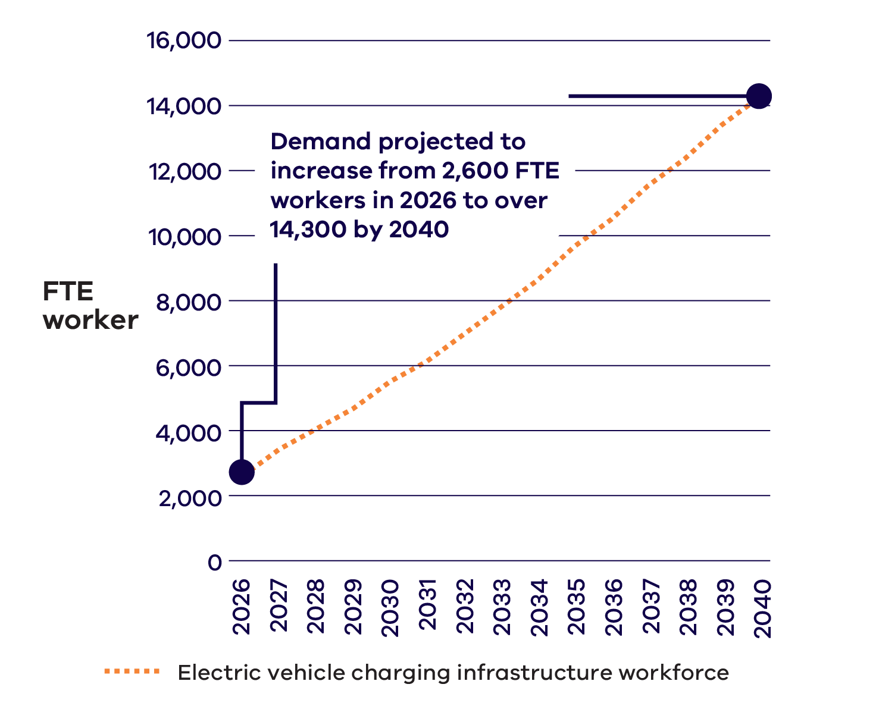

Jobs
In-demand jobs in the electric vehicle charging infrastructure workforce include ICT managers, electricians, and sale representatives (Figure 35).
Top jobs required in the electric vehicle charging infrastructure workforce
Figure 35: Top jobs in the electric vehicle charging infrastructure workforce between 2026 and 2040
Rank | Job title | 2026-2040  Average  FTE
1 | ICT Managers | 2,742
2 | Electricians | 2,215
3 | Sales Representatives | 980
4 | Clerical and Administrative Workers | 934
5 | Telecommunications Trades Workers | 456

Education
Around two in five workers (40%) in the electric vehicle charging infrastructure workforce are projected to require a bachelor degree or higher qualification, while nearly half (48%) will require a Certificate IV (or Certificate III with at least two years of on-the-job training) to associate degree qualifications (Figure 36).
Most of the roles in electric vehicle charging infrastructure will require post-secondary qualifications
Figure 36: Education categories for the electric vehicle charging infrastructure sector workforce between 2026 and 2040
Education category | Share of workforce
Bachelor degree or higher | 40%
Certificate IV (Or Certificate III with at least 2 years of on-the-job training) to associate degree | 48%
High school and Certificate I, II, III | 12%
Renewable hydrogen vehicle refuelling infrastructure
The shift towards zero emissions heavy vehicles is driving potential demand for renewable hydrogen. Victoria currently has three hydrogen vehicle refuelling stations and several more under consideration.
Key roles for renewable hydrogen vehicle refuelling infrastructure are still emerging and may include ICT managers, electricians, supply, distribution and procurement managers and clerical and administrative workers.
More information in the Data Appendix.

Energy upgrades and services
- Residential electrification and services
(Residential heating, cooling and cooking services)
- Residential energy efficiency
- Commercial electrification and energy efficiency
- Industrial electrification and energy efficiency
Agriculture and forestry electrification and energy efficiency
Victoria is improving energy efficiency and electrifying homes, and commercial, industrial and agricultural premises to reduce energy use, lower bills, and reach net zero emissions.
Currently, over 2 million Victorian households and businesses rely on gas for heating, hot water, and cooking – more than in any other state or territory in Australia. However, the Victorian energy system is moving away from fossil gas due to increasing gas prices, uncertainty in global gas supply, high emissions, and strong government support for renewable energy.
There has already been an increase in the level of residential electrification services work in Victoria, evidenced by the uptake of efficient electric appliances through the Victorian Energy Upgrades and Solar Homes programs. The introduction of building electrification regulations and minimum energy efficiency standards for rental homes will continue to support electrification. The growing need for households and businesses to electrify and improve energy efficiency – such as replacing gas hot water systems with energy efficient electric heat pumps – will drive increased demand for skilled installers and maintenance workers.

Workforce demand: Energy upgrades and services

Projections
The energy upgrades and services sector is projected to have nearly 17,900 FTE workers in 2026, making up 40% of the overall energy workforce.
This is the largest workforce in the energy sector, including workers in residential electrification and services, residential energy efficiency and commercial, industrial and agricultural electrification and energy efficiency.
The number of FTE workers in the energy upgrades and services sector is expected to grow to over 22,300 in 2040.
Within electrification, industrial workforces will peak in the early 2030s and require over 1,000 FTE workers. Agriculture and forestry workforces will continue to grow quickly in the mid-to-late 2030s, requiring 3,400 FTE workers by 2039.
The biggest share of jobs in energy upgrades and services will come from residential electrification and services, and residential energy efficiency
Figure 37: Average annual workforce projected for residential electrification and services, residential energy efficiency and commercial, industrial and agricultural electrification and energy efficiency sectors between 2026 and 2040
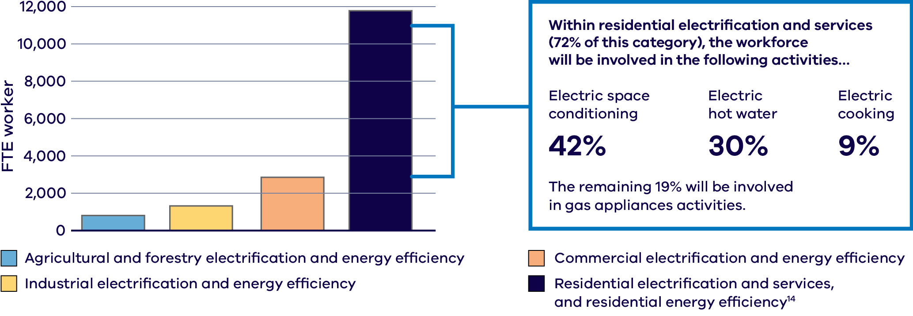
Within residential electrification and services (72% of the residential category), the workforce will be involved in the following activities:
Activity breakdown within residential electrification and services workforce
Activity | Share of residential electrification and services workforce
Electric space conditioning | 42%
Electric hot water | 30%
Electric cooking | 9%
Gas appliances activities | 19%
The energy efficiency workforce demand remains strong throughout the period to 2040, averaging around 7,100 FTE across the commercial, industrial and residential sectors. Demand is highest between 2026 and 2030, averaging around 10,100 FTE workers. This is followed by another period of high demand in the late 2030s, with approximately 9,600 FTE workers required in 2040.

Residential electrification and services jobs and education
Demand for workers in residential electrification and services is projected to grow gradually from 7,800 to 9,000 FTE workers between 2026 and 2040. The majority of this work will be in electric space conditioning, electric hot water and electric cooking.
The most in-demand jobs required in the residential electrification and services workforce are projected to be plumbers, electricians and airconditioning and refrigeration mechanics (Figure 39).
Jobs in residential electrification and services include plumbers who install and replace gas and water systems, electricians who connect and upgrade electric appliances, and airconditioning mechanics who fit and maintain heat pumps.
The large majority (89%) of roles in residential electrification and services will require Certificate IV (or Certificate III with at least 2 years of on-the-job training) to associate degree
Figure 38: Education categories for the residential electrification and services workforce between 2026 and 2040
Education category | Share of workforce
Bachelor degree or higher | 10%
Certificate IV (Or Certificate III with at least 2 years of on-the-job training) to associate degree | 89%
High school and Certificate I, II, III | 1%
Top jobs required in the residential electrification and services workforce
Figure 39: Top jobs in the residential electrification and services workforce between 2026 and 2040
Rank | Job title | 2026-2040  Average  FTE
1 | Plumbers | 3,527
2 | Electricians | 1,951
3 | Airconditioning and Refrigeration Mechanics | 1,767
4 | Engineers | 576
5 | Sales, Marketing and Public Relations Professionals | 236

Electrification jobs
The remaining electrification workforce covers roles across commercial, industrial, agricultural and forestry electrification. Further work is required to better understand the occupations that make up the electrification workforce outside of residential electrification and services.

Energy efficiency jobs
Jobs in the energy efficiency workforce include engineers specialised in performance measurement and verification analysis; energy management system advisors that assist businesses to implement energy performance measures; insulation installers; glaziers; and administration and support staff.
More information in the Data Appendix.
The Victorian Energy Upgrades program
Victorian Energy Upgrades (VEU) is the Victorian Government’s flagship energy savings and emissions reduction program. It provides incentives for Victorian homes and businesses to reduce their electricity and gas use and move to efficient electric appliances.
In 2023, the VEU program was expanded to include hot water and space heating upgrades to support the move from gas to efficient electric appliances. Since then, hundreds of Victorian installers have replaced tens of thousands of inefficient gas space heating and hot water systems with modern cost-saving electric alternatives in Victorian homes and businesses.

Projected regional Victoria energy sector workforces 2026-2040
Australian Bureau of Statistics (ABS) Statistical Area Level 4 (SA4)
This map shows the potential location of energy sector activity. Job locations may be different from activity locations.
Note: This information relates only to sectors with available location, occupation and education data (see Endnote 3).
See workforce projections for metropolitan Melbourne on page 95.

North West
- 2,200 FTE Average workforce size
- Highest workforce year 2035 (2,700 FTE)

Education category
Education category | Share of workforce
Bachelor degree or higher | 36%
Certificate IV (Or Certificate III with at least 2 years of on-the-job training) to associate degree | 53%
High school and Certificate I, II, III | 11%

Top sectors
- Wind (onshore) 34%
- Electric vehicle charging infrastructure 15%
- Utility-scale solar 13%
- Residential electrification and services 8%
- Transmission O&M 7%

Top jobs
- Electricians
- Mechanical Engineering Trades Workers
- Clerical and Administrative Workers
- Construction, Distribution and Production Managers
- ICT Managers

Warrnambool and South West
- 2,000 FTE Average workforce size
- Highest workforce year 2038 (2,600 FTE)

Education category
Education category | Share of workforce
Bachelor degree or higher | 35%
Certificate IV (Or Certificate III with at least 2 years of on-the-job training) to associate degree | 56%
High school and Certificate I, II, III | 9%

Top sectors
- Wind (onshore) 42%
- Electric vehicle charging infrastructure 11%
- Transmission O&M 8%
- Residential electrification and services 7%
- Distribution 6%

Top jobs
- Electricians
- Mechanical Engineering Trades Workers
- Construction, Distribution and Production Managers
- Clerical and Administrative Workers
- ICT Managers

Bendigo
- 1,100 FTE Average workforce size
- Highest workforce year 2040 (1,300 FTE)

Education category
Education category | Share of workforce
Bachelor degree or higher | 39%
Certificate IV (Or Certificate III with at least 2 years of on-the-job training) to associate degree | 47%
High school and Certificate I, II, III | 14%

Top sectors
- Electric vehicle charging infrastructure 24%
- Distribution 22%
- Residential electrification and services 19%
- Energy retail 13%
- Rooftop solar 11%

Top jobs
- Electricians
- ICT Managers
- Plumbers
- Clerical and Administrative Workers
- Engineers

Ballarat
- 1,700 FTE Average workforce size
- Highest workforce year 2040 (2,100 FTE)

Education category
Education category | Share of workforce
Bachelor degree or higher | 37%
Certificate IV (Or Certificate III with at least 2 years of on-the-job training) to associate degree | 53%
High school and Certificate I, II, III | 10%

Top sectors
- Wind (onshore) 32%
- Electric vehicle charging infrastructure 19%
- Distribution 15%
- Residential electrification and services 13%
- Retail 8%

Top jobs
- Electricians
- ICT Managers
- Mechanical Engineering Trades Workers
- Clerical and Administrative Workers
- Plumbers

Shepparton
- 900 FTE Average workforce size
- Highest workforce year 2040 (1,200 FTE)

Education category
Education category | Share of workforce
Bachelor degree or higher | 39%
Certificate IV (Or Certificate III with at least 2 years of on-the-job training) to associate degree | 48%
High school and Certificate I, II, III | 13%

Top sectors
- Electric vehicle charging infrastructure 28%
- Distribution 19%
- Residential electrification and services 17%
- Rooftop solar 11%
- Retail 11%

Top jobs
- Electricians
- ICT Managers
- Plumbers
- Clerical and Administrative Workers
- Engineers

Geelong
- 2,100 FTE Average workforce size
- Highest workforce year 2040 (2,700 FTE)

Education category
Education category | Share of workforce
Bachelor degree or higher | 40%
Certificate IV (Or Certificate III with at least 2 years of on-the-job training) to associate degree | 47%
High school and Certificate I, II, III | 13%

Top sectors
- Distribution 23%
- Residential electrification and services 21%
- Electric vehicle charging infrastructure 20%
- Energy retail 14%
- Rooftop solar 9%

Top jobs
- Electricians
- Plumbers
- ICT Managers
- Clerical and Administrative Workers
- Engineers

Hume
- 1,800 FTE Average workforce size
- Highest workforce year 2040 (2,100 FTE)

Education category
Education category | Share of workforce
Bachelor degree or higher | 42%
Certificate IV (Or Certificate III with at least 2 years of on-the-job training) to associate degree | 46%
High school and Certificate I, II, III | 12%

Top sectors
- Electric vehicle charging infrastructure 19%
- Hydroelectric 17%
- Distribution 14%
- Transmission O&M 13%
- Residential electrification and services 12%

Top jobs
- Electricians
- ICT Managers
- Engineers
- Clerical and Administrative Workers
- Plumbers

Latrobe-Gippsland
- 4,100 FTE Average workforce size
- Highest workforce year 2029 (4,900 FTE)

Education category
Education category | Share of workforce
Bachelor degree or higher | 35%
Certificate IV (Or Certificate III with at least 2 years of on-the-job training) to associate degree | 53%
High school and Certificate I, II, III | 12%

Top sectors
- Wind (offshore) 28%
- Electric vehicle charging infrastructure 12%
- Coal 11%
- Distribution 10%
- Wind (onshore) 9%

Top jobs
- Electricians
- Other Miscellaneous Technicians and Trades Workers
- Engineers
- ICT Managers
- Clerical and Administrative Workers
A regional hub of hydrogen expertise: Deakin Hydrogen Hub
Part-funded by the Victorian Higher Education State Investment Fund, Deakin University’s Hydrogen Hub (formerly Hycel Technology Hub) is a nation-leading hydrogen facility dedicated to research, testing, prototyping, education and training in Warrnambool, Eastern Maar Country. The facility features purpose-built incubation spaces for industry and fuel cell testing equipment to support hydrogen technology adoption. Deakin Hydrogen Hub also develops training pathways for the next generation of hydrogen workers by developing hydrogen curriculums for school students, short courses for professionals and vocational courses with South West TAFE.
Deakin Hydrogen Hub's new purpose-built facility embeds an Indigenous perspective through its design, developed in partnership with First Peoples consultants who acted as conduits between local Elders and the University.
The design of the building was informed by the ethos ‘build it in, don’t bolt it on’ and includes six circles, which represent the six communities that reside within the wider Warrnambool area. The entrance to the building is representative of a Kuyang (eel) trap – an historic object of Aboriginal ingenuity with strong cultural significance to the area.
“It’s important to encourage young people to enter STEM careers, and that includes Indigenous cohorts. We are proud that Deakin Hydrogen Hub’s design highlights our region’s sustained scientific innovation, which started with First Nations eel trapping thousands of years ago.”
– Deakin Hydrogen Hub’s Interim Director, Adam Fletcher
For more information on the Deakin Hydrogen Hub and the courses on offer visit the Deakin Hydrogen Hub website

Projected metropolitan Melbourne energy sector workforces 2026-2040
Australian Bureau of Statistics (ABS) Statistical Area Level 4 (SA4)
This map shows the potential location of energy sector activity. Job locations may be different from activity locations.
Metropolitan Melbourne comprises the SA4 regions Melbourne – Inner, Melbourne – Inner East, Melbourne – Inner South, Melbourne – North East, Melbourne – North West, Melbourne – Outer East, Melbourne – South East, Melbourne – West, and Mornington Peninsula.

Metropolitan Melbourne
- 27,600 FTE Average workforce size
- Highest workforce year 2040 (34,900 FTE)

Education category
Education category | Share of workforce
Bachelor degree or higher | 39%
Certificate IV (Or Certificate III with at least 2 years of on-the-job training) to associate degree | 49%
High school and Certificate I, II, III | 12%

Top sectors
- Distribution 24%
- Residential electrification and services 24%
- Electric vehicle charging infrastructure 20%
- Energy retail 16%
- Rooftop solar 8%

Top jobs
- Electricians
- Plumbers
- ICT Managers
- Airconditioning and Refrigeration Mechanics
- Clerical and Administrative Workers
This information relates only to sectors with available location, occupation and education data (see Endnote 3).

Actions for change
Ensuring Victoria has a supply of skilled workers for the energy workforce is essential to the energy transition. This section sets out actions for creating change and their outcomes across three focus areas:
- Focus area 1: Growing and retaining capacity
Ensuring there are enough people seeking, and staying in, jobs in the energy sector to support industry needs
- Focus area 2: Building workforce capability
Ensuring that the workforce has the skills and qualifications required to deliver an orderly energy transition
- Focus area 3: Improving confidence and coordination
Ensuring demand for energy workers is planned for and coordinated

Focus area 1: Growing and retaining capacity
Vision
The energy sector offers clear and attractive career options for all workers, students, and job seekers. Workplaces in the energy sector prioritise enhancing diversity and fostering thriving workforce cultures.

Workforce capacity challenges and opportunities
To deliver the energy transition, Victoria needs to attract and retain a skilled workforce. Between 2026 and 2040 the Victorian energy workforce is projected to grow from 45,000 to 68,000 FTE workers, a 53% increase.

Demand for workers is projected to increase for a wide range of occupations
As Victoria’s energy system expands, the types of occupations needed will also evolve, with demand rising across many roles to support new infrastructure and technologies.
Technicians and trades workers, including electricians, plumbers, and airconditioning and refrigeration mechanics, are projected to continue to be the most in-demand occupations in the energy sector between 2026 and 2040 (Figure 40). This is followed by professionals, including engineers, information and organisation professionals, and business and systems analysts, and programmers. The most in-demand managers include ICT managers, business administrative managers, and construction, distribution and production managers.
The energy sector workforce will continue to require a breadth of jobs through to 2040
Figure 40: Workforce projected for the energy sector by ANZSCO major groups between 2026 and 2040
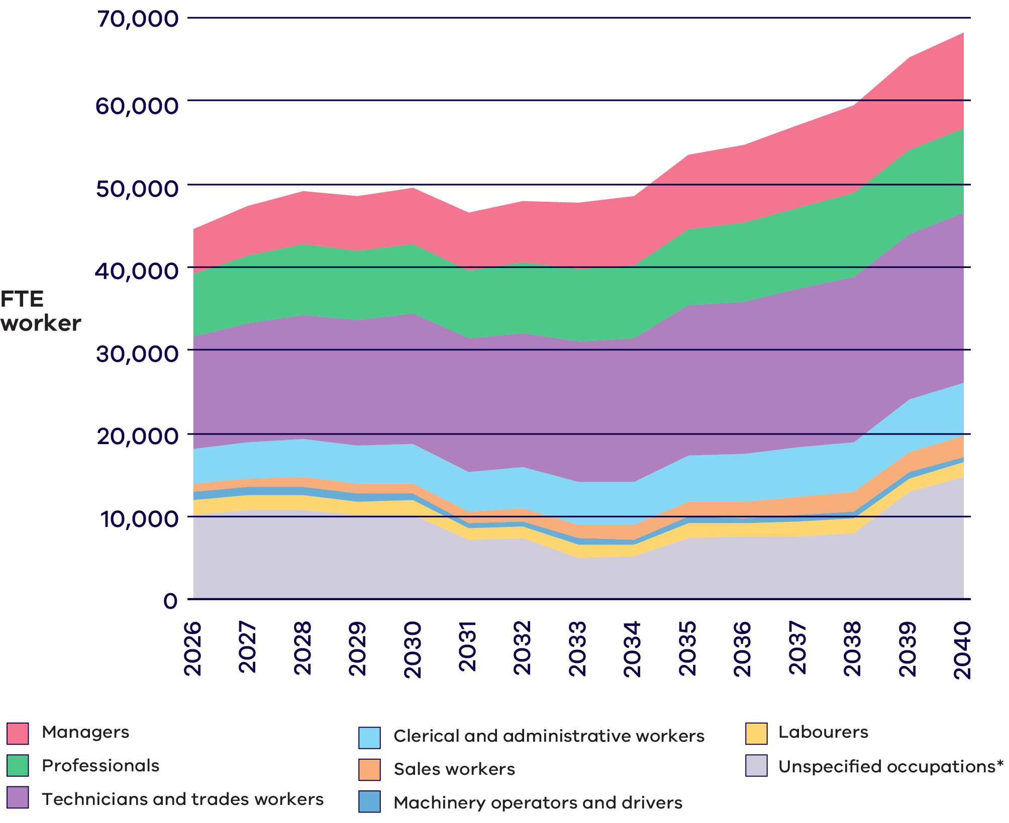
*Note: The energy sector workforce in Figure 40 includes all the energy sectors that comprise the Victorian energy sector. Occupational information is available for 53,300 FTE of the 68,100 FTE workers projected for 2040. ‘Unspecified occupations’ includes the remaining 14,800 FTE workers that could not be allocated to a specific ANZSCO major group due to limitations in the available occupational data, including residential energy efficiency, commercial, industrial, agricultural and forestry electrification and energy efficiency, hydrogen vehicle refuelling infrastructure and construction of gas powered generation workforces that cannot currently be disaggregated by ANZSCO classification.

Meeting workforce demand will require attracting and supporting workers
Attracting and retaining a skilled workforce is critical for achieving the energy transition. Workers are required across the energy sector, from the expansion of renewable generation, upgrades to electricity networks, widespread electrification of homes and businesses, greater energy efficiency, and increased uptake of electric vehicles.
Employers in the energy sector can attract new workers by offering diverse opportunities, ensuring worker safety and wellbeing, and providing flexible, competitive working conditions.
To ensure workforce growth, people from a range of diverse backgrounds need to be attracted to, and supported in, joining Victoria’s energy workforce. This includes career changers, people upskilling and reskilling, apprentices, new graduates, and workers arriving through the Commonwealth Government’s migration program pathways.

Awareness of job and career opportunities and education pathways is needed
The breadth of occupation options in the energy workforce presents opportunities to attract new workers, including people who may previously not have considered working in the energy sector.
Continuing to define and promote jobs, career pathways, and qualifications for future workers for the energy workforce will be necessary.

Existing workers need to be supported
To meet the demand for energy sector workers, it is essential to support and retain those already working in renewable energy.
Providing welcoming workplaces that address physical, psychological and cultural safety is essential. As is providing career development opportunities, including continuous learning. Ongoing skills development helps workers keep up with changing needs and fosters confidence and commitment to the sector.

Transitioning workforces
Transitioning workers from sectors such as coal, gas and native timber harvesting will be essential to meeting future workforce needs. Analysis indicates that many of these workers possess transferable skills, and targeted transition support and education programs can help them adapt and apply their capabilities in renewable energy roles, while also delivering benefits for their local communities.
A top energy workforce occupation
Plumbers
Plumbers are a key part of Victoria’s skilled trades workforce, with just under 33,000 currently employed across the Victorian economy and around 11% working directly in the energy sector. They install and maintain systems for water, gas and heating - supporting efficient residential technologies like electric hot water, heat pumps and gas connections.
Plumbers will be the most in-demand profession across the energy upgrades and services sector over the next 15 years. To meet broader growth and replace retirees, Victoria will need to train nearly 10,000 new plumbers by 2034, for energy and other sectors.

Read more about gender equity in the energy workforce in the Women in Energy Strategy
Visit the Our Energy Workforce website to find out more about how the Victorian Government is supporting women’s full and equitable participation in the renewable energy transition through the Women in Energy Strategy, including by:
- Attracting women to the energy sector
- Ensuring women can access and complete education and training
Ensuring women can enter and thrive in the workplace.
The Women in Energy Strategy delivers on a commitment made in the Victorian Government’s Our equal state.
Inspiring Victorian students – our future energy workforce
SEC’s education program brings renewables to life, showcasing the breadth of study and career opportunities to inspire young people as they choose pathways into work. Young people have a big stake in the energy transition and today’s students are tomorrow’s renewable energy workers and decision makers.
Since 2023, SEC has engaged with over 8,000 students across Victoria about renewable energy careers. SEC’s education program builds awareness and excitement for the energy transition and opportunities it brings, including practical examples of jobs and career pathways.
The program’s free curriculum-aligned activities include project site visits, so students can experience firsthand the renewable energy industry and the jobs it creates. SEC also delivers hands-on workshops in schools to inspire students in science, technology, engineering, arts and mathematics (STEAM) and problem solving.

To meet demand for workers and support business outcomes, the energy sector needs to attract and retain workers from all backgrounds and experiences

Increasing diversity can improve outcomes for workers, businesses, and the energy sector broadly
Lack of diversity in the energy sector workforce is both an ongoing challenge and an opportunity. Increasing diversity of workers can both improve outcomes and help grow the energy workforce.
Research of over 1,000 companies across 12 countries globally shows that inclusivity not only improves outcomes for diverse workers but also for their businesses.
- Companies in the top-quartile for gender diversity on executive teams were 39% more likely to have industry-leading profitability.
Beyond gender, companies in the top-quartile for ethnic and cultural diversity on executive teams were 39% more likely to have industry-leading profitability.
Increasing diversity, inclusion and equity requirements in procurement can help address workforce challenges, especially for regional areas with skill and labour shortages. Recent research into economic equality observed that when occupational gender segregation intensifies, labour shortages tend to get worse.
Underrepresented groups need support to complete studies and find jobs. Supportive work cultures and fair employment conditions will help retain workers in the sector.

Recognising barriers to participation and leadership opportunities
Women make up around 26% of the workforce in energy-related occupations across Victoria. In addition to being underrepresented, women face challenges such as pay inequity, occupational gender segregation, and specific barriers to participation.
Women are underrepresented in technical, leadership and professional roles within the energy workforce, and on average are paid less than their male counterparts for the same or similar positions. In electricity supply, women are paid on average 24.1% less than men.
- 6% of technicians and trade workers in the electricity supply workforce are women, compared to 18% of workers across the whole workforce.
- 36% of professionals in the electricity supply workforce are women, compared to 56% of workers across the whole workforce.
- On average, women employed as electricians earn $13,700 less than men in the same role.
Stakeholder feedback suggests that a lack of visibility of women working in the sector reaffirms preexisting gender stereotypes and discourages women and girls from considering energy as a career option.
Structural and cultural barriers may be faced across key stages of an energy career pathway: attraction, education and training, and entering and thriving in the workplace. These range from stereotypes impacting beliefs about the suitability of women for certain occupations, to financial barriers to undertaking education, and the availability of flexible education and work options.
What we heard
Community and non-profit sector
Increasing workforce participation of underrepresented groups requires more than a ‘one-size-fits-all’ approach. Flexible working conditions, mentors, and role models are particularly needed for culturally and linguistically diverse women. Challenges like student ‘placement poverty’ remain significant barriers to completing education and training. Free TAFE was welcomed as a positive policy direction.

Workplace culture is essential in a competitive context
Creating and maintaining positive workplace cultures is essential as competition for workers grows. Workers seek and switch to jobs where they feel safe, included and where workplaces prioritise wellbeing and learning.
Workplaces with poor cultures can struggle to attract top talent, especially from new worker sources. If unchecked, such cultures become inhospitable and unattractive to all workers. Workplace culture and wellbeing issues impact workers’ quality of life, and can cost the Australian economy billions of dollars every year. Where a culture does not support diversity, women, culturally and linguistically diverse people, First Peoples, lesbian, gay, bisexual, trans and gender diverse, intersex, queer, and asexual (LGBTIQA+) people, and people with disabilities are disproportionately impacted.
Improving workplace environments so individuals feel their cultural identities are welcomed and respected will be essential to attracting workers from various backgrounds. Coupled with other efforts to increase workplace safety, diversity and inclusion, this will help lower turnover rates and expand the workforce. Additionally, progress in education, skills, and training environments must complement these cultural improvements.

Empowering First Peoples’ Self Determination
First Peoples’ participation in employment and economic activity is a critical enabler of wellbeing and self-determination. Employment and entrepreneurship opportunities generated by the energy transition also represent an opportunity for First Peoples to achieve wealth and prosperity outcomes.
What we heard
First Peoples-led education, training, and employment organisations
Successful education initiatives for First Peoples prioritise cultural wellbeing and tailored wraparound supports. With focused industry commitment, there are opportunities for First Peoples to access meaningful employment in the energy sector. Additionally, First Peoples-owned businesses participating in the energy transition provide economic benefits and opportunities for self-determination.

Yurringa Energy
Australia’s first and only First Nations-owned retail energy provider has begun operating in Victoria, powering Victoria’s biggest road project.
Yurringa Energy is a First Nations-owned energy retail business which was supported by the Victorian Government in the initial establishment of the organisation. Yurringa Energy offers supply of energy to commercial and industrial markets. The company has secured the energy supply contract for the North East Link Project, and in partnership with Alinta Energy as their energy wholesale partner, will deliver 100% renewable Green Power during the construction of the North East Link tunnels.

Attracting and retaining workers in regional Victoria will be critical for the energy transition
Workers in the energy sector are required across Victoria, with 37% of all energy jobs between 2026 and 2040 to be in regional areas.
Attracting and retaining workers in these regions can be difficult as many regions currently face low unemployment, whilst businesses are responding to unfilled jobs. Effective planning and delivery of renewable energy infrastructure projects like solar energy, onshore and offshore wind, utility-scale energy storage and transmission infrastructure can bring significant benefits.
Providing local workers, communities and businesses with clarity on future skill requirements can reduce unfilled positions and make the sector more appealing to jobseekers. Stronger links with local education providers can create clearer entry pathways, helping local workers understand how to begin and grow a career in energy. Effective planning also supports retention by smoothing project cycles, reducing stop-start employment, and building more stable, long‑term roles for local workers. This combination can improve the sector’s capacity to attract new talent and keep experienced workers.
What we heard
Traditional Owners
Almost half of Victoria’s First Peoples live in regional and remote communities. There are 12 formally recognised Traditional Owner groups in Victoria with rights and responsibilities for Country. Traditional Owner groups are interested in maximising education and employment opportunities for their communities as part of the renewable energy transition. This includes seeking support to build required capacity and capability to respond to energy transition demands, such as negotiating with renewable energy developers. Additionally, Traditional Owners are calling for greater government coordination and transparency to ensure meaningful and equitable participation in energy transition processes.
37% of all Victorian energy jobs between 2026 and 2040 are to be in regional areas
What we heard
Regional workforces
Regional businesses, such as civil contractors and farming enterprises, have reported challenges in replacing staff lost to renewable energy project developments. In some regional areas, renewable energy developers are relying on skilled and mobile ‘drive in / drive out’ workforces that follow projects across the eastern states. As investment in the energy sector grows across regional Victoria, ongoing consideration of how to sustainably attract and retain workers in the sector and local regional communities will be required.

Meeting the challenge
To build the workforce Victoria needs for the energy transition, more people must be encouraged to choose energy careers, supportive and flexible workplaces where people want to stay should be fostered, and jobs need to be made more open and welcoming to all Victorians. Current and transitioning workers must also be supported with clear pathways, practical incentives and better ways to recognise their existing skills.
Targeted actions have been identified to help create change across four key outcomes:
- Outcome 1: More people are aware of and attracted to energy sector roles and careers
- Outcome 2: Employers retain workers by fostering positive and flexible workplace cultures that support career development
- Outcome 3: Jobs in the energy workforce are accessible for all and represent the diversity of the community
- Outcome 4: Existing and transitioning workers are supported by incentives and improved skills recognition

Outcome 1: More people are aware of and attracted to energy sector roles and careers
To attract and retain talent in the energy sector, we must make energy jobs more visible and appealing; provide clear information about job opportunities, career paths, and qualifications; and help current workers transition into the sector.
The Victorian Government is acting to make more people aware of and attracted to energy sector roles and careers through:

Initiatives underway:
- Providing free career, jobs and training advice, including energy workforce and education pathways information, through Skills and Jobs Centres located across Victoria.
- Connecting people with the training and skills they need for in-demand and emerging jobs in the energy sector by delivering the annual Victorian Skills Plan, Employment Projections Dashboard and the Victorian Skills Gateway.
Raising awareness and interest in renewable energy sector careers and promoting workforce pathways to students through the SEC’s education program.

The call to action
To achieve this outcome, the energy industry, the education and training sector, and governments need to work together to:
- Promote careers in the energy sector by explaining the energy transition and showcasing opportunities in Victoria’s new energy workforce
- Empower people to make informed career choices by developing and promoting resources that set out the specific jobs, careers, qualifications, and education pathways for the new energy workforce
Reduce barriers for existing workers to move within and transition to the energy workforce.

Outcome 2: Employers retain workers by fostering positive and flexible workplace cultures that support career development
The Victorian energy sector needs to attract and retain a larger workforce by making workplaces safer and more welcoming, and by improving access to continuous learning opportunities.
The Victorian Government is acting to support employers to retain workers through:

Initiatives underway:
- Ensuring electrical trade workers’ knowledge and skills remain current and relevant by delivering Victoria’s first Continuing Professional Development program through Energy Safe Victoria.
- Strengthening regulatory requirements relating to apprentice safety through regulatory and legislative reforms in line with the Government’s response to the Apprenticeships Taskforce final report.
- Leveraging SEC investments and activities to support workforce training and create entry level opportunities, including apprenticeships and traineeships.
Providing information to employers and apprentices to clarify roles, rights, responsibilities, and expectations through digital resources published on the Apprenticeships Victoria website.

The call to action
To achieve this outcome, the energy industry, the education and training sector, and governments need to work together to:
- Make workplaces safer and more welcoming for all people by working with energy industry employers to improve safety in workplaces
- Support the energy sector to retain workers by improving access to continuous learning opportunities.

Outcome 3: Jobs in the energy workforce are accessible for all and represent the diversity of the community
To attract and retain a diverse energy workforce that reflects the community, it is crucial to reduce employment barriers for underrepresented groups, including women, First Peoples, people with disabilities, and culturally and linguistically diverse people.
The Victorian Government is acting to support the energy workforce to be accessible for all and represent the diversity of the community through:

Initiatives underway:
- Leading by example as an employer of the energy workforce with flexible and equitable conditions, including committing to the ‘Equal by 30’ campaign.
- Delivering social and sustainable outcomes benefitting the Victorian community by continuing to shape government procurement activity through the Victorian Government’s Social Procurement Framework.
- Role-modelling industry standards for diversity and inclusion, by providing job opportunities for underrepresented groups, including women and First Peoples, through the SEC.
Promoting pathways into renewable energy for groups including First Peoples, women, and transitioning workers, including from existing power and forestry industries, through the Skills and Jobs Centres.

Initiatives commencing:
- Assisting women apprentices to find supportive employers and encouraging the provision of hygiene facilities, uniforms, and support for women by establishing a ‘gender equity employer list’ through a voluntary pledge for employers as a response to the Apprenticeship Taskforce’s recommendation.

The call to action
To achieve this outcome, the energy industry, the education and training sector, and governments need to work together to:
- Reduce barriers to employment for women, First Peoples, people with a disability and culturally and linguistically diverse people by encouraging the development of supportive and equitable workforce conditions
- Increase diversity, particularly in leadership, governance, trade, technical and regionally based roles by continuing to support and invest in programs for underrepresented groups that support them to enter and progress within the energy workforce.

Outcome 4: Existing and transitioning workers are supported by incentives and improved skills recognition
Skills recognition across industries and jurisdictions is critical to making sure workers can shift into different roles and industries throughout their careers. Targeted incentives, training and support programs will help create a resilient and adaptable workforce equipped to meet the needs of the energy transition.
The Victorian Government is acting to support existing and transitioning workers through:

Initiatives underway:
- Supporting workers at the Yallourn coal-fired power station to plan, prepare and train for the future, by contributing to ongoing, place-based approaches, including through the Power Your Future Program delivered by Energy Australia.
Supporting implementation of the Loy Yang A Structured Transition Agreement with AGL and continuing to identify opportunities for regional jobs growth to support workers to access new opportunities.

Initiatives commencing:
Facilitating support for workers impacted by the net zero transition in the Latrobe and broader Gippsland region to gain new opportunities, including careers in renewable energy, by working with the Australian Government’s Net Zero Economy Authority and Department of Employment and Workplace Relations on initiatives including the Regional Workforce Transition Plan and Transitioning Workforce Fund.

The call to action
To achieve this outcome, the energy industry, the education and training sector, and governments need to work together to:
- Ease workers’ transition within or to the energy workforce, by investing in incentives, training, and support programs
- Strengthen employer participation in recognition of skills and experience to reinforce worker value
Tailor retention measures to mid-career and late-career workers with high levels of critical experience.

Focus area 2: Building workforce capability
Vision
The education, skills, and training sector supports the needs of students, teachers, workers, and the energy industry, ensuring Victoria’s workforce can effectively support the energy transition and maximise the benefits to Victoria.

Workforce capability challenges and opportunities
Different education pathways are required to support the workers needed across Victoria’s energy workforce.
Demand for occupations requiring vocational and higher education qualifications is expected to grow significantly
As the energy sector continues to transition towards renewable energy technologies like wind, solar, and batteries, the workforce is projected to grow and become more highly skilled.
By 2040 the Victorian energy workforce will be made up of occupations requiring education levels of 12% high school and Certificate I, II, and III, 48% Certificate IV (or Certificate III with at least two years of on-the-job training) to associate degree, and 40% bachelor degree or higher (Figure 41).
Vocational pathways will continue to develop in-demand occupations including electricians, plumbers, clerical and administrative workers, and airconditioning and refrigeration mechanics.
Higher education pathways are playing a growing role, developing in-demand occupations including engineers and construction, distribution and production managers, as well as fast growing occupations such as ICT managers, information and organisation professionals, and business and systems analysts, and programmers.
Most of the energy sector workforce will continue to require post-secondary qualifications between 2026 and 2040
Figure 41: Education categories required for the Victorian energy sector workforce between 2026 and 2040
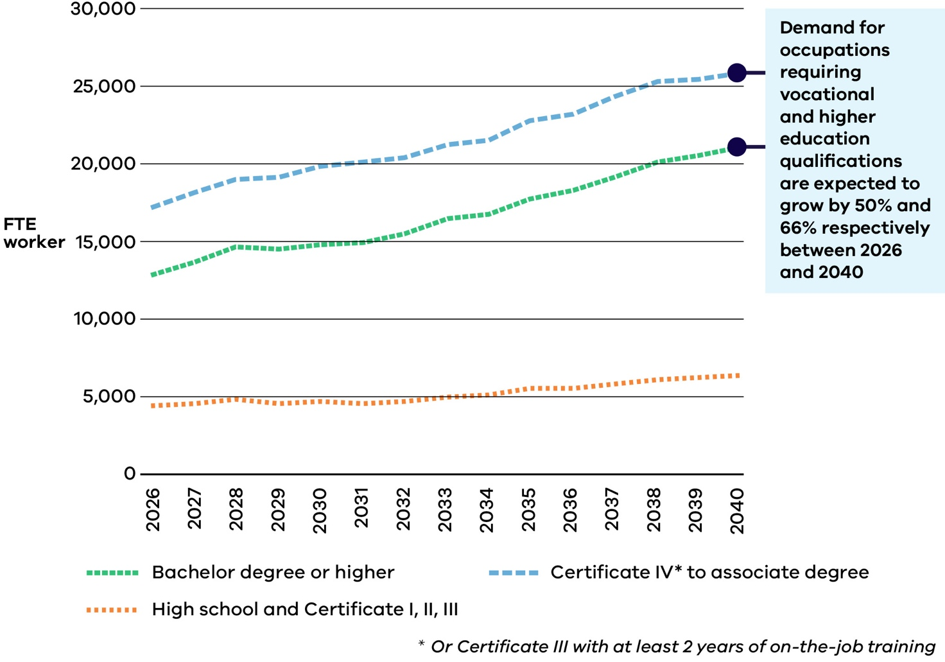
The energy sector workforce in Figure 41 includes the majority of energy generation (excluding construction of gas powered generation), energy networks, utility-scale energy storage, energy enablers, distributed energy resources, selected zero-emissions vehicle (ZEV) infrastructure (electric vehicle charging infrastructure only, excluding hydrogen vehicle refuelling infrastructure), and selected energy upgrades and services (residential electrification and services only, excluding residential energy efficiency and commercial, industrial, agricultural and forestry electrification and energy efficiency). It shows 53,300 FTE of the 68,100 FTE workers projected for 2040.
Skills First and Free TAFE: fee-free and subsidised access to training
Through Skills First and Free TAFE, the Victorian Government provides subsidised or fee-free access to clean energy training pathways.
Relevant energy sector subsidised training offerings include:
Accredited Short Courses (Skill Sets)
Course in Working Safely on Rooftop Renewable Energy Systems – also available as a Free TAFE short course
Grid-connected Photovoltaic Systems Designer-Installer Skill Set
Certificate II – apprenticeship pathways, also available as Free TAFE
Certificate II in Electrotechnology (Career Start)
Certificate II in Electrotechnology (Pre-vocational)
Certificate III
Certificate III in Electrotechnology Electrician – apprenticeship
Certificate IV
Certificate IV in Electrical Inspection
Certificate IV in Electrotechnology – Systems Electrician – apprenticeship
Certificate IV in Energy Management and Control – apprenticeship
Certificate IV in Electrical – Renewable Energy – apprenticeship
Note: Courses are subject to availability.

Higher education supported to lead the way in emerging energy technologies
Through the $350 million Victorian Higher Education State Investment Fund, the Victorian Government supported universities with capital works, applied research, and research infrastructure to boost Victoria’s economy.
More than $57 million in funding supported energy-related projects like Swinburne University’s Victorian Hydrogen Hub (VH2), the University of Melbourne’s Zero Emissions Energy Laboratory (ZEE Lab) and the Deakin Hydrogen Hub.
The Victorian Hydrogen Hub (VH2), led by Swinburne University in partnership with CSIRO and Germany’s ARENA2036, enables hydrogen research for industry and develops new hydrogen skill sets to equip the next generation of skilled workers that Australia needs to grow this emerging sector. VH2 has funded over 20 hydrogen PhD projects as well as internship opportunities at bachelor and postgraduate level in partnership with industry. Demonstration projects such as the VH2/CSIRO hydrogen refuelling station will provide the critical infrastructure needed to train future engineering students on hydrogen refuelling technology.

Education and training
For this Plan, the education and training sector includes learning opportunities for all ages, from primary school through to adulthood, across all abilities and levels, provided by both state-run and private institutions.
This sector covers primary school, secondary school, pre-accredited training, post-secondary qualifications, vocational education and training (VET) such as TAFEs and other registered training organisations. It also includes higher education, such as universities, and dual‑sector providers that combine vocational and higher‑education pathways. Other learning options, including micro‑credentials and industry‑recognised training, are also part of this sector.
Recognising that people have different learning preferences, strengths, and career ambitions, the sector aims to create pathways for Victorians to enter and move between education options as needed throughout their lives. As the energy system transitions, there is an ongoing need for education and training offerings and pathways to adapt and change to support the unique demands of the sector. Stakeholders note that this often requires workers to undergo additional training on the job or outside of work. Finding and accessing the right training can be challenging.
Industry will play a key role in providing expertise and ‘top up’ training in renewable energy specific technologies. Learners will benefit from industry and education partnerships to co-design and co-deliver the required skills.
Education and training Pathways
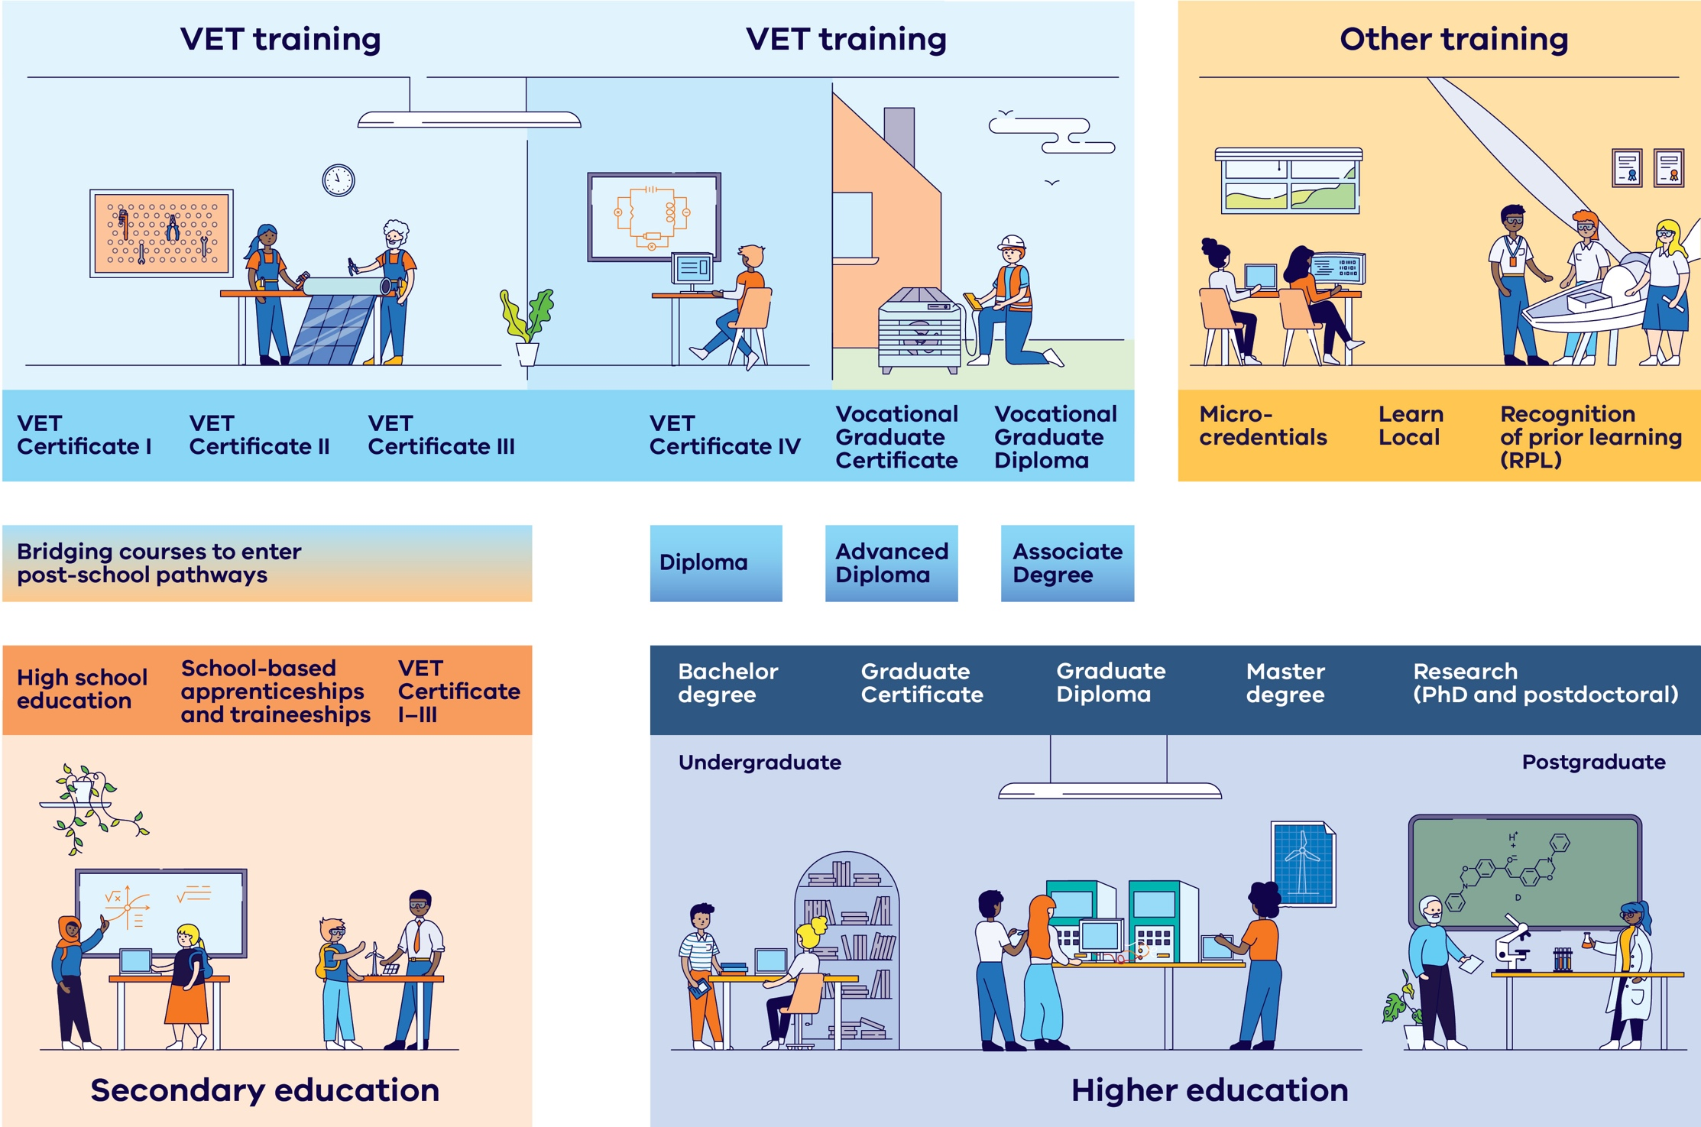

Education pathways into top occupations across the energy workforce vary
Top jobs | Education category | Education requirement
Electricians | Certificate IV (or Certificate III with at least 2 years of on-the-job training) to associate degree | Certificate III in Electrotechnology and apprenticeship
Plumbers | Certificate IV (or Certificate III with at least 2 years of on-the-job training) to associate degree | Certificate III in Plumbing and apprenticeship
ICT managers | Bachelor degree or higher | Bachelor degree or higher in a relevant field such as computer science, information technology, or a related field
Clerical and administrative workers | Certificate IV (or Certificate III with at least 2 years of on-the-job training) to associate degree | Certificate IV (or Certificate III with at least 2 years of on-the-job training) to associate degree qualification in a relevant field such as business or office administration
Engineers | Bachelor degree or higher | Bachelor degree in engineering

A top energy workforce occupation

Clerical and administrative workers
Clerical and administrative workers are essential to delivering energy services and projects, providing support to managers, professionals and organisations. They support teams and customers across project lifecycles from planning to construction and operations, and in the delivery of energy upgrades and services.
As the energy sector grows, demand for workers with clerical and administrative skills will increase.

Transferable, specialised, and foundational training is required
The roles and skills needed in the energy sector are changing, and education and training pathways must adapt quickly for the workforce to develop the required foundational, transferable and specialised skills. Vocational, higher education, and industry recognised training will each have a role to play.

Transferable training
There is a growing need for broad qualifications that offer transferable skills for various energy sector roles. These qualifications provide a base on which industry-specific skills, across a range of renewable energy areas, can be built. For example, there is a need for more people to complete qualifications such as a Bachelor of Electrical Engineering and a Certificate III in Electrotechnology.

Specialised training
There is also a rising demand for specialised training for roles and skills required for established and emerging renewable technologies. New training will be required to support development and capture the benefits of Victoria’s emerging energy technologies. For example, offshore wind projects will require wind yield performance analysts and workers installing rooftop solar and batteries or upgrading residential appliances will need specialised training.

Foundational training
Entry level positions that require foundational skills are also needed in the energy sector. Education pathways should provide opportunities to improve foundational skills such as literacy, numeracy, and communication to enable workers to enter these roles.

Upskilling
Rapid upskilling and reskilling is crucial to meet industry demands from the energy transition, and micro-credentials can help support this effort. For example, the Victorian Government’s Digital Jobs Program has helped workers improve their digital abilities rapidly, offering essential digital skills that could be used for roles in energy technologies like onshore and offshore wind, rooftop solar, utility-scale solar, and emerging technologies including renewable gases.
Figure 42: Foundational, transferable and specialised skills required across the energy sector.
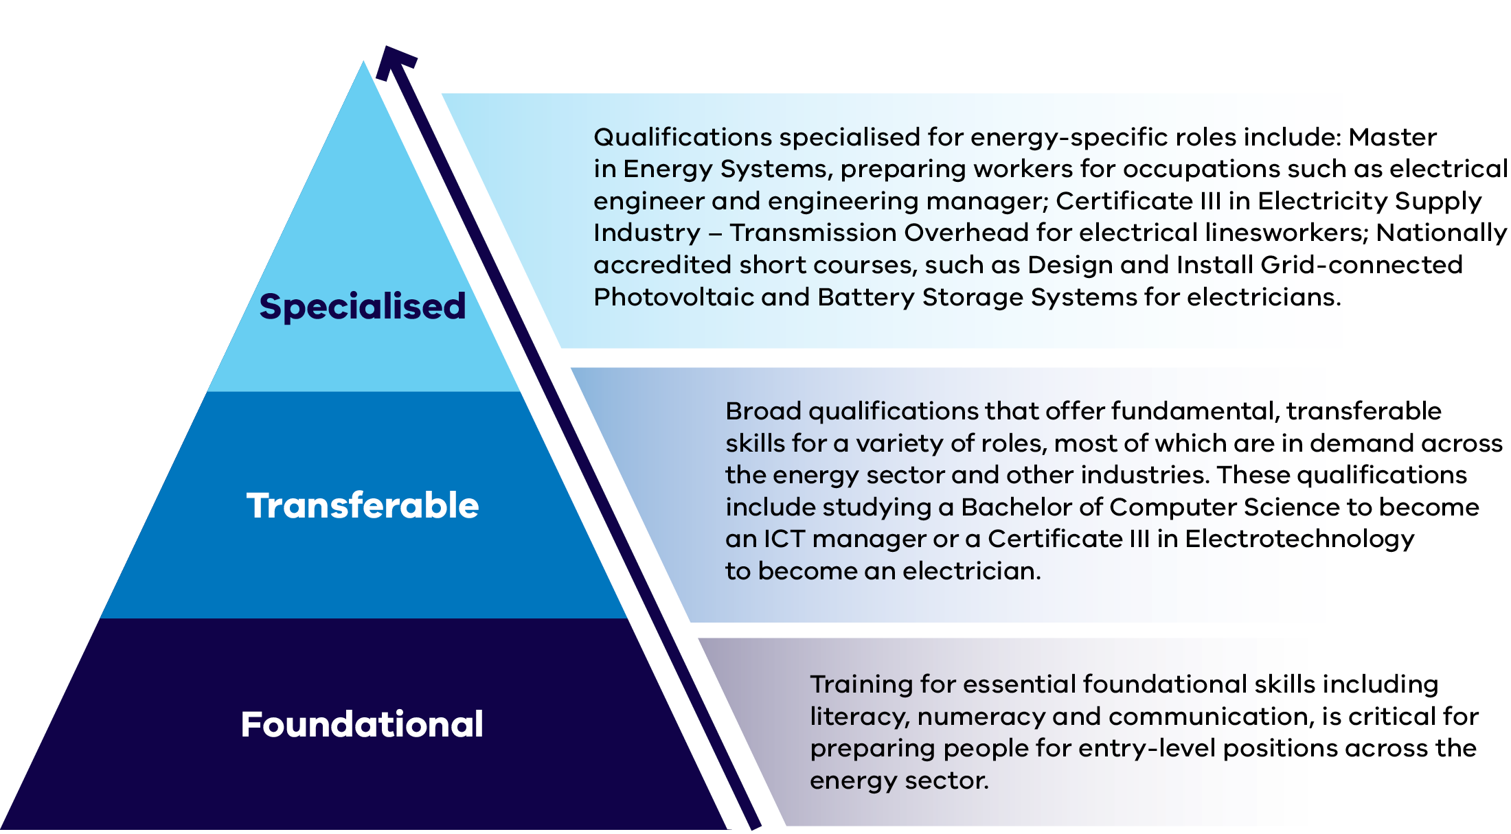
Foundational, transferable and specialised skills required across the energy sector
Skills type | Description
Specialised | Qualifications specialised for energy‑specific roles include: Master in Energy Systems, preparing workers for occupations such as electrical engineer and engineering manager; Certificate III in Electricity Supply Industry – Transmission Overhead for electrical linesworkers; Nationally accredited short courses, such as Design and Install Grid‑connected Photovoltaic and Battery Storage Systems for electricians.
Transferable | Broad qualifications that offer fundamental, transferable skills for a variety of roles, most of which are in demand across the energy sector and other industries. These qualifications include studying a Bachelor of Computer Science to become an ICT manager or a Certificate III in Electrotechnology to become an electrician.
Foundational | Training for essential foundational skills including literacy, numeracy and communication, is critical for preparing people for entry‑level positions across the energy sector.
A top energy workforce occupation
Engineers
Engineers are critical to Victoria’s energy workforce, spanning electrical, civil, mechanical, environmental and software roles. They design and improve systems that deliver energy safely – supporting renewables, grid upgrades, storage, transport electrification and digital infrastructure.
As energy programs grow, Victoria will need engineers with diverse expertise to meet demand across the transition and wider economy.

A shared approach to clean energy workforce development: the Clean Energy, Job Ready program
The Clean Energy Council’s Clean Energy, Job Ready program creates an industry-first, industry-agreed, sector-wide skills matrix, providing clear guidance on the qualifications, licences, and safety training needed for renewable energy trade roles.
Students and workers can also access a free skills passport enabling them to share their verified qualifications with employers and discover career pathways in clean energy.
Federation University and TAFE Gippsland are project partners. The Clean Energy, Job Ready program will be delivered nationally by Powering Skills Organisation.

Pathways should be clear and connected
Clear and connected education pathways will support students and workers, including transitioning workers, to skill, upskill or reskill. Information about these pathways and related training must be easily accessible to help students, apprentices, and transitioning workers see their options for progressing through different qualifications and potential careers.
Victoria already has a range of education offerings for students of all ages:
- Tech Schools provide Victorian secondary students with STEM exposure programs.
- Vocational Education and Training Delivered to School Students (VETDSS) enables students to undertake a VET certificate while completing secondary studies.
At a post-secondary level, options include universities, TAFE, dual-sector universities, registered training organisations, Learn Local Education and short course micro-credentials offered through both higher education and VET systems.
Mapping these connections is essential. It will highlight gaps in the pathways from education to a career in energy and help incorporate industry knowledge into current programs. Clear links between courses and renewable energy jobs will aid recruitment and support local businesses.
What we heard
Universities
Universities highlighted the significance of place-based approaches that integrate industry with research, education, and training to foster collaboration and innovation. Universities are actively working with industry partners to trial ‘earn while you learn’ models, including cooperative education programs featuring six-month paid internships and degree apprenticeships. Universities expressed support for initiatives that strengthen school-industry engagement pathways to higher education, such as entering university studies through vocational education and training programs, Local Learning and Employment Networks (LLENs), and Tech Schools, to better equip students for future energy careers.

Teachers and trainers for energy sector skills are required
An increasing number of educators will support the energy transition. Attracting enough teachers and trainers skilled in renewable energy technology is challenging. The industry is changing fast, and there is often a limited pool of qualified candidates who regularly have competing job offers.
Victoria needs to have the right number of VET trainers at TAFEs, schools, and Registered Training Organisations (RTOs). More competitive conditions and simpler pathways into teaching could attract more candidates. Flexibility in teaching roles, such as fellowships and secondments, could help skilled workers transition into these in-demand roles.
Encouraging industry professionals or retirees to join the VET workforce can also help fill the gap.
What we heard
Addressing training workforce shortages
Stakeholders suggested strategies to encourage experienced industry workers to contribute as part-time trainers, or ‘subject matter experts.’ These strategies included: industry-sponsored secondments and agreements specifying staff time release to deliver training; simplifying the process to gain training competency and qualifications; and providing more trainer role flexibility. Additionally, splitting dual trainer and assessor roles was recognised as a way of creating more possibilities for industry workers to match their skills with training work.

Apprentice numbers and completion rates could be improved
Completion rates for apprentices in key energy sector occupations and studies could be improved through increased support for apprentices, trainees, and their employers. Additionally, there are concerns regarding the experiences of female apprentices and other underrepresented groups within predominantly male workplaces.
To boost study completion, we need better on-the-job training and supervision. Creating positive, inclusive, and safe work cultures is essential. Exploring accessible delivery methods, guidance, financial aid, and diverse content can also help students complete their studies successfully.
Strengthening the connections between industry and the education sector is key. This can be done through work experience placements for students, hiring more apprentices and trainees, and industry-aligned curriculums. This approach will foster partnerships that benefit both students and employers in the long run.
Apprenticeships Taskforce
The Victorian Government established the Apprenticeships Taskforce to improve safety and fairness for apprentices and trainees in workplaces across Victoria. The Taskforce comprised of members with direct knowledge of the apprenticeship and traineeship system and made 16 recommendations to the Victorian Government to improve Victoria’s apprenticeship and traineeship system.
The Victorian Government has supported in-full or in-principle all 16 Taskforce recommendations, including:
- Establishing a central Helpdesk as a single point of guidance and case management
- Information sheets to set out rights and responsibilities for employers, apprentices, and trainees
- Legislative and regulatory reform to modernise the regulation of apprenticeships and traineeships
- Establishing a voluntary register of employers pledging to support gender equity in the employment of apprentices.

Energy education and training opportunities are required across Victoria
Victoria’s education and training system is supporting Victoria’s energy transition. The map shows where TAFEs, dual‑sector universities and universities are located across Victoria, alongside designated Renewable Energy Zones and key transmission infrastructure, illustrating how training providers are positioned to support workforce needs in the renewable energy transition.

Victoria’s energy and education system
Victoria has a world-class tertiary education system, with 10 universities, including four dual-sector universities offering both VET and higher education qualifications, and 11 TAFE institutes which, combined with the four dual-sector universities, make up the Victorian TAFE Network.
The Victorian Government has placed TAFE at the centre of the VET system, underlined by its commitment to a 70% funding guarantee. The Victorian TAFE Network is the largest supplier of VET in Victoria and trains more than 70% of the state’s apprentices. With over 90 campuses across Victoria and a presence in each of Victoria’s designated Renewable Energy Zones, TAFE will be a key provider in realising the clean economy.
The Victorian TAFE Clean Economy Prospectus outlines the skills and training contributions the Victorian TAFE Network can make to support this realisation, and opportunities for partnerships with industry.
Universities will also make a critical contribution in realising the clean economy, including by driving research, innovation and technological development, and delivering the skills and workforce needs to transition to net zero.

Renewable Energy Zones
Renewable energy zones (REZs) are areas in Victoria identified as the best places to host wind and solar projects and batteries for storage.

Offshore wind area
Offshore wind zones are areas declared by the Commonwealth Government as suitable for offshore wind energy.
Figure 43: Victoria’s energy and education system
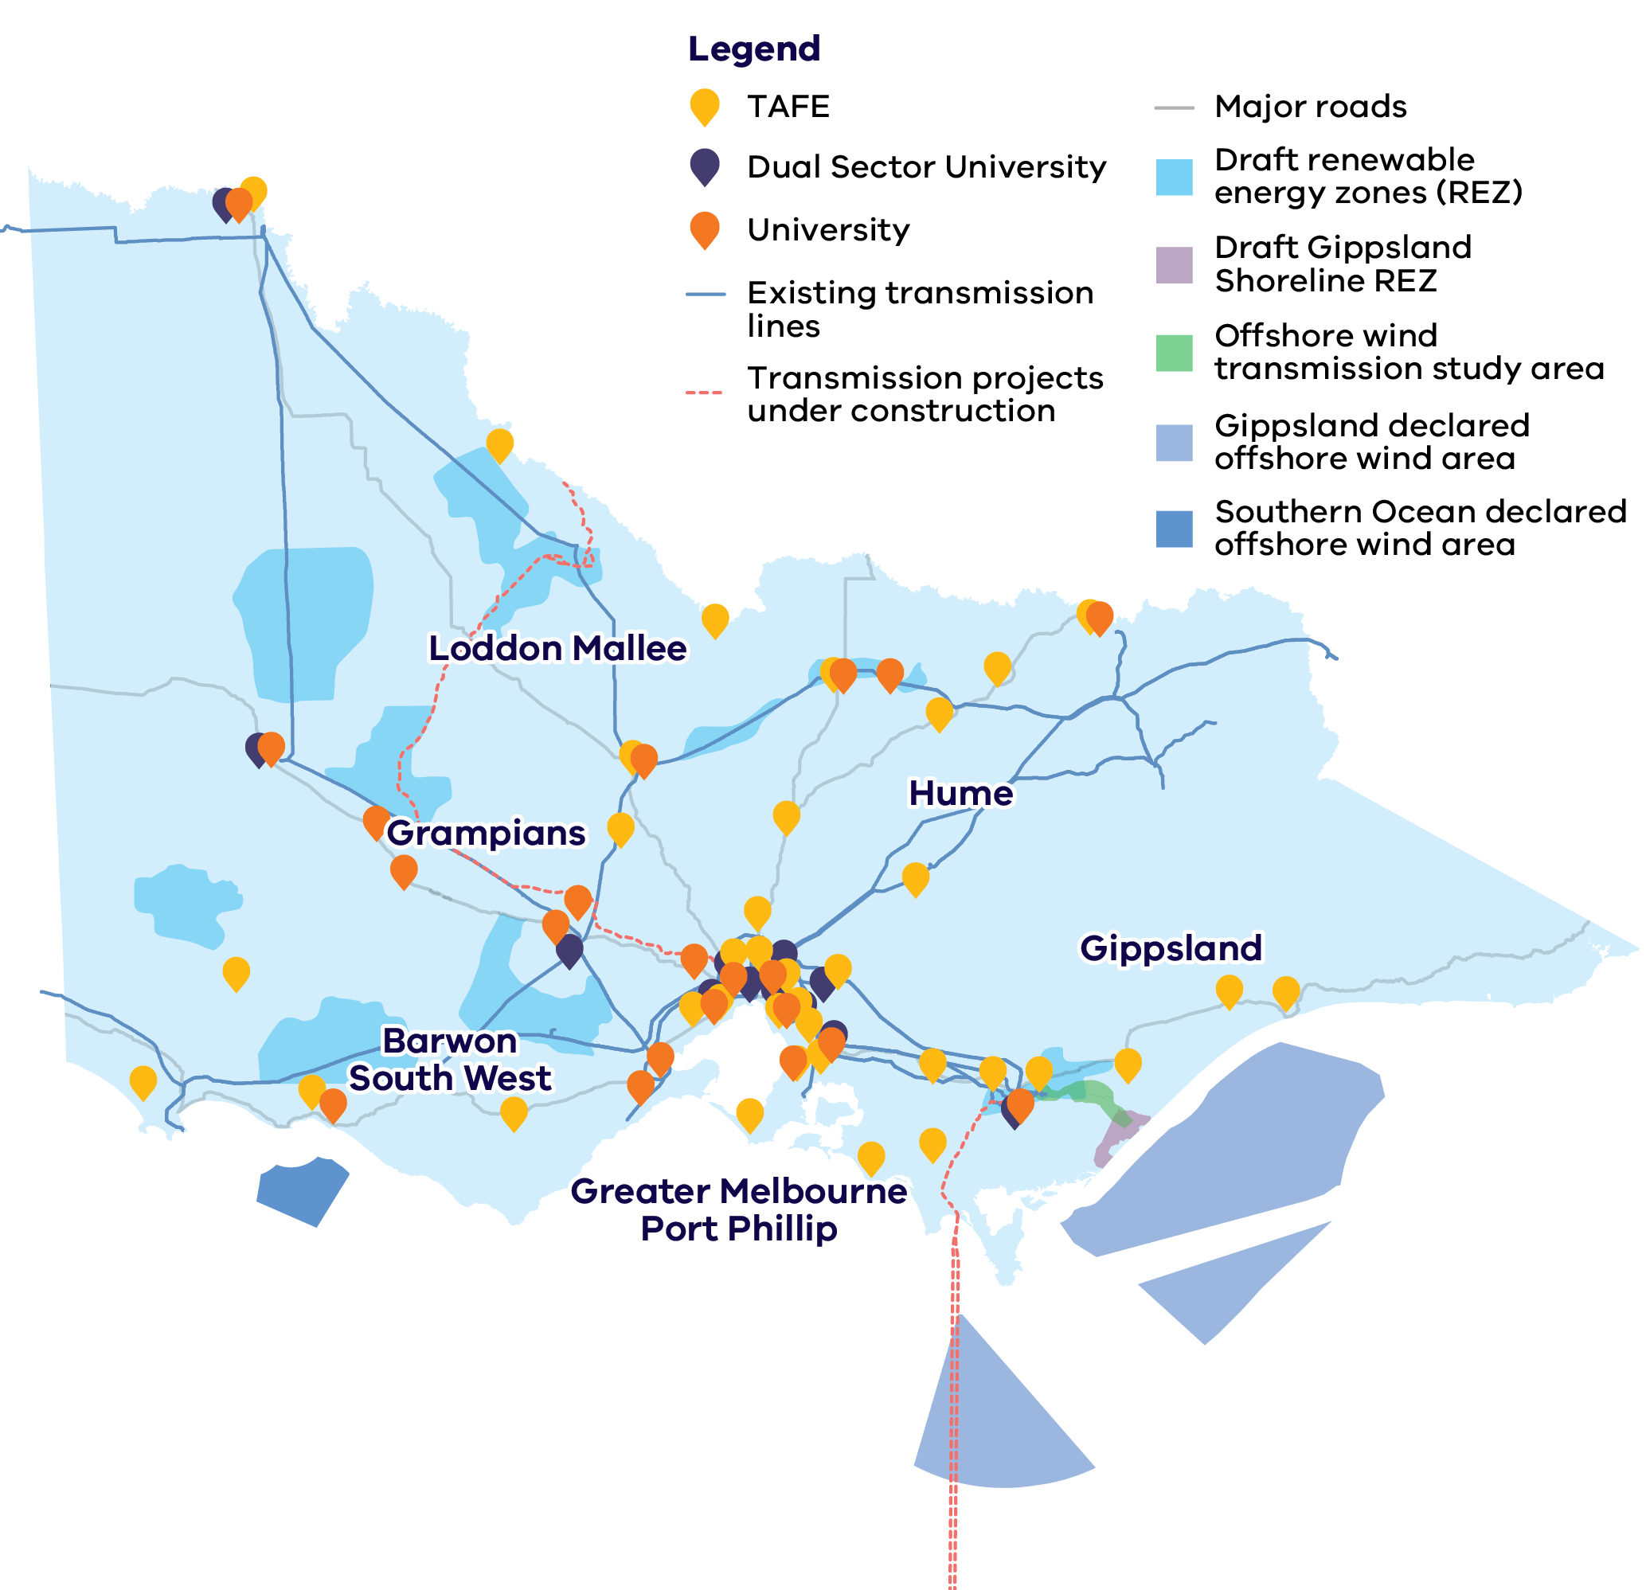

Addressing the energy transition through AI and digital innovation
Digital technologies and the integration of artificial intelligence (AI) are reshaping industries globally, including energy. The Victorian Government is taking steps to harness the power of AI and digital innovation, ensuring that both the workforce and energy sector are equipped to adapt and thrive in this changing landscape. These efforts are designed to unlock new economic opportunities, improve energy outcomes, and provide a skilled workforce to meet the growing demand for digital expertise.
The Victorian Government has released the AI Mission Statement, a key plan to drive Victoria’s responsible development and adoption of artificial intelligence and to generate AI investment, supported by a skilled workforce.

Building skills through the Digital Jobs Program
The Victorian Government is helping to address critical skill shortages through nation-leading skills programs such as the Digital Jobs program which has reskilled over 5,500 mid-career Victorians and upskilled over 500 workers in the manufacturing sector.
New funding of $4.25 million was announced in 2025 to extend this successful program for two years.
Commencing in August 2025, the EGS Digital Jobs program is fast tracking digital adoption in construction and advanced manufacturing by upskilling 1,000 workers and leaders in these priority sectors. The program will run over 4 rounds until June 2027.

Supporting digital innovation through CivVic Labs Challenges
Working in partnership with LaunchVic, DEECA has delivered two CivVic Labs Challenges – pre‑accelerators designed to help early‑stage founders develop solutions that accelerate Victoria’s transition to renewable energy. This initiative has demonstrated the potential for home-grown innovators to create employment opportunities for a broad range of skilled workers.
The 2023 Challenge selected ten early-stage digital solution start-ups for a 6-week bootcamp, providing $15,000 in equity-free funding, with two teams receiving an additional $35,000 to advance their prototypes. A success story from the program is HAL Systems, which applies AI to deliver energy efficient climate control in commercial buildings.
The 2025 Challenge selected 16 early-stage energy technology start-ups for an 8-week bootcamp, providing $10,000 in equity-free funding, with four teams receiving an additional $35,000 to progress their solutions further. A notable example is FleetOPT, a digital twin and software platform that optimises EV bus fleet operations.

Meeting the challenge
To build energy workforce capability, more people must be encouraged into energy education pathways. Students and apprentices must be supported to finish their studies and gain qualifications. At the same time, the number of teachers needs to increase. It is also important to ensure courses stay aligned with changing industry needs.
Targeted actions have been identified to help create change across four key outcomes:
- Outcome 5: People actively seek teaching roles in the energy sector
- Outcome 6: Students, apprentices and trainees engage with study and complete qualifications
- Outcome 7: Education offerings and pathways adapt to evolving skills needs
- Outcome 8: Education pathways from school to the energy workforce are clear and connected

Outcome 5: People actively seek teaching roles in the energy sector
Addressing the shortage of VET trainers for TAFEs, schools, and RTOs is crucial. Creating clear pathways into secure, well-remunerated teaching roles, with increased flexibility and support from industry and educational institutions, is essential.
The Victorian Government is acting to support people to enter teaching roles in the energy sector through:

Initiatives underway:
- Encouraging industry professionals to transition into teaching roles by covering tuition fees for teaching qualifications, such as the Certificate IV in Training and Assessment, under Victoria’s Free TAFE program.
Supporting a responsive, high quality training workforce through the provision of professional development supports including a Clean Economy e-learn and opportunities for research fellowships in clean energy through the International Specialised Skills Institute.

Initiatives commencing:
Supporting existing TAFE teachers in the energy sector to remain in the VET workforce and access higher-level teaching roles by covering tuition fees for higher teaching qualifications, such as the Diploma of Vocational Education and Training and the Graduate Certificate of Adult Vocational Education and Training.

The call to action
To achieve this outcome, the energy industry, the education and training sector, and governments need to work together to:
- Increase flexibility for skilled workers to take on teaching roles by supporting links between education institutions and industry
- Encourage teaching in the energy sector by creating clear pathways into well-remunerated teaching roles.

Outcome 6: Students, apprentices and trainees engage with study and complete qualifications
Increasing support for students, apprentices, and trainees, along with their employers, will boost completion rates. Strengthening legislation to ensure quality training and supervision, while fostering inclusive and safe workplaces, will create a positive environment for learning and working.
The Victorian Government is acting to support students, apprentices, and trainees to engage with study and complete qualifications through:

Initiatives underway:
- Providing secondary students with a valuable introduction to energy careers and workplaces, by delivering 10,000 work experiences placements for in-demand industries including renewable energy.
- Providing apprentices and trainees with free information and support through the Apprentice Helpdesk and confidential short-term counselling and coaching for a broad range of health and wellbeing matters through the Apprentice Employee Assistance Program.
- Providing apprentices with free and confidential support and advice through Apprenticeship Support Officers (ASOs) located across Victoria.
- Addressing diverse students’ needs by continuing to implement existing education delivery mandates such as the Equal Opportunity Act and Disability Discrimination Act.
Continuing to support Aboriginal and Torres Strait Islander students in Victoria to reach their full potential through implementation of Victoria’s commitments under the National Agreement on Closing the Gap.

Initiatives commencing:
Improving safeguards for apprentices and trainees by reforming legislation including through reform of the Apprenticeships and Traineeship Regulator, mandating data sharing processes, and modernising the Education and Training Reform Act 2006 (Vic) (ETRA) to clarify objectives and enhance safeguards and oversight.

The call to action
To achieve this outcome, the energy industry, the education and training sector, and governments need to work together to:
- Improve conditions and safeguards for apprentices and trainees
- Enhance learning outcomes and career prospects by strengthening links between the energy sector and education and employment institutions
- Address barriers for people to complete their studies by investing in student and apprenticeship support models and financial assistance
Support underrepresented groups and local students and workers to complete their studies by ensuring education and training delivery methods are accessible and content meets diverse needs.

Outcome 7: Education offerings and pathways adapt to evolving skills needs
Victoria has a strong foundation in higher and vocational education and training. As the renewable energy industry evolves and new skills are needed, providers must make education more accessible, update pathways and content, improve delivery methods, and strengthen industry connections to meet demand.
The Victorian Government is acting to support education offerings and pathways to adapt to evolving skills needs through:

Initiatives underway:
- Investing in new and upgraded education and training facilities, including in regional Victoria, through the $50 million TAFE Clean Energy Fund, such as the Asia Pacific Renewable Energy Training Centre (APRETC) at Federation University , a clean energy centre at TAFE Gippsland’s Morwell Campus and a Building Innovation and Design Centre at South West TAFE’s Sherwood Park campus.
- Supporting business and industry to understand and engage with the Victorian TAFE network on the clean economy and developing solutions for emerging workforce and skills needs through the TAFE Clean Economy Prospectus.
- Providing opportunities for workers to upskill via training and workforce development activities including Solar Victoria’s Electrification Skills Program, and Energy Safe Victoria’s Continuing Professional Development Program.
- Supporting people to access essential foundational skills training, such as literacy, numeracy, use of ICT, and communication, through Skills and Jobs Centres.
- Ensuring the skills required for the renewable energy workforce are identified and built into education products and pathways through evidence-based co-design with learners and industry, including VET offerings at schools and TAFEs through the $7 million VET certificates in renewable energy project.
- Advocating for Victoria’s strategic workforce priorities through engagement in national reform of the higher education system, following the Australian Universities Accord.

Initiatives commencing:
- Identifying critical workforce needs and delivering specialist training programs to prepare workers for renewable energy careers by establishing the Victorian Renewable Energy TAFE Centre of Excellence – with Victorian and Australian Government
co-funding.

The call to action
To achieve this outcome, the energy industry, the education and training sector, and governments need to work together to:
- Address workforce needs by designing training models and qualifications through collaboration
- Support students to access higher education and VET systems throughout their careers in the energy workforce
- Ensure training programs and facilities meet industry needs by exploring collaboration and co-investment opportunities
- Support workers to upskill quickly by supporting the development and recognition of shorter courses that address targeted required skills for the energy sector
- Support workers to acquire the transferable skills needed for energy sector jobs by integrating energy-related qualifications into broader education products and pathways
Support more people to gain employment through entry level roles in the energy workforce by building foundational knowledge skills into energy education pathways.

Outcome 8: Education pathways from school to the energy workforce are clear and connected
To attract and retain workers, awareness of energy sector roles must start at school and continue through all education levels, with clear pathways into vocational and higher education. The Victorian Government is acting to support education pathways from school to the energy workforce through:

Initiatives underway:
- Increasing school students’ understanding of renewable electricity through the ResourceSmart Schools program.
- Encouraging more school students to consider careers in essential trades and STEM careers, including through Victoria’s Tech Schools.
Expanding student pathways into clean energy related roles, by delivering a Renewable Energy VCE VET program containing qualifications including a Certificate II and Certificate III in Renewable Energy.

The call to action
To achieve this outcome, the energy industry, the education and training sector, and governments need to work together to:
- Improve connections between school learning, post-secondary studies, and the energy workforce by identifying and addressing gaps in the education pathways into an energy career
- Help individuals enter and complete industry-relevant studies by creating education pathways for new and emerging energy sector occupations and skills.

Focus area 3:
Improving confidence and coordination

Vision
Confidence and investment in Victoria’s energy transition is buoyed by coordinated efforts across the sector, and supports the creation of a robust, future-ready energy workforce.

Confidence and coordination challenges and opportunities
As demand for energy workers increases across Victoria, planning and coordination will be integral to the delivery of Victoria’s energy transition, which will maximise investment and local community benefits.

Planning and coordination will be required to respond to workforce demand across Victoria

A coordinated energy transition will support workforce demand
The energy transition demands an overall increase in workforce numbers. Coordinating infrastructure projects is important to ensure workforces can move between projects.
Project coordination can support workers to more easily move from one project to another, helping to mitigate construction delays. This is particularly the case for specialised occupations with fewer qualified people, such as transmission linesworkers.
Figure 44: Highest workforce demand by region and year across Victoria between 2026 and 2040
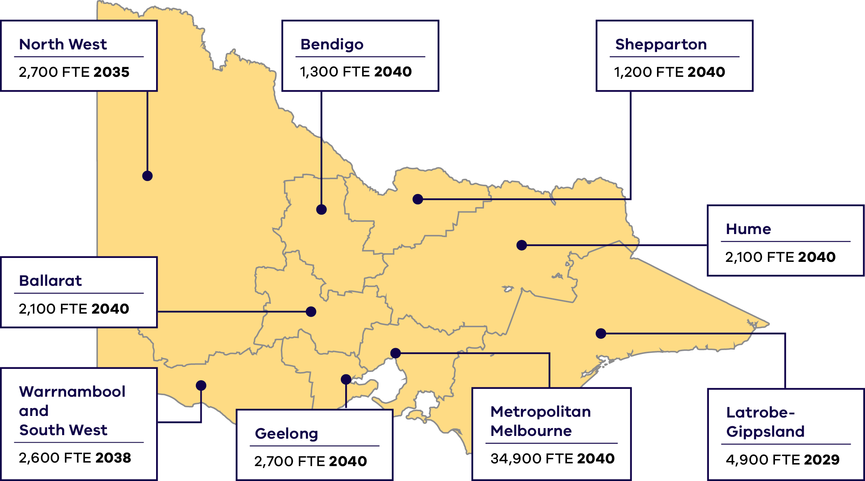
Highest workforce demand by region and year across Victoria between 2026 and 2040 as shown in Figure 44.
Region | Peak workforce  demand (FTE) | Year of  peak demand
North West | 2,700 | 2035
Warrnambool and South West | 2,600 | 2038
Bendigo | 1,300 | 2040
Ballarat | 2,100 | 2040
Shepparton | 1,200 | 2040
Geelong | 2,700 | 2040
Hume | 2,100 | 2040
Latrobe-Gippsland | 4,900 | 2029
Metropolitan Melbourne | 34,900 | 2040
The map in Figure 44 shows the potential location of energy sector activity. Job locations may be different from activity locations.
Source: Australian Bureau of Statistics (ABS) Statistical Area Level 4 (SA4)
The energy sector workforce demand regional breakdown in Figure 44 includes energy generation (excluding construction of gas powered generation), energy networks, utility-scale energy storage, energy enablers, distributed energy resources, zero emissions vehicle (ZEV) infrastructure (electric vehicle charging infrastructure only, excluding hydrogen vehicle refuelling infrastructure), and energy upgrades and services (residential electrification and services only, excluding residential energy efficiency and commercial, industrial, agricultural and forestry electrification and energy efficiency). It shows 53,300 FTE of the 68,100 FTE workers projected for 2040.
A coordinated transition ensures sustainable benefits for workers and the community, helping to ensure workers are where they are needed and there is a smooth transition from construction to maintenance phases. This should include a coordinated approach to attracting interstate residents and migrants to work in Victoria’s energy sector.
Local communities will play a key role and benefit from greater project planning. The Victorian Government is committed to engaging with local communities early and often. This approach will support local workers and businesses and ensure benefit-sharing arrangements for hosting infrastructure.
In 2040, it is projected that 18,400 FTE jobs will be in regional areas and 34,900 FTE jobs will be in metropolitan Melbourne across the energy sector.

Workforces for different project phases will need to be planned for and coordinated
From 2026 to 2040, significant construction, operations and maintenance workforces will be needed across Victoria to build and service large scale generation, storage and transmission projects. Planning and coordination will be required to manage periods of high workforce demand.
The construction workforce for large-scale generation, storage and networks infrastructure projects is projected to be at its highest in 2028.
This aligns with Victoria’s renewable energy targets – 65% by 2030 and 95% by 2035 – alongside targets for energy storage and offshore wind. As these milestones drive different phases of the energy transition – from planning and construction to integration and operation – workforce needs will evolve, requiring new skills, roles, and capacity at each stage.
Demand for operations and maintenance workers is projected to steadily increase as new infrastructure comes online.
Construction and operation and maintenance workforces will be required throughout the period to 2040
Figure 45: Projected workforces for large scale energy generation, utility-scale energy storage, and energy networks* between 2026 and 2040
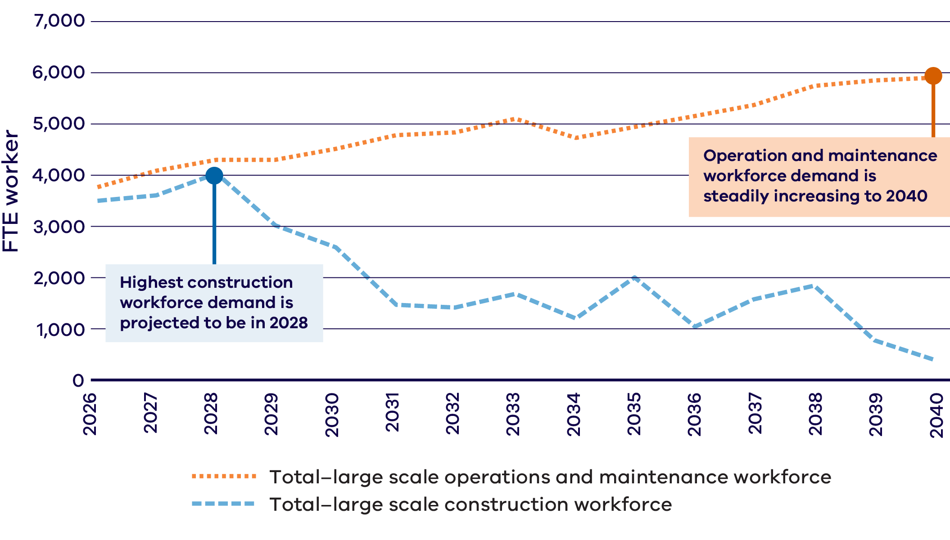
*Note: Energy networks does not include distribution network workforce projections due to lack of available information on construction and operation and maintenance requirements within distribution.

Improved understanding and preparation is required to support the transition and market confidence

Market certainty is a key enabler of the transition
Securing the investment needed for constructing new energy infrastructure requires developers to forecast future revenue. This prediction depends heavily on clear government policies and the alignment of key players in the sector. Such confidence is essential not only for investors but also for education and training providers to adapt and meet future workforce needs.
Victoria’s energy targets have driven certainty around the energy transition. Further policy certainty and confidence in investment can be achieved by working with the Commonwealth on national workforce challenges. Victoria’s social procurement and Local Jobs First policies can support the renewable energy workforce transition.
Promoting large-scale projects, strong energy policies, and natural renewable resources will bolster confidence in renewable energy jobs. Removing barriers and creating incentives will encourage industry and consumers to switch to renewable energy sources.

Understanding future workforce needs will support planning and coordination
To support the energy transition and boost confidence in investment, better data and insights about the Victorian energy workforce are essential.
Detailed data on project pipelines, including type, size, and timing, is also necessary. Region-specific data will help local industries better plan their workforce and education pathways.
The Victorian Government is committed to developing effective data collection and analysis methods. This includes providing up-to-date data, with the ability to view
region-specific or demographic information. These tools could in future enable targeted responses to the needs of regional communities and underrepresented groups, such as First Peoples, women, and people with disabilities.

Taking the lead in developing renewable energy skills and workforce can bring opportunities to Victoria
Over the past decade, Victoria has made world leading progress on the energy transition and invested in developing its renewable energy skills and workforce capabilities. This progress has helped lay the foundation for upcoming investments including the National Training Centre in New Energy Skills, which will be established in Melbourne’s west, and the Victorian Renewable Energy TAFE Centre of Excellence. With Victorian Government and Commonwealth co-funding, these two initiatives represent a combined investment of $90 million in developing the skills needed for Victoria’s energy workforce.
Raising the profile of Victoria’s energy transition and developing training offerings targeted to building renewable energy capabilities, can attract talent from across Australia and internationally. Alongside developing our local workforce, continuing to attract skilled workers and new renewable energy projects to Victoria will be important to delivering Victoria’s energy transition.
National Training Centre in New Energy Skills
The National Training Centre in New Energy Skills (the Centre) will be established in Melbourne’s west, bolstering Victoria’s reputation as Australia’s leader in new energy education and training.
The Victorian Government is committing $10 million to establish the Centre, with $20 million being contributed by the Australian Government and $10 million by the Plumbing Industry Climate Action Centre (PICAC) for a total of $40 million in co-funding.
Delivery of the Centre will be led by PICAC, and will prioritise training for tradespeople and apprentices in installing and maintaining new and energy efficient technologies – such as heat pumps.
Once established, the Centre will have capacity to train and upskill over 2,000 tradespeople and apprentices each year across new energy occupations, including but not limited to plumbers, gasfitters, electricians and refrigeration workers.
Supporting the Latrobe and broader Gippsland region’s net zero workforce transition
In early 2026, the Victorian Government entered a partnership agreement with the Australian Government’s Net Zero Economy Authority and Department of Employment and Workplace Relations. This partnership has been established to support the Latrobe and broader Gippsland region’s economic and net zero transition – with a strong focus on workforce transition in anticipation of planned coal power plant closures.
The partnership will work across all levels of government to unlock and coordinate a variety of supports for transitioning workers and their surrounding communities, including businesses, industry, and First Peoples.
Through this agreement, the Victorian and Australian Governments will collaborate on investment facilitation to grow future employment opportunities in the region – particularly in offshore wind and other renewable energy industries – ensuring Gippsland benefits from the economic opportunities created by Victoria’s clean energy transition.

Meeting the challenge
Clear policy, workforce data and collaborative workforce planning is required to coordinate workforce demand and encourage investment and innovation from industry and the education and training sector. This will help guide investment and ensure the workforce is available where and when it is required.
Targeted actions have been identified to help create change across four key outcomes:
- Outcome 9: Victoria is the national leader in developing renewable energy skills and workforces
- Outcome 10: Public and private investment in the energy workforce is driven by clear, consistent and coordinated renewable energy policies and workforce strategies
- Outcome 11: Publicly available data provides a clear picture of energy workforce and skills needs
- Outcome 12: Workforce planning is improved by effective coordination and forward planning of infrastructure projects

Outcome 9: Victoria is the national leader in developing renewable energy skills and workforce
To continue to build Victoria’s reputation as a leader in renewable energy education, we must promote Victoria’s energy transition, support the energy industry with education and training institutions to build connections, prepare for emerging energy technologies, and simplify pathways for skilled workers from across Australia and abroad to move to Victoria.
The Victorian Government is acting to support Victoria to be the national leader in developing renewable energy skills and workforce through:

Initiatives underway:
- Bolstering the Victorian Government’s renewable energy investment attraction activities to create job opportunities across the sector, through the annual Renewable Energy Investment Prospectus updates.
- Supporting international talent to move to Victoria by continuing to prioritise energy sector occupations through Victoria’s Skilled Migration Visa Nomination Program.
- Supporting businesses and industries, including in the energy sector, by advocating to the Commonwealth Government for changes to Australian migration program settings.
- Increasing opportunities for skilled migrants in the energy sector by collaborating with the Commonwealth Government to investigate streamlining visa and migration processes and filling critical energy skills shortages.
Increasing opportunities for international students and graduates in the Victorian energy workforce by addressing employment barriers and promoting post-study pathways for global talent through the Victorian Government’s lead agency for international education and international students, Study Melbourne.

Initiatives commencing:
- Training thousands of tradespeople to install and maintain new and energy efficient technologies by establishing the National Training Centre in New Energy Skills – a joint initiative between the Australian Government, Victoria and the Plumbing Industry Climate Action Centre.
- Exploring the potential for applied skills development and training-to-employment pathways as part of the Victorian Government’s renewable energy industrial precincts analysis.
Reducing barriers to national and international energy sector talent moving to Victoria for work, by identifying high priority energy sector qualifications and advocating to recognition authorities for more effective recognition of Australian qualified workers and overseas qualifications.

The call to action:
To achieve this outcome, the energy industry, the education and training sector, and governments need to work together to:
- Seek to enhance innovation through actively co-locating energy industry and infrastructure with education and training entities, drawing upon national and international best practice
- Prepare for the future workforce now by leveraging Victoria’s unique education and training capabilities to support emerging energy technologies that can have Australia-wide benefits
- Make it easier for skilled national and international energy talent to move to Victoria by reducing barriers.

Outcome 10: Public and private investment in the energy workforce is driven by clear, consistent and coordinated renewable energy policies and workforce strategies
To build confidence in the energy transition the Victorian Government has set ambitious, nation-leading renewable energy targets and will support the coordination of competing infrastructure projects through prioritised planning and policies that deliver long-term benefits to communities.
The Victorian Government is acting to support public and private investment in the energy workforce through:

Initiatives underway:
Helping to create local job opportunities, including for apprentices, trainees and cadets, by ensuring small and medium size enterprises are given a full and fair opportunity to compete for both large and small government contracts, through the application of Local Jobs First to Victorian Government supported energy projects in Victoria.
Ensuring renewable energy skills are appropriately identified and classified nationally, by continuing to work with Jobs and Skills Australia to inform the development of the National Skills Taxonomy.
De-risking industry investment in skills and workforce and promoting local workforce opportunities, through the SEC partnering with the private sector to invest an initial $1 billion in renewable energy generation and storage.
Articulating Traditional Owners objectives for the renewable energy transition, including employment and mentoring opportunities, by co-designing the First Peoples Renewable Energy Strategic Plan with a working group of nominated officers from Registered Aboriginal Parties.

Initiatives commencing:
- Improving outcomes for the Victorian energy workforce, including net zero transition and boosting digital skills, by working with the Commonwealth and state and territory governments on the National Skills Agreement including TAFE Centres of Excellence.
- Facilitating public and private sector participation and investment in the Latrobe and broader Gippsland region energy transition by collaborating with Australian Government entities including the Net Zero Economy Authority to unlock funding pathways such as Future Made in Australia.

The call to action:
To achieve this outcome, the energy industry, the education and training sector, and governments need to work together to:
- Build community confidence in the energy transition and its workforce opportunities by promoting sustainable employment and delivering positive social and environmental outcomes for communities
- Support a national approach to developing the energy workforce by planning for new and transitioning sector workforces
Encourage private and Commonwealth investment in the Victorian energy transition and its workforce by identifying, creating, and promoting co-investment opportunities.

Outcome 11: Publicly available data provides a clear picture of energy workforce and skills needs
To support informed decision‑making and boost investment confidence, the Victorian Government will improve access to high‑quality, transparent data on the state’s energy workforce, project pipeline and regional needs. This will enable industry, education providers and communities to plan effectively for future skills and workforce requirements.
The Victorian Government is acting to provide a clear picture of the energy workforce and skills needs through:

Initiatives underway:
Improving understanding of the energy workforce, by working with RACE for 2030 Cooperative Research Centre and the Institute for Sustainable Futures at the University of Sydney to undertake energy sector workforce projections, conducting research and analysis, and exploring linking together existing workforce skills and training data products.

Initiatives commencing:
- Improving access to workforce data and analysis by publishing regular and robust reports of the current and forecast energy sector workforce to inform government, industry and community planning, including through the annual report of the Victorian Skills Plan, and utilising the publicly accessible Employment Projections Dashboard.
- Improving access to energy workforce-specific data and analysis by reviewing the Victorian Energy Jobs Plan regularly to ensure it meets the needs of the changing energy sector.
Enhancing understanding of workforce potential and projects for emerging energy technologies, including renewable hydrogen, biomethane and other renewable fuels, and alternative energy storage technologies.

The call to action:
To achieve this outcome, the energy industry, the education and training sector, and governments need to work together to:
- Support informed decision making by improving access to energy workforce-specific data and analysis
Improve the shared understanding of the energy workforce by enhancing data consistency.

Outcome 12: Workforce planning is improved by effective coordination and forward planning of infrastructure projects
To improve workforce planning, the Victorian Government will strengthen coordination between workforce and infrastructure needs by supporting long‑term planning for transmission and renewable energy projects, and by working with local governments and communities to provide greater certainty, reduce disruptions and maximise local benefits.
The Victorian Government is acting to support improved workforce planning through:

Initiatives underway:
- Supporting the delivery of the transmission projects Victoria needs for the energy transition through VicGrid and the delivery of the Victorian Transmission Plan, which sets out a clear prioritisation and timeline for these projects. The 2025 Plan provides a 15-year outlook. It will be updated in 2027 with a 25-year outlook and every 4 years after or more often if required.
- Coordinating the development of Victoria’s offshore wind sector, guiding industry and communities, and supporting Traditional Owners’ aspirations, through Offshore Wind Energy Victoria (OWEV) and the delivery of Offshore Wind Energy Implementation Statements.
- Supporting local government to plan for renewable energy development in their regions, by working with Regional Development Australia and Regional Partnerships on initiatives such as Renewable Energy Impact and Readiness Studies.
- Updating Victorian Government expectations on energy infrastructure developers’ delivery of social value, including local jobs and local industry participation, in line with contemporary best practice.
- Providing an escalation point to ensure agencies, regulators and statutory authorities meet all required approvals deadlines for major projects of state significance through the Investment Coordinator General.
Coordinating government, industry and community partnerships to support renewable energy zone hosting communities to plan for renewable energy development in their regions, minimise cumulative impacts and enhance economic and social value for their region.

Initiatives commencing:
- Supporting local governments to seek funding for investment attraction campaigns and local workforce social procurement.
Preparing to commence a Request for Proposal (RFP) process for offshore wind feasibility licence holders in 2026, subject to a future government decision.

The call to action:
To achieve this outcome, the energy industry, the education and training sector, and governments need to work together to:
- Enhance workforce capacity for Victorian energy projects through actively seeking opportunities to better integrate workforce and infrastructure planning
- Support planning for and investment in local jobs by working collaboratively across developers, local businesses (including sub-contractors), and governments to plan for local energy projects
- Updating Victorian Government expectations on energy infrastructure developers’ delivery of social value, including local jobs and local industry participation, in line with contemporary best practice
- Improve delivery of social value, including local jobs and local industry participation in energy sector project delivery through inclusive project planning and coordination.

Towards 2040 and beyond: Empowering a future-ready Victorian energy workforce

Working together
Victoria’s renewable energy transition is unlocking new possibilities and thousands of jobs. Together, government, the energy industry, and the education and training sector can build a future-ready energy workforce, prepared to shape Victoria’s evolving energy system.

A new coordinated position, backed by foundational workforce modelling
This Plan establishes a new coordinated position to prepare Victoria’s energy workforce for future demands. It introduces new workforce modelling and analysis that advances our understanding of Victoria’s energy workforce and brings together initiatives that are supporting the development of a skilled Victorian energy sector workforce.

Building workforce capacity and capability, and driving coordination
Through this Plan, we are setting out to grow the Victorian energy workforce’s capacity, build capability and drive coordination and investment.
Growing and retaining capacity is vital to ensuring Victoria’s energy sector workforce can reach its projected size of 68,000 FTE workers by 2040. Attracting and keeping people in the energy sector is a priority, and the sector must offer clear, engaging career options for all potential workers, students, and job seekers. Workplaces can champion diversity and foster inclusive cultures, creating environments where all people are welcome.
Strengthening workforce capability is key to meeting the demands of new and evolving technologies. Education and training offering and pathways must be able to support the needs of students, teachers, workers, and the energy industry, ensuring the workforce is equipped to drive the transition and maximise the benefits to Victoria.
Clear energy sector policy direction, workforce insights and collaborative workforce planning are guiding coordination, encourage investment and can help ensure the energy workforce is available where and when needed.

Implementation
The Victorian Government commits to realising the outcomes of this Plan, working closely with the energy industry and the education and training sector. Through coordinated action, Victoria is building an energy system and workforce equipped to meet the needs of 2040 and beyond.

Data appendix

Notes
Where top occupations are listed with multiple five- or ten-year full-time equivalent (FTE) averages, they are ordered by their average representation across the 2026-2040 period, reflecting their relative demand over time.
Occupational data for the energy upgrades and services sector includes only residential electrification and services in this data appendix.
Occupational data for the distributed energy resources and ZEV infrastructure sector excludes hydrogen vehicle refuelling infrastructure due to available occupational data in this data appendix.

Data appendix A

Projected workforce by ANZSCO major groups and by energy sector, 2026-2040
This table shows Victoria’s projected energy workforce by ANZSCO major groups and by energy sector from 2026 to 2040.
The projected annual average worker demand is shown by full-time equivalent (FTE) workers.
Table 2: Projected workforce by ANZSCO major groups and by energy sector, 2026-2040
Workforce breakdown |  |  |  |  | Victoria’s energy sector
 |  | 2026 | 2040 | 2026-2040 | Annual average FTE workers needed 2026-2040
ANZSCO  Group no. | Job category | FTE  workers | FTE  workers | Annual average FTE workers | Energy  generation | Energy networks |  | Energy enablers |  | Large-scale energy storage | Energy upgrades and services | DER  and ZEV infrastructure
1 | Managers  e.g. Production Manager | 5,347 | 11,439 | 8,167 | 875 | 1,735 |  | 1,653 |  | 26 | 50 | 3,828
2 | Professionals  e.g. Engineers | 7,665 | 10,219 | 8,952 | 993 | 3,493 |  | 2,287 |  | 24 | 812 | 1,343
3 | Technicians and Trades Workers  e.g. Electricians and plumbers | 13,564 | 20,311 | 17,055 | 2,654 | 2,093 |  | 798 |  | 62 | 7,292 | 4,156
5 | Clerical and Administrative Workers  e.g. Call Centre Information Clerk | 4,135 | 6,427 | 5,199 | 405 | 2,116 |  | 1,131 |  | 17 | 196 | 1,334
6 | Sales Workers  e.g. Sales Representative | 872 | 2,527 | 1,666 | – | 355 |  | 331 |  | – | – | 980
7 | Machinery Operators and Drivers  e.g. Truck driver | 982 | 702 | 792 | 202 | 198 |  | – |  | 14 | – | 378
8 | Labourers  e.g. Concreter | 1,816 | 1,721 | 1,675 | 223 | 267 |  | – |  | 49 | 67 | 1,069
N/A | Emerging sectors and activities without available occupational data | 10,251 | 14,786 | 9,031 | 101 | – |  | – |  | – | 8,307 | 623
Total jobs |  | 45,000  (44,632) | 68,000  (68,132)

Data appendix B

Top 7 occupations by energy sector, 2026-2040
This table shows the top 7 occupations across the energy sector between 2026 and 2040. This information relates only to sectors with available occupation data (see Endnote 1).
Table 3: Victoria’s top energy jobs (by ANZSCO Level 3 and 4 codes) and % and annual average FTE workers needed 2026-2040
 | Energy  generation |  |  | Energy  networks |  |  | Energy  enablers |  |  | Large-scale  energy storage |  |  | Energy upgrades and services |  |  | DER and ZEV infrastructure
Rank | Job titles | % | FTE | Job titles | % | FTE | Job titles | % | FTE | Job titles | % | FTE | Job titles | % | FTE | Job titles | % | FTE
1 | Electricians | 19% | 1,011 | Call or Contact Centre Information Clerks | 7% | 759 | Information and Organisation Professionals | 10% | 598 | Labourers | 22% | 43 | Plumbers | 42% | 3,527 | Electricians | 24% | 3,106
2 | Mechanical Engineering Trades Workers | 10% | 511 | Engineers | 7% | 724 | Business and Systems Analysts, and Programmers | 8% | 486 | Electricians | 16% | 31 | Electricians | 23% | 1,951 | ICT Managers | 21% | 2,742
3 | Construction, Distribution and Production Managers | 8% | 405 | Information and Organisation Professionals | 7% | 691 | Call or Contact Centre Information Clerks | 7% | 416 | Clerical and Administrative  Workers | 9% | 17 | Airconditioning and Refrigeration Mechanics | 21% | 1,767 | Clerical and Administrative Workers | 10% | 1,334
4 | Other Miscellaneous Technicians and Trades Workers | 7% | 366 | Electronics and Telecommunications Trades Workers | 6% | 654 | Business Administration Managers | 5% | 338 | Engineers | 6% | 12 | Engineers | 7% | 576 | Sales Representatives | 7% | 980
5 | Engineers | 7% | 351 | Professionals | 5% | 501 | Advertising, Public Relations and Sales Managers | 5% | 295 | Machinery Operators and Drivers | 6% | 12 | Sales, Marketing and Public Relations Professionals | 3% | 236 | Other Miscellaneous Labourers | 4% | 570
6 | Clerical and Administrative Workers | 6% | 328 | Business and Systems Analysts, and Programmers | 4% | 458 | Clerical and Administrative Workers | 4% | 240 | Managers | 6% | 12 | Clerical and Administrative Workers | 2% | 196 | Business, Human Resource and Marketing Professionals | 4% | 569
7 | Business, Human Resource and Marketing Professionals | 5% | 284 | Contract, Program and Project Administrators | 4% | 441 | ICT Managers | 4% | 222 | Construction Managers | 6% | 12 | Construction, Distribution and Production Managers | 1% | 50 | Building and Plumbing  Labourers | 4% | 499

Data appendix C

Top 10 occupations’ education categories and average FTE, 5-year averages
This table shows the education categories and annual average FTE workers required for the top 10 energy occupations, in 5-year averages. This information relates only to sectors with available occupation data (see Endnote 1).
Table 4: Top 10 occupations’ education categories and average FTE, 5-year averages
Rank | Occupation | Education category | 2026-2040 Annual average FTE workers | 2026  FTE workers | 2026-2030  Annual average FTE workers | 2031-2035  Annual average FTE workers | 2036-2040  Annual average FTE workers | 2040  FTE  workers
1 | Electricians | Certificate IV* to associate degree | 6,530 | 4,444 | 5,175 | 6,439 | 7,975 | 8,518
2 | Plumbers | Certificate IV* to associate degree | 3,532 | 3,492 | 3,534 | 3,507 | 3,555 | 3,599
3 | ICT Managers | Bachelor Degree or Higher Qualification | 3,222 | 1,091 | 1,623 | 3,080 | 4,963 | 5,767
4 | Clerical and Administrative Workers | Certificate IV* to associate degree | 2,218 | 1,615 | 1,775 | 2,125 | 2,753 | 2,986
5 | Engineers | Bachelor Degree or Higher Qualification | 2,022 | 2,004 | 2,076 | 1,941 | 2,048 | 2,046
6 | Airconditioning and Refrigeration Mechanics | Certificate IV* to associate degree | 1,767 | 1,523 | 1,619 | 1,768 | 1,914 | 1,976
7 | Information and Organisation Professionals | Bachelor Degree or Higher Qualification | 1,289 | 1,002 | 1,086 | 1,288 | 1,494 | 1,578
8 | Business Administration Managers | Bachelor Degree or Higher Qualification | 1,236 | 1,075 | 1,142 | 1,199 | 1,366 | 1,419
9 | Construction, Distribution and Production Managers | Bachelor Degree or Higher Qualification | 1,217 | 1,150 | 1,239 | 1,171 | 1,241 | 1,251
10 | Call or Contact Centre Information Clerks | High school and Certificate I, II, III | 1,175 | 1,031 | 1,074 | 1,174 | 1,278 | 1,320
*Note: In the Education category a Certificate IV or Certificate III with at least 2 years of on-the-job training is required.

Data appendix D

Top occupations for energy generation, 2026-2040
This table shows the top occupations in demand in the energy generation sector from 2026 to 2040.
The projected annual average worker demand is shown in full-time equivalent (FTE) workers. This information relates only to sectors with available occupation data (see Endnote 1).
Table 5: Top occupations for energy generation, 2026-2040
 | Managers |  | Professionals |  | Technicians and Trades workers |  | Clerical and Administrative workers |  |  |  | Machinery Operators and Drivers |  | Labourers
 | Major Group 1 |  | Major Group 2 |  | Major Group 3 |  | Major Group 5 |  |  | Major Group 7 |  |  | Major Group 8
Annual average FTE workers required at major group level 2026-2040 | 876 |  | 993 |  | 2,654 |  | 405 |  |  | 202 |  |  | 223
Top jobs required at ANZSCO  3-4 level  2026-2040 | ANZSCO  name | Annual average  FTE  workers | ANZSCO  name | Annual average  FTE  workers | ANZSCO  name | Annual average  FTE  workers | ANZSCO  name | Annual average  FTE  workers |  | ANZSCO  name |  | Annual average  FTE  workers | ANZSCO  name | Annual average  FTE  workers
Top jobs required at ANZSCO  3-4 level  2026-2040 | Construction, Distribution and Production Managers | 405 | Engineers | 351 | Electricians | 1,011 | Personal Assistants | 49 |  | Drillers, Miners and Shot Firers |  | 54 | Building and Plumbing Labourers | 64
Top jobs required at ANZSCO  3-4 level  2026-2040 | Business Administration Managers | 127 | Occupational and Environmental Health Professionals | 156 | Mechanical Engineering Trades Workers | 511 | Inspectors and Regulatory Officers | 14 |  | Crane, Hoist and Lift Operators |  | 45 | Structural Steel Construction Workers | 53
Top jobs required at ANZSCO  3-4 level  2026-2040 | Chief Executives, General Managers and Legislators | 113 | Marine Transport Professionals | 56 | Other Miscellaneous Technicians and Trades Workers | 366 | Office Managers | 14 |  | Earthmoving Plant Operators |  | 45 | Other Miscellaneous Labourers | 47
Top jobs required at ANZSCO  3-4 level  2026-2040 | Supply, Distribution and Procurement Managers | 76 | Public Relations Professionals | 47 | Chemical, Gas, Petroleum and Power Generation Plant Operators* | 233 | NA | NA |  | Truck Drivers |  | 29 | Product Assemblers | 28
Top jobs required at ANZSCO  3-4 level  2026-2040 | General Managers | 63 | Sales, Marketing and Public Relations Professionals | 44 | Fabrication Engineering Trades Workers | 129 | NA | NA | Other Stationary Plant Operators |  |  | 21 | Concreters | 24
* Note: Chemical, gas, petroleum and power generation plant operators are a level 4 ANZSCO unit group, 3992, which includes power plant operators. Within VEJP modelling, this workforce is associated with plant operations primarily in electricity generation across a number of technologies including in renewable energy.

Data appendix E

Top occupations for utility-scale energy storage, 2026-2040
This table shows the top occupations in demand in the utility-scale energy storage sector from 2026 to 2040.
This information relates only to sectors with available occupation data (see Endnote 1).
Table 6: Top occupations for utility-scale energy storage, 2026-2040
 | Managers |  | Professionals |  | Technicians and Trades workers |  | Clerical and Administrative workers |  |  | Machinery Operators and Drivers |  | Labourers
 | Major Group 1 |  | Major Group 2 |  | Major Group 3 |  | Major Group 5 |  | Major Group 7 |  |  | Major Group 8
Annual average FTE workers required at major group level 2026-2040 | 26 |  | 24 |  | 62 |  | 17 |  | 14 |  |  | 49
Top jobs required at ANZSCO  3-4 level  2026-2040 | ANZSCO  name | Annual average  FTE  workers | ANZSCO  name | Annual average  FTE  workers | ANZSCO  name | Annual average  FTE  workers | ANZSCO  name | Annual average  FTE  workers | ANZSCO  name |  | Annual average  FTE  workers | ANZSCO  name | Annual average  FTE  workers
Top jobs required at ANZSCO  3-4 level  2026-2040 | Construction Managers | 12 | Engineers | 12 | Electricians | 1,011 | NA | NA | Truck Drivers |  | 1 | Building and Plumbing Labourers | 3
Top jobs required at ANZSCO  3-4 level  2026-2040 | Business Administration Managers | 1 | NA | NA | Mechanical Engineering Trades Workers | 511 | NA | NA | NA |  | NA | Concreters | 2
Top jobs required at ANZSCO  3-4 level  2026-2040 | NA | NA | NA | NA | Automotive Electricians and Mechanics | 366 | NA | NA | NA |  | NA | Structural Steel Construction Workers | 1

Data appendix F

Top occupations for energy networks, 2026-2040
This table shows the top occupations in demand in the energy networks sector from 2026 to 2040.
This information relates only to sectors with available occupation data (see Endnote 1).x
Table 7: Top occupations for energy networks, 2026-2040
 | Managers |  | Professionals |  | Technicians and Trades workers |  | Clerical and Administrative workers |  | Sales Representatives |  | Machinery Operators and Drivers |  | Labourers
 | Major Group 1 |  | Major Group 2 |  | Major Group 3 |  | Major Group 5 |  | Major Group 6 |  | Major Group 7 |  | Major Group 8
Annual average FTE workers required at major group level 2026-2040 | 1,735 |  | 3,493 |  | 2,093 |  | 2,116 |  | 355 |  | 198 |  | 267
Top jobs required at ANZSCO  3-4 level  2026-2040 | ANZSCO  name | Annual average FTE workers | ANZSCO  name | Annual average FTE workers | ANZSCO  name | Annual average FTE workers | ANZSCO  name | Annual average FTE workers | ANZSCO  name | Annual average FTE workers | ANZSCO  name | Annual average FTE workers | ANZSCO  name | Annual average FTE workers
Top jobs required at ANZSCO  3-4 level  2026-2040 | Business Administration Managers | 392 | Engineers | 724 | Electronics and Telecommunications Trades Workers | 654 | Call or Contact Centre Information Clerks | 759 | Sales Assistants and Salespersons | 209 | Earthmoving Plant Operators | 24 | Structural Steel Construction Workers | 55
Top jobs required at ANZSCO  3-4 level  2026-2040 | Construction, Distribution and Production Managers | 368 | Information and Organisation Professionals | 691 | Building and Engineering Technicians | 344 | Contract, Program and Project Administrators | 441 | Insurance Agents and Sales Representatives | 80 | Mobile Plant Operators | 21 | Construction and Mining Labourers | 36
Top jobs required at ANZSCO  3-4 level  2026-2040 | ICT Managers | 222 | Business and Systems Analysts, and Programmers | 458 | Electricians | 261 | Accounting Clerks and Bookkeepers | 182 | Miscellaneous Sales Support Workers | 67 | Truck Drivers | 20 | Miscellaneous Labourers | 26
Top jobs required at ANZSCO  3-4 level  2026-2040 | Miscellaneous Specialist Managers | 180 | Accountants, Auditors and Company Secretaries | 304 | Miscellaneous Technicians and Trades Workers | 170 | Miscellaneous Clerical and Administrative Workers | 181 | NA | NA | Stationary Plant Operators | 19 | Building and Plumbing Labourers | 16
Top jobs required at ANZSCO  3-4 level  2026-2040 | Advertising, Public Relations and Sales Managers | 161 | Human Resource and Training Professionals | 143 | ICT and Telecommunications Technicians | 80 | General Clerks | 133 | NA | NA | Machine Operators | 15 | Concreters | 10

Data appendix G

Top occupations for energy enablers, 2026-2040
This table shows the top occupations in demand in the energy enablers sector from 2026 to 2040.
This information relates only to sectors with available occupation data (see Endnote 1).
Table 8: Top occupations for energy enablers, 2026-2040
 | Managers |  | Professionals |  | Technicians and  Trades workers |  | Clerical and Administrative workers |  | Sales Representatives
 | Major Group 1 |  | Major Group 2 |  | Major Group 3 |  | Major Group 5 |  | Major Group 6
Annual average FTE workers required at major group level 2026-2040 | 1,653 |  | 2,287 |  | 798 |  | 1,131 |  | 331
Top jobs required at ANZSCO  3-4 level  2026-2040 | ANZSCO  name | Annual average FTE workers | ANZSCO  name | Annual average FTE workers | ANZSCO  name | Annual average FTE workers | ANZSCO  name | Annual average FTE workers | ANZSCO  name | Annual average FTE workers
Top jobs required at ANZSCO  3-4 level  2026-2040 | Business Administration Managers | 338 | Information and Organisation Professionals | 598 | Miscellaneous Technicians and Trades Workers | 193 | Call or Contact Centre Information Clerks | 416 | Sales Assistants and Salespersons | 154
Top jobs required at ANZSCO  3-4 level  2026-2040 | Advertising, Public Relations  and Sales Managers | 295 | Business and Systems Analysts, and Programmers | 486 | Electricians | 170 | Contract, Program and Project Administrators | 138 | Insurance Agents and Sales Representatives | 136
Top jobs required at ANZSCO  3-4 level  2026-2040 | ICT Managers | 222 | Accountants, Auditors and Company Secretaries | 210 | Building and Engineering Technicians | 142 | Accounting Clerks and Bookkeepers | 110 | Miscellaneous Sales Support Workers | 33
Top jobs required at ANZSCO  3-4 level  2026-2040 | Miscellaneous Specialist Managers | 188 | Sales, Marketing and Public Relations Professionals | 206 | ICT and Telecommunications Technicians | 65 | Miscellaneous Clerical and Administrative Workers | 59 | NA | NA
Top jobs required at ANZSCO  3-4 level  2026-2040 | Construction, Distribution and Production Managers | 152 | Financial Brokers and Dealers, and Investment Advisers | 127 | Electronics and Telecommunications Trades Workers | 31 | General Clerks | 46 | NA | NA

Data appendix H

Top occupations for distributed energy resources and zero emissions vehicles (ZEV) infrastructure, 2026-2040
This table shows the top occupations in demand in the distributed energy resources and zero emissions vehicles infrastructure sector from 2026 to 2040. This information relates only to sectors with available occupation data (see Endnote 1).
Table 9: Top occupations for distributed energy resources and zero emissions vehicles (ZEV) infrastructure, 2026-2040
 | Managers |  | Professionals |  | Technicians and  Trades workers |  | Clerical and Administrative workers |  | Sales Workers |  | Machinery Operators and Drivers |  | Labourers
 | Major Group 1 |  | Major Group 2 |  | Major Group 3 |  | Major Group 5 |  | Major Group 6 |  | Major Group 7 |  | Major Group 8
Annual average FTE workers required at major group level 2026-2040 | 3,829 |  | 1,343 |  | 4,156 |  | 1,334 |  | 980 |  | 378 |  | 1,069
Top jobs required at ANZSCO  3-4 level  2026-2040 | ANZSCO  name | Annual average FTE workers | ANZSCO  name | Annual average FTE workers | ANZSCO  name | Annual average FTE workers | ANZSCO  name | Annual average FTE workers | ANZSCO  name | Annual average FTE workers | ANZSCO  name | Annual average FTE workers | ANZSCO  name | Annual average FTE workers
Top jobs required at ANZSCO  3-4 level  2026-2040 | ICT Managers | 2,742 | Sales, Marketing and Public Relations Professionals | 293 | Electricians | 3,106 | NA | NA | Sales Representatives | 980 | Truck Drivers | 192 | Other Miscellaneous Labourers | 570
Top jobs required at ANZSCO  3-4 level  2026-2040 | Business Administration Managers | 378 | Engineers | 242 | Telecommunications Trades Workers | 456 | NA | NA | NA | NA | Store persons | 171 | Building and Plumbing Labourers | 499
Top jobs required at ANZSCO  3-4 level  2026-2040 | Chief Executives, General Managers and Legislators | 270 | ICT Support and Test Engineers | 136 | Mechanical Engineering Trades Workers | 11 | NA | NA | NA | NA | Crane, Hoist and Lift Operators | 15 | NA | NA
Top jobs required at ANZSCO  3-4 level  2026-2040 | Construction, Distribution and Production Managers | 242 | Occupational and Environmental Health Professionals | 102 | Building and Engineering Technicians | 2 | NA | NA | NA | NA | NA | NA | NA | NA
Top jobs required at ANZSCO  3-4 level  2026-2040 | Supply, Distribution and Procurement Managers | 195 | Architects, Designers, Planners and Surveyors | 1 | NA | NA | NA | NA | NA | NA | NA | NA | NA | NA

Data appendix I

Top occupations for energy upgrades and services, 2026-2040
This table shows the top occupations in demand in the energy upgrades and services sector from 2026 to 2040.
This information relates only to sectors with available occupation data (see Endnote 1).
Table 10: Top occupations for energy upgrades and services, 2026-2040
 | Managers |  | Professionals |  | Technicians and  Trades workers |  | Clerical and Administrative workers |  | Labourers
 | Major Group 1 |  | Major Group 2 |  | Major Group 3 |  | Major Group 5 |  | Major Group 8
Annual average FTE workers required at major group level 2026-2040 | 50 |  | 812 |  | 7,292 |  | 196 |  | 67
Top jobs required at ANZSCO  3-4 level  2026-2040 | ANZSCO  name | Annual average FTE workers | ANZSCO  name | Annual average FTE workers | ANZSCO  name | Annual average FTE workers | ANZSCO  name | Annual average FTE workers | ANZSCO  name | Annual average FTE workers
Top jobs required at ANZSCO  3-4 level  2026-2040 | Construction, Distribution and Production Managers | 50 | Engineers | 576 | Plumbers | 3,527 | NA | NA | Other Miscellaneous Labourers | 36
Top jobs required at ANZSCO  3-4 level  2026-2040 | NA | NA | Sales, Marketing and  Public Relations Professionals | 236 | Electricians | 1,951 | NA | NA | Concreters | 31
Top jobs required at ANZSCO  3-4 level  2026-2040 | NA | NA | NA | NA | Airconditioning and Refrigeration Mechanics | 1,767 | NA | NA | NA | NA
Top jobs required at ANZSCO  3-4 level  2026-2040 | NA | NA | NA | NA | Building and Engineering Technicians | 20 | NA | NA | NA | NA
Top jobs required at ANZSCO  3-4 level  2026-2040 | NA | NA | NA | NA | Plumbers | 3,527 | NA | NA | NA | NA

Data appendix J

Average FTE by Australian Bureau of Statistics (ABS) Statistic Area Level 4 (SA4) region, 5-year averages
This table shows the annual average FTE workers by ABS SA4 region, in 5-year averages. This information relates only to sectors with available location data (see Endnote 3).
Table 11: Average FTE by Australian Bureau of Statistics (ABS) Statistic Area Level 4 (SA4) region, 5-year averages
Region | 2026-2030  Annual average  FTE workers | 2031-2035  Annual average  FTE workers | 2036-2040  Annual average  FTE workers
Ballarat | 1,396 | 1,730 | 1,985
Bendigo | 937 | 1,052 | 1,250
Geelong | 1,766 | 2,100 | 2,541
Hume | 1,682 | 1,698 | 1,962
Latrobe-Gippsland | 4,125 | 3,626 | 4,570
North West | 2,160 | 2,195 | 2,188
Shepparton | 756 | 878 | 1,121
Warrnambool and South West | 1,869 | 1,943 | 2,268

Data appendix K

Top 5 jobs by Australian Bureau of Statistics (ABS) Statistic Area Level 4 (SA4) region, 5-year averages
This table shows the top 5 jobs in demand in each ABS SA4 region, as well as the average percentage of the energy sector workforce that each job represents in that region over three five-year periods.
This information relates only to sectors with available location data (see Endnote 3).
Table 12: Top 5 jobs by Australian Bureau of Statistics (ABS) Statistic Area Level 4 (SA4) region, 5-year averages
Region | 2026-2030 |  | 2031-2035 |  | 2036-2040
 | Top 5 Jobs | Average %* | Top 5 Jobs | Average %* | Top 5 Jobs | Average %*
Ballarat | - Electricians | 20% | - Electricians | 23% | - Electricians | 23%
 | - Plumbers | 7% | - Mechanical Engineering Trades Workers | 7% | - ICT Managers | 10%
 | - Mechanical Engineering Trades Workers | 6% | - ICT Managers | 7% | - Mechanical Engineering Trades Workers | 6%
 | - Clerical and Administrative Workers | 5% | - Clerical and Administrative Workers | 6% | - Clerical and Administrative Workers | 6%
 | - Construction, Distribution and Production Managers | 5% | - Construction, Distribution and Production Managers | 5% | - Construction, Distribution and Production Managers | 5%
Bendigo | - Electricians | 14% | - Electricians | 15% | - Electricians | 16%
 | - Plumbers | 9% | - ICT Managers | 9% | - ICT Managers | 12%
 | - Engineers | 5% | - Plumbers | 8% | - Plumbers | 7%
 | - ICT Managers | 5% | - Clerical and Administrative Workers | 5% | - Clerical and Administrative Workers | 5%
 | - Clerical and Administrative Workers | 4% | - Engineers | 4% | - Sales Representatives | 4%
Geelong | - Electricians | 14% | - Electricians | 16% | - Electricians | 16%
 | - Plumbers | 10% | - Plumbers | 9% | - ICT Managers | 10%
 | - Engineers | 5% | - ICT Managers | 8% | - Plumbers | 7%
 | - ICT Managers | 5% | - Airconditioning and Refrigeration Mechanics | 4% | - Clerical and Administrative Workers | 5%
 | - Airconditioning and Refrigeration Mechanics | 5% | - Clerical and Administrative Workers | 4% | - Airconditioning and Refrigeration Mechanics | 4%
Hume | - Electricians | 11% | - Electricians | 12% | - Electricians | 14%
 | - Engineers | 8% | - ICT Managers | 7% | - ICT Managers | 10%
 | - Clerical and Administrative Workers | 6% | - Engineers | 7% | - Clerical and Administrative Workers | 7%
 | - Plumbers | 6% | - Clerical and Administrative Workers | 7% | - Engineers | 6%
 | - Professionals | 5% | - Professionals | 6% | - Professionals | 5%
Latrobe-Gippsland | - Electricians | 12% | - Electricians | 10% | - Other Miscellaneous Technicians and Trades Workers | 14%
 | - Engineers | 7% | - Other Miscellaneous  Technicians and Trades Workers | 9% | - Electricians | 10%
 | - Clerical and Administrative Workers | 6% | - Engineers | 6% | - ICT Managers | 8%
 | - Construction, Distribution  and Production Managers | 6% | - ICT Managers | 6% | - Engineers | 6%
 | - Plumbers | 4% | - Plumbers | 4% | - Clerical and Administrative Workers | 3%
Metropolitan Melbourne# | - Electricians | 13% | - Electricians | 14% | - Electricians | 15%
 | - Plumbers | 12% | - Plumbers | 10% | - ICT Managers | 10%
 | - Airconditioning and  Refrigeration Mechanics | 5% | - ICT Managers | 8% | - Plumbers | 8%
 | - Engineers | 5% | - Airconditioning and Refrigeration Mechanics | 5% | - Clerical and Administrative Workers | 5%
 | - ICT Managers | 5% | - Clerical and Administrative Workers | 5% | - Airconditioning and Refrigeration Mechanics | 5%
North West | - Electricians | 18% | - Electricians | 23% | - Electricians | 25%
 | - Construction, Distribution  and Production Managers | 6% | - Mechanical Engineering  Trades Workers | 9% | - ICT Managers | 9%
 | - Mechanical Engineering  Trades Workers | 6% | - Construction, Distribution  and Production Managers | 7% | - Mechanical Engineering  Trades Workers | 8%
 | - Clerical and Administrative Workers | 6% | - Clerical and Administrative Workers | 6% | - Clerical and Administrative Workers | 7%
 | - Engineers | 6% | - ICT Managers | 5% | - Construction, Distribution and Production Managers | 6%
Shepparton | - Electricians | 14% | - Electricians | 16% | - Electricians | 18%
 | - Plumbers | 9% | - ICT Managers | 10% | - ICT Managers | 14%
 | - ICT Managers | 6% | - Plumbers | 7% | - Clerical and Administrative Workers | 6%
 | - Engineers | 5% | - Clerical and Administrative Workers | 5% | - Plumbers | 6%
 | - Clerical and Administrative Workers | 5% | - Engineers | 4% | - Sales Representatives | 4%
Warrnambool and South West | - Electricians | 19% | - Electricians | 22% | - Electricians | 21%
 | - Mechanical Engineering Trades Workers | 8% | - Mechanical Engineering Trades Workers | 9% | - Mechanical Engineering Trades Workers | 8%
 | - Construction, Distribution  and Production Managers | 7% | - Construction, Distribution  and Production Managers | 6% | - ICT Managers | 6%
 | - Engineers | 6% | - Clerical and Administrative Workers | 6% | - Clerical and Administrative Workers | 6%
 | - Clerical and Administrative Workers | 6% | - ICT Managers | 4% | - Construction, Distribution  and Production Managers | 5%
*Note 1: Average %’ represents the average percentage of the workforce each job represents, averaged over the corresponding 5-year period.
#Note 2: Metropolitan Melbourne comprises the SA4 regions Melbourne – Inner, Melbourne – Inner East, Melbourne – Inner South, Melbourne – North East, Melbourne – North West, Melbourne – Outer East, Melbourne – South East, Melbourne – West, and Mornington Peninsula.

Data appendix L

Top jobs by energy sector, now (2026, 2026-2030) and future (2031-2040)
This table shows the top 5 jobs in each energy sector, now and in the future. This information relates only to sectors with available occupation data (see Endnote 1).
Table 13: Top jobs by energy sector, now (2026, 2026-2030) and future (2031-2040)
Energy sector | Activities | Now |  |  | Future
 |  | Top 5 jobs | 2026 FTE | 2026-2030 Average FTE | Top 5 jobs | 2031-2040 Average FTE
Energy  generation | Wind (onshore)  Wind (offshore)  Utility-scale solar  Hydroelectric  Gas-powered generation  Coal | - Electricians | 805 | 970 | - Electricians | 1,032
Energy  generation |  | - Construction, Distribution and Production Managers | 463 | 506 | - Other Miscellaneous Technicians and Trades Workers | 533
Energy  generation |  | - Engineers | 422 | 446 | - Mechanical Engineering Trades Workers | 524
Energy  generation |  | - Clerical and Administrative Workers | 406 | 415 | - Construction, Distribution and Production Managers | 354
Energy  generation |  | - Mechanical Engineering Trades Workers | 388 | 486 | - Engineers | 303
Utility-scale  energy storage | Utility-scale batteries  Pumped Hydroelectric | - Labourers | 179 | 88 | - Labourers | 20
Utility-scale  energy storage | Utility-scale batteries  Pumped Hydroelectric | - Electricians | 127 | 62 | - Electricians | 15
Utility-scale  energy storage | Utility-scale batteries  Pumped Hydroelectric | - Clerical and Administrative Workers | 67 | 33 | - Clerical and Administrative Workers | 8
Utility-scale  energy storage | Utility-scale batteries  Pumped Hydroelectric | - Machinery Operators and Drivers | 52 | 26 | - Engineers | 8
Utility-scale  energy storage | Utility-scale batteries  Pumped Hydroelectric | - Managers | 52 | 26 | - Managers | 6
Energy  networks | Electricity distribution networks  Electricity transmission networks | - Engineers | 626 | 655 | - Call or Contact Centre Information Clerks | 810
Energy  networks |  | - Call or Contact Centre Information Clerks | 615 | 658 | - Engineers | 759
Energy  networks |  | - Electronics and Telecommunications Trades Workers | 609 | 623 | - Information and Organisation Professionals | 749
Energy  networks |  | - Information and Organisation Professionals | 524 | 574 | - Electronics and Telecommunications Trades Workers | 670
Energy  networks |  | - Professionals | 366 | 440 | - Professionals | 531
Energy  enablers | Energy retail  Safety, licensing and regulation | - Information and Organisation Professionals | 478 | 512 | - Information and Organisation Professionals | 641
Energy  enablers | Energy retail  Safety, licensing and regulation | - Call or Contact Centre Information Clerks | 416 | 416 | - Business and Systems Analysts, and Programmers | 521
Energy  enablers | Energy retail  Safety, licensing and regulation | - Business and Systems Analysts, and Programmers | 388 | 416 | - Call or Contact Centre Information Clerks | 416
Energy  enablers | Energy retail  Safety, licensing and regulation | - Business Administration Managers | 265 | 286 | - Business Administration Managers | 365
Energy  enablers | Energy retail  Safety, licensing and regulation | - Advertising, Public Relations and Sales Managers | 232 | 250 | - Advertising, Public Relations and Sales Managers | 318
Distributed energy resources and zero emissions vehicles (ZEV) infrastructure | Distributed batteries  Rooftop solar  Zero emissions vehicles (ZEV) infrastructure | - Electricians | 1,520 | 1,932 | - Electricians | 3,693
 |  | - ICT Managers | 741 | 1,238 | - ICT Managers | 3,495
 |  | - Clerical and Administrative Workers | 670 | 839 | - Clerical and Administrative Workers | 1,582
 |  | - Other Miscellaneous Labourers | 488 | 499 | - Sales Representatives | 1,240
 |  | - Business, Human Resource and Marketing Professionals | 486 | 498 | - Other Miscellaneous Labourers | 605
Energy  upgrades and services | Residential electrification and services  Energy efficiency  Electrification | - Plumbers | 3,482 | 3,525 | - Plumbers | 3,528
Energy  upgrades and services |  | - Electricians | 1,535 | 1,776 | - Electricians | 2,038
Energy  upgrades and services |  | - Airconditioning and Refrigeration Mechanics | 1,523 | 1,619 | - Airconditioning and Refrigeration Mechanics | 1,841
Energy  upgrades and services |  | - Engineers | 693 | 699 | - Engineers | 514
Energy  upgrades and services |  | - Clerical and Administrative Workers | 219 | 203 | - Sales, Marketing and Public Relations Professionals | 246

Endnotes

This column reflects all occupations that comprise the projected energy sector workforce, where available. It includes occupations in energy generation (excluding construction of gas powered generation), energy networks, utility-scale energy storage, energy enablers, distributed energy resources, zero emissions vehicle (ZEV) infrastructure (electric vehicle charging infrastructure only, excluding hydrogen vehicle refuelling infrastructure), and energy upgrades and services (residential electrification and services only, excluding residential energy efficiency and commercial, industrial, agricultural and forestry electrification and energy efficiency). Occupational information is available for 53,300 FTE of the 68,100 FTE workers projected for 2040.
Throughout this document, the education categories are based on the Australia and New Zealand Standard Classification of Occupations (ANZSCO) skill levels. ANZSCO’s five skill levels have been aggregated into three broad education categories. Bachelor degree or higher, or at least 5 years of relevant experience, is retained unchanged. Certificate IV* to associate degree combines ‘AQF Certificate IV’ and ‘AQF Associate Degree, Advanced Diploma or Diploma’. High school and Certificate I, II, III combines ‘Compulsory Secondary Education’ and ‘AQF Certificate I, II and III’. Education information is available for energy generation (excluding construction of gas powered generation), energy networks, utility-scale energy storage, energy enablers, distributed energy resources, zero emissions vehicle (ZEV) infrastructure (electric vehicle charging infrastructure only, excluding hydrogen vehicle refuelling infrastructure), and energy upgrades and services (residential electrification and services only, excluding residential energy efficiency and commercial, industrial, agricultural and forestry electrification and energy efficiency). Education information is available for 53,300 FTE of the 68,100 FTE workers projected for 2040.
Throughout this document, locations are classified using Australian Bureau of Statistics (ABS) Statistical Area Level 4 (SA4) regions. Locations indicate where energy sector projects and activities may be located; however, job locations may differ. Regional areas include Ballarat, Bendigo, Geelong, Hume, Latrobe-Gippsland, North West, Shepparton, Warrnambool and South West. Metropolitan areas include Melbourne – Inner, Melbourne – Inner East, Melbourne – Inner South, Melbourne – North East, Melbourne – North West, Melbourne – Outer East, Melbourne – South East, Melbourne – West, and Mornington Peninsula. Locational information is available for energy generation (excluding construction of gas powered generation), energy networks, utility-scale energy storage, energy enablers, distributed energy resources, zero emissions vehicle (ZEV) infrastructure (electric vehicle charging infrastructure only, excluding hydrogen vehicle refuelling infrastructure), and energy upgrades and services (residential electrification and services only, excluding residential energy efficiency and commercial, industrial, agricultural and forestry electrification and energy efficiency). Locational information is available for 53,300 FTE of the 68,100 FTE workers projected for 2040.
Occupational information is available for energy generation (excluding construction of gas powered generation), energy networks, utility-scale energy storage, energy enablers, distributed energy resources, zero emissions vehicle (ZEV) infrastructure (electric vehicle charging infrastructure only, excluding hydrogen vehicle refuelling infrastructure), and energy upgrades and services (residential electrification and services only, excluding residential energy efficiency and commercial, industrial, agricultural and forestry electrification and energy efficiency).
Occupational groups are based on the Australia and New Zealand Standard Classification of Occupations (ANZSCO), a skill-based classification used to categorise occupations in the Australian and New Zealand labour markets. This analysis combines ANZSCO Major Groups 1 and 2, 5 and 6, and 7 and 8. ANZSCO Major Group 4 is excluded in Victoria’ energy sector 2026 projection, as no energy sector jobs are estimated for 2026.
Jobs and Skills Australia, 2025 Occupation Shortage List Key Findings Report, Australian Government, 2025, accessed 16 March 2026.
The top ten jobs in the energy sector in 2026 reflect all occupations comprising the energy sector workforce, by ANZSCO occupation name where available. This includes occupations in energy generation (excluding construction of gas powered generation), energy networks, utility-scale energy storage, energy enablers, distributed energy resources, zero emissions vehicle (ZEV) infrastructure (electric vehicle charging infrastructure only, excluding hydrogen vehicle refuelling infrastructure), and energy upgrades and services (residential electrification and services only, excluding residential energy efficiency and commercial, industrial, agricultural and forestry electrification and energy efficiency).
Throughout all job lists in this document, references to Engineers include occupations classified under ANZSCO codes 233, 2332, 2333, 2334 and 2335.
Department of Energy, Environment and Climate Action, Cheaper, Cleaner, Renewable: Our Plan for Victoria’s Electricity Future, Victorian Government, 2024.
Demand forecasts from 2024 Australian Energy Market Operator Integrated System Plan Step Change scenario. See Australian Energy Market Operator, Electricity Forecasting Data Portal, 2025, accessed 16 March 2026.
The top ten jobs in the energy sector in 2040 reflect all occupations comprising the energy sector workforce, by ANZSCO occupation name where available. This includes occupations in energy generation (excluding construction of gas powered generation), energy networks, utility-scale energy storage, energy enablers, distributed energy resources, zero emissions vehicle (ZEV) infrastructure (electric vehicle charging infrastructure only, excluding hydrogen vehicle refuelling infrastructure), and energy upgrades and services (residential electrification and services only, excluding residential energy efficiency and commercial, industrial, agricultural and forestry electrification and energy efficiency).
Rutovitz, J., Langdon, R., Liu, A., Lara, H., Dwyer, S., Briggs, C., and Gerrard, E. 2026. Victorian Energy Workforce Projections to 2040.
Department of Energy, Environment and Climate Action, Cheaper, Cleaner, Renewable: Our Plan for Victoria’s Electricity Future, Victorian Government, 2024.
McKinsey & Company, Diversity Matters Even More: The case for holistic impact, November 2023, accessed 30 January 2025.
Jobs and Skills Australia, New Perspectives on Old Problems: Gendered Jobs, Work and Pay, Australian Government, 2026, accessed 11 February 2026.
Workplace Gender Equality Agency, Industry data explorer – 2024–25, Australian Government, 2025, accessed 15 February 2026.
Workplace Gender Equality Agency, Industry data explorer – 2024–25, Australian Government, 2025, accessed 15 February 2026.
Workplace Gender Equality Agency, Industry data explorer – 2024–25, Australian Government, 2025, accessed 15 February 2026.
Jobs and Skills Australia, Clean Energy Capacity Study, Australian Government, 2023, accessed 16 March 2026.
Australian Bureau of Statistics (2024) Experience of discrimination: Valuing diversity, belonging and culture, accessed 20 December 2024.
This includes occupations across energy generation, energy networks, utility‑scale energy storage, energy enablers, distributed energy resources (DER), selected zero‑emissions vehicle (ZEV) infrastructure (electric vehicle charging infrastructure only), and selected energy upgrades and services (residential electrification and services only). Residential energy efficiency, commercial, industrial, agricultural and forestry electrification and energy efficiency, and hydrogen vehicle refuelling infrastructure are included in the ‘Energy efficiency jobs and emerging sectors’ row.
ANZSCO is the Australia and New Zealand Standard Classification of Occupations, a skill‑based classification used to categorise occupations in the Australian and New Zealand labour markets. The full classification is available from the Australian Bureau of Statistics (www.abs.gov.au). ANZSCO Major Group 4 is excluded, as no energy sector jobs are estimated in this group.
This includes residential energy efficiency, commercial, industrial, agricultural and forestry electrification and energy efficiency, and hydrogen vehicle refuelling infrastructure workforces that cannot currently be disaggregated by ANZSCO classification and are therefore reported as N/A.
Total jobs estimates are not exhaustive. Further research into additional energy sector activities may increase projected full‑time equivalent (FTE) employment. End of document.

