Renewable Energy Investment Prospectus: Renewable Fuels and Feedstocks: Sustainable Aviation Fuel
  - October 2026

Table of Contents
Traditional Owners at the centre for decision-making processes 3
Welcome to Victoria’s renewable energy sector 4
Victoria’s competitive advantage 6
Invest in Victoria’s SAF sector 8
Emissions rules and airline targets are strengthening SAF demand 10
Biomass for renewable fuels production 14
Bioenergy opportunities in Victoria 15
Leverage established energy infrastructure 18
Victorian Government policies driving renewable fuels investment 21
Australian Government initiatives 23
Access to Victoria’s world-class renewable energy talent 25
A clear pathway to partner with First Peoples 27
Key Victorian Government entities 29
Subsector packs 32
Publication information 33

Traditional Owners at the centre for decision-making processes
Strong and mutually beneficial partnerships with Traditional Owners and First Peoples are imperative to the energy transition’s success and integral to ensuring the goals and objectives of self-determination set out in the Victorian Government’s Self Determination Reform Framework and the Department of Energy, Environment and Climate Action’s (DEECA) Pupangarli Marnmarnepu ‘Owning Our Future’ Aboriginal Self-Determination Reform Strategy 2020–2025.
For more information, visit the Pupangarli Marnmarnepu ‘Owning Our Future’ strategy page.

Acknowledgement of Country
We acknowledge and respect Victorian Traditional Owners as the original custodians of Victoria’s land and waters, their unique ability to care for Country and deep spiritual connection to it.
We honour Elders past and present whose knowledge and wisdom have ensured the continuation of culture and traditional practices.
We are committed to genuinely partner, and meaningfully engage, with Victoria’s Traditional Owners and Aboriginal communities to support the protection of Country, the maintenance of spiritual and cultural practices and their broader aspirations in the 21st century and beyond.

Welcome to Victoria’s renewable energy sector
Our legislated targets and changing energy market are creating investment opportunities.
As Victoria accelerates its transition to net-zero, demand is growing for Sustainable Aviation Fuel (SAF).
The aviation industry is one of the most complex sectors to decarbonise, responsible for around 2 to 3% of global carbon dioxide (CO₂) emissions. As international and domestic carriers transition towards net-zero commitments, SAF represents the most immediate and scalable pathway to reducing lifecycle emissions from aviation.
Victoria is well placed to become a leading producer and user of SAF, creating new opportunities for investment, industry growth and emissions reduction. With excellent renewable energy and biomass resources, strong supply chains, world-class research and development capabilities and a highly skilled workforce, Victoria is a great investment destination.
Victoria is a globally connected economy that relies on aviation to support trade, tourism, freight and business connectivity. As aviation remains one of the most difficult sectors to decarbonise, SAF will play a critical role in reducing emissions while maintaining the connectivity and economic benefits that aviation provides.

Victoria’s aviation sector at a glance
- More than 70 direct flight routes from Victoria.
- 6 out of 10 of Australia’s busiest domestic routes and 3 out of 10 of Australia’s busiest international routes are from Melbourne Airport.
- Home to Melbourne Airport, Australia’s largest 24-hour airport, Avalon Airport, Victoria’s second international airport, and a strong network of regional airports.
- More than 2 times passenger growth and 1.7 times air freight growth forecast in the next 20 years.
Victoria accounts for 28% of Australia’s domestic and international aviation fuel demand.
Table 1: The Victorian Government’s legislated emissions reduction targets
Year | Target
2025 | Exceeded target
2030 | 45 to 50% emissions reduction
2035 | 75 to 80% emissions reduction
2045 | Net-zero emissions

Victoria’s competitive advantage
Victoria is well placed to compete globally in SAF development due to its strengths across feedstocks, research, demand, workforce, infrastructure and policy.

Abundant feedstocks
Victoria’s agricultural residues, forestry by-products and waste streams provide reliable local feedstock supply.

World-class research leadership
World-class universities and applied research institutes are leading in bioenergy, materials science and chemical engineering.

Strong demand
Forecast aviation growth is driving local SAF demand.

Skilled workforce
Advanced manufacturing, engineering, energy and aviation expertise.

Strategic infrastructure
Melbourne Airport (Australia’s busiest 24/7 international hub), Avalon Airport (freight and training hub), deepwater ports and fuel infrastructure.

Energy transition momentum
Energy system transition including Renewable Energy Zones and offshore wind complementing SAF development.

Refining capacity
Viva Energy’s Geelong Refinery is a cornerstone asset enabling transition to SAF production.

Supportive policy environment
Legislated net-zero by 2045, the Bioenergy Roadmap, the Gas Substitution Roadmap and broader state and federal climate commitments.

Victoria at a glance
- Victoria is the fastest-growing state in the country with the population expected to reach 10.3 million by 2051.
- Victoria contributes nearly a quarter of Australia’s economic activity.
Melbourne is ranked the world’s 3rd most liveable city and Australia’s most liveable city.

Invest in Victoria’s SAF sector
Melbourne is a globally connected city, with growing international and domestic air travel demand signalling strong demand for SAF.
There is a clear market opportunity for local production and use of SAF in Victoria. Growing regional adoption of SAF policies, including Singapore’s SAF levy, is accelerating the transition from voluntary uptake to mandatory market demand. The projected growth in aviation services, alongside external market drivers and existing infrastructure, make Victoria a leading destination for investing in SAF.
Figure 1: Aviation passenger growth in Victoria
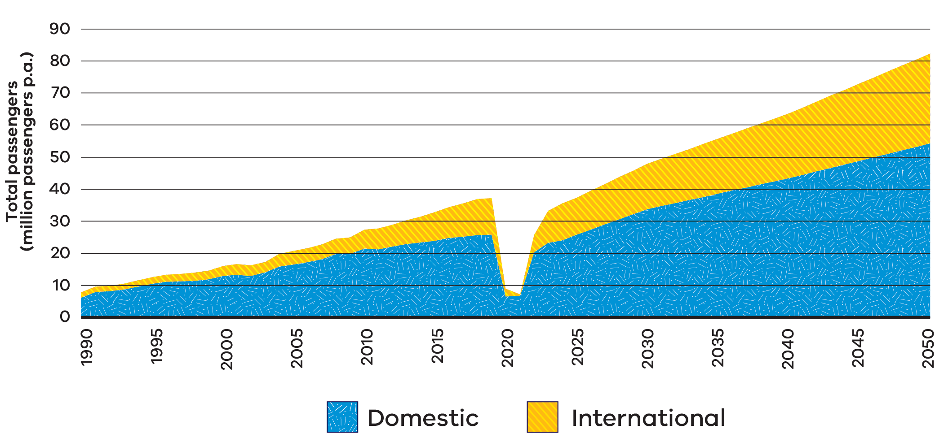
Figure 1 is a stacked area chart of total air passengers in Victoria in millions of passengers per annum (p.a.), split into domestic and international, from 1990 to 2050. It shows:
- steady growth from about 7 million passengers in 1990 to about 37 million in 2019, of which about 25 million were domestic
- a sharp fall to about 7 million passengers in 2020 and 2021, during the COVID-19 pandemic
- a rapid recovery from 2022, with forecast growth to almost 50 million passengers by 2030
continued forecast growth to more than 75 million passengers by 2045 and about 80 million by 2050, of which about 54 million are domestic.
Table 2: Victoria’s aviation market at a glance
Value | Measure
2 | Curfew-free international airports, including Australia’s largest 24-hour airport, with more than 76 nonstop destinations today
About 30% | Of Australia’s international passengers and freight
75 million+ | Domestic and international passengers by 2045
6 of 10 | Of the busiest domestic passenger routes depart from or arrive in Melbourne

Emissions rules and airline targets are strengthening SAF demand

Domestic aviation
The Safeguard Mechanism sets declining emissions limits for Australia’s largest emitters, strengthening the incentive to decarbonise through options such as SAF. Australia’s largest airlines, Qantas Group and Virgin Australia, are subject to the Safeguard Mechanism for their domestic operations.

Global aviation
The Carbon Offsetting and Reduction Scheme for International Aviation (CORSIA) is a global scheme that requires airlines to offset growth in international aviation emissions above agreed baseline levels, helping limit the climate impact of international flights. CORSIA obligations apply to an increasing number of international routes from Melbourne.

Airline commitments
Major airlines serving Melbourne already have voluntary SAF uptake targets, including Qantas (10% by 2030), Air New Zealand (10% by 2030) and Singapore Airlines (5% by 2030).

Airport infrastructure
SAF can use existing airport fuel infrastructure, meaning it can be adopted faster and with lower implementation risk.

Melbourne’s direct flight routes
Figure 2 is a world map of direct international flight routes from Melbourne. Countries are shaded to show whether they are current CORSIA states, will join CORSIA from 2027, or are exempt from CORSIA but can voluntarily participate. Australian domestic flights are covered by the Safeguard Mechanism. Direct routes from Melbourne connect to:
- New Zealand and Fiji in the Pacific
- Japan, the People’s Republic of China, Taiwan, Vietnam, the Philippines, Thailand, Malaysia, Singapore and Indonesia in East and South-East Asia
- India, Sri Lanka and the Maldives in South Asia
- the United Arab Emirates in the Middle East
the United States of America and Chile in the Americas.
Figure 2: Melbourne’s direct flight routes
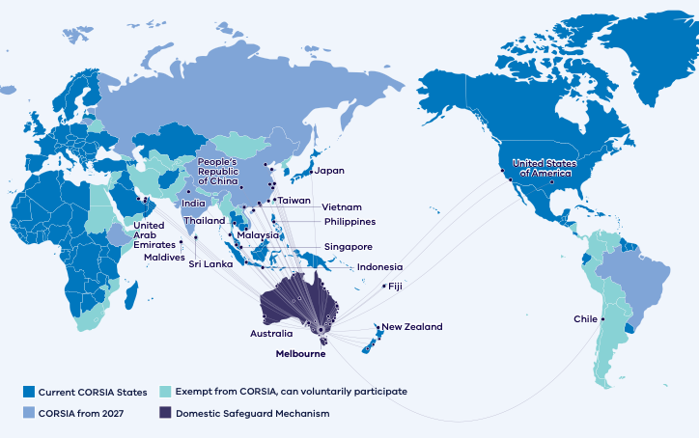

Case study: HAMR Energy

Sustainable Aviation Fuel
HAMR’s flagship development, the Portland Renewable Fuels project, is a world-scale renewable methanol development in Portland, Victoria, with a target capacity of 300 kilotonnes per annum (ktpa).
This innovative renewable fuels project utilises biomass and renewable hydrogen to produce low carbon methanol. Leveraging locally sourced biomass and nearby onshore wind resources, the project aims to create a sustainable, low-carbon methanol that can be transported to local and international customers via the Port of Portland or road and rail. The methanol will be used to support the decarbonisation of hard-to-abate sectors and is a key building block for many SAF pathways.
The Victorian Government is supporting the Portland Renewable Fuels Project with $500,000 for a feasibility study through its Portland Diversification Fund.
For more information, visit the HAMR Energy Portland Renewable Fuels project page.

Biomass for renewable fuels production
Victoria’s regions offer strong opportunities to convert agricultural residues, organic waste streams and other sustainable biomass into renewable fuels and biogenic carbon products, supporting emissions reduction and new regional industries.

Large, diverse biomass base
Victoria produces substantial biogenic residues and waste streams across agriculture, food processing, forestry, municipal solid waste and wastewater. These existing streams can provide near term feedstock options and support circular economy outcomes.

Strong research and development to unlock new feedstocks
Victorian research institutions and industry partners can support innovation across feedstock supply chains and conversion pathways, helping to validate new feedstocks, improve yields and reduce technical and commercial risk.

Guidance on Victorian project development
The Victorian Government is investigating the most suitable feedstock and fuel production pathways that assist industry to develop the best project for Victoria and connect them with state and federal funding opportunities.

Bioenergy opportunities in Victoria
Victoria is Australia’s largest food and fibre producing state and is well positioned for biofuels production.
Existing oilseeds, waste and residues alongside opportunities for emerging energy crops and farming techniques such as crop rotation, have the potential for bioenergy to support renewable fuels production and regional development.
For example, Victoria’s practically available biogas potential from waste and residues alone is estimated at 47 petajoules (PJ) per year currently, rising to 69 PJ per year in 2045.
Figure 3: Practically available biomass residues and key bioenergy facilities by Victorian region
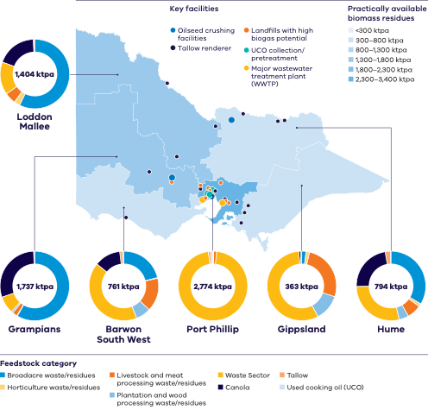
Figure 3 is a map of Victoria’s 6 regions, shaded by the volume of practically available biomass residues in kilotonnes per annum (ktpa), in bands from less than 300 ktpa up to a top band of 2,300 to 3,400 ktpa. A doughnut chart for each region shows the mix of feedstock categories: broadacre waste and residues, horticulture waste and residues, livestock and meat processing waste and residues, plantation and wood processing waste and residues, waste sector, canola, tallow and used cooking oil (UCO). Table 3 summarises the data for each region.
The map also marks key facilities: oilseed crushing facilities, tallow renderers, landfills with high biogas potential, UCO collection and pretreatment sites, and major wastewater treatment plants (WWTP). Most landfills, UCO sites and wastewater treatment plants are clustered in and around Melbourne, while oilseed crushing facilities and tallow renderers are spread across northern, central and western Victoria.
Table 3: Practically available biomass residues by region
Region | Practically available biomass residues (ktpa) | Main feedstock categories
Port Phillip | 2,774 | Almost entirely waste sector, with small amounts of tallow and livestock and meat processing waste
Grampians | 1,737 | Mainly broadacre waste and residues and canola, with some waste sector
Loddon Mallee | 1,404 | Mainly broadacre waste and residues, with canola, waste sector and small amounts of livestock and horticulture waste
Hume | 794 | Broadacre waste and residues, waste sector and canola, with small amounts of livestock and plantation waste
Barwon South West | 761 | Mainly waste sector, with broadacre waste and residues, livestock and meat processing waste, canola and plantation waste
Gippsland | 363 | Mainly waste sector, with livestock and meat processing waste and plantation and wood processing waste

Leverage established energy infrastructure
Victoria sits at the intersection of major electricity, gas, fuel and logistics networks, with established refining, storage, terminal and distribution infrastructure already serving large domestic markets.
One of only 2 refineries remaining in Australia, the Geelong refinery anchors this system and supplies more than half of Victoria’s fuel. This existing infrastructure network can support the development, handling and distribution of low-carbon liquid fuels, helping to reduce delivery risk for future projects.
Figure 4: Victoria’s energy and fuel infrastructure can support local renewable fuel production and distribution
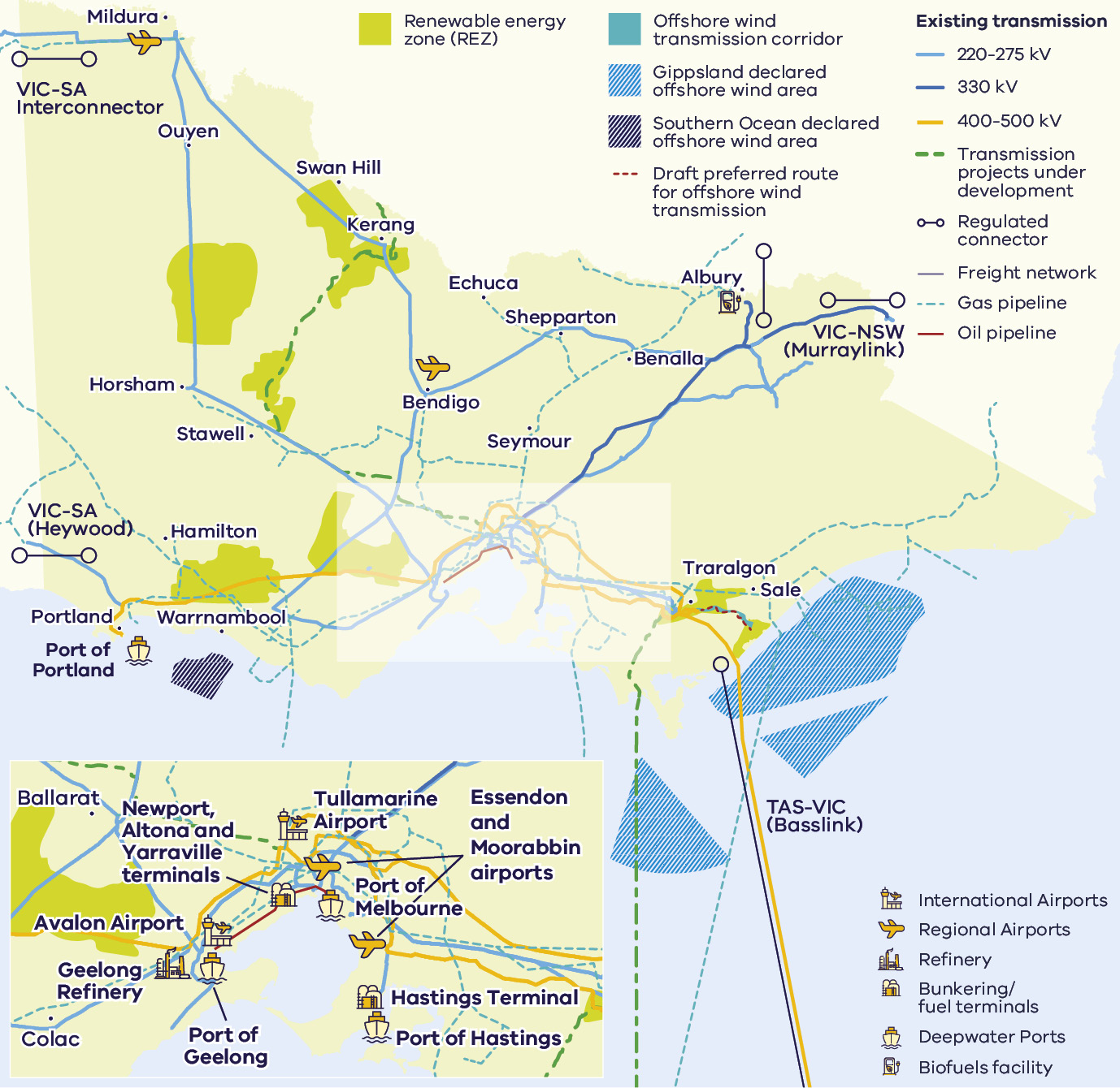
Figure 4 is a map of Victoria’s energy and fuel infrastructure. It shows:
- renewable energy zones (REZ) across western, northern and south-eastern Victoria
- existing electricity transmission lines (220 to 275 kV, 330 kV and 400 to 500 kV), transmission projects under development and the draft preferred route for offshore wind transmission
- interconnectors to other states: VIC-SA Interconnector (near Mildura) and VIC-SA (Heywood) to South Australia, VIC-NSW (Murraylink) to New South Wales, and TAS-VIC (Basslink) to Tasmania
- the Gippsland and Southern Ocean declared offshore wind areas and an offshore wind transmission corridor
- gas pipelines, oil pipelines and the freight network connecting regional centres including Mildura, Swan Hill, Bendigo, Shepparton, Ballarat, Horsham, Warrnambool, Portland, Traralgon and Sale
- the Geelong Refinery and fuel terminals at Newport, Altona, Yarraville and Hastings
- deepwater ports at Portland, Geelong, Melbourne and Hastings
- international airports at Tullamarine and Avalon, Essendon and Moorabbin airports, and regional airports including Mildura and Bendigo
a biofuels facility in north-eastern Victoria near Albury.

Case study: Viva Energy
Viva Energy’s co-processing trials at the Geelong Refinery are demonstrating how existing industrial infrastructure could support Victoria’s transition to a circular economy and the production of lower-carbon fuels and products. By trialling the use of alternative feedstocks such as used cooking oil, Viva Energy is showing how established refinery assets can contribute to creating new materials and support future pathways for renewable fuels and other circular products.
Viva Energy has undertaken a trial with Snackbrands Australia and Cleanaway, transforming used cooking oil into food-grade plastic packaging, highlighting the potential to extend material life and create higher-value uses for waste streams.

Victorian Government policies driving renewable fuels investment
Building on the Renewable Hydrogen Industry Development Plan (2021), Victoria has expanded its focus to include multiple renewable fuels that can deliver earlier emissions reductions and faster deployment, while continuing to support hydrogen’s long-term role.

Climate Action Act 2017 and Climate Change Strategy 2026–30
Victoria’s legislated emissions reduction targets create a clear long-term demand signal for renewable fuels.
For more information, visit the Victoria’s Climate Change Strategy page.

Victorian Economic Growth Statement
Victoria’s Economic Growth Statement targets opening the door to investment and innovation, cutting red tape, building new skills and reaching every corner of Victoria.
For more information, visit the Economic Growth Statement page.

Victorian Industry Policy
Identifies renewable fuels as part of Victoria’s strategic industry growth agenda.
For more information, visit the Victorian Industry Policy page.

Victorian Freight Plan
Highlights renewable fuels as a pathway to decarbonise heavy freight and supply chains.
For more information, visit the Victorian Freight Plan page.

Other intersecting policies
- Recycling Victoria: A new economy. For more information, visit the Recycling Victoria: A new economy page.
- Clean Economy Workforce Development Strategy 2023 to 2033. For more information, visit the Clean Economy Workforce Development Strategy page.
- Victorian Energy Jobs Plan. For more information, visit the Victorian Energy Jobs Plan page.
- Women in Energy Strategy. For more information, visit the Women in Energy Strategy page.
- Water Sector Emissions Transition Plan. For more information, visit the net-zero emissions water sector page.
Water Security Plan. For more information, visit the Water Security Plan page.

Australian Government initiatives
The Australian Government has outlined the crucial role of renewable fuels.
Key federal policies include the Net Zero Plan and 6 sector emissions reduction plans, the 2024 National Hydrogen Strategy and Future Made in Australia initiatives. Substantial Australian Government funding has been made available to bring online renewable fuels production.
Table 4: Key Australian Government funding for renewable fuels
Funding | Program
$1.1 billion | Cleaner Fuels Program
$250 million | Made through the Future Made in Australia Innovation Fund
$4 billion | Through Hydrogen Headstart
$2 per kilogram | Hydrogen production tax incentive: an uncapped refundable tax offset for every kilogram of eligible hydrogen for up to 10 years

Funding opportunities for renewable fuel derivatives including fertiliser
Funding opportunities include:
- The $1 billion Economic Resilience Program to be drawn from the $15 billion National Reconstruction Fund supporting businesses in areas such as freight, fuel, plastics and fertiliser who are materially impacted by market disruptions related to current conflicts and global price rises for key inputs.
- The $5 billion Net Zero Fund, announced as part of the Industry Sector Plan, is part of the Australian Government’s approach to driving decarbonisation, unlocking new manufacturing investment, and improving energy affordability in hard-to-abate sectors of the Australian economy.
The $1.5 billion Future Made in Australia Innovation Fund will provide support for the development and commercialisation of new technologies in priority sectors, including clean energy, green metals and other emerging low-emissions industries that can support the renewable fuels value chain.

Access to Victoria’s world-class renewable energy talent
Our growing, highly skilled workforce drives project delivery and fosters industry growth.
To meet the needs of the sector, our energy workforce is predicted to grow by 53% to 68,000 between 2026 and 2040. The Victorian Government has committed to significant new skills and workforce initiatives to ensure the workforce is available when and where it’s needed, including:
- investing $5 million in Solar Victoria’s Electrification Skills Program
- investing $25 million toward the $50 million Victorian Renewable Energy technical and further education (TAFE) Centre of Excellence
- releasing regular energy workforce data to support informed decision-making and boost investor confidence
- developing new energy training pathways through the $7 million for new vocational education and training (VET) certificates in renewable energy projects
- simplifying pathways for skilled workers to move to Victoria through improved qualification recognition and Victoria’s Skilled Migration Visa Nomination Program
investing $10 million toward the $40 million National Training Centre in New Energy Skills.

Victorian Energy Jobs Plan
The Victorian Energy Jobs Plan provides a framework for developing the robust, future-ready energy workforce needed to deliver the transition and strengthen investment confidence.
For more information, visit the Victorian Energy Jobs Plan page.

Sparking Change: The Women in Energy Strategy
The Women in Energy Strategy recognises that attracting and retaining more women in the renewable energy workforce provides significant benefit to this growing sector. It aims to drive significant change for women in energy through Victoria’s energy transition.
For more information, visit the Women in Energy Strategy page.

A clear pathway to partner with First Peoples

Victorian Traditional Owners are actively involved in the energy transition
Investments have been made in developing frameworks and localised plans for the energy transition to create clear pathways for development in Victoria.
Traditional Owner Corporations have clearly defined strategies and processes for partnering to achieve best development outcomes in Victoria.

Access to specialist support
DEECA has invested in dedicated First Peoples energy specialists who can help developers and investors:
- understand Traditional Owner priorities and aspirations
- navigate engagement and partnership processes
build strong, long-term relationships that support project success.
For more information, visit the First Peoples energy page.

Clear guidance from Traditional Owners
Many Traditional Owner Corporations have published guidance and planning documents that help proponents:
- identify community priorities and aspirations
- understand preferred engagement and partnership models
align projects with local economic, social and cultural outcomes.

Strong government policy and guidance
Victoria has established strategic policies and guidance to support collaboration with First Peoples throughout the renewable energy development lifecycle, reducing uncertainty and creating stronger foundations for project development, investment confidence and long-term social value.

First Peoples Renewable Energy Strategic Plan
Identifies First Peoples priorities and desired outcomes within Victoria’s renewable transition.
For more information, visit the First Peoples resources page.

Community Engagement and Social Value Guidelines
Clear guidance on engagement pathways and creating social value in renewable development.
For more information, visit the VicGrid news story about driving better community engagement and benefits from renewable energy projects.

Key Victorian Government entities
We can help facilitate connections with key Victorian Government entities and industry members across our renewable energy sector.

Department of Energy, Environment and Climate Action (DEECA)
DEECA works with industry and the community to develop Victoria’s secure and sustainable energy future.
For information on Victoria’s energy policy landscape and facilitated connections across the Victorian Government and renewable energy sector, contact the Business and Industry Engagement team at: BIE@deeca.vic.gov.au
For more information, visit the renewable energy investment opportunities page.

Offshore Wind Energy Victoria
Offshore Wind Energy Victoria (OWEV) has been established as the single point of entry for industry and community engagement on offshore wind.
For more information, visit the Offshore Wind Energy Victoria page.

Solar Victoria
Solar Victoria is responsible for the delivery of the Victorian Government’s $1.3 billion Solar Homes Program – one of the most ambitious and transformative renewable energy programs in Australia.
For more information, visit the Solar Victoria website.

VicGrid
VicGrid coordinates the planning and development of Victorian Renewable Energy Zones (REZs). It is also investing $480 million that will be used to strengthen the grid and develop each REZ.
For more information, visit the renewable energy zones page.

Invest Victoria
Invest Victoria is the Victorian Government’s investment attraction agency. Services include:
- market regulatory information
- statutory approvals coordination
- site location services
- identification of infrastructure and utility requirements
advocacy within government.
For more information, visit the Invest Victoria website.

Investment Coordinator-General
The Investment Coordinator-General role and function also sits within Invest Victoria, working across agencies to ensure approvals deadlines are met and helping to reduce delays.
For more information, visit Victoria’s Investment Coordinator-General page.

Innovation Victoria
Innovation Victoria is the Victorian Government’s single front door for innovation, supporting founders, researchers, entrepreneurs and investors from early idea through to commercialisation and scale. It provides the capability uplift, connections and capital pathways to accelerate the commercialisation from idea to growth, scale and global opportunity.
For more information, visit the Innovation Victoria website.

SEC
SEC is a Victorian Government-owned renewable energy company. It is partnering with the private sector to deliver 4.5 gigawatts (GW) of new renewable energy and storage projects with an initial investment of $1 billion.
For more information, visit the SEC website.

Subsector packs
To access the Renewable Energy subsector packs, please visit the renewable energy subsector packs page.
The following subsector packs are available:
- Distributed Energy Resources and Electric Vehicles (EVs)
- Offshore Wind
- Utility-scale Electricity Generation and Storage
- Renewable Fuels and Feedstocks
Renewable Fuels and Feedstocks: Sustainable Aviation Fuel.

Publication information

Copyright
© The State of Victoria Department of Energy, Environment and Climate Action, September 2026.

Creative Commons
This work is licensed under a Creative Commons Attribution 4.0 International licence, visit the Creative Commons website.
You are free to re-use the work under that licence, on the condition that you credit the State of Victoria as author. The licence does not apply to any images, photographs or branding, including the Victorian Coat of Arms, and the Victorian Government and Department logos.
ISBN 978-1-76176-999-3 (print)
ISBN 978-1-76176-003-7 (pdf/online/MS word)

Disclaimer
This publication may be of assistance to you but the State of Victoria and its employees do not guarantee that the publication is without flaw of any kind or is wholly appropriate for your particular purposes and therefore disclaims all liability for any error, loss or other consequence which may arise from you relying on any information in this publication.

Accessibility
To receive this document in an alternative format, phone the Customer Contact Centre on 136 186, email customer.service@deeca.vic.gov.au, or contact National Relay Service on 133 677 or visit the National Relay Service website. This document is available on the DEECA website.
End of document.

Domestic Airlines Top Routes and Totals dataset | Australian Government | data.gov.au
Melbourne Airport Master Plan | Melbourne Airport | melbourneairportprojectshub.com.au/master-plan
Victoria in Future | Department of Transport and Planning | planning.vic.gov.au/guides-and-resources/Data-spatial-and-insights/discover-and-access-planning-open-data/victoria-in-future
Why invest in Melbourne? | City of Melbourne | melbourne.vic.gov.au/why-invest-melbourne
EIU Global Liveability Index 2026 | Economist Intelligence Unit | eiu.com/n/wp-content/uploads/2026/07/EIU_Liveability-Index-2026.pdf
Passenger forecasts per Australian Aviation Forecasts 2024 to 2050 | Bureau of Infrastructure and Transport Research Economics (BITRE) | bitre.gov.au/resource/aviation/australian-aviation-forecasts-2024-2050
Airport traffic data | BITRE | bitre.gov.au/resource/aviation/airport-traffic-data
CORSIA States for Chapter 3 State Pairs | International Civil Aviation Organization | icao.int/CORSIA/corsia-states-chapter-3-state-pairs
Sustainable aviation fuel | Qantas | qantas.com/corporate/sustainability/our-planet/sustainable-aviation-fuel
Sustainable aviation fuel | Air New Zealand | airnewzealand.co.nz/sustainability-saf
Environment | Singapore Airlines | singaporeair.com/en_UK/sg/about-us/sustainability/environment/

