Renewable Energy Investment Prospectus Overview
  - October 2026

Table of Contents
Traditional Owners at the centre for decision-making processes 4
Minister’s Foreword 5
Government settings supporting investment 8
Our legislated targets are driving investment 9
Victoria is at the forefront of the transition to net-zero 11
A trusted location for your next energy investment 12
Victoria is at the heart of Australia’s National Electricity Market 14
Fast-tracking planning approvals 18
Victoria’s new Renewable Energy Zones 21
VicGrid – Shaping Victoria’s Future grid 24
Victorian Government initiatives drive sector growth 25
SEC: Powering Victoria’s renewable energy future 27
Underwriting new renewable energy capacity 28
Access to government co-investment 31
Investing in a Future Made in Australia 33
In-demand critical mineral deposits 34
A leader in manufacturing 36
Unlocking value in reuse and recycling of renewable energy technologies 38
Research and innovation capabilities 40
Where research, industry and talent converge 42
Access to Victoria’s world-class renewable energy talent 44
A clear pathway to partner with First Peoples 46
Dive into Victoria’s renewable energy sectors 48
Key Victorian Government entities 58
For international investors 61
Subsector packs 63
Publication information 64

Traditional Owners at the centre for decision-making processes
Strong and mutually beneficial partnerships with Traditional Owners and First Peoples are imperative to the energy transition’s success and integral to ensuring the goals and objectives of self-determination set out in the Victorian Government’s Self Determination Reform Framework and the Department of Energy, Environment and Climate Action’s (DEECA) Pupangarli Marnmarnepu ‘Owning Our Future’ Aboriginal Self-Determination Reform Strategy 2020–2025.
For more information, visit the Pupangarli Marnmarnepu ‘Owning Our Future’ strategy page.

Acknowledgement of Country
We acknowledge and respect Victorian Traditional Owners as the original custodians of Victoria’s land and waters, their unique ability to care for Country and deep spiritual connection to it.
We honour Elders past and present whose knowledge and wisdom have ensured the continuation of culture and traditional practices.
We are committed to genuinely partner, and meaningfully engage, with Victoria’s Traditional Owners and Aboriginal communities to support the protection of Country, the maintenance of spiritual and cultural practices and their broader aspirations in the 21st century and beyond.

Minister’s Foreword
At the centre of Australia’s energy system, Victoria is leading the way towards a renewable energy future.
Victoria’s energy system is undergoing a generational shift, moving from a historic reliance on brown coal to a more diversified and renewable energy mix. Our renewable energy future is being built today – a transformation that is not only essential to achieving our climate goals, but one providing significant investment opportunities across our state.
Victoria has led Australia’s renewable transition with vision, ambitious targets and a strong record of delivery. Supported by clear policy settings, robust supply chains, a skilled workforce and world-class research, Victoria has managed to become the national leader for renewable energy development.
Our 2026 Renewable Energy Investment Prospectus outlines the exceptional opportunities currently available in Victoria.
We are backing the renewable energy sector with legislated targets of 65% renewable electricity generation by 2030 and 95% by 2035, supporting our goal of net-zero emissions by 2045. Last year, Victoria exceeded its 40% by 2025 renewable energy target and that share has continued to grow, with the latest data showing 45.1% of our electricity was generated from renewable energy sources over the 2025/26 financial year.
Victoria is also home to more than 100 large-scale renewable energy projects and a rapidly growing battery storage sector. This includes 57 operating solar farms, 44 wind farms, and 26 large-scale batteries, with more than 145 projects approved, under construction and in the pipeline. These large-scale projects are complemented by more than 900,000 small-scale solar photovoltaic (PV) systems on rooftops across the state.
Achieving the next stage of Victoria’s energy transition requires more than a vision. It demands policy certainty, coordination and efficient delivery pathways to give the market confidence to bring projects forward. This is what Victoria offers, and it's why we will be home to Australia’s first offshore wind industry.
The offshore wind auction announced this year will bring forward the first 2 gigawatts (GW) of generation and support the long-term development of up to 9 GW of capacity by 2040, creating jobs, reinforcing energy security and unlocking new investment opportunities.
To strengthen efficient project delivery, we are laying the foundations for the next generation of energy infrastructure. Through VicGrid and the 2025 Victorian Transmission Plan, we are ensuring renewable energy and transmission infrastructure is developed in the right locations, minimising impacts on communities, landholders, Traditional Owners and the environment while helping keep costs down for consumers.
We are also streamlining planning and environmental approvals to provide greater clarity, certainty and efficiency for industry. Reforms to the Environment Effects Statement process are targeting assessment timeframes of no more than 18 months, while the Development Facilitation Program has fast-tracked 37 renewable energy projects representing more than $14.6 billion in investment.
Beyond utility-scale generation, opportunities are emerging across distributed energy and electrification. Victoria's leadership in rooftop solar and consumer energy resources is driving growth in aggregation and customer energy services, while increasing electric vehicle uptake is accelerating demand for charging infrastructure and smart-grid technologies.
Alongside electrification, renewable fuels can reduce emissions in some hard-to-abate sectors across transport, industry and the electricity system. Renewable fuels can also increase fuel security and create economic growth opportunities, particularly for regional Victoria.
Together, these developments are creating a deep and diverse pipeline of investment opportunities in an environment where renewable energy projects can move from concept to operation with confidence.
My message to investors is clear: Victoria's commitment to renewable energy is matched by our commitment to delivery. We are creating the right conditions for investment, industry growth and innovation, and we look forward to partnering with those who want to help build Australia's renewable energy future.
Jaclyn Symes MP
Minister for Energy and Resources
Minister for Environment
Minister for Climate Action
Minister for the State Electricity Commission

Government settings supporting investment
Government settings create a predictable, efficient and lower risk investment environment by supporting projects to move faster, connect securely and deliver reliable returns.
- Policy certainty: legislated targets and long-term climate commitments provide stable demand signals.
- Fast-tracked approvals: streamlined planning pathways reduce development risk and approval timeframes.
- Grid and transmission certainty: government-led transmission planning and funding for $480 million enables connection, scale and dispatch.
- Revenue and investment support: underwriting mechanisms improve bankability and investor confidence.
- Government partnership: active co-investment and delivery support reduce execution risk.

Our legislated targets are driving investment
Victoria is one of the world’s most exciting renewable energy markets, where a rapidly transforming energy system and clear policy ambition are driving significant investment opportunities.
Victoria’s energy market is rapidly transitioning away from a historic reliance on fossil fuels to a distributed and diversified renewable supply mix. The state’s largest coal-fired generators are set to retire by 2035. At the same time, electricity demand is growing as households, businesses and transport electrify and more data centres are added to the mix. Together, these trends are driving the need for new, reliable and clean energy supply.
Victoria's legislated renewable energy and storage targets provide investors with long-term policy certainty and a clear pipeline of demand for renewable energy projects. The state has committed to generating 95% of its electricity from renewable sources by 2035, supported by legislated energy storage targets of at least 2.6 GW by 2030 and 6.3 GW by 2035.
The Victorian Government’s vision is outlined in Cheaper, cleaner, renewable: our plan for Victoria’s electricity Future. This is a 4-pillar plan to enable the renewables big build, empower households and businesses to lower energy bills, manage the transition away from fossil fuels, and create jobs, skills and supply chains.
Table 1: Key renewable energy figures
Figure | Description
27 GW | New renewable generation and storage capacity required by 2035 in Victoria
82% | Australia's renewable energy target by 2030
9 GW | Targeted offshore wind capacity
Note: the 27 GW figure is an estimate only.
Table 2: The Victorian Government's legislated targets
Year | Target | Status
2020 | 25% renewable electricity generation | Achieved
2025 | 40% renewable electricity generation | Achieved
2030 | 65% renewable electricity generation and 2.6 GW energy storage capacity | Target
2035 | 95% renewable electricity generation and 6.3 GW energy storage capacity | Target
2045 | Net-zero emissions | Target

Victoria is at the forefront of the transition to net-zero
Victoria's emissions reduction targets place it among the most ambitious jurisdictions globally.
Our legislated emissions reduction targets provide a clear and long-term pathway for the state's transition to a net-zero economy.
With targets to reduce emissions by 75 to 80% by 2035 and achieve net-zero emissions by 2045, Victoria is creating sustained demand for investment that decarbonises not just the electricity system, but the renewable fuels that offer alternatives to decarbonise transport and industry.
Table 3: Emissions reduction targets below 2005 levels
Jurisdiction | Target | Target year
Canada | 45 to 50% | 2035
New Zealand | 51 to 55% | 2035
Brazil | 59 to 67% | 2035
Victoria | 75 to 80% | 2035
Victoria | Net-zero | 2045
- Victoria is the fastest-growing state in the country with the population expected to reach 10.3 million by 2051.
- Victoria contributes nearly a quarter of Australia's economic activity.
- Melbourne is ranked the world’s 3rd most liveable city and Australia’s most liveable city.

A trusted location for your next energy investment

A strong economy
Business investment has grown by 44% since September 2020, faster than the rest of Australia.

Verifiable, ethical business practices
Proximity to critical minerals and transparent local supply chains support responsible sourcing while reducing Victoria’s manufacturing carbon footprint.

Globally connected
Victoria connects to global and domestic markets via 4 major seaports, a 24-hour international airport, and extensive road and rail networks.

Stable and trusted
Australia and Victoria offer excellent environmental, social and governance (ESG) outcomes, political stability, strong intellectual property (IP) protection and fair governance.

A world-class skilled workforce
The Victorian energy workforce is predicted to be 68,000 strong by 2040. Victoria is building on its world class universities and integrated technical and further education (TAFE) network with significant new energy skills and workforce initiatives.

Clear and aligned Australian and Victorian Government policy ambition
Legislated renewable energy generation, storage and emissions reduction targets provide market certainty.

Victoria is at the heart of Australia’s National Electricity Market
Victoria is located at the very centre of Australia’s National Electricity Market (NEM), linking the state to major load centres and critical infrastructure.

The National Electricity Market (NEM)
The NEM is one of the world’s largest interconnected power systems, stretching 5,000 kilometres (km) along Australia’s east and south-east seaboard. It has 5 interconnected states that function as pricing regions. It is a wholesale 5-minute spot market to trade electricity between generators and retailers.

Australian Energy Market Operator (AEMO)
AEMO manages the electricity and gas systems and markets across Australia, ensuring Australians have access to affordable, secure and reliable energy. AEMO produces trusted publications and reports which can support investment decisions.
For more information, visit the AEMO publications library.

Other regulatory bodies
- Australian Energy Market Commission is the rule maker for Australian electricity and gas markets. For more information, visit the Australian Energy Market Commission website.
- Australian Energy Regulator regulates energy networks and the wholesale and retail markets in Australia to ensure they are secure, reliable and affordable for consumers. For more information, visit the Australian Energy Regulator website.

Victoria’s connections to the NEM
The National Electricity Market service area covers Queensland, New South Wales, Victoria, South Australia and Tasmania. Victoria is directly connected to 3 other states by 4 regulated interconnectors:
- VIC-SA (Heywood), connecting Victoria and South Australia
- VIC-SA (Murraylink), connecting Victoria and South Australia
- VIC-NSW (Murraylink), connecting Victoria and New South Wales
- TAS-VIC (Basslink), connecting Tasmania and Victoria.
A further interconnector between Victoria and Tasmania, Marinus Link, is currently under planning and development.

Investment opportunities
Victoria’s fully competitive, privatised electricity market creates many opportunities for investors. This includes the spot and contract markets for companies that specialise in buying and selling electricity, with opportunities to leverage market fluctuations and participate in existing and emerging grid services markets.
For more information, visit the Victorian electricity sector overview page.
Figure 1: The National Electricity Market
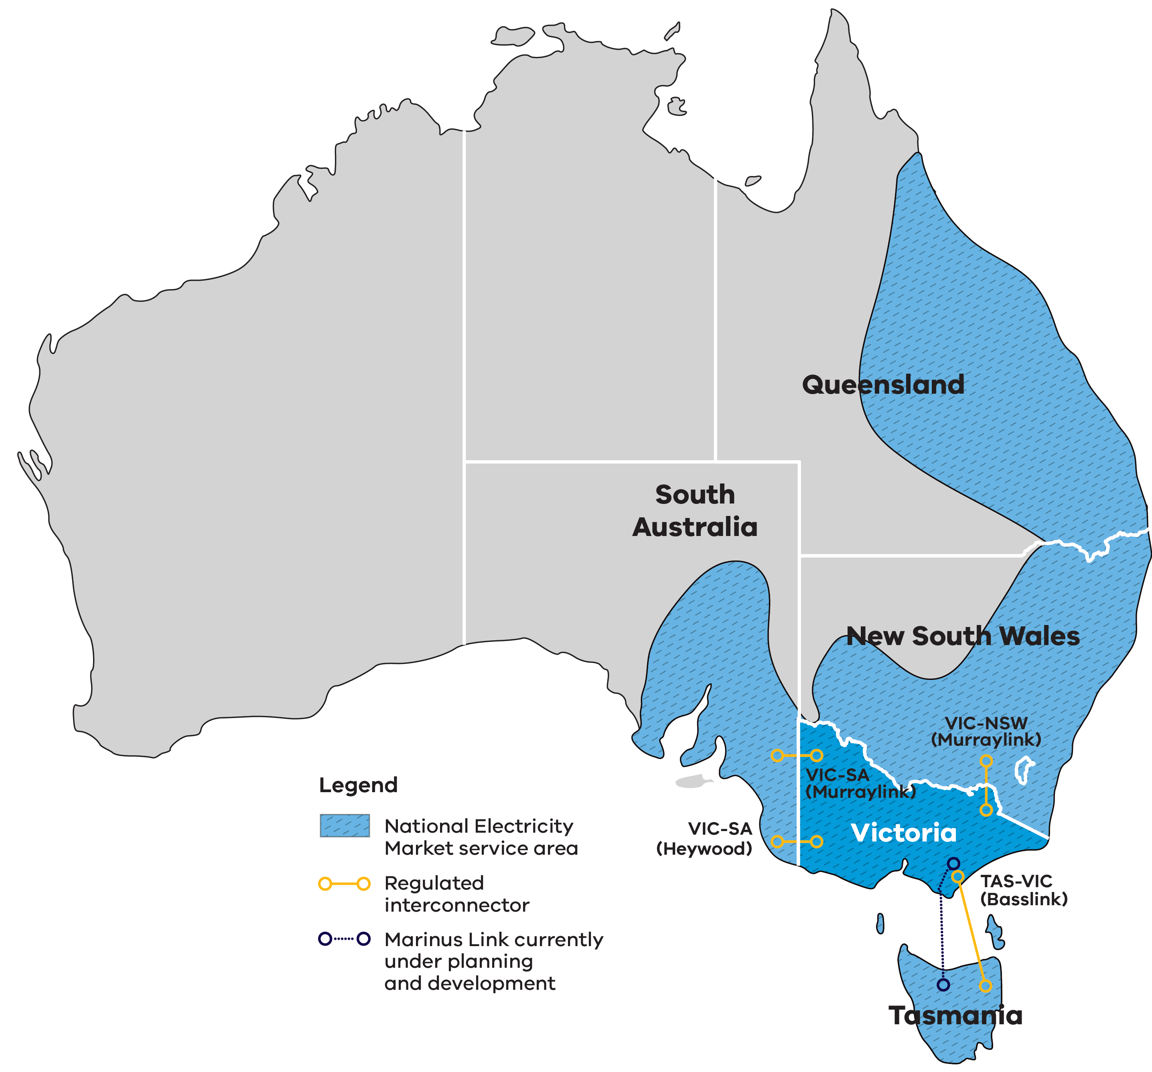
Table 4: The National Electricity Market at a glance
Measure | Value
Value traded in financial year (FY) 2024–25 | $25 billion
Spot price market cap FY2025–26 | $20,300 per megawatt hour (MWh)
Share of Australia’s population serviced | About 85%
Customers | About 11 million
Transmission lines | 40,000 km
Regulated interconnectors directly connecting Victoria to 3 other states | 4 interconnectors
Electricity supplied each year | About 200 terawatt hours (TWh)
Total generation | About 99 GW
Sources: NEM Factsheet, AEMO; Australian Energy Regulator (customers); 2026 Integrated System Plan (ISP), AEMO (total generation).

Fast-tracking planning approvals
The Victorian Government is committed to getting your project through planning approvals as quickly as possible.

Dedicated renewable energy planning pathways
Victoria's Development Facilitation Program (DFP) is an accelerated planning pathway for the delivery of significant economic development, including renewable energy facilities and utility installations. This streamlined planning process provides greater certainty and can reduce assessment timeframes by approximately 9 to 12 months.

Faster, more focused and consistent environmental assessments in Victoria
Recent reforms have modernised Victoria’s environmental assessment processes. Supporting timely project delivery while maintaining robust environmental assessment and community engagement is a key priority.
This includes new digital streamlined interfaces between proponents and government agencies, and updated guidance, templates and governance arrangements to increase predictability, clarity, transparency and tracking.

Investment Coordinator-General
The Investment Coordinator-General role and function sits within Invest Victoria and works across agencies to ensure approval deadlines are met and reduce delays.

Australian Government funding to fast-track approvals
Victoria works closely with the Australian Government to facilitate projects. In 2024–25, the Australian Government's Future Made in Australia allocated $134.2 million to better prioritise approvals for renewable energy projects of national significance, and support faster decisions on environment, cultural heritage and planning approvals.
The Australian Government also committed over $70 million from 2026–27 to fast-track approvals in priority areas like energy and critical minerals.

Development Facilitation Program achievements
Since April 2024 the Development Facilitation Program has achieved:
- less than 4 months of statutory days for approvals
- 34 renewable energy projects approved
more than $14 billion in investment.

Better information, tools and guidance to manage biodiversity impacts of renewable energy projects
Victoria has developed tools and guidance to help renewable energy projects manage biodiversity impacts with greater clarity and certainty. Ongoing work focuses on continued improvements to the information and guidance currently available.

Guidance to support faster renewable energy development
Published in May 2025, the Handbook for the development of renewable energy in Victoria outlines a risk-based approach to identifying, assessing and managing biodiversity impacts.
For more information, visit the managing the impacts of renewable energy on the environment page.

Biodiversity mapping to support lower-risk project siting
Victoria’s Habitat Value and Marine Biodiversity Values maps can be used to consider the relative value of biodiversity in different areas, to help site and design infrastructure that minimises impacts.
For more information, visit the Habitat Value maps page and the Marine Biodiversity Values page.

Research to reduce development risk
Victoria continues to undertake and release targeted research to help developers and decision-makers better understand biodiversity impacts for onshore renewable energy development.
For more information, visit the science for renewable energy policy page.

Victoria’s new Renewable Energy Zones
VicGrid is implementing the Victorian Transmission Plan, a long-term strategic plan for transmission and renewable energy zone development in Victoria.
This plan will ensure Victoria builds the right amount of energy infrastructure in the right places at the right time to support the transition to renewable energy.
The Victorian Government has declared 5 renewable energy zones, along with the shoreline renewable energy zone to connect offshore wind projects in Gippsland, that were proposed in the 2025 Victorian Transmission Plan.
The Gippsland Shoreline Renewable Energy Zone is different from other renewable energy zones. It is a defined planning area for offshore wind developers to run underground cables from the shoreline to the electricity grid.
Renewable energy zones are areas identified as most suitable to host new renewable energy generation, such as wind turbines, solar farms, and battery storage.
Renewable energy zones will:
- ensure better coordination of renewable projects and reduce the need for unnecessary transmission lines and other infrastructure
- enable VicGrid to implement clear rules that manage how projects gain access to the grid, including expectations for how developers engage with community
- provide greater certainty about how and where renewables projects should be built
- unlock new economic benefits for regional communities and Traditional Owners.

Location of Victoria’s renewable energy zones
The map – Figure 2 – shows the location of Victoria’s renewable energy zones (REZ), declared offshore wind areas, existing 220 kilovolt (kV), 330 kV and 500 kV transmission lines, transmission projects under development, and the draft preferred route for offshore wind transmission. The zones and areas shown are:
- Western REZ, around Horsham and Stawell in western Victoria
- North West REZ, around Swan Hill and Kerang in northern Victoria
- Central Highlands REZ, around Ballarat
- South West REZ, between Hamilton, Warrnambool and Colac
- Gippsland REZ, around Traralgon and Sale
- Gippsland Shoreline REZ, on the Gippsland coast
- Gippsland declared offshore wind area, off the Gippsland coast
- Southern Ocean declared offshore wind area, off the coast near Portland and Warrnambool.
Figure 2: The location of Victoria’s renewable energy zones
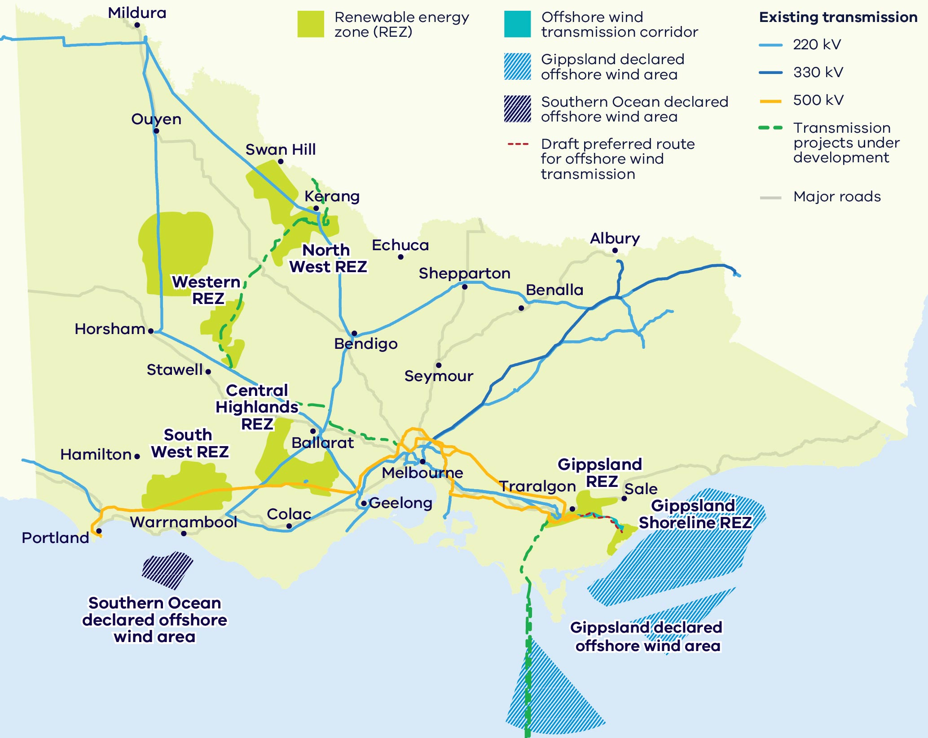

VicGrid – Shaping Victoria’s Future grid
VicGrid is changing the way renewable energy zones are planned and developed, and delivering the infrastructure Victoria needs to unlock more renewable energy resources.

VicGrid’s flagship projects
VicGrid is working on flagship projects that will not only unlock significant new generation and storage, but present strong investment opportunities.
Flagship projects include:
- investing $480 million in a portfolio of projects across the state to strengthen and modernise Victoria’s grid
- leading the development of Gippsland offshore wind transmission infrastructure
- working with the Australian Energy Market Operator (AEMO) to deliver crucial new transmission projects including the Victoria to New South Wales Interconnector West (VNI West) and the Western Renewables Link (WRL)
- investing in the Marinus Link interconnector between Victoria and Tasmania to enhance energy reliability and affordability
- rebuilding existing transmission lines and delivering new lines identified in the Victorian Transmission Plan.

Victorian Government initiatives drive sector growth
The Victorian Government has committed almost $4 billion to support the energy transition over the last seven years. Initiatives include:
Table 5: Victorian Government energy transition initiatives
Initiative | Funding | Purpose
Network stability | $480 million | For transmission upgrades to unlock new renewable energy investment, supporting regional economic growth and jobs.
Energy efficiency | $654 million | In energy efficiency and electrification upgrades unlocked through the Victorian Energy Upgrades (VEU) program in 2025.
Upskilling workers | $50 million | For the new Victorian Renewable Energy TAFE Centre of Excellence.
Zero Emission Vehicle promotion | $84 million | To accelerate the uptake of zero emission and battery electric vehicles (EVs).
Offshore wind | $124.5 million | To progress activities for the Victorian Renewable Energy Terminal at the Port of Hastings.
State Electricity Commission (SEC) | $1+ billion | Towards delivering 4.5 GW of power through renewable energy and storage projects over the next 10 years, delivered by the SEC, a government-owned energy company.
Solar and batteries | $1.3 billion | Provided to Solar Victoria under the Solar Homes Program for rebates and no-interest loans to accelerate the uptake of rooftop solar PV, batteries, heat pumps and solar hot water systems for eligible homes.
Victorian Renewable Energy Target auctions | $2 billion | Of investment leveraged by the Victorian Renewable Energy Target auctions (VRET1 and VRET2), by awarding long-term support agreements that provide investment certainty.
Innovation | $118 million | To support the commercialisation of innovative, emerging renewable energy technologies in Victoria, including offshore wind, renewable hydrogen, bioenergy, battery energy storage systems and industrial electrification projects focused on the food and beverage processing and manufacturing sector.

SEC: Powering Victoria’s renewable energy future
SEC is working with the private sector to accelerate the transition and deliver renewable, affordable, reliable energy for Victorians.
As a Victorian government-owned renewable energy company, SEC’s investments address system gaps, crowd-in private capital, and support a broader market response.
SEC operates across 3 domains:

Scaled investment in renewable generation and storage projects
SEC is investing to deliver 4.5 GW of renewable energy and storage capacity, with over 1 GW already built or under construction. These investments have helped to add critical storage capacity, strengthen energy security and support regional economic growth, including jobs, training and community benefit-sharing.

Enabling decarbonisation for businesses and industry
SEC provides renewable retail and wholesale electricity solutions to commercial and industrial customers to help businesses reduce costs and emissions.

Driving electrification of households at scale
SEC supports households switch from gas to electric appliances through Easy Electric SEC, a digital platform and accredited installer network, reducing energy costs and emissions.

Underwriting new renewable energy capacity
The Australian Government has set a renewable energy target of 82% by 2030. To achieve this goal, it is helping to de-risk projects through long-term revenue underwriting.

Capacity Investment Scheme (CIS)
The Capacity Investment Scheme (CIS) provides a national framework to underwrite 23 GW of renewable capacity and 9 GW of clean dispatchable capacity by 2030.
Competitive tenders for renewable energy and storage will be held approximately every 6 months. The Victorian Government and Australian Government have entered a bilateral Renewable Energy Transformation Agreement (RETA) which secures target allocations for Victorian projects in these tenders for at least 5 GW or 11 TWh of renewable energy and 1.7 GW of 4-hour equivalent storage.
To date in Victoria, the Commonwealth has awarded contracts for 5.9 GW of generation and storage capacity. An additional 2.4 GW of generation capacity is expected to be announced for Victoria from existing CIS tender rounds and future tender rounds commencing over the course of 2026 to meet Victoria’s target allocation.
The final tender round is proposed to open in December 2026 with the indicative date announced in July 2027.
For more information, visit the Capacity Investment Scheme page.
Key figures:
- 5.9 GW of generation and storage announced for Victoria through CIS tenders
- 2.4 GW is Victoria’s minimum remaining capacity allocation.

Electricity Service Entry Mechanism (ESEM)
The Electricity Service Entry Mechanism (ESEM) is a proposed long-term investment framework designed to provide ongoing investment certainty following the CIS. State and Territory Energy Ministers (except Queensland) have agreed to target ESEM commencement by the end of 2027.
It aims to support investment by bridging the ‘tenor gap’ – the mismatch between generators’ need for price certainty over a long period (15+ years), compared with market customers’ appetite to enter price hedging over the short-term (e.g. up to 3 years). It will do this by awarding hedging contracts through competitive tenders for only the mid to later years (5+) of a project, then sell those contracts to market customers as the hedging period approaches. This ‘recycling’ of contracts, and their fungible nature, is a key innovation on previous underwrite schemes.
The ESEM Administrator is expected to conduct competitive reverse auctions to procure for 3 specific services:
- bulk zero-emissions energy
- shaping services
- firming services.
The ESEM is being implemented by the Commonwealth and NEM jurisdictions, with amendments to the National Electricity Law anticipated for Q1 or Q2 2027, and the ESEM being fully operational by Q4 2027.
For more information, visit the NEM wholesale market settings review page.

Access to government co-investment
Australian Government Specialist Investment Vehicles (SIVs) provide debt, equity and grant support to help net-zero projects get off the ground and scale alongside private capital.
The Victorian Government can connect you with the following organisations.

Clean Energy Finance Corporation (CEFC)
The CEFC is Australia’s specialist climate investor, helping cut emissions in the race towards net-zero by 2050. We invest in the latest technologies to generate, store, manage and transmit clean energy. Our discounted asset finance programs help put more Australians on the path to sustainability, in their homes and on the road. CEFC capital is also backing the net-zero transformation of our natural capital, infrastructure, property and resources sectors, while providing critical capital for the emerging climate tech businesses of tomorrow. With access to more than $33 billion from the Australian Government, the CEFC invests with commercial rigour and is governed by an independent board.
For more information, visit the Clean Energy Finance Corporation website.

National Reconstruction Fund Corporation (NRFC)
The NRFC manages a $15 billion sovereign fund that provides financing to grow Australia's advanced manufacturing base, including a dedicated $5 billion Net Zero Fund for renewable energy technologies, batteries, hydrogen and industrial decarbonisation projects.
For more information, visit the National Reconstruction Fund Corporation website.

Australian Renewable Energy Agency (ARENA)
ARENA accelerates innovation and deployment of renewable energy by funding pre-commercial, renewable solutions. This helps move ideas from concept to market and supports Australia's emissions reduction. As part of its role, ARENA administers programs like the Future Made in Australia Innovation Fund and Hydrogen Headstart Program.
For more information, visit the Australian Renewable Energy Agency website.

Australia's Investor Front Door
Australia's Investor Front Door streamlines the development of major, nationally significant projects by providing coordinated government support for investment and project delivery.
For more information, visit Australia’s Investor Front Door page.

Investing in a Future Made in Australia
The Australian Government is investing to transform the nation into a renewable energy superpower.
In the 2024–25 Federal budget, $22.7 billion was announced for initiatives that are part of a Future Made in Australia package designed to maximise the economic and industrial benefits of the net-zero transition. It is focused on facilitating private sector investment and building a stronger, more diversified and more resilient economy powered by renewable energy.
For more information, visit the Future Made in Australia page.
Under the Future Made in Australia initiative, the Australian Government has made the following commitments.
Table 6: Future Made in Australia commitments
Funding | Commitment
$1.5 billion | In support for priority areas through the Future Made in Australia Innovation Fund: $250 million for low carbon liquid fuels; $500 million for clean energy technology manufacturing capabilities; $750 million for green metals.
Up to $1 billion | To scale domestic solar manufacturing and strengthen solar panel supply chains through production incentives and grants.
$3 billion | For early-mover renewable hydrogen projects, under the Hydrogen Headstart program.
$13.7 billion | In hydrogen and critical minerals production tax incentives.
$2 billion | Green aluminium production credit to position Australian aluminium as some of the greenest in the world.
$1 billion | Green Iron Investment Fund to setup new facilities and supply chains.

In-demand critical mineral deposits
The energy transition presents significant opportunities across Victoria’s critical minerals value chain – from mining and processing to advanced manufacturing.
Regional Victoria has significant mineral sand deposits containing titanium, zirconium, and rare earth elements (REEs), as well as other resources like antimony, copper, high-purity alumina, and silica.
North-west Victoria's mineral sands deposits are globally significant and host substantial resources of ilmenite, rutile and zircon.
These deposits could support downstream processing and manufacturing opportunities for rare earth products:
- REEs are found in monazite and xenotime in Victoria’s mineral sand deposits
- titanium is found in ilmenite and rutile
- zirconium is found in zircon.
Table 7: Victoria’s contribution to the national and global resource base
Mineral | Share of Australia’s resource | Share of global economically demonstrated resource
Ilmenite (FeTiO₃) | 22% | About 7%
Rutile (TiO₂) | 51% | About 32%
Zircon (Zr) | 39% | About 27%
Note: figures as of July 2026.
Table 8: Victoria’s potential mining-to-manufacturing opportunities
Product | Critical mineral inputs
Permanent magnets | REEs
Solar | Silicon and other critical mineral inputs including antimony
Wind turbines | REEs and copper
Batteries | Lithium and antimony
Hydrogen electrolysers | Titanium and other advanced materials used in electrolyser manufacturing

Victoria’s Critical Mineral Roadmap
The Victorian Government’s Critical Mineral Roadmap creates the foundations for a coordinated and integrated approach to foster this new industry – tailored to Victoria.
For more information, visit the Resources Victoria critical minerals page.

A leader in manufacturing
Victoria is primed to be a global leader for low carbon production, leveraging our existing resource endowments, nation-leading manufacturing base, and low carbon research and innovation capabilities, to expand our clean energy export potential.

Nation-leading manufacturing base
Victoria has a nation leading manufacturing base that provides the foundation for capturing clean energy export opportunities, including:
- a $39 billion manufacturing sector that supports more than 275,000 jobs, and exports goods valued at over $11 billion
- a highly skilled workforce, including one of Australia’s largest pools of manufacturing engineers
- a long history in automotive, aerospace, defence, metal, food and fibre, medical technologies, chemical and general manufacturing.

Victoria’s production advantage
- Critical minerals endowments provide extraction and mid and downstream processing opportunities, including establishing future critical minerals ‘mine to manufacture’ supply chain production, energy storage product design, and recycling for local and export markets.
- World-class solar and wind resources provide a low-cost and reliable renewable energy source for production, preparing Victorian industry for low carbon and zero emissions metals production.
Table 9: Approximate levels of new equipment and infrastructure required to meet the 2035 targets
Equipment | Approximate number required
Solar panels on solar farms | 4.3 million
Distributed (rooftop) solar panels | 8.8 million
Onshore wind turbines | 800
Offshore wind turbines | 220
Large-scale battery packs | 3,300
Distributed battery packs | 295,000
Note: these figures are estimates.

Unlocking value in reuse and recycling of renewable energy technologies
A growing volume of end-of-life and end-of-use renewable energy components is unlocking a scalable supply of high value materials for repurposing, recycling and reusing.
Victoria has strong investment potential, both in expanding existing recycling infrastructure and establishing new facilities, aligned with Victoria’s commitment to a circular economy.

An emerging market ready to grow
- Victoria's world-leading rooftop solar uptake means increasing volumes of rooftop solar PV panels are reaching end-of-life, providing a reliable, scalable feedstock.
- Strong existing manufacturing base to support industry development.
- Existing recycling facilities create momentum but leave room for new players.
- Opportunity to recover and process valuable materials, including critical minerals, for reuse in local and global supply chains.
- Strong policy and regulatory settings, including e-waste landfill ban and wider circular economy initiatives.
- World-class universities and research institutions can support innovation and help unlock higher value recovery and new market opportunities.

Investment opportunities
- Recycling and recovery infrastructure for solar, wind and battery technologies
- Collection, logistics and aggregation systems
- Advanced processing and material recovery technologies
- Reuse and repurposing pathways for renewable energy components
Downstream manufacturing using recovered materials

Case study: Lotus Energy Recycling
“Our decision to establish operations in Victoria was driven by the state’s strong commitment to renewable energy, sustainability, and innovation. By building our recycling facility in Melbourne, we are creating a local circular economy that recaptures valuable materials from end-of-life solar panels and transforms them into the resources needed for the next generation of clean energy technologies.”
Anthony Vippond, Chief Executive Officer, Lotus Recycling
Lotus Energy Recycling (LER) was established in 2020 to recover valuable minerals from end-of-life solar panels and support a circular renewable economy. Based in Campbellfield, Melbourne, LER is Australia’s first fully operational solar recycling facility recovering over 97% of material.
LER responsibly recycles solar panels and e-waste, while following strict environmental standards. Current material recovery includes copper, aluminium, glass and silicon while future initiatives focus on sustainable silver extraction and Nano-Silicon production for next-generation lithium-ion batteries through partnerships in Germany and Canada.
For more information, visit the Lotus Energy Recycling website.

Research and innovation capabilities
Victoria is home to a strong innovation ecosystem, helping emerging renewable energy technologies move from research, pilot to commercial scale.
Victoria is a place where renewable energy technologies can move from research to real-world deployment. The state combines world-class universities and research institutions, targeted government support, industrial capability and a large transitioning energy market to help emerging technologies be tested, commercialised and scaled. For investors, this creates access to a strong pipeline of innovation with clear pathways to partnership, adoption and long-term growth.

Energy innovation in Victoria
- A startup ecosystem valued at $139 billion, with more than 4,400 start-ups
- In 2025 Victorian start-ups secured 34% of Australian Venture Capital funding
- The largest number of tech graduates in Australia
- Strong university and applied research base, plus industry collaboration capabilities.

Battery Research and Innovation Hub
The Battery Research and Innovation Hub, managed by the Deakin Institute for Frontier Materials, provides world-class equipment for advanced battery prototyping and the commercialisation of energy storage technologies.
The hub includes a research laboratory for new battery design and development, prototyping and a cell and systems test facility for multiple battery types and sizes.
Research can be tailored to meet specific industry needs and consumer demands as batteries continue to evolve from small personal use items to powering our modes of transport and electricity supply.
For more information, visit the Battery Research and Innovation Hub website.

Energy Innovation Fund
The Energy Innovation Fund (EIF) supports the commercialisation of innovative, emerging renewable energy technologies required to meet the net-zero emissions by 2045 target. Round 3 of the EIF was launched in June 2025 and supports industrial electrification in Victoria, with a specific focus on the food and beverage processing and manufacturing sector.
For more information, visit the Energy Innovation Fund page.

Where research, industry and talent converge

World-class education and training
Victoria has a globally renowned education and training system, including:
- 2 global ‘Top 40’ universities
- 8 universities, including 4 dual-sector universities (offering both tertiary and vocational education)
- 12 independent technical and further education (TAFE) institutions under a single TAFE network
a diverse talent pool with strong growth across the broad range of occupations relevant to the renewable energy sector.

Research and innovation centres
- Commonwealth Scientific and Industrial Research Organisation (CSIRO): Energy Research Unit
- Deakin University: Recycling and Clean Energy Commercialisation Hub and Hycel Technology Hub
- Melbourne University: Melbourne Energy Institute
- Monash University: Monash Innovation Labs and Monash Energy Institute
- RMIT University: Energy@RMIT
- Swinburne University: Siemens Swinburne Energy Transition Hub
- Victoria University: Energy Policy Centre

Location of education providers
Figure 3: Location of education providers, renewable energy zones, declared offshore wind areas and transmission infrastructure
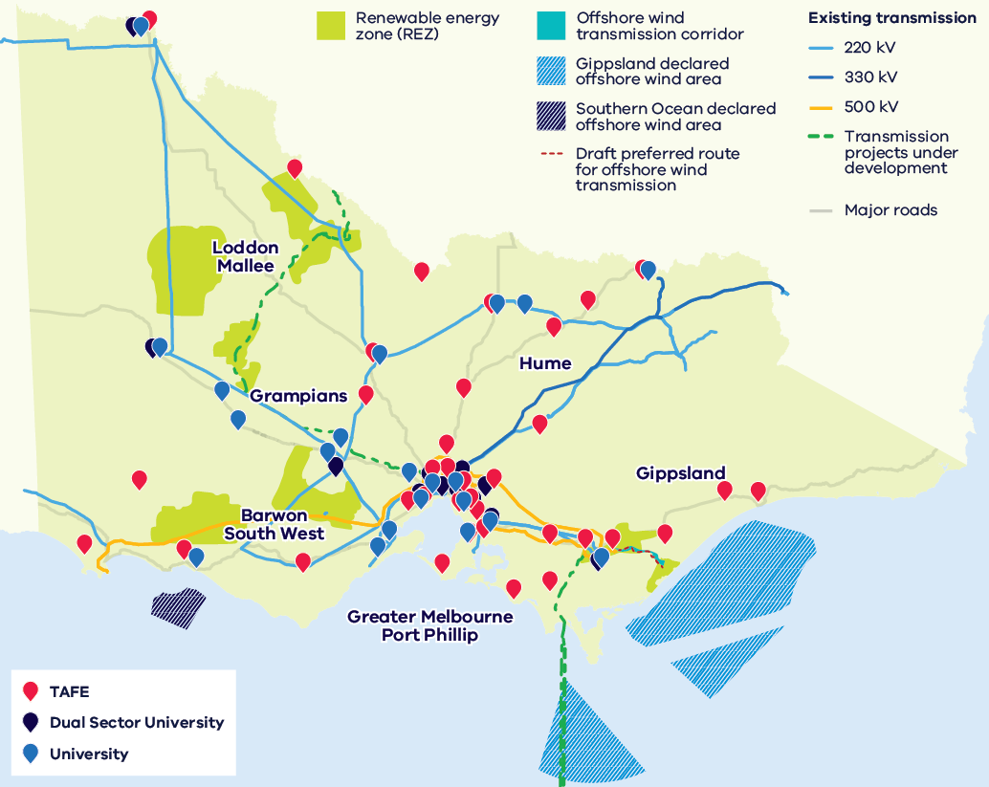
Figure 3 shows the locations of universities, dual-sector universities and TAFE institutes across Victoria, together with renewable energy zones, declared offshore wind areas and transmission infrastructure. Providers are located across all regions of Victoria: Loddon Mallee, Grampians, Hume, Gippsland, Barwon South West, and Greater Melbourne and Port Phillip, with the greatest concentration in Greater Melbourne.

Access to Victoria’s world-class renewable energy talent
Our growing, highly skilled workforce drives project delivery and fosters industry growth.
To meet the needs of the sector, our energy workforce is predicted to grow by 53% to 68,000 between 2026 and 2040. The Victorian Government has committed to significant new skills and workforce initiatives to ensure the workforce is available when and where it's needed, including:
- investing $5 million in Solar Victoria’s Electrification Skills Program
- investing $25 million toward the $50 million Victorian Renewable Energy TAFE Centre of Excellence
- releasing regular energy workforce data to support informed decision-making and boost investor confidence
- developing new energy training pathways through the $7 million for new vocational education and training (VET) certificates in renewable energy project
- simplifying pathways for skilled workers to move to Victoria though improved qualification recognition and Victoria’s Skilled Migration Visa Nomination Program
- investing $10 million toward the $40 million National Training Centre in New Energy Skills.

Victorian Energy Jobs Plan
The Victorian Energy Jobs Plan provides a framework for developing the robust, future-ready energy workforce needed to deliver the transition and strengthen investment confidence.
For more information, visit the Victorian Energy Jobs Plan page.

Sparking Change: The Women in Energy Strategy
The Women in Energy Strategy recognises that attracting and retaining more women in the renewable energy workforce provides significant benefit to this growing sector. It aims to drive significant change for women in energy through Victoria’s energy transition.
For more information, visit the Women in Energy Strategy page.

A clear pathway to partner with First Peoples

Victorian Traditional Owners are actively involved in the energy transition
Investments have been made in developing frameworks and localised plans for the energy transition to create clear pathways for development in Victoria.
Traditional Owner Corporations have clearly defined strategies and processes for partnering to achieve best development outcomes in Victoria.

Clear Guidance from Traditional Owners
Many Traditional Owner Corporations have published guidance and planning documents that help proponents:
- identify community priorities and aspirations
- understand preferred engagement and partnership models
- align projects with local economic, social and cultural outcomes.

Access to specialist support
DEECA has invested in dedicated First Peoples energy specialists who can help developers and investors:
- understand Traditional Owner priorities and aspirations
- navigate engagement and partnership processes
- build strong, long-term relationships that support project success.
For more information, visit the First Peoples energy page.

Strong Government Policy and Guidance
Victoria has established strategic policies and guidance to support collaboration with First Peoples throughout the renewable energy development life cycle. Reducing uncertainty and creating stronger foundations for project development, investment confidence and long-term social value.

First Peoples Renewable Energy Strategic Plan
Identifies First Peoples priorities and desired outcomes within Victoria's renewable transition.
For more information, visit the First Peoples energy resources page.

Community Engagement and Social Value Guidelines
Clear guidance on engagement pathways and creating social value in renewable development.
For more information, visit the VicGrid news story on community engagement and social value.

Dive into Victoria’s renewable energy sectors
This section covers 4 renewable energy sectors:
- utility-scale electricity generation and storage
- distributed energy resources including battery electric vehicles (EVs)
- renewable fuels and feedstocks (including sustainable aviation fuel)
offshore wind.

Utility-scale electricity generation and storage
The utility-scale electricity generation and storage sector is at the heart of our energy transition, supported by legislated renewable energy electricity generation and energy storage targets. With excellent resources, strong supply chains, world-class research and development capabilities and a highly skilled workforce, Victoria is a great destination for your investment.

Clear targets
Legislated targets of 95% renewable electricity generation and 6.3 GW of storage by 2035.

World-class wind
Excellent wind resources, with top average wind speeds of 8.4 metres per second (m/s) in western Victoria.

Excellent solar
Solar irradiation levels are world-leading, with north-west Victoria exceeding 1,900 kilowatt hours per square metre (kWh/m²) annually.

Transmission investment
Planned transmission upgrades unlocking more of Victoria’s wind and solar resources.

Faster planning
Streamlined planning approvals through the Development Facilitation Program.

Competitive electricity market
At the centre of Australia’s competitive, transparent and privatised National Electricity Market.

Case study: Moorabool Wind Farm
“Goldwind’s delivery of the Moorabool Wind Farm highlights Victoria as a prime destination for renewable energy investment, supported by coordinated planning, a skilled workforce, and a strong supply chain.” – Goldwind Australia
The Moorabool Wind Farm is a 312 megawatt (MW) onshore wind project located near Ballarat in western Victoria, delivering clean energy to power approximately 228,000 homes annually. Owned by BJEI Australia and Nebras Power, the project comprises 104 turbines across 2 sections and was fully commissioned in 2022.
Moorabool Wind Farm represents a significant international investment in Victoria. Developed by Goldwind Australia, construction commenced in 2018 before entering full commercial operation in 2022.
Key facts:
- 312 MW installed generation capacity
- 104 turbines
enough electricity to power 228,000 homes.
For more information, visit the Moorabool Wind Farm website.

Distributed energy resources and electric vehicles
Victoria offers investors a mature and rapidly expanding distributed energy resources (DER) market.
Underpinned by strong policy support, near-universal smart meter infrastructure, and one of the highest rates of rooftop solar uptake globally, Victoria provides an advanced environment to deploy, integrate and commercialise rooftop solar, batteries, flexible loads and smart energy technologies.
As it enters a rapid growth phase, Victoria’s battery electric vehicle (EV) sector presents compelling investment opportunities. Combining strong policy targets, accelerating adoption, and a scalable infrastructure and energy integration opportunity, Victoria is a leading investment destination in Australia’s transport electrification transition.

World-leading smart meter adoption
More than 99% smart meter adoption, one of the highest globally.

Large flexible asset base
Growth in home batteries (75,000 installed in 2025–26), EVs, heat pumps and electric appliances is rapidly increasing the volume of flexible load.

Fast-growing startup ecosystem
Startup ecosystem valued at $139 billion, with more than 4,400 start-ups.

Extensive pipeline of digital talent
The fastest growing digital technology sector in Australia, with over 259,000 tech professionals.

Market reforms
Key market changes unlocking stackable, grid service revenues from DER.

Manufacturing and recycling
Access the skilled workforce, existing supply chains and critical minerals required to manufacture or recycle components.

Case study: NewVolt Infrastructure
“We chose Melbourne because it is home to Australia's busiest, most efficient port and Victoria sits at the intersection of the country's most significant renewable energy build-out from the assets clustered along and around the Hume Highway corridor to the broader regional grid. With a clear freight decarbonisation vision, the Victorian Government understood early what NewVolt were trying to do and supported us along the way. The Victorian Freight Decarbonisation Co-Investment Program has now turned into real operator co-investment for us. Victoria is where Australia's first truck charging network starts.”
Anthony Headlam and Rainer Knobloch, Co-Founders, NewVolt Infrastructure
NewVolt Infrastructure is building Australia's first open-access shared charging network for electric trucks. Founded in Melbourne, the company is developing the NewVolt Network – a national platform of high-powered charging hubs anchored in major freight precincts and regional corridors.
Stage 1 of the NewVolt Network of three charging hubs across Melbourne is under construction, backed by $25.3M in co-funding through ARENA's Driving the Nation Program. The Hume Highway corridor, recognised as a Global Green Road Corridor at the 30th United Nations Climate Change Conference (COP30) in Belém, is next as part of Stage 2 works. This will include more sites in Melbourne, Bendigo, Ballarat and more.
NewVolt's model makes electric trucks the lowest-cost freight option, using Australia's renewable energy advantage to drive down operator costs and eliminate diesel exhaust from our freight corridors.

Renewable fuels and feedstocks including sustainable aviation fuel
Renewable fuels can provide a renewable pathway for all our fossil fuel use that is complementary to electrification by decarbonising hard-to-abate activities, driving regional investment and innovation as well as building energy independence through local production.

A developing sector
Victoria's continues to explore how to best support the development of a competitive and sustainable Victorian renewable fuels sector.

Committed targets
Victoria's legislated decarbonisation target to reach net-zero by 2045 will drive renewable fuels uptake in hard to abate sectors.

Research excellence
World-class universities applied research institutes and a skilled workforce accelerate commercialisation and reduce technology risk.

Sustainable feedstocks
Victoria’s agricultural, forestry, municipal, waste and industrial sectors supply diverse, renewable carbon and waste streams.

Established infrastructure
Access to one of Australia’s two refineries, four deepwater ports, oilseed crushing facilities and fuel infrastructure.

Strong demand
Aviation, shipping, industry and heavy transport create strong demand for renewable liquid and gaseous fuels.

Case study: HAMR Energy Portland Renewable Fuels
Backed by $32 million in conditional funding from ARENA, HAMR’s flagship development, the Portland Renewable Fuels project, is a world scale renewable methanol development in Portland, Victoria. It has a target capacity of 300 kilotonnes per annum (ktpa).
This innovative renewable fuels project proposes to utilise biomass and renewable hydrogen to produce low carbon methanol. Leveraging locally sourced biomass and nearby onshore wind resources, the project aims to create a sustainable, low-carbon methanol that can be transported to local and international customers via the Port of Portland or road and rail. The methanol will be used to support the decarbonisation of hard to abate sectors and is a key building block for many sustainable aviation fuel (SAF) pathways.
The Victorian Government is supporting the Portland Renewable Fuels Project with $500,000 for a feasibility study through its Portland Diversification Fund.
For more information, visit the HAMR Energy Portland Renewable Fuels page.

Victoria’s energy and fuel infrastructure can support local renewable fuel production and distribution
Figure 4: A map of Victoria’s energy and fuel infrastructure
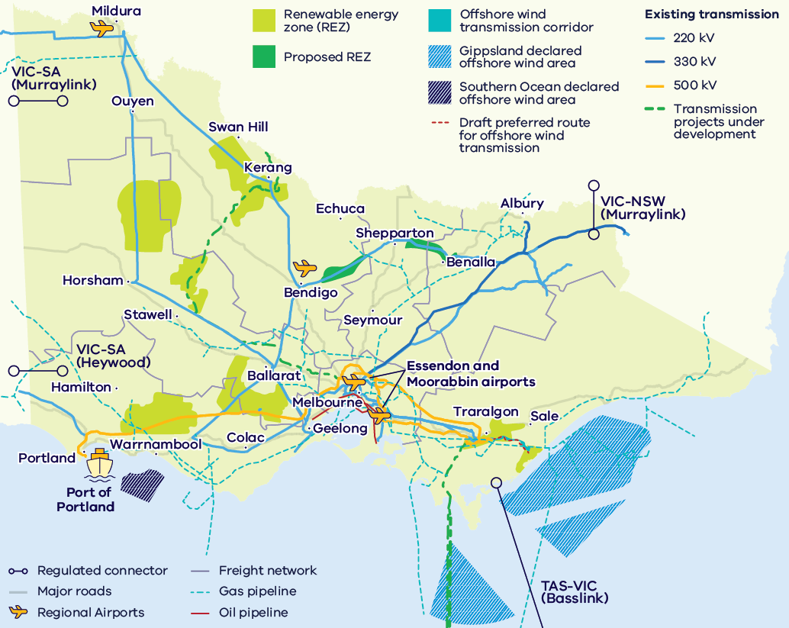
Figure 4 shows Victoria’s energy and fuel infrastructure, including:
- renewable energy zones and proposed renewable energy zones
- existing 220 kV, 330 kV and 500 kV transmission lines, transmission projects under development and the draft preferred route for offshore wind transmission
- regulated interconnectors: VIC-SA (Heywood), VIC-SA (Murraylink), VIC-NSW (Murraylink) and TAS-VIC (Basslink)
- the gas pipeline, oil pipeline, freight and major road networks
- the Port of Portland
- regional airports, including Mildura and Bendigo, and Essendon and Moorabbin airports in Melbourne
the Gippsland and Southern Ocean declared offshore wind areas.

Offshore wind
Offshore wind has a critical role to play in Victoria’s renewable energy future, with the Victorian Government targeting 9 GW of offshore wind capacity by 2040.

Clear commitment
First auction for 2 GW of energy generation opened in August 2026, leading to 9 GW of targeted capacity – a clear pipeline for investment.

National leadership
Australia’s first and largest declared area for offshore wind energy in Gippsland.

World-class resources
Strong and consistent wind speeds comparable to the best offshore wind regions globally.

Supply chain and manufacturing
A strong pipeline of projects for original equipment manufacturers and local supply chains.

Access to skilled workers
Home to the Asia Pacific Renewable Energy Training Centre in Ballarat and the Victorian Renewable Energy TAFE Centre of Excellence in Gippsland.

Enabling infrastructure
VicGrid is delivering the shared transmission infrastructure to connect offshore wind energy to the grid. The Victorian Renewable Energy Terminal at the Port of Hastings will deliver critical port capacity.

Key Victorian Government entities
We can help facilitate connections with key Victorian Government entities and industry members across our renewable energy sector.

Department of Energy, Environment and Climate Action (DEECA)
DEECA works with industry and the community to develop Victoria's secure and sustainable energy future.
For information on Victoria’s energy policy landscape and facilitated connections across the Victorian Government and renewable energy sector, contact the Business and Industry Engagement team at: BIE@deeca.vic.gov.au
For more information, visit the renewable energy investment opportunities page.

Offshore Wind Energy Victoria
Offshore Wind Energy Victoria (OWEV) has been established as the single point of entry for industry and community engagement on offshore wind.
For more information, visit the Offshore Wind Energy Victoria page.

Solar Victoria
Solar Victoria is responsible for the delivery of the Victorian Government’s $1.3 billion Solar Homes Program – one of the most ambitious and transformative renewable energy programs in Australia.
For more information, visit the Solar Victoria website.

VicGrid
VicGrid coordinates the planning and development of Victorian Renewable Energy Zones (REZs). It is also investing $480 million that will be used to strengthen the grid and develop each REZ.
For more information, visit the renewable energy zones page.

Invest Victoria
Invest Victoria is the Victorian Government’s investment attraction agency. Services include:
- market regulatory information
- statutory approvals coordination
- site location services
- identification of infrastructure and utility requirements
- advocacy within government.
For more information, visit the Invest Victoria website.

Investment Coordinator-General
The Investment Coordinator-General role and function also sits within Invest Victoria, working across agencies to ensure approvals deadlines are met and helping to reduce delays.
For more information, visit Victoria’s Investment Coordinator-General page.

Innovation Victoria
Innovation Victoria is the Victorian Government’s single front door for innovation, supporting founders, researchers, entrepreneurs and investors from early idea through to commercialisation and scale. It provides the capability uplift, connections and capital pathways to accelerate the commercialisation from idea to growth, scale and global opportunity.
For more information, visit the Innovation Victoria website.

SEC
SEC is a Victorian Government-owned renewable energy company. It is partnering with the private sector to deliver 4.5 GW of new renewable energy and storage projects with an initial investment of $1 billion.
For more information, visit the SEC website.

For international investors
Contact a local Victorian Government Trade and Investment Office to help you:
- navigate investment opportunities in Victoria’s new energy technology sector
- set up a briefing with energy specialists
- arrange inbound market visits
- introduce you to the Victorian Government’s Energy Business and Industry Engagement team and Invest Victoria.
For more information, visit the Trade and Investment office locations page.

Victorian Government Trade and Investment office locations
- Australia: Melbourne
- North America: Boston, Chicago, New York, San Francisco, Washington DC
- South America: Santiago
- Europe: Frankfurt, London, Paris
- Middle East: Dubai, Tel Aviv
- South Asia: Bangalore, Mumbai
- North Asia: Beijing, Chengdu, Hong Kong, Nanjing, Seoul, Shanghai, Tokyo
- South-East Asia: Jakarta, Kuala Lumpur, Singapore, Vietnam
Figure 5: World map showing the locations of Victorian Government Trade and Investment offices
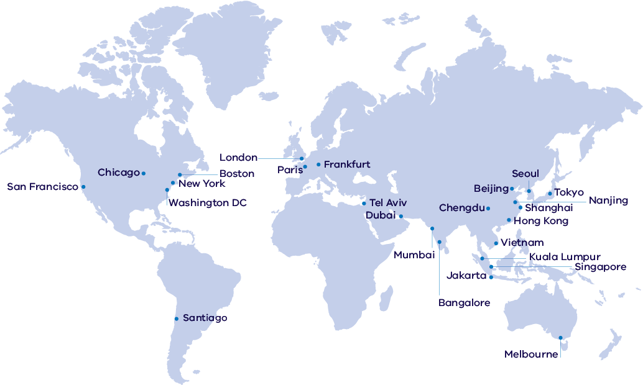

Subsector packs
To access the Renewable Energy subsector packs, please visit the renewable energy subsector packs page.
The following subsector packs are available:
- Distributed Energy Resources and EVs
- Offshore Wind
- Utility-scale Electricity Generation and Storage
- Renewable Fuels and Feedstocks
- Renewable Fuels and Feedstocks: Sustainable Aviation Fuel.

Publication information

Copyright
© The State of Victoria Department of Energy, Environment and Climate Action, September 2026.

Creative Commons
This work is licensed under a Creative Commons Attribution 4.0 International licence, visit the Creative Commons website.
You are free to re-use the work under that licence, on the condition that you credit the State of Victoria as author. The licence does not apply to any images, photographs or branding, including the Victorian Coat of Arms, and the Victorian Government and Department logos.
ISBN 978-1-76176-989-4 (print)
ISBN 978-1-76176-990-0 (pdf/online/MS word)

Disclaimer
This publication may be of assistance to you but the State of Victoria and its employees do not guarantee that the publication is without flaw of any kind or is wholly appropriate for your particular purposes and therefore disclaims all liability for any error, loss or other consequence which may arise from you relying on any information in this publication.

Accessibility
To receive this document in an alternative format, phone the Customer Contact Centre on 136 186, email customer.service@deeca.vic.gov.au, or contact National Relay Service on 133 677 or visit the National Relay Service website. This document is available on the DEECA website.
End of document.

Total additional capacity required reflect estimates only, based on AEMO's 2026 ISP Generation and Storage Outlook – step change scenario – Optimal Development Path – Victoria (2026 to 2035).
Victoria in Future | 2023 planning.vic.gov.au/guides-and-resources/Data-spatial-and-insights/discover-and-access-planning-open-data/victoria-in-future
Why invest in Melbourne? | City of Melbourne | melbourne.vic.gov.au/why-invest-melbourne
EIU Global Liveability Index 2026 | eiu.com/n/wp-content/uploads/2026/07/EIU_ Liveability-Index-2026.pdf
State Budget 2026 | dtf.vic.gov.au/state-budget
The Victorian Energy Jobs Plan 2026 | energy.vic.gov.au/renewable-energy/our-energy-workforce/victorian-energy-jobs-plan
NEM Factsheet, AEMO
Australian Energy Regulator | aer.gov.au/about/aer/our-role
2026 ISP, AEMO | aemo.com.au/energy-systems/major-publications/integrated-system-plan-isp/2026-integrated-system-plan-isp
Figures correct as of August 2026 | Department of Transport and Planning
Includes funding announced in the 2020–21, 2021–22, 2022–23, 2023–24, 2024–25, 2025–26 and 2026–26 Victorian Budgets, all figures are in $A. Funding for the Solar Homes program is over 2018 to 2028. Batteries are no longer supported under the Solar Homes program.
Figure correct as of August 2026 | Department of Energy, Environment and Climate Action
Figures as of July 2026 based on Geoscience Australia identified mineral resource estimates | Resources Victoria
Economic Growth Statement | December 2024 vic.gov.au/economic-growth-statement
Estimates are based on internal forecasts and modelling by Department of Energy, Environment and Climate Action and are subject to change.
Figure correct as of July 2026 | LaunchVic | launchvic.org/about-the-ecosystem/
State of Australian Startup Funding 2025 | Folklore Ventures/Cut Through Venture | 2026 australianstartupfunding.com
Access a highly skilled workforce | 2025 invest.vic.gov.au/understand-the-market/know-the-victorian-economy/workforce-and-skilled-talent
World University Rankings | QS | Accessed July 2026 topuniversities.com/world-university-rankings
Victorian Energy Jobs Plan | 2026 | energy.vic.gov.au/renewable-energy/our-energy-workforce/victorian-energy-jobs-plan
Manufacturing Statement | djsir.vic.gov.au/made-in-victoria/manufacturing-statement
Small-scale installation postcode data | Clean Energy Regulator | July 2026 | cer.gov.au/markets/reports-and-data/small-scale-installation-postcode-data
A thriving startup ecosystem | Study Melbourne | July 2026 | studymelbourne.vic.gov.au/why-melbourne/a-global-hub-forresearchtechnology-and-entrepreneurship/a-thriving-startup-ecosystem
Australia’s Tech Jobs Opportunity – Cracking the Code to Australia’s Best Jobs | Tech Council of Australia | February 2022 | techcouncil.com.au/wp-content/uploads/2022/03/2022-Tech-Jobs-Opportunity-report.pdf

