Victorian Government response to the Coroners Court inquest into the death of
Sonia Sofianopoulos

The Victorian Government offers its sincere condolences to the family and friends of Mrs Sofianopoulos. The Victorian Government thanks Coroner Hawkins for conducting the inquiry into this tragic event and for providing recommendations to improve public health and safety. This document sets out of the whole of Victorian Government response to the Coroner’s recommendations.

Overview and CONTEXT
On 22 August 2018, Coroner Hawkins handed down her findings into the death of Mrs Sonia Sofianopoulos. The Coroner found “that there was no one single factor involved in the death of Mrs Sofianopoulos but a confluence of events that proved to be fatal”.
The Coroner concluded that open flue gas space heaters are incompatible with modern homes and found that “[n]ew and renovated housing, commonly characterised by a reduction in ventilation, together with the use of internal exhaust fans, can be a deadly combination when an [open flue gas] heater is installed and operating.” The Coroner identified open flue gas heaters as posing an “important public health and safety issue”.
The safety of Victorians is the Government’s first priority and there are important lessons to be taken from this tragic incident. The Government is taking action in response to the Coroner’s recommendations and to address related issues that will deliver improved protection for Victorian households. The Government will provide Victorians with strengthened safeguards so that they can use gas appliances with confidence, knowing that they are fit for purpose, that they can be expertly serviced and tested, and that they are subject to appropriate regulatory oversight.
What is an open flue gas space heater?
An open flue gas space heater is designed to interact with airflow in the home, drawing air from the room to support combustion and venting emissions outside through the flue.
More modern designs for space heaters involve a ‘room sealed’ flue through which the heater both draws air in and expels combustion products back outside, with no impact on interior air quality.
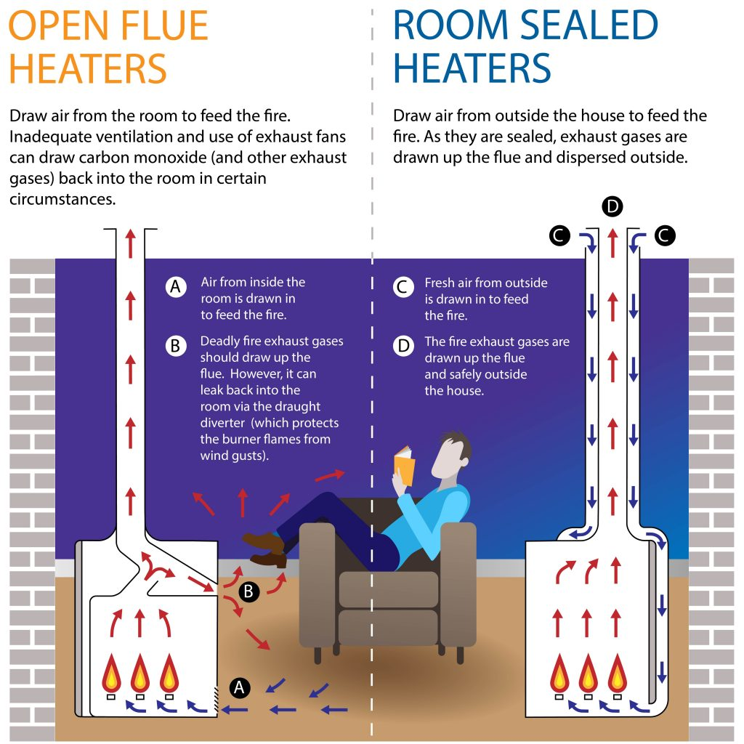

It can be difficult to accurately identify an open flue gas space heater just by looking at it. If unsure, a plumber licensed and registered in gasfitting or ‘Type A’ gas appliance servicing is the best port of call to identify the type of heater.

Gas heating – adapting to changing technology, house design and household preferences
Over the past decade, Victorian homes have become progressively better weather-sealed, improving comfort and reducing energy costs. Building standards, introduced in 2005 and strengthened in 2010, mean that our homes have been increasingly retrofitted and built to higher standards to improve energy efficiency.
As consumers seek to improve the comfort and energy efficiency of their homes, even minor modifications (such as improved weather sealing) may create risks where there is an open flue gas space heater installed. Open flue gas space heaters can have a long operating life of up to 25 years and new installations are most likely to be as a replacement for an existing open flue heater.
These changes mean that we need to reconsider the safety of some forms of gas heating and manage the risks through a range of measures.

Carbon monoxide poisoning risks
Carbon monoxide (CO) is a poisonous, odourless and tasteless gas, which reduces the ability of the blood to retain oxygen. High concentrations of CO in the air can kill, but even low concentrations may cause illness. The nature of CO poisoning (with generic symptoms including tiredness, shortness of breath, headaches, dizziness, nausea, weakness, confusion and/or malaise) means that there may be many cases of low level chronic CO poisoning associated with open flue gas heaters that go undiagnosed and unrecorded.
In Victoria, there have been three confirmed fatalities from CO poisoning associated with open flue gas space heaters since 2010; two young children, Chase and Tyler Robinson, died in 2010; and Sonia Sofianopoulos died in 2017.
The separate Coroners’ reports into these deaths noted the confluence of factors that contributed to the malfunctioning of the heaters and production of CO, and then the leakage of CO into living areas and bedrooms, and the specific susceptibility of open flue gas space heaters to these risks.
“When there is inadequate ventilation, combined with the use of internal exhaust fans, this type of heater is not only unsuitable for use in these conditions, but potentially, life threatening.” (Finding into the death of Sonia Sofianopoulos, August 2018, para 205)
“…it is clear from the subsequent testing that the negative pressure created by operation of only two exhaust fans was sufficient to override the operation of the flue and by-pass it as a safety device.” (Finding into the death of Tyler Robinson, July 2013, Finding 6)
There are two key risk conditions associated with open flue gas space heaters which, when presenting in combination, create a heightened CO exposure risk to households:
- Combustion failure – this means the heater does not burn properly and produces CO. Combustion failures can be caused by age/deterioration of the equipment, lack of servicing and any other condition that would starve the heater of oxygen, including downdraughts and negative pressure. Combustion failures can occur in all gas appliances but with an open flue gas space heater there is a risk that the CO may spill into the home rather than being discharged up the flue.
- Negative pressure – this is created when extraction fans remove more air from the building than can enter it again. When this happens, air can be drawn down an open flue gas space heater’s flue (adverse air flow), resulting in combustion products being drawn into the room instead of being vented outside. This is particularly an issue with open flue gas space heaters with draught diverters, as combustion products can spill from these vents under negative pressure conditions. Negative pressure conditions can also starve the heater of oxygen, leading to combustion failure and excessive CO production. Negative pressure is a common condition in modern, well-sealed homes. As noted above, our homes are becoming better weather sealed and often have several, powerful exhaust fans meaning that negative pressure conditions are readily created. Better weather sealing (reduced ventilation) also means that if the heater malfunctions, dangerous levels of CO are more likely to build up and not be dispersed by air movement.

The regulatory environment
Victoria’s independent regulators, Energy Safe Victoria (ESV) and the Victorian Building Authority (VBA), play important roles in ensuring the safety of gas heaters for Victorian households. Their roles are outlined in the box below.
Box 1: Victoria’s independent regulators
Energy Safe Victoria
ESV is the independent regulator for gas, electricity and pipeline safety in Victoria. It is responsible for regulating against standards for gas safety, testing products to verify their safety, while also investigating safety issues in homes and businesses.
Victorian Building Authority
VBA is the independent authority responsible for regulating building and plumber practitioners in Victoria. It registers, licenses and disciplines plumbers, provides training and expert technical advice to practitioners, and undertakes compliance inspections and investigations to ensure consumers are protected.

Recommendations of the Victorian Coroner
The Coroner made eight recommendations, the main recommendation being that open flue gas space heaters should be phased out (Recommendation 1).
The Coroner’s other seven recommendations focused on four key areas:
- Improved testing of carbon monoxide leakage by: ensuring “up-to-date knowledge” of gasfitters and plumbers, including investigation of mandatory continuous professional development training; advice on “appropriate CO spillage testing equipment”; and updating standards to readily identify CO poisoning risks (Recommendations 2, 4 and 6);
- Strengthened compliance to assure quality of work, with issuing of compliance certificates for servicing work to be investigated in consultation with industry (Recommendation 5);
- More effective communication with relevant industry stakeholders: identifying a range of mechanisms for communicating updates to statutory requirements (Recommendation 7); and
- Targeted risk information for the community: Criticality of appropriate and accurate community information on the dangers associated with these types of heaters, especially in combination with negative pressure and inadequate ventilation, and targeted advice regarding specific models that have identified safety issues (Recommendations 3 and 8).

Victorian Government Response
The Victorian Government supports or supports in principle all eight recommendations of the Victorian Coroner. The Victorian Government is working with stakeholders to deliver on these recommendations and make homes safer from the risk of elevated and potentially life-threatening CO levels from open flue gas heaters. The Victorian Government’s response to each of the Coroner’s recommendations is set out below.

Recommendation 1: The Australian Gas Association and Energy Safe Victoria collaborate to implement a strategy and a plan to phase out all open flue gas heaters.
Government Response: Support-in-principle
The Coroner found that this type of heater was “unsuitable” and “potentially life threatening” in conditions where there is inadequate ventilation combined with the use of internal exhaust fans – conditions likely to be found in new and renovated housing in Victoria. This was the basis for the Coroner’s recommendation that all open flue gas heaters – not just the particular model implicated in this incident – should be phased out. Her recommendation directs government and industry to plan for, and give effect to, a transition to safer forms of gas heating.
The Victorian Government will conduct a review of open flue gas space heaters, with options such as a phase out to be assessed through a regulatory impact statement process under the Gas Safety Act 1997. This review will commence in early 2019 and be informed by public and industry consultation.
The Australian Gas Association (AGA) referred to in this recommendation is one of a number of privately owned Conformity Assurance Bodies who will be provided with an opportunity to provide input into the regulatory review process, along with other industry and community stakeholders.

Recommendation 2: The Department of Environment, Land, Water and Planning conduct a regulatory impact statement to consider the implementation of a system of mandatory continuous professional development training for plumbers and fitters as a condition of being registered or licensed.
Government Response: Support
Training is essential to ensure that practitioners’ knowledge and practices are kept up to date so that they can readily and appropriately respond to these risks. The Government has already taken steps to enable further investigation into the development of a system of mandatory continuous professional development for licensed and registered plumbers. This included amendment to the Building Act 1993, through the Building Amendment (Registration of Building Trades and Other Matters) Act 2018, to provide a relevant power to make regulations for this purpose.
The Department of Environment, Land, Water and Planning (DELWP) will conduct a regulatory impact statement process to assess options for mandatory continuous professional development across the building and plumbing industries in 2019.
In August 2018, the VBA, in partnership with ESV, delivered CO spillage testing and negative pressure training across Victoria, providing practical guidance to over 2,500 plumbers and gas-fitters. The VBA has also launched an online instructional training video on negative pressure and CO spillage testing and an online training module and exam that must be completed by all registered and licensed Gasfitters and Type A Gas Appliance Servicing plumbers by 1 November 2018 in order for them to be eligible to renew a plumbing or gas fitting registration or licence at their next renewal date.

Recommendation 3: Climate Technologies, the manufacturer of the Vulcan/Pyrox Heritage open flue gas heater which was implicated in the death of Mrs Sofianopoulos, publish an article in The Age and The Herald Sun warning the public about the necessity of regular servicing and maintenance. This is to ensure that it operates in a safe and efficient manner and does not expose residents to carbon monoxide poisoning.
Government Response: Support
Regular servicing is essential to support the safe functioning of heaters and all gas appliances. Efforts by government and industry to inform the public of the need for regular servicing are essential and welcomed by the Victorian Government. While a phase out is important to reduce the ongoing risks posed by these heaters through new sales, there will remain a large number of these heaters in Victorian homes which will need to be regularly maintained until they reach their end-of-life, to support their safe use.
ESV will support Climate Technologies to publish advertisements that align with the latest safety messaging, including the importance of regular servicing and maintenance.

Recommendation 4: Energy Safe Victoria publish an article in their quarterly newsletter about the importance of testing for carbon monoxide spillage and provide guidance as the appropriate detection equipment to use to obtain the most accurate results and to ensure the safety of the users.
Government Response: Support
ESV’s quarterly newsletter (EnergySafe magazine), published in September 2018, included a section on check testing, negative pressure, new gas scheme rules, CO risks and non-compliances, and new Type A gas appliance information sheets. Subsequent editions will reiterate this information.
There are different types of equipment to test for CO spillage available to practitioners. ESV will work closely with industry and the VBA to investigate the appropriateness of different types of detectors, and provide advice to plumbers, gasfitters and consumers.

Recommendation 5: The Victorian Building Authority consult with relevant industry stakeholders and review its requirements for the provision of Certificates of Compliance to the extent that they relate to the servicing, testing and maintenance of open flue gas heaters.
Government Response: Support
It is important for consumers to have assurance of the quality of servicing, testing or maintenance undertaken. The VBA has commenced reviewing requirements for compliance certificates and will advise on the outcomes of this review in early 2019. The requirements for compliance certificates are set out in the Building Act 1993. Any changes to the requirements may require legislative amendment.

Recommendation 6: The Chairman of Standards Australia – Committee Responsible for Australian Standard: 4575 Gas Appliances – Quality of Servicing to consider amending that standard to incorporate Appendix R of AS5601 as soon as practicable.
Government Response: Support
It is important that CO spillage is tested not only when a heater is installed, but also during servicing. Under the Gas Safety Act 1997, all gas-fitting work (including repair and maintenance work) is required to comply with Australian Standard AS/NZ5601.1. The Government supports the revision and republication of AS4575 to further clarify safety testing requirements for practitioners when servicing Type A gas appliances.

Recommendation 7: Energy Safe Victoria conduct a review on the best way for Energy Safe Victoria to communicate guidelines, changes to legislation and industry updates to relevant industry stakeholders using all forms of modern technology including phone applications, social media, and YouTube videos.
Government Response: Support
Updates to guidelines, standards and other requirements are frequent, and it is essential that critical changes are communicated in a way that is accessible and appropriate to industry needs.
ESV is reviewing the way it communicates these important updates and will be consulting with industry and practitioners on approaches to best meet their needs. This review will be completed in 2018, with appropriate new communication tools and methods expected to be in use by early 2019.

Recommendation 8: Energy Safe Victoria conduct a widespread media and public awareness campaign on the dangers associated with open flue gas heaters, especially in the context of negative pressure and lack of adventitious ventilation and the need and importance of servicing and maintaining open flue gas heaters.
Government Response: Support
Information and education for consumers is essential to support consumers in readily identifying risks. The Victorian Government is currently implementing updates to community information provided through ESV’s website to highlight critical risk messages and promote community action on precautionary measures, including regular servicing of open flue gas heaters and the installation of CO alarms. This will also provide clear advice to consumers and practitioners on open flue gas heaters that are subject to remedial action.
Safe Heating with Gas – Top Tips
Get your heater serviced once every two years: this will ensure your heater runs safely and efficiently.
Only use a qualified gasfitter: ask your gasfitter for a Compliance Certificate on completion of any installation work.
Don’t leave the heater on overnight: avoid using your gas heater for extended periods or when not required.
Buy and install a carbon monoxide alarm as a back-up precaution: carbon monoxide alarms are a useful precautionary measure but are not a substitute for regular maintenance of gas heating appliances.
Consider replacing old appliances: also avoid buying second-hand appliances.

The government will also develop a community campaign designed to empower people to manage their open flue gas heater to avoid or mitigate risks in the lead up to winter 2019. The campaign will be led by a cross-government taskforce including ESV, VBA, DELWP, Consumer Affairs Victoria and the Department of Health and Human Services (DHHS).

further actionS BEING TAKEN BY THE VICTORIAN GOVERNMENT to mitigate the risks
In addition to implementing the Coroner’s recommendations, the Victorian Government is taking further action to respond to the risks of CO poisoning from open flue gas heaters. An overview of these actions is set out below.
Replacement program for public housing residents
DHHS has commenced a replacement program where these heaters are installed in public housing. Open flue gas heaters in these homes will be progressively disconnected, and alternative heating provided. A CO alarm installation program is also underway in public housing with gas appliances to assist in preventing CO poisoning.
Improving protection for tenants
In August 2018, the Victorian Government introduced amendments to the Residential Tenancies Act 1997 as part of its commitment to ensure Victorians who rent have access to fairer, safer housing. The reform package includes mandatory safety-related obligations which will mean that residential rental providers will be required to service electrical and gas appliances every two years.
Regular service checks, which include testing for CO leakage and negative pressure conditions, are an important way of mitigating risks associated with open flue gas heaters already installed in Victorian homes. Many of these are likely to be installed in older rental properties and renters will often be unaware of what type of heater is installed and whether it has been recently serviced. This reform will help to keep these Victorian households safe and warm.
Carbon monoxide alarms can save lives
While gas appliances are generally safe to use, CO alarms are a useful additional safeguard, drawing occupants’ attention to potential health risks. ESV has updated its advice to recommend the installation of CO alarms in homes with open flue gas heaters.
The government will commence a regulatory review process to assess options for mandatory installation of CO alarms in Victorian homes where additional safeguards are needed. With around 360,000 open flue gas space heaters currently installed in Victorian homes that may be used for years to come, it is important to provide robust measures to ensure ongoing risk mitigation. DELWP will prepare a regulatory impact statement as a basis for consultations with the community in the first half of 2019.
A CO alarm does not replace the need for regular servicing. Information on the types of alarms available and how to install them is provided on ESV’s website – www.esv.vic.gov.au
Reviewing regulatory frameworks to ensure they are fit-for-purpose
Ensuring a robust regulatory framework is essential to protect consumers, support compliance by practitioners and industry, and promptly respond to any emerging issues. The recent Coroner’s report has identified a number of specific areas for action by ESV and the VBA. These independent regulators both play important roles in gas heater safety.
The Victorian Government will commence a review of the regulatory framework for gas heater safety, including a review of regulator roles and responsibilities, to ensure that Victoria has a well-integrated regulatory framework that is:
- easier for consumers and industry to navigate;
- provides all relevant agencies with clear accountabilities; and
- aligns responsibilities to maximise effective risk management and provide for pro-active risk identification and monitoring.
This review will also examine the adequacy of national certification and testing processes for gas appliances, in consultation with other jurisdictions and the Gas Technical Regulators Committee.
Further information
For further information on managing CO risks and the maintenance of gas appliances, please visit ESV’s website – www.esv.vic.gov.au

Victorian Coroner, August 2018, Inquest into the death of Sonia Sofianopoulos, para 199.
Ibid, para 161.
Ibid, para 204.
Ibid, para 210.
Ibid, para 162.
Ibid, para 174-7.

