Renewable Energy Investment Prospectus: Offshore Wind
  - October 2026

Table of Contents
Traditional Owners at the centre for decision-making processes 3
Welcome to Victoria’s renewable energy sector 5
Invest in Victoria’s offshore wind sector 7
World class resource 9
Australian-first Request for Proposal now open 11
Asia-Pacific offshore wind growth 16
Victoria’s declared offshore wind zones 20
Unlocking investment opportunities along the supply chain 23
Leverage existing supply chain capabilities 26
Enabling port infrastructure 28
Victoria’s new Renewable Energy Zones 31
Gippsland Shoreline Renewable Energy Zone 34
World class renewable energy talent 36
Where research, industry and talent converge 38
Industry events and conferences 40
Key Victorian Government entities 44
Subsector packs 47
Publication information 48

Traditional Owners at the centre for decision-making processes
Victoria celebrates the richness and diversity of Aboriginal history and culture, recognises the resilience and strength of Aboriginal communities, and is committed to advancing Aboriginal self-determination.
Both the Offshore Wind Energy Implementation Statement 4 and the Victorian Government’s testimony to the Yoorrook Justice Commission reaffirm the Government’s commitment to supporting Traditional Owner aspirations through mutually beneficial agreements with developers that align with international best practice.
Traditional Owners hold enduring rights and responsibilities for Country and Sea Country. Developers are expected to ensure that all engagement and partnership activities are culturally safe, respectful and informed by Traditional Owner self-determination. This includes creating opportunities for Traditional Owners to shape, participate in, lead and benefit from the renewable energy transition in ways determined by them.
Traditional Owners’ cultural and legal rights must be recognised and upheld in accordance with the Traditional Owner Settlement Act 2010 (Vic), the Aboriginal Heritage Act 2006 (Vic), the Charter of Human Rights and Responsibilities Act 2006 (Vic), and the Native Title Act 1993 (Cth).
Respect for Aboriginal cultures, values, knowledge and practices is fundamental to meaningful engagement and enduring partnerships.

Acknowledgement of Country
We acknowledge and respect Victorian Traditional Owners as the original custodians of Victoria’s land and waters, their unique ability to care for Country and deep spiritual connection to it.
We honour Elders past and present whose knowledge and wisdom have ensured the continuation of culture and traditional practices.
We are committed to genuinely partner, and meaningfully engage, with Victoria’s Traditional Owners and Aboriginal communities to support the protection of Country, the maintenance of spiritual and cultural practices and their broader aspirations in the 21st century and beyond.

Welcome to Victoria’s renewable energy sector
Our legislated targets and changing energy market are creating investment opportunities.
Victoria’s energy market is rapidly transitioning away from a historic reliance on fossil fuels to a distributed and diversified renewable supply mix as the state’s largest coal-fired generators are set to retire. At the same time, electricity demand is growing as households, businesses and transport electrify and more data centres are added to the mix. Together, these trends are driving the need for new, reliable and clean energy supply.
Victoria is leading offshore wind development in Australia, targeting 9 GW of offshore wind capacity with the first and largest declared area for offshore wind energy located in Gippsland. Supported by world-class wind resources, strong supply chains, research and development capabilities, and a highly skilled workforce, Victoria is a great destination for your investment.
Table 1: Key renewable energy figures
Figure | Description
27 GW | New renewable generation and storage capacity required by 2035 in Victoria
82% | Australia’s renewable energy target by 2030
9 GW | Targeted offshore wind capacity
Table 2: The Victorian Government’s legislated targets
Year | Target | Status
2020 | 25% renewable electricity generation | Achieved
2025 | 40% renewable electricity generation | Achieved
2030 | 65% renewable electricity generation  2.6 GW energy storage capacity | Target
2035 | 95% renewable electricity generation  6.3 GW energy storage capacity | Target
2045 | Net-zero emissions | Target

Invest in Victoria’s offshore wind sector

Clear commitment
First auction for 2 GW of energy generation opened in August 2026, leading to 9 GW of targeted capacity – a clear pipeline for investment.

National leadership
Australia’s first and largest declared area for offshore wind energy in Gippsland.

World-class resources
Strong and consistent wind speeds comparable to the best offshore wind regions globally.

Supply chain and manufacturing
A strong pipeline of projects for original equipment manufacturers and local supply chains.

Access to skilled workers
Home to the Asia Pacific Renewable Energy Training Centre in Ballarat and the Victorian Renewable Energy TAFE Centre of Excellence in Gippsland.

Enabling infrastructure
VicGrid is delivering the shared transmission infrastructure to connect offshore wind energy to the grid. The Victorian Renewable Energy Terminal at the Port of Hastings will deliver critical port capacity.

Victoria at a glance
- Victoria is the fastest-growing state in the country with the population expected to reach 10.3 million by 2051.
- Victoria contributes nearly a quarter of Australia’s economic activity.
Melbourne is ranked the world’s 3rd most liveable city and Australia’s most liveable city.

World class resource
Victoria’s coastline boasts average wind speeds of 9–10 m/s, which is comparable to Northern Scandinavia, the North Sea, and the north-east coasts of the USA.
Victoria’s on and offshore wind sectors are primed for investment, with wind power set to play a critical role in achieving the state’s renewable energy targets.
Victoria is perfectly positioned to lead the nation in establishing a thriving offshore wind industry, combining world-class wind resources with a skilled regional workforce, strong supply chain capability and a proven track record in renewable energy delivery.
Victoria is ideal for offshore wind development with:
- some of the world’s strongest and most consistent offshore wind resources
- relatively shallow ocean depths
proximity to existing 500 kV transmission infrastructure in the Latrobe Valley.
Figure 1: Offshore wind resource map
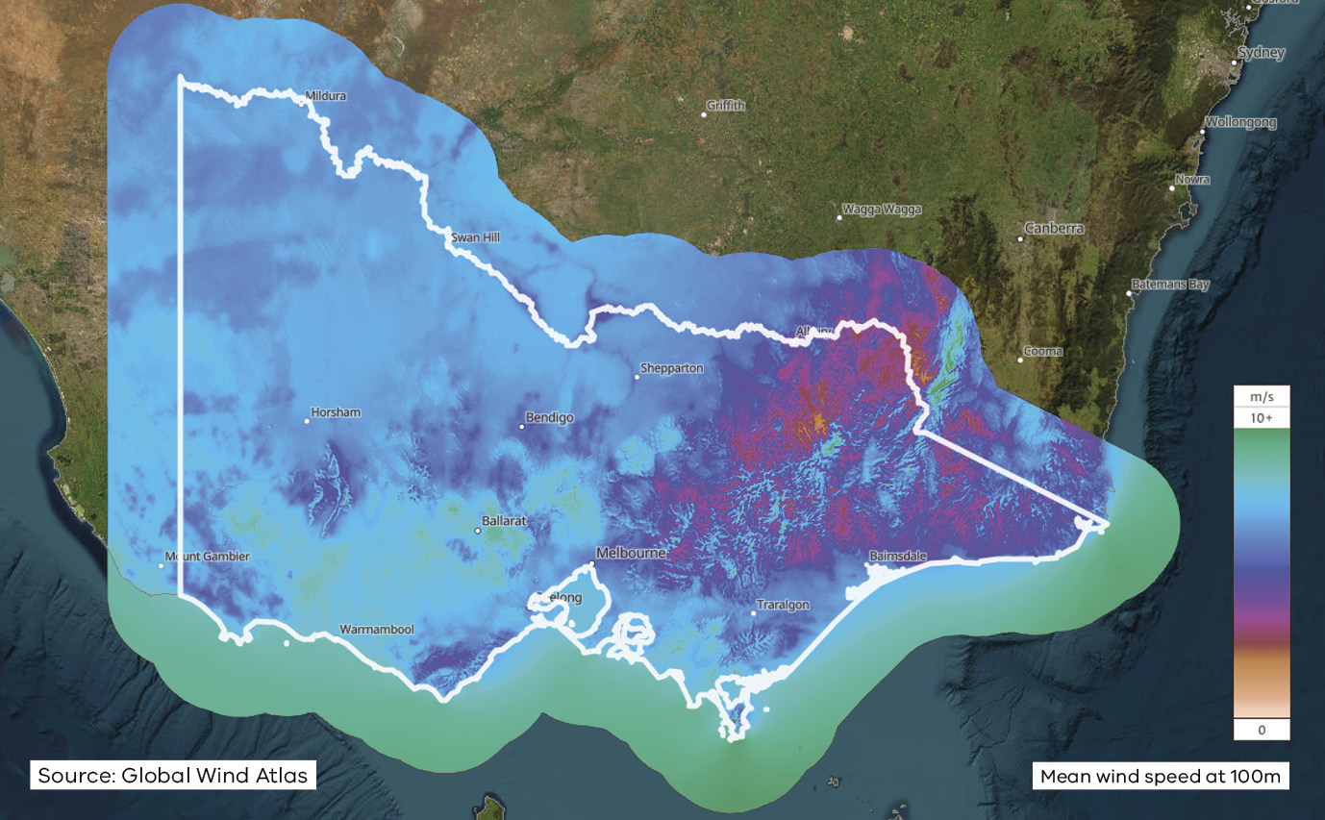
Figure 1 shows mean wind speed at 100 metres across Victoria and its coastal waters. The strongest and most consistent winds, averaging 9 to 10 metres per second, are found offshore along the Victorian coastline, particularly in Bass Strait off Gippsland and in the Southern Ocean off south-west Victoria. Wind speeds are generally lower inland.
Source: Global Wind Atlas.

Dedicated government coordination
Offshore Wind Energy Victoria (OWEV) is a dedicated division within the Energy Group of the Victorian Government’s DEECA, established to lead and accelerate the development of Victoria’s offshore wind industry.
OWEV is responsible for coordinating the growth of the sector, supporting the delivery of Victoria’s offshore wind energy targets, and facilitating the development of a globally competitive industry. Working in partnership with industry, communities and Traditional Owners, OWEV plays a key role in creating the policy, regulatory and investment environment required to enable offshore wind projects and associated supply chain opportunities.
As Victoria’s offshore wind sector progresses from planning to delivery, OWEV is helping to unlock investment, build local industry capability and support workforce development.
For more information about OWEV and Victoria’s offshore wind energy, visit the offshore wind page.

Australian-first Request for Proposal now open
Victoria continues to lay the foundations for the industry to thrive with the commencement of Australia’s first offshore wind auction.

Offshore wind auction
The opening of the Request for Proposal (RFP) in August 2026 marked the commencement of the first formal auction process to deliver up to 2 GW of offshore wind capacity to Victoria’s energy grid.
The auction will award a support package to winning bidders. The package will consist of a contract for difference mechanism (CfD) with a term of 20 years to help mitigate market revenue variability risk, and an Availability Payment.
The Availability Payment is a fixed-sum periodic payment, conditional upon the infrastructure being available to generate electricity and only payable following achievement of commercial operation.
Victoria will assess proposals based on:
- value for money
- deliverability
local content commitments.
Deliverability criteria will consider:
- quality, maturity and robustness of project design
- engineering and construction approaches
- technical capability
- supply chain readiness
- workforce capability
- risk management arrangements
overall ability to safely and effectively deliver the project.
The assessment will also examine feasibility licence holders’ partnerships with Traditional Owners, broader community engagement, and the extent of their social value and economic benefit commitments.

Electricity Service Entry Mechanism (ESEM)
Victoria intends to integrate offshore wind contracts into the ESEM – a proposed national framework, designed to support investment in new electricity generation and storage across the National Electricity Market (NEM).
The ESEM will provide a strong, enduring delivery pathway for offshore wind in line with Victoria’s long-term targets. The design and delivery of ESEM is underway and the scheme is expected to be operational by late 2027, subject to future Energy and Climate Change Ministerial Council decisions.

Offshore wind energy timeline
Table 3: Offshore wind energy timeline
Year | Month | Milestone
2021 | – | Offshore Electricity Infrastructure Act 2021 (Cth) allows for declaration of areas suitable for offshore wind, regulation and licensing of offshore wind projects
2021 | November | Victoria kick-starts development of the sector through the Energy Innovation Fund
2022 | August | Commonwealth announced priority areas in Australia for offshore wind, including Gippsland and Southern Ocean in Victoria
2022 | August to October | Commonwealth public consultation on Gippsland proposed area
2022 | October | Implementation Statement 1 released
2022 | December | Commonwealth declared an area off Gippsland as suitable for offshore renewable energy
2022 | December | Offshore Wind Energy Victoria established to coordinate the development of Victoria’s offshore wind industry
2023 | March | Implementation Statement 2 released
2023 | June to August | Public consultation on Southern Ocean proposed area
2023 | August | Commonwealth refined the Gippsland declared area
2023 | December | Implementation Statement 3 released
2024 | May | Victoria legislates offshore wind targets: Energy and Public Land Legislation Amendment (Enabling Offshore Wind Energy) Act 2024 (Vic) enacted
2024 | July | Commonwealth awards feasibility licences, Gippsland
2024 | December | Procurement expression of interest (EOI) for transmission line, Gippsland
2024 | December | Victorian offshore wind Feasibility Access Licence for Gippsland
2025 | February | Commonwealth awards feasibility licence, Southern Ocean
2025 | March | Auction Registration of Interest (ROI) process commences
2025 | April | Implementation Statement 4 released
2025 | August | Commonwealth Port of Hastings EPBC controlled action decision
2025 | September | Victorian Transmission Plan released
2025 | October | Offshore wind transmission invitation to tender released
2025 | December | Electricity Services Entry Mechanism (ESEM) in-principle approval
2026 | May | $124.5 million allocated to develop Victorian Renewable Energy Terminal at Port of Hastings
2026 | May | Gippsland Shoreline REZ declared
2026 | August | Victorian Request for Proposal (RFP) open
2026 | Late 2026 | Transmission development partner to be appointed
2027 | – | Expected completion of Port Environment Effects Statement (EES). State and Commonwealth approvals to be sought
2027 | August | RFP close
2027 | Late 2027 | ESEM operation expected
2028 | – | RFP contract award expected
2032 | – | Construction commencement*
2034 | – | Offshore wind energy expected to start flowing into the Victorian grid*
*Subject to tender processes and favourable outcomes.

Asia-Pacific offshore wind growth
Victoria is strategically positioned within the world’s fastest growing offshore wind region, connecting Australia to major Asia-Pacific markets.

Offshore wind market maturity
Asia-Pacific offshore wind markets are at 4 stages of maturity:
- Rapid growth: large scale deployment, strong supply chain and mature market.
- Mature market: established policy frameworks and significant development underway.
- Scaling market: deployment growth with clear national targets and pipeline.
Emerging market: early-stage development with high future potential.

Australia
Significant pipeline of opportunities.

Victoria
Victoria is Australia's leading offshore wind investment destination, offering world-class wind resources, planned strategic transmission and port infrastructure, advanced industrial capability and proximity to rapidly growing Asia-Pacific markets.

China
Largest offshore wind market in the world.

South Korea
Strong government ambitions and pipeline growth.

Japan
Accelerating deployment supported by national targets and reform.

Taiwan
Established offshore wind programme and supply chain.

Vietnam
Strong ambition and increasing investment in offshore wind.

Philippines
High resource potential and early stage development.

India
High potential market with growing policy momentum.

New Zealand
Early stage market with long-term potential.

Figure 2: Asia-Pacific offshore wind targets map
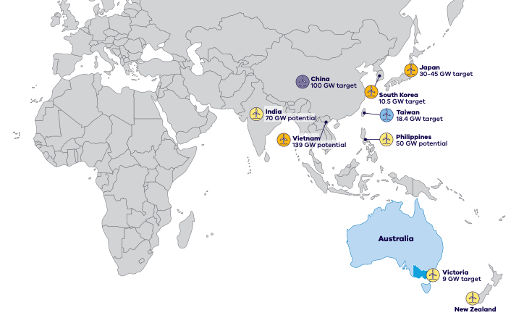

Figure 2 shows offshore wind markets across the Asia-Pacific region, colour-coded by market maturity, with each market’s offshore wind target or potential capacity. The details are set out in Table 4.
Table 4: Asia-Pacific offshore wind markets
Market | Maturity | Target or potential | Description
Australia (Victoria) | Emerging market | 9 GW target (Victoria) | Significant pipeline of opportunities. Victoria is Australia’s leading offshore wind investment destination, offering world-class wind resources, planned strategic transmission and port infrastructure, advanced industrial capability and proximity to rapidly growing Asia-Pacific markets.
China | Rapid growth | 100 GW target | Largest offshore wind market in the world.
South Korea | Scaling market | 10.5 GW target | Strong government ambitions and pipeline growth.
Japan | Scaling market | 30–45 GW target | Accelerating deployment supported by national targets and reform.
Taiwan | Mature market | 18.4 GW target | Established offshore wind programme and supply chain.
Vietnam | Scaling market | 139 GW potential | Strong ambition and increasing investment in offshore wind.
Philippines | Emerging market | 50 GW potential | High resource potential and early stage development.
India | Scaling market | 70 GW potential | High potential market with growing policy momentum.
New Zealand | Emerging market | – | Early stage market with long-term potential.

Victoria’s declared offshore wind zones
Offshore wind farms can only be built in areas declared by the Australian Government.

Gippsland
In December 2022, the Gippsland declared area was announced and offshore wind developers were invited to apply for feasibility licences. The Gippsland offshore wind area is Australia’s largest declared offshore wind energy area, reinforcing its first-mover advantage in this sector. The 9 feasibility licences cover approximately 4,850 km².
Figure 3: Gippsland declared offshore wind area and feasibility licence areas
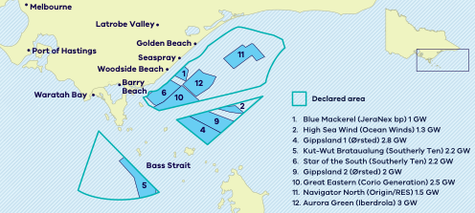
Figure 3 shows the Gippsland declared area in Bass Strait, off the coast near Golden Beach, Seaspray and Woodside Beach, with Melbourne, the Latrobe Valley, the Port of Hastings, Waratah Bay and Barry Beach also marked. Most feasibility licence areas sit off the coast between Seaspray and Woodside Beach, with Kut-Wut Brataualung located further south-west in Bass Strait. The feasibility licence holders are listed in Table 5.
Table 5: Gippsland feasibility licences
Map number | Project | Licence holder | Capacity
1 | Blue Mackerel | JeraNex bp | 1 GW
2 | High Sea Wind | Ocean Winds | 1.3 GW
4 | Gippsland 1 | Ørsted | 2.8 GW
5 | Kut-Wut Brataualung | Southerly Ten | 2.2 GW
6 | Star of the South | Southerly Ten | 2.2 GW
9 | Gippsland 2 | Ørsted | 2 GW
10 | Great Eastern | Corio Generation | 2.5 GW
11 | Navigator North | Origin/RES | 1.5 GW
12 | Aurora Green | Iberdrola | 3 GW

Southern Ocean
In March 2024, the Southern Ocean declared area was announced. Located 15–20 km off the coast of Warrnambool and Port Fairy, the feasibility licence in this area covers approximately 265 km².
Figure 4: Southern Ocean declared offshore wind area
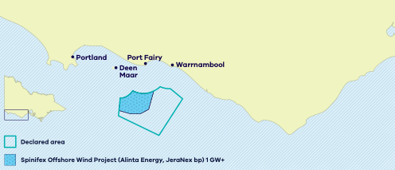
Figure 4 shows the Southern Ocean declared area off the coast between Portland, Port Fairy and Warrnambool, with Deen Maar also marked. The area contains one feasibility licence: the Spinifex Offshore Wind Project (Alinta Energy, JeraNex bp), with a capacity of 1 GW or more.
For more information, visit the Victoria’s offshore wind farm locations page.

Unlocking investment opportunities along the supply chain
The development of offshore wind projects in Victoria creates a major investment opportunity for new industries to develop along the supply chain, including manufacturing, research, production, and logistics capabilities.
Victoria’s offshore wind projects create opportunities for local businesses to participate in the supply chain and partner with experienced global offshore wind companies as developers progress project delivery.
- Near-term local supply chain opportunities are strongest in onshore transmission infrastructure, substations, secondary steel fabrication, transformers, cable accessories, protective coatings, component repair, digital technologies and marine support services. Regional operations and maintenance bases, workforce development initiatives and OEM partnerships will be critical to maximising long-term economic value and creating enduring industry capability.
Larger manufacturing opportunities, such as tower fabrication, could emerge over time with sufficient project demand, access to suitable industrial facilities and industry partnerships. Victoria’s long-term competitive advantage is likely to be built around engineering, maintenance, training, digital solutions, logistics, recycling and specialised services, creating opportunities to support projects across Australia and participate in the broader Asia-Pacific offshore wind market.
The Local Jobs First Act 2023, Major Projects Skills Guarantee and Social Procurement Framework are key policies that set expectations and requirements for Victoria’s offshore wind sector.

Local content settings
- Maximise the use of local content during the construction phase.
- Achieve 80% minimum local content during the operations and maintenance phase as averaged over a 30-year period.
- Ensure 10% of labour hours come from apprentices, trainees, and cadets during onshore construction and operations.
- Maximise use of locally produced, milled and/or fabricated steel.
- Maximise the use of materials, products and services produced or manufactured by suppliers based in Victoria’s regions.
Provide a Local Industry Development Plan (LIDP) and a Supply Chain Action Plan and Engagement Plan that sets out the approach for investing in and developing the local industry and workforce.

Social procurement settings
- Submit a social procurement commitment proposal that achieves the State’s Social Procurement Framework objectives.
Propose initiatives for supporting the participation of women, the First Peoples of Victoria and disadvantaged Victorians.

Industry Capability Network (ICN)
Feasibility licence holders will work with the ICN to publish forward work packages to provide Australian and Victorian businesses with the opportunity to tender for contracts and participate in relevant offshore wind project phases.

Key offshore wind farm elements
Figure 5: Key offshore wind farm elements
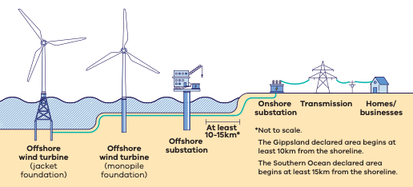
Figure 5 shows, from sea to land, the key elements of an offshore wind farm (diagram not to scale):
- offshore wind turbines, on either jacket foundations or monopile foundations
- an offshore substation that collects the electricity generated by the turbines
- an onshore substation, on the shore, with the offshore wind farm located at least 10–15 km offshore
transmission lines that carry the electricity to homes and businesses.
The Gippsland declared area begins at least 10 km from the shoreline. The Southern Ocean declared area begins at least 15 km from the shoreline.

Leverage existing supply chain capabilities
Victoria combines Australia’s largest offshore wind pipeline with an established industrial, energy and professional services base. Victoria’s national leadership, capacity target and industry capabilities will lay the foundation for the industry to thrive.
Victoria’s supply chain advantages include:
- leveraging established strengths across professional services, engineering, environmental approvals, marine operations and advanced manufacturing
- deep energy production experience via thermal power infrastructure and Bass Strait oil and gas operations, providing a strong foundation in surveying, engineering, subsea services, logistics, asset management, and operations and maintenance
- a skilled workforce and established industrial base with experience delivering major energy infrastructure projects
- access to a suite of ports including:
- the Port of Hastings, which is well located for offshore wind construction, assembly and marshalling activities
- regional ports capable of providing vessel support, marine logistics and long-term operations and maintenance services
industrial centres that offer substantial capability in fabrication, logistics, storage, maintenance and manufacturing.

Investment opportunities across the project phases of offshore wind development

1. Design
The design and development phase typically occurs several years before construction and includes site investigations, environmental assessments, engineering design, consenting, project management and supply chain planning.
This phase draws on specialist technical, environmental and professional services capabilities and provides early opportunities for Victorian businesses in engineering, geoscience, marine surveying, environmental consulting, legal and project delivery services.

2. Construction
The manufacturing, construction, and installation phase of an offshore wind farm is typically 3 to 4 years in duration. It covers the supply, manufacturing and transportation of components, installation activities, logistics, assembly and testing of components and equipment.
Capability required in this phase includes turbine and foundation installation, specialist vessels, marine logistics and construction services.

3. Operations and maintenance
This phase consists of the activities required to operate, maintain and optimise wind farm performance over its 25–30-year operational life.
Regional and local manufacturers, marine service providers and specialist contractors are well positioned to support long term operations and maintenance activities, creating sustained employment and supply chain opportunities throughout the life of each project.

Enabling port infrastructure
The Victorian Renewable Energy Terminal (VRET) is being developed at the Port of Hastings to deliver critical port capacity to meet Victoria’s offshore wind ambitions.
The VRET is located 75 km south-east from Melbourne CBD and approximately 120–190 nautical miles (220–350 km) from the declared Gippsland offshore wind area. This proximity reduces vessel transit times, lowers construction risk and improves the efficiency of offshore installation.
The VRET will enable the storage, preassembly and transport of large offshore wind components, including foundations (monopile and jackets) and turbine towers.
In August 2025, the Australian Government determined the VRET to be a controlled action under the Environment Protection and Biodiversity Conservation Act 1999 (Cth), requiring further assessment of the environmental impacts of the project. An Environment Effects Statement (EES) process is currently underway to assess these impacts and identify appropriate mitigation measures.
Victoria invested $124.5 million in the 2026–27 budget to continue progressing EES and procurement activities for the VRET.
Figure 6: Victorian Renewable Energy Terminal site image
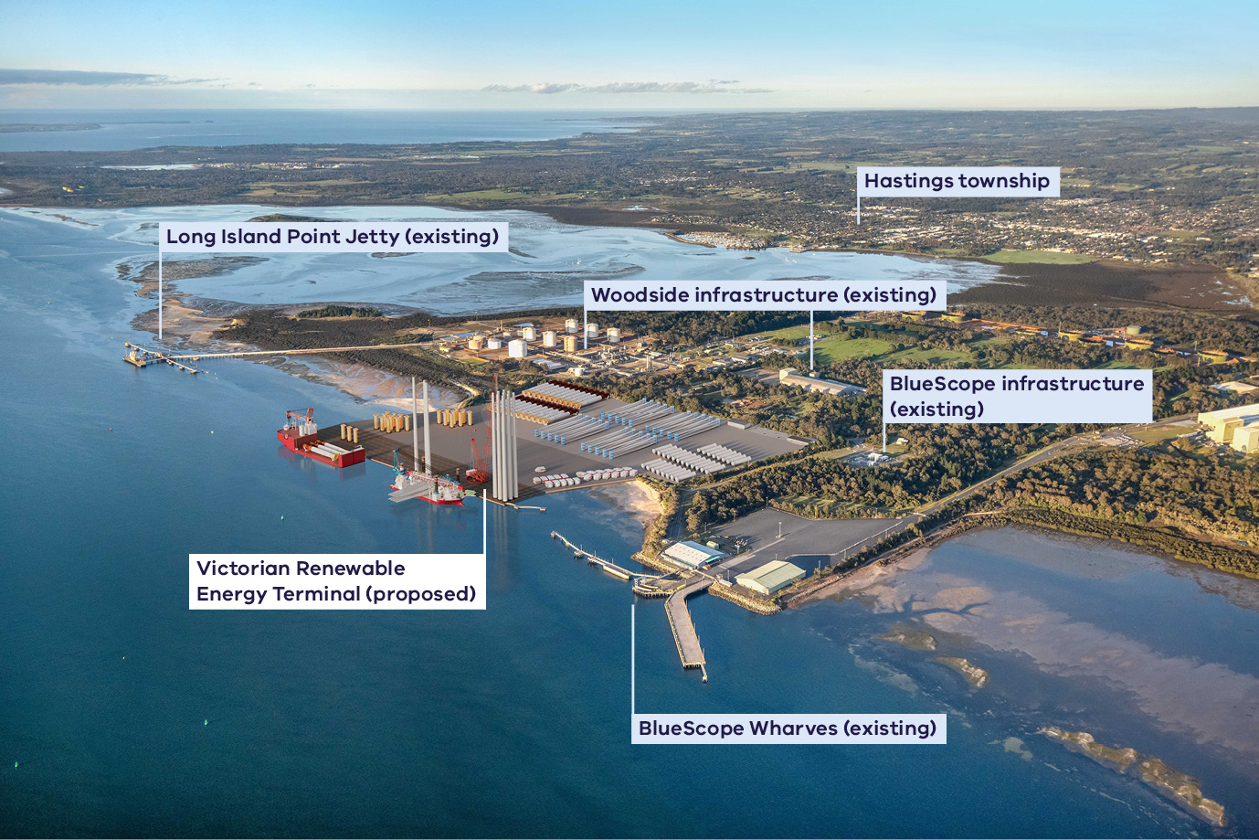
Figure 6 is an aerial photograph of the Port of Hastings showing the location of the proposed VRET in relation to:
- Hastings township
- Long Island Point Jetty (existing)
- Woodside infrastructure (existing)
- BlueScope infrastructure (existing)
BlueScope Wharves (existing).

Additional port opportunities: operations and maintenance
As offshore wind projects are completed, operations and maintenance ports will play a key role for this industry.
The ports in Corner Inlet, such as Barry Beach Marine Terminal and Port Anthony, are well-positioned to support operations and maintenance activities in the Gippsland offshore wind area.
Opportunities also exist for developers to work with other ports around Victoria and beyond.

Victoria’s new Renewable Energy Zones
VicGrid is implementing the Victorian Transmission Plan, a long-term strategic plan for transmission and renewable energy zone development.
This plan will ensure Victoria builds the right amount of energy infrastructure in the right places at the right time to support the transition to renewable energy.
The Victorian Government has declared 5 renewable energy zones, along with the shoreline renewable energy zone to connect offshore wind projects in Gippsland.
Renewable energy zones are areas identified as most suitable to host new renewable energy generation, such as wind turbines, solar farms, and battery storage.
Renewable energy zones will:
- ensure better coordination of renewable projects and reduce the need for unnecessary transmission lines and other infrastructure
- enable VicGrid to implement clear rules that manage how projects gain access to the grid, including expectations for how developers engage with community
- provide greater certainty about how and where renewables projects should be built
unlock new economic benefits for regional communities and Traditional Owners.
Figure 7: Victoria’s renewable energy zones, transmission network and declared offshore wind areas
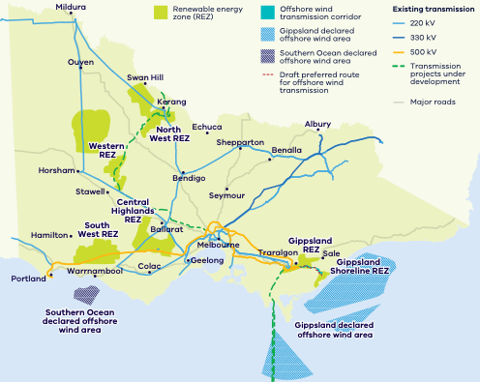
Figure 7 is a map of Victoria showing:
- the North West REZ, around Mildura, Ouyen, Swan Hill and Kerang
- the Western REZ, around Horsham and Stawell
- the Central Highlands REZ, around Bendigo, Ballarat and Seymour
- the South West REZ, around Hamilton, Warrnambool and Colac
- the Gippsland REZ, around Traralgon and Sale
- the Gippsland Shoreline REZ, on the Gippsland coast, connecting the Gippsland declared offshore wind area to the grid via the offshore wind transmission corridor and draft preferred route
- the Southern Ocean declared offshore wind area off Portland and Warrnambool, and the Gippsland declared offshore wind area in Bass Strait
existing 220 kV, 330 kV and 500 kV transmission lines, transmission projects under development and major roads.

Gippsland Shoreline Renewable Energy Zone
The Gippsland Shoreline Renewable Energy Zone is a defined planning area for offshore wind developers to run underground cables from the shoreline to the electricity grid.
The Victorian Government has set targets to generate 9 GW of offshore wind energy from declared areas.
To enable the first 2 GW of offshore wind energy, VicGrid is building a new 500 kV double circuit overhead transmission line from the proposed Giffard terminal station to the Loy Yang Power Station switchyard.
An Environment Effects Statement is currently being prepared to assess potential environmental, social, cultural and economic impacts of the corridor and draft preferred route. The final easement, around 70 metres wide, is expected to be confirmed in 2027.

Development partner
VicGrid has run a competitive invitation to tender to select a development partner to design, build, finance, operate, and maintain the project. A development partner is expected to be announced late 2026.
Figure 8: Gippsland offshore wind transmission diagram
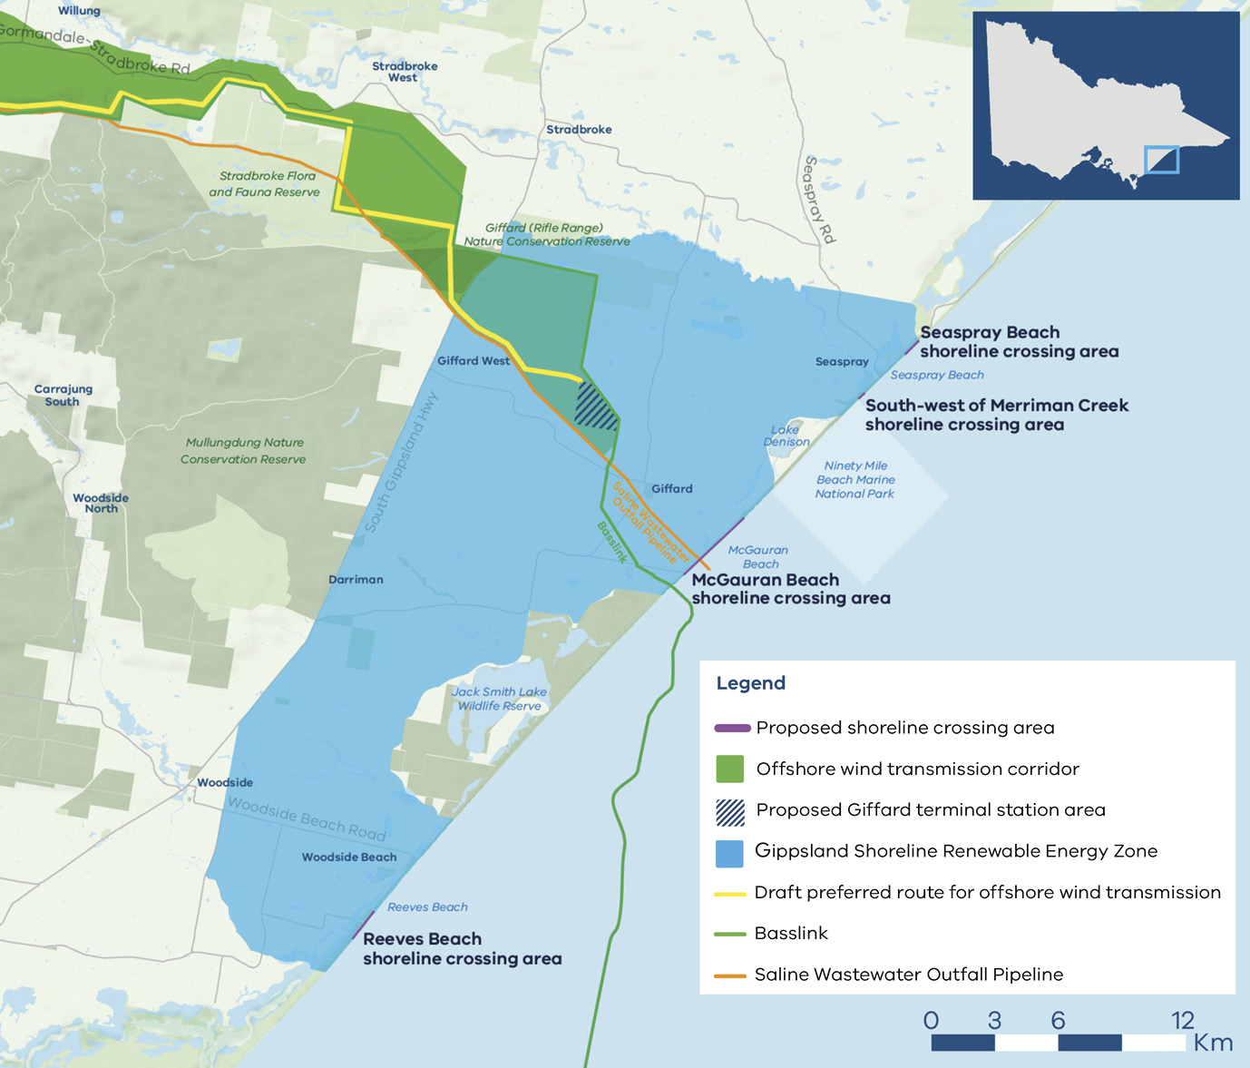
Figure 8 is a map of the Gippsland coast near Seaspray showing:
- the Gippsland Shoreline Renewable Energy Zone along the coast
- proposed shoreline crossing areas at Seaspray Beach, south-west of Merriman Creek, McGauran Beach and Reeves Beach
- the proposed Giffard terminal station area
- the offshore wind transmission corridor and draft preferred route running north to the Loy Yang Power Station switchyard
existing infrastructure, including Basslink and the Saline Wastewater Outfall Pipeline.

World class renewable energy talent
Victoria’s energy workforce is predicted to grow by 53% to 68,000 between 2026 and 2040. The offshore wind workforce will see significant growth in development, project management, construction, manufacturing, operations and maintenance phases.
Victoria is developing a dedicated renewable energy workforce to support the growth of offshore wind and broader clean energy industries. The Asia Pacific Renewable Energy Training Centre (APRETC) in Ballarat provides specialist wind industry training, including Global Wind Organisation (GWO) accredited safety and technical programs delivered through Australia’s first wind turbine training tower.
In Gippsland, the Victorian Renewable Energy TAFE Centre of Excellence is establishing a renewable energy digital training hub in Morwell, incorporating advanced simulation and virtual reality capability to support training for offshore wind, transmission and energy infrastructure. Together with industry partnerships, these initiatives are creating clear training pathways and developing the skilled workforce required to support Victoria’s long-term offshore wind ambitions.

Offshore wind workforce
- The offshore wind workforce is projected to peak at 2,300–4,000 FTE workers.
The offshore wind sector will attract skilled workers, with 94% of the workforce requiring vocational education and training or university qualifications.

Victorian Government workforce initiatives
The Victorian Government is:
- investing $10 million toward the $40 million National Training Centre in New Energy Skills
- investing $25 million toward the $50 million Victorian Renewable Energy TAFE Centre of Excellence
- developing new energy training pathways through the $7 million for new VET certificates in renewable energy projects
simplifying pathways for skilled workers to move to Victoria though improved qualification recognition and Victoria’s Skilled Migration Visa Nomination Program.

Victorian Energy Jobs Plan
The Victorian Energy Jobs Plan provides a framework for developing the robust, future-ready energy workforce needed to deliver the transition and strengthen investment confidence.
For more information, visit the Victorian Energy Jobs Plan page.

Sparking Change: The Women in Energy Strategy
The Women in Energy Strategy recognises that attracting and retaining more women in the renewable energy workforce provides significant benefit to this growing sector.
For more information, visit the Women in Energy Strategy page.

Where research, industry and talent converge

World-class education and training
Victoria has a globally renowned education and training system, including:
- 2 global ‘Top 40’ universities
- 8 universities, including 4 dual-sector universities (offering both tertiary and vocational education)
- 12 independent technical and further education (TAFE) institutions under a single TAFE network
a diverse talent pool with strong growth across the broad range of occupations relevant to the renewable energy sector.

Research and innovation centres
- Deakin University: Recycling and Clean Energy Commercialisation Hub
- Melbourne University: Melbourne Energy Institute
- Monash University: Monash Innovation Labs and Monash Energy Institute
Swinburne University: Siemens Swinburne Energy Transition Hub.
The Australian Centre for Offshore Wind Energy (ACOWE) is a national, interdisciplinary research and training partnership to enable sustainable offshore wind development in Australia. Melbourne University, Deakin University, Federation University, University of Western Australia, University of Wollongong and University of Newcastle collaborate to deliver this work.
Figure 9: Victorian universities and TAFE institutions, renewable energy zones and transmission network
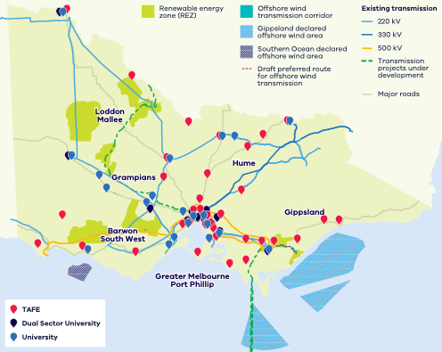
Figure 9 shows the locations of TAFE institutions, dual sector universities and universities across Victoria’s regions – Loddon Mallee, Hume, Grampians, Barwon South West, Gippsland, and Greater Melbourne and Port Phillip – together with the renewable energy zones, declared offshore wind areas, offshore wind transmission corridor and existing transmission network. Education and training providers are concentrated in Greater Melbourne, with campuses in major regional centres across every region.

Industry events and conferences

Victoria

Clean Energy Investor Conference – Melbourne
Typical timing: March
Leading clean energy investment forum connecting investors, developers, policymakers and industry leaders to discuss emerging investment opportunities.
For more information, visit the Clean Energy Investor Conference website.

Australian Energy Week – Melbourne
Typical timing: June
National conference covering electricity markets, generation, transmission, storage and major infrastructure projects.
For more information, visit the Australian Energy Week website.

Australia Wind Energy (AuWE) – Melbourne
Typical timing: July
Brings together developers, investors, government and supply chain leaders across the offshore and onshore wind sectors.
For more information, visit the Australia Wind Energy website.

Gippsland New Energy Conference (GNEC) – Gippsland
Typical timing: August
Australia’s leading regional energy transition conference which brings together government, developers, manufacturers, ports, investors, researchers, Traditional Owners and regional communities.
For more information, visit the Gippsland New Energy Conference website.

Australian Centre for Offshore Wind Energy (ACOWE) Technical Symposium – Gippsland
Typical timing: August (held in conjunction with GNEC)
National technical symposium focused on offshore wind engineering, research, environmental science, grid integration and innovation.
For more information, visit the ACOWE Technical Symposium page.

All Energy Australia – Melbourne
Typical timing: October
The largest clean energy exhibition and conference in the Southern Hemisphere, which covers renewable generation, transmission, storage, hydrogen and investment.
One of the world’s leading offshore wind conferences, attracting global developers, OEMs, investors and governments.
For more information, visit the All Energy Australia website.

Australia

Energy Exchange Australia (AOG Energy) – Perth
Typical timing: March
Major energy industry conference with increasing emphasis on offshore wind, marine engineering and energy transition.
For more information, visit the Energy Exchange Australia website.

Australian Wind Industry Forum
Typical timing: Varies (generally Q2–Q3)
National conference focused on wind energy development, policy, investment and supply chain capability.
For more information, visit the Australian Wind Industry Forum page.

Energy Networks Conference
Typical timing: May
Key event for transmission planning, grid investment and network development.
For more information, visit the Energy Networks Conference website.

Australian Manufacturing Week
Typical timing: May
Showcases advanced manufacturing capability and local industry participation.
For more information, visit the Australian Manufacturing Week website.

Clean Energy Summit (Clean Energy Council) – Sydney
Typical timing: July
Australia’s flagship clean energy policy and investment event attended by governments, developers, investors and financiers.
For more information, visit the Australian Clean Energy Summit page.

Ports Australia Conference – Sydney
Typical timing: Varies
Relevant for offshore wind logistics, heavy lift capability and port infrastructure investment.
For more information, visit the Ports Australia events page.

Key Victorian Government entities
We can help facilitate connections with key Victorian Government entities and industry members across our renewable energy sector.

Department of Energy, Environment and Climate Action (DEECA)
DEECA works with industry and the community to develop Victoria’s secure and sustainable energy future.
For information on Victoria’s energy policy landscape and facilitated connections across the Victorian Government and renewable energy sector, contact the Business and Industry Engagement team at BIE@deeca.vic.gov.au.
For more information, visit the renewable energy investment opportunities page.

Offshore Wind Energy Victoria
Offshore Wind Energy Victoria (OWEV) has been established within DEECA as the single point of entry for industry and community engagement on offshore wind.
For more information, visit the Offshore Wind Energy Victoria page.
Contact OWEV at offshorewind@deeca.vic.gov.au.

Solar Victoria
Solar Victoria is responsible for the delivery of the Victorian Government’s $1.3 billion Solar Homes Program – one of the most ambitious and transformative renewable energy programs in Australia.
For more information, visit the Solar Victoria website.

VicGrid
VicGrid coordinates the planning and development of Victorian Renewable Energy Zones (REZs). It is also investing $480 million that will be used to strengthen the grid and develop each REZ.
For more information, visit the renewable energy zones page.

Invest Victoria
Invest Victoria is the Victorian Government’s investment attraction agency. Services include:
- market regulatory information
- statutory approvals coordination
- site location services
- identification of infrastructure and utility requirements
advocacy within government.
For more information, visit the Invest Victoria website.

Investment Coordinator-General
The Investment Coordinator-General role and function also sits within Invest Victoria, working across agencies to ensure approvals deadlines are met and helping to reduce delays.
For more information, visit Victoria’s Investment Coordinator-General page.

Innovation Victoria
Innovation Victoria is the Victorian Government’s single front door for innovation, supporting founders, researchers, entrepreneurs and investors from early idea through to commercialisation and scale. It provides the capability uplift, connections and capital pathways to accelerate the commercialisation from idea to growth, scale and global opportunity.
For more information, visit the Innovation Victoria website.

SEC
SEC is a Victorian Government-owned renewable energy company. It is partnering with the private sector to deliver 4.5 GW of new renewable energy and storage projects with an initial investment of $1 billion.
For more information, visit the SEC website.

Subsector packs
To access the Renewable Energy subsector packs, please visit the renewable energy subsector packs page.
The following subsector packs are available:
- Distributed Energy Resources and EVs
- Offshore Wind
- Utility-scale Electricity Generation and Storage
- Renewable Fuels and Feedstocks
Renewable Fuels and Feedstocks: Sustainable Aviation Fuel.

Publication information

Copyright
© The State of Victoria Department of Energy, Environment and Climate Action, September 2026.

Creative Commons
This work is licensed under a Creative Commons Attribution 4.0 International licence, visit the Creative Commons website.
You are free to re-use the work under that licence, on the condition that you credit the State of Victoria as author. The licence does not apply to any images, photographs or branding, including the Victorian Coat of Arms, and the Victorian Government and Department logos.
ISBN 978-1-76176-995-5 (print)
ISBN 978-1-76176-996-2 (pdf/online/MS word)

Disclaimer
This publication may be of assistance to you but the State of Victoria and its employees do not guarantee that the publication is without flaw of any kind or is wholly appropriate for your particular purposes and therefore disclaims all liability for any error, loss or other consequence which may arise from you relying on any information in this publication.

Accessibility
To receive this document in an alternative format, phone the Customer Contact Centre on 136 186, email customer.service@deeca.vic.gov.au, or contact National Relay Service on 133 677 or visit the National Relay Service website. This document is available on the DEECA website.
End of document.

Total additional capacity required reflect estimates only, based on AEMO's 2026 ISP Generation and Storage Outlook – step change scenario – Optimal Development Path – Victoria (2026 to 2035)
Victoria in Future | Department of Transport and Planning | planning.vic.gov.au/guides-and-resources/Data-spatial-and-insights/discover-and-access-planning-open-data/victoria-in-future
Why invest in Melbourne? | City of Melbourne | melbourne.vic.gov.au/why-invest-melbourne
EIU Global Liveability Index 2026 | eiu.com/n/wp-content/uploads/2026/07/EIU_ Liveability-Index-2026.pdf
Sources: GWEC Global Offshore Wind Report 2026; GWEC Global Offshore Wind Report 2025.
Victorian Energy Jobs Plan | 2026 | energy.vic.gov.au/renewable-energy/our-energy-workforce/victorian-energy-jobs-plan
World University Rankings | QS | Accessed July 2026 | topuniversities.com/world-university-rankings

