3.2 – Safely isolating PV and battery systems
Technical Guidance Series – VEU ceiling insulation activity


This is part of a series developed with WorkSafe to help installers in the VEU program to work safely while installing insulation.
Use this sheet and others in this series to plan safe series of work while installing insulation.

VEU Ceiling Insulation activity – Technical Guidance Series
Working safely at heights
1.1 | Working safely at heights during rooftop insulation installations
1.2 | Edge protection – working at heights
1.3 | Manual handling of heavy and bulky items
1.4 | Working safely with ladders
1.5 | Safe work practices using elevating work platforms
1.6 | Falls through skylights, fragile roofs, voids and penetrations
Working safely in ceiling spaces
2.1 | Working in pairs (best practice)
2.2 | Working near asbestos containing material
2.3 | Working in heated ceiling spaces when installing insulation
2.4 | Working in confined ceiling spaces
2.5 | Falls through ceiling spaces
Working safely with electricity
3.1 | Safe Elements of Electrical Isolation
3.2 | Safely Isolating PV and Battery Systems  (this sheet)

Components of a solar photovoltaic (PV) system
Rooftop solar PV systems have become a common sight on Australian residential roofs over the past 15 years. While the benefits of rooftop solar (including reduced carbon emissions and electricity bills) are evident, they can make the process of electrically isolating a home more complex. As many solar PV wires are run through ceiling spaces, it is integral they are isolated before work commences.
Isolating a solar PV system at a residential home is more complex than simply isolating all switches at the main switchboard, including the PV ARRAY MAIN SWITCH. Isolation is also required at the solar inverter and potentially on DC isolators, which may be located elsewhere.
Figure 1 shows components of an electrical system that need to be isolated before performing rooftop insulation work.
- Items in blue are components in all homes that require isolation.
- Items in green are components unique to homes with rooftop solar that may require isolation. This includes the inverter (converts DC power from panels to AC for use in homes) and DC isolators.
Figure 1: Components of a residential solar photovoltaic system
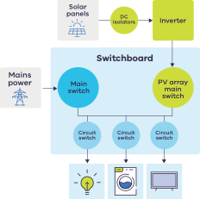

How to safely isolate a solar photovoltaic system
Solar PV and battery systems require extra steps to safely isolate electricity before performing rooftop insulation work. These steps are described next.

Part 1: Solar PV and battery signage
Australian Standards (specifically AS 4777.1:2024) require electrical switchboards to have signage installed if a solar PV or battery system is connected to the installation. These signs include the following and are shown in Figures 2 -4.
- Figure 2: A circular green “PV” or “ES” sign, indicating the presence of a solar PV or battery system respectively.
- Figure 3: A “warning: multiple supplies” sign.
- Figure 4: A “shutdown procedure” sign, indicating how to safely power down the solar PV system – which must be followed.
Figure 2:
Left: Sign near switchboard to indicate presence of PV system
Right: Sign near switchboard to indicate presence of Battery system
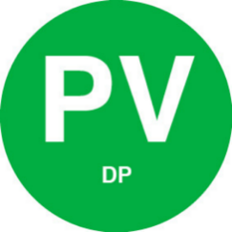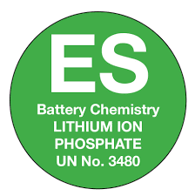
Figure 3: A “Warning: Multiple Supplies” sign
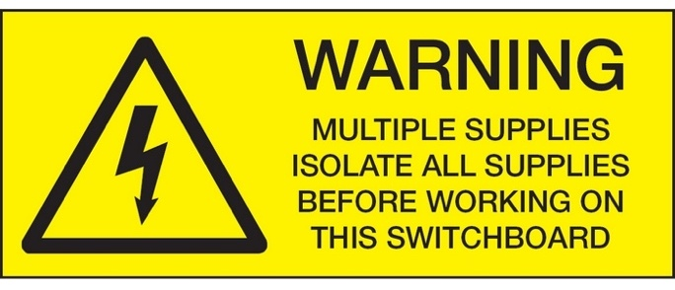
Figure 4: A typical “shutdown procedure” sign
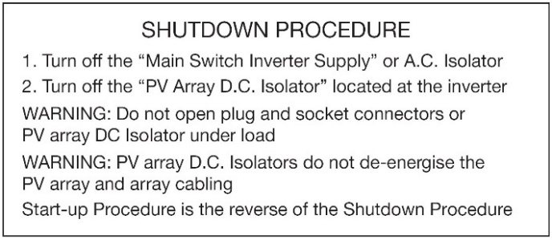
These signs clearly indicate that rooftop solar or a battery is present, and that simply isolating at the switchboard will not be sufficient to ensure safety.

Part 2: Isolating the main switchboard
In most scenarios, the first step is to safely isolate the main switchboard by following these steps.
- Identify all sources of electricity.
- Isolate the main switchboard.
- Lock out the isolation point.
- Tag out the isolation point.
Refer to Guidance Sheet 3.1 – Safe elements of electrical isolation for a comprehensive guide on how to disconnect
However, it is important to note that if an electrical system is isolated only by switching and locking off the circuits at the main switchboard, some components may still be live. This includes:
- Inverter and DC isolators: without properly switching off the inverter (and DC Isolators if required), solar photovoltaic panels may continue to produce electricity, resulting in cables being live.
- Mains power to the switchboard will still be active.
Isolating the main switchboard does not make a residential solar PV system fully safe. Even after isolation at the switchboard, parts of the system remain energised. Live components (shown in Green) can still include connections to main supply, as well as the DC cabling between the solar panels and the inverter, and the wiring from the inverter to the switchboard
Figure 5: Live components of a residential electrical system after isolation is achieved at the switchboard
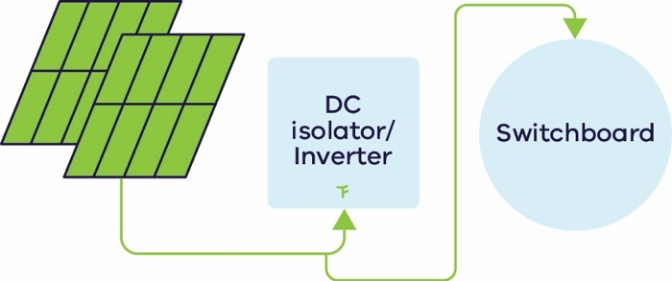
Live components are shown in green and include any connections to mains power, as well as the connections between solar panels and the DC isolator/inverter, and from the inverter to the switchboard.

Part 3: Follow the shutdown procedure
Follow the shutdown procedure for the solar system (and battery system, if present) to safely ensure these systems are not operational before starting work.
Typically, for solar photovoltaic systems (also shown in Figure 6), the shutdown procedure involves:
- switching off the “Main Switch Inverter Supply” (at the switchboard)
- turning off the “PV Array – D.C. Isolator”. This is normally located close to the inverter.
Figure 6: Shutdown procedure instructions
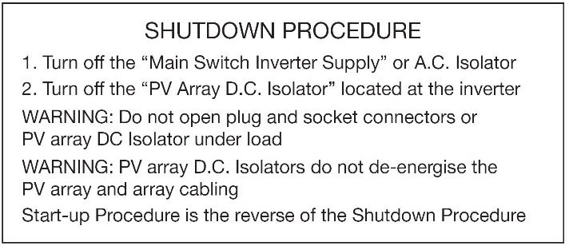
Note: This does not isolate the cabling from the PV Array to the inverter, which will remain active. These cables should be labelled “SOLAR PV DC CIRCUIT” or “PHOTOVOLTAIC POWER SOURCE”.
Battery systems also have a specified shutdown procedure which should be followed.

© The State of Victoria Department of Energy, Environment and Climate Action September 2026.
ISBN 978-1-86520-010-1 (pdf/online/MS word)
Disclaimer
This publication may be of assistance to you but the State of Victoria and its employees do not guarantee that the publication is without flaw of any kind or is wholly appropriate for your particular purposes and therefore disclaims all liability for any error, loss or other consequence which may arise from you relying on any information in this publication.
Accessibility
To receive this publication in an alternative format, please contact the Victorian Energy Upgrades team at energy.upgrades@deeca.vic.gov.au. This document is also available on the internet at energy.vic.gov.au/victorian-energy-upgrades.

Part 4: Test isolation and take ongoing precautions
Confirm that the isolation was effective by testing the electrical installation for voltage. This can be done in the following ways.
- Testing internal/external lighting circuits
- Testing for absence of voltage using an appropriate test instrument (e.g. multimeter)
- Checking that socket outlets are de-energised (e.g. using a plug-in tester or meter)
- Confirming that household appliances, such as microwaves or televisions, cannot be switched on.
- Verifying that all relevant circuits, including solar PV supply, are de-energised.
It is prudent to treat any cable as “live”, even after performing isolation of electrical sources. This is particularly important when working on residential homes with Solar installed as some wires can remain live despite shutting down the inverter.

