Victoria’s Zero Emissions Vehicle Roadmap

Acknowledgment
We acknowledge and respect Victorian Traditional Owners as the original custodians of Victoria's land and waters, their unique ability to care for Country and deep spiritual connection to it. We honour Elders past and present whose knowledge and wisdom has ensured the continuation of culture and traditional practices.
We are committed to genuinely partner, and meaningfully engage, with Victoria's Traditional Owners and Aboriginal communities to support the protection of Country, the maintenance of spiritual and cultural practices and their broader aspirations in the 21st century and beyond.
Design Green Scribble
© The State of Victoria Department of Environment, Land, Water and Planning, May 2021
This work is licensed under a Creative Commons Attribution 4.0 International licence. You are free to re-use the work under that licence, on the condition that you credit the State of Victoria as author. The licence does not apply to any images, photographs or branding, including the Victorian Coat of Arms, the Victorian Government logo and the Department of Environment, Land, Water and Planning (DELWP) logo. To view a copy of this licence, visit creativecommons.org/licenses/by/4.0/
ISBN 978-1-76105-569-0 (pdf/online/MS word)

Disclaimer
This publication may be of assistance to you but the State of Victoria and its employees do not guarantee that the publication is without flaw of any kind or is wholly appropriate for your particular purposes and therefore disclaims all liability for any error, loss or other consequence which may arise from you relying on any information in this publication.

Accessibility
If you would like to receive this publication in an alternative format, please telephone the DELWP Customer Service Centre on 136 186, or email customer.service@delwp.vic.gov.au, or via the National Relay Service on 133 677, www.relayservice.com.au. This document is also available on the internet at www.delwp.vic.gov.au

Contents
Ministerial foreword 4
Minister for Energy, Environment and Climate Change Minister for Solar Homes 4
Minister for Roads and Road Safety Minister for Public Transport 4
Executive Summary 5
Overview 5
Why Zero Emissions Vehicles? 5
What is the Victorian Government doing? 6
Infrastructure Victoria’s 2018 Advice on Automated and Zero Emissions Vehicles 7
Infrastructure Victoria community panel report on low and zero emissions vehicles 8
Introduction – A roadmap for Victoria’s transition to Zero Emissions Vehicles 8
Purpose of the Roadmap 8
Scope 9
A Roadmap to where? 9
Policy Interlinkages 9
Roadmap Structure 10
1. Why zero emissions vehicles? 10
1.1. To combat climate change, the Victorian Government has committed to achieving net-zero emissions by 2050 10
1.2. Decarbonising Victoria’s road transport sector is critical to achieving net-zero emissions 10
1.3. ZEVs are needed to fully decarbonise road transport 12
1.4. ZEVs will also improve urban air quality and reduce noise pollution 13
1.5. Global markets are already shifting away from polluting forms of transport 13
Battery Electric Vehicle and Hydrogen Fuel Cell technologies compared 15
1.6. The Mid-2020s: A projected global tipping point for BEVs 17
Battery innovation holds the prospect of greatly improved range 20
1.7. The promise of hydrogen – potential transport uses 20
2. Challenges and opportunities for Victoria 20
2.1 Where are we now? ZEVs today in Australia and Victoria 20
2.2. What are the key barriers to the uptake of ZEVs in Australia? 23
2.3. Key priority policy challenges and major opportunities for Victoria 25
3. How are we responding? 32
3.1. Addressing concerns about ZEVs and their performance 33
3.2. Supporting an improved understanding about ZEV options and transition pathways 41
Victorian Greenhouse Alliances have already been playing an important role in building local government capability around electric vehicles 42
3.3 Advocating for more supportive Commonwealth government action 43
Access to imported second-hand models is driving New Zealand’s uptake of electric vehicles 44
3.4. Ensuring that we are ‘ZEV-ready’ 45
3.5. Accelerating the electrification of road transport 48
Through its climate change pledges, the Victorian Government is taking action to drive the transition to a net-zero emissions future 48
3.6. Managing the integration of eVs into our energy system 49
3.7. Exploring opportunities for transitioning Victorian Industry and its workforce 53
The Renewable Hydrogen Industry Development Plan 54
Melbourne is emerging as a hub for eV technology training 55
4. The pathway to 2050 56
4.1. What does success look like in the 2020s? 56
4.2. Towards 2050 - Decarbonising road transport 57
4.3. Next steps 58
Glossary 58
Endnotes 59

Ministerial foreword

Minister for Energy, Environment and Climate Change
Minister for Solar Homes
There are three key reasons why Victoria is investing $100 million to accelerate our drive to zero emissions vehicles.
First, we don’t want to get left behind – globally. Victoria needs to transition quickly to zero emissions vehicles (ZEV) because, right now, Australia is falling behind the rest of the world – risking future jobs, productivity and sustainability.
Second, we want Victorians to have the best cars in the world – not the dirtiest. Due to a lack of national policy leadership, Australia has a limited range of affordable ZEV models to choose from and is behind other countries on ZEV uptake – and that’s not good enough for Victorian motorists.
Third, we want a more affordable, reliable energy grid. A carefully managed transition which allows fleets of battery-electric vehicles to contribute to Victoria’s energy grid will reward car owners and our electricity system. Vehicle-to-grid charging could provide as much capacity as another Victorian Big Battery, boosting renewable energy storage and providing other services that benefit every household and business.
The Victorian Government has led the country in building a clean energy future and our Government wants Victoria to lead Australia’s transition to zero emissions vehicles also.
We need to hit renewable energy targets of 40 per cent by 2025 and 50 per cent by 2030. We need to achieve net-zero emissions by 2050. And we need to remove any and all barriers to net-zero.
This Zero Emissions Vehicle Roadmap is all about leading the market – by replacing the Victorian Government’s car fleet with zero emissions vehicles, as well as accelerating the transition to zero emissions public transport buses.
It’s all about stimulating the market – by launching Australian’s first zero emissions vehicle subsidy, as well as seeding a commercial innovation fund.
And it’s all about building infrastructure – by putting electric vehicle charging stations in every corner of the state.
Victoria will support national measures - but we won’t get stuck in traffic waiting for national action. By 2030, we will see 50 per cent of light vehicles sold in Victoria with zero emissions technology. We know accelerating to zero emissions is in the best interests of our community, environment and economy.
The Zero Emissions Vehicle Roadmap will get Victorians where they need to go.
The Hon. Lily D’Ambrosio, Minister for Energy, Environment and Climate Change
Minister for Solar Homes

Minister for Roads and Road Safety
Minister for Public Transport
More than 25 per cent of all emissions in our State come from the transport sector – and private vehicles are the biggest contributor.
That’s why the Victorian Government has released a transport sector pledge and a Zero Emissions Vehicle Roadmap as part of our Climate Change Strategy. The Roadmap sets out the positive steps we will take to ensure we meet our commitment to net-zero emissions by 2050.
We want ZEVs to make up 50 per cent of all new light vehicle sales by 2030. That’s why we will deliver $46 million in direct subsidies to cut the cost of buying a ZEV. We’re also investing $19 million in the rollout of charging infrastructure across the state, so all Victorians can be part of this transformation.
The Zero Emissions Vehicle Roadmap provides the overarching framework for these initiatives and establishes how the Victorian Government will coordinate ongoing work to smooth the transition to ZEVs and support industry development.
We’re getting this work underway immediately by trialling electric buses, investing $5 million in innovation to drive transformation in the commercial and adding 400 ZEVs to the government fleet.
As more people and businesses choose ZEVs, we need a complete picture of how the change will impact our planning for road transport. The Roadmap recognises the importance of working with industry to understand trends. It also recognises the need for experts to advise on policies and other measures to guide a smooth transition to ZEVs. An Expert Advisory Panel will be established to support our future decision making.
Cutting transport emissions is not just a state issue. The Roadmap will support our advocacy for change for improved vehicle emissions standards and the use of other policy levers it has that can support the uptake of ZEVs.
The Roadmap sends a clear signal to the community and industry: Victoria is ready to take the lead in driving the shift to ZEVs. It’s not only central to addressing climate change. Our Roadmap recognises that this shift is an opportunity for innovation and economic growth that will support manufacturing and create jobs for the future.
The Hon. Ben Carroll MP, Minister for Roads and Road Safety
Minister for Public Transport

Executive Summary
The $100 million zero emissions vehicle support package is Australia’s first comprehensive strategy to fast-track the transition to zero emissions vehicles.

Overview
The Climate Change Act 2017 legislated a long-term emissions target for Victoria. Under the Act, Victoria is legally committed to achieve net-zero emissions by 2050.
- Victoria’s transport sector accounts for 25 per cent of Victoria’s carbon emissions. Transitioning to zero emissions vehicles (ZEVs) will help Victoria reach net-zero emissions, but there’s no time to waste.
- It will take 25 years for the community and industry to fully transition to ZEVs. That is why Victoria needs to act now to fully transition to ZEVs before 2050.
- With that in mind, this Roadmap is setting sustainable targets and making strategic investments.
- The sustainable targets are for:
  - 400 vehicles in VicFleet to be replaced by ZEVs by 2023.
  - Electric vehicle charging stations to be installed across regional Victoria by 2024.
  - All public transport bus purchases to be ZEVs from 2025.
  - 50 per cent of light vehicle sales to be ZEVs by 2030.
- A $100 million package of new policies and programs will ensure Victoria is a leader in the adoption of ZEVs in Australia and position the state to take full advantage of the emerging global shift towards this new technology. This is made possible by a zero and low-emissions road user charge that will be introduced at a fraction of the motor vehicle-related taxes and charges other vehicle owners pay, ensuring all road users are contributing to the upkeep of our roads.
- The Government is strategically investing this $100 million package to meet those sustainable targets by delivering:
  - $46 million for Australia’s first public ZEV subsidy program – supporting the purchase of more than 20,000 ZEVs.
  - $20 million for a ZEV public transport bus trial.
  - $10 million to replace 400 vehicles in the Victorian Government Fleet (VicFleet) with 400 ZEVs.
  - $5 million to establish a Commercial Sector Zero Emissions Vehicle Innovation Fund.
  - $19 million to accelerate the rollout of EV charging infrastructure.

Why Zero Emissions Vehicles?
Victoria needs to decarbonise its transport sector to achieve net-zero emissions by 2050. For that to occur, how motorised road transport is powered must fundamentally change.
- Transport-related greenhouse gas (GHG) emissions have been on an upward trend in Australia. There is potential to promote a shift to less carbon-intensive transport choices, reducing transport-related GHG emissions.
- To cut transport emissions and meet mobility and freight needs, Victoria must transition from non-renewable energy sources and towards ZEV technologies. The two principal ZEV contenders are:
  - battery electric vehicles or BEVs
  - hydrogen fuel cell electric vehicles or FCEVs
- ZEVs are socially and economically beneficial because of their potential to reduce emissions, and improve health outcomes and productivity.
Australia is falling behind other advanced economies in the transition to ZEVs. Federal, state and territory and local governments need to work together to ensure Australian motorists are not left behind.
- Australia’s sales of electric vehicles surged in 2019. However, this increase in sales is coming off a small base and – despite the statistical jump – the hard reality is that the uptake of electric vehicles across Australia has been slower than in other advanced economies such as Europe, the United States and New Zealand. Australia is falling behind for a range of reasons, including the relatively higher cost of, and consumer misperceptions about, ZEVs.
- As a consequence of the national failure to encourage a ZEV market, global ZEV manufacturers are beginning to treat Australia as a secondary market – constraining supply and not building demand.
- Victoria believes that it is in the national interest for all levels of government to work individually and collectively to turn Australian into a primary market for ZEVs.
- Victoria will work to promote both ZEV-readiness and a stronger uptake of ZEVs, while exploring ZEV-related opportunities for Victorian industry and preparing the workforce for the transition to ZEV technology.

What is the Victorian Government doing?
Victoria’s ZEV Roadmap is focused on actions that will be taken this decade to remove barriers to the uptake of ZEV technology, as well as leverage opportunities associated with the impact of this technology transition.

Key Victorian Government actions promoting the transition to ZEV technology in Victoria’s road transport sector
To send a clear signal to the market about Victoria’s commitment to decarbonisation, encourage overseas manufacturers to supply more ZEV models to Australia, and thereby improve consumer choice and affordability… | $46 million for Australia’s first public ZEV subsidy program – supporting the purchase of more than 20,000 ZEVs  Set a target of 50 per cent of new light vehicle sales to be zero emissions by 2030  $100 registration discount for ZEVs  Lower road user charge than all other vehicles, on average  Motor vehicle duty concessions for ZEVs
To ensure that we can achieve the goal of emissions reductions in transport in a way that maximises the benefits for Victorians… | Establish an expert advisory panel to recommend policies, enabling investments and timelines to support the achievement of the 2030 ZEV target
To promote confidence in the ability of ZEVs to meet the travel needs of all Victorians…  To address infrastructure barriers to the uptake of ZEVs and promote uptake | $19 million to accelerate the rollout of EV charging infrastructure across regional Victoria, and support electric vehicle fleets
To increase public awareness and promote uptake of ZEVs, including in corporate and local council fleets… | A public education campaign, including online tools and guidance, demonstration events, capability-building, etc
To help reduce public transport CO2 emissions and spur the development of associated supply-chains… | $20 million to undertake a ZEV bus trial  Set a target for all public transport buses purchases to be ZEVs from 2025
To reduce government and commercial fleet emissions and help support the development of a second-hand market of affordable ZEVs… | $10 million to green the Victorian Government Fleet, including replacement of 400 vehicles with ZEVs by 2023  $5 million to establish a Commercial Sector Zero Emissions Vehicle Innovation Fund
To reduce the need for expensive retrofitting of infrastructure supporting EV charging in residential and other buildings… | $298,000 for a ‘EV-readiness’ in new buildings study  Support changes to the National Construction Code
To minimise the need for expensive energy system upgrades to accommodate electric vehicle charging... | Manage the integration of ZEVs into our energy system through participation in inter-jurisdictional forums and research activities
To address key national regulatory barriers to a greater supply of ZEV models to Australia… | Work with other States and Territories to look at options for developing a harmonised approach to vehicle emissions standards, given the lack of action at the national level, and allowing parallel imports from other right-hand drive markets.
To explore opportunities for Victorian industry associated with ZEV manufacturing, maintenance, repair and recycling… | Deliver a ZEV industry development and transition plan, while continuing to provide support to promote Victorian recycling of EV batteries
To ensure Victoria remains at the forefront of efforts to develop a national hydrogen industry… | $10 million to fund the Swinburne University of Technology Victorian Hydrogen Hub (VH2) to be a major national precinct to explore new hydrogen technologies, including clean energy vehicles and hydrogen storage containers.  Investigate the role of hydrogen in transport, which may include through the $10 million Advancing Victoria's Hydrogen Industry initiative outlined in the Renewable Hydrogen Industry Development Plan.
To ensure that we have the skills and capabilities needed to support a transition to ZEVs, and support affected workers through the transition… | Plan for how to support Victoria’s workforce through the transition to ZEVs – e.g. through skills capability building and potential re-training opportunities

Infrastructure Victoria’s 2018 Advice on Automated and Zero Emissions Vehicles
In their report Infrastructure Victoria set out evidence on the challenges and projected benefits of these new and emerging technologies. The report detailed the potential infrastructure requirements for automated and zero emissions vehicles by analysing the current situation, recommending delivery pathways and identifying key decision or trigger points for the infrastructure. It made 17 recommendations that were tested against the context of seven possible future scenarios, including zero emissions scenarios and an all-electric and an all-hydrogen future.
For ZEVs, the key recommendations are:
 | Addressed
Recommendations 10 – Transition to zero emissions – Establishing a supportive environment for the Victorian fleet in transitioning to zero emissions technologies and capturing the health and emissions benefits whilst balancing the need for planning of charging and energy infrastructure | Yes
Recommendation 11 – Plan for energy changes – Enable the energy sector to respond to the emergence of ZEVs by optimally responding to the additional demand while continuing to meet reliability and affordability requirements | Yes
Recommendation 12 – Encourage Demand Management - Allow for incentives or other mechanisms to shift energy demand from peak periods and reducing the need for additional energy infrastructure | Yes
Recommendation 14 - Create planning flexibility – Create flexibility for property owners and local authorities to adapt to future changes due to automated and zero emissions vehicles | Yes
Recommendation 15 – Prepare for new waste – Implement change to the state-wide waste and resource recovery infrastructure plan and Recycling industry strategic plan to incorporate impacts from new forms of waste due to the emergence of automated and zero emissions vehicles | Yes
Recommendation 16 – Keep track of trends – Initiate monitoring and annual reporting of automated and zero emissions vehicles developments, benefits and risks, focusing on uptake, performance, safety vehicle connectivity, road wear, road structure and public transport usage changes | Yes

Infrastructure Victoria community panel report on low and zero emissions vehicles
This year Infrastructure Victoria established a community panel of 211 Victorians who took part in a month-long virtual workshop series to answer the question of: “How should the Victorian Government support more people to adopt low or zero-emissions vehicles sooner?”
The panel delivered 21 recommendations for Victoria’s independent infrastructure advisory body to consider in supporting this transition. The recommendation that had the greatest support is the advocacy for government fleets to use electric cars, which could create a second-hand market with lower prices. This is something the Victorian Government is now addressing by announcing the procurement of 400 ZEVs by 2023 for the Government fleet.
These recommendations have now been taken forward by Infrastructure Victoria to undertake a detailed technical review. The reviewed recommendations will inform Infrastructure Victoria’s advice to government in Victoria’s 30-year infrastructure strategy. This Strategy is planned to be released in the middle of this year.
The community panel report can be found at https://www.infrastructurevictoria.com.au/wp-content/uploads/2021/04/Tackling-Transport-Emissions-Community-Panel-Report-April-2021.pdf

Introduction – A roadmap for Victoria’s transition to Zero Emissions Vehicles
The ZEV Roadmap details the Victorian Government’s strategy to establish a pathway to a net-zero emissions future for road transport. It focuses on actions that will be taken in the coming decade to both prepare for and promote a stronger uptake of ZEVs.

Purpose of the Roadmap
The purpose of this ZEV Roadmap (‘the Roadmap’) is to identify and outline the actions the Victorian Government is taking to support the transition to net-zero emissions in road transport by 2050.
The Roadmap, in part, constitutes one of two responses of the Victorian government to recommendations made by Infrastructure Victoria in 2018 on the subject of emerging and potentially transformative transport technologies, the other being the Connected and Automated Vehicle Strategy.
Having taken into consideration the advice from Infrastructure Victoria (see page 9), this Roadmap establishes a foundation for an ongoing and coordinated planning and policy development process aimed at:
- Supporting and preparing for the transition to ZEVs
- Exploring ZEV-related opportunities and supporting Victoria’s workforce through this transition.

Scope
The scope of this Roadmap covers (1) motor vehicles, such as cars, buses, vans and trucks, which currently contribute to around 90 per cent of the total transport emissions, and (2) ZEV technologies, which may be defined as those motor vehicles which produce no ‘tailpipe’ emissions – i.e. battery electric vehicles (BEVs) and hydrogen fuel cell vehicles (FCEVs).
Note that the term ‘electric vehicles’ is generally understood to encompass both BEVs and plug-in hybrid vehicles (PHEVs), which, like BEVs, have an electric motor powered by a lithium-ion battery; however, they also have a ‘range-extending’ petrol-based internal combustion engine.
PHEVs have the potential to be superior to internal combustion engine vehicles (ICEVs) in their environmental performance (to the extent that their petroleum-based engines are not used during operation). During the transition to pure ZEVs, PHEVs can provide a familiar and convenient stepping stone until ZEVs and supporting infrastructure become mainstream. Whilst PHEVs are not a focus of the ZEV Roadmap, they do benefit from the Government initiatives to support the uptake of ZEVs.
Figure 1. Relationship between electric and zero emissions vehicles
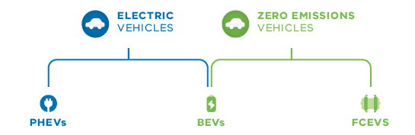

A Roadmap to where?
The Roadmap envisages three key phases to net-zero emissions by 2050:
- limiting emissions growth phase
- reducing emissions phase
- approaching zero phase
The principal focus of this Roadmap is on the decade to 2030, understood as contained within the ‘limiting emissions growth phase.’
The Roadmap is more than a document; it’s the start of an ongoing planning and policy development process focused on the longer-term goal of net-zero emissions by 2050.

Policy Interlinkages
The ZEV Roadmap is a whole-of-Victorian-government exercise which is closely linked to the Climate Change Strategy and the setting of interim GHG emissions targets. It also has further links to, and implications for, a variety of other policy areas, such as:
- transport planning, regulation, procurement
and operations
- road planning, building and maintenance, including through the road user charge
- Government vehicle fleet procurement policy
- energy policy
- public health and air quality
- environmental policy and circular economy
- industry development, jobs, innovation,
training and skills

Roadmap Structure
The Roadmap consists of four main sections:
- a background section outlines the broader context for ZEVs, including the emissions challenge for transport and global technology trends
- a second section details the particular challenges for, and opportunities available to, Victoria in its transition to net-zero emissions road transport
- a third section describes key actions of the Victorian government in responding to the above challenges and opportunities – i.e. to promote, prepare for and address barriers to a more mainstream uptake of ZEVs in Victoria
- a fourth and final section covers key considerations in the journey towards net-zero emissions by 2050.

1. Why zero emissions vehicles?

1.1. To combat climate change, the Victorian Government has committed to achieving net-zero emissions by 2050
Victoria’s Climate Change Act 2017 establishes a long-term target of net-zero greenhouse gas emissions by 2050. The Act also requires the establishment of five-yearly interim emissions reduction targets to keep Victoria on track to meet this long-term target.

We are taking strong action on climate change
We have introduced world-leading legislation, Victoria’s Climate Change Act 2017, which cements our net-zero emissions goal in law and establishes a comprehensive framework to get there while also planning for and adapting to our changing climate. We have also set ambitious renewable energy targets, and comfortably achieved both our emissions reduction and renewable energy targets for 2020.

We will achieve a net-zero emissions, resilient Victoria by 2050
To avoid the worst effects of climate change, the international Paris Agreement aims to limit the rise in global average temperature to between 1.5 and 2 degrees Celsius. To help achieve this goal, Victoria – along with many governments around the world – is committed to net-zero emissions by 2050.
We are also committed to safeguarding Victoria from the future effects of climate change with long-term investments in the built and natural environments to improve resilience and support adaptation.

Victoria’s Climate Change Strategy sets out our current responses to climate change and our next steps
We will reduce emissions while creating jobs, stimulating innovation and cutting costs for all Victorians with:
- ambitious emissions reduction targets for 2025 and 2030
- actions that reduce emissions now and lay the foundations for future emissions reductions
- priority measures to build Victoria’s climate resilience.

1.2. Decarbonising Victoria’s road transport sector is critical to achieving net-zero emissions
The transport sector is the second largest contributor in Victoria to GHG emissions, accounting for around 25 per cent of the state’s total (22.7 out of around 114 million tonnes).
As Figure 2 shows, up to 90 per cent of these emissions comes from road transport, with almost 56 per cent of this total coming from light passenger vehicles. Although Victoria is smaller than most of the other states, it has the highest average motor vehicles kilometres travelled in the nation (14.1 thousand kilometres), followed by Queensland (13.7 thousand kilometres).
These total GHG emissions have been trending upward, as Figure 3 illustrates. Despite the temporary effects of the COVID-19 crisis, these emissions are projected, on a business-as-usual basis, to continue to grow further as the population and travel demand also continues to grow – unless we move to decarbonise the transport sector.
Figure 2. Transport sector CO₂ emissions
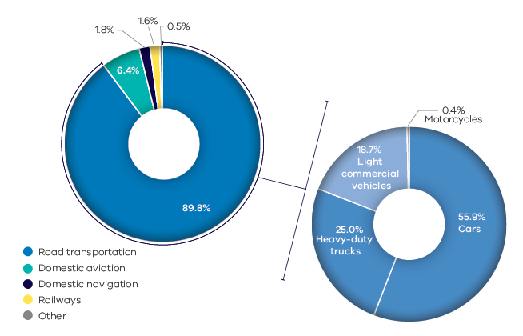
Victorian Greenhouse Gas Emissions Report 2019:
“Growth in emissions from cars (which increased by 18.4% between 1990 and 2017) was driven by growth in the number of passenger vehicles and total passenger vehicle kilometres travelled, which reflected strong population growth in the State. For example, the number of registered passenger vehicles in Victoria increased by approximately 79,000 each year from 2012 to 2017.”
Figure 3. Road transport CO₂ emissions trends
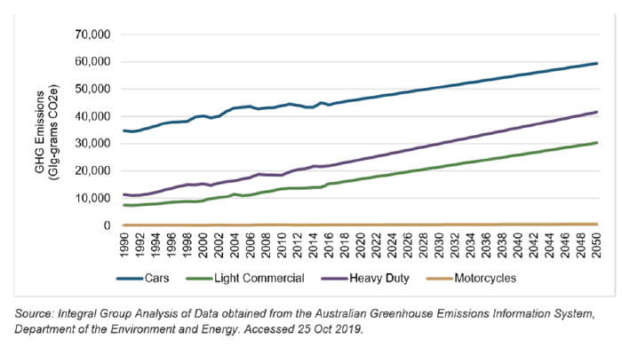

1.3. ZEVs are needed to fully decarbonise road transport
The Victorian Government is addressing the emissions challenge for road transport by planning for and investing in a transport system that provides more sustainable transport options, enables more people to embrace public and active transport choices, and reduces the emissions intensity of freight transport. However, this will not be enough to fully decarbonise the road transport sector.
To ensure, as our population grows, that Victorians can meet their everyday travel needs in a way that
is both efficient and sustainable, the Government is working to build the transport system of the future, including:
- a metropolitan public transport network that is easy to use and that provides simple, connected journeys, with expanded rail capacity, better, more integrated bus services and more seamless payment systems. This will encourage more people to use public transport for more of their travel needs
- better integrated land use and transport planning that will enable and encourage more people to choose active transport, such as walking and cycling, thereby reducing the need for household car ownership and travel
- introduction of a road user charge for low and zero emissions vehicles to more equitably fund roads and optimise their usage in the absence of fuel excise raised on hydrocarbon fuels
- planning for and adapting to the emergence of new technologies, such as ride-sharing and automated vehicles, that could enable more convenient, flexible and carbon-efficient demand-responsive transport choices, particularly for first-and-last-mile travel needs.
- the establishment of a network of port-rail shuttles and intermodal terminals to enable
more freight to be transported by rail.
These measures to promote a shift to more sustainable modes of transport have a vital role to play in curbing the projected growth in transport-related emissions; however, they will not be enough to achieve a complete decarbonisation of the road transport sector. Most critically we also need to focus on changing how motor vehicles, including cars, trucks and buses are powered. It is only through a transition away from ICEVs and toward ZEV technology that a full decarbonisation of road transport can be achieved in Victoria.
Implications of COVID-19 for zero emissions vehicles
COVID-19 has had significant impacts on the transport in Victoria. It is as yet unclear what the longer-lasting impacts of the COVID-19 pandemic will be on the road transport sector, and for ZEVs in particular. The avoidance of some work trips and changed transport patterns due to the continued uptake of remote working over the medium to longer term could also impact road and public transport users, the network, air quality and greenhouse gas emissions. Future planning for the transition to ZEVs will consider these issues.
What is certainly clear in the interim is that, at the very least, the current pandemic has seen an increase in interest internationally in the role that ZEVs could play in improving air quality. (see Section 1.4).

1.4. ZEVs will also improve urban air quality and reduce noise pollution
The uptake of ZEVs is not only a vital element in efforts to combat climate change, it also has the potential to reduce the incidence and severity of health issues caused by high vehicle exhaust concentrations, as well as reduce the impacts of vehicle-related noise on local communities.
Around 3,000 Australian deaths each year can be attributed to urban air pollution, more than double the national annual road toll. ICEVs are a major contributor to this air pollution. They emit pollutants such as particulate matter, nitrogen oxides, volatile organic compounds and carbon monoxide – all of which can affect human health and the environment. For example, inhalation of particulate matter and nitrogen oxides can aggravate existing respiratory illnesses like asthma and is linked, moreover, to an increased risk of cardiovascular and respiratory disease, and premature death. According to a recent study conducted by the University of Wollongong, particulate pollution at busy intersections has been detected as being almost ten times higher than general urban measurement levels.
Infrastructure Victoria’s modelling indicates that achieving 100 per cent uptake of ZEVs by 2046 would reduce particulate matter emissions by 1.2 million kilograms each subsequent year and deliver savings of $706 million in healthcare costs in 2046 alone.
Adoption of ZEVs will also reduce noise pollution in our cities associated with ICE engines. This has the potential to improve public health outcomes, given the contribution road traffic is understood to have on urban noise pollution and human health. The Environmental Protection Agency has estimated the social impact of noise pollution to be around $250 per vehicle per annum.

1.5. Global markets are already shifting away from polluting forms of transport
The global road vehicle market is currently undergoing an unprecedented shift away from traditional internal combustion engine (ICE) technologies to new and more environmentally sustainable transport technologies.
Up to now, hybrid vehicles, including PHEVs, have been at the forefront of this shift, proving popular with consumers, and making a valuable contribution to reducing the carbon intensity of passenger vehicles on our roads. However, as hybrids still retain petrol or diesel engines, they may be regarded as a transition technology on the path towards net zero emissions in road transport. Fortunately, there are two key zero emissions technologies that have emerged as viable prospects to enable a complete transition away from ICEVs to battery electric vehicles (BEVs) and hydrogen fuel cell vehicles (FCEVS), which are both classed as ZEVs.

1.5.1. Battery Electric Vehicles
The reappearance over the last decade of BEVs as a viable market proposition is a critical milestone in the journey toward the goal of net zero emissions globally, and, thus, a critical part of the global response to the challenge of climate change.
As the production of BEVs has expanded, and the cost of the batteries trends downwards (see Figure 4), we have seen sales of BEVs grow internationally. It is projected that by 2023 the market average price for lithium batteries will drop to a major milestone of $US100 per kilowatt hour (kWh) storage.
According to the International Energy Agency, the global stock of electric passenger cars (BEVs and PHEVs) had passed seven million in 2019 (see Figure 5).
Figure 4. The cost of storing a kilowatt hour of electricity is trending downwards ($us)
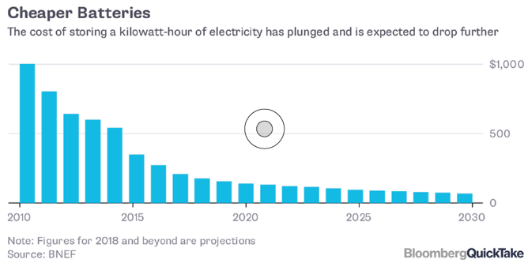
Figure 5. Passenger electric car stock in principal EV MARKETS 2010 - 2019
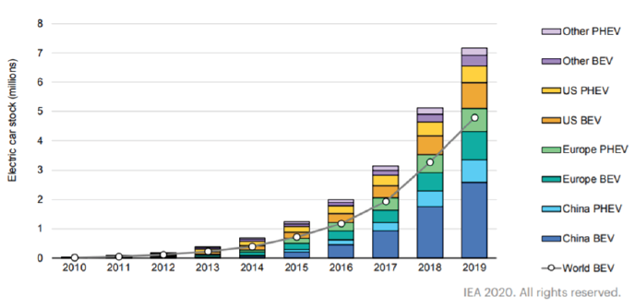

Figure 6. Hydrogen supply chain
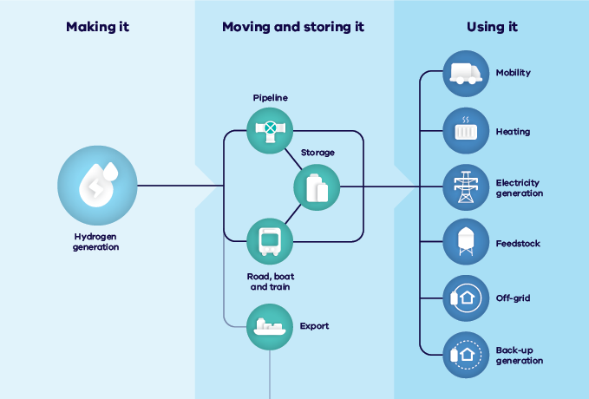

1.5.2. Hydrogen Fuel Cell Vehicles
Alongside BEVs and PHEVs, there have also been increasing efforts internationally in recent years to develop and commercialise hydrogen fuel cell vehicles (FCEVs), which is another form of electric vehicle, but one which uses compressed hydrogen via a fuel cell to power their motors.
As hydrogen supply chain and technologies are emerging and largely pre-commercial globally, the uptake of FCEVs has to-date been more limited than PHEVs or BEVs which have been commercially available for longer. However, FCEVs are currently being trialled at various locations internationally, and now Melbourne is host to a hydrogen fueling station recently opened by Toyota in Altona. Toyota is seeking to be a major player in the global FCEV market, including using 100 hydrogen fuel cell buses and 500 Mirai hydrogen fuel cell passenger vehicles this year at the Tokyo Olympic games.
Light passenger FCEV models are now being trialled in Australia. Toyota is trialling 20 examples of the Mirai in Melbourne and 20 Hyundai Nexos are being operated by the ACT Government, with supporting refuelling infrastructure also installed. Another five Nexo FCEVs are headed to Queensland.

Battery Electric Vehicle and Hydrogen Fuel Cell technologies compared
There are two key technologies that enable vehicles to produce no emissions during their operation, hydrogen fuel cell vehicles (FCEVs) and battery electric vehicles (BEVs).
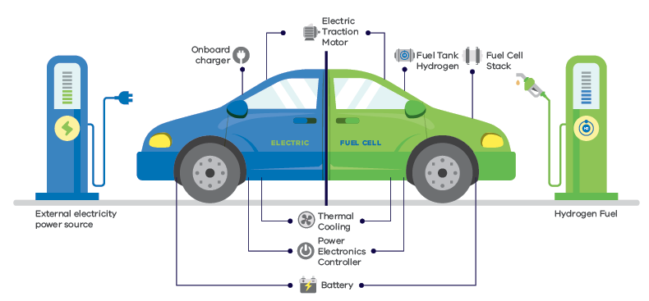
The role that hydrogen will play in the global transition to ZEVs is not yet clear. While BEV technology has a rapidly growing market presence and mature supply chains, there are transport uses that are presently unfeasible for battery electric, such as long-haul heavy transport, and high-mileage applications where hydrogen has some advantages.

 | BEVs – Advantages | FCEVs - Disadvantages
Technology readiness | Well established and readily available technology, with scope for further improvements in performance | Yet to be established at scale in the market, with emerging supply chain formation
Efficiency | BEVs are highly efficient in converting electricity into motive power, with ‘well-to-wheel’ energy losses of only around 27 per cent (i.e. 73 per cent efficiency overall), whereas ICEVs can experience energy losses of up to 87 per cent in the production and storage of petroleum fuels and operation of internal combustion engines (i.e. ICEs are 13 per cent efficient). | The process of generating hydrogen for FCEVs is relatively energy inefficient (around 50%) – however, this may not be an issue provided that the sale-price of the hydrogen is cost-competitive. Large-scale production of hydrogen is not yet established in Australia.
Infrastructure readiness | BEVs can charge at home or work, connecting to existing electricity networks at modest cost. A network of public DC charging stations is already growing, with both government and sector investment. | Requires establishment of new generation, transportation, storage and re-fuelling infrastructure.
Vehicle capabilities | Batteries are heavy and while their range per charge is rapidly improving, it is currently less than the range of equivalent ICEVs. They also rely on certain precious metals whose supply into the future may be constrained. | Longer driving range, lighter weight and quicker refuelling capacity.
Energy system demand | There is some potential for peak demand issues with a more completely electrified vehicle fleet, but this is likely to be substantially offset by a domestic uptake also of ‘smart-charging’, load management and vehicle-to-grid/vehicle-to-home technologies. | There appear to be no peak demand issues for the grid in the generation of hydrogen power, with the expectation that hydrogen can be generated using excess grid capacity. Hydrogen can be stored as a gas or liquid fuel for long periods, allowing flexibility in generation times.

1.6. The Mid-2020s: A projected global tipping point for BEVs
The middle of this decade will likely see a convergence of factors that could spur an accelerated global uptake of BEV technology and transition of the global light vehicle fleet away from ICE technology.

1.6.1.Scaling up of supply
While the demand for BEVs continues to rise and is expected to exceed that of hybrid vehicles by 2025, so too manufacturers are ramping up their capacity to supply vehicles to market. An example of this is the increasing number of vehicle and battery 'mega' and 'giga' factories around the world.

1.6.2. Increasing number of available models in differing vehicle categories
Alongside greater production capacity is the increasing number of new models coming onto leading global markets this decade, providing greater choice for consumers (as indicated by the European Federation of Transport and Environment – see Figure 8, overleaf). This will see an increasing number of models available across differing price points, including new offerings within vehicle classes, such as SUVs, sportscars and light vans. This will increase opportunities for like-for-like replacement of ICEVs with ZEVs.
Figure 7. New Tesla Gigafactory in Shanghai, China
Image courtesy of Tesla Australia
Figure 8. Projected new BEV models by maker available in overseas markets to 2025
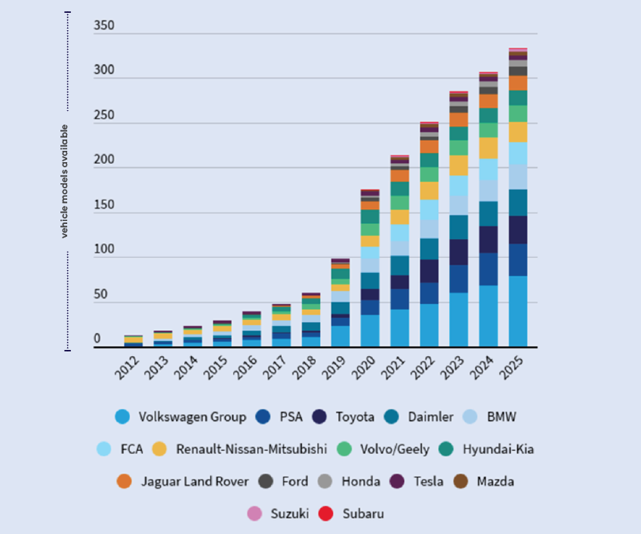
Figure 9. Price parity projections to 2030
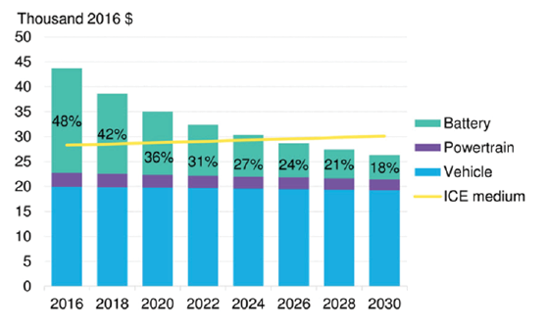

1.6.3. The achievement of price parity with ICEVs
One of the most significant barriers to stronger consumer uptake of BEVs is the higher purchase price compared to their ICE equivalents. While there has been much debate as to when price parity might occur, it is widely believed that price parity could be achieved internationally by 2025 or earlier, driven largely by declining battery costs (see Figure 9).
However, this price parity may not occur for all models by 2025 or in every market. Instead, it is more likely to occur first in more established and competitive markets where there is already strong support for ZEV uptake as well as stronger levels of demand , such as in Europe (see Figure 12, page 32). The achievement of price parity may be significantly delayed in Australia, in the absence of the actions in this Roadmap (see page 36).
The achievement, sooner or later, of price parity for BEVs will likely result in a surge in uptake in Australia.
Australian Energy Market Operator (AEMO) has estimated that the total number of ZEVs in Victoria could range between 56,000 to 220,000 by 2025-26. If poorly managed, the integration of BEVs could drive a rapid increase in network capacity investment to meet growth in peak demand.
Therefore timely pre-planning is required to ensure optimal integration of BEVs into the energy network.

1.6.4. Improved battery performance and other technological advances
Beyond price parity for consumers, the other key factor in accelerating the growth in sales of BEVs is the potential for further, game-changing advancements in battery technology – e.g. ‘denser’ batteries with new chemistries that would offer considerably more range than presently available, quicker and safer re-charging, as well as longer retainment of charge-capacity. For example, research is continuing to progress on the development of ‘solid state’ technology (see page 26), with a focus on commercialisation.
Emerging technologies such as wireless charging could also enable vehicles to be charged while stationary, potentially even while travelling. Once fully commercialised, such developments could be a game-changer, enabling reduced battery size in cars or otherwise extending the range of BEVs to equal or beyond that of equivalent ICEVs of today.

Battery innovation holds the prospect of greatly improved range

Solid-state batteries
Lithium batteries currently rely on liquid electrolytes which effectively limit energy density and can result in some degraded performance over time. Recent advances however have reportedly been made in the form of solid state technology. This technology could offer much greater stability and energy density, faster charging, and almost unlimited durability of battery performance. Toyota has announced that it will be debuting such a battery at the 2021 Tokyo Olympics.

Lithium sulphur batteries
Researchers at Monash University (see image above) have developed the world’s most efficient lithium-sulphur battery, which could potentially enable an increase EV driving range to up 1000 kms on a single charge.

Inductive (i.e. wireless) charging
This technology is already available for devices like mobile phones and is being explored globally to facilitate the charging of BEVs – it involves a vehicle with a receiver standing or moving over a charging plate installed in the ground. Charging can occur with up to 97% efficiency. Demonstrations and trials of this technology are currently taking place in Europe, Japan and the United States, and is likely to find a wide application in the future, particularly with the rise of automated vehicles.

1.7. The promise of hydrogen – potential transport uses
In November 2019, the Council of Australian Governments (COAG) (now known as the National Federation Reform Agenda) released the National Hydrogen Strategy to set a vision for a clean, innovative, safe and competitive hydrogen industry.
The strategy outlines an adaptive approach that equips Australia to scale up quickly as the domestic and international hydrogen market grows. It includes a set of nationally coordinated actions involving federal and state governments, industry and the community. The overall aim is to remove market barriers; build demand and develop production capacity; invest in research and development, skills and workforce development, all in a way that can accelerate Australia’s cost-competitiveness in the supply of hydrogen to global markets.
The actions consider hydrogen in relation to exports, transport, industrial use, gas networks, electricity systems, and cross-cutting issues such as safety, skills, and environmental impacts, with an emphasis on building a pathway to the supply of renewable hydrogen.
A key element of Australia’s approach will be the creation of both hydrogen hubs and clusters. Hydrogen hubs represent regions where hydrogen generation, supply and infrastructure is co-located, including around ports, cities, or regional areas. Hydrogen hubs will provide the industry with its springboard to scale. Similarly, clusters are geographic concentrations of interconnected companies, specialised suppliers, service providers, firms in related industries and associated institutions in particular fields. The focus of clusters is on enabling knowledge sharing, growing capabilities, enable collaboration, and help build hydrogen supply chains.
Both hubs and clusters ensure that sector development is more cost-effective, promotes efficiency from economies of scale, fosters innovation, stimulate investment, and promotes synergies from sector coupling. These will be complemented and enhanced by other early steps to use hydrogen in transport and freight, export capabilities, industry and gas distribution networks and integrate hydrogen technologies into our electricity systems in a way that enhances reliability.

2. Challenges and opportunities for Victoria

2.1 Where are we now? ZEVs today in Australia and Victoria
While the uptake of ZEVs has been slow in Australia compared to other advanced economies, there is growing interest in their potential benefits.

2.1.1. Sales of electric vehicles have been trending upwards in Australia over the last few years
Figure 10. BEV and P sales in Australia 2011-2020
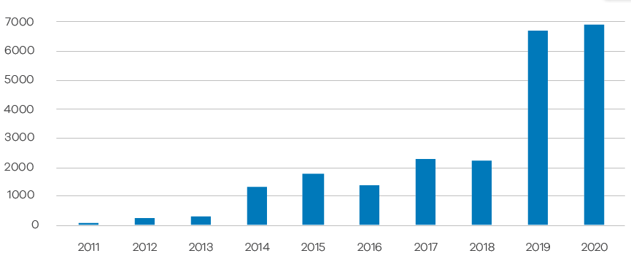
According to figures provided by manufacturers, there has been a rapid increase in the number of both BEVs and PHEVs sold in Australia in recent years. Moreover, in 2020, the sales of new electric cars around the country reached an historic high of close to 7,000 vehicles, or about 0.7 per cent of the total new car market. This coincides over the last two years with the release of lower priced models, such as the Tesla Model 3 and the Nissan Leaf (see Figure 10). This increase is despite overall car sales decreasing in 2020 due to the impacts of COVID-19.
While Tesla does not release its sales figures for Australia, it is estimated that Tesla vehicles constitute around 80 per cent of national sales. Other popular BEVs, according to recent sales data, are the Hyundai Kona and Ioniq and Nissan Leaf. As for Victoria, the state continues to have the highest total number of (non-Tesla) electric vehicle sales in the nation, although the industry reports (see Figure 11) that South Australia and the Australian Capital Territory appear to have a higher percentage of EV vehicle sales.
Figure 11. EV sales by state
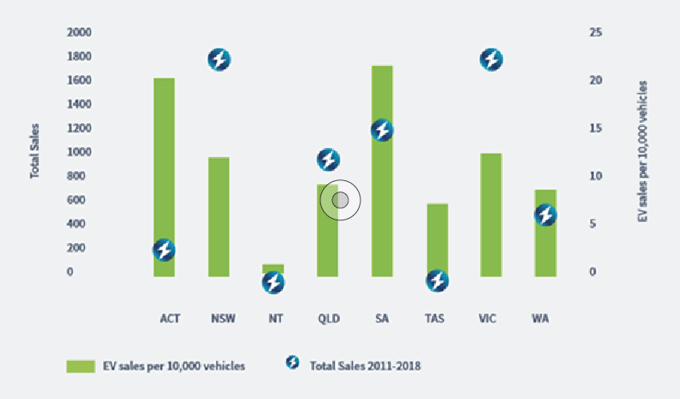
2.1.2. More fleet owners and operators in Victoria are showing interest in pilot deployments, and in transitioning to ZEVs
For the last two years Woolworths has been trialling electric vehicles in Victoria, using a fully electric truck for store deliveries.
Also, Linfox, a major freight and logistics company based in Victoria, is supporting Woolworths as it trials electric vehicle technologies at the Linfox-owned Australian Automotive Research Centre in Anglesea.
Bus operator Transdev has been trialling the first fully-electric bus to operate on Melbourne’s metropolitan bus network. Assembled by bus-maker Volgren in Dandenong, this e-bus had been operating on Route 246 between Clifton Hill and Elsternwick. The e-bus is currently operating on Route 251 between the City and Northland Shopping Centre. The e-bus has saved over 60 tonnes of carbon dioxide emissions in its first 300 days of service compared with a standard diesel bus.
Deakin University is building a Hydrogen Research Centre, Hycel, at its Warrnambool campus. In partnership with Australia’s leading truck manufacturer, Kenworth, it will undertake research and development of hydrogen fuel cell trucks for the freight industry.

2.1.3. There are also a number of Victorian councils which have already begun to transition their fleets to ZEVs.
Maribyrnong City Council, in Melbourne’s inner west, has played a leading role among councils in Victoria in its adoption of ZEVs. Maribyrnong City Council endorsed an Electric Vehicle Charging Infrastructure Policy in 2020 to facilitate the transition EVs, including encouraging, enabling and guiding the installation of EV infrastructure.
Other examples of local councils adopting ZEV technology include the City of Yarra, the City of Casey, Moreland City Council, and Hobsons Bay Council who have all begun to use electric trucks in their operations.

2.1.4. Victorian Government Fleet (‘VicFleet’)
The approved list of vehicles for state government procurement now includes a number of PHEVs and BEVs, in addition to hybrid ICEs (i.e. vehicles in which the petroleum-based engine is supplemented by battery-powered propulsion). There is an opportunity going forward for an expansion in the use of ZEVs where it can be established that they are fit-for-purpose.
As discussed in Section 3, the Victorian Government is undertaking a business case to accelerate uptake of ZEVs in VicFleet and has set a target to purchase 400 new light passenger ZEVs by 2023.

2.1.5. Australia is still lagging the world in the adoption of ZEVs
Notwithstanding the upward sales trend in Australia, the uptake of ZEVs in this country continues to lag the world (see Figure 12). Of the 36 countries that make up the OECD (Organisation for Economic Cooperation and Development), 32 of them have higher sales rates than Australia. New Zealand, has almost double the number of electric vehicles as the whole of Australia despite having a population size similar to Melbourne.
Figure 12. Plug-in electric vehicles - percentage of new sales by country, 2020
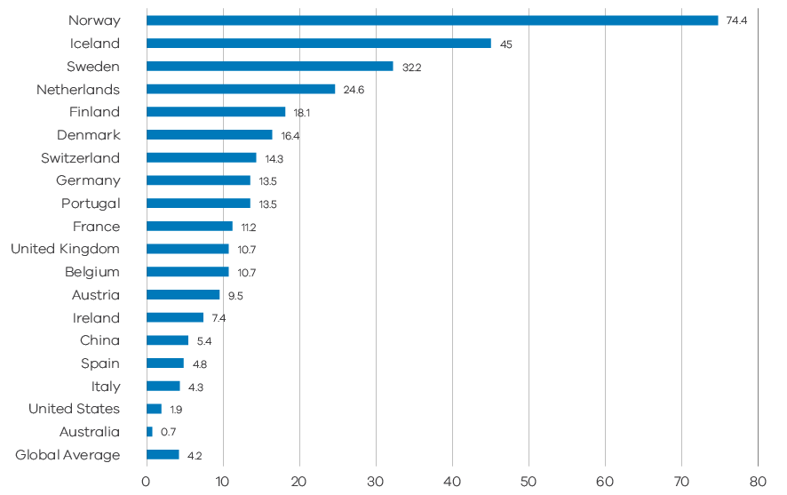

2.2. What are the key barriers to the uptake of ZEVs in Australia?

2.2.1. Barriers for BEVs
While surveys and recent sales figures show that public interest in electric vehicles is increasing, a mass market either for BEVs or FCEVs has yet to emerge in Australia or internationally. Evidence suggests that there are a number of barriers to the development of a stronger market for ZEVs.
Surveys of consumer attitudes, both in Australia and internationally, indicate that a key barrier to more widespread adoption of BEVs is their current upfront cost (i.e. vehicle purchase price) compared to their ICE equivalents. For example, a survey conducted by the Australian Electric Vehicle Council for its 2020 State of Electric Vehicles report shows that 50 per cent of respondents identified the higher price of electric vehicles as a factor that would discourage them from purchasing a BEV, while only 22 per cent would not be so discouraged.
Exactly when price-parity for ZEVs might occur in Australia has been the subject of much debate and conjecture (e.g. by the Australian Energy Market Operator and CSIRO among others). However, it is generally acknowledged that the achievement of retail price parity here (1) is dependent on supply by overseas vehicle manufacturers, and (2) will likely result in an upsurge of demand, with implications also, in the case of BEVs, for electricity network demand and capacity.
Another factor is how confident consumers feel about their level of understanding of BEVs. Studies show that while there is now almost universal awareness among consumers of the existence of electric vehicles, only a minority feel confident that they know enough about the technology. A recent Nielsen survey, for example, found that only 16 per cent of people in Australia considered themselves “adequately informed” about electric vehicles, while 60 per cent thought they were not informed.
A number of barriers identified in these surveys relate to a series of concerns widely held by consumers about the benefits and performance of BEVs. These concerns are arguably based on misperceptions or a lack of awareness about the capabilities and performance of these vehicles.
This includes concerns about:
How far one can travel on a full charge (i.e. ‘range anxiety’)
Range anxiety, the fear that one may be stranded at the roadside with an out-of-charge BEV, or otherwise constrained in one’s travel behaviour, is widely cited as a key concern for consumers. For example, the Electric Vehicle Council reports that as many as 80 per cent of surveyed respondents underestimated the range of electric vehicles currently available, and that 45 per cent nominated the distance able to be travelled per charge as one of the reasons that would most discourage them from purchasing a BEV.
Access to charging infrastructure
Concerns about the availability of public BEV charging is another way in which range anxiety is often expressed, with many consumers also concerned about the level of charging that might be available to them at BEV charging stations. An RACV survey has found that respondents nominated the availability of public charging as the most important factor in their decision to buy an electric vehicle.
Installation of private charging points within multi-unit dwellings, particularly in apartment carparks, can be a costly and complicated process for residents if the infrastructure is retrofitted after the building has been developed.
The fact that at present it generally takes longer to charge a vehicle than to refuel its ICE equivalent may also be a barrier for those whose vehicles might be in continuous operation (such as taxis).
The price of ICEVs relative to that of ZEVs
The upfront price of ICEVs in Australia has on average been lower than it has been in major overseas markets such as in Europe, where more stringent fuel efficiency requirements have increased vehicle production costs and created cross subsidies that are reflected in higher prices.
The exception is luxury vehicles, which in Australia attract a commonwealth purchase tax (the ‘luxury car tax’ or ‘LCT’). This relatively low upfront cost here of ICEVs, should it continue, will likely make the achievement of price-parity in Australia more difficult.
The prices of ZEVs continues to decrease to the point of price parity and will soon become cheaper than equivalent specification ICEVs. This is largely driven by rapidly decreasing battery costs (which is also increasing vehicle range) and greater economies of scale as manufacturers ramp up production of ZEVs. Victoria currently has a motor vehicle duty concession for ZEVs to help with this price gap.
Battery life
While some consumers may still hold concerns about the effective lifespan of EV batteries (i.e. when they might need to be replaced), evidence is showing that current-generation batteries are retaining up to 80 per cent or more of their charge capability after 10 years, with the expectation that lifespan may be significantly increased as a result of various technological advances (see page 26). Most manufacturers are also currently offering warranties of between eight and ten years.
The environmental and lifecycle benefits of electric vehicles
While the EVC found in its 2019 survey that the environmental benefits of EVs were those that appeared to be valued most highly by the respondents, other evidence suggests that consumers internationally are also concerned about if (and the degree to which) BEVs are indeed more carbon-efficient than traditional ICEVs, when taking into account their manufacture, how they are powered, and other factors.
While the above concerns appear to be shared widely across the world, some of the barriers to the uptake of electric vehicles reflect the particular circumstances faced in Australia. These include the structural barriers listed below, which are detailed further in the following sections.
The comparatively limited choice and availability of more affordable BEV models nationally
Not only is uptake of BEVs relatively slow in Australia, but we also have fewer vehicle models to choose from within the Australian market compared to other advanced economies (see the section below on the challenges of establishing a mass market for BEVs in Australia).
The consequent lack of a functioning ZEV second-hand market
While the retail market for ZEVs in Australia is currently very small compared to that for ICEVs, the second-hand market for ZEVs is even smaller. This has limited the availability of affordable vehicles in Victoria, and meant there has not been enough models available to enable the estimation of an established re-sale value for BEVs (which, in turn, may discourage retail sales).

2.2.2. Barriers for FCEVs
There are also a number of key barriers to the uptake of FCEVs in Australia, including the following.
- Higher manufacturing costs for fuel cell vehicles compared to ICEVs and BEVs
- Limited availability presently of FCEV models and hydrogen refuelling stations for consumers
- High production costs of hydrogen fuel and
high upfront costs of building a network of refuelling stations
- Limited development to date of a renewable hydrogen supply chain
- FCEVs face strong cost-competition from BEVs, other than in heavy and long-haul transport uses
What role hydrogen may ultimately play in the transport sector may depend on a range of factors, such as further technological developments (for both FCEVs and BEVs), private sector investment, consumer demand and national and international policy settings. While there is much uncertainty in the outlook for a number of these factors, it is widely believed that there will continue to be a viable and complementary role for both hydrogen and battery electric technology well into the future.
The anticipated formation of a growing export market for hydrogen is a factor for consideration in terms of government policy, and for maintaining a flexible and technology-neutral approach going forward to government investment in ZEV technology.

2.3. Key priority policy challenges and major opportunities for Victoria

2.3.1. There are three key priority policy challenges for Victoria in the early transition to ZEVs, but also new opportunities for optimising their impact
As the previous section outlines, there are a range of barriers to the uptake of ZEVs in Australia and which potentially stand in the way of Victoria achieving its goal of net-zero emissions by 2050. In addressing these barriers, the key priorities for Victoria in this decade are threefold:
- promote a stronger market for and more mainstream adoption of ZEVs
- optimise the integration of these vehicles into Victoria’s energy network
- take full advantage of opportunities to promote industry transition, job creation and economic growth in Victoria.

2.3.2. Promoting a stronger market for ZEVs in Victoria
The global motor vehicle market is made up of a series of separately regulated regional markets, of which Australian is one. Australia is now mostly an importer of vehicles, including ZEVs. Local participation in this global market, while governed by national import rules, is largely dependent on the decisions of overseas vehicle manufacturers to make vehicle models available to our market. This is not guaranteed.
While the supply of new ZEV models ramps up to meet growing global demand, evidence shows that major overseas manufacturers are choosing to prioritise their limited supply to their local markets and those markets in which there is already strong and growing demand – i.e. principally China, but also Europe (where there are more stringent fuel emissions standards and thus stronger demand for low and zero emissions vehicles - see Figure 13).
Figure 13. Electric vehicles - global exports and sales 2018
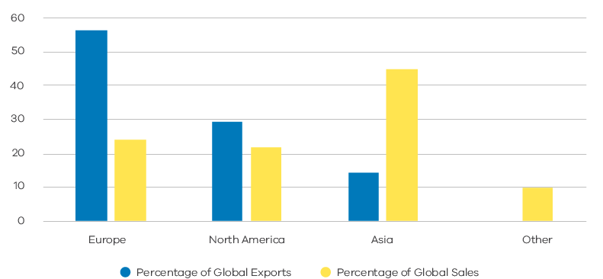

Figure 14. ZEVs in Australia: Vicious cycle of repressed demand and constrained supply
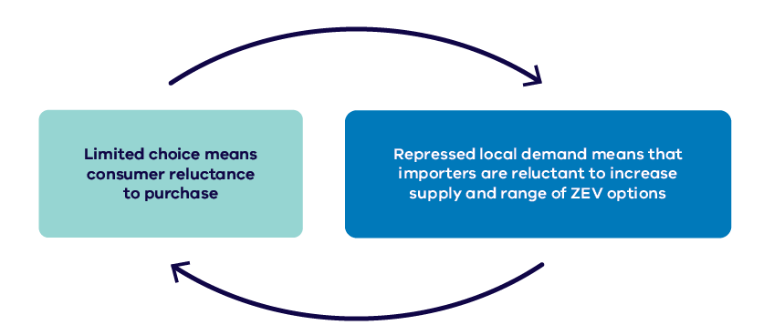
The upshot is that even though some new models are being introduced to Australia, we continue to lag behind other advanced economies in the range of ZEV models available. As the Electric Vehicle Council notes in its 2020 State of Electric Vehicles report, there were 28 electric vehicle models available for purchase in Australia (with eight of these being BEVs), with six more due to be introduced by the end of 2021, compared to 128 vehicles to choose from in the United Kingdom.
The absence of effective national policy and regulatory settings designed to promote the uptake of ZEVs is creating a ‘vicious cycle’ of repressed demand and constrained supply in Australia. This vicious cycle or ‘chicken-and-egg’ situation has potential longer-term implications. As Infrastructure Victoria has noted, manufacturers in future “may be reluctant to bring ZEV models to Australia without further encouragement of their uptake, and without a range of options a wide take-up by consumers is highly unlikely.”
In other words, unless this particular barrier to uptake in Australia is addressed, the full range of models available globally may continue to be witheld from the Australian market, potentially delaying the achievement here of full price parity across the widest range of vehicle classes. This could, in turn, hamper the development of more mainstream adoption of ZEVs that is vital to the reduction of road transport emissions in Australia.
Fuel cell technology faces a similar ‘chicken-and-egg’ situation in that demand growth for FCEVs will also be heavily dependent on strong infrastructure investment to support their deployment, and yet obtaining such investment is necessarily challenging without demonstrated demand.
If, however, these challenges for ZEVs can be overcome, Victoria, and Australia more broadly, will have greater opportunity to participate more fully in an accelerating global uptake of ZEVs.

2.3.3. Optimising the integration of electric vehicles into Victoria’s energy system
The growing uptake of electric vehicles could require significant capacity upgrades to the state’s electricity networks. Fortunately there are options emerging that represent an opportunity to minimise the impact of increased demand for electricity and even build greater resilience and generation capacity in our energy system.
Victoria‘s electricity grid is part of the National Electricity Market (NEM), which is made up of several elements that operate together in real time to deliver power to consumers as they need it - i.e. the poles and wires that make up the key regional transmission and local distribution networks that connect the power at its source (e.g. power stations) with those who consume it (see Figure 15).
Figure 15. Victoria's electrical grid - key elements
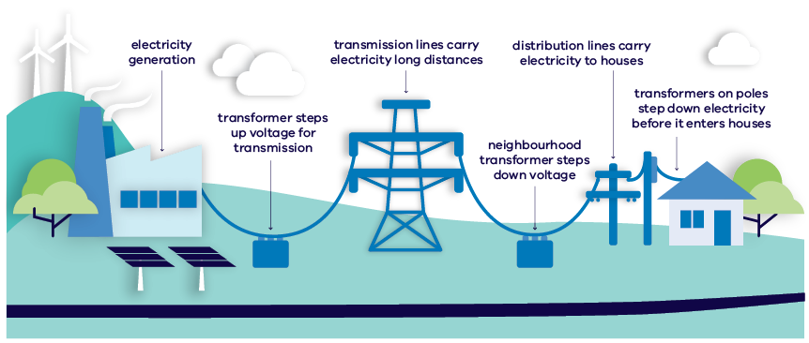
There has been some recent public discussion, including in the 2018 advice to government on ZEVs from Infrastructure Victoria, about the potential impacts of an increased uptake of electric vehicles on this electricity grid. For example, KPMG has found that universal adoption of BEVs by 2046 will likely increase total electricity consumption by about 50 per cent, and that, as “existing generation capacity will not be able to absorb this extra consumption, … new generation capacity will be required.”
The key issue in relation to any such expansion in capacity, however, is not the projected increase in the total volume of demand as such, but the extent to which BEVs might drive higher levels of peak demand. This is to say, where the expected uptake of BEVs is likely to present the most pressing challenge for the energy grid is when commuters return home at the end of the day and charge up their BEVs. The charging unit for a BEV can draw up to 6-10 kW, making it the highest energy consuming device in most homes.
Infrastructure Victoria’s advice on automated and ZEV infrastructure – final report:
“Adding a 9.5kW fast-charger to a local grid is the equivalent of more than three new homes being connected to the local network. The actual impact of each additional charging unit on the local network is heavily dependent on the proximity of the charger to the local transformer. One local study found that one charger located at a relatively weak point in the network could have the same impact as 45 charging loads located close to a local transformer. This could have significant implications on the ability of local networks to support the uptake of battery electric vehicles.”
The prospect of an increase in peak demand for electricity has potential implications both for energy generation and distribution. Firstly, it might require new investment in infrastructure to expand the amount of dispatchable power at a network level. Secondly, depending on the spread and clustering of BEVs in the community (i.e. where they charge), it might require increased network capacity at particular locations, such as at local substations. Both these impacts have the potential to result in higher electricity costs for consumers, while also raising the prospect of sub-optimal grid performance.
The key challenge thus for BEVs, in terms of energy system integration, is to manage the impact of increasing uptake in such a way as to maximise efficiency and thereby avoid, where possible, the need for new and costly capacity enhancements to both energy generation and distribution networks. Another question is how long we might have, in Australia, until price parity for BEVs in particular could drive an upsurge in peak-demand for electricity, and therefore how long we might have to plan for this eventuality. Fortunately, there are methods and technologies available that have the potential, in the coming years, to not only manage, but also to optimise the role, particularly of BEVs, in our broader energy system.
These methods include (as illustrated in Figure 16):
Leveraging household solar power generation and battery storage – Australia already has one of the strongest uptakes of solar photovoltaic systems in the world - such systems can reduce the impact of electric vehicle charging on the grid when coupled with stationary household battery storage.
‘Vehicle-to-Grid’ (V2G) technology, an emerging technology that will enable bi-directional flows of power between electric vehicle batteries and the local distribution network. This technology, in particular, represents an opportunity to turn electric vehicles into a positive asset for the electricity network - i.e. as another form of distributed energy generation.
‘Smart-charging’ – i.e. ‘set and forget’ technology at charging locations that can automatically and proactively manage charging loads, reducing them in periods of peak electricity demand, such as in the early evening. This could form part of a broader home energy management system.
‘Time of Use’ (ToU) network tariffs that encourage users to charge their vehicles outside of peak periods by providing them with the incentive of lower rates for off-peak electricity.
See Figure 16 for illustration of the potential impact of time-of-use tariffs on a demand profile for Victoria, and of the role of smart charging and V2G technologies.
Figure 16. Options for moderating peak demand implications of BEV charging
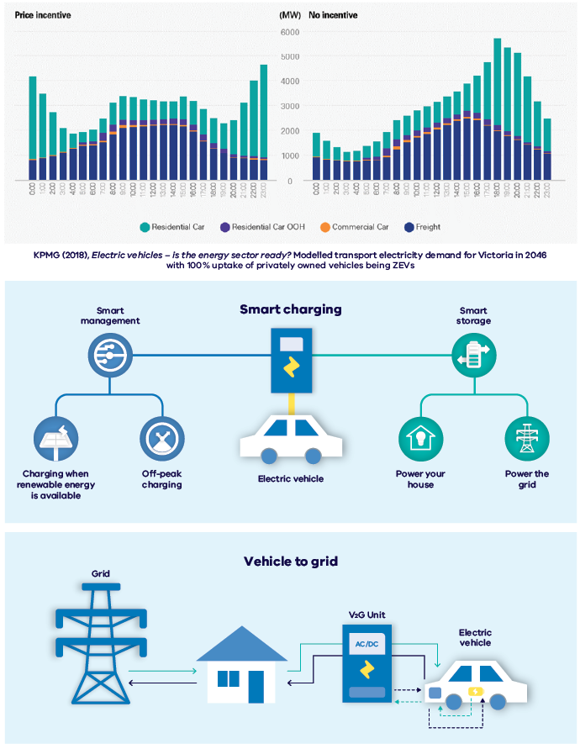

2.3.4. Taking advantage of opportunities to promote industry and workforce transition and economic growth in Victoria
Overcoming challenges and exploring ZEV-related opportunities has the potential to generate both direct and indirect benefits to the Victorian economy and community, including the productivity benefits of zero emission freight vehicles
The early decades of the twenty-first century have seen major economies around the world begin to come to grips with key interlinked trends such as climate change and the advent of new and emerging technologies, such as automation, artificial intelligence, and the rise of more sustainable motorised transport modes and associated renewable energy sources.
These trends and the fundamental changes they trigger present both challenges and opportunities for the Victorian economy and particularly in relation to the industry and manufacturing sector.
The challenges ahead for Victoria include:
- promoting a smooth and planned transition for existing industries to a more carbon-constrained world, and in a way that either maintains or bolsters our competitiveness overcoming local demand and supply constraints for ZEVs
- addressing the implications of a transition to ZEVs for the workforce – i.e. minimising its disruptive potential for existing ICE-related businesses and employment
- supporting the establishment of new, ZEV-related industries that build on the state’s natural advantages
- supporting the transition of our transport sector to more sustainable technology platforms.
There are also a range of potential opportunities for Victoria in terms of industry and workforce transition, which include the following
- electric vehicle manufacturing and assembly, including EV conversions
- local manufacturing of components for electric vehicles - Nissan Casting in Dandenong exports components all over the world for the manufacture of EVs.
- to become a nation-wide leader in establishing a strong skills and training base for electric vehicle repair and maintenance, while supporting the existing ICE-related workforce through the transition with re-skilling opportunities
- opportunities for local battery production, assembly, repair and recycling (using Australian lithium and other precious metals), and for potential transport sector uses – in concordance with Circular Economy policies
- the potential for the establishment of a range of other ZEV-related ancillary services
- exploring the potential opportunities for the local use of hydrogen in transport to stimulate the growth of a domestic hydrogen production industry, including the establishment of hydrogen hubs
- the potential role for hydrogen hubs in supporting back-to-base heavy vehicle fleet operations for FCEVs or major highway refuelling stations for long-haul freight

2.3.4.1. ZEVs will bring productivity and wider economic benefits
Commercial passenger vehicles, including taxis and ride share, have already made a significant transition towards hybrid ICEVs due to their higher fuel efficiency and therefore economic benefits over the life of the vehicles. ZEVs are even more energy efficient and have the added benefit of lower maintenance costs owing to their mechanical simplicity. The trend towards greener vehicles will continue as the purchase price of ZEVs reaches price parity, making them more attractive over the total operating life of the vehicle.
The adoption of ZEV technology will not only enable the commercial and freight sectors in Victoria to reduce their emissions but will provide associated savings on fuel and maintenance. The introduction of a road user charge for low and zero emissions vehicles will more equitably fund roads and encourage optimisation of their usage in the absence of fuel excise raised on petroleum fuels. The resulting productivity improvements are likely to flow on to the rest of economy, and the community, in the form of cheaper goods and services.
An area of particular opportunity in this regard is the ‘first and last mile’ segment of the freight industry, with trucking businesses like Linfox, parcel delivery firms like DHL, as well as Australia Post and major retailer Ikea (through its delivery partner ANC) looking to incorporate ZEVs into their delivery operations. Ikea in particular has announced that it wants 100 per cent of its national delivery fleet to be electric by 2025, estimating that each truck can save up to 36.3 metric tonnes of carbon dioxide each year. In future years, as the upfront purchase price of ZEVs declines compared to their ICE equivalents, the financial benefits of transitioning away from ICEVs will grow.
For freight and logistics businesses, these benefits will not just be in substantially lower operating costs, but in greater flexibility to delivery times in neighbourhoods with noise restrictions due to emitting very little noise. For example, enabling greater scope for deliveries to occur at times when traffic-loads are lower, such as before the morning peak and after the evening peak, has the potential to improve overall productivity, whilst still meeting environmental noise regulations.
Longer-haul trucking also has the potential to benefit financially from the uptake of ZEV technology. While the current range limitations of EV batteries make their use largely unfeasible in this context, it is widely recognised that hydrogen fuel cell technology could be a long-term option, and one that similarly has advantages in lower maintenance costs and greater energy efficiency (compared to traditional diesel vehicles). A number of manufacturers including Toyota are developing or even trialling large fuel cell powered trucks for long-haul freight purposes.
Given that every industry in Australia depends on freight and logistics to some degree, the productivity benefits of adopting ZEVs in this sector is likely to spread throughout the wider economy. These benefits have the potential to be substantial, given the estimate by consultants ACIL Allen that a one per cent improvement in efficiency in the freight and logistics sector can generate up to $2 billion in gains for the economy each year (2014 figures).
From a broader perspective, the Australian Electric Vehicle Association has estimated that if five million of Australia’s on-road vehicles were replaced by BEVs, “a direct fuel cost saving to the national economy of at least $2.2 billion annually … could be realised.” While this could have significant national balance of payments benefits (given that our petroleum fuel is mostly imported), this is money that could be diverted to other forms of household consumption that could benefit the economy and grow jobs.

2.3.4.2. ZEVs will enable improved energy security and resilience
Due to our high dependency on imported petroleum fuels to power our road transport sector, Australia is particularly sensitive to the continuing volatility in global oil prices. This volatility can have an impact on prospects for economic growth for the state and the nation, including impacts on individual households and businesses. Oil price hikes, for example, impose costs across the economy that can lead to higher inflation and higher levels of unemployment.
Given that ZEVs will be powered by local sources of energy, their uptake over time will enable Australia to reduce its dependency on imported oil, while also strengthening our economic resilience in the face of global geopolitical uncertainties. It will provide greater reliability in the supply and greater local control of a substantial cost-driver for the operation of both commercial and private road transport.
Further, both battery and hydrogen-based technologies have the potential to assist in promoting resilience in the energy sector. For example, the same hydrogen that can power FCEVs can, like large-grid scale batteries or pumped hydro, be used to stabilise the grid and thereby facilitate the transition away from coal-based power generation. BEVs, when combined with vehicle-to-grid technology, have the potential to do the same in the form of virtual power plants (see Section 3.6).
Figure 17. 2018 senate report into electric vehicles - analysis of benefits
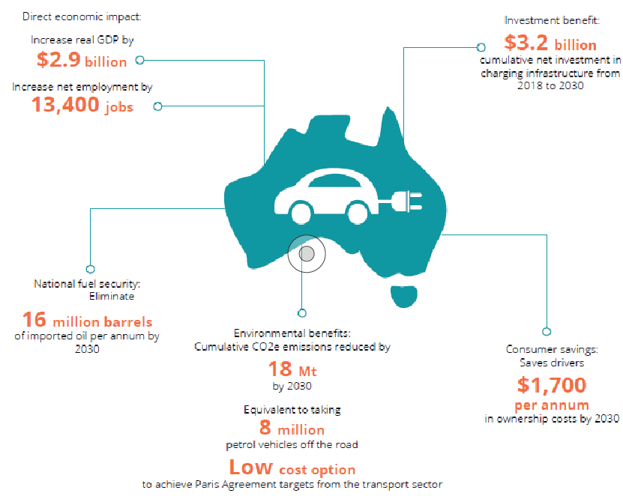

3. How are we responding?
Table 1. Key ZEV roadmap actions to prepare for and promote a stronger uptake of ZEVs, explore ZEV-related industry opportunities and support workforce transition
Public Education | Addressing concerns about ZEVs and their performance (Section 3.1)  Supporting an improved understanding about ZEV options and transition pathways, particularly among fleet operators (Section 3.2)
Advocacy | Working with other States and Territories to look at options for developing a harmonised approach to vehicle emissions standards, given the lack of action at the national level, and allowing parallel imports from other right-hand drive markets. (Section 3.3)
Promoting ‘ZEV-readiness’ | - Investing $19 million to accelerate the rollout of BEV charging infrastructure across regional Victoria, and support electric vehicle fleets. (Section 3.4)  - Supporting changes to the National Construction Code from 2022 to reduce barriers to future installation of EV charging in new buildings (Section 3.4)  - Undertaking a $298,000 study on ‘EV-readiness’ in new buildings  - Developing an online guide for apartment owners and body corporate committees to assist them in identifying and assessing options to enable EV charging in existing buildings (Section 3.4)  - Investigating the need for, and feasibility of, hydrogen re-fuelling stations and other supporting infrastructure (Section 3.4)
Transitioning our fleets | - Investing $46 million for Australia’s first public ZEV subsidy program – supporting the purchase of more than 20,000 ZEVs (Section 3.5)  - Setting a target of 50 per cent of new light vehicle sales to be ZEV by 2030  (Section 3.5)  - Establishing an expert panel to recommend policies, enabling investments and timelines to support the achievement of this 2030 target (Section 3.5)  - $10 million to green the Victorian Government Fleet, including replacement of 400 vehicles with ZEVs by 2023 (Section 3.5)  - $5 million to establish a Commercial Sector Zero Emissions Vehicle Innovation Fund (Section 3.5)  - $20 million to undertake a ZEV bus trial  - Setting a target for all public transport bus purchases to be ZEVs from 2025 (Section 3.5)
Transitioning our energy sector | - Managing the integration of ZEVs into our energy system through participation in inter-jurisdictional forums and research activities (Section 3.6)
Transitioning Victorian Industry and Workforce | - Commencing work on an industry development and transition plan to explore opportunities for Victorian industry associated with ZEV manufacturing, maintenance, repair and recycling (Section 3.7)  - Identifying industry development pathways for emerging technologies, including investigating the potential for hydrogen in transport (Section 3.7)  - Planning to support our workforce through the transition to zero emissions road transport as part of Victoria’s clean economy workforce development strategy (Section 3.7)

3.1. Addressing concerns about ZEVs and their performance
The concerns that some consumers appear to have about ZEVs, their value for money and environmental performance are increasingly unwarranted

3.1.1. Battery electric - from ‘range anxiety’ to ‘range confidence’
Figure 18. Estimated range of BEVs available in Australia in 2020 as reported by manufacturers (km)
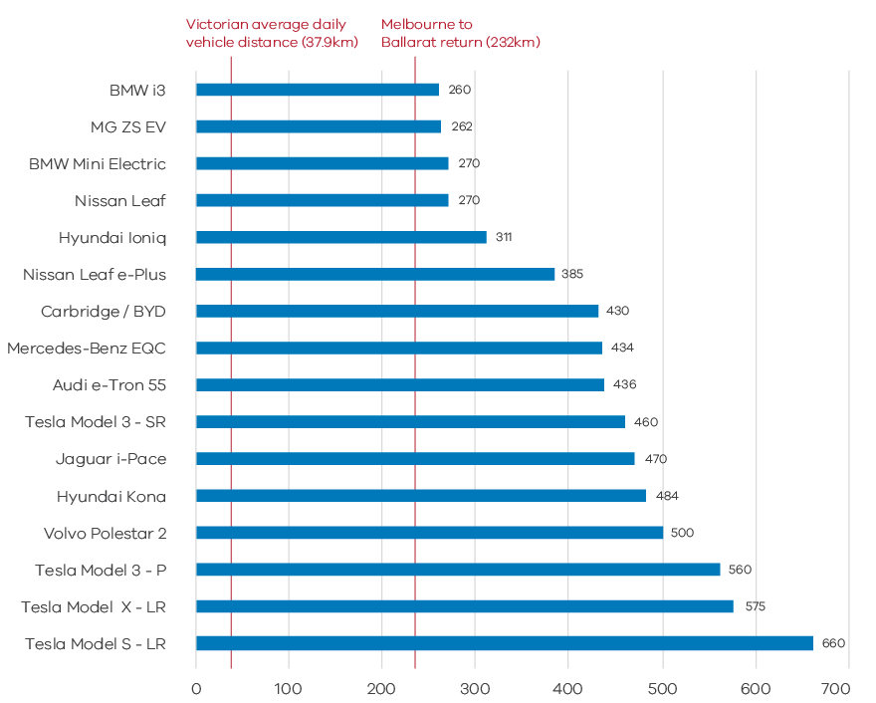
Note: Actual range is dependent on a range of factors including driving style, terrain and climate conditions.
As noted in Section 2, concerns about battery range and its impact on travel needs (i.e. ‘range anxiety’) is widely cited as a key barrier to consumer uptake of BEVs.
However, as Figure 18 shows, many BEVs currently available in Australia, including those in the mid-price bracket can travel Melbourne to Ballarat return on a single charge, whilst other models compete with ICEVs for total range. This current battery range greatly exceeds the daily travel distances for all but a few Victorian motorists, as found in recent travel survey results for Victoria detailed in Figure 19 below. This is the case even when allowing for individual driving profiles which impact effective range performance.
According to the Department of Transport’s ‘Victorian Integrated Survey of Travel and Activity’, nine out of ten people travel less than 27 kms a day when commuting by car, and less than 29 kms for any trip purpose.
Figure 19. Average trip distances by car for commuting purposes, based on Victorian integrated survey of travel & activity, 2018
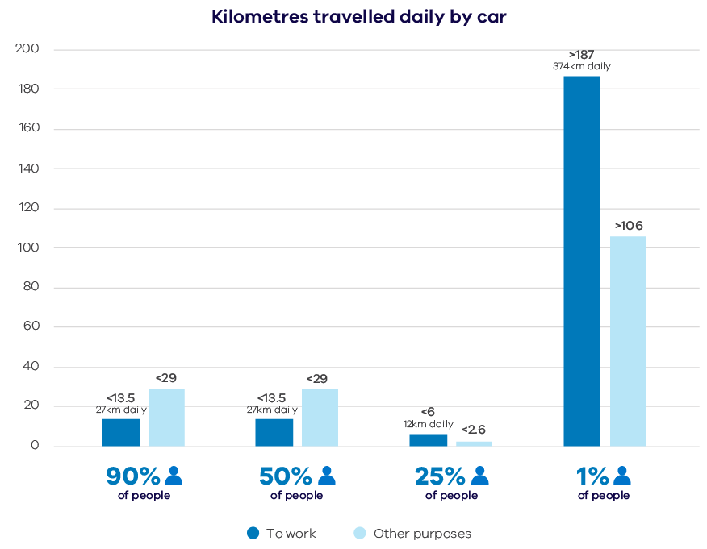
To support those undertaking longer-distance travel in BEVs, such as to or within regional Victoria, the government is supporting the expansion of a coordinated network of DC chargers across the state. This includes:
- the rollout in 2019-2020 of ultra-rapid 350kW DC chargers at seven locations across metropolitan and regional Victoria.
- of the $19 million announced for charging infrastructure, $6 million to support the installation of fast-charging stations at popular destinations around Victoria, including regional town centres, tourist hotspots and high-use locations.
As the density and coverage of this network of chargers expands over time, so too will the ‘range confidence’ of BEV owners in Victoria. In the interim, PHEVs may be considered a useful transition technology for those who might occasionally undertake longer highway journeys in Victoria.
Figure 20. Latest details on the availability of public electric vehicle charging in Victoria can be found at plugshare.com (example screenshot pictured)
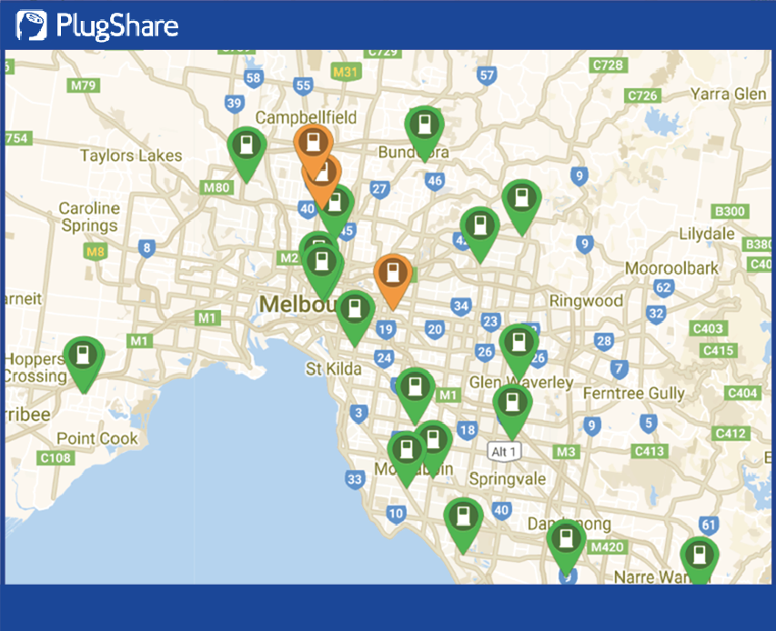
Investigating EV charging consumer preferences and behaviours
The Victorian Government is currently partnering with the Centre for New Energy Technologies (C4NET), Energy Networks Australia, the Australian Power Institute, RMIT University and the University of Melbourne on research intended to accelerate the uptake of EVs, improve EV consumer experience and provide a better understanding of the network impact of EVs on the grid. This work includes:
- a review of the international literature on consumer EV charging needs, preferences and behaviour
- a new empirical study investigating customer behaviour, acceptance and expectations of EVs in Australia, as well as strategies and techno-economic analysis to promote effective network and system integration
- research to develop customer charging profiles, models and network impact analysis in home, work and public settings.
This research will inform policy development and assist Victorian distribution network service providers to improve consumers’ charging experiences by better understanding what type and level of charging infrastructure should be made available to cater to their needs.

3.1.2. Fuel Cell Vehicle technology is safe and straightforward to use and will get cheaper over time
Reports indicate that there are a number of popularly-held concerns about hydrogen fuel cell technology, including questions about how safe it is and whether hydrogen re-fuelling is more difficult than using a conventional petroleum bowser. The reality, however, is that:
- extensive use over decades and rigorous testing has shown that, properly handled, compressed hydrogen is no less safe to use than petroleum fuels or electricity (and batteries) as an energy source. For example, hydrogen storage tanks such as those used in fuel cell vehicles are made from high-strength composite materials much stronger than steel, and are usually supported by a range of intelligent safety systems. Indeed, in some respects hydrogen is safer than petroleum fuel, in that, if a leak should occur as the result of an accident, the venting gas, unlike a petrol or diesel spill, will quickly dissipate in open air.
- it is no more complicated to refuel a hydrogen fuel cell vehicle than a traditional ICEV, as it similarly involves the use of a bowser pump and nozzle at a hydrogen re-fuelling station. Re-fuelling time is about the same as filling up the tank of an ICEV.
- while hydrogen fuel is currently more expensive than petroleum fuels at the bowser, it is expected to drop in price over time as the hydrogen supply-chain develops and production capacity grows, just as the cost of batteries came down as supply went up.

3.1.3. What are the value and benefits of ZEVs compared to ICEVs?
3.1.3.1. ZEVs cost less to operate than ICEVs
One of the key consumer benefits of driving a ZEV is that they both require much less costly maintenance than ICEVs, as they have fewer moving parts that require regular servicing or might need to be replaced. The NSW government has estimated the savings from this lower maintenance requirement compared to ICEVs to be around $300 per annum.
BEVs, moreover, have the advantage of significantly lower ‘re-fuelling’ costs per kilometre compared to ICEVs. Households switching to a battery electric vehicle can save upwards of $1,300 per annum on fuel (see Table 2 on page 50). Fuel savings can be even higher when compared to older ICEVs, which become less efficient as they age³⁷.
These fuel and maintenance savings are to be offset to a small degree by the introduction in Victoria of a modest road user charge for fully electric vehicles of $0.025 (i.e. 2.5 cents) per kilometre from 2021. Fully electric vehicles will be cheaper to operate than their ICEV equivalents, as is indicated in Table 2 below, which shows yearly fuel savings for BEV owners (minus the road user charge) of over $1,000 per annum.
Table 2. Energy cost comparison between BEVs and ICEVs
 | Battery Electric Vehicle | ICE Vehicle
Energy usage per km | 0.150 kWh | 0.106 kWh
Electricity/fuel cost | $0.33/kWh | $1.44/L
Cost per km | $0.05 | $0.15
Average annual travel | 13,100km | 13,100km
Average annual costs | $648.45 | $1,999.58
Fuel savings | $1,351.13 per year
Fuel savings (after road user charge) | $1,023.63
Five-year savings | $6,755.65
Five-year savings (after road user charge) | $5,118.15
Figure 21. 10-year TCO comparison for heavy vehicle fleets
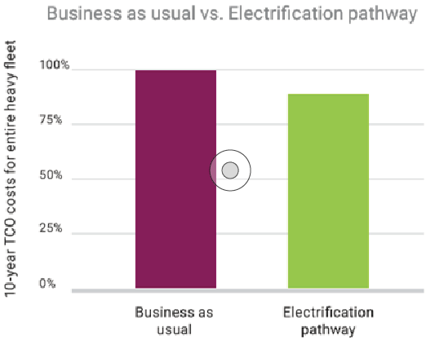
Consultants Evenergi, have published a white paper demonstrating that the adoption of electric vehicle technology not only reduces emissions, but is also good for business. Findings from a major fleet analysis of 85 commercial vehicles indicate that over a ten-year period, the use of electric vehicles can already result in savings for business due to lower total costs of ownership (see Figure 21). These savings are likely to increase over time, as battery costs continue to decline.
In the white paper, Electric heavy vehicles for profit and the Environment, Evenergi notes that there are a growing range of heavy electric vehicles, such as vans, garbage trucks, and light and heavier freight vehicles, that meet the needs of today’s businesses. They outline and provide guidance to fleet operators on the steps needed to transition to electric vehicle technology.
3.1.3.2. Battery lifespan is increasing
Concerns about battery degradation is a recognised barrier to ZEV adoption; however, the reality is that current generation lithium-ion batteries used in ZEVs can lose as little as 10-20 per cent of their charging capacity after eight to ten years. Most global electric vehicle manufacturers, meanwhile, offer warranties of between eight and ten years or 100,000 miles (i.e. 160,935 kilometres), far longer than the standard manufacturer warranties offered for ICEVs.
The picture so far seems to be mixed as to how battery lifespan might be affecting depreciation values for BEVs in particular, and their rate of depreciation compared to ICEVs. While there has been some evidence to-date of lower depreciation values for some BEV models, the market for retail and second-hand vehicles is still forming and there is some indication that other BEV models are holding their value well, and that the outlook overall is positive. For example, it is understood that further expansion of the market for BEVs, as well as the expanded network of public charging stations, could support depreciation values little different from that of ICEVs. It should also be noted that even where, after many years of use, EV batteries might need replacing, they can continue to have value due to ‘second life’ opportunities (e.g. for home or grid storage).
The longer-term future is even more promising for maintaining the post-purchase value of ZEVs. Emerging advances in battery technology, such as new chemistries and solid state batteries, could mean that electric vehicles batteries have a lifespan that well exceeds the average lifespan for a light passenger ICEV in Australia (i.e. 9.8 years) – Tesla, for example, has foreshadowed the introduction of batteries that could purportedly last up to a ‘million miles’.
Figure 22. Typical motor vehicle life cycle
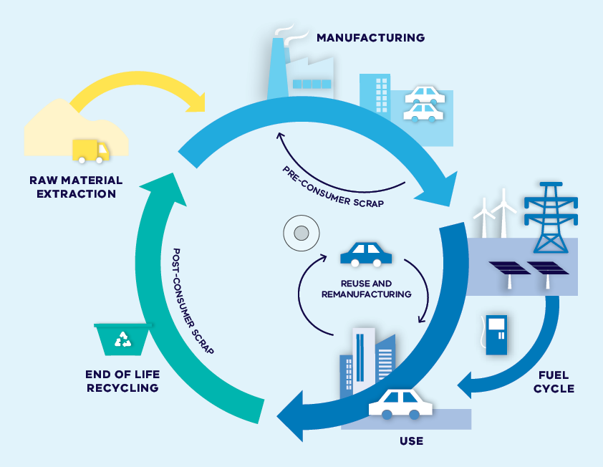

3.1.4. How sustainable are ZEVs in Victoria?
3.1.4.1. Lifecycle versus tailpipe emissions
ZEVs are defined by the fact that they do not emit harmful tailpipe emissions, but this is not the only way to measure their environmental performance. Another, and perhaps more meaningful, way is to consider their lifecycle emissions – i.e. the amount of carbon emissions generated in the course of a vehicle’s manufacture, operation and end-of-life disposal.
The fact that BEVs, first of all, have tended to be more carbon-intensive to manufacture than ICEVs, and may also use coal-fired electricity in their operation, has led some to question the environmental benefits of BEVs, particularly in cases where, like in Victoria, electricity-generation has historically been reliant on the burning of brown coal.
The reality, however, as recent studies have shown, is that from a lifecycle perspective BEVs are still more carbon-efficient than ICEVs even when they use coal-fired electricity.
For example, analysis cited by the Australian Energy Council shows that, from a lifecycle perspective, “even with fossil fuel-based electricity generation and power losses during transmission from electricity generation to filling the battery, electric cars were found to have lower levels of greenhouse gas production … even on the coal rich Australian grid, EVs produce 40 per cent less GHG when compared with equivalent ICEVs.”
Analysis undertaken for Europe similarly finds that BEVs are more carbon-efficient from a lifecycle perspective than ICEVs, even in Poland, which relies heavily on coal-generated power (see Figure 22).
Figure 23. Fossil energy use analysis comparing lifecycle GHG emissions
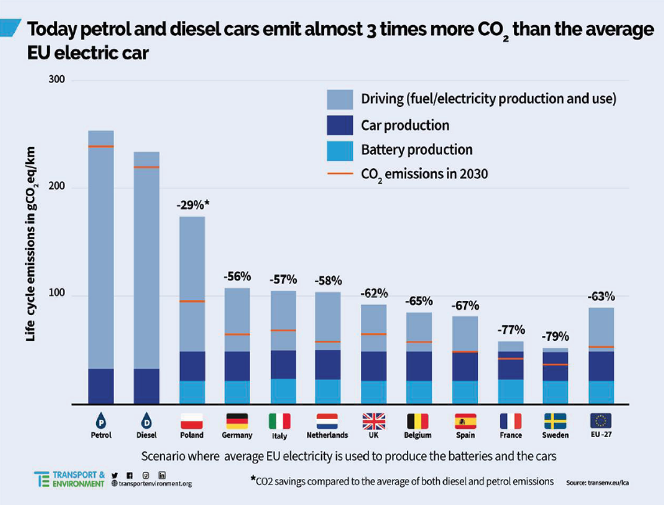
Replacing ICEVs with FCEVs supported by renewable hydrogen similarly has the potential, from a lifecycle perspective, to substantially reduce transport GHG emissions.
3.1.4.2. The Victorian Renewable Energy Target
As part of its commitment to combat climate change, the government is aiming to increase the level of renewable energy generation in Victoria to 40 per cent by 2025 and 50 per cent by 2030. This will make a big difference to the per kilometre carbon-efficiency of ZEVs into the future.
Although both electric and fuel cell vehicles are more carbon-efficient than ICEVs over their lifecycle, even when powered by fossil fuels, it will be vitally important, in terms of reducing total carbon emissions from transport, that future uptake of ZEVs be accompanied by an adequate expansion in renewable energy generation.
The Victorian government has been working to increase the proportion of the state’s energy generation from renewal sources (including wind and solar) and has now met its 2020 target of 25 per cent renewable generation. The aim is now to reach 40 per cent renewables by 2025, and 50 per cent by 2030.
Figure 24. Victorian renewable energy target 2020 to 2030
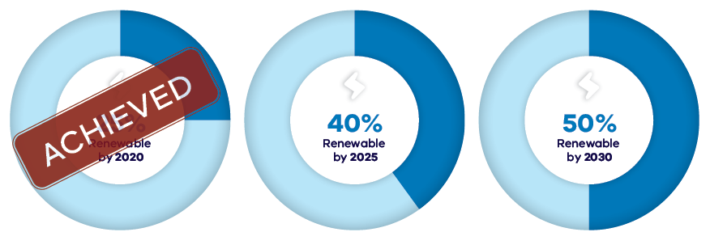

3.2. Supporting an improved understanding about ZEV options and transition pathways

3.2.1. Getting the word out on and building consumer familiarity with ZEVs
The government will be seeking opportunities to collaborate with industry and local government to improve the organisational capability of Victorian fleet owners and operators as they consider the transition to ZEV technology, as well as raise community awareness of ZEV options and benefits.
In this age of transition and technological disruption, one of the key challenges, particularly for the transport sector, is to gain and promote an understanding of the technical issues involved, and options available, in a prospective shift to zero-emissions vehicle technology. Without a better basic understanding of the technology, for example, and its potential implications for their bottom line, many organisations operating vehicle fleets, including local councils, may be reluctant or feel unable to begin to invest in these new technologies. Smaller businesses in particular may have less capacity to seek out information on relevant options and their advantages.
A lack of understanding of these issues is also a key barrier to a wider uptake of ZEVs among households. Although there is a considerable amount of information available online, for example, for those who might seek it out, surveys have shown that the great majority of people do not feel adequately informed about electric vehicles (see page 33).
3.2.1.1. Exploring the role for industry forums involving key government, academic and private sector players to share knowledge, identify issues and promote research relevant to Victoria
Industry and government collaboration has the potential to play an important role in ensuring that both households and businesses are better-informed regarding ZEVs. Industry forums can, for example, provide a locus for discussion for a varied range of industry players on issues of common interest, enabling them to pursue and share research and data on technical issues, and gain access to consistent, relevant and up-to-date information on, and therefore a better understanding of:
- the technologies themselves, what they can offer and how they are likely to evolve over time
- the implications for existing business models, including investment return and transition pathways
- best-practice learnings for fleet managers and owners on optimising the use of ZEV technologies
- regulatory issues.
3.2.1.2. Exploring opportunities for government to provide consistent, accessible and up-to-date information, promote best-practice and facilitate increased community exposure to ZEV technology
The Victorian Government is undertaking a coordinated public education campaign to promote greater awareness about ZEVs, incorporating the following elements:
- online and social media messaging, as well as the development and provision of informational materials, including in relation to adoption case studies.
- a ‘how-to’ guide for members of body corporates and residents in regard to the installation of charging equipment in apartment buildings.
- given the role that personal experiences and family and friendship networks are understood to play in influencing major household decisions such as the purchase of a new vehicle, the government will also be looking for opportunities to build awareness of and familiarity with ZEV technologies at a ‘grassroots’ level, including through:
  - the promotion of demonstration events and ‘drive days’ – i.e. where people can get a ‘hands-on’ experience of ZEV vehicles and ask questions about the performance and capabilities of these vehicles.
  - investigating and promoting the potential role for car-sharing and subscription/leasing schemes in expanding consumer familiarity with ZEV technology.
- working collaboratively with Victorian Greenhouse Alliances, which have the potential to play an increasingly important role as a coordinating point for council action and, in partnership with industry and other levels of government, as a locus for community education, guidance and information-sharing about best-practice in relation to ZEVs, including how to support ZEV uptake and use through the provision of public charging infrastructure and transition-planning.

Victorian Greenhouse Alliances have already been playing an important role in building local government capability around electric vehicles
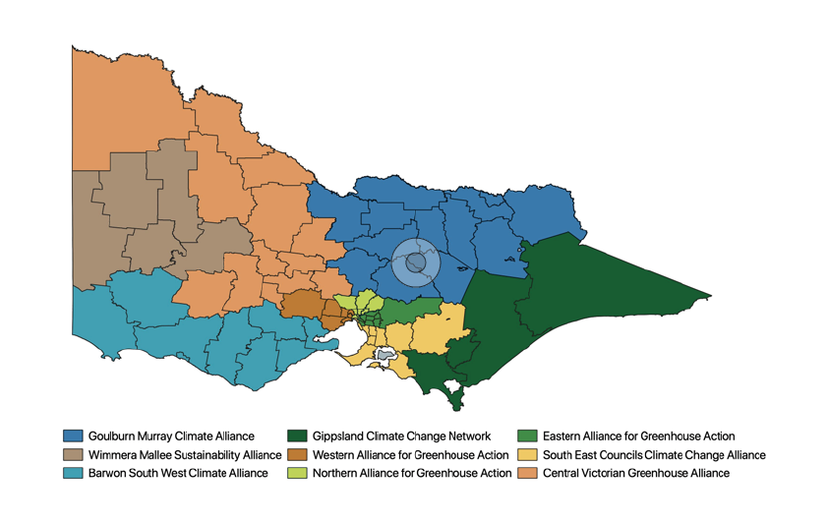
Greenhouse Alliances are collaborative partnerships of local governments (and sometimes other organisations) working together on climate change, energy and sustainability issues.
Beginning in the year 2000 with the founding of the Central Victorian Greenhouse Alliance (including the regional cities of Ballarat and Bendigo), the network of Alliances now covers up to 70 councils and most of Victoria.
The eight current Greenhouse Alliances (see above) work across three main functions:
- Projects: Develop and implement innovative, regional strategies and projects typically beyond the reach of individual councils
- Advocacy: Advocate on behalf of member councils
- Knowledge sharing: Undertake a range of knowledge sharing/capacity building activities for council.
These Greenhouse Alliances, recognised in Australia and internationally as a best-practice governance model for climate change, have to-date played an important role in coordinating regional efforts to support the transition to a net-zero emissions future. This has been done through the delivery of projects and programs that support abatement and build capability, including those related to ZEVs. Achievements to date in this regard include:
- the completion of an Electric vehicle feasibility study by the Northern Alliance for Greenhouse Action (incorporating councils from the northern metropolitan region of Melbourne), which resulted in the development of an assessment tool that can be used by other councils across the state.
- the Charging the Regions program - a feasibility study enabling local councils to understand the opportunities for a joint investment program that could see a dense and coordinated network of EV charging across the state. This study has informed the rollout of up to 15 charging stations across the Loddon-Mallee region last year and this year.

3.3 Advocating for more supportive Commonwealth government action
The Commonwealth has the potential to play a critical role in promoting an accelerated uptake of ZEVs in Australia, and thereby enabling a timely transition to net-zero emissions by 2050 (as agreed to in the Paris Climate Accord, to which Australia is a signatory). Given its particular powers and responsibilities, there are a number of ways the Commonwealth could promote greater adoption of ZEVs in Australia.

3.3.1. Introduce vehicle emissions standards for new vehicles
Figure 25. Average emissions intensity for new passenger vehicles by country, 2017 or latest available (national transport commission)
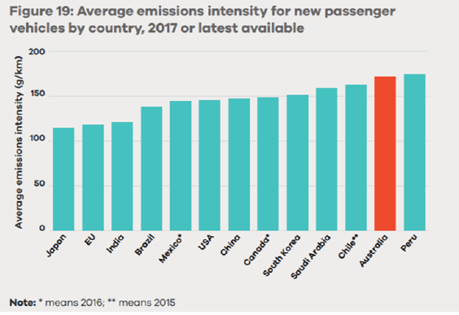
Australia is one of the few remaining developed countries without motor vehicle GHG emission standards in place, with such standards covering most of the global automotive market, including many developing nations. These standards tend to be applied on a corporate-average basis – i.e. averaged out over a range of vehicle models offered to market by particular manufacturers for a given model-year.
The absence of such standards in Australia accounts for why Australia’s fleet-averaged GHG emissions continue to compare poorly to other countries and global markets, for example, the European Union, but also India, Brazil and Mexico (see Figure 25).
New vehicle emissions standards would give vehicle importers and manufacturers extra incentives to bring ZEVs into the Australian market.
In 2016 the Commonwealth released a Regulatory Impact Statement (RIS) proposing the introduction of fleet-averaged emissions standards for Australia, but five years later they have yet to be implemented. This inaction has occurred despite the Commonwealth having acknowledged both the importance of such standards in curbing rising transport-related carbon emissions, and the significant savings they could produce for consumers in Australia.
The Australian Federal Chamber of Automotive Industries (FCAI), representing major automakers, had in 2020 introduced a voluntary scheme whereby its members each agree to transition to a lower whole-of-fleet emissions target for light passenger and commercial vehicles of 98 grams per CO₂ per kilometre by 2030, with progress to be reported annually.
The Victorian Government welcomes this initiative from industry. It is important that this effort be supported by national regulation. In this respect, the government continues to call on the Commonwealth to support the establishment of standards stronger than those proposed as part of the 2016 RIS – i.e. a target of 105 grams of CO₂ per kilometre to be phased in by 2025 – noting that many other countries have already committed to more ambitious targets.
The mandating nationally of these stronger standards has the potential to play an important role in accelerating the uptake of ZEVs in Australia, and thus achieving net-zero emissions by 2050 – i.e. it will send a clear signal to global automakers that Australia is no less serious about reducing road transport emissions than many other advanced economies.

3.3.2. Facilitate parallel importing of ZEVs into Australia
‘Parallel importing’ is defined as the importing of goods, such as motor vehicles, outside the manufacturer’s existing distribution channels, and for sale at less than the manufacturer’s official retail price. In Australia, the parallel importing of motor vehicles has historically only been allowed by exception, and on very limited grounds (i.e. largely restricted to “specialist or enthusiast vehicles”). This is a legacy of Australia’s past domestic motor vehicle manufacturing industry.
The 2015 Harper Review (an independent review of Australia’s competition law and policy) recommended that these restrictions be removed. In response, however, the Commonwealth has opted to relax restrictions only to a degree, by streamlining the eligibility criteria for specialist and enthusiast vehicles, requiring satisfaction of only one rather than multiple criteria. Given that one of the six new criteria refers to those vehicles “offering meaningfully better environmental performance, or meeting international categories for low power,” this has meant in effect that overseas electric vehicles could now be imported into Australia, with the stipulation that this importation exclude any model-years and variants that had not previously been released into the Australian market.
Although legislation was passed in 2018 providing for these new rules, it is yet to be enacted - indeed, the introduction of these rules has been deferred to as late as mid-2021. In the meantime, interim measures have been put in place enabling importation of eligible vehicles to occur as a matter of ministerial discretion.
The Victoria government calls on the Commonwealth to expedite enactment of the new rules permitting parallel importation of electric vehicles, and, further, to remove barriers to the importation of vehicle model-years that have been previously supplied to the Australian market.
In taking such action, the Commonwealth will improve competition, reduce prices and encourage manufacturers to increase their supply of more affordable electric vehicle models to Australia, thereby accelerating the uptake of zero emissions technology. It will also bring us into line with New Zealand, whose consumers already have access to a greater range of affordable ZEV options due to parallel importing of new and used vehicles from right-hand drive markets such as the United Kingdom and Japan. The experience of New Zealand shows that parallel importing of ZEVs need not result in compromised safety or consumer protection, given the role of their Consumer Guarantee Act and availability of manufacture warrantees. Motor vehicle dealers in New Zealand have also benefitted from an increase in demand for servicing due to the expansion of imported second-hand vehicles.

Access to imported second-hand models is driving New Zealand’s uptake of electric vehicles
Around 30 years ago New Zealand removed restrictions on parallel imports, including for motor vehicles, resulting in the development of a substantial import market for second-hand motor vehicles.
This proved to have great benefits for New Zealand consumers, in that the availability of used cars from overseas markets, particularly Japan, prompted manufacturers to also reduce the purchase price of their new imported vehicles.
Figure 26. New Zealand EV fleet size (NZ ministry of transport)
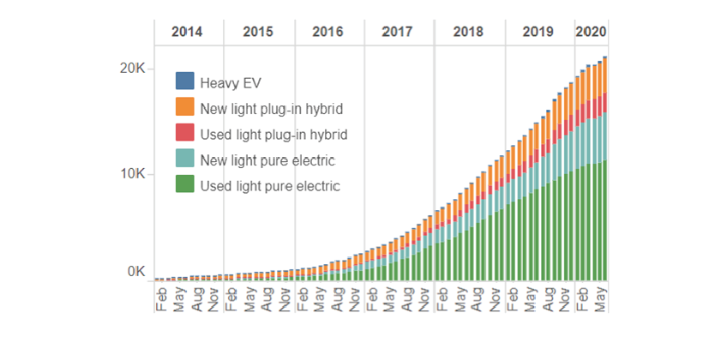
This policy has now given New Zealanders greater access to a wider range of affordable second-hand EV models than that which is presently available to Australian consumers.
As a result, New Zealand is leading Australia in the uptake of electric vehicle technology, at little cost to government or taxpayers in this neighbouring country – i.e. despite its smaller population, New Zealand has a larger number of EVs than Australia. A large proportion of these are imported second-hand vehicles (see Figure 26), many of them from Japan.

3.4. Ensuring that we are ‘ZEV-ready’
As part of both encouraging and preparing for the transition to ZEVs in Victoria, the Government is committed to expanding the network of public fast-charging stations across the state, working to improve access to home charging and giving consideration to potential future hydrogen refuelling needs.

3.4.1. Victoria has already begun to develop a network of public fast-charging stations across the state
Victoria is well on the way to developing the kind of infrastructure it will need to support the future mass adoption of electric vehicles. For example, while Tesla has been quick to build a network of ‘superchargers’ to cater for its own customers at various locations across the state, other commercial public charging stations have begun appearing in Victoria, as a foretaste of what will happen as we move from a mostly ‘early-adopter’ market to a more mainstream market for electric vehicles, and demand for public charging thus increases.
Ahead of this expected expansion of commercial charging in Victoria, and with the aim of building confidence among consumers and addressing perceptions of ‘range anxiety’, both local and state government have been active in laying the foundations of a network of charging stations.
At a state level, the Victorian Government is committing $19 million to expand the availability of charging across the state. This includes:
- charging infrastructure for Victorian Government (VicFleet), council and dedicated commercial fleet ZEV uptake.
- highly visible destination charging throughout regional Victoria
- support for emerging ZEV technology.
This comes on top of the ultra-rapid charging stations that have recently been delivered, with the support of the Victorian government and ARENA, at seven locations across regional Victoria and Melbourne. Capable of delivering 400 kilometres of range in just 15 minutes, this coordinated network of charging stations will support longer-distance electric vehicle journeys in Victoria, thereby building confidence in zero emissions technology.
Towards ‘Range Confidence’ - Establishing a network of ultra-rapid EV chargers in Victoria
The Victorian government has been getting Victoria ready for a strong uptake in ZEVs, making sure Victorians can recharge right across the state and along major highways. This has included contributing $3 million to support the establishment of a coordinated network of ultra-rapid 350kW chargers at seven sites in metropolitan and regional Victoria, including at Airport West, Ballarat, Euroa, Barnawartha North, Torquay, Moe and Horsham.
Multiple chargers have been installed at each site, all of which are now open for use by the public. Backed up by 100 per cent renewable energy, each charge-point can deliver around 400 kilometres of range in just 15 minutes, and at just a fraction of the cost of refuelling a petrol or diesel vehicle. In what has been described as a world first, the charging station at Euroa is also backed up by its own dedicated solar farm and associated battery storage.
Metropolitan and regional Victorians to have greater access to reliable charging
The Victorian Government is currently working to establish a coordinated network of 25kW and 50kW DC fast-charging stations across Victoria, including at key regional centres and tourist destinations. As a first step, the government has committed $644,000 toward the installation of 15 or more new charging stations in northern Victoria, including at Ouyen, Swan Hill, Kerang, Maryborough, Wedderburn and Echuca.
The government has also now committed a further $6 million toward the installation of charging stations in at least 50 locations across Victoria, with a focus on regional destination charging.
Together with the growing network of ultrafast highway chargers, these destination-based EV chargers will not only open up EV tourism in Victoria’s regions, but also promote uptake of electric vehicles across the state through stronger ‘range confidence’.

3.4.2. Victoria is working with other jurisdictions to investigate provisions that will facilitate ‘EV-readiness’ in new commercial and residential buildings from 2022
As the demand for electric vehicles grows as expected during this decade there will likely be growing demand also for charging infrastructure, and particularly Level 2 (7kW AC charging – see Table 3, page 62), in residential and commercial buildings. In larger buildings with multiple car-parking spaces the installation of a multiple charge points can also necessitate the installation, where it doesn’t already exist, of properly-rated cabling, multiple junction boxes and upgraded load management systems (depending on the number of car-spaces and car-parking levels a building has).
As incorporating this enabling infrastructure, including conduits and cable trays, at the time of construction can be considerably cheaper than retrofitting buildings later on, it makes sense to ‘future-proof’ new buildings, in anticipation of the need for multiple charging points.
The Victorian Government is participating in a national process currently being undertaken to review and update the energy efficiency provisions of the National Construction Code (NCC) for residential buildings. The NCC is published and maintained by the Australian Building Codes Board. It sets out the technical provisions for the design and construction of buildings and other structures throughout Australia, which are given legal effect by building regulatory legislation in each state and territory.
While the key focus of changes being considered for the 2022 version of the NCC are the energy efficiency provisions for residential buildings, the review will also seek to ensure all buildings can accommodate the future installation of on-site renewable energy equipment and electric vehicle charging. Subject to ratification, new provisions are expected to become operational in 2022. In the meantime, the government will consider opportunities for non-statutory measures and guidance to help future-proof buildings being designed and constructed prior to 2022.
Table 3. Guide to Electric Vehicle Charging
EV charger types | Level 1  AC | Level 2  AC/DC | Level 3  DC
Example | An electrical outlet | A wall charging unit | A high-powered DC fast-charger
Typical application | Home | Home, work, shopping centre and car park | Regional near highways,  motorways and key routes
Power | 1-2.4kW | 3.7-22kW | 50kW | 120kW | 350kW
Typical charge rate* | 7-15km/hr | 15-100km/hr | 60km/15 minutes | 290km/15 minutes | 400km/15 minutes
*Charge rate may vary depending on the charging station and the vehicle’s battery capacity.
Source: https://www.drivezero.com.au/charging/charging-guides/electric-car-charging-guide/

3.4.3. Consideration is also being given to how to promote EV-readiness in existing residential buildings
While the government is working with other jurisdictions to update the National Construction Code to ‘future-proof’ new buildings for electric vehicles, it is also working to promote EV-readiness in existing multi-unit dwellings. While many existing apartment car-parks will have some power outlets with shared metering for the residents’ convenience, most will have little provision for EV charging – i.e. in terms of:
- properly-rated cabling to enable the installation of one or more Level 2 AC 7kW charging points in particular car-spaces
- available conduits and cable-trays and, if needed, junction-boxes, to enable ready installation of shared cabling connecting the charging point to the central switchboard
- sufficient switchboard and / or sub-station capacity to support charging for multiple vehicles at the same time, particularly in the early evening when electricity demand generally reaches its peak.
To address this lack of EV-readiness, the government is, firstly, developing an online guide for apartment owners and body corporate committees to assist them in identifying and assessing options to enable EV charging in resident carparks. This could include strategies for optimising existing switchboard capacity, infrastructure options to increase such capacity and options for how to manage the cost of infrastructure upgrades on common property.
Secondly, the government will be looking to support the future-proofing of apartment buildings and commercial fleet facilities to reduce the establishment (base infrastructure) costs of installing electric vehicle charging, as well as support the installation of smart charging in individual homes.
Furthermore, the government is investing in incentives to address cost-barriers to the installation of electric vehicle charging in existing residential and commercial buildings, as well as exploring the role that rooftop solar, in combination with storage batteries, can play in managing peak demand and thereby reducing the net cost of supporting EV charging in existing residential buildings.

3.4.4. The Victorian Government will continue to work with other jurisdictions to investigate the need for, and feasibility of, hydrogen re-fuelling stations and other supporting infrastructure.
Whereas battery electric vehicles can be powered from the existing electricity grid, FCEVs require the installation of wholly new re-fuelling infrastructure capable of storing, and where needed, transporting compressed hydrogen to refuelling stations.
What shape and scale the development of hydrogen re-fuelling infrastructure in Victoria will take in the future will largely depend on the particular role that emerges for FCEVs within both the road transport and the broader transport sectors (which includes potential rail, maritime and aviation uses). The full extent of this role in road transport will largely depend, in turn, on the establishment and maintenance over time of cost-competitive and advantageous ‘use-cases’ for FCEV technology.
Opportunities currently being explored include the investigation uses for hydrogen currently being produced, such as at Altona in Victoria (see page 64). Viable uses being considered currently in the road transport sector include long-haul, heavy freight vehicles, and, potentially also, passenger buses. To support the former use-case, investigations are ongoing into the potential location of strategically-placed hydrogen re-fuelling stations along major national road freight corridors in Australia, including in Victoria.
Toyota Australia is establishing Victoria’s first hydrogen hub at Altona, Melbourne
Toyota Australia has built a $7.4 million Hydrogen Centre at the mobility company’s former site of car manufacturing at Altona in Melbourne’s west. As part of this project, existing manufacturing infrastructure has been repurposed into Victoria’s first integrated hydrogen site, complete with electrolyser, commercial grade hydrogen refuelling station and an education centre with live demonstrations.

3.5. Accelerating the electrification of road transport
Victoria is working to accelerate the adoption of ZEVs to ensure a timely transition to net-zero emissions by 2050
While some ZEV-readiness measures, such as the rollout of public charging infrastructure, have the potential to stimulate local demand for BEVs by addressing ‘range anxiety’ and thereby instilling ‘range confidence’ among consumers and prospective owners, the government is also taking a range of other actions to accelerate the adoption of ZEVs in Victoria.
A number of these actions, outlined below, form part of the Victorian Government’s Climate Change pledge process designed to drive emissions reductions.

Through its climate change pledges, the Victorian Government is taking action to drive the transition to a net-zero emissions future
Victoria’s Climate Change Act 2017 sets a legislated state target of net-zero emissions by 2050. The Act requires the setting of five yearly interim emissions reduction targets to ensure Victoria makes steady progress towards the long-term net-zero target.
The Act also requires development of emissions reduction pledges, which describe the actions government will take to reduce Victoria’s emissions. In 2019, the government invited input from Victorians following the release of Independent expert advice on interim targets to inform its decision on the first interim targets, for the five-year periods to 2025 and 2030.
The Government has announced that Victoria’s first interim target will be a 28-33 per cent reduction in emissions in 2025 compared to 2005, and that the second interim target will be a 45-50 per cent reduction in emissions in 2030.
A set of foundational policies has also been announced to help drive emissions reductions across all sectors, in line with the interim targets. These policies are based on the following five point plan:
- a clean energy economy
- innovation for the future
- resilient farms and forests
- climate smart businesses and communities, and
- a climate resilient Victoria.
The foundational policies are an important first step in charting the way to a low-emissions future. The Victorian Government will continue to develop additional policies to ensure the State achieves its interim targets and its long-term net-zero emissions goal. Detail on the current list of foundational policies (and associated actions) can be found at:
climatechange.vic.gov.au

3.5.1. Key actions to promote accelerated ZEV adoption
The following actions will send a clear signal to overseas manufacturers that Australia is a viable market for ZEVs, and thus encourage them to supply us with a greater range of models, thereby addressing the ‘chicken-and-egg’ situation currently constraining a shift to more mainstream adoption of ZEVs in Australia (see page 36).
Provide consumers with a $46 million package for upfront subsidies to purchase ZEVs and a further $10 million for Government and $5 million for commercial fleets | The price difference between ZEVs and ICEs is a key barrier to uptake that will reduce overtime as technology becomes more common and cheaper. In the meantime, the Victorian Government will offer subsidies to public, commercial and government vehicle buyers to help accelerate the uptake of ZEVs – making them more affordable for all.
Establishing a target of 50 per cent of new light vehicle sales to be zero emissions by 2030 | The transition of the light vehicle fleet in Victoria is expected to take over 25 years. Accelerating the uptake of ZEVs will be a vital part of reaching our net-zero emission commitments. The Victorian Government has set a target of 50 per cent of new light vehicle sales to be zero emission by 2030.
Establishing an expert panel to recommend policies, enabling investments and timelines to support the achievement of this 2030 target | An expert panel will advise Government on the most effective ways to reach our goal of 50 per cent of new light vehicle sales to be zero emissions by 2030.
Purchase 400 battery electric vehicles for the Victorian Government fleet and undertake a business case to further accelerate the uptake of ZEVs in the Government fleet | The Victorian Government is showing leadership in the adoption of ZEVs. These purchases will encourage the introduction of models into the Victorian market and increase options in the second-hand market. This has the potential to increase the availability of more affordable ZEV options to Victorian consumers.
$20 million for a ZEV bus trial to inform the commitment that all buses purchased for use on public transport services will be ZEVs from 2025 | A trial of these buses will explore the merits of ZEVs, operational capability and supporting infrastructure requirements for a future zero-emissions fleet. The trial will ensure that procurement of zero emissions buses from 2025 are appropriate and continue to deliver a quality service.
Promoting greater awareness of parallel importing opportunities | Recent Commonwealth government legislation has expanded opportunities for the parallel importing of low and zero emissions vehicles from overseas markets. This has the potential to substantially increase availability of more affordable second-hand ZEVs in Australia (as it has in New Zealand), enabling more consumers to take advantage of the lower ZEV running costs.
Improving vehicle emissions standards | Vehicles imported today can be on the road for up to 25 years. That means vehicle emissions standards from today’s vehicles are in effect locked in over the vehicle’s life. Victoria will work with other States and Territories to look at options for developing a harmonised approach to vehicle emissions standards, given the lack of action at the national level.
Supporting and promoting evidence-based tools that enable fleet operators, and consumers more broadly, to identify savings in terms of running costs from using ZEVs | Web-based resources like ‘Charge Together Fleets’ total cost of ownership tool have an important role to play in enabling consumers to determine where the use of ZEVs are likely to result in ‘total cost of ownership’ savings, given their own particular circumstances.
Investigating the potential role for domestic electric vehicle conversions in the availability of affordable ZEVs | Provided that the cost of the conversion is competitive with parallel imported vehicles, this has the potential to accelerate uptake particularly among lower-income and multi-vehicle households.
Investigating the potential for Hydrogen in Transport | The Victorian Government is exploring opportunities to support the development of a domestic hydrogen industry through the Renewable Hydrogen Industry Development Plan.

3.6. Managing the integration of eVs into our energy system
The prospective rise of BEVs, while challenging for the grid, also presents an opportunity to build a closer nexus between the transport and energy sectors in which power supply can be adequately maintained and demand better managed. In order to realise this optimised future for transport and energy integration, the Victorian Government is working with a range of stakeholders and other jurisdictions to implement reforms that can open up new ways to manage demand for electricity at charging locations.

3.6.1. Victoria is working with other jurisdictions in Australia to promote integration and optimise energy network performance
There are opportunities to utilise BEV integration to build a more resilient electricity grid and provide for more efficient investment to assist the transition of the electricity network (see overleaf, Table 4). The future uptake of EVs provides an important opportunity to ensure effective integration and avoid locking in higher infrastructure costs that would otherwise be recovered from all consumers over coming decades. The Victorian government is working with industry and other jurisdictions to address these challenges ahead of a wider uptake of EVs.
Table 4. Optimising integration of BEVs into Victoria’s energy network
Issues | Challenges | Opportunities
Visibility of home charging | Lack of visibility of home charging is making it harder for Distribution Network Service Providers to efficiently manage the network. | Improved visibility will make it easier for Distribution Network Service Providers to increase network utilisation and better forecast peak demand load profiles, minimising stress on the network and the risk of outages.
Peak demand management | Allowing BEVs to be charged at times of peak demand in the electricity network could necessitate costly local capacity upgrades. | Managed BEV charging will moderate new peak demand ensuring quality, capacity and reliability of supply are maintained. This will help avoid costly network upgrades, the cost of which flow on to consumers.
BEV adoption forecasting | Forecasting the pace of EV uptake and where EV charging may occur at scale is difficult in the early stages of adoption. | More reliable BEV forecasting will result in better alignment between localised demand and targeted network upgrades.
New connection costs | Lack of clarity about local network capacity, and associated connection costs, can inhibit EV charging companies from investing in new public charging stations | Transparent distribution network capacity information will assist BEV public charging companies to identify optimal charging stations locations, reducing costs to the end user.
EV Grid integration standards | There are currently no agreed standards in Australia to guide and ensure consistency in regard to EV charging, communications and interoperability. | The adoption of clear and agreed National EV grid integration standards will provide greater certainty and interoperability for manufacturers, installers, investors and consumers.

Distributed Energy Integration Program (DEIP)
Victoria is participating in the national Distributed Energy Integration Program (DEIP), a collaborative government and industry forum whose key objective is to optimise the integration of distributed energy resources into our energy networks, including the sale of locally-generated power back into the grid.
Established in 2018, the Distributed Energy Integration Program (DEIP) is a collaboration of government agencies, market authorities, industry and consumer associations aimed at maximising the value of customers’ distributed energy resources (DER) for all energy users. It is organised around a number of key focus areas whose overall goal is to promote and facilitate the development of a functioning DER market responsive to the needs and preferences of consumers, including the identification of appropriate regulatory settings and development of technical standards to promote system interoperability.
An EV Grid Integration Working Group has been established as part of this DEIP process, whose goal is to facilitate the efficient integration of EVs into existing networks and markets. This working group is currently developing recommended responses to a range of institutional and market barriers to optimal integration of electric vehicles into the energy grid.

The Equipment Energy Efficiency (E3) program
Mandating the use of smart-charging technology at all charge points (Level 2 and above)
The Equipment Energy Efficiency (E3) program is a cross jurisdictional program through which the Australian Government, states and territories and the New Zealand Government collaborate to deliver a single, integrated program on energy efficiency standards and energy labelling for equipment and appliances. As part of this program, the Council of Australian Governments agreed in November 2019 to require, by July 2026, the use of only smart-charging technology in Australia for home and other charging. Investigations are currently being undertaken to identify an appropriate international standard to apply in this case, with recommendations to be made by mid-2022.

Electricity Distribution Price Review - Tariff Reform
The Victorian Government has provided a submission into the Electricity Distribution Price Review (EDPR) supporting the introduction of time of use (ToU) network tariffs for customers with an EV charger at their premises and is currently in discussion with electricity distribution companies about the role that differential tariffs could play in helping to manage new demands on the electricity network.
Under the National Electricity Rules, the Australian Energy Regulator conducts a pricing review for electricity distribution every five years. Through the EDPR process, the regulator determines the level of investment and prices the distribution network businesses can charge for safe, reliable electricity supply of electricity to their customers. This process is currently underway for the 2021 to 2026 regulatory period.
From 1 July 2021, Victorian distribution businesses are proposing to introduce ToU network tariffs for certain residential customers, including for EV owners. The Victorian Government supports assignment of ToU tariffs to owners of EV chargers to ensure that effective price signals are in place to avoid locking in higher infrastructure costs that would be recovered from all consumers over the coming decades if there was no incentive in place to encourage charging outside the peak period. Providing such price signals and incentives for customers to charge outside peak demand periods can benefit both EV owners who take advantage of cheaper rates of electricity to charge their EV during off-peak periods and all electricity consumers by avoiding additional demand on the network during peak periods and moderating growth in peak demand over time.

3.6.2. Exploring the potential of distributed energy resources
The increasing popularity and potential of rooftop solar and other forms of localised generation, as well as residential battery systems, has the potential to optimise the impact of electric vehicles on our energy networks.
The rise of household solar photovoltaic systems and home storage batteries, otherwise known as ‘distributed energy resources’ (see below), represent a fundamental change to how our energy networks have previously operated. In this emerging model, power no longer simply flows in one direction from large-scale generation through a transmission network to consumers. Rather, consumers of electricity who have rooftop solar, and / or home battery storage devices or electric vehicles equipped with V2G technology, can also act as generators who sell their excess power back into the grid when there is a need for it.
Figure 27. Shift from a centralised to a distributed energy network
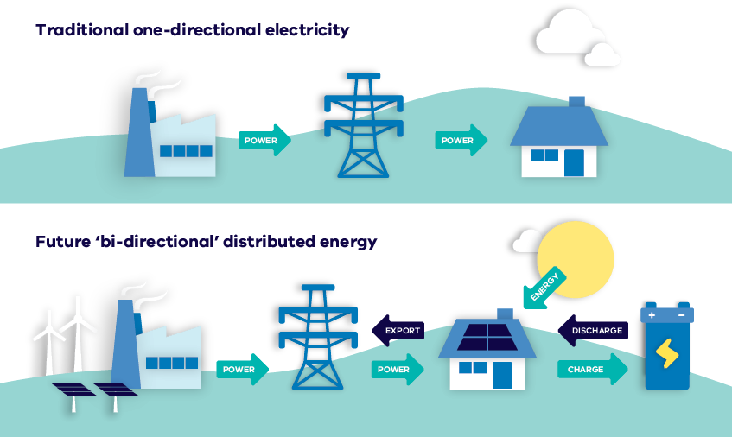
In this way, in the future, householders who may have either or both rooftop solar, home batteries or V2G-enabled BEVs can work individually, or together with third-party providers to create so-called ‘virtual power plants’ that can provide dispatchable power when needed – e.g. including for the charging of electric vehicles. It is forecast that such distributed electricity generation could deliver almost half of all electricity supplied by 2050, with investment in distributed energy resources expected to reduce estimated network expansion costs by nearly 60 per cent. Preparing now for how best to integrate electric vehicles into the energy system will not only avoid problems, but could actually result in a more efficient and better performing grid.

3.6.3. Exploring grid-assistive emerging technologies such as vehicle-to-grid (V2G)
The Victorian Government is a participant in a trial being led by the Australian National University (ANU) into vehicle-to-grid technologies - knowledge-sharing and lessons from this study will inform future demonstration projects and facilitate the potential deployment of this technology in Victoria later in the 2020s.
Vehicle-to-grid technology, which enables power to flow back from vehicle batteries into the grid, has the potential to provide an immediate back-up supply of power to the broader grid when needed, while at the same time generating income for participating BEV owners. This has the potential to be done at significant scale.
However, the technology is still in development, with up to 50 trials being undertaken across the globe to test its market-readiness. In 2020 the ANU launched its ground-breaking ‘Realising Electric Vehicle-to-Grid Services’ (REVS) project, which aims to demonstrate the feasibility of vehicle-to-grid services in Australia.
The Victorian Government, through the Department of Environment, Energy, Land, Water and Planning, is participating in a Vehicle-to-Grid Knowledge Sharing Group that aims to leverage insights from the REVS trial and other V2G initiatives in Australia. These insights will help inform future demonstration projects to facilitate the eventual market rollout of this important technology, expected to occur later this decade.

The ground-breaking ‘Realising Electric Vehicle-to-Grid Services’ (REVS) project
A team at the Australian National University is currently leading a $6.26 million, two-year trial of 50 Nissan Leaf electric vehicles to test how they can act as mobile batteries for the grid. The biggest trial in Australia to-date of vehicle-to-grid technology, and one of the biggest in the world, the REVS project could potentially lead the way to the creation of an EV fleet that could deliver five times the storage of Snowy Hydro 2.0.
In the trial, EVs will be used for normal transport fleet operations around the ACT during business hours. However, they will be plugged into the network when not being used and therefore available up to 70 per cent of the time to provide support to the electricity grid.
The cars will use bi-directional chargers, allowing them to return energy to the grid when network demand is high, as well as maintain energy system stability. The bi-directional flow of energy refers to the ability for an electric vehicle to both draw energy from the grid and inject it back when needed (see Figure 27).

3.7. Exploring opportunities for transitioning Victorian Industry and its workforce
New and emerging technologies are reshaping how we live, work and travel, with one particularly disruptive transformation being the rise of ZEVs and electrification of road transport. The Victorian Government is taking action to address the challenges and take advantage of the emerging economic opportunities associated with this transformation, and the broader transition to net-zero emissions.

3.7.1. The Victorian Government is working on an industry development and transition plan for ZEVs
The Government is working on an industry development and transition plan for ZEVs, as part of its broader plan to explore new opportunities relating to emerging transport technologies, including those related to Connected and Automated Vehicles. The key objectives of this plan include the boosting of Victorian manufacturers’ capabilities to export and secure global supply chain opportunities related to electric vehicles and batteries, as well as prioritising attraction of advanced manufacturing investment in Victoria that builds on the State’s existing strengths in automotive engineering.

3.7.2. Supporting a circular economy in regard to ZEVs
Recycling Victoria: A new economy is the Victorian Government’s 10-year circular economy policy and action plan. Through this policy, the Government will invest over $300 million to transform our recycling sector to deliver a recycling system Victorians can rely on. More than that, it will drive fundamental change in our economy to reduce waste and make more productive use of our resources.
In a circular economy, people minimise waste and make the most of resources. Shifting to a more circular economy will grow the economy, increase jobs and reduce impacts on the environment.
Lithium batteries have become the main source of power for EVs, as well as mobile electronics and large storage batteries in homes and industry. As the chart below indicates, global consumption of lithium is expected to grow from 184,000 tonnes in 2015 to 534,000 tonnes in 2025, chiefly through the rapid adoption of electric vehicles, e-bikes and energy storage systems.
Figure 28. Projected growth in global demand for lithium carbonate 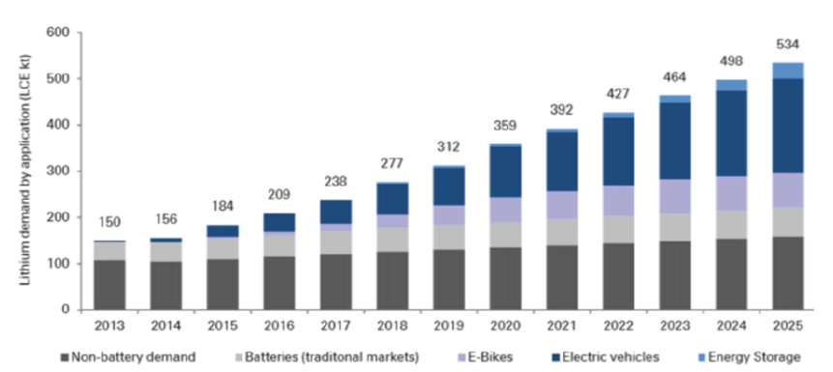
The Government has provided support to Victorian companies to increase the local recycling of batteries, including the establishment of Australia’s first facility for recycling lithium. This shows how opportunities can be developed in Australia’s resource recovery sector, to create jobs and capture valuable chemicals, copper, steel, nickel, lithium, other metals and graphene so they can be used in new batteries. Only three per cent of Australian batteries are currently recovered, the lowest rate in the OECD.
Recycling Victoria includes a $10 million dollar grants program for business support in a circular economy, and other financial opportunities for recycling infrastructure and innovative manufacturing. More information on Recycling Victoria can be found at www.vic.gov.au/recycling.

3.7.3. Identifying industry development pathways for emerging technologies, including investigating the potential for Hydrogen in Transport
Hydrogen has the potential to decarbonise energy use across our economy in a variety of ways, from hydrogen fuel cell vehicles to blending in the reticulated natural gas distribution network, increasing the stability of our electricity supply to greening industrial processes.
As such, the Victorian Government is investigating the role that hydrogen could play both in the energy and transport sectors, and what opportunities this might bring for Victorian industry. Moreover, it is putting in place a broad range of programs and initiatives to support emerging industries and position our state at the forefront of the transition both to clean energy and net-zero emissions transport.
3.7.3.1. Developing a Victorian Renewable Hydrogen Industry
The Renewable Hydrogen Industry Development Plan for Victoria’s hydrogen sector sets out foundations, connect the economy and lead the way to a thriving renewable hydrogen industry.
The Plan identifies a pathway to unlocking renewable hydrogen’s potential for the state, including opportunities for integration of renewable hydrogen into Victoria’s heavy transport and freight sectors, drawing out the potential for fuel cell vehicles and mapping the infrastructure needs for this technology.
A sustainable supply of renewable hydrogen and well-planned enabling infrastructure for transport applications, including refuelling stations, can establish a viable hydrogen FCEV market in Victoria. This could be a path to economic growth and new jobs for Victorian businesses to manufacture both vehicles and supporting infrastructure, as well as increase opportunities from the associated supply chain and skilled workforce sector. The Industry Development Plan supports opportunities to grow the hydrogen sector in Victoria across the supply chain, including recognising the role FCEVs could play in both decarbonisation of the transport sector and economic growth for the state.

The Renewable Hydrogen Industry Development Plan
The Victorian Government is investing in emerging energy technologies to ensure Victoria is at the forefront of the clean energy transition, and renewable hydrogen could be the next game-changer.
A renewable hydrogen economy can activate options for decarbonising our gas, freight, transport and industry sectors, supporting more renewable energy in our electricity system, and taking our renewable energy to the rest of the world.
The Renewable Hydrogen Industry Development Plan sets out a blueprint for how the Victorian Government supports the growth of high potential hydrogen industry sectors and sets out how Victoria can create a thriving renewable hydrogen economy through three focus areas:
- Foundation for renewable hydrogen, addressing critical aspects of hydrogen technology such as safety, regulations, education, skills and workforce, planning, and research and development
- Connecting the sector by leveraging Victoria’s competitive advantages, building scale and taking advantage of sector coupling opportunities;
- Leading the way through investment attraction and building community confidence.
The emergence of a new hydrogen industry is ideally timed. Hydrogen could play a critical role in reshaping Victoria’s economy as it rebuilds following the COVID-19 pandemic.
Renewable hydrogen technology could also position Victoria to capitalise on our vast energy resources, provide low cost energy options in the long term and create opportunities for new jobs and economic growth.
More information on the Renewable Hydrogen Industry Development Plan can be found at:
https://www.energy.vic.gov.au/renewable-hydrogen/industry-development-plan
3.7.3.2. Strengthening links between industry and research, design and engineering capabilities to facilitate uptake of transformative technologies
The government is continuing to investigate the future role of emerging technologies that have the potential to fundamentally reshape road transport. This includes (1) the potential role and development of so-called ‘hydrogen highways’ to support the use of long-haul FCEVs, as well as (2) the future prospects for the deployment of ‘wireless’ electric vehicle charging.
This latter technology, currently being trialled in various locations across the world, including in Melbourne by Australian company Lumen, could enable electric vehicles to be charged without the need for physically plugging into a charger. This could include not only stationary applications (e.g. where the car parks over a base-plate that delivers the charge inductively), but also dynamic charging, where an electric vehicle can receive charge while moving along a specially-equipped section of road (see Figure 29, overleaf). Charging vehicles both wirelessly and dynamically, if feasible at scale, has the potential not only to lessen the need for charging stations, but also to enable cheaper electric vehicles with smaller batteries, which could, in turn, accelerate uptake further.
Figure 29. Potential future applications for wireless EV charging
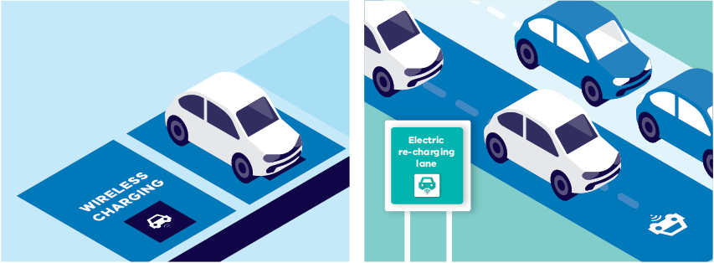

3.7.4. Supporting Victoria’s workforce through the transition to zero emissions road transport
For this reason, the Victorian Government will work with the newly established Clean Economy Skills and Jobs Taskforce, and other skills and training engagement mechanisms such as the Victorian Skills Commissioner, to identify and prepare for future ZEV-related skills needs, while also giving consideration to the need for broader workforce transition programs. This work will be reflected in the Victorian Government Clean Economy Workforce Development Strategy to be developed this year.
Initiatives for skills and training could include the development of Victorian accredited courses and skill-sets, as well as reskilling opportunities for workers in transitioning industries. There may also be opportunities for Victoria’s TAFE and training system to partner with industry to deliver training and to develop innovative training models to meet the needs of industry. Major manufacturers of electric vehicles, such as Nissan, have already begun to undertake steps towards creating training facilities in Victoria.

Melbourne is emerging as a hub for EV technology training
Nissan Australia has opened its new national headquarters and training centre in Melbourne.
Nissan was the first global automaker to introduce a battery electric vehicle to the Australian market, with the Leaf. Now, with the assistance of the Victorian Government, Nissan Australia has established its new national headquarters and training centre at Mulgrave in Melbourne’s south-east. Focusing on Nissan’s new and emerging electric vehicle range, this new facility will be used to train dealers, engineers and technicians from Nissan sites around Australia and New Zealand, as well as to extend Nissan Australia’s capabilities in electric vehicle component manufacture and maintenance.
Nissan’s decision to locate its national headquarters and training centre in Victoria will bring with it 60 new jobs on top of the existing 400 jobs relocated from Nissan’s former base at Dandenong South.

4. The pathway to 2050

4.1. What does success look like in the 2020s?
The transition to zero emissions technology in our road transport sector will likely take over 25 years. A critical first step, as outlined in this, Victoria’s first ZEV Roadmap, is to address the range of barriers to the development, in Victoria, of a mainstream market for ZEVs, and for Victoria to thus more fully participate in a growing global shift away from ICE technology.
It is expected that the current ‘vicious cycle’ or ‘chicken-and-egg’ situation in Victoria, and Australia, of constrained supply and repressed demand, will give way this decade to a ‘virtuous cycle’ of increasing choice and competition, and expansion of both demand and supply, as illustrated in Figure 30, below.
Figure 30. Promoting a stronger market for ZEV in Victoria - broad policy directions for the 2020s
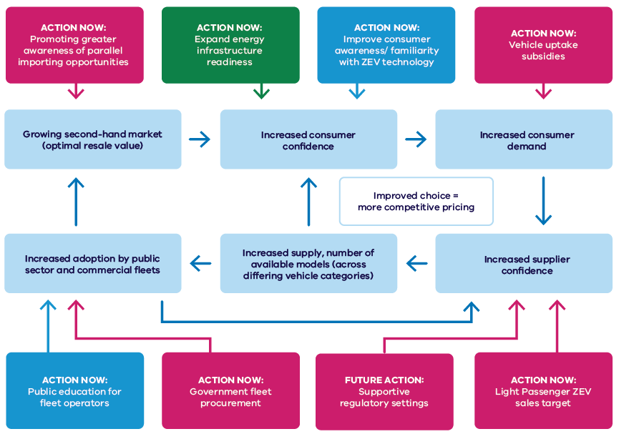
Further measures to accelerate the uptake of ZEVs in coming years will be considered by the government's expert advisory panel.
Strengthening the transition to ZEV technology this decade will bring with it, moreover, a range of benefits beyond the impact on emissions, including economic opportunities for industry and workforce development, as illustrated in Figure 31, below.
Figure 31. Promoting ZEV-related industry and workforce development
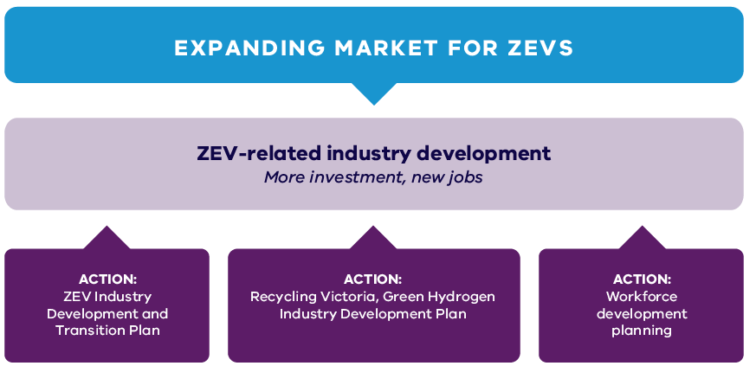

4.2. Towards 2050 - Decarbonising road transport
Achieving our 2050 net zero target will require ongoing analysis, as well as a continued whole-of-Victorian Government approach, involving both strategic and adaptable policy development and planning.
Achieving 50 per cent of new sales for light passenger ZEVs by 2030 will be a major milestone along the road to net-zero emissions in Victoria.
The longer-term challenge is to plan for and complete the transition to ZEV technology by 2050, while also making the transition in the energy sector to renewable and net-zero emission forms of energy generation. Along the way there will be many opportunities, challenges, uncertainties, and factors on which the Government may have limited influence, including the pace and direction of technological change and global market developments that could reshape the nature of transport itself. For example, the rise of connected and automated vehicles (CAV) and a potential shift toward on-demand shared mobility could hasten the retirement of existing ICEV stock as consumers embrace the improved functionality and safety of more automated vehicles. Exactly when this might be expected to occur, however, and whether it will occur at all, cannot yet be determined with any certainty.
It is currently unclear as to how soon and how quickly major global automakers could pivot to becoming mostly ZEV manufacturers, and therefore start reducing the availability to market of ICEVs. Volvo is already aiming for 50 per cent EV sales by 2025 and being a 100 per cent EV company by 2030.
It is also possible that governments in major overseas markets could themselves seek to further hasten the transition to ZEV technology; for example, the United Kingdom and New Zealand have already brought forward to 2030 their target-year for banning the sale of light ICEVs, joining other markets like Sweden, the Netherlands, India and California. Such developments would have substantial flow-on implications for Australia.
On account of these and other uncertainties, we will need to ensure that our planning for ZEVs is strategic, integrated and adaptive. We need to continue to work with other jurisdictions, including the Commonwealth, to pursue our common interests and promote national action where necessary.
This will include analysis to determine appropriate time frames for future milestones for the Reducing Emissions and Approaching Zero phases - i.e. involving key measures such as:
- percentage of new sales for various vehicle categories, overall percentage of vehicle stock, etc.
- emissions-intensity of road transport - i.e. net lifecycle emissions for transport, as represented by measures such as e-CO₂ grams per vehicle and per passenger kilometre.
By such measures we will be able to chart – through these key onward milestones – a pathway to net-zero emissions in road transport by 2050, one that also supports the achievement of Victoria’s interim emissions targets.

4.3. Next steps
The ZEV Roadmap is not a standalone exercise but the start of an ongoing public conversation, and coordinated policy development and planning process. This process includes the appointment of an expert panel to consider and recommend policies, enabling investments and timelines to support the achievement of the 2030 sales target for ZEVs.
The journey to 2030, and to the ultimate goal of a fully decarbonised road transport sector by 2050, will involve significant challenges but also enormous opportunities for Victoria. These include social, economic, and environmental benefits beyond just emissions reduction, including industry development, new jobs, lower transport costs, improved air quality and enhanced community well-being.
The expert panel is expected to report on its findings and recommendations later this year. In the meantime, the Government will continue, in consultation with industry and the community, to implement actions detailed in the Roadmap – to prepare for and promote the uptake of ZEV technology. This work will proceed alongside the ongoing sector pledge process, with the goal of both being to forge a pathway to net-zero emissions by 2050.
Focus areas for further exploration as part of this ongoing, coordinated policy development process include:
• continuing, as part of our public education effort, to explore opportunities to raise community and business awareness about ZEV options and benefits, including working closely with metropolitan and regionally-based Victorian Greenhouse Alliances
- continuing, ahead of the achievement of price-parity for ZEVs, to explore opportunities to promote improved access to ZEV technology for all Victorians, including alternatives to individual household purchase
- continuing to explore opportunities to improve access to public charging for all Victorians
- working with industry:
  - to support the ongoing development of a shared evidence base on ZEV transition for fleets and improve awareness among fleet owners and managers
  - to support demonstration events targeted at commercial freight providers
  - to develop, as needed, TAFE certified courses for ZEV maintenance, battery repair and servicing, emergency services, etc.
- supporting the transition plan to net-zero emissions in the freight and logistics sector in Victoria
- building on the transition to hybrids by the commercial passenger vehicle industry, by supporting the transition to ZEVs
- ensuring that the outcomes of ZEV bus trials inform the effective roll out of zero emissions technology across the bus network in Victoria
- continuing to monitor and identify opportunities for emerging ZEV technologies, including exploring potential opportunities for Vehicle-to-Grid applications arising from the REVs trial
- exploring the need for enhanced consumer protections in relation to ZEVs
- exploring opportunities to collaborate with other jurisdictions in Australia on issues of common concern in regard to ZEVs
- continuing to monitor and evaluate the effectiveness locally, and internationally, of policy actions in regard to ZEVs.
More information on Victoria’s ZEV Roadmap can be found at: https://www.energy.vic.gov.au/renewable-energy/zero-emissions-vehicles
If you would like to know more or make any comments in regard to Victoria’s transition to zero emissions vehicles, please email: zev@delwp.vic.gov.au

Glossary
Terms | Explanation
AC | Alternating current. The electricity grid delivers AC, but EVs charge their batteries with DC. For AC charging infrastructure, a battery needs to convert AC power to DC using its onboard charger, which slows down the charging process.
BEV | Battery electric vehicle – sometimes known as a ‘pure’ EV
CAV | Connected and automated (i.e. self-driving) vehicle
DC | Direct current. EV batteries are DC. DC charging infrastructure allows for a direct connection and communication between the car battery and chargers, enabling faster charging and ‘smart-charging’ where the EV can communicate to the charger how much is needed to charge its battery.
DNSP | Distribution network service provider
EV | Electric vehicle (includes both BEVs and PHEVs)
FCEV | Hydrogen fuel cell electric vehicle
GHG | Greenhouse gas
Hybrid | A motor vehicle incorporating both an internal combustion engine and a battery to power propulsion, but without a need to ‘plug-in’ to an external electrical power source (e.g. an EV charger)
ICEV | Internal combustion engine vehicle
Induction | A method by which electric vehicles can be powered wirelessly – i.e. without the need for charging cables and connectors
kW | Kilowatt. A unit of electric power
Lifecycle emissions | These are the GHG emissions produced over the course of the vehicle’s lifetime (including emissions associated with manufacture, operation, fuel sources and ultimate disposal)
Lifetime costs | The combined costs of a vehicle, including upfront price, operation (including energy and maintenance) and depreciation (the loss in value post-purchase).
OECD | Organisation for Economic Cooperation and Development
PHEV | Plug-in hybrid electric vehicle – i.e. a vehicle with an electric battery-powered drivetrain, but also a small petrol engine (range extender).
Tailpipe emissions | The emissions produced by a motor vehicle in operation, which can include greenhouse gas as well as particulate emissions
TCO | Total cost of ownership – i.e. including upfront price and operating costs
VEU | Victorian Energy Upgrades Program
V2G | Vehicle-to-Grid technology, which enables electric vehicle batteries to be used as resource to stabilise and feed back energy into the electricity grid.
ZEV | Zero emissions vehicle – i.e. those vehicles which do not use petroleum fuels, and therefore do not emit greenhouse gas (GHG) emissions while operating. For the purposes of this Roadmap we will be defining ZEVs to mean only BEVs (which have no tailpipe) and hydrogen FCEVs (which produce only water as a by-product).
ZEV-ready | For the purposes of this roadmap ZEV-readiness is defined as the absence or at least minimisation of technical, informational, regulatory or other barriers that might work to constrain the uptake of ZEV technologies.

Endnotes

Victorian Greenhouse Gas Emissions Report 2019, p. 20
Australian Bureau of Statistics, Motor Vehicle Census (for 31 January 2020), https://www.abs.gov.au/ausstats/abs@.nsf/mf/9309.0; https://www.abs.gov.au/ausstats/abs@.nsf/mf/9208.0
Austroads (2020), Issues Paper: Decarbonisation of Road Transport Network Operations in Australia and New Zealand, p. 16.
AIHW (Australian institute of Health and Welfare) (2016), Australian burden of disease study: impact and causes of illness and death in Australia 2011, AIHW, Canberra. https://soe.environment.gov.au/theme/ambient-air-quality/topic/2016/health-impacts-air-pollution
Truck Industry Council – Budget Submission to the Commonwealth 2019/20.
Hugh Forehead (2020), ‘ Air quality near busy Australian roads up to 10 times worse than official figures’, The Conversation, 30 April 2020, https://theconversation.com/air-quality-near-busy-australian-roads-up-to-10-times-worse-than-official-figures-137227
Infrastructure Victoria, Advice on Automated and Zero Emissions Vehicles, October 2018, p. 108.
European Environment Agency, ‘Road Traffic remains the biggest source of noise pollution in Europe’, Published 24 Apr 2017 (Last modified 10 Dec 2019), https://www.eea.europa.eu/highlights/road-traffic-remains-biggest-source; Australian Academy of Science, ‘Health effects of environmental noise pollution’ (Last updated 21-11-2017), https://www.science.org.au/curious/earth-environment/health-effects-environmental-noise-pollution
Jaser Jolly, ‘ Electric cars ‘as cheap to manufacture’ as regular models by 2024’, The Guardian Online, 22 October 2020, https://www.theguardian.com/environment/2020/oct/21/electric-cars-as-cheap-to-manufacture-as-regular-models-by-2024; Bloomberg New Energy Finance, ‘Batter Pack Prices Fall As Market Ramps Up With Market Average At $156/kWh In 2019’, 3 December 2019, https://about.bnef.com/blog/better-pack-prices-fall-as-market-ramps-up-with-market-average-at-156-kwh-in-2019/; Sophie Vorrath, ‘What the “Tesla effect” means for Australian battery storage prices’, One Step Off the Grid, 2 November 2016, https://onestepoffthegrid.com.au/tesla-effect-means-australian-battery-storage-prices/
IEA Global EV Outlook, 2020: Entering the decade of electric drive?, p. 11.
Mark Vaughn, ‘Fuel Cells and the Mirai: Toyota Explains Its Vision for a Hydrogen Future‘, Autoweek, 27 December 2019, https://www.autoweek.com/news/green-cars/a30289241/fuel-cells-and-the-mirai-toyota-explains-its-vision-for-a-hydrogen-future/
Mark Kane, ‘Efficiency Compared: Battery-Electric 73%, Hydrogen 22%, ICE 13%’, Inside EVs, 2 October 2017, https://insideevs.com/news/332584/efficiency-compared-battery-electric-73-hydrogen-22-ice-13/
Delloite LLP, Battery Electric Vehicles: New Market, New Entrants, New Challenges, https://www2.deloitte.com/content/dam/Deloitte/uk/Documents/manufacturing/deloitte-uk-battery-electric-vehicles.pdf
Bloomberg New Energy Finance, ‘Electric Cars to Reach Price Parity by 2025’, 23 June 2017, https://about.bnef.com/blog/electric-cars-reach-price-parity-2025/; FleetNews, ‘Deloitte predicts electric vehicle price parity by 2024’, 22 January 2019, https://www.fleetnews.co.uk/news/environment/2019/01/21/deloitte-predicts-electric-vehicle-price-parity-by-2024
Bridie Schmidt, ‘Tesla claims 80% of Australian market as electric vehicles near 18,000 mark’, The Driven, 6 March 2020, https://thedriven.io/2020/03/06/tesla-claims-80-of-australian-market-as-electric-vehicles-hit-8000-mark/
Electric Vehicle Council, State of Electric Vehicles 2019 Report, p. 10.
Fleet Auto News, ‘Linfox trial SEA Electric truck for online deliveries‘, 11 April 2019, https://fleetautonews.com.au/linfox-trial-sea-electric-truck-for-online-deliveries/
Budget Direct, ‘Electric Car Sales 2020’, June 2020, https://www.budgetdirect.com.au/car-insurance/research/electric-car-sales-australia.html
Driving Insights, ‘New Zealand heads towards carbon zero – but what about Australia’ https://drivinginsights.com.au/fleet-management/carbon-zero-nz-vs-aus/
Gail Broadbent, Daniella Drozdrewski, and Graciella Metternicht (2017), ‘Electric Vehicle Adoption: An analysis of best practice and pitfalls of policy-making from experiences in Europe and the US’, Submission to the Australian Senate Select Committee on Electric Vehicles Inquiry into the use and manufacture of electric vehicles in Australia.
Electric Vehicle Council (2019), State of EVs in Australia 2019, p. 25.
Nielsen Australia, Caught in the Slow Lane: Australians’ Adoption of Electric Vehicles, 2019 https://www.nielsen.com/wp-content/uploads/sites/3/2019/10/nielsen-australia-adoption-electric-vehicles-caught-in-the-slow-lane-report.pdf
Patricia Lavieri, Electric Vehicle Charging: A review of consumer preferences and usage patterns (report prepared for the Department of Environment, Land, Water and Planning), 2020, p. 11
Electric Vehicle Council, State of Electric Vehicles 2020, p. 20.
Royal Automobile Club of Victoria, ‘RACV invests in ultra-rapid EV charging network’, Royal Auto, 23 October 2018, https://www.racv.com.au/royalauto/moving/news-information/racv-chargefox-EV-charging-network.html
Broadbent, et al., p. 3.
Sophie Vorrath, ‘Australians aren’t buying electric vehicles: three charts illustrate why’, Renew Economy, 15 June 2017, https://reneweconomy.com.au/australians-arent-buying-electric-cars-three-charts-illustrate-why-78101/
Electric Vehicle Council (2020), State of Electric Vehicles 2020, p. 15.
Infrastructure Victoria, Advice on Automated and Zero Emissions Vehicles, October 2018, p. 111.
KPMG (2018), Electric Vehicles: Is the Energy System Ready?, p. 4: “The investment challenge will be substantial. We estimate that additional generation capacity to meet demand for electric vehicles in an incentivised charging scenario, could be 12,669 MW, or 120% of the existing installed capacity of the Victorian system. This increases to 15,513 MW in a non-incentivised scenario.”
Ikea Australia Drives the Switch to Electric Vehicles for Home Delivery”, Unwrap, 23 July 2019, https://www.unwraplfra.com.au/ikea-australia-drives-the-switch-to-electric-vehicles-for-home-delivery/
Australian Logistics Council (2014), The Economic Significance of the Australian Logistics Industry, p. ii.
Australian Electric Vehicle Association, Submission to the Productivity Commission discussion paper on the 5 year productivity review, November 2016, p. 1.
Hydrogen Council, Path to Hydrogen Competitiveness: a cost perspective, 20 January 2020.
Charlotte Argue, ‘What can 6,000 electric vehicles tell us about EV battery health?’, Geotab.com, 8 July 2020, https://www.geotab.com/blog/ev-battery-health/; Bill Roberson, ‘The Clock Is Ticking On Electric Car Batteries - And How Long They Will Last’, Forbes, 30 September 2019, https://www.forbes.com/sites/billroberson/2019/09/30/the-clock-is-ticking-on-electric-car-batteriesand-how-long-they-will-last/#1c730be221d9
Ibid
Evenergi (2020), Electric heavy vehicles for profit and the Environment, p. 4.
United States Office of Energy Efficiency & Renewable Energy, ‘Electric Car Safety, Maintenance, and Battery Life’, Accessed on 15 October 2020, https://www.energy.gov/eere/electricvehicles/electric-car-safety-maintenance-and-battery-life
American Automobile Association, Your driving costs: How much are you really paying to drive?, 2017 Edition
American Automobile Association, Your driving costs: How much are you really paying to drive?, 2017 Edition
L. Canals Casals, et al. (2019), ‘Second life batteries lifespan: Rest of useful life and environmental analysis’, Journal of Environmental Management, Vol. 232, February 2019, pp. 354-363.
Mike Costello, ‘Samsung prototypes long-life solid-state EV battery’, Car Advice, 18 March 2020, https://www.caradvice.com.au/835310/samsung-prototypes-long-life-solid-state-ev-battery/; Daniel Oberhaus, ‘Tesla May Soon Have a Battery That Can Last a Million Miles’, Wired, 23 September 2019 https://www.wired.com/story/tesla-may-soon-have-a-battery-that-can-last-a-million-miles/
Justine Lovell, ‘EVs: Are they really more efficient?’, Australian Energy Council, 30 January 2020, https://www.energycouncil.com.au/analysis/evs-are-they-really-more-efficient/; Eoin Bannon, ‘ Does an electric vehicle emit less than a petrol or diesel?’, Transport & Environment, 21 April 2020, https://www.transportenvironment.org/news/does-electric-vehicle-emit-less-petrol-or-diesel
Climate Change Authority, ‘ International implementation of vehicle emissions standards’, Accessed on 15 October 2020, http://www.climatechangeauthority.gov.au/reviews/light-vehicle-emissions-standards-australia/international-implementation-vehicle-emissions
National Transport Commission (June 2020), Carbon Dioxide Emissions Intensity for New Australian Light Vehicles 2019, p. 26.
Robin Smit, Jake Whitehead, Nic Surawski, ‘Australians could have saved over $1 billon in fuel if car emissions standards were introduced 3 years ago’, The Mandarin, 30 May 2019, https://www.themandarin.com.au/109307-australians-could-have-saved-over-1-billon-in-fuel-if-car-emissions-standards-were-introduced-3-years-ago/; Electric Vehicle Council, ‘Real cost would come from ignoring emissions standards, and would be paid by Australian drivers’, 7 May 2019, https://electricvehiclecouncil.com.au/real-cost-would-come-from-ignoring-emissions-standards-and-would-be-paid-by-australian-drivers/
Scott Collie, ‘Road Vehicle Standards Act: New rules passed for imports, recalls’, Car Advice, 3 December 2018, https://www.caradvice.com.au/708629/road-vehicle-standards-act-new-rules-imports-recalls/
NZ Ministry of Transport, ‘Monthly electric and hybrid light vehicle registrations’, Last updated on 4 September 2020, https://www.transport.govt.nz/mot-resources/vehicle-fleet-statistics/httpswww-transport-govt-nzmot-resourcesvehicle-fleet-statisticshttpswww-transport-govt-nzmot-resourcesvehicle-fleet-statisticsmonthly-electric-and-hybrid-light-vehicle-registrations/
Tara Whitsed, ‘Power up at Euroa station’, Riverine Herald, 29 October 2018, https://www.riverineherald.com.au/2018/10/29/296527/power-up-at-euroa-station; Drive Zero, ‘ What’s involved in the construction of an ultra-rapid electric car charging station?’, 23 October 2018, https://www.drivezero.com.au/charging/whats-involved-in-the-construction-of-an-ultra-rapid-electric-car-charging-station/
Kristian Handberg, ‘The Long Road for EVs’, The Australian, 25 June 2013, https://www.theaustralian.com.au/business/business-spectator/news-story/the-long-road-for-evs/786db3c68ad12fcb3050e63641ad71b4
Australian Renewable Energy Agency, ‘What are distributed energy resources?’, Arenawire, 15 March 2018, https://arena.gov.au/blog/what-are-distributed-energy-resources/

