Renewable Energy Investment Prospectus:
Renewable Fuels and Feedstocks
  - October 2026

Table of Contents
Traditional Owners at the centre for decision-making processes 3
Welcome to Victoria’s renewable energy sector 4
Invest in Victoria’s renewable fuels sector 6
Investment opportunities in low carbon liquid fuels 9
Drivers of low carbon liquid fuel (LCLF) uptake 12
Investment focus on Sustainable Aviation Fuels 14
Emissions rules and airline targets are strengthening SAF demand 15
Investment opportunities in renewable gas 20
Drivers for renewable gas 22
Biomass for renewable fuels production 26
Bioenergy opportunities in Victoria 27
Leverage established energy infrastructure 29
Victorian Government policies driving renewable fuels investment 33
Australian Government initiatives 35
Access to Victoria’s world-class renewable energy talent 37
A clear pathway to partner with First Peoples 39
Key Victorian Government entities 41
Subsector packs 44
Publication information 45

Traditional Owners at the centre for decision-making processes
Strong and mutually beneficial partnerships with Traditional Owners and First Peoples are imperative to the energy transition’s success and integral to ensuring the goals and objectives of self-determination set out in the Victorian Government’s Self Determination Reform Framework and the Department of Energy, Environment and Climate Action’s (DEECA) Pupangarli Marnmarnepu ‘Owning Our Future’ Aboriginal Self-Determination Reform Strategy 2020–2025.
For more information, visit the Pupangarli Marnmarnepu ‘Owning Our Future’ strategy page.

Acknowledgement of Country
We acknowledge and respect Victorian Traditional Owners as the original custodians of Victoria’s land and waters, their unique ability to care for Country and deep spiritual connection to it.
We honour Elders past and present whose knowledge and wisdom have ensured the continuation of culture and traditional practices.
We are committed to genuinely partner, and meaningfully engage, with Victoria’s Traditional Owners and Aboriginal communities to support the protection of Country, the maintenance of spiritual and cultural practices and their broader aspirations in the 21st century and beyond.

Welcome to Victoria’s renewable energy sector
Our legislated targets and changing energy market are creating investment opportunities.
As Victoria accelerates its transition to renewable energy, demand is emerging for renewable fuels to decarbonise hard-to-abate sectors. This presents a significant opportunity for investment across renewable fuel production, infrastructure and supply chains.
Victoria is well placed to become a leading producer and user of renewable fuels, creating new opportunities for investment, industry growth and emissions reduction. With excellent renewable energy and biomass resources, strong supply chains, world-class research and development capabilities, strategic infrastructure and a highly skilled workforce, Victoria is a great investment destination.
Significant progress is being made in electrification, but a material share of Victoria’s energy demand will continue to rely on fuels, particularly in hard-to-electrify sectors including heavy transport, aviation, shipping and high-temperature industrial processes.
The scale of fuel demand across Victoria’s economy creates a long-term opportunity for Victoria’s renewable fuel sector. Backed by strong policy direction, abundant renewable resources and a proven track record in energy innovation, Victoria is well positioned to lead the next wave of clean fuel development. For investors, this represents an opportunity to participate in a growing market at scale, supporting decarbonisation while meeting critical energy needs across the economy.
Figure 1: Energy consumed by Victorians,
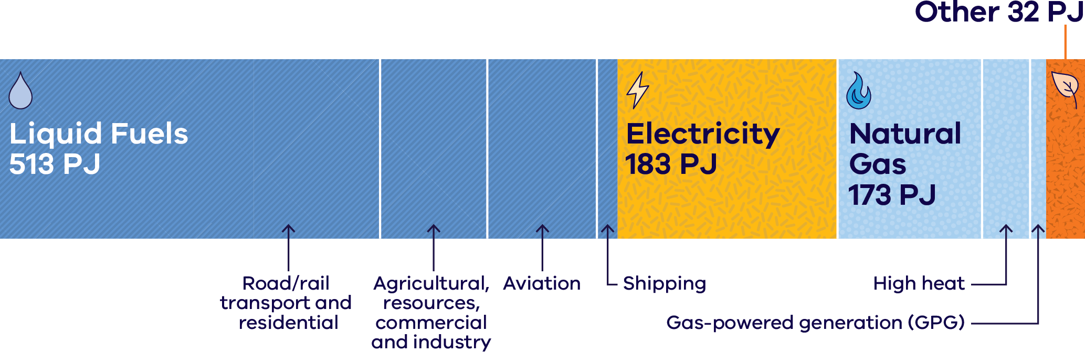
Figure 1 shows the energy consumed by Victorians each year, measured in petajoules (PJ). Liquid fuels make up more than half of all energy consumed:
- Liquid fuels: 513 PJ, used mainly for road and rail transport and residential use; agricultural, resources, commercial and industry use; aviation; and shipping
- Electricity: 183 PJ
- Natural gas: 173 PJ, including use for high-heat industrial processes and gas-powered generation (GPG)
Other: 32 PJ, including residential solar energy and bioenergy.
Table 1: The Victorian Government’s legislated emissions reduction targets
Year | Target
2025 | Exceeded target
2030 | 45–50% emissions reduction
2035 | 75–80% emissions reduction
2045 | Net-zero emissions

Invest in Victoria’s renewable fuels sector

A developing sector
Victoria continues to explore how to best support the development of a competitive and sustainable Victorian renewable fuels sector.

Committed targets
Victoria’s legislated decarbonisation target to reach net zero by 2045 will drive renewable fuels uptake in hard-to-abate sectors.

Strong demand
Aviation, shipping, industry and heavy transport create strong demand for renewable liquid and gaseous fuels.

Sustainable feedstocks
Victoria’s agricultural, forestry, municipal, waste and industrial sectors supply diverse, renewable carbon and waste streams.

Established infrastructure
Access one of Australia’s 2 refineries, 4 deepwater ports, oilseed crushing facilities and fuel infrastructure.

Research excellence
World-class universities, applied research institutes and a skilled workforce accelerate commercialisation and reduce technology risk.

Victoria at a glance
- Victoria is the fastest-growing state in the country with the population expected to reach 10.3 million by 2051.
- Victoria contributes nearly a quarter of Australia’s economic activity.
Melbourne is ranked the world’s 3rd most liveable city and Australia’s most liveable city.

Investment opportunities in low carbon liquid fuels
While electrification and renewable electricity generation continues to expand across Victoria’s energy system, a material share of demand will remain reliant on liquid fuels.
In sectors such as aviation, heavy transport, agriculture and high-temperature industries where electrification is not yet viable or cost-effective, there is a clear and growing investment opportunity. As these sectors seek to reduce emissions and strengthen fuel security, demand is emerging for scalable renewable fuel alternatives to complement the electrification transition. With more than half of Victoria’s current energy demand met by liquid fuels, the shift toward low-carbon liquid fuels represents a substantial and enduring market. This makes Victoria an ideal destination for investment in renewable fuels.
Figure 2: Victorian liquid fuel consumption and end use
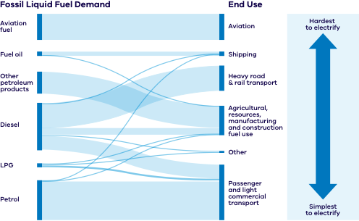
Figure 2 shows how Victoria’s fossil liquid fuel demand flows from each fuel type to its end use. The fuel types are aviation fuel, fuel oil, other petroleum products, diesel, liquefied petroleum gas (LPG) and petrol, with diesel and petrol the largest. End uses are ranked from hardest to simplest to electrify:
- Aviation (hardest to electrify): supplied by aviation fuel
- Shipping: supplied mainly by fuel oil, with small amounts of diesel, LPG and petrol
- Heavy road and rail transport: supplied mainly by diesel and other petroleum products
- Agricultural, resources, manufacturing and construction fuel use: supplied by diesel, other petroleum products, fuel oil, LPG and petrol
- Other uses: supplied by small amounts of diesel and LPG
Passenger and light commercial transport (simplest to electrify): supplied mainly by petrol, with some diesel and LPG.
Aviation, shipping and heavy transport, which are hardest to electrify, are where low carbon liquid fuels offer the greatest opportunity.

Drivers of low carbon liquid fuel (LCLF) uptake

Emissions policies
Australia’s Safeguard Mechanism puts declining emissions limits on large emitters. The mechanism will continue to evolve and drive the uptake of low carbon liquid fuels.

Demand side measures
Alongside the $1.1 billion Cleaner Fuels Program announced in 2025, the 2026–27 Australian Federal Budget outlined the introduction of a demand measure for new Australian low carbon liquid fuel production.
For more information, visit the Securing Australia’s cleaner fuels industry consultation page.

Growing demand
Melbourne is projected to become Australia’s most populous city by the early 2030s, increasing demand for energy and fuels in hard-to-electrify use cases.

Existing infrastructure
Many LCLFs can use existing fuel storage and distribution infrastructure for faster adoption with lower implementation risk.

Case study: Just BioChem

Low carbon liquid fuel
Just BioChem is a key contributor to Victoria’s existing renewable fuel capacity and supply, specialising in biodiesel production. The company operates a state-of-the-art biodiesel manufacturing facility located in Barnawartha, Victoria.
This facility was constructed in 2006 for $70 million. The feedstock for making biodiesel is a combination of canola, tallow and used cooking oil (UCO). The canola oil and tallows are sourced from regional processing facilities, and the UCO is collected from restaurants across the country.
Just Biodiesel supplies biofuel to Viva Energy and Refuelling Solutions that is blended with mineral diesel at a ratio of around 5%. This blend is currently used in various sectors, showcasing the practical application of biodiesel in reducing carbon emissions.

Investment focus on Sustainable Aviation Fuels
Melbourne is a globally connected city, with forecast growth in air travel providing an increasing, domestic market opportunity for Sustainable Aviation Fuel (SAF).
Victoria is home to 2 international airports, including Australia’s largest 24-hour airport. Demand for both domestic and international flights is projected to grow to 75 million passengers by 2045. Most domestic and international routes from Victoria’s airports are subject to increasing emissions mandates. This represents a clear demand signal for SAF in Victoria.
Figure 3: Aviation passenger growth in Victoria
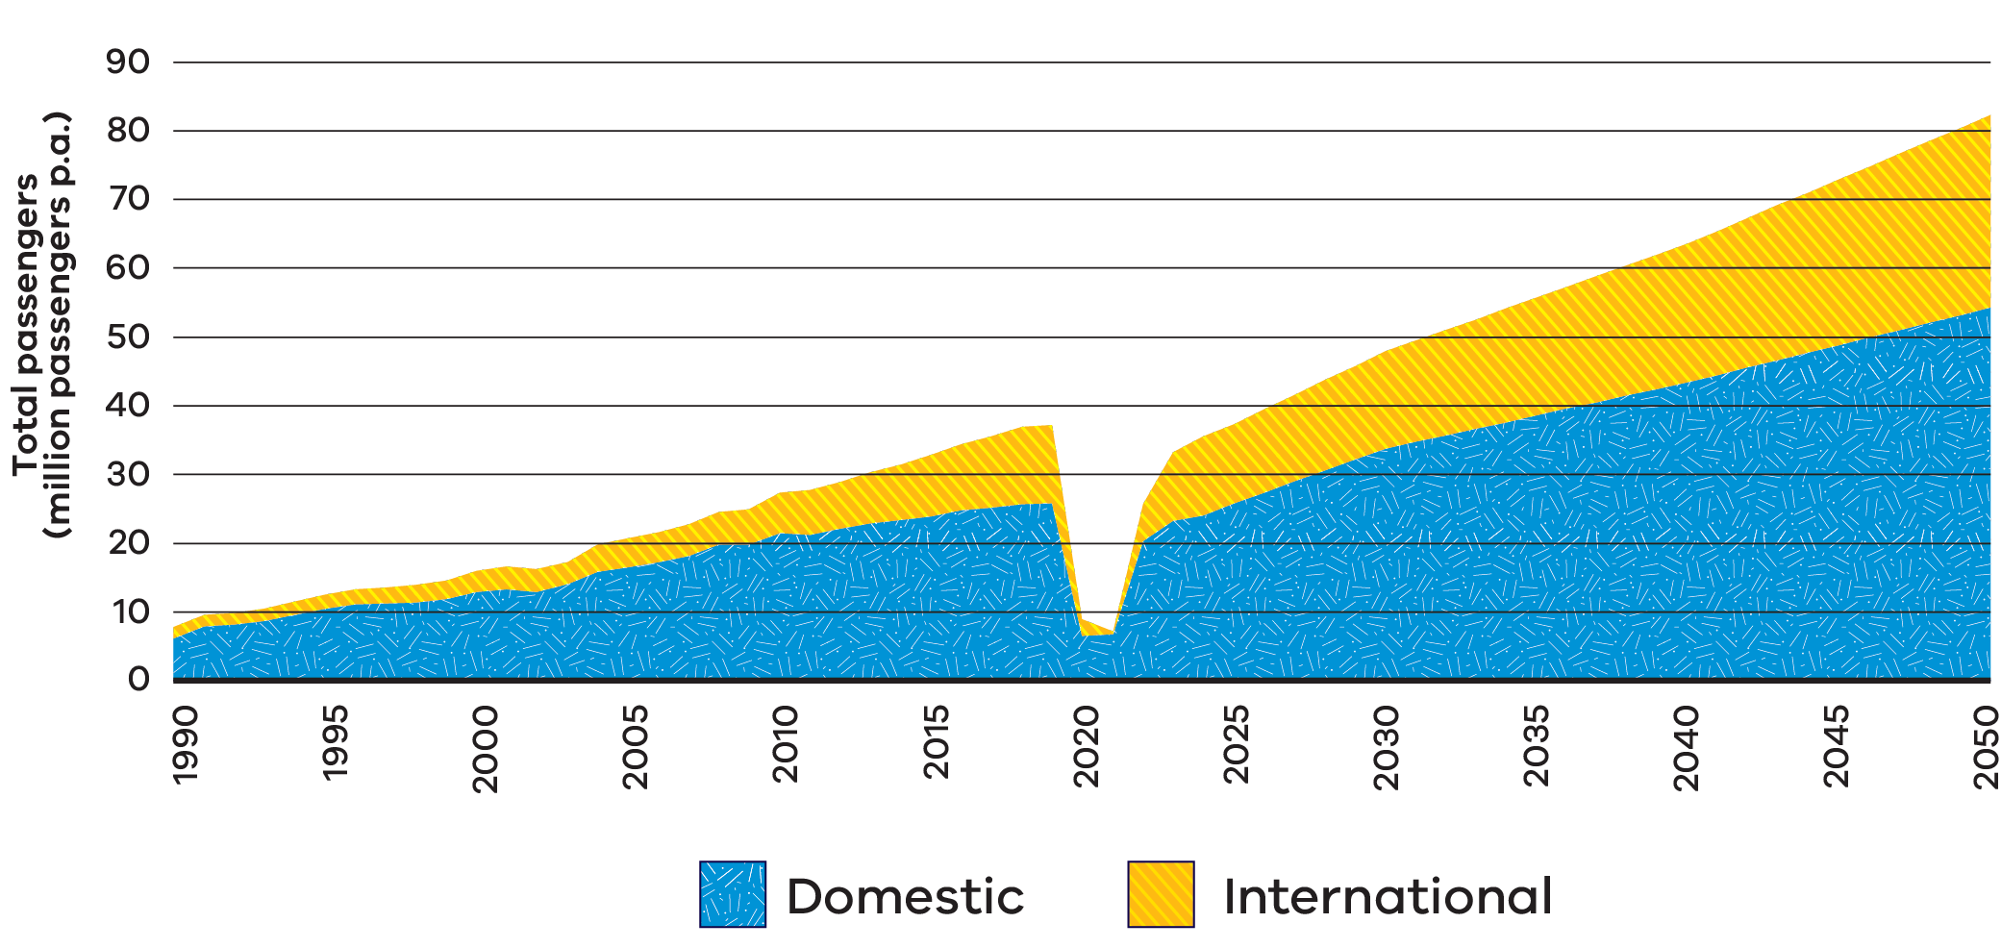
Figure 3 is a stacked area chart of total air passengers in Victoria in millions of passengers per annum (p.a.), split into domestic and international, from 1990 to 2050. It shows:
- steady growth from about 7 million passengers in 1990 to about 37 million in 2019, of which about 25 million were domestic
- a sharp fall to about 7 million passengers in 2020 and 2021, during the COVID-19 pandemic
- a rapid recovery from 2022, with forecast growth to almost 50 million passengers by 2030
continued forecast growth to more than 75 million passengers by 2045 and about 80 million by 2050, of which about 54 million are domestic.
Table 2: Victoria’s aviation market at a glance
Value | Measure
75 million+ | Passengers by 2045
70+ | Non-stop destinations from Melbourne today
100% | Domestic Qantas Group and Virgin Australia flight emissions captured under the Safeguard Mechanism
>96% | International flights from Melbourne expected to operate on Carbon Offsetting and Reduction Scheme for International Aviation (CORSIA)-covered routes from 2027, increasing pressure on airlines to reduce or offset emissions and increase SAF uptake

Emissions rules and airline targets are strengthening SAF demand

Domestic aviation
The Safeguard Mechanism sets declining emissions limits for Australia’s largest emitters, strengthening the incentive to decarbonise through options such as SAF. Australia’s largest airlines, Qantas Group and Virgin Australia, are subject to the Safeguard Mechanism for their domestic operations.

Global aviation
CORSIA is a global scheme that requires airlines to offset growth in international aviation emissions above agreed baseline levels, helping limit the climate impact of international flights. CORSIA obligations apply to an increasing number of international routes from Melbourne.

Airline commitments
Major airlines serving Melbourne already have voluntary SAF uptake targets, including Qantas (10% by 2030), Air New Zealand (10% by 2030) and Singapore Airlines (5% by 2030).

Airport infrastructure
SAF can use existing airport fuel infrastructure, meaning it can be adopted faster and with lower implementation risk.

Melbourne’s direct flight routes
Figure 4 is a world map of direct international flight routes from Melbourne. Countries are shaded to show whether they are current CORSIA states, will join CORSIA from 2027, or are exempt from CORSIA but can voluntarily participate. Australian domestic flights are covered by the Safeguard Mechanism. Direct routes from Melbourne connect to:
- New Zealand and Fiji in the Pacific
- Japan, the People’s Republic of China, Taiwan, Vietnam, the Philippines, Thailand, Malaysia, Singapore and Indonesia in East and South-East Asia
- India, Sri Lanka and the Maldives in South Asia
- the United Arab Emirates in the Middle East
the United States of America and Chile in the Americas.
Figure 4: Melbourne’s direct flight routes
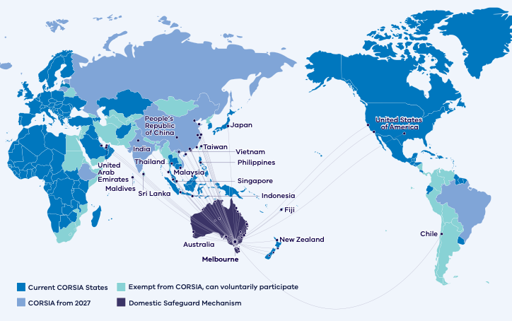

Case study: HAMR Energy

Sustainable Aviation Fuel
HAMR’s flagship development, the Portland Renewable Fuels project, is a world-scale renewable methanol development in Portland, Victoria, with a target capacity of 300 kilotonnes per annum (ktpa).
This innovative renewable fuels project utilises biomass and renewable hydrogen to produce low carbon methanol. Leveraging locally sourced biomass and nearby onshore wind resources, the project aims to create a sustainable, low-carbon methanol that can be transported to local and international customers via the Port of Portland or road and rail. The methanol will be used to support the decarbonisation of hard-to-abate sectors and is a key building block for many SAF pathways.
The Victorian Government is supporting the Portland Renewable Fuels Project with $500,000 for a feasibility study through its Portland Diversification Fund.
For more information, visit the HAMR Energy Portland Renewable Fuels project page.

Investment opportunities in renewable gas
Scaling up a thriving Victorian renewable gas sector presents a significant investment opportunity, while also being essential for Victoria to achieve its legislated target of net-zero emissions by 2045.

Complements electrification
Electrification is expected to be the primary decarbonisation pathway for many energy uses. However, renewable gas has an important role in sectors where alternatives remain limited, including high-heat industry, some transport, chemical feedstocks and gas powered generation.

Supports net-zero targets
Victoria’s legislated emissions reduction targets, including net-zero by 2045, are expected to drive demand for low-emissions alternatives across the economy. Renewable gas can help reduce emissions in sectors where gaseous fuels continue to play a role.

Supports the energy transition
AEMO’s 2024 forecasts indicate growing risks of gas supply shortfalls across south-eastern Australia as conventional gas production declines. While renewable gas is not expected to fully offset these shortfalls, it represents an important long-term opportunity to diversify fuel supply and support emissions reduction in sectors that continue to require gaseous fuels.

Strong feedstock potential
Victoria’s agricultural, forestry, municipal and industrial sectors generate diverse biomass resources that can support the production of renewable gas and other renewable fuels. The Victorian Government has published detailed biomass and biomethane assessments to help inform investment and project development.

Drivers for renewable gas
Victoria offers strong fundamentals for renewable gas investment, including abundant feedstocks, policy support and growing demand for low-emissions fuels.
Growing risks of gas supply shortfalls across Australia’s southern states highlight the need for alternative low-emissions gaseous fuels. Victoria’s biomass and waste resources create a significant opportunity to develop renewable gas projects that can contribute to future low-emissions fuel supply.
Figure 5: Forecast of Victorian gas supply and demand
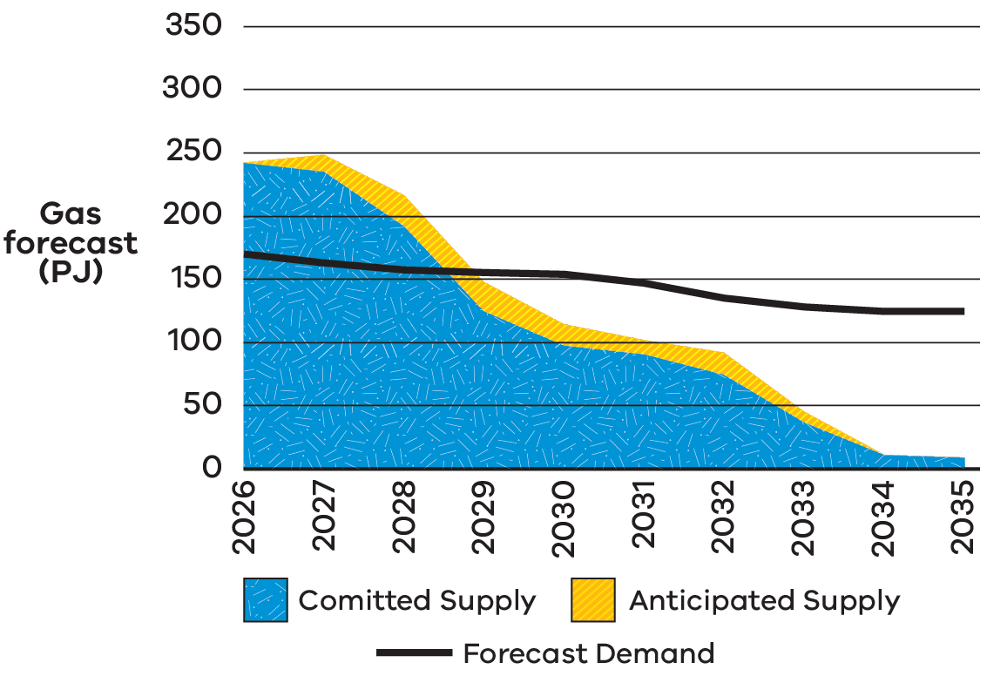
Figure 5 compares forecast Victorian gas supply with forecast demand, in petajoules (PJ), from 2026 to 2035:
- Committed supply falls from about 240 PJ in 2026 to about 125 PJ in 2029, about 100 PJ in 2030 and about 10 PJ by 2034–35.
- Anticipated supply adds only a small amount on top of committed supply each year.
- Forecast demand declines gradually from about 170 PJ in 2026 to about 125 PJ in 2035.
Supply falls below forecast demand from around 2029, and the gap widens each year after that.

Renewable gas for industrial use
The Gas Substitution Roadmap outlines the Victorian Government’s approach to reducing reliance on fossil gas use across the Victorian economy. While electrification is the most cost-effective way to reduce fossil gas use in buildings and low temperature industrial processes, it is not yet technically or commercially viable for many high heat (above 200 degrees Celsius) industrial applications, chemical feedstocks, and gas-powered electricity generation.
Industrial sectors with high temperature requirements account for around three quarters of Victoria’s industrial gas use. For these sectors renewable gases such as biomethane and renewable hydrogen offer long-term decarbonisation opportunities.
The Victorian Government has previously sought feedback on a potential model for a Victorian renewable gas scheme through the Renewable Gas Directions Paper and Government will continue to consider development of this scheme in the context of the broader Victoria’s Renewable Fuels and Feedstocks Future: Industry Development Plan.
The Victorian Government also continues to advocate for the establishment of a national renewable gas scheme.
For more information, visit the Victoria’s Gas Substitution Roadmap page.

Case study: Melton bioenergy facility
Greater Western Water (one of Victoria’s 18 water corporations) has built a waste to energy facility at its Melton Recycled Water Plant. The first facility of its type in the region, the $3.3 million co-digestion project was made possible by securing more than $800,000 through Sustainability Victoria’s original $2.3 million Waste to Energy Infrastructure Fund.
The facility will receive up to 5,000 kilolitres of liquid organic waste each year from local businesses and support the Victorian Government’s goal to halve the amount of organic material going to landfill by 2030. This waste is then treated through an anaerobic digester where it is converted into biogas.
Renewable energy produced from the biogas and existing on-site solar array will provide up to 100% of the plant’s energy needs during the day and is expected to reduce Greater Western Water’s greenhouse gas emissions by 900 tonnes per year.
For more information, visit the Sustainability Victoria news article about harnessing the power of organic waste.

Case study: Pavilion Farms
Pavilion Farms, a large broiler chicken growing operation in Victoria, is working towards 100% sustainable circular farming, with organic fertiliser production, responsible re-use of 100% of its waste, renewable energy generation, bird welfare, lowering greenhouse gas emissions and providing local jobs part of its operational and growth strategy.
Awarded $9.31 million through Round 2 of the Energy Innovation Fund, Pavilion Farms is installing an anaerobic digestion plant which will use chicken litter as its primary feedstock to produce biogas and granulated organic, pathogen free and sustainable fertiliser.
The power generated will be used to run the chicken farms and anaerobic digestion plant, with approximately 18 GWh per annum being sold to local Victorian food producers as baseload renewable power.
Projects like Pavilion Farms are helping us support the commercialisation of innovative, emerging renewable energy technologies in Victoria.
For more information, visit the Pavilion Biogas website.

Biomass for renewable fuels production
Victoria’s regions offer strong opportunities to convert agricultural residues, organic waste streams and other sustainable biomass into renewable fuels and biogenic carbon products, supporting emissions reduction and new regional industries.

Large, diverse biomass base
Victoria produces substantial biogenic residues and waste streams across agriculture, food processing, forestry, municipal solid waste and wastewater. These existing streams can provide near term feedstock options and support circular economy outcomes.

Strong R&D to unlock new feedstocks
Victorian research institutions and industry partners can support innovation across feedstock supply chains and conversion pathways, helping to validate new feedstocks, improve yields and reduce technical and commercial risk.

Guidance on Victorian project development
The Victorian Government is investigating the most suitable feedstock and fuel production pathways that assist industry to develop the best project for Victoria and connect them with state and federal funding opportunities.

Bioenergy opportunities in Victoria
Victoria is Australia’s largest food and fibre producing state and is well positioned for biofuels production.
Existing oilseeds, waste and residues alongside opportunities for emerging energy crops and farming techniques such as crop rotation, have the potential for bioenergy to support renewable fuels production and regional development.
For example, Victoria’s practically available biogas potential from waste and residues alone is estimated at 47 PJ per year currently, rising to 69 PJ per year in 2045.
Figure 6: Practically available biomass residues and key bioenergy facilities by Victorian region
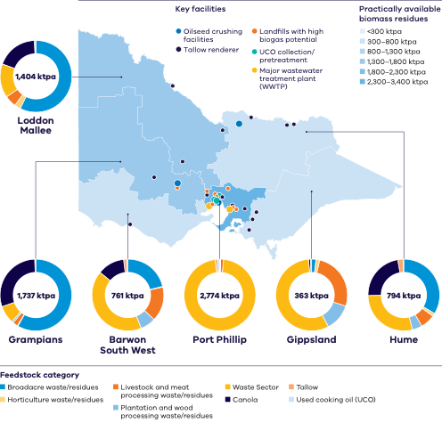
Figure 6 is a map of Victoria’s 6 regions, shaded by the volume of practically available biomass residues in kilotonnes per annum (ktpa), in bands from less than 300 ktpa to 2,300–3,400 ktpa. A doughnut chart for each region shows the mix of feedstock categories: broadacre waste and residues, horticulture waste and residues, livestock and meat processing waste and residues, plantation and wood processing waste and residues, waste sector, canola, tallow and used cooking oil (UCO). Table 3 summarises the data for each region.
The map also marks key facilities: oilseed crushing facilities, tallow renderers, landfills with high biogas potential, UCO collection and pretreatment sites, and major wastewater treatment plants (WWTP). Most landfills, UCO sites and wastewater treatment plants are clustered in and around Melbourne, while oilseed crushing facilities and tallow renderers are spread across northern, central and western Victoria.
Table 3: Practically available biomass residues by region
Region | Practically available biomass residues (ktpa) | Main feedstock categories
Port Phillip | 2,774 | Almost entirely waste sector, with small amounts of tallow and livestock and meat processing waste
Grampians | 1,737 | Mainly broadacre waste and residues and canola, with some waste sector
Loddon Mallee | 1,404 | Mainly broadacre waste and residues, with canola, waste sector and small amounts of livestock and horticulture waste
Hume | 794 | Broadacre waste and residues, waste sector and canola, with small amounts of livestock and plantation waste
Barwon South West | 761 | Mainly waste sector, with broadacre waste and residues, livestock and meat processing waste, canola and plantation waste
Gippsland | 363 | Mainly waste sector, with livestock and meat processing waste and plantation and wood processing waste

Leverage established energy infrastructure
Victoria sits at the intersection of major electricity, gas, fuel and logistics networks, with established refining, storage, terminal and distribution infrastructure already serving large domestic markets.
One of only 2 refineries remaining in Australia, the Geelong refinery anchors this system and supplies more than half of Victoria’s fuel. This existing infrastructure network can support the development, handling and distribution of low-carbon liquid fuels, helping to reduce delivery risk for future projects.
Figure 7: Victoria’s energy and fuel infrastructure can support local renewable fuel production and distribution
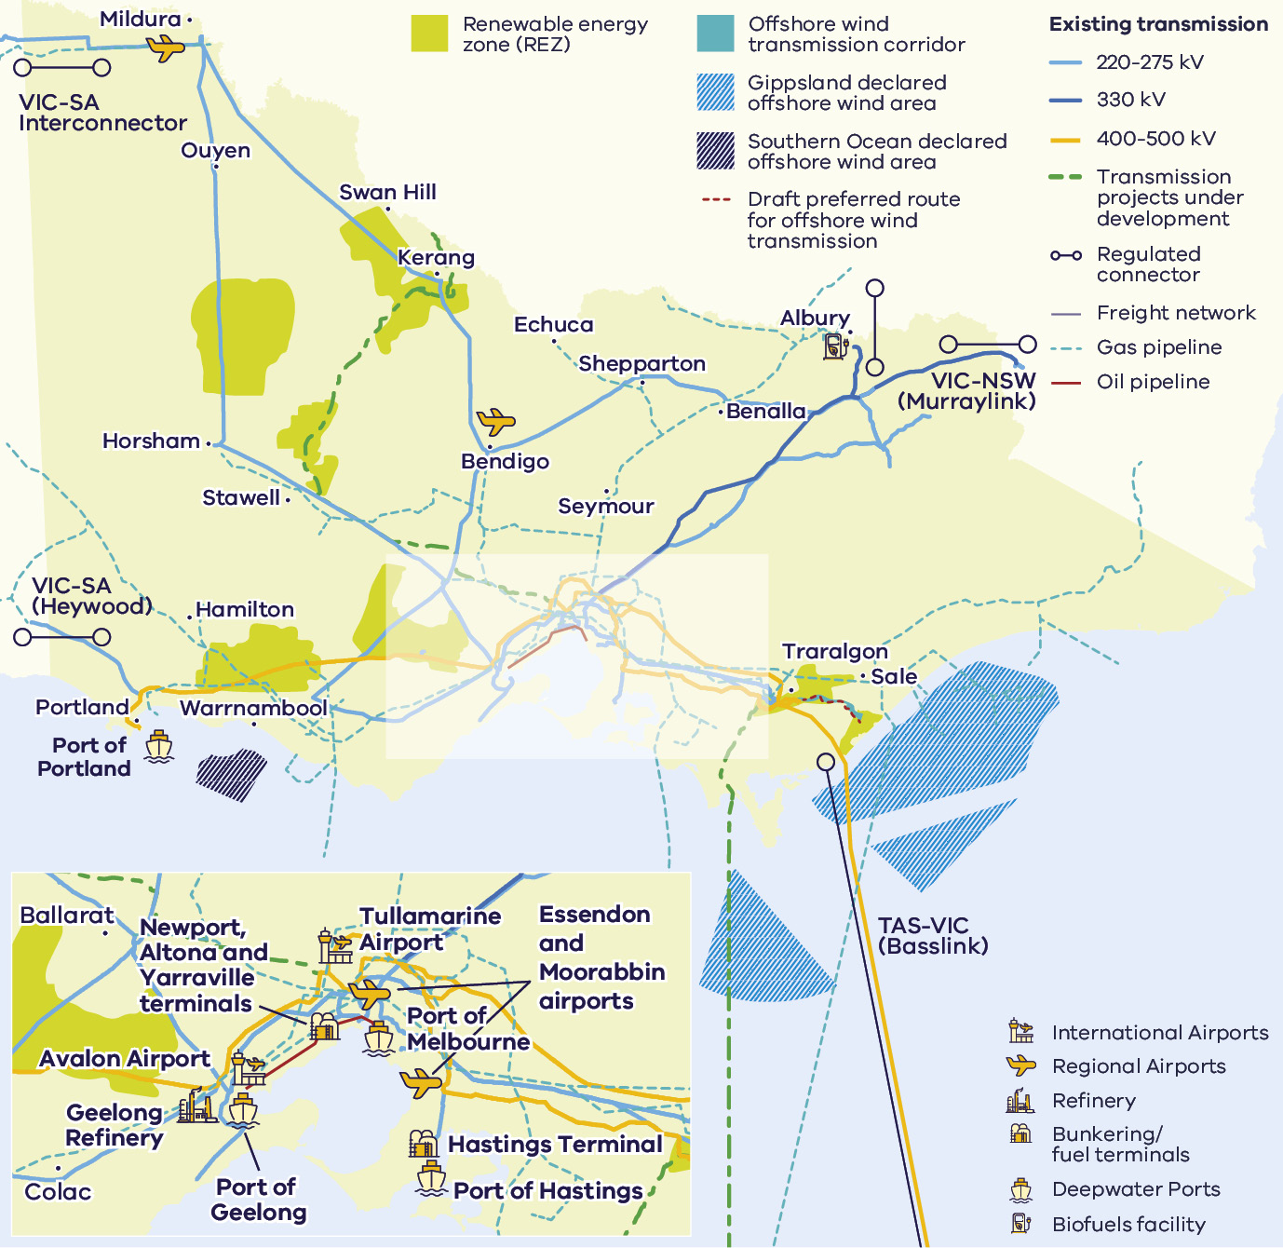
Figure 7 is a map of Victoria’s energy and fuel infrastructure. It shows:
- renewable energy zones (REZ) across western, northern and south-eastern Victoria
- existing electricity transmission lines (220–275 kV, 330 kV and 400–500 kV), transmission projects under development and the draft preferred route for offshore wind transmission
- interconnectors to other states: VIC-SA Interconnector (near Mildura) and VIC-SA (Heywood) to South Australia, VIC-NSW (Murraylink) to New South Wales, and TAS-VIC (Basslink) to Tasmania
- the Gippsland and Southern Ocean declared offshore wind areas and an offshore wind transmission corridor
- gas pipelines, oil pipelines and the freight network connecting regional centres including Mildura, Swan Hill, Bendigo, Shepparton, Ballarat, Horsham, Warrnambool, Portland, Traralgon and Sale
- the Geelong Refinery and fuel terminals at Newport, Altona, Yarraville and Hastings
- deepwater ports at Portland, Geelong, Melbourne and Hastings
- international airports at Tullamarine and Avalon, Essendon and Moorabbin airports, and regional airports including Mildura and Bendigo
a biofuels facility in north-eastern Victoria near Albury.

Case study: Viva Energy
Viva Energy’s co-processing trials at the Geelong Refinery are demonstrating how existing industrial infrastructure could support Victoria’s transition to a circular economy and the production of lower-carbon fuels and products. By trialling the use of alternative feedstocks such as used cooking oil, Viva Energy is showing how established refinery assets can contribute to creating new materials and support future pathways for renewable fuels and other circular products.
Viva Energy has undertaken a trial with Snackbrands Australia and Cleanaway, transforming used cooking oil into food-grade plastic packaging, highlighting the potential to extend material life and create higher-value uses for waste streams.

Victorian Government policies driving renewable fuels investment
Building on the Renewable Hydrogen Industry Development Plan (2021), Victoria has expanded its focus to include multiple renewable fuels that can deliver earlier emissions reductions and faster deployment, while continuing to support hydrogen’s long-term role.

Climate Action Act 2017 and Climate Change Strategy 2026–30
Victoria’s legislated emissions reduction targets create a clear long-term demand signal for renewable fuels.
For more information, visit the Victoria’s Climate Change Strategy page.

Victorian Economic Growth Statement
Victoria’s Economic Growth Statement targets opening the door to investment and innovation, cutting red tape, building new skills and reaching every corner of Victoria.
For more information, visit the Economic Growth Statement page.

Victorian Industry Policy
Identifies renewable fuels as part of Victoria’s strategic industry growth agenda.
For more information, visit the Victorian Industry Policy page.

Victorian Freight Plan
Highlights renewable fuels as a pathway to decarbonise heavy freight and supply chains.
For more information, visit the Victorian Freight Plan page.

Other intersecting policies
- Recycling Victoria: A new economy. For more information, visit the Recycling Victoria: A new economy page.
- Clean Economy Workforce Development Strategy 2023 to 2033. For more information, visit the Clean Economy Workforce Development Strategy page.
- Victorian Energy Jobs Plan. For more information, visit the Victorian Energy Jobs Plan page.
- Women in Energy Strategy. For more information, visit the Women in Energy Strategy page.
- Water Sector Emissions Transition Plan. For more information, visit the net-zero emissions water sector page.
Water Security Plan. For more information, visit the Water Security Plan page.

Australian Government initiatives
The Australian Government has outlined the crucial role of renewable fuels.
Key federal policies include the Net Zero Plan and 6 sector emissions reduction plans, the 2024 National Hydrogen Strategy and Future Made in Australia initiatives. Substantial Australian Government funding has been made available to bring online renewable fuels production.
Table 4: Key Australian Government funding for renewable fuels
Funding | Program
$1.1 billion | Cleaner Fuels Program
$250 million | Made through the Future Made in Australia Innovation Fund
$4 billion | Through Hydrogen Headstart
$2 per kilogram | Hydrogen production tax incentive: an uncapped refundable tax offset for every kilogram of eligible hydrogen for up to 10 years

Funding opportunities for renewable fuel derivatives including fertiliser
Funding opportunities include:
- The $1 billion Economic Resilience Program to be drawn from the $15 billion National Reconstruction Fund supporting businesses in areas such as freight, fuel, plastics and fertiliser who are materially impacted by market disruptions related to current conflicts and global price rises for key inputs.
- The $5 billion Net Zero Fund, announced as part of the Industry Sector Plan, is part of the Australian Government’s approach to driving decarbonisation, unlocking new manufacturing investment, and improving energy affordability in hard-to-abate sectors of the Australian economy.
The $1.5 billion Future Made in Australia Innovation Fund will provide support for the development and commercialisation of new technologies in priority sectors, including clean energy, green metals and other emerging low-emissions industries that can support the renewable fuels value chain.

Access to Victoria’s world-class renewable energy talent
Our growing, highly skilled workforce drives project delivery and fosters industry growth.
To meet the needs of the sector, our energy workforce is predicted to grow by 53% to 68,000 between 2026 and 2040. The Victorian Government has committed to significant new skills and workforce initiatives to ensure the workforce is available when and where it’s needed, including:
- investing $5 million in Solar Victoria’s Electrification Skills Program
- investing $25 million toward the $50 million Victorian Renewable Energy technical and further education (TAFE) Centre of Excellence
- releasing regular energy workforce data to support informed decision-making and boost investor confidence
- developing new energy training pathways through the $7 million for new vocational education and training (VET) certificates in renewable energy projects
- simplifying pathways for skilled workers to move to Victoria through improved qualification recognition and Victoria’s Skilled Migration Visa Nomination Program
investing $10 million toward the $40 million National Training Centre in New Energy Skills.

Victorian Energy Jobs Plan
The Victorian Energy Jobs Plan provides a framework for developing the robust, future-ready energy workforce needed to deliver the transition and strengthen investment confidence.
For more information, visit the Victorian Energy Jobs Plan page.

Sparking Change: The Women in Energy Strategy
The Women in Energy Strategy recognises that attracting and retaining more women in the renewable energy workforce provides significant benefit to this growing sector. It aims to drive significant change for women in energy through Victoria’s energy transition.
For more information, visit the Women in Energy Strategy page.

A clear pathway to partner with First Peoples

Victorian Traditional Owners are actively involved in the energy transition
Investments have been made in developing frameworks and localised plans for the energy transition to create clear pathways for development in Victoria.
Traditional Owner Corporations have clearly defined strategies and processes for partnering to achieve best development outcomes in Victoria.

Access to specialist support
DEECA has invested in dedicated First Peoples energy specialists who can help developers and investors:
- understand Traditional Owner priorities and aspirations
- navigate engagement and partnership processes
build strong, long-term relationships that support project success.
For more information, visit the First Peoples energy page.

Clear guidance from Traditional Owners
Many Traditional Owner Corporations have published guidance and planning documents that help proponents:
- identify community priorities and aspirations
- understand preferred engagement and partnership models
align projects with local economic, social and cultural outcomes.

Strong government policy and guidance
Victoria has established strategic policies and guidance to support collaboration with First Peoples throughout the renewable energy development lifecycle, reducing uncertainty and creating stronger foundations for project development, investment confidence and long-term social value.

First Peoples Renewable Energy Strategic Plan
Identifies First Peoples priorities and desired outcomes within Victoria’s renewable transition.
For more information, visit the First Peoples resources page.

Community Engagement and Social Value Guidelines
Clear guidance on engagement pathways and creating social value in renewable development.
For more information, visit the VicGrid news story about driving better community engagement and benefits from renewable energy projects.

Key Victorian Government entities
We can help facilitate connections with key Victorian Government entities and industry members across our renewable energy sector.

Department of Energy, Environment and Climate Action (DEECA)
DEECA works with industry and the community to develop Victoria’s secure and sustainable energy future.
For information on Victoria’s energy policy landscape and facilitated connections across the Victorian Government and renewable energy sector, contact the Business and Industry Engagement team at: BIE@deeca.vic.gov.au
For more information, visit the renewable energy investment opportunities page.

Offshore Wind Energy Victoria
Offshore Wind Energy Victoria (OWEV) has been established as the single point of entry for industry and community engagement on offshore wind.
For more information, visit the Offshore Wind Energy Victoria page.

Solar Victoria
Solar Victoria is responsible for the delivery of the Victorian Government’s $1.3 billion Solar Homes Program – one of the most ambitious and transformative renewable energy programs in Australia.
For more information, visit the Solar Victoria website.

VicGrid
VicGrid coordinates the planning and development of Victorian Renewable Energy Zones (REZs). It is also investing $480 million that will be used to strengthen the grid and develop each REZ.
For more information, visit the renewable energy zones page.

Invest Victoria
Invest Victoria is the Victorian Government’s investment attraction agency. Services include:
- market regulatory information
- statutory approvals coordination
- site location services
- identification of infrastructure and utility requirements
advocacy within government.
For more information, visit the Invest Victoria website.

Investment Coordinator-General
The Investment Coordinator-General role and function also sits within Invest Victoria, working across agencies to ensure approvals deadlines are met and helping to reduce delays.
For more information, visit Victoria’s Investment Coordinator-General page.

Innovation Victoria
Innovation Victoria is the Victorian Government’s single front door for innovation, supporting founders, researchers, entrepreneurs and investors from early idea through to commercialisation and scale. It provides the capability uplift, connections and capital pathways to accelerate the commercialisation from idea to growth, scale and global opportunity.
For more information, visit the Innovation Victoria website.

SEC
SEC is a Victorian Government-owned renewable energy company. It is partnering with the private sector to deliver 4.5 GW of new renewable energy and storage projects with an initial investment of $1 billion.
For more information, visit the SEC website.

Subsector packs
To access the Renewable Energy subsector packs, please visit the renewable energy subsector packs page.
The following subsector packs are available:
- Distributed Energy Resources and EVs
- Offshore Wind
- Utility-scale Electricity Generation and Storage
- Renewable Fuels and Feedstocks
Renewable Fuels and Feedstocks: Sustainable Aviation Fuel.

Publication information

Copyright
© The State of Victoria Department of Energy, Environment and Climate Action, September 2026.

Creative Commons
This work is licensed under a Creative Commons Attribution 4.0 International licence, visit the Creative Commons website.
You are free to re-use the work under that licence, on the condition that you credit the State of Victoria as author. The licence does not apply to any images, photographs or branding, including the Victorian Coat of Arms, and the Victorian Government and Department logos.
ISBN 978-1-76176-997-9 (print)
ISBN 978-1-76176-998-6 (pdf/online/MS word)

Disclaimer
This publication may be of assistance to you but the State of Victoria and its employees do not guarantee that the publication is without flaw of any kind or is wholly appropriate for your particular purposes and therefore disclaims all liability for any error, loss or other consequence which may arise from you relying on any information in this publication.

Accessibility
To receive this document in an alternative format, phone the Customer Contact Centre on 136 186, email customer.service@deeca.vic.gov.au, or contact National Relay Service on 133 677 or visit the National Relay Service website. This document is available on the DEECA website.
End of document.

Victorian energy consumption data collated from: Australian Energy Update 2025 | Department of Climate Change, Energy, the Environment and Water | energy.gov.au/publications/australian-energy-update-2025; The Superpower Institute, Annual Victorian Consumption 2025 | explore.openelectricity.org.au; Gas Statement of Opportunities | AEMO | aemo.com.au/energy-systems/gas/gas-forecasting-and-planning/gas-statement-of-opportunities-gsoo. Natural gas figure is based on the 2026 Victorian Gas Planning Report and includes 167 PJ Victorian Declared Transmission System (DTS) and 6.1 PJ non-DTS consumption.
Other includes 6.6 PJ residential solar energy, 20.1 PJ wood and wood waste bioenergy and 5.3 PJ liquid and gas bioenergy.
Victoria in Future | Department of Transport and Planning | planning.vic.gov.au/guides-and-resources/Data-spatial-and-insights/discover-and-access-planning-open-data/victoria-in-future
Why invest in Melbourne? | City of Melbourne | melbourne.vic.gov.au/why-invest-melbourne
EIU Global Liveability Index 2026 | Economist Intelligence Unit | eiu.com/n/wp-content/uploads/2026/07/EIU_Liveability-Index-2026.pdf
Energy consumption data (PJ) derived from Australian Energy Update 2025, Table F (2023 data) | Department of Climate Change, Energy, the Environment and Water | energy.gov.au/publications/australian-energy-update-2025
Passenger forecasts as defined in the Melbourne Airport Master Plan | Melbourne Airport | melbourneairport.com.au/corporate/master-plan
CORSIA States for Chapter 3 State Pairs | International Civil Aviation Organization | icao.int/CORSIA/corsia-states-chapter-3-state-pairs
Sustainable aviation fuel | Qantas | qantas.com/corporate/sustainability/our-planet/sustainable-aviation-fuel
Sustainable aviation fuel | Air New Zealand | airnewzealand.co.nz/sustainability-saf
Environment | Singapore Airlines | singaporeair.com/en_UK/sg/about-us/sustainability/environment/
Victorian Gas Planning Report Update | AEMO | March 2026; and practically available biomethane potential data from DEECA-commissioned studies.
Forecast gas shortfall, 2026 Gas Statement of Opportunities (GSOO) report | AEMO | aemo.com.au/energy-systems/gas/gas-forecasting-and-planning/gas-statement-of-opportunities-gsoo

