Renewable Energy Investment Prospectus:
Distributed Energy Resources and EVs
  - October 2026

Table of Contents
Traditional Owners at the centre for decision-making processes 4
Welcome to Victoria’s renewable energy sector 5
Invest in Victoria’s distributed energy resources and electric vehicles sector 7
Victoria’s digital and smart technology are advantages driving investment 9
Energy distribution businesses 11
Victoria is at the heart of Australia’s National Electricity Market 15
Rooftop solar 19
Solar Homes and the Victorian Energy Upgrades program 21
Distributed storage 22
Flexible demand is creating opportunities for enabling platforms 25
SEC: Powering Victoria’s renewable energy future 29
Access to government co-investment 31
Battery electric vehicles and charging 33
Market reforms unlocking DER and consumer energy resources (CER) benefits 39
Manufacturing and recycling opportunities in Victoria’s distributed
energy technologies sector 41
A hub for innovation 45
Digital Energy Economy Program 46
Research to support innovation 48
Access to Victoria’s world-class renewable energy talent 50
Key Victorian Government entities 52
Subsector packs 55
Publication information 56

Traditional Owners at the centre for decision-making processes
Strong and mutually beneficial partnerships with Traditional Owners and First Peoples are imperative to the energy transition’s success and integral to ensuring the goals and objectives of self-determination set out in the Victorian Government’s Self Determination Reform Framework and the Department of Energy, Environment and Climate Action’s (DEECA) Pupangarli Marnmarnepu ‘Owning Our Future’ Aboriginal Self-Determination Reform Strategy 2020–2025.
For more information, visit the Pupangarli Marnmarnepu ‘Owning Our Future’ strategy page.

Acknowledgement of Country
We acknowledge and respect Victorian Traditional Owners as the original custodians of Victoria’s land and waters, their unique ability to care for Country and deep spiritual connection to it.
We honour Elders past and present whose knowledge and wisdom have ensured the continuation of culture and traditional practices.
We are committed to genuinely partner, and meaningfully engage, with Victoria’s Traditional Owners and Aboriginal communities to support the protection of Country, the maintenance of spiritual and cultural practices and their broader aspirations in the 21st century and beyond.

Welcome to Victoria’s renewable energy sector
Our legislated targets and changing energy market are creating investment opportunities.
Victoria’s energy market is undergoing a major transition, shifting away from its historic fuel source of brown coal to a more diversified and resilient renewable supply mix. This creates unprecedented opportunities for investment across our renewable energy sector.
Victoria is at the forefront of the global shift to decentralised, renewable energy systems, offering investors a mature and rapidly expanding distributed energy resources (DER) market. Underpinned by strong policy support, near-universal smart meter infrastructure, and one of the highest rates of rooftop solar uptake globally, Victoria provides a uniquely advanced environment to deploy, integrate and monetise rooftop solar, batteries, flexible loads and smart energy technologies.
As it enters a rapid growth phase, Victoria’s battery electric vehicle (EV) sector presents compelling investment opportunities. Combining strong policy targets, accelerating adoption, and a scalable infrastructure and energy integration opportunity, Victoria is a leading investment destination in Australia’s transport electrification transition.
As electrification accelerates across homes, transport and industry, DER is becoming a critical component of the state’s energy system – unlocking new opportunities for aggregation, value stacking, and grid services.
Table 1: Key renewable energy figures
Figure | Description
27 gigawatts  (GW) | New renewable generation and storage capacity required by 2035 in Victoria
82% | Australia's renewable energy target by 2030
Note: the 27 GW figure is an estimate only.
Table 2: The Victorian Government's legislated targets
Year | Target | Status
2020 | 25% renewable electricity generation | Achieved
2025 | 40% renewable electricity generation | Achieved
2030 | 65% renewable electricity generation and 2.6 GW energy storage capacity | Target
2035 | 95% renewable electricity generation and 6.3 GW energy storage capacity | Target
2045 | Net-zero emissions | Target

Invest in Victoria’s distributed energy resources and electric vehicles sector

World-leading smart meter adoption
More than 99% smart meter adoption, one of the highest globally.

Large flexible asset base
Growth in home batteries (75,000 installed in 2025–26), EVs, heat pumps and electric appliances rapidly increasing the volume of flexible load.

Fast-growing startup ecosystem
Startup ecosystem valued at $139 billion, with more than 4,400 start-ups.

Extensive pipeline of digital talent
The fastest growing digital technology sector in Australia, with over 259,000 tech professionals.

Market reforms
Key market changes unlocking stackable grid service revenues from DER.

Manufacturing and recycling
Home to the skilled workforce, existing supply chains and critical minerals required to manufacture or recycle component.

Victoria at a glance
- Victoria is the fastest-growing state in the country with the population expected to reach 10.3 million by 2051.
- Victoria contributes nearly a quarter of Australia's economic activity.
Melbourne is ranked the world’s 3rd most liveable city and Australia’s most liveable city.

Victoria’s digital and smart technology are advantages driving investment
Leverage near-universal smart meters and a strong innovation ecosystem to turn DER into scalable, data-enabled revenue streams. The Victorian market makes the perfect real-world testbed for developing and deploying next generation digital and innovative energy solutions.

Smart meters
Victoria is the only state in Australia with a fully digitised energy system, thanks to the roll-out of over 3.2 million smart meters to residential and small business electricity customers (over 99% coverage).
This makes Victoria the ideal place to develop and test new digital energy innovations. Smart meters:
- enable near real-time remote monitoring of customer electricity flows
allow digital energy businesses to provide customers with new product offerings and greater insight into their energy use.
Table 3: Smart meter coverage around Australia
Location | Smart meter coverage
Victoria | 99%
The rest of Australia | 57%

Smart inverters
Victoria is likely to have one of the largest and fastest-growing installed bases of CSIP-AUS-capable inverters in Australia, driven by mandates through the Emergency Backstop Mechanism and Solar Victoria rebate. This could create more opportunities for virtual power plants (VPPs) and software orchestration platforms.

A strong innovation sector positioned for growth
Rich data sources, open data initiatives, local innovation capabilities and world-class research and development hubs make Victoria a prime destination to create, develop and invest in digital and innovative energy products.

Energy distribution businesses
5 regulated electricity distribution businesses connect millions of customers and underpin Victoria's rapidly growing distributed energy market: Citipower, Jemena, Powercor Australia, AusNet and United Energy.
Figure 1: Victoria’s electricity distribution areas
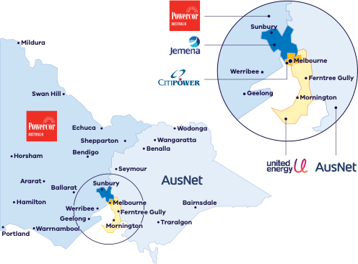
Figure 1 shows the areas of Victoria served by each distribution business:
- Powercor Australia: western and central Victoria, including Mildura, Swan Hill, Horsham, Hamilton, Ararat, Ballarat, Bendigo, Echuca, Shepparton, Geelong, Werribee, Warrnambool and Portland
- AusNet: eastern and north-eastern Victoria and Melbourne’s outer eastern suburbs, including Wodonga, Wangaratta, Benalla, Seymour, Traralgon and Bairnsdale
- Jemena: Melbourne’s north-western suburbs, including Sunbury
- CitiPower: Melbourne’s central business district and inner suburbs
United Energy: Melbourne’s south-eastern suburbs and the Mornington Peninsula, including Ferntree Gully and Mornington.

Victoria’s distributed energy resources landscape
Figure 2: How distributed energy resources work together across homes, businesses and the grid
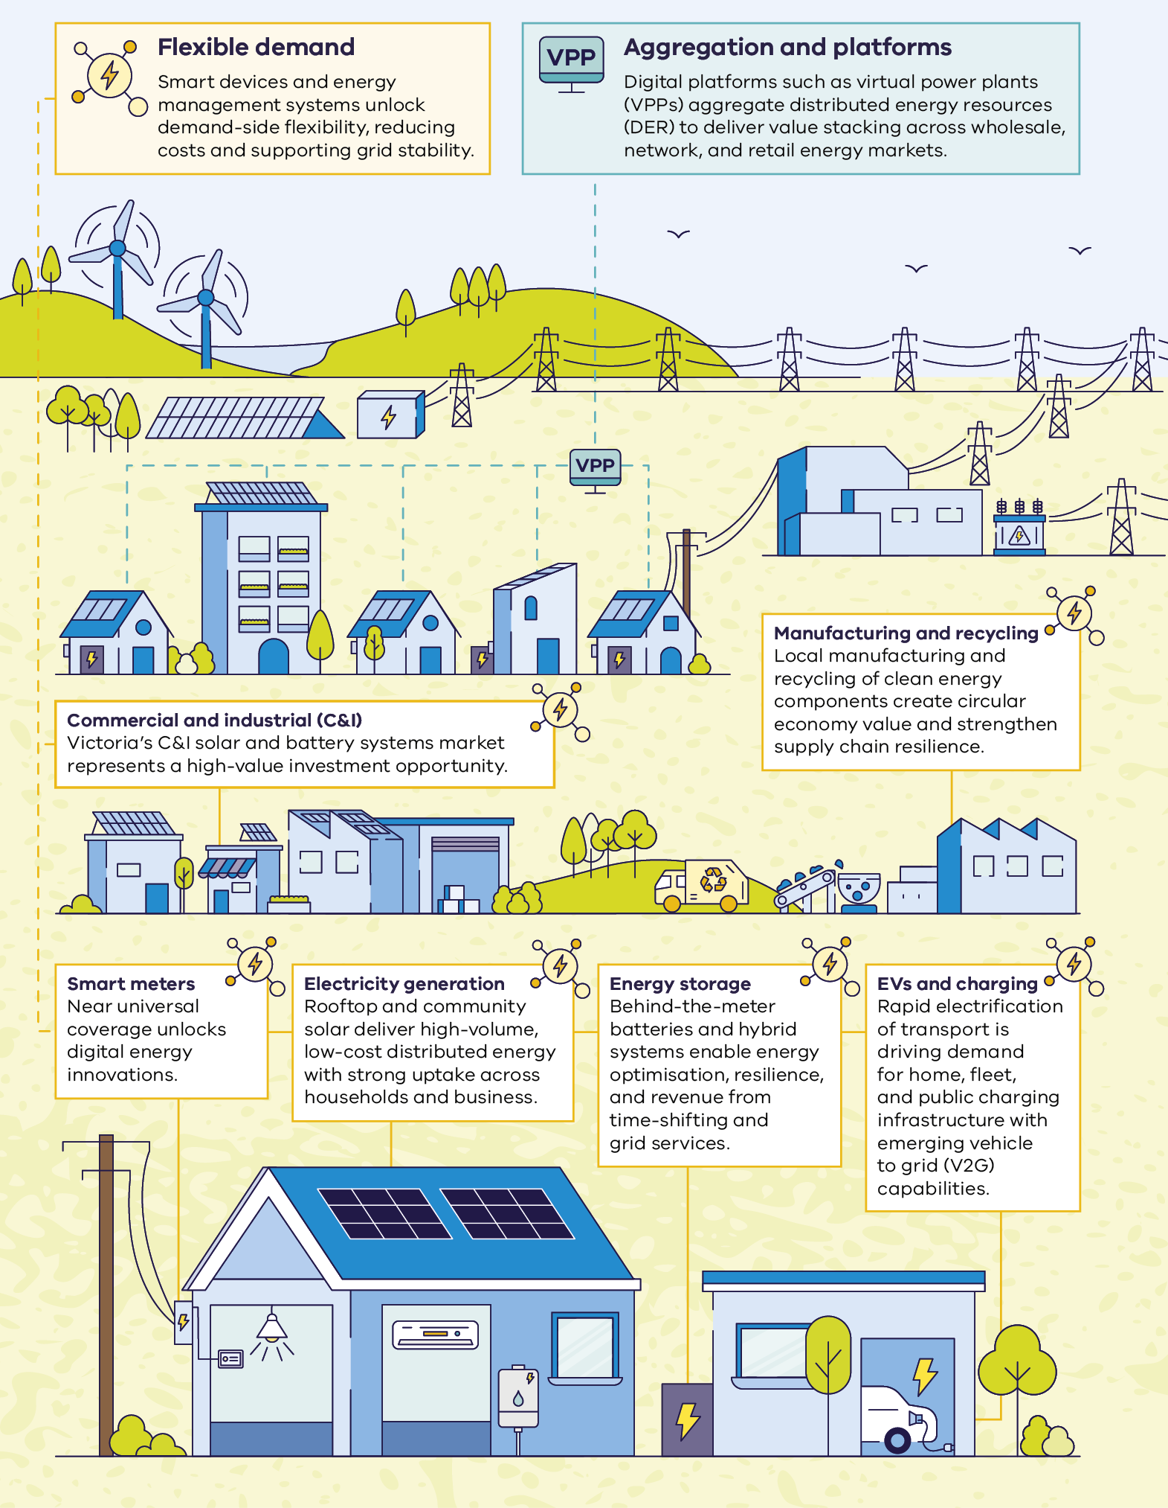
Figure 2 shows how distributed energy resources work together across homes, businesses and the grid:
- Flexible demand: smart devices and energy management systems unlock demand-side flexibility, reducing costs and supporting grid stability.
- Aggregation and platforms: digital platforms such as virtual power plants (VPPs) aggregate distributed energy resources (DER) to deliver value stacking across wholesale, network, and retail energy markets.
- Commercial and industrial (C&I): Victoria’s C&I solar and battery systems market represents a high-value investment opportunity.
- Manufacturing and recycling: local manufacturing and recycling of clean energy components create circular economy value and strengthen supply chain resilience.
- Smart meters: near universal coverage unlocks digital energy innovations.
- Electricity generation: rooftop and community solar deliver high-volume, low-cost distributed energy with strong uptake across households and business.
- Energy storage: behind-the-meter batteries and hybrid systems enable energy optimisation, resilience, and revenue from time-shifting and grid services.
EVs and charging: rapid electrification of transport is driving demand for home, fleet, and public charging infrastructure with emerging vehicle to grid (V2G) capabilities.

Victoria is at the heart of Australia’s National Electricity Market
Victoria is located at the very centre of Australia’s National Electricity Market (NEM), linking the state to major load centres and critical infrastructure.

The National Electricity Market (NEM)
The NEM is one of the world’s largest interconnected power systems, stretching 5,000 kilometres (km) along Australia’s east and south-east seaboard. It has 5 interconnected states that function as pricing regions. It is a wholesale 5-minute spot market to trade electricity between generators and retailers.

Australian Energy Market Operator (AEMO)
AEMO manages the electricity and gas systems and markets across Australia, ensuring Australians have access to affordable, secure and reliable energy. AEMO produces trusted publications and reports which can support investment decisions.
For more information, visit the AEMO publications library.

Other regulatory bodies
- Australian Energy Market Commission is the rule maker for Australian electricity and gas markets. For more information, visit the Australian Energy Market Commission website.
Australian Energy Regulator regulates energy networks and the wholesale and retail markets in Australia to ensure they are secure, reliable and affordable for consumers. For more information, visit the Australian Energy Regulator website.

Victoria’s connections to the NEM
Figure 3: The National Electricity Market
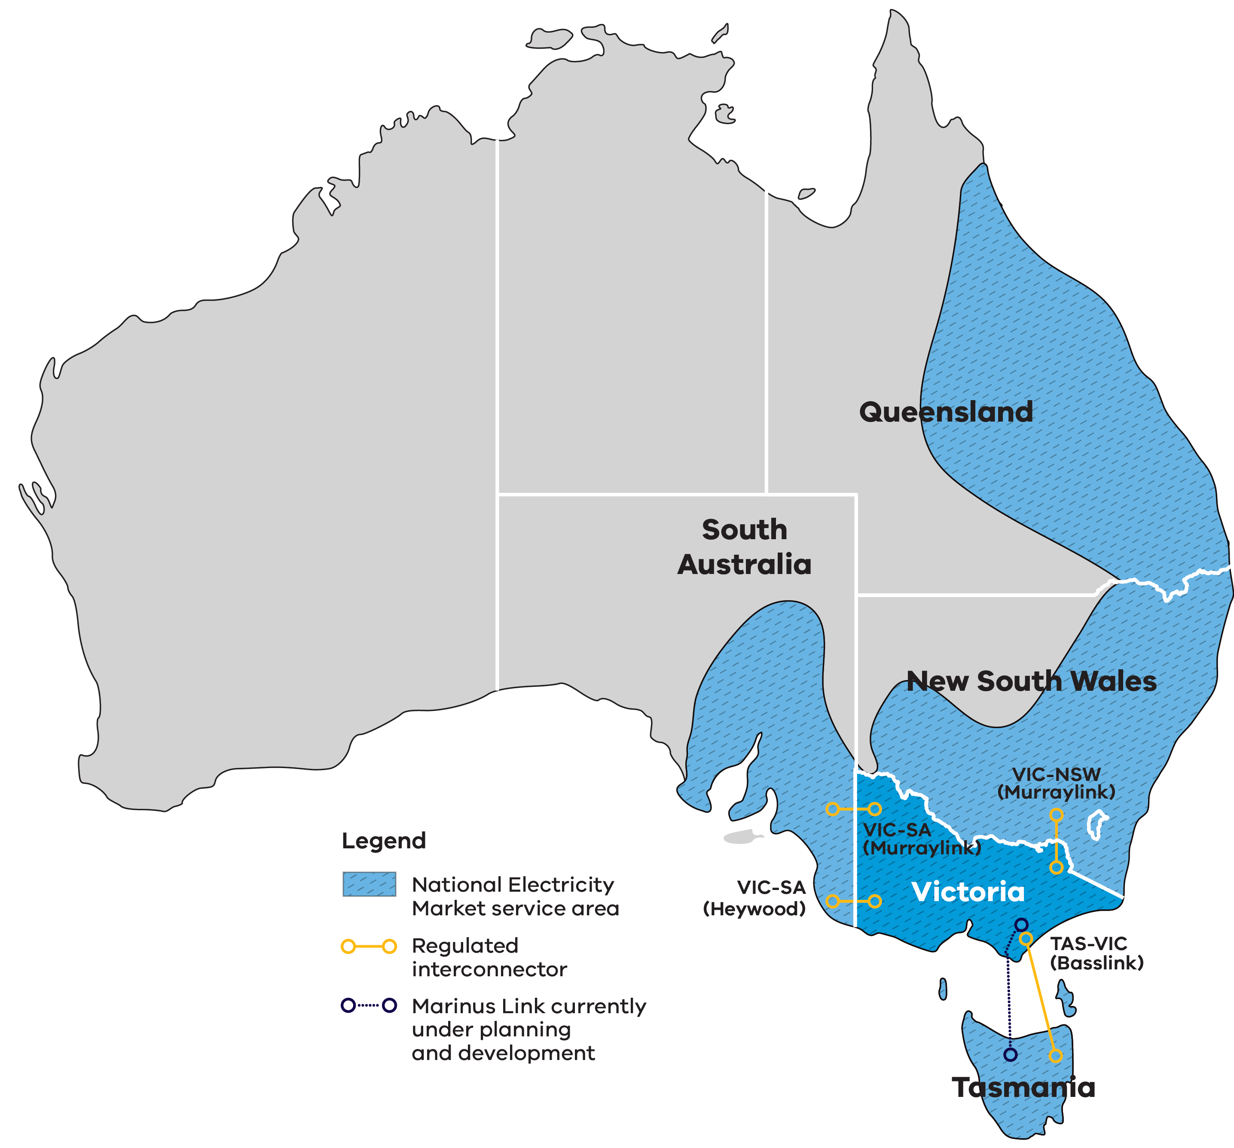
Figure 3 shows the National Electricity Market service area, which covers Queensland, New South Wales, Victoria, South Australia and Tasmania. Victoria is directly connected to 3 other states by 4 regulated interconnectors:
- VIC-SA (Heywood), connecting Victoria and South Australia
- VIC-SA (Murraylink), connecting Victoria and South Australia
- VIC-NSW (Murraylink), connecting Victoria and New South Wales
TAS-VIC (Basslink), connecting Tasmania and Victoria.
A further interconnector between Victoria and Tasmania, Marinus Link, is currently under planning and development.

Investment opportunities
Victoria’s fully competitive, privatised electricity market creates many opportunities for investors. This includes the spot and contract markets for companies that specialise in buying and selling electricity, with opportunities to leverage market fluctuations and participate in existing and emerging grid services markets.
For more information, visit the Victorian electricity sector overview page.
Table 4: The National Electricity Market at a glance
Measure | Value
Value traded in financial year (FY) 2024–25 | $25 billion
Spot price market cap FY2025–26 | $20,300 per megawatt hour (MWh)
Share of Australia’s population serviced | About 85%
Customers | About 11 million
Transmission lines | 40,000 km
Regulated interconnectors directly connecting Victoria to 3 other states | 4 interconnectors
Electricity supplied each year | About 200 terawatt hours (TWh)
Total generation | About 99 GW
Sources: NEM Factsheet, AEMO (value traded, population serviced and electricity supplied); 2026 Integrated System Plan (ISP), AEMO (rooftop solar and total generation and storage); Australian Energy Regulator (customers).

Rooftop solar
Victoria’s rooftop solar sector offers a scalable, policy-backed investment opportunity supported by abundant solar resources, world-leading rooftop solar penetration and near-universal smart meters.

Investment opportunities
- Growing commercial and industrial (C&I) market: Victoria’s C&I solar market represents a large, underdeveloped opportunity. Government incentives now directly target mid-scale rooftop systems to accelerate uptake across warehouses, factories and public infrastructure.
Community and precinct solar: Victoria’s community and precinct solar sector presents an opportunity to create new business models and unlock new customer cohorts. With strong demand, government backing and smart meter saturation, there is an opportunity to generate scalable, long-term contracted revenues across commercial and residential embedded networks and integrated DER systems.

Government initiatives driving market demand
Solar Victoria is driving sustained rooftop photovoltaic (PV) demand by combining upfront rebates, zero interest financing, and targeted expansion into apartments and rental markets. Electrification policies further strengthen the economics of installing solar PV.
Key initiatives include:
- $1,400 solar panel rebate (households)
- $1,400 interest free loans
- $2,800 Solar for Apartments rebate
- rental and community housing programs
$1,000 Hot Water Program rebate (up to $1,400 for local content-enhanced hot water products).
The Victorian Energy Upgrades (VEU) program also further increases the value of solar through discounts on energy-efficient products and provides upfront incentives of $9,100 (100 kilowatt (kW)) and about $34,000 (200 kW systems) to install rooftop PV in the C&I sector.
For more information, visit the Solar Victoria website and the Victorian Energy Upgrades for homes page.
Table 5: Solar Homes Program achievements
Measure | Result
Installed PV capacity across Victorian households since 2018 | 2.5 GW
Share of Victorian homes with solar installed | About 31%
Households generating their own energy (solar-enabled homes) | 900,000+
Solar systems supported through Solar Homes | 350,000+
Note: figures correct as of 31 December 2025.

Solar Homes and the Victorian Energy Upgrades program
Solar Victoria drives the uptake of rooftop solar, electrification and energy efficiency through rebates, loans, discounts and industry support.
Solar Victoria delivers the Victorian Government’s flagship Solar Homes Program. The program is a $1.3 billion investment to assist Victorians adopt renewable energy technologies. Since 2018, Solar Homes rebates have supported more than 350,000 solar PV and 93,500 energy-efficient hot water installations.
The program has helped create one of Australia’s largest distributed energy markets and has supported strong growth across the residential solar, electrification and energy services sectors.
Solar Victoria is also responsible for the Victorian Energy Upgrades (VEU) program, Australia’s largest market-based energy efficiency program and a cornerstone of Victoria’s emissions reduction efforts. The VEU program helps Victorian homes and businesses to reduce their energy use by providing discounts on energy-efficient products and services.
Since 2009, the VEU program has helped more than 2.6 million Victorian households and businesses undertake energy-saving upgrades, reducing greenhouse gas emissions by over 93 million tonnes. Between 2021 and 2025, the program avoided an estimated $3.8 billion in energy system costs by reducing energy demand and easing pressure on the grid, while supporting investment, innovation and employment across Victoria's energy efficiency sector.
For more information, visit the Solar Victoria website and the Victorian Energy Upgrades page.

Distributed storage
Victoria’s distributed storage sector is entering a growth phase as high rooftop penetration and subsidy programs drive demand for battery installations across residential, community, and C&I sectors.
Victoria’s distributed battery market is moving into a rapid scale-up phase. High rooftop solar penetration is creating a structural need for storage to shift excess daytime generation to evening demand and support grid stability. Australia’s Cheaper Home Batteries Program – offering about 30% upfront subsidies – has transformed the market by rapidly accelerating battery adoption. It has driven a step change in installations and system sizes, reducing payback periods and shifting the sector from niche uptake to a high growth, mainstream distributed energy market.
Growth is also expanding beyond households into commercial, industrial, and community-scale batteries, increasing market depth and system size. Victoria’s C&I storage market offers a scalable, high-value investment opportunity to deploy battery systems across energy intensive businesses. This delivers long term contracted savings, reduces exposure to shifts in electricity prices and unlocks additional revenue through emerging flexible demand and orchestration opportunities.

Victorian Government initiative driving consumer demand
Victoria’s Midday Power Saver initiative creates an emerging market signal for battery storage, smart charging and home energy management technologies. This initiative gives customers access to free or low-cost daytime electricity, supporting new business models that help customers charge batteries, EVs or flexible appliances when renewable generation is abundant, then use or export stored energy later.

Storage market outlook
As at the end of 2025, behind-the-meter battery installations for both residential and commercial demand are forecast to continue growing through to 2030, as shown in Figure 5.
Figure 4: Annual small-scale storage capacity additions, historical and forecast
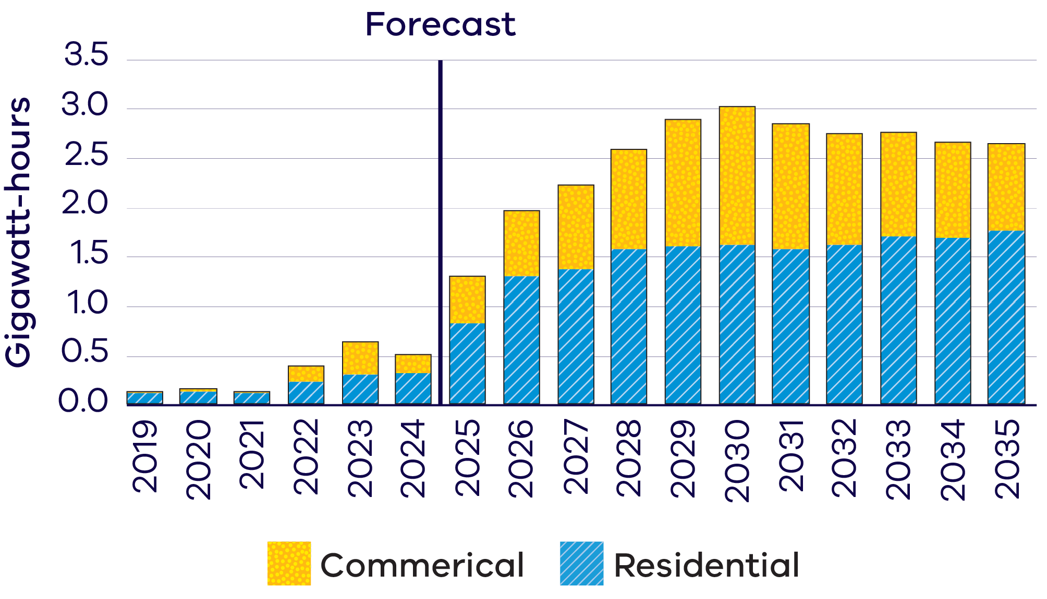
Figure 4 is a stacked bar chart of annual small-scale storage capacity additions in gigawatt hours (GWh), split into residential and commercial, from 2019 to 2035, with years from 2025 shown as forecast. Additions are below 0.5 GWh a year until 2024, rise to about 2 GWh in 2026 and peak at about 3 GWh in 2030, then ease slightly to about 2.6 GWh by 2035. Residential installations make up the majority of additions in every year.
At a national scale, Australia’s small-scale battery market is up 619% from 2024, with 1.6 GW/3.9 GWh installed.

Case study: GloBird Energy

Orchestration platform
GloBird Energy is a Victorian-founded energy retailer that has grown from an independent challenger into a larger retailer serving customers across Australia.
The business is built around 2 core pillars: local customer service and practical innovation. Having both the customer care and technology teams operating from GloBird’s headquarters in Melbourne’s eastern suburbs has been central to strengthening these capabilities.
GloBird offers products designed to support customers at every stage of their energy transition journey. One example is ZEROHERO, which is designed to help customers derive greater value from their solar, battery and even EV. The GloBird mobile app also includes gamification features specifically designed for ZEROHERO, encouraging customers to engage with the energy transition in way that supports engagement with energy use and distributed energy technologies.
Victoria has been central to GloBird’s growth, providing an engaged customer base, strong rooftop solar adoption, increasing interest in batteries, and a market that rewards practical retail innovation. GloBird’s focus remains on making distributed energy resources simpler, more accessible, more practical for customers.
For more information, visit the GloBird Energy website.
“Access to strong local technology talent and the ability to closely integrate our technology and customer care teams from our Melbourne headquarters has been a key advantage in building out our proprietary Energy Operating System platform, which is a cornerstone of our innovation. Victoria continues to provide the right mix of customers, talent, and energy transition opportunities for companies like GloBird to innovate and scale.”
Evan Giosis, Chief Technology Officer (CTO), GloBird Energy

Flexible demand is creating opportunities for enabling platforms
Near-universal smart meter roll-out, high electrification uptake and advanced DER integration standards unlock opportunities to monetise demand-side flexibility at scale.
Victoria presents a strong investment opportunity in platforms that orchestrate and aggregate distributed energy assets into scalable, dispatchable grid services. This includes VPPs, flexible demand, smart EV charging and energy management solutions that enhance coordination, visibility and flexibility across the energy system.

Investment opportunity

World-leading digital enablement
Victoria’s near-universal smart meter roll-out provides distribution network service providers (DNSPs) real-time visibility and control across nearly all households and businesses. This gives investors an opportunity to work with DNSPs to identify, aggregate and orchestrate flexible demand at scale.

High renewable penetration creating demand for flexibility
With high rooftop solar uptake, Victoria increasingly needs demand to shift into daytime periods. There is strong underlying value for flexible loads to absorb excess generation and reduce system peaks.

Rapid electrification expanding the flexible asset base
Growth in electric vehicles, heat pumps and electric appliances is rapidly increasing the volume of flexible load, expanding the investible market and improving aggregation economics.

Low-capex, scalable investment model
Unlike generation or storage, flexible loads are primarily a software-led opportunity, allowing investors to scale quickly with lower capital intensity while capturing multiple revenue streams.

What proponents can do in Victoria
- Test and scale VPPs or other energy platforms across residential, commercial, industrial and community sectors.
- Partner with energy retailers, distribution businesses, councils, technology providers, property owners and large energy users to develop flexible energy services.
- Develop business models that help customers manage costs, support more efficient network operation and access new value streams from distributed energy assets.

Victorian Energy Upgrades (VEU) program

Commercial incentives
The VEU program provides financial opportunities for emissions reducing services or technologies, including flexible demand platforms. Many commercial businesses utilise the program to build their portfolio.

Residential incentives
Through the VEU program, more than 740,000 Victorian homes have installed an in-home display unit since 2013. This has helped build customer familiarity with digital energy management systems and connected energy services, which could support VPP uptake.

New residential and commercial building electrification standards
These standards will increase flexible electrical loads – such as electric hot water and heating appliances – that can integrate with rooftop solar, batteries and other DER. This expands the opportunities for aggregation and demand response.

Case study: Enel X and Air Liquide

Flexible demand
Air Liquide has partnered with Enel X since 2011 to support grid reliability and decarbonisation through flexible demand participation across Australia and New Zealand, including Victoria.
Through Enel X’s Virtual Power Plant, Air Liquide temporarily adjusts electricity demand during periods of grid stress while maintaining reliable gas supply to critical industries and healthcare.
Victoria’s renewable energy transition, supportive policy environment and industrial businesses have enabled flexible demand to support a cleaner, more resilient electricity grid.
For more information, visit the Enel X Australia website.
“Victoria is an important market for scaling flexible demand and supporting a more reliable, renewables-led grid. The state’s focus on the energy transition, supportive policy settings and engaged industrial sector have created strong conditions for Enel X to help businesses unlock operational flexibility and actively support the grid. Through Enel X’s Virtual Power Plant, organisations like Air Liquide can temporarily reduce or shift electricity use during periods of peak demand or low renewable output, helping balance the grid, firm renewables and keep the lights on during periods of system stress, all while maintaining safe and reliable operations.”
Carl Hutchinson, Managing Director, Enel X Australia and New Zealand

SEC: Powering Victoria’s renewable energy future
The State Electricity Commission (SEC) is working with the private sector to accelerate the transition and deliver renewable, affordable, reliable energy for Victorians.
As a government-owned renewable energy company, SEC’s investments address system gaps, crowd-in private capital, and support a broader market response to the energy transition.
SEC operates across 3 domains:

Investing in renewable generation and storage projects
SEC is investing to deliver 4.5 GW of renewable energy and storage capacity, with over 1 GW already built or under construction. These investments are adding to critical storage capacity, strengthening energy security and supporting regional economic growth, including jobs, training and community benefit-sharing.

Powering Victorian businesses with renewable energy solutions
SEC provides renewable retail and wholesale electricity and behind-the-meter energy solutions to C&I customers to help businesses reduce costs, build resilience and lower emissions.

Driving electrification of households at scale
SEC supports households switch from gas to electric appliances through Easy Electric SEC, a digital platform and SEC-endorsed installer network, reducing energy costs and emissions.

Helping C&I businesses to decarbonise
More than ever, businesses need to take control of their energy management to build energy resilience, lower costs and ensure that operations are powered sustainably.
As a trusted partner and electricity supplier to more than 4,400 sites across Victoria, SEC offers more than just 100% renewable electricity. SEC supports businesses to unlock flexibility behind-the-meter and align their energy consumption with a variable renewable grid, lowering costs over time. SEC also helps customers invest in behind-the-meter generation and storage solutions and unlock flexibility in existing assets, helping them control and better manage their electricity supply and costs through the transition.
SEC’s VPP enables Victorian businesses to participate in energy markets by connecting distributed energy assets into a coordinated network that responds to grid and market signals in real-time. Distributed energy assets include solar and batteries, and flexible loads such as heating and cooling. This allows businesses to generate new value, reduce electricity costs and help create a cleaner, more reliable energy system.

Access to government co-investment
Australian Government Specialist Investment Vehicles (SIVs) provide debt, equity and grant support to help net-zero projects get off the ground and scale alongside private capital.
The Victorian Government can connect you with the following organisations.

Clean Energy Finance Corporation (CEFC)
The CEFC is Australia’s specialist climate investor, helping cut emissions in the race towards net-zero by 2050. We invest in the latest technologies to generate, store, manage and transmit clean energy. Our discounted asset finance programs help put more Australians on the path to sustainability, in their homes and on the road. CEFC capital is also backing the net-zero transformation of our natural capital, infrastructure, property and resources sectors, while providing critical capital for the emerging climate tech businesses of tomorrow. With access to more than $33 billion from the Australian Government, the CEFC invests with commercial rigour and is governed by an independent board.
For more information, visit the Clean Energy Finance Corporation website.

National Reconstruction Fund Corporation (NRFC)
The NRFC manages a $15 billion sovereign fund that provides financing to grow Australia's advanced manufacturing base, including a dedicated $5 billion Net Zero Fund for renewable energy technologies, batteries, hydrogen and industrial decarbonisation projects.
For more information, visit the National Reconstruction Fund Corporation website.

Australian Renewable Energy Agency (ARENA)
ARENA accelerates innovation and deployment of renewable energy by funding pre-commercial, renewable solutions. This helps move ideas from concept to market and supports Australia's emissions reduction. As part of its role, ARENA administers programs like the Future Made in Australia Innovation Fund and Hydrogen Headstart Program.
For more information, visit the Australian Renewable Energy Agency website.

Australia's Investor Front Door
Australia's Investor Front Door streamlines the development of major, nationally significant projects by providing coordinated government support for investment and project delivery.
For more information, visit Australia’s Investor Front Door page.

Battery electric vehicles and charging
Victoria’s EV market is entering a rapid growth phase. Strong policy targets, accelerating adoption and a scalable infrastructure and energy integration opportunity position the state as a leading investment destination in Australia’s transport electrification transition.
Victoria’s EV market share has gone from 1.8% of new light vehicle sales in 2021 to 12.9% year to date (YTD) for the 2025–26 financial year, making this the state's strongest year yet.
Victoria hit the milestone of 100,000 EVs on Victorian roads in March 2026 and set a record high for monthly EV sales at 22% in May 2026.
Table 6: Victoria’s EV market at a glance
Measure | Value
Increase in EV market share between 2021 and 2025–26 | +11.1%
EV share of new vehicle sales in May 2026 | 22%
Target for zero-emissions vehicles as a proportion of new light vehicle sales | 50% by 2030

Investment opportunities
- Charging infrastructure (public, corridor and depot): Scale high-utilisation fast and ultra-fast networks across urban, regional and freight corridors.
- Smart charging, V2G and DER integration: Monetise flexible load, bidirectional charging and energy market participation using Victoria’s DER-enabled grid.
- Fleet electrification (including heavy vehicles): Deliver end-to-end solutions for commercial, government, bus and freight fleet transition.
- EV infrastructure and component manufacturing: Localise production of chargers, power electronics and grid interface equipment aligned to Victoria’s advanced manufacturing base.
Integrated energy, software and platform ecosystems: Develop co-located charging and storage hubs and digital platforms for network optimisation, fleet analytics and customer interfaces.

Key government initiatives driving investment
Victoria’s EV Charging Regulatory Statement will unlock the roll-out of vehicle charging infrastructure across the state.
- Reform electricity tariffs for public EV charging: Provide fair access to tariff structures for public EV charging that lower operating costs and improve commercial viability of public charging infrastructure.
- Streamline and de-risk grid connections: Remove barriers to approvals to help reduce connection timeframes and costs, and improve network data transparency to enable faster, scalable charger deployment.
Unlock access and new business models (kerbside and V2G): Ongoing work to ensure fair access to public/kerbside charging and support bidirectional charging (V2G) to create new revenue streams and expand market participation.
For more information, visit the zero emission vehicles page.

Vehicle to grid (V2G) and vehicle to home (V2H)
In late 2024, Standards Australia published an updated standard that allows for the connection of bidirectional chargers to the grid. As such, there are no regulatory barriers to V2G or V2H in Victoria. Bidirectional chargers approved by the Clean Energy Council are now available on the market and more options are on the way.

Case study: NewVolt Infrastructure

EV truck charging infrastructure
NewVolt Infrastructure is building Australia's first open-access shared charging network for electric trucks. Founded in Melbourne, the company is developing the NewVolt Network – a national platform of high-powered charging hubs anchored in major freight precincts and regional corridors.
Stage 1 of the NewVolt Network of 3 charging hubs across Melbourne is under construction, backed by $25.3M in co-funding through ARENA's Driving the Nation Program. The Hume Highway corridor, recognised as a Global Green Road Corridor at the 30th United Nations Climate Change Conference (COP30) in Belém, is next as part of Stage 2 works. This will include more sites in Melbourne, Bendigo, Ballarat and more.
NewVolt's model makes electric trucks the lowest-cost freight option, using Australia's renewable energy advantage to drive down operator costs and eliminate diesel exhaust from our freight corridors.
For more information, visit the NewVolt Infrastructure website.
“We chose Melbourne because it is home to Australia's busiest, most efficient port and Victoria sits at the intersection of the country's most significant renewable energy build-out – from the assets clustered along and around the Hume Highway corridor to the broader regional grid. With a clear freight decarbonisation vision, the Victorian Government understood early what NewVolt were trying to do and supported us along the way. The Victorian Freight Decarbonisation Co-Investment Program has now turned into real operator co-investment for us. Victoria is where Australia's first truck charging network starts.”
Anthony Headlam and Rainer Knobloch, Co-Founders, NewVolt Infrastructure

Case study: Vehicle Charging Solutions Australia
Vehicle Charging Solutions Australia (VCSA) has developed an innovative charging solution that enables electricity from a home to be safely delivered over the footpath in front of the house, to the car when it’s parked in the street. VCSA’s journey began with combining the complementary electrical and engineering skills of co-founders David and Ross, both with decades of experience in corporate roles. They noticed their neighbourhood was increasingly full of EV drivers without off-street parking.
VCSA believes demand for what they offer is only going to increase over the coming years. VCSA has enjoyed the support of Merri-bek City Council in the trial deployment of their first product, the VCS One.
The business has also had great support from DEECA and LaunchVic (now Innovation Victoria), the Victorian Government's startup agency, who partnered to deliver the CivVic Labs program which was of immense value to the team as founders of a business doing something new in Australia. 18 months on, with learnings from their first product and trial, they’ve developed their second product, the VCS Two and are on the cusp of launching it across Melbourne, with a view to expanding interstate in 2027.
For more information, visit the Vehicle Charging Solutions Australia website.
“Melbourne is a standout market for us. This is not just because we, as the founders, are locals, but because Melburnians in our inner suburbs have bought lots of EVs, supported by policy incentives at state and federal levels. We've got great data from the state government on EV uptake by postcode and benefited from the excellent CivVic Labs startup program run by LaunchVic (now Innovation Victoria). Once we've built our sales volumes to a profitable level close to home, we'll be taking our “Made in Melbourne” product interstate!”
Ross De Rango, co-founder of VCSA

Case study: Bortana EV
Based in regional Victoria, Bortana is the first and only Australian company to manufacture and deploy battery electric vehicles tailored for use in hard rock underground mines.
With a goal to create safe, durable and reliable zero emissions vehicles, Bortana has custom designed and purpose-built its EV product and software defined vehicle architecture to meet Australian and international industry standards. The 100% electric vehicles come with a 10-year expected lifespan, multiple charging options, and modular battery configurations.
Bortana’s vehicles are manufactured onsite in Bendigo, giving Victoria sovereign manufacturing capability and bringing economic growth and jobs to the region. Following 3 years of successful prototype testing in field trials across Australia, the vehicles are ready for scaled deployment to meet zero emissions targets.
For more information, visit the Bortana EV website.
“Victoria has provided Bortana EV with the right environment to build, test and grow. Its mix of capable manufacturers, technology partners, informed suppliers and energy-transition momentum creates real commercial advantage, proving regional Victoria can support ambitious businesses competing well beyond local markets.”
Sean Myers, Automotive Product Owner

Market reforms unlocking DER and consumer energy resources (CER) benefits
The Australian Energy Market Commission (AEMC) is the rule maker for Australian electricity and gas markets. Key AEMC market reforms are systematically transforming DER from behind-the-meter assets to fully tradable, dispatchable market resources.
- Access, pricing and incentive arrangements for distributed energy resources (2021) has 3 main components: clear obligations on distribution businesses to support more DER connecting to the grid; enabling distribution businesses to offer a range of options to encourage solar owners to limit solar waste, save money and benefit the grid; and strengthening consumer protections.
- Integrating price responsive resources into the National Electricity Market (NEM) (2023–ongoing) enable aggregated DER, demand response and independent small generators/batteries to be scheduled and dispatchable in the NEM.
- Flexible trading arrangements (2024) enable secondary settlement points and give multiple retailers access to behind-the-meter assets.
- Integrating energy storage systems into the NEM (IEES rule) (2024) enables batteries and aggregated DER to earn stacked wholesale and frequency control ancillary services (FCAS) revenues.
- The Pricing Review – Electricity pricing for a consumer driven future (2026) sets a clear direction for the future; a simpler, more transparent energy market that unlocks the full potential of a consumer-led system.
Enhancing distribution network planning and reporting (2026) amends distribution network planning and reporting arrangements so that they remain fit for purpose as CER become an increasingly important part of Australia's energy system.

What these market reforms will do
- increase revenues (value stacking)
- reduce costs (connection and metering)
enable new business models (VPPs, aggregators, flexible demand).

Establishment of CER regulator
A national technical regulator is being established to develop, coordinate and streamline the regulation of CER, including consistent technical standards, across Australian jurisdictions.

National Consumer Energy Roadmap (CER)
The National Consumer Energy Roadmap (CER) will set out a national vision and plan to unlock CER at scale across Australia by coordinating reforms that enable households and businesses to fully participate in and benefit from a decarbonised, consumer-driven energy system.
For more information, visit the consumer energy resources page.

Manufacturing and recycling opportunities in Victoria’s distributed energy technologies sector
Victoria is home to Australia's largest manufacturing base, a thriving domestic renewable energy market, and a growing pipeline of end-of-life solar, battery and energy infrastructure assets. This creates a significant opportunity for investors and developers along the reuse, recycling and manufacturing value chain.
Table 7: Additional distributed energy equipment Victoria is estimated to need by 2035
Equipment | Approximate number required
Distributed solar PV panels | 8.8 million
Distributed battery packs | 295,000
Sources: solar PV panel estimate; battery pack estimate13.

Manufacturing opportunities
- An established manufacturing sector worth $39 billion, supported by over 275,000 workers.
- Sustained demand for DER technologies, including home batteries, electric vehicles, rooftop solar and smart appliances creates opportunities for locally manufactured components and advanced control systems.
- World class, purpose-built, research and innovation centres for battery design and development. Visit the Battery Research and Innovation Hub website.
Critical mineral endowments provide a ‘mine to manufacture’ opportunity, including rare earths essential for permanent magnets used in wind turbines, EV motors and advanced energy technologies. For more information, visit the Resources Victoria critical minerals page.

Recycling opportunities

Significant emerging waste streams
Rapid growth in deployed solar PV and batteries creates a significant future waste stream, giving investors first-mover advantage in recycling, material recovery, and circular business models.

High-value materials recovery potential
Recoverable critical and strategic materials (e.g. lithium, cobalt, copper, aluminium, silicon and silver) can be recycled and re-used in manufacturing supply chains.

Policy and regulatory drivers
Victoria’s circular economy policy and e-waste landfill ban increase demand for recycling solutions, supported by targeted funding and innovation programs to commercialise new technologies.

Victorian and Australian Government initiatives
- Victorian e-waste landfill ban
- Recycling Victoria: A new economy (Victoria’s circular economy plan)
- Circular Economy Market Report (annual)
- Victorian Recycling Infrastructure Plan
- Victorian Industry Policy
Future Made in Australia initiative.

Case study: Lotus Recycling
Lotus Energy Recycling (LER) was established in 2020 to recover valuable minerals from end-of-life solar panels and support a circular renewable economy. Based in Campbellfield, Melbourne, LER is Australia’s first fully operational solar recycling facility recovering over 97% of material.
LER responsibly recycles solar panels and e-waste, while following strict environmental standards. Current material recovery includes copper, aluminium, glass and silicon while future initiatives focus on sustainable silver extraction and nano-silicon production for next-generation lithium-ion batteries through partnerships in Germany and Canada.
For more information, visit the Lotus Energy Recycling website.
“Our decision to establish operations in Victoria was driven by the state’s strong commitment to renewable energy, sustainability, and innovation. By building our recycling facility in Melbourne, we are creating a local circular economy that recaptures valuable materials from end-of-life solar panels and transforms them into the resources needed for the next generation of clean energy technologies.”
Anthony Vippond, Chief Executive Officer, Lotus Recycling

Case study: Envirostream
Envirostream, a wholly owned subsidiary of Livium Ltd, is a leading Australian recycler of end-of-life lithium-ion batteries. Operating Victoria’s first Environment Protection Authority (EPA) licensed lithium-ion battery recycling facility, Envirostream works with major global battery brands, manufacturers, retailers, and energy storage supply chain participants to recover valuable materials from spent batteries.
Since commencing operations in Victoria, Envirostream has helped establish critical battery recycling capability within Australia’s circular economy and energy transition sectors. The company’s proprietary processes recover up to 95% of battery materials, including valuable metals that can be reintroduced into domestic and global supply chains.
With growing demand driven by electric vehicles, battery energy storage systems, and consumer electronics, Envirostream continues to expand its role in supporting Victoria’s renewable energy future through sustainable resource recovery and advanced battery recycling solutions.
For more information, visit the Livium battery recycling page.
“Victoria has played a pivotal role in Envirostream’s growth by supporting innovation, advanced manufacturing, and circular economy initiatives. As demand for battery recycling continues to accelerate, we are proud to be building sovereign capability that supports Australia’s energy transition while recovering valuable resources for reuse in future battery supply chains.”
Simon Linge, Chief Executive Officer and Managing Director, Livium Ltd

A hub for innovation
Home to world-class universities, research institutions and clean energy innovators, Victoria is a launchpad for renewable energy technology development and commercialisation.

Innovation Victoria
Innovation Victoria is the Victorian Government’s single front door for innovation, supporting founders, researchers, entrepreneurs and investors from early idea stage through to commercialisation and scale. It provides the capability uplift, connections and capital pathways to accelerate the commercialisation from idea to growth, scale and global opportunity.
By bringing these functions together, Innovation Victoria will make it easier for founders, researchers and investors to navigate support, access capital and commercialise new ideas.
For more information, visit the Innovation Victoria website.

Victoria’s startup ecosystem
Victoria’s renewable energy transition is supported by one of Australia’s strongest startup ecosystems, with more than:
- 4,400 startups
- $139 billion in ecosystem value13
66,900+ jobs created by Victorian startups.13
In 2025, Victorian startups raised $2.4 billion, leading the nation for startup investment.

Digital Energy Economy Program
The Digital Energy Economy Program supports Victoria’s energy tech ecosystem by helping early-stage startups develop and commercialise technologies, platforms and services for a cleaner, more flexible and more efficient energy system.
The program has supported 26 startup ventures through grants, pre-accelerators, events and industry engagement. Notable past initiatives include:
- CivVic Labs Digital Energy Challenge (2024)
- Energy Market Ready Grants Program (2024)
- CivVic Labs EnergyTech Challenge (2025)
EnergyTech Market Ready Support Grants Program (2026).

Victoria’s startup sector
- Victoria was the leading state by total capital raised in 2025
- Within ClimateTech, renewables, the built environment and storage are the top investment subsectors
ClimateTech is a top 3 funded sector in Victoria and top 4 in Australia.

Case study: Amber
Amber is an innovative climate tech company giving households access to the real-time wholesale price of electricity and the technology to automate their home batteries and electric vehicles. This allows households to unlock more value from their assets while accelerating the energy transition.
Founded in 2017, Amber is backed by Australia's leading venture capitalists, impact-focused investors and individuals.
Through batteries and vehicle-to-grid technology, Amber customers can automate when they charge, store and export energy – earning more by responding to the grid in real-time.
In February 2024, Victorian Government-backed investment fund Breakthrough Victoria (now Innovation Victoria) announced an equity investment of $4.5m. Since then, Amber has grown to become the market leader. They have 70% market share of automated home batteries in Australia.
For more information, visit the Amber website.
“Victoria has been central to how we've scaled. Melbourne's universities feed a strong pipeline of talent into the business – that's made building our team here something we're really proud of. Add in investor, industry and government support and it's a great environment to grow.”
Emily Rubin, Chief Growth Officer, Amber

Research to support innovation
Victoria has a thriving energy research and development sector, supported by 10 universities across Melbourne and regional Victoria, including 2 universities ranked within Australia’s top 5 and in the world’s top 50.

Monash Innovation Labs
Monash Innovation Labs (MiLabs) is Monash University's flagship deep tech innovation hub, hosting a growing community of companies working across clean energy, advanced manufacturing, critical minerals and biomedical translation.
Startups and scaleups access Monash's research capability, engineering talent and advanced facilities to take their technology from prototype to production. Resident companies include ElectraLith, developing next-generation lithium extraction technology.
For more information, visit the Monash Innovation Labs website.

Deakin University’s Recycling and Clean Energy Commercialisation Hub (REACH)
Deakin University’s Recycling and Clean Energy Commercialisation Hub (REACH) connects industry, government and researchers to accelerate the development and commercialisation of renewable energy technologies and sustainable manufacturing solutions. Through access to world-class expertise, specialised facilities and industry partnerships, Deakin’s REACH supports innovation in renewable energy, hydrogen, energy storage, the circular economy and advanced manufacturing.
Deakin’s REACH is supported by the Australian Government’s Trailblazer Universities Program.
For more information, visit the Deakin REACH website.

Victorian universities
Victorian universities with energy research capability include:
- The University of Melbourne
- Monash University, including the Monash Energy Institute
- Deakin University, including the Deakin Institute for Frontier Materials
- Swinburne University of Technology
- Victoria University
- RMIT University
Federation University Australia.

Access to Victoria’s world-class renewable energy talent
Our growing, highly skilled workforce drives project delivery and fosters industry growth.
To meet the needs of the sector, our energy workforce is predicted to grow by 53% to 68,000 between 2026 and 2040. The Victorian Government has committed to significant new skills and workforce initiatives to ensure the workforce is available when and where it's needed, including:
- investing $5 million in Solar Victoria’s Electrification Skills Program
- investing $25 million toward the $50 million Victorian Renewable Energy technical and further education (TAFE) Centre of Excellence
- releasing regular energy workforce data to support informed decision-making and boost investor confidence
- developing new energy training pathways through the $7 million for new vocational education and training (VET) certificates in renewable energy project
- simplifying pathways for skilled workers to move to Victoria though improved qualification recognition and Victoria’s Skilled Migration Visa Nomination Program
investing $10 million toward the $40 million National Training Centre in New Energy Skills.

Victorian Energy Jobs Plan
The Victorian Energy Jobs Plan provides a framework for developing the robust,
future-ready energy workforce needed to deliver the transition and strengthen investment confidence.
For more information, visit the Victorian Energy Jobs Plan page.

Sparking Change: The Women in Energy Strategy
The Women in Energy Strategy recognises that attracting and retaining more women in the renewable energy workforce provides significant benefit to this growing sector. It aims to drive significant change for women in energy through Victoria’s energy transition.
For more information, visit the Women in Energy Strategy page.

Key Victorian Government entities
We can help facilitate connections with key Victorian Government entities and industry members across our renewable energy sector.

Department of Energy, Environment and Climate Action (DEECA)
DEECA works with industry and the community to develop Victoria's secure and sustainable energy future.
For information on Victoria’s energy policy landscape and facilitated connections across the Victorian Government and renewable energy sector, contact the Business and Industry Engagement team at: BIE@deeca.vic.gov.au
For more information, visit the renewable energy investment opportunities page.

Offshore Wind Energy Victoria
Offshore Wind Energy Victoria (OWEV) has been established as the single point of entry for industry and community engagement on offshore wind.
For more information, visit the Offshore Wind Energy Victoria page.

Solar Victoria
Solar Victoria is responsible for the delivery of the Victorian Government’s $1.3 billion Solar Homes Program – one of the most ambitious and transformative renewable energy programs in Australia.
For more information, visit the Solar Victoria website.

VicGrid
VicGrid coordinates the planning and development of Victorian Renewable Energy Zones (REZs). It is also investing $480 million that will be used to strengthen the grid and develop each REZ.
For more information, visit the renewable energy zones page.

Invest Victoria
Invest Victoria is the Victorian Government’s investment attraction agency. Services include:
- market regulatory information
- statutory approvals coordination
- site location services
- identification of infrastructure and utility requirements
advocacy within government.
For more information, visit the Invest Victoria website.

Investment Coordinator-General
The Investment Coordinator-General role and function also sits within Invest Victoria, working across agencies to ensure approvals deadlines are met and helping to reduce delays.
For more information, visit Victoria’s Investment Coordinator-General page.

Innovation Victoria
Innovation Victoria is the Victorian Government’s single front door for innovation, supporting founders, researchers, entrepreneurs and investors from early idea through to commercialisation and scale. It provides the capability uplift, connections and capital pathways to accelerate the commercialisation from idea to growth, scale and global opportunity.
For more information, visit the Innovation Victoria website.

SEC
SEC is a Victorian Government-owned renewable energy company. It is partnering with the private sector to deliver 4.5 GW of new renewable energy and storage projects with an initial investment of $1 billion.
For more information, visit the SEC website.

Subsector packs
To access the Renewable Energy subsector packs, please visit the renewable energy subsector packs page.
The following subsector packs are available:
- Distributed Energy Resources and EVs
- Offshore Wind
- Utility-scale Electricity Generation and Storage
- Renewable Fuels and Feedstocks
Renewable Fuels and Feedstocks: Sustainable Aviation Fuel.

Publication information

Copyright
© The State of Victoria Department of Energy, Environment and Climate Action, September 2026.

Creative Commons
This work is licensed under a Creative Commons Attribution 4.0 International licence, visit the Creative Commons website.
You are free to re-use the work under that licence, on the condition that you credit the State of Victoria as author. The licence does not apply to any images, photographs or branding, including the Victorian Coat of Arms, and the Victorian Government and Department logos.
ISBN 978-1-76176-991-7 (print)
ISBN 978-1-76176-992-4 (pdf/online/MS word)

Disclaimer
This publication may be of assistance to you but the State of Victoria and its employees do not guarantee that the publication is without flaw of any kind or is wholly appropriate for your particular purposes and therefore disclaims all liability for any error, loss or other consequence which may arise from you relying on any information in this publication.

Accessibility
To receive this document in an alternative format, phone the Customer Contact Centre on 136 186, email customer.service@deeca.vic.gov.au, or contact National Relay Service on 133 677 or visit the National Relay Service website. This document is available on the DEECA website.
End of document.

Total additional capacity required reflect estimates only, based on AEMO's 2026 ISP Generation and Storage Outlook – step change scenario – Optimal Development Path – Victoria (2026 to 2035)
Small-scale installation postcode data | Clean Energy Regulator | July 2026 | cer.gov.au/markets/reports-and-data/small-scale-installation-postcode-data
Victorian Startup Growth Report 2025 | March 2026 | launchvic.org/victorian-startup-growth-report-2025
Australia’s Tech Jobs Opportunity – Cracking the Code to Australia’s Best Jobs | Tech Council of Australia | February 2022 | techcouncil.com.au/wp-content/uploads/2022/03/2022-Tech-Jobs-Opportunity-report.pdf
Victoria in Future | November 2025 | planning.vic.gov.au/guides-and-resources/Data-spatial-and-insights/discover-and-access-planning-open-data/victoria-in-future
Why invest in Melbourne? | City of Melbourne | melbourne.vic.gov.au/why-invest-melbourne
EIU Global Liveability Index 2026 | The Economist Group | May 2026 | eiu.com/n/wp-content/uploads/2026/07/EIU_Liveability-Index-2026.pdf
NEM Factsheet, AEMO
2026 ISP, AEMO | aemo.com.au/energy-systems/major-publications/integrated-system-plan-isp/2026-integrated-system-plan-isp
Australian Energy Regulator | aer.gov.au/about/aer/our-role
Figures correct as of 31 December 2025 | Solar Victoria
2H 2025 Energy Storage Market Outlook | Bloomberg New Energy Finance | May 2026
Energy Storage Market Outlook 1H 2026 | Bloomberg New Energy Finance | May 2026
Estimates are based on internal forecasts and modelling by the Department of Energy, Environment and Climate Action and are subject to change.
Economic Growth Statement | December 2024 | vic.gov.au/economic-growth-statement
Victorian Startup Growth Report 2025 | March 2026 | launchvic.org/victorian-startup-growth-report-2025
Victorian Startup Growth Report 2025 | launchvic.org/victorian-startup-growth-report-2025
QS World University Rankings 2027: Top Global Universities | TopUniversities | June 2026 (topuniversities.com/world-university-rankings?countries=au)
Victorian Energy Jobs Plan | 2026 | energy.vic.gov.au/renewable-energy/our-energy-workforce/victorian-energy-jobs-plan

