2025 Victorian Transmission Plan Appendix A: Candidate development pathways
  - August 2025
Contents
Acronyms 4
Glossary 5
Appendix A: Candidate development pathways 8
A.1 Our approach to developing candidate development pathways 9
A.2 Candidate development pathways 12
A.3 Optimal development pathway 17
A.4 Transmission program and project details 17

Disclaimer
This 2025 Victorian Transmission Plan is published by the State of Victoria pursuant to amendments to the National Electricity (Victoria) Act 2005, which implement the first stage of Victorian Transmission Investment Framework reforms and empowers the CEO VicGrid to develop a Victorian Transmission Plan. It has been prepared for the purposes of consultation and comment, in connection with the 2024 Victorian Transmission Plan Guidelines.
While the State of Victoria has made reasonable efforts to ensure the quality and accuracy of the information in this publication, the State of Victoria and its employees do not guarantee that the publication is without flaw of any kind or is wholly appropriate for your particular purposes and therefore, to the extent permitted by law, disclaims all liability for any error, loss or other consequence which may arise from you relying on any information in this publication.
This publication does not include all of the information that an investor, participant or potential participant in the National Electricity Market might require, and does not amount to a recommendation of any investment. The modelling work included herein inherently requires assumptions about future behaviours and market interactions. Anyone proposing to utilise this publication should note that there may be differences between estimated and actual results which may be material.
Anyone proposing to use the information in this publication (which includes information and forecasts from third parties) should independently verify its accuracy, completeness and suitability for purpose, and obtain independent and specific advice from appropriate experts.
Please visit our website for the latest updates.

Copyright
© The State of Victoria Department of Energy, Environment and Climate Action 2025

Acronyms
Term | Definition
AEMO | Australian Energy Market Operator
CDP | Candidate development pathway
CIS | Capacity Investment Scheme
GW | Gigawatt (one million kilowatts)
ISP | Integrated System Plan
LGA | Local Government Area
NEM | National Electricity Market
PSS/E | Power system simulation for engineering
RAP | Registered Aboriginal Party
RDP | Renewable Energy Zones Development Plan
REZ | Renewable energy zone
RIT-T | Regulatory Investment Test for Transmission
SC | Scenario
STATCOM | Static synchronous compensator
SVC | Static var compensator
TEOR | Transmission Expansion Options Report
VAPR | Victorian Annual Planning Report
VNI | Victoria to New South Wales Interconnector
VRET | Victorian Renewable Energy Targets
VTP | Victorian Transmission Plan
WRL | Western Renewables Link

Glossary
This glossary has been prepared as a quick guide to help readers understand terms used in this document. Words and phrases defined in the National Electricity (Victoria) Act 2005 and other Victorian legislation have the meaning given to them in legislation.
Term | Definition
Augmentations | These are improvements or additions made to the existing electricity transmission network to increase its capacity, efficiency, or reliability. This can involve upgrading current infrastructure or building new components to handle increased demand or integrate new generation sources.
Candidate development pathway | A set of possible transmission projects and proposed timings to upgrade the Declared Shared Network, needed to accommodate the development of new generation and storage capacity in REZs.
Committed | Generation and storage projects are considered committed if they have reached a sufficiently advanced stage of planning and development. Projects have been considered committed for the purposes of energy market modelling in the VTP if they meet any of the following criteria:  it was classified as Committed or In Commissioning by AEMO as at April 2025, or  it is completed or in the construction phase as identified in AEMO Victorian Planning’s Connections Portfolio list as at May 2025, or  it was successful in CIS auction results released in or before December 2024, or  it was successful in the VRET2 auction results.
Curtailment | A situation where energy generators are required to limit their energy supply into the market due to capacity limitations on the grid and corresponding market signals.
Declared Shared Network | The Victorian interconnected high-voltage power lines and shared terminal stations that transport large amounts of electricity from where it is generated to where it is needed across the state. It allows multiple electricity providers to share the infrastructure for transporting electricity. Sometimes wind and solar developments need to build their own private lines to connect their project to the shared network.
Easement | This is a legal right allowing someone to use another person’s land for a specified purpose. For transmission lines, easements typically include the land parcels where both overhead and underground lines are situated, along with an adjacent buffer zone to ensure safe operation. Common uses of easements also include routes for drainage, sewage, and roadways.
Firming | Firming infrastructure includes facilities that can supply electricity during times when the network experiences a shortfall of surplus generation. Battery storage, gas-fired generation and long duration energy storage schemes can provide the desired firming.
Generation resource plan | A spatial plan that identifies indicative locations for the new generation capacity needed to meet Victoria’s energy needs under different future scenarios. The plan is developed based on a multicriteria analysis and, alongside the results of a strategic land use assessment, is used to inform potential REZ candidate areas. The generation resource plan includes possible amounts, types and timing of new generation build across different locations in Victoria.
Greenfield | Greenfield development refers to construction in land not previously developed for that use. In terms of transmission, it refers to erecting new transmission infrastructure on land that hasn’t previously hosted transmission lines.
Landholder | An individual or organisation eligible to receive landholder benefits under the National Electricity (Victoria) Act 2005, for the siting of transmission infrastructure on land where they are the freehold landholder or, in relation to Crown Land, where they are a Traditional Owner, or long-term lease or licence holder who is materially impacted.
The optimal development pathway | The optimal mix of transmission projects needed to connect REZs with Victoria’s Declared Shared Network over the next 15 years, taking into account economic cost-benefit and robustness analysis across different scenarios, as well as power system security and reliability. For the 2025 VTP, the optimal development pathway sets out proposed projects and sequencing over the next 15 years. Future VTPs will take a 25-year timeframe.
Proposed REZs | The areas proposed to be considered for REZ declaration. These are presented in the 2025 VTP (this document) and, over time, may be declared by the Minister for Energy as REZs.
Registered Aboriginal Party | A body registered by the Aboriginal Heritage Council which performs the functions set out in the Aboriginal Heritage Act 2006.
Renewable energy zone (REZ) | An area declared in a renewable energy zone Order where a REZ access scheme and special benefits arrangements will apply.
REZ access scheme | A scheme, under the proposed Victorian Access Regime, declared by the Minister for Energy and Resources which sets out arrangements governing network connections for new renewable generation and storage projects located in a REZ. These arrangements include access limits for each type of renewable generation, access fees, access conditions, and the process for allocating access.
REZ candidate areas | More refined areas within the study area that are assessed as being most suitable for renewable energy generation through energy market modelling and community and industry consultation. .
REZ study area | A broad geographic area suitable for further investigation in planning for future renewable energy zones, based on the results of a strategic land use assessment and consultation feedback.
Robustness analysis | Robustness analysis is undertaken on all candidate development pathways to select the one that performs best (i.e., can adapt with minimal cost) across all scenarios. This approach, often called ‘least worst regrets’, is used to determine the optimal development pathway and seeks to minimise the risks of over- and under-investment.
Scenarios | Scenarios are a collection of assumptions that describe how the future may unfold. Scenario-based planning is useful in highly uncertain environments, and can help assess future risks, opportunities, and development needs in the energy industry.
Strategic land use assessment | An assessment that identifies suitable areas for siting infrastructure based on a range of social, cultural, technical, environmental, and economic factors.
Synchronous condensers | These are machines connected to the electricity grid that help maintain the stability and reliability of the power system. They do not generate electricity but provide essential services to the transmission network by supporting voltage levels, increasing system strength and enhancing the grid's ability to respond to changes in operating conditions.
System strength | This describes the ability of the power system to maintain and control the voltage waveform at a given location, both during steady state operation and following a disturbance. System strength is often approximated by the amount of electrical current available during a network fault (fault level), however the concept also encompasses a collection of broader electrical characteristics and power system interactions.
Traditional Owner | A member of a Traditional Owner group, having the meaning set out in the Traditional Owner Settlement Act 2010. Traditional Owners have rights that must be upheld as laid out under the Charter of Human Rights and Responsibilities Act 2006, the Traditional Owner Settlement Act 2010, Aboriginal Heritage Act 2006 and Native Title Act 1993 (Cth).
Victorian Access Regime | The proposed set of new rules, to be defined under the National Electricity (Victoria) Act 2005, for how new generation projects can connect to the Declared Shared Network, both within and outside of REZs. Under the Victorian Access Regime, the Minister will declare REZ access schemes, and all new generation projects outside of REZs will be subject to a Grid Impact Assessment to reduce the risk of curtailment for REZ generators.
Victorian Transmission Investment Framework | A set of reforms being implemented to transmission planning in Victoria, including: a new transmission planning objective; a new planning process through the Victorian Transmission Plan; the Victorian Access Regime; new community and Traditional Owner benefit arrangements; and new approaches to procuring transmission infrastructure.
Victorian transmission plan | A document setting out an optimal set of transmission projects that address the planning and development needs over the following periods related to new major electricity transmission infrastructure to facilitate connection of renewable energy zones to the declared shared network:  (a) 15 years for the first Victorian transmission plan;  (b) 25 years for each subsequent Victorian transmission plan.

A.1 Our approach to developing candidate development pathways

A.1.1 Overview
This appendix documents Step 3 of the VTP methodology, outlined in the VTP Guidelines, to develop a set of feasible candidate development pathways designed to support the generation forecast in the proposed REZs and connect it to Victorian consumers.
We have developed 3 candidate development pathways, one for each hypothetical scenario outlined in the VTP Guidelines and summarised in Figure A - 1. Further details on the VTP scenarios can be found in the 2024 VTP Guidelines. Each candidate development pathway is assessed via cost-benefit analysis and robustness analysis across all 3 scenarios to identify the optimal development pathway (see Appendix D).
Figure A - 1 Summary of the 3 hypothetical VTP scenarios
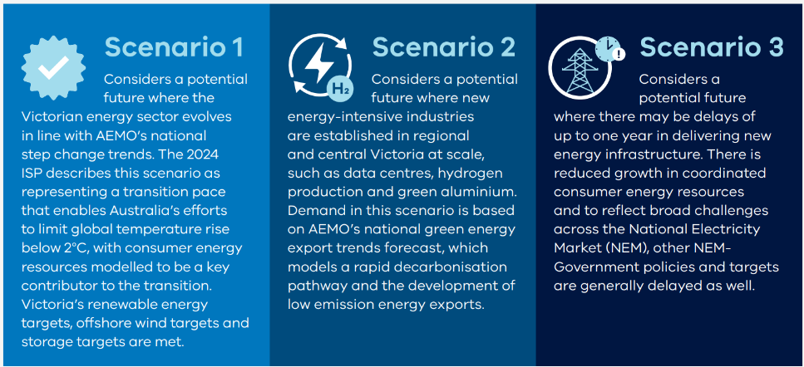
Scenario 1: Considers a potential future where the Victorian energy sector evolves in line with AEMO’s national step change trends. The 2024 ISP describes this scenario as representing a transition pace that enables Australia’s efforts to limit global temperature rise below 2°C, with consumer energy resources modelled to be a key contributor to the transition. Victoria’s renewable energy targets, offshore wind targets and storage targets are met.
Scenario 2: Considers a potential future where new energy-intensive industries are established in regional and central Victoria at scale, such as data centres, hydrogen production and green aluminium. Demand in this scenario is based on AEMI’s national green energy export trends forecast, which models a rapid decarbonisation pathway and the development of low emission energy exports.
Scenario 3: Considers a potential future where there may be delays of up to one year in delivering new energy infrastructure. There is reduced growth in coordinated consumer energy resources and to reflect broad challenges across the National Electricity Market (NEM), other NEM-Government policies and targets are generally delayed as well.

A.1.2 The existing transmission network and projects under development
The transmission network in Victoria is made up of terminal stations, substations, and high voltage transmission lines that work together to transport electricity over long distances, from large-scale generating systems to substations and loads. Victoria’s transmission network is part of the National Electricity Market (NEM), and is interconnected with New South Wales, South Australia, and Tasmania’s networks.
Much of the transmission network in Victoria was developed many years ago to supply electricity from coal-fired generation in the Latrobe Valley to greater Melbourne and Victorian regional centres. As the energy transition develops, the network needs to adapt to diverse and dispersed renewable generation located across Victoria.
The development of the Snowy Mountains scheme provided the first interconnector between New South Wales and Victoria. Interconnection capacity has since expanded with interconnectors to South Australia and Tasmania and is now a critical element in the NEM that provides access to diverse renewable energy resources and the sharing of firming resources.
The existing network continues to evolve. The VTP planning process has considered those projects that are underway under other transmission planning processes. This includes committed projects and those that are at an advanced stage of development before delivery. Each of these projects are assumed as a baseline input for the VTP planning and modelling process. These projects are illustrated in Figure A-2 and further details are provided in Section A.4.3.
Figure A - 2 Transmission projects under development assumed as a baseline input for the VTP
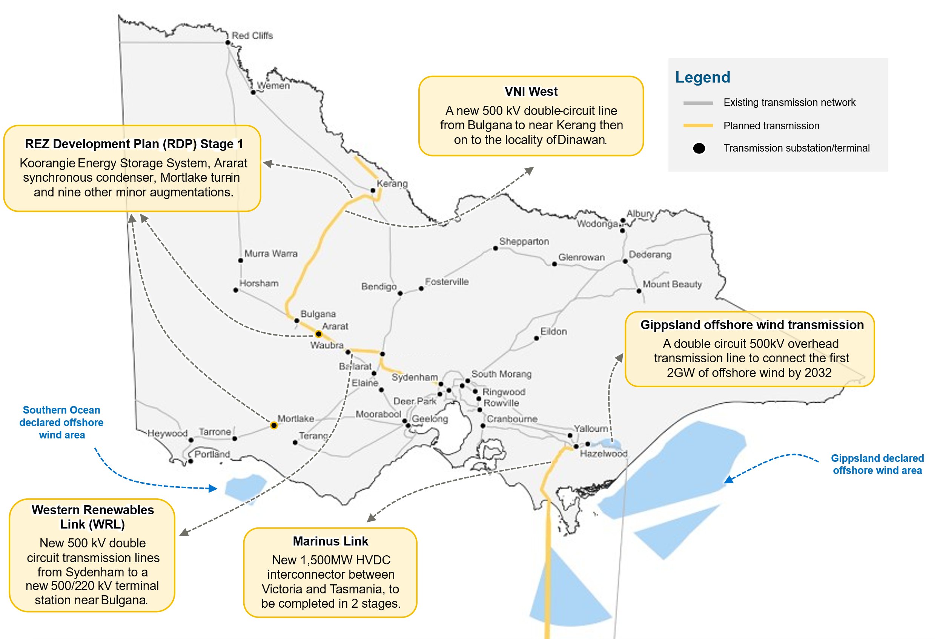
Map reference source: VicGrid Analysis – Victorian Annual Planning Report (VAPR) 2024. Note: This figure includes projects defined as Committed and Anticipated or Actionable under the Australian Energy Market Operator’s 2024 Integrated System Plan (ISP), including: proposed alignments for Marinus Link, Victoria to New South Wales Interconnector West (VNI West), Western Renewables Link (WRL) and the Gippsland offshore wind transmission stage 1.
We developed the candidate development pathways through detailed consideration of the current transmission network in Victoria, its strengths and limitations, and how well it would meet future demand identified in the VTP scenarios and forecast generation in the proposed REZs. Further details of the generation identified in each proposed REZ is provided in Part B of the VTP, with detailed energy market modelling results included in Appendix B. The candidate development pathways also consider the investments needed to support the most efficient transfer of electricity from the proposed REZs to Victoria’s load centres.

A.1.3 Understanding the need for transmission
The transmission network needs for each proposed REZ, under each scenario, have driven the design of candidate development pathways. The need for additional transmission is primarily identified through a detailed analysis of the energy market modelling outcomes for projected generation in each proposed REZ and the system-wide demand for each scenario (refer Appendix B). A staged approach was adopted that included reviewing:
generation duration and dispatch curves to understand load, including locations of large loads
resource correlation outputs to understand coincidental peaks and troughs
additional transmission capacity requirements as identified through energy market modelling (see Appendix B)
existing constraint-related information.
A key consideration is to reduce the need for additional transmission where possible, to reduce costs and impacts on communities, landholders, the environment and cultural heritage. This has been considered, where possible, through:
the development of the generation resource plan, including the planned generation in the proposed REZs
the use of dynamic wind monitoring and system overload control schemes
the energy market optimisation undertaken in our approach to energy market modelling (refer to Appendix B).
Once this staged approach was complete, the need for changes to the transmission network was clearly documented (refer to Appendix C for further details).

A.1.4 Transmission planning
As outlined above, the energy market modelling (refer Appendix B) identified the need for transmission expansion across Victoria, to support the projected renewable energy generation from the proposed REZs on a year-to-year basis. Adopting a transmission planning approach, we then identified a series of transmission projects that, over time, could potentially meet the identified need.
In developing a longlist of plausible transmission projects, we also considered other planning documents and processes, including AEMO’s ISP and VAPR, previous reports by the Victorian Government, and other energy planning documentation. We supplemented this long-list with additional projects based on existing planning documents and modelling undertaken by VicGrid.
To ensure the candidate development pathways included the most effective projects to meet the established need, we assessed the projects and their alternatives against 5 high-level transmission network planning considerations, outlined in Table A-1. Following this assessment, the most appropriate projects were included in the candidate development pathways and assessed in power systems modelling software (refer to Appendix C).
Table A-1: Transmission network development planning considerations
Consideration | Rationale and how it was applied
Network performance | Indicative network performance outcomes were assessed through a review of the power system simulation for engineering (PSS/E) model – see Appendix C – and reporting as part of other planning documents such as the ISP and VAPR. This was later verified through power systems modelling.
Indicative delivery cost | Indicative delivery costs were assessed for each project by comparing the indicative project scope against other similar benchmarked projects. More detailed costing of projects was subsequently conducted in Step 4 of the methodology for down-selected projects, to facilitate the cost-benefit analysis of the candidate development pathways. See Section A.4 for cost estimates for each project.
Land use, community acceptance and traditional owner’s perspectives | When defining a project option, preference was given to alignments and solutions which are within existing transmission corridors. Where this was not possible, inputs from the strategic land use assessment were assessed to minimise new impacts of potential transmission infrastructure projects.
Delivery timing and constructability | High level constructability considerations (including factors such as topography and access) were identified for each project option as applicable. A more detailed scheduling review was subsequently conducted in Step 4 for down-selected projects, to determine delivery dates and support cost profiling in the cost-benefit analysis of the candidate development pathways. See Section A.4 for the proposed delivery dates for each project.
Long-term future network requirements | Project options were defined with a view to potential long-term future network requirements. Where practical, the project option which is more adaptable to uncertain future requirements was preferred.
Note: For the VTP, power systems modelling was conducted for candidate development pathway 1 and 2 under Scenarios 1 and 2 respectively, and limited to thermal analysis. Further details are provided in Appendix C. The modelling results were then extended for candidate development pathway 3 where appropriate.

A.2 Candidate development pathways
The projects identified through transmission planning and power systems analysis (refer to Appendix C) were grouped into programs depending on their need, location, timing, and project type. Table A-2 outlines the delivery dates for each program under each candidate development pathway. Further details on each program and project are outlined in Section A.4.
Table A-2: Transmission programs and required timing for each candidate development pathway
Program | Why it’s needed | What it does | CDP1 delivery date | CDP2 delivery date | CDP3 delivery date
1. Western Victoria reinforcement program | Western Victoria is a resource-rich region with potential for substantial new generation that would exceed the existing transfer capacity. This program is needed to facilitate the connection of generation in the South West, Western, Central Highlands and North West proposed REZs and to reinforce the network supply to metropolitan Melbourne. | The program includes minor network augmentations and upgrades of existing infrastructure, including substation works at Elaine, South Morang and Keilor, Deer Park turn-in, and increasing the capacity of the Ballarat to Moorabool 220 kV line. | Between 2028 and 2030 | Between 2028 and 2030 | Between 2028 and 2030
2. Eastern Victoria reinforcement program | To meet increased demand in eastern metropolitan Melbourne, respond to shifting supply from the east of Victoria to the west of Victoria and support the connection and security of supply in the Gippsland and Central North proposed REZs and the Gippsland offshore wind area. | A suite of minor network augmentations, an upgrade of the 220kV line between Dederang and Eildon and an additional line between Hazelwood and Yallourn.  This program is needed to optimise existing assets to accept higher demands and to utilise the 220 kV network after Yallourn retires. | Between 2028 and 2030 | Between 2028 and 2030 | Between 2028 and 2030
3. North West strengthening program | The North West region of the network is inherently low capacity and was not initially designed for high levels of generation. This program is needed to support additional generation in the Western and North West proposed REZs and support its transfer to load centres. | These projects will replace the existing single circuit transmission in sections with a new high-capacity double circuit line including from Murra Warra to Ballarat and from Kerang to Bendigo.  In candidate development pathway 2, this program also involves replacing the existing single circuit with a new high-capacity double circuit line from Red Cliffs to Kerang to support additional generation. | 2035 | 2034 | 2035
4. South West expansion program | South West Victoria has the potential for new generation that would exceed the existing transfer capacity. This program is needed to meet significant demand for high-quality wind generation, including additional generation in the South West and Central Highlands proposed REZs. It also accommodates the South Australia to Victoria interconnector. | New double circuit 500 kV line from Tarrone to Truganina and a new single circuit 500 kV line from Truganina to Sydenham in Melbourne’s north, passing through Mortlake and Moorabool.  This program also includes a new 500/220 kV substation at Truganina and high-capacity 220 kV lines to Deer Park and Keilor to provide an alternative flow path from the proposed REZs into Melbourne and service potential new large loads in this area.  Under candidate development pathway 2 this program also extends the new double circuit 500 kV line from Tarrone to Heywood. | 2033 | Between 2032 and 2038 | 2034
5. Gippsland offshore wind transmission stage 2 program | A new network is required to accept bulk offshore wind and renewables for integration into existing Latrobe Valley infrastructure. This program is needed to connect significant generation in the Gippsland offshore wind area. | The Gippsland ring will connect 7.5 GW of offshore wind and onshore generation by 2040. A high-level analysis has been conducted based on system needs and a preferred route will only be identified after a public consultation process. | Between 2033 and 2038 | Between 2033 and 2038 | Between 2034 and 2039
6. Latrobe Valley strengthening program | This program enables increased utilisation of existing 220 kV assets following retirement of Yallourn and absence of coal generation. It supports connection and transfer to load centres of generation in the Gippsland proposed REZ and the Gippsland offshore wind area. | Provision of power flow controllers in the Latrobe Valley to ensure optimal use of existing infrastructure. The program also includes an additional transformer at either Rowville or Cranbourne to support increased demand in the Melbourne metropolitan area. | Between 2034 and 2035 | Between 2034 and 2035 | 2035
7. Offshore wind upgrade | Present assets are insufficiently rated to accept target offshore wind values, requiring network augmentation. This program is needed to connect generation in the Southern Ocean offshore wind area. | Uprating of existing Portland to Heywood 500 kV double circuit lines. VicGrid will seek to deliver this to align with the timing of offshore development in Southern Ocean, so there is flexibility to deliver this project earlier. | 2038 | 2038 | 2039
8. New Sydenham to Keilor link | Increasing Melbourne metropolitan demand requires network flow paths for distribution of power from the proposed REZs to load centres. This program addresses network limitations in scenario 2. | An additional Sydenham to Keilor 500 kV single circuit to support the distribution of power to Melbourne. | N/A | 2035 | N/A
9. Central North strengthening program | This region of the network is inherently low capacity and was not initially designed to accept high values of generation. This program is required to accommodate higher forecast generation in scenario 2 in the Central North proposed REZ. | Program of works to facilitate the transfer of increased power from the central north of the state to Melbourne. | N/A | Between 2033 and 2035 | N/A
10. Inner South West strengthening program | This program addresses network limitations under higher generation forecast in scenario 2 in the South West, Western and North West proposed REZs. | Program of works to add increased capacity and resilience to the inner south west area of Victoria. | N/A | Between 2031 and 2038 | N/A

A.2.1 Candidate development pathway 1
Candidate development pathway 1 has been designed to support the generation forecast in the proposed REZs under VTP scenario 1. Scenario 1 considers a potential future where the Victorian energy sector evolves in line with AEMO’s national demand trends (step change scenario) with consumer energy resources modelled to be a key contributor to the transition.
Candidate development pathway 1 is made up of 7 programs. Two of these are needed by 2030, to support generation in the proposed REZs required to achieve the 2030 Victorian Renewable Energy Targets (VRET) and the Capacity Investment Scheme (CIS) targets outlined in the Renewable Energy Transformation Agreement signed between the Australian and Victorian Governments in late 2024.
Candidate development pathway 1 includes 5 programs that are required between 2030 and 2040. This includes expanding the south west Victorian transmission network through the duplication of the existing 500 kV transmission lines from Tarrone to Truganina via connections at Mortlake and Moorabool, and a new single circuit from Truganina to Sydenham by 2033, rebalancing Victoria’s transmission network from coal-fired generation in the south east of Victoria, to renewable energy generation in the South West and Central Highlands proposed REZs. New infrastructure, including a second radial line and tie-in loop, developed in 2 stages, is also required in the Latrobe Valley and Gippsland to support generation in the Gippsland proposed REZ and the Gippsland offshore wind area.
The candidate development pathway also includes upgrades to the 220 kV network in Western, North West and Central North Victoria to support the Western, North West and Central North proposed REZs.
The 7 programs in candidate development pathway 1 are shown in Figure A-3. Further details, including the projects in each program, are included in Section A.4.
Figure A - 3 Candidate development pathway 1
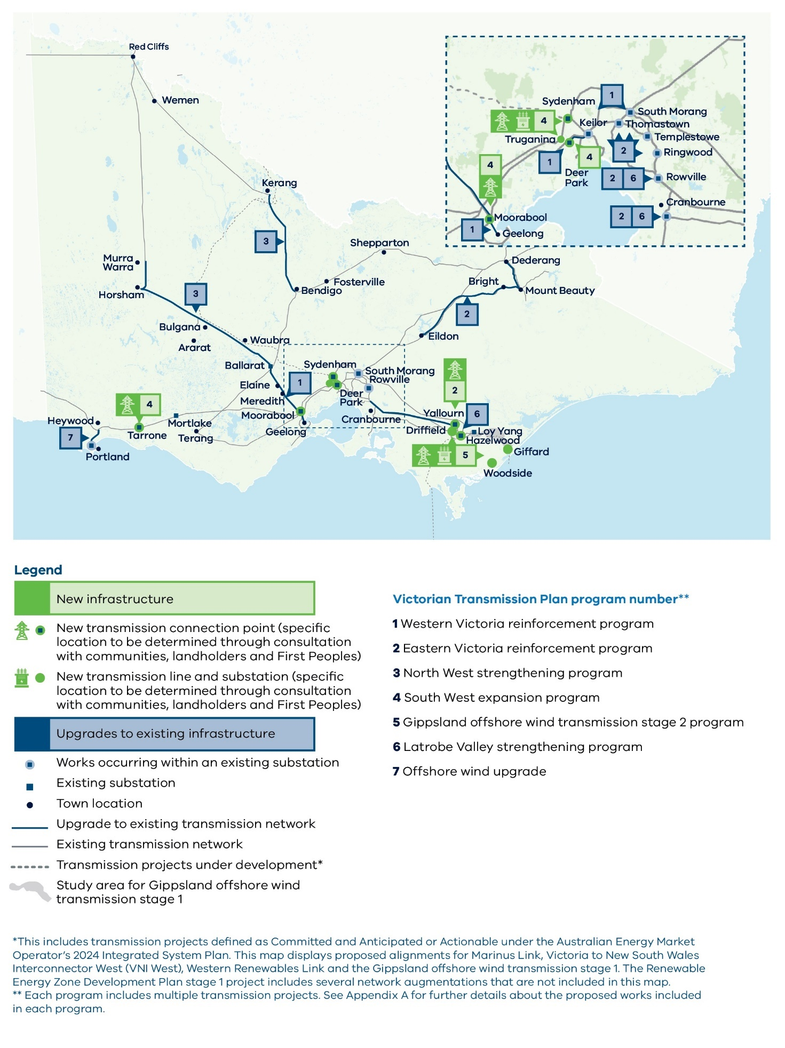
Map disclaimer: This map includes transmission projects defined as Committed and Anticipated or Actionable under the Australian Energy Market Operator’s 2024 Integrated System Plan. This map displays proposed alignments for Marinus Link, Victoria to New South Wales Interconnector West (VNI West), Western Renewables Link and the Gippsland offshore wind transmission stage 1. The Renewable Energy Zone Development Plan stage 1 project includes several network augmentations that are not included in this map. Each program includes multiple transmission projects.

A.2.2 Candidate development pathway 2
Candidate development pathway 2 has been designed to support the generation forecast in the proposed REZs under VTP scenario 2. Scenario 2 considers a potential future where new energy-intensive industries are established in regional and central Victoria at scale, such as data centres, hydrogen production and green aluminium. Demand in this scenario is based on AEMO’s national green energy export trends forecast, which models a rapid decarbonisation pathway and the development of low-emission energy exports. The level of industry development and scale of energy demand from this scenario is greater than in scenarios 1 and 3, resulting in increased generation requirements to cater for these industries, and an associated increase in transmission capacity.
Candidate development pathway 2 includes all 7 programs outlined in candidate development pathway 1, with 2 of them delivered earlier to meet the higher energy generation and demand forecast in scenario 2 (see table A-2 above for reference). Candidate development pathway 2 also includes some additional projects and programs, as described below.
Both the North West strengthening program and the South West expansion program each include one additional project to address the need for additional generation in the proposed REZs in the North West, West and South West respectively:
North West strengthening program – in candidate development pathway 2, this program includes an additional project to replace the existing single-circuit transmission between Red Cliffs and Kerang with a new high-capacity double circuit line to support additional solar generation in the North West proposed REZ.
South West expansion program – in candidate development pathway 2, this program includes an extension of the new Moorabool to Tarrone 500 kV double circuit line in candidate development pathway 1 to Heywood, to support additional wind generation in the South West proposed REZ.
Candidate development pathway 2 introduces 3 new programs designed to strengthen supply to Melbourne, and address the need for additional generation in the South West and Central North:
Sydenham to Keilor link – A new circuit between Sydenham to Keilor to support the distribution of power from the Wimmera Southern Mallee, Grampians Wimmera and North West proposed REZs to load centres.
Central North strengthening program – A program of works to facilitate the transfer of increased power from the Central North proposed REZ to load centres.
Inner South West strengthening program – A program of works to add increased capacity and resilience to the inner south west area of Victoria and support the transfer of power from the South West, Western and North West proposed REZs.
Further details of candidate development pathway 2, including the projects in each program, are included in Section A.4.

A.2.3 Candidate development pathway 3
Candidate development pathway 3 was designed to support the generation forecast in the proposed REZs in VTP scenario 3. Scenario 3 considers a potential future where there may be delays of up to one year in delivering new energy infrastructure, there is reduced growth in coordinated consumer energy resources, and NEM-government policies and targets are delayed, reflecting broad challenges in energy transition across the NEM.
The transmission projects included in candidate development pathway 3 are the same as those included in candidate development pathway 1 (see Table A-2 for further detail).
The primary distinction of candidate development pathway 3 is that the delivery dates for most projects can be deferred in line with the delays seen under scenario 3.
Further details of candidate development pathway 3, including the projects in each program, are included in Section A.4.

A.2.4 Program and project delivery
The transmission programs and their projects represent an ambitious pathway of projects over the next 10 to 15 years. In line with the modelled timeframes, detailed delivery cases, design and planning for key projects will commence imminently. All proposed transmission projects will continue to be subject to relevant planning and environmental approvals in Victoria, with consultation building on the broad and early engagement undertaken during development of the VTP.

A.3 Optimal development pathway
The pathways outlined above have each been designed to best match the needs of a particular scenario. While each of the 3 VTP scenarios are plausible and high impact, the future is uncertain, and the optimal development pathway needs to outline a plan which is optimised over a range of possible futures.
To identify the optimal development pathway, a robustness analysis has been undertaken in which each candidate development pathway is tested in all 3 scenarios. Appendix D provides further details on the methodology for the robustness analysis. Our analysis confirms candidate development pathway 1 is the optimal development pathway for the VTP.
Importantly, candidate development pathway 2 comprises the same programs as candidate development pathway 1, plus 3 additional programs (and 2 additional projects). If future outcomes are more consistent with the outcomes observed under scenario 2, these 3 additional programs and projects can be progressed, providing further options as the energy transition unfolds. Conversely, should demand be lower than anticipated, or there are infrastructure delays such as the potential future considered in scenario 3, programs can be deferred (or not progressed).

A.4 Transmission program and project details
The transmission programs and projects included in each candidate development pathway, as well as their anticipated timing, are summarised in Table A-3. Each program and project are further detailed in this section.
We have estimated capital expenditure costs for each project included in the candidate development pathways. Cost estimates have been assessed to a Class 5 estimate (-50% to +100%) and are based on industry benchmarks and data sources. AEMO published an updated transmission cost database in late May and the cost increases estimated by VicGrid largely aligns with the increases in this database.
The costs do not include operating and maintenance expenditure. They also exclude allowances for land acquisition, VicGrid and development/delivery partner, financing, risk and escalation costs. These exclusions are consistent with the Class 5 estimate level.
Further details of the total cost of each candidate development pathway are included in Appendix D. Cost estimates will be refined further and increase in accuracy as projects are designed in detail in subsequent planning stages and engineered into fully costed solutions.
Table A-3: List of transmission programs and projects in each of the candidate development pathways
Program number | Project | CDP1 delivery date | CDP2 delivery date | CDP3 delivery date
1.1 | Increase the rating of the Moorabool to Geelong 220 kV circuits (No.1 and No.2) | 2028 | 2028 | 2028
1.2 | Replace the H1 and H2 330/220 kV transformers at South Morang | 2030 | 2030 | 2030
1.3 | Rebuild the existing transmission line between Ballarat and Moorabool into a 220 kV high-capacity double circuit | 2030 | 2030 | 2030
1.4 | Switch the existing Geelong to Keilor circuits into Deer Park (No.1 and No.3) | 2029 | 2029 | 2029
1.5 | Undertake a 1000MVA replacement of the A2, A3 and A4 500/220 kV transformers at Keilor | 2030 | 2030 | 2030
2.1 | Install a second Hazelwood to Yallourn double circuit line | 2028 | 2028 | 2028
2.2 | Install a second 500/220 kV transformer at Cranbourne and tie in the existing Hazelwood to Rowville 500 kV (No.3) circuit at Cranbourne | 2030 | 2030 | 2030
2.3 | Undertake load management works on the Rowville to Templestowe to Thomastown 220 kV circuit, and Rowville to Ringwood to Thomastown 220 kV circuit | 2028 | 2028 | 2028
2.4 | Undertake fault level mitigation at Keilor, Rowville, South Morang and Thomastown 220 kV buses, and Templestowe and Thomastown 66 kV buses | 2028 | 2028 | 2028
2.5 | Increase the rating of the existing Mount Beauty to Dederang and Mount Beauty to Eildon lines | 2029 | 2029 | 2029
3.1 | Rebuild the existing transmission line between Murra Warra, Horsham and Ballarat into a high-capacity double circuit line | 2035 | 2034 | 2035
3.2 | Rebuild the existing transmission line between Red Cliffs and New Kerang into a high-capacity double circuit line | NA | 2034 | NA
3.3 | Rebuild the existing transmission line between New Kerang and Bendigo into a high-capacity double circuit line | 2035 | 2034 | 2035
4.1 | Install a new 500/220 kV terminal station at Truganina and 2 220 kV double circuit lines from Truganina to Deer Park | 2033 | 2032 | 2034
4.2 | Install a new 500 kV double circuit line from Tarrone to Mortlake to Moorabool and Tarrone 500 kV turn in | 2033 | 2032 | 2034
4.3 | Install a new 500 kV double circuit from Moorabool to Truganina and single circuit from Truganina to Sydenham | 2033 | 2032 | 2034
4.4 | Rebuild the 3 existing transmission lines between Deer Park and Keilor with new high-capacity double circuit lines | 2033 | 2032 | 2034
4.5 | Install a new 500 kV double circuit line from Heywood to Tarrone | NA | 2038 | NA
5.1 | Install a second Gippsland 500 kV double circuit radial line and tie-in loop | Between 2033 and 2038 | Between 2033 and 2038 | Between 2033 and 2039
6.1 | Install power flow controllers at Hazelwood | 2034 | 2034 | 2035
6.2 | Install an additional transformer at Cranbourne or Rowville | 2035 | 2035 | 2035
7.1 | Increase the rating of the Portland to Heywood 500 kV double circuit lines | 2038 | 2038 | 2039
8.1 | Install a new 500 kV single circuit from Sydenham to Keilor | NA | 2035 | NA
9.1 | Rebuild the existing 220 kV transmission line between Shepparton and Dederang as a double circuit | NA | 2033 | NA
9.2 | Add a fourth 330/220 kV transformer at Dederang | NA | 2035 | NA
9.3 | Rebuild the existing 220 kV transmission line between Shepparton and Bendigo as a double circuit | NA | 2033 | NA
10.1 | Install a new 220 kV single circuit from Moorabool to Geelong | NA | 2031 | NA
10.2 | Add a fourth 1000 MVA 500/220 kV transformer at Keilor | NA | 2038 | NA
10.3 | Install a new 500 kV double circuit from Mortlake to Bulgana | NA | 2035 | NA
Notes: Candidate development pathway 1 has been identified as the optimal development pathway.
Further details on each project are provided in this section.

1: Western Victoria reinforcement program

1.1 Increase the rating of the Moorabool to Geelong 220 kV circuits (No.1 and No.2)
Project summary:
Type: Upgrade to existing infrastructure
Reference: AEMO Victorian Annual Planning Report 2024
In service date:
  - SC1: 2028
  - SC2: 2028
  - SC3: 2028
- Estimate cost: $10M
Project overview:
This project increases the rating of the Moorabool to Geelong 220 kV circuits (No.1 and No.2) by reassessing the existing system overload control scheme in the vicinity and investigating whether it can be modified to enable increased capacity, along with upgrading any low-rated interplant equipment. Alternatively, a new system overload scheme may need to be put in place.
This project supports forecast generation in the South West, Central Highlands, Western and North West proposed REZs, and increases capacity into South West metropolitan Melbourne and consumers.
The line between Moorabool and Geelong is located within the Registered Aboriginal Party (RAP) boundary of Wadawurrung Traditional Owners Aboriginal Corporation and is in the Greater Geelong City Local Government Area (LGA).
Project benefits
The system overload control scheme allows for more efficient use of the existing transmission lines, with real-time thermal capacity based on wind speed and ambient temperature conditions.
The increased thermal capacity will accommodate increased demand and reduce network congestion without the need for significant new infrastructure.
Alternatives considered
In the 2024 VAPR, AEMO considered the following alternative options to manage line loadings in this area:
Install a third circuit from Moorabool to Geelong. These works would entail constructing a third Geelong to Moorabool 220 kV line, however this would be more costly than the preferred solution. This project has been included as part of Project 10.1, which was considered in CDP 2 to facilitate a higher load forecast in South West metropolitan Melbourne for Scenario 2.
Construct a new 500/220 kV Truganina terminal station cutting into the existing Moorabool to Sydenham 500 kV lines and build 220 kV lines from Truganina to Deer Park (Project 4.1). This project has been included as part of the South West expansion program to be delivered at a later date.
Figure A - 4 1.1 Increase the rating of the Moorabool to Geelong 220 kV circuits (No.1 and No.2)
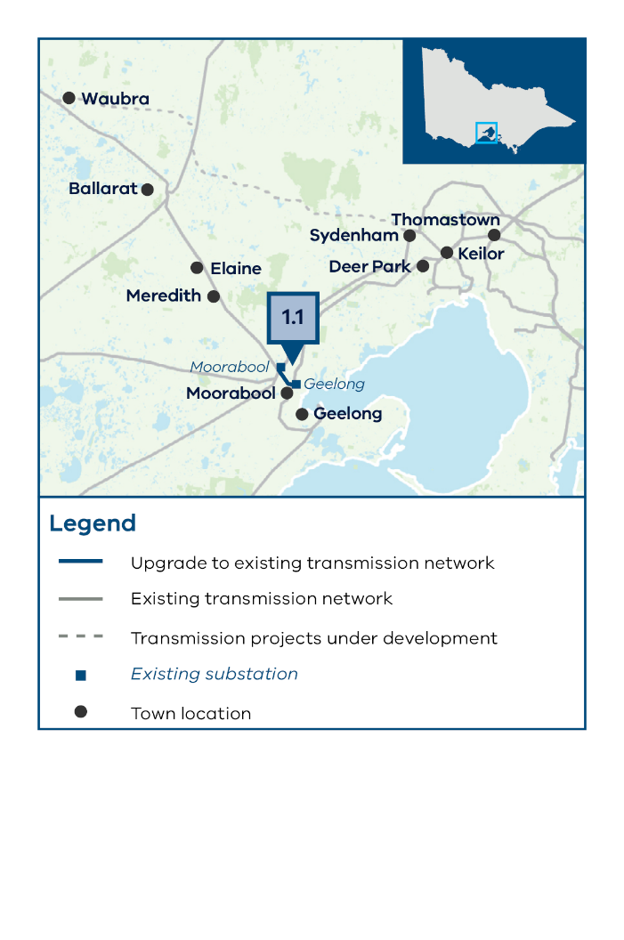

1.2 Replace the H1 and H2 330/220 kV transformers at South Morang

Project summary:
Type: Upgrade to existing infrastructure
Reference: AEMO Victorian Annual Planning Report 2024
In service date:
  - SC1: 2030
  - SC2: 2030
  - SC3: 2030
- Estimate cost: $70M
Project overview:
This project involves replacing the H1 and H2 South Morang 330/220 kV transformers in 2030. One of the transformers will be used as an in-service unit and the other as a hot spare. The project also replaces associated secondary equipment.
This project is needed to increase supply capacity from the proposed REZs to Melbourne consumers and to mitigate risks from asset failures.
This project is located within the RAP boundary of Wurundjeri Woi Wurrung Cultural Heritage Aboriginal Corporation and is within the Whittlesea City LGA.
Project benefits
Replacing the existing South Morang transformers will reduce energy loss during transmission and increase energy reliability by reducing the likelihood of transformer failure. This critical new infrastructure will help to ensure the reliability and efficiency of the system and allow for more effective integration of renewable energy generation from the proposed REZs.
Additional comments
The 2024 AEMO VAPR previously considered replacing the H1 South Morang 330/220kV transformer. This project (1.2) also includes replacing the H2 South Morang 330/220kV transformer.
The replacement of the transformers at South Morang is also part of an active asset replacement Regulatory Investment Test for Transmission (RIT-T) being undertaken by AusNet Services.
VicGrid will continue to monitor this project and assess the differential cost and benefit of either replacing with higher capacity units or operation of 330kV/220kV transformers in parallel, depending on forecasted demand and generation.
Alternatives considered
Not applicable.

Figure A - 5 1.2 Replace the H1 and H2 330/220 kV transformers at South Morang
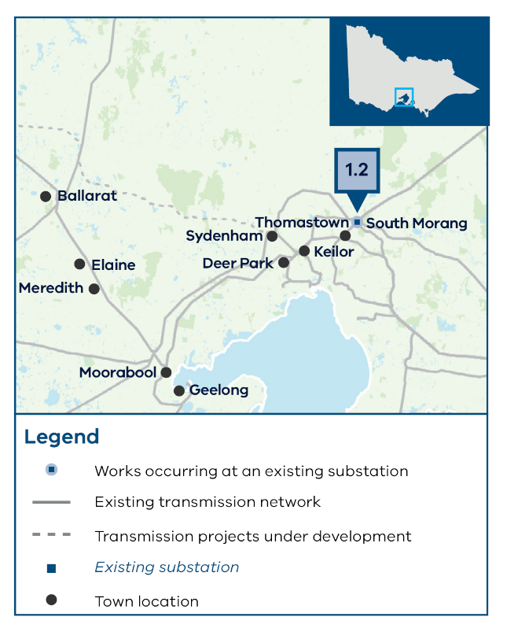

1.3 Rebuild the existing transmission line between Ballarat and Moorabool into a 220 kV high-capacity double circuit
Project summary:
Type: Upgrade to existing infrastructure
Reference: REZ Development Direction Paper and AEMO Victorian Annual Planning Report 2024
In service date:
  - SC1: 2030
  - SC2: 2030
  - SC3: 2030
- Estimate cost: $360M
Project overview:
This project involves rebuilding the existing 220 kV single circuit transmission line from Ballarat Terminal Station to Moorabool Terminal Station (No.1) into a double circuit 220 kV transmission line with higher capacity per circuit.
This project is needed to increase network capacity to support new generation from the Western and North West proposed REZs, and to minimise generator curtailment during periods of high renewable generation.
The length of this project is approximately 63 km.
The project is located within the RAP boundary of Wadawurrung Traditional Owners Aboriginal Corporation and is within the Ballarat, Moorabool, Golden Plains Shire and Greater Geelong City LGAs.
Project benefits
This project will provide additional network capacity for future renewable energy generation projects and increase utilised renewable energy.
Additional comments
The REZ Development Plan (RDP) Directions Paper and 2023 AEMO Transmission Expansion Options Report (TEOR) previously considered constructing a new 220 kV single circuit overhead transmission line from Elaine to Moorabool. Comparatively, this project includes rebuilding the existing transmission line from Ballarat to Moorabool into a 220kV high-capacity double circuit.
VicGrid will monitor and assess the differential cost and benefit of a cut-in of the proposed high-capacity circuits at Elaine. It is expected that this could require additional series impedance to manage the thermal loadings of the lines and further engineering assessment is required to determine the scope of this cut-in.
Alternatives considered
No alternative projects were identified that could meet the expected need for transmission as this is a key corridor for generation from western and north western Victoria flowing toward metropolitan Melbourne.
Figure A - 6 1.3 Rebuild the existing transmission line between Ballarat and Moorabool into a 220 kV high-capacity double circuit
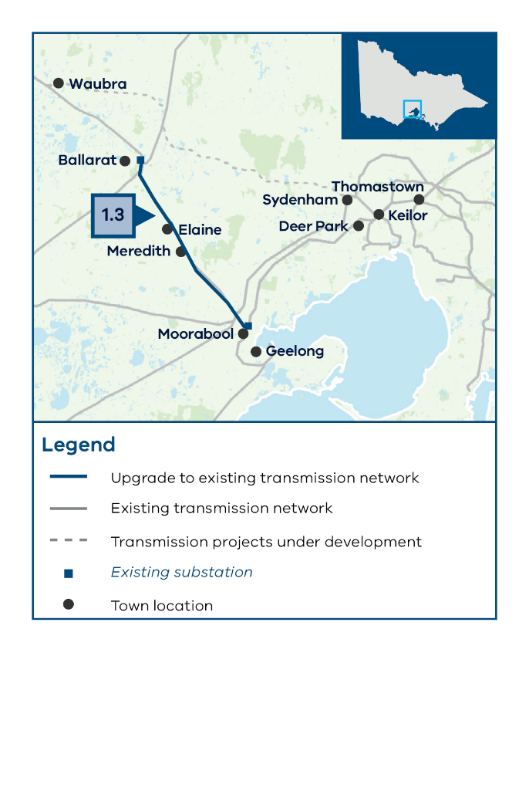

1.4 Switch the existing Geelong to Keilor circuits into Deer Park (No.1 and No.3)
Project summary:
Type: Upgrade to existing infrastructure
Reference: AEMO Victorian Annual Planning Report 2024
In service date:
  - SC1: 2029
  - SC2: 2029
  - SC3: 2029
- Estimate cost: $50M
Project overview:
- This project involves redirecting the 2 Geelong to Keilor lines that currently bypass Deer Park and turning them into Deer Park. This will create 3 parallel lines from Geelong to Deer Park to Keilor. This project assumes that the 3 220 kV lines running from Deer Park to Keilor will operate as normally open.
- However, this project also allows for operational flexibility, and depending on network conditions, could operate with Deer Park to Keilor as normally closed, with Deer Park to Geelong as normally open to manage better manage network constraints.
- This project is needed to connect large-scale forecast new generation from the South West, North West, Western and Central Highlands proposed REZs to metropolitan Melbourne consumers and to reduce network congestion.
- The project is located within the RAP boundaries of the Wurundjeri Woi Wurrung Cultural Heritage Aboriginal Corporation and the Bunurong Land Council Aboriginal Corporation and is within the Melton City LGA.
Project benefits
Turning in the existing circuits to create 3 parallel lines from Geelong to Deer Park to Keilor will support greater reliability in the Western Victorian network.
Alternatives considered
No alternatives were considered, as this project is essential to the delivery of capacity to service consumer demand in the Melbourne metropolitan area.
Figure A - 7 1.4 Switch the existing Geelong to Keilor circuits into Deer Park (No.1 and No.3)
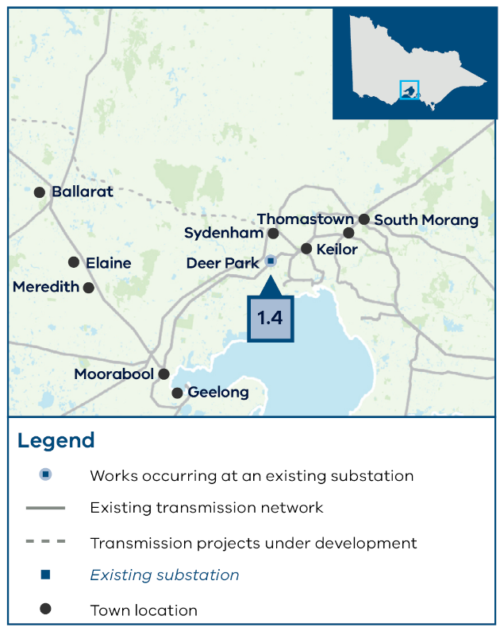

1.5 Undertake a 1000 MVA replacement of the A2, A3 and A4 500/220 kV transformers at Keilor
Project summary:
Type: Upgrade to existing infrastructure
Reference: AEMO Victorian Annual Planning Report 2024
In service date:
  - SC1: 2029
  - SC2: 2029
  - SC3: 2029
- Estimate cost: $150M
Project overview:
This project involves replacing the 3 existing 750 MVA 500/220 kV transformers with higher capacity 1000 MVA transformers and performing fault mitigation to support this upgrade.
This project is needed to connect large-scale forecast new generation from the South West, North West, Western and Central Highlands proposed REZs to metropolitan Melbourne consumers and reduce network congestion.
The project is located within the RAP boundary of the Wurundjeri Woi Wurrung Cultural Heritage Aboriginal Corporation and is within the City of Brimbank LGA.
Project benefits
The existing transformers at Keilor have been identified for replacement by AusNet Services and AEMO to ensure safe and reliable transmission services, due to the age and condition of these assets. This replacement represents an opportunity to alleviate the thermal limitations at the Keilor Terminal Station during peak demand periods. This limit arises not only due to forecasted demand growth in the western metropolitan Melbourne network but also increased generation located in the west of Victoria.
Additional comments
AusNet Services and AEMO both have active RIT-Ts consulting on the replacement of the transformers at Keilor. These are considering 2 options: like for like replacement and upgrade to 1000 MVA. AusNet’s preferred option is the latter, which presents a higher net economic benefit. The scope set out in AusNet’s RIT-T also includes additional scope, such as the replacement of the B4 220kV/66 kV transformer at Keilor, and therefore carries a higher estimated capital cost.
Alternatives considered
No alternatives were considered, as this project is essential to the delivery of capacity to service consumer demand in the Melbourne metropolitan area.
Figure A - 8 1.5 Undertake a 1000 MVA replacement of the A2, A3 and A4 500/220 kV transformers at Keilor
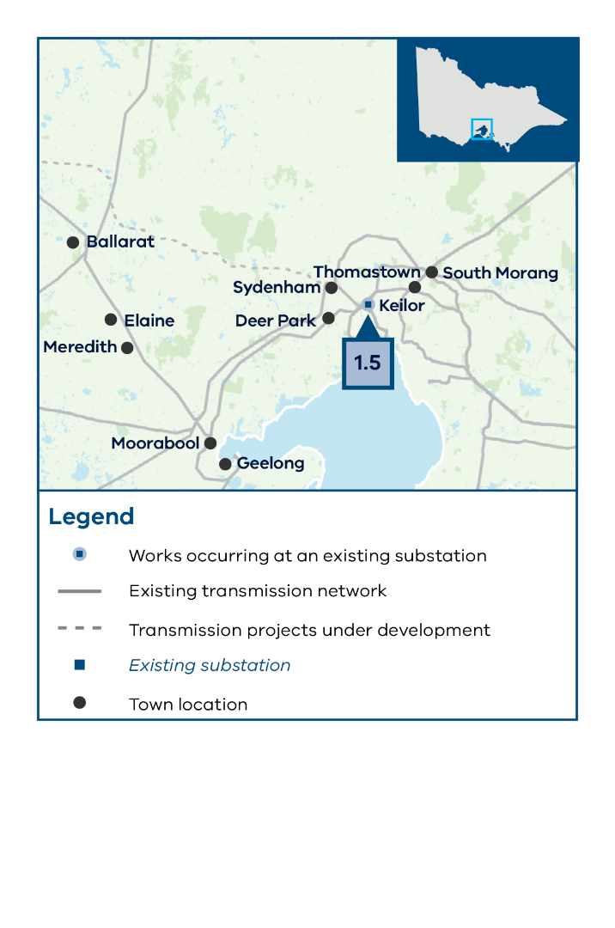

2: Eastern Victoria reinforcement program

2.1 Install a second Hazelwood to Yallourn double circuit line
Project summary:
Type: New infrastructure required
Reference: AEMO Transmission Expansion Options Report 2023
In service date:
  - SC1: 2028
  - SC2: 2028
  - SC3: 2028
- Estimate cost: $100M
Project overview:
This project installs a second Hazelwood to Yallourn 220 kV double circuit (No.3 and No.4).
This project is needed to increase the transfer from the Gippsland area after the Yallourn Power Station retirement to ensure security of supply to consumers from onshore and offshore generation in the Gippsland proposed REZ and the Gippsland offshore wind area.
The length of this project is approximately 10 km between Hazelwood and Yallourn.
The project is located within the RAP boundary of the Gunaikurnai Land and Waters Aboriginal Corporation and is within the Latrobe City LGA.
Project benefits
This project will enable the connection of onshore wind in the Gippsland proposed REZ and offshore wind generation in the Gippsland offshore wind area.
Additional comments
The VTP has identified a need for this project but has not yet identified a preferred route, which could involve widening the existing 220 kV double circuit (No.1 and No.2) easement. VicGrid will consult publicly to determine a study area for this project before identifying a preferred corridor.
Alternatives considered
Installation of an additional 500 kV circuit between Hazelwood and South Morang. This project would be significantly more expensive and is therefore not the preferred option.
Figure A - 9 2.1 Install a second Hazelwood to Yallourn double circuit line
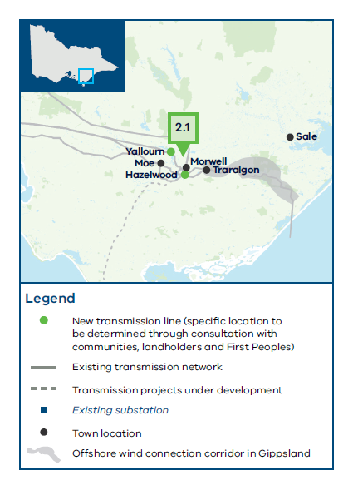

2.2 Install a second 500/220 kV transformer at Cranbourne and tie in the existing Hazelwood to Rowville 500 kV (No.3) circuit at Cranbourne
Project summary:
Type: Upgrade to existing infrastructure
Reference: AEMO Victorian Annual Planning Report 2024
In service date:
  - SC1: 2030
  - SC2: 2030
  - SC3: 2030
- Estimate cost: $90M
Project overview:
This project includes installing a second 1000 MVA 500/220 kV transformer at Cranbourne and delivering associated substation augmentation works. It also involves turning in the Hazelwood to Rowville No.3 500 kV circuit at Cranbourne and transferring the existing 500/220 kV A2 transformer at Rowville to supply the Rowville No.3-4 220 kV bus group. This results in a total of 2 500/220 kV transformers supplying the Rowville No.3-4 220 kV bus group.
This project is needed to create additional capacity in the eastern metropolitan area, address impacts created by the Yallourn Power Station retirement, and alleviate constraints for new generation connecting in the Gippsland proposed REZ and Gippsland offshore wind area. The Cranbourne transformers supply eastern metropolitan Melbourne via the 500 kV transmission lines from the Latrobe Valley.
The project is located within the RAP boundary of the Bunurong Land Council Aboriginal Corporation and is within the Casey City LGA.
Project benefits
Installing a second transformer will help to meet forecast demand in the eastern metropolitan area, allowing additional capacity from the proposed REZs to be realised.
Tying the existing Hazelwood to Rowville 500 kV circuit at Cranbourne will support improved network reliability at Cranbourne, help to maintain voltage stability and provide greater network capacity for operators to manage power flows.
Alternatives considered
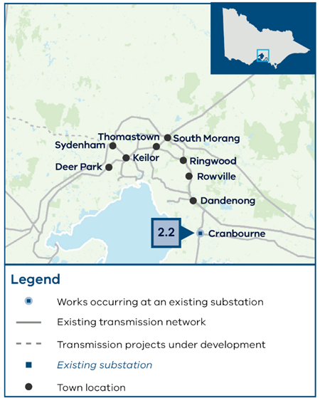
Installation of a third 500/220 kV transformer at Rowville to back up the A1 transformer providing supply to the Rowville No.3-4 220 kV bus group. While this project has many benefits, the Cranbourne transformer is preferred as it meets long term planning objectives and provides improved supply reliability in the Cranbourne area.
Figure A - 10 2.2 Install a second 500/220 kV transformer at Cranbourne and tie in the existing Hazelwood to Rowville 500 kV (No.3) circuit at Cranbourne

2.3 Undertake load management works on the Rowville to Templestowe to Thomastown 220 kV circuit, and Rowville to Ringwood to Thomastown 220 kV circuit
Project summary:
Type: Upgrade to existing infrastructure
Reference: AEMO Victorian Annual Planning Report 2023
In service date:
  - SC1: 2028
  - SC2: 2028
  - SC3: 2028
- Estimate cost: $40M
Project overview:
This project involves turning in the existing Rowville to Templestowe 220 kV circuit at Ringwood and turning in the existing Ringwood to Thomastown 220 kV circuit at Templestowe substation. The Ringwood to Templestowe 220 kV circuits would operate as normally open to manage fault levels at these locations.
This project is needed to address thermal loading limitations on these circuits and to support the forecast demand growth in metropolitan Melbourne supplied by generation in the proposed REZs. It also provides an overall benefit for the wider Victorian network.
The project is located with the RAP boundaries the Wurundjeri Woi Wurrung Aboriginal Corporation and the Bunurong Land Council Aboriginal Corporation and is within the Maroondah City and Manningham City LGAs.
Project benefits
This project will help to avoid line overloading and fault level issues in metropolitan Melbourne.
Additional comments
This arrangement will modify the supply arrangements to both Ringwood and Templestowe, as both locations will be supplied via a double circuit single tower from a single location, where previously they were supplied by 2 circuits from 2 different locations. Double circuit radial connections are an acceptable network arrangement and in line with industry practice.
Alternatives considerations
• Not applicable.
Figure A - 11 2.3 Undertake load management works on the Rowville to Templestowe to Thomastown 220 kV circuit, and Rowville to Ringwood to Thomastown 220 kV circuit
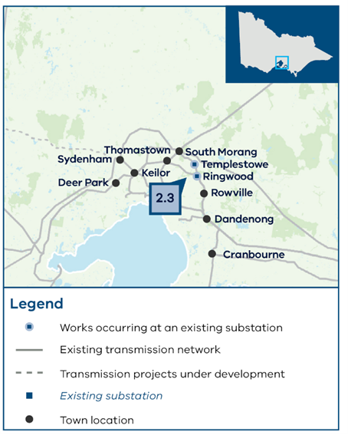

2.4 Undertake fault level mitigation at Keilor, Rowville, South Morang and Thomastown 220 kV buses and Templestowe and Thomastown 66 kV buses
Project summary:
Type: Upgrade to existing infrastructure
Reference: AEMO Victorian Annual Planning Report 2024
In service date:
  - SC1: 2028
  - SC2: 2028
  - SC3: 2028
- Estimate cost: $140M
Project overview:
This project involves fault level mitigation at Keilor, Rowville, South Morang and Thomastown 220 kV buses and Templestowe and Thomastown 66 kV buses.
This project is needed to address fault level constraints in metropolitan Melbourne. These fault level constraints arise from increasing demand and the forecast increase in renewable energy generation across the network and from proposed REZs.
The project is located within the boundaries of the Wurundjeri Woi Wurrung Aboriginal Corporation and the Bunurong Land Council Aboriginal Corporation, and is within the Brimbank City, Knox City, Whittlesea City, and Manningham City LGAs.
Project benefits
Fault level mitigation will prevent potential infrastructure damage during fault conditions
Alternatives considerations
Not applicable.
Figure A - 12 2.4 Undertake fault level mitigation at Keilor, Rowville, South Morang and Thomastown 220 kV buses and Templestowe and Thomastown 66 kV buses
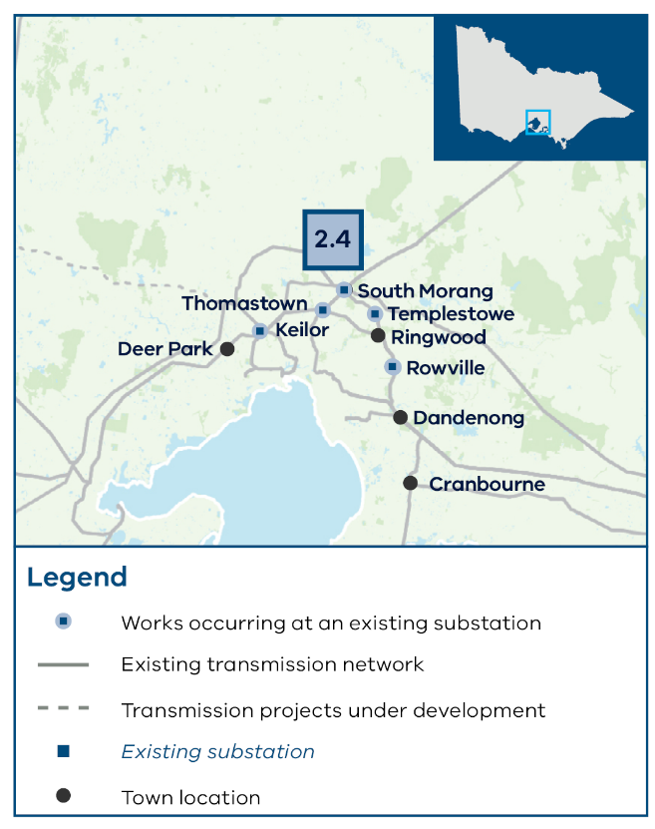

2.5 Increase the rating of the existing Mount Beauty to Dederang and Mount Beauty to Eildon lines
Project summary:
Type: Upgrade to existing infrastructure
Reference: AEMO Victorian Annual Planning Report 2024
In service date:
  - SC1: 2029
  - SC2: 2029
  - SC3: 2029
- Estimate cost: $30M
Project overview:
This project involves uprating the line to operate at a higher operating temperature by remediating the spans which have clearance issues at these higher operating temperatures.
This project is needed because the existing lines from Dederang to Mount Beauty and Mount Beauty to Eildon, which supports Victorian hydro generators and generation in the Central North proposed REZ, may be constrained under increased demand forecast in metropolitan Melbourne or with increased import of energy from New South Wales.
This project is located within the RAP boundary of the Taungurung Land and Waters Aboriginal Corporation, in addition to specific areas without a formally recognised Traditional Owner group. The project is also within the Murrindindi Shire, Alpine Shire, Wangaratta Rural City and Mansfield Shire LGAs.
Project benefits
The increased line rating will help to accommodate increased demand and reduce network congestion without the need for new infrastructure.
Additional comments
The 2024 VAPR previously considered line loading works including uprating the temperatures for the Dederang – Mount Beauty and Mount Beauty – Eildon lines.
Alternatives considerations
Rebuild the Mount Beauty to Eildon to Thomastown 220 kV line with a higher capacity 220 kV double circuit transmission line. This project could resolve existing constraints on the network but would be more costly and time consuming than the preferred project.
Install wind monitoring on the Mount Beauty to Dederang and Mount Beauty to Eildon lines. However, wind monitoring is not considered an appropriate or effective solution given the topography of the area.
Figure A - 13 2.5 Increase the rating of the existing Mount Beauty to Dederang and Mount Beauty to Eildon lines
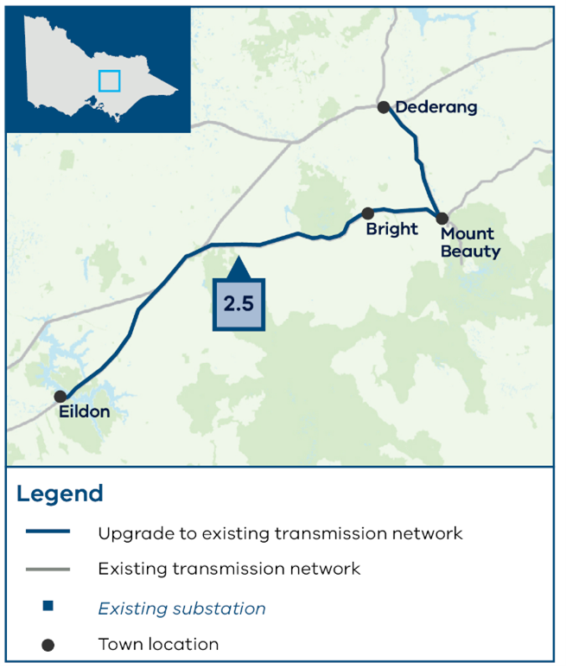

3: North West strengthening program

3.1 Rebuild the existing transmission line between Murra Warra, Horsham and Ballarat into a high-capacity double circuit line
Project summary:
Type: Upgrade to existing infrastructure
Reference: REZ Development Plan Directions Paper
In service date:
  - SC1: 2035
  - SC2: 2034
  - SC3: 2035
- Estimate cost: $1,350M
Project overview:
This project involves replacing the existing single circuit transmission with a new high-capacity double circuit line from Murra Warra to Ballarat.
The transmission line would be cut into all substations along this line and result in the decommissioning of the existing 220 KV single circuit line.
This project is needed to expand the capacity and reliability of the network and increase power supply resilience and stability during peak demand periods. It supports new renewable energy connections in the Western proposed REZ and improved transmission to consumers.
The length of this project is approximately 225 km.
The project is located within the RAP boundaries of the Wadawurrung Traditional Owners Aboriginal Corporation, the Dja Dja Wurrung Clans Aboriginal Corporation, the Eastern Maar Aboriginal Corporation, and the Barengi Gadjin Land Council, in addition to specific areas without a formally recognised Traditional Owner Group. The project is also within the Yarriambiack Shire, Horsham Rural City, Northern Grampians Shire, Ararat Rural, Pyrenees Shire and Ballarat City LGAs.
Project benefits
Upgrading from a single circuit to a double circuit will expand the capacity of the transmission network in this region, mitigate existing voltage stability constraints and reduce the constraints faced by generators in this area.
Additional comments
A new substation may need to be built nearby outside the town of Ballarat due to land constraints for the existing Ballarat substation, which requires further assessment.
The RDP Directions Paper previously considered a new high-capacity double circuit line from Murra Warra to Bulgana.
Alternatives considerations
Install automatic generation runback control schemes. While installing automatic generation runback control schemes would be cost-effective and relatively quick to implement, this is not the preferred option as they would not sufficiently increase network capacity to support longer-term transmission needs.
Other options may be considered in the detailed project planning and development stage.
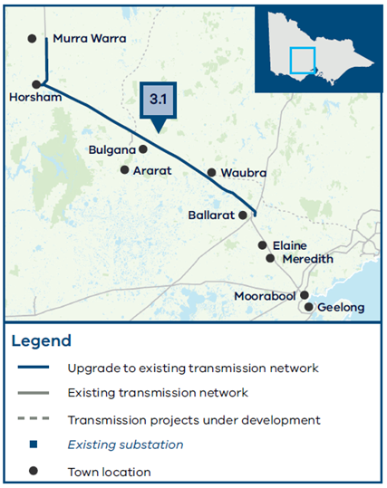
Figure A - 14 Figure A - 14 3.1 Rebuild the existing transmission line between Murra Warra, Horsham and Ballarat into a high-capacity double circuit line

3.2 Rebuild the existing transmission line between Red Cliffs and New Kerang into a high-capacity double circuit line

Project summary:
Type: Upgrade to existing infrastructure
Reference: REZ Development Plan Directions Paper and AEMO Transmission Expansion Options Report 2023
In service date:
  - SC1: -
  - SC2: 2034
  - SC3: -
- Estimate cost: $1,270M
Project overview:
This project is not included in the optimal development pathway.
This project includes a new high-capacity double circuit Line from Red Cliffs to the new Kerang Terminal Station being developed as part of the VNI West project. The line would be cut into Wemen and result in the decommissioning of the existing 220 KV single circuit line.
This project is needed in candidate development pathway 2 to meet additional generation forecast in the North West proposed REZ in scenario 2 and to allow for improved transmission of power to consumers.
The length of this project is approximately 235 km.
The project is located within the RAP boundaries of the Wamba Wemba Aboriginal Corporation, and the First People of the Millewa-Mallee Aboriginal Corporation, in addition to specific areas without a formally recognised Traditional owner group and is within the Mildura Rural City, Swan Hill Rural City, and Gannawarra Shire LGAs.
Project benefits
Reduced generator curtailment during high levels of renewable generation.
The increased network capacity will support imports from New South Wales through Buronga to Red Cliffs and from South Australia (Murray Link).
Additional comments
Further analysis is required to determine whether this project is required in candidate development pathways 1 and 3.
Alternatives considerations
Install a power flow controller (or similar device) on the Red Cliffs to Wemen to Kerang 220 kV line to divert flow away from the line at times of high demand. Installing a power flow controller could be timely and cost-effective, but it is not the preferred option because it only optimises existing capacity rather than increasing the overall capacity of the network.
Install a protection scheme to run back generators to limit the flow from Victorian generators and generators supplying into Red Cliffs from New South Wales. Installing a protection scheme could prevent the system from overloading by automatically reducing generation following a network event. While this could create some additional capacity in the network, the increase is insufficient to address the overall need and is therefore not the preferred option.
Figure 7 3.2 Rebuild the existing transmission line between Red Cliffs and New Kerang into a high-capacity double circuit line
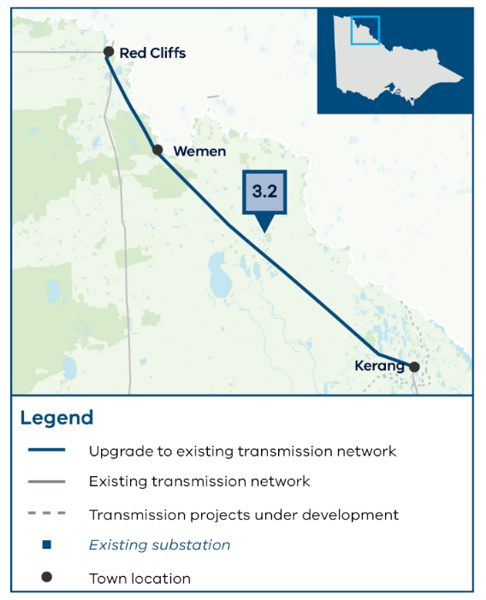

3.3 Rebuild the single circuit line between New Kerang and Bendigo into a high-capacity double circuit line
Project summary:
Type: Upgrade to existing infrastructure
Reference: AEMO Victorian Annual Planning Report 2024
In service date:
  - SC1: 2035
  - SC2: 2034
  - SC3: 2035
- Estimate cost: $750M
Project overview:
This project involves a new high-capacity double circuit line from the new Kerang Terminal Station, being developed as part of the VNI West project, to Bendigo.
This project is needed due to the significant shortfall of network capacity in the region and to meet new generation forecast in the North West proposed REZ.
The length of this project is approximately 125 km.
This project is located within the RAP boundary of the Dja Dja Wurrung Clans Aboriginal Corporation in addition to specific areas without a formally recognised Traditional Owner Group. It is within the Gannawarra Shire, Loddon Shire and Greater Bendigo City LGAs
Project benefits
Upgrading from a single circuit to a double circuit will expand the capacity of the transmission network in this region.
Generator curtailment will be minimised during high levels of renewable generation and the number of constraints for generators in the area will be reduced.
The increased network capacity will also support imports from New South Wales through Buronga to Red Cliffs, from South Australia via Murray Link, and from VNI West.
Additional comments
This project may also require a new substation to be built nearby Bendigo which would require further assessment.
The 2024 VAPR previously considered a high-capacity double circuit line from Bendigo to Kerang – Wemen – Red Cliffs. The Red Cliffs to Kerang portion is included in Project 3.2, included in candidate development pathway 2.
Alternatives considerations
Install a protection scheme to run back generators to limit the flow from Victorian generators. Installing a protection scheme could prevent the system from overloading by automatically reducing generation following a network event. While this could create some additional capacity in the network, this increase is insufficient to address the overall need and is therefore not the preferred option.
Figure 8 3.3 Rebuild the single circuit line between New Kerang and Bendigo into a high-capacity double circuit line
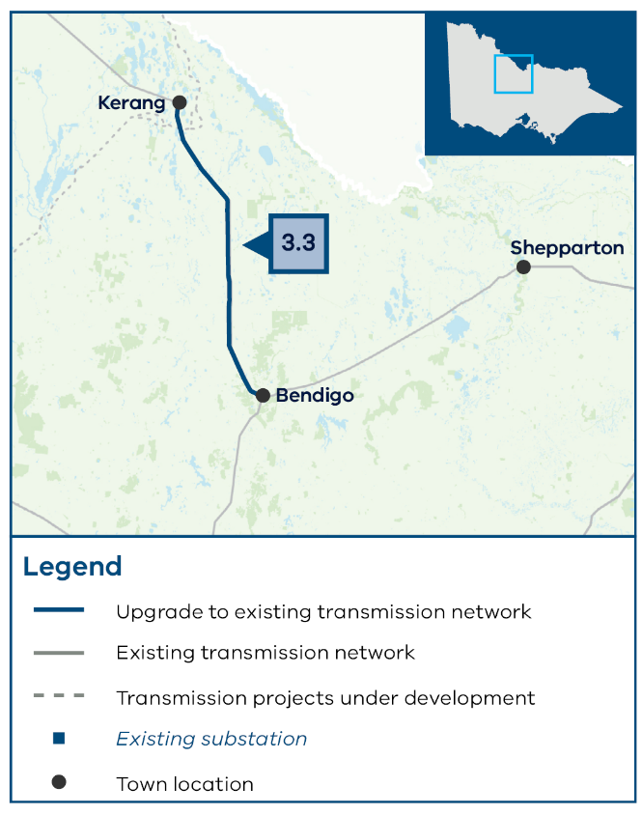

4: South West expansion program

4.1 Install a new 500/220 kV terminal station at Truganina and 2 220 kV double circuit lines from Truganina to Deer Park
Project summary:
Type: New infrastructure required
Reference: AEMO Victorian Annual Planning Report 2024
In service date:
  - SC1: 2033
  - SC2: 2032
  - SC3: 2034
- Estimate cost: $410M
Project overview:
This project involves establishing a new terminal station at Truganina, cutting into the existing Moorabool to Sydenham 500 kV lines. It will include 2 500/220 kV transformers and 2 220 kV double circuit transmission lines from the new Truganina Terminal Station to Deer Park Terminal Station.
This project is needed to manage the large-scale increase in new generation in western Victoria from the South West, Central Highlands, Western and North West proposed REZs, and to provide improved access to consumers in metropolitan Melbourne.
The length of this project is approximately 8 km with the specific location of the terminal station and new lines to be determined.
The project is located within the RAP boundary of the Bunurong Land Council Aboriginal Corporation and the Wurundjeri Woi Wurrung Cultural Heritage Aboriginal Corporation and is within the Wyndham City and Melton City LGAs.
Project benefits
This project will help to reduce the load on the Sydenham to Keilor/South Morang 500 kV lines at times of high generation across the South West, Central Highlands, Western and North West proposed REZs. The new 500/220 kV tie transformers will help to reinforce the 220 kV network and improve local power flow distribution to consumers.
The 2 double circuit lines from the new Truganina Terminal Station will provide increased redundancy and enhance capacity of the power supply from the proposed REZs.
Additional comments
Note that after Project 1.4 is complete, Deer Park Terminal Station will be supplied from Geelong Terminal Station. After this project (4.1), Deer Park will be supplied from Keilor, with a normally open point from Deer Park to Geelong.
The VTP has identified a need for this project but has not yet identified a preferred route. VicGrid will consult publicly to determine a study area for this project before identifying a preferred corridor.
The 2024 AEMO VAPR previously considered the construction of a terminal station at Truganina and an unspecified number of 220 kV lines and additional bonding works. This project specifies 2 220kV lines and does not include bonding works.
Alternatives considerations
A Deer Park cut-in together with Moorabool Terminal Station to Geelong uprating. This project would include a new 220 kV double circuit or single circuit from Moorabool to Geelong. This would require substation augmentation to accommodate new circuits and there are key land constraints around Geelong. The Deer Park cut in would involve terminating the existing transmission lines that currently bypass the station which may present challenges around land constraints. The establishment of a new terminal station at Truganina with 2 double circuit lines to Deer Park provides a lower-risk, long-term solution that enhances overall capacity.
Figure A - 15 Figure 9 4.1 Install a new 500/220 kV terminal station at Truganina and 2 220 kV double circuit lines from Truganina to Deer Park
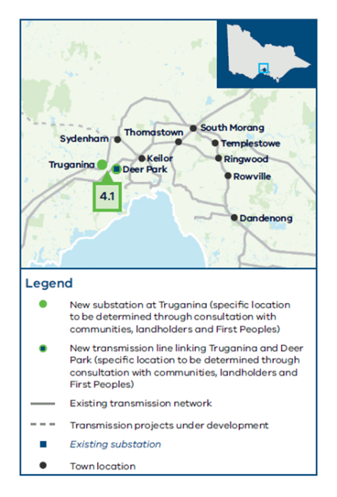

4.2 Install a new 500 kV double circuit line from Tarrone to Mortlake to Moorabool and Tarrone 500 kV turn in
Project summary:
Type: New infrastructure required
Reference: AEMO Transmission Expansion Options Report 2023
In service date:
  - SC1: 2033
  - SC2: 2032
  - SC3: 2034
- Estimate cost: $1,930M
Project overview:
This project involves constructing a new Tarrone to Mortlake to Moorabool 500 kV double circuit line. It also includes the cut in of the existing Heywood to Mortlake 500kV transmission line at Tarrone Terminal Station.
This project is needed to ensure network security to support energy from the South West and Central Highland proposed REZs to travel to metropolitan Melbourne through Moorabool.
The length of this project is approximately 200 km.
The project is located within the RAP boundary of the Wadawurrung Traditional Owners Aboriginal Corporation and the Eastern Maar Aboriginal Corporation, and is within the Moyne Shire, Corangamite Shire, Golden Plains Shire and Greater Geelong City LGAs.
Project benefits
This project will provide an additional circuit that is needed to provide sufficient capacity to the network under contingency conditions.
The existing 500 kV double circuit transmission line from Tarrone to Moorabool is now over 40 years old. The new proposed 500 kV double circuit transmission line will be designed to contemporary standards to withstand higher wind speeds as well as high-risk, low-probability weather events.
Additional comments
The VTP has identified a need for this project but has not yet identified a preferred route. VicGrid will consult publicly to determine a study area for this project before identifying a preferred corridor.
The 2023 AEMO TEOR previously considered a single circuit line from Heywood to Mortlake and Mortlake to Moorabool in addition to Sydenham line uprating. Sydenham line uprating and single circuit lines are not included within this project (refer Project 4.3). The Heywood to Tarrone portion can be found in Project 4.5 (included in candidate development pathway 2).
Alternatives considerations
Build a single circuit expansion only between Mortlake and Moorabool. A single circuit line would have lower upfront costs but would not provide the same capacity and network reliability improvements and may need to be expanded again in the future. This option is detailed in the AEMO TEOR.
Construct the new double circuit but only string the first circuit. While this alternative may marginally reduce visual impact, it is not preferred as it does not futureproof the lines, and it would be more costly to string a second circuit (if required) at a later date, while also being more hazardous.
Figure 10 4.2 Install a new 500 kV double circuit line from Tarrone to Mortlake to Moorabool and Tarrone 500 kV turn in
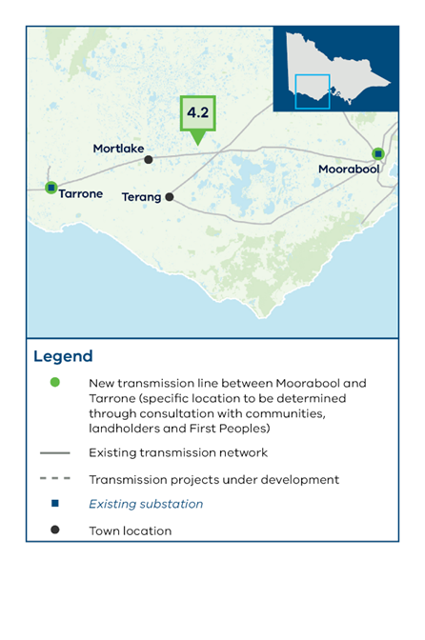

4.3 Install a new 500 kV double circuit from Moorabool to Truganina and single circuit from Truganina to Sydenham
Project summary:
Type: New infrastructure required
Reference: AEMO Transmission Expansion Options Report 2023
In service date:
  - SC1: 2033
  - SC2: 2032
  - SC3: 2034
- Estimate cost: $670M
Project overview:
This project involves a new Moorabool to Truganina 500 kV double circuit, and a new 500 kV single circuit from Truganina to Sydenham.
This project is needed because energy from the South West, Western and Central Highlands proposed REZs travels to metropolitan Melbourne through Moorabool and the high-capacity input at Moorabool needs an equally high-capacity distribution through to the rest of the network.
The length of this project is approximately 70 km.
The project is located within the RAP boundary of the Wurundjeri Woi Wurrung Cultural Heritage Aboriginal Corporation, the Bunurong Land Council Aboriginal Corporation and the Wadawurrung Traditional Owners Aboriginal Corporation and is within the Greater Geelong, Wyndham, and Melton City LGAs.
Project benefits
This project, together with the new Truganina Terminal Station included in Project 4.1, will provide the high-capacity distribution needed at Moorabool.
Additional comments
The VTP has identified a need for this project but has not yet identified a preferred route. VicGrid will consult publicly to determine a study area for this project before identifying a preferred corridor.
The 2023 AEMO TEOR previously considered a single circuit line from Moorabool to Sydenham.
Alternatives considerations
Reinforcement of the 220 kV network between Moorabool, Geelong, Truganina and Keilor to provide a parallel circuit. This option would not have as much capacity as the 500 kV option and would be less efficient at delivering energy than the preferred solution.
Figure 11 4.3 Install a new 500 kV double circuit from Moorabool to Truganina and single circuit from Truganina to Sydenham
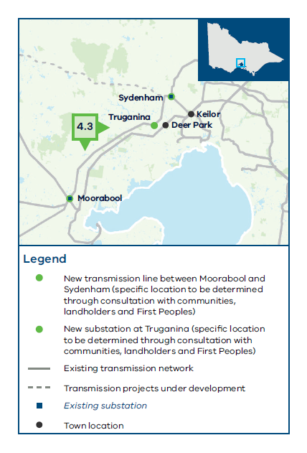

4.4 Rebuild existing 3 existing transmission lines from Deer Park to Keilor with new high-capacity double circuit lines
Project summary:
Type: New infrastructure required
Reference: AEMO Victorian Annual Planning Report 2024
In service date:
  - SC1: 2033
  - SC2: 2032
  - SC3: 2034
- Estimate cost: $250M
Project overview:
This project involves replacing the existing 3 Deer Park to Keilor 220 kV lines with 3 new high-capacity lines. Decommissioning of the existing 220 kV transmission lines would be required. It also involves minor substation augmentations at Deer Park and Keilor Terminal Stations.
This project is needed to improve network interconnectivity and reliability supporting new generation in the proposed REZs located in Western Victoria to supply consumers in metropolitan Melbourne.
The length of this project is approximately 15 km.
This project is located within the RAP boundary of Wurundjeri Woi Wurrung Cultural Heritage Aboriginal Corporation and Bunurong Land Council Aboriginal Corporation and is within the Brimbank City and Melton City LGAs.
Project benefits
New double circuit lines would significantly increase transmission capacity and allow for greater flow between Deer Park and Keilor, which may also address congestion during peak demand periods.
Additional comments
Supply to metro Melbourne will need to be maintained throughout construction. The Deer Park cut-in will make this easier to manage and has therefore been noted as a prerequisite for this project.
This project may also require fault level mitigations at Deer Park.
The 2024 VAPR previously considered bonding the existing Geelong – Keilor and Deer Park – Keilor 220kV lines together to form a high-capacity connection between Deer Park and Keilor. This project is a variation to achieve the same outcome.
Alternatives considerations
The bonding of the existing Geelong – Keilor and Deer Park – Keilor 220kV lines mentioned above does not deliver the same reliability benefit as 3 separate lines and hence was not further considered.
Figure 12 4.4 Rebuild existing 3 existing transmission lines from Deer Park to Keilor with new high-capacity double circuit lines
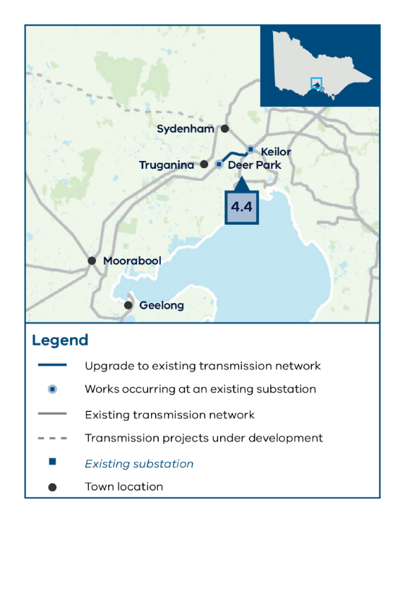

4.5 Install a new 500 kV double circuit line from Heywood to Tarrone.
Project summary:
Type: New infrastructure required
Reference: AEMO Transmission Expansion Options Report 2023
In service date:
  - SC1: -
  - SC2: 2038
  - SC3: -
- Estimate cost: $510M
Project overview:
This project is not included in the optimal development pathway.
This project would involve an extension of the new double circuit line from Heywood to Tarrone, along with substation augmentations.
This project would be needed in candidate development pathway 2 to support increased onshore generation required in VTP scenario 2 expected in the South West proposed REZ and the Southern Ocean offshore wind area.
The length of this project is approximately 55 km
The project is located within the RAP boundary of the Eastern Maar Aboriginal Corporation and the Gunditj Mirring Traditional Owners Aboriginal Corporation and is within the Glenelg Shire and Moyne Shire LGAs.
Project benefits
A new double circuit line between Heywood to Tarrone will accommodate higher electricity flows, increase capacity and reduce bottlenecks in the network. As well as supporting new offshore and onshore renewable energy, these lines also need to have enough capacity to accommodate the existing interconnection with South Australia, which currently connects at Heywood. Substation augmentations will improve system reliability and stability and better accommodate wind and solar renewable energy.
This project will provide a connection point for generation around Portland, Heywood and Tarrone, as well as support potential future load growth in this area in scenario 2.
Additional comments
The 2023 AEMO TEOR previously considered a single circuit line from Heywood to Mortlake and Mortlake to Moorabool in addition to Sydenham line uprating. These other sections can be found in Projects 4.2 and 4.3.
The VTP has identified a need for this project but has not yet identified a preferred route. VicGrid will consult publicly to determine a study area for this project before identifying a preferred corridor, if this project is required on the optimal development pathway.
Alternatives considerations
Not applicable.
Figure 13 4.5 Install a new 500 kV double circuit line from Heywood to Tarrone.
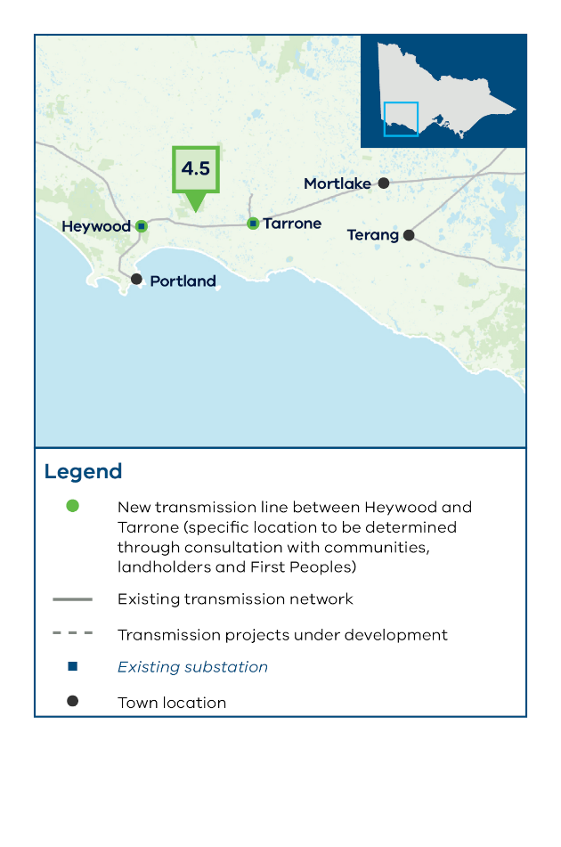

5: Gippsland offshore wind transmission stage 2 program

5.1 Install a second Gippsland 500 kV double circuit radial line and tie-in loop
Project summary:
Type: New infrastructure required
Reference: VicGrid
Phase 1 In service date:
  - SC1: 2033
  - SC2: 2033
  - SC3: 2034
Phase 2 In service date:
  - SC1: 2038
  - SC2: 2038
  - SC3: 2039
- Estimate cost: $1,190M
Project overview:
This project is a greenfield development to establish a second connection hub for offshore wind energy from the Gippsland offshore wind area and is needed to facilitate the transfer of offshore wind generation to the existing 500 kV infrastructure in the Latrobe Valley.
This project builds on the first radial offshore wind connection in Gippsland from Loy Yang to Giffard and involves 2 phases:
- Phase 1: A new 500 kV double circuit line linking new terminal stations near Driffield and Woodside (locations to be determined).
- Phase 2: A new 500 kV double circuit tie-in loop between the new terminal station near Woodside and the new terminal station near Giffard (associated with the first Gippsland radial line).
The length of this project is approximately 120 km.
The project is located within the RAP boundary of the Gunaikurnai Land and Waters Aboriginal Corporation and is within the Wellington Shire and Latrobe City LGAs.
Project benefits
The 2 Gippsland radial lines (and tie-in loop) will facilitate the connection of 7GW of offshore wind, separated across 2 connection points and terminating at 2 different locations on the existing 500 kV network. This will create greater network security in the instance of a high-impact, low-probability event.
Additional comments
The VTP has identified a need for this project but has not yet identified a preferred route. VicGrid will consult publicly to determine a study area for this project before identifying a preferred corridor.
The 2021 REZ Development Plan Directions Paper has previously considered 500kV double circuit lines to facilitate onshore and offshore wind production in Gippsland but did not specify locations or routes.
Alternatives considerations
Options that direct all generation through a single terminal station (e.g. the Hazelwood Terminal Station) were discounted given they pose an unacceptable system security risk.
Figure 14 5.1 Install a second Gippsland 500 kV double circuit radial line and tie-in loop
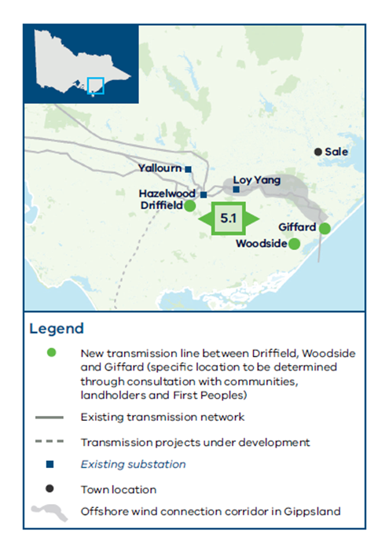

6: Latrobe Valley strengthening program

6.1 Install power flow controllers at Hazelwood
Project summary:
Type: Upgrade to existing infrastructure
Reference: AEMO Transmission Expansion Options Report 2023
In service date:
  - SC1: 2034
  - SC2: 2034
  - SC3: 2035
- Estimate cost: $280M
Project overview:
This project involves the installation of power flow controllers to control power flowing through the Hazelwood Terminal Station 500/220 kV transformers.
This project is needed to manage the forecast power flows in the region from the Gippsland proposed REZ and Gippsland offshore wind area to metropolitan Melbourne.
The project is located within RAP boundary of Gunaikurnai Land and Waters Aboriginal Corporation and is within the Latrobe City LGA.
Project benefits
The existing assets will be optimised by managing load sharing between the 500 kV network and the 220 kV networks. It will also facilitate the transfer of electricity from the Gippsland offshore wind area and facilitate imports from Tasmania to Victoria.
Power flow controllers will optimise the distribution of electricity in this area and ensure that power is transmitted more efficiently. They also allow for adjustments and configuration as needed to accommodate changes in demand and supply, making the grid more adaptable to future expansions or modifications.
Additional comments
In addition to power flow controllers at Hazelwood, the 2023 TEOR previously considered a double circuit line and substation works. These additional works are not included as a part of this project (6.1).
Alternatives considerations
Install phase shifting transformers. Phase shifting transformers are also effective in achieving flow control, however, power flow controllers are more flexible and provide finer control and faster response and are therefore the preferred technology solution.
Rebuild the 220 kV network with higher capacity circuits. This would be an effective technical solution but it is not as cost-effective as power flow controllers.
A new 500 kV single circuit from Loy Yang to South Morang within the existing easement corridor. This would be an effective technical solution but it is not as cost-effective as power flow controllers.
Figure 15 6.1 Install power flow controllers at Hazelwood
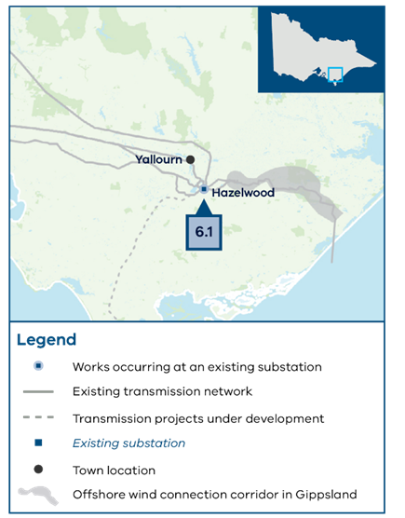

6.2 Install an additional transformer at Cranbourne or Rowville
Project summary:
Type: Upgrade to existing infrastructure
Reference: VicGrid
In service date:
  - SC1: 2035
  - SC2: 2035
  - SC3: 2035
- Estimate cost: $70M
Project overview:
This project involves constructing a new transformer at the existing Rowville or Cranbourne substations. The preferred location will be subject to further analysis.
This project is needed to service increased demand in eastern metropolitan Melbourne in the late 2030s, with increased supply from the 500 kV network from the Latrobe Valley and Gippsland proposed REZ as well as the Gippsland offshore wind area.
The project is located within the RAP boundary of the Bunurong Land Council Aboriginal Corporation and is within Casey City and Knox City LGAs.
Project benefits
This project facilitates both demand growth forecast in eastern metropolitan Melbourne in the late 2030s and increased supply from the 500 kV network from the Latrobe Valley and Gippsland areas.
This transformer could also operate as a spare to manage an outage of a Rowville or Cranbourne transformer, which could restrict generation from the Latrobe Valley for an extended period.
Alternatives considerations
Controls scheme or shifting load away from Rowville or Cranbourne. The need for this transformer is primarily driven by load growth assumptions in eastern metropolitan Melbourne. Such alternative options are unlikely to create as much capacity as an additional transformer.
Figure 16 6.2 Install an additional transformer at Cranbourne or Rowville
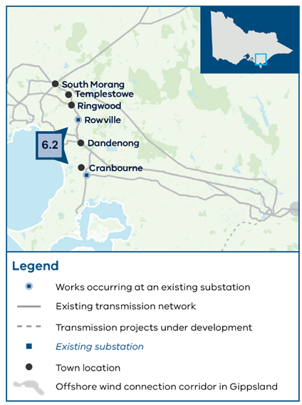

7: Portland Offshore wind upgrade

7.1 Increase the rating of the Portland to Heywood 500 kV double circuit line
Project summary:
Type: Upgrade to existing infrastructure
Reference: AEMO Victorian Planning South West Victoria REZ expansion
In service date:
  - SC1: 2038
  - SC2: 2038
  - SC3: 2039
- Estimate cost: $10M
Project overview:
This project involves uprating the existing 500 kV double circuit transmission line from Portland to Heywood and includes an upgrade of the station plant to meet requirements to uplift capacity to the original rating.
This project is needed to support the connection of the offshore wind generation from the Southern Ocean offshore wind area.
The project is located within the RAP boundary of the Gunditj Mirring Traditional Owners Aboriginal Corporation and is within the Glenelg Shire LGA.
Project benefits
The existing Portland to Heywood lines are not as highly rated as the lines from Heywood to Mortlake to Moorabool. Uprating the existing transmission lines and station plant will allow for the transmission of more electricity through the same infrastructure, supporting offshore wind generation in the Southern Ocean offshore wind area.
Alternatives considerations
There are limited alternative options that can be considered given that this project is required to connect offshore wind at Portland. While some offshore wind generation capacity would be able to connect at Portland without these lines being upgraded, the total amount of expected energy will not be able to be transferred without upgrading the line.
Figure 17 7.1 Increase the rating of the Portland to Heywood 500 kV double circuit line
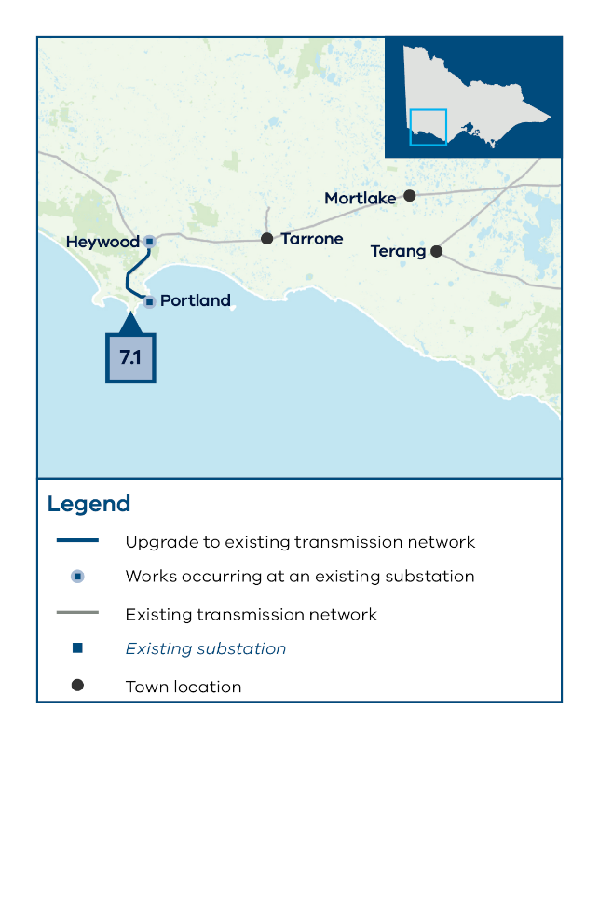

8: New Sydenham to Keilor link

8.1 Install a new 500 kV single circuit from Sydenham to Keilor
Project summary:
Type: New infrastructure required
Reference: AEMO Victorian Annual Planning Report 2024
In service date:
  - SC1: -
  - SC2: 2035
  - SC3: -
- Estimate cost: $240M
Project overview:
This project is not included in the optimal development pathway.
This project involves the installation of a new single circuit Sydenham to Keilor 500 kV line, which will also require substation augmentation at Sydenham and Keilor.
This project is needed to support the distribution of power into Melbourne and the higher generation forecast in scenario 2 in the South West, Central Highlands, North West, and Western proposed REZs.
The length of this project is approximately 15 km.
The project is located within the RAP boundary of the Wurundjeri Woi Wurrung Cultural Heritage Aboriginal Corporation and is within the Brimbank City and Melton City LGAs.
Project benefits
The new circuit provides additional capacity to support increased generation and transmission need and increases the 500 kV supply capacity from Southwest and Western Victoria to metropolitan Melbourne.
Alternatives considerations
No alternatives were considered. The nature of the network flow-paths and performance characteristics mean that this project is the only solution to overcoming the identified network constraints.
Figure 18 8.1 Install a new 500 kV single circuit from Sydenham to Keilor
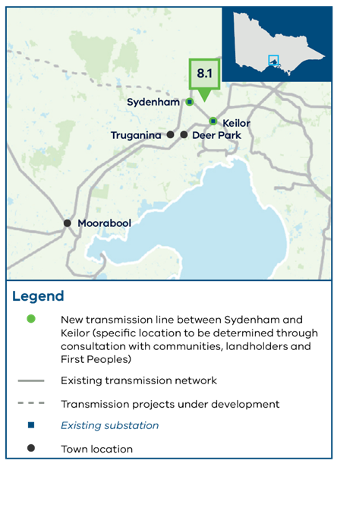

9: Central North strengthening program

9.1 Rebuild the existing 220 kV transmission line between Shepparton and Dederang as a double circuit
Project summary:
Type: Upgrade to existing infrastructure
Reference: AEMO Victorian Annual Planning Report 2024
In service date:
  - SC1: -
  - SC2: 2033
  - SC3: -
- Estimate cost: $99M
Project overview:
This project is not included in the optimal development pathway.
This project is needed to reduce network constraints and expand line capacity to support increased forecast generation under scenario 2 in the Central North proposed REZ.
This project involves rebuilding the existing single circuit line from Shepparton to Dederang as a double circuit higher capacity line along the existing route. At completion, the single circuit line would be decommissioned.
The length of this project is approximately 155 km.
The project is located within the RAP boundaries of the Yorta Yorta Nation Aboriginal Corporation and the Taungurung Land and Waters Council Aboriginal Corporation, in addition to specific areas without a formally recognised Traditional owner group. It is within the Greater Shepparton City, Wangaratta Rural City, Benalla Rural City and Alpine Shire LGAs.
Project benefits
This project facilitates both increased demand in the Central North region and increased generation in the Central North proposed REZ by providing 4 circuits between Shepparton and Dederang via Glenrowan.
Alternatives considerations
Install automatic generation runback control schemes. While this option would be cost effective and relatively quick to implement, it is not the preferred option because it would not increase network capacity or support long term transmission needs.
Figure 19 9.1 Rebuild the existing 220 kV transmission line between Shepparton and Dederang as a double circuit

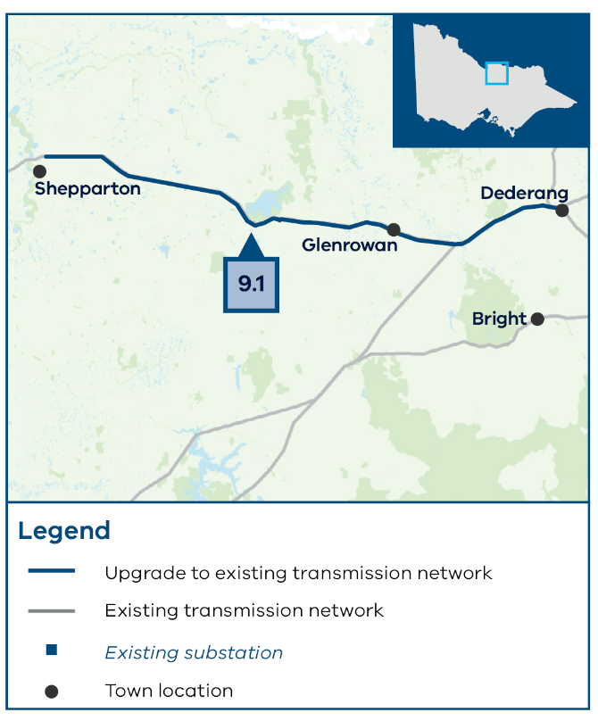

9.2 Add a fourth 330/220kV transformer at Dederang
Project summary:
Type: Upgrade to existing infrastructure
Reference: AEMO Victorian Annual Planning Report 2024
In service date:
  - SC1: -
  - SC2: 2035
  - SC3: -
- Estimate cost: $30M
Project overview:
This project is not included in the optimal development pathway.
This project is needed under scenario 2 to achieve the higher capacity required for higher generation build in scenario 2 in the Central North REZ, and support imports from New South Wales. This project also maximises the capacity that is unlocked from the rebuild of the 220kV line from Shepparton to Dederang (Project 9.1).
The project is located within an area without a formally appointed RAP and is in the Alpine Shire Council LGA.
Project benefits
This project facilitates both increased demand in the Central North region and increased imports from New South Wales. This project also maximises the capacity that is unlocked by the 220 kV rebuild from Shepparton to Dederang, considered in Scenario 2.
Alternatives considerations
No alternatives were considered
Figure A - 16 9.2 Add a fourth 330/220kV transformer at Dederang
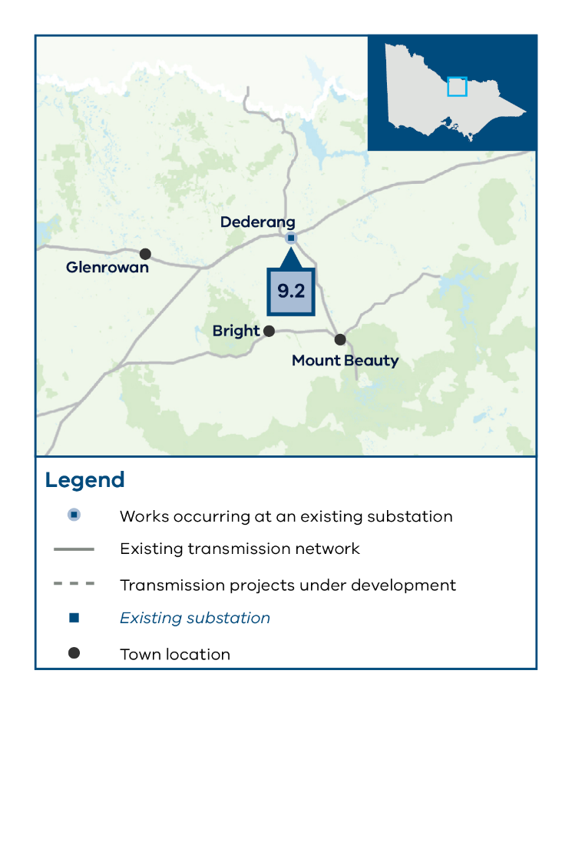

9.3 Rebuild the existing 220 kV transmission line between Shepparton and Bendigo as a double circuit
Project summary:
Type: Upgrade to existing infrastructure
Reference: REZ Development Plan Directions Paper
In service date:
  - SC1: -
  - SC2: 2033
  - SC3: -
- Estimate cost: $790M
Project overview:
This project is not included in the optimal development pathway.
This project involves replacing the existing single circuit line from Shepparton to Bendigo with a double circuit line. At completion, the single circuit line will be decommissioned.
This project is needed under scenario 2 to relieve network constraints and expand line capacity, supporting new generation connecting in the North West and Central North proposed REZs.
The length of this project is approximately 120 km.
The project is located within the RAP boundary of the Dja Dja Wurrung Clans Aboriginal Corporation, the Yorta Yorta Nation Aboriginal Corporation, and the Taungurung Land and Waters Aboriginal Corporation. It is also within the Greater Bendigo City, Campaspe Shire and Greater Shepparton City LGAs.
Project benefits
Facilitates greater flow from Dederang to Bendigo and reduces constraints in the Central North and North West proposed REZs.
Additional comments
A new substation may be required nearby Bendigo, as there may be land constraints requiring further assessment.
Alternatives considerations
Installation of a power flow controller (or similar device) on the Bendigo to Fosterville to Shepperton 220 kV line to divert flow away from the line at times of high demand. Installing a power flow controller, while relatively faster to implement, is not preferred because it only optimises existing capacity rather than increasing the overall capacity of the network.
Figure 21 9.3 Rebuild the existing 220 kV transmission line between Shepparton and Bendigo as a double circuit
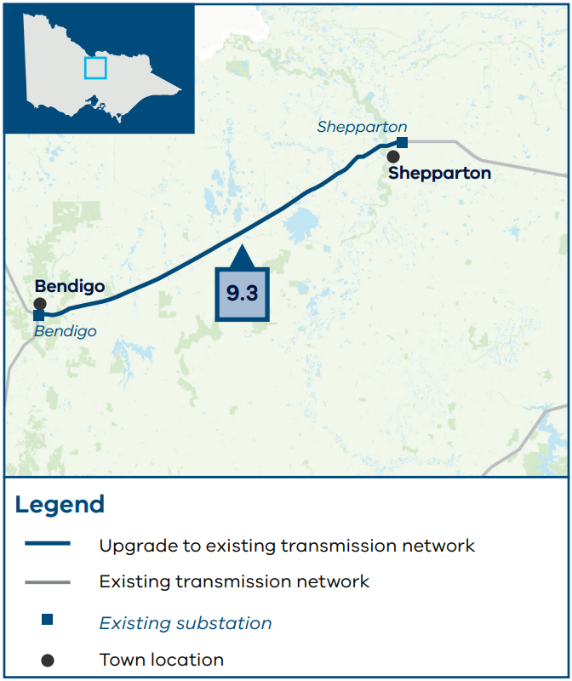

10: Inner South West strengthening program

10.1 Install a new 220 kV single circuit from Moorabool to Geelong
Project summary:
Type: New infrastructure required
Reference: AEMO Victorian Annual Planning Report 2024
In service date:
  - SC1: -
  - SC2: 2030
  - SC3: -
- Estimate cost: $60M
Project overview:
This project is not included in the optimal development pathway.
This project involves a new higher capacity 220 kV single circuit from Moorabool to Geelong Terminal Station. Substation augmentation at Moorabool and Geelong will be required to accommodate the new circuit.
This project is needed under scenario 2 to support forecast generation in the Western, South West and Central Highlands proposed REZs to supply Victorian consumers.
The length of this project is approximately 10 km.
The project is located within the boundary of the Wadawurrung Traditional Owners Aboriginal Corporation, and the Greater Geelong City LGA.
Project benefits
This project provides increased capacity to support additional generation in the proposed REZs and demand forecast in scenario 2.
Additional comments
This project is not on the optimal development pathway. If this project was to be identified as part of the optimal development pathway, then VicGrid would consult publicly on a study area for this project before identifying a preferred corridor. There is an existing easement that could be reused for the proposed double circuit line however there are key land constraints near Geelong that may need to be further assessed.
The 2024 AEMO VAPR previously considered a third Geelong to Moorabool 220kV line with additional cut-in and decoupling works. This project (10.1) does not include the cut-in and decoupling works.
Alternatives considerations
Not applicable.
Figure 22 10.1 Install a new 220 kV single circuit from Moorabool to Geelong
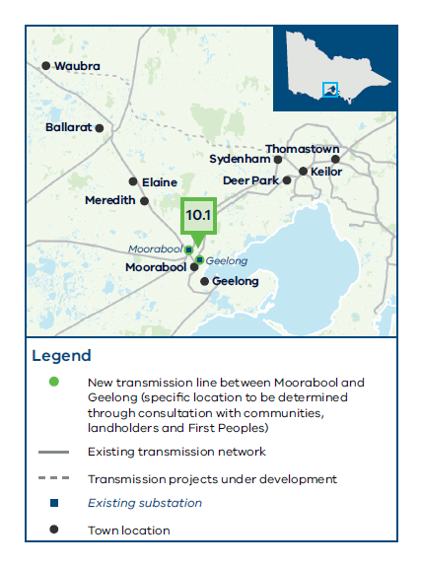

10.2 Add a fourth 1000 MVA 500/220 kV transformer at Keilor
Project summary:
Type: Upgrade to existing infrastructure
Reference: VicGrid
In service date:
  - SC1: -
  - SC2: 2038
  - SC3: -
- Estimate cost: $50M
Project overview:
This project is not included in the optimal development pathway.
The pre-requisite for this project is Project 1.5 that replaces the 3 existing 500/220 kV transformers at this terminal station with 1000 MVA units.
The current configuration at Keilor Terminal Station is to operate in a split bus arrangement where the 220kV buses are independent of each other, with Bus A supplied via 2 500/220 kV transformers and Bus B supplied via one 500/220kV transformer
This project involves installing a fourth 1000MVA 500/220kV transformer at Keilor, which supplies 220kV Bus B and results in a total of 2 500/220kV transformers supplying Bus B. The current layout at Keilor allows for a fourth transformer to be added.
This project is needed under Scenario 2 to connect large-scale forecast new generation from the South West, North West, Western and Central Highlands proposed REZs to metropolitan Melbourne consumers and to reduce network congestion. The project is located within the RAP boundaries of the Wurundjeri Woi Wurrung Cultural Heritage Aboriginal Corporation and is within the City of Brimbank LGA.
Project benefits
This project facilitates both demand growth forecast in western metropolitan Melbourne in the late 2030s and increased supply from the 500 kV network from Western Victoria considered in Scenario 2.
Alternatives considerations
Controls scheme or shifting load away from Keilor. The need for this transformer is primarily driven by load growth assumptions in western metropolitan Melbourne in Scenario 2. Such alternative options are unlikely to create as much capacity as an additional transformer and would require further discussion with distribution businesses.
Figure 23 10.2 Add a fourth 1000 MVA 500/220 kV transformer at Keilor
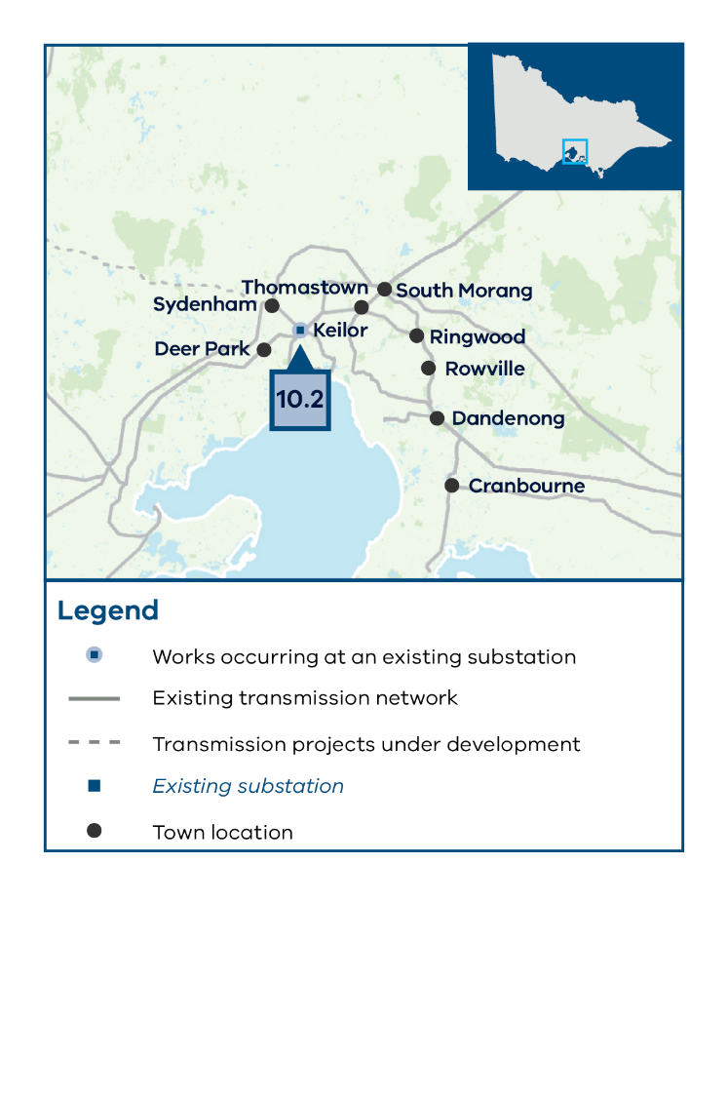

10.3 Install a new 500 kV double circuit from Mortlake to Bulgana
Project summary:
Type: New infrastructure required
Reference: REZ Development Plan Directions Paper and AEMO Transmission Expansion Options Report 2023
In service date:
  - SC1: -
  - SC2: 2035
  - SC3: -
- Estimate cost: $1,310M
Project overview:
This project is not included in the optimal development pathway.
This project involves the construction of a new 500 kV double circuit line from Mortlake to the Bulgana Terminal Station expansion that forms part of the WRL.
This project is needed under scenario 2 to enable the connection of new generation forecast in the South West and Central Highlands proposed REZs. It also improves the overall reliability and stability of the grid.
The length of this project is approximately 140km.
The project is located within the RAP boundary of the Barengi Gadjin Land Council and Eastern Maar Aboriginal Corporation, and is a part of the Northern Grampians Shire, Ararat Rural City and Moyne Shire LGAs.
Project benefits
This project will provide an alternative flow path and connection point for the significant additional wind generation forecast under scenario 2 in the South West and Central Highlands proposed REZs.
The direct connection from Mortlake to Bulgana will improve power flows from South Australia through to New South Wales, avoiding potentially constrained parts of the Victorian network.
Alternatives considerations
Build a new 500 kV line from Heywood to Bulgana. This option was disregarded due to land-use constraints and proximity to the Grampians National Park. This route would also be considerably longer and more expensive than the preferred option.
Figure 24 10.3 Install a new 500 kV double circuit from Mortlake to Bulgana

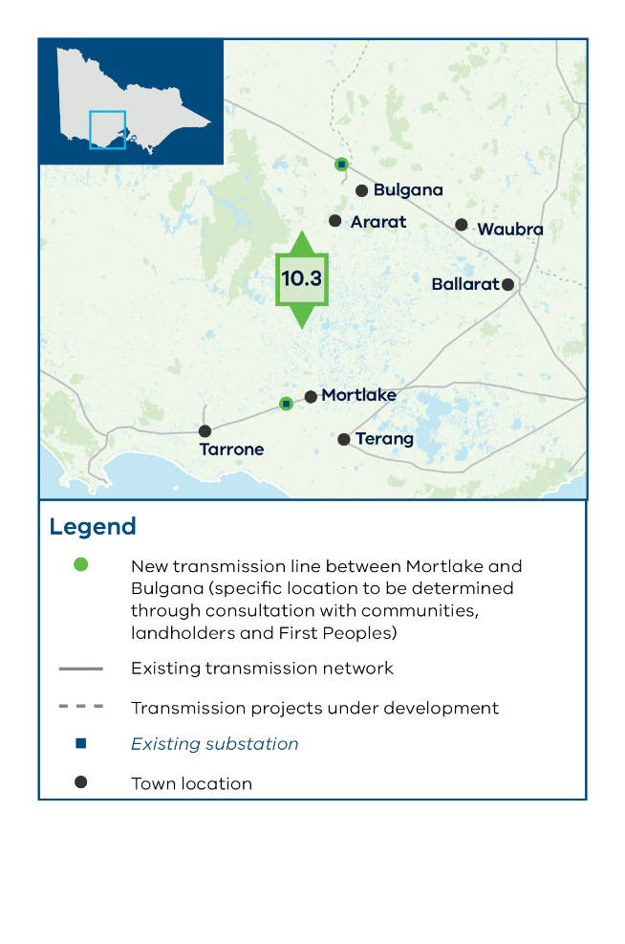

A.4.1 System strength
While system strength is not a focus of the VTP, there will also be a need for projects to address system strength over the planning horizon (these are not included in the optimal development pathway). Without coal-fired generation, system strength can be provided by synchronous condensers – large rotating machines – or other technologies such as grid firming batteries or other synchronous machines to regulate voltage and network stability. This could include gas powered or hydro generation. AEMO is currently consulting on proposed Victorian system strength projects – see their RIT-T to address system strength requirements in Victoria.

A.4.2 Voltage management
Although voltage management, especially for the Melbourne metropolitan area, is not the primary focus of the VTP, there will still be a need for projects to maintain transmission system voltages in this region to ensure regulatory compliance with the National Electricity Rules and may be considered by VicGrid in the future or managed through other Victorian planning processes such as the VAPR.
The necessity for these projects will arise not only from an increase in maximum demand but also from a decrease in minimum demand. Technologies to improve voltage management include static reactive plant such as shunt capacitors, which support the network during maximum demand, and shunt reactors, which support the network during minimum demand. These types of technologies are currently being assessed by AEMO as part of their RIT-T for Melbourne Metropolitan Voltage Management. Other technologies include dynamic reactive plant, such as static var compensators (SVC), static synchronous compensators (STATCOM) or synchronous condensers, which can supply or absorb reactive power dynamically to regulate voltage on the network.

A.4.3 Baseline project assumptions
Section A.1.2 outlines the baseline projects that have been considered as a key input for the VTP planning and modelling process. Further details of these projects are outlined in Table A-4.
Table A-4: List of baseline projects assumed across all the candidate development pathways
Project Name | Responsible agency | In service date and comments
RDP Stage 1 Projects | AEMO | Assumed to be completed by 2030.
Marinus Link Stage 1 | Marinus Link Pty Ltd | Assumed to be completed by 2030 in scenario 1 and 2, and 2031 in scenario 3.
Marinus Link Stage 2 | Marinus Link Pty Ltd | Assumed to be completed by 2032 in scenario 1, 2037 in scenario 2 and to not eventuate in scenario 3.
WRL | AusNet | Assumed to be completed by 2029 in scenarios 1 and 2.  Scenario 3 considers a potential future where this project is delayed to 2030.
VNI West | Transgrid (New South Wales), Transmission Company Victoria (Victoria) | Assumed to be constructed and commissioned by 2030. We also assume Project Energy Connect is completed prior to VNI West.  Scenario 3 considers a potential future where VNI West is delayed to 2031.  Note: Transmission Company Victoria is currently leading the development of VNI West, but the asset will be owned and operated by another entity that will be selected from a competitive tender process.
Gippsland Offshore Wind Transmission | VicGrid | To be delivered as part of connecting the first 2 GW of Gippsland offshore wind generation by 2032.

Contact us
Phone: 1800 418 341
Email: vicgrid@deeca.vic.gov.au
Deaf, hearing or speech impaired? Please contact the National Relay Service on 133 677 or communications.gov.au/accesshub/nrs
Need an interpreter? Contact Translating and Interpreting Service (TIS) on 131 450 (within Australia) or visit www.tisnational.gov.au
ISBN 978-1-76176-421-9 (Print)
ISBN 978-1-76176-422-6 (pdf/online/MS word)
Disclaimer: The information in this document is current at the time of printing, may be subject to change and should not be relied upon. Please visit vicgrid.vic.gov.au for the latest updates.

