Offshore Wind

Implementation Statement 1

October 2022

Victoria State Government

Accessibility
If you would like to receive this publication in an alternative format, please telephone the DElWP Customer Service Centre on 136 186, or email customer.service@delwp.vic.gov.au, or via the national Relay Service on 133 677, www.relayservice.com.au. This document is also available on the internet at www.delwp.vic.gov.au.

Traditional Owners acknowledgment
We acknowledge and respect Victorian Traditional Owners as the original custodians of Victoria’s land and waters, their unique ability to care for Country and deep spiritual connection to it. We honour Elders past and present whose knowledge and wisdom has ensured the continuation of culture and traditional practices.
We are committed to genuinely partner, and meaningfully engage, with Victoria’s Traditional Owners and Aboriginal communities to support the protection of Country, the maintenance of spiritual and cultural practices and their broader aspirations in the 21st century and beyond.

Disclaimer
This publication may be of assistance to you but the State of Victoria and its employees do not guarantee that the publication is without flaw of any kind or is wholly appropriate for your particular purposes and therefore disclaims all liability for any error, loss or other consequence which may arise from you relying on any information in this publication.
© The State of Victoria Department of Environment, land, Water and Planning 2022
ISBn 978-1-76136-121-0 (Print)
This work is licensed under a Creative
Commons Attribution 4.0 International licence. You are free to re-use the work under that licence, on the condition that you credit the State of Victoria as author. The licence does not apply to any images, photographs or branding, including the Victorian Coat of Arms, the Victorian Government logo and the Department of Environment, land, Water and Planning (DElWP) logo. To view a copy of this licence, visit creativecommons.org/licenses/by/4.0/

Contents
Minister’s foreword 3
Introduction 5
1 Transmission schedule and plan 10
2 Ports schedule and plan 15
3 Procurement process update 22
4 Policy, legislative and regulatory changes 23

At a glance

Transmission schedule and plan
VicGrid will lead a coordinated approach to transmission

Notices
1 VicGrid will lead the development of transmission infrastructure
2 VicGrid will lead the development of transmission infrastructure that provides a coordinated connection point near the Gippsland Coast and Portland
3 VicGrid-led transmission will facilitate connection of up to 2-2.5 GW capacity in both Gippsland Coast and Portland
4 VicGrid-led transmission will be developed in line with Government targets
5 VicGrid-led transmission will be developed working with local communities, Traditional Owners, and stakeholders

Ports schedule and plan
The Port of Hastings is likely to be the preferred port to support offshore wind construction, subject to necessary community and industry consultation and environment and planning approvals

Notices
The Victorian Government has identified the state-owned Port of Hastings as being the most suitable port for offshore wind construction
The redevelopment of the Port of Hastings could be completed by 2027
The Port of Hastings has the potential to be multipurpose and allow for construction, manufacturing, and research firms to co-locate
There are significant opportunities for commercial ports in Victoria to benefit from offshore wind

Procurement process update
The Victorian Government is exploring ways to ensure offshore wind projects are financially viable. Further detail will be released in Implementation Statement 2

Policy, legislative and regulatory changes
We are working with the Commonwealth to deliver streamlined regulations and legislation

Notices
10 The Victorian Government will establish a new Offshore Wind Office – Offshore Wind Energy Victoria (or OWEV) – to support the successful establishment of the offshore wind sector
11 In early 2023, the Victorian Government will confirm the legislative and regulatory approach to support offshore wind development in Victoria

Minister’s foreword

The Hon. Lily D’Ambrosio MP
Minister for Energy
Minister for Environment and Climate Action
Minister for Solar Homes
Offshore wind energy is a huge opportunity for Victoria – with the potential to create over 6,000 jobs, create new supply chains and help us decarbonise our energy system. And Victoria is leading the way in the transition to renewable energy.
In 2021, we saw the largest annual jump in renewable generation of any State, ever. This is driving down Victorian families’ power bills while cleaning up our grid. Almost 200,000 Victorians are installing solar panels on their homes thanks to our Solar Homes Program.
We are Australia’s home of big batteries, with the largest battery in the southern hemisphere operating right here.
To make sure we keep delivering energy storage we have set an ambitious target to bring online 2.6 gigawatts of renewable energy storage capacity by 2030 and 6.3 gigawatts of storage by 2035 – that is enough renewable energy to power around half of Victoria's current homes at their peak energy use.
We are helping Victorian households and businesses take advantage of electrification and energy efficiency while we drive the development of hydrogen for those businesses that cannot electrify.
And we are leading the nation on climate action – smashing the state’s 2020 emission reduction target as we work towards net-zero.
Everything we have delivered has created decent, secure jobs, pushed power bills down and led to a cleaner future for our state.
But we have more to do.
We are proud to be the nation’s leader in unlocking offshore wind energy.
We have set bold targets to bring online at least 2 gigawatts of capacity by 2032, 4 gigawatts by 2035 and 9 gigawatts by 2040. As a result, we will create thousands of jobs, drive billions of dollars of investment and position Victoria as the home for the offshore wind industry in Australia and our region.
Following the release of the Offshore Wind Policy Directions Paper earlier this year, we have continued to engage with industry, local communities, investors, unions, developers and supply chain partners, to better understand the opportunities that the offshore wind sector can bring to Victoria. We have also begun our work with Traditional Owners to understand their expectations of how offshore wind energy can drive self-determination.
We have heard from industry and the community that a coordinated, consultative approach is needed to establish an offshore wind sector that benefits all Victorians. We understand that industry and investors are looking for long-term commitment through policy certainty, streamlined regulation and sector support. And we understand that local communities want to work with government and industry to develop a new sector that benefits the regions and workers for years to come.
We are pleased to present the first steps of our plan to create this new industry in this first Implementation Statement. This is the first in a series of implementation statements that will be released over the coming years – designed to provide certainty and to facilitate ongoing collaboration with all stakeholders and rightsholders.
We recognise that there is much work to be done, and so the Victorian Government will establish Offshore Wind Energy Victoria as a dedicated entity to realise our offshore wind vision.
As a one-stop shop for the offshore wind energy industry, Offshore Wind Energy Victoria will continue this essential engagement to support the long-term success of this emerging sector and to support industry and stakeholders.
The Victorian Government, through VicGrid, is stepping up to lead the development of a coordinated transmission infrastructure approach for offshore wind.
This will ensure local communities, Traditional Owners and industry stakeholders have their voices heard, and ensure local communities see benefits from these developments.
A thriving offshore wind sector will need a suitable port to construct and deliver offshore wind infrastructure. This also presents an opportunity to engage local businesses, build local capability and boost our ports’ ability to service Australian and international renewable energy needs into the future.
We have identified the Port of the Hastings as being the most suitable port to support offshore wind construction, subject to consultation with industry and the community, and environment and planning approvals.
The Victorian Government will ensure that this once-in-a-generation transformation of our energy system benefits all Victorians – delivering clean power, accelerating our transition to net zero emissions, creating clean energy jobs and providing better and fairer opportunities for our state.

Introduction
Victoria is establishing a thriving offshore wind sector – paving the way for our state to host the first offshore wind energy projects in Australia.
Our Victorian Offshore Wind Policy Directions Paper, released in March 2022, sets ambitious targets for offshore wind generation of at least 2 gigawatts (GW) by 2032, 4 GW by 2035 and 9 GW by 2040 (see Figure 1). With some of the best offshore wind resources in the world, our coastal regions off Gippsland and Portland have the potential to support up to 13 GW of capacity using fixed platforms in shallow waters – which would equate to more than five times the current renewable energy generation in Victoria.
We are set to become the national leader in offshore wind – supporting a growing industry, creating thousands of jobs, driving economic development and helping Victoria reach net-zero emissions by 2050.
The Victorian Government is making significant progress on delivering its offshore wind targets

Figure 1 Offshore Wind Policy Directions Paper targets
2032 2 GW
2035 4 GW
2040 9 GW

There is strong stakeholder support for offshore wind in Victoria
There is strong support for the offshore wind sector in Victoria. Since the release of the Policy Directions Paper, the Victorian Government has commenced engagement with government agencies, developers, investors, supply chain participants, local communities and industry to understand the opportunities that this emerging sector can bring to Victoria and considerations about how best to develop the offshore wind sector.
This initial round of engagement on the establishment of an offshore wind sector in Victoria has revealed a strong level of support from industry and the community. Key stakeholders in the two Victorian regions where offshore wind is being explored, Gippsland and Portland, have also expressed enthusiasm.
In response to the engagement and in recognition of government’s offshore wind commitments, we are pleased to make the following announcements and updates.

Transmission
VicGrid will lead a coordinated approach to transmission

Ports
The Port of Hastings is likely to be the preferred port to support offshore wind construction, subject to necessary community and industry consultation and environment and planning approvals

Local industry
We will boost the capability of local industry

Offshore Wind Energy Victoria
We will dedicate significant resources to successfully establish the offshore wind sector

Legislation and regulation
We are working with the Commonwealth to deliver streamlined regulation and legislation

Traditional Owners
We understand and respect the First Nations peoples’ legal and cultural rights, along with their deep connections with Land and Sea Country as original custodians. The Victorian Government has committed to transferring power and resources through the Victorian Aboriginal Affairs Framework and continues to do so through its Treaty and Truth reform agendas.
We know that Traditional Owners are more than stakeholders, they are partners who have rights that must be upheld. Under the Traditional Owner Settlement Act 2010 (Vic), Aboriginal Heritage Act 2006 (Vic) and Native Title Act 1993, Traditional Owners have legal rights and cultural responsibility that will be recognised.

Transmission
VicGrid will lead a coordinated approach to transmission.
We have heard from local communities and industry stakeholders that coordinated transmission is a priority for offshore wind development in Victoria. VicGrid will lead the development of transmission infrastructure to coordinate offshore wind connections, working with the Australian Energy Market Operator (AEMO). Transmission will facilitate connection of up to 2-2.5 GW capacity in both Gippsland Coast and Portland.
We will work closely to develop and design transmission infrastructure in consultation with local communities and industry stakeholders in Gippsland and Portland. Early and meaningful engagement will allow VicGrid to understand local values, priorities and concerns so we can work to minimise any impacts and ensure local communities see benefits from these developments.

Ports
The Port of Hastings is likely to be the preferred port to support offshore wind construction, subject to necessary community and industry consultation and environment and planning approvals.
Government is making a commitment and providing early investment in the redevelopment of the Port of Hastings to support the establishment of the offshore wind sector. The Port of Hastings has the potential to be multipurpose and allow for construction, manufacturing and research firms to co-locate on land zoned for these purposes which minimises impacts on public amenity.
The preference for the Port of Hastings comes after assessing and comparing the viability of various ports to deliver on offshore wind targets. A final decision on the Port of Hastings will be the subject of further industry and community consultation, commencing in late 2022, and subsequent environment and planning approvals.
Government support for the redevelopment of the Port of Hastings does not preclude other commercial ports in Victoria from competing for the trade generated by offshore wind development. Other ports are encouraged to consider the opportunities to support the offshore wind sector, acknowledging that significant capital investment will be required to play a meaningful role in the construction of offshore wind developments.

Local industry
We will boost the capability of local industry.
The scale of the proposed Victorian offshore wind industry provides great economic opportunity for Victoria. The waters near Gippsland and Portland have the potential to support 13 GW of offshore wind capacity, which could generate up to 3,100 development and construction jobs and 3,000 ongoing operations jobs.
For Victoria to fully capture the economic opportunities of offshore wind, local businesses must be active participants throughout the entire value chain, from development through construction and into maintenance and decommission.
The Local Jobs First policy will be applied so that local content will scale up as the supply chain matures. We will also look towards developing a new skills and workforce strategy for Victoria’s offshore wind sector. The strategy will include a detailed workforce planning and skills assessment, ensuring that the Victorian workforce is positioned to deliver the state’s offshore wind goals.
The Victorian Government’s Social Procurement Framework will be applied to ensure the development of offshore wind delivers social value for local communities.

Offshore Wind Energy Victoria
We will dedicate significant resources to successfully establish the offshore wind sector.
Government support is seen as essential to kick start the offshore wind sector in Victoria and ensure the best outcome for the Victorian economy, environment and local communities. Significant government resources are needed to ensure the successful implementation of offshore wind in Victoria. Therefore, the Victorian Government is establishing Offshore Wind Energy Victoria (OWEV) – a dedicated government-led one-stop shop for sector development and for industry and community engagement. OWEV will continue the Victorian Government’s commitment to engage extensively with communities, developers, investors, supply chain participants and all other key stakeholders.
We also recognise that the legislative, regulatory and policy frameworks are currently complicated to navigate. In 2023, we will publish further advice to support developers in understanding and complying with these frameworks.

Legislation and regulation
We are working with the Commonwealth to deliver streamlined regulation and legislation.
The Victorian Government recognises that the size and complexity of offshore wind projects (and their enabling infrastructure) creates unique challenges that can be best addressed through legislation that gives industry and the community clarity and confidence about how this industry will be developed. The Victorian Government will be working to optimise Commonwealth and State processes and ensure a planning framework that supports social licence for this emerging industry.
In the coming year, the Victorian Government will introduce an enabling reforms package to remove critical barriers and give offshore wind proponents the certainty required to proceed to final investment decision. A complementary suite of administrative arrangements will be considered to address gaps within the regulatory framework along with reforms to the Victorian land and electricity safety legislation.
In addition, the Victorian Government will consider a more comprehensive set of reforms aimed at establishing a ‘best-practice’ regulatory framework for the offshore wind sector in Victoria for the future.
We are also working closely with the Commonwealth to coordinate parallel regulatory processes, which will ease the administrative burden on developers and minimise the risk of delays to offshore wind development.

We will keep communicating with industry, investors and Victorians through additional Implementation Statements in 2023
We are committed to delivering on our offshore wind targets, but further work is required to ensure that the industry is established in a coordinated way that provides the most benefit to Victorians.
To ensure that stakeholders are kept well-informed about key information and the direction for Victoria’s offshore wind sector, we plan to release two further Implementation Statements, one in early 2023 and one in late 2023. Figure 2 below outlines the key information contained in each Implementation Statement and will be complemented by further information to support developers as part of the formal market engagement activities as we progress towards the first procurement.

Figure 2 Implementation Statements schedule and planned announcements for 2023

October 2022
Implementation Statement 1
- Transmission schedule and plan
- Ports schedule and plan
- Local supply chain and workforce update
- Procurement process update
- Policy, legislative and regulatory changes

Early 2023
Implementation Statement 2
- Update on policy, legislative and regulatory work
- Update on transmission and ports
- Update on procurement process, including timelines, tranche size and support mechanism

Late 2023
Implementation Statement 3
- Procurement process plan
- Update on local content requirements

1 Transmission schedule and plan
VicGrid will lead transmission development to ensure offshore wind connections are coordinated.

Stakeholder engagement insights
- Industry stakeholders and local communities have made it clear that coordinated transmission is a priority for offshore wind development in Victoria.
- Early engagement with local landholders and communities during the development of transmission infrastructure options is essential.
- Developers cannot design and price their projects accurately without a clear view of the offshore wind transmission solution.
- Government needs to provide guidance on whether a transmission connection will be shared or private, how a connection will be funded and how costs will be recovered.

Key features

Notice 1, VicGrid will lead the development of transmission infrastructure
Offshore wind farms cannot transport the electricity they generate to homes and businesses without connection to Victoria’s transmission network. It is important to develop the transmission network in a way that coordinates offshore wind connections and achieves cost effective outcomes for electricity consumers and generators. Coordinated connections also assist in minimising development impacts while increasing benefits for local communities and Traditional Owners.
VicGrid, a new body within the Department of Environment, Land, Water and Planning, will coordinate the overarching planning and development of Victorian renewable energy zones (REZ). VicGrid will lead the development of transmission infrastructure to coordinate offshore wind connections.
For the first offshore wind target, the transmission infrastructure will be procured in partnership with AEMO through Stage Two of the Victorian Government’s REZ Development Plan. This will ensure transmission development in Gippsland and Portland is coordinated. We have heard from local communities and industry stakeholders that coordinated transmission is a priority for offshore wind development in Victoria.
A coordinated, government-led transmission solution is the best way to reach offshore wind targets, securing Victoria’s energy future while minimising impacts on communities and costs for consumers.

Notice 2, VicGrid will lead the development of transmission infrastructure that provides a coordinated connection point near the Gippsland Coast and Portland
The Victorian Offshore Wind Policy Directions Paper released in March 2022, identified that Gippsland and Portland are attractive for offshore wind projects for a range of reasons, including high quality wind resources. As such, we will focus on developing transmission infrastructure that provides a coordinated connection point for offshore wind projects near the Gippsland Coast and Portland.
We will deliver a coordinated transmission connection point for offshore wind projects near the Gippsland Coast (east of Wilsons Promontory) and Portland (at or near the existing Portland terminal station). Offshore wind farms will be required to connect underground to these connection points, as a condition of the Victorian Government’s procurement process.

Figure 3 Gippsland Coast area of interest for investigation and consultation, and existing transmission infrastructure
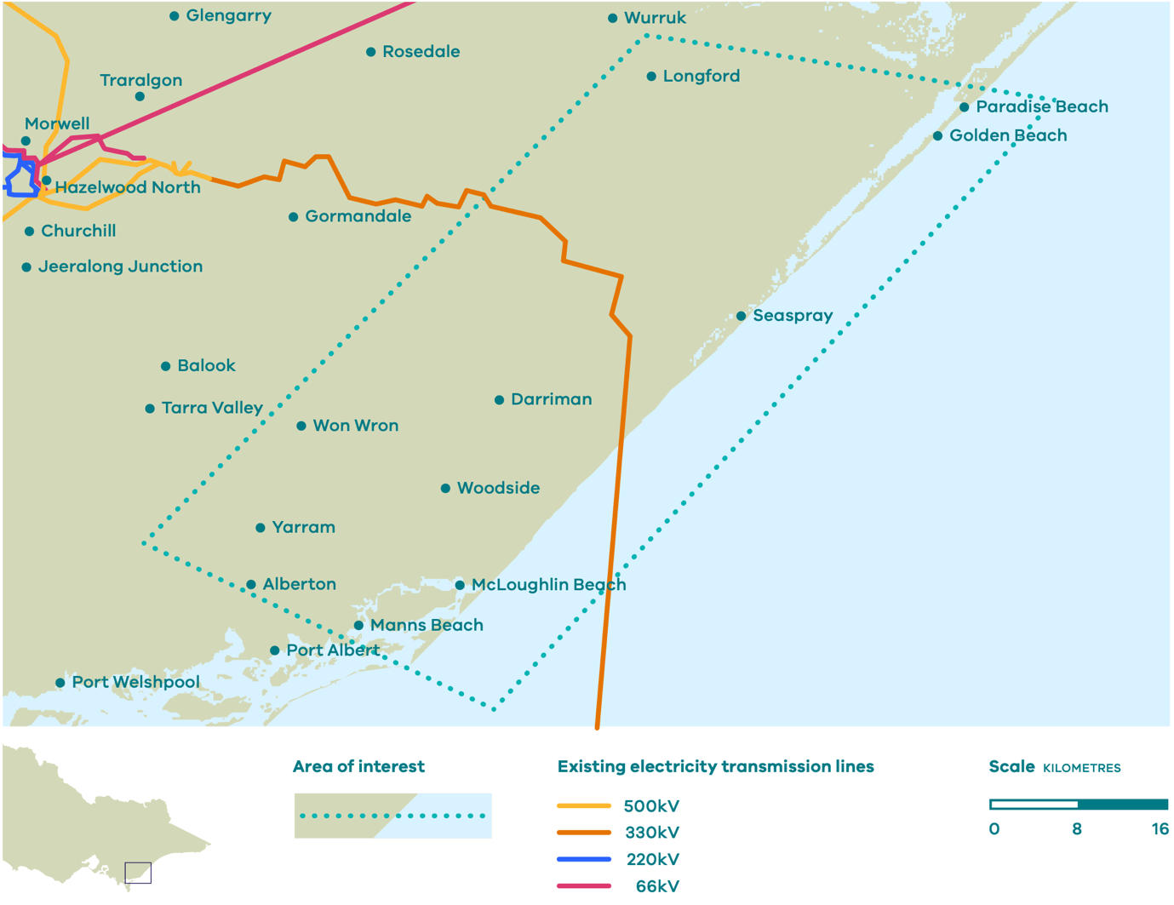
We have provided initial areas of interest for the connection points in Figure 3 and Figure 4, which is where we will start our investigations and consultation to identify appropriate sites. We are committed to developing the transmission infrastructure in consultation with local communities and stakeholders.
The first offshore wind target is at least 2 GW by 2032, which is currently targeted across Gippsland and Portland regions. Once the offshore wind procurement outcomes are known, we may adapt the timelines for the transmission infrastructure in Gippsland or Portland to ensure they are built and commissioned as they are needed.

Figure 4 Portland area of interest for investigation and consultation, and existing transmission infrastructure
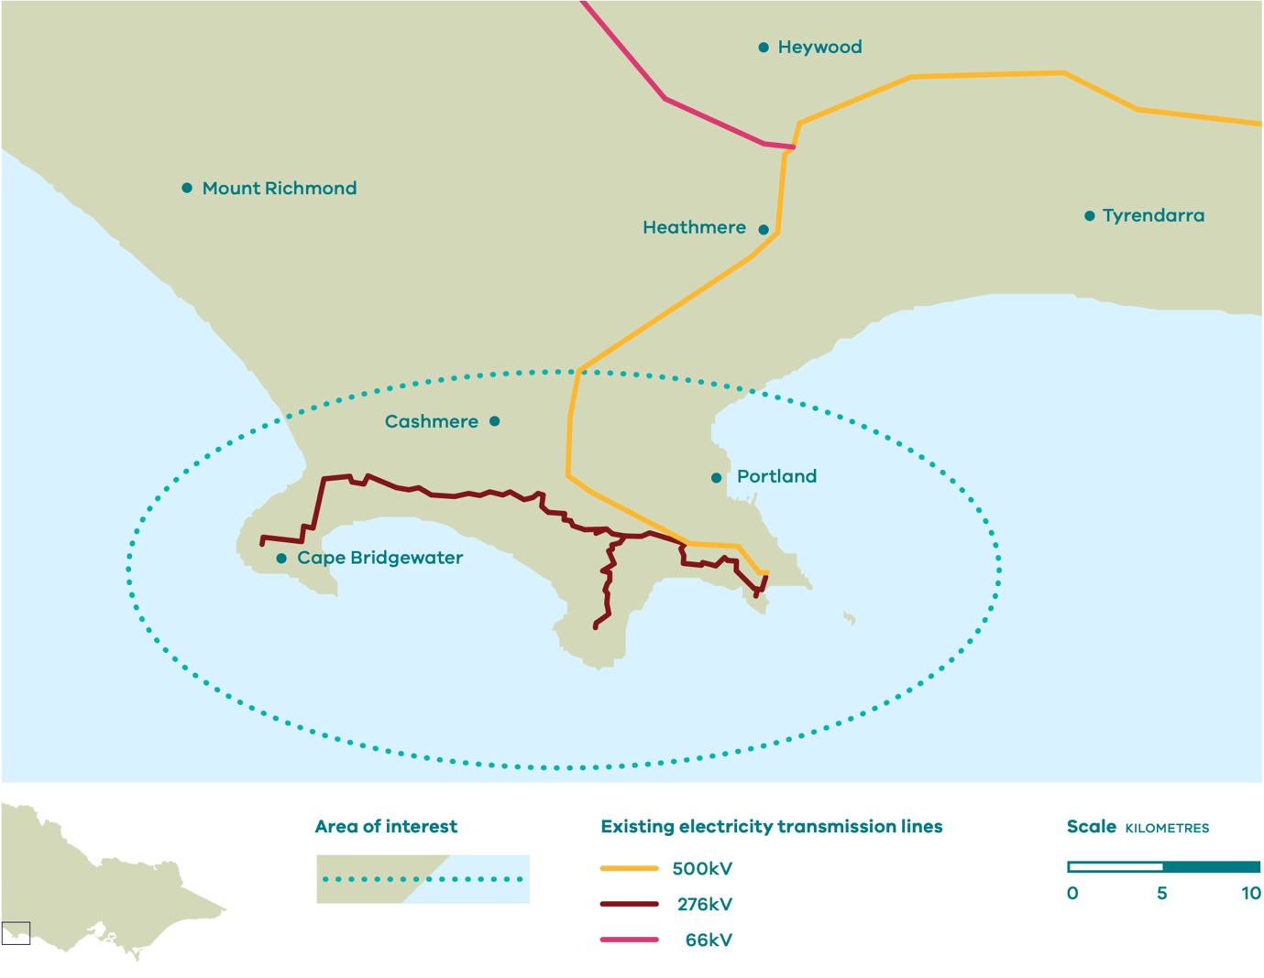

Notice 3, VicGrid-led transmission will facilitate connection of up to 2-2.5 GW capacity in both Gippsland Coast and Portland
The Victorian Government has committed to a first offshore wind target of at least 2 GW by 2032. To accommodate this, transmission infrastructure will be developed to facilitate connection of up to 2-2.5 GW generation capacity in both Gippsland and Portland respectively.
In Portland, this will be enabled through a new or upgraded 500 kilovolt (kV) switchyard, because the existing transmission network already runs close to the coast in that area. In Gippsland, this will be enabled through a 500kV double circuit transmission line and terminal station that extends the existing transmission network from the Latrobe Valley towards the Gippsland Coast. This more significant transmission development is needed in Gippsland because the existing transmission network does not extend past the Latrobe Valley, and the alternative would be multiple uncoordinated transmission lines running from the coast to the Latrobe Valley.
The transmission infrastructure developed in Gippsland and Portland to coordinate offshore wind connections will ultimately form part of Victoria’s declared transmission system (DTS). We also intend to provide access to offshore wind generators so they can connect to the infrastructure without experiencing significant network curtailment up to the existing transmission network. This is important because offshore wind farms will be required to connect to the provided transmission infrastructure, unlike other generators. More information on offshore wind access arrangements will be provided by June 2023.

Notice 4, VicGrid-led transmission will be developed in line with Government targets
The Victorian Government has committed to the first offshore wind target by 2032. VicGrid will work closely with AEMO to ensure the transmission infrastructure to coordinate offshore wind connections meets the timing commitments set by the Victorian Government.
The key stages of the transmission development process include:
- VicGrid working with AEMO, local communities, Traditional Owners and stakeholders in 2023 to investigate and develop the transmission infrastructure options. This includes a rigorous cost benefit analysis to ensure the transmission infrastructure has net benefits, including for local communities and the environment, and is cost effective. The specific transmission connection point locations and high-level route corridors in Gippsland and Portland is expected to be announced in late 2023.
- VicGrid and AEMO commencing the lead-in to procurement in late 2023, with the formal competitive procurement process for the transmission infrastructure in 2024.
- The successful tenderer planning, designing, constructing and commissioning the transmission infrastructure by the delivery date specified in their contracts with AEMO and/or VicGrid.
Offshore wind farms will manage their own connections to the transmission connection, which will be subject to a range of planning and environmental controls.

Notice 5, VicGrid-led transmission will be developed working with local communities, Traditional Owners, and stakeholders
VicGrid is committed to the timely, coordinated development of large-scale renewable generation and transmission infrastructure, and to fostering community acceptance. The transmission infrastructure to coordinate offshore wind connections will be developed and designed in partnership with Traditional Owners, and in consultation with local communities and stakeholders in Gippsland and Portland.
Early and meaningful engagement will allow VicGrid to understand local values, priorities and concerns so we can work to minimise impacts and ensure local communities see benefits from these developments. We will commence this consultation and engagement process in early 2023, by talking with communities, Traditional Owners and other interested stakeholders around the Gippsland and Portland areas of interest.
We will develop a Community Engagement Plan that will explain our engagement approach and how it will interact with and influence the development of the transmission infrastructure. We will ensure our engagement approach is coordinated and integrated with other offshore wind engagement processes.
We are also mindful of potential impacts on electricity consumers and the importance of attracting investment to maintain affordable and reliable energy throughout the transition to renewable energy. In developing the transmission infrastructure, we will seek to balance the needs of local communities and Traditional Owners, electricity consumers and the energy industry to deliver better outcomes for all Victorians.

Major milestones
Q1 2023 Community and stakeholder consultation (including Community Engagement Plan) and project development begins
Q4 2023 Connection point identification and high- level route corridor determination
Q1 2024 Competitive procurement for infrastructure provider begins
2024/2025 Planning and design activities begin – overall timeline to be consistent with Victorian Government targets and informed by offshore wind generation procurement

2 Ports schedule and plan
The Port of Hastings is likely to be the preferred port to support offshore wind construction subject to necessary community and industry consultation and environment and planning approvals.

Stakeholder engagement insights
- Ports are crucial to support offshore wind construction and ongoing operations and maintenance. Stakeholders have raised their preference for government to fund and administer any required port upgrades.
- Developers need to understand the access to and capability of a port many years before commencing construction on a new project. Government can support its offshore wind targets by communicating its plan for port upgrades in advance.
- Industry stakeholders have highlighted the need for more than one port to support operations and maintenance at offshore wind farms.

Key features

Notice 6, The Victorian Government has identified the state-owned Port of Hastings as being the most suitable port for offshore wind construction
Port infrastructure is crucial to support offshore wind construction. Offshore wind development has unique and challenging demands, requiring large areas of heavy-duty pavements adjacent to available berths and adequate channel capacity to manage specialist vessel movements. There are currently no existing ports in Victoria that meet the requirements to enable offshore wind construction.
To support the development of the offshore wind sector, we have identified the state-owned Port of Hastings as a suitable port for construction, following expert advice and engagement with offshore wind developers and ports.
The advice was supported by a multi-criteria assessment of the feasibility of ports to service offshore wind construction and evidence-based advice on the optimal port requirements for development.
The area of the Port of Hastings identified for redevelopment is the Old Tyabb Reclamation Area (OTRA), located within the port precinct between Esso’s Long Island Point and BlueScope Steel. The OTRA site is located within an existing port and industrial zone. The development would see OTRA transformed into a multiuser facility with new berths and adjacent landside infrastructure.
The port would be able to service multiple offshore wind proponents concurrently. A final decision on the Port of Hastings as the construction port for offshore wind is subject to further industry and community consultation commencing in late 2022, and subsequent planning and environmental approvals.

Notice 7, The redevelopment of the Port of Hastings could be completed by 2027
The timeline for the redevelopment of the Port of Hastings would align with our offshore wind targets. Construction of the requisite new berths and landside storage areas at the OTRA site could be completed in 2027, with a staged approach able to deliver some of the port infrastructure earlier if required.
The Port of Hastings Corporation has indicated it could invest early to understand the offshore wind industry’s needs, including cargo flows through the to-be-constructed berths and terminals, the through-put, number, size and weight of the infrastructure parts and associated cargo handling equipment, the types of vessels that will transit and berth in port waters, and the necessary landside area required. Engineering design and planning for the EES process will commence, with delivery of the construction port to be subject to further consideration as the design develops.
While offshore wind construction ports are large facilities, the benefit of the OTRA site being located within an existing port and industrial zone means that amenity impacts are able to be minimised. Existing management strategies to support the health of the Western Port RAMSAR site will be continued. The Department of Transport and the Port of Hastings would engage with local communities from late 2022 to listen to local values, priorities and concerns so the Port can work to minimise impacts and ensure local communities would benefit from the development. A Community Engagement Plan will be developed to outline the engagement approach through design and approvals.

Notice 8, The Port of Hastings has the potential to be multipurpose and allow for construction, manufacturing, and research firms to co‑locate
The redevelopment of the Port of Hastings could provide significant long-term strategic benefits for Victoria, including developing local industry capability. The Port of Hastings has the potential to support the development of a local manufacturing and research hub due to the amount of available land adjacent to the port. Such facilities would bring economic and job opportunities to Victoria while also increasing energy security through the local manufacture of critical offshore wind components. Hastings could also capitalise on the large complementary manufacturing and logistic workforce in the southeast metro and local catchment areas.
Investing early in a port upgrade will provide an opportunity for local industry to service offshore wind developments beyond Victoria in the long-term. The creation of a new multi-user facility would also add resilience to Victoria’s port system and creates the potential to facilitate bulk commodities as new trades emerge or other ports reach capacity.

Notice 9, There are significant opportunities for commercial ports in Victoria to benefit from offshore wind
We are committed to the long-term success of the offshore wind sector in Victoria, which includes creating opportunities for private sector investment. Many commercial ports in Victoria can benefit from the establishment of the offshore wind sector, including for operations and maintenance services that will be required once the offshore wind sector is established.
Many Victorian ports could accommodate the smaller crew transfer vessels and larger service operations vessels for these activities, with proximity to offshore wind developments a primary consideration. Local ports and communities are well situated to benefit economically from ongoing support activities. We encourage all ports to consider how their facilities can support the establishment of the offshore wind sector.

Major milestones
Q2 2022 Procurement and early works. Port of Hastings Corporation commenced studies and further design, with many studies ongoing until Q3 2024 to support the design and approval process
Late 2022 Stakeholder and community engagement. Port of Hastings will commence engaging with communities and stakeholders to understand community expectations and any concerns, and the port will work to ensure amenity and environmental impacts will be minimised
Q1 2023 Approvals. EES referral, with EES to commence and conclude Q1 2025
Q1 2025 Construction. Construction could commence with phased opening from Q2 2027 to support the potential for first power from offshore wind by 2028

Local industry
The Victorian Government will boost the capability of local industry.

Stakeholder engagement insights
- Victoria is competing in a fast-growing global market, where other jurisdictions are more progressed in offshore wind development and operations. To be sustainable, the rate of local industry development should reflect the maturity of the market, gradually increasing over time.
- Local capability should be developed to build on Victoria’s existing strengths. Stakeholders identified several opportunities to scale-up support for the offshore wind sector, particularly in the ongoing operations and maintenance areas.
- Workforce planning and skills development is a critical role for government. Careful planning is essential to ensure the local workforce develops the capacity and capability to delivery offshore wind in a timely and sustainable manner.
- Regional stakeholders from Gippsland and Portland are very enthusiastic about the opportunities the industry could bring for regional development.
- Stakeholders expect government to work closely with the energy sector, education sector, and local communities to develop a sustainable approach to local content and workforce strategy.

Key features
The Victorian Government will develop a strategy to build the required offshore wind workforce.
Offshore wind presents significant job opportunities for a meaningful, just transition for Victoria. Victoria has the potential for 13 GW of offshore wind resources, which could support up to 1,200 development jobs, 1,900 construction jobs, and 3,000 ongoing operations jobs (Figure 5).
To ensure that the Victorian workforce is well-prepared to deliver the state’s offshore wind goals, we will create a workforce and skills strategy for Victoria’s offshore wind sector. The strategy will consider both demand and supply factors that may affect the industry.
It will include a detailed workforce planning and skills assessment. With the support of the Department of Education and Training, we will engage with TAFEs, universities, and private registered training organisations to understand existing qualifications and any gaps in education and skills. The offshore wind workforce strategy will also consider the opportunities to develop a new workforce by reskilling workers from waning industries and encouraging young people to achieve qualifications and enter the industry.
The Victorian Skills Plan for 2022 highlighted the importance of developing new skills and capabilities across Victoria to enable the state to achieve a target of halving emissions by 2030 and net-zero emissions by 2050. Victoria’s commitment to establishing an offshore wind industry is a significant contributor to the net-zero ambition. Activating an offshore wind industry will require both identifying new workers and supporting existing workers to update, amend, or add relevant qualifications. Additionally, clean economy skills, such as those required for offshore wind, must be built into existing tertiary and vocational qualifications.
The government has already established the Clean Economy Workforce Skills and Jobs Taskforce to identify the skills and workforce required to support the major clean economy pivot across industry and society over the next 30 years. The Clean Economy Workforce Development Strategy, due for release in the next six months, will outline priorities for schooling, TAFE and training and higher education providers to empower businesses, workers and households to take up the de-carbonisation challenge.
An offshore wind workforce strategy will identify specific initiatives that the government should pursue to close the identified gaps and to support workforce development in the offshore wind industry. We will engage closely with other areas within government, including with the Clean Economy Taskforce, the Victorian Skills Authority and the Latrobe Valley Authority, to ensure the offshore wind workforce strategy complements and reinforces existing work underway.
More information on the strategy will be released to the market in 2023 through further Implementation Statements.

Figure 5 Potential job creation from 13 GW in Gippsland and Portland
Offshore wind creates the opportunity for a meaningful, just transition for Victoria’s coal, oil and gas regions.
Localised employment opportunities from 13 GW of offshore wind off Gippsland and Portland.
*Approximate estimates only
- Development (Development jobs include planning, design and engineering)
  - 900 – 1,200 jobs , over 16 years
- Construction
  - 800 – 1,900 jobs*, over 14 years
- Operations
  - 2800 – 3,000 jobs*, over 44 years
Source: Consortium analysis commissioned by the Department of Environment, and, water and Planning
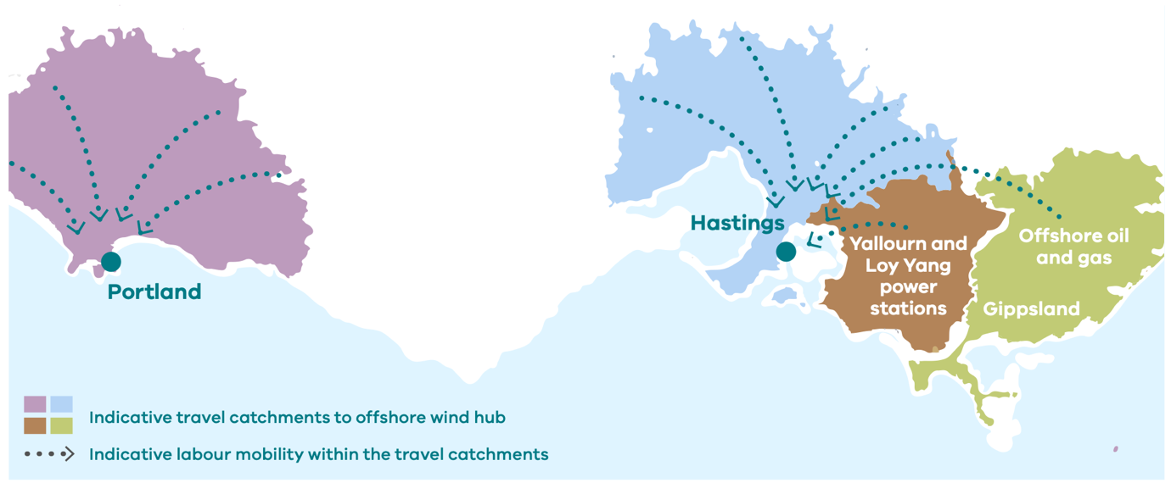
The Victorian Government is developing a plan to optimise local content policy
To ensure we set up the industry for long-term success, we intend to create a balanced local content policy that will develop our local capability and capacity over time. The policy will be applied so that the targets will scale up as the supply chain matures. This aligns with the experience of jurisdictions overseas, including the United Kingdom.
Our government agencies are currently working together to optimise local content policy for the sector. The Industry Capability Network (ICN) is assessing the Victorian and Australian capability and capacity to deliver offshore wind projects. The Department of Jobs, Precincts and Regions (DJPR) with the Department of Environment, Land, Water and Planning (DELWP) will review the recommendation of ICN and consider how best to apply requirements to align with state government policies and priorities.
Offshore wind is a significant economic opportunity for the whole of Victoria. It will not only support the state’s transition to a net-zero future, but also the scale of investment and industry development will create thousands of direct jobs and induce thousands more through the flow-on impact to secondary industries. The Victorian Government is committed to supporting the development of this industry and to building prosperity and resilience in our regions, especially in the regions of Gippsland and Portland, which are already preparing and contributing to the future of an offshore wind industry.
A place-based approach to economic development will ensure that where possible the industry will empower local people from an economic perspective. Regional development has united community, business and government in regions closest to the proposed offshore wind zones and the industry has already generated initial employment opportunities in Gippsland.
Modelling undertaken by the Victorian Skills Authority to support the Victorian Skills Plan for 2022 shows that the workforce impact of clean energy projects points to new skills being required across Victoria, particularly in regional areas as new forms of energy generation, transmission and distribution are put in place. Offshore wind is no exception, and recent engagement with regional peak bodies and observations of trends and best-practice overseas highlight that there will be significant opportunity generated in regional areas and in close proximity to the infrastructure developments. The government will introduce investment support and apply procurement levers to ensure that offshore wind contributes to a just transition for local communities in both Gippsland and Portland.
Victoria has the potential to create value throughout the entire offshore wind supply chain and supporting industries. A place-based lens will be applied to our approach to skills, education, research and development, and local supply chains to optimise the delivery of a new industry and generate benefits for all Victoria.
The Victorian Government is exploring ways to incentivise local capital investment and to build the capacity and capability of local suppliers, outside of local content requirements.
We are currently assessing a range of support options with further information to be provided to the market in 2023 through the release of additional Implementation Statements.
We also have a significant opportunity to follow international best-practice and create local construction, manufacturing and research ‘hubs’ or ‘precincts’ for offshore wind in and around the Port of Hastings, and in Gippsland – the first proposed declared area for the offshore wind industry in Australia.
Operations and maintenance opportunities will be assessed to determine opportunities to support development of regional support hubs located close to wind farms in both Gippsland and Portland. This can provide the basis for skills training and research facilities in these locations as well as provide long‑term secure employment for regional Victorians.

Supply chain and skills spotlight

Operation and maintenance services.
Operations and Maintenance Services (OMS) provide long-term stable job opportunities for skilled workers over the duration of a wind farm’s life (up to 40 years). There are opportunities for both graduates and non-graduates ranging from technicians, engineers, logistic specialists, captains and marine vessel crew, and port crew. Typically, at least half the direct jobs created in the OMS workforce are for qualified tradespersons or semi-skilled workers. These include wind turbine technicians, heavy-lift crane vessel operators, helicopter pilots, marine engineering technicians, boat captains, and deckhands.
The Victorian Government’s assessment of ports and port infrastructure is ongoing. Preliminary analysis suggests that Barry Beach (Gippsland) and the Port of Portland are existing port sites that are capable of being upgraded to support provision of OMS for the industry. The proximity of these ports to the development zones makes them attractive to developers. These sites, if suitable, could support an economic hub of OMS activity with supporting manufacturing, training, and research facilities.

Major milestones
Early 2023 Further update on local content policy in Implementation Statement 2
2023/2024 Public release of detailed workforce assessment and skills plan

3 Procurement process update
The Victorian Government is exploring ways to ensure offshore wind projects are financially viable. Further detail will be released in Implementation Statement 2.

Stakeholder engagement insights
- Offshore wind farm development is complex and exposed to a wide range of risks including planning and approvals, financial certainty, and securing social acceptance.
- Industry engagement has made it clear that early offshore wind projects will require financial support from the government.
- Support must ensure a project is bankable and insurable through simple, long-term revenue stabilisation mechanisms, pricing certainty, and approval confidence.
- Industry feedback suggests that greater support will be needed in the early days of the market, but it can be reduced over time once the market becomes more competitive. This trajectory has been observed in more mature markets.
- Communication of detail on support mechanisms, procurement, sequencing of tranches will contribute towards de-risking projects and attracting more investment.

Key features
We will provide information on the procurement process and support mechanisms for the 2 GW by 2032 in Implementation Statement 2.
The Policy Directions Paper detailed the Victorian Government’s commitment to deliver an initial offshore wind tranche of at least 2 GW by 2032, to help power Victorian homes and workplaces.
The first offshore wind tranche will be procured in the mid-2020s, following a competitive process – to allow sufficient time for the government and offshore wind developers to complete the necessary development activities, including:
- planning and approvals
- procurement, supply chain and workforce development
- stakeholder impacts
- the Commonwealth’s regulatory framework
- enabling infrastructure such as ports and transmission.
Further details on the target for the first offshore wind tranche will be announced in Implementation Statement 2.

Major milestones
Early 2023 Details about the offshore wind procurement process will be released in Implementation Statement 2
Mid 2020s A competitive procurement process will commence

4 Policy, legislative and regulatory changes
The Victorian Government is committed to establishing an appropriate regulatory framework for offshore wind projects.

Stakeholder engagement insights
- Victoria’s existing regulatory frameworks do not permit developers to obtain tenure of sufficient duration over Victorian seabed and onshore land.
- The current process for obtaining licences, approvals and permits is fragmented and de-centralised, which is likely to increase the risk of delays to project timelines and increase the regulatory burden on developers.
- Effective coordination of environmental impact assessment between the Victorian and Commonwealth governments will reduce regulatory burden on developers and expedite approvals.

Key features

Notice 10, The Victorian Government will establish a new Offshore Wind Office – Offshore Wind Energy Victoria (or OWEV) – to support the successful establishment of the offshore wind sector
The successful implementation of offshore wind in Victoria will require significant additional resources from the Victorian Government.
We will establish a new Offshore Wind Energy Victoria within DELWP to lead the establishment of the sector.

Notice 11, In early 2023, the Victorian Government will confirm the legislative and regulatory approach to support offshore wind development in Victoria
Offshore wind projects will be governed by a wide range of regulatory frameworks established under both Victorian and Commonwealth legislation due to offshore wind projects spanning the boundaries of Victorian and Commonwealth jurisdictions. Figure 6 below outlines the identified key frameworks.

Major milestones
Early 2023 The Victorian Government will confirm the legislative and regulatory approach to support offshore wind development in Victoria

Figure 6, Key regulatory and legal frameworks impacting offshore wind development in Victoria
- State law (green)
- Commonwealth law (blue)
 | Onshore |  | Victorian waters |  | Commonwealth waters
 | Cabling and substation | Cabling and dunes | Cabling (mean high watermark) | Cabling (mean low watermark) | Offshore substation and wind farm
Environmental and Planning Approvals | Environment Protection and Biodiversity Conservation Act 1999 (Cth): assessment and approval
Environment Effects Act 1978 (Vic):
Environment Effects Statement
 | Aboriginal Heritage Act 2006 (Vic): CHMP(s)
 |  | Marine and Coastal Act 2018 (Vic): Coastal Crown land consent(s)
 | Planning and Environment Act 1987 (Vic): Minister for Planning is responsible for permits for energy generation and utility installations
Tenure | Freehold land: Easements (by consent, or compulsorily acquired in reliance on Electricity Industry Act 2000 (Vic) powers); some freehold |  |  |  | Offshore Electricity Infrastructure Act 2021 (Cth): feasibility licence, commercial licence, transmission licence
 | Land Act 1958 (Vic) and Crown Land (Reserves) Act 1958 (Vic): Crown land licences or management agreements
Native Title | Native Title Act 1993 (Cth): future act process and/or ILUA and/or Traditional Owner Settlement Act 2010 (Vic) requirements
National Electricity Laws | National Electricity Law and Rules, as applied by the National Electricity (Victoria) Act 2005 (Vic) |  |  |  | National Electricity Law and Rules, as applied by the Australian Energy Market Act 2004 (Cth)
Other laws | Electricity Industry Act 2000 (Vic), Heritage Act 2017 (Vic), Environment Protection Act 2017 (Vic), Road Management Act 2004 (Vic), Wildlife Act 1975 (Vic), Flora and Fauna Guarantee Act 1988 (Vic), Pollution of Waters from Oil and Noxious Substances Act 1986 (Vic), Occupational Health and Safety Act 2004 (Vic), Marine Safety Act 2010 (Vic), Electricity Safety Act 1998 (Vic), Marine Safety (Domestic Commercial Vessel) National Law Act 2012 (Cth) |  |  |  | Victorian legislation assessed on a case by case basis, Work Health and Safety Act 2011 (Cth), Underwater Cultural Heritage Act 2018 (Cth)
This diagram is a general illustrative example only. Actual application of legislation and regulations should be assessed on a project-by-project basis.

