delwp.vic.gov.au

A guide for Accredited Providers

|  |
| --- |
| Accounting for COVID-19 under Victorian Energy Upgrades Measurement & Verification Projects  Provisions for projects with COVID-affected data |
| Bruce Rowse – 8020 Green |
| June 2021 |

|  |  |
| --- | --- |
|  |  |

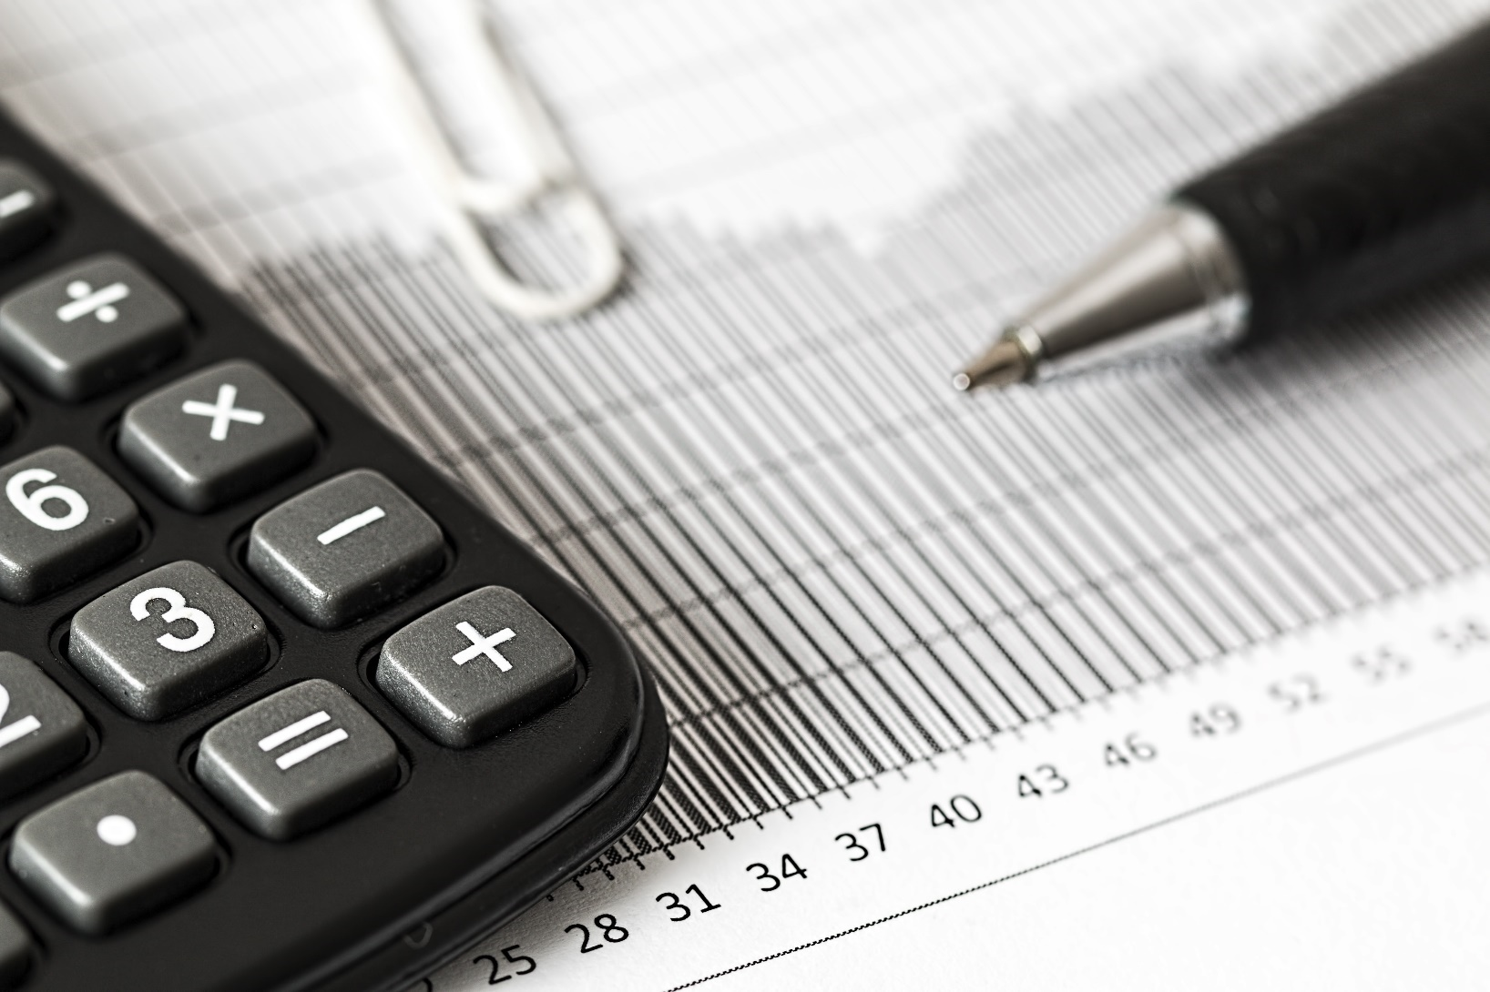November 2020

|  |  |  |  |
| --- | --- | --- | --- |
|  |  |  |  |
|  |  |  |  |

Photo credit

Pixabay

|  |
| --- |
| Acknowledgment  We acknowledge and respect Victorian Traditional Owners as the original custodians of Victoria's land and waters, their unique ability to care for Country and deep spiritual connection to it. We honour Elders past and present whose knowledge and wisdom has ensured the continuation of culture and traditional practices.  We are committed to genuinely partner, and meaningfully engage, with Victoria's Traditional Owners and Aboriginal communities to support the protection of Country, the maintenance of spiritual and cultural practices and their broader aspirations in the 21st century and beyond. |
| © The State of Victoria Department of Environment, Land, Water and Planning 2021  LogoThis work is licensed under a Creative Commons Attribution 4.0 International licence. You are free to re-use the work under that licence, on the condition that you credit the State of Victoria as author. The licence does not apply to any images, photographs or branding, including the Victorian Coat of Arms, the Victorian Government logo and the Department of Environment, Land, Water and Planning (DELWP) logo. To view a copy of this licence, visit <http://creativecommons.org/licenses/by/4.0/>  Disclaimer  This publication may be of assistance to you but the State of Victoria and its employees and 8020Green Pty Ltd do not guarantee that the publication is without flaw of any kind or is wholly appropriate for your particular purposes and therefore disclaims all liability for any error, loss or other consequence which may arise from you relying on any information in this publication.  Accessibility  If you would like to receive this publication in an alternative format, please telephone the DELWP Customer Service Centre on 136186, email [customer.service@delwp.vic.gov.au](mailto:customer.service@delwp.vic.gov.au), or via the National Relay Service on 133 677 [www.relayservice.com.au](http://www.relayservice.com.au). This document is also available on the internet at [www.delwp.vic.gov.au](http://www.delwp.vic.gov.au). |

|  |
| --- |
| Accounting for COVID-19 under Victorian Energy Upgrades Measurement & Verification Projects  Provisions for projects with COVID-affected data |

Bruce Rowse – 8020Green

|  |
| --- |
| June 2021  DELWP – Energy – Energy Demand, Programs and Safety |

Acknowledgements

|  |  |  |  |
| --- | --- | --- | --- |
|  |  |  |  |

DELWP and 8020Green would like to thank those who volunteered their time to give input and feedback into the development of these provisions:

Green Energy Trading

Beovista

Wattly/Northmore Gordon

ERM Power

Author

The State of Victoria and Bruce Rowse of 8020Green ([www.8020green.com](http://www.8020green.com))

Editor

Katie Wittman (DELWP)

|  |
| --- |
| Report produced by:  Energy Group  Department of Environment, Land, Water and Planning  8 Nicholson Street  East Melbourne, 3002  Phone 136 186  Website: www.delwp.vic.gov.au  Citation  Rowse, Bruce (2021)  for Energy Demand and Efficiency Policy, Department of Environment, Land, Water and Planning, East Melbourne, Victoria |

Contents

1 Background and Overview 8

1.1 Background 8

1.2 Overview 8

1.2.1 Sites which do not experience change due to COVID 8

1.2.2 Sites which experience change due to COVID 8

1.3 Scope 10

2 Definitions and Acronyms 11

2.1 Definitions 11

2.2 Acronyms 12

3 COVID provisions 13

3.1 COVID provisions for forward creation 13

3.2 Provisions for annual creation or top up VEEC creation 15

3.2.1 Variations to provisions 3 and 8 for annual creation or top up. 15

4 Procedure 16

4.1 Identify whether COVID has impacted site energy usage. 16

4.2 Describe the impacts of COVID on site energy usage. 17

4.3 Explain how COVID has changed energy use 17

4.4 Identify the COVID impacted period 18

4.5 Identify whether baseline and operating periods containing COVID can be avoided 18

4.6 If there is a new normal, account for it 18

4.7 Decide how to account for COVID 19

4.8 Apply COVID methods 19

4.9 Support your claim 19

5 Mini method 20

5.1 Description of method 20

5.1.1 Provisions applicable to the mini method 20

*5.1.2* Extension of the eligible range for mini methods 21

5.2 Example of the mini method 22

5.2.1 Identify whether COVID has impacted on site energy usage. 22

5.2.2 Describe the impacts COVID has had on site energy usage. 22

5.2.3 Explain how the site’s COVID response has caused a change in energy usage 23

5.2.4 Identify the COVID impacted period 23

5.2.5 Select the method 23

5.2.6 Is there a new normal? 24

5.2.7 Application of the method 24

6 Avoided Energy Method 28

6.1 Description of method 28

6.1.1 Provisions applicable to the avoided energy method 28

6.1.2 Avoided energy: adjusting to normal year conditions 29

6.1.3 Adjustments to allow for IVs that don’t vary at all, or by a minimal amount, outside of COVID 29

6.1.4 Uncertainty for the avoided energy method 30

6.2 Example of the avoided energy method 30

6.2.1 Identify whether COVID has impacted on site energy usage. 31

6.2.2 Describe the impacts COVID has had on site energy usage 31

6.2.3 Explain how the site’s COVID response has caused a change in energy usage 31

6.2.4 Identify the COVID impacted period 32

6.2.5 Select the method 32

6.2.6 Is there a new normal? 32

6.2.7 Application of the method 32

7 Usual but Accounting for COVID method 38

7.1 Description of method 38

7.1.1 Provisions applicable to the usual but accounting for COVID method 38

7.1.2 Determination of the BAF for normal year savings when models may be skewed by COVID 38

7.2 Example of the Usual but accounting for COVID method 39

7.2.1 Identify whether COVID has impacted on site energy usage. 39

7.2.2 Describe the impacts of COVID on site energy usage 39

7.2.3 Explain how the site’s COVID response has caused a change in energy usage 40

7.2.4 Identify the COVID impacted period 41

7.2.5 Select the method 41

7.2.6 Is there a new normal? 41

7.2.7 Application of the method 41

8 Interactions with other M&V rules 46

8.1 Implementation start time and emissions factors 46

8.2 Eligible time intervals 46

9 Annex – comments on statistical tests 47

**List of Figures**

Figure 1 Determination of eligible range for normalised savings 11

Figure 2 Illustration of eligible periods for forward creation with respect to COVID 13

Figure 4 Examples of possible mini periods 20

Figure 5 Mini method example - change in energy usage due to COVID 23

Figure 6 Mini method example - Baseline energy vs temperature scatterplot 24

Figure 7 Mini method example - actual energy, modelled baseline, modelled operating 26

Figure 8 Examples of possible avoided energy periods 29

Figure 9 Avoided energy method example - change in energy usage due to COVID 31

Figure 10 Avoided energy method example - Baseline energy vs temperature scatterplot 34

Figure 10 Avoided energy method example - actual energy, modelled baseline, modelled operating 36

Figure 11 Examples of possible usual but accounting for COVID periods. 38

Figure 12 Usual but accounting for COVID method example - change in energy usage due to COVID 40

Figure 13 Usual but accounting for COVID method example - actual energy, modelled baseline. 45

**List of tables**

Table 1: When would my project use which method? 10

Table 2 Dates of significant events in Victoria related to COVID. For information only. 16

Table 3: Describe and quantify changes at the site which have impacted on energy usage. 18

Table 4: Decision matrix for deciding how to account for COVID 19

Table 5 Mini method example - site details 22

Table 6 Mini method example - COVID induced changes which have impacted on energy usage 23

Table 7 Mini method example - check against method provisions 24

Table 8 Mini method example - model coefficients 25

Table 9 Mini method example - check against IPMVP regression tests 25

Table 10 Mini method example - eligible range 25

Table 11 Avoided energy method example - site details 31

Table 12 Avoided energy method example - COVID induced changes which have impacted on energy usage 32

Table 13 Avoided energy method example - check against method provisions 33

Table 14 Avoided energy method example - model coefficients 34

Table 15 Avoided energy method example - check against IPMVP regression tests 34

Table 16 Avoided energy method example - eligible range 34

Table 17 Avoided energy method example – contribution of IVs to variation in daily energy use 35

Table 18 Usual but accounting for COVID method example - site details 39

Table 19 Usual but accounting for COVID method example - how COVID has impacted on energy usage 40

Table 20 Usual but accounting for COVID method example - check against method provisions 41

Table 21 Usual but accounting for COVID method example - COVID induced changes which have impacted on energy usage 42

Table 22 Usual but accounting for COVID method example - model coefficients 42

Table 23 Usual but accounting for COVID method example - check against IPMVP regression tests 42

Table 24 Usual but accounting for COVID method example – contribution of IVs to variation in daily energy use 44

# Background and Overview

## Background

The Victorian Energy Upgrades program introduced the Measurement & Verification (M&V) method in 2017 to allow large and bespoke energy efficiency upgrades to generate incentives under the program.

The M&V method uses real energy data before and after an upgrade to accurately determine the avoided emissions resulting from an upgrade. The M&V method has built in allowances for data disruptions, or for times when energy consumption at a site is not representative of what is typically observed for that site. During COVID-19 (COVID) or other declared states of emergency or states of disaster, changes in the operation of facilities may have caused disruptions or atypical energy consumption patterns for longer periods of time than what the current rules allow. These changes may mean that some projects would no longer be eligible to create certificates.

This document describes the procedure that Accredited Providers (**APs**) must use to account for COVID or other declared states of emergency or disaster when undertaking M&V under the VEU program. The procedures prescribed in this document are detailed and complex and are primarily aimed at qualified M&V professionals with comprehensive understanding of the M&V requirements under the VEU program.

This guide was written in response to the novel coronavirus (COVID-19) pandemic but is intended to be used in the case of any other state of emergency or state of disaster. Throughout this guide the term “COVID” is used frequently, but this guide applies to any period in relation to which a state of emergency or disaster has been declared.

This guide should be applied as required by the Measurement and Verification in Victorian Energy Upgrades, as amended from time to time, which are specifications made under the *Victorian Energy Efficiency Target (Project-Based Activities) Regulations 2017* (the VEET PBA Regulations).

## Overview

If COVID (or any other declared state of emergency or declared state of disaster) occurs at any time during an M&V project in relation to which an **AP** intends to create Victorian Energy Efficiency Certificates (VEECs), the AP must determine whether the energy use at the site has materially changed due to COVID (ie. the AP must determine whether the project is an ‘impacted project’ for the purposes of the VEU M&V Specifications). Evidence must be provided to support this determination.

### Sites which do not experience change due to COVID

If there is no material change due to COVID (ie. the project is not an impacted project), the AP must provide supporting evidence. VEEC creation should then proceed as usual, and the remaining provisions in this document DO NOT apply.

### Sites which experience change due to COVID

If the project is an impacted project, then as a first option, all projects must ascertain if they can first discard up to 20% of the data in a baseline or operating/reporting period to comply with VEU’s M&V method.

In cases where this method cannot create a valid model:

1. Projects should use the allowances set out in this document to shift their intended baseline and operating/reporting periods so that the effects of COVID are avoided. These allowances are described in this document as; the Mini method, the Avoided Energy method, and the Usual but Accounting for COVID method.
2. Alternatively, APs may choose to wait until the COVID impacted period is over, ensuring both the baseline and operating periods occur outside the COVID impacted period.

**The three COVID methods:**

1. In the **mini method**, the baseline and operating periods can be reduced to less than a full operating cycle, but both periods must occur outside of the COVID impacted period. An Eligible Range Adjustment Factor (ERAF) can be applied where the range of independent variables (IVs) in the operating period is outside the eligible range. The ERAF allows for savings to be included for time intervals outside the eligible range. A penalty is applied in proportion to how far the IVs are outside the eligible range.
2. The **avoided energy method** can be applied where either the baseline or operating period covers a period both in and outside the COVID impacted period. The IVs that explain the change of energy use during COVID may bias the model in the COVD-free period. To counteract this a Bias Adjustment Factor (BAF) must be applied.
3. The **usual but accounting for COVID method** requires both the baseline and operating period to cover a period both in and outside the COVID impacted period. This method also uses a BAF to account for the bias in the model from the IVs. This will explain the change in energy use during COVID.

These methods are only suited to the use of regression models and cannot be used in association with an estimate of the mean. Projects using an estimate of the mean must have a baseline and operating period completely outside of COVID. If an estimate of the mean project can prove that it has not been affected by COVID it may proceed as usual. Otherwise these projects may use an engineering calculation to describe the “new normal”. Estimate of the mean projects which cannot justify a new normal may not be eligible to create VEECs.

After COVID, if the site has a “new normal”, this can be accounted for by either:

a) using IVs that reasonably explain the difference in energy use before COVID and under the “new normal” conditions; or

b) undertaking an engineering calculation to explain the difference. Such a calculation would need to be approved by the ESC in advance, and only used as a last resort.

If there is a “new normal” and neither of these approaches (IVs that explain the difference or engineering calculations) can be used, VEECs cannot be created.

Examples of when a project might use each of the three methods are tabled below.

Table 1: When would my project use which method?

|  |  |  |
| --- | --- | --- |
| **The Mini method** | **The Avoided Energy method** | **The Usual but Accounting for COVID method** |
| My operating period would have run two months into the beginning of COVID. I chose to use the mini method, with 10 month baseline and operating periods so I can claim certificates without needing to make any new measurements of my IVs or account for the effects of COVID in my energy models. | The site owner is relying on VEEC creation to cover a significant portion of project cost, so they have decided to use 12 month baseline and operating periods even though some of this time contains COVID and a new IV needs to be introduced to the model. | |
| My project doesn’t have any data for an IV that explains site energy consumption during COVID, so even though using shorter baseline and operating periods reduces VEEC creation we’ve decided to use the mini method. | My site has a lot of monitoring, so we were able to use pre-existing site-specific data to add a new IV to the model which accounts for site energy consumption during COVID. | |
| The energy consumption at this site became unpredictable during COVID to the point that no suitable IV could be found which accurately modelled these changes. | The site is relatively new and only has one year of data with which to create a baseline energy model, this year includes time in COVID. The upgrade works began during COVID and were completed after COVID. | This upgrade occurred during COVID, so the planned baseline and operating periods both have some time in COVID and some time out of COVID. We also had electronic records of orders during and outside of COVID which act as a suitable IV. |
|  |  | Baseline and operating periods can be chosen outside of the declared state of emergency, but a stable new normal has not yet been reached. A compliant energy model will require a new IV that explains factors which describe site behaviour during COVID and have not yet stabilised. |

## Scope

The provisions in this document are limited to accounting for COVID and other states of emergency or states of disaster. Unless expressly varied by the operation of this document, the VEU M&V Specifications apply. Where this document ceases to provide guidance, the normal procedure for certificate creation is followed.

This document applies to any project which has an implementation start time during any of the following periods:

1. up to 12 months prior to any state of emergency or state of disaster;
2. during any state of emergency or state of disaster; and
3. up to 3 years after the end of any state of emergency or state of disaster has ended.

For projects with multiple premises, the provisions apply in relation to the completion of works at a premises rather than the implementation start time.

# Definitions and Acronyms

## Definitions

**Activity** - An upgrade made with the intent of saving energy.

**Adjustment factor** - A factor used to adjust savings, either in one interval, or across a whole reported period, but only applicable to COVID impact calculation methods.

**Bias adjustment factor (BAF)** -A factor used to adjust for bias in a regression model due to independent variables that explain the variation in energy use during COVID, but which vary little outside the COVID impacted period, as defined in section 3.1.

**COVID or COVID-19** - In this document the term COVID or COVID-19 refer to any period in which Victoria, or part of Victoria, is subject to a declared state of emergency or state of disaster. E.g. “during COVID…” would mean “during the period in which part or the whole of Victoria was subject to a state of emergency or state of disaster whether due to the novel coronavirus or any other reason”.

**COVID impacted period** – Any period commencing at or after the start of COVID during which a site operated differently than before COVID, provided such difference can be attributed to COVID. An AP is required to define the COVID impacted period for a site using the methodology outlined in this document. A site may be subject to multiple COVID impacted periods.

**COVID method** - Any one of the three methods outlined in this document, being the “Mini” method, “Avoided Energy” method and “Usual but Accounting for COVID” method.

**Eligible range** -As defined in the VEU program rules and explained by the diagram below for normalised savings.

Normal year range

Baseline model range

Operating period model range

Eligible range

(Effective) Range

5% of range

5% of range

Figure 1 Determination of eligible range for normalised savings

**Eligible Range Adjustment Factor (ERAF)** - An adjustment factor that can be applied to each interval in a regression model where the independent variables are outside the eligible range, as defined in section 5.1.2 of this document. The ERAF can only be applied when using the mini method.

**Interval** - A single time interval of energy use, used in the data of a regression model e.g. daily, weekly, fortnightly, or monthly.

**Impacted project** – has the meaning set out in the *Measurement and Verification in Victorian Energy Upgrades Specifications*.

**New normal** - When operating conditions after COVID are stable but different to before COVID, the new operating conditions shall be considered the new normal. Accounting for a new normal can be used with any of the three COVID methods outlined in this document.

**Operating cycle** - The period over which an independent variable has a full cycle. For example, in Victoria a weather based independent variable such as CDD or HDD has an operating cycle of 12 months.

**Project works** – in relation to an energy efficiency project under Victorian Energy Upgrades, the energy efficiency upgrade works.

**State of disaster** has the meaning set out in the *Measurement and Verification in Victorian Energy Upgrades Specifications*.

**State of emergency** has the meaning set out in the *Measurement and Verification in Victorian Energy Upgrades Specifications*.

**Upgrade** - All or part of an activity implemented to save energy (see definition of activity).

**VEU M&V Specifications/M&V Specifications/ the Specifications** - Measurement and Verification in Victorian Energy Upgrades – Specifications v 4.0, available here: <https://www.energy.vic.gov.au/__data/assets/pdf_file/0021/505065/Measurement-and-Verification-in-Victorian-Energy-Upgrades-Specifications-Version-4.0.pdf>

## Acronyms

**AP** -Accredited Provider

**BAF** - Bias Adjustment Factor

**CDD** - Cooling Degree Days

**DELWP** - Department of Environment, Land, Water and Planning

**ERAF** - Eligible Range Adjustment Factor

**ESC** - Essential Services Commission

**HDD** - Heating Degree Days

**IPMVP** - International Performance Measurement and Verification Protocol.

**IV** - Independent Variable

**NRA** - Non-Routine Adjustment

# 

# COVID provisions

To enable the procedure prescribed in this document the following temporary provisions apply for M&V projects in the VEU program.

The provisions outlined in section 3.1 are for forward creation of VEECs, which uses an operating model. At the time of writing, almost all M&V certificate claims in the VEU program use forward creation.

Section 3.2 describes how provisions are applied for APs wishing to undertake annual creation and/ or to top up from a single reporting period.

## COVID provisions for forward creation

The procedure outlined in this document must be followed for submission of any M&V scoping plans, project plans, or impact reports made from the date this document is published up to 3 years after the end of COVID.

1. **Impacts of COVID on a site’s energy usage must be established.**
2. **If proven that COVID has had no significant impact, the remainder of these provisions DO NOT apply.**
3. **Timeframes from which eligible baseline and operating periods can be chosen will be extended by the length of a site’s COVID impacted period, and:**

**This extension may only be applied to the baseline and/or operating period(s) which occurred during COVID or were planned for a time which was then impacted by COVID.**

**If the project works start less than a complete operating cycle after the end of COVID, an additional extension to the eligible timeframe for the baseline period shall be allowed, equal to the time between the end of the COVID impacted period and the start of project works.**

**If the project works finish less than a complete operating cycle before the start of COVID, an additional extension to the eligible timeframe for the operating period shall be allowed, equal to the time between the implementation start time and the start of COVID impacted period.**

The diagram below illustrates application of this provision. Each row of the diagram shows the eligible periods in relation to the project works and COVID.

Figure 2 Illustration of eligible periods for forward creation with respect to COVID

Assumptions in this diagram:

- The COVID impacted period is 12 months. Depending on how long the state of emergency runs for, and the site-specific impacts of COVID, the actual COVID impacted period may be shorter or longer.

- The duration of the site’s operating cycle is 12 months.

- Project works take 3 months. Note that any period which runs for a continuous uninterrupted operating cycle outside of the COVID impacted period counts as either an eligible baseline, or operating period.

1. **If an estimate of the mean is being used to determine savings, baseline and operating periods must be entirely outside the COVID impacted period.**
2. **Where sites have an unaffected baseline and a new normal exists after COVID,**

i**f one or more Independent Variables (IVs) can be used to explain the change from the pre-COVID baseline, then normal year savings can be claimed.**

**if it cannot be explained by IVs, an engineering calculation may be submitted (as a last resort) to justify a baseline adjustment. The ESC must approve the justification for the calculation to be valid. Review of such a baseline adjustment may require payment of an additional fee.**

1. **For application of the “mini method” as outlined in this document:**
2. **normal year savings can be claimed in intervals where the independent variables are outside of the eligible range using an ERAF.**
3. **The number of intervals in both the baseline period and operating period regression models must be no less than 4 times the number of IVs.**
4. **When substantiating the value of an IV which helps explain variations in energy use both outside and during the COVID impacted period:**
5. **The use of an IV labelled “COVID”, as a binary switch, is not allowed.**
6. **The requirements of the ESC must be satisfied.**

In the absence of measured data the following are an indication of what the ESC may consider acceptable evidence of IV values:

1. Reference to state-imposed requirements or restrictions (including patron limitations if applicable), for facilities specifically named under the restrictions.
2. Screenshots of dated photographic evidence from social media postings, websites, or similar (e.g. showing a closed facility, and its usual opening hours).
3. Copies of internal correspondence (e.g. email to staff), timesheets, payrolls, or similar.
4. As a last resort, an estimate made by a knowledgeable employee at the facility (e.g. manager, facility manager), accompanied with a statutory declaration.

The ESC may request one or more of the above items.

1. **Bias in a model which spans both a non COVID impacted period and a COVID impacted period is to be accounted for by applying a Bias Adjustment Factor (BAF). This applies to the “avoided energy” method or “Usual but accounting for COVID” method.**

The BAF is calculated based on the relative contribution to overall variation in energy use during the COVID-containing period, from non-COVID IVs. The Bias Adjustment Factor is taken as the square root of this relative contribution.

BAF = $\sqrt{\frac{\sum_{k=1}^{k=m}{({IVNcoeff}_{k} x {\overline{IVN}}_{k})}}{\sum_{j=1}^{j=n}{({IVcoeff}_{j} x {\overline{IV}}_{j}})}}$

Where:

*n* is the number of independent variables in the regression model

*j,* which ranges from 1 to *n*, is the order in which an IV appears in the regression model.

*IVcoeffj* is the coefficient of the jth independent variable in the regression model.

${\overline{IV}}_{j}$ is the average value of the jth independent variable.

*m* is the number of independent variables, which do not explain the variation in energy use due to COVID, in the regression model

*k*, which ranges from 1 to *m*, is the order in which an IVNC appears in the regression model.

IVNcoeffk is the coefficient of the kth independent variable, which does not explain the variation in energy use due to COVID. i.e. an Independent Variable Not explaining COVID, in the regression model.

$\overline{IVN}$*k* is the average value of the kth independent variable not explaining COVID

**When use of a BAF is permissible, equation 2 of the VEU M&V Specifications shall change to be:**

Energy savings = $\sum_{i}{(normal year savings x ({AF x {DF}_{i} x BAF)}^{\frac{normal year savings}{\left|normal year savings\right|}} }$

Where:

1. i is a year of the maximum period for forward creation for the project
2. Normal year savings is calculated using equation 4.
3. AF is the accuracy factor for the measurement boundary
4. DFi is the decay factor for that measurement boundary in year i.
5. BAF is the bias adjustment factor as described above
6. **Projects which have been affected by COVID and planned to forward create only (no top up), may subsequently request a variation to allow top up.**
7. **Each of the three COVID methods (the “Mini” method, “Avoided Energy” method and “Usual but Accounting for COVID” method) has a set of provisions, described in sections** 5.1.1**,** 6.1.1 **and** 7.1.1 **respectively.**

## Provisions for annual creation or top up VEEC creation

For annual creation or top up, except when using the Mini method, the provisions outlined in section 3.1 apply on the following basis:

**The term “operating” can be substituted with “reporting”.**

**The term “normal year” can be substituted with “reporting year”.**

**Provisions 3 and 8 vary as described in** **section 3.2.1****.**

The Mini method is not suitable for annual creation or top-up and cannot be used in this way.

### Variations to provisions 3 and 8 for annual creation or top up.

The following variations to specific provisions apply:

**Provision 3. Extension of periods**: Where the baseline occurs before COVID, the first eligible reporting period may be selected from a period that includes a complete, continuous operating cycle outside of COVID. Any subsequent reporting periods must begin immediately after the previous reporting period.

**Provision 8: Bias Adjustment Factor.** When using the avoided energy method, if the baseline period contains COVID a BAF is calculated and applied for each year of certificate creation. If the reporting period contains COVID the BAF is only used when creating certificates for a COVID containing year. When using the usual but accounting for COVID method a single BAF will be calculated from two contributing BAFs (outlined in section 7.1.2) and this BAF should be used for subsequent years of certificate creation.

# Procedure

1. Identify whether COVID has impacted on site energy usage.

2. Describe the impacts COVID has had on site energy usage.

3. Explain how the site’s COVID response has caused a change in energy use.

4. Identify the COVID impacted period.

5. Identify whether baseline and operating periods containing COVID can be avoided.

6. If there is a new normal, account for it.

7. Apply one of the three COVID methods.

8. Support your claim with evidence.

## Identify whether COVID has impacted site energy usage.

Identify if there have been any changes at the site due to COVID which could be reasonably expected to impact on energy use. The timeline of Victorian restrictions and significant events relating to COVID, shown below, may be useful.

It is up to APs, as the project proponents, to nominate the relevant dates. The table below is for information only.

Table 2 Dates of significant events in Victoria related to COVID. For information only.

| **Date of change** | **Change** |
| --- | --- |
| 13 Mar 2020 | Grand prix cancelled |
| 16 Mar 2020 | Premier declares State of Emergency |
| 22 Mar 2020 | Shutdown of all non-essential activities over the next 48 hours announced by the Premier |
| 23 Mar 2020 | Stage 2 restrictions announced by the Premier from midnight |
| 29 Mar 2020 | Stage 3 restrictions announced by the Premier from midnight |
| 5 May 2020 | Restrictions partially eased, up to 10 people outside, 5 in a home, effective midnight |
| 1 Jun 2020 | Restrictions further eased, with restaurants and cafes allowed to reopen with up to 20 patrons inside |
| 22 Jun 2020 | Restrictions further eased with up to 50 patrons per enclosed space |
| 1 Jul 2020 | Stage 3 restrictions imposed from midnight in postcodes 3012, 3021, 3032, 3038, 3042, 3046, 3047, 3055, 3060, 3064 |
| 4 Jul 2020 | Stage 3 restrictions imposed from midnight in further 2 postcodes, 3031, 3051 |
| 8 Jul 2020 | Stage 3 restrictions imposed on all Melbourne Metro and Mitchell Shire, from midnight |
| 2 Aug 2020 | Face covering mandatory for all Victorians from midnight, curfew implemented |
| 5 Aug 2020 | Stage 4 lockdowns come into effect from midnight in Melbourne. Many businesses not permitted to operate. Stage 3 restrictions come into effect from midnight for the rest of the State |
| 13 Aug 2020 | Staged return of education in regional Victoria from midnight |
| 13 Sept 2020 | 11:59pm 13 Sept 2020 - Move from Stage 4 to the First Step of the roadmap to reopening  [How we live](https://www.coronavirus.vic.gov.au/sites/default/files/2020-11/Victoria%27s%20roadmap%20for%20reopening%20-%20How%20we%20live.pdf) – [How we work](https://www.coronavirus.vic.gov.au/sites/default/files/2020-11/Victoria%27s%20roadmap%20for%20reopening%20-%20How%20we%20work%20in%20Victoria_0.pdf) |
| 16 Sept 2020 | Increased reopening for sport, recreation, and special ceremonies for regional Victoria from midnight ([Regional Third Step](https://www.premier.vic.gov.au/sites/default/files/2020-09/Regional%20VIC%20-%20Third%20Step.pdf)) |
| 27 Sept 2020 | Staged return of face to face education in Melbourne from midnight ([Second Step](https://www.premier.vic.gov.au/sites/default/files/2020-10/201026%20-%20Metro%20Melb%20Easing%20Restrictions.pdf)) |
| 27 Oct 2020 | Removal of the four reasons to leave home in metropolitan Melbourne from midnight, other restrictions still in place ([Third Step](https://www.premier.vic.gov.au/sites/default/files/2020-10/201026%20-%20Metro%20Melb%20Easing%20Restrictions.pdf)) |
| 22 Nov 2020 | From 11:59pm 22 Nov 2020 Restrictions ease – ‘[Last Step](https://www.premier.vic.gov.au/sites/default/files/2020-10/201026%20-%20Metro%20Melb%20Easing%20Restrictions.pdf)’ |
| 6 December 2020 | From 11:59pm 6 December, masks will only be required in a limited number of places – Density and visitor requirements relaxed |
| 18 Jan 2021 | 50% capacity in offices – 25% on site for public service – Mask requirements relaxed |
| 22 Jan 2021 | Visitors in home increased from 15 to 30 |
| 8 Feb 2021 | 75% capacity in offices |
| 12 Feb2021 | Restrictions in place from 11.59pm Friday 12 February 2021 for a period of five days, until 11:59pm on Wednesday 17 February 2021. 5 reasons to leave home. |
| 17 Feb 2021 | Restrictions removed - “largely return to the previous rules” |
| 27 May 2021 | Lockdown with 5 reasons to leave home starting at midnight. |
| 2 June 2021 | Restrictions extended until 11:59pm 10 June 2021 – slight easing of restrictions |
| Future | Reference: <https://www.coronavirus.vic.gov.au/coronavirus-covid-19-restrictions-roadmaps> |

If COVID has not triggered any changes that impact on energy usage and either the baseline or operating period occurs during COVID, you must:

1. Explain why COVID has had no impact.

2. Provide evidence to show lack of impact on the energy source you are claiming for. For example, graphs of interval data showing no change from typical usage profiles, copies of energy bills, or plots showing that actual energy usage is similar to that predicted by an energy model.

**If you can prove that COVID has had no impact, DO NOT follow the rest of these provisions.**

## Describe the impacts of COVID on site energy usage.

For any energy source you intend to claim VEECs for, provide evidence of a change in use. For example, graphs of interval data showing changes from typical usage profiles, copies of energy bills, plots showing that actual energy usage is different to that predicted by an energy model, or similar.

## Explain how COVID has changed energy use

Describe the reasons why energy usage has changed during COVID, or why a new normal has been established due to COVID.

Be as specific as possible, for example changes in:

- production levels

- sales

- number of staff at site

- number of customers

- number of shifts

- operational schedules

- product mix

For each change, identify the date it occurred and quantify, if possible, the change. E.g. “Production days reduced from 5 to 4”, using a table as outlined below

Table 3: Describe and quantify changes at the site which have impacted on energy usage.

| **Date of change** | **Change trigger** | **Change description** |
| --- | --- | --- |
|  |  |  |
|  |  |  |
|  |  |  |
|  |  |  |
|  |  |  |

Note it is not acceptable to simply identify “COVID” as the reason for any change in energy usage.

## Identify the COVID impacted period

Identify the start and end date of the COVID impacted period, referencing changes in energy consumption data and operational changes.

Note:

* The COVID impacted period must occur within COVID.
* If you are still in a COVID impacted period, the end date can be written as “In the future”.

## Identify whether baseline and operating periods containing COVID can be avoided

If it is possible to select an earlier baseline period or later operating period which completely avoid the declared states of emergency and disaster, do so. Timeframes from which eligible baseline and operating periods can be chosen are extended by the length of a site’s COVID impacted period. There are additional allowances when project works occur within less than a full operating cycle either side of COVID.

If it is possible to omit COVID-affected data within the 20% threshold allowed by the VEU program, do so.

## If there is a new normal, account for it

A new normal could either exaggerate or hide savings, depending on whether the new normal results in an energy increase or decrease.

To account for a new normal these are the provisions:

1. Where there is data for one or more IVs that can reasonably explain the difference between the pre-COVID normal and post-COVID normal include these variables.
   1. If the IV(s) vary in both baseline and operating period you may select any of the COVID methods provided in this document.
   2. If the IV(s) have negligible variation outside of COVID but do vary in the COVID impacted period you can either
      1. Select baseline and operating periods which are both partially COVID-affected and use the “Usual but accounting for COVID” method, or
      2. Select one period outside of COVID and another which partially contains COVID and use the “avoided energy” method.
2. If IVs cannot explain the difference between the pre-COVID normal and post-COVID normal,
   1. Adjust the baseline using an engineering calculation, and
   2. Submit the engineering calculation to the ESC for review.

Where a “new normal” situation doesn’t meet any of these criteria, DO NOT use the methods outlined in this document.

## Decide how to account for COVID

Use the decision matrix below to decide how to account for COVID.

Table 4: Decision matrix for deciding how to account for COVID

| **No.** | **Question** | **If yes, go to step no.** | **If no, go to step no.** |
| --- | --- | --- | --- |
| 1 | Has a new normal been established due to COVID? | 2 | 3 |
| 2 | Account for the new normal (as outlined below in Section 4.6) *Then go to Step 3* |  |  |
| 3 | Is either an estimate of the mean being used, or is it acceptable to have both the baseline and operating periods outside the COVID impacted period? | 4 | 5 |
| 4 | Undertake M&V as you usually would, with the baseline and operating periods outside of COVID, noting the provisions for eligible periods for COVID impacted sites. *Exit this decision matrix* |  |  |
| 5 | Can baseline and operating periods be chosen so that each contain a similar amount of time in and out of COVID? (including zero time in COVID) | 7 | 6 |
| 6 | Use either the ‘mini’ method or ‘avoided energy’ method |  |  |
| 7 | Use either the ‘mini’ method or ‘avoided energy’ method or the ‘usual but accounting for COVID method’ |  |  |

## Apply COVID methods

If you have not selected to have both complete baseline and operating periods outside of COVID, apply one of the three COVID methods outlined in sections 5, 6, and 7.

## Support your claim

To support your claim, you will need to provide a document that goes through each of the steps 4.1 to 4.8 (above), and includes supporting evidence as outlined in Provision 7.

# Mini method

## Description of method

The mini method uses models with less than a full operating cycle of data (a full operating cycle is usually one year). Both mini periods (baseline and operating) must be outside of COVID. The mini periods must be of roughly similar length.

The figure below shows examples of possible mini periods, with each row representing a possible scenario.

|  |  |  |  |  |  |  |  |  |  |  |  |  |  |  |  |
| --- | --- | --- | --- | --- | --- | --- | --- | --- | --- | --- | --- | --- | --- | --- | --- |
|  |  |  |  |  |  |  |  |  |  |  |  |  |  |  |  |
|  |  |  |  |  |  |  |  |  |  |  |  |  |  |  |  |
|  |  |  |  |  |  |  |  |  |  |  |  |  |  |  |  |
|  |  |  |  |  |  |  |  |  |  |  |  |  |  |  |  |
|  |  |  |  |  |  |  |  |  |  |  |  |  |  |  |  |
|  |  |  |  |  |  |  |  |  |  |  |  |  |  |  |  |
|  |  |  |  |  |  |  |  |  |  |  |  |  |  |  |  |

|  |  |
| --- | --- |
| Legend | |
|  | 3 months |
|  | Mini baseline |
|  | Project works |
|  | Mini operating |
|  | COVID impacted period |

Figure 4 Examples of possible mini periods

### Provisions applicable to the mini method

For this method to be used:

(a) The number of intervals must be at least 4 times the number of IVs.

(b) The range of IVs in both the baseline and operating periods must be roughly similar. E.g. if weather is an IV, for a 45-day operating model just before COVID (summer) the baseline model must also be from a summer period. It is acceptable to use adjacent periods if the range of IVs is roughly similar.

(c) The number of intervals in each model must be roughly similar (the model with the longer period must have ≤130% the number of intervals of the shorter period).

(d) An ERAF may be applied, as described in section 5.1.2 below.

(e) If a baseline model already exists (covering a full year) it must be replaced with a mini baseline model.

The box below gives examples of how the baseline period might be selected where the operating period starts before COVID (but runs into COVID).

1. The project works finished on 20 January 2020. Using a model with one-day time intervals, the mini-operating period is 21 January 2020 to 15 March 2020, a period of 55 days. The only IV with acceptable t-stats is CDD. A baseline period can be chosen as either:
   1. The same period of the previous year (Jan to March 2019), or, to reduce uncertainty about site constants; or
   2. The period just before the upgrade activity is implemented and where the range of CDDs is roughly similar (e.g. 10 Nov 2019 to 19 Jan 2020 – a period of 70 days).
2. The project works took place over the period 1 Nov to 16 Nov 2019. A model with one-week time intervals is used, with 17 weeks in the operating period up until the start of COVID. The IVs with suitable t-stats are CDD and production. To capture a similar range of IVs, the mini baseline period is considered to start exactly 52 weeks earlier and run for 17 weeks.
3. The project works finished at the end of June 2019. Only monthly energy data is available. A model with one-month time intervals is used, with two IVs and 8 months in the operating period (July 2019 to Feb 2020). The baseline period is the same 8 months, a year earlier (July 2018 to Feb 2019).

*These examples assume businesses were affected beginning 16 March 2020

### Extension of the eligible range for mini methods

It is likely that the range of IVs in the mini models is less than it would be in a normal year, so IVs in the normal year would fall outside the eligible range. This means the eligible savings will be lower, as a smaller number of intervals in the normal year would be eligible for certificate creation. For more certificates to be created, an exemption to the eligible range rule in the M&V Specifications should be applied, but with an ERAF that progressively decreases outside of the eligible range.

**The Eligible Range Adjustment Factor (ERAF) shall be calculated as follows:**

* 1. **Within the eligible range, an adjustment factor of 1 applies to the normalised savings.**
  2. **For every percent that one interval in a normal year is outside the eligible range, the ERAF shall diminish by 2.5%, and is defined by:**

0 < ERAF < 1

ERAF = 1-ABS(2.5 x POER)

Where POER is the Percentage Outside of the Eligible Range for the IV. For time intervals in which more than one IV is outside of the Eligible Range, the IV which is farthest outside of the eligible range in that time interval is used when calculating the POER.

**When use of an ERAF is permissible, equation 4 of the VEU M&V Specifications shall be:**

**Normal year savings =**

Where:

* 1. *t* is a time interval in the normal year
  2. E*BM,t* is the energy consumption for t from the baseline model
  3. E*OM,t* is the energy consumption for t from the operational model
  4. E*int* is the total interactive energy savings for the measurement boundary in the normal year
  5. ERAF*t* is the eligible range adjustment factor for *t* as defined above.

Example: consider a weekly model, with CDD as the sole IV. The eligible range from the mini models is from 10 to 60 CDD. In week 25, there are 0 CDDs. This is |(0-10)|/(60-10) = 20% outside of the eligible range. The ERAF applied to the savings determined for week 25 would be   
(1 – 2.5 x 20%) = 50%.

If the intended operating or baseline period runs into or out of COVID, a mini-period which does not include COVID is chosen. The corresponding baseline or operating period must be of a similar length with a similar range of IVs.

For example, if CDD is used as an IV, the baseline and operating periods are both chosen to be in summer to achieve a similar range of IV values.

## Example of the mini method

The facility is a restaurant located in suburban Melbourne. An upgrade activity was implemented in early November 2019. The site wishes to create VEECs for the upgrade.

Further details are provided in Table 5.

Table 5 Mini method example - site details

| **Site type** | **Restaurant** |
| --- | --- |
| Location | Suburban Melbourne |
| Changes at site likely to impact energy use (apart from COVID) | There were no recorded changes from 1 July 2018 up until the period 20 January to 2 Feb 2020, which is when the upgrade works took place. |
| COVID response | * From 23 March to 31 March 2020, the site was closed to the public, with some staff remaining * From 1 April to 31 May the site was completely closed * From 1 June the site was open, through to 4 July * From 5 July to 30 July 2020 (date of most recent data) the site was open, with some staff remaining |
| ***Data sources*** |  |
| Interval data | Site |
| Weather data | BOM data |
| Closed to public/ staff | Staff timeclock records |

### Identify whether COVID has impacted on site energy usage.

Where energy usage has changed, this change can be attributed to COVID-induced changes in the way the site is used.

### Describe the impacts COVID has had on site energy usage.

The graph below shows significant changes in electricity consumption.

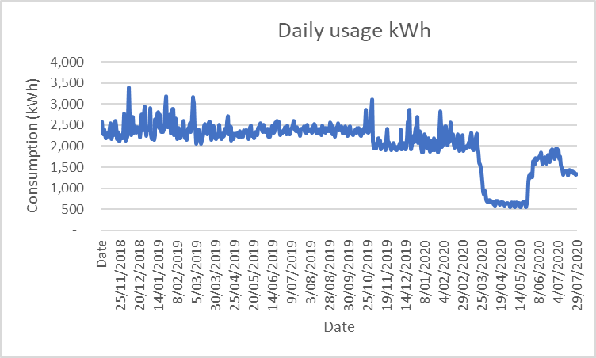

Figure 5 Mini method example - change in energy usage due to COVID

### Explain how the site’s COVID response has caused a change in energy usage

The site had reduced staffing levels and was closed to the public, with impacts starting from 23 March 2020.

Table 6 Mini method example - COVID induced changes which have impacted on energy usage

| **Date of change** | **Change trigger** | **Change** |
| --- | --- | --- |
| 23 Mar 2020 | Stage 2 restrictions announced by Premier, beginning midnight | Site closed to public, some staff remain |
| 1 Apr 2020 | Stage 3 restrictions announced | Site completely shut, no staff at work |
| 1 Jun 2020 | Restrictions further eased, with restaurants and cafes allowed up to 20 patrons inside | Site reopened |
| 4 Jul 2020 | Stage 3 restrictions imposed from midnight in further 2 postcodes 3031, 3051 | Site prepares to shut down, but keep open take-away |
| 5 Jul 2020 |  | Site shuts down, some staff remain for takeaway service |
| Future | Additional rows to be added as required |  |

Available data includes:

- Interval data

- Weather data

- Whether site open or shut to public

- *Note there is missing data for the period 18 - 26/09/2019.*

### Identify the COVID impacted period

The COVID impacted period starts from 23 March 2020 and is ongoing.

### Select the method

The mini method shall be applied.

### Is there a new normal?

N/A. VEECs are being created before the end of the COVID impacted period.

### Application of the method

#### Check that the data meets the provisions applicable to the method

Table 7 shows an example of how to check that the requirements for these COVID provisions are being met.

Table 7 Mini method example - check against method provisions

| **Provision** | **Is the requirement met?** |
| --- | --- |
| The number of intervals must be at least 4 times the number of independent variables | There are 2 IVs, so at least 8 intervals are required. This requirement is met for daily and weekly models.  The operating period runs from 10 Nov 2019 to 22 March 2020.  The baseline period runs from 10 Nov 2018 to 22 March 2019. |
| The range of IVs in both the baseline and operating periods must be roughly similar. E.g. if weather is an IV, for a 45-day operating model just before COVID (summer) the baseline model must also be from a summer period | Yes, the baseline mini period has been selected to be exactly a year before the operating period |
| The number of intervals in each model must be roughly similar. The model with the longer period must have ≤130% the number of intervals of the shorter period | Yes |
| An Eligible Range Adjustment Factor (ERAF) may be applied | As described below |
| If a baseline model already exists (covering a full year) it must be replaced with the mini baseline model | There was no prior baseline model |

#### Check that the data meets the provisions applicable to the method

Models have been built using CDD, and Fridays, as the IVs. Whilst HDD had an acceptable t-stat in the baseline period, it failed to have an adequate t-stat in the operating period and was rejected for the model.

The HDD and CDD balance point were both set at 15°C, based on a scatterplot of kWh vs temperature in the baseline period (see Figure 6).

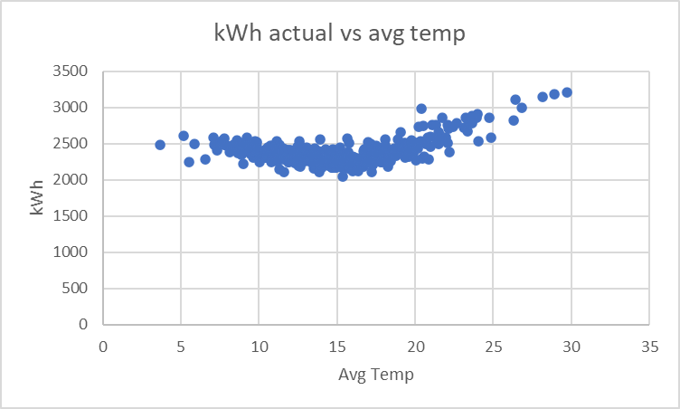

Figure 6 Mini method example - Baseline energy vs temperature scatterplot

Table 8 Mini method example - model coefficients

|  |  |  |  |  |
| --- | --- | --- | --- | --- |
| Period |  | Intercept | CDD | Is Friday |
| Baseline | Coefficient | 2160.114338 | 66.7938684 | 79.1210544 |
|  | t.stat | 151.5731442 | 23.4895744 | 3.02213345 |
|  | Min |  | 0 | 0 |
|  | Max |  | 14.7354 | 1 |
| Operating | Coefficient | 1955.223552 | 53.17718383 | 91.5357422 |
|  | t.stat | 143.7777682 | 15.37759233 | 3.22210419 |
|  | Min |  | 0 | 0 |
|  | Max |  | 12.8494 | 1 |

The operating model fails the IPMVP R2 test, otherwise all requirements are met.

Table 9 Mini method example - check against IPMVP regression tests

|  |  |  |  |  |
| --- | --- | --- | --- | --- |
|  | Baseline | Operating |  |  |
| Cvrmse | 0.042939558 | 0.0543855 | <0.2 | Y |
| r2 | 0.820609387 | 0.664439473* | >0.75 | Y |
| tstats |  |  | >|2| | Y |
| Bias error | 0.000% | 0.000% | < 0.005% | Y |

*Refer to annexe for discussion on R2.

As better models are not possible, and r2 is the least important of the criteria, the models are acceptable.

The eligible range of values is determined by adding 5% of the effective range (see Table 10).

Table 10 Mini method example - eligible range

|  |  |  |
| --- | --- | --- |
| Eligible Range | *CDD* | *Is Friday* |
| Min | 0 | 0 |
| Max | 13.49187 | 1 |

#### Identify the normal year

The normal year is 1 Nov 2018 to 31 Oct 2019. As data is missing for the period 18 – 26/09/2019 the normal year has 356 days.

The regression models developed are shown graphically in Figure 7, when applied to the conditions of the normal year.

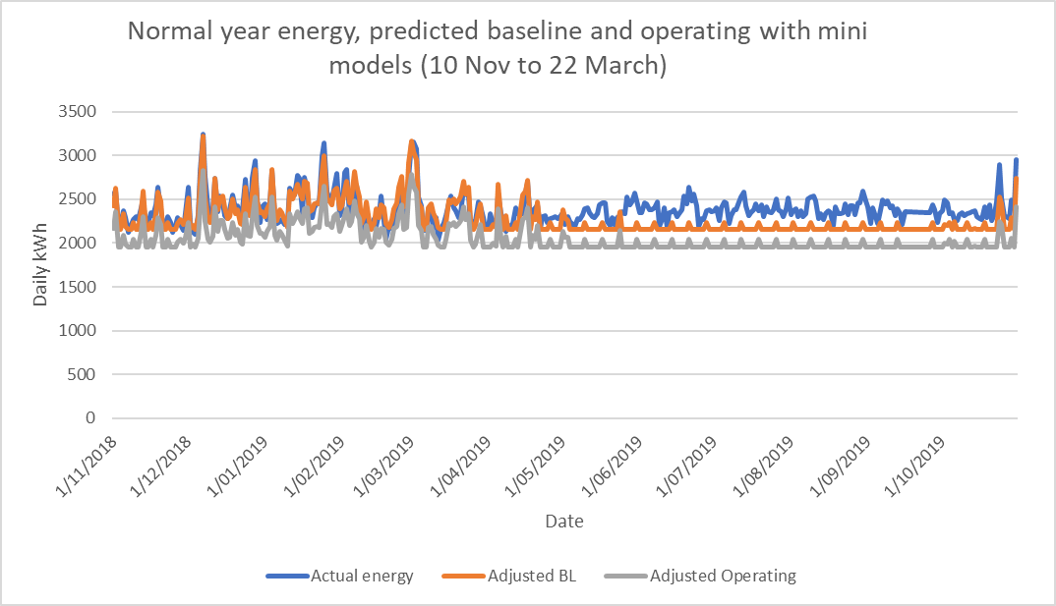

Figure 7 Mini method example - actual energy, modelled baseline, modelled operating

#### Determine normal year savings

Normal year savings are determined:

1. Adjust the baseline and operating models to the conditions of the normal year.

2. Calculate the normal year savings by summing the normalized energy savings for each interval of the normal year where the IVs fall within the eligible range. In time intervals where the eligible range is exceeded, an ERAF is applied to allow for some of the savings in those intervals to be recognized.

3. Determine the uncertainty in the savings and the relative precision.

4. Use table 1 in the VEU M&V Specifications to determine the accuracy factor and apply this to calculate overall savings as usual.

**Step 1. Adjust the baseline and operating models to the normal period.**

As shown in Figure 7 above.

**Step 2. Determine the normal year savings**

This method allows for some extension of the eligible range, by applying an ERAF.

For every percent that one interval in a normal year is outside the eligible range, the ERAF shall diminish by 2.5%.

In this example over the normal year, 354 days have IVs within the eligible range. A further 2 days have IVs which are somewhat outside of the eligible range, and have the savings diminished by 2.5% for every percent outside the eligible range.

Example: on 7 Dec 2018 the normal year had 14.735 CDDs. This is 9% beyond the eligible range for CDDs. This resulted in an ERAF of (1-9*2.5% = 78%) being applied to the avoided energy for that day.

The savings over the normal year are 80,583 kWh, comprised of 79,923 kWh from periods within the eligible range, and 661 kWh in periods where an ERAF has been applied.

**Step 3. Determine uncertainty in savings and the relative precision.**

The uncertainty in the models at 90% confidence level over the modelled baseline and operating periods is:

- Baseline: 1,969 kWh

- Operating: 2,156 kWh

Combined in quadrature the uncertainty is 2,919 kWh

The uncertainty is multiplied by sqrt(365/134) (number of days in period) to get an annual uncertainty of   
4,819 kWh.

This gives a relative precision in the savings of 4,759/80,583 = 6%, to be used with Table 1 in the M&V Specifications.

**Step 4. Multiply the saved energy by the accuracy factor to determine annual saved energy**

For a relative precision of 6%, an accuracy factor of 1 applies (using table 1 in the VEU M&V Specifications).

Overall annual avoided energy is thus:

1 * 80,583kWh = 80,583kWh.

# Avoided Energy Method

## Description of method

The avoided energy method is used when one period (baseline or operating) is partially within COVID, and the other period is completely outside of COVID. This method can be used where it is not possible to build a model for both the baseline and operating period with a common set of IVs. This will be because one or more of the IVs (typically the one used to describe the COVID impacted period), has zero or minimal variation in the other, COVID-free period.

This method can either be applied as:

(a) The conventional IPMVP avoided energy method - “fore-casting” - where the baseline includes COVID, and the operating period does not include COVID; or

(b) The “back-casting” method - where the operating period includes COVID, and the baseline period does not include COVID.

### Provisions applicable to the avoided energy method

This method can only be applied where:

a. One period includes time both during COVID and outside of COVID; and

b. The other period is completely outside of COVID; and

c. At least 3 months (monthly or fortnightly model), 10 weeks (weekly model) or 30 days (daily model) of the COVID-containing period must be outside COVID; and

d. Independent variables must satisfy both of the following conditions (noting that this may be possible with a single IV):

i. At least one of the IVs must explain the variation in energy use during COVID. E.g. the number of people permitted in an enclosed space during COVID; and

ii. At least one of the IVs must help explain energy use in the period outside of COVID. E.g. for many facilities, HDD and/or CDD are determinants of energy use.

If a baseline model already exists, and the back-cast version of this method is being applied, the baseline model must not be used.

The COVID-free year must be selected as the normal year, as described below in section 6.1.2.

A BAF must be applied, as described below in Section 6.1.3.

The overall uncertainty shall be the uncertainty in the COVID-containing period multiplied by 2, as described below in Section 6.1.4.

An example of this back-cast avoided energy method is shown in the box below.

A restaurant normally never closes and always has roughly the same number of staff at the site. An activity was implemented 2 months before COVID.

During COVID the restaurant had varying levels of closure and correspondingly different staffing levels. An operating period model, which covers both the period pre COVID and into COVID, is built with one of the IVs being number of staff working. The model satisfies the usual statistical requirements. The inclusion of the IV “number of staff working” is essential in building an operating period model that returns acceptable regression statistics. Another IV is HDD, which helps explain energy usage outside of COVID.

This model is then back-cast to the conditions of the baseline “normal” year, and this is subtracted from the baseline “normal” year to calculate avoided energy use.

Figure 8 shows examples of possible periods for the application of this method, with each row representing one possible scenario.

|  |  |  |  |  |  |  |  |  |  |  |  |  |  |  |  |  |  |  |  |  |
| --- | --- | --- | --- | --- | --- | --- | --- | --- | --- | --- | --- | --- | --- | --- | --- | --- | --- | --- | --- | --- |
|  |  |  |  |  |  |  |  | C |  |  |  |  |  |  |  |  |  |  |  | Back-cast – model the operating period then back-cast to the baseline period |
|  |  |  |  |  |  |  |  | C | C |  |  |  |  |  |  |  |  |  |  |
|  |  |  |  |  |  |  |  | C | C | C |  |  |  |  |  |  |  |  |  |
|  |  |  |  |  |  |  |  | C |  |  |  |  |  |  |  |  |  |  |  | Fore-cast – model the baseline then fore-cast to the operating period |
|  |  |  |  |  |  |  |  | C | C |  |  |  |  |  |  |  |  |  |  |
|  |  |  |  |  |  |  |  | C | C | C |  |  |  |  |  |  |  |  |  |
|  |  |  |  |  |  |  |  |  | C | C | C |  |  |  |  |  |  |  |  |
|  |  |  |  |  |  |  |  |  |  | C | C |  |  |  |  |  |  |  |  |
|  |  |  |  |  |  |  |  |  |  |  | C |  |  |  |  |  |  |  |  |

|  |  |
| --- | --- |
| Legend | |
|  | 3 months |
| **C** | Baseline into COVID |
|  | Baseline |
|  | Project works |
| C | Operating into COVID |
|  | Operating |
|  | COVID impacted period |

Figure 8 Examples of possible avoided energy periods

To determine the savings that are eligible for VEECs under this method, savings need to be adjusted considering:

1. The conditions of a normal year (this is also required by projects not suing COVID provisions). This adjustment is described in section 6.1.2 below.

2. The significance of those variables which are included in the model, but which do not vary much, or at all, in the COVID-free period. This adjustment is described in section 6.1.3 below.

### Avoided energy: adjusting to normal year conditions

The COVID-free period must be selected as the normal year. This is because a regression model does not exist for the COVID-free period, so it cannot be adjusted.

### Adjustments to allow for IVs that don’t vary at all, or by a minimal amount, outside of COVID

An IV that helps explain variations in energy use during COVID will “dampen” the performance of that model when applied to the conditions outside of COVID, where that same IV may not vary at all, or only by a minimal amount. Typically, such an IV would not be useful in explaining energy use in the COVID-free period (e.g. were a model to be developed, it would have a low t-stat). It may additionally bias the model, particularly where the COVID-containing period only has a small percentage of data that is COVID free. This bias may be significant.

In this case a Bias Adjustment Factor (BAF) must be calculated based on the relative contribution to overall variation in energy use, during the COVID-containing period, from those IVs that aren’t used to account for COVID caused variation in energy use. The calculation of the BAF is described above in section 3.1.

An example of BAF calculation is shown in the box below.

A daily kWh model is developed that covers a period both during COVID and outside of COVID has two IVs – HDD and percent occupancy.

Percent occupancy is used to explain the variation in energy usage during COVID. Outside of COVID percent occupancy is constant at 100%.

Over the COVID-containing period, HDD has a max of 12, a min of 0, and an average value of 4, with a coefficient of 30 in the regression. On average, it contributes 4 x 30 = 120 kWh of daily usage.

Percent occupancy has a max of 100%, a min of 0, and an average value of 30%, with a coefficient of 500 in the regression. On average, it contributes 30% x 500 = 150 kWh of daily usage over the COVID-containing period.

On average, 120 + 150 = 270 kWh of daily usage in the model is explained by HDD and percent occupancy.

For the COVID-containing period, HDD accounts for, on average, 120/270 = 44% of the variation in energy use.

The adjustment factor is the square root of the relative contribution to overall variation in energy use, during the COVID-containing period, from those IVs that don’t account for COVID caused variation in energy use.

In this case, HDD is the only IV that isn’t used to account for the COVID caused variation in energy usage. The adjustment factor is thus sqrt(44%) = 0.67.

Expressing the above in terms of the formula for BAF

BAF = $\sqrt{\frac{\sum_{k=1}^{k=m}{({IVNcoeff}_{k} x {\overline{IVN}}_{k})}}{\sum_{j=1}^{j=n}{({IVcoeff}_{j} x {\overline{IV}}_{j}})}}$

Where the IVN is HDD, and the IVs are HDD and percent occupancy.

BAF = $\sqrt{\frac{30 x 4}{30 x 4+500 x 0.3}}$ = 0.67

### Uncertainty for the avoided energy method

The determination of overall uncertainty when calculating normal year savings requires combining the uncertainty of the baseline model and the operating period model in quadrature.

As the uncertainty in this case is only based on one model, to account for the fact that uncertainty would increase if a second model was also used (as is the case when calculating normal year savings), multiply the uncertainty in the COVID-containing period regression, by two.

## Example of the avoided energy method

The facility is a licensed premises located in suburban Melbourne. An upgrade activity was implemented in late January 2020. The site wishes to create VEECs for the upgrade activity.

Further details are tabled below.

Table 11 Avoided energy method example - site details

| **Site type** | **Licensed premises** |
| --- | --- |
| Location | Suburban Melbourne |
| Changes at site likely to impact energy use (apart from COVID) | There were no recorded changes from 1 July 2018 up until the period 20 January to 2 Feb 2020, which is when the upgrade activity was implemented |
| COVID response | - From 23 March to 31 March 2020 the site was closed to the public, however 50% of staff remained at work.  - From 1 April to 31 May 2020 the site was closed to the public; however, 50% of staff came back to work from 26 May.  - From 1 June the site was open, with a maximum of 20 patrons permitted, with 75% of staff at work.  - From 15 June the site closed to the public, however 75% of staff remained at work, providing take away food. This was the situation up to the point of latest data (30 July 2020). |
| ***Data Sources*** |  |
| Interval data | Site |
| Weather data | BOM data |
| Closed to public | Screenshots of site facebook page |

### Identify whether COVID has impacted on site energy usage.

Energy usage has changed, this change can be attributed to COVID-induced changes in use.

### Describe the impacts COVID has had on site energy usage

Interval data plotted below shows a significant change in energy consumption during COVID.

Figure 9 Avoided energy method example - change in energy usage due to COVID

### Explain how the site’s COVID response has caused a change in energy usage

As shown below there have been site closures, different staffing levels, and reduced patronage, all of which have reduced energy usage.

Table 12 Avoided energy method example - COVID induced changes which have impacted on energy usage

| **Date of change** | **Change trigger** | **Change at site impacting on energy** |
| --- | --- | --- |
| 22 Mar 2020 | Shutdown of all non-essential activities over next 48 hours announced by Premier | Shut down planned |
| 23 Mar 2020 | Stage 2 restrictions announced by Premier, beginning midnight | Site closed to public, 50% of staff remain |
| 1 Apr 2020 | Introduction of stage 3 restrictions | Site completely shut, no staff at work |
| 26 May 2020 | Anticipation of relaxed restrictions | 50% of staff return to work to prepare for reopening |
| 1 Jun 2020 | Restrictions further eased, with restaurants and cafes allowed to reopen with up to 20 patrons inside | Site reopened, with 75% staff, max of 20 patrons permitted |
| 15 Jun 2020 | Rising COVID case numbers in Victoria | Site closes on-site service but offers takeaway |

Available data includes:

- Interval data

- Weather data

- Staff percent at work

- Number of patrons allowed. For the pre-COVID period its assumed 100 patrons are allowed.

### Identify the COVID impacted period

The start of the COVID impacted period is 23 March 2020, when the site was closed. The likely date of the end of the COVID impacted period is unknown.

### Select the method

The avoided energy method shall be applied.

### Is there a new normal?

N/A. VEECs are being created before the end of the COVID impacted period.

### Application of the method

#### Check that the data meets the requirements of the method

Table 13 shows an example of how to check that the requirements for these COVID provisions are being met.

Table 13 Avoided energy method example - check against method provisions

| **Provision** | **Is the requirement met?** |
| --- | --- |
| The COVID-containing period includes time both during COVID and outside of COVID | Yes. The operating period includes time in and out of COVID. |
| The COVID-free period is in a period completely outside of COVID | Yes. The baseline occurs before COVID. |
| At least 3 months (monthly or fortnightly model), 10 weeks (weekly model) or 30 days (daily model) of the COVID-containing period must be outside COVID | The operating period will start from 3 Feb 2020, straight after the activity commissioning was completed. This gives 49 days (7 weeks) before COVID restrictions were implemented (on 23 March). So, the requirement is met, but only for a daily model. |
| At least one of the IVs must explain the variation in energy use during COVID | In the operating period permissible patrons and percent staff in attendance explain the variation in energy use. For both t stats > |2| are achieved. |
| If a baseline model already exists, and the back-cast version of this method is being applied, it must be abandoned | No baseline model already exists. |
| The COVID-free year must be selected as the normal year | The baseline period is chosen as the normal year. It runs from 20 January 2019 to 19 January 2020. |
| A Bias Adjustment Factor (BAF) must be applied | As shown below. |
| The overall uncertainty shall be the uncertainty in the COVID-containing period multiplied by 2 | As shown below. |

***7.2.7.2 Identify the period to be modelled***

The COVID-containing period, in this case the operating period, will be modelled.

The operating period is considered to run from 3 February 2020. It would normally run for 12 months, but for the purpose of creating this example is considered to run to 30 July 2020. Note that a short operating period, less than a full operating cycle, is not in compliance with the requirements of this method and has only been used to illustrate application of the model, with complete data not yet available.

***7.2.7.3 Develop the model***

An operating model has been built using HDD, CDD, permissible patrons, and percent staff in attendance. In this way we capture a range of independent variables spanning both the period before COVID and during COVID.

The HDD and CDD balance point are both set at 15°C, based on a scatterplot of kWh vs temperature in the baseline period. This scatterplot also confirms that HDD and CDD drive energy usage.

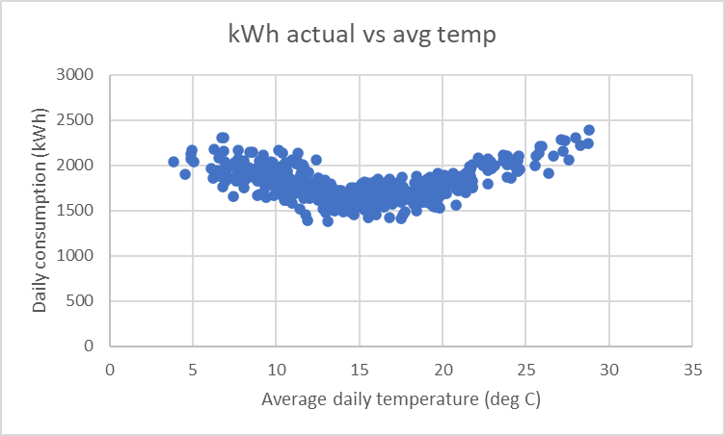

Figure 10 Avoided energy method example - Baseline energy vs temperature scatterplot

The operating period model has the following coefficients, and range of IVs:

Table 14 Avoided energy method example - model coefficients

|  |  |  |  |  |  |
| --- | --- | --- | --- | --- | --- |
|  | Intercept | HDD | CDD | Permissible patrons | Percent staff in attendance (1 = 100%) |
| Coefficient | 832.0367278 | 14.52649384 | 29.9298042 | 1.17831 | 488.8961 |
| t.stat | 52.7207244 | 4.90741382 | 3.09268415 | 3.665548 | 19.76127 |
| Min |  | 0 | 0 | 0 | 0 |
| Max |  | 11.4994 | 6.1723 | 100 | 1 |

The model passes the IPMVP regression tests.

Table 15 Avoided energy method example - check against IPMVP regression tests

|  |  |  |  |
| --- | --- | --- | --- |
| Cvrmse | 0.075394908 | <0.2 | Y |
| R2 | 0.874363624 | >0.75 | Y |
| tstats |  | >|2| | Y |
| Bias error | 0.000% | < 0.005% | Y |

The eligible range of values in the operating period is determined by adding 5% of the range, as tabled below.

Table 16 Avoided energy method example - eligible range

|  |  |  |
| --- | --- | --- |
|  | Baseline period | Operating period |
| Min daily avg temperature (deg C) | 3.5 | 2.1 |
| Max daily average temperature (deg C) | 25.9 | 21.8 |
| Range (deg C) | 3.5 to 21.8 |  |
| Eligible range = Range ± 5% (deg C) | 2.59 to 22.72 |  |

***7.2.7.4 Identify the normal year period***

The normal year must be chosen to be the COVID-free period, in this example it is the baseline.

The baseline is considered to run from 20 January 2019 to 19 January 2020 (the day before the project works start).

The regression model developed from the operating period, back-cast into the baseline period, is shown in Figure 10 overleaf.

***7.2.7.5 Determine avoided energy***

Avoided energy is determined:

1. Back-cast the operating model back to the conditions of the baseline.

2. Determine the raw avoided energy in the baseline by summing the avoided energy for each interval in the baseline where IVs fall within the eligible range of the operating period.

3. Adjust the avoided energy to account for IVs that don’t vary much in the COVID-free period by applying a BAF.

4. Determine the uncertainty in the savings and the relative precision.

5. Using table 1 in the VEU M&V Specifications and the relative precision, determine the accuracy factor and apply this to determine overall savings.

**Step 1. Back-cast the operating period model to the conditions of the baseline**

As shown in Figure 10 above.

**Step 2. Determine the avoided energy in the baseline**

Over the 365 days of the baseline period, 22 days have IVs outside the eligible range of IVs. The total avoided energy for the remaining 343 days is 84,468 kWh.

**Step 3. Adjust the avoided energy to account for IVs that don’t vary much in the COVID-free period, by applying a BAF.**

The IVs that vary little in the COVID free period (i.e. the baseline) are in this case:

- Staff percent at work. We consider that in the baseline 100% of the number of staff who are usually at work, are at work at all the times (even though this won’t be 100% of the total staff count, as some may be absent on any given day for holidays or sick leave).

- Number of patrons allowed. In the baseline this is at its maximum value of 100 patrons.

Because of this, the projection of the baseline back into the operating period may exhibit bias and needs to be adjusted. The BAF is based on the relative contribution to overall variation in energy use, during the COVID-containing period, from those IVs that aren’t used to account for COVID caused variation in energy use.

The relative contribution of each IV to the variation in daily usage is shown in the table below

Table 17 Avoided energy method example – contribution of IVs to variation in daily energy use

|  |  |  |  |  |  |
| --- | --- | --- | --- | --- | --- |
|  | HDD | CDD | Permissible patrons/enclosed space | Percent staff in attendance | Total |
| Average value | 3.597078 | 0.728947 | 28.58757 | 0.563559 |  |
| Regression coefficient | 15.09848 | 38.01465 | 1.383299 | 487.0784 |  |
| Contribution to avg usage in each interval of the model (kWh) = Avg value x regression coefficient | 54.31041 | 27.71068 | 39.54517 | 274.4976 | 396.0638 |
| Percent of total | 14% | 7% | 10% | 69% | 100% |

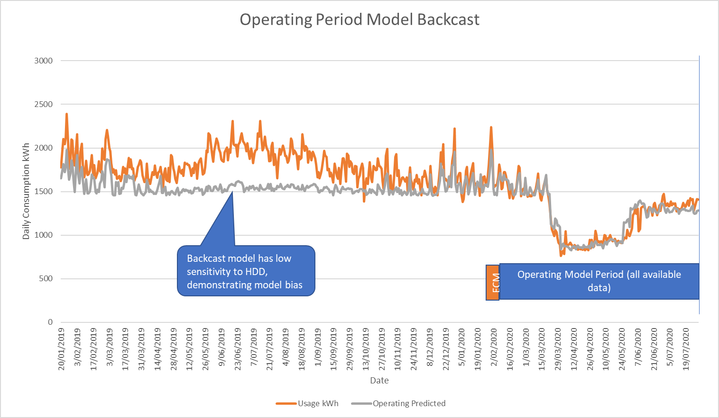

Figure 10 Avoided energy method example - actual energy, modelled baseline, modelled operating

The Bias Adjustment Factor is calculated as follows:

BAF = $\sqrt{\frac{\sum_{k=1}^{k=m}{({IVNcoeff}_{k} x {\overline{IVN}}_{k})}}{\sum_{j=1}^{j=n}{({IVcoeff}_{j} x {\overline{IV}}_{j}})}}$

The:

* IVNs are HDD and CDD
* IVs are HDD, CDD, permissible patrons/enclosed space, percent staff in attendance

BAF = $\sqrt{\frac{3.597078 x 15.09848+0.728947 x 38.01465 }{3.597078 x 15.09848+0.728947 x 38.01465 +28.58757 x 1,383299+0.563559 x 487.0784}}$ = 0.455

Another way of calculating the BAF that provides the same result:

HDD and CDD do not explain the variation in energy use during COVID

These two variables account for 14% + 7% = 21% of the variation in energy usage in the COVID-containing period.

The BAF is thus sqrt (0.21) = 0.455

Adjusted avoided energy = 0.455 * 84,468 kWh = 38,439 kWh.

**Step 4. Determine uncertainty in savings and the relative precision.**

The operating model period covers 177 days. The uncertainty over this period at the 90% confidence level, ignoring autocorrelation, is 1,614 kWh.

The uncertainty is multiplied by 2, which gives an uncertainty of 3,229 kWh.

In this case the savings uncertainty, based on 177 days, is expanded out to what it would be over 365 days. Noting that only for the purposes of this example (and not in the real-life application of this method) is the operating period less than a year long.

Uncertainty over 365 days = 3,229 * sqrt(365/177) = 4,637 kWh.

This gives a relative uncertainty, called relative precision under VEU, in the savings of 4,737/38,439 = 12%.

**Step 5. Multiply the saved energy by the accuracy factor to determine overall annual avoided energy**

For a relative precision of 12%, an accuracy factor of 1 applies (using table 1 in the VEU M&V Specifications)

Overall saved energy that year is thus:

1 * 38,439 kWh = 38,439 kWh.

# Usual but Accounting for COVID method

## Description of method

This method assumes that:

(a) Both part of the baseline and part of the operating period occur during COVID, and neither the entire baseline nor the entire operating period occur during COVID; or

(b) The entire baseline and entire operating periods are out of COVID.

The normal year must be a period with no COVID.

The figure below shows examples of possible periods for the application of this method, with each row representing a possible scenario.

|  |  |  |  |  |  |  |  |  |  |  |  |  |  |  |  |  |
| --- | --- | --- | --- | --- | --- | --- | --- | --- | --- | --- | --- | --- | --- | --- | --- | --- |
|  |  |  |  |  |  |  |  |  |  |  |  |  |  |  |  |  |
|  |  |  |  |  |  | C |  |  |  | C |  |  |  |  |  |  |
|  |  |  |  |  |  | C | C |  | C | C |  |  |  |  |  |  |

|  |  |
| --- | --- |
| Legend | |
|  | 3 months |
| C | Baseline into COVID |
|  | Baseline |
|  | Project works |
| C | Operating into COVID |
|  | Operating |
|  | COVID impacted period |

Figure 11 Examples of possible usual but accounting for COVID periods.

### Provisions applicable to the usual but accounting for COVID method

This method can be applied where either:

1. Both part of the baseline, and part of the operating period, occur during COVID and neither the entire baseline, nor the entire operating period, occur during COVID; or
2. The entire baseline and entire operating periods are out of COVID.

If both part of the baseline, and part of the operating period, occur during COVID:

1. Independent variables which account for the changed energy use during COVID must be included in the model; and
2. The proportion of time in COVID must be roughly the same for both the operating period model and baseline model. The period with the longest time in COVID should have no more than 130% of the time in COVID compared with the shortest time in COVID; and
3. If the normal year does not have the full range of IVs that are used to account for the changed energy use during COVID, a BAF must be applied, as described below in section 7.1.2.; and
4. At least 3 months (monthly or fortnightly model), 10 weeks (weekly model) or 30 days (daily model), for both the baseline and operating periods, must be both outside and inside COVID.

### Determination of the BAF for normal year savings when models may be skewed by COVID

An IV that helps explain variations in energy use during COVID will “dampen” the sensitivity of that model to other IVs when applied outside of COVID. Thus, a Bias Adjustment Factor (BAF) needs to be applied.

The BAF factor shall be calculated as follows:

1. Calculate the BAF for each model (baseline and operating) as described in section 3.

2. Select the lowest of the BAFs from the two models.

3. Take the average of this BAF, and 1, to determine the overall BAF.

An example of the adjustment factor calculation is shown in the box below.

A BAF of 0.5 is calculated for the baseline, and 0.6 for the operating period.

The lowest of the BAFs is 0.5.

The average of 0.5 and 1, is 0.75

The resulting BAF is 0.75.

The BAF may additionally bias the model, particularly where the modelled (COVID-containing) period only has a small percentage of data that is COVID-free. The bias, however, would apply to both operating period and baseline models, and thus be expected to cancel out some of its effect.

## Example of the Usual but accounting for COVID method

This example illustrates development of the baseline model only. At the time of writing, it is not possible to provide a complete example, as COVID has not yet finished.

The facility is an office located in suburban Melbourne. Upgrade works were carried out during COVID, starting on 11 July and running through to 4 August 2020. The site wishes to create VEECs for the upgrade.

Further details are tabled below.

Table 18 Usual but accounting for COVID method example - site details

| **Site type** | **Office** |
| --- | --- |
| Location | Suburban Melbourne |
| Changes at site likely to impact energy use (apart from COVID) | There were no recorded changes from 1 July 2018 up until around 11 July 2020, when the project works started. The project works took about 3 weeks. |
| COVID response | From 16 March 2020 the number of staff attending the office dropped. The site was closed to the public then too. |
| ***Data sources*** |  |
| Interval data | Site |
| Weather data | BOM data |
| Closed to public | As evidenced by a screenshot of the facility’s public facing website, and advised by facility manager, who has signed a statutory declaration. |
| Occupancy period | IT records showing wifi connections at the site. |

### Identify whether COVID has impacted on site energy usage.

Changed energy usage can be attributed to COVID-induced differences in the way the site is used.

### Describe the impacts of COVID on site energy usage

Site electricity consumption has dropped due to COVID, as shown in the daily load profiles below for May (harsher restrictions) and June (restrictions eased) 2020 vs 2019.

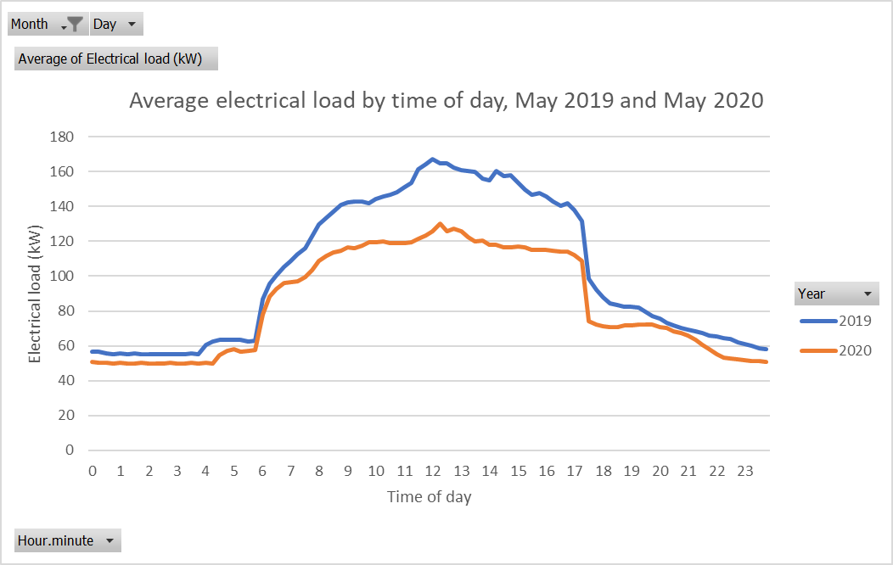

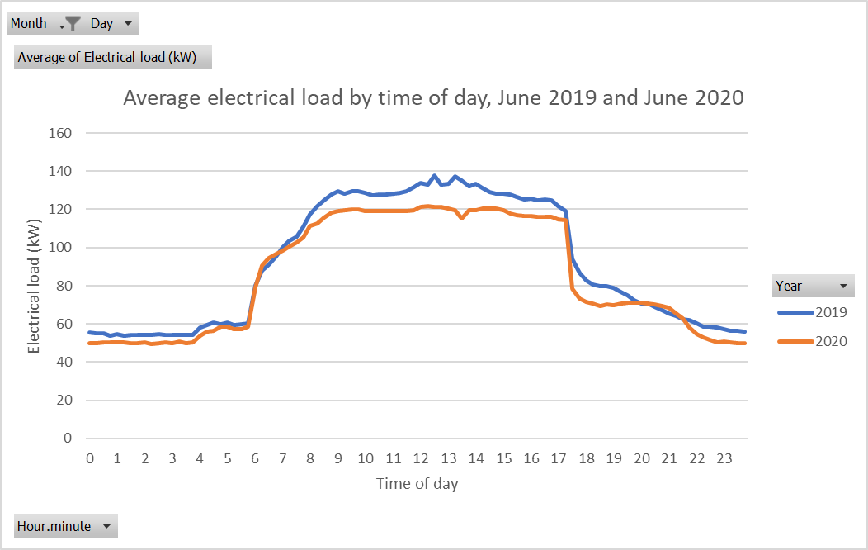

Figure 12 Usual but accounting for COVID method example - change in energy usage due to COVID

### Explain how the site’s COVID response has caused a change in energy usage

The lowered number of staff attending the office has reduced use of lifts, ventilation requirements, IT loads, and lighting usage.

Table 19 Usual but accounting for COVID method example - how COVID has impacted on energy usage

| **Date of change** | **Change trigger** | **Change description** |
| --- | --- | --- |
| 16 Mar 2020 | Premier declares a state of emergency | Number of staff at site drops to 20% of staff usually at site. Site closed to public |

Available data includes:

- Interval data

- Weather data

- Public holidays that have occurred on weekdays

- Occupancy percent

- Whether or not the site is closed to the public

### Identify the COVID impacted period

COVID impacts begin from 23 March 2020, when restrictions were first imposed, and are ongoing.

### Select the method

The usual but accounting for COVID method shall be applied.

### Is there a new normal?

N/A. VEECs are being created before the end of the COVID impacted period (for the purpose of this example only).

### Application of the method

#### Check that the provisions applicable to the method are met

Table 20 shows an example of how to check that the requirements for these COVID provisions are being met.

Table 20 Usual but accounting for COVID method example - check against method provisions

| **Provision** | **Is the requirement met?** |
| --- | --- |
| Either:  a. Both part of the baseline, and part of the operating period, occur during COVID and neither the entire baseline, nor the entire operating period, occur during COVID; or  b. The entire baseline and entire operating periods are out of COVID. | Part of the baseline, and part of the operating period, occur during COVID and neither the entire baseline, nor the entire operating period, occur during COVID.  The baseline model runs from 11 July 2019 to 10 July 2020, with HDD, CDD, percent occupancy by day of week, a weekday public holiday indicator, and a closed to public indicator chosen as IVs. In this way we capture a range of independent variables spanning both the period before and during COVID.  The operating period will run for 12 months, starting before the COVID impacted period ends. |
| In the case of both part of the baseline, and part of the operating period, occurring during COVID and neither the entire baseline, nor the entire operating period, occur during COVID  a. Independent variables which account for the changed energy use during COVID must be included in the model.  b. The proportion of time in COVID must be roughly the same for both the operating period model and baseline model. The period with the longest time in COVID should be no more than 130% of the period with the shortest time in COVID.  c. If the normal year does not have the full range of IVs that are used to account for the changed energy use during COVID, a BAF must be applied.  d. At least 3 months (monthly or fortnightly model), 10 weeks (weekly model) or 30 days (daily model), for both the baseline and operating periods, must be both outside and inside COVID | a. Percent occupancy is included in the model and describes the variation due to COVID  b. 117 days of the baseline (32% of one year) occur during COVID. On this basis the operating model should have no less than 90 days and no more than 152 days in COVID. Complete data is not yet available.  c. A BAF has been calculated as shown below.  d. A daily model has been used. For the baseline model at least 30 days are in and out of COVID. As described above the operating model will also meet this requirement, with a minimum of 90 days, and no more than 152 days, in COVID. |

The percent occupancy by day of week is tabled below (Table 21).

Table 21 Usual but accounting for COVID method example - COVID induced changes which have impacted on energy usage

|  |  |  |
| --- | --- | --- |
| Day | Percent occupancy | |
| Pre COVID | COVID |
| Monday | 100 | 30 |
| Tuesday | 100 | 30 |
| Wednesday | 100 | 30 |
| Thursday | 100 | 30 |
| Friday | 100 | 30 |
| Saturday | 0 | 0 |
| Sunday | 0 | 0 |

The HDD and CDD balance point are both set at 20°C.

The baseline model coefficients and range of IVs are shown in Table 22.

Table 22 Usual but accounting for COVID method example - model coefficients

|  |  |  |  |  |  |  |
| --- | --- | --- | --- | --- | --- | --- |
|  | Intercept | HDD | CDD | Occupancy | Pub Hol | Building closed to public |
| Coefficient | 1522.8104 | -80.75853 | 186.5239 | 1994.595 | -1222.8 | 943.565 |
| t.stat | 24.213472 | -10.83535 | 12.484421 | 33.306768 | -8.8195 | 15.67612 |
| Min |  | 0 | 0 | 0 | 0 | 0 |
| Max |  | 12.25 | 2.4 | 1 | 1 | 0 |

The model passes the IPMVP regression tests (seeTable 23).

Table 23 Usual but accounting for COVID method example - check against IPMVP regression tests

|  |  |  |  |
| --- | --- | --- | --- |
| Cvrmse | 0.168428146 | <0.2 | Y |
| R2 | 0.837200849 | >0.75 | Y |
| tstats |  | >|2| | Y |
| Bias error | 0.000% | < 0.005% | Y |

The percentage uncertainty in the baseline model at a confidence level of 90% over one year, ignoring autocorrelation, is 1.5%.

The model is shown graphically in Figure 13, projected forward across the project works period and start of the operating period.

***8.2.7.2 Calculate the Bias Adjustment Factor***

For the baseline model the range and relative contribution of each IV to the variation in daily usage is shown in

Table 24.

Table 24 Usual but accounting for COVID method example – contribution of IVs to variation in daily energy use

|  |  |  |  |  |  |  |
| --- | --- | --- | --- | --- | --- | --- |
|  | HDD | CDD | Occupancy fraction | Public holidays on a weekday | Building closed to public | Total |
| Min | 0 | 0 | 0 | 0 | 0 |  |
| Max | 12.9 | 12.2 | 1 | 1 | 1 |  |
| Average value | 5.05 | 0.56 | 0.53 | 0.03 | 0.31 |  |
| Regression coefficient | - 80.76 | 186.52 | 1,994.60 | - 1,222.84 | 943.56 |  |
| Contribution to modelled avg usage of each IV (kWh) = Avg value x regression coefficient | 408.17 | 103.68 | 1,065.96 | 33.41 | 296.48 | 1,907.71 |
| Percent of total | 21% | 5% | 56% | 2% | 16% | 100% |

The BAF for the baseline model is calculated as follows:

BAF = $\sqrt{\frac{\sum_{k=1}^{k=m}{({IVNcoeff}_{k} x {\overline{IVN}}_{k})}}{\sum_{j=1}^{j=n}{({IVcoeff}_{j} x {\overline{IV}}_{j}})}}$

The:

- IVNs are HDD, CDD, Occupancy fraction, Public holidays occurring on a weekday.

- IVs are HDD, CDD, Occupancy fraction, Public holidays occurring on a weekday, building closed to public

BAF = $\sqrt{\frac{408.17+103.68+1065.96+33.41 }{408.17+103.68+1065.96+33.41+296.48}}$ = 0.919

**Another way of calculating the BAF:**

HDD, CDD, Occupancy fraction, and Public holidays occurring on a weekday do not explain the variation in energy use during COVID.

These four variables account for 21% + 5% +56% + 2% = 84% of the variation in energy usage in the baseline period.

The BAF is thus sqrt (0.84) = 0.919

When determining the overall adjustment factor, the lower of the adjustment factor for the baseline period (0.919) and the operating period will be used. The average of this value and 1 is the overall adjustment factor.

For example:

- the operating period BAF is 0.93.

- the baseline BAF of 0.919 is lower, so will be used in the calculation of the overall adjustment factor.

- the overall BAF would be the average of (1, 0.919) = 0.96.

Baseline 11 July 2019 to 10 July 2020

COVID

Figure 13 Usual but accounting for COVID method example - actual energy, modelled baseline.

# Interactions with other M&V rules

## Implementation start time and emissions factors

The implementation start time is defined in the Project-Based Activities Regulations as

*“…the date, and optionally the time, normal operations are capable of commencing after all changes to be implemented by the project, including any testing and commissioning, are completed”*

The implementation start time, and hence the emissions factor, are defined by the site’s ability to return back to normal operations. This means that the implementation start time immediately follows completion of the upgrade.

In the case of a COVID-affected site, operations may have reached a new normal, or may take months or years to return to normal. Project owners may wish to commence the operating period before operations have returned to normal. Alternatively, project owners may finish an upgrade and decide to wait until operations have returned to normal or reached a new normal to commence measurements for the operating period. In either case the emissions factor is set at the implementation start time.

## Eligible time intervals

M&V projects may build models using as little as 80% of the total number of time intervals in the baseline or operating period, discarding data that is considered not to be representative of the site’s operation. This allowance is still available to projects affected by a state of emergency or state of disaster, but the model must meet the requirement for number of independent observations of independent variables after removing the 20% of data that may be excluded from the model. Projects using the mini method may wish to record more than four times as many independent observations of the independent variables as the number of independent variables in the energy model to allow for the possibility that some data must be discarded.

# Annex – comments on statistical tests

The VEU program has no stated statistical test requirements.

IPMVP generally accepted requirements are:

1. r2>0.75

2. CVrmse<0.2

3. T-stats (for all coefficients except the intercept) >|2|

4. Mean bias error < 0.005% (actual vs predicted values)

Additionally, regressions should adhere to the LINE requirements:

- Linear: the regression function should be linear. Any non-linear functions must be converted to linear (for example, following this method: <https://stattrek.com/regression/linear-transformation.aspx> ).

- Independence: each independent variable should be independent of other independent variables.

- Normality: the distribution of the residuals should be a normal distribution

- Equal variance (Homoscadacity) – the variance should be equal, including across the range of the dependent variable.

For daily models it can be difficult to meet some of these tests. The r2 test is often considered to be the most important, however the t-stat requirements and CVrmse requirements could be considered more valuable. Particularly, a low CVrmse, indicates low model uncertainty. (<https://evo-world.org/en/news-media/m-v-focus/868-m-v-focus-issue-5/1164-why-r2-doesn-t-matter?tmpl=component&print=>1).

Generally aim to satisfy the CVrmse, t-stat, and bias error requirements, whilst also selecting IVs that are independent of each other. If r2<0.75, provided the expected savings are at least twice the standard uncertainty (hence the requirement for a low CVrmse), a model may be deemed acceptable. Note that for daily models, best practise M&V will often need to consider autocorrelation when calculating uncertainty. Uncertainty Assessment for IMPVP (2018, with 2019 update), available on the EVO website, can be consulted for guidance on accounting for autocorrelation.

A useful test, not outlined in IPMVP, is to test the baseline model with a set of baseline data outside the modelled period. Where errors are large, this could indicate “over-fitting”. Over-fitting occurs where too many IVs are selected, creating what appears to be a very good baseline model. However, correlation doesn’t equal causation, and some of the IVs may not actually have much of an impact on energy use.