Energy efficiency for rental homes in Victoria
  - Information for rental providers
We are boosting energy efficiency standards to slash bills for Victorian renters – delivering benefits of up to $454 with ceiling insulation, $220 with efficient electric hotwater and $215 with efficient electric heating and cooling, every year.
New Minimum Energy Efficiency Standards for Rental Homes will be phased in from 1 March 2027. These reforms will make rental homes safer and more comfortable to live in, save renters hundreds of dollars a year on their energy bills, and cut greenhouse gas emissions. These reforms will also help alleviate gas shortfalls and preserve gas supply for the Victorian industries that need it most.
These changes will also improve property values, with recent data showing energy efficient houses in Melbourne fetching up to $197,000 more than non-energy efficient houses at sale, while units averaged at $95,000 more.
The new standards cover the most cost-effective measures for cutting energy waste in a home – insulation, draughtproofing and low-flow showerheads, as well as efficiency ratings for hot water, heating and cooling.
Figure 1: Electrification and Efficiency in the home
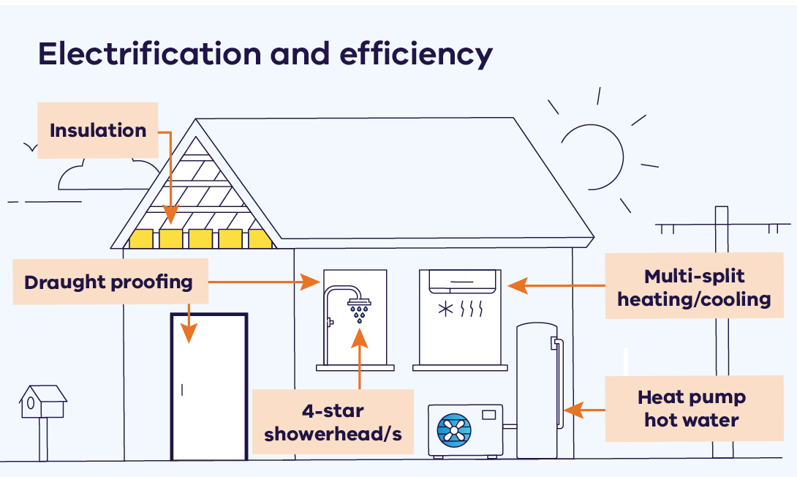
The standards are designed to improve rental homes while keeping costs manageable for rental providers. The standards also kick in at different times to help spread expenses over time.
- From 1 March 2027 at the start of a new lease (or conversion to a periodic lease):
- insulation must be installed to R5.0 rating by an accredited installer in ceiling spaces where no insulation is present (under-insulated ceiling spaces are not required to be upgraded)
- 4-star showerhead/s must be installed
- efficient cooling must be installed in the living area.
- From 1 March 2027, heating and hot water systems that reach end of life must be replaced with efficient electric systems (hot water heat pumps or reverse cycle air-conditioners).
- From 1 July 2027, at the start of a new lease (or conversion to a periodic lease) external doors, windows and wall vents must have draught proofing installed.
From 1 July 2030, efficient cooling must be installed in the main living area of all rental homes, irrespective of whether a new lease has been entered into.
Exemptions apply where compliance is impractical or too costly – for example in some apartment buildings where the ceiling space is shared property, or heating or hot water are supplied by a centralised system. There is also an exemption from draughtproofing where open-flued or flueless gas appliances are present to ensure the health and safety of occupants.

When do the new minimum standards apply?
The new minimum standards will apply:
- if your rental agreement (including a renewal) starts on or after the commencement date for each standard or
- if your rental agreement became a periodic agreement (month to month) on or after the commencement date for each standard.
The new standards do not apply if your rental agreement became a periodic agreement (month to month) before the commencement date for each standard.

Your obligations as a rental provider
Everybody deserves to live in a safe and secure home. As a rental provider, you’re required by law to ensure your property meets the applicable minimum standards on or before the day a renter moves in.
Under the Residential Tenancies Act 1997, it is a criminal offence to let a new renter move into a rental property that does not meet minimum standards. Individuals can face maximum penalties of over $11,800, while companies face maximum fines of over $59,000.
If the property does not meet minimum standards, a renter can request that you make repairs or changes before signing the agreement or before they move in.
If a rental agreement has been signed but the renter has not moved in yet, and the property does not meet minimum standards, the renter can either:
- end the rental agreement immediately without fees by notifying the rental provider that the property does not meet minimum standards, or
move in anyway, then make a request for urgent repairs.
If a property falls below minimum standards any time during a rental agreement, the renter can contact the rental provider or agent straight away to request an urgent repair to meet the standards. As a rental provider, you must make urgent repairs immediately. If you don’t take immediate action, renters may arrange urgent repairs themselves if they cost less than $2,500. You will then need to reimburse the renter.
More information about the rights and obligations of rental providers and renters is available here.

Where to go for help?
If you need help solving a dispute with a renter, Rent Dispute Resolution Victoria (RDRV) is a specialist rental dispute resolution and case management service provided by the Victorian Civil and Administrative Tribunal (VCAT). It helps renters and rental providers to resolve disputes quickly and fairly, before they escalate to a formal hearing.
RDRV can help with issues about bonds, compensation, excessive rent and repairs.
If you are finding it hard to afford to make repairs because of financial hardship, you will be required to provide VCAT with evidence.
If you are experiencing financial hardship, you can speak to a financial counsellor via the following service:
National Debt Helpline: Telephone 1800 007 007 or visit ndh.org.au
Find further details about financial counselling services on the CAV website Financial Counselling Program – Consumer Affairs Victoria.

For more information
Learn more at energy.vic.gov.au/households/electric-and-efficiency-standards-for-buildings

Our nation-leading programs are supporting Victorians with rebates and discounts
To support these changes, we are slashing the up-front cost of going electric and improving energy efficiency. With our nation-leading Victorian Energy Upgrades and Solar Homes programs, efficient electric appliances need not cost more than gas alternatives – and will help Victorian households and businesses save thousands on their energy bills each year.

Victorian Energy Upgrades

Heating and cooling discounts
Households can claim a discount of up to $1,610 and save up to $460 in operating costs annually when they install or replace an existing gas space heater with an efficient reverse cycle air conditioner. Households can claim a discount of up to $5,530 and save up to $1,140 annually when removing and replacing an existing ducted gas heater with an efficient reverse cycle air conditioner.

Hot water discounts
Households can claim a discount of up to $560 and save up to $400 in operating costs annually when they install or replace an existing gas hot water heater with a heat pump water heater.

Cooking discounts
Purchasing an induction cooktop will attract a rebate of about $140 if you have an existing gas cooktop. If cooking is your last gas appliance, you can save around $360 a year in supply charges by disconnecting from gas altogether.
For more information about the Victorian Energy Upgrades visit: www.energy.vic.gov.au/victorian-energy-upgrades
Discounts are also available for showerheads, draughtproofing and home energy assessments.

Solar Homes Program

Solar rebates for rental properties
Eligible rental providers can claim a rebate on 50% of the cost to install solar panels, up to $1,400, plus the option of an equivalent interest-free loan. Rental providers can access rebates for up to two tenanted rental properties each financial year.
Using solar to power electric appliances can cut energy bills for renters while allowing rental providers to invest in and upgrade their property.
Figure 2: Solar-Powered Home
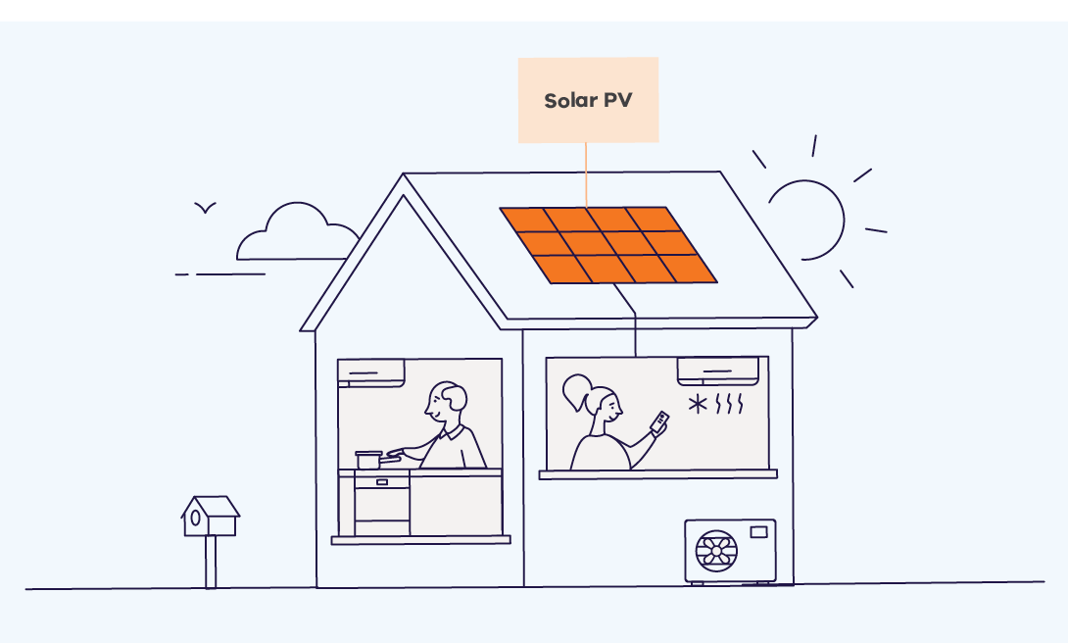

State Electricity Commission of Victoria (SEC)
The SEC is supporting households, including renters, to go electric by providing products and services that remove some of the barriers to switching.
The SEC is developing solutions to help more Victorian households make the switch to electric appliances to reduce their energy bills and emissions.
Cost and complexity can be barriers to switching to electric, and many people don’t know about the services and technologies available or the longer-term financial benefits. The challenges are even greater for tenants and those who live in apartments.

Did you know?
The new standards are not expected to impact rental supply, with real estate sector research showing that the introduction of health and safety standards in 2021 did not lead to an increase in rents or sales by rental providers.
Learn more at secvictoria.com.au/households
energy.vic.gov.au

Publication information

Acknowledgements
We acknowledge and respect Victorian Traditional Owners as the original custodians of Victoria’s land and waters, their unique ability to care for Country and deep spiritual connection to it.
We honour Elders past and present whose knowledge and wisdom has ensured the continuation of culture and traditional practices.
DEECA is committed to genuinely partnering with Victorian Traditional Owners and Victoria’s Aboriginal community to progress their aspirations.

Copyright
© The State of Victoria Department of Energy, Environment and Climate Action, August 2025.

Creative Commons
This work is licensed under a Creative Commons Attribution 4.0 International licence, visit the Creative Commons website (http://creativecommons.org/licenses/by/4.0/).
You are free to re-use the work under that licence, on the condition that you credit the State of Victoria as author. The licence does not apply to any images, photographs or branding, including the Victorian Coat of Arms, and the Victorian Government and Department logos.
ISBN 978-1-76176-476-9 (pdf/online/MS word)

Disclaimer
This publication may be of assistance to you but the State of Victoria and its employees do not guarantee that the publication is without flaw of any kind or is wholly appropriate for your particular purposes and therefore disclaims all liability for any error, loss or other consequence which may arise from you relying on any information in this publication.

Accessibility
To receive this document in an alternative format, phone the Customer Service Centre on 136 186, email customer.service@delwp.vic.gov.au, or contact National Relay Service on 133 677 or visit http://www.accesshub.gov.au/. Available at DEECA website (www.deeca.vic.gov.au).
End of document.

Domain (2025). Domain insight – Sustainability Report 2025. Domain Group.
AHURI (2022) What impact does regulation of residential tenancies have on investment in rental property?, Final Report No. 391, Australian Housing and Urban Research Institute

