Requirements for Distributed Solar – Victoria’s Emergency Backstop Mechanism
  - Supporting guidance for industry
deeca.vic.gov.au

We acknowledge and respect Victorian Traditional Owners as the original custodians of Victoria’s land and waters, their unique ability to care for Country and deep spiritual connection to it.
We honour Elders past and present whose knowledge and wisdom
has ensured the continuation of culture and traditional practices.
DEECA is committed to genuinely partnering with Victorian Traditional Owners and Victoria’s Aboriginal community to progress their aspirations.
© The State of Victoria Department of Energy, Environment and Climate Action April 2024.
Creative Commons
This work is licensed under a Creative Commons Attribution 4.0 International licence, visit the Creative Commons website (http://creativecommons.org/licenses/by/4.0/).
You are free to re-use the work under that licence, on the condition that you credit the State of Victoria as author. The licence does not apply to any images, photographs or branding, including the Victorian Coat of Arms, and the Victorian Government and Department logos.
ISBN 978-1-76136-610-9 (pdf)
Disclaimer
This publication may be of assistance to you but the State of Victoria and its employees do not guarantee that the publication is without flaw of any kind or is wholly appropriate for your particular purposes and therefore disclaims all liability for any error, loss or other consequence which may arise from you relying on any information in this publication.
Accessibility
To receive this document in an alternative format, phone the Customer Service Centre on 136 186, email customer.service@delwp.vic.gov.au, or contact National Relay Service on 133 677. Available at Energy Victoria website (www.energy.vic.gov.au/renewable-energy/solar-energy/victorias-emergency-backstop-mechanism-for-solar).

Purpose of this document
The Victorian Government is implementing an emergency backstop mechanism (the emergency backstop) to ensure that new, upgrading and replacement rooftop solar systems connected to the electricity distribution network can be remotely curtailed in a minimum system load emergency, to safeguard system security for all Victorians.
The Victorian Government is introducing the emergency backstop for new and replacement solar systems in two stages.
- Stage 1 – Large solar systems: From 25 October 2023, an emergency backstop applies to all new, upgrading and replacement solar systems greater than 200 kVA. Details of the conditions placed on distribution businesses to implement this stage can be found here. Your distribution business can provide more information about these requirements when you apply to connect or replace a large solar system.
- Stage 2 – Small and medium solar systems: From 1 July 2024, an emergency backstop applies to all new, upgrading and replacement rooftop solar systems less than or equal to 200 kVA. Details of the conditions placed on distribution businesses to implement this stage can be found here. This document provides further guidance on the interpretation and application of the requirements.

Intended audience
This document provides guidance to support rooftop solar system manufacturers, installers, and retailers to understand and meet the requirements of the emergency backstop, particularly Stage 2 requirements for small and medium solar systems.
The information contained in this document is intended to be used by installers and retailers as a starting guide. Further questions regarding the connections process should be directed to the relevant distribution business.

Version control
Version | Date | Changes
1.0 | April 2024 | Initial version ahead of commencement of Stage 2 emergency backstop requirements in Victoria

Contents
1. Key information 5
1.1. New requirements for rooftop solar systems 5
1.2. Why Victoria needs the emergency backstop 5
1.3. How the emergency backstop is being implemented 5
1.3.1. Benefits of the emergency backstop 5
1.3.2. Benefits of implementing CSIP-AUS technology 6
1.3.3. Enabling flexible exports 6
1.4. Rooftop solar installer checklist 6
1.5. Determining if a rooftop solar system must be emergency backstop enabled 7
1.6. Roles and responsibilities 8
1.7. Determining if a rooftop solar system is new, upgrading, or a replacement 11
1.8. Sites must be connected to the internet 11
1.8.1. Sites 30 kVA or less that cannot practicably be connected to the internet 12
1.9. Sites with a low static export limit 12
1.10. New, upgrading or replacement solar systems applied for prior to 1 July 2024 12
1.11. Where a distribution business can remotely interrupt or curtail a solar system >30 kVA using alternative technology 12
1.12. Telling customers about the emergency backstop 13
2. Technical guidance 13
2.1. Selecting compatible equipment 13
2.1.1. Key functions of CSIP-AUS 13
2.1.2. Solar inverters compliant with Common Smart Inverter Profile Australia (CSIP-AUS) 14
2.1.3. Inverter communication models 14
2.1.4. Secure Gateway Devices (SGDs) 16
2.1.5. Site monitoring 16
2.2. Connecting an inverter to the internet 17
2.2.1. Internet connection options (Wi-Fi, ethernet, cellular) 17
2.2.2. Positioning of Wi-Fi router 17
2.2.3. Loss of connectivity 17
2.2.4. Reconnecting to the internet after Wi-Fi router or password changes 17
2.2.5. Installer obligations and compliance 18
2.2.6. Solar inverter settings 18
2.2.7. Establishing connectivity with the distribution business’ server and running capability tests 18
3. More information 18
3.1. Distribution businesses 18
3.2. Training 19
3.3. Information for customers 19
3.4. Minimum system load 19
3.5. Australian Standards and Handbooks 19
3.6. Consultation on emergency backstop 19
4. Contact Us 19

Key information

New requirements for rooftop solar systems
The emergency backstop requires that all new, upgrading and replacement rooftop solar systems connected to the electricity distribution network are emergency backstop enabled. This means that electricity generation from these systems can be remotely turned down or switched off in a minimum system load emergency.
To be emergency backstop enabled, new, upgrading and replacement rooftop solar systems less than or equal to 200 kVA must be installed with smart internet-based technology, known as the Common Smart Inverter Profile Australia (CSIP-AUS) protocol.
This document applies to Stage 2 of the emergency backstop only. Stage 2 applies from 1 July 2024.

Why Victoria needs the emergency backstop
The rapid uptake of rooftop solar is helping people benefit from and contribute to the energy transition – but it also creates challenges which need to be actively managed to support a smooth transition to a high-solar future.
In the short term, we need an extra safeguard to protect electricity system security in times of minimum system load. This happens when solar exports are high, but energy use is low (typically in spring and autumn) and can mean the electricity grid exceeds safe operating parameters.
Minimum system load emergencies are rare but have the potential to lead to local or state-wide blackouts. The emergency backstop addresses this risk by providing a last-resort safety net, to remotely curtail excess energy and restore the system to a secure state.
The emergency backstop will also allow more solar to be installed.
To ensure we can keep safely installing rooftop solar and support the renewable energy transition, compliance needs to be enabled on all new, upgrading and replacement solar systems in Victoria from 1 July 2024.
Installing inverters with this capability in the right way is essential to making sure the technology needed to perform the backstop function is working as it should.

How the emergency backstop is being implemented
Victoria’s emergency backstop will be introduced in two stages for all new, upgrading and replacement rooftop solar systems connected to the electricity distribution system.
Stage 1 of the emergency backstop came into effect on 25 October 2023, ensuring all new solar systems greater than 200 kVA have the capability to be turned down or temporarily switched off during a minimum system load emergency.
Stage 2 of the emergency backstop will come into effect on 1 July 2024. The Stage 2 backstop requires that new, upgrading and replacement rooftop solar systems less than or equal to 200 kVA are emergency backstop enabled.
To be emergency backstop enabled, a solar system must be able to communicate using the Common Smart Inverter Profile Australia (CSIP-AUS) and be connected to the internet.
The use of CSIP-AUS technology aligns with existing mechanisms in other states. Victoria is implementing CSIP-AUS technology so that our approach maximises national consistency, including through the use of a single national product list of inverters with software communication channels compliant to CSIP-AUS.
The emergency backstop will not impact electricity supply to a household.

Benefits of the emergency backstop
As well as providing a last-resort safety net during minimum system load emergencies, the emergency backstop will deliver benefits for Victorians. The backstop:
- enables the installation of more, and larger, solar systems,
- supports rooftop solar to help meet renewable energy targets sooner,
- reduces requirements for distribution network upgrades, and
- reduces emissions and helps support climate action.

Benefits of implementing CSIP-AUS technology
The CSIP-AUS technology protocol is designed to facilitate remote management of rooftop solar systems over the internet. The technology has been successfully trialled through several end-to-end market integration trials, supported by the Australian Renewable Energy Agency and is already being rolled out in South Australia.
Responses to public consultation on the emergency backstop were overwhelmingly supportive of the use of CSIP-AUS as the technology to enable the backstop.
Adopting CSIP-AUS for the emergency backstop has significant benefits, including:
- standardising requirements for industry and avoiding future technological changes,
- ease of connection to distribution businesses’ systems,
- the ability to underpin the roll out of flexible connections in the future,
- protecting consumers from technology lock-in.

Enabling flexible exports
Currently, rooftop solar customers often have ‘static’ export limits applied by distribution businesses, which means they can only export a set, conservative amount back to the grid. Static limits are often based on worst-case scenario conditions, even though those conditions are likely to occur a limited number of times each year.
The adoption of CSIP-AUS for Victoria’s emergency backstop will future-proof solar systems to cater for flexible exports, which are currently live in the AusNet network and being trialled across distribution networks.
With flexible exports, export levels can be changed dynamically according to the real-time conditions of the electricity grid. This allows Victorians to export more solar, more of the time. A lower limit can be applied on the rare days when it’s required, to manage the grid safely and securely.

Rooftop solar installer checklist
The checklist below identifies the key steps required to complete rooftop solar system installations compliant with the emergency backstop.
 | Action | Relevant information
☐ | Determine if a solar system is required to be emergency backstop enabled | Section 1.5
☐ | Select equipment (or combination of equipment) that is CSIP-AUS compliant (including an export monitoring or gateway device) | Section 2.1 and Clean Energy Council list of compliant inverters
☐ | Follow instructions from the relevant distributor to ensure the inverter can receive remote instructions | Section 2
☐ | Ensure you have complied with all connection requirements including correctly configuring inverter settings to ‘Australia A’ | Solar Victoria website
☐ | Ensure the inverter is connected to the customer’s internet | Section 2.2
☐ | Show customer(s) how to reconnect their inverter to the internet if it loses connectivity | Section 2.2.4
☐ | Complete the relevant distribution business’ commissioning tests | Section 2.2.7
☐ | Recommended: Share customer fact sheet with customers at the point of installation | Customer fact sheet

Determining if a rooftop solar system must be emergency backstop enabled
Most rooftop solar systems are required to be emergency backstop enabled. The flowcharts below (Figure 1 and 2) outline the requirements for different rooftop solar systems.
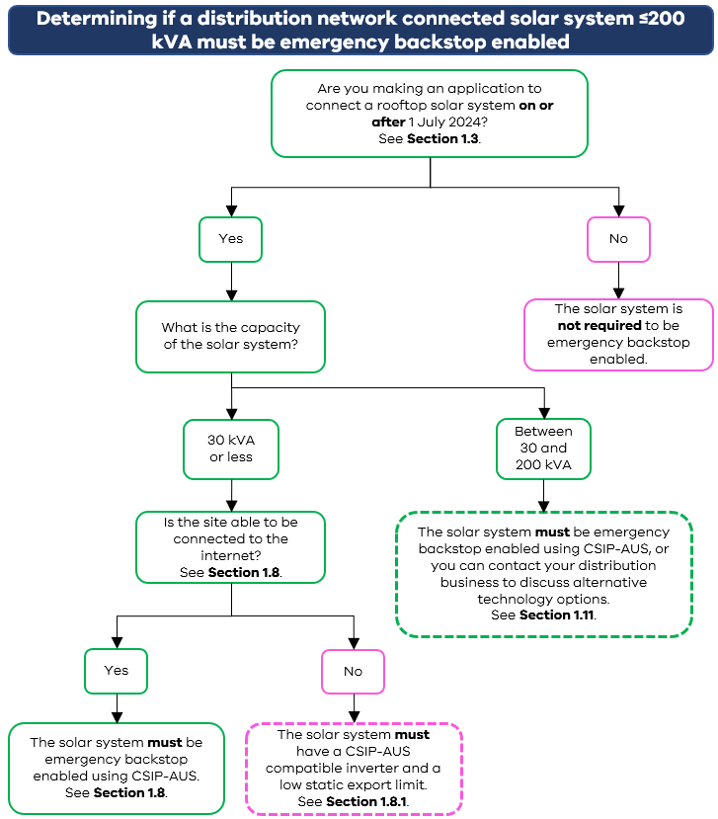
Figure 1: Determining if a rooftop solar system ≤200 kVA must be emergency backstop enabled

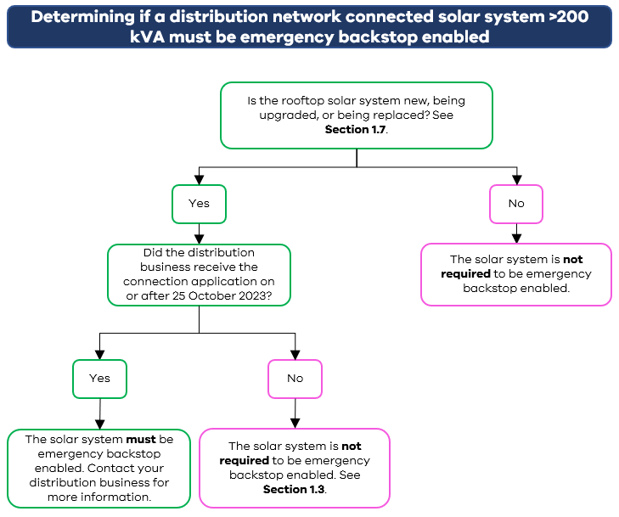
Figure 2: Determining if a rooftop solar system >200 kVA must be emergency backstop enabled

Roles and responsibilities
Person or organisation | Roles and responsibilities
Rooftop solar installers | - Install new, upgrading or replacement solar systems compliantly with backstop requirements. Typically, this will involve:  - selecting CSIP-AUS compliant equipment (or combination of equipment),  - connecting the inverter(s) to the internet, and  - configuring the installation to communicate with the relevant distribution business’ utility server.  - Adhere to relevant Australian Standards (AS 4777.2:2020, AS 4509, AS/NZS 5033, AS/NZS 5139:2019).  - Ensure that knowledge of solar installation requirements and practice is up to date, including:  - accreditation with the Accreditation Scheme Operator (ASO)  - as part of maintaining accreditation, completing relevant training in line with the Accreditation Scheme’s Continuous Professional Development (CPD) requirements.  - Share information with householders and consumers at the point of installation, including the customer fact sheet.  - Show customers how to reconnect the inverter to the internet if it becomes disconnected.
Distributed Energy Resources (DER) manufacturers and suppliers | - Understand timing of requirements and details of the emergency backstop.  - Provide instructions to installers for connecting to the internet.  - Produce and supply compliant technology with appropriate default settings.  - Provide appropriate warranties.  - If complying with CSIP-AUS via a cloud platform, maintain a connection to the distribution business’ utility server.  - Work with distribution businesses to resolve issues, such as losses of server connectivity.
Rooftop solar retailers | - Incorporate communication materials for consumers into existing processes, including the customer fact sheet.  - Consider the impact on consumers’ bills, in line with the indicative potential feed-in-tariff impacts outlined in the emergency backstop customer fact sheet.
Rooftop solar customers | - Ensure new systems are appropriately maintained.  - Ensure backstop enabled systems remain internet connected, including when updating Wi-Fi passwords or changing internet providers.  - Ensure contact details provided to the distribution business remain up to date.  - If notification is received from the manufacturer or distribution business that the solar system has lost internet connectivity, follow manufacturer instructions to reconnect (typically through the inverter smart phone application or display).
Distribution businesses | - Operate a utility server that can remotely interrupt and curtail the electricity generation of solar systems (less than or equal to 200 kVA) connected to their distribution system, from 1 July 2024.  - Implement and publish an emergency backstop procedure(s).  - Publish information in their Distribution System Planning Report (often referred to as the Distribution Annual Planning Report) about:  - any uses of the emergency backstop for testing purposes, and  - emergency backstop enabled solar connections in their network.  - Meet the requirements of the emergency backstop for large solar systems (greater than 200 kVA), which commenced on 25 October 2023.  - Ensure activations of the emergency backstop prioritise actions which minimise customer harm. To do this, in an emergency event, distribution businesses should prioritise:  - bringing on new loads to offset minimum system load,  - curtailing large-scale distributed generation,  - curtailing only the exports of small-scale customer resources, so that these customers can continue to self-consume, and  - interrupting all generation from small-scale customers only in a last resort to maintain system security where all alternative options have been exhausted.  - Incorporate communication materials into the existing connection process.  - Ensure connection agreements include necessary backstop requirements and if relevant, are approved by the relevant regulator.  - Manage the connection agreement process.  - Implement the commissioning process to embed compliance.  - Monitor and report on compliance.  - Publish a notice on their website as soon as possible in an emergency backstop event.  - Wherever possible, notify affected customers about uses of the emergency backstop.  - Give affected customers at least 48 hours’ written notice of any tests that the distribution business anticipates will result in their solar system’s generation being interrupted or curtailed for over 15 minutes in total within a 48-hour period.
Australian Energy Market Operator (AEMO) | - Responsible for power system operation in the National Electricity Market.  - Use power under the National Electricity Rules to issue directions to distribution businesses to maintain and return the power system to a normal operating state.  - Where necessary, intervene when operational demand falls below required thresholds, to maintain system security. This can include:  - directing network service providers to return lines or elements to service,  - directing generators (or loads) to operate in a certain way or deliver essential services, and  - as a last resort, directing a distribution business to switch off or turn down a solar system’s electricity generation.  - Issue market notices (known as ‘minimum system load notifications’) to notify the market when the power system is under stress and the emergency backstop may be activated.  - Monitor and report on power system operation and emerging issues.
Victorian Government | - Prepare Ministerial Orders.  - Work with distribution businesses to develop a consistent process for ensuring compliance in the commissioning process.  - Prepare and disseminate communications for residential and business rooftop solar owners and installers.  - Update these guidelines as required.  - Work with training providers to develop emergency backstop/CSIP-AUS CPD training.
Solar Victoria | - Incorporate equipment requirements into the Solar Homes program, to be communicated via the Solar Victoria Notice to Market.
Clean Energy Council | - Provide and maintain list of CSIP-AUS compliant equipment.  - Host emergency backstop/CSIP-AUS CPD online training for installers.
Accreditation Scheme Operator | - Manage accreditation requirements for solar design and installation.  - Provide relevant solar design and installation training.
Essential Services Commission | - Regulate distribution businesses through legislation and licence conditions, including codes of practice and Ministerial Orders.  - Report on performance of distribution businesses.  - Promote and enforce compliance with relevant obligations.

Determining if a rooftop solar system is new, upgrading, or a replacement
From 1 July 2024, if a new connection application, or an application to alter to an existing connection, is required with the relevant distribution business, then the rooftop solar system will need to meet emergency backstop requirements. In practice, ‘new, upgrading or replacement’ will usually include:
- New solar systems where an inverter and array are being installed for the first time, including on a new build.
- Existing solar systems where an inverter is being replaced as part of the upgrade.
- Replacement of an existing solar system where an inverter is being replaced as a repair, but not where the inverter is being replaced with like-for-like equipment under warranty and the replacement is not able to be emergency backstop enabled.
Where a new inverter is added to an existing solar system, only the new inverter needs to comply with the emergency backstop requirements. However, where the entire site is able to comply, for example through a secure gateway device, it is recommended to do so as this will lead to a more streamlined connection process and eligibility to participate in future flexible export offerings.
The relevant distribution business must be notified of all rooftop solar system installations, including upgrades and replacements.
If you are unsure whether a new connection application, or alteration to an existing connection is required, contact the relevant distribution business.

Sites must be connected to the internet
For a site to be emergency backstop enabled, it will need to be connected to the internet. The options for connecting an inverter or Secure Gateway Device (SGD) to the internet include ethernet, Wi-Fi, or a sim card. Each of these options have pros and cons which you should consider to ensure an option is selected which best meets a customer’s needs. Some of these considerations are detailed below.
Internet connection option | Pros | Cons
Ethernet | Typically reliable.  Typically fast.  Does not require additional data costs.  Less prone to issues causing loss of connection than Wi-Fi. | Needs to be directly plugged into the inverter.
Wi-Fi | Typically low cost.  Typically easy to configure.  Does not require additional data costs. | May not work if the router is very far away from the inverter (mitigation options include a Wi-Fi range extender).  The connection can be lost if the Wi-Fi password is changed. The customer should be shown how to reconnect to the internet.
Sim card | May be more reliable than Wi-Fi.  May be less prone to issues causing loss of connection than Wi-Fi. | Requires additional data costs.
Temporary internet connection (e.g. a tethered mobile phone) | Suitable to enable emergency backstop at sites where other internet connection options are unavailable, such as in new builds. | Customer will need to reconnect to the internet once it becomes available. The customer should be shown how to do this.

Sites 30 kVA or less that cannot practicably be connected to the internet
A new solar system is not required to be emergency backstop enabled if the customer (or the customer’s authorised agent) has advised the distribution business that the solar system has a capacity of 30 kVA or less and the site cannot practicably be connected to the internet.
A site may be considered unable to practicably connect to the internet if:
- There is no internet coverage at the premises.
- There is a way to connect to the internet at the premises, but it would be prohibitively costly for the customer.
- There is internet coverage, but it is so patchy or unreliable that the installer is unable to complete the process of connecting the equipment to the distribution business’ server.
In these circumstances, the solar system:
- Must have CSIP-AUS compliant equipment but it will not need to be connected to the internet or be set up to communicate with the distribution business’ server.
- Will have a low static export limit applied to the solar system, meaning that it can only export a small amount of electricity to the grid. This export limit will be set by the distribution business and be based on several factors including the nearby rooftop solar penetration and the local capacity of the electricity grid, but is unlikely to be greater than 1.5 kW.
The distribution business must include terms reflecting these requirements in its agreement with the customer.
If the customer’s internet circumstances change (for example a new customer moves in and connects internet at the premises), then it will be possible for the customer to apply to the distribution business to have the low static export limit removed. To have this limit removed, the inverter will need to be connected to the internet and the distribution business’ server (i.e. be emergency backstop enabled). This will typically require a site visit by a solar installer.

Sites with a low static export limit
Sites with a low static export limit (that can be connected to the internet) are required to be emergency backstop enabled, to ensure that their electricity generation can be turned down or switched off in a minimum system load emergency.
The emergency backstop has been implemented in a way that ensures solar systems are also flexible export ready. Flexible exports enable export limits to be changed dynamically according to the real-time conditions of the electricity grid. For customers with a low static (or zero) export limit, the implementation of flexible exports can enable these customers to have their export limits increased in the future if they choose to participate in a flexible exports. This will allow Victorians to export more solar, more of the time.
Distribution business will contact eligible customers when flexible export limit pilots and products are available.

New, upgrading or replacement solar systems applied for prior to 1 July 2024
A solar system is not required to be emergency backstop enabled if:
- the solar system has a capacity less than or equal to 200 kVA, and
- the application for the solar system connection or modification was made before 1 July 2024.

Where a distribution business can remotely interrupt or curtail a solar system >30 kVA using alternative technology
A new solar system is not required to be emergency backstop enabled using CSIP-AUS if the solar system:
- has a capacity between 30 and 200 kVA, and
- the distribution business can remotely interrupt or curtail the solar system’s electricity generation using an alternative technology (such as through a Generation Monitoring Meter (GMM) or Supervisory Control and Data Acquisition (SCADA)).
For larger solar systems this creates additional options which may be necessary to reflect these customers’ specific circumstances. Contact your distribution business for more information about these options.

Telling customers about the emergency backstop
The Victorian Government has prepared a fact sheet which we recommend you provide to your customers. This fact sheet is available on the Energy Victoria website.

Technical guidance
The guidance below outlines requirements for completing solar system installations in line with CSIP-AUS requirements.
Please refer to the relevant distribution business' website for any process requirements that are specific to the distribution business.

Selecting compatible equipment
To meet the requirements of the emergency backstop, equipment must be compliant with the Common Smart Inverter Profile Australia (CSIP-AUS) protocol. Some inverters have CSIP-AUS capability in built, while others require the installation of a third-party device. Solar retailers and installers must ensure compliant equipment, or combination or equipment is installed including third-party devices where relevant.
CSIP-AUS is the Australian implementation guide for the IEEE 2030.5 Smart DER communications protocol. This protocol is designed to facilitate the remote management of distributed energy resources by a utility server over internet communications. More information about CSIP-AUS is available on the Australian Renewable Energy Agency website and through Standards Australia.

Key functions of CSIP-AUS
The table below outlines key functions of CSIP-AUS that must be utilised.
Function | Requirements
Export limit monitoring | The communications software client must monitor net export at the network connection point and manage the solar system to keep the site within the export limit under the relevant distribution business connection agreement.  Export limits will be communicated from the distribution business utility server to the communications software client using the CSIP-AUS OpModExpLimW command.
Emergency curtailment | The communications software client must have the capability to:  - manage the gross generation setpoint of the solar system in response to the command from the distribution business’ utility server.  - de-energise the solar system in response to the command from the distribution business’ utility server.
Communications failsafe | The communications software client must have the capability to manage export to a failsafe level on the expiration of an export limit, where no further export limit has been received (e.g. when communications to the distribution business’ utility server is lost or an export limit expires). The value of this communications failsafe export limit shall be updateable by the utility server.
Monitoring | The communications software client must be capable of monitoring telemetry readings from the network point of common coupling and all exporting devices on site. These telemetry readings shall be provided to the distribution business’ utility server as part of commissioning of the site where required. Any ongoing provision of monitoring telemetry readings shall be in accordance with the distribution business’ connection agreement conditions.

Solar inverters compliant with Common Smart Inverter Profile Australia (CSIP-AUS)
The list of CSIP-AUS compatible equipment is maintained by the Clean Energy Council. From 1 July 2024, a site will be considered compliant if the solar system (and related devices as necessary) contains equipment which has successfully completed the communications software client test procedure provided by the distribution business and subsequently been approved and listed as a compliant interoperable pairing by the Clean Energy Council.

Inverter communication models
A solar system can be backstop enabled using a compliant native inverter, single or multiple PV inverters using a SGD, as shown below (Figure 3). An export monitoring device will also need to be installed.
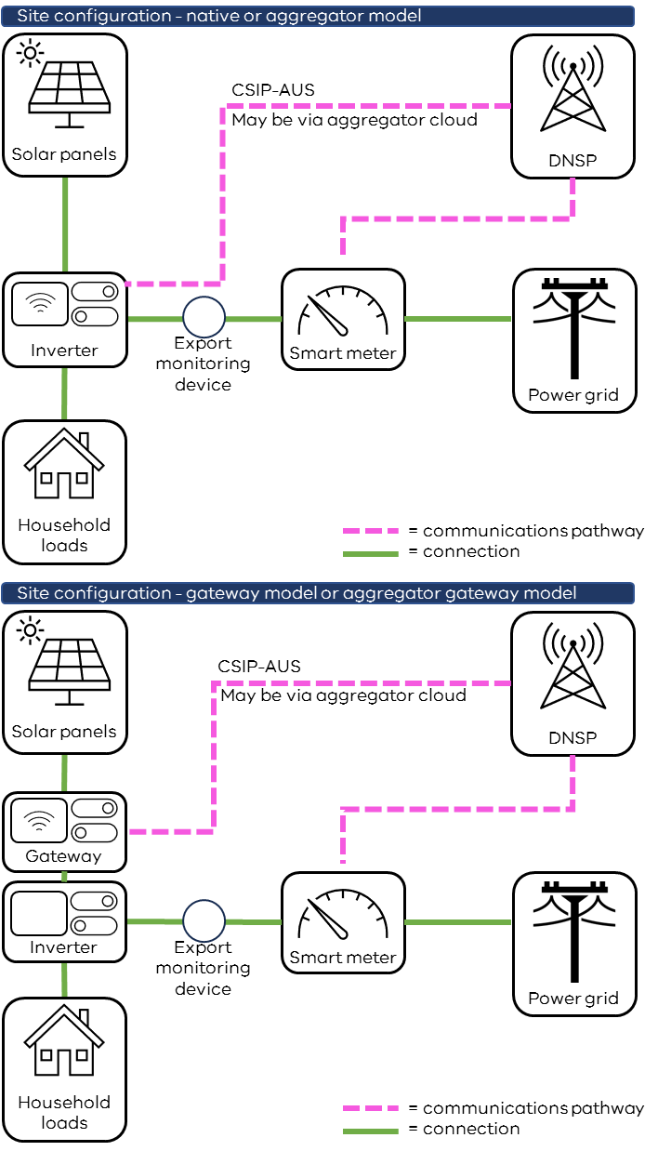
Figure 3: CSIP-AUS site configuration and communication models

Inverter model | Use
Native model | Suitable for small installations such as residential rooftop solar systems.  The inverter is CSIP-AUS compliant and has a built-in communications software client enabling direct communications between the utility server and the solar system.
Gateway model | Suitable for larger or more complex installations with multiple end devices (e.g. inverters, battery storage, electric vehicle charging) where an inverter cannot act as the communications software client. Also suitable for small installations where there is no native inverter functionality. The gateway is CSIP-AUS compliant and collects data from and controls the end devices. It may appear as a single device to the utility server.  Fail-safe operating modes must be implemented at each site, either in the end device or within the local gateway/Generating Facility Management System (GFEMS).
Aggregator model | Suitable where an aggregator platform is used for multiple end devices.  The aggregator platform acts as the communications software client, communicating with the utility server and end devices.  The end devices do not need to be located within one electrical installation and can be distributed across a large geographic area but aggregated together by a single entity.  The utility server must be able to identify each individual end device as an IEEE 2030.5 end device so that each can be monitored and controlled individually.  Fail-safe operating modes must be implemented at each site (such as in the end device), so that fail-safe export limits will operate correctly if there is a failure of the aggregator platform.
Aggregator gateway model | Suitable where an aggregator platform and gateway device(s) are used in conjunction.  The aggregator platform acts as the communications software client, communicating with the utility server. The aggregator platform then communicates with a combination of a gateway(s) and end devices.  The end devices and gateway(s) do not need to be located within one electrical installation and can be distributed across a large geographic area but aggregated together by a single entity.  The utility server must be able to identify each individual end device as an IEEE 2030.5 end device so that each can be monitored and controlled individually.  Fail-safe operating modes must be implemented at each site (such as in the end device), so that fail-safe export limits will operate correctly if there is a failure of the aggregator platform.

Secure Gateway Devices (SGDs)
Cloud vendors utilising the cloud pathway must have a CSIP-AUS compliant IEEE 2030.5 software client which can, in response to signals provided by the distribution business’ utility server, exert export limit control via communication to sites which utilise their services to achieve CSIP-AUS capability and provide the required monitoring data to the distribution business.

Site monitoring
Emergency backstop enabled sites must have site level monitoring capability (may be achieved through an export monitoring device, current transformer, inverter meter or other relevant device).

Connecting an inverter to the internet

Internet connection options (Wi-Fi, ethernet, cellular)
To communicate with the server of the relevant distribution business, a solar system’s inverter will need to be internet-connected.
Customers and installers have the flexibility to choose the most appropriate method to connect to the internet based on the individual characteristics of the site. Where a permanent internet option is unavailable at the site, a temporary internet connection (such as a tethered mobile phone) can be used to commission and confirm the site is emergency backstop enabled. See also Section 1.8.

Positioning of Wi-Fi router
Where a site is connected via Wi-Fi, installers should confirm a reliable signal can be received. If the Wi-Fi router is located too far from the inverter such that a reliable signal cannot be received, a Wi-Fi range extender may be needed to ensure a reliable connection can be established.

Loss of connectivity
Site connectivity may be lost for a range of reasons including:
- temporary internet outages,
- an inverter has lost connectivity to the internet, due to a change in Wi-Fi router or password,
- a manufacturer cloud has lost connectivity with the distribution business’ utility server.
If a site loses connectivity, the inverter will slowly turn down export to a default ‘failsafe’ limit. Typically, this limit is 1.5 kVA. For temporary outages, the inverter will return to a normal operating state when connectivity is restored. For longer outages, distribution businesses must have a procedure that sets out the process they will follow to contact customers if an emergency backstop enabled solar system loses connectivity. Distribution businesses are required to publish these procedures on their websites.

Reconnecting to the internet after Wi-Fi router or password changes
As part of the installation process, customers should be shown how to reconnect their inverter to the internet in the case of a Wi-Fi router or password change. Typically, this can be done via the solar inverter smart phone application or the display.
Guides including internet connection instructions for some common devices are listed in the table below. If the relevant device does not appear in the table, please refer to the manufacturer’s website.
Manufacturer | Internet connection instructions
GoodWe Technologies | Micro Inverter User Manual  Smart Dongle Installation Guide
Shenzhen Growatt New Energy | Growatt Monitoring Device Setup Guidance
Fronius Australia | Commissioning Fronius Monitoring via smartphone/tablet
Sungrow Power Supply | Sungrow Wi-Fi configuration
Ginlong Technologies | Ginlong SOLIS Wi-Fi Dongle connection
SolarEdge Technologies | SolarEdge Wi-Fi instructions
Enphase Energy Australia | Enphase Instructions (refer to support article)
Shenzhen SOFAR SOLAR | SOFAR Residential PV inverters (select the relevant device, then download the user manual)
Huawei Technologies | Huawei SUN2000 – Commissioning
SolaX Power Network Technology Zhejiang | SolaX Pocket Wi-Fi Set-Up
SMA Australia | SMA Sunny Boy Inverter Wi-Fi connection (refer to service tip)
Delta Electronics | My Delta Solar connection instructions

Installer obligations and compliance
Privacy
When handling sensitive customer information such as Wi-Fi credentials, installers must adhere to Accreditation Scheme requirements.
Cybersecurity
All parties remotely communicating with solar systems have a shared responsibility to apply best-practice measures to ensure that communication with the solar system is cybersecure.
Platforms and communication channels outside the utility server to IEEE 2030.5 software client communication channel are not governed by CSIP-AUS or the IEEE 2030.5 standard. This includes:
- gateway to downstream inverter(s), and
- cloud platform to downstream inverter(s).
These communications channels must be secure.

Solar inverter settings
In line with the Australian Standards for inverters, solar and battery inverters in Victoria and all Eastern Australia must be installed with AS/NZS 4777.2:2020 Australia A settings.
Instructions for correctly configuring inverter settings are available on the Solar Victoria website.

Establishing connectivity with the distribution business’ server and running capability tests
The site must be registered within the distribution business’ utility server by providing the distribution business with:
- the IEEE 2030.5 software client Long Form Device Identifier (LFDI), and
- the site National Metering Identifier (NMI).
For a solar system to be considered emergency backstop enabled, confirmation must be provided by the distribution business' utility server.
A temporary internet connection (such as a tethered mobile phone) may be used for running capability tests to confirm a site is backstop enabled. If a temporary connection is used, once removed, the solar system must be configured to connect to the distribution business' utility server via a permanent on-site internet connection.
Instructions for connecting to each Victorian distribution business’ utility server will be available via distribution business websites/portals in the near future. For links to distribution business websites, please see Section 3 below.

More information

Distribution businesses
Solar installation information specific to each distribution business can be found at each Victorian distribution business’ website:
- CitiPower/Powercor
- United Energy
- AusNet
- Jemena

Training
How to correctly configure inverter settings | Solar Victoria
Multiple reviews have found that many inverters have been installed to incorrect inverter settings. This page outlines the process for correctly configuring solar inverter settings.
Accreditation Scheme’s Continuous Professional Development (CPD) requirements
This page lists the education and training courses that meet the learning criteria for Accreditation Scheme’s Continuous Professional Development (CPD) requirements. Accredited persons are required to complete 100 CPD points annually to maintain their accreditation.

Information for customers
Energy Victoria - Victoria's emergency backstop mechanism for solar
A downloadable customer fact sheet is available on the Energy Victoria website. It is recommended that you share this fact sheet with customers at the point of installation.

Minimum system load
AEMO Minimum Operational Demand fact sheet
This fact sheet provides further information on minimum system load (also known as minimum operational demand).

Australian Standards and Handbooks
Standard/Reference | Title
CSIP Implementation Guide | Common Smart Inverter Profile CSIP Implementation Guide
AS HB 218:2023 | Common Smart Inverter Profile – Australia with Test Procedures
CSIP-AUS Communications Client Test Procedures v1.0 | CSIP-AUS Communications Client Test Procedures v1.0

Consultation on emergency backstop
Engage Victoria
Information about the public consultation process for the emergency backstop may be found on this webpage. You can subscribe for project updates using the ‘Follow’ button.

Contact Us
If you have any feedback on this guidance, please let us know at DER.Victoria@delwp.vic.gov.au.

A small number of solar systems may be exempt from being emergency backstop enabled because they are unable to be internet connected. See Section 1.8.1 for further information.

