2025 Victorian Transmission Plan

August 2025

Contents

Acknowledgment of Traditional Owners 2

Acronyms 4

How to read this document 5

Message from the Minister 6

Executive summary 7

Part A: A new approach to planning Victoria’s energy grid 21

1. Victoria’s renewable energy future 21

2. The Victorian Transmission Plan: our new approach to planning transmission infrastructure 24

3. The policy context for the Victorian Transmission Plan 34

4. VicGrid is working with Traditional Owners and First Peoples 38

5. Engaging with communities and industry 40

Part B: Our plan for renewable energy zones and transmission projects 45

6. Areas we are proposing for future renewable energy generation development 45

7. Planning for offshore wind connections 84

8. The optimal development pathway for Victoria 88

Part C: Delivering the VTP 100

9. Developing renewable energy zones 100

10. Delivering projects in the optimal development pathway 106

Part D: What comes next after publication of this 2025 Victorian Transmission Plan 108

11. What comes next after publication of this 2025 Victorian Transmission Plan 108

Glossary 110

Appendix information and links 114

Contact us 114

# Acknowledgment of Traditional Owners

We acknowledge and respect Victoria’s Traditional Owners as the original custodians of Victoria’s land and waters, their unique ability to care for Country and deep spiritual connection to it. We honour Elders past and present whose knowledge and wisdom has ensured the continuation of culture and traditional practices.

We are committed to genuinely partnering and meaningfully engaging with Victoria’s Traditional Owners and First Peoples to support the protection of Country, the maintenance of spiritual and cultural practices and their broader aspirations in the 21st century and beyond.

## Our commitment to Victoria’s Traditional Owners and First Peoples

We acknowledge we have more work to do to support meaningful participation of Traditional Owners and First Peoples in the development of future Victorian Transmission Plans and renewable energy zones.

The first phase of the Victorian Transmission Plan strategic land use assessment included only publicly available datasets for Aboriginal and Historical cultural heritage. As such, the data relating to Aboriginal cultural heritage is limited and does not capture all known heritage values.

We will continue ongoing conversations with formally recognised Traditional Owners and impacted non-formally recognised Traditional Owners to design an appropriate process for incorporating further cultural heritage information into renewable energy zone development and subsequent Victorian Transmission Plans, in alignment with principles of data sovereignty. We have heard how critical cultural heritage mapping is, and we are committed to making sure this process is Traditional Owner-led.

### Disclaimer

This 2025 Victorian Transmission Plan is published by the State of Victoria pursuant to amendments to the National Electricity (Victoria) Act 2005, which implement the first stage of Victorian Transmission Investment Framework reforms and empowers the CEO VicGrid to develop a Victorian Transmission Plan. It has been prepared in connection with the Victorian Transmission Plan Guidelines.

While the State of Victoria has made reasonable efforts to ensure the quality and accuracy of the information in this publication, the State of Victoria and its employees do not guarantee that the publication is without flaw of any kind or is wholly appropriate for your particular purposes and therefore, to the extent permitted by law, disclaims all liability for any error, loss or other consequence which may arise from you relying on any information in this publication.

This publication does not include all of the information that an investor, participant or potential participant in the National Electricity Market might require, and does not amount to a recommendation of any investment. The modelling work included herein inherently requires assumptions about future behaviours and market interactions.

Anyone proposing to utilise this publication should note that there may be differences between estimated and actual results which may be material. Anyone proposing to use the information in this publication (which includes information and forecasts from third parties) should independently verify its accuracy, completeness and suitability for purpose, and obtain independent and specific advice from appropriate experts. The maps at Figures 1, 2, 4, 9, 10, 12, 13, 14, 15, 16, 17, and 19 show locations of proposed renewable energy zones (REZs). Data used to develop these maps was sourced on or before the date of publication and is subject to change. The maps at Figures 1, 3, 9, 12, 13, 14, 15, 17 and 20 show proposed alignments for the Western Renewables Link (WRL), Victoria to New South Wales Interconnector West (VNI West), Marinus Link and offshore wind transmission as at the time of publication. These alignments are subject to assessment through relevant planning and environmental approvals processes and, together with the identified locations of in service and committed generation projects, are indicative only.

Please visit [the VicGrid web page](http://www.vicgrid.vic.gov.au/) for the latest updates.

# Acronyms

The following table provides definitions for acronyms used in this document.

Table A: Acronyms

|  |  |
| --- | --- |
| **Term** | **Definition** |
| AEMO | Australian Energy Market Operator |
| CDP | Candidate development pathway |
| CER | Consumer energy resources |
| CIS | Capacity Investment Scheme |
| DEECA | Department of Energy, Environment and Climate Action |
| DNSP | Distribution Network Service Provider |
| DSN | Declared shared network |
| EIRR | Economic Internal Rate of Return |
| ESOO | Electricity Statement of Opportunities |
| EV | Electric vehicle |
| EES | Environment Effects Statement |
| GIA | Grid Impact Assessment |
| GSOO | Gas Statement of Opportunities |
| GW | Gigawatt (one million kilowatts) |
| GWh | Gigawatt hour (one million kilowatt hours) |
| IAP2 | International Association of Public Participation |
| ISP | Integrated System Plan |
| MCA | Multi-criteria analysis |
| ML | Marinus Link |
| MW | Megawatt (one thousand kilowatts) |
| MWh | Megawatt hour (one thousand kilowatt hours) |
| NEM | National Electricity Market |
| NEVA | National Electricity (Victoria) Act 2025 |
| NPV | Net Present Value |
| OSW | Offshore wind |
| PSS/E | Power system simulation for engineering |
| RAP | Registered Aboriginal Party |
| RAAF | Royal Australian Air Force |
| REZ | Renewable energy zone |
| RFP | Request for proposal |
| SBC | State Business Corporation |
| SLUA | Strategic land use assessment |
| TW | Terawatt (one billion kilowatts) |
| TWh | Terawatt hour (one billion kilowatt hours) |
| VAPR | Victorian Annual Planning Report |
| VGPR | Victorian Gas Planning Report |
| VNI WEST | Victoria to New South Wales Interconnector West |
| VRET | Victorian Renewable Energy Targets |
| VTIF | Victorian Transmission Investment Framework |
| VTP | Victorian Transmission Plan |
| WRL | Western Renewables Link |

# How to read this document

## Part A

### A new approach to planning Victoria’s energy grid

Part A introduces the context for the 2025 Victorian Transmission Plan (VTP). It provides an overview of VicGrid’s methodology for developing the VTP and describes how VicGrid is working with Traditional Owners and First Peoples, communities and industry as part of the process.

Part A also summarises key themes from feedback that VicGrid has received and how these have helped to shape the 2025 VTP.

## Part B

### Our plan for renewable energy zones and transmission projects

Part B presents the outputs of the 2025 VTP. This includes details on each of the proposed renewable energy zones (REZs) for Victoria, the priority programs of transmission upgrades needed over the next 15 years, and the proposed shoreline REZ to enable the development of offshore wind in Gippsland.

## Part C

### Delivering the VTP

Part C provides information about the next steps for delivering the VTP. This includes information on what to expect as renewable energy zones are formally declared and developed, as well as next steps for planning transmission projects identified in the 2025 VTP.

## Part D

### What comes next after publication of this 2025 Victorian Transmission Plan?

Part D provides an overview of what comes after the publication of the 2025 VTP.

Supporting technical information can be found in the Appendices, available on [the VicGrid website](https://delwpvicgovau.sharepoint.com/sites/O365-GRP-XCS-VTIFEngagementPlanning/Shared%20Documents/VTIF%20Engagement%20Planning/Final%202025%20VTP/Collateral/Accessible%20versions/vicgrid.vic.gov.au).



# Message from the Minister

## The Hon. Lily D’Ambrosio MP

### Minister for Energy and Resources

The release of the 2025 Victorian Transmission Plan (VTP) represents a major milestone in Victoria’s energy transition.

As coal-fired power stations close and we move further toward a future powered by renewables, we need to support this transformational change with a plan that balances the long-term interests of all Victorians.

The VTP is the cornerstone of a new approach – one that reflects not just engineering and economics, but also the values and voices of communities who host our energy infrastructure.

I want to thank every individual, representative group, local government authority and business who provided feedback through the development of this plan, from the release of draft VTP Guidelines in 2024 to the release of the draft VTP earlier this year.

The input of community, formally recognised Traditional Owners, the agriculture industry and renewable project developers and investors has been critical in shaping the final plan.

We recognise the strength of feeling in some sections of the community who remain concerned about the development of renewable energy projects and transmission infrastructure, and we are committed to understanding and addressing impacts on host communities and ensuring the benefits and opportunities of the energy transition are shared more fairly.

The plan attempts to minimise the area of Victoria required for renewable energy zones and the new transmission infrastructure needed, while also providing project developers and investors with sufficient opportunity to generate the energy we need to power homes, farms, schools, businesses, hospitals and other essential services.

Without the plan, we couldn't connect new renewables to the grid, pushing up energy bills, leaving our industry, businesses and homes without secure power, and ultimately costing our economy $9.6 billion.

We have already taken significant strides in the transition to renewable energy and with this plan now in place, we can ensure we build the right infrastructure in the right place at the right time to provide all Victorians with reliable and affordable power.

# Executive summary

VicGrid is developing a new strategic plan for renewable energy infrastructure to deliver better outcomes for Victorian consumers and communities.

This is our first Victorian Transmission Plan (VTP) – a long-term plan for renewable energy zones (REZs) and transmission to ensure we have the right infrastructure in the right place at the right time to support the transition to renewables.

The VTP is a big change to how energy infrastructure has been planned in the past. Victoria needs a significant amount of new renewable energy generation and storage capacity – supported by upgrades to Victoria’s transmission network – to replace coal-fired power stations as they reach end of life and close and ensure Victoria’s electricity system is affordable, reliable, safe and sustainable.

Planning for this new energy infrastructure needs to balance a range of factors, including the impacts on local communities, landholders, Traditional Owners and First Peoples, agriculture and industry, while ensuring we protect the natural environment, biodiversity and cultural heritage.

We also need to avoid under or over-investing, so we can maintain energy security and control costs to avoid unnecessary bill increases for all Victorians. The VTP is a new approach to planning that considers important factors, including land use, environmental impacts, and community views, much earlier in the process. This aims to minimise negative impacts to regional communities, landholders and rights holders, keep costs low for consumers and give industry the certainty it needs to invest in the renewable energy Victoria requires for the future.

## Our plan aims to deliver the best overall outcome for all Victorians

We have developed, refined and now plan to deliver the VTP in a way that creates benefits for Victorians and encourages the critical investment we need to maintain reliable and affordable energy. Early and meaningful engagement is at the heart of our approach. We are committed to partnering with Traditional Owners, and engaging early and often with landholders, communities and industry.

The VTP sets out the plan for Victoria’s renewable energy zones and the transmission infrastructure required to enable an orderly energy transition. The 2025 VTP is a long-term plan based on a future energy mix that responds to changing needs as coal-fired power stations close, meets growing demand from new sources such as data centres, clean fuel production and electric vehicles and meets Victoria’s targets for renewable generation, storage and offshore wind. Our plan is based on scenarios identified in the VTP Guidelines published in 2024 and is designed to be flexible as the energy needs of Victorian homes and businesses change in the future.

We will publish an updated VTP in 2027, and every 4 years after that, or more often if required, to ensure the plan remains up-to-date with new technology developments and changes in energy demand

## Summary of key changes from the draft 2025 VTP

We have made changes to the VTP to reflect feedback received on the draft 2025 VTP. An overview of the key changes is set out below. Since the draft 2025 VTP, we have:

* Energy Market Operator’s (AEMO’s) recently released Transmission Cost Database
* modified renewable energy zone footprints in response to community and Traditional Owner feedback and expanded some renewable energy zones to allow for greater participation by renewable energy generators and to reflect the need for larger areas to develop technically and commercially viable projects
* consolidated the Wimmera Southern Mallee and Grampians Wimmera renewable energy zones into a single renewable energy zones (now called the Western renewable energy zone) that is comprised of 2 separate parts. This decision means there are now 6 proposed renewable energy zones and the proposed Gippsland Shoreline renewable energy zone
* after consistent feedback from both community and industry, we have clarified that the modelled generation amounts for each renewable energy zone are not caps on the generation in that renewable energy zone, but are estimates that are used to inform how much transmission infrastructure is needed
* made minor changes to the transmission projects included in the candidate development pathways to reflect updated power systems engineering studies and feedback from industry stakeholders
* revised the cost estimates for transmission projects to reflect updated information and benchmarked these costs against the Australian
* finalised the cost-benefit analysis which highlights the benefits to Victorian energy consumers that come from investing in the transmission projects on the optimal development pathway
* estimated a range of energy we need across different technology types. VicGrid has considered different scenarios for future energy use, including where demand for energy increases at anticipated levels in line with AEMO’s national step change trends (scenario 1), and also a future where energy-intensive industries, such as data centres, hydrogen production or green aluminium, are developed in Victoria and demand is significantly higher (scenario 2)

The draft VTP presented modelled estimates aligned to scenario 1. The actual generation in each renewable energy zone determined by an allocation process could be different to the modelled generation in scenario 1. Therefore, we have provided a range from scenario 1 and scenario 2 in the final VTP to reflect that there are many plausible and different possible futures for Victoria’s energy landscape.

For more information, see Part B of this plan, the What We Heard Engagement Summary Report and the VTP Changes Summary Report, which can be found on [VicGrid’s web page](https://delwpvicgovau.sharepoint.com/sites/O365-GRP-XCS-VTIFEngagementPlanning/Shared%20Documents/VTIF%20Engagement%20Planning/Final%202025%20VTP/Collateral/Accessible%20versions/vicgrid.vic.gov.au).

Additional renewable generation capacity in our plan

By 2040, we are planning for:

* 5.7 to 9.6 GW of new onshore wind
* 9 GW of new offshore wind
* 2.3 to 8.9 GW of new utility-scale solar
* 4.8 to 7.7 GW of new short and long duration (utility) storage capacity.

Notes: These figures include new capacity from already committed projects across Victoria and the additional new generation capacity that we are planning for by 2040. The ranges shown represent the differences between the generation modelled under different planning scenarios. These modelled figures are not caps on the generation that will actually be built. VicGrid’s proposed new access regime will set caps for generation in each renewable energy zone.

## What’s included in the VTP?

The 2025 VTP sets out what renewable energy technologies and transmission should be built, when, where, and in what capacity to meet Victoria’s future energy needs over the next 15 years.

### The VTP sets out:

#### Proposed renewable energy zones, which are areas identified as most suitable to host new onshore renewable generation and storage.

Establishing renewable energy zones will deliver new benefits for local communities and provide a signal to industry on where to focus when developing new projects. By coordinating development in renewable energy zones, we can streamline grid connections and plan transmission upgrades to make the best use of Victoria’s existing network. It will also help minimise environmental and community impacts.

The draft proposed renewable energy zones from the draft VTP have been updated based on feedback received during consultation. The design process for the proposed renewable energy zones considered economic costs, land use, community preferences, regional development opportunities, generator interest, existing levels of development, wind and solar resource potential and community and industry feedback.

Read more about how community and industry engagement has shaped the proposed renewable energy zones in Section 6.

#### Proposed new transmission investments required in the next 15 years to support renewable energy zone development and deliver network security and reliability.

The plan recognises that significant new investment in transmission will be required to strengthen and modernise Victoria’s grid. These transmission upgrades will unlock new network capacity in the right places to support investment in renewable generation and storage, and ensure Victorians continue to have access to secure and reliable energy.

In this VTP, we are proposing 7 transmission programs, which include 4 new transmission projects: a second radial line and tie in loop in Gippsland to facilitate offshore wind, a new line between Sydenham and Tarrone, a new line between Truganina and Deer Park, and an additional short line between Hazelwood and Yallourn. The remaining projects across the programs range from augmentations within existing terminal stations to significant reconstruction of existing transmission infrastructure.

The scope, schedule and costing of the proposed transmission projects from the draft VTP have been updated based on feedback and further analysis. Read more about the proposed programs of transmission investments in Section 8.

#### A proposed renewable energy zone on Gippsland’s shoreline, which is needed to support offshore wind connection assets.

A shoreline renewable energy zone supporting offshore wind is different to an onshore renewable energy zone and is not designed to host onshore wind and solar projects. The proposed Gippsland Shoreline Renewable Energy Zone signals to offshore wind developers where to locate their onshore connection infrastructure (for example onshore cables), while their wind turbines will be located offshore.

The shoreline renewable energy zone will facilitate coordination, help deliver benefits for the local community, provide a clear signal to project developers, and minimise the impact on areas outside of the zone.

There have been minor updates to the shape of the Gippsland Shoreline Renewable Energy Zone from the draft VTP. Read more about the proposed Gippsland Shoreline Renewable Energy Zone in Section 7.

## Our plan for renewable energy zones

### Where are the proposed renewable energy zones?

We have identified 6 proposed renewable energy zones for Victoria: Central Highlands, Central North, Gippsland, the North West, the South West and the Western.

In total, the proposed renewable energy zones cover 7.9% of Victoria’s land area. There is a trade-off between smaller zones with more concentrated infrastructure development, and larger zones that affect a wider area but result in less concentrated development within each zone. Based on feedback received and our assessment of different land use considerations, we have kept the area covered by the proposed renewable energy zones as small as possible (noting that some of the proposed zones have increased in size from those presented in the draft VTP).

Feedback we have received from regional communities so far has helped shape the size and location of the proposed renewable energy zones. Community feedback continued to stress the importance of minimising impacts on biodiversity and water systems, protecting farmland, and minimising cumulative impacts on regional communities. We also received feedback about infrastructure development in regions prone to natural hazards, including bushfires and flooding. At the same time, we consulted with industry and the Australian Energy Market Operator (AEMO) to understand where current projects are in development.

We are prioritising early engagement and involvement of Traditional Owners and First Peoples in planning for renewable energy and transmission infrastructure. This engagement and involvement has started and we are committed to working together with Traditional Owners and First Peoples over the years ahead.

The location of proposed renewable energy zones also takes into account access to transmission infrastructure, including the new transmission capacity that will be unlocked by the proposed programs of transmission upgrades set out in this plan.

The location of proposed renewable energy zones also considers the resource potential of wind and solar energy. Both onshore and offshore wind are a critical component of the future generation mix to ensure energy can be supplied at the lowest cost to consumers.

The proposed onshore renewable energy zone in Gippsland is separate to the proposed Gippsland Shoreline Renewable Energy Zone, which is designed to host onshore connection infrastructure linking offshore wind generation with Victoria’s transmission network. For more information on the proposed shoreline renewable energy zone, see page 22 and Section 7.

### What is the generation plan for proposed renewable energy zones?

The draft VTP described the additional wind and solar generation capacity we are planning for in each of the 6 draft proposed renewable energy zones by 2040.

VicGrid received consistent feedback from communities that the modelled new generation does not represent the total picture. Table 1 below shows a breakdown of in service generation, generation projects that are planned and already committed as well as the additional generation that VicGrid is modelling to be required by 2040 under 3 different future scenarios. See Section 2.3 for further information about the 3 scenarios which we have used to help determine how much transmission infrastructure is required.

Table 1: Total renewable energy including in service and planned modelled to be in the system by 2040

|  |  |  |  |  |  |
| --- | --- | --- | --- | --- | --- |
| **Generation location** | **In service wind and solar** | **Committed wind and solar** | **2040 new wind and solar modelled for scenario 1** | **2040 new wind and solar modelled for scenario 2** | **2040 new wind and solar modelled for scenario 3** |
| Proposed Central Highlands Renewable Energy Zone | 0.5 GW | 1.4 GW | 0.6 GW | 2.2 GW | 0.6 GW |
| Proposed South West Renewable Energy Zone | 0.3 GW | 0.0 GW | 1.3 GW | 2.0 GW | 1.7 GW |
| Proposed Western Renewable Energy Zone | 0.4 GW | 0.0 GW | 0.8 GW | 4.5 GW | 0.8 GW |
| Proposed North West Renewable Energy Zone | 0.1 GW | 0.0 GW | 0.4 GW | 1.9 GW | 0.7 GW |
| Proposed Central North Renewable Energy Zone | 0.2 GW | 0.9 GW | 0.0 GW | 2.4 GW | 0.1 GW |
| Proposed Gippsland Renewable Energy Zone | 0.0 GW | 0.2 GW | 0.4 GW | 1.1 GW | 0.4 GW |
| **Renewable Energy Zone total** | **1.5 GW** | **2.5 GW** | **3.5 GW** | **14.2 GW** | **4.4 GW** |
| Outside Renewable Energy Zones (onshore) | 3.3 GW | 1.9 GW | 0.0 GW | 0.0 GW | 0.0 GW |
| Offshore | 0.0 GW | 0.0 GW | 9.0 GW | 9.0 GW | 8.0 GW |
| **Total** | **4.8 GW** | **4.4 GW** | **12.5 GW** | **23.2 GW** | **12.4 GW** |

Note: as a modelling simplification, no new generation has been modelled outside renewable energy zones, however it is expected that some projects will still proceed in these areas.

Note: Totals may not add due to rounding.

Long and short duration storage is also a key part of Victoria’s energy future and the VTP has planned for 5.1 GW under scenario 1, 4.8 GW under scenario 2 and 7.7 GW under scenario 3, comprising in service, committed and new entrant capacity. Rooftop solar, consumer energy resources and gas powered generation will continue to play important roles under all scenarios. VicGrid also heard feedback from industry that the modelled generation capacities included in the draft VTP for scenario 1 were too low to encourage investment in onshore generation, particularly if these figures were used as ‘caps’ on the levels of generation within renewable energy zones.

Recognising this feedback, VicGrid notes the following:

* The modelled generation figures in the VTP are not intended to represent caps on generation in renewable energy zones. Rather they represent what a modelled optimal mix of generation would be if the assumptions in scenario 1 became reality and the optimal development pathway of transmission projects was built. The assumptions include electricity demand, the timing and sizing of future transmission projects, the quality of wind and solar resources, the locations of renewable energy zones, the timing of in service generation closures (including coal, gas and renewables), the achievement of government policies and the development of future generation projects.
* While modelled outcomes and scenario analysis are an important part of long-term strategic planning, the actual amount of generation built in each renewable energy zone will likely differ from the modelled values.
* VicGrid will allocate generation in each renewable energy zone by technology type (wind or solar), which will be capped by an access limit.
* The access limit is proposed to be a maximum cap in megawatts (MW) on generation that can connect in a renewable energy zone – without violating technical constraints or surpassing efficient levels of network curtailment forecast for the zone.
* Setting access limits and allocating access rights in an interconnected transmission network is complex. Developments in one part of the network can impact other parts. Work to define the caps and allocate capacity for each renewable energy zone is ongoing.

## Proposed renewable energy zones

Figure 1: We have identified 6 proposed renewable energy zones across Victoria for onshore renewable energy and a shoreline renewable energy zone to coordinate offshore wind connections

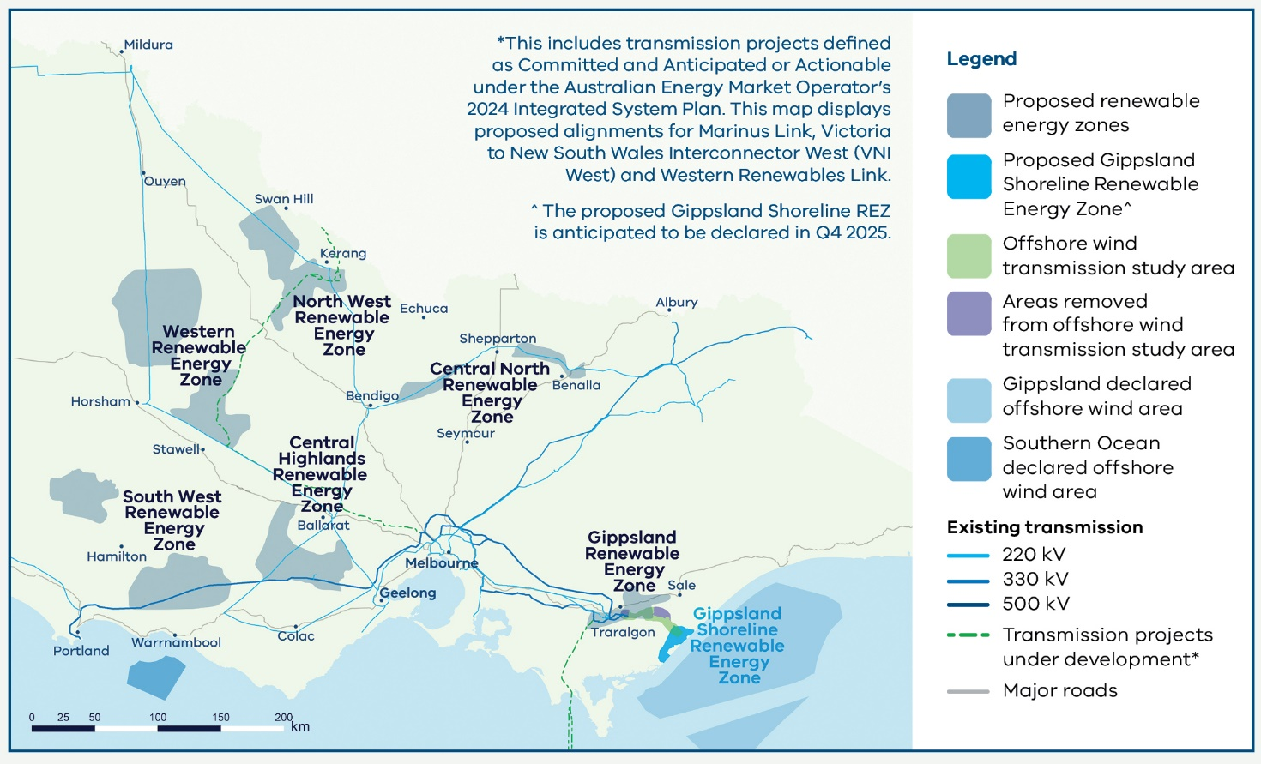

Figure 2: Proposed renewable energy zones and Registered Aboriginal Party boundaries

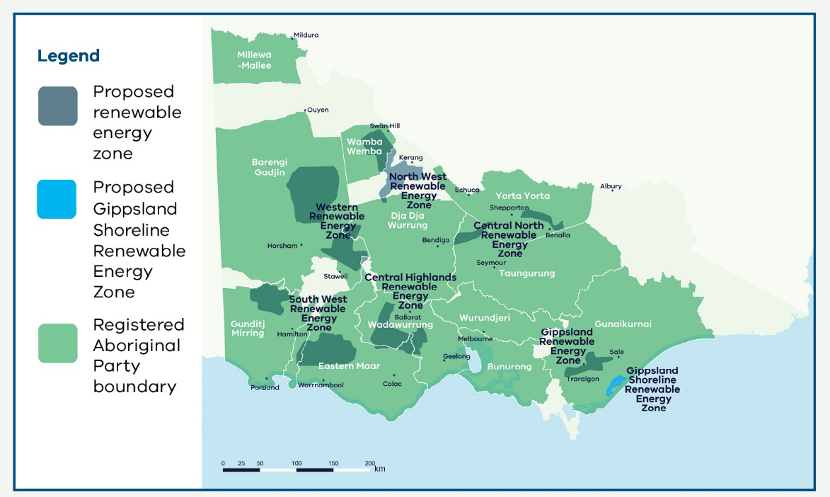

**Figure 2 disclaimer:** The Registered Aboriginal Party boundaries shown in Figure 2 are a computer representation. The boundaries show the general vicinity of land and waters subject to the Native Title Act 1993 (Cth) and Traditional Settlement Act 2010 (Vic) as at the time of publication and could conceivably change. For more details, please see full disclaimer on Page 3.

### How will the final renewable energy zones be decided?

Following the publication of this VTP, there will be a statutory process for each renewable energy zone to be declared. This process provides a further opportunity for consultation prior to any renewable energy zone being declared.

**The process to refine and finalise renewable energy zones includes the following steps:**

1. Study area
2. Draft proposed REZs
3. Proposed REZs (we are here)
4. Draft REZs
5. Declared REZs

## What will the renewable energy zones mean for me?

Introducing renewable energy zones will shape how renewable energy development occurs in Victoria. This will have different impacts for regional communities and landholders, Traditional Owners and First Peoples and industry.

### Regional communities, landholders and Traditional Owners

Communities in declared renewable energy zones will see increased investment in renewable generation and storage infrastructure over time.

Project proponents will need to negotiate with landholders for rights to develop projects on their land and a landholder has a right to say no to having new renewable generation on their property. Landholders who do agree to new renewable development will receive financial compensation that is negotiated with the developer.

VicGrid is implementing new benefits for communities that host renewable energy zones. New Renewable Energy Zone Community Energy Funds are proposed to support projects that improve energy supply, reliability, efficiency and affordability for businesses, communities and households. They will also support initiatives that create economic development opportunities from the energy transition, for example projects that build renewable energy supply chains, create jobs in the energy sector, promote renewable energy research and innovation, or help attract renewable energy investment. For more information visit [our Engage Victoria web page](https://delwpvicgovau.sharepoint.com/sites/O365-GRP-XCS-VTIFEngagementPlanning/Shared%20Documents/VTIF%20Engagement%20Planning/Final%202025%20VTP/Collateral/Accessible%20versions/engage.vic.gov.au/vtif-rez-community-benefits)

Traditional Owners are distinct rights holders to Country and Sea Country and these rights must be upheld. We are committed to working together with Traditional Owners and First Peoples in a way that is grounded in respect and enables self-determination and shared benefits.

We are working in partnership with Traditional Owners to consider models for dedicated benefits for Traditional Owners affected by renewable energy zones and transmission projects. This process aims to go beyond inclusion, to give control over how funds are spent to ensure they deliver economic empowerment and support self-determination.

The development of renewable energy zones will require an ongoing dialogue with Traditional Owners to ensure we minimise impacts to Country. We will continue to work with Traditional Owners to develop a process for incorporating cultural heritage into renewable energy zone planning.

### Industry, generation and storage project developers

Responsible project developers will be critical to the success of the renewable energy zones. VicGrid is introducing reforms that will give generators within renewable energy zones greater certainty over their ability to get their energy to market.

Once renewable energy zones are declared, projects within the zones will benefit from network access arrangements that will help protect against excessive network curtailment – when generators need to limit the energy they supply due to constraints on the transmission network.

Projects located inside declared renewable energy zones will have the opportunity to participate in a competitive application process for allocating access to the grid.

We propose projects located outside of declared renewable energy zones will be subject to a Grid Impact Assessment and will need to demonstrate that their project would not result in generators located within renewable energy zones being ‘excessively curtailed’.

The new access arrangements will also set clear expectations and requirements for how project developers inside and outside of renewable energy zones should engage with communities, Traditional Owners and landholders as well as provide meaningful benefits.

## Our plan for transmission infrastructure investments

### What transmission infrastructure investments are needed?

The VTP sets out 7 programs of transmission infrastructure investments to be implemented by 2040 to enable the development of renewable energy zones and offshore wind.

The proposed transmission investments will support renewable generation and help to ensure a smooth transition as coal-fired power plants close and Victoria’s electricity demands grow.

Our proposed plan for transmission has been carefully chosen to deliver a path forward that keeps costs as low as possible for Victorians while providing flexibility to adapt to changing energy needs in the future. Transmission programs may be altered, added or removed as the energy transition and demand evolves over time.

We have prioritised rebuilding and upgrading existing transmission lines where possible, while recognising the impact that these rebuilds have on local communities. In this VTP, we are proposing 4 new transmission projects across 3 programs: a second radial line and tie in loop in Gippsland to facilitate offshore wind, a new line between Sydenham and Tarrone, a new line between Truganina and Deer Park, and an additional short line between Hazelwood and Yallourn. The remaining projects across the 7 programs range from augmentations within existing terminal stations to significant reconstruction of existing transmission lines.

A number of the proposed programs are needed urgently to prepare for coal-fired power stations to close and avoid bottlenecks in delivering new generation and storage infrastructure, including new renewables projects supported by the Australian Government’s Capacity Investment Scheme. Of the 7 programs, 2 are needed by 2030, 3 by 2035 and 2 by 2040.

Table 2 describes each of the transmission programs, their proposed implementation timing, and why they are needed. Figure 3 illustrates the locations of these programs across Victoria.

The 7 priority programs below describe what is needed over and above existing transmission projects that are already under development across Victoria. Marinus Link Stage 1, Victoria to New South Wales Interconnector West, Western Renewables Link, and the transmission infrastructure required for the first 2 GW of offshore wind in Gippsland have all been factored in as inputs to the 2025 VTP.

Table 2: The 7 priority programs of transmission upgrades to unlock renewable generation

|  |  |  |
| --- | --- | --- |
| **Program** | **Why it is needed** | **Proposed year needed by** |
| Western Victoria reinforcement program: A collection of network augmentations and upgrades of existing infrastructure. | To support connection of onshore wind and solar generation in the proposed Western, Central Highlands and South West renewable energy zones and reinforce the network supply to metropolitan Melbourne. | Between 2028 and 2030 |
| Eastern Victoria reinforcement program: A suite of network augmentations and upgrades of existing infrastructure, as well as an additional line between Hazelwood and Yallourn. | To meet increased demand in eastern metropolitan Melbourne, respond to shifting supply from the east of Victoria to the west of Victoria and ensure connection and security of supply from the proposed Gippsland and Central North renewable  energy zones and the Gippsland offshore wind area. | Between 2028 and 2030 |
| North West strengthening program: Replacement of sections of the existing single circuit transmission with a new high capacity double circuit line. | To support additional generation in the proposed Western and North West renewable energy zones and facilitate its transfer to areas of high energy demand. | 2035 |
| South West expansion program: A new double circuit 500 kV line and associated works in South West Victoria. | To meet significant demand for high-quality wind generation in Victoria’s west, including additional generation in the proposed South West and Central Highlands renewable energy zones. | 2033 |
| 5 Gippsland offshore wind transmission stage 2 program: A new transmission loop to support offshore wind. | Building on the first Gippsland offshore wind transmission project, this new program is required to connect additional offshore wind generation in the Gippsland offshore wind area to meet Victoria’s 2035 and 2040 offshore wind targets. | Between 2033 and 2038 |
| Latrobe Valley strengthening program: New power flow controllers and dynamic load rating devices in the Latrobe Valley. | To allow for easier integration of wind and solar into the grid, manage significant power flows and address network congestion. It supports connection and transfer of generation from the proposed Gippsland Renewable Energy Zone and Gippsland offshore wind area. | Between 2034 and 2035 |
| Offshore wind upgrade: Uprating of existing lines from Heywood to Portland. | To connect offshore generation from the Southern Ocean offshore wind area to Portland. | 2038, or earlier, to align with the timing of offshore development in the Southern Ocean offshore wind area. |

Figure 3: Map of the 7 VTP priority transmission programs

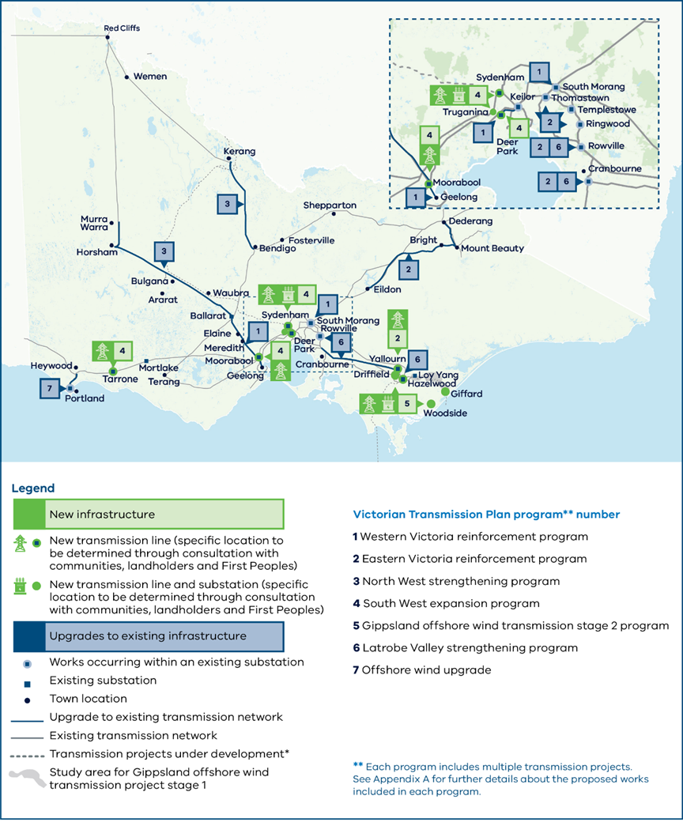

**Map disclaimers:** This includes transmission projects defined as Committed and Anticipated or Actionable under the Australian Energy Market Operator’s 2024 Integrated System Plan. This map displays proposed alignments for Marinus Link, Victoria to New South Wales Interconnector West (VNI West), Western Renewables Link and the Gippsland offshore wind transmission stage 1. The Renewable Energy Zone Development Plan stage 1 project includes several network augmentations that are not included in this map.

Each program includes multiple transmission projects. See Appendix A for further details about the proposed works included in each program.

## Benefits of the VTP

Delivery of the 7 priority transmission programs will require investment in new infrastructure. This will mean spending money on the materials, equipment and workers that are needed to keep Victoria’s lights on. This investment in new transmission infrastructure comes at a cost to Victorian electricity consumers and it is important that we invest in the right projects at the right times to unlock the benefits that justify the investment in new infrastructure.

Our analysis has considered what would happen if the 7 programs are delivered and compared this to a future they are not delivered. By investing in the transmission infrastructure projects prioritised in the VTP, Victorians will benefit through:

* needing less new generation and storage infrastructure to meet rising electricity demand
* needing fewer ‘connection asset’ powerlines between new generation projects and the transmission network
* using lower cost and cleaner generation sources more efficiently
* having more electricity sourced from renewable electricity and less from emissions-intensive sources
* having an energy system that is more reliable, secure and able to withstand change and uncertainty.

The economic analysis of the programs identified in the VTP is summarised in Section 8, with more detail included in Appendix D. This analysis shows that the economic benefits of delivering the priority transmission programs exceed the costs by a considerable margin.

Replacing Victoria’s ageing, emissions-intensive power stations is complex and requires significant investment. Delivering the VTP’s priority transmission projects provides Victorian communities, landholders, industry and infrastructure investors with a clear pathway that delivers more affordable, reliable, secure and sustainable outcomes for all Victorians.

## Next steps for VTP transmission projects

With the release of the 2025 VTP, VicGrid will begin detailed planning for the transmission projects under each priority program. There will be further opportunities for consultation as these transmission projects are planned and developed.

Under proposed reforms, VicGrid will be responsible for coordinating the procurement of VTP transmission projects.

We are currently proposing changes to procurement of major transmission projects in Victoria. This is to ensure that the procurement approach is flexible enough to support the pace required to meet the State’s emissions reduction commitments, deliver value for money for Victorian energy consumers and minimise impacts on power bills. The changes will allow VicGrid to plan and procure transmission augmentations effectively in anticipation of new renewable generation connecting to the grid and without the need for further regulatory investment tests. The proposed procurement reforms are subject to the passage of the National Electricity (Victoria) Amendment (VicGrid – Stage 2 Reform) Bill 2025 in the Victorian Parliament, establishing necessary regulations and the transfer of declared network functions for Victoria from AEMO to VicGrid. This is expected to occur on 1 November 2025.

The proposed projects include new transmission as well as upgrades to existing transmission lines. VicGrid is introducing new benefits arrangements for landholders, neighbours, communities and Traditional Owners significantly affected by new transmission.

These new benefits will be in addition to existing compensation arrangements under the Land Acquisition and Compensation Act 1986, Traditional Owner Settlement Act 2010 and the Native Title Act 1993 (Cth), as well as any discretionary payments made by transmission project developers. For more information, visit [our Engage Victoria page](https://engage.vic.gov.au/vtif-rez-community-benefits).

## Planning for offshore wind connections

The 2025 VTP process takes into account the planning that is already under way to develop offshore wind in Victoria.

The Australian Government has declared 2 offshore wind areas in Victoria, off the coast of Gippsland and in the Southern Ocean off the coast of South West Victoria. Planning is most advanced in Gippsland, and the next step is to set out suitable shoreline locations for offshore wind developers to connect their infrastructure to the grid.

As part of the draft 2025 VTP, we sought feedback on a draft proposed renewable energy zone near the shoreline in the south of Gippsland. For more information about the zone, see Section 7.

The proposed Gippsland Shoreline Renewable Energy Zone is shown below. This shoreline renewable energy zone for offshore wind is different to the 6 proposed renewable energy zones we have identified to host onshore wind and solar generation. It sets out a designated area for offshore wind developers to site their onshore connection infrastructure. It is not designed to host new onshore generation such as wind turbines and solar farms. The offshore wind turbines themselves will be hosted in Commonwealth waters off the coast of Victoria.

The boundaries of the proposed shoreline renewable energy zone reflect a range of factors. This includes technical considerations around shore crossings for offshore wind cables to support the first 2 GW of offshore wind energy, underground cable routes to the Giffard connection hub, as well as the exclusion of towns, environmentally and culturally sensitive areas such as waterways and wetlands, and minimising crossings of major roads such as the South Gippsland Highway.

There will be designated areas within the proposed Gippsland Shoreline Renewable Energy Zone where offshore wind export cables are allowed to cross the shore. VicGrid is coordinating further work to narrow down suitable shore crossing locations to ensure environmentally and culturally sensitive areas along the coast are protected.

Figure 4: Proposed Gippsland Shoreline Renewable Energy Zone

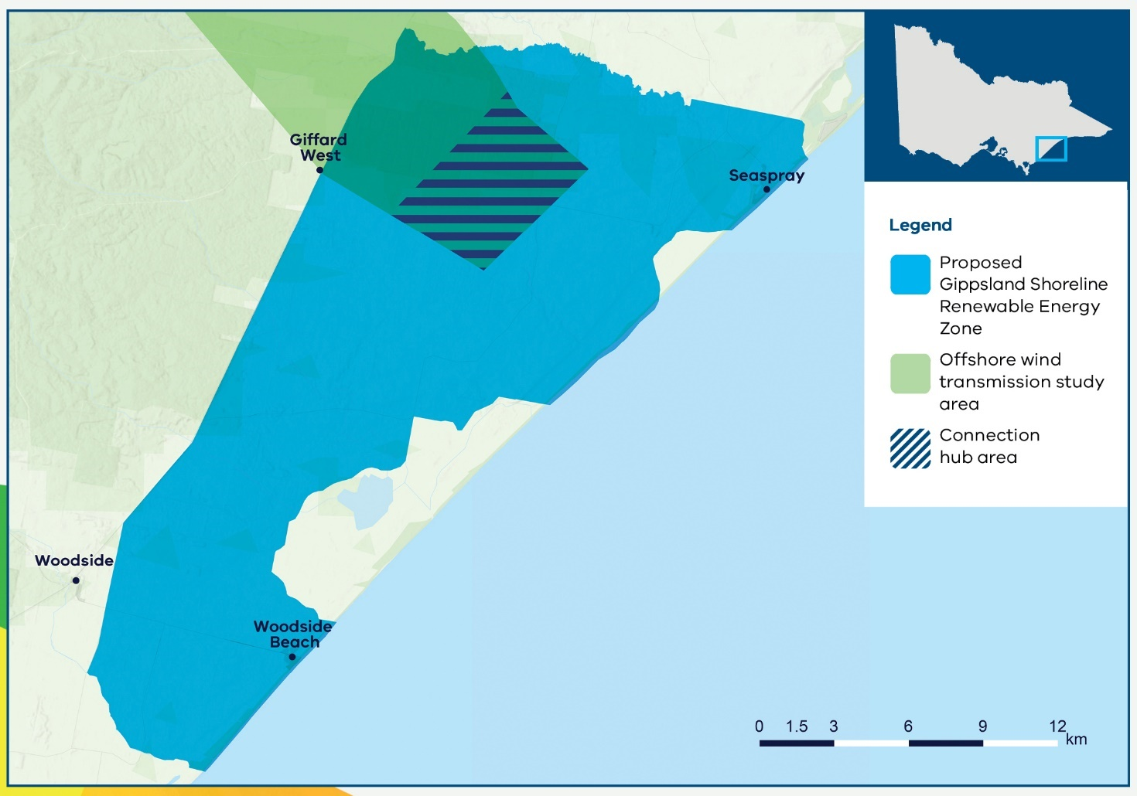

## Next steps for the proposed Gippsland Shoreline Renewable Energy Zone

After the release of this 2025 VTP, the Victorian Minister for Energy and Resources can proceed with the renewable energy zone declaration process, culminating in a formal declaration of the proposed Gippsland Shoreline Renewable Energy Zone. The declaration process will include opportunity for further consultation.

VicGrid will soon consult on a draft renewable energy zone access scheme for offshore wind developers. It is important to note that – unlike for other renewable energy zones – this access scheme will apply only to offshore generation, and new onshore generation projects located within the boundaries of the shoreline renewable energy zone will be subject to the Grid Impact Assessment that applies elsewhere in Victoria.

Communities impacted by the renewable energy zone on Gippsland’s shoreline will receive new dedicated benefits, similar to our approach for onshore renewable energy zones. These benefits will be in addition to any discretionary benefits paid by offshore wind developers.

## Next steps for community, industry and Traditional Owners

VicGrid is committed to ongoing engagement with communities, industry and Traditional Owners throughout the implementation of the 2025 VTP. Draft Renewable Energy Zone Orders outlining proposed zone boundaries and transmission hosting capacities will soon be placed on public notice for a minimum of 6 weeks, allowing further input from community, industry and Traditional Owners to inform final Renewable Energy Zone Orders, expected to be released in late 2025. VicGrid will also seek feedback during the rollout of Renewable Energy Zone Community Energy Funds and network access schemes, and will engage directly with Traditional Owners, landholders, neighbours, and affected communities throughout the planning process for VTP transmission projects. We will continue to seek to partner with Traditional Owners and First Peoples, and work closely with communities and industry in future design phases and VTPs.

We will consult on detailed design of the new Victorian Access Regime by inviting feedback on an Access and Connections Consultation Paper and draft Grid Impact Assessment Guidelines. The consultation documents will provide more detailed information about how project developers will gain access and connect to the transmission network inside and outside of renewable energy zones once the new regime comes into effect.

It is anticipated that later in 2025 we will also release for consultation a draft updated guide to community engagement and sharing economic and social benefits, setting out the government’s expectations for how developers engage with and create value for communities, Traditional Owners, landholders and neighbours. For more details, see Section 9.1.1. This will set the benchmark for our assessment of access applications by project developers.

VicGrid will lead the delivery of transmission projects prioritised in the Victorian Transmission Plan, ensuring projects are strategically planned and built to support Victoria’s energy transition. This coordinated approach provides greater certainty for industry and helps unlock investment in renewable energy zones.

The VTP outlines a new set of provisions and benefits for communities, landholders and Traditional Owners. Projects located within renewable energy zones will benefit from streamlined access arrangements and policy support. In return, projects are expected to meet government expectations for community and Traditional Owner engagement, which will be defined in the draft updated guide to community engagement and sharing economic and social benefits. Renewable energy zone development will also bring investment in regional infrastructure, creating job opportunities and other local economic benefits.

# Part A: A new approach to planning Victoria’s energy grid

# 1. Victoria’s renewable energy future

Victoria’s energy system is changing rapidly. As ageing and increasingly unreliable coal-fired power stations close and our electricity demand increases, our electricity system must evolve. The Victorian Government has recognised that significant large-scale renewable energy generation and storage investment is needed to provide reliable and affordable electricity.

To enable renewable energy generation in the most suitable areas, we need the timely coordination of investment in transmission, generation and storage.

## 1.1 Planning for the energy transition

As our ageing coal-fired power stations close, they are being replaced by new renewable energy such as wind and solar as well as batteries and other energy storage. At the same time, consumer demand for electricity is changing, as households move away from gas appliances, electric vehicles become more common, and new sources of demand such as data centres emerge.

The Victorian Government has set ambitious targets for renewable energy generation to achieve the world-leading climate target of net zero emissions by 2045. To reach this target, we are planning for 65% of the state’s electricity to come from renewable sources by 2030 and 95% by 2035.

The transition to renewables is already under way. Renewable energy generation in Victoria has tripled in the past decade, and the state has exceeded its 2020 target of 25% renewable electricity. Victoria is on track to meet the next 40% renewable electricity target in 2025. The government must continue supporting an orderly transition to deliver affordable, reliable energy for communities, businesses and industry.

The government’s vision for Victoria’s future electricity system is laid out in Cheaper, Cleaner, Renewable: Our Plan for Victoria’s Electricity Future. It provides a whole-system view of the Victorian Government’s actions and the private sector’s investment opportunities through to 2035.

Figure 5: Victoria’s energy transition timeline

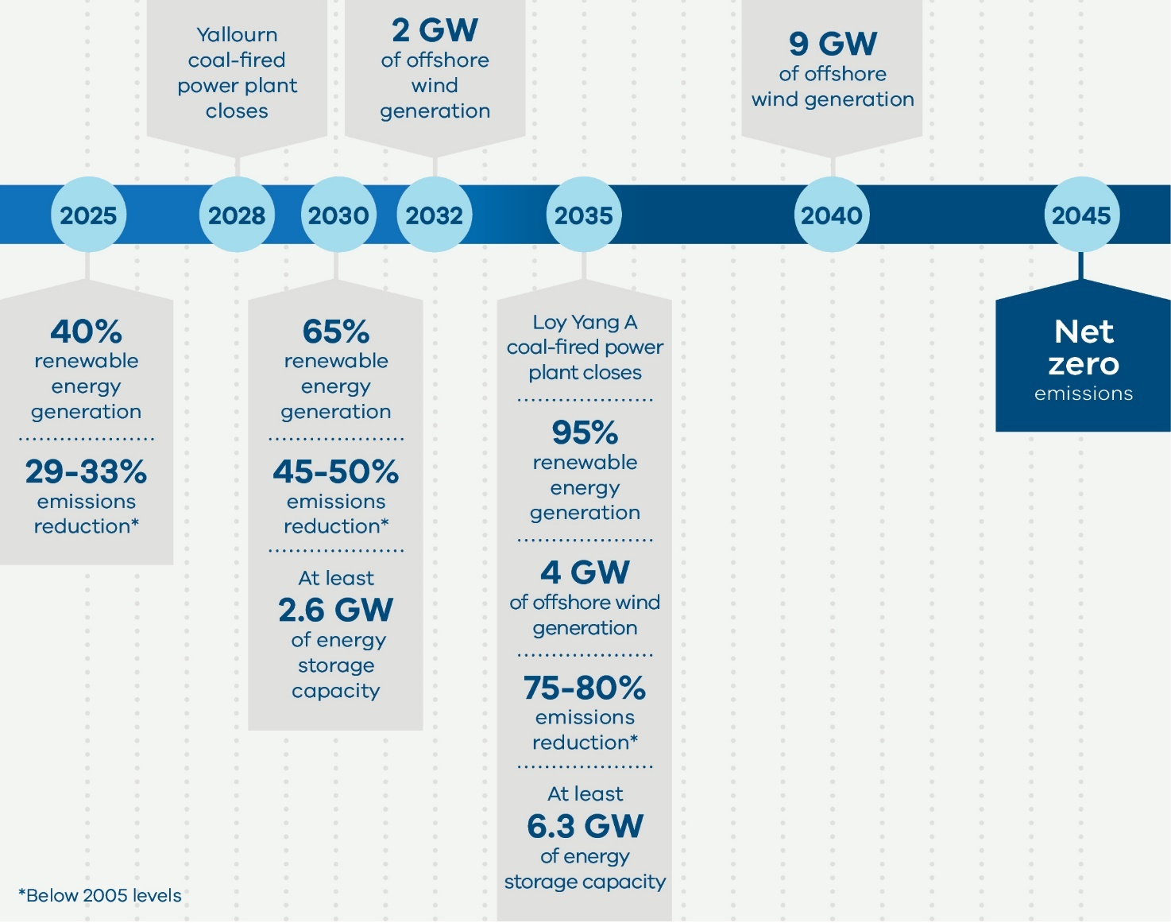

## 1.2 Why we need a new approach to planning energy infrastructure

As Victoria’s energy system changes, the way we plan and develop energy transmission and generation also needs to change to adapt to this new landscape.

The previous transmission planning framework was not designed to meet Victoria’s long-term energy needs in a system transitioning to renewable energy. The planning process was not designed to anticipate the significant changes to the energy system and network that we are now seeing. It also did not involve First Peoples, communities, landholders and regional stakeholders early enough to minimise impacts.

We need to take a long-term, statewide view to make sure we build the right amount of energy infrastructure in the right places, at the right time, to keep the lights on and deliver power to Victorian homes and businesses.

We also need to ensure we do not build more infrastructure than Victoria needs – so we can minimise impacts on communities, industries and the environment, and keep down costs to reduce impacts on power bills.

VicGrid is putting in place a new approach to planning renewable energy zones (REZs) and transmission infrastructure through the delivery of the Victorian Transmission Investment Framework (VTIF). This new approach features a long-term strategic plan (this Victorian Transmission Plan), early and meaningful engagement with landholders and local communities, partnerships with Traditional Owners and First Peoples, fairer community benefit arrangements and certainty for investors.

Our approach is designed to give communities and stakeholders a real voice in the process so we can minimise impacts on landholders, the environment, cultural heritage and important regional industries such as agriculture.

At the same time, the new approach supports a strong investment environment for renewable energy in Victoria. The Victorian Transmission Plan (VTP) is designed to improve certainty for investors in renewable energy by providing clear signals on where to invest, and how we will unlock new generation capacity through investing in Victoria’s transmission system.

### The energy transition will have different impacts for Victorians

Planning for new energy infrastructure needs to balance the range of different impacts on regional communities, landholders, Traditional Owners, First Peoples, agriculture and industry, while ensuring we protect our environmental and cultural heritage. We also need to avoid under or over-investing, so we can maintain energy security and affordability for all Victorians as coal-fired power stations close.

The energy transition will have different impacts for Victorians, including:

* Landholders hosting transmission infrastructure
* Neighbours
* First Peoples
* Regional communities
* Energy consumers
* Farmers
* Local industry
* Energy workers

## 1.3 The role of transmission in supporting the energy transition

We urgently need to change our power grid to carry energy from new renewable sources and storage across the state to Victorian homes, businesses, hospitals, schools and other vital services.

Victoria’s current transmission network was designed to deliver power from coal-fired power stations in the Latrobe Valley to homes and businesses.

New sources of renewable generation, such as wind and solar, are spread across Victoria and are not always located close to the existing transmission network.

We need to deliver new transmission and network upgrades to modernise the grid in areas where sun and wind are abundant so more renewable energy can flow to where it’s needed across Victoria.

## 1.4 The role of renewable energy zones

Renewable energy zones (REZs) will be areas of the state with abundant renewable energy resources, such as wind or solar, that have the potential to host new electricity generation infrastructure while minimising the impact on communities and the environment. REZs will provide important locational signals to project developers and have a critical role to play in supporting Victoria’s energy transition and delivering economic benefits for regional communities. REZs will help coordinate investment in renewable energy generation with transmission network upgrades, provide greater certainty to communities and industry, and ensure projects align with Victoria’s infrastructure and environmental planning objectives.

Importantly, coordinating generation and storage investments through REZs will allow Victoria to reduce the total amount of transmission infrastructure required to connect new sources of energy supply, reducing the infrastructure costs that are ultimately passed on to consumers and minimising impacts on communities and the environment.

REZs will also allow for appropriate consultation, community benefits and compensation arrangements for landholders, communities and First Peoples, while providing greater certainty for project developers to encourage investment.

# 2. The Victorian Transmission Plan: our new approach to planning transmission infrastructure

VicGrid is developing a new integrated approach to planning and developing transmission infrastructure in our state. The Victorian Transmission Plan (VTP) sits at the heart of this new approach, setting out the strategic plan for renewable energy infrastructure and transmission investments over the next 15 years.

## 2.1 Introducing the VTP

As part of Victoria’s new approach to transmission planning, VicGrid is required to prepare and publish a VTP at regular intervals. This 2025 VTP is the first.

**The 2025 VTP sets out:**

Proposed renewable energy zones (REZs): The geographic areas we will prioritise to meet Victoria’s needs for future renewable generation and storage development in the coming 15 years. The REZs will enable us to coordinate the right amount of transmission development in the right places.

A proposed shoreline REZ in Gippsland: This shoreline REZ is needed to host onshore connection infrastructure linking offshore wind generation with Victoria’s onshore transmission network.

The optimal development pathway: The transmission projects that we will need to connect REZs and offshore wind to the grid over the next 15 years, and proposed sequencing for these projects. Transmission projects can include new transmission lines or upgrades, and will be chosen to ensure Victoria’s future renewable energy needs are met while maintaining reliability and minimising costs for consumers.

**Through the 2025 VTP, we aim to:**

* Provide greater certainty for communities and industry about when and where new renewable generation and transmission infrastructure will be developed.
* Give Traditional Owners and First Peoples, landholders, communities and industry a voice throughout the planning process and incorporate a range of perspectives into REZ and transmission planning.
* Provide transparency about the methodology we have used to prepare the plan.

## 2.2 The VTP will be updated over time

The 2025 VTP is a first step along the path of long-term transmission planning in Victoria, covering the period from now until 2040. We have taken an accelerated approach to developing the 2025 VTP, to provide certainty as we prepare for coal-fired power stations to close over the coming years.

The 2025 VTP takes a 15-year view of Victoria’s transmission and renewable energy generation needs, to enable a timely and smooth transition from coal-fired power. The second plan, to be published in 2027, will take a 25-year view, as will subsequent plans published every 4 years.

### Legislative requirements for the 2025 VTP

The *National Electricity (Victoria) Act* 2005 (NEVA) sets out certain requirements that the VTP must meet (see Sections 59 and 60). These are summarised below.

### The Victorian transmission planning objective

VicGrid must have regard to the Victorian transmission planning objective, which is defined in the NEVA as follows:

a. to promote efficient investment in, and efficient operation and use of, electricity services for the long-term interests of consumers of electricity with respect to

i. price, quality, safety and reliability and security of supply of electricity and

ii. the reliability, safety and security of the national electricity system and

b. the delivery of transmission services consistent with a least-regrets development pathway and

c. the achievement of targets set by Victorian legislation

i. for reducing Victoria’s greenhouse gas emissions or

ii. that are likely to contribute to reducing Victoria’s greenhouse gas emissions.

### Analysis

VicGrid must carry out the following types of analysis and have regard to the results of these assessments:

* Strategic land use assessment
* Multi-criteria analysis
* Robustness analysis
* Cost-benefit analysis.

### Consultation

VicGrid must undertake any consultation required by the Victorian transmission plan guidelines and consider the results of that consultation.

### Other requirements for future VTPs

The first VTP must be a 15-year plan and subsequent VTPs must plan over a 25-year period. Subsequent VTPs must meet certain additional requirements set out in section 59 (2) of the NEVA. Although these are not mandatory for the 2025 VTP, we have adopted a number of these requirements, including:

* identification of areas for renewable energy development
* use of scenarios and sensitivities
* development of a viable plan for each scenario that integrates economic, social and environmental factors including least-cost system design, technical system requirements, strategic land use assessment and wider factors
* inclusion of the specified projects for that plan.

## 2.3 Scenarios: how we determine how much energy is needed and when

There are many plausible and different possible futures for Victoria’s energy landscape. Factors such as the adoption of consumer energy resources (such as solar panels, batteries and electric vehicles) and changes in industry and technology will impact our demand for renewable energy.

We have developed 3 hypothetical scenarios to help us determine how much new renewable energy we need and when. Planning for a range of potential futures helps us consider the risks of under-investment and over-investment. It ensures the combination of projects we identify can respond to future uncertainties. Table 3 summarises the scenarios that have been used to develop the 2025 VTP.

All 3 of the scenarios are aligned with the Australian Energy Market Operator’s (AEMO’s) 2024 Integrated System Plan (ISP) scenarios, adapted to meet Victoria’s needs in line with the Victorian Transmission Investment Framework (VTIF).

The scenarios are not forecasts and do not represent our view on how the energy transition will occur, nor does the VTP endorse one scenario over another. There are many plausible and different possible futures. Recognising this, VicGrid has also undertaken sensitivity analysis to test what would happen if we made different assumptions to those considered in the scenarios. Scenarios and sensitivity analysis are important tools for planning and managing future risks and uncertainties.

The 2024 VTP Guidelines provide further details on the inputs and assumptions of each scenario.

These scenarios will be updated for future VTPs to reflect new technology developments and the latest information on consumer energy demand. As these scenarios evolve, so will the VTP modelling and outputs, ensuring the pathway of future transmission projects accounts for changing circumstances.

### The 3 hypothetical scenarios used in the 2025 VTP

* Scenario 1 considers a potential future where the Victorian energy sector evolves in line with AEMO’s national step change trends. The 2024 ISP describes this scenario as representing a transition pace that enables Australia’s efforts to limit global temperature rise below 2°C, with consumer energy resources modelled to be a key contributor to the transition. Victoria’s renewable energy targets, offshore wind targets and storage targets are met.
* Scenario 2 considers a potential future where new energy-intensive industries are established in regional and central Victoria at scale, such as data centres, hydrogen production and green aluminium. Demand in this scenario is based on AEMO’s national green energy export trends forecast, which models a rapid decarbonisation pathway and the development of low emission energy exports.
* Scenario 3 considers a potential future where there may be delays of up to one year in delivering new energy infrastructure. There is reduced growth in coordinated consumer energy resources and to reflect broad challenges across the National Electricity Market (NEM), other NEM-Government policies and targets are generally delayed as well.

Table 3: Summary of key factors considered in each scenario

|  |  |  |  |
| --- | --- | --- | --- |
| **Parameters** | **Scenario 1** | **Scenario 2** | **Scenario 3** |
| Demand: | Demand: | Demand: | Demand: |
| AEMO demand scenario | AEMO’s step-change | AEMO’s green exports with revisions to treatment in other states | AEMO’s step-change |
| 2050 operational demand (TWh) | 73.7 | 110.3 | 73.7 |
| Other key factors: | Other key factors: | Other key factors: | Other key factors: |
| Victorian Renewable Energy Targets (2025, 2030 and 2035) | Achieved | Achieved | Achieved |
| Storage targets (2030 and 2035) | Achieved | Achieved | Achieved |
| Offshore wind targets | Achieved | Achieved | Achieved but delayed up to one year |
| Gas constraints | As per AEMO’s 2024 ISP | As per AEMO’s 2024 ISP | As per AEMO’s 2024 ISP |
| Interconnection | As per announcements / AEMO’s ISP | Marinus Link (ML) Stage 2 – July 2037 | WRL, VNI-West and Marinus Link (ML) Stage 1 delayed up to one year, no ML Stage 2 |
| NEM coal closure | As per announcements / Victorian Renewable Energy Target | As per announcements / Victorian Renewable Energy Target | As per announcements / Victorian Renewable Energy Target |
| Non-VIC government policies | Aligned with announcements | Aligned with announcements | Generally delayed due to various challenges associated with the energy transition.  For example, Snowy Hydro is delayed by one year. |

## 2.4 Our approach to developing the VTP

The process we have used to develop the VTP is set out in the VTP Guidelines. VicGrid released the final guidelines for this VTP in September 2024, following public consultation.

The guidelines include 5 key steps to develop the 2025 VTP, outlined in Table 4 and Figure 6. Developing the VTP has been an iterative process that considered which areas are most suitable to host REZs, how much new generation is required in each REZ, and the transmission upgrades needed to connect these REZs to the grid.

The VTP development process considers 3 different scenarios of future energy requirements across Victoria, to ensure the VTP is robust across a range of possible futures. These scenarios are described in detail in the guidelines and summarised in Section 2.3.

The VTP Guidelines will be updated over time as we prepare future VTPs. You can view the 2024 VTP Guidelines and learn more about how we developed them at [VicGrid’s web page](https://www.energy.vic.gov.au/renewable-energy/vicgrid).

Table 4: The 5 steps to develop the 2025 VTP

|  |  |
| --- | --- |
| **Key analytical steps** | **Description** |
| **Step 1: Identifying areas for investigation**  Key outputs:   * REZ study area * REZ areas for investigation | The first step to develop the VTP involved assessing the broad geographic areas that may be suitable to host renewable generation and narrowing this down to areas for investigation for hosting REZs. This was a 2-part process:   1. A broad study area was identified using a strategic land use assessment. The assessment took into account existing land uses and landscape features across the state from several, and sometimes competing, perspectives, including environment, cultural heritage, social, land use and engineering. The assessment identified areas that we should avoid considering due to land use and landscape constraints, areas that we should investigate further for renewable energy development, and features that provide investment opportunities. 2. The study area was then narrowed to areas for investigation. To do this, we undertook energy market modelling to identify smaller areas within the study area that are most suitable to host generation from an economic standpoint (referred to as a least-cost generation mix). This identified the generation types and locations to meet Victoria’s energy requirements at the lowest cost to consumers. Unlike traditional planning processes, this least-cost analysis took broader land use factors into account. Areas that had been deprioritised due to land-use constraints during the strategic land use assessment were excluded from the least-cost analysis. |
| **Step 2: Developing draft proposed REZs**  Key outputs:   * REZ candidate areas * Preliminary generation resource plans for each scenario * Draft proposed REZs | Our next step was to refine the REZ areas of interest into potential REZ candidate areas, and then narrow these down further into draft proposed REZs. To do this, we took an iterative approach that considered how much generation would be needed across different scenarios of future demand, as well as a range of local factors related to land use, community preferences, generator interest and regional economic development.  Refining the areas of interest into draft proposed REZs was a 4-part process:   1. **Spatial multi-criteria analysis:** Using the areas for investigation as an input, we first completed a spatial multi-criteria analysis to further consider broader qualitative factors in addition to the least-cost generation outcome. This provided valuable information on whether certain areas should be reprioritised based on factors such as:   a. Community preferences relating to the development of renewable energy generation and transmission infrastructure across Victoria  b. Land use, through detailed land-use information from the strategic land use assessment  c. Generator/developer interest, including information obtained from a survey for developers of generation and storage projects, and  d. Regional development indicators to assess the comparative strengths of Victoria’s regions in relation to REZ development, and how hosting a REZ could support other regional development opportunities.   1. **Calibration checks:** Next we completed calibration checks on the results of the multi-criteria analysis. This considered 2 key factors:   a. The size and location of in-service and committed generation projects. This allowed us to consider cumulative impacts from the overall level of development concentrated in a given region when determining the most appropriate locations for siting future generation across the state.  b. A network planning review to evaluate transmission corridor feasibility. Certain areas were infeasible for generation and storage development, for reasons such as they would require transmission lines to traverse a national park, or the required length of new transmission was considered prohibitive.   1. **Preliminary generation resource plans:** We completed further energy market modelling to develop the preliminary generation resource plans for each of the 3 VTP scenarios, building on the results of the multi-criteria analysis and calibration checks. These plans included:   a. which technologies to build (including storage)  b. how much capacity to build  c. when this capacity should be built the location of the new generation build.  The preliminary generation resource plans provided a more refined picture of the suitable areas for REZ development, taking into account a range of land-use factors and generator interest in addition to cost and technical constraints. Alongside feedback we received on the study area from communities, Traditional Owners and First Peoples and industry, these detailed plans helped us to narrow the REZ areas for investigation into a set of REZ candidate areas.   1. **Refinement into draft proposed REZs:** The final sub-step was to further refine the boundaries of the REZ candidate areas to develop the draft proposed REZs for consultation. This involved a carefully considered assessment of regional and local factors for each candidate area, which aimed to balance a range of perspectives and trade-offs. In addition to detailed energy market modelling, we considered:   a. stakeholder views collated from engagement with formally recognised Traditional Owner groups; local communities through drop-in sessions, feedback form responses and submissions; and local councils and industry bodies through briefings and submissions  b. alignment with regional and local economic development strategies  c. in service and committed generation projects, and potential for cumulative economic, social and environmental impacts due to the concentration of projects in a region  d. transmission network design and utilisation, including feasibility of network augmentation, community acceptance and overall deliverability of the plan  e. environmental, cultural heritage and other land-use constraints (based on available data)  f. level of developer interest and support in a region. |
| **Step 3: Identifying candidate development pathways**  Key outputs:   * Candidate development pathways for each scenario | In Step 3, we considered what transmission upgrades would be needed to enable the generation amounts and locations identified in the preliminary generation resource plans and draft proposed REZs from Step 2. We did this for each of the VTP scenarios, creating a ‘candidate development pathway’ for each scenario. These pathways identify the potential transmission projects needed and by when, to maintain secure operation of the power system, meet supply requirements and deliver reliable power to Victorian homes and businesses.  To achieve this, we assessed the capacity of the existing transmission network against the maximum additional generation identified in Step 2. Where we identified constraints, we completed transmission network planning to identify feasible project options. The technical feasibility of these transmission project options was then assessed through power systems analysis.  Where necessary, the results of this network planning and feasibility analysis were then used to further refine the generation resource plans and draft proposed REZs from Step 2. This in turn fed into finalising the 3 candidate development pathways. This iterative approach across Steps 2 and 3 helped us select draft proposed REZ locations, generation resource plans and transmission pathways that would deliver the best overall outcome. |
| **Step 4: Assessing candidate development pathways**  Key outputs:   * Draft optimal development pathway | In this step, we evaluated the 3 candidate development pathways to select the draft ‘optimal development pathway’: the pathway that performs best when considering the Victorian transmission planning objective, including technical feasibility, benefits for Victorians, costs to energy consumers and robustness across a range of future scenarios.  We used 4 different tools to assess the candidate development pathways:   * Further energy market modelling across all scenarios. * Cost-benefit analysis to compare the costs and benefits of the candidate development pathways, taking into account capital and operating costs for both generation and transmission, as well as benefits from reduced carbon emissions and improved system reliability. * Robustness analysis – also known as a least-regret analysis – to identify the pathway that minimises the net cost across all scenarios and is least sensitive to future uncertainties. A preliminary robustness analysis was undertaken to determine the draft optimal pathway. * Power systems analysis. |
| **Step 5: Developing the final proposed REZs and optimal development pathway**  Key outputs:   * Final proposed REZs * Final optimal development pathway | In Step 5, we refined the draft proposed REZs which were included in the draft VTP to develop the final proposed REZs described in this 2025 VTP. In doing so, we considered various factors (as applicable) including:   * Feedback received from communities, landholders, formally recognised Traditional Owners and industry on the draft 2025 VTP and the draft proposed REZs * Land use considerations * Generation projects in planning and developer interest and * Transmission network considerations.   For more information about the factors considered in the development of each of the proposed REZs, engagement feedback received and how we have developed the final proposed REZs see Section 6.  The candidate development pathways were further refined, through additional power systems analysis, as well as feedback and collaboration with industry. This resulted in some scope and timing changes to the transmission projects required under the 3 scenarios. The impact of these changes on the optimal development pathway was assessed. For more detail on this process, see Section 8 and Appendix A. |

Note that this table includes some updates compared with the version presented in the 2024 VTP Guidelines. A second phase of strategic land use assessment to identify draft areas of interest for transmission projects is no longer undertaken under Step 4, given that the majority of candidate development projects consist of network augmentations and may not require new transmission easements. We have also added additional detail and clarified the process to refine REZ candidate areas into draft proposed REZs.

Figure 6: The 5 steps of 2025 VTP development

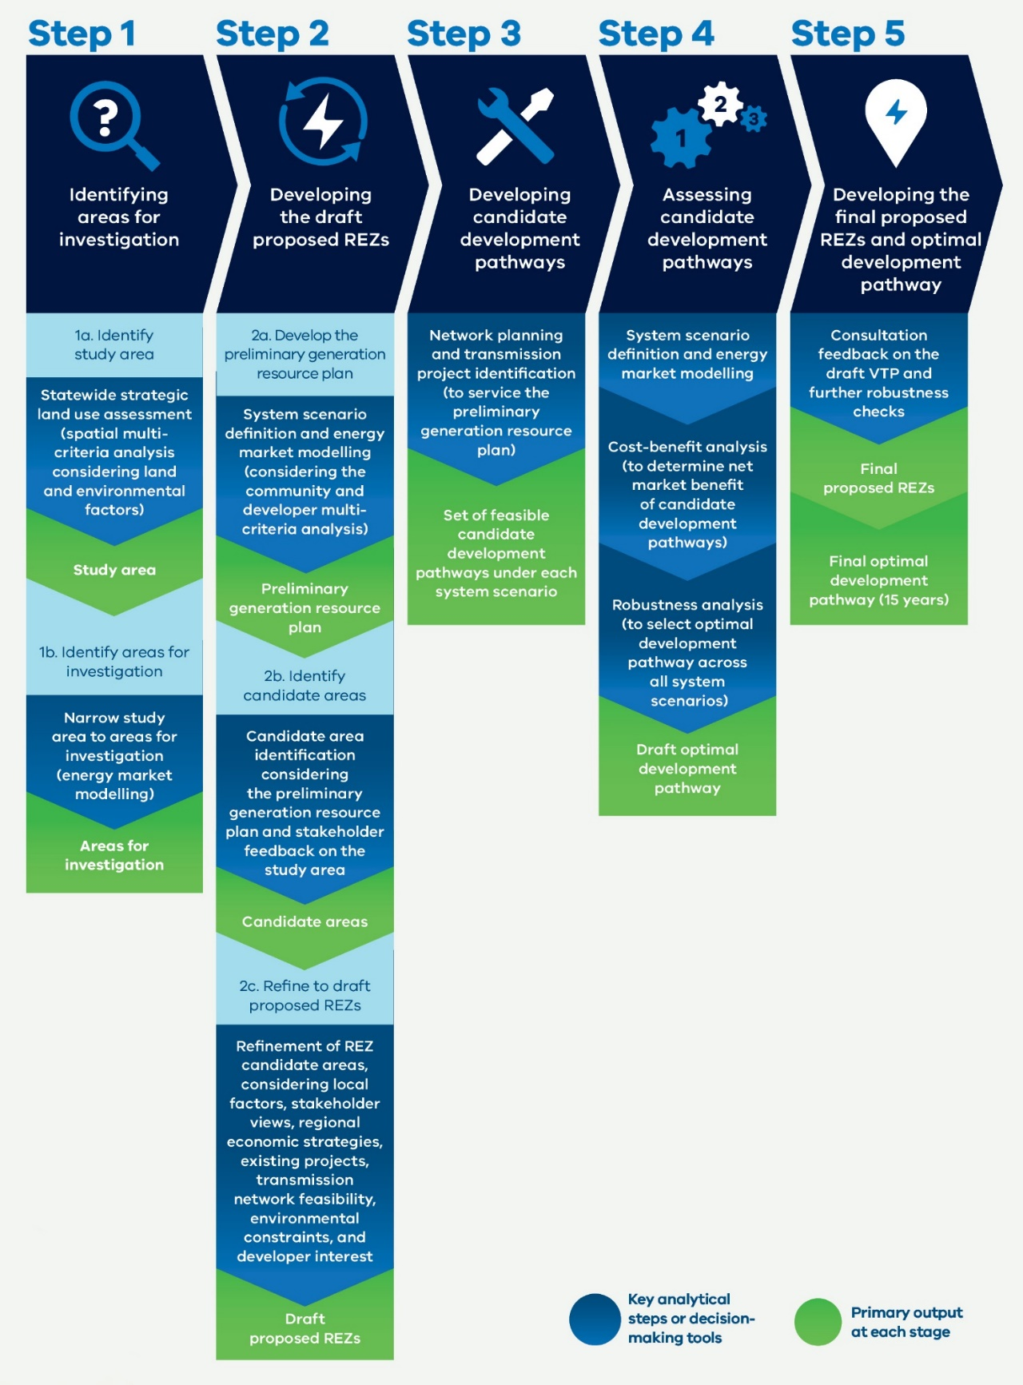

### What is energy market modelling?

Energy market modelling is a method used to simulate and forecast how energy markets will behave in response to future changes. We have used energy market modelling software called PLEXOS that is widely used in industry. It helps to analyse how different factors such as energy demand, consumer energy resource uptake, government policies and generator capital and operating costs can influence the supply and demand of energy, and consequently the types and capacity of energy generation development in the future. This type of modelling is crucial for understanding the future dynamics of the energy market and provides insights that assist stakeholders including policymakers, energy companies, and investors in strategic decision-making. These models enable us to forecast the impact different transmission options have on future developer investment and operational decisions. We use energy market modelling to produce the generation sector costs used in the cost-benefit analysis.

### What is power system modelling?

Power system modelling is a specialised approach used to represent the intricate workings of electrical power systems through computer simulation of generation, transmission lines, substations, and end-users of electricity.

By employing these simulations, we can predict how the system will behave under different conditions, assess reliability, plan upgrades, and integrate renewable energy sources. This process is crucial for ensuring that the power grid remains stable and efficient, minimising outages, and adapting to the evolving energy demands of Victoria. To do this, we have used a power system simulation for engineering (PSS/E) software, which is an advanced tool widely used within the industry for this purpose.

### Strategic land use assessment: Our new approach to identifying land use and landscape values to support the 2025 VTP

The strategic land use assessment is a new planning tool VicGrid is introducing to help identify areas to protect and avoid and areas that are more suitable to host renewable energy and transmission infrastructure.

It recognises important values many Victorians place on our land and landscape, including culture and heritage, livelihoods, ecosystems and biodiversity, food and fibre, recreation, strategic minerals and many others.

#### How the strategic land use assessment helped to shape the 2025 VTP

A statewide strategic land use assessment was used to identify the REZ study area published in the 2024 VTP Guidelines. This included a high-level, statewide mapping of land use constraints and opportunities for renewable energy development, using spatial datasets across a range of environmental, cultural heritage, social, land use (including agriculture) and engineering themes. The methodology and outputs are published in Appendix A of the 2024 VTP Guidelines.

The strategic land use assessment include the following themes:

* **Natural environment: biodiversity and water**. This theme included biodiversity and water systems.
* **Natural environment: community amenity**: This theme included significant areas.
* **Land use and social economic**. This theme included agricultural performance, earth resources and existing use.
* **Cultural heritage**. This theme included cultural heritage, Aboriginal heritage and historic heritage.
* **Natural hazard and climate change vulnerability.** This theme included flood risk, bushfire risk and sea level rise risk.

Figure 7: Strategic land use assessment themes

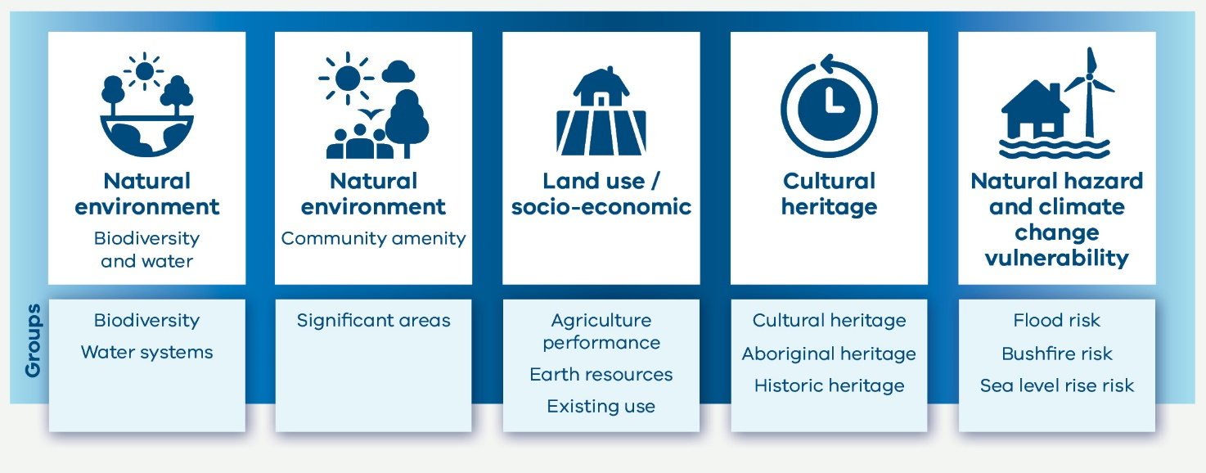

The strategic land use assessment was also used to support investigations at a regional level, as we narrowed the study area to draft proposed REZs. At this stage, the assessment was expanded to include some additional considerations based on feedback we received during consultation on the VTP Guidelines. These additional considerations included:

* Distinctive area landscapes: the following distinctive landscapes in the Victorian Planning Provisions were added as avoidance areas: Bass Coast, Bellarine Peninsula, Surf Coast, and Macedon Ranges.
* Major (named) rivers and inland lakes: these existing criteria were reclassified as avoidance areas.
* Significant landforms: extended to include additional areas of known high significance from publicly available data.
* Residential growth areas: additional residential growth areas identified during engagement with local governments.
* Agricultural compatibility: the relative compatibility (i.e., impact) of different farming practices with different renewable energy technologies, identified through engagement with agricultural groups and stakeholders. For more information about how farmland and agriculture has been considered, see Section 5.
* Aggregated housing density: indirect representation of dwelling density based on census housing count statistics.

It is important to note that this is a strategic assessment using available, authoritative data, mostly from public sources, and does not consider the full breadth of issues related to siting individual renewable energy projects, including property level constraints. Further inputs or updates to the strategic land use assessment may be included in future plans or mapping exercises.

# 3. The policy context for the Victorian Transmission Plan

The Victorian Transmission Plan (VTP) is designed to align with and complement other existing state and national policy processes.

## 3.1 Relationship with other statutory planning and environmental frameworks

The 2025 VTP sets out the proposed high-level plan for renewable energy zones (REZs) and future transmission investments. It does not replace statutory planning and environmental approval processes, including approvals and engagement requirements under the Planning and Environment Act 1987 and Environment Effects Act 1978.

The VTP process is intended to support these approval processes by incorporating community consultation and environmental, land use and social factors early in identifying the most suitable locations for transmission and generation infrastructure.

The Victorian Government is working to maximise the benefits of siting generation and storage projects within REZs. For project proponents, this means policy support and new network access arrangements that provide greater certainty about grid connection and reduce the risk of excessive curtailment. The new access arrangements in REZs will also set clear expectations about community engagement and benefits requirements, improving outcomes for local communities, stakeholders and project developers. For further details, see Section 9.

### Speeding up planning and environmental approval processes

The Development Facilitation Program is an accelerated planning assessment pathway for eligible projects to inject investment into the Victorian economy. Renewable energy is one of the priority sectors under the program. For more information, visit the [Department of Transport and Plannings web page](https://delwpvicgovau.sharepoint.com/sites/O365-GRP-XCS-VTIFEngagementPlanning/Shared%20Documents/VTIF%20Engagement%20Planning/Final%202025%20VTP/Collateral/Accessible%20versions/planning.vic.gov.au/planningapprovals/planning-enquiries-and-requests/%20development-facilitation-program).

The Victorian Government is also speeding up assessment review times for Environment Effects Statements (EESs), targeting a review time of no longer than 18 months. Making the EES system faster, cheaper and more predictable will encourage investment and shorten development time for renewable energy infrastructure and other projects important to the Victorian economy, while continuing to protect Victoria’s environment. For more information visit the [Victorian Government web page](https://delwpvicgovau.sharepoint.com/sites/O365-GRP-XCS-VTIFEngagementPlanning/Shared%20Documents/VTIF%20Engagement%20Planning/Final%202025%20VTP/Collateral/Accessible%20versions/vic.gov.au/action-two-cut-red-tape).

## 3.2 Integration with other planning processes, programs and projects

The 2025 VTP has factored in how existing Victorian and Commonwealth policies and programs will contribute to Victoria’s energy mix over the coming decade, along with other state and national electricity transmission and generation planning frameworks. Table 5 summarises how we consider these energy policy initiatives in the VTP.

In addition, we considered a range of broader Victorian Government strategies and initiatives when deciding the location of proposed REZs (for example, impacts on agriculture and irrigation, tourism and mineral resources, and delivering local benefits in line with the Victorian Energy Jobs Plan). For more detail, see Section 5.

Table 5: How the VTP considers other planning processes, programs and projects

|  |  |  |
| --- | --- | --- |
| **Processes, program or project** | **Description** | **How we’ve considered it in the VTP** |
| Australian Energy Market Operator’s (AEMO) Integrated System Plan (ISP) | The overarching plan for required investments in generation, storage and network infrastructure across the National Electricity Market. The ISP takes a 20-year development outlook and is published every 2 years. | We have broadly aligned our inputs, assumptions and scenarios with the 2024 ISP. This avoids duplication and allows the VTP to build on the extensive existing analysis and stakeholder consultation that has informed the ISP.  The sequencing of future ISPs and future VTPs will allow them to inform one another. This will help ensure consistency between national and Victorian transmission development, which remains critical for planning transmission developments across the National Electricity Market, including transmission interconnectors with other states.  Future ISPs will also consider REZs that have been identified through the VTP and declared in Victoria. |
| AEMO’s Victorian Annual Planning Report (VAPR) | Published annually in October, the VAPR assesses the adequacy of the existing Victorian transmission network to meet reliability and security requirements. It identifies limitations over the next 10 years that need to be addressed through network upgrades. | VAPR reports have informed the longlist of transmission projects we considered when creating the VTP candidate development pathways. For details, see Appendix A.  Roles and responsibilities for the VAPR are likely to change in the future to support alignment with the VTP. National Electricity (Victoria) Amendment (VicGrid Stage 2 Reform) Bill 2025 (the Bill) was introduced to Parliament in June 2025. The Bill proposes to transfer the existing transmission network planning functions, including the VAPR, from AEMO to VicGrid. Subject to passage, these reforms are expected to come into effect in late 2025. |
| Other AEMO planning documents | AEMO publishes several planning documents for East Coast electricity and gas markets, including the Electricity Statement of Opportunities (ESOO), Gas Statement of Opportunities (GSOO) and the Victorian Gas Planning Report. | As set out under the National Electricity (Victoria) Act 2005, VicGrid has had regard to these planning documents when performing REZ planning functions, including the preparation of the VTP. |
| Victorian Renewable Energy Targets (VRET) | Victoria has legislated targets to increase the share of electricity generated from renewables (see Section 1).  To support achieving these targets, the Victorian Government has implemented the VRET2 auction scheme. The VRET2 is designed to provide long-term contracts that create investment certainty for new energy generation projects. Six projects have been successful under VRET2. | The VTP scenarios and modelling are designed to be consistent with the achievement of Victoria’s renewable energy targets. The VTP also factors in the in service (Glenrowan Solar Farm) and anticipated capacity from the VRET2 projects (totalling more than 500 MW of additional generation capacity and 600 MWh of battery storage). |
| Offshore wind targets | The Victorian Government is working closely with the Australian Government to coordinate development of Victoria’s offshore wind industry.  To date, the Australian Government has declared 2 offshore wind areas off the coast of Victoria, which are separate to the onshore REZs that are proposed in the VTP. VicGrid is coordinating transmission infrastructure development for these areas. | All VTP scenarios factor in meeting Victoria’s offshore wind targets, and transmission requirements to connect the Australian Government’s declared offshore wind zones in the Southern Ocean and Gippsland have been incorporated.  This 2025 VTP includes a proposed shoreline REZ in Gippsland, which is needed to host onshore connection infrastructure linking offshore wind generation with Victoria’s onshore transmission network. For more information, see Section 7. |
| Capacity Investment Scheme (CIS) | To support its target to reach 82% renewable generation nationally by 2030, the Australian Government has committed to provide revenue underwriting for 32 GW of new renewable generation and storage capacity under the Capacity Investment Scheme (CIS). Project proponents in Victoria can bid for Australian Government revenue underwriting support in a series of competitive tenders from 2024 to 2027. | The Victorian and Australian Governments have agreed that at least 5.0 GW / 11 TWh of generation capacity and 1.7 GW / 6.8 GWh of storage capacity will be tendered under the CIS from 2024 to 2026, for delivery in Victoria by 2030. A maximum of 1.5 GW worth of solar projects will be awarded to ensure an overall mix of generation types that supports energy system reliability in Victoria.  The CIS target capacities have been factored in as an input to the VTP development process, helping to shape the sequencing of priority transmission projects over the next 5 years. |

### What is different between the 2024 ISP and the VTP?

One important distinction between the 2024 ISP and the VTP is how each refers to REZs. As part of the ISP process, AEMO has identified potential REZs across the National Electricity Market, including 6 in Victoria. These areas have been based largely on desktop studies considering a mix of resource potential, technical, and other engineering considerations. These are different to the Victorian REZs discussed in this document, which have a particular meaning under Victorian legislation.

The REZs discussed in the Victorian transmission planning process will ultimately be formally declared by the Victorian Minister for Energy following the 2025 VTP. The declared REZs will reflect more precise geographical areas refined through a process that includes partnering with Traditional Owners and First Peoples and engaging with landholders, communities and industry through several stages of consultation. Special community benefits arrangements will apply to declared REZs, as well as network access arrangements that increase certainty for investors. For more information, see Section 9.

#### Relationship with distribution network planning

The VTP and VAPR focus on planning for the high-voltage transmission network that is needed to transport electricity over long distances. The proposed REZs identified in this VTP are designed around connecting generators to this high-voltage transmission network.

Generators may also connect to the distribution network – the poles and wires that carry lowervoltage electricity to homes and businesses. However, planning for the distribution network is the responsibility of individual distribution network service providers (DNSPs) and is not part of the VTP process.

In Victoria there are 5 DNSPs that each cover different geographic areas: Ausnet, Citipower, Jemena, Powercor and United Energy. Planning information for distribution networks can be found in DNSPs’ Distribution Annual Planning Reports.

The relationship between electricity network planning documents in Victoria is summarised in Table 6.

The Victorian Transmission Investment Framework (VTIF) reforms propose that the responsibility for planning Victoria’s declared shared network, and all of AEMO’s associated declared network functions will be transferred to VicGrid from AEMO. Once implemented, this will end AEMO’s role as Victoria’s transmission network service provider. Legislation to enable this transfer was introduced to the Victorian Parliament in June 2025.

### Relationship between electricity planning documents in Victoria

Table 6: The relationship between electricity planning documents and who is responsible for what

| **Entity** | **AEMO** | **VicGrid** | **AEMO** | **AusNet, Citipower, Jemena, Powercor, United Energy** |
| --- | --- | --- | --- | --- |
| Document | Integrated System Plan | Victorian Transmission Plan | Victorian Annual Planning Report | Distribution Annual Planning Report |
| Coverage | Queensland, New South Wales, Victoria, South Australia, Tasmania | Victoria | Victoria | Victoria |
| Scope | National Electricity Market | REZ identification and associated transmission | Existing transmission network and other projects | Existing distribution network and other projects |
| Time horizon | 2- years and beyond | 15 and 25 years | 10 plys years | 5 plus year |

# 4. VicGrid is working with Traditional Owners and First Peoples

VicGrid is committed to recognising and respecting the rights of Traditional Owners and strengthening our relationships with First Peoples through planning renewable energy and transmission infrastructure.

Working together with Traditional Owners and First Peoples is critical to the successful delivery of the 2025 Victorian Transmission Plan (VTP) and future VTPs. Meaningful engagement will help us plan renewable energy generation and transmission in a way that minimises impacts to Country, protects cultural heritage and delivers tangible benefits.

We have received strong feedback through our engagement with Traditional Owners and First Peoples that has helped inform the 2025 VTP and will also inform our engagement approach moving forward.

Our work with Traditional Owners and First Peoples is only beginning with this first VTP. We will continue to build on the conversations started with the first VTP and embed processes through which Traditional Owners and First Peoples can shape decisions about subsequent VTPs and renewable energy zone (REZ) development.

## 4.1 Principles for working together

Our vision is to work together with Traditional Owners as respected partners in development and delivery of policy and projects. We are committed to doing this in a way that upholds transparency, mutual respect and shared benefits.

Traditional Owners are distinct rights holders to Country and Sea Country and their rights must be upheld as laid out under the *Charter of Human Rights and Responsibilities Act 2006*, the *Traditional Owner Settlement Act 2010*, *Aboriginal Heritage Act 2006* and *Native Title Act 1993* (Cth). VicGrid’s activities will be underpinned by respectful, long-term relationships with Traditional Owners that support the realisation of their goals and objectives for Country, Sea Country, and Culture. This is our unwavering commitment. VicGrid is also committed to respecting the outcomes of Treaty negotiations in Victoria.

**VicGrid’s engagement with Traditional Owners is guided by the following:**

* self-determination
* respectful and meaningful engagement
* transparency and accountability
* cultural respect and safety.

VicGrid is also committed to the Department of Energy, Environment and Climate Action’s Pupangarli Marnmarnepu ‘Owning Our Future’ Aboriginal Self- Determination Reform Strategy. With the support and leadership of Traditional Owners, we will together identify key considerations, concerns, benefits and opportunities to enable Traditional Owners to play an active role in Victoria’s energy transition. This includes through the development of this and future VTPs.

## 4.2 The role of Traditional Owners and First Peoples in shaping the VTP

Engagement with Traditional Owners and First Peoples has helped to shape the first VTP, REZ design and will be crucial to shape future VTPs.

We have heard about the need to better understand and protect cultural heritage across Victoria, the importance of sharing tangible economic benefits of renewable energy infrastructure projects, and the need for more meaningful and longer-term support for Traditional Owners to engage with future VTPs and REZ development. We have also heard about the ongoing impact to Country and Traditional Owners from existing development and the need to set clearer expectations for how developers engage with Traditional Owners.

We acknowledge we have more work to do to support meaningful participation of Traditional Owners and First Peoples in the development of future VTPs and REZs. It is our commitment to work closely with Traditional Owner groups to understand their priorities and aspirations, so that we can deliver on our vision to walk together.

Protecting cultural heritage as REZs are developed will continue to be a key focus for this work. The first phase of the VTP strategic land use assessment included only publicly available datasets for Aboriginal and historical cultural heritage. As such, the data relating to Aboriginal cultural heritage is limited and does not capture all known heritage values.

VicGrid has worked to establish relationships with formally recognised Traditional Owner corporations as well as the Victorian Aboriginal Heritage Council to supplement the publicly available data. To support this, we held 6 individual and group briefing sessions with formally recognised Traditional Owner corporations as part of consultation on the draft VTP Guidelines and study area during 2024. We held another 10 briefing sessions with formally recognised Traditional Owner groups as part of engagement on the draft 2025 VTP.

We will maintain ongoing conversations with both formally recognised and non-formally recognised Traditional Owner groups to design an appropriate process for incorporating further cultural heritage information into REZ development and subsequent VTPs. This work will align with principles of indigenous data sovereignty. We have heard how critical cultural heritage mapping is, and we are committed to making sure this process is Traditional Owner-led.

Integrating a self-determined approach to cultural heritage will be an ongoing process that we will continue to build on collaboratively throughout the lifecycle of the 2025 VTP, subsequent VTPs and through the process for declaring REZs. The development of REZs will require an ongoing dialogue with Traditional Owners to ensure we minimise impacts to Country and deliver real value.

As part of the Victorian Transmission Investment Framework (VTIF) reforms, VicGrid is working with Traditional Owners and the First Peoples Assembly of Victoria to deliver dedicated benefits for Traditional Owners affected by REZs and new transmission corridors. This process aims to give Traditional Owners control over how funds are spent to ensure they deliver economic empowerment and support self-determination. These dedicated benefits will be funded by mandatory contributions from transmission, generation and storage companies, and will be in addition to any discretionary payments by energy companies to Traditional Owners.

An important milestone in our engagement with Traditional Owner groups was a Traditional Owner Forum, held in September 2024. This was an opportunity to bring together Traditional Owners and representatives from VicGrid, the Department of Energy, Environment and Climate Action and other agencies, to openly discuss the renewable energy transition in Victoria and the impact on Victoria’s Traditional Owner communities. The conversations at this forum were integral in shaping VicGrid’s thinking about the impacts of renewable energy and transmission, the opportunities for the future and the real harms that must not be repeated.

Since the forum, we have continued conversations with formally recognised Traditional Owner groups, and this has informed our approach to developing the 2025 VTP and will continue to shape work to protect cultural values and develop a dedicated model for benefits for Traditional Owners.

This work does not end with the first VTP, and we are committed to building on this foundation to establish more meaningful partnerships with formally recognised Traditional Owners and First Peoples.

# 5. Engaging with communities and industry

Engaging with landholders, communities and industry, and seeking to partner with Traditional Owners and First Peoples, is critical to the successful delivery of the 2025 Victorian Transmission Plan (VTP) and future VTPs.

Our new approach to planning has at its core a commitment to give Traditional Owners, First Peoples, landholders, communities and regional stakeholders a real voice in the process. Meaningful engagement and incorporating community views earlier will help us plan renewable energy generation and transmission in a way that minimises impacts and delivers tangible benefits.

We have received extensive feedback through ongoing engagement as we have been developing the VTP.

Feedback has provided valuable insights to inform the 2025 VTP and proposed renewable energy zones (REZs). It will also continue to shape decisions about subsequent VTPs, REZ development and the development of the transmission projects identified in the VTP.

## 5.1 Our engagement model

We know that the process used to plan transmission under the previous framework has not adequately considered community, cultural, land use and environmental values early in the process.

Under the Victorian Transmission Investment Framework (VTIF), we seek to partner with Traditional Owners and First Peoples and to engage early and often with landholders and local communities. We are committed to listening to and considering all feedback, balanced against technical and financial requirements of planning future renewable energy infrastructure projects.

Our approach is guided by the Victorian Government’s Public Engagement Framework 2021-2025. The Public Engagement Framework focuses on meaningful, principled and inclusive public engagement, and aligns with the best practice approaches set out by the International Association of Public Participation (IAP2). The framework embodies 6 principles that guide our engagement with First Peoples, communities and industry:

* Meaningful: The process of public engagement is genuine and informs the final decisions.
* Inclusive: The engagement is respectful, inclusive and accessible.
* Transparent: The engagement is clear and open about what the public can and cannot influence.
* Informed: The engagement provides relevant and timely information to the public.
* Accountable: The engagement is high quality and responsive to the public.
* Valuable: The engagement creates value for the community and government. This can include social, economic and environmental values.

## 5.2 Engaging with local communities to develop the Victorian Transmission Plan

We are using a place-based approach to incorporate early, deeper and ongoing community engagement in the planning process. Our goal is to ensure regions and communities have the agency and opportunity to meaningfully participate in shaping the VTP, REZs and transmission projects, and share in the benefits of the energy transition. To achieve this, VicGrid’s community engagement model has 6 objectives:

* To raise community awareness and understanding of REZs and why large-scale transmission is critical to the energy transition.
* To facilitate community input into key stages of the planning and investment lifecycle for transmission projects, including through the strategic land use assessment and consultation on the 2025 VTP.
* To enable First Peoples to be resourced with the capacity and capability to participate in REZ discussions and make decisions.
* To support the delivery of community benefits to ensure impacted host communities and First Peoples directly benefit.
* To foster government-industry-community partnerships to unlock regional development opportunities in line with local aspirations and build local adaptive capacities.
* To facilitate a cross-sectoral and multi-level governance response to issues and provide an escalation point for resolving issues throughout the end-to-end planning and development process.
* To work towards these objectives, we are engaging with regional and rural communities and stakeholders using many channels.

VicGrid started engagement on Victoria’s transmission planning in November 2023 with the Renewable Energy Planning Survey, which was designed to explore community values and concerns related to areas considered more or less appropriate for REZ development. The survey was open from 17 November to 16 February 2024. Over 2,015 survey responses and 2,465 pindrops on the map highlighted the significance communities place on protecting Victoria’s natural environment, parks, water systems (rivers and lakes), agricultural land and biodiversity. The feedback informed the process to identify the REZ study area which formed the basis for the next round of consultation.

On 22 July 2024, VicGrid released the draft VTP Guidelines and REZ study area map for formal consultation to collect feedback to help narrow the study area to draft proposed REZs. Between 22 July and 30 September 2024, we received over 1,300 feedback forms, more than 170 submissions, and held conversations with more than 450 community members. Community feedback emphasised the importance of minimising land use, cultural, and environmental impacts, and avoiding overdevelopment to minimise cumulative impacts.

We released the draft VTP on 19 May 2025, commencing a 6-week community and industry consultation period between 19 May and 24 June 2025. The purpose of this engagement was to collect feedback on the draft VTP and the draft proposed REZs. We received more than 260 feedback forms and 460 submissions. We also conducted more than 100 community briefings and held conversations with more than 400 community members during engagement events across regional Victoria.

We invited Victorians to provide feedback on the draft proposed REZs, draft proposed Gippsland Shoreline REZ, and proposed transmission projects. Community feedback emphasised the importance of minimising impacts on regions during the transition, exploring alternatives to overhead high-voltage transmission lines, ensuring that engagement is transparent and genuine, and protecting farmland. People shared their feedback on REZ boundaries to accommodate or avoid particular areas due to concerns around land use impacts and features or areas of local importance.

### Engagement results overview: Community and local government

Responses to the feedback forms, submissions, meetings, emails, contact centre enquiries and feedback from community drop-in sessions revealed key themes. These themes generally align with what we heard during the engagement for the draft VTP Guidelines, with some emphasised more heavily than previous engagements.

* Impact on the regions: We heard concerns about the impost on regional areas to service metropolitan energy demands, community division linked to developer behaviour, and concerns about industrialisation of regions. There was also feedback about compounding stresses on communities from multiple projects and plans across renewable energy and beyond.
* Transmission planning: We heard feedback on experiences with current transmission projects, such as Western Renewables Link (WRL) and Victorian to New South Wales Interconnector West (VNI West) including frustration about unclear route planning, inadequate consultation and the perceived cost prioritisation over long-term community and environmental wellbeing. This included concerns about visual impact and disruption of farming activities, with many advocating for underground transmission.
* Engagement feedback: We heard feedback about the accessibility of the VTP, the choice of engagement channels, awareness of engagement and concerns about the impact feedback would have on the VTP.
* Agriculture and land use: Respondents stressed the need to protect farmland and raised concerns about impacts to farming activities, biosecurity risks and productivity. There was an underlying sentiment that farms are for food and fibre production, not for the production of energy. Efforts to avoid farmland in the design of the draft proposed REZs were also acknowledged.
* Refinement of study area: Feedback was received suggesting specific changes to REZs including requests to extend or shift REZ boundaries. These requests were often related to geographical features or areas of local importance. There was also feedback requesting boundaries be increased to allow for greater participation.
* Energy source: Feedback was received about different types of energy sources and generation technologies.
* VTP feedback: Respondents provided feedback on the VTP, expressing both support for and rejection of the plan as a whole.
* Biodiversity and natural environment: We heard concerns about impacts on biodiversity and water systems including endangered species’ habitats.
* Regional economic development: There was both optimism for community benefits and regional development opportunities such as job creation and infrastructure investment, and concerns about uneven benefit distribution and the impact on local infrastructure such as roads, housing and local services.
* Natural hazard vulnerability: Feedback highlighted concerns about infrastructure development in flood and bushfire-prone areas. This included concerns about the impact on firefighting and the impact of infrastructure on flood waters.

This feedback provided valuable insights into regional concerns, values and priorities as well as location-specific risks and factors related to topography, wildlife and infrastructure. For more information about engagement with communities and local governments, read the Draft 2025 Victorian Transmission Plan Final Engagement Report – What We Heard at [engage.vic.gov.au/victransmissionplan](https://engage.vic.gov.au/victransmissionplan)

This information was considered, alongside other modelling inputs, to finalise the proposed REZs and proposed transmission projects included in the 2025 VTP. Communities will have further opportunities to participate in place-based engagement during the REZ declaration process, REZ design, transmission project development and future VTPs. For more details, see Section 6.3.

## 5.3 Energy industry engagement

The energy industry continues to play a crucial role in the transmission planning process. VicGrid is committed to ensuring industry perspectives, expertise and knowledge are considered. Industry stakeholders include developers of generation and storage projects, transmission owners and operators, in service generators and retailers, market and regulatory bodies, construction companies, investors and all businesses involved in the supply chain for new transmission infrastructure.

During previous engagement on the VTIF, industry stakeholders expressed support for Victoria’s new approach to transmission planning and its aim to deliver better engagement and benefits for Traditional Owners and communities. Feedback also emphasised the importance of energy affordability and alignment with national and other state planning processes.

Engagement on the VTP Guidelines included briefings with peak bodies, key stakeholders, and an industry webinar. VicGrid also engaged renewable energy developers through a survey to understand their plans for proposed new projects in Victoria. Feedback highlighted the need for holistic engagement on related policy development, robust scenario planning, a flexible VTP process and modelling suggestions.

For the draft VTP, VicGrid expanded industry engagement efforts to include briefings and individual meetings with renewable energy developers to discuss the potential impact of the draft VTP on pipeline projects. This was in addition to a project status survey and an industry webinar. We received 79 submissions from industry on the draft VTP and 70 responses to the project status survey.

Industry feedback highlighted a need for greater clarity and alignment on access and connections policies, underlying inputs and assumptions and transmission planning delivery timelines and coordination.

### Engagement results overview: Energy industry

Industry generally supported the strategic intent of the VTP and was supportive of the collaborative approach to engagement. However, there were several suggestions for improvement. The analysis of feedback forms, submissions, and industry briefings and meetings revealed several interrelated themes. These themes are summarised below.

* Greater clarity is needed on access and connections: There was considerable feedback requesting clarity on access and connections policies, particularly on how these policies relate to pipeline projects and transitional arrangements. This feedback emphasised the impact on developer confidence.
* Inputs and assumptions: A large body of feedback focused on the underlying inputs and assumptions of the draft VTP. Concerns were raised that modelled generation for onshore renewable energy was too low and did not sufficiently allow for uncertainty, storage needs, gas price projections, the uptake of distributed energy resources and electricity demand forecasts, especially concerning data centres. There was also feedback regarding underlying cost assumptions.
* Transmission project costs: There was feedback regarding underlying cost estimates for the projects that VicGrid was proposing. Stakeholders were concerned that the cost estimates in the draft VTP underestimated the cost of projects.
* Timely delivery of transmission infrastructure: Feedback on the optimal development pathway and transmission projects included concerns about the timely delivery and coordination of the transmission infrastructure. Participants shared specific feedback about program prioritisation, as well as taking distribution networks into account.
* Storage strategy and system strength: We heard concerns that the VTP underestimates the need for storage and lacks clarity on long-duration storage, grid-forming batteries and system strength improvements.
* REZ design, capacity, boundaries and flexibility: Feedback highlighted concerns about the REZ boundaries and hosting capacities being too restrictive. There was also concern that modelled generation was too low if used as caps, which may deter investment and hinder advanced developments. In response to these concerns, there were calls for changes to REZ designs.
* Engagement feedback: We heard concerns that the timelines for engagement on the draft VTP and related policies were too tight, fearing that this could affect the quality of the final outcomes.
* Regulatory complexity: We heard many suggestions to streamline planning and environmental approvals for projects within REZs to enhance the value proposition of REZ development.

Industry feedback provided valuable insights that have shaped the development of the 2025 VTP and supporting access and connections arrangements. For more details about industry feedback that has shaped the VTP, download the Draft 2025 Victorian Transmission Plan Final Engagement Report – What We Heard at [VicGrid's Engage Victoria web page](https://engage.vic.gov.au/victransmissionplan).

## 5.4 Agriculture and other industry engagement

VicGrid continues to recognise the crucial contribution the agriculture sector makes to Victoria’s economy, regional and rural communities, food security and way of life. We are committed to engaging closely with landholders and agriculture industry groups to make sure they have a voice in the planning of energy infrastructure.

In developing the VTP Guidelines and 2025 VTP, we have engaged with agriculture industry stakeholders to understand the potential impacts of development on farming systems and agricultural operations. Engagement included briefings with peak bodies and meetings with landholder groups, as well as submissions from individuals and organisations focusing on the value and importance of farmland. We have also engaged with groups and peak bodies representing other industries, including minerals, forestry, manufacturing and education.

Feedback from these stakeholders on the draft VTP focused on minimising the social, economic, environmental impacts of transmission and renewable energy development on agricultural land and rural communities. There was also a call for greater investment in an integrated, agriculture-sensitive engagement approach, to ensure that local voices continue to shape the transmission planning process. For more detail about agriculture sector feedback that has shaped the VTP, download the Draft 2025 Victorian Transmission Plan Final Engagement Report – What We Heard at [VicGrid's Engage Victoria web page](https://engage.vic.gov.au/victransmissionplan).

To support VicGrid’s work developing the VTP and identifying suitable areas for potential renewable energy zones, VicGrid commissioned agricultural consultancy RMCG to determine a consistent, evidence-based method to identify relative compatibility of different agriculture land uses with colocated renewable energy infrastructure. In undertaking this work, RMCG interviewed representatives from Victorian and national agricultural groups representing grains, livestock grazing, cropping, dairy, forestry, nursery and horticulture industries. You can download a copy of the Agriculture – Renewable Energy Compatibility Study prepared by RMCG at our [Engage Victoria document library](https://engage.vic.gov.au/project/victransmissionplan/page/document-library).

# Part B: Our plan for renewable energy zones and transmission projects

# 6. Areas we are proposing for future renewable energy generation development

The 2025 Victorian Transmission Plan (VTP) sets out proposed renewable energy zones (REZs), areas we have identified as most suitable to host new renewable generation project development over the next 15 years.

We have identified 6 proposed REZs in Victoria to support onshore renewable projects, such as wind and solar projects.

Their size and location are designed to accommodate Victoria’s requirements for renewable energy generation as part of our state’s overall energy mix from 2025 to 2040.

In total, the proposed REZs cover approximately 7.9% of Victoria’s land area (see Figure 9). On average statewide, we need about 9.1% of the land area of REZs to host wind and solar projects to meet the expected renewable energy capacity modelled for scenario 1 in 2040. However, only a fraction of the land within project sites will be needed for infrastructure. For example, on a typical wind farm, the turbines themselves along with access roads and other infrastructure occupy only about 2% of the project site. Figures will vary by individual REZs and projects.

To identify locations for the proposed REZs, we investigated parts of Victoria to understand and balance factors including existing land uses, the environment, publicly available cultural heritage information, generator interest, renewable energy resource potential such as wind and sun, technical requirements for transmission infrastructure, regional development opportunities, and costs to energy consumers. We also considered feedback received from communities and industry during consultation on the REZ study area in 2024 and the draft VTP (including the draft proposed REZs) over May and June 2025.

The overall size of REZs is an important consideration. There is a trade-off between smaller zones with more concentrated infrastructure development, and larger zones that affect a wider area but result in less concentrated development within each zone. Based on feedback received and our assessment of different land use considerations, we have kept the area covered by the proposed renewable energy zones as small as possible (noting that some of the proposed REZs have increased in size from those presented in the draft VTP).

**What will the REZs mean for me?**

Communities in REZs will see increased development of renewable generation and storage infrastructure over time. Importantly, only some of the land within a REZ will be needed for new renewable projects.

Landholders can choose whether or not to host new wind, solar or battery projects on their land. Developers of generation projects like wind and solar farms, and batteries, will need to negotiate with landholders for the ability to build projects on their property.

REZs will deliver benefits for landholders, Traditional Owners, neighbours and communities, through channels such as job creation, infrastructure investment, and regional development. New REZ Community Energy Funds will invest in the region, through projects and initiatives that create economic benefits and regional development opportunities. More information can be found in Section 9. Traditional Owners can expect ongoing dialogue with VicGrid to ensure impacts to Country are minimised and expectations set for project proponents to engage with and share benefits with Traditional Owners. We will also continue to work with Traditional Owners to ensure further cultural heritage information is incorporated into development of REZs, transmission projects and future VTPs.

The REZ locations harness the state’s strong winds and solar energy while minimising environmental and social impacts to help build community understanding and support for development. Together with new access arrangements, REZs are designed to provide confidence that developers can supply energy to the market.

## 6.1 Victoria’s future energy mix informed our REZs

An important step in identifying the proposed REZs was to consider how much additional renewable generation will be needed to meet Victoria’s future energy needs, and by when. To do this, we analysed the mix of technologies that would best meet future energy demand and Victorian policy targets from 2025 to 2040. We considered factors such as:

* capital and operating costs and their impact on consumer energy bills
* land use constraints
* community preferences and cumulative impacts of development
* generator and developer interest
* regional economic development opportunities
* technical feasibility
* energy reliability.

For more details on the methodology, see Section 2.

The resulting generation mix is presented in Figure 8. Under our plan, onshore wind and solar generation will have a key role in Victoria’s overall generation mix over the next 15 years, delivering approximately 12.8 GW or 40% of total grid-supplied generation capacity by 2040 and 32.7 TWh or 48% of total grid generation output. Percentages are calculated based on the share of grid-scale generation capacity or output in the 2040 financial year. This includes wind (onshore and offshore), utility-scale solar, gas and hydro projects that service operational demand. This means we are planning for 5.7 GW of new onshore wind and 2.3 GW of new utility-scale solar to connect to the grid. Offshore wind will also be important, contributing 9 GW or 28% of grid-supplied generation capacity by 2040 and 29.2 TWh or 43% of grid-supplied generation output.

This generation mix is designed for scenario 1 (see Section 2 for more information on how we used scenarios to develop the VTP). We also considered generation needs for scenario 2 and 3, which are presented in Appendix B. In scenario 2, Victoria’s energy needs are greater, requiring larger future investments in onshore wind, solar and storage infrastructure.

The outcomes of generation modelling are inherently uncertain, reflecting the variety of possible economic futures that could eventuate and would alter electricity demand and supply. The generation mix that ultimately will be built will have some differences compared with the mix that has been modelled. The actual generation and storage build will be influenced by several factors, including electricity demand (such as from new data centres) and supply (including the development or non-development of interstate generation), transmission project timing, wind and solar resource quality, the economics of particular generation and storage technologies, and permitting, approvals and land use constraints. VicGrid’s plans are intentionally developed to accommodate a range of futures.

While renewable generation in REZs will have a leading role, offshore wind, storage and backup generation technologies, and energy imported from other states will all help to maintain a reliable and affordable electricity supply in the coming years. The growth of consumer energy resources such as rooftop solar and batteries may also help to limit the amount of energy that needs to be supplied from the transmission system.

### Additional renewable generation capacity in our plan

By 2040, we are planning for:

* 5.7 to 9.6 GW of new onshore wind
* 9 GW of new offshore wind
* 2.3 to 8.9 GW of new utility-scale solar
* 4.8 to 7.7 GW of new short and long duration (utility) storage capacity.

Note, these figures include new capacity from already committed projects across Victoria and the additional new generation capacity that we are planning for by 2040. The ranges shown represent the differences between the generation modelled under different planning scenarios. These modelled figures are not caps on the generation that will actually be built. VicGrid’s proposed new access regime will set caps for generation in each REZ. For more information about the proposed new access regime, see Section 9.2.

### The role of other technologies in supporting wind and solar generation

Several other technologies will be needed over the next 15 years to complement renewables and ensure we maintain a reliable and secure energy mix:

#### Energy firming technologies

Batteries and longduration storage such as pumped hydro will have an important role in helping balance variable renewable output from wind and solar to meet demand – known as firming. By 2035, our projected energy mix under scenario 1 includes a total of 7.5 GW of storage capacity, including 5.0 GW of utility short and long-duration storage and 2.5 GW of distributed storage. By 2040, storage capacity increases to 9.8 GW, including 5.1 GW of utility short and long duration storage and 4.7 GW of distributed storage, supported by 3.1 GW of gas-fired power generation to meet periods of peak demand or low renewables output.

#### Interconnectors

Under our plan, interconnectors such as Victoria to New South Wales Interconnector West (VNI West) and Marinus Link will provide Victoria access to additional diverse renewables and firming capacity from other National Electricity Market (NEM) regions.

#### Consumer energy resources

Household uptake of technologies such as rooftop solar and batteries will help limit the amount of new gridscale generation and storage that’s needed. Our projected generation mix for Victoria’s grid factors in growth in consumer energy resources in line with the Australian Energy Market Operator’s scenarios, which sees up to 16 GW in distributed solar by 2040.

Figure 8: Victoria’s future energy grid under scenario 1

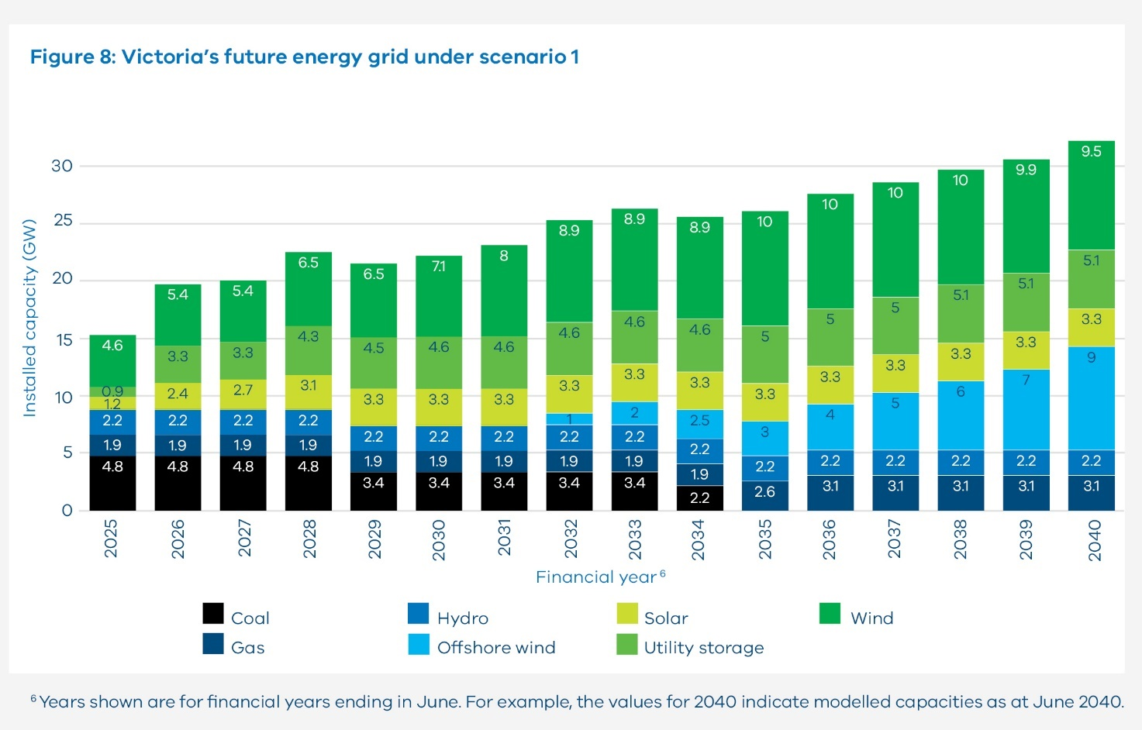

The table below details Victoria's future energy grid under scenario 1. It details the installed capacity (GW) of renewable energy technology types each year between 2025 and 2040.

Figure 8: Table description of Victoria’s future energy grid under scenario 1

|  |  |  |  |  |  |  |  |
| --- | --- | --- | --- | --- | --- | --- | --- |
| **Financial year** | **Coal** | **Gas** | **Hydro** | **Offshore wind** | **Solar** | **Utility storage** | **Wind** |
| 2025 | 4.8 | 1.9 | 2.2 | 0 | 1.2 | 0.9 | 4.6 |
| 2026 | 4.8 | 1.9 | 2.2 | 0 | 2.4 | 3.3 | 5.4 |
| 2027 | 4.8 | 1.9 | 2.2 | 0 | 2.7 | 3.3 | 5.4 |
| 2028 | 4.8 | 1.9 | 2.2 | 0 | 3.1 | 4.3 | 6.5 |
| 2029 | 3.4 | 1.9 | 2.2 | 0 | 3.3 | 4.5 | 6.5 |
| 2030 | 3.4 | 1.9 | 2.2 | 0 | 3.3 | 4.6 | 7.1 |
| 2031 | 3.4 | 1.9 | 2.2 | 0 | 3.3 | 4.6 | 8 |
| 2032 | 3.4 | 1.9 | 2.2 | 1 | 3.3 | 4.6 | 8.9 |
| 2033 | 3.4 | 1.9 | 2.2 | 2 | 3.3 | 4.6 | 8.9 |
| 2034 | 2.2 | 1.9 | 2.2 | 2.5 | 3.3 | 4.6 | 8.9 |
| 2035 | 0 | 2.6 | 2.2 | 3 | 3.3 | 5 | 10 |
| 2036 | 0 | 3.1 | 2.2 | 4 | 3.3 | 5 | 10 |
| 2037 | 0 | 3.1 | 2.2 | 5 | 3.3 | 5 | 10 |
| 2038 | 0 | 3.1 | 2.2 | 6 | 3.3 | 5.1 | 10 |
| 2039 | 0 | 3.1 | 2.2 | 7 | 3.3 | 5.1 | 9.9 |
| 2040 | 0 | 3.1 | 2.2 | 9 | 3.3 | 5.1 | 9.5 |

Years shown are for financial years ending in June. For example, the values for 2040 indicate modelled capacities as at June 2040.

### Managing periods of low renewable generation

Wind and solar generation are inherently variable, and it is not uncommon to experience periods when there is little wind and sunshine. This is most likely in winter, when energy demand is also high to provide heating during cold weather.

The risk of limited periods of low renewable generation is an important planning consideration for modern electricity networks. In Victoria, this risk will become more pronounced in the late 2030s, following the closure of coal-fired power plants. There are well-documented examples of periods such as these in Australia, Europe and the United States. VicGrid will seek to learn from these examples as we plan for the future.

The VTP considers the risks of periods of low renewable generation in its approach to energy market modelling. As noted above, our modelled energy mixes for the 3 VTP scenarios include a significant share of batteries and new longduration storage technologies that will help to address seasonal variability in renewable generation. Interconnectors providing energy from other states will also help smooth Victoria’s energy supply, along with a small but important role for gas-fired power generation to provide critical power supply when it is needed, and to meet periods of peak demand.

Transmission upgrades within the Victorian network also provide an important solution, helping ensure energy generated in different regions can be transferred to other locations across the state to meet demand when weather conditions vary.

### Renewable energy zones and critical minerals deposits

The Victorian Government supports energy infrastructure development in key regional areas. Some of these areas are also identified as having high potential for critical mineral deposits, particularly in north-west and central Victoria. In developing the VTP, VicGrid has created proposed REZ boundaries that aim to avoid areas known to have the most potential for critical minerals extraction. To ensure adaptability to future project opportunities, the VTP also provides for review of REZ boundaries that will reduce the likelihood of overlaps with critical minerals deposits identified from Victoria’s geoscience knowledge and data. There are multiple known occurrences of critical and strategic minerals and metals in the proposed Western, Central Highlands, North West and Central North REZs, along with potentially undiscovered deposits. Victoria is highly likely to hold other significant, yet underexplored critical minerals.

Where a proposed or future REZ overlaps with an area of critical mineral deposits, authorised exploration, extraction, and production derived from that area are not excluded or limited by the existence of the REZ, noting that critical mineral deposits occur in fixed locations that formed over extended geological periods. The type and nature of mineral deposits, and implications for limiting or preventing access, should be considered during the approval of above-ground land uses.

Released in December 2024, the Resources Victoria Critical Minerals Roadmap (Roadmap) outlines actions to establish a responsible and sustainable critical minerals industry in Victoria. It highlights the strategic importance of minerals, especially in the northwest of the State. As part of the Roadmap, a land use coexistence framework will be developed to balance energy, agriculture, and resource priorities and to support coordinated and transparent decision making. For more information, visit [Resources Victoria web page](https://resources.vic.gov.au/critical-minerals).

#### Declared Irrigation Districts

There has been over $2 billion in investment in modernising the irrigation infrastructure in Victorian declared irrigation districts. This supports the ongoing productivity and viability of irrigation districts and it is important to maximise these districts for agricultural production. The Victorian government has released the Solar Energy Facilities Design and Development Guideline which outlines a process to facilitate the appropriate siting of solar energy facilities in declared irrigation districts. For more information visit [the Department of Transport and Planning's web page](https://www.planning.vic.gov.au/guides-and-resources/guides/all-guides/renewable-energy-facilities/solar-energy-facilities).

## 6.1 What are the proposed REZs?

The 6 proposed REZs are areas we have identified as being most suitable to host the new onshore wind and solar generation Victoria will need over the next 15 years.

They are the Central Highlands, Central North, Gippsland, North West, South West, and Western proposed REZs. See Figure 9. Details of each are presented in the following pages. The South West REZ, Western REZ and Central North REZ are each comprised of 2 separate sections.

Details about the proposed Gippsland Shoreline REZ are presented in Section 7. It is designed to coordinate the onshore connection infrastructure of offshore wind generators and is separate from the 6 proposed REZs for onshore generation discussed in this section.

A wide range of factors were considered in determining the proposed size and location of each of the 6 proposed REZs. We conducted energy market modelling to understand the suitability of different locations from an economic and technical perspective. We considered sensitive land uses and landscape values including biodiversity and environmental constraints, cultural heritage, agriculture, natural hazards and community values.

We also sought to balance engagement feedback and regional economic development priorities with inputs on the location of current and future generation projects and transmission infrastructure.

We acknowledge that we have considered only publicly available datasets for Aboriginal and historical cultural heritage supplemented by early feedback from formally recognised Traditional Owners. We know we have more work to do to support meaningful participation of Traditional Owners and First Peoples in the development of REZs. Protecting cultural heritage as REZs are developed will continue to be a key focus for this work.

We also acknowledge the potential for renewable energy facilities such as wind turbines, wind monitoring towers, solar farms and associated transmission infrastructure to interact with a wide range of aviation activities that may be conducted in their vicinity. VicGrid will work with stakeholders on ways to manage these as REZs are developed. This could include setting expectations that developers consider potential aviation impacts and consult with relevant stakeholders in the planning stage of generation projects.

Table 7 summarises the different factors we considered in identifying the proposed REZs, and Section 2 provides further detail on our methodology

Table 7: Factors we considered in determining the location of proposed REZs

|  |  |
| --- | --- |
| Processes, program or project | Description |
| Agricultural land use | We considered farmland at a statewide and regional level, taking into account data including farmgate output, soil quality, rainfall, access to irrigation water and farm infrastructure investment. We also considered the compatibility of different types of farming with the co-location of renewable energy infrastructure. For more information, see Section 5. |
| Land use and landscape values | Where possible, we avoided areas such as national parks, world heritage sites, Ramsar wetlands, residential areas and other areas of significance. We sought to minimise impacts to areas of high biodiversity value, and prioritised areas with relatively fewer land use constraints. |
| Generation potential | We considered areas that have strong potential for renewable energy investment, based on factors like wind and solar resource quality, proximity to transmission, sensitive land values, terrain type and market interest demonstrated by projects already in development. |
| Modelled generation build | We considered the results of energy market modelling that identifies which technologies are needed (including storage), how much capacity to build, and when and where this capacity should be built. |
| Transmission network requirements | We preferenced areas that are close to the existing transmission network and assessed what additional or upgraded transmission infrastructure would be needed to accommodate additional renewable energy generation in different areas. |
| Engagement feedback | We considered feedback from communities, industry and local governments. This includes feedback received in connection with the draft proposed REZs presented in the draft VTP. For more information, see Sections 5 and 6. |
| Partnering with Traditional Owners and First Peoples | Where possible, we sought to avoid known areas of high cultural significance or sensitivity based on publicly available Aboriginal cultural heritage information and prioritise areas with fewer known constraints. We acknowledge that consideration of Aboriginal cultural values can only occur through engagement with the relevant Aboriginal cultural knowledge holders. Whilst we have had some conversations with Traditional Owner representative bodies, we have not yet consulted with Traditional Owners in this process. VicGrid is seeking to partner with Traditional Owners and First Peoples to supplement limited public datasets on Aboriginal cultural heritage and integrate a self-determined approach to protecting cultural heritage during REZ design and development. For more information, see Section 4. |
| Regional development considerations | We considered the readiness of different regional economies to host REZs, taking into account existing housing, social and transport infrastructure in each area as well as local workforce profiles. We sought to prioritise areas where there was strong alignment with regional economic development strategies. |

Figure 9: We have identified 6 proposed renewable energy zones across Victoria for onshore renewable energy and a shoreline REZ to coordinate offshore wind connections

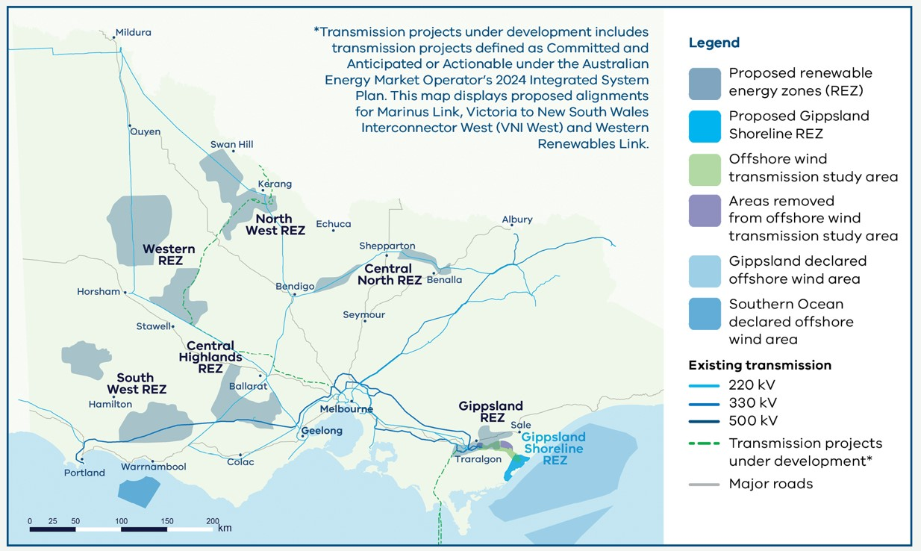

Figure 10: Proposed renewable energy zones and Registered Aboriginal Party boundaries

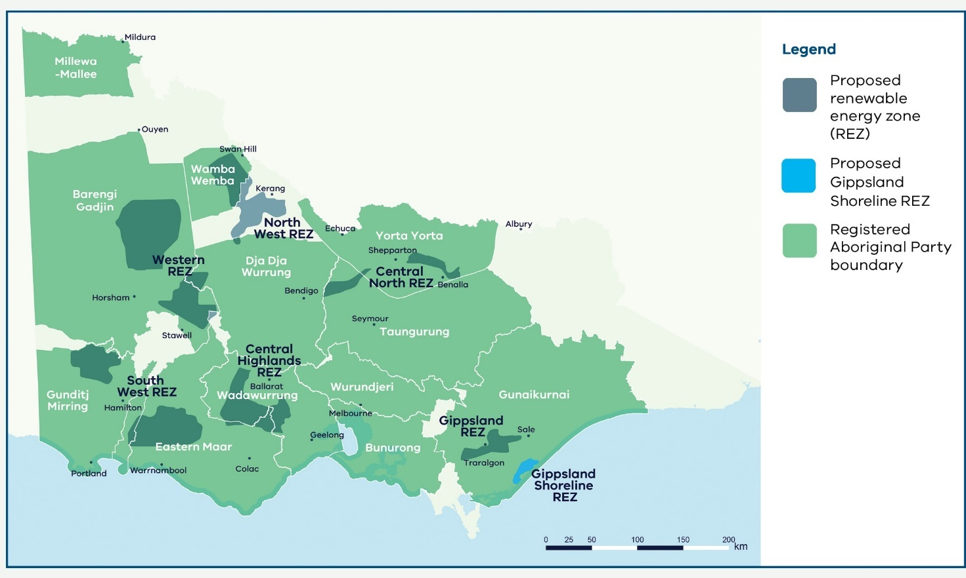

**Figure 10 disclaimer:** The Registered Aboriginal Party boundaries shown in the Figure 10 are a computer representation. The boundaries show the general vicinity of land and waters subject to the Native Title Act 1993 (Cth) and Traditional Settlement Act 2010 as at the time of publication and could conceivably change. For more details, please see full disclaimer on page 3.

The 6 proposed REZs cover approximately 1.8 million hectares, which equates to 7.9% of Victoria’s total land area of 22.8 million hectares. In comparison, the potential REZs identified in the Australian Energy Market Operator’s 2024 Integrated System Plan (AEMO ISP) would cover approximately 8.5 million hectares, or 37% of Victoria’s total land area.

Under scenario 1, about 9.1% of the combined area of the 6 proposed REZs would host wind and solar generation in 2040. Those land parcels will not be fully occupied. In fact, approximately 0.04% of Victoria’s total land area is required for the physical infrastructure such as wind turbines, solar panels, access roads and others. The land area required for physical infrastructure is an estimate based on 2% for an onshore wind farm and 75% for a solar farm. The figures are consistent with a review of studies on land impacts of renewable energy generation in Australia and overseas. VicGrid acknowledges that these estimates are evolving as technology and construction techniques change over time. The estimated area of the land parcels in which onshore renewables will be hosted by 2040 (both inside and outside a REZ) is approximately 230,000 hectares, or about 1% of Victoria’s total land area.

Figure 11: How much land is needed for renewable generation?

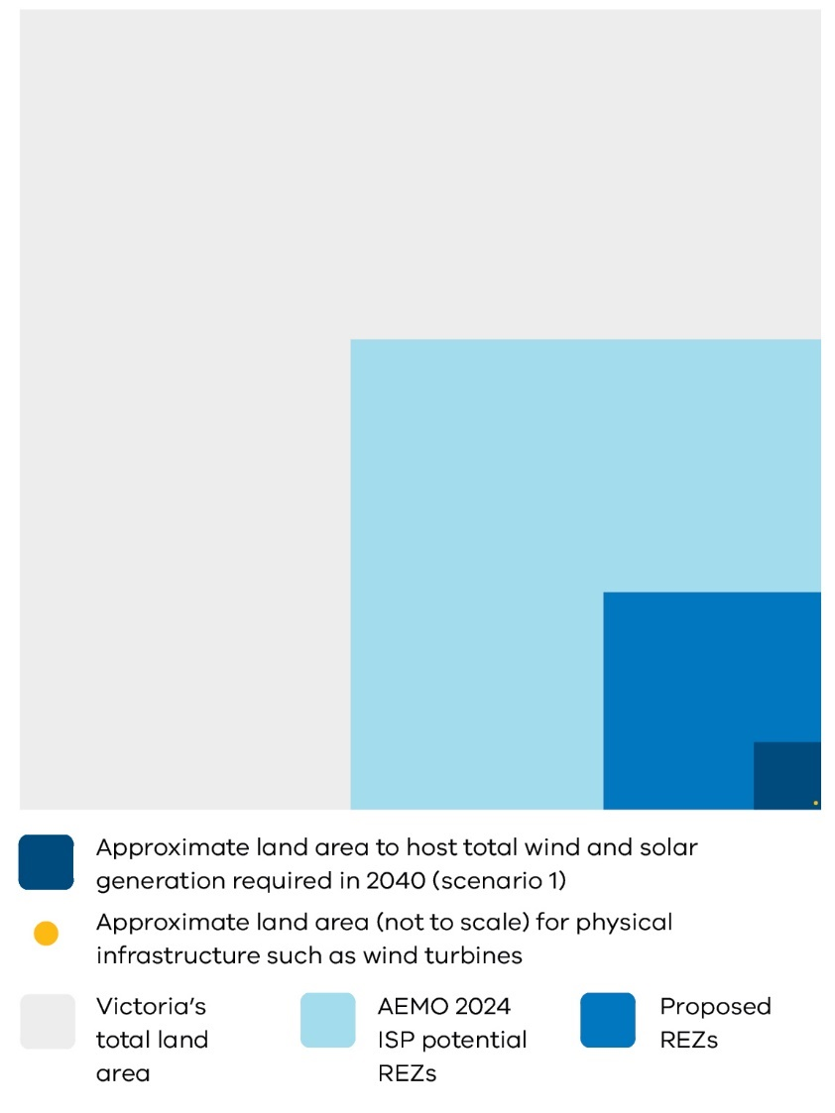

**Note on the graphic:** The total land area for in service and committed onshore wind and solar projects is derived from data provided by the Department of Transport and Planning. Note that: (i) only projects that service operational demand have been included in this calculation and (ii) any in service projects that are expected to be decommissioned by FY41 have not been included in this figure.

The total land area for new entrant projects has been approximated using capacity density values of 0.05 MW/ha and 0.5 MW/ha for onshore wind and solar respectively. This is an estimate only, and the actual size of new projects may differ for a range of reasons, including site-specific considerations and the development of technology over time. Data on Victoria’s total land area is sourced from VicGov Region.

### Indicative generation allocations across the proposed REZs

Table 8 shows the modelled generation we will need in each of the 6 proposed REZs by 2040 to meet energy demand most efficiently. This includes the existing pipeline of committed generation projects, as well as the additional capacity that we are planning for beyond the committed project pipeline. The ranges indicate the likely scale of new generation within each REZ based on our modelling, noting that that the final figures may sit outside this range.

The figures are not caps or limits. These are quantities of generation that could be supported in each REZ, having regard to the land area, transmission network transfer capacity and the renewable resource. A cap on the new generation that can connect within each REZ – called an access limit – will be released in the REZ declaration and access scheme associated with each REZ. For more information, see Section 9.

Table 8: Total renewable energy including in service and planned modelled to be in system by 2040

|  |  |  |  |  |  |
| --- | --- | --- | --- | --- | --- |
| **Generation location** | **In service wind and solar** | **Committed wind and solar** | **2040 new wind and solar modelled for scenario 1** | **2040 new wind and solar modelled for scenario 2** | **2040 new wind and solar modelled for scenario 3** |
| Proposed Central Highlands REZ | 0.5 GW | 1.4 GW | 0.6 GW | 2.2 GW | 0.6 GW |
| Proposed South West REZ | 0.3 GW | 0.0 GW | 1.3 GW | 2.0 GW | 1.7 GW |
| Proposed Western REZ | 0.4 GW | 0.0 GW | 0.8 GW | 4.5 GW | 0.8 GW |
| Proposed North West REZ | 0.1 GW | 0.0 GW | 0.4 GW | 1.9 GW | 0.7 GW |
| Proposed Central North REZ | 0.2 GW | 0.9 GW | 0.0 GW | 2.4 GW | 0.1 GW |
| Proposed Gippsland REZ | 0.0 GW | 0.2 GW | 0.4 GW | 1.1 GW | 0.4 GW |
| **REZ total** | **1.5 GW** | **2.5 GW** | **3.5 GW** | **14.2 GW** | **4.4 GW** |
| Outside REZs (onshore) | 3.3 GW | 1.9 GW | 0.0 GW | 0.0 GW | 0.0 GW |
| Offshore | 0.0 GW | 0.0 GW | 9.0 GW | 9.0 GW | 8.0 GW |
| **Total** | **4.8 GW** | **4.4 GW** | **12.5 GW** | **23.2 GW** | **12.4 GW** |

Note: as a modelling simplification, no new generation has been modelled outside REZs, however it is expected that some projects will still proceed in these areas.

Note: Totals may not add due to rounding.

### Feedback across Victoria

We have considered feedback from communities and industry received throughout the entire process of developing the 2025 VTP. This began with the Renewable Energy Planning Survey in 2023, which highlighted key community values and concerns related to areas considered more and less appropriate for REZ development. This helped to inform the REZ study area which was then consulted on in 2024 during engagement on the draft VTP Guidelines and study area. This enabled feedback from community and industry to be considered as the study area was narrowed to the draft proposed REZs presented in the draft VTP. Feedback on the draft VTP in 2025 provided further insight and has resulted in some changes to the draft proposed REZs which are presented in this 2025 VTP.

Feedback from the latest round of consultation has resulted in the following key changes to the draft proposed REZs:

* The total footprint of the REZs has increased in size following feedback from industry regarding the need for larger areas to develop technically and commercially viable renewable projects and to respond to calls from some sections of the community to increase the opportunity for landholder and community participation.
* Some of the proposed REZs have changed shape in response to feedback about sensitive areas within the original draft proposed REZs and to align with generator interest.
* Two zones, the Grampians Wimmera and the Wimmera Southern Mallee REZs, have now been combined to allow more flexibility in how and where projects are delivered and to make better use of transmission infrastructure.

### What we heard during consultation on the study area

Agricultural land-use feedback helped inform all the proposed REZs, including feedback from both communities and the Victorian Farmers Federation about areas to be considered for avoidance across the state. Protecting biodiversity and environmental values was also a common concern across all regions, and biodiversity feedback and data has informed the proposed REZs.

We heard a body of feedback concerning natural hazard vulnerability, specifically fire and floods. This ranged from region-specific insights to concerns about firefighting and renewable energy infrastructure broadly. Natural hazards and climate vulnerability were considered in our assessments, and this feedback was considered when refining the study area.

We also considered current and planned energy generation and transmission projects across all of Victoria, with the dual aims of preventing any region from being overburdened by energy infrastructure and maintaining momentum in Victoria’s energy transition. All regions provided feedback about cumulative impacts and the need to take in service and planned energy projects into account.

Much of the feedback from communities highlighted factors that could influence and support the planning of renewable generation, storage and transmission infrastructure within REZs over time. This feedback will continue to support decisions as the REZs are developed and is discussed below.

### What we heard during consultation on the draft VTP

#### Community

During consultation on the draft proposed REZs, community themes remained broadly the same as seen in consultation on the study area, but the emphasis on areas of concern shifted. We received less feedback on the impact to agriculture and biodiversity during this round of engagement. This may be, in part, due to efforts made to avoid agricultural land and areas of high biodiversity value where possible in developing the draft proposed REZs.

Community feedback focused heavily on the impact of renewable energy development on specific regions. This included feedback about regions shouldering the burden to provide energy to the city with repeated requests for the city to ‘do their part’. It also included concerns about the industrialisation of rural landscapes and the impact of development on local infrastructure. There was also feedback about community division caused by prior experiences with development, both generation and transmission. Across the state, communities expressed that they were unclear about the benefits of hosting renewable energy infrastructure, with much of the feedback focused on fears that development might cause falling land prices, damage income from farming and force families to move. Impact was expressed differently across regions, strongly linked to prior experiences with transmission and generation projects. This sentiment that the regions are shouldering the burden of the transition was fairly consistent across the state, and reflects the idea that the city is not doing its fair share.

There was also some feedback from community and local governments to expand certain REZs to allow for more participation and to benefit from centralised planning, adherence to developer standards and access to shared community benefits.

#### Industry

Feedback from industry noted the reliance of the VTP scenarios on achieving offshore wind targets. There were calls for more flexible REZ shapes, sizes and capacities with the current REZ configurations considered to be too narrow in geographic scope, and too conservative in expected generation, to accommodate the scale and diversity of renewable energy projects already in development. Industry feedback also highlighted the need for the 2025 VTP to support investment so Victoria can remain competitive in the global transition to renewables. There were also multiple requests to increase the capacity of each REZ and ensure any capacity limits weren’t too restrictive to accommodate pipeline projects.

Other feedback from industry focused on calls to clarify new access arrangements. Information about changes to the proposed Victorian Access Regime and further detail about proposed access limits will be provided in the Access and Connections Consultation Paper and draft Grid Impact Assessment (GIA) Guidelines. This will include details about access limits for each type of renewable generation, access fees, access conditions and the process for allocating access. For more information about the Access and Connections Consultation Paper and draft GIA Guidelines, see Section 9.

### What has changed

#### Proposed REZ footprint expansion

Some REZs have now increased in size to provide project developers and investors an opportunity to identify technically and commercially viable sites and allow for greater landholder and generator participation. Due to land use constraints, biodiversity concerns and efforts to avoid agricultural land least suitable to co-locating with renewable energy infrastructure, expanding the footprint of some of the draft proposed REZs was challenging. Some modest expansions have been made across proposed REZs. The former Wimmera Southern Mallee REZ (see below) has seen the largest expansion as the surrounding area has comparatively fewer known land-use and biodiversity constraints. It is acknowledged that the expanded proposed Southwest and Northwest REZ does include broadacre cropping and grazing land. This land has been included as our research identified these farming practices are more compatible with co-location with renewable energy infrastructure.

#### Proposed REZ footprint redesign

The draft proposed Grampians Wimmera REZ and Wimmera Southern Mallee REZ have been re-named and are being considered as 2 separate sections of a single Western REZ.

This is to increase the flexibility of connection and access arrangements across this region. Project developers will have more opportunity to investigate potential sites where landholder and developer interests are aligned, and the potential to deliver tangible benefits for communities. Having 2 separate sections also allows for more connection options to make better use of transmission infrastructure.

Other changes have been made to the some of the proposed REZs in response to feedback about biodiversity and land-use concerns and generator interest.

Part of the draft proposed South West REZ has been removed in response to community and industry feedback, and a new standalone section has been added.

The draft proposed Central North REZ has been substantially redesigned and split into 2 sections, in response to feedback on areas of high biodiversity value and to align with generator interest elsewhere in the region.

Details of these changes are summarised below.

For more information about the community and industry feedback that has helped shape the proposed REZs, download the Draft 2025 Victorian Transmission Plan Final Engagement Report – What We Heard at [our Engage Victoria web page](https://delwpvicgovau.sharepoint.com/sites/O365-GRP-XCS-VTIFEngagementPlanning/Shared%20Documents/VTIF%20Engagement%20Planning/Final%202025%20VTP/Collateral/Accessible%20versions/engage.vic.gov.au/%20victransmissionplan).

The proposed REZs presented in the following section, are not yet finalised. The Minister for Energy and Resources can now consider whether to proceed with formal declaration of a proposed REZ. The REZ declaration process requires that the Minister make a declaration in a formal order (Order). This involves the proposed REZ being placed on public notice for a minimum of 6 weeks, enabling the community and industry to provide any comments and submissions. The Minister must consider any submissions when determining whether the REZ should be declared under an Order. More information about the REZ declaration process can be found in Sections 6.3 and 9.

During the REZ declaration process, there will be a further opportunity to refine the REZ boundaries including with further feedback from communities, Traditional Owners, industry and local stakeholders.

## Central Highlands

The proposed Central Highlands REZ is in an area with high-quality wind resources and offers access to existing transmission network capacity. The local region has a diverse mix of land uses and landscapes, including productive farmland, national and state parks, wetlands, plains and river valleys, which have been taken into account in defining its shape and location.

It sits within the Registered Aboriginal Party (RAP) boundaries of the Wadawurrung Traditional Owners Aboriginal Corporation and Eastern Maar Aboriginal Corporation.

The proposed REZ is situated west and south of Ballarat, in an area where known land use constraints are lower, relative to surrounding areas. It includes parts of the Golden Plains, Corangamite and Pyrenees local government areas. Small sections of the REZ also sit within the Moorabool and Colac Otway local government areas. The southern boundary runs close to the existing 500 kV transmission line from Moorabool towards Haunted Gully and takes in a section of the 220 kV line from Ballarat to Terang.

Agriculture production in the area includes cropping and grazing. There are nearby areas of cultural and historical significance. Scattered wetlands in the surrounding area provide habitat for important species including the brolga. As highlighted in feedback on the draft VTP, across the region there are known nesting sites and habitat areas for wedgetailed eagles and other birds. Managing risk to these species is an important consideration for wind developments.

### We considered many factors when identifying and refining the shape of the proposed REZ

In addition to the overarching factors outlined in Table 7, we considered regional and local factors and engagement feedback to help identify and refine the REZ shape. These factors included but were not limited to:

* the area’s high-quality wind resources
* productive farmland and compatibility of farming practices with renewable energy infrastructure
* wetlands, national and state parks and forests
* areas with significant biodiversity, cultural and social values
* publicly available cultural sites and areas of cultural heritage sensitivity identified on the Aboriginal Cultural Heritage Register and Information System
* residential growth areas and dwelling density
* projects in planning
* transmission network capacity
* cumulative impacts of energy infrastructure development.

We are committed to having ongoing conversations with Wadawurrung Traditional Owners Aboriginal Corporation and Eastern Maar Aboriginal Corporation to incorporate further cultural heritage information into REZ development and subsequent VTPs, in alignment with the principle of selfdetermination.

Figure 12 shows a map of the proposed Central Highlands REZ, including some of the significant land use and landscape values that influenced its location, size and shape. The identified land use and landscape values in the region are a sub-set only and are not exhaustive of the values present.

Figure 12: Proposed Central Highlands REZ

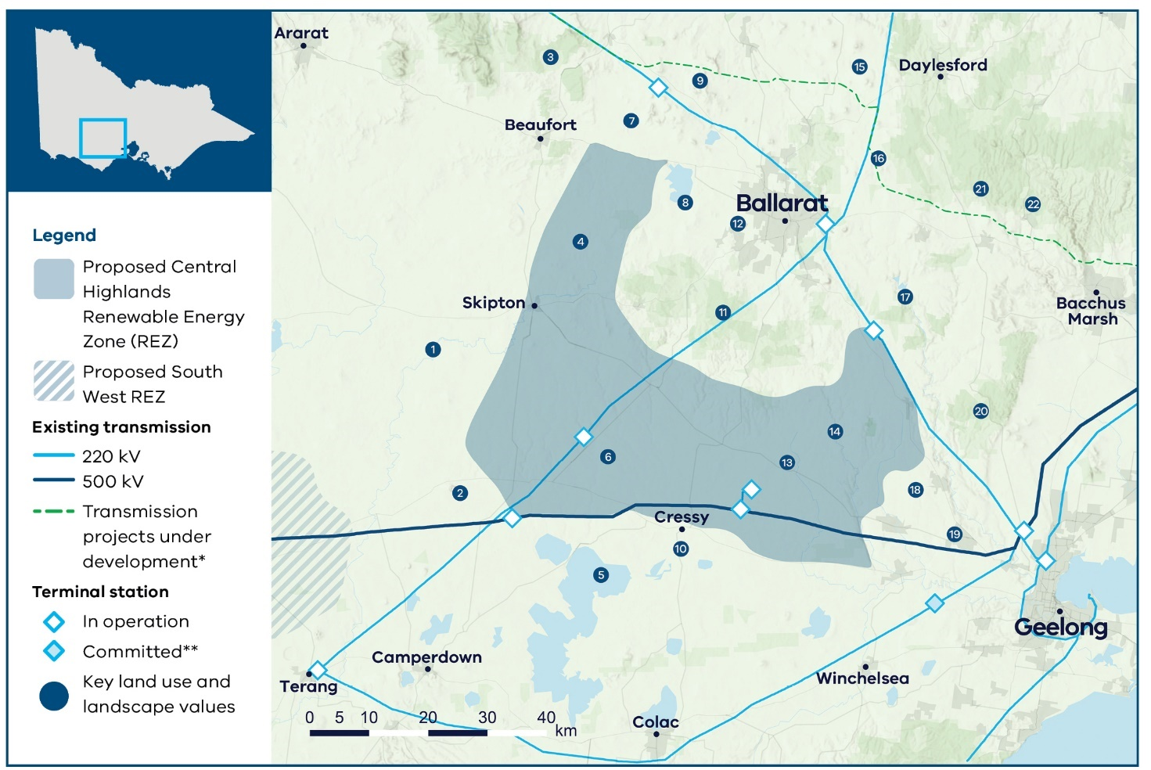

### Key land use and landscape values

1. Biodiversity: Wetlands scattered across region with high biodiversity value, home to native flora and fauna including brolgas
2. Biodiversity/cultural: Wetlands and volcanic landscape around Mount Elephant
3. Biodiversity: State forests and park forming the Lower Pyrenees environs, home to native flora and fauna
4. Community/cultural: Mount Emu and surrounding areas of sensitivity
5. Biodiversity/cultural: Western District Lakes Ramsar-listed wetlands, home to native flora and fauna including brolgas
6. Agriculture: Area with a high proportion of cropping in the southwest of the REZ, with increased livestock grazing the north and east of the REZ
7. Agriculture: Horticulture farming
8. Biodiversity/cultural: Lake Burrumbeet and surrounding areas of sensitivity
9. Community/cultural: Mount Bolton, Mount Beckworth and Mount Ercildoune, part of the Island Uplands volcanic landscape
10. Biodiversity: Brolga flocking area (The Brolga is listed as endangered under the *Flora and Fauna Guarantee Act 1998* (Vic) and is at high risk of extinction in Victoria. Brolga flocking areas are areas mapped by DEECA which provide important Brolga habitat for Brolgas to drink, roost and feed during drier months until breeding. DEECA’s Handbook for the Development of Renewable Energy Facilities includes specific guidance for wind facilities and the Victorian Brolga including avoiding Brolga flocking areas.)
11. Biodiversity: State parks and forests across the region, home to native flora and fauna
12. Community: Area with higher aggregated dwelling density
13. Biodiversity/cultural: Scattered wetlands and other areas of high biodiversity value
14. Biodiversity: Area with high biodiversity values including protected biodiversity area
15. Heritage: Victorian Goldfields
16. Agriculture: Horticulture farming
17. Cultural: Lal Lal Falls
18. Biodiversity/cultural: Wetlands including protected biodiversity area, home to native flora and fauna
19. Community: Proposed residential growth areas around Bannockburn
20. Biodiversity/cultural/ community: Brisbane Ranges National Park
21. Biodiversity/ cultural/ community: Wombat State Forest and surrounding bushland, home to native flora and fauna
22. Bushfire risk: Higher bushfire risk within densely vegetated state forests and parks

Note: The map shows transmission projects under development including transmission projects defined as Committed and Anticipated or Actionable under the Australian Energy Market Operator’s 2024 Integrated System Plan. This map displays the proposed alignment for Western Renewables Link.

Note: Committed terminal station’ includes new terminal stations on the Victorian Declared Shared Network that are proposed to be operational in the coming years, as identified by AEMO Victorian Planning in its Terminal Stations in Victoria report dated 2 September 2024.

### What we heard

Feedback in this region focused on the importance of minimising impacts on productive farmland and agriculture and protecting biodiversity and the natural environment.

Biodiversity concerns related to the wedgetailed eagle, the brolga and the Wombat State Forest. There was feedback about natural hazard vulnerability, in particular bushfires. We also heard about the impact increased renewable infrastructure could have on the region and the impacts that the Western Renewables Link (WRL) project is having on local communities.

Feedback from the agriculture sector raised concerns about potential impacts on local horticulture production, particularly potato farming near Ballarat, and the compatibility of farming practices with energy infrastructure.

Feedback from local shires focused on the strategic importance of preserving high-quality soils for food production and asked for residential and industrial growth areas highlighted in council strategies to be considered.

During engagement on the draft VTP, we heard more feedback about horticulture within the draft proposed REZ. We also heard feedback about sensitive areas around Mount Bolton and Mount Beckworth. There was also concern about cumulative impact particularly in the Pyrenees Shire. There were multiple calls from developers to increase both the size and expected capacity of this REZ to account for planned capacity and location of pipeline projects.

### What we did

When originally designing the proposed Central Highlands REZ, we considered agricultural land across the region and aimed to include areas with fewer land use and environmental constraints. To the north, we have taken into account high productivity farmland, including important horticulture production around Ballarat and Ballan, which has been identified as less compatible with renewable energy infrastructure. We also aimed to protect wetlands, lakes, parks and reserves to the south of the proposed REZ, as well as areas of high environmental, cultural and biodiversity value. We considered areas of high habitat value for biodiversity, such as the brolga.

The eastern border near Geelong and outer Melbourne has been shaped by areas of higher dwelling density and future residential growth.

In service and planned generation projects across the region were considered as we designed the proposed REZ. It includes several in service and planned large-scale wind farms and seeks to coordinate new development south and west of Ballarat to streamline future connections at several possible points on the existing network.

In response to feedback on the draft VTP, the northern area of the draft proposed REZ has been reduced. This reflects multiple considerations, including likely preference of generators to connect to the 500kV network to the south, land use sensitivities and limited land availability. In the south, a small area has been added to allow additional space close to the 500kV transmission line, while still avoiding wetlands and lakes in the area.

During the REZ declaration process, there will be a further opportunity to refine the REZ boundaries including with further feedback from communities, Traditional Owners, industry and local stakeholders.

## South West

The proposed South West REZ has some of the strongest wind resources in the state. It is in an area characterised by farmland, lakes and volcanic plains.

This zone has been split into 2 sections in response to community feedback on the draft VTP. While the areas are separate, they are both considered to be part of the proposed South West REZ.

One section is north-west of Hamilton, located between Casterton and Balmoral. It covers parts of the Southern Grampians, Glenelg and West Wimmera local government areas. This section sits within the RAP boundaries of Gunditj Mirring Traditional Owners Aboriginal Corporation.

The other section is south-east of Hamilton, located between Macarthur and Darlington. The existing 500 kV line that runs from Mortlake to Tarrone terminal stations runs through the southern part of this section. It covers parts of the Moyne, Southern Grampians and Corangamite local government areas. It sits within the RAP boundaries of Eastern Maar Aboriginal Corporation and Gunditj Mirring Traditional Owners Aboriginal Corporation.

South West Victoria has seen wind project development over the past several decades. In service wind projects in the region contribute about 12% of Victoria’s current energy generation capacity (calculated based on the generation capacity of onshore wind, solar, gas, coal and hydro projects that service operational demand), and 23% of the renewable generation capacity (calculated based on the generation capacity of onshore wind, solar and hydro projects that service operational demand).

The Southern Ocean offshore wind declared area is located off the coast of the proposed REZ, and one project has been awarded an offshore wind feasibility licence in this area by the Australian Government.

The broader areas surrounding the proposed REZ includes national parks, state forests, rivers and surrounding areas of sensitivity, Ramsar wetlands, tourist attractions and agricultural land, with one of the state’s leading dairy-farming areas in southern Corangamite and Moyne shires.

### We considered many factors when identifying and refining the shape of the proposed REZ

In addition to the overarching factors outlined in Table 7, we considered regional and local factors and engagement feedback to help identify and refine the REZ shape. These factors included but were not limited to:

* the area’s very high-quality wind resources
* cumulative impacts of existing projects and infrastructure
* farmland, particularly local dairy production, and compatibility of farming practices with renewable energy infrastructure
* areas of high biodiversity value
* publicly available cultural sites and areas of cultural heritage sensitivity identified on the Aboriginal Cultural Heritage Register and Information system
* transmission network capacity.

We are committed to having ongoing conversations with Eastern Maar Aboriginal Corporation and Gunditj Mirring Traditional Owners Aboriginal Corporation to incorporate cultural heritage information into REZ development and subsequent VTPs, in alignment with the principle of self-determination.

Figure 13 shows a map of the proposed South West REZ, including some of the significant land use and landscape values that influenced its location, size and shape. The identified land use and landscape values in the region are a sub-set only and are not exhaustive of the values present.

Figure 13: Proposed South West REZ

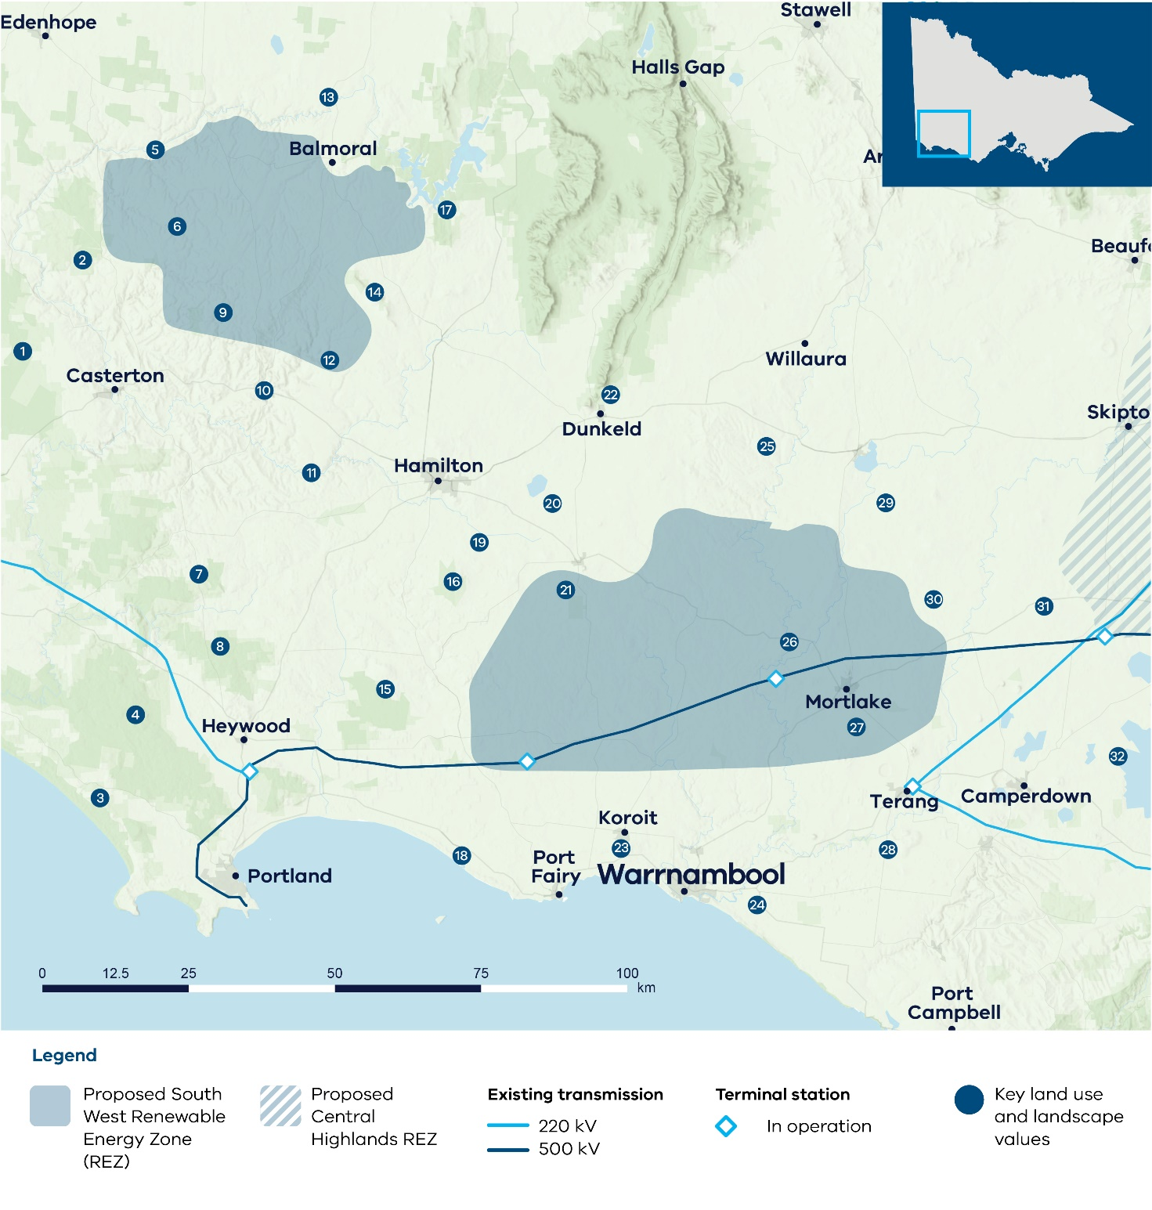

### Key land use and landscape values

1. Biodiversity/cultural: Roseneath, Nangeela and Drajurk state forests, home to native flora and fauna
2. Biodiversity/cultural: Brimboal State Forest, home to native flora and fauna
3. Biodiversity/community/ cultural: Discovery Bay Coastal Park
4. Biodiversity/ cultural/community: Cobboboonee and Lower Glenelg National Parks
5. Biodiversity/cultural: Glenelg river and surrounding areas of sensitivity
6. Biodiversity/cultural: Chetwynd River and Wando River and surrounding areas of sensitivity
7. Biodiversity: State parks and forests, home to native flora and fauna
8. Bushfire risk: Higher bushfire risk across parks and forested areas
9. Agriculture: Area of higher timber production across the centre of the REZ, surrounded predominantly by livestock grazing across the REZ to the south east and north
10. Community/agriculture: Area of higher aggregated dwelling density around Coleraine, with a high proportion of cropping surrounding the south of Coleraine
11. Biodiversity/cultural: Wannon River and surrounding areas of sensitivity, including scattered protected biodiversity areas
12. Biodiversity/cultural: Higher value biodiversity and cultural values associated with waterways (creeks)
13. Mining: Mining licence and minerals retention licence, including heavy mineral sands deposits
14. Biodiversity/cultural/ community: Dundas Range Scenic Reserve, including protected biodiversity area for native flora and fauna
15. Cultural heritage: Budj Bim World Heritage Cultural Landscape
16. Biodiversity/cultural: Mount Napier State Park, including protected biodiversity area
17. Biodiversity/cultural: Multiple State Forests, home to native flora and fauna
18. Community/biodiversity/ cultural: Coastal parks, reserves and tourism sites
19. Biodiversity: Public Conservation and Resource Zone Area
20. Biodiversity/cultural: Lake Linlithgow and surrounding lakes, home to native flora and fauna including brolga flocking area
21. Cultural: Western volcanic cones and lava flows from Mount Rouse
22. Cultural/biodiversity/ community: The Grampians (Gariwerd Cultural Landscape) – significant landform and landscape with high cultural, community and biodiversity values, including significant viewpoints of the region
23. Biodiversity/cultural: Tower Hill Wildlife Reserve, home to native flora and fauna
24. Land use: Wind farm prohibition area within 5 km of the coast east of Warrnambool (Victorian Planning Provisions)
25. Mining: Retention licence
26. Biodiversity/cultural: Hopkins River and surrounding areas of sensitivity
27. Agriculture: High agricultural productivity dairy farming area with relatively lower compatibility with renewables
28. Agriculture: High productivity dairy farming area with relatively lower compatibility with renewables
29. Biodiversity/cultural: Lake Bolac and surrounding wetlands and reserves, home to native flora and fauna including brolgas
30. Biodiversity: Brolga flocking area. The Brolga is listed as endangered under the Flora and Fauna Guarantee Act 1998 (Vic) and is at high risk of extinction in Victoria. Brolga flocking areas are areas mapped by DEECA which provide important Brolga habitat for Brolgas to drink, roost and feed during drier months until breeding. DEECA’s Handbook for the Development of Renewable Energy Facilities includes specific guidance for wind facilities and the Victorian Brolga, including avoiding Brolga flocking areas.
31. Biodiversity/cultural: Wetlands and volcanic landscape around Mount Elephant
32. Biodiversity/cultural: Western District Lakes Ramsar-listed wetlands, home to native flora and fauna including brolgas

### What we heard

Feedback from this region focused on the significant role this region has played in Victoria’s energy transition so far, noting the large number of in service and proposed local renewable projects. Concerns were raised about the cumulative impacts of wind projects, particularly on visual amenity, and how potential overdevelopment might affect peoples’ sense of place and way of life.

Feedback also stressed the importance of minimising impacts on agriculture, including the region’s dairy farmland, recognising the sector’s contribution to the local economy and to food security. Community members also raised concerns about biodiversity, including the brolga and Southern Bent-Wing Bat.

Local governments mirrored community feedback, stressing the importance of protecting dairy farmland south of the Princes Highway and minimising cumulative impacts of renewable development.

During consultation on the draft VTP we received feedback focused on the area of the draft proposed REZ around Hamilton and Penshurst. Notably, feedback focused on ground water access and associated agricultural productivity in this area, areas of environmental and cultural significance, lower wind resource quality and lack of developer interest. We also heard concerns and received additional data on brolga flocking grounds on the edge of the draft proposed REZ.

There was also some feedback from community and industry calling for land near Coleraine to be considered for inclusion.

### What we did

When originally developing the shape and size of this proposed REZ, we aimed to balance the need to harness the strongest winds in the state while managing the amount of new development to reduce cumulative impacts for the region.

To address concerns about agricultural land, the size and location of the proposed REZ takes into account areas of concentrated dairy farming in southern Corangamite Shire, and east of Warrnambool in southern Moyne Shire.

In response to feedback, we considered a range of significant landscapes and landforms, including Budj Bim World Heritage Cultural Landscape, the Grampians (Gariwerd) National Park, Lake Corangamite and the Great Otway National Park. We also considered coastal areas and their cultural, biodiversity and social (tourism) values for communities. Areas with important biodiversity values, including known brolga habitat and areas with a high concentration of wetlands to the east and north-east of the proposed REZ, have also been considered.

As a result of feedback on the draft VTP, the section of the draft proposed REZ around Hamilton and Penshurst has been removed. With access to additional data, some sections have been removed to avoid brolga flocking grounds that provide restrictions on the planning of new wind facilities.

To replace the removed sections, a new standalone section of the proposed REZ has been identified north of Coleraine. This area has a higher quality wind resource than the area removed. Situated between the Glenelg and Wannon rivers, the area has predominantly grazing agriculture, with some cropping and plantation areas. The southern section of the REZ includes steeper terrain and rolling hills which may require more careful review for suitability while areas further north are flatter with less terrain complexities.

We acknowledge that the stand-alone section of the REZ is new and was not consulted on during the draft 2025 VTP process. We will seek feedback on this area during the REZ declaration process, when there will be a further opportunity to refine the REZ boundaries.

A consideration of Traditional Owner values, such as tangible and intangible cultural heritage, biocultural species and sensitive sites associated with first contact, has not yet been incorporated into the design of the South West REZ.

We will maintain ongoing conversations with both formally recognised and non-formally recognised Traditional Owner groups to design an appropriate process for incorporating cultural heritage information into REZ development and subsequent VTPs.

## Western REZ

Formerly the draft proposed Grampians Wimmera and Wimmera Southern Mallee REZs.

This zone has changed from being 2 separate draft proposed REZs (the Grampians Wimmera and Wimmera Southern Mallee) to being considered as a single Western REZ with 2 sections.

While the sections are separate, they are both considered to be part of the proposed Western REZ.

By combining the REZs, access to the electricity grid will be allocated across both sections combined. This will provide more flexibility in where renewable energy projects such as wind farms are developed. For communities, this will mean developers can more easily avoid sensitive areas, reduce pressure on any one town or region, and look for sites that offer the best local benefits, including new jobs, community partnerships, or improved infrastructure.

The eastern section (the former draft proposed Grampians Wimmera REZ) is located between Stawell and Donald, with its southern boundary following an existing 220 kV transmission line and its eastern boundary following the VNI West corridor. It is mainly located within the Northern Grampians Shire and also intersects with Yarriambiack and Pyrenees local government areas.

The western section (the former draft proposed Wimmera Southern Mallee REZ) is located north of Horsham, between Dooen and Hopetoun. It is located within the Yarriambiack, Hindmarsh, Buloke and Horsham Rural City local government areas.

The proposed REZ sits within the RAP boundaries of the Barengi Gadjin Land Council and Dja Dja Wurrung Clans Aboriginal Corporation.

The western section is along the 220 kV transmission line from Horsham to Ouyen, allowing for connections into the network at Murra Warra, while the eastern section provides opportunity for connections to the 500 kV network at Bulgana terminal station.

The proposed REZ offers access to strong wind and maximises access to existing and planned transmission capacity. It is in an area that is characterised by diverse farmland, with broadacre cropping and grazing.

The south of the region is characterised by significant landscapes including The Grampians (Gariwerd Cultural Landscape) and Mount Arapiles (Dyurrite Cultural Landscape), which were highlighted in feedback for their national and state significance and connect to several important parks, reserves and conservation areas. Given their significant cultural, biodiversity and community (tourism) values, VicGrid will continue to assess and seek feedback on these significant landscapes and areas in refining the REZs.

The region also includes areas of mining and substantial critical minerals resources.

### We considered many factors when identifying and refining the shape of the proposed REZ

In addition to the overarching factors outlined in Table 7, we considered regional and local factors and engagement feedback to help identify and refine the REZ shape. These factors included but were not limited to:

* significant cultural and environmental landscapes such as The Grampians (Gariwerd Cultural Landscape) and Mount Arapiles (Dyurrite Cultural Landscape)
* potential impacts on biodiversity, conservation areas and wetlands
* publicly available cultural sites and areas of cultural heritage sensitivity identified on the Aboriginal Cultural Heritage Register and Information System
* compatibility of farming practices with renewable energy infrastructure
* feedback from communities impacted by generation development
* feedback from communities already impacted by development of VNI West
* in service generation and developer interest in the area
* areas of lower constraint and higher compatibility with renewables in the northwest of the region
* transmission network capacity
* other land uses and natural resources
* regional development opportunities.

We are committed to having ongoing conversations with Barengi Gadjin Land Council and Dja Dja Wurrung Clans Aboriginal Corporation to incorporate further cultural heritage information into REZ development and subsequent VTPs, in alignment with the principle of self-determination.

Figure 14 shows a map of the proposed Western REZ, including some of the significant land use and landscape values that influenced its location, size and shape. The identified land use and landscape values in the region are a sub-set only and are not exhaustive of the values present.

Figure 14: Proposed Western REZ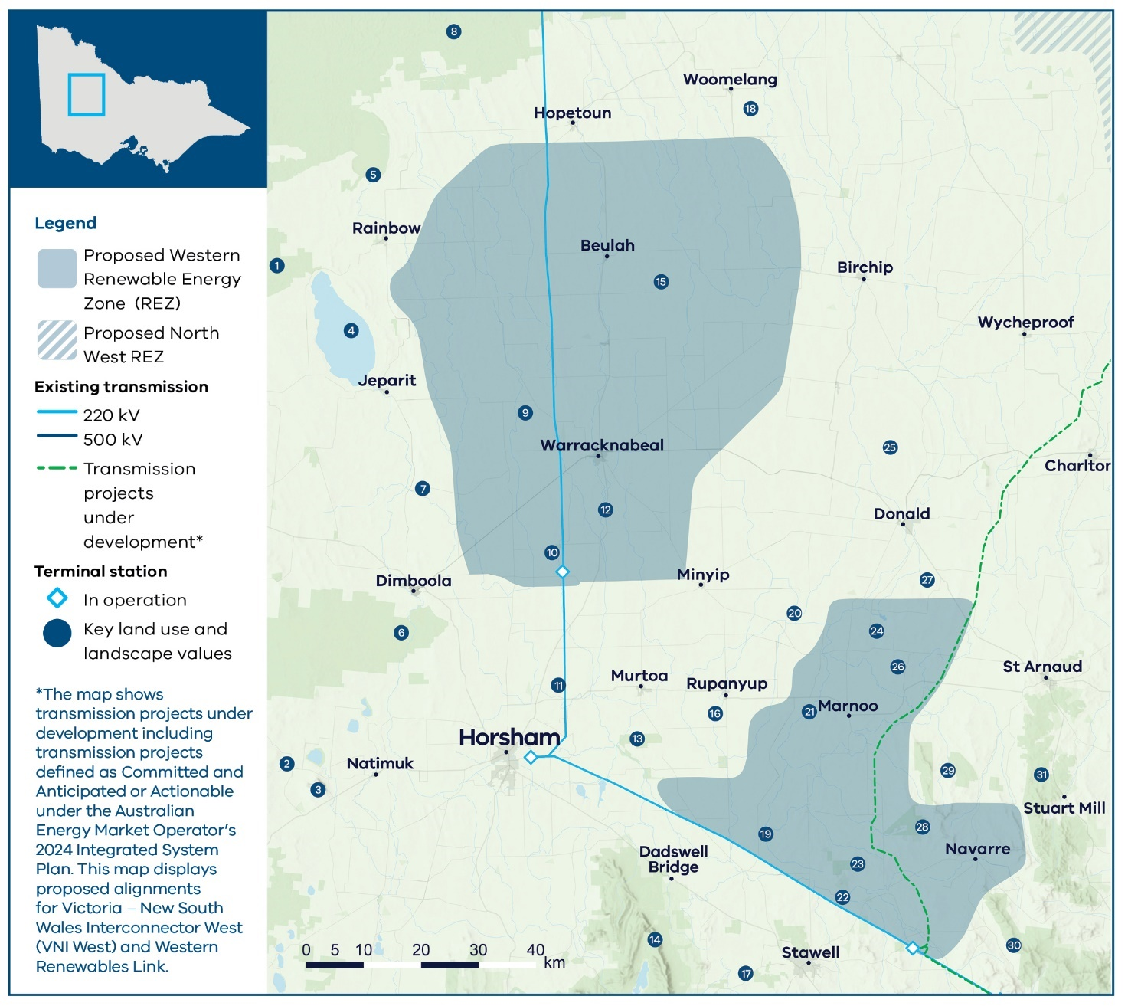

### Key land use and landscape values

1. Biodiversity/community: Big Desert State Forest
2. Biodiversity/cultural: Multiple parks, reserves and wetlands, including protected biodiversity areas, home to native flora and fauna
3. Cultural/biodiversity/ community: Mount Arapiles (Dyurrite Cultural Landscape) – significant landscape with high cultural, biodiversity and tourism values for the region
4. Biodiversity/cultural: Lake Hindmarsh and surrounding areas of sensitivity
5. Biodiversity: Lake Albacutya Ramsar-listed wetland
6. Biodiversity/community: Little Desert National Park
7. Biodiversity/cultural: Wimmera River and surrounding areas of sensitivity
8. Biodiversity/cultural/ community: Wyperfeld National Park
9. Mining: Heavy mineral sands deposits
10. Biodiversity: Protected biodiversity area
11. Mining: Mining tenement and mineral sands deposits
12. Biodiversity/cultural: Yarriambiack Creek and surrounding areas of sensitivity
13. Biodiversity: Barrabool Flora and Fauna Reserve and Marma State Forest, including protected biodiversity area, home to native flora and fauna
14. Biodiversity/cultural/ community: The Grampians (Gariwerd Cultural Landscape) National Park – significant landform and landscape with high cultural, community and biodiversity values, including significant viewpoints of the region
15. Agriculture: Significant broadacre cropping across this region potential to be compatible with colocating renewable energy infrastructure in appropriate locations
16. Mining: Minerals retention licence
17. Biodiversity: Conservation reserves and wetlands, home to native flora and fauna
18. Mining: Heavy minerals sands deposits
19. Mining: Minerals retention licence
20. Mining: Mining licence application and retention licence
21. Biodiversity/cultural: Richardson River and surrounding areas of sensitivity
22. Biodiversity/cultural: Wimmera River and surrounding areas of sensitivity
23. Biodiversity/cultural: Glynwylln State Forest and surrounding remnant bushland and reserves connecting areas to the northeast, west and southwest towards The Grampians (Gariwerd Cultural Landscape) and home to native flora and fauna
24. Biodiversity/cultural: Wetlands including Lake Batyo Catyo and surrounding lakes
25. Biodiversity/cultural: Lake Buloke and surrounding areas of sensitivity
26. Flooding risk: Floodway and land subject to inundation
27. Biodiversity/cultural: Wetlands including Lake Cope Cope and Waltons Lakes
28. Biodiversity/cultural: Morrl Morrl Nature Conservation Reserve, protected biodiversity area for native flora and fauna
29. Biodiversity/cultural: Mount Bolangum and Big Tottington Nature Conservation Reserves, home to native flora and fauna
30. Biodiversity/cultural: Pyrenees State Forest and Landsborough Nature Conservation Reserve, home to native flora and fauna
31. Biodiversity/cultural/ community: Kara Kara National Park

### What we heard

#### Eastern section (formerly the draft proposed Grampians Wimmera REZ)

Feedback from the region focused on the impact of energy infrastructure on agriculture production as well as concerns around key landscapes for cultural, biodiversity and community values. VicGrid heard concerns surrounding the southern portion of the Grampians Wimmera REZ including cumulative impacts of projects seeking to connect into the proposed Bulgana terminal station and the proximity of the REZ to the iconic Grampians National Park (Gariwerd Cultural Landscape).

The community highlighted the biodiversity values of the area, including bird species such as the wedgetailed eagle. There was feedback about protecting bio-links between nature conservation reserves, national and regional parks and other areas of high conservation value in the region, including the lakes system in Buloke Shire from both a biodiversity and tourism perspective. Local councils raised concerns about flood risk and impact on surface water flows.

The community also raised concerns about competing land use due to additional industrial projects in the area. Community engagement, particularly from Stawell, St Arnaud and Donald, reflects strong concerns about infrastructure development. We recognise the impact of VNI West development and related community opposition. During consultation on the draft VTP, feedback reiterated the community’s unwillingness to host renewable energy infrastructure in this eastern section, including concerns around negative experiences with previous development. Community concerns and objections to the REZ were echoed by local councils.

#### Western section (formerly the draft proposed Wimmera Southern Mallee REZ)

Feedback from the region highlighted the need to minimise the impact of renewable energy development on agricultural land, noting the area includes highly productive soils. There were suggestions that areas in the north-west with more marginal soils would be better suited to infrastructure development and that farmers in the area increasingly used advanced technology giving them the ability to boost productivity with less rain. Concerns were raised about the impact of renewable energy infrastructure on use of these technologies. Negative experiences with previous and planned generation and transmission development were often raised. There was also some interest in better understanding how renewable energy and transmission development could bring economic and social benefits to the region.

Local councils raised concerns about potential impacts on Horsham Airport’s expansion plans, and the importance of protecting the surrounding flight descending zone. Local councils also echoed community concerns about protecting agricultural land and potential impacts on precision farming technology.

Feedback on the draft VTP provided further context. Concerns were raised about the cumulative impact of overdevelopment and further calls to avoid impacts to agricultural land. There was also feedback about the community divisions caused by renewable energy development.

There were some calls from both community and renewable energy developers to increase both the size and capacity of this section of the REZ. In particular, feedback highlighted the desire to locate renewable energy development further north to move away from areas and landscapes with significant environmental, cultural and community values further south, aligned to areas with strong generator interest.

For community members this was framed as a chance for more landholders to benefit from hosting infrastructure. While developers were calling for an increase to better reflect capacity and current pipeline projects. There was significant feedback from industry that the modelled renewable generation capacity published in the draft VTP, was insufficient to meet future energy demand and that more flexibility is required to allow for a variety of contingencies.

### What we did

#### Eastern section (formerly the draft proposed Grampians Wimmera REZ)

When the proposed eastern section of the Western REZ was designed, considerations included sensitive landscapes and landforms with high cultural, biodiversity and community significance including The Grampians (Gariwerd Cultural Landscape), national and state parks including Kara Kara National Park and natural conservation reserves around Stawell, Avoca and St Arnaud (east of VNI West), and Lake Buloke. The proposed REZ also considers sensitive land uses and landscapes around the Bulgana terminal station, including areas along the Wimmera River and to the south-east. While this south-east area of the REZ focuses on including the connection point of VNI West and WRL, it is an area with sensitive land use and landscape values and existing development, which will require further consideration during REZ and project design to minimise impacts. The north-west edge of the proposed REZ is shaped to limit impacts to strategic mineral sands resource areas.

The proposed REZ runs north along the proposed VNI West route with optionality for future generation projects utilising the planned network capacity on this line. The northern end of the REZ seeks to avoid major wetlands to the north, and sensitive parks and reserves to the east. The north-west boundary is shaped to limit impacts and land use conflicts with strategic mineral sands resource areas.

At the northern end of this section, there are some sensitive wetlands recognised for their biodiversity value. These areas will need to be carefully managed in planning for generation. Further flood studies and mapping will also be required and additional planning approvals at a project level will also help to address these issues.

There were no changes to the footprint of this eastern section of the REZ as a result of the consultation on the draft VTP. While this section is designed to capitalise on strong wind resource, access to planned transmission capacity at the Bulgana terminal station and generator interest, we have heard, and continue to hear, the depth of community feedback and concerns about the suitability of renewable energy development in this region. In particular, VicGrid expects further changes will be needed to this REZ shape to address concerns about proximity to the iconic Grampians National Park (Gariwerd Cultural Landscape) and will continue to assess this area and seek further feedback in relation to its suitability for hosting renewable energy development.

VicGrid will continue to work with local communities, Traditional Owners and industry to explore these issues further, including refining the design of the REZ and managing ongoing development to minimise impacts and support local communities.

#### Western section (formerly the draft proposed Wimmera Southern Mallee REZ)

When the western section of the proposed Western REZ was originally designed, efforts were made to balance many factors including community feedback, opportunity to harness the area’s strong wind resource, developer interest, opportunity to co-locate infrastructure with existing farming practices and proximity to the 220 kV line. The western section of this proposed REZ predominantly contains broadacre agricultural land. Engagement with agricultural groups and peak bodies so far has suggested broadacre dryland cropping operations have more potential to be compatible with co-locating renewable energy infrastructure. However, further work through project planning stages will be required to understand issues related to precision farming technology.

Proximity to Horsham Airport and other aviation activities means wind projects will need to consider and propose mitigations to potential aviation impacts in the planning stage. VicGrid will continue to work with stakeholders on development of the proposed REZ.

Industry feedback on the draft VTP called for the size of REZs to increase to enable more participation from project developers while continuing to support investment in Victoria. As a result, there has been an overall increase in REZ footprints. Other REZs saw modest expansions, however, this western section of the proposed Western REZ has seen the largest increase in size because further land use assessments identified relatively few constraints when compared to other areas of the state and strong developer interest. As a result of feedback, the REZ was expanded and shifted further north-east, enabling more projects to harness the strong wind resource in the area and proximity to transmission and allowing more flexibility within the proposed REZ to host renewable energy generation projects. However, although the expansion of this section of the proposed REZ has largely avoided areas of high biodiversity, cultural and community values, more farmland is now included which we know will be of concern to some community members and landholders. Research has shown that dryland broadacre cropping and grazing show the highest compatibility with renewable energy infrastructure. It should also be noted, individual landholders can choose whether or not to host renewable energy generation projects such as wind turbines or solar panels.

We acknowledge that the expanded area of the western section of the REZ is new and was not consulted on during the draft 2025 VTP process. We will seek feedback on this area during the REZ declaration process, when there will be a further opportunity to refine the REZ boundaries.

### Why the REZs were combined

The Grampians Wimmera and Wimmera Southern Mallee REZ have been brought together in one combined area to allow more choice about where projects can be located. This helps to avoid putting too much pressure on any one place and allows sharing of access arrangements to the grid. This provides all participants more flexibility in where they connect and makes better use of transmission infrastructure. For communities this means a more balanced and strategic approach to how and where projects are delivered.

During the REZ declaration process, there will be a further opportunity to refine the REZ boundaries including with further feedback from communities, Traditional Owners, industry and local stakeholders.

## North West

The proposed North West REZ has wind and solar resources and provides access to existing and planned transmission network capacity. It is in an area with rivers, floodplains and dry landscapes, with broadacre dryland agriculture in its north-west section and irrigated farming in the east. It sits within the RAP boundaries of Wamba Wemba Aboriginal Corporation, Dja Dja Wurrung Clans Aboriginal Corporation and across areas of Country to the east that do not have a formally recognised Traditional Owner group. Wetlands, rivers, lakes and national parks provide habitat for important species and have cultural and social value for Traditional Owners and local communities.

The proposed REZ is located south of Swan Hill and Kerang, following the natural shape of Victoria’s border. It includes parts of the Swan Hill, Gannawarra, Loddon and Buloke local government areas and is transversed by the Loddon and Avoca Rivers. It also includes part of the corridor for the new VNI West transmission line and part of the existing 220 kV Kerang to Wemen line. These transmission lines, the existing terminal station at Kerang and the proposed VNI West terminal station at Tragowel provide an opportunity to coordinate project connections into the grid.

As a result of feedback on the draft VTP, a minor extension of the proposed REZ has been made running south along VNI West, providing additional area and optionality for future renewable energy projects with access to the planned 500 kV network.

### We considered many factors when identifying and refining the shape of the proposed REZ

In addition to the overarching factors outlined in Table 7, we considered regional and local factors and engagement feedback to help identify and develop the REZ shape. These factors included but were not limited to:

* the environment and biodiversity
* publicly available cultural sites and areas of cultural heritage sensitivity identified on the Aboriginal Cultural Heritage Register and Information System
* transmission network capacity
* the region’s solar and wind resources
* in service renewables projects close to the existing terminal stations at Kerang and Tragowel
* the compatibility of different farming practices with renewable energy infrastructure
* other land uses and natural resources
* regional development opportunities.

We are committed to having ongoing conversations with Wamba Wemba Aboriginal Corporation, DJAARA and affected Traditional Owners to incorporate further cultural heritage information into REZ development and subsequent VTPs, in alignment with the principle of self-determination.

Figure 15 shows a map of the proposed North West REZ, including some of the significant land use and landscape values that influenced its location, size and shape. The identified land use and landscape values in the region are a sub-set only and are not exhaustive of the values present.

Figure 15: Proposed North West REZ

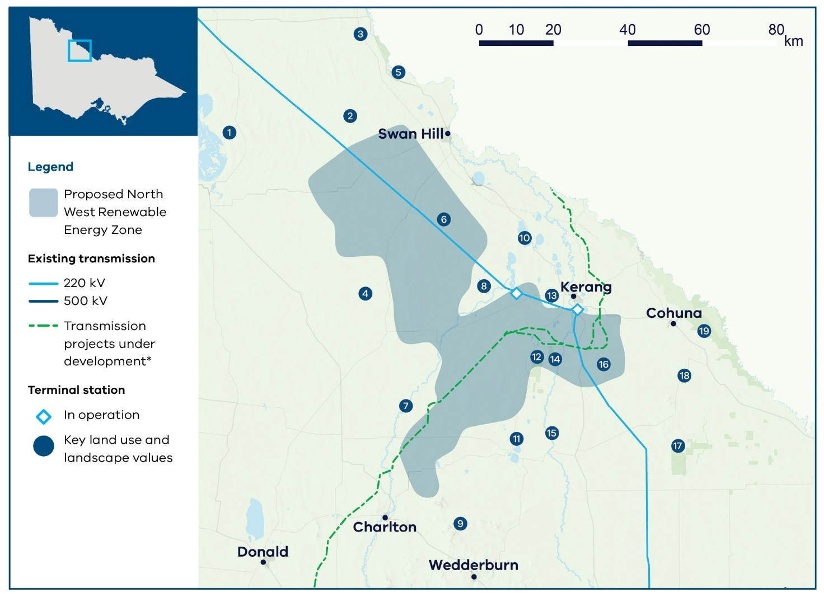

### Key land use and landscape values

1. Biodiversity/cultural/ community: Lake Tyrrell and surrounding sensitive landscape
2. Mining: Minerals retention licence
3. Agriculture: High agricultural productivity area with irrigated horticulture, dairy and cropping along the Murray River
4. Biodiversity/cultural: Lalbert Lake, Lalbert Creek and surrounding areas of sensitivity
5. Biodiversity/cultural/ community: Murray River and surrounding sensitive landscapes
6. Biodiversity/cultural: Avoca River and surrounding areas of sensitivity
7. Mining: Mining licence applications and retention licence
8. Biodiversity: Protected biodiversity area for native flora and fauna
9. Biodiversity/cultural: Wychitella Nature Conservation Reserve, home to native flora and fauna
10. Biodiversity: Kerang Lakes Ramsar-listed wetlands
11. Biodiversity/cultural: Wetlands and parks surrounding Boort
12. Biodiversity/cultural: Leaghur State Park and Meran Lakes Complex, protected biodiversity area for native flora and fauna
13. Biodiversity: Protected biodiversity area for native flora and fauna
14. Flooding risk: Floodplains across the Loddon River catchment area
15. Biodiversity/cultural: Loddon River and surrounding areas of sensitivity
16. Agriculture: High agricultural productivity area with irrigated horticulture, dairy and cropping within the Goulburn Murray Irrigation District
17. Biodiversity/cultural/ community: Terrick Terrick National Park
18. Biodiversity/cultural: Wetlands and waterways with surrounding areas of sensitivity, including protected biodiversity areas
19. Biodiversity/cultural/ community: Gunbower National Park and surrounding sensitive parks and wetlands (swamps)

Note: The map shows transmission projects under development including transmission projects defined as Committed and Anticipated or Actionable under the Australian Energy Market Operator’s 2024 Integrated System Plan. This map displays the proposed alignment for Victoria – New South Wales Interconnector West (VNI West).

### What we heard

Feedback in this region focused on the importance of protecting agricultural land and other land uses, and concern over the local impacts associated with hosting infrastructure to supply power to urban areas. Community members raised concerns about potential impacts of widespread uncoordinated development and called for more transparency and consultation in planning processes. Community members also focused on the development of the VNI West project and its contribution to cumulative impacts for local communities. Feedback from the area near Birchip expressed strong opposition to hosting renewable energy infrastructure.

Feedback about biodiversity focused on protecting significant wetlands across the region including habitat for migratory species and the wedge-tailed eagle.

Local governments voiced some support for the regional development opportunities associated with the energy transition but stressed the importance of recognising the value of irrigated agricultural land.

During feedback on the draft VTP, we heard concerns about Lake Meran and Leaghur State Forest. Some residents outside the REZ advocated to be included due to regional economic benefits. There was some support to extend the REZ north of Kerang and calls from developers, landholders and LGAs to increase the capacity of the REZ to accommodate pipeline projects. This included a request from Mildura Rural City Council to be included in a REZ.

### What we did

We considered agricultural land uses when shaping the draft proposed REZ, including areas of irrigated farmland along the Murray River and near Tragowel and Kerang terminal stations. Engagement with agriculture industry stakeholders identified some areas of irrigated farmland as less compatible with renewable energy infrastructure, and these were taken into account.

We also considered rivers, lakes, wetland systems, parks and reserves, particularly near the Murray River, aiming to protect sites such as Koorangie Wildlife Reserve and Korrak Korrak Nature Conservation Reserve. These areas include high cultural and biodiversity values and support regional and local tourism. Some wetlands and parks near Kerang fall within the proposed REZ, and will need to be carefully considered during REZ and project design.

Community feedback about the importance of consultation and calls for a more coordinated approach to development are informing our approach to new network access arrangements, and will continue to shape decisions throughout REZ declaration and design.

South of Swan Hill, a limited area of mineral sands deposits is also within the proposed REZ, with a number of mining projects currently under development.

While there is strong developer interest and resource potential outside of the proposed REZ, this was considered against community feedback, land use and biodiversity concerns to limit the overall footprint of the REZ for the 2025 VTP. The proposed REZ seeks to balance these factors and is designed to accommodate new renewable generation near existing transmission infrastructure and allow coordinated connections into the network at Tragowel through the 500 kV line. Several planned projects fall within the draft proposed REZ boundary.

In response to feedback on the draft VTP that greater flexibility is required in REZ design and capacity, further assessment was undertaken to consider options to adjust the REZ boundaries to accommodate constraints and identify potential areas for expansion for future investment. Given the various land use constraints surrounding the North West REZ and the need for further investigations to understand the suitability of those areas, changes to the REZ were limited to a small expansion south-west along the VNI West corridor, providing greater optionality for future generation projects to connect into VNI West. Areas of the REZ have not been removed at this stage of the process, given the small size and intricate shape of the proposed REZ and the need to ensure sufficient space for proposed projects in the REZ.

Moreover, it is acknowledged that there are still several rivers, lakes, wetland systems, parks and reserves within this REZ all of which will require careful consideration when considering project location and design.

Requests from Mildura City Council will continue to be considered in the 2027 VTP including available options to upgrade the transmission network to make scalable investment in this area feasible.

During the REZ declaration process, there will be a further opportunity to refine the REZ boundaries including with further feedback from communities, Traditional Owners, industry and local stakeholders.

## Central North

The proposed Central North REZ is in a location with diverse solar and wind resource that can provide flexibility in supporting Victoria’s overall energy mix. The area includes several major rivers, waterways, regionally important wetlands and lakes, and farmland. The solar resource is strong across the north of the region while wind resource tends to be higher further north-west.

The proposed REZ has been split into 2 sections in response to feedback about potential impacts on biodiversity and farmland and generator interest elsewhere in the region.

While the sections are separate, they are both considered to be part of the proposed Central North REZ.

The western section is located between Bendigo and Shepparton, while the eastern section is between Shepparton and Glenrowan.

The western section sits within the RAP boundaries of Yorta Yorta Nation Aboriginal Corporation and Taungurung Land and Waters Council. The eastern section sits within the RAP boundaries of Yorta Yorta Nation Aboriginal Corporation.

The western section of the proposed REZ is narrow and runs along the 220kV transmission line from Fosterville to Waranga Shores, including areas near Colbinabbin. It includes parts of the Campaspe local government area and small sections of the REZ also sit within the Shepparton and Bendigo local government areas.

The eastern section of the proposed REZ is also narrow, running along the 220kV transmission line from Pine Lodge east of Shepparton (avoiding irrigated farmland in the Goulburn Muray Irrigation District) to Benalla. It includes parts of the Shepparton and Benalla local government areas.

The existing 220 kV transmission line from Fosterville to Glenrowan provides potential for coordinated connections for future generation.

Agricultural production sustains the regional economy and communities, and the proposed REZ includes some dairy and cropping farmland, and vineyards.

The proposed REZ minimises overlap with the Goulburn Muray Irrigation District and avoids the most highly productive areas of the irrigation district. There are a number of sensitive wetlands, waterways and parks nearby or inside the Central North REZ that will require further consideration by individual project proponents.

### We considered many factors when identifying and refining the shape of the proposed REZ

In addition to the overarching factors outlined in Table 7, we considered regional and local factors and engagement feedback to help identify and refine the REZ shape. These factors included but were not limited to:

* the importance of irrigated farmland and compatibility of farming practices with renewable energy infrastructure
* national and state parks and conservation reserves south west towards Bendigo and south east towards Heathcote/Rushworth
* significant cultural and biodiversity values in the Corop Wetlands Cultural Waterscape, as well as identified brolga flocking areas around the Corop Wetlands complex
* areas of high cultural, ecological and community significance near major rivers
* in service generation and developer interest in the area, particularly along the existing transmission network
* regional economic development opportunities
* publicly available cultural sites and areas of cultural heritage sensitivity identified on the Aboriginal Cultural heritage Register and Information System
* the potential of local wind resources to allow for diversity within Victoria’s generation mix.

We are committed to having ongoing conversations with Yorta Yorta Nation Aboriginal Corporation and Taungurung Land and Waters Council to incorporate further cultural heritage information into REZ development and subsequent VTPs, in alignment with the principle of self-determination.

Figure 16 shows a map of the proposed Central North REZ, including some of the significant land use and landscape values that influenced its location, size and shape. The identified land use and landscape values in the region are a sub-set only and are not exhaustive of the values present.

Figure 16: Proposed Central North REZ

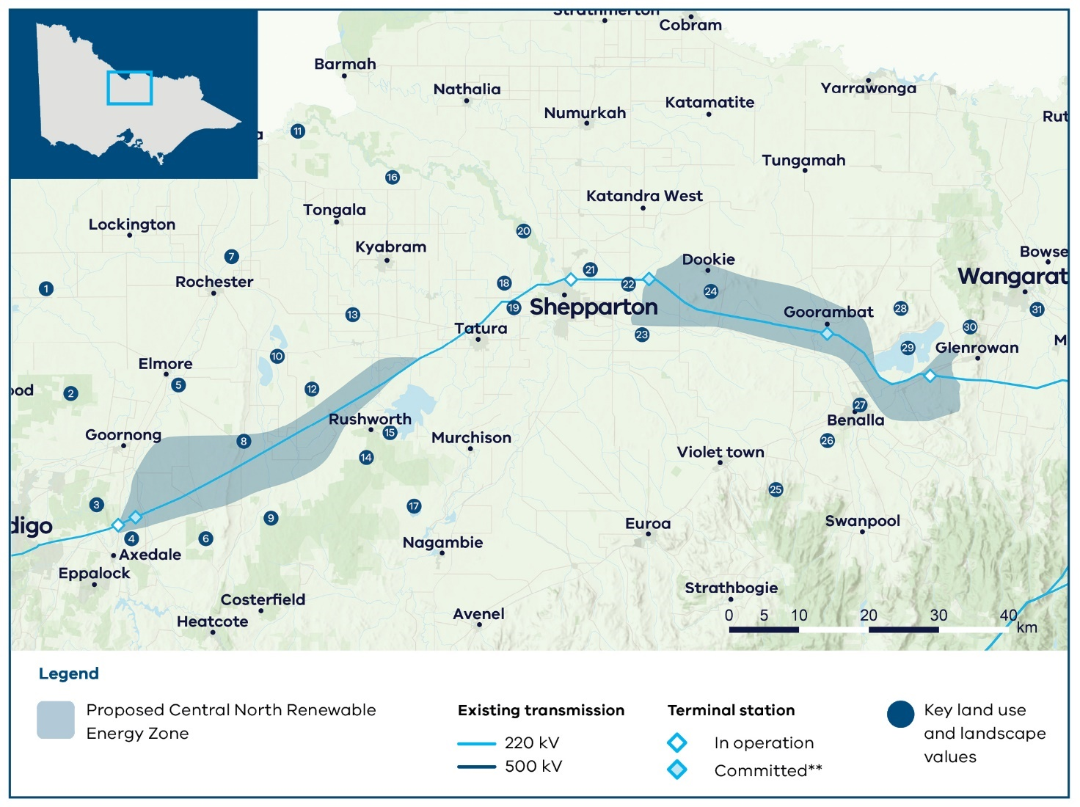

Note: The map shows committed terminal stations including new terminal stations on the Victorian Declared Shared Network that are proposed to be operational in the coming years, as identified by AEMO Victorian Planning in its Terminal Stations in Victoria report dated 2 September 2024.

### Key land use and landscape values

1. Flooding risk: Floodplain and land subject to inundation
2. Biodiversity/cultural/ community: Greater Bendigo National Park and protected biodiversity areas
3. Biodiversity: Mount Sugarloaf Nature Conservation Reserve and surrounding parks and reserves, home to native flora and fauna
4. Mining: Active mine sites and Extractive Industry Interest Areas
5. Biodiversity/cultural: Campaspe River and surrounding areas of sensitivity
6. Biodiversity: Parks, reserves and state forests, home to native flora and fauna
7. Flooding risk: Floodplain and land subject to inundation
8. Biodiversity/cultural/ community: Corop Wetlands Cultural Waterscape, connecting significant waterways, wetlands and landscapes including the Corop wetlands complex in the north, extending south east to Reedy Lake and the forested hills around Rushworth and Whroo, and including the entire Mount Camel Range to the west
9. Biodiversity/cultural/ community: Heathcote Graytown National Park and surrounding parks, reserves and state forests, including protected biodiversity areas for native flora and fauna
10. Biodiversity/cultural: Corop wetlands complex including Lake Cooper, Greens Lake, Gaynor Swamp, Wallenjoe Swamp, Mansfield Swamp and surrounding parks and reserves
11. Biodiversity/cultural: Murray River and surrounding sensitive landscapes
12. Biodiversity: One Tree Swamp and Two Tree Swamp Nature Conservation Reserves, including biodiversity protected areas
13. Agriculture: Agricultural productivity area within the Goulburn Murray Irrigation District, particularly irrigated dairy and cropping
14. Biodiversity/cultural/ community: Corop Wetlands Cultural Waterscape, see value 8 for full description of this waterscape
15. Biodiversity/cultural/ community: Corop Wetlands Cultural Waterscape, see value 8 for full description of this waterscape
16. Biodiversity/cultural: Goulburn River and surrounding areas of sensitivity
17. Biodiversity/cultural/ community: Reedy Lake Nagambie Wildlife Reserve
18. Community: Area of higher aggregated dwelling density around Shepparton
19. Agriculture: Agricultural productivity area within the Goulburn Murray Irrigation District, particularly irrigated dairy and cropping
20. Biodiversity/cultural/ community: Lower Goulburn National Park and surrounding landscapes, including biodiversity protected areas
21. Agriculture: Irrigated agriculture within the Goulburn Murray Irrigation District
22. Flooding risk: Floodplain and land subject to inundation
23. Biodiversity/cultural: Broken River and surrounding areas of sensitivity
24. Biodiversity/cultural/ community: Mount Major
25. Biodiversity/cultural: Strathbogie State Forest, home to native flora and fauna
26. Biodiversity/cultural/ community: Reef Hills State Park including protected biodiversity area for native flora and fauna
27. Community: Area of higher aggregated dwelling density around Benalla
28. Biodiversity: Mount Meg Nature Conservation Reserve, home to native flora and fauna
29. Biodiversity/Cultural: Winton Wetlands and surrounding areas of sensitivity, protected area and home to native flora and fauna
30. Biodiversity/cultural/ community: WarbyOvens National Park
31. Biodiversity/cultural: Ovens River and King River, and surrounding areas of sensitivity

### What we heard

Feedback from this region focused heavily on minimising impacts on agriculture and land use, as well as protecting the natural environment and biodiversity, with many significant wetlands, waterways and parks across the region. Concerns were also raised about flooding, and the impact new infrastructure might have during future flood events.

Local government feedback stressed that the major concern in the region is protecting the irrigation district and water security. Engagement with agriculture sector stakeholders found that farmland across irrigation districts had less opportunity to co-locate wind and solar infrastructure due to the complexity and intensity of operations. However, it was suggested that potential projects in these areas could be considered on a case by case basis. Feedback was also received about areas of high rural dwelling density and projected growth areas. There was support from councils for the regional economic benefits that increased investment in renewable energy infrastructure could bring.

We also considered the positive regional development opportunities for the region when designing the proposed REZ location. In particular, we considered irrigated farmland in the Goulburn Murray Irrigation District. The district contains an extensive network of irrigation channels that supply water to farmers. We sought to avoid overlap with this irrigation district where possible.

During engagement on the draft VTP we heard further concerns about the impact to agriculture and flood risk of new renewable energy projects. We heard about biodiversity concerns, particularly around Lake Cooper, the Mount Camel Range, Gaynor Swamp and One/Two Tree Swamp as part of the Corop wetlands, which include areas of brolga habitat and other species. Additional data identified significant brolga flocking grounds within the draft proposed REZ, which provide restrictions on the planning of new renewable energy infrastructure.

There were also calls to expand or relocate the REZ towards Benalla and Glenrowan, an area with multiple solar projects in development and access to the existing transmission network.

### What we did

Due to the complex land use constraints inside the original draft proposed REZ, coupled with limited developer interest, there have been some substantial changes to the Central North REZ.

A large portion of the draft proposed REZ to the north and northwest has been removed, consolidating the proposed REZ to the area along the 220kV line, minimising the overlap with areas of high biodiversity and cultural values as well as the overlap of the REZ with irrigated agriculture and areas of higher flooding risk. These changes to the north sections of the proposed Central North REZ recognise the uncertainties of development in this area, particularly for wind, and the need for further investigation and engagement through the implementation of the 2025 VTP and future planning in subsequent VTPs.

To replace the section removed, an eastern section of the REZ has been added, running from the east of Shepparton towards Benalla and Glenrowan, picking up Dookie and Goorambat. This new section responds to calls from industry and community to consider the high solar interest in the area towards Glenrowan, with many projects well progressed, and access to existing transmission infrastructure.

We acknowledge that the eastern section of the REZ is new and was not consulted on during the draft 2025 VTP process. We will seek feedback on this area during the REZ declaration process, when there will be a further opportunity to refine the REZ boundaries.

## Gippsland

The proposed Gippsland REZ is in an area of the Latrobe Valley with significant transmission network capacity and good wind resources. Its footprint includes agricultural land and forestry. It sits within the RAP boundaries of the Gunaikurnai Land and Waters Aboriginal Corporation. The existing transmission network capacity was built to connect coal-fired power in the valley. Growing interest has been seen in wind and solar projects in Latrobe and Wellington Shires.

The proposed Gippsland REZ for onshore renewable generation stretches from Morwell in the west towards Sale in the east. It will cover parts of the the Wellington, LaTrobe, Baw Baw and South Gippsland local government areas. The proposed location provides potential for coordinated connections into the 500 kV transmission network around Loy Yang. It is designed to use existing capacity in the transmission network to support new onshore generation.

The wider surrounding region includes farmland, high biodiversity values, areas of natural beauty and significance, and key tourism destinations. The region has one of the state’s most valuable dairyfarming areas with dairy farms across the Latrobe Valley and the Macalister Irrigation District around Maffra. Horticulture is also an important land use.

Australia’s first declared offshore wind area is located off the coast of Gippsland and VicGrid is coordinating development of the transmission that will bring offshore wind energy from the coast to the Latrobe Valley. Part of the proposed Gippsland REZ overlaps with the proposed offshore wind transmission infrastructure. The detailed design of the access scheme and Grid Impact Assessment frameworks is being developed and will be released in our Access and Connections Consultation Paper and draft Grid Impact Assessment (GIA) Guidelines for consultation (see Section 9.2 for more details). However, it is currently anticipated that new onshore generation in the REZ will connect to existing connection hubs in the Latrobe Valley rather than connecting to the new offshore wind transmission line. For more information on REZ access and connection arrangements, see Section 9.2.

### We considered many factors when identifying and refining the shape of the proposed REZ

In addition to the overarching factors outlined in Table 7, we carefully considered regional and local factors and engagement feedback to help identify and refine the REZ shape. These factors included but were not limited to:

* biodiversity and the natural environment
* farmland, particularly local dairy production, and compatibility of farming practices with renewable energy infrastructure
* the Macalister Irrigation District
* national and state parks
* habitat for important species
* areas of high cultural, ecological and community significance nearer the coast
* wind and solar generation projects currently proposed in Gippsland
* publicly available cultural sites and areas of cultural heritage sensitivity identified on the Aboriginal Cultural Heritage Register and Information System
* offshore wind development
* transmission network capacity
* supporting the region’s workforce as coal-fired power closes.

We are committed to having ongoing conversations with Gunaikurnai Land and Waters Aboriginal Corporation to incorporate further cultural heritage information into REZ development and subsequent VTPs, in alignment with the principle of self-determination.

A separate Gippsland Shoreline REZ is being proposed to facilitate connection of offshore wind generation to Victoria’s transmission network. Onshore generation is not intended to be hosted in this area. More information on the proposed Gippsland Shoreline REZ is in Section 7.

Figure 17 shows a map of the proposed Gippsland REZ, including some of the significant land use and landscape values that influenced its location, size and shape. The identified land use and landscape values in the region are a sub-set only and are not exhaustive of the values present.

Figure 17: Proposed Gippsland REZ

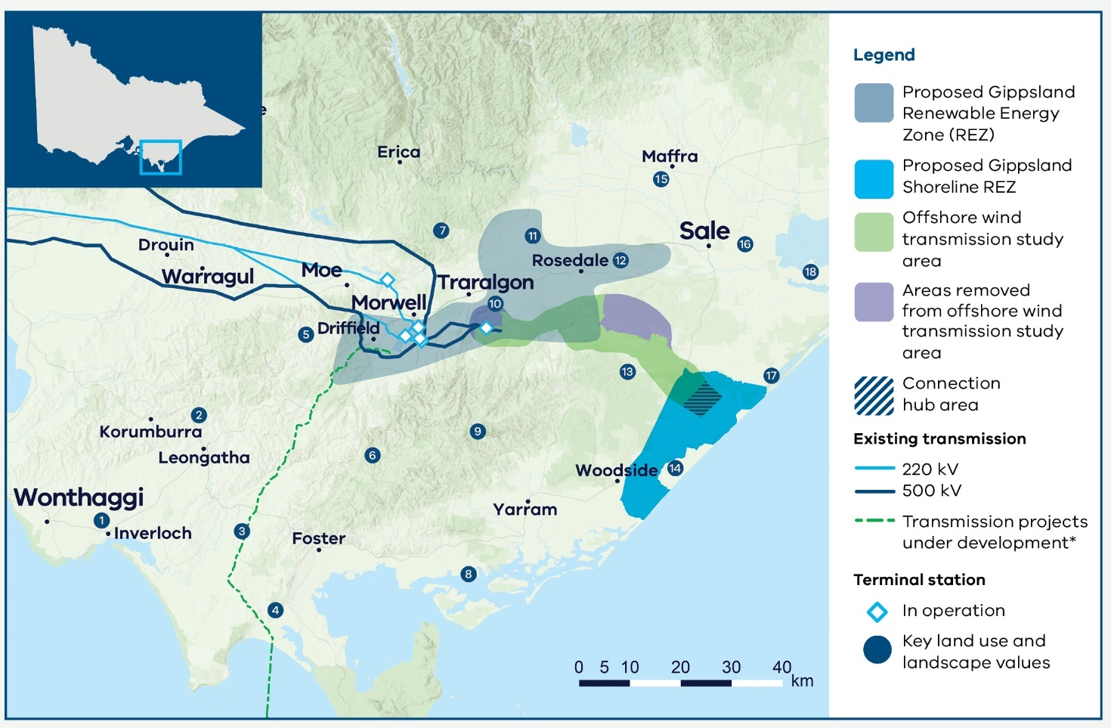

### Key land use and landscape values

1. Community: Bass Coast Distinctive Area Landscape and wind farm prohibition area (Victorian Planning Provisions)
2. Community: Area of higher aggregated dwelling density in west and southwest Gippsland
3. Agriculture: Medium to high productivity agriculture across southwest Gippsland, particularly dairy farming
4. Biodiversity/cultural/ community: Wilsons Promontory and surrounding significant and sensitive landscape
5. Agriculture: High agricultural productivity area and lower compatibility with renewables around Thorpdale, particularly horticulture farming
6. Land use: Restricted and non-restricted use plantation land across the Strzelecki ranges and broader region (Restricted plantation land refers to plantations subject to the Victorian Plantations Corporation Act 1993 (Vic) represent areas of existing productive land use for growing large-scale crops with existing legislative restrictions around co-location with other land uses such as renewable energy generation)
7. Biodiversity: State parks and forests, home to native flora and fauna
8. Biodiversity: Corner Inlet Ramsar-listed wetlands
9. Biodiversity/cultural/ community: Strzelecki Ranges including Tarra-Bulga National Park and surrounding parks and forests, home to native flora and fauna
10. Mining: Active mine site
11. Agriculture: Medium to high agricultural productivity area adjacent to the Macalister Irrigation District
12. Biodiversity/cultural: Latrobe River and surrounding areas of sensitivity
13. Biodiversity/cultural: Mullungdung State Forest and Stradbroke Flora and Fauna Reserve, home to native flora and fauna
14. Biodiversity/cultural: Coastal wetlands and protected biodiversity area for native flora and fauna
15. Agriculture: High agricultural productivity area within the Macalister Irrigation District, including dairy farming
16. Land use: Height restrictions associated with the Royal Australian Air Force base
17. Biodiversity/cultural: Gippsland Lakes Coastal Park and Ramsar-listed wetlands
18. Biodiversity/cultural: Lake Wellington and surrounding sensitive areas

Note: The map shows transmission projects under development including transmission projects defined as Committed and Anticipated or Actionable under the Australian Energy Market Operator’s 2024 Integrated System Plan. This map displays the proposed alignment for Marinus Link.

### What we heard

Feedback focused on the importance of protecting biodiversity and the natural environment, followed by minimising impacts on agriculture and land use. Feedback reflected strong regional pride in the natural beauty of the area and the rich farming tradition. Concerns included protecting the habitat of the giant Gippsland earthworm, Wilsons Promontory, and important agricultural areas including dairy farms in South and West Gippsland, along the coast and in the Macalister Irrigation District south of the Great Dividing Range.

Community members and local governments asked us to consider South Gippsland’s high dwelling density, which adds complexity to developing wind projects. Some feedback focused on personal experiences of stress related to the energy transition, reflecting local impacts of the impending closure of coal-fired power stations, offshore wind development and significant in service and proposed local renewable projects. Other considerations included using existing transmission infrastructure in the Latrobe Valley to support new renewable generation. Local governments also expressed support for regional development opportunities that renewable energy infrastructure could bring, provided regional concerns were addressed.

There was also feedback from the forestry industry about potential co-location opportunities for wind farms in certain circumstances. In addition, considerations were raised about airspace used by the Royal Australian Air Force (RAAF) base in East Sale. During engagement on the draft VTP there was far less feedback about impacts on agriculture and land use and biodiversity concerns due to the siting of the proposed REZ. We did again hear about co-location opportunities with plantation land. We also heard a strong preference for underground transmission and concerns about the impact to current infrastructure.

### What we did

When originally designing this proposed Gippsland REZ, we considered important agricultural areas, in particular dairy farming areas in the south west and the Macalister Irrigation District when shaping the proposed REZ. Through engagement with agriculture industry stakeholders, we identified dairy as a farming practice that is less compatible with wind and solar infrastructure. Some freehold plantation land is included in the proposed REZ, following feedback.

The size and location of the proposed Gippsland REZ takes into account South Gippsland’s high dwelling density and the habitat of the giant earthworm. It has been shaped by significant landscapes including along the Bass Coast, Wilsons Promontory, the Strzelecki ranges and coastal reserves and wetlands.

The proposed REZ’s proximity to the Royal Australian Air Force (RAAF) Base East Sale and other aviation activities means that wind projects will need to consider and propose mitigations to potential aviation impacts in the planning stage. VicGrid will continue to work with the Department of Defence and other stakeholders on development of the draft proposed REZ.

Gippsland has several areas with planning scheme restrictions designed to maintain access to brown coal reserves. A portion of these areas overlap with the proposed REZ and the restrictions will need to be worked through as part of declaring and eventually developing the REZ.

Areas further to the east were also considered due to the potential for regional economic development, but distance from required transmission capacity meant the draft proposed REZ needed to be located closer to existing transmission.

The proposed REZ balances complex land use issues across the region, while also providing coordination with planned transmission capacity and connection points to unlock Victoria’s offshore wind potential.

As a result of feedback on the draft proposed Gippsland REZ no changes were made to the proposed zone. Considering the small size of the proposed REZ and existing land use constraints, we considered options to expand the REZ further east and south east, including further use of plantation land. However, these options were not progressed due to complexities with the proximity to the nearby RAAF base and low flying aircraft, as well as biodiversity and cultural heritage constraints with nearby parks. We consider the proposed REZ appropriate given the overall level of offshore and onshore development proposed in Gippsland, with further opportunities to assess onshore generation in future VTPs.

During the REZ declaration process, there will be a further opportunity to refine the REZ boundaries including with further feedback from communities, Traditional Owners, industry and local stakeholders.

## 6.2 Next steps for finalising the renewable energy zones

The next step after the release of the 2025 VTP is to begin the formal REZ declaration process, which will provide further opportunity for engagement with communities and industry.

### The REZ declaration process

Now that the 2025 VTP has been published, the Minister for Energy and Resources can consider whether to proceed with formal declaration of a proposed REZ. The REZ declaration process requires that the Minister make a declaration in a formal order (Order). The Order will set out key information on the REZ to be declared, including a map of the REZ boundaries and the intended transmission hosting capacity within the REZ. As part of this process, a draft of the Order showing the proposed REZ will be placed on public notice for a minimum of 6 weeks, enabling the community and industry to provide any comments and submissions. The Minister must consider any submissions when determining whether the REZ should be declared under an Order.

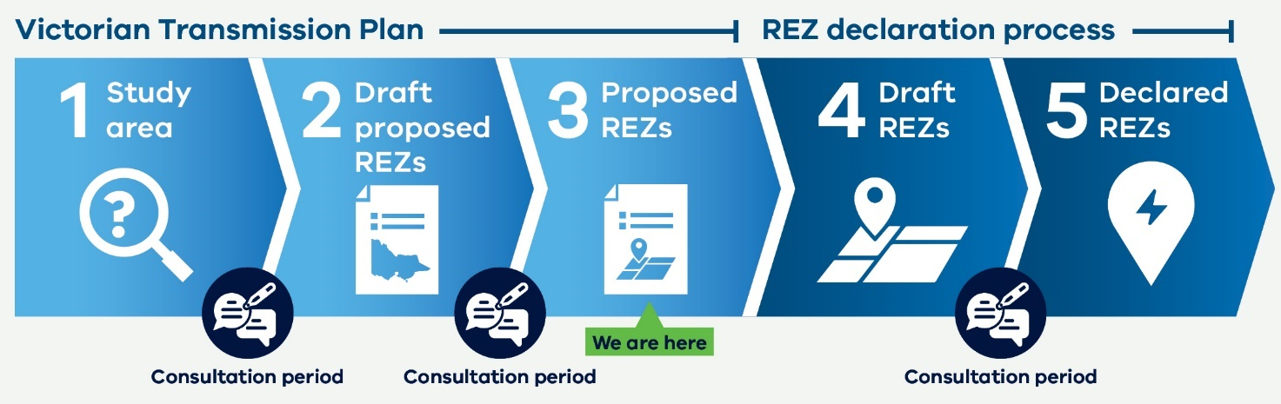

# 7. Planning for offshore wind connections

The 2025 Victorian Transmission Plan (VTP) process takes into account Victoria’s targets for offshore wind generation and the planning that is already under way to develop offshore wind in Victoria.

The Australian Government has declared 2 offshore wind areas in Victoria, off the coast of Gippsland and in the Southern Ocean off the coast of Western Victoria. Planning is most advanced in Gippsland and the next step is to set out suitable shoreline locations for offshore wind developers to connect their infrastructure to the grid.

This 2025 VTP includes a proposed Gippsland Shoreline Renewable Energy Zone (REZ) for offshore wind in the South of Gippsland, which is different to the 6 proposed REZs we have identified to host onshore wind and solar generation. It sets out a designated area for offshore wind developers to site their onshore connection infrastructure, rather than for hosting new onshore generation. The wind turbines themselves will be hosted in Commonwealth waters off the coast of Victoria.

## 7.1 Planning is well under way towards Victoria’s offshore wind targets

The Victorian Government has set ambitious offshore wind generation targets of at least 2 GW of generation capacity by 2032, 4 GW by 2035 and 9 GW by 2040.

Work is well under way towards these targets. In July 2024 the Australian Government granted feasibility licences for 12 potential projects in the Gippsland offshore wind declared area, and in February 2025 a feasibility licence was awarded in the Southern Ocean declared area.

VicGrid is responsible for planning the shared transmission infrastructure needed to connect these future projects to the grid. Preparation for a new Gippsland shared transmission line is already under way to support the first 2 GW of offshore wind. This will avoid the ‘spaghetti effect’ of multiple private transmission lines crossing the landscape, reducing the infrastructure costs that are passed on in consumers’ power bills and helping to minimise impacts on the environment.

The shared transmission infrastructure that VicGrid is planning will connect from the Latrobe Valley to a new connection hub near Giffard. Offshore wind generators are responsible for planning the connection of their offshore infrastructure to the connection hub that VicGrid is developing. For more information, see Section 7.2.

Additional transmission infrastructure will be required to accommodate offshore wind generation beyond the first 2 GW of offshore wind capacity in Gippsland. The need for this has been identified as part of the 2025 VTP (see Section 8). Further work will be done to identify the appropriate route for this infrastructure to ensure it is in place to enable achievement of Victoria’s offshore wind targets. The VTP also proposes upgrades to transmission lines in the Portland area to be carried out in the 2030s to accommodate offshore wind in the Southern Ocean.

### Offshore wind transmission in Gippsland

We are now planning the new transmission infrastructure needed to connect the first 2 GW of offshore wind in Gippsland. Our work to-date has included:

### Strategic options assessment

In 2023, we carried out a strategic options assessment to identify and refine the longlist of feasible transmission project options for both Gippsland and the Southern Ocean. The assessment method was informed by consultation feedback and the principles of the Victorian Transmission Investment Framework (VTIF). It considered social, cultural, economic, environmental and technical factors to evaluate project options.

### Gippsland transmission study area and refinement

In March 2024, VicGrid published the Offshore Wind Energy Transmission Gippsland Options Assessment Report, which identified the preferred study area and preferred transmission technology for connecting offshore wind energy generated off the coast of Gippsland into Victoria’s electricity network.

The Gippsland transmission study area starts approximately 6 km from the coast near Giffard and travels north-west past Stradbroke West to Willung, across to Flynns Creek and then to the Loy Yang Power Station. The study area is about 3 km wide at its narrowest point and up to 12 km at its widest point. The proposed transmission technology is a double circuit 500 kV overhead transmission line.

In December 2024, VicGrid completed preliminary desktop investigations to narrow the study area to areas suitable for further investigations. Areas deemed not suitable to host transmission were ruled out due to a range of factors including the presence of highly sensitive protected species, technical constructability or feasibility challenges.

VicGrid is now working closely with landholders to understand unique features and values of their properties to further refine the study area.

### Environmental assessments

In September 2024, the Minister for Planning declared the Gippsland offshore wind transmission project as public works requiring the preparation of an Environment Effects Statement (EES). This process is currently under way and will involve community consultation and an independent panel review to inform the Minister’s assessment of the project’s environmental effects. The Minister’s assessment will then inform decision-making required under other legislation, including the Environment Protection and Biodiversity Conservation Act 1999 (Cth).

### Procurement

We are now seeking a development partner to work alongside VicGrid to design, build and operate the new transmission line. In December 2024, VicGrid released an invitation for Expressions of Interest (EOI) from leading transmission design and delivery providers with a track record of working with host communities. We expect to complete procurement and appoint a development partner in 2026, in time to support the project’s design and environmental assessments.

Figure 18: Offshore wind infrastructure in Gippsland

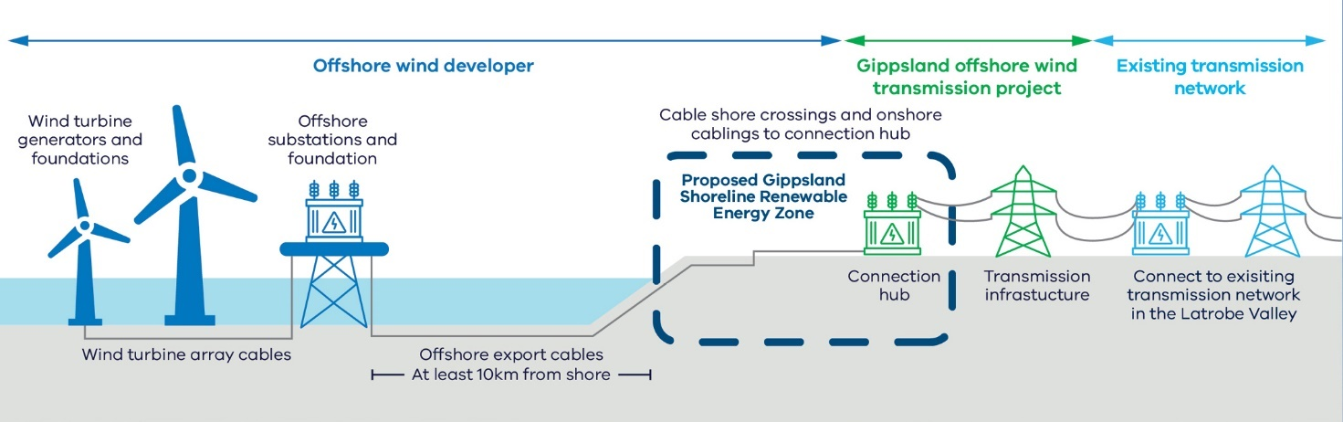

## 7.2 The proposed Gippsland Shoreline REZ is the next critical step What we did

Offshore wind developers in Gippsland will be required to connect to VicGrid’s Giffard connection hub via underground cables to access the shared transmission infrastructure.

While offshore wind developers are responsible for planning of their individual projects, VicGrid is committed to taking a coordination role in the area between the coast and the Giffard connection hub to minimise impacts on coastal communities and landholders. A proposed new Gippsland Shoreline REZ will set out a designated area that enables offshore wind developers to determine suitable routes to the transmission connection hub, while minimising impacts on nearby towns and landscapes.

Establishing the Gippsland Shoreline REZ is also a key step to provide certainty to offshore wind developers on their ability to connect to the transmission network. VicGrid will soon consult on a proposed access scheme for the Gippsland Shoreline REZ. This draft access scheme will set out the intended 2 GW hosting capacity for offshore wind in the Gippsland Shoreline REZ and the process for allocating access to this capacity, along with other requirements. Only offshore wind projects will be eligible to participate in the shoreline REZ.

For more information on REZ access schemes, see Section 9.

## 7.3 Where is the proposed Gippsland Shoreline REZ?

The proposed Gippsland Shoreline REZ is located in the region’s south, near the towns of Woodside and Giffard, and between the coastline and the South Gippsland Highway.

The proposed location of the Gippsland Shoreline REZ has been developed as part of our work to identify a transmission study area and in consultation with prospective offshore wind developers. It takes account of a range of factors, including:

* potential shore crossing locations where offshore wind project export cables will cross the shore
* providing sufficient space for offshore wind developers to plan suitable cable routes to the Giffard connection hub
* avoiding residential areas
* avoiding environmentally and culturally sensitive areas including waterways and waterbodies, areas of high biodiversity value and protected biodiversity value
* minimising major arterial road crossings such as the South Gippsland Highway.

There will be designated areas within the proposed Gippsland Shoreline REZ where offshore wind export cables are allowed to cross the shore.

VicGrid is coordinating further work to identify suitable shore crossing locations for offshore wind projects, which will facilitate greater protection of environmentally and culturally sensitive areas along the coast.

The proposed Gippsland Shoreline REZ sits within the boundaries of the Gunaikurnai Land and Waters Aboriginal Corporation and the Wellington Shire local government area.

The location of the proposed Gippsland Shoreline REZ is illustrated in Figure 19.

Figure 19: Proposed Gippsland Shoreline REZ

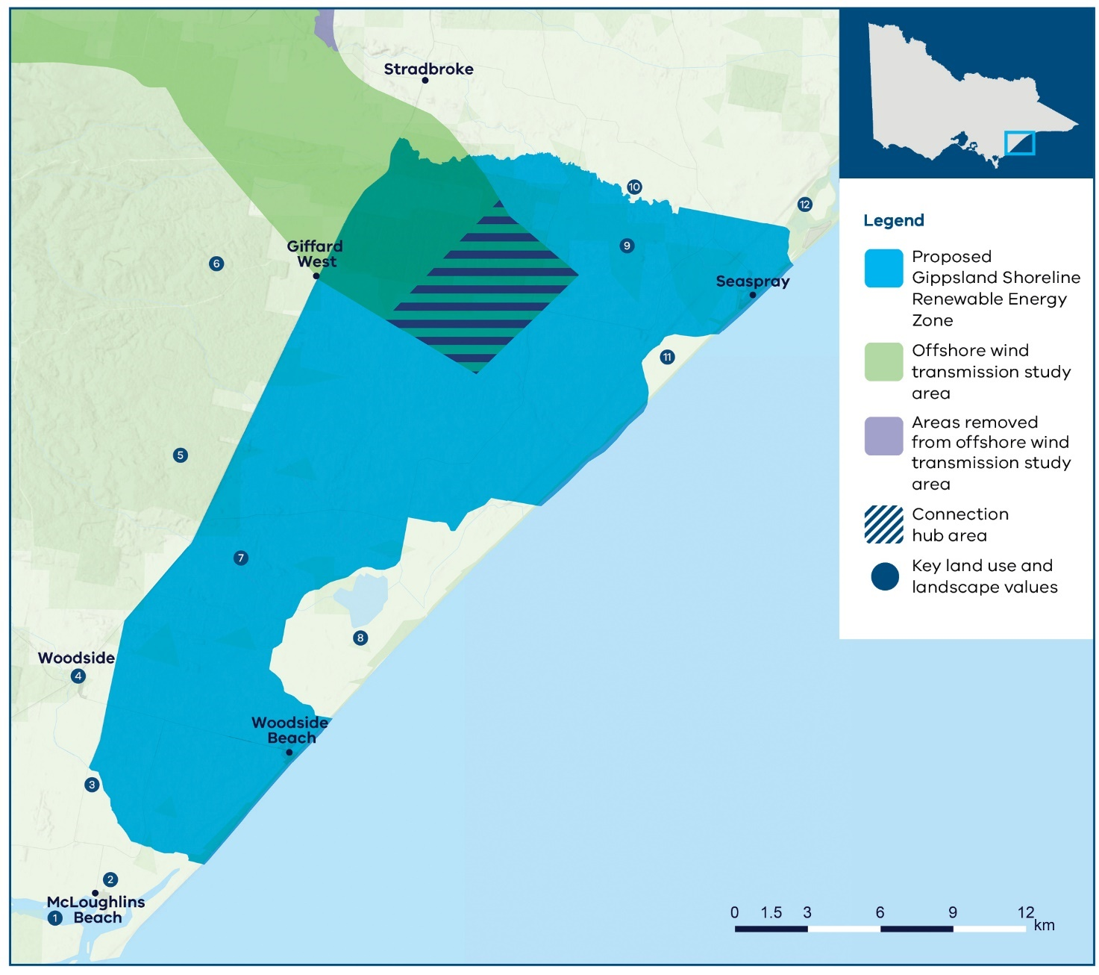

### Key land use and landscape values including REZ boundary considerations

1. Biodiversity: Corner Inlet Ramsar-listed wetlands
2. Community: McLoughlins Beach residential area
3. Biodiversity/cultural: Bruthen Creek
4. Community: Woodside town and residential area
5. Biodiversity/cultural: Mullungdung Flora and Fauna Reserve, home to native flora and fauna
6. Biodiversity/cultural: Mullungdung State Forest and Stradbroke Flora and Fauna Reserve, home to native flora and fauna
7. Biodiversity: Protected biodiversity area
8. Biodiversity/cultural: Coastal wetlands and protected biodiversity area
9. Biodiversity: Area containing high biodiversity values
10. Biodiversity/cultural: Merriman creek
11. Biodiversity/cultural: Lake Denison wetlands
12. Biodiversity/cultural: Gippsland Lakes Coastal Park and Ramsar-listed wetlands

### What we heard

During engagement on the draft VTP, the feedback received in relation to the Gippsland Shoreline REZ included:

* Mixed feedback from different stakeholder groups on the size of the Gippsland Shoreline REZ, with some calling for a reduction in the size of the REZ to minimise impacts on community and landholders and others calling for an increase to the REZ to allow greater flexibility for determining onshore cable routes for offshore wind development.
* Requests to ensure the Gippsland Shoreline REZ captured the full extent of feasible shore crossing areas.
* Concerns raised over the management of overlapping onshore cable corridors within the Gippsland Shoreline REZ.
* Concerns over the proximity of the Gippsland Shoreline REZ to key ecological and culturally sensitive sites such as Ramsar wetlands and other coastal reserves.
* Requests to expand the Gippsland Shoreline REZ to include viable onshore wind areas in the Giffard and Darriman areas.

For more detail about feedback in relation to the Gippsland Shoreline REZ, read the Draft 2025 Victorian Transmission Plan Final Engagement Report –What We Heard at [engage.vic.gov.au/ victransmissionplan](https://engage.vic.gov.au/victransmissionplan)

### What we did

Minor amendments to the boundaries of the Gippsland Shoreline REZ have been made, particularly along the coastline, to ensure all feasible shore crossing areas are contained within the boundaries of the REZ. This provides offshore wind developers with the opportunity to fully explore the range of appropriate potential shore crossing sites.

# The optimal development pathway for Victoria

VicGrid has identified the transmission network upgrades that will be needed to support Victoria’s energy transition over the next 15 years. We’ve grouped these investments into work programs and identified when each will be needed to support renewable energy zone (REZ) development and maintain energy security and reliability.

Together, the programs and their timings make up the optimal development pathway.

We developed 3 candidate development pathways, each designed to meet a different scenario of future energy needs. The one that was most robust to future uncertainty and provided greatest net benefit for Victorians was selected as the optimal development pathway. This decision took into account network reliability, keeping costs as low as possible for consumers, and minimising social and environmental impacts. For more information about the 3 scenarios we considered, see Section 2.

## 8.1 The optimal development pathway

The optimal development pathway sets out 7 programs of transmission investments to be delivered by 2040. These programs are designed to support development of the proposed REZs, taking into account the expected types and locations of new generation and storage projects over the next 15 years.

The proposed programs will increase capacity in important parts of Victoria’s transmission network and maintain network security and reliability. They are designed to ensure a smooth transition as coalfired power stations close and Victoria’s electricity demands grow.

The optimal development pathway builds on projects that are already under development or in construction. This includes Western Renewables Link (WRL), Victoria to New South Wales Interconnector West (VNI West), Marinus Link Stage 1 and the transmission infrastructure required for the first 2 GW of offshore wind in Gippsland.

Some of the proposed transmission programs in the VTP are needed urgently to prepare for coal-fired power stations to close and avoid bottlenecks in delivering new generation and storage infrastructure, including new renewable projects supported by the Australian Government’s Capacity Investment Scheme. Of the 7 programs, 2 are needed by 2030, 3 are needed by 2035 and 2 are needed by 2040.

The optimal development pathway supports the achievement of the Victorian Government’s targets for renewable energy, offshore wind and storage. Two of the transmission programs have been designed to unlock offshore wind in the Southern Ocean and Gippsland declared areas.

Where possible, we prioritised upgrades along existing transmission lines. This minimises impacts on landholders, regional communities and the environment and limits cost impacts on consumer power bills. At the same time, we recognise rebuilding existing transmission infrastructure can have significant impacts on local communities.

The VTP includes 4 new transmission projects across 3 programs: a second radial line and tie in loop in Gippsland to facilitate offshore wind, a new line between Sydenham and Tarrone, a new line between Truganina and Deer Park, and an additional short line between Hazelwood and Yallourn. The remaining projects across the 7 programs range from augmentations within existing terminal stations to significant reconstruction of existing transmission lines. The optimal pathway includes upgrading about 430 km of existing lines and about 380 km of new lines.

Australia’s interconnected energy system is undergoing a significant transition. Multiple large, complex and expensive transmission, generation and storage projects are in different stages of development, and timing for completion of these projects may change.

VicGrid recognises that long term plans involve a level of uncertainty, with potential changes in project scope and timeframes. The VTP includes assumptions that proposed projects will proceed as planned but is also flexible to allow for future changes to these projects.

The *National Electricity (Victoria) Act* 2025 (NEVA) allows VicGrid to update the VTP if there are significant changes in project delivery and timeframes.

The optimal pathway is designed to meet the energy needs that would occur in scenario 1. It is also robust to the other possible futures considered in scenarios 2 and 3, should future energy needs change. In this regard, the pathway is flexible to changes in future energy demand and transmission programs can be brought forward if the need arises, or deferred. If energy demand increases rapidly, as in scenario 2, we can add 3 additional programs to the optimal pathway to address the need for more generation in the proposed REZs. For more information on how robustness analysis can be used for different scenarios, see Appendix D.

Table 9 describes each of the transmission programs, their timing, and why they are needed. For a full description of the proposed projects in each of the 7 programs, see Appendix A.

### Investments to support system strength

System strength is a characteristic of an electric power system that ensures stable voltage and operation during faults or disturbances, to keep generators online and protect the system from events such as lightning strikes.

System strength will be critical in the future as Victoria transitions to more renewable generation. Without coal-fired generation, system strength can be provided by other technologies such as synchronous condensers – large rotating machines – to regulate voltage and network stability.

High-level assessments undertaken by VicGrid indicate there may be need for additional investments into system strength statewide and in the Latrobe Valley. There are different regulatory mechanisms to support the delivery of system strength and further analysis will be undertaken to further understand the need and determine the most appropriate regulatory mechanism for their delivery. Additional details on potential investments to support system strength are included in Appendix A.

The 7 priority programs below describe what is needed over and above existing transmission projects that are already under development across Victoria.

### Projects already under development

The following projects have been factored in as inputs to the 2025 VTP and are being progressed:

* Marinus Link stage 1
* Victoria to New South Wales Interconnector West (VNI West)
* Western Renewables Link
* Gippsland offshore wind transmission stage 1
* Renewable Energy Zone Development Plan stage 1

Table 9: The 7 priority programs of transmission upgrades

|  |  |  |
| --- | --- | --- |
| **Program** | **Why it is needed** | **Proposed year needed** |
| 1. Western Victoria reinforcement program: A collection of network augmentations and upgrades of existing infrastructure. | To support connection of onshore wind and solar generation in the proposed Western, Central Highlands and South West REZs and reinforce the network supply to metropolitan Melbourne. | Between 2028 and 2030 |
| 1. Eastern Victoria reinforcement program: A suite of network augmentations and upgrades of existing infrastructure, as well as an additional line between Hazelwood and Yallourn. | To meet increased demand in eastern metropolitan Melbourne, respond to shifting supply from the east of Victoria to the west of Victoria and ensure connection and security of supply from the proposed Gippsland and Central North REZs and the Gippsland offshore wind area. | Between 2028 and 2030 |
| 1. North West strengthening program: Replacement of sections of the existing single circuit transmission with a new high capacity double circuit line. | To support additional generation in the proposed Western and North West REZs and facilitate its transfer to areas of high energy demand. | By 2035 |
| 1. South West expansion program: A new double circuit 500 kV line and associated works in South West Victoria. | To meet significant demand for high-quality wind generation in Victoria’s west, including additional generation in the proposed South West and Central Highlands REZs. | By 2033 |
| 1. Gippsland offshore wind transmission stage 2 program: A new transmission loop to support offshore wind. | Building on the first Gippsland offshore wind transmission project, this new program is required to connect additional offshore wind generation in the Gippsland offshore wind area to meet Victoria’s 2035 and 2040 offshore wind targets. | Between 2033 and 2038 |
| 1. Latrobe Valley strengthening program: New power flow controllers and dynamic load rating devices in the Latrobe Valley. | To allow for easier integration of wind and solar into the grid, manage significant power flows and  address network congestion. It supports connection and transfer of generation from the proposed Gippsland REZ and Gippsland offshore wind area. | Between 2034 and 2035 |
| 1. Offshore wind upgrade: Uprating of existing lines from Heywood to Portland. | To connect offshore generation from the Southern Ocean offshore wind area to Portland. | 2038, or earlier, to align with the timing of offshore development in the Southern Ocean offshore wind area) |

### Why Victoria’s transmission network needs to change

The demands on Victoria’s transmission network are changing rapidly. We urgently need to modernise our grid to connect new sources of energy supply and keep up with changing patterns of energy consumption across the state. These changing demands are influenced by:

* new supply locations as the energy mix shifts from coal to renewables, including offshore wind
* increasing development of variable renewable energy such as wind and solar, which alters system security and strength requirements
* growth of consumer energy resources (CER) such as rooftop solar, batteries and electric vehicles (EVs), which is contributing to increasing two-way energy flows as well as lower levels of minimum demand
* increasing electricity consumption and peak electricity demand during the energy transition.

### What we heard

During engagement on the draft VTP, feedback about transmission planning and the optimal development pathway as a whole included concerns about the impacts of transmission delivery, supply chain constraints, alternative solutions, the delivery timelines and cost estimates. We also received feedback about specific priority programs and the consideration of connection infrastructure and distribution networks.

Industry called for clarity on transmission delivery timelines, especially for projects nearing commercial readiness with delays potentially jeopardising investment certainty and potentially causing supply chain disruption. There were calls to consider alternative plans and potential routes. The view from industry on the cost estimates was that they were too optimistic and there was a desire for greater transparency on costing assumptions. There was some criticism from industry about WRL and VNI West being considered as committed projects. In addition, there was feedback that the draft VTP focused too narrowly on transmission-based REZs, overlooking viable and cost-effective alternatives such as distribution-based REZs, which are framed as delivering faster, lower-cost and more community-aligned outcomes for regional and rural areas.

For more information, read the Draft 2025 Victorian Transmission Plan Final Engagement Report - What We Heard at [our Engage Victoria web page](https://engage.vic.gov.au/victransmissionplan).

### What we did

VicGrid has refined the transmission programs through further power systems analysis and collaboration with our network partners. We have also undertaken a re-costing and delivery schedule review with input from industry to revise the transmission projects’ cost estimates and delivery dates. Section 8.4 contains more detail on revised project cost estimates. The delivery review noted that the supply chain for transmission infrastructure is challenging, resulting from increasing electrification and the energy transition globally. Collaboration with key suppliers will form part of our overall delivery strategy.

Feedback about specific programs will be considered as we undertake detailed project assessments, development and delivery planning. There will be further opportunities for consultation at each stage of this planning process. For more detail, see Section 10.

WRL has a key role to play in securing Victoria’s energy future and supporting the transition from coal to renewables. The project is currently going through an Environment Effects Statement (EES) process. VicGrid is working closely with AEMO to support the early delivery of VNI West and the Victorian and Commonwealth Governments have jointly committed to deliver VNI West 2 years ahead of its originally scheduled date. As such, both projects remain as baseline inputs into the 2025 VTP and will continue to be subject to a thorough planning process.

VicGrid has examined feedback about greater integration with the distribution networks and plans to undertake joint planning with the Victorian distribution network in the development of the 2027 VTP. VicGrid is designing a proposed approach to improve coordination of connection infrastructure. Details will be released for feedback in the Access and Connections Consultation Paper. For more information, visit [our Engage Victoria web page](https://engage.vic.gov.au/vicgrid).

## 8.2 Where are the proposed transmission programs?

The proposed transmission programs are located across Victoria, linking proposed REZs and offshore wind areas to demand centres and the greater Melbourne area.

Two of the programs are located primarily in greater Melbourne and the remaining 5 are located primarily in Victoria’s regions, with connecting infrastructure in greater Melbourne. For a map of project locations, see Figure 20.

While most programs involve upgrading and rebuilding existing infrastructure, 3 of the programs need new infrastructure that is likely to require new transmission easements to be developed. For new developments, the VTP has identified a need for these projects but has not yet identified a preferred route. VicGrid will consult publicly to determine a study area for these projects before identifying preferred corridors.

Figure 20: The optimal development pathway program map

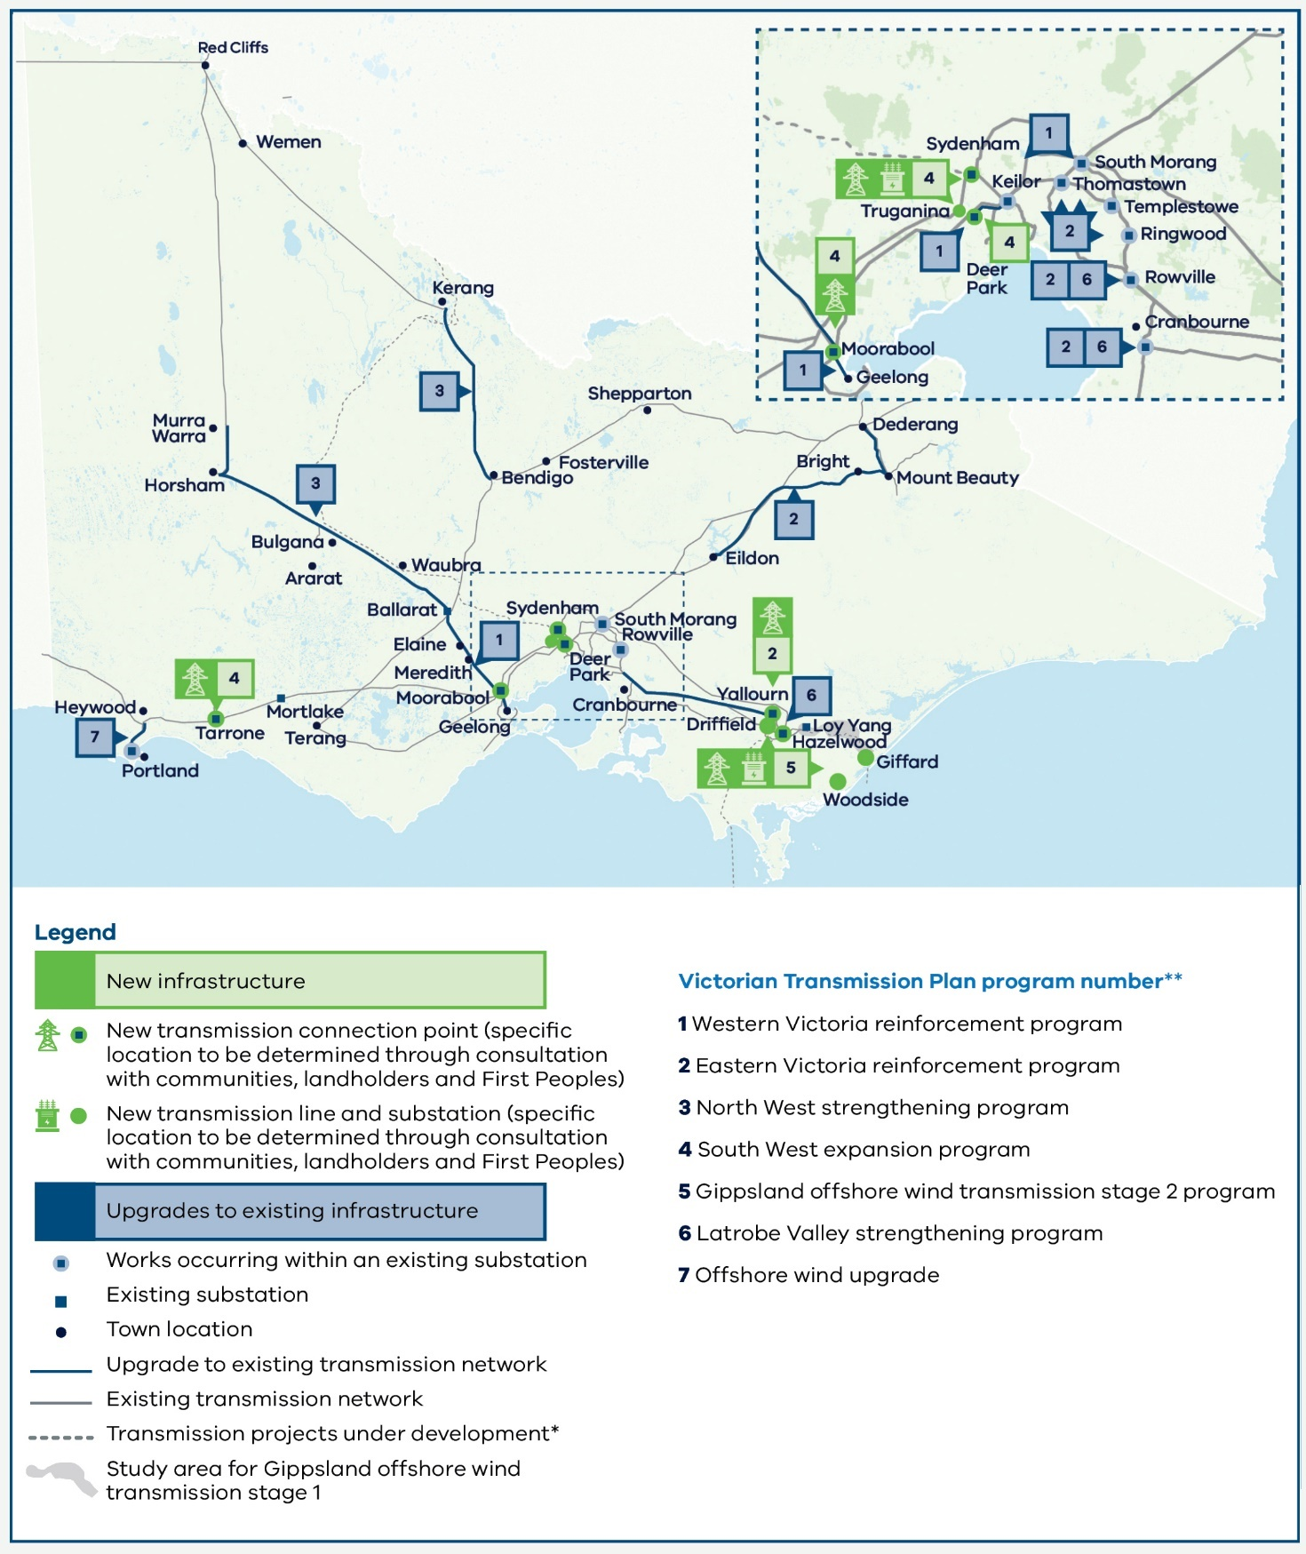

Note: This includes transmission projects defined as Committed and Anticipated or Actionable under the Australian Energy Market Operator’s 2024 Integrated System Plan. This map displays proposed alignments for Marinus Link, Victoria to New South Wales Interconnector West (VNI West), Western Renewables Link and the Gippsland offshore wind transmission stage 1. The Renewable Energy Zone Development Plan stage 1 project includes several network augmentations that are not included in this map.

Note: Each program includes multiple transmission projects. See Appendix A for further details about the proposed works included in each program.

## 8.3 What other options did we consider?

Three candidate development pathways were developed to meet the energy system needs in each of the 3 scenarios. For more information about the 3 scenarios, see Section 7.3 and Appendix B.

This section outlines the candidate pathways designed for scenarios 2 and 3. Where multiple options were available, we evaluated these to ensure the best project was included to address the identified needs. We used the transmission planning considerations outlined below to assess the alternatives and select the project that would be tested as part of the candidate pathway. For more details about projects and their alternatives, see Appendix A.

### The 5 factors we used to assess potential transmission projects

There were 5 key considerations when prioritising potential transmission projects for inclusion in the candidate development pathways. For details, see Appendix A.

* Network performance (including reliability, security, thermal capacity, curtailment)
* Indicative delivery cost
* Land use, community acceptance and Traditional Owner perspectives
* Delivery timing and constructability
* Long-term future network requirements

We also completed an initial assessment of non-network solutions in the development of the candidate development pathways. Non-network solutions may reduce, defer or replace the need for network investment, reducing system costs and the impact on consumers.

### Non-network solutions

The Australian Energy Market Operator (AEMO) defines a non-network option as a “solution or service that provides an alternative to investment in transmission system apparatus, such as transmission lines or substations.”

Battery storage is an important type of non-network solution that we have assessed in developing the candidate development pathways. The VTP energy market modelling optimises the location of generation across Victoria and the National Electricity Market (NEM) by considering the quality of renewable resources against the cost of transmission needed to support that generation. Battery storage is included in this optimisation. Battery storage is also employed in several system integrity protection systems which allow better use of important transmission assets.

More detailed assessment in the project design phase could highlight additional potential for nonnetwork solutions to replace, defer or supplement network solutions currently in the candidate development pathways and thereby reduce costs for consumers. Projects may also be delivered through a technology-neutral procurement process where interested parties may propose alternative nonnetwork solutions.

All the candidate development pathways represent an ambitious program of transmission investment and it is important to ensure that the proposed timeframes are achievable. We developed the proposed timings based on power systems modelling of network needs as well as a project deliverability assessment.

For more information about detailed planning and delivery of projects under the optimal development pathway, see Section 10.

### 8.3.1 Candidate development pathway 2

Candidate development pathway 2 has been developed to meet the significantly higher future energy demand of scenario 2. This scenario considers a potential future where new energy-intensive industries are established in regional and central Victoria at scale, such as data centres, hydrogen production and green aluminium.

The industry development and scale of energy demand in scenario 2 exceeds the levels seen in scenarios 1 and 3, resulting in a need for nearly double the amount of onshore generation by 2040 compared to scenario 1. Candidate pathway 2 therefore also outlines the largest need for transmission. In particular, it includes 3 additional programs of investments:

* Program 8: Sydenham to Keilor link – a new circuit between Sydenham and Keilor to support the distribution of power from the proposed REZs to Melbourne.
* Program 9: Central North Victoria strengthening program – a program of works to facilitate the transfer of increased power from the Central North proposed REZ to areas of high energy demand.
* Program 10: Inner South West strengthening program – a program of works to add increased capacity and resilience to the inner southwest area of Victoria and support the transfer of power from the proposed South West, Western and North West REZs.

This candidate pathway also includes an extension of the South West expansion program from Tarrone to Heywood, and an additional project as part of the North West strengthening program between Kerang and Red Cliffs. For more details about the projects in candidate development pathway 2, see Appendix A.

### 8.3.2 Candidate development pathway 3

Candidate development pathway 3 has been developed to meet the future generation and energy demand needs in scenario 3. Scenario 3 considers a potential future where there may be delays of up to one year in delivering new energy infrastructure. There may also be reduced growth in coordinated consumer energy resources reflecting broad challenges across the NEM, and other NEMGovernment policies and targets may be delayed as well. The scenario also considers a potential future in which Marinus Link Stage 2 is not built.

Candidate pathway 3 includes the same 7 programs as the optimal development pathway.

This candidate pathway also sees some programs deferred by one year to coincide with the infrastructure delays broadly considered in scenario 3.

For more details about the programs and projects in candidate development pathway 3, see Appendix A.

Table 10 summarises the proposed transmission programs for all 3 candidate development pathways, and the differences between each pathway and delivery date.

Table 10: Differences between the 3 candidate development pathways

|  |  |  |  |
| --- | --- | --- | --- |
| **Program** | **Delivery date for candidate development pathway 1 (the optimal pathway)** | **Delivery date for candidate development pathway 2** | **Delivery date for candidate development pathway 3** |
| 1. Western Victoria reinforcement program | Between 2028 and 2030 | Between 2028 and 2030 | Between 2028 and 2030 |
| 2. Eastern Victoria reinforcement program | Between 2028 and 2030 | Between 2028 and 2030 | Between 2028 and 2030 |
| 3. North West strengthening program | 2035 | 2034 (accelerated timing relative to candidate development pathway 1) | 2035 |
| 4. South West expansion program | 2033 | Between 2032 and 2038 (accelerated timing relative to candidate development pathway 1) | 2034 (deferred timing relative to candidate development pathway 1) |
| 5. Gippsland offshore wind transmission stage 2 program | Between 2033 and 2038 | Between 2033 and 2038 | Between 2034 and 2039 (deferred timing relative to candidate development pathway 1) |
| 6. Latrobe Valley strengthening program | Between 2034 and 2035 | Between 2034 and 2035 | 2035 |
| 7. Offshore wind upgrade | 2038 | 2038 | 2039 (deferred timing relative to candidate development pathway 1) |
| **Additional programs for candidate development pathways 2 and 3** | | | |
| 8. New Sydenham to Keilor link | Not applicable | 2035 | Not applicable |
| 9. Central North strengthening program | Not applicable | Between 2033 and 2035 | Not applicable |
| 10. Inner South West strengthening program | Not applicable | Between 2031and 2038 | Not applicable |

## 8.4 Benefits of the optimal development pathway

The proposed investments set out in the optimal development pathway will provide a foundation for Victoria’s transition to renewable energy.

By unlocking critical capacity constraints along parts of the transmission network, the work programs will support investment in new renewable generation to meet Victoria’s needs as coal-fired power stations close. The programs will also improve reliability and system strength as energy demand continues to grow.

The optimal development pathway is a key foundation for achieving the Victorian Government’s legislated renewable energy targets, including for generation, storage, and offshore wind.

### Transmission project costs

The transmission infrastructure market is dynamic and has experienced sharp increases in costs in recent times. Key drivers of change have been increasing global demand from energy transition and electrification, rising raw materials, labour and contracting costs, supply chain constraints and market capacity pressures. Suppliers and construction companies are also facing substantial rises in overheads, including insurance for larger contracts, logistics of increasingly globalised operations and environmental offset costs. Transmission projects are also undertaking more extensive community and stakeholder engagement activities, which also contributes to increased delivery costs.

Since the draft VTP was released, VicGrid has reviewed its cost estimates for projects across the candidate development pathways using industry benchmarks and data sources. This review has resulted in an increase in the estimated project costs. AEMO published an updated transmission cost database in late May and the cost increases estimated by VicGrid largely align with the increases in this database.

The costs have been estimated based on Class 5 estimates (+100%/-50%), as per the Association for the Advancement of Cost Engineering International Cost Estimate classification system. This is typical of cost estimates at this stage of project definition. Cost estimates will be refined further and increase in accuracy as projects are designed in detail in subsequent stages and engineered into fully costed solutions.

The transmission costs reflect capital expenditure of the projects and do not include operating and maintenance expenditure, although allowances for operations and maintenance costs are included in the cost-benefit analysis. The costs also exclude allowances for land acquisition, VicGrid and development/delivery partner, financing, and risk and escalation costs. These exclusions are consistent with the Class 5 estimate level, however VicGrid has undertaken sensitivity analysis to consider the impact of increased costs on the cost-benefit analysis.

Economic cost estimates are produced for the purpose of the VTP’s economic analysis and are not equivalent to financial costs. For example, economic costs exclude financing costs (interest payments) and are based on real rather than nominal values. The total, unescalated economic cost of the optimal development pathway is $7.9 billion. Some of this cost must be incurred even if the optimal development pathway is not delivered, for example, because they relate to the end-of-life replacement of critical assets or relate to offshore wind transmission infrastructure required to meet the legislated offshore wind targets. Because these projects must go ahead, our economic analysis adjusts for this. After these adjustments, and others that reflect expected escalation above inflation, the total net economic cost of the projects in the optimal development pathway is $6.6 billion, or $4.2 billion in present value terms. All values are expressed in real terms in financial year 2025 dollars. The present value cost is calculated assuming a 7 per cent discount rate (real). For more detail on how we have calculated economic costs, see Appendix D.

This cost will enable delivery of the 7 programs of transmission investments by 2040 that deliver the benefits of the VTP and support future development of the proposed REZs described in Section 6.

### Economic appraisal results

The optimal development pathway will deliver significant benefits to Victorians and consumers across the NEM, by making it possible to build new renewable generation capacity in the right places and at the right time to meet demand. The transmission upgrades will reduce the total amount of new generation that Victoria needs to build, compared with an alternative future where Victoria doesn’t continue to invest in the transmission network beyond committed projects. This will minimise the costs that are ultimately passed on to consumers in power bills.

The transmission investments will also allow renewable generation to be built sooner, meaning Victoria will need to use coal-fired generation less intensively in the coming years before coal plants close. This brings additional benefits to Victoria by avoiding fossil fuel emissions.

The economic and environmental benefits described above are separate to the new benefits arrangements that VicGrid is implementing for landholders, Traditional Owners, neighbours and communities near new transmission infrastructure. For more information about these benefits, see [engage.vic.gov.au/vtif-rez-community-benefits](https://engage.vic.gov.au/vtif-rez-community-benefits)

The costs and benefits of the optimal development pathway were evaluated through an economic appraisal, which includes 3 key components:

* cost benefit analysis (CBA)
* consumer bill impact analysis
* macroeconomic modelling.

The approach to, and results of, the economic appraisal are detailed in Appendix D.

### 8.4.1 Cost benefit analysis

The CBA compares the system-wide costs and benefits of each candidate development pathway. Costs include capital and operating expenditures, while benefits fall into 3 broad categories:

* Market impacts – changes in the variable operating costs incurred to generate electricity, as well as reliability benefits, avoided voluntary load curtailment and avoided gas constraint violation costs.
* Social impacts – benefits to society that result from decreased greenhouse gas emissions, a reduction in health expenditure and changes to embodied emissions.
* Commercial impacts – avoided generation capital and operating costs and net residual value of infrastructure at the end of the appraisal period.

The following tables detail the cost benefit analysis results for the optimal development pathway (present value, $FY25)

Table 11 Benefit – Cost benefit analysis results, optimal development pathway (present value, $FY25)

|  |  |  |
| --- | --- | --- |
| Impact type | Item | Value |
| Market impact | Avoided generation variable costs | $5,300m |
| Market impact | Improved reliability | $400m |
| Market impact | Avoided demand side participation costs | $0 |
| Market impact | Avoided gas constraint violation costs | $600m |
| Social impact | Avoided emissions | $6,050m |
| Social impact | Avoided health costs | $0 |
| Social impact | Net embodied emissions | -$300m |
| Commercial impact | Avoided generation capital expenditure | $1,450m |
| Commercial impact | Avoided generation operating and maintenance expenditure | $300m |
| Commercial impact | Net residual asset value | $450m |
|  | **Total benefits** | **$14,250m** |

Table 11 Cost – Cost benefit analysis results, optimal development pathway (present value, $FY25)

|  |  |
| --- | --- |
| Item | Value |
| Capital expenditure | $4,200m |
| Operating expenditure | $450m |
| Total | **$4,650m** |

Table 11 Economic indicators – Cost benefit analysis results, optimal development pathway (present value, $FY25)

|  |  |
| --- | --- |
| Item | Value |
| Net Present Value | $9,600m |
| Economic Internal Rate of Return | 19% |

The CBA assesses the core candidate development pathways against the following economic indicators:

* Net Present Value (NPV) – gives an indication of the magnitude of the net benefit to society, calculated by taking the difference between the present value of the total incremental benefits and the present value of the total incremental costs. A positive NPV indicates that an investment is desirable to society as a whole.
* Economic Internal Rate of Return (EIRR) – the discount rate that makes the NPV of a pathway equal to zero by equating the present value of benefits to the present value of costs. The EIRR is used to determine whether a project should proceed through comparison to an appropriate discount rate.

The NPV of the optimal development pathway is $9.6 billion. This is driven by a significant reduction in gas generation which decreases generation variable costs and reduces emissions (when compared against a future without the optimal development pathway). The optimal development pathway also provides substantial uplift to transfer capacities across the transmission network, reducing the need for new generation and storage capacities. This drives significant savings in generation capital expenditure and operating and maintenance expenditure.

*Potential cost of not delivering the VTP*

This plan will deliver cheaper and reliable power for homes and businesses, lowering annual Victorian energy bills by $20 for households and $50 for businesses compared to not implementing the plan.

Not implementing the plan will prevent new, cheap renewables from being connected, risking energy security, pushing up energy bills and ultimately costing the economy $9.6 billion over the next three decades.

*Consumer bill impact analysis*

Delivering the optimal development pathway and facilitating generation in the renewable energy zones is expected to result in lower electricity bills for Victorians compared to an alternative future without the optimal development plan.

Energy bills comprise several components, including transmission charges and wholesale electricity charges. Delivering the transmission projects on the optimal development pathway is expected to increase the transmission component of energy bills by $14 per household and $34 per small business annually (real $2025).

However, this is offset by a reduction in wholesale electricity costs as a result of the generation and storage unlocked by the optimal development plan. Overall VicGrid’s modelling suggests that Victorian energy bills could be $20 lower per household and $50 lower per small business each year (real $2025). Further details are provided in Appendix D.

# Part C: Delivering the VTP

# Developing renewable energy zones

Introducing renewable energy zones (REZs) will shape how renewable development occurs in Victoria. This will have different impacts for regional communities and landholders, First Peoples and industry.

The development of REZs will provide certainty for investors and enable private investment in generation, storage and supply chains across Victoria’s regions. This investment in regional infrastructure will bring job opportunities and other local economic benefits for host communities.

Following the publication of this 2025 Victorian Transmission Plan (VTP) and the formal declaration of REZs, VicGrid will work together with communities and industry to develop these REZs over the coming years. This will involve engaging with communities located within REZs, prioritising jobs and other economic benefits for local communities, Traditional Owners and First Peoples, and working with investors and developers to strengthen coordination of generation and storage investments.

## 9.1 What to expect as REZs are developed

### 9.1.1 For communities and landholders

Communities in declared REZs will see increased investment in renewable generation and storage infrastructure over time. VicGrid is committed to ensuring that new development is coordinated to minimise impacts on landscapes and the environment, while delivering economic benefits to rural and regional communities.

As it was prior to the release of this plan, generation and storage project developers will be able to identify specific locations of interest within a REZ. Renewable development companies will need to negotiate with landholders for rights to develop projects on their land and a landholder has a right to say no to having new renewable generation on their property. Landholders who agree to new renewable development will receive financial compensation that is negotiated with the developer.

All proposed projects will continue to be subject to the planning and environmental approval processes under the Planning and Environment Act 1987 and Environment Effects Act 1978.

The establishment of REZs creates an opportunity for rural and regional communities to harness the economic development opportunities associated with renewable energy projects. VicGrid is committed to working together with REZ communities to realise these opportunities and build long-term, communitywide benefits from the renewable energy transition.

#### REZ Community Benefits

As part of establishing REZs, VicGrid is introducing new benefits arrangements for communities that host them. New community energy funds will be created for each region hosting a REZ to support projects aimed at improving energy supply, reliability, efficiency and affordability for businesses, communities and households (REZ Community Energy Fund). These funds will also support initiatives that drive economic development through the energy transition. For example, the funds may support projects that build renewable energy supply chains, create jobs in the energy sector, promote renewable energy research and innovation, or help attract renewable energy investment. For more information, see [engage.vic.gov.au/vtif-rez-community-benefits](https://engage.vic.gov.au/vtif-rez-community-benefits)

**We are introducing new benefits for:**

* Landholders: Landholders who host new electricity transmission infrastructure will receive payments of $8,000 per kilometre of typical easement area per year for 25 years. These payments are over and above existing compensation arrangements.
* Traditional Owners: The Victorian Government is working in partnership with First Peoples to design benefits for Traditional Owners of REZ areas and related transmission corridors.
* Regional communities: REZ Community Energy Funds will fund projects that improve energy outcomes, or create benefits from the energy transition, for communities in regions hosting REZs and new transmission infrastructure.
* Significantly impacted neighbours: Transmission companies will make benefits available to Victorians whose land is near and significantly impacted by new transmission infrastructure.

For more information, vist our [Engage Victoria web page](https://engage.vic.gov.au/vtif-rez-community-benefits).

#### REZ Areas of Benefit

REZ area of benefit refers to a defined area in and around a REZ in which eligibility for funding through the REZ Community Energy Funds and membership of REZ community reference groups will be assessed (REZ Area of Benefit). This area will also guide REZ readiness activities and development initiatives.

REZ Areas of Benefit will ensure that REZ development, community benefit and other benefit outcomes arising in relation to REZs are delivered for communities within a geography in and around the REZ and not unreasonably diminished by being distributed over larger areas or populations that may not be directly impacted by REZs.

As part of the formal REZ declaration process and mandatory public consultation process for draft REZ Orders, a proposed REZ Area of Benefit geography for each proposed REZ will be set out in the draft Order.

As part of the public consultation on draft REZ Orders, VicGrid will also consult with local governments, other regional stakeholders and Traditional Owners regarding approaches to defining REZ Areas of Benefit.

#### Community Engagement and Benefit Sharing Guide

The Community Engagement and Benefit Sharing in Renewable Energy Development in Victoria Guide for renewable energy developers was last updated in 2021. This guide outlines the Victorian Government’s expectations of leading practice in community engagement and benefit sharing and provides practical advice on how to meet these expectations. Together with DEECA, VicGrid is updating expectations through a revised guide to community engagement and sharing economic and social benefits.

The introduction of a new Victorian Access Regime means renewable energy projects both inside and outside of REZs will now require formal access authorities. With this change comes an opportunity to set consistent updated expectations for community engagement and the creation of social value in both renewable energy and transmission projects.

The new guide will support developers of renewable energy generation and transmission projects by informing the community engagement they must undertake when applying for access to Victoria’s declared shared network (DSN) or when tendering for transmission projects. The guide also provides the minimum expectations for how project developers engage with communities, landholders, Traditional Owners and local industries when designing community and economic benefits initiatives. It provides clarity on what these groups may expect from project developers.

As part of its evaluation of transmission tenders, VicGrid will apply social performance criteria, requiring transmission developers to demonstrate how they will meet the specific criteria of each project.

It is anticipated that the updated guide to community engagement and sharing economic and social benefits will be published later in 2025.

### 9.1.2 For Traditional Owners

VicGrid is working in partnership with Traditional Owners to implement a model for dedicated benefits where their Country is affected by REZs and transmission projects. This aims to give Traditional Owners control over how funds are spent to ensure they deliver economic empowerment and support self-determination. Dedicated benefits are expected to be funded through mandatory contributions from generation and storage developers operating within REZs along with contributions from transmission companies. They will be provided in addition to any voluntary payments made by energy companies to Traditional Owners as well as existing legislated compensation.

Integrating a self-determined approach to cultural heritage will be an ongoing process as our collaboration with Traditional Owners continues. VicGrid will work to strengthen Traditional Owners’ roles in shaping future transmission plans and REZ development to minimise impacts to Country.

Importantly, the Aboriginal Heritage Act 2006, the Heritage Act 2017, and other relevant state and Commonwealth legislation continue to apply to any future projects.

### 9.1.3 For industry

REZs are designed to support investment in renewable energy in Victoria, providing a clear signal to project developers on the locations most suitable for siting renewable generation projects. Projects developed within REZs will benefit from a new network access regime that will provide more certainty and reduce the risk of excessive curtailment – when a generator has to restrict the amount of energy they supply due to constraints on the transmission network. Together, the VTP and access regime will improve the coordination of generation and transmission investment. For more information, see Section 9.2.

We are also exploring other ways we can enable timely generation development and connection in REZs while ensuring a coordinated approach that avoids, where possible, multiple developers building individual transmission connections that could create a ‘spaghetti effect’ across the REZ landscape.

We recognise there are developers that have generation and storage projects in various stages of the planning and development process. We are developing an integrated REZ access and connection approach that provides a clear process for all developers inside and outside the proposed REZs identified in this 2025 VTP.

We will develop our approach in consultation with industry, communities, landholders, Traditional Owners and other stakeholders.

#### What to expect for Capacity Investment Scheme participants

The Australian Government’s Capacity Investment Scheme (CIS) provides underwriting to encourage investment in renewable energy generation and storage to connect to the grid by 2030. The Australian Government is holding competitive tenders for CIS contracts every 6 months, with the first held in May 2024.

In preparing the VTP, we have planned for transmission infrastructure that will support the targeted amount of Victorian CIS investment to be delivered by 2030, including 5.0 GW / 11 TWh of new generation capacity. The optimal development pathway includes 2 programs of upgrades to be delivered by 2030. This is anticipated to unlock required network capacity for these important CIS generation projects.

We will consult on the new access regime (see Section 9.2), and this includes information about our proposed approach for successful tenderers from select CIS tender(s) to be eligible for transitional arrangements. We propose successful tenderers from the May and November 2024 CIS tenders will be eligible for transitional arrangements.

#### Transmission connections within REZs

It is the responsibility of individual project developers to establish their own connections to the transmission network. However, we are proposing to work with developers to promote, where possible, a coordinated approach to connection infrastructure within REZs that limits community and environmental impacts and keeps costs low.

The need for additional shared transmission infrastructure to support generator and storage connections within REZs will depend on the REZ’s proximity to the existing network and the locations that developers choose for their projects.

To best promote the development of efficient and coordinated network infrastructure within REZs, we are proposing to develop a REZ Infrastructure Plan for each REZ, which will set out a preferred strategy for coordinating connection infrastructure in the REZ. More information will be released for feedback in the Access and Connections Consultation Paper. For more information, visit [engage.vic.gov.au/vicgrid](https://engage.vic.gov.au/vicgrid)

## 9.2 Increasing investor certainty with new access arrangements

The Victorian Access Regime will be an important foundation for attracting investment and improving coordination in Victoria’s REZs. Introduced by VicGrid, the regime is designed to better support the development of renewable energy generation and storage projects by:

* providing a clear pathway to grid access
* reducing the risk of excessive network curtailment
* supporting efficient and coordinated investment
* setting clear expectations for engagement and benefits sharing with landholders, communities, and Traditional Owners.

In determining which projects to allocate access to in each REZ, VicGrid will ensure key factors are considered, including:

* applications received and the amount of electricity Victoria needs to generate to meet expected demand
* access limits within each REZ
* the access allocation assessment criteria, including meeting Government expectations for landholder, community and Traditional Owner engagement and benefits
* the Victorian Access Regime objectives, including promoting coordinated project development within REZs.

Also, generation projects are typically built by private sector developers and each project will proceed or not proceed in response to various factors, including access to land, access to transmission infrastructure, the attainment of permits and approvals, developers’ views on the wind or solar resource quality, costs to build and operate, developers’ energy market price projections and appetite for investment risk.

We recognise the new access regime is a significant shift from how access and connections have previously operated in Victoria. With many projects already at different stages of development, we understand the need for transitional arrangements that minimise impacts of the change for projects in advanced stages of development.

We also acknowledge the importance of progressing these reforms to support the energy transition and improve outcomes for consumers, landholders, Traditional Owners and communities, particularly through the planned development of REZs.

The Victorian Access Regime was presented to the Victorian Parliament in June 2025 through proposed amendments to the National Electricity (Victoria) Act 2005. It remains subject to the passage of legislation later in 2025.

We will release an Access and Connections Consultation Paper and draft Grid Impact Assessment (GIA) Guidelines for consultation. We will invite feedback from investors, landholders, communities, Traditional Owners and other stakeholders on the issues identified in these documents, as well as on the implementation of the Victorian Access Regime to ensure the new regime builds both investor and community confidence and effectively supports a thriving local renewable energy industry. For more information about these consultation documents, visit [engage.vic.gov.au/ vicgrid](https://engage.vic.gov.au/vicgrid)

There are 2 key features of the proposed Victorian Access Regime:

1. REZ access schemes: These govern access for eligible renewable energy generation, energy storage systems and hybrid projects within REZs, tailored to the specific requirements of each REZ.
2. Grid Impact Assessments (GIAs): These apply to proposed generation, storage and hybrid projects outside REZs, as well as to technologies that are not covered by REZ access schemes inside REZs. Both of these features are described further below.

### 9.2.1 REZ access schemes

Once a REZ is declared, VicGrid will publish a draft REZ access scheme for consultation. It is expected that the scheme will set out:

* **Access limits:** Access limits cap the maximum capacity of different types of renewable generation that can be connected within the REZ. Access limits give investors visibility of the REZ’s hosting capacity and assurance that a REZ’s capacity will not be oversubscribed. We propose to set access limits at the maximum amount of generation capacity that can be connected within the REZ without violating technical constraints or surpassing efficient levels of network curtailment forecast for the REZ.
* **REZ scheme fees:** REZ scheme fees are to be paid by approved projects. Operators will pay an annual REZ scheme fee to access the transmission network in the REZ. The REZ scheme fees may be used to contribute to the REZ Community Energy Funds and Traditional Owners Fund.
* **Access conditions:** A REZ scheme authority will be issued to successful projects, which will include a list of enforceable conditions. For example, this could include requirements relating to an applicant’s community engagement performance, dates when the project must be operational, or other technical performance requirements.
* **The access allocation process**: The REZ access scheme will set out a description of the process to allocate and issue REZ scheme authorities to projects, up to the access limit. We propose a competitive application process for access within each REZ. The process will include assessment against a set of merit criteria, which will include but not be limited to meeting government expectations for community and Traditional Owner engagement and providing meaningful benefits.

### 9.2.2 Grid Impact Assessment

Generator and storage developers seeking to connect, or amend a connection, outside of REZs or planning projects inside REZs using technologies that are not specified in REZ access schemes, will be subject to a Grid Impact Assessment. This assessment is designed to provide greater assurance that proposed renewable energy generation within REZs will not be excessively network curtailed as capacity within the network is taken up by new generation.

As noted above, we consulted earlier this year with industry on the proposed approach to the Grid Impact Assessment. The feedback has been reviewed and informed the development of draft Grid Impact Assessment Guidelines, which we will release for consultation.

Applicants will need to demonstrate that their proposed project meets both the following criteria:

* Criterion 1: The proposed connection is unlikely to result in excessive network curtailment of in existing and planned REZ scheme generators in Victoria; and
* Criterion 2: The GIA applicant meets government expectations for community, landholder and Traditional Owner engagement and provides meaningful benefits.

For more information, visit our [Engage Victoria web page](https://delwpvicgovau.sharepoint.com/sites/O365-GRP-XCS-VTIFEngagementPlanning/Shared%20Documents/VTIF%20Engagement%20Planning/Final%202025%20VTP/Collateral/Accessible%20versions/engage.vic.gov.au/gridimpact-assessment).

## The proposed Gippsland Shoreline REZ is different to onshore REZs

The proposed Gippsland Shoreline REZ is intended to host onshore connection infrastructure for offshore wind generators to reach the transmission network. Onshore generation projects located within the boundaries of the shoreline REZ will not be eligible to participate in the access scheme for priority access to the network. These projects will be subject to the same Grid Impact Assessment process that will apply elsewhere in Victoria for projects located outside of REZ boundaries.

Communities impacted by the Gippsland Shoreline REZ will receive new dedicated benefits, similar to our approach for onshore renewable energy zones. These benefits will be in addition to any discretionary benefits paid by offshore wind developers.

# Delivering projects in the optimal development pathway

With the publication of the 2025 Victorian Transmission Plan (VTP), VicGrid will begin detailed planning for delivery of the optimal development pathway – the priority programs of transmission projects we have identified for the next 15 years.

There will be further opportunities for consultation as these transmission projects are planned and developed. VicGrid will also oversee the implementation of dedicated benefits arrangements for those impacted by new transmission projects.

Under proposed reforms, VicGrid will be responsible for coordinating the procurement of VTP transmission projects.

We are currently proposing changes to the procurement of major transmission projects in Victoria. These changes aim to ensure that the procurement approach is flexible enough to support the pace required to meet the state emissions reduction commitments, deliver value for money for Victorian energy consumers and minimise impacts on power bills. The reforms will enable VicGrid to plan and procure transmission augmentations effectively, in anticipation of new renewable generation connecting to the grid and without the need for further regulatory investment tests.

The proposed procurement reforms are subject to the passage of the National Electricity (Victoria) Amendment (VicGrid Stage 2 Reform) Bill 2025 in the Victorian Parliament, the making of necessary regulations and the transfer of declared network functions from AEMO to VicGrid. This transfer of functions is anticipated to occur on 1 November 2025 and is discussed further in Section 3.

## 10.1 Consultation on proposed VTP transmission projects

All proposed transmission projects in the optimal development pathway will continue to be subject to relevant planning and environmental approvals in Victoria, with consultation building on the broad and early engagement undertaken during development of the VTP.

At each stage of the planning process, consultation with landholders, communities, industries and First Peoples will provide important feedback and help shape decisions. As planning progresses, VicGrid will carry out targeted engagement with directly impacted Traditional Owners, landholders, neighbours and communities.

## 10.2 Benefits arrangements

In this VTP we are proposing 4 new transmission projects across 3 programs. The remaining projects range from augmentations within existing terminal stations to significant reconstruction of existing transmission lines. Some proposed projects will require new transmission easements. VicGrid is introducing new benefits arrangements for landholders, neighbours, communities and Traditional Owners in regions hosting renewable energy zones and impacted by new transmission developments. For more information, vist [Engage Victoria web page](https://engage.vic.gov.au/vtif-rez-community-benefits).

These new benefits will be in addition to existing compensation arrangements under the Land Acquisition and Compensation Act 1986, Traditional Owner Settlement Act 2010 and the Native Title Act 1993 (Cth), as well as any discretionary payments made by transmission project developers.

## 10.3 VicGrid’s role in planning and delivering transmission projects

VicGrid will be responsible for coordinating the planning, procurement and development of transmission infrastructure prioritised in the optimal development pathway. For details on the proposed projects included in the optimal development pathway, see Appendix A.

The next step will be to develop detailed solutions for priority projects identified in the VTP. This will include further optioneering and consideration of alternative solutions. Joint planning with distribution networks will also provide opportunities for optioneering. Projects will be subject to a delivery case, which may identify a preferred solution or recommend a technology-neutral procurement process that is open to different types of solutions (for example, batteries that could provide an alternative to investing in additional transmission).

Once developed, project solutions will proceed to a procurement process subject to independent oversight. A separate economic assessment will not be required, given that projects identified in the optimal development pathway will have already been considered in the cost-benefit and robustness analysis completed in the VTP process.

As part of project planning, VicGrid will determine whether the project will follow a contestable or noncontestable procurement process. A competitive procurement for every transmission project identified in the VTP may not always be possible or appropriate. For example, we will consider factors such as the value of the project, if the project can be separated from in service assets, if there is capacity and capability in the market, and the costs and benefits associated with a competitive process.

VicGrid’s approach to determining contestability is part of the proposed procurement reforms, which will come into effect after necessary regulations are made following the passage of the National Electricity (Victoria) Amendment (VicGrid – Stage 2 Reform) Bill. This is anticipated by 1 November 2025.

Procurement models adopted will seek to best achieve project objectives while ensuring projects are delivered as efficiently as possible, represent value for money and ensure an appropriate level of rigour and protection for consumers.

We are currently proposing changes to procurement of major transmission projects in Victoria. This is to ensure that the procurement approach is flexible enough to support the pace required to meet the State’s emissions reduction commitments, deliver value for money for Victorian energy consumers and minimise impacts on power bills. The changes will allow VicGrid to plan and procure transmission augmentations effectively in anticipation of new renewable generation connecting to the grid and without the need for further regulatory investment tests. The proposed procurement reforms are subject to the passage of the National Electricity (Victoria) Amendment (VicGrid – Stage 2 Reform) Bill 2025 in the Victorian Parliament, the making of necessary regulations and the transfer of declared network functions for Victoria from AEMO to VicGrid. This transfer of functions is expected to occur on 1 November 2025.

The specific delivery, operations and maintenance approach will vary project by project based on the project requirements and other determining factors. VicGrid will play an active role throughout delivery, operations, and maintenance phases to ensure projects meet their objectives on time and within budget, delivering value to consumers and stakeholders.

The delivery dates of projects are subject to change from what has been proposed in this VTP, which has been driven by the modelling assumptions set out in Appendix C. Some projects may be delivered earlier to enable accelerated generation builds, while some projects may be delivered later if not required as early as modelled or due to deliverability timeframes.

VicGrid will continue to work with AEMO on alignment with the ISP 2026 and other strategic transmission planning exercises. AEMO will consider the programs and comprising projects identified in the optimal development pathway as part of its ISP planning processes.

# Part D: What comes next after publication of this 2025 Victorian Transmission Plan

# 11. What comes next after publication of this 2025 Victorian Transmission Plan

## 11.1 Continued engagement with communities and industry

VicGrid will continue to engage with communities and industry as we implement the 2025 Victorian Transmission Plan (VTP). This will include opportunities to provide input and feedback about Renewable Energy Zone (REZ) declarations, detailed REZ design, implementation of REZ Community Energy Funds and network access schemes. VicGrid will also carry out targeted engagement with directly impacted Traditional Owners, landholders, neighbours and communities throughout the planning process for VTP transmission projects.

## 11.2 REZ declarations

Once the 2025 VTP has been published, the Minister for Energy and Resources can consider whether to proceed with formal declaration of a proposed REZ. The REZ declaration process requires that the Minister make a declaration in a formal order (Order). The Order will set out key information on the REZ to be declared, including a map of the REZ boundaries and the intended transmission hosting capacity within the REZ.

As part of this REZ declaration process, a draft of the Order showing the draft REZ will be placed on public notice for a minimum of 6 weeks, enabling the community and industry to provide any comments and submissions. The Minister must consider any submissions when determining whether the REZ should be declared under an Order.

## 11.3 Access arrangements

We will consult on detailed design of the new Victorian Access Regime, inviting feedback on an Access and Connections Consultation Paper and draft Grid Impact Assessment (GIA) Guidelines. The consultation documents will provide detailed information on how project developers can access and connect to the transmission network inside and outside of REZs once the new regime comes into effect. The documents will also include information about proposed transitional arrangements. For more information, visit our [Engage Victoria web page](https://engage.vic.gov.au/vicgrid).

We will also release a draft updated guide to community engagement and sharing economic and social benefits, setting out the government’s expectations for how developers engage with and create value for communities, Traditional Owners, landholders and neighbours. This will set the benchmark for our assessment of access applications by project developers. We want to hear feedback from industry, landholders, Traditional Owners and communities, so we can design the access regime to meet its objectives.

We will incorporate feedback into the development of an Access and Connections Handbook, final GIA Guidelines and updated guide to community engagement and sharing economic and social benefits, anticipated to be released later in 2025.

## 11.4 Transmission projects

We will develop detailed project solutions for the priority projects identified in this 2025 VTP. This will include further optioneering and consideration of alternative solutions. Projects will be subject to a delivery case which may identify a preferred solution or recommend a technology-neutral procurement process that is open to different types of solutions. Once developed, project solutions will proceed to a procurement process subject to independent oversight.

## 11.5 2027 VTP

We will publish an updated VTP in 2027, and every 4 years after that or more often if required to ensure the plan remains up-to-date with new technology developments and changes in energy demand. Following publication of this 2025 VTP, we will commence detailed planning for the publication of the 2027 VTP. This will include the review and update to the VTP Guidelines in 2026.

## 11.6 Integrated System Plan and Victorian Annual Planning Report interactions

The Australian Energy Market Operator’s Integrated System Plan (AEMO’s ISP) is the overarching plan for required investments in generation, storage and network infrastructure across the National Electricity Market (NEM). The ISP takes a 20-year development outlook and is published every 2 years. The sequencing of future ISPs and future VTPs will allow them to inform one another. This will help ensure consistency between national and Victorian transmission development. Future ISPs will also consider REZs that have been identified through the VTP and declared in Victoria.

Published annually in October, the VAPR assesses the adequacy of the existing Victorian transmission network to meet reliability and security requirements. It identifies limitations over the next 10 years that need to be addressed through network upgrades. The VAPR has informed the longlist of transmission projects we considered when creating the VTP candidate development pathways (for details, see Appendix A). Likewise, future VAPRs and future VTPs will be able to inform one another.

Under the Victorian Transmission Investment Framework (VTIF) reforms, the responsibility for planning Victoria’s declared shared network and associated declared network function, will be transferred to VicGrid from AEMO. This transfer of functions includes responsibility to develop the VAPR. The Bill to enact these reforms was introduced to Parliament in June 2025 and the legislation is expected to come into effect in late 2025. The transfer is intended to be enacted in a staged and carefully considered approach in close consultation with AEMO to enable an orderly transfer of responsibilities.

## 11.7 VicGrid’s transition

VicGrid is undergoing a transition to become a State Business Corporation. In April 2025, VicGrid was established as a body corporate under the State Owned Enterprise Act 1992. Subject to the passage of the National Electricity (Victoria) Amendment (VicGrid Stage 2 Reform) Bill 2025, VicGrid will transition to a State Business Corporation (SBC) and take over from AEMO the declared network functions in Victoria and will plan and deliver the transmission augmentations needed for Victoria.

# Glossary

This glossary has been prepared as a quick guide to help readers understand terms used in this document. Words and phrases defined in the National Electricity (Victoria) Act 2005 and other Victorian legislation have the meaning given to them in legislation.

Glossary of terms and definitions

|  |  |
| --- | --- |
| Term | Definition |
| Augmentations | These are improvements or additions made to the existing electricity transmission network to increase its capacity, efficiency, or reliability. This can involve upgrading current infrastructure or building new components to handle increased demand or integrate new generation sources. |
| Avoidance area | Avoidance areas are areas to avoid for renewable generation development where there are areas protected in legislation (e.g., defence sites, national parks), or areas with no acceptable trade-offs. They are shown as areas to avoid in the strategic land use assessment constraints analysis. These avoidance areas are outputs of a strategic assessment based on high-level publicly available data only, as a guide for decision makers. They are non-exhaustive and may change over time. |
| Candidate development pathway | A set of possible transmission projects and proposed timings to upgrade the declared shared network, needed to accommodate the development of new generation and storage capacity in renewable energy zones (REZs). |
| Committed | Generation and storage projects are considered committed if they have reached a sufficiently advanced stage of planning and development. Projects have been considered committed for the purposes of energy market modelling in the Victorian Transmission Plan (VTP) if they meet any of the following criteria:   * it was classified as Committed or In Commissioning by AEMO as at April 2025, or * it is completed or in the construction phase as identified in AEMO Victorian Planning’s Connections Portfolio list as at May 2025, or * it was successful in CIS auction results released in or before December 2024, or * it was successful in the VRET2 auction results. |
| Curtailment | A situation where energy generators are required to limit their energy supply into the market due to capacity limitations on the grid and corresponding market signals. |
| Declared REZ | A declared REZ, in the context of the VTP, is a designated geographical area that has been declared by Order of the Minister for Energy and Resources, having been identified by VicGrid as having high potential for renewable energy generation. |
| Declared Shared Network | The Victorian interconnected high-voltage power lines and shared terminal stations that transport large amounts of electricity from where it is generated to where it is needed across the state. It allows multiple electricity providers to share the infrastructure for transporting electricity. Sometimes wind and solar developments need to build their own private lines to connect their project to the shared network. |
| Draft REZ | A geographical area proposed for REZ declaration by the Minister for Energy and Resources, that is published for consultation in a draft Order. |
| Draft proposed REZ | The draft areas proposed to be considered for REZ declaration that will be finalised following industry and community consultation. These were presented in the draft 2025 VTP. |
| Easement | This is a legal right allowing someone to use another person’s land for a specified purpose. For transmission lines, easements typically include the land parcels where both overhead and underground lines are situated, along with an adjacent buffer zone to ensure safe operation. Common uses of easements also include routes for drainage, sewage, and roadways. |
| Firming | Firming infrastructure includes facilities that can supply electricity during times when the network experiences a shortfall of surplus generation. Battery storage, gas-fired generation and long duration energy storage schemes can provide the desired firming. |
| Generation resource plan | A spatial plan that identifies indicative locations for the new generation capacity needed to meet Victoria’s energy needs under different future scenarios. The plan is developed based on a multicriteria analysis and, alongside the results of a strategic land use assessment, is used to inform potential REZ candidate areas. The generation resource plan includes possible amounts, types and timing of new generation build across different locations in Victoria. |
| Grid Impact Assessment | An assessment carried out as part of the grid connection application process for proposed connections to the Declared Shared Network outside a REZ or within a renewable energy zone but not of a technology listed in the associated renewable energy zone scheme. It requires that new connections do not impose excessive curtailment on in service and planned REZ generators. |
| Integrated System Plan | An integrated 20-year plan for the efficient development of the National Electricity Market (NEM), prepared every 2 years by the Australian Energy Market Operator. |
| Landholder | An individual or organisation eligible to receive landholder benefits under the National Electricity (Victoria) Act 2005, for the siting of transmission infrastructure on land where they are the freehold landholder or, in relation to Crown Land, where they are a Traditional Owner, or long-term lease or licence holder who is materially impacted. |
| Least-regrets development pathway | A process of selecting transmission development pathways, having regard to the risks associated with underinvestment or overinvestment in light of the uncertainties reflected across a range of scenarios. |
| Multi-criteria analysis | A methodology for evaluating qualitative economic, social, cultural and environmental factors as part of a process for determining where, when and how Victoria’s electricity transmission network should develop. |
| The optimal development pathway | The optimal mix of transmission projects needed to connect REZs with Victoria’s Declared Shared Network over the next 15 years, taking into account economic cost-benefit and robustness analysis across different scenarios, as well as power system security and reliability. For the 2025 VTP, the optimal development pathway sets out proposed projects and sequencing over the next 15 years. Future VTPs will take a 25-year timeframe. |
| Proposed REZs | The areas proposed to be considered for REZ declaration. These are presented in the 2025 VTP (this document) and, over time, may be declared by the Minister for Energy as REZs. |
| Ramsar | Ramsar wetlands are rare or unique wetlands that are important for preserving biodiversity. They are designated to be of international importance under the Ramsar Convention. |
| Registered Aboriginal Party | A body registered by the Aboriginal Heritage Council which performs the functions set out in the Aboriginal Heritage Act 2006. |
| Renewable energy zone (REZ) | An area declared in a renewable energy zone Order where a REZ access scheme and special benefits arrangements will apply. |
| REZ access scheme | A scheme, under the proposed Victorian Access Regime, declared by the Minister for Energy and Resources which sets out arrangements governing network connections for new renewable generation and storage projects located in a REZ. These arrangements include access limits for each type of renewable generation, access fees, access conditions, and the process for allocating access. |
| REZ candidate areas | More refined areas within the study area that are assessed as being most suitable for renewable energy generation through energy market modelling and community and industry consultation. |
| REZ study area | A broad geographic area suitable for further investigation in planning for future renewable energy zones, based on the results of a strategic land use assessment and consultation feedback. |
| Robustness analysis | Robustness analysis is undertaken on all candidate development pathways to select the one that performs best (i.e., can adapt with minimal cost) across all scenarios. This approach, often called ‘least worst regrets’, is used to determine the optimal development pathway and seeks to minimise the risks of over- and under-investment. |
| Scenarios | Scenarios are a collection of assumptions that describe how the future may unfold. Scenarios-based planning is useful in highly uncertain environments, and can help assess future risks, opportunities, and development needs in the energy industry. |
| Shoreline renewable energy zone | A shoreline renewable energy zone sets out a designated area for offshore wind developers to site their onshore connection infrastructure (for example, onshore cables), rather than for hosting new onshore generation. |
| Strategic land use assessment | An assessment that identifies suitable areas for siting infrastructure based on a range of social, cultural, technical, environmental, and economic factors. |
| Synchronous condensers | These are machines connected to the electricity grid that help maintain the stability and reliability of the power system. They do not generate electricity but provide essential services to the transmission network by supporting voltage levels, increasing system strength and enhancing the grid's ability to respond to changes in operating conditions. |
| System strength | This describes the ability of the power system to maintain and control the voltage waveform at a given location, both during steady state operation and following a disturbance. System strength is often approximated by the amount of electrical current available during a network fault (fault level), however the concept also encompasses a collection of broader electrical characteristics and power system interactions. |
| Traditional Owner | A member of a Traditional Owner group, having the meaning set out in the Traditional Owner Settlement Act 2010. Traditional Owners have rights that must be upheld as laid out under the Charter of Human Rights and Responsibilities Act 2006, the Traditional Owner Settlement Act 2010, Aboriginal Heritage Act 2006 and Native Title Act 1993 (Cth). |
| Uprating of existing lines | This refers to enhancing the capacity of existing transmission lines to carry more electricity. This can be achieved through various methods, such as using higher current rating conductors, increasing clearance for the conductors, upgrading transformers or improving the structure of the lines to support increased capacity, without necessarily building entirely new lines. |
| Victorian Access Regime | The proposed set of new rules, to be defined under the National Electricity (Victoria) Act 2005, for how new generation projects can connect to the Declared Shared Network, both within and outside of REZs. Under the Victorian Access Regime, the Minister will declare REZ access schemes, and all new generation projects outside of REZs will be subject to a Grid Impact Assessment to reduce the risk of curtailment for REZ generators. |
| Victorian Transmission Investment Framework | A set of reforms being implemented to transmission planning in Victoria, including: a new transmission planning objective; a new planning process through the Victorian Transmission Plan; the Victorian Access Regime; new community and Traditional Owner benefit arrangements; and new approaches to procuring transmission infrastructure. |
| Victorian transmission plan | A document setting out an optimal set of transmission projects that address the planning and development needs over the following periods related to new major electricity transmission infrastructure to facilitate connection of renewable energy zones to the declared shared network: (a) 15 years for the first Victorian transmission plan; (b) 25 years for each subsequent Victorian transmission plan. |

# Appendix information and links

Appendix A: Candidate development pathways

Appendix B: Energy market modelling

Appendix C: Power system modelling

Appendix D: Economic appraisal

To download and read the appendices, visit [VicGrid’s web page](https://delwpvicgovau.sharepoint.com/sites/O365-GRP-XCS-VTIFEngagementPlanning/Shared%20Documents/VTIF%20Engagement%20Planning/Final%202025%20VTP/Collateral/Accessible%20versions/energy.vic.gov.au/renewable-energy/vicgrid/the-victorian-transmission-plan).

# Contact us

Phone: 1800 418 341

Email: [vicgrid@deeca.vic.gov.au](mailto:vicgrid@deeca.vic.gov.au)

Deaf, hearing or speech impaired? Please contact the National Relay Service on 133 677 or [communications.gov.au/accesshub/nrs](https://www.accesshub.gov.au/about-the-nrs)

Need an interpreter? Contact Translating and Interpreting Service (TIS) on 131 450 (within Australia) or visit [www.tisnational.gov.au](http://www.tisnational.gov.au)

ISBN 978-1-76176-417-2 (Print)

ISBN 978-1-76176-418-9 (pdf/online/MS word)

Disclaimer: The information in this document is current at the time of printing, may be subject to change and should not be relied upon. Please visit [vicgrid.vic.gov.au](https://www.energy.vic.gov.au/renewable-energy/vicgrid) for the latest updates.