Offshore Wind Energy Transmission
  - Gippsland Options Assessment Report
March 2024
Table of Contents
Executive summary 2
Section A: VicGrid’s role in the renewable energy transition 9
1. Reliable and affordable energy for Victorians 9
2. VicGrid’s role 9
3. Transforming Victoria’s transmission network 10
4. About this report 11
Section B: Gippsland offshore wind energy transmission 11
1. Offshore wind for large scale renewable energy generation 12
2. Offshore wind transmission 13
Section C: Preferred option for Gippsland offshore wind transmission 15
1. Study Area for further development 16
Section D: How corridor and technical options were developed and assessed 19
1. A balanced approach to transmission planning 19
2. Designing the Assessment Method with communities 19
3. VicGrid’s offshore wind transmission Assessment Method 20
Section E: Corridor options assessed and what we found 27
1. Identifying feasible corridor options 27
2. Selecting a short list of corridor options 33
3. Selecting the preferred corridor option 40
Section F: Technical options assessed and what we found 52
1. Identifying feasible technical options 55
2. Selecting a short list of technical options 56
3. Selecting the preferred technical option 59
Section G: Preferred option, Study Area and next steps 73
1. Creating a Study Area for further development and engagement 73
2. A snapshot of the next steps 75

Acknowledgment of Traditional Owners
We acknowledge the Gunaikurnai people, and in particular the Brataualung and Brayakaulung clans, as the original custodians of the land, water, sea and sky of much of Gippsland, including the areas in which this project will be undertaken. We acknowledge Gunaikurnai First Peoples’ unique ability to care for Country and their deep spiritual connection to it.
We honour Elders past and present whose knowledge and wisdom has ensured the continuation of Gunaikurnai culture and lore. We are committed to genuinely partnering and meaningfully engaging with Victoria’s First Peoples to support self-determination, the protection of Country, and the endurance of spiritual and cultural practices in the 21st century and beyond.

Executive summary
  - This report explains how VicGrid developed and assessed options for new transmission infrastructure to connect offshore wind energy to the existing power grid.
VicGrid has identified a Study Area for the transmission infrastructure using an assessment that compares different options against a set of criteria, informed by community feedback, desktop analysis and technical advice.
The assessment looked at a wide range of potential transmission corridor and technical options. It identified a broad Study Area between 3 km to 12 km wide that will be refined further to select a corridor, and then ultimately a route. The Study Area contains 2 preferred technologies, both high-voltage overhead lines.
The Study Area and technologies will be subject to further detailed studies, on-the-ground investigations, and most importantly, consultation.

VicGrid’s role in the renewable energy transition
New transmission infrastructure is urgently needed to carry renewable energy to homes, businesses and vital services across Victoria.
This renewable energy will replace the coal-fired power Victoria has relied on for generations, help tackle climate change and achieve the state’s world-leading renewable energy targets.
New transmission infrastructure is needed to deliver the safe, reliable and affordable energy Victoria needs to power our future and provide the increasing amount of electricity that will be required for homes, businesses and vehicles.
VicGrid is changing the way transmission infrastructure is delivered in Victoria. VicGrid is planning new transmission infrastructure through engagement with First Peoples, landholders, farmers and local communities, and ensuring the benefits of hosting infrastructure are shared fairly.
VicGrid aims to reduce the impacts of new transmission lines on landscapes and communities, keep energy costs down and ensure Victoria is an attractive destination for renewable energy investment.

Offshore wind for large scale renewable energy generation
Offshore wind is a key pillar in the renewable energy transition, and Victoria has some of the best offshore wind resources in the world. That is why the Victorian Government has set targets to generate at least 2 GW of offshore wind energy by 2032, 4 GW by 2035, and 9 GW by 2040.
Offshore wind energy will be generated in the Bass Strait, off the Gippsland coast, under licences to be provided by the Australian Government.
New transmission is needed to extend the existing network from the Latrobe Valley to a connection hub near the Gippsland coast, which offshore wind generators will connect to.
VicGrid will lead the development of this new transmission to provide coordinated connection hubs for offshore wind generators in Gippsland, and to accommodate renewable energy more broadly.
Coordination avoids multiple developers building individual transmission lines that could create a ‘spaghetti effect’ across the local landscape.
The Australian Government is currently assessing feasibility licence applications from offshore wind proponents in Gippsland and has recently declared a second offshore wind area off the Victorian coast in the Southern Ocean region. VicGrid will now take time to assess the implications of the Southern Ocean announcement and the area that has been identified.

How transmission options were developed and assessed
When assessing possible transmission corridors and technologies, planners need to balance different and often competing priorities to design the right solution.
VicGrid developed a rigorous method for assessing potential transmission corridor and technical options, balancing these competing priorities and ensuring community and stakeholder feedback informed the approach.
This decision-making tool is known as the Options Assessment Method.
The Assessment Method gave equal consideration
to maximising positive outcomes of each option (Project Objectives) and minimising negative
outcomes (Guiding Principles). These criteria are summarised below.

Figure 1: Assessment criteria used to assess transmission options
Criteria | Description
Project objectives – criteria based on maximising positive outcomes | Project objectives – criteria based on maximising positive outcomes
1 Project  Objective | Ensure investment in viable transmission infrastructure that is fit-for-purpose,  resilient and built with future needs in mind
2 Project  Objective | Contribute to regional development opportunities, including community benefits and governance, and economic development in the energy sector
3 Project  Objective | Maintain transmission system security, reliability, and strength, enabling the transport  of generation to load
Guiding principles – criteria based on minimising negative outcomes | Guiding principles – criteria based on minimising negative outcomes
1 Guiding Principle | Minimise impact on host landholders and communities, including visual amenity
2 Guiding Principle | Minimise impact on the environment
3 Guiding Principle | Identify areas of cultural heritage sensitivity (Aboriginal and non-Aboriginal) to minimise impact on known and potential cultural values
4 Guiding Principle | Minimise impact on existing and future land use
5 Guiding Principle | Minimise cost impacts to energy consumers and generators
6 Guiding Principle | Limit engineering complexities during construction and impacts on existing infrastructure

VicGrid also designed a weighting system to help consider competing criteria. This was an important step in carefully balancing the project’s needs, the priorities and perspectives of potentially affected communities, and the priorities and perspectives of all Victorians.
Feedback from landholders, local communities and First Peoples has helped VicGrid make decisions about the transmission infrastructure to transport offshore wind energy into the grid.
In mid 2023, VicGrid published community and stakeholder feedback that was used to refine the Assessment Method. The feedback gathered helped us design the Assessment Method and balance the relative importance of each factor being considered.
For example, survey results showed that minimising cost and environmental impacts are high priorities for participants across Victoria, and minimising land use and host landholder / community impacts are high priorities for Gippsland participants.
VicGrid’s approach is a big change from the way transmission is usually planned – where the only considerations during early stages are technical and economic.
VicGrid has considered social, environmental and cultural factors alongside technical and economic factors in the early stages of planning to achieve better outcomes for local communities and all Victorians.

How the corridor option was chosen
VicGrid developed a long list of 12 transmission corridor options by mapping existing land uses, features, values, and areas of sensitivity to identify potential pathways for the new transmission.
VicGrid used the Assessment Method to undertake a high-level analysis of the long list of corridor options and identify key points of difference between the options.
The 5 best-performing options were included in a short list for detailed assessment using the criteria
in the Assessment Method.
Table 1 summarises the relative percentages of key land and environmental values in each of the corridor areas. For example, 3 of the 5 short listed corridor options would pass through the highest percentage of agricultural land.

Table 1: Indicative percentage of land and environmental values
Option | Plantation | Crown | Native | Agriculture | Cultural
C2 | 20% | 13% | 18% | 92% | 25%
C5 | 64% | 53% | 43% | 67% | 52%
C6 | 53% | 30% | 52% | 63% | 19%
C7 | 37% | 33% | 51% | 72% | 26%
C10 | 46% | 50% | 53% | 80% | 22%
Note: The 5 options are described on pages 34 - 38. Percentages add up to more than 100% due to overlapping definitions of land use. For example, some may fall into categories of both Crown land and land used for plantations.

This assessment identified a preferred option, known as Corridor 5, which has the following features in comparison with the other 4 short listed options:
- shorter length (approximately 68 km) and fewer engineering complexities which helps to reduce the project cost, flow-on cost to consumers and construction time
- avoids major residential areas and sensitive community assets
- opportunities to explore alignment with other infrastructure, including roads and the Basslink transmission line, a preference raised through local community engagement
- balances different land uses, interacting with a lower proportion of agricultural land and a higher proportion of public and plantation land – such that they are more similar in size
- central to the offshore wind declared area, with flexibility to respond and extend to different offshore wind farm locations.
The preferred corridor (C5) requires further discussion with the Traditional Owner Corporation Gunaikurnai Land and Waters Aboriginal Corporation (GLaWAC) to better understand
cultural heritage sensitivities.

How the technical option was chosen
VicGrid identified and assessed transmission technology options to meet the first offshore wind energy target of at least 2 GW by 2032. VicGrid also took into consideration how these options may need to be expanded to cater for the longer term targets of at least 4 GW by 2035 and 9 GW by 2040.
A long list of 8 technical options was identified, with different transmission technologies and designs including High Voltage Alternating Current (HVAC) and High Voltage Direct Current (HVDC) overhead and underground options, operating at different voltages.
VicGrid used the Assessment Method to undertake a high-level analysis of the long list of technical options and identify key points of difference between the options.
The 5 best-performing options were included in a short list for detailed assessment, including HVAC overhead, HVDC underground and hybrid transmission options which involve a long-term combination of both overhead and underground infrastructure.
This assessment found that the HVAC 330 kV and 500 kV overhead options scored the highest overall, particularly due to lower cost impacts to energy consumers and lower engineering complexities.
In addition to the significant additional costs, the underground HVDC options would involve longer construction times and higher procurement risk.
This could make it harder to achieve the 2030 target for building the new Gippsland offshore wind energy transmission project.
The overhead transmission options did not score as well as underground options in relation to potential visual impacts and local landholder and community preferences for underground cable infrastructure.
The scoring for the preferred options was tested for sensitivity to changes that assigned more weight to minimising impacts on host landholders and communities. This sensitivity testing still resulted in higher overall scores for the HVAC 330 kV and 500 kV overhead options.
VicGrid used accepted transmission cost estimating methods to develop indicative cost estimates for the purpose of comparing short listed technical options and their cost impacts to energy consumers.
For the first 2 GW offshore wind energy target, the preferred HVAC overhead options are indicatively estimated to cost between approximately $700 million and $1.5 billion, compared with between approximately $2 billion and $4.5 billion for the HVDC underground option. At this early stage of the project development process, these estimates have a wide accuracy range.

Selecting a study area for the Gippsland offshore wind transmission project
The Gippsland preferred option is a new set of 330 kV or 500 kV HVAC overhead transmission lines from
a new connection hub near Giffard to an area near Loy Yang Power Station.
This will enable offshore wind developers to connect and transport 2 GW of renewable energy across Victoria.
VicGrid has used the preferred option to create a broader Study Area.
This is because assessments so far have been based on available desktop information. Further technical studies, on-the-ground environmental assessments and engagement with landholders, First Peoples and local communities is now needed to better understand and refine the Study Area.
The connection hub area has been selected based on the Australian Government’s declared offshore wind area. Feasibility licences will be granted by the Australian Government. The outcome of the licensing process is pending, and when it concludes, VicGrid will review the connection hub area to ensure it is aligned with the licence locations. VicGrid will engage with landholders and communities during this process.

Figure 2: Study Area and indicative connection hub
A map of Gippsland shows the Study Area and indicative connection hub area. The Study Area starts approximately 6km from the coast near Giffard and travels northwest past Stradbroke West to Willung, across to Flynns Creek and then to the Loy Yang Power Station.
The map also shows a cross-hatched area along the coast, running approximately from Seaspray to Reeves beach. The legend for this area reads: Offshore wind energy connections to the VicGrid connection hub are subject to the outcome of the feasibility licence process which is pending.

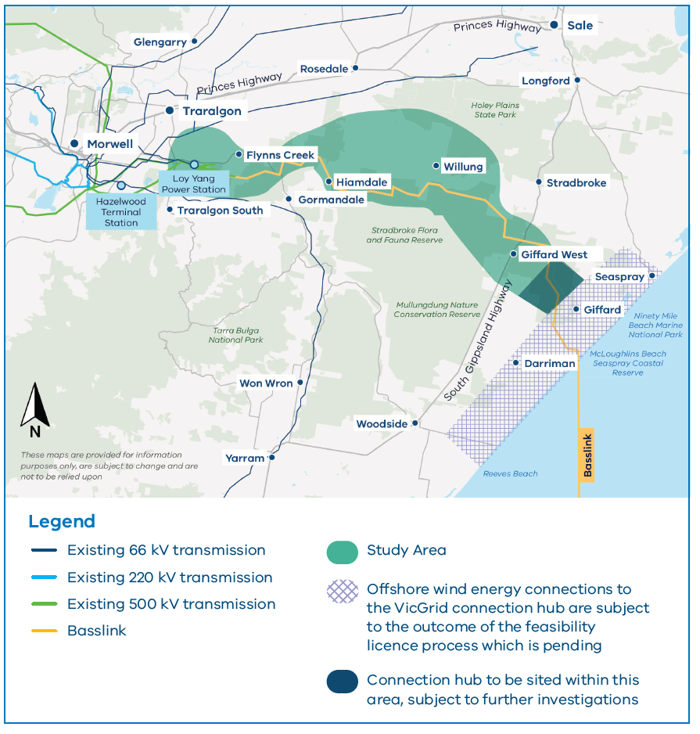
Next steps and how communities can stay involved
Now that VicGrid has selected a Study Area, the next steps involve refining and narrowing this area to a corridor (and then route) using detailed studies, on-the-ground assessments and engagement with landholders, farmers and community members.
VicGrid will also seek further discussions with the GLaWAC, about ways to understand and minimise potential impacts to cultural heritage and values. It will continue working to build a partnership approach with GLaWAC.
VicGrid’s aim through this further work and engagement is to better understand and improve the project by listening to and learning from landholders and local community members. VicGrid has dedicated team members available to provide information and answer questions from landholders and community members.
At the same time, VicGrid is preparing another roadmap that will provide more detail on the
next stages of project development and engagement opportunities.
Even so, engagement is an ongoing process with questions, feedback and discussions always welcome. Engagement with First Peoples, landholders and local communities will continue to be at the heart of transmission planning in Gippsland.
Section A: VicGrid’s role in the renewable energy transition

1. Reliable and affordable energy for Victorians
Victoria’s energy system is changing.
The coal-fired power stations Australia has relied on to power our lives are becoming unreliable and retiring faster than expected. Since 2012, more than 10 large coal-fired generators have closed across Australia – including the Hazelwood Power Station in the Latrobe Valley. Victoria’s largest coal-fired power station, Loy Yang A, will close in 2035, a decade earlier than expected.
We urgently need to change our power grid to carry energy from new renewable sources and batteries across the state to Victorian homes, businesses, hospitals, schools and other vital services. Around 1,000 km of new transmission lines will be needed in Victoria to support this transition to renewable energy.
Victoria is legislating world-leading renewable energy targets of 40% by 2025, 65% by 2030 and 95% by 2035. This will set us on our way to achieve net-zero carbon emissions by 2045.
New transmission infrastructure will secure Victoria’s energy future and help us tackle climate change by meeting our renewable energy targets.
VicGrid is working to make sure this change delivers the safe, reliable and affordable power Victoria needs to keep the lights on.

2. VicGrid’s role
VicGrid is the Victorian Government agency responsible for planning and developing the new infrastructure that will transport offshore wind energy to the electricity grid.
VicGrid is changing the way energy infrastructure is delivered in Victoria. Our approach aims to reduce transmission line impacts on landscapes and communities. At the same time, we need to ensure Victoria is an attractive destination for renewable energy investment.
We want to build the right amount of energy infrastructure in the right places at the right time. We also need to ensure we are not building more infrastructure than Victoria needs – so we can minimise impacts on communities, industries and the environment, and keep down costs to reduce impacts on energy bills.

3. Transforming Victoria’s transmission network
VicGrid is leading the roll-out of the Victorian Transmission Investment Framework (VTIF) – a new integrated approach to planning and delivering transmission infrastructure in our state.
The VTIF introduces a strategic and proactive process to coordinate investment in transmission, generation and storage infrastructure across the Renewable Energy Zones being planned across Victoria.
VicGrid is also currently developing the Victorian Transmission Plan (VTP), a long-term strategic plan for Victoria’s transmission and Renewable Energy Zone development that will support the energy transition over the next 15 years.
This plan will prepare Victoria for a range of possible future scenarios to minimise the risk of under-investment (not being prepared) and over investment (building more than is necessary) in transmission infrastructure.
At its core is early engagement with landholders and local communities and seeking to partner with First Peoples to minimise impacts and make the most of regional development opportunities.
New benefit sharing arrangements will see renewable energy developers and transmission companies contributing funds for the benefit of host communities and First Peoples.
This new approach will better integrate land use considerations, environmental impacts and community views into the planning process.

Partnerships with Traditional Owners and First Peoples
VicGrid understands and respects Traditional Owners’ legal and cultural rights, along with their deep connections with Country and Sea Country as original custodians. VicGrid is committed to the Pupangarli Marnmarnepu ‘Owning Our Future’ Aboriginal Self-Determination Reform Strategy
and will partner with First Peoples in the region to identify key considerations and concerns, and benefits and opportunities that may be of interest.
Partnerships with First Peoples will support the protection of Country, maintain spiritual and cultural heritage and practices and acknowledge broader aspirations if First Peoples are impacted by new critical energy infrastructure.
The VTIF reforms make a commitment to partner with First Peoples to address their concerns and priorities, providing them with the support and funding required to fully participate in the energy transition.
The VTIF is currently being prepared for legislation and is expected to be introduced into the Victorian Parliament in 2024.

The central role of community engagement in transmission planning
First Peoples, landholders and local communities are at the heart of our work. We are giving them a real voice in the planning of new infrastructure and making sure the benefits of the energy transition are shared more fairly.
We listen to and seriously consider all feedback, balanced against the technical requirements of the project, and incorporate the full range of community and stakeholder views into a fair and technically robust assessment process.
Incorporating community views earlier in the process means we can make decisions that minimise impacts and maximise benefits for regional communities.

4. About this report
The purpose of this report is to outline the strategic options assessment VicGrid has undertaken to support the planning and development of new transmission infrastructure in Gippsland.
The assessment has been focussed on planning the new infrastructure needed to deliver the first stage of Victoria’s offshore wind energy targets and transport at least 2 gigawatts (GW) of renewable energy into the grid by 2032.
This report describes how VicGrid has assessed a wide range of potential corridor and technical options and identified a preferred option and broad Study Area using the Assessment Method informed by community feedback, publicly available information and technical advice from subject matter experts.
The assessment considered a range of competing criteria that reflect the different positive and negative impacts transmission infrastructure may have on landholders, local communities and First Peoples. These criteria were assessed both quantitatively and qualitatively, with additional analysis undertaken on the preferred options to test the outcomes of the assessment.
The assessment involved desktop assessments using available data, which reflects this early stage of the transmission development process.
Identification of the Study Area is a starting point for more detailed technical investigations, desktop studies, engagement and field studies to determine the exact location of transmission infrastructure. This report does not constitute a decision on the exact location or nature of transmission infrastructure needed in Gippsland.
This report is also focussed on the options assessment VicGrid has undertaken in Gippsland.
The Australian Government is currently assessing feasibility licence applications from offshore wind proponents in Gippsland and has recently declared a second offshore wind area off the Victorian coast in the Southern Ocean region. VicGrid will now take time to assess the implications of the Southern Ocean announcement and the area that has been identified.
Section B: Gippsland offshore wind energy transmission

1. Offshore wind for large scale renewable energy generation
Victoria has some of the best offshore wind resources in the world.
That is why the Victorian Government has set targets of generating at least 2 GW of offshore wind energy by 2032, 4 GW by 2035, and 9 GW by 2040.
The energy generated by the first target alone will be enough to power 1.5 million homes. The development of offshore wind energy will create opportunities for communities and regions. It will bring considerable opportunities for Victoria’s workforce, mobilising thousands of workers during the lifetime of the industry.
In Australia, offshore wind farms will be located in Commonwealth waters and can only be built in areas approved by the Australian Government. These are called declared areas.
After an area is declared suitable for offshore wind, developers can apply for a feasibility licence, giving them permission to investigate their proposed project in more detail. The developer will then need a commercial licence to proceed. This gives them permission to build, and is only given to developers who have completed all the steps and approvals needed for their feasibility licence.
The Australian Government has declared areas of the Bass Strait off the coast of Gippsland as Australia’s first offshore wind area. This spans approximately 15,000 square kilometres in Commonwealth waters, running from Lakes Entrance in the east to south of Wilsons Promontory in the west.
The Australian Government is currently assessing feasibility licence applications in the Gippsland declared area and provided an update on their preliminary considerations in December 2023. This means VicGrid needs to be flexible in its development of transmission connection hubs, as the outcome of the licensing process is still pending.

Figure 3: Gippsland declared offshore wind area
A map shows three dark blue areas over the ocean off the coast of Gippsland. These indicate the Gippsland declared offshore wind area.
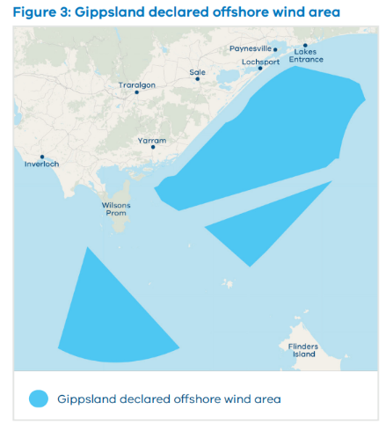

2. Offshore wind transmission
Offshore wind presents a significant opportunity for Victoria to reduce emissions, enhance energy security, create thousands of jobs, drive economic growth and partner with First Peoples.
To ensure new transmission is coordinated and in the best interests of local communities and key stakeholders, VicGrid will lead the development of transmission infrastructure to provide common connection points or hubs for offshore wind developers.
In addition to offshore wind energy, there are a number of proposed onshore renewable energy projects in Gippsland. VicGrid is developing transmission infrastructure to accommodate onshore and offshore energy generation to ensure holistic energy planning for Victoria. This will ensure we are not building more infrastructure than Victoria needs. This will minimise impacts on communities, industries and the environment, and keep down costs to reduce impacts on power bills.

Initial area of interest
Figure 4 shows the initial area of interest identified in October 2022 for the development of the new offshore wind transmission connection point(s) in Gippsland. VicGrid’s investigations and local engagement started by considering this area of interest, and a range of corridor and technology options for achieving the needs and objectives for the offshore wind energy transmission project.

Figure 4: Initial area of interest for offshore wind transmission connection point(s):
A map of Gippsland showing VicGrid’s initial area of interest, stretching from Paradise Beach across to Longford, down to Manns Beach and across to just west of Yarram. The map also shows existing transmission routes nearby.
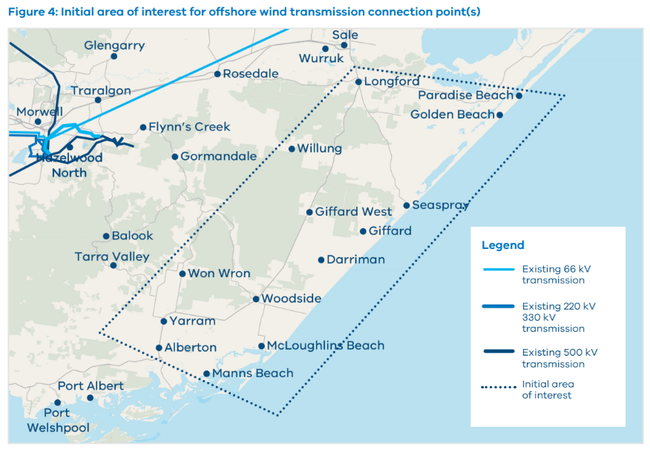

Objectives for offshore wind transmission
- VicGrid’s Offshore Wind Transmission Development and Engagement Roadmap set out the following 9 objectives for coordinated offshore wind transmission:
- Ensure that Victoria has sufficient transmission infrastructure in place to power our state as energy demand increases and ageing coal-fired generators close.
- Support Victoria’s offshore wind energy targets, the 95% renewable energy target by 2035 and the net-zero emissions target by 2045.
- Guide efficient, effective and responsible investment in viable transmission infrastructure that is high performing, resilient and built with future needs in mind.
- Ensure that energy consumers and Victorian taxpayers do not pay unnecessary costs for duplicative infrastructure.
- Provide confidence to offshore wind project developers that their energy can connect to the grid in a timely manner.
- Reduce cumulative impacts on land, environment and communities.
- Reflect and uphold the critical values, expectations and priorities of First Peoples, host landholders and communities, and stakeholders.
- Ensure benefits that flow from new transmission infrastructure developments are appropriate and equitable.
- Facilitate a simpler and more straightforward consultation process for local communities.

Future transmission needs for offshore wind energy
VicGrid’s initial focus is on the infrastructure required to support the Victorian Government’s first offshore wind energy target of at least 2 GW by 2032.
VicGrid has also been considering what infrastructure would be needed to support the longer term targets of at least 4 GW by 2035 and 9 GW by 2040. This ensures the new transmission is planned to cater for each target, enabling optimal staged development that avoids unnecessary or redundant infrastructure.
It is important to note that decisions on the future infrastructure have not yet been made. These will be the subject of further technical studies, extensive community engagement and government decision-making processes.
However, a second connection hub and further transmission lines will likely be needed in Gippsland to meet the longer term offshore wind energy targets.
These additional lines may also need to be developed in a separate corridor to ensure energy system security and reliability.
Future infrastructure to meet the long term offshore wind energy targets would be planned under the VTIF reforms, which feature landholder and community engagement, strategic land use assessments, new benefit sharing approaches and partnering with First Peoples.

Figure 5: Comparing uncoordinated transmission lines with a coordinated and planned approach
With coordinated transmission: VicGrid will develop transmission solutions that provide common connection points for offshore wind farms and shared transmission lines to connect to the current network where necessary
Without coordinated transmission: There is a risk that renewable energy projects will develop their own individual transmission infrastructure to connect to the current network

Other transmission proposals
VicGrid is leading the delivery of common connection hubs for offshore wind developers. Offshore wind projects will have to connect to these hubs as a condition of the Victorian Government’s offshore wind generation procurement process.
This will help minimise transmission duplication and avoid multiple proponents developing individual lines that create a ‘spaghetti effect’ as shown in Figure 5, which impacts on local communities and the environment and drives up power bills.
We are aware that some other developers have undertaken feasibility assessments for transmission lines that may overlap with the VicGrid-led transmission.
We expect that as VicGrid progresses its development and engagement activities, these developers will remove any overlapping or additional transmission from their development and engagement activities. This will reduce confusion and promote a coordinated approach to engagement.
Section C: Preferred option for Gippsland offshore wind transmission
New transmission infrastructure is needed to extend the existing transmission network from the Latrobe Valley to a connection hub near the Gippsland coast which offshore wind generators will connect to.
This section of the report provides an overview of the preferred option for new transmission in Gippsland and the rationale for its selection. Section E of this report describes the assessment method used to identify the preferred option from a range of corridor and technical options. Sections F and G provide detailed findings of the assessment of corridor and technical options.

1. Study Area for further development
The Gippsland preferred option is a new set of overhead transmission lines from a new connection hub near Giffard to a grid connection point near Loy Yang Power Station along an area that provides opportunities to reduce impacts by exploring alignment with other infrastructure.
The preferred option was identified through an assessment of a wide range of potential corridor and technical options, using the Assessment Method VicGrid developed in 2023. Community and stakeholder feedback was applied to help assess and balance a range of competing factors.
Rigorous assessment of environmental, visual, heritage, cost and technical factors found that new overhead transmission lines along a corridor away from major towns is the best balance for keeping household energy bills down while minimising impacts for Gippsland communities.

What is a Study Area?
VicGrid used the preferred option to create a broader Study Area.
The Study Area around the preferred corridor option is necessarily broad to enable detailed on-the-ground environmental assessments to be undertaken across a wide area.
The options assessment in this report has largely been based on early engagement and desktop assessments using available information. Further engagement and in-depth investigations are now needed to inform the decision about the design and location of the new transmission to minimise impacts as much as possible.
Selecting a broader Study Area helps retain flexibility to respond to new information that will be identified through community and landholder engagement, technical studies and field work which now needs to get underway.
VicGrid seeks to talk with landholders, farmers and residents of nearby townships to better understand their needs, their properties and activities, like agricultural practices, with the aim of improving the project and minimising impacts as much as possible.
The Study Area also needs further discussion with the Traditional Owner Corporation, Gunaikurnai Land and Waters Aboriginal Corporation (GLaWAC), and will be investigated in more detail to avoid and minimise potential impacts to cultural heritage and values.
Discussions with public land managers and plantation operators will also be needed to identify ways to minimise impacts on native vegetation, other environmental values and local business operations.

Figure 6: Study Area and indicative connection hub
A map of Gippsland shows the Study Area and indicative connection hub area. The Study Area starts approximately 6km from the coast near Giffard and travels northwest past Stradbroke West to Willung, across to Flynns Creek and then to the Loy Yang Power Station.
The map also shows a cross-hatched area along the coast, running approximately from Seaspray to Reeves beach. The legend for this area reads: Offshore wind energy connections to the VicGrid connection hub are subject to the outcome of the feasibility licence process which is pending.
About the Study Area:
- Based on a corridor option that has a lower proportion of agricultural land than almost all other short listed options considered, has the second lowest proportion of native vegetation, and has a higher proportion of public land and plantation land.
- Provides opportunities to explore alignment with other infrastructure such as roads and the Basslink interconnector.
- Suitable for 2 High Voltage Alternating Current (HVAC) overhead transmission lines (330 or 500 kV) on 1 set of double circuit towers. Other tower types (e.g. single circuit towers) are also possible but would need to be further explored.
- A grid connection point at or near Loy Yang Power Station which allows for the utilisation of existing network assets. The connection at or near Loy Yang is subject to further investigations and due diligence.
- An onshore connection hub and substation with 500 / 275 kV transformation or a 330 / 275 kV transformation to connect cables from the offshore wind projects. The area identified near Giffard for the connection hub requires further investigations and refinement and is subject to the outcomes of the offshore wind generation licensing and procurement processes.

Figure 7: Examples of overhead line structure types
A diagram of overhead line structure types shows Steel poles, Guyed towers, Lattice towers, European Composite Pylons and T-Pylons. There are several examples of Lattice towers, including Double circuit towers and Single circuit towers.

Summary of key reasons for choosing this Study Area

Preferred corridor option
Cost and engineering complexities:ald
This option is shorter in length (approx. 68 km) which influences project costs. It also has fewer engineering complexities as it traverses relatively flat terrain and is not considered to pose major construction complexities relative to other options. This has an impact on timing and cost.
Alignment with community preferences:
The option is set away from major residential areas and does not have any community assets within the corridor area that are likely to impact sensitive receptors (e.g. sporting, healthcare, care or educational facilities). It also presents some opportunities to explore alignment with other infrastructure, which was raised as a community preference in VicGrid’s Phase 2 engagement.
Agricultural land:
This option has a lower proportion of agricultural land and less proximity to private land compared to most other options. It contains similar proportions of Crown and plantation land (which are higher than other options), balancing different land uses at this early stage.
Flexibility to accommodate offshore wind locations:
This option is central to the declared offshore wind zone and has more flexibility to respond and extend to different offshore wind farm locations. This is important as the outcome of the Australian Government’s feasibility licensing process is still pending.

Preferred technical options
Cost, complexity and program:
In comparison to the underground options assessed, the preferred overhead technical solution has lower cost impacts on energy consumers, lower engineering complexities and reduced supply chain and procurement risks.
Less impact on Aboriginal cultural heritage:
The construction of an overhead solution has less ground disturbance and is expected to have less relative impact related to potential Aboriginal artefacts beneath the ground compared to, for example, underground cables. However, it is understood there is significant complexity with Aboriginal tangible and intangible cultural heritage that needs to be worked through with GLaWAC.
Flexibility to achieve future offshore wind targets:
The preferred solution has greater flexibility to support post-2032 offshore wind energy targets, with lower complexity to expand. Onshore generators can also connect more easily along HVAC overhead transmission lines than HVDC lines.

Understanding key terms
Voltage (V): Voltage is the pressure that pushes charged electrons through a circuit. Voltage is measured in volts (V) – from the 1.5 V battery in a TV remote, to the 230 V wires running through street poles to our houses. In a transmission network, much larger amounts of pressure are needed to keep the electricity flowing and ensure energy is not lost. This voltage is measured in thousands of volts, or kilovolts (kV).
Kilovolts (kV): High voltage transmission lines can range between 11 kV and 1,000 kV depending on how far they need to carry power. Higher voltages are better at transmitting large amounts of power over long distances.
AC: Alternating Current (AC) is a type of electrical current where the direction of the flow of electrons switches back and forth at regular intervals. The current flowing in our homes is AC.
DC: Direct Current (DC) is a type of electrical current that is unidirectional – this means that the flow of charge is always going in the same direction. DC is used in many household electronics and devices that use batteries.
HVAC: High Voltage Alternating Current. All standard power systems in Australia use AC.
HVDC: High Voltage Direct Current. HVDC moves power between separate AC networks. It is used for transporting large amounts of energy point-to-point over long distances.
Section D: How corridor and technical options were developed and assessed

1. A balanced approach to transmission planning
When assessing possible transmission technologies and locations and deciding on preferred transmission options, transmission planners need to balance different and often competing priorities to design the right solution.
That is why VicGrid developed the Assessment Method, a tool that ensures clear and rigorous methodology for balancing competing priorities. The Assessment Method also ensures community and stakeholder feedback informs our decision-making approach because it was developed using inputs from consultation.
In April 2023, VicGrid published the Offshore Wind Transmission Development and Engagement Roadmap. This set out a 4-phase process for engagement on the assessment of options for new transmission infrastructure and coordinated connection points for offshore wind developers.

Figure 8: 2023 Offshore Wind Development and Engagement Roadmap
Early – mid 2023 | Mid 2023 | Mid – late 2023 | Late 2023 – early 2024
Phase 1 | Phase 2 | Phase 3 | Phase 4
Sharing information and refining our engagement approach | Developing our Assessment Method through consultation | Assessing options using published Assessment Method | Confirming preferred options and next steps

2. Designing the Assessment Method with communities
Feedback from landholders, local communities and First Peoples is helping VicGrid make decisions about the transmission infrastructure to transport offshore wind energy into the grid.
In mid 2023, VicGrid published community and stakeholder feedback that was used to refine the Assessment Method, the decision-making tool we have used to assess and decide on short listed project options. The feedback gathered helped us design the Assessment Method and balance the relative importance of each factor being considered.
For example, survey results showed that minimising cost and environmental impacts are high priorities for participants across Victoria, and minimising land use and host landholder and community impacts are high priorities for Gippsland participants.
VicGrid’s approach is a big change from the way transmission is usually planned – where the only considerations during early stages are technical and economic.
VicGrid is considering social, environmental and cultural factors alongside technical and economic factors in the early stages of planning to achieve better outcomes for local communities and all Victorians.
See engagement reports by visiting Engage Victoria engage.vic.gov.au/offshore-wind-transmission, the Victorian Government’s online consultation platform.

3. VicGrid’s offshore wind transmission Assessment Method
Transmission projects need to be developed and designed to ensure a reliable, secure, resilient and expandable electricity system and meet a range of energy system planning criteria. A reliable power system has enough generation, demand response and network capacity to supply customers with the energy that they demand with a very high degree of confidence.
The Assessment Method provides a consistent, fit-for-purpose decision-making process that balances a wide range of criteria to assess potential corridor and technical options for offshore wind transmission.
The Assessment Method has been informed by the VTIF, a review of Australian and international examples of transmission project assessments, and community and stakeholder input and feedback.
VicGrid used established assessment methods like Multi-Criteria Analysis, which are widely used on major projects, to understand and balance competing factors and assess qualitative and quantitative factors together.
The options were developed and assessed by technical specialists and were based on desktop studies of publicly available, industry-specific planning and technical information.

Table 2: Assessment criteria used to assess transmission corridor and technical options
Criteria | Description | Key considerations
Assessment criteria based on maximising positive outcomes (Project Objectives) | Assessment criteria based on maximising positive outcomes (Project Objectives) | Assessment criteria based on maximising positive outcomes (Project Objectives)
1 Project  Objective | Ensure investment in viable transmission infrastructure that is fit-for-purpose, resilient and built with future needs in mind | Consideration of the option’s ability to service  current and future electricity system needs, including flexibility to expand capacity in line with future offshore wind targets
2 Project  Objective | Contribute to regional development opportunities, including community benefits and governance, and economic development in the energy sector. | Consideration of the option’s ability to contribute  to regional development and local job opportunities  and deliver community benefits that can give back  to impacted Traditional Owners and host communities.
3 Project  Objective | Maintain transmission system security, reliability, and strength, enabling the transport of generation to load | Consideration of the option’s ability to interface with generation (onshore and offshore) and enable transport of generation to load, including consideration of losses.
Assessment criteria based on minimising negative outcomes (Guiding Principles) | Assessment criteria based on minimising negative outcomes (Guiding Principles) | Assessment criteria based on minimising negative outcomes (Guiding Principles)
1 Guiding Principle | Minimise impact on host landholders and communities, including visual amenity | Consideration of the effect on visual amenity, health and local assets valued by host communities and landholders; and impact on compatibility with local government strategies and visions.
2 Guiding Principle | Minimise impact on the environment | Consideration of impact on the environment  (including flora, fauna and water) and the risk  of natural hazards/disasters.
3 Guiding Principle | Identify areas of cultural heritage sensitivity (Aboriginal and non-Aboriginal) to minimise impact on known and potential cultural values | Consideration of areas of cultural heritage sensitivity (including known or previously unrecorded significant cultural heritage and/or archaeological sites), while acknowledging and respecting Traditional Owners’ legal rights, cultural values, and deep ongoing connection to land, sea and sky Countries.
4 Guiding Principle | Minimise impact on existing and future land use | Consideration of impact on existing land use, including agricultural and forestry land (including resulting effect on agricultural and forestry businesses) and tourism/ recreation values (including resulting effect on tourism industry).
5 Guiding Principle | Minimise cost impacts to energy consumers and generators | Consideration of the cost to build and operate the new transmission infrastructure, and the resulting impacts on consumer electricity bills and costs for generation developers.
6 Guiding Principle | Limit engineering complexities during construction and impacts on existing infrastructure | Consideration of the effect on program and constructability for delivery including construction complexity, disruption during construction and supply chain constraints.
Note: Heritage values, including post-contact heritage, were included in Guiding Principle 3 as many of the Acts or inventories include both pre and post contact heritage sites.

Balancing a range of factors using assessment criteria
A key consideration informing criteria selection was whether they could be meaningfully measured to sufficiently differentiate between the options.
Equal consideration was given to maximising positive outcomes (Project Objectives) and minimising negative outcomes (Guiding Principles), with the relative importance and weighting of each informed by the community, landholder and stakeholder engagement process.
The final assessment criteria, including the key considerations and relative importance and weighting of each criterion, was informed through independent community attitudes research, the Engage Victoria survey and feedback from VicGrid’s engagement activities in 2023.
See VicGrid’s Options Assessment Method for more information engage.vic.gov.au/offshore-wind-transmission

Multi-Criteria Analysis to compare qualitative and quantitative impacts
A Multi-Criteria Analysis compares quantitative and qualitative impacts arising from different options by assigning scores to various criteria. It provides a structured, systematic and transparent framework for comparing options with costs and benefits that are difficult to quantify.
The assessment works by assigning a score to each criterion, which gives an indication of its potential impact. The following scoring approach was used to rate qualitative and quantitative measures of positive and negative outcomes for each proposed option.
Each criterion was scored according to a scale from -5 to +5, with lower scores between 0 to -5 indicating higher negative impacts and higher scores between 0 to +5 indicating higher positive impacts.
Measures specific to each criterion are used to understand and analyse the potential impact of each project option.
For example, to assess cost impacts under Guiding Principle 5 – Minimise cost impacts to energy consumers and generators – the corridor assessment looked at the length of each corridor option; and the technical assessment looked at indicative costs to build each technical option. In this example, a longer corridor option would receive a lower score (or higher negative score) to indicate a higher cost impact.
Once each project option is given a score for each criterion, these scores are then multiplied by the weightings described in the next section. For example, if the longer corridor option had been given a score of 4 under Guiding Principle 5, this score would be multiplied by 11%.
The weighted scores across all criteria are then added up to generate a total score for each project option.

Table 3: Scoring table used to assess options against the assessment criteria
Score | Rating | Description
0 | No impact | No impact discernible or predicted
+/- 1 | Limited impact | Impacts confined to a small number of locations, generally small in magnitude, short-term, and of a scale significant at a local level
+/- 2 | Minimal impact | Impacts affecting a moderate number of locations within the project area, potentially small in magnitude and medium-term or moderate in magnitude  and short-term, and of a scale significant at a local level
+/- 3 | Moderate impact | Impacts affecting a large number of locations within the project area, potentially small in magnitude and long-term or large in magnitude and short-term, and  of a scale significant at a municipality level
+/- 4 | Major impact | Impacts affecting a significant portion of the project area, generally large in magnitude, long-term, and of a scale significant at a regional level
+/- 5 | Extreme impact | Impacts widespread across the project area and beyond, of vast magnitude, long-term, and of a scale significant at a state level.

Weighting the assessment criteria
VicGrid also designed a weighting system to help balance the competing criteria. This was an important step in carefully balancing the project needs, the priorities and perspectives of potentially affected local residents, and the priorities and perspectives of all Victorians.
The Phase 2 Engagement Report summarises priorities for Gippsland and state-wide communities identified through surveys in Phase 2 of engagement, which have helped inform a balanced approach to weighting the assessment criteria.
These priorities have been balanced with important factors like maintaining transmission system security, reliability and strength, and enabling the transport of energy to where it is needed.
Weighting involved allocating a percentage to each of the assessment criteria, which ensures higher priority criteria will be emphasised in the assessment of each option. Table 4 sets out the weighting out
of 100% allocated to the assessment criteria. 50% was shared across the 3 Project Objectives and 50% was shared across the 6 Guiding Principles.

Sensitivity testing
VicGrid also conducted sensitivity testing to understand if the preferred options are sensitive to changes in scoring and/or weighting profiles of the assessment criteria (i.e. does the preferred option change if the scoring of options or weighting of assessment criteria is changed). This is important to ensure the preferred option is robust.

Key features of the Assessment Method include:
- a filtering process that allows VicGrid to assess a wide range of technically feasible options
- the establishment of assessment criteria comprising Project Objectives that maximise positive outcomes, and Guiding Principles that minimise negative outcomes
- an assessment of social, environmental, cultural, land use, economic and technical factors alongside electricity transmission factors
- early engagement with landholders and local communities to inform the development, weighting and scoring of assessment criteria
- robustness testing of the results through sensitivity analysis
- separate discussions with GLaWAC about partnership and engagement approaches on offshore wind transmission.
The Assessment Method is based on desktop analysis using available data and early assumptions on the potential corridor and technical options. This data has not been verified through on-the-ground assessments and does not pre-empt detailed environmental studies. The assessment also uses quantitative and qualitative data, acknowledging qualitative data can have an element of subjectivity.

Table 4: Weightings assigned to the assessment criteria (for selecting the preferred option)
Criteria | Weighting | Engagement inputs to weighting selection
Assessment criteria based on maximising positive outcomes (Project Objectives) | Assessment criteria based on maximising positive outcomes (Project Objectives) | Assessment criteria based on maximising positive outcomes (Project Objectives)
Project Objective 1 – Ensure investment in viable transmission infrastructure that is fit-for-purpose, resilient and built with future needs in mind | 17% | Community attitudes research and Engage Victoria survey respondents weighted Project Objectives relatively equally. Maintaining transmission system security, reliability and strength is an important factor and weighted higher than the other project objectives.
Project Objective 2 – Contribute to regional development opportunities, including community benefits and governance, and economic development in the energy sector | 14% | Community attitudes research and Engage Victoria survey respondents weighted Project Objectives relatively equally. Maintaining transmission system security, reliability and strength is an important factor and weighted higher than the other project objectives.
Project Objective 3 – Maintain transmission system security, reliability and strength, enabling the transport of generation to load | 19% | Community attitudes research and Engage Victoria survey respondents weighted Project Objectives relatively equally. Maintaining transmission system security, reliability and strength is an important factor and weighted higher than the other project objectives.

Criteria | Weighting | Engagement inputs to weighting selection
Assessment criteria based on minimising negative outcomes (Guiding Principles) | Assessment criteria based on minimising negative outcomes (Guiding Principles) | Assessment criteria based on minimising negative outcomes (Guiding Principles)
Guiding Principle 1 - Minimise impact on host landholders and communities, including visual amenity | 8% | Community attitudes research respondents, including in areas impacted by transmission, weighted this lower than other criteria (when normalised, it was weighted as 7% by the state-wide respondents). However, respondents to the survey on Engage Victoria weighted this criterion significantly higher.
Guiding Principle 2 - Minimise impact on the environment | 10% | Community attitudes research respondents, including in areas impacted by transmission, weighted this higher than other criteria (when normalised, it was weighted as 10% by the state-wide respondents). Similarly, respondents to the survey on Engage Victoria also weighted this criterion highly.
Guiding Principle 3 - Identify areas of cultural heritage sensitivity (Aboriginal and  non-Aboriginal) to minimise impact on known and potential cultural values | 8% | Weighting for this guiding principle was set equal to Guiding Principle 1, reflecting Traditional Owners being rights holders, and Aboriginal and Torres Strait Islander people as the traditional custodians of the land. This weighting does not alter the overarching need to respect Traditional Owners’ legal rights, cultural values, and deep ongoing connection to land, sea and sky Countries.
Guiding Principle 4 - Minimise impact on existing and future land use | 9% | State-wide community attitudes research respondents weighted this lower than other criteria (when normalised, it was weighted as 7% by the state-wide respondents). However, community attitudes research undertaken in Gippsland and Portland and respondents to the survey on Engage Victoria weighted this criterion higher.
Guiding Principle 5 - Minimise cost impacts to energy consumers and generators | 11% | Community attitudes research respondents, including in areas impacted by transmission, weighted this higher than other criteria (when normalised, it was weighted as 12% by the state-wide respondents). However, respondents to the survey on Engage Victoria weighted this criterion significantly lower.
Guiding Principle 6 - Limit engineering complexities during construction and impacts on existing infrastructure | 4% | Community attitudes research respondents, including in areas impacted by transmission, weighted this lower than other criteria (when normalised, it was weighted as 7% by the state-wide respondents). Respondents to the survey on Engage Vic also weighted this criterion relatively low.
Note: Heritage values, including post-contact heritage, were included in Guiding Principle 3 as many of the Acts or inventories include both pre and post contact heritage sites

Early approach to assessing potential costs
Cost estimates at this early stage of options identification and assessment are indicative only. Extensive further work is needed to develop and refine the new transmission infrastructure in discussion with First Peoples, landholders and local communities.
The project is also sensitive to local and international construction markets for steel, concrete, engineering equipment and labour, and technical project management skills. These markets are anticipated to be extremely tight over the coming 2 decades as all national economies face the same energy transition challenges and priorities. This could place significant upward price pressure on transmission infrastructure equipment, as well as labour supply, costs and expertise.
The indicative cost estimates were developed using specialist transmission expertise and the AEMO Transmission Cost Database (TCD).
The Association for Advancement of Cost Engineering (AACE) international classification system is commonly used in many industries for defining the level of accuracy of a cost estimate, based on the amount of design work that has been done.
This system defines a series of ‘classes’ of estimates, ranging from Class 5 (least accurate) to Class 1
(most accurate). The TCD provides a level accuracy that lies between class 5 (-30% to +50%) and class 4 (-15% to +30%), depending on the maturity of the project scope.
The indicative cost estimates used in this report are within a range of -30% / +50% accuracy, which is a standard level of estimation for this early stage of transmission planning.

Consideration of health impacts in the assessment method
VicGrid acknowledges that the prospect of new transmission infrastructure can be challenging and stressful for impacted landholders and local communities.
Our community engagement to date has heard that people are concerned about how new infrastructure could impact the landscape, their health and amenity and their farming operations. VicGrid is also aware that some landholders in Gippsland have already been dealing with uncertainty related to other project developments in the region for some time.
These concerns and potential health impacts have been factored into the assessment process, by considering potential impacts on visual and local amenity, noise and air quality, and community development preferences (in Guiding Principle 1 - Minimise impact on host landholders and communities, including visual amenity).
VicGrid is also leading key approaches to support landholders and others impacted by new transmission infrastructure. These include:
- establishing a landholder engagement team who will provide dedicated contacts for landholders in the Study Area, to listen, answer questions about the project, and collect feedback
- appointing an Independent Facilitator, a Gippsland local who can talk directly with landholders and provide an independent avenue for discussions about landholders’ experiences and needs through the development of the new transmission
- adhering to best practice engagement and project planning approaches, guided by industry leading engagement standards and frameworks, including recent community engagement recommendations by the Australian Energy Infrastructure Commissioner
- training VicGrid people to ensure they are equipped to understand the specific experiences and priorities of regional communities and provide practical support that makes a difference.
Section E: Corridor options assessed and what we found

1. Identifying feasible corridor options
An important part of the early work was to undertake a desktop assessment of the known values and features in the initial area of interest in Gippsland. The assessment identified known areas that may not be suitable or feasible for transmission infrastructure.
The assessment was largely based on geospatial (or locational) data layers. It produced a map with each layer adding more information to tell a visual story of significant or sensitive features in the landscape.
These geospatial layers largely comprised publicly available information from multiple sources, such as planning schemes, national and state parks, water bodies and other reputable sources.
Corridor options for the new transmission infrastructure were developed using a spatial mapping tool that considered existing land uses, features, values and areas of sensitivity to identify potential areas for transmission corridors and identify a long list of options.

Figure 9: Identifying feasible options as part of the Development and Engagement Roadmap
2023 – early 2024 | 2023 – early 2024 | 2023 – early 2024
Offshore Wind Transmission Development and Engagement Roadmap  Develop Assessment Method to assess options and select Study Area | Offshore Wind Transmission Development and Engagement Roadmap  Develop Assessment Method to assess options and select Study Area | Offshore Wind Transmission Development and Engagement Roadmap  Develop Assessment Method to assess options and select Study Area
Identify feasible corridor and technical options. | Assess corridor and technical options and  select short list | Assess short list and  select preferred options  and Study Area
Use spatial mapping technology to identify sensitive areas and feasible corridor options Use technical engineering methods to identify feasible technical options | Identify long list of options  Select short list of options by filtering using assessment criteria | Use assessment criteria to assess short list  Use scoring and weighting to assess short list  Select preferred option
Community and landholder engagement  Traditional Owner / First Peoples engagement and partnership approach | Community and landholder engagement  Traditional Owner / First Peoples engagement and partnership approach | Community and landholder engagement  Traditional Owner / First Peoples engagement and partnership approach

Identifying significant and sensitive areas to help avoid or minimise impacts
A total of 30 environmental, heritage, community and land use criteria were established to develop understanding of significant and sensitive areas to avoid or minimise impacts on these areas as much as possible.

Criteria used to develop potential transmission corridor options
Environmental criteria
A significant number of terrestrial, aquatic and marine flora and fauna values of local, State,
Commonwealth and international importance have been identified through database searches
for the Gippsland areas of interest. This includes habitat of environmental and social importance.

Table 5: Environmental criteria
Criteria | Criteria description
Wetlands of International Importance | Ramsar wetlands are internationally recognised as rare or unique wetlands, and are important for conserving biological diversity. Ramsar wetlands are protected under the Commonwealth Environment Protection and Biodiversity Conservation (EPBC) Act and international treaties.
Waterways and waterbodies | Waterways and waterbodies offer important habitat for aquatic and semi-aquatic biodiversity. This can be locally and nationally significant species.
High Condition Native Vegetation | Using the Native Vegetation Extent under the Native Vegetation Regulation, in combination with Strategic Biodiversity Scores, to create a dataset of high value native vegetation to incorporate at risk flora and fauna at an appropriate scale.
Remaining Native Vegetation | Using the Native Vegetation Extent under the Native Vegetation Regulation, in combination with Strategic Biodiversity Scores, to create a dataset of high value native vegetation to incorporate at risk flora and fauna at an appropriate scale.
Important wetlands in Australia | Nationally important wetlands, their environment, social and cultural values.
Marine parks | Marine environments which provide significant environmental value for marine biodiversity and/or marine ecological processes.
Marine species | Threatened marine species or threatened marine ecological communities to be preserved for their environment and social values.
Aboriginal, European and other historical and cultural heritage criteria
The project regions have a range of known (and potential) heritage places, ranging from local-scale Aboriginal or historic heritage places, to World Heritage Listed cultural places.

Table 6: Heritage criteria
Criteria | Criteria description
State, Areas of Aboriginal Cultural Heritage Sensitivity (CHS) | Areas that contain registered Aboriginal cultural heritage places, or landforms/land categories considered more likely to contain Aboriginal cultural heritages. Areas of CHS are defined under the Aboriginal Heritage Regulations 2018.
Commonwealth Heritage List | The Commonwealth Heritage List (CHL) is prescribed under the EPBC Act. Heritage Places on the CHL can have local, state or national heritage values but must be Commonwealth owned or managed land. Significant impacts to these places will trigger an EPBC Act Referral.
National Heritage List | National Heritage List (NHL) includes places of heritage significance to the nation of Australia and are administered under the EPBC Act. National Heritage Listed places are considered a Matter of National Environmental Significance (MNES) and any significant impact to these places will trigger an EPBC Act Referral.
State, Victorian Heritage  Register (VHR) | The VHR provides protection for places, objects, relics or shipwrecks assessed as being of outstanding cultural significance within the State of Victoria.
State, Victorian Heritage Inventory (VHI) | The VHI includes historical (non-Aboriginal) archaeological sites which meet a series of thresholds for archaeological significance.
Australia National Shipwrecks | Australian National Shipwrecks are protected under the Underwater Cultural Heritage Act 2018.
Land use and planning criteria
The review of spatial databases identified land and land uses that are significant for their strategic resource value, contribute to open space, the environment and landscapes, are constrained by current and past land use practices or have Commonwealth Government and Crown land interests.

Table 7: Land use and planning criteria
Criteria | Criteria description
Resources and Mining | Tenements Resources and Mining Tenements are types of property rights that give mining and quarry companies the exclusive right to explore and mine minerals within a designated area for a specified period.
Public Conservation and Recreation Zone (PCRZ) | Land that has been zoned PCRZ for the purpose of protecting and enhancing the natural environment and natural processes for their historic, archaeological and scientific interest, landscape, faunal habitat and cultural values.
Significant Overlays | Overlays are maps that show the location and extent of special features or constraints that affect the land. Overlays are used on significant landscapes that have been recognised for their natural values that need to be protected or managed. These areas include – Significant Landscape Overlay, Vegetation Protection Overlay, Environmental Significance Overlay, Heritage Overlay.
Commonwealth Land | Land that is owned or held by the Commonwealth. Commonwealth Land can include land that is used for government services, such as defence, education or transport, or land that is leased or licensed to other parties for various purposes.
Aboriginal Title | Aboriginal Title is the grant of Crown land to Traditional Owners for the sole purpose of joint management, and recognises First Peoples’ deep understanding of land, water and biodiversity. Gunaikurnai Land and Waters Aboriginal Corporation (GLaWAC) was granted Aboriginal Title over 14 national parks and reserves, including:  - Knob Reserve, Stratford  - Tarra Bulga National Park  - Mitchell River National Park  - The Lakes National Park  - Gippsland Lakes Coastal Park  - New Guinea Cave (within Snowy River National Park)  - Lake Tyers Catchment Area  - Buchan Caves Reserve  - Gippsland Lakes Reserve at Raymond Island  - Corringle Foreshore Reserve.  Joint management of this land is a partnership between Gunaikurnai Traditional Owners and the State, allowing both to bring their knowledge and skills to the management of protected areas.
Irrigation districts | An irrigation district is a defined area where water is supplied for irrigation purposes by a water corporation or authority.
Large Contamination Areas | Registered areas of contamination have been identified by the Environment Protection Authority (EPA) Victoria as having a potential or actual risk of causing harm to human health or the environment due to the presence of pollutants or hazardous substances in the soil, water, or air.
Crown land | Crown land is land owned by the Crown but is managed by the Victorian Government. Crown land can be leased or licensed to private parties for various purposes, such as agriculture, mining, or business. Some Crown land can also be public land, which is land that is owned or managed by the Victorian Government for public benefit. Public land can include land that is reserved for a particular purpose, such as parks, forests or reserves, or land that is used for government services, such as education, health or transport. Crown land can also be subject to Native Title claims by Traditional Owners, who have a historical and cultural connection to the land.
Plantations | A plantation is a farm that specialises in growing 1 or more crops on a large scale. Softwood and hardwood plantations are types of farms that grow trees for timber production and are mostly located in the Gippsland region.
Community land use criteria
Community criteria have been developed to capture 2 land uses; residential and associated buildings
and infrastructure, along with farming land.

Table 8: Community land use criteria
Criteria | Criteria description
Residential areas/Residences/Township Adjacent | This criterion was determined with the relevant planning zones (e.g. Residential Zone), however it also covers a 500 m buffer from the community exclusion zone, to acknowledge that communities may spread beyond formal boundaries.
Agricultural land | For the purpose of this land use criterion, agricultural land is all land that is zoned Farming Zone in the relevant planning schemes.

Areas excluded due to their significance
There are areas that should be avoided due to technical feasibility or due to the level of significance of the feature. Townships and communities, airports and some waterbodies are examples of areas that have been designated as exclusion areas.
For the purposes of this process, communities and townships were identified using Urban Centres and Localities (UCLs) data, which represent areas of concentrated urban development with populations of 200 people or more, and Township Zone data.
There are also some areas of high cultural sensitivity and importance for First Peoples that have been considered as exclusion areas. VicGrid will work directly with Gunaikurnai Land and Waters Aboriginal Corporation (GLaWAC) to ensure these areas are protected and respected.

Mapping significant and sensitive areas to identify potential corridors
Options criteria and exclusion area data were inputted into a spatial mapping tool which was used to carry out a constraints assessment. This assessment produced maps of the accumulation of the criteria, showing areas that displayed more or fewer areas of sensitivity.
The mapping tool provides a desktop approach to identifying potential pathway options between the Gippsland coast and the Latrobe Valley. The tool allows planners to better understand how the options would potentially interact with identified heritage, community, environmental and land use criteria.
The assessment of sensitive and significant areas in the maps were the starting point for developing a wide range of possible pathways between the Gippsland coast and the Latrobe Valley that considered existing land uses, features, values and areas of sensitivity.
These pathways started from different points in the Latrobe Valley, including Loy Yang Power Station, Hazelwood Power Station and two indicative greenfield locations, and travelled towards the Gippsland coast.
To identify a long list of 12 corridor options from the pathways, some additional analysis was undertaken to group pathways that traversed similar areas and to filter out the pathways that started at Hazelwood Power Station. This is because a range of connections are already in place or planned at Hazelwood, so choosing a different point to connect to existing transmission helps to protect energy system security.
Based on this initial assessment, a long list of 12 corridor options was identified to progress to the rapid assessment stage of the Assessment Method.

Figure 10: Corridor options long list
A map of Gippsland shows 10 transmission corridor options in different colours. The options run from various spots along the Gippsland coastline to areas north, south and east of the Latrobe Valley.
Note: This map shows 10 corridor options generated via the spatial mapping tool. 2 additional corridor options were considered with potential to align with other linear infrastructure like roads or pipelines.
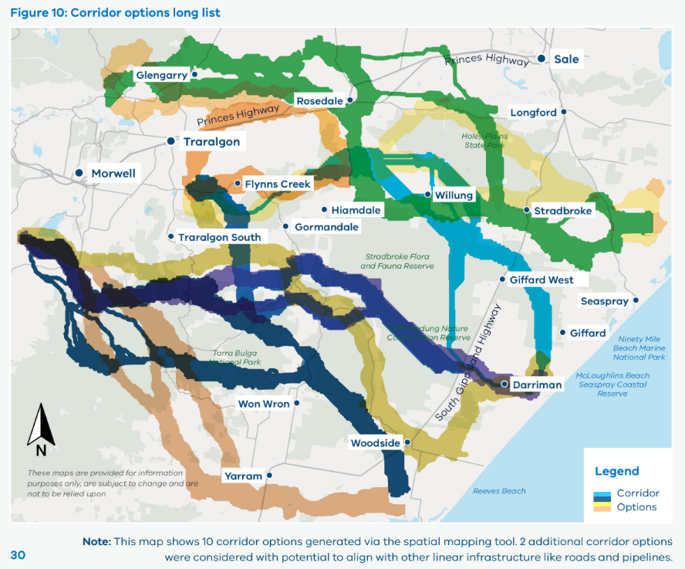

2. Selecting a short list of corridor options
The next step in assessing corridor options for the new transmission was to undertake a rapid assessment of the long list of 12 corridor options to select a short list. This was a high level assessment which is suitable for screening and filtering a large number of options.

Figure 11: Selecting a short list of options as part of the Development and Engagement Roadmap
2023 – early 2024 | 2023 – early 2024 | 2023 – early 2024
Offshore Wind Transmission Development and Engagement Roadmap  Develop Assessment Method to assess options and select Study Area | Offshore Wind Transmission Development and Engagement Roadmap  Develop Assessment Method to assess options and select Study Area | Offshore Wind Transmission Development and Engagement Roadmap  Develop Assessment Method to assess options and select Study Area
Identify feasible corridor  and technical options | Assess corridor and technical options and select short list | Assess short list and  select preferred options  and Study Area
Use spatial mapping technology to identify sensitive areas and feasible corridor options  Use technical engineering methods to identify feasible technical options | Identify long list of options Select short list of options by filtering using assessment criteria | Use assessment criteria to assess short list  Use scoring and weighting  to assess short list  Select preferred option
Community and landholder engagement  Traditional Owner / First Peoples engagement and partnership approach | Community and landholder engagement  Traditional Owner / First Peoples engagement and partnership approach | Community and landholder engagement  Traditional Owner / First Peoples engagement and partnership approach

The assessment criteria were used in the rapid assessment to filter down the long list of options to a short list for the detailed assessment. This high-level analysis focussed on identifying key points of difference between project options across the assessment criteria.
Table 9 provides the rapid assessment scores for each of the long listed corridor options considered. A higher score means that the option performed more favourably when assessed against the assessment criteria. Conversely, a lower score indicates that this option did not perform as well against the assessment criteria.

Table 9: Summary of corridor long list rapid assessment scores
Corridor options - numbered | C1 | C2 | C3 | C4 | C5 | C6 | C7 | C8 | C9 | C10 | C11 | C12
Total score | -0.09 | 0.03 | -0.17 | 0.01 | 0.07 | 0.07 | 0.14 | -0.19 | -0.09 | 0.24 | -0.11 | -0.07
Rank | 9 | 5 | 11 | 6 | 3 | 4 | 2 | 12 | 8 | 1 | 10 | 7

The short listed corridor options
Based on the scoring shown in Table 10, the 5 best-performing options were included in a short list for detailed assessment.
This short list represents a diverse selection of corridors across a wide geographic range across the Gippsland area of interest. The options progress through different types of land use and terrain and are different lengths. All options also have least one point where the corridor option branches out, enabling manoeuvrability around specific sites and constraints.

The short listed options are:
- Corridor Option 2 (C2)
- Corridor Option 5 (C5)
- Corridor Option 6 (C6)
- Corridor Option 7 (C7)
- Corridor Option 10 (C10)

Figure 12: Short list of 5 corridor options
A map of Gippsland shows the 5 shortlisted corridor options: Corridor Option 2, 5, 6, 7 and 10.
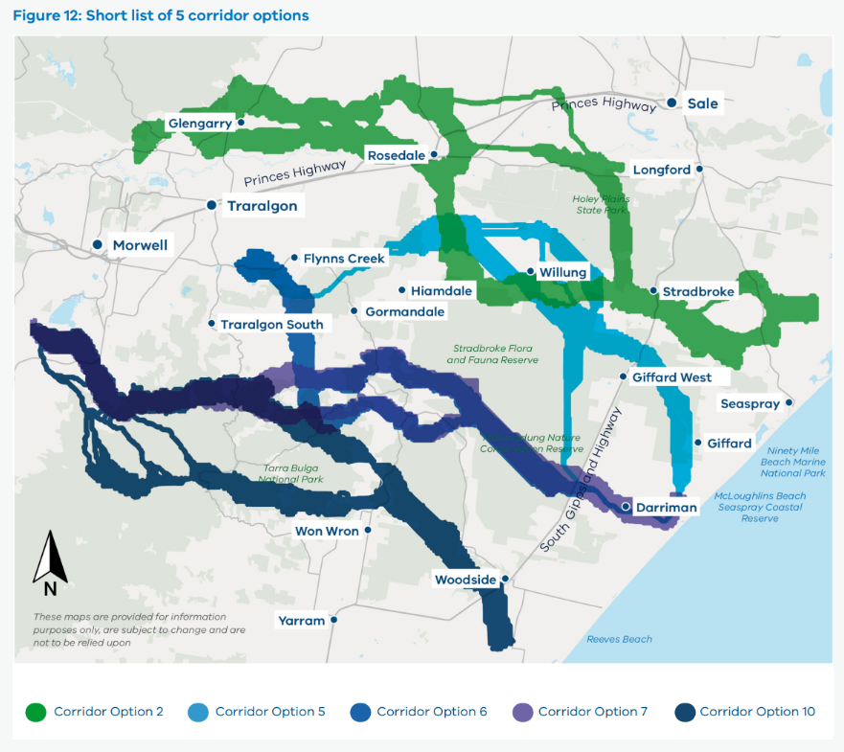
Table 10 summarises the indicative percentages of land type in each of the corridor areas, based on the environmental, heritage, community and land use criteria data used in the spatial mapping tool (described above). For example, corridor options 2, 7 and 10 pass through the highest percentage of agricultural land. Note the information is based on desktop data, and has not been verified via comprehensive surveys.

Table 10: Indicative percentage of land/environmental value
Option | Plantation | Crown | Native | Agriculture | Cultural
C2 | 20% | 13% | 18% | 92% | 25%
C5 | 64% | 53% | 43% | 67% | 52%
C6 | 53% | 30% | 52% | 63% | 19%
C7 | 37% | 33% | 51% | 72% | 26%
C10 | 46% | 50% | 53% | 80% | 22%
Note: The 5 options are described on pages 34 - 38. Percentages add up to more than 100% due to overlapping definitions of land use. For example, some may fall into categories of both Crown land and land used for plantations.

Corridor option C2

Figure 13: Corridor option C2
A map of Gippsland showing Corridor option C2. The corridor runs from an area near the coast above Seaspray and across past Stradbroke and Willung, up to Rosedale and west to Glengarry. It ends just west of Glengarry.
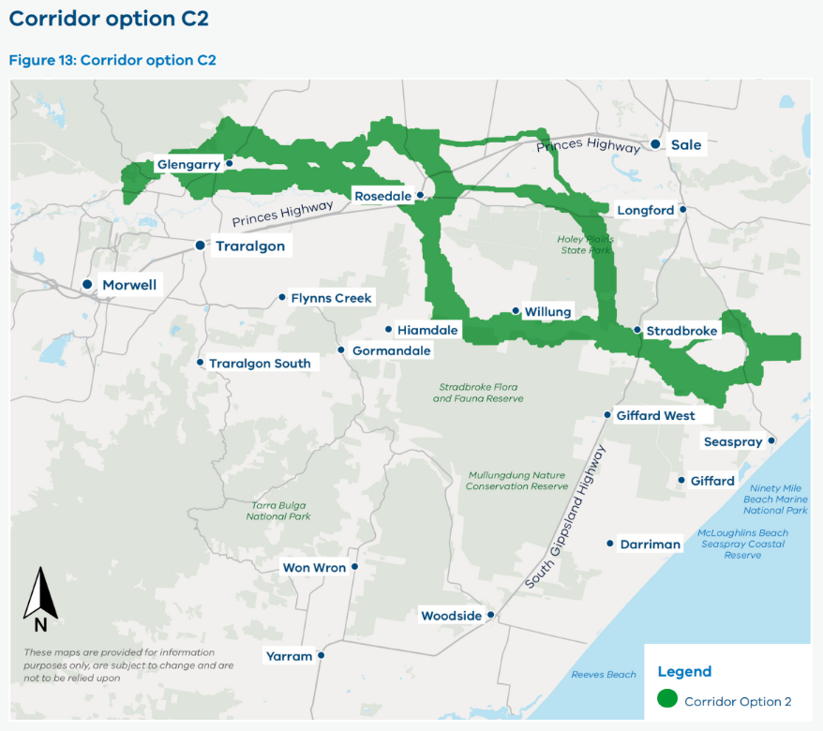

Key findings
- Lowest proportion of high condition native vegetation, public conservation and recreation zones and areas of potential cultural heritage sensitivity
- Passes through the most agricultural land (92% of total corridor area)
- Intersects with Latrobe River, Blue Rock Lake, Tyers River, Fells Creek and Mermann Creek
- Near observed surface water
- Interacts with an irrigation district
- Passes through residential areas or land adjacent to residential areas (including Tyers, Glengarry and Rosedale)
- Commonwealth Defence land exists across a small portion of the area.
Note: Percentages add up to more than 100% due to overlapping definitions of land use.
For example, some land may fall into categories of both Crown land and land used for plantations.

Corridor option C5

Figure 14: Corridor option C5
A map of Gippsland shows Corridor option C5. The corridor starts near the coast near Giffard and travels northwest past Stradbroke West to Willung, across to Flynns Creek and then to the Loy Yang Power Station.
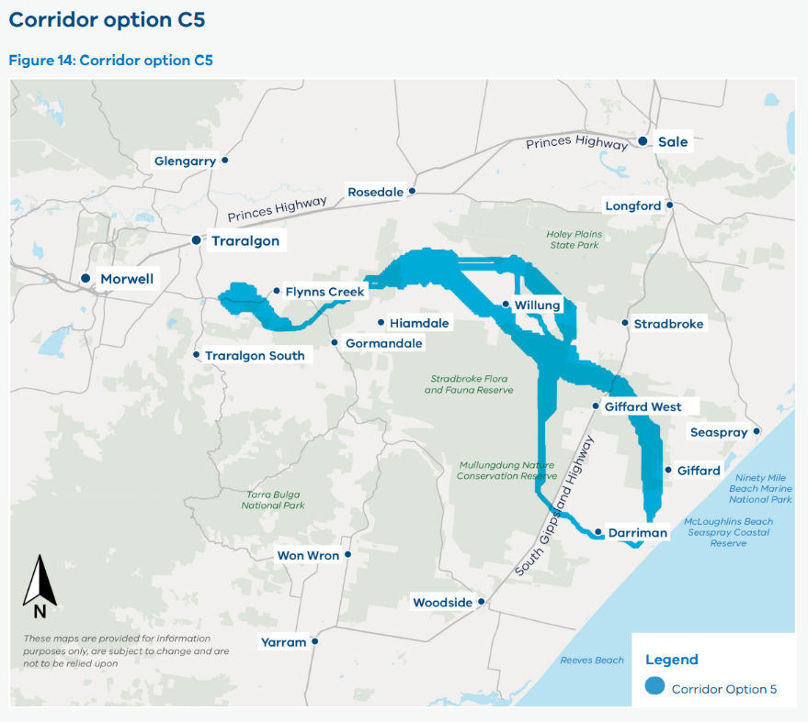

Key findings
- Moderate portion traverses Crown land (53% of total corridor area), plantations (64%) and agricultural land (67%)
- Terminates inland at Loy Yang near an open cut brown coal mine covered by a State Resource Overlay
- Moderate proportion of high-condition native vegetation and public conservation and recreation zones
- Around half of the corridor (52%) interacts with areas of possible cultural heritage sensitivity including the Jack Smith Lake State Game Reserve, Stradbroke Flora and Fauna Reserve, Mullungdung State Forest, Giffard Nature Conservation Reserve, and Mullungdung Flora and Fauna Reserve
- Traverses some waterways, but represent only 0.7% of the total corridor area.
Note: Percentages add up to more than 100% due to overlapping definitions of land use. For example, some land may fall into categories of both Crown land and land used for plantations.

Corridor option C6

Figure 15: Corridor option C6
A map of Gippsland shows Corridor option C6. The corridor starts near the coast near Darriman and travels north west between Gormandale and Traralgon South, and then to Loy Yang Power Station.
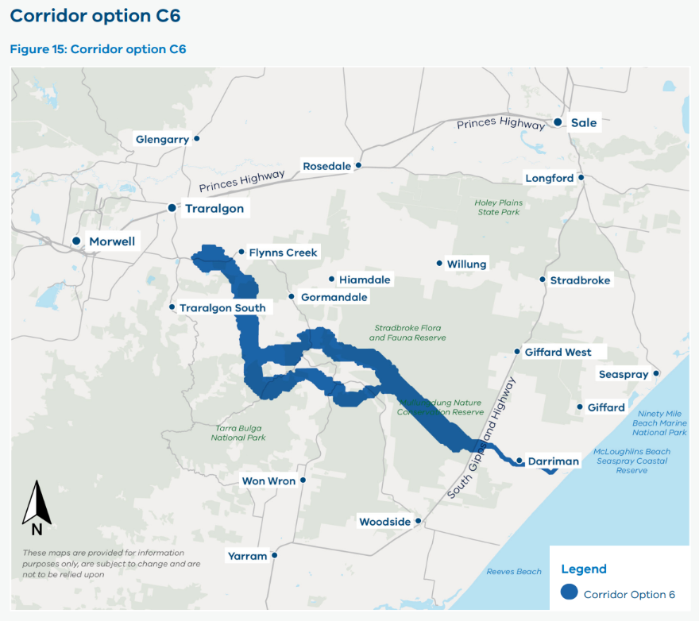

Key findings
- Moderate portion passes through plantations (53% of total corridor area) and agricultural land (63%)
- Intersects with areas of cultural heritage sensitivity including Mullungdung Flora and Fauna Reserve and Mullungdung State Forest
- Interacts with several waterways including Flynns Creek, Mermann Creek and Bruthen Creek
- Near the town of Carrajung.
Note: Percentages add up to more than 100% due to overlapping definitions of land use.
For example, some land may fall into categories of both Crown land and land used for plantations.

Corridor option C7

Figure 16: Corridor option C7
A map of Gippsland shows Corridor option C7. The corridor starts near the coast near Darriman and runs north west above Balook and to west of Hazelwood South.
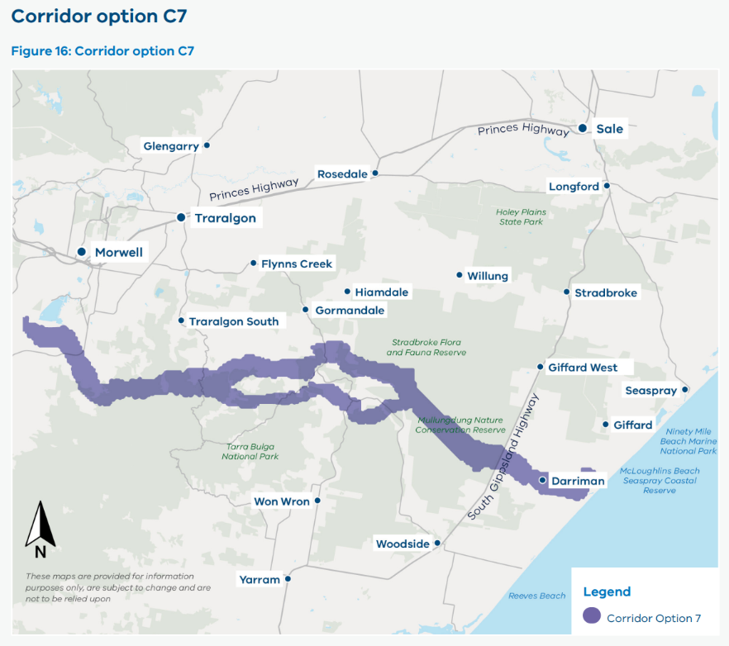

Key findings
- Terminates close to the Hazelwood Power Station site and associated brown coal mining region, which is covered by a State Resource Overlay
- High portion passes through agricultural land (72% of total corridor area)
- Traverses possible areas of cultural heritage sensitivity, including Mullungdung Flora and Fauna Reserve, and intersects with Mullungdung State Forest
- Interacts with Traralgon Creek, Flynns Creek, Mermann Creek and Bruthen Creek
- Close to Yinnar, Churchill and Carrajung.
Note: Percentages add up to more than 100% due to overlapping definitions of land use.
For example, some land may fall into categories of both Crown land and land used for plantations.

Corridor option C10

Figure 17: Corridor option C10
A map of Gippsland shows Corridor option C10. The corridor starts near the coast south of Woodside and runs north west above Won Wron, along to west of Hazelwood South.
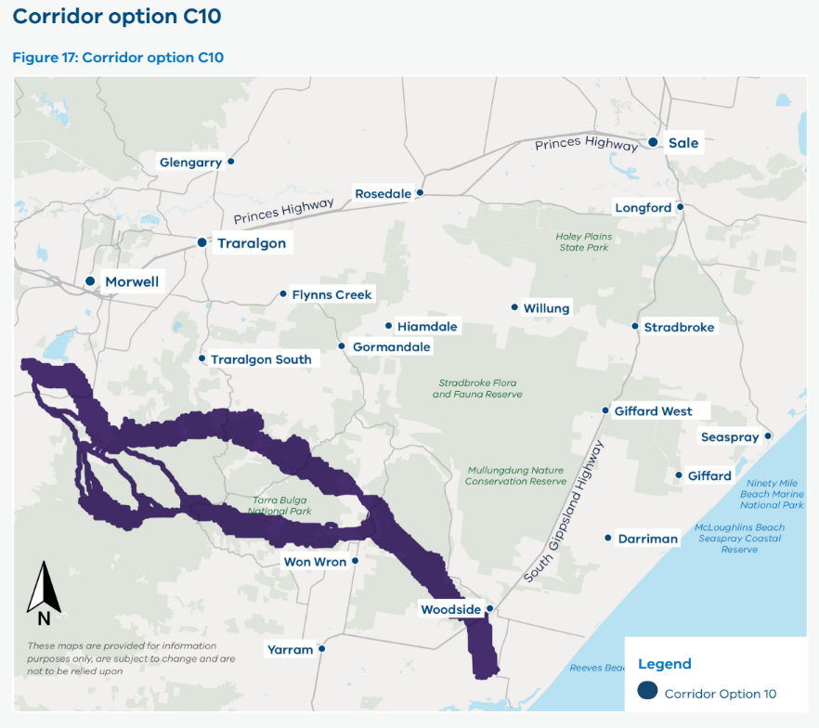

Key findings
- Terminates close to the Hazelwood Power Station site and associated brown coal mining region, which is covered by a State Resource Overlay
- High proportion (80%) passes through agricultural land
- Traverses two national parks: Tarra-Bulga National Park and Morwell National Park - both parks are considered public conservation and recreation zones
- Traverses Won Wron State Forest, which is considered a public conservation and recreation zone and has occurrences of high condition vegetation
- Interacts with Morwell River, Traralgon Creek, Tarra River, Flynns Creek, Mermann Creek and Bruthen Creek.
Note: Percentages add up to more than 100% due to overlapping definitions of land use. For example, some land may fall into categories of both Crown land and land used for plantations.

3. Selecting the preferred corridor option
The assessment criteria and Multi-Criteria Analysis approach established in VicGrid’s
Assessment Method were used for a detailed assessment of the 5 short listed corridor options
to identify a preferred option.

Figure 18: Selecting a preferred option as part of the Development and Engagement Roadmap
2023 – early 2024 | 2023 – early 2024 | 2023 – early 2024
Offshore Wind Transmission Development and Engagement Roadmap  Develop Assessment Method to assess options and select Study Area | Offshore Wind Transmission Development and Engagement Roadmap  Develop Assessment Method to assess options and select Study Area | Offshore Wind Transmission Development and Engagement Roadmap  Develop Assessment Method to assess options and select Study Area
Identify feasible corridor  and technical options | Assess corridor and technical options and  select short list | Assess short list and  select preferred options  and Study Area
Use spatial mapping technology to identify sensitive areas and feasible corridor options  Use technical engineering methods to identify feasible technical options | Identify long list of options  Select short list of options by filtering using assessment criteria | Use assessment criteria to  assess short list  Use scoring and weighting to assess  short list  Select preferred option
Community and landholder engagement  Traditional Owner / First Peoples engagement and partnership approach | Community and landholder engagement  Traditional Owner / First Peoples engagement and partnership approach | Community and landholder engagement  Traditional Owner / First Peoples engagement and partnership approach
The detailed corridor options assessment systematically evaluated each of the 5 short listed options against the assessment criteria. It included:
- an extensive assessment of the likely quantitative and qualitative impacts of each option based on more detailed data and information
- consideration of the outputs of Phase 2 community and stakeholder engagement to ensure that community views and specific knowledge of the region and community were taken into account
- additional use of land use, terrain and ground conditions data, as well as a high level constructability assessment.
The detailed assessment is based on desktop analysis only. Comprehensive surveys have not been undertaken across the corridor option areas, and if environmental and cultural heritage values are not identified in this detailed assessment it does not mean they are not present. Section H outlines further steps needed to build on this desktop work with on-site investigations and further engagement.
Table 11 provides the detailed assessment scores for each of the short listed corridor options considered. A higher score means that the option performed more favourably when assessed against the assessment criteria. Conversely, lower scores indicate that this option did not perform as well against the assessment criteria.

Table 11: Short listed corridor options by score (weighted)
Options | Option C2 | Option C5 | Option C6 | Option C7 | Option C10
1 Project Objective  Fit-for-purpose infrastructure | 0.39 | 0.51 | 0.48 | 0.39 | 0.34
2 Project Objective  Contribute to regional development | 0.14 | 0.42 | 0.42 | 0.28 | 0.28
3 Project Objective  Maintain transmission system security, reliability and strength | 0.43 | 0.33 | 0.33 | 0.38 | 0.38
1 Guiding Principle  Minimise impact on host landholders and communities | -0.21 | -0.08 | -0.11 | -0.16 | -0.16
2 Guiding Principle  Minimise impact on the environment | -0.20 | -0.20 | -0.30 | -0.30 | -0.30
3 Guiding Principle  Identify areas of cultural heritage  sensitivity (Aboriginal and non-Aboriginal) | -0.16 | -0.19 | -0.13 | -0.21 | -0.13
4 Guiding Principle  Minimise impact on existing and future land use | -0.36 | -0.23 | -0.23 | -0.32 | -0.32
5 Guiding Principle  Minimise cost impacts to energy consumers and generators | -0.17 | -0.11 | -0.11 | -0.22 | -0.22
6 Guiding Principle  Limit engineering | -0.03 | -0.05 | -0.09 | -0.11 | -0.11
Total Score | -0.17 | 0.41 | 0.26 | -0.26 | -0.24
Rank | 3 | 1 | 2 | 5 | 4

Table 12: Comparing the short listed corridor options
Criteria | Criteria description
1 Project Objective  Fit-for-purpose infrastructure | Optionality and future-proofing  This criterion looked at the relative extent to which the corridor option areas were able to cater to different options for connection point locations, different parts of the declared offshore wind area, and compatibility with short-listed technical options. An option received a more favourable score if it was more centrally located and/or more flexible to cater for changes in offshore wind development.  Key findings  - The central corridor options (C5 and C6) scored the best overall for this criterion as they are more central to the declared offshore wind zone.  - The other options were scored less favourably as they are less central to the offshore wind zone or because they include challenging terrain for some types of transmission technology.
2 Project Objective  Contribute to regional development | Benefit sharing  This criterion included an assessment of each option area’s proximity to private land. The assessment assumes more regional development can occur in option areas with lower levels of private land impacted.  Key findings  - With more moderate proportions of private land than the other corridor options, Options C5 and C6 achieved the best score for this criterion.
3 Project Objective  Maintain transmission system security, reliability and strength | System security, reliability and strength  Scoring for this criterion was informed by a qualitative assessment of reliability and security. An option received a higher score where there was greater flexibility to accommodate future requirements on system security, reliability and strength.  Interface with onshore generators  Scoring for this criterion was also informed by the location and distribution of new generation developments. Proximity to areas of possible future onshore generation developments may facilitate connection of these assets. The scoring also reflected the difficulty in predicting the location of future onshore generation assets and their connection points.  Key findings  - Options C2, C7 and C10 scored the best in terms of system security, reliability and strength, as these options terminate at indicative greenfield inland connection sites, providing greater flexibility and lower potential future constraints for inland connections.  - Options C5 and C6 scored lower given that they terminate near Loy Yang Power Station, which has some constraints that require further technical investigation and due diligence.  - All options were close to some announced new onshore generation development with Option C2 closer to a higher number.
1 Guiding Principle  Minimise impact on host landholders and communities | Landscape, visual amenity, local amenity and placemaking  This criterion assessed potential impacts on the local and surrounding landscape, including visual and local amenity. Communities expressed the importance of transmission infrastructure having minimal impact on the visual amenity in their communities, local neighbourhoods and around important community assets. An option received a better score if it was further away from populated areas, State and National Parks, and if there was a lower impact on identified community assets.  Community development preferences  This criterion also assessed corridor options against community preferences around economic and regional development in Gippsland. This included an assessment of compatibility with the Gippsland Regional Plan and other local government strategies and visions, compatibility with local community values, preferences and desired benefits based on output from Phase 2 of engagement. An option received a higher score if it was more consistent with regional strategic priorities and key themes from community feedback.  Noise and air quality  This criterion measured the potential effect of noise, vibration and air quality on sensitive cohorts such as children, elderly, asthmatics who are at heightened risk of negative health outcomes. This assessed how many sensitive community assets like schools, hospitals, and aged care facilities were in or near the corridor option. An option received a lower score the closer it was to these community assets.  Key findings  - Option C5 achieved the best score for this criterion as it does not contain major residential areas or sensitive community assets. There were some community assets identified in the option area (such as a camping area and lookout area), though direct impacts may be avoided through further refinement.  - Option C2 scored lower than the other options because of its proximity to major residential areas and townships (including areas of Tyers (population circa 860), Glengarry (population circa 1,100) and Rosedale (population circa 1,200). C2 also contains a high proportion of agricultural land (92%) (noting community preferences to keep agricultural lands available for current and future land use), and was the only option located near sensitive community assets.  - C7 and C10 also scored relatively low because of proximity to population centres. Both have some interactions with residential areas near Churchill (population circa 4,500) and Option C7 is also in close proximity to Yinnar (population circa 1000).  - Both options also have interactions with State/National Parks and public open spaces. C7 traverses Morwell National Park while C10 traverses Morwell National Park, Tarra-Bulga National Park and Won Wron State Forest.  - Option C6 received a similar score to C5. Key differences were lower opportunities to explore alignment with existing infrastructure for C6 (a community preference based on feedback in VicGrid’s Phase 2 engagement), and one pathway in C6 that overlaps with the town of Carrajung (population circa 100).
2 Guiding Principle  Minimise impact on the environment | Flora and fauna  Each option was assessed against a number of environmental considerations, including the extent to which an option area interacted with Ramsar Wetlands of International Importance, waterways and waterbodies, areas of native vegetation, important wetlands and marine parks. Environmental assets identified through community consultation also impacted scoring of this criterion. Options which interact less with these features achieved a more favourable score, for example the proportion of Ramsar Wetlands in a corridor option.  Natural hazards / disasters  This criterion also included a high-level assessment of the risks of natural hazards that could occur and impact transmission infrastructure in each corridor option, including bushfire risk, flooding risk and the risk of landslides. This included assessing areas of observed surface water (as a proxy for flooding risk), areas of native vegetation and elevation (as proxies for the risk of bushfires and speed at which they may spread), and elevation (as a proxy for the risk of landslides). An option received a better score where terrain conditions indicated lower risk of natural hazards or disasters.  Key findings  - Options C2 and C5 achieved the best scores for this criterion. Option C2 avoids large areas of native vegetation. 43% of Option C5 includes areas of native vegetation but this is less than Options C6, C7 and C10. C5 also traverses Holey Plains State Park and Stradbroke Flora and Fauna reserve.  - C6, C7 and C10 scored the lowest given their higher impact on native vegetation (over 50% of the area of these corridors were identified as native vegetation). They traverse through a number of State Forests and National Parks including McLoughlins Beach – Seaspray Coastal Reserve, Mullungdung Flora and Fauna Reserve and Won Wron State Forest. C6 and C7 also interact with a number of waterways including Flynns Creek, Mermann Creek and Traralgon Creek.  - All options scored similarly in terms of potential natural disasters / hazards as all options included terrain that was at potential risk of flooding, bushfires and/or landslides. Option C5 scored slightly higher as this corridor option avoided areas of observed surface water (as a proxy for flooding risk) and consisted of relatively flat terrain which indicated reduced relative risk of flooding and landslides.
3 Guiding Principle  Identify areas of cultural heritage  sensitivity (Aboriginal and non-Aboriginal) | Traditional Owner values  This criterion assessed the potential effect of the corridor options on known or previously unrecorded Traditional Owner values, which includes cultural heritage sites and other areas of cultural heritage sensitivity. This involved an assessment of the location and level of areas of cultural heritage sensitivity, with options receiving a higher score if there was a lower proportion of these areas in a corridor or potential to avoid them. The approximate number of Traditional Owner values identified through Phase 2 engagement, and compatibility with known Traditional Owner Corporation preferences (where possible), was also considered in scoring.  Significant cultural and historical assets  This criterion also assessed whether corridor options have an impact on known or previously unrecorded significant cultural, archaeological sites and impacts to heritage values. Options scored higher based on the level of constraint for ‘historical heritage’ (which included state and national historical heritage sites and shipwrecks) and the approximate number of significant cultural or historical assets within the corridor area that were identified through community engagement.  Key findings  - C6 and C10 achieved the best scores as the information available indicated they have the lowest interactions with potential Aboriginal cultural heritage sites (19% and 22%, respectively). Option C2 has a slightly larger area of possible cultural heritage sensitivity (25%) and scored slightly lower than Options C6 and C10.  - Option C5 and C7 had the lowest scores for this criterion. Option C5 has the most area that may contain cultural heritage sensitivity (52%). C7 has a high proportion of areas of possible cultural heritage sensitivity (26%), which also includes two potential Aboriginal cultural heritage sites (in Mullungdung Flora and Fauna Reserve and the Jack Smith Lake State Game Reserve) and one specific site related to the Warrigal Creek Massacre. C7 therefore scored the lowest compared to other options
4 Guiding Principle  Minimise impact on existing and future land use | Existing and future land use  This criterion assessed potential impacts on existing and future land use, including local industries such as agriculture, forest, regional tourism, recreational businesses, mining and shipping, as well as public conservation and recreation zones and individual sites tagged as ‘social’ in community consultation. The latter are used as proxies for tourist sites, as indicated by community feedback. Options received lower scores if there was a higher proportion of land types in the corridor. Agricultural land was given a higher priority for avoidance due to strong community preferences indicated through consultation.  Potential easement impacts on land use  This criterion also assessed the impacts of the corridor option on the land uses that may be directly or indirectly impacted by creation of the easement for the new transmission. The presence of public land was also considered as a possible opportunity to minimise private land impacts.  Key findings  - All corridor options had areas supporting local industry, including agriculture and plantations.  - C2 scored the lowest as it has the highest proportion of potential existing and future land use impact (e.g. 92% of the option area is agricultural land), as well as a high proportion of private land that may be affected (96% of the corridor is proximate to private land). VicGrid’s Phase 2 engagement also identified one recreational/tourist asset in this option area.  - Options C5 and C6 achieved the best scores as they have the lowest proportion of potential existing and future land use impact (including 67% and 63% agricultural land, respectively), as well as the lowest proportion of private land that may be affected (66% and 63% of each option area is near private land, respectively). Option C5 also has the highest proportion of Crown land (53%).  - Note Option C2 has lower levels of plantation land (20%), and resources and mineral tenements (6%) relative to other options (which range between 37% to 64% for plantation land and 11% to 20% for resources and mineral tenements).
5 Guiding Principle  Minimise cost impacts to energy consumers and generators | Transmission and energy consumer costs  This criterion assessed the potential difference in costs to energy consumers and generators and assumes that longer path lengths and elevated terrain increase capital and operational costs.  Key findings  - The options did not vary significantly, with C7 and C10 scoring the lowest given their longer average length (85 km and 69 km respectively) and sections of mountainous terrain, which could result in higher construction, capital and operational costs.  - Options C5 and C6 achieved the best scores as they were relatively shorter (average length of 68 km and 64 km respectively) and had relatively flat terrain.
6 Guiding Principle  Limit engineering | Constructability and Program  This criterion assessed the potential effect on construction complexity of terrain in each option area. This included a qualitative assessment of elevation and topography for each option. Options received a higher score if the terrain in the corridor reduced potential construction complexity.  Disruption  This criterion also assessed the potential disruption to public infrastructure assets and amenities that could occur during the construction of transmission infrastructure. This was measured by assessing the extent of impacts of construction on transport infrastructure and utilities, as well as the anticipated access and construction traffic requirements needed during construction. Options were scored lower if there were intersections with major highways or roads which were likely to result in disruptions such as potential construction traffic.  Key findings  - Options C7 and C10 scored lower than the other options as they were both highly constrained due to traversing mountainous terrain, which would increase engineering complexities.  - Option C2 achieved the best score as it traversed through relatively flat terrain and was assessed to cause the least disruption during construction. Option C5 also scored highly, as the option also traverses relatively flat terrain and is not considered to pose major construction complexities relative to other options.

Preferred corridor option and connection hubs
Based on the scoring shown in Table 11 and the assessment findings outlined in Table 12, Option C5 was identified as the preferred corridor option and is shown in Figure 19.

Figure 19: Corridor option C5
A map of Gippsland shows Corridor option C5. The corridor starts near the coast near Giffard and travels northwest past Stradbroke West to Willung, across to Flynns Creek and then to the Loy Yang Power Station.

Features of the preferred corridor option
Cost and engineering complexities
This option is shorter in length (approx. 68 km) which influences project costs. It also has fewer engineering complexities as it traverses relatively flat terrain and is not considered to pose major construction complexities relative to other options. These have an impact on timing and cost.
Alignment with community preferences
The option is set away from major residential areas and does not have any community assets within the corridor area that are likely to impact sensitive receptors (e.g. sporting, healthcare, care or educational facilities). It also presents some opportunities to explore alignment with other infrastructure, which was raised as a community preference in VicGrid's Phase 2 engagement.
Agricultural land
In comparison to most other options, this option has a lower proportion of agricultural land and less proximity to private land. It contains similar proportions of Crown and plantation land (which are higher than other options), balancing different land uses at this early stage.
Flexibility to accommodate offshore wind locations
This option is central to the declared offshore wind area and has more flexibility to respond and extend to different offshore wind farm locations. This is important as the outcome of the Australian Government’s feasibility licensing process is still pending.

Sensitivity of preferred corridor option to changes in scoring and weighting
Sensitivity analysis was performed on the preferred corridor option to test the robustness of the results. Overall, based on the results of the detailed corridor options assessment, this option presents a suitable corridor area on which to progress future analysis and detailed investigations of where to locate transmission infrastructure in the Gippsland region.
Based on the analysis performed, the preferred corridor option is robust to changes in scores and weightings across the assessment criteria. Scores had to change by 50% or more to alter the results. VicGrid also tested a scenario where the weighting of project objectives was reduced to 0% and the weighting of Guiding Principles 1, 3 and 6 was increased to around 20%, and found this did not change the results.

Potential connection hub locations
The preferred corridor option needs an area for the connection hub. This area needs to be able to host high voltage substation plant and equipment which enable offshore wind generators to connect and transport their renewable energy back to the transmission grid and to homes and businesses.
Once the preferred corridor and technical options were selected, analysis was conducted to identify areas that could accommodate a connection hub. The analysis used the following criteria to identify 4 potential connection hub areas representing viable sites that can accommodate a substation footprint of varying sizes:
- not subject to flooding or water inundation
- free of sensitive noise receivers in close proximity
- flat land area
- able to facilitate connection of land cables (i.e. the distance from the shore crossing is less than 20 km)
- close to one or more short listed corridor options
- large enough to accommodate a station footprint.
A connection hub area was selected which overlapped with the preferred corridor option area. This was based on the declared offshore wind area. The outcome of the Australian Government’s feasibility licensing process is pending, and when it concludes, VicGrid will review the connection hub area to ensure it is aligned with the licence locations. VicGrid will engage with landholders and communities during this process.
The inland grid connection point is at or near the Loy Yang Power Station. This allows VicGrid to explore re-use of existing assets in the Latrobe Valley. This option requires further technical investigation and due diligence to assess whether there will be adequate capacity for the new energy supply on the existing Loy Yang-Hazelwood 500 kV corridor while the Loy Yang power stations continue to operate.
The connection hub and inland grid connection point areas are shown with the Study Area in Figure 22. Significant further engagement and environment, heritage and planning investigations are needed to determine connection point locations, particularly at the coast.
Section F: Technical options assessed and what we found
Technical options need to be developed to ensure a reliable, secure, resilient and expandable electricity transmission system and meet a range of system planning criteria. There are essential requirements when designing a power system to ensure that it continues to operate reliably, even with scenarios or events that could disrupt it.
In addition to these essential requirements, transmission planners need to consider many different variables when making choices about the best technical solution for a given project.
These include the volume of electricity being transported, the distance being covered, the need to connect to generation along the line, vegetation and terrain, land uses, cultural heritage and whether lines should go overhead or underground.
A range of technically feasible and efficient transmission options were developed to meet the first offshore wind target of at least 2 GW, with consideration of the technical solutions that would be required to meet the additional longer term future targets.
The options were developed by technical specialists using industry-specific planning and technical information, and transmission planning criteria which were developed jointly with the Australian Energy Market Operator (AEMO).

Understanding transmission terminology
This section of the report includes a large amount of technical terms and information.
This table is provided to help readers of this section understand some of the terms and language used

Table 13: Transmission terminology
Term | Description
AC | Alternating Current (AC) is a type of electrical current where the direction of the flow of electrons switches back and forth at regular intervals. The current flowing in our homes is AC.
DC | Direct Current (DC) is a type of electrical current that is unidirectional – this means that the flow of charge is always going in the same direction. DC is used in many household electronics and devices that use batteries.
Circuit | The path for the flow of electricity between stations.
Double circuit towers | A lattice structure that can support two independent electrical circuits, 1 on each side  of the tower.
Single circuit towers | A lattice structure that can support 1 circuit per tower.
Declared Shared Network (DSN) | Victoria’s electricity transmission network.
HVAC | High voltage alternating current. All standard power systems in Australia use AC.
HVDC | High voltage direct current. HVDC moves power between separate AC networks. It is used for transporting large amounts of energy point-to-point over long distances.
Hybrid option | For offshore wind transmission in Gippsland, this refers to a technical option comprising both HVAC overhead lines and HVDC underground cables. The HVAC lines are used for the first 2 GW offshore wind target, and are set out in a way that would allow future potential development of HVDC cables to cater for the longer-term offshore wind targets.
Kilovolts (kV) | High voltage transmission lines can range between 11 kV and 1,000 kV depending on how far they need to carry power. Higher voltages are better at transmitting large amounts of power over long distances.
Loop tie | For offshore wind transmission in Gippsland, a loop tie is either an overhead line(s) or an underground cable(s) connecting two onshore connection hubs, which turns two radial networks into a loop. A loop tie is not needed to cater for the 2 GW offshore wind target and would only be needed to cater for the longer-term offshore wind targets.
OHL | Overhead line. Overhead lines can carry alternating current (AC) or direct current (DC) voltages.
Radial network | An overhead or underground transmission line(s) which sources power from a single point.
RCAS | REZ Curtailment Abatement Scheme. A battery energy storage system that switches on in the event of an outage of an HVAC circuit, maximising the utilisation of available transmission infrastructure and avoiding building more transmission than needed to cater for the first offshore wind target (at least 2 GW by 2032).
Shunt reactor | Shunt reactors are similar to transformers, and are used to compensate the reactive power in high voltage cables and long transmission lines. Reactors remove reactive power – a type of wasted energy.  To protect a high voltage cable from overloading reactive power must be removed. This is achieved by bringing the HVAC underground cables above ground at regular intervals in large stations to connect them to reactors. HVDC underground cables do not need to be brought above ground to reactors.
Symmetrical monopole | A symmetrical monopole is a type of HVDC system that uses a single converter station at each end, and two high voltage conductors running between each converter station. This is not related to the overhead line structure type called a monopole
Stations | All transmission infrastructure types need stations. Stations convert and connect power into different parts of the network.
Converter  station | In HVDC transmission, converter stations are needed at each end of the overhead line or underground cables. A converter at the start of the line converts the AC power to DC. A converter at the end of the line converts the DC power into AC. These converters connect to the AC networks through HVAC terminal stations. The size of a converter station will depend on the voltage, the arrangement of equipment and the HVDC configuration.
Terminal station | HVAC terminal stations connect overhead lines or underground cables to move energy. The terminal station may include transformers to decrease or increase the voltage and allow for power to be transferred to different parts of the network. All parts of a terminal station operate as HVAC equipment. The size of a terminal station depends on the voltage, the arrangement of the equipment and the transmission infrastructure type that is used.
Transformers | Equipment used in transmission networks to increase and decrease the voltage of electricity so that it can be transported efficiently and safely.
Voltage (V) | Voltage is the pressure that pushes charged electrons through a circuit. Voltage is measured in volts (V) – from the 1.5 V battery in a TV remote, to the 230 V wires running through street poles to our houses. In a transmission network, much larger amounts of pressure are needed to keep the electricity flowing and ensure energy is not lost. This voltage is measured in thousands of volts, or kilovolts (kV).

Planning for the long term
Technical options were developed to support an initial 2 GW of offshore wind energy and to allow for further development to cater for longer term offshore wind energy targets.
Any network development should have the flexibility to adapt and expand further to address future needs and opportunities. Ideally the transmission for the initial 2 GW should be selected to allow for optimal staged development and to avoid unnecessary or redundant transmission infrastructure.
Recognising that a second connection point and further transmission lines will likely be needed to meet the longer term offshore wind targets in Gippsland, the technical options identified have been developed in a way that can expand and provide capacity for this growth.
For the ultimate transmission development to cater for the longer term offshore wind energy targets, the network development would be expected to factor in the following future design requirements:
- 2 connections to the Declared Shared Network for system security purposes.
- 2 connection hubs near the coast for offshore wind generators to connect into, again for system security purposes.
- A transmission circuit known as a loop tie between the connection hubs, or additional circuits installed between the Declared Shared Network connection points and connection hubs.

1. Identifying feasible technical options
A long list of 8 technically acceptable and practical technical options was identified. The long list of options includes a variety of different transmission technologies and designs, including HVAC and HVDC overhead and underground options, operating at different voltages.
Both HVAC and HVDC technologies are considered technically feasible, where the selected voltages represent current state-of-the-art designs for power transfer at high power levels.
Hybrid options (T11) were also considered technically feasible. A hybrid option would involve an overhead HVAC system to meet the 2 GW offshore wind target in potential combination with 1 or more underground HVDC systems to meet the longer term offshore wind energy targets.
Hybrid options are not partial undergrounding – 1 transmission line is underground and 1 is overhead and they work together. Any consideration of partial undergrounding is more appropriately assessed as variants in an individual option in a subsequent stage of analysis, where non-technical needs, length and location can be properly explored.

Early options not included on long list
VicGrid considered some options that were not included in the long list for assessment because they were not technically acceptable or practical.
One option was an offshore connection hub, which is described on page 52. Another option which was considered at this early stage but did not progress to the long list was a HVAC 500 kV underground transmission line. HVAC 500 kV underground transmission is not proven over long distances and requires electrical stations called shunt reactors at regular intervals along the line.
There are no examples anywhere in the world where a HVAC 500 kV underground transmission line of this distance has been installed.

Decision to select an onshore connection point
A key reason for preferencing an onshore connection option is because an offshore hub connection option is unlikely to reduce the onshore footprint or the number of export cable shore crossings needed because of standard requirements for the way the existing grid operates.
An offshore connection point would also present additional complexity and expense to expand from 2 GW to cater for the longer term offshore wind energy targets. More investment would likely be required up-front to accommodate future stages and this investment would be wasted if offshore wind developers do not develop projects near the offshore connection point.
As part of the ongoing work to refine the Study Area and transmission location, VicGrid will engage with offshore wind developers and help coordinate the planning of shore crossings to connect the offshore wind cables with the new transmission connection hub.

Table 14: Long list of technical options
Option | Description
T1 | HVAC 500 kV  Overhead transmission line
T3 | HVAC 330 kV  Overhead transmission line
T4 | HVAC 330 kV  Underground transmission line
T7 | HVDC +/- 320 kV  Overhead transmission line
T8 | HVDC +/- 525 kV  Overhead transmission line
T9 | HVDC +/- 320 kV  Underground transmission line
T10 | HVDC +/- 525 kV  Underground transmission line
T11 | Hybrid HVAC and HVDC options

2. Selecting a short list of technical options
The next step in assessing technical options was to undertake a rapid assessment of the long list of 8 technical options to select a short list. This was a high level assessment which is suitable for screening and filtering a large number of options.

Figure 20: Selecting a short list of options as part of the Development and Engagement Roadmap
2023 – early 2024 |  | 2023 – early 2024 |  | 2023 – early 2024
Offshore Wind Transmission Development and Engagement Roadmap  Develop Assessment Method to assess options and select Study Area |  | Offshore Wind Transmission Development and Engagement Roadmap  Develop Assessment Method to assess options and select Study Area |  | Offshore Wind Transmission Development and Engagement Roadmap  Develop Assessment Method to assess options and select Study Area
Identify feasible corridor  and technical options | Assess corridor and technical options and select short list |  | Assess short list and  select preferred options  and Study Area
Use spatial mapping technology to identify sensitive areas and feasible corridor options  Use technical engineering methods to identify feasible technical options | Identify long list of options  Select short list of options by filtering using assessment criteria |  | Use assessment criteria to assess short list  Use scoring and weighting  to assess short list  Select preferred option
Community and landholder engagement  Traditional Owner / First Peoples engagement and partnership approach |  | Community and landholder engagement  Traditional Owner / First Peoples engagement and partnership approach |  | Community and landholder engagement  Traditional Owner / First Peoples engagement and partnership approach
The assessment criteria were used in the rapid assessment to filter down the long list of options to a short list for the detailed assessment. This high-level analysis focussed on identifying key points of difference between project options across the assessment criteria.
Table 15 provides the rapid assessment scores for each of the long listed technical options considered. A higher score means that the option performed more favourably when assessed against the assessment criteria. Conversely, a lower score indicates that this option did not perform as well against the assessment criteria.

Table 15: Summary of technical long list rapid assessment scores
Technical Option | T1 | T3 | T4 | T7 | T8 | T9 | T10 | T11
Total score | 0.38 | 0.38 | -0.42 | -0.35 | -0.35 | -0.36 | -0.07 | 0.19
Rank | 1 | 1 | 8 | 5 | 5 | 7 | 4 | 3

The short listed technical options
Based on the scoring shown in Table 15, the 5 best-performing options were included in a short list for detailed assessment. These options included HVAC overhead, HVDC underground and hybrid options.
These technical options include a variety of different transmission technologies and designs, requiring a different mix of linear infrastructure, substations and other energy infrastructure.
The 5 short listed options include the 4 highest-scoring technical options from the rapid assessment, with the Hybrid option (T11) separated into 2 different types of hybrid options.
The short listed options were:
- 2 HVAC overhead options operating at 500 kV and 330 kV (T1 and T3)
- 1 HVDC underground option operating at +/-525 kV (T10)
- 2 Hybrid options comprising a combination of both HVAC 330 kV overhead and HVDC +/- 525 kV underground technologies (T11A and T11B).
The Hybrid technical option (T11) was developed into two options (T11A and T11B) to reflect the different ways a hybrid option can cater for both the 2 GW and longer-term offshore wind energy targets.
The HVAC 330 kV underground option and HVDC +/- 320 kV underground option were excluded at this assessment stage for the following reasons.
The HVAC 330 kV underground transmission was excluded because it requires the following elements which would have greater impacts:
- technology is not proven over long distances
- shunt reactors along the line (although fewer than the 500 kV underground option)
- a wider easement than other underground options
- the greatest number of cables and joints of all options
- significant plant and infrastructure requirements so expected to take a longer time to build.
The HVDC +/- 320 kV underground option was excluded because it:
- is better suited to lower capacity requirements, limiting its ability to cater for the longer-term offshore wind energy targets
- presents limitations on connecting additional onshore generation
- expected to take a longer time to build and requires overseas expertise and equipment.

Table 16: Description of short listed technical options
To help understand the technical options described here, see ‘Understanding transmission terminology’ on page 49.
Option | Short listed option | Detailed description
T1 | HVAC 500 kV overhead | This option caters for the 2 GW offshore wind target with a single radial network comprising one set of HVAC double circuit 500 kV towers, and ending with a connection hub near the coast. It is supported by a RCAS which helps maximise the amount of generation that can connect to the towers.  To cater for the longer term offshore wind targets, this option would require a second radial network and connection hub, and a loop tie between the 2 connection hubs near the coast.
T3 | HVAC 330 kV overhead | This option caters for the 2 GW offshore wind target with a single radial network comprising one set of HVAC double circuit overhead 330 kV towers, and ending with a connection hub near the coast. It requires 500 / 330 kV transformation at the grid connection point. It is supported by a RCAS which helps maximise the amount of generation that can connect to the towers.  To cater for the longer term offshore wind targets, this option would require a second radial network, connection hub and transformation, and a loop tie between the 2 connection hubs near the coast.
T10 | HVDC +/- 525 kV underground | This option caters for the 2 GW offshore wind target with a single radial network comprising HVDC underground cables with two 1433 MW symmetrical monopoles, and ending with a connection hub near the coast. A HVDC converter station is required at each end of the radial network.  To cater for the longer term offshore wind targets, this option would require a second radial network, connection hub and HVDC converter stations. A HVAC loop tie may be required to balance energy loading between the 2 radial networks.
T11A | Hybrid HVAC  330 kV overhead and HVDC +/- 525 kV underground (in separate corridors) | This option caters for the 2 GW offshore wind target with a single radial network comprising one set of HVAC double circuit overhead 330 kV towers, and ending with a connection hub near the coast. It supported by a RCAS which helps maximise the amount of generation that can connect to the towers.  To cater for the longer term offshore wind targets, this option would require a second radial network with HVDC underground cables, a connection hub and HVDC converter stations. A HVAC loop tie may be required to balance loading between the 2 radial networks.
T11B | Hybrid HVAC  330 kV overhead and HVDC +/- 525 kV underground (combined in corridors) | This option caters for the 2 GW offshore wind target with a HVAC 330 kV overhead loop, with a connection hub near the coast. It supported by a RCAS which helps maximise the amount of generation that can connect to the towers.  To cater for the longer term offshore wind targets, this option would require HVDC underground cables to be built in the same corridors as the HVAC overhead loop (except for the loop tie), and a second connection hub.
Note: the HVAC overhead networks consist of one set of double circuit towers, but it is also technically feasible for these options to consist of 2 sets of single circuit towers.

3. Selecting the preferred technical option
The assessment criteria and Multi-Criteria Analysis approach used to assess the corridor options were also used for a detailed assessment of the 5 short listed technical options to identify a preferred option.

Figure 21: Selecting a preferred option as part of the Development and Engagement Roadmap
2023 – early 2024 | 2023 – early 2024 | 2023 – early 2024
Offshore Wind Transmission Development and Engagement Roadmap  Develop Assessment Method to assess options and select Study Area | Offshore Wind Transmission Development and Engagement Roadmap  Develop Assessment Method to assess options and select Study Area | Offshore Wind Transmission Development and Engagement Roadmap  Develop Assessment Method to assess options and select Study Area
Identify feasible corridor  and technical options | Assess corridor and technical options and  select short list | Assess short list and  select preferred options and Study Area
Use spatial mapping technology to identify sensitive areas and feasible corridor options  Use technical engineering methods to identify feasible technical options | Identify long list of options  Select short list of options by filtering using assessment criteria | Use assessment criteria to assess  short list  Use scoring and weighting to  assess short list  Select preferred option
Community and landholder engagement  Traditional Owner / First Peoples engagement and partnership approach | Community and landholder engagement  Traditional Owner / First Peoples engagement and partnership approach | Community and landholder engagement  Traditional Owner / First Peoples engagement and partnership approach
The detailed technical options assessment systematically evaluated each of the 5 short listed options against the assessment criteria. It included:
- an extensive assessment of the likely quantitative and qualitative impacts of each technical option based on the solution for the first 2 GW offshore wind target but in the context of being able to facilitate development of the longer term targets
- consideration of initial data on technical design, specifications, costing and the delivery program for short listed options
- consideration of the outputs of Phase 2 community and stakeholder engagement to ensure community views and specific knowledge of the region and community were taken into account.
Table 18 provides the detailed assessment scores for each of the short listed technical options considered. A higher score means that the option performed more favourably when assessed against the assessment criteria. Conversely, lower scores indicate that this option did not perform as well against the assessment criteria.

Table 17: Short listed technical options by score
Option Number | Option T1 | Option T3 | Option T10 | Option 11A | Option 11B
Project Objective 1  Fit-for-purpose infrastructure | 0.51 | 0.51 | 0.38 | 0.43 | 0.30
Project Objective 2  Contribute to regional development | 0.42 | 0.42 | 0.42 | 0.42 | 0.42
Project Objective 3  Maintain transmission system security, reliability and strength | 0.55 | 0.55 | 0.55 | 0.59 | 0.59
Guiding Principle 1  Minimise impact on host landholders  and communities | -0.26 | -0.27 | -0.07 | -0.19 | -0.22
Guiding Principle 2  Minimise impact on the environment | -0.30 | -0.30 | -0.20 | -0.30 | -0.30
Guiding Principle 3  Identify areas of cultural heritage  sensitivity (Aboriginal and non-Aboriginal) | -0.16 | -0.16 | -0.32 | -0.24 | -0.32
Guiding Principle 4  Minimise impact on existing and future  land use | -0.32 | -0.32 | -0.23 | -0.27 | -0.32
Guiding Principle 5  Minimise cost impacts to energy  consumers and generators | -0.11 | -0.11 | -0.44 | -0.44 | -0.44
Guiding Principle 6  Limit engineering | -0.04 | -0.04 | -0.12 | -0.08 | -0.08
Total Score | 0.29 | 0.28 | -0.03 | -0.08 | -0.36
Rank | 1 | 2 | 3 | 4 | 5

Table 18: Comparing the short listed technical options
To help understand the technical options described here, see ‘Understanding transmission terminology’ on page 49.
Criteria | Criteria description
1 Project Objective  Fit-for-purpose infrastructure | Optionality and futureproofing  This criterion assessed the ability of the option to be delivered at the right time and at the best cost to support long-term renewable energy targets. This criterion was assessed based on the ability for the option to be developed to achieve the 2 GW target and scaled to cater for the longer term targets while minimising unnecessary expenditure. It was also assessed based on the complexity of additional infrastructure needed to cater for the longer-term offshore wind targets.  Key findings  - All options were identified as being technically feasible and able to cater for both the 2 GW and longer-term offshore wind targets.  - Options T1 and T3 achieved the best score overall. A HVAC overhead line solution caters for the 2 GW offshore wind target with a single corridor and without needing to over-invest now in infrastructure needed to achieve the longer-term offshore wind targets. The indicative final arrangement minimises the total number of circuits required and involves less complexity to expand for the longer-term targets because less substation plant and equipment is required.  - Options T10 and T11A require up-front and less efficient investment or are more complex to expand. These options require additional substation plant and equipment to support expansion of capacity at each stage. Option T10 would also require partial installation of infrastructure needed to cater for the longer-term offshore wind targets. Option T11B received the lowest score as the arrangement requires developing infrastructure across two corridors to cater for the 2 GW offshore wind target.
2 Project Objective  Contribute to regional development | Regional economic development opportunities  This criterion assessed the ability of the option to support economic growth and development across local industry. It considered the potential to leverage local supply chains and diversify local economies and income streams through local content and investment opportunities. It also considered opportunities to innovate and develop Victoria’s energy sector through training, skills and capability building. Regardless of the technology selected, investment in transmission infrastructure will add value to sectors including civil engineering and construction, manufacturing and electricity distribution sectors and create local jobs in construction and operation.  Key findings  - Scores for this criterion were consistent across all options.  - Options T1 and T3 are standard HVAC overhead designs, enabling a higher proportion of local supply chains to be leveraged during project development, compared to a higher reliance on overseas expertise for Options T10, T11A and T11B.  - However, the other HVDC underground and the hybrid options would need significantly higher project expenditure and provide opportunities to create new capabilities in HVDC technology.
3 Project Objective  Maintain transmission system security, reliability and strength | System security, reliability and strength  The list of transmission terminology on page 49 of the report can assist with some of the terms used below. This criterion assessed the ability of the technical option to maintain energy system security, reliability and strength and was assessed on the following measures:  - fault rate, power transfer impacts and repair time over the life of the asset  - total losses based on analysis of actual (average) losses and losses at peak output extent to which the technology creates reactive power charging, requiring reactive compensation equipment  - extent to which the option can support voltage support, damping control or system strength services, based on analysis of the option’s design and its ability to support services and capabilities that enhance overall system strength and stability.  Interface with onshore generators  This criterion also assessed the ability of the technical option to facilitate additional onshore generation connections at connection points and mid-points and minimise duplication or requirements for additional transmission development in the future.  Key findings  All options received similar scores for balancing system security and strength and the ability to integrate onshore connections. Hybrid options scored marginally better as they can leverage the benefits of both HVAC and HVDC solutions in the long term. All options adhere to technical criteria which define secure operating arrangements and the minimum network requirements to support defined levels of energy generation. Reliability factors, such as losses and unserved energy, were also found to be largely consistent across all options during standard operations. HVAC overhead options may experience a higher fault rate but with lower power transfer impacts and lower repair time, and HVDC underground options may experience a lower fault rate but with higher power transfer impacts and higher repair time.  - As full or partial HVAC overhead systems, Options T1, T3, T11A and T11B are better able to support additional mid-point connections to new onshore renewable generation projects. For Option T10, additional connections can only be facilitated from substations at either end of the HVDC underground cable. Mid-point connections would require an additional converter station.  - Options T10, T11A and T11B can be designed to provide additional system support services that are not possible with a HVAC system.
1 Guiding Principle  Minimise impact  on host landholders and communities | Landscape, visual amenity, local amenity and placemaking  This criterion assessed the potential impacts of technical options on the local and surrounding landscape, including visual and local amenity. Communities expressed the importance of transmission infrastructure having minimal visual impact in their communities, local neighbourhoods and around important community assets. This criterion was assessed based on the following measures:  - approximate footprint and height of transmission lines  - approximate footprint of substations and balance of connection hubs, terminal stations and other new transmission infrastructure.  Community development preferences  This criterion also assessed technical options against community preferences around economic and regional development in Gippsland. This included:  - an assessment of compatibility with the Gippsland Regional Plan and other local government strategies and visions  - compatibility with local community values, preferences and desired benefits based on key themes from Phase 2 of engagement  - the extent to which the option can align with existing infrastructure and/ easements.  Noise and air quality  This criterion also assessed the potential effect of noise, vibration and air quality on vulnerable people in the area. The measure for assessment was the extent of noise and electromagnetic field (EMF) levels generated by linear infrastructure and substations during normal operation.  Key findings  - Option T10 achieved the best score against this criterion as a fully underground solution is not visible once buried and this aligns with local community preferences for underground infrastructure, based on feedback received during VicGrid’s Phase 2 engagement. Underground cables also do not produce audible noise whereas overhead line solutions may emit some low crackling or hissing.  - Options T1 and T3 scored the lowest as overhead lines are not aligned with local community preferences (based on feedback received during VicGrid’s Phase 2 engagement), and potentially have visual impacts due to the height of overhead transmission lines and towers along the corridor. This was the only criterion with different scoring between Options T1 and T3, based on a subjective assessment of increased potential visual impacts from terminal stations in Option T3.  - Options T11A and T11B are hybrid options so involve the potential visual impacts of the overhead line and alignment with local community preferences from the underground cable.  - In terms of electric and magnetic fields (EMF), HVAC overhead lines are designed to ensure EMF levels are safe for public exposure, and HVDC underground cables produce a static magnetic field, which have a higher acceptable limit for safe public exposure.
2 Guiding Principle  Minimise impact on the environment | Flora and fauna  This criterion assessed the potential impact of the technical options on flora and fauna based on the following measures:  - indicative disturbance to the local environment, flora and fauna during construction based on analysis of construction site requirements and construction techniques, including ability to use non-destructive construction techniques  - indicative disturbance to the local environment, flora and fauna during operation.  Natural hazards / disasters  This criterion also qualitatively assessed the potential for damage to transmission assets from natural disasters and hazards.  Key findings  All options have a similar potential impact on flora and fauna during construction due to the clearing of vegetation required to establish site access and support construction activity.  - The underground Option T10 achieved a more favourable score than overhead options T1 and T3 when considering both the construction and operation phases. Underground options may involve more disturbance of flora and fauna during construction but HVDC underground easements are narrower than HVAC overhead easements which may reduce the potential operational impact.  - Option T10 would also be less affected by bushfire and extreme wind events compared to other options (all else equal), as it is buried underground. However, storm damage to underground cables can occur due to soil erosion from flood events or landslips from heavy rainfall.  - Impacts on biodiversity are expected to be similar across overhead and underground transmission infrastructure.
3 Guiding Principle  Identify areas of cultural heritage  sensitivity (Aboriginal and non-Aboriginal) | Traditional Owner/ First Peoples values  This criterion assessed the potential effect of the technical options on known or previously unrecorded First Peoples values, which includes cultural heritage sites and other areas of cultural heritage sensitivity. The measure for assessment was the extent of potential impact of the technical option based on cultural heritage advice from a construction, operations and approvals perspective. A cultural values assessment and further consultation and partnership with Traditional Owner groups (for this project, GLaWAC) will consider additional inputs to guide the design of the technical option.  Significant cultural and historical assets  This criterion also assessed whether the corridor options may impact known or previously unrecorded significant cultural, archaeological sites and impacts to heritage values. The measure for assessment was the extent of potential impact from construction and operation of the technical option.  Key findings  - Options T1 and T3 achieved the most favourable scores as the construction of overhead lines require a lower level of ground disturbance compared to underground cables, reducing the likelihood of impacting culturally sensitive and historical assets beneath the ground.  - Conversely, Options T10 and T11B scored the lowest as installing underground cables across two corridors (for the indicative final arrangement) has a significantly greater chance of discovering (and impacting) sensitive assets, requiring salvage excavations of impacted sites, archaeological activity, and longer approval processes.  - However, this assessment of potential impacts on areas of cultural heritage sensitivity is indicative only. These impacts will need to be discussed further with GLaWAC, and subject to more detailed assessments (including of intangible cultural values).
4 Guiding Principle  Minimise impact on existing and future land use | Existing and future land use  This criterion assessed the potential impact of the technical option on existing and future land use and on existing local businesses and local industries during construction and operation. This was evaluated based on analysis of select land zoning and management and permitted activities adjacent to or within infrastructure easements.  Potential easement impacts on land use  This criterion also assessed the potential impacts of the option on the land uses that may be directly or indirectly impacted by creation of easements for the new transmission. The measure for assessment was the estimated approximate width of easement required to support the technical option.  Key findings  - All options scored similarly as any transmission solution is expected to have some impact on current and future land use.  - Options T1, T3 and T11A are more favourable from an agricultural land use perspective, as grazing and cropping is generally permitted within an overhead line easement, whereas Options T10 and T11B are significantly limited as agricultural activities are restricted within underground line easements. Farming activity will likely be impacted as cropping is generally not permitted within an underground easement.  - In contrast, Option T10 requires a narrower easement width than the HVAC overhead options, reducing potential land use impacts to a smaller footprint.  - Forest plantations would no longer be possible within the easements across all options.
5 Guiding Principle  Minimise cost impacts to energy consumers and generators | Transmission and energy consumer costs  This criterion assessed the potential impact of the technical option on transmission costs and the subsequent costs that would flow to energy consumers. The measures used to assess the technical options were:  indicative estimates of nominal capital expenditure (capex) for the development of transmission infrastructure (see information below on approach to cost estimates)  operational expenditure (opex) for the transmission infrastructure based on an indicative estimate of operating and maintenance costs over the technical option’s operating life (as a percentage of total capex per annum).  Generator costs  This criterion assessed the potential impact of the technical option on generator costs. The measure for assessment was the ease and simplicity of connection for generators, based on ability to accommodate export cables of different designs and voltages.  Key findings  - This assessment focused on costs associated with transmission needed to cater for the longer-term offshore wind targets. This was to avoid favouring an option with lower estimated costs to cater for the 2 GW offshore wind target but higher estimated costs overall (for example, Option T11A has relatively low estimated costs to cater for the 2 GW offshore wind target but the second-highest estimated costs when also considering the longer-term offshore wind targets).  - Options T1 and T3 scored more favourably compared to the other options as estimates indicate it will cost significantly less than Option T10 for the first 2 GW, and significantly less than all other options for the longer term targets. For the first 2 GW, indicative high level capex estimates range from approximately $700 million to $4.5 billion, with Options T1 and T3 at the low end of the range, and Option T10 at the high end of the range.  - Indicative opex estimates are lower for HVDC underground than HVAC overhead options, but this does not materially offset the higher indictive capex estimates because the opex is only a small fraction of the capex.
6 Guiding Principle  Limit engineering | Constructability and program  This criterion assessed the potential impact of the technical option on the efficient delivery of the project within the target dates set by the Victorian offshore wind energy targets. The measures used to assess the technical options were:  - technical complexity of the transmission technical option based on the requirement for specialist components, ease of operation and maintenance, adoption of the technology in Australia and the impact of weather windows on staging  - extent to which the project option can optimise time to build, based on analysis of design and construction timeframes to cater for the 2 GW offshore wind target  - extent of impact of unfavourable ground and terrain conditions on the ability to construct the technical option, based on the impact of different ground and terrain conditions on constructability.  Supply chain, procurement and workforce  This criterion also assessed the potential impact on the delivery of the project from supply chain and procurement risk, including lead times for specialised components, technology and skilled workforce.  Key findings  - Options T1 and T3 scored most favourably as they involve standard designs that have already been installed in Australia at scale so local expertise, materials and equipment are expected to be more readily available. This leads to less supply chain and procurement risks.  - Option T10 scored lower as HVDC technology is more technically complex and is expected to require a longer time to build, impacted by significant supply chain and procurement risks for long lead time HVDC converter equipment. In particular, cables, substation switchgear equipment and converter equipment will require overseas design and manufacturing expertise.  - Options T11A and T11B scored more favourably than Option T10 on the basis that delivery to cater for the longer-term offshore wind targets may take less time if HVDC systems are ordered in parallel with the construction of HVAC systems.

Consideration of overhead and underground options
VicGrid’s assessment of technical options considered several underground and overhead options against the Project Objectives and Guiding Principles set out in the Assessment Method.
HVAC overhead transmission lines have been proven worldwide over a long period of time to be the lowest cost system for the safe and reliable delivery of large amounts of energy over long distances. They have been used across the Australian transmission network for many years.
Underground cables have several limitations. They have significantly higher capital costs, and these costs are ultimately passed directly onto energy bills. Further, underground cables have longer construction lead times and engineering complexities, particularly in hilly terrain.
These longer lead times could put at risk the 2030 target for building new transmission infrastructure needed to connect Victorian homes and businesses with renewable energy. This date needs to be achieved to ensure transmission is ready in time for offshore wind to start commissioning, which could commence from early 2031. This is a tight timeframe for transmission delivery.
The Assessment Method sought to balance a large range of competing factors. This balanced approach considered the potential impacts of overhead transmission on visual amenity, land uses including agricultural, forestry and public land, and sensitive areas such as cultural heritage sites and native vegetation.
It also considered other criteria which indicate that overhead transmission offers expandable generation capacity, easy maintenance access and, importantly, the ability to connect new renewable generation projects, including onshore wind and solar, along the line.
The detailed assessment found that the HVAC 330 kV and 500 kV overhead options scored the highest overall, higher than the HVDC +/- 525 kV underground option. This did not change with sensitivity testing of this outcome against different scoring and weighting profiles.
While the scoring considered community preferences for undergrounding, overhead options scored more highly when balanced against other criteria, particularly project costs.
The construction of overhead solutions is expected to have less ground disturbance and potentially fewer impacts to culturally sensitive artefacts/values beneath the ground compared to underground solutions. HVAC overhead systems are also more flexible than HVDC in their ability to facilitate additional mid-point connections to onshore renewable generation.
Further, the preferred corridor option provides opportunities to explore alignment with other infrastructure and public or plantation land (where appropriate) which aligns with community preferences.

Preferred technical options
Based on the scoring shown in Table 16 and the assessment findings outlined in Table 17, the detailed assessment found that the HVAC 330 kV and 500 kV overhead options scored the highest overall.
Two preferred technical options were identified as they both scored favourably against alternatives and do not present significant differences at this early stage of analysis (only 0.01 difference in total score), so both warrant further detailed investigation through the technical work and engagement steps outlined in Section G.
Both Options T1 and T3 are designed to be expandable and adaptable to future network growth, which would be needed to meet future offshore wind targets.

Table 19: Preferred technical options
Preferred options | Detailed description
T1  HVAC 500 kV Overhead | This option caters for the 2 GW offshore wind target with a single radial network comprising one set of HVAC double circuit 500 kV towers, and ending with a connection hub near the coast. It is supported by a RCAS which helps maximise the amount of generation that can connect to the towers.  Number of circuits: 2  Easement width: approximately 70 m  Number of transformers: 3  Tower height: approximately 70 m - 75 m  Connection hub dimensions: approximately 550 m x 300 m
T3  HVAC 330 kV Overhead | This option caters for the 2 GW offshore wind target with a single radial network comprising one set of HVAC double circuit overhead 330 kV towers, and ending with a connection hub near the coast. It requires 500 / 330 kV transformation at the grid connection point. It is supported by a RCAS which helps maximise the amount of generation that can connect to the towers.  Number of circuits: 2  Easement width: approximately 60 m  Number of transformers: 5  Tower height: approximately 60 m – 65 m  Connection hub dimensions: approximately 550 m x 300 m
Note: the connection hub dimensions allow space for future expansion to meet the longer term offshore wind energy targets.

Sensitivity of preferred options to changes in scoring and weighting
Options T1 and T3 are highly robust to changes in scores across the assessment criteria as changes to scores of between -80% and +80% do not change the results.
The preferred technical option only changed when Option T1 and T3’s score for Guiding Principle 5 was reduced by almost 300%. The technical option ranking does not change when any score within the limits of the scoring scale is applied to Options T1 and T3 for Guiding Principle 1.
The underground option score only came close to the preferred option score when the weighting of Guiding Principle 1 was increased to 20% (with a corresponding equal decrease in weighting across Project Objectives (12%) to retain a 100% total).

Approach to cost estimates
A high level indicative cost estimate was developed for each short listed technical option to inform the assessment of Guiding Principle 5 - Minimise cost impacts to energy consumers and generators.
The short listed technical options represent different transmission technologies and designs, requiring a different mix of linear infrastructure, substations and other plant.
Cost estimates were therefore developed specifically for the purpose of the options assessment and are not confirmed or expected estimates for the project.
This is due to the large number of current variables, including unconfirmed route lengths, terrain, technical specifications and ongoing technical assessments and corridor investigations.
The preliminary capital cost assessments identified that both the preferred overhead technical options were lower cost than the other short listed options.
The preferred options to cater for the 2 GW offshore wind target are estimated to cost between approximately $700 million and $1.5 billion for the HVAC overhead options, compared with between approximately $2 billion and $4.5 billion for the short listed HVDC underground option.
These cost estimates were developed through the options assessment process and are not confirmed or expected costs for the project. Further work now needs to be done in consultation with First Peoples, landholders, local communities and technical advisers to refine the preferred options.
Section G: Preferred option, Study Area and next steps

1. Creating a Study Area for further development and engagement
The Gippsland preferred option is a new set of overhead HVAC 330 kV or 500 kV transmission lines from a new connection hub near Giffard to a grid connection point near Loy Yang Power Station.
VicGrid has used the preferred option to create a broader Study Area which will now be used for further detailed investigations and engagement with communities, landowners, First Peoples and regional stakeholders.

Figure 22: Study Area and indicative connection hub
A map of Gippsland shows the Study Area and indicative connection hub area. The Study Area starts approximately 6km from the coast near Giffard and travels northwest past Stradbroke West to Willung, across to Flynns Creek and then to the Loy Yang Power Station.
The map also shows a cross-hatched area along the coast, running approximately from Seaspray to Reeves beach. The legend for this area reads: Offshore wind energy connections to the VicGrid connection hub are subject to the outcome of the feasibility licence process which is pending.
Broadening the preferred corridor option into a Study Area is important because the detailed options assessments have largely been based on initial engagement and desktop assessments.
For example, significant changes may need to be made based on environment, planning, heritage and social information identified through detailed investigations, on the ground assessments and landholder and community consultation.
Selecting a broader Study Area helps to retain flexibility to respond to new information that will be identified through the engagement and in-depth work which now needs to get underway.
The Study Area accommodates the following aspects of the preferred corridor and technical options:
- All parts of the preferred corridor option except for a branch to the south close to the Stradbroke Flora and Fauna Reserve which will not be further progressed because it is in areas of higher environmental and cultural sensitivity.
- Opportunities for alignment with other infrastructure, such as existing roads and the Basslink interconnector.
- A connection hub area near the coast. The connection hub area has been selected based on the declared offshore wind area. The outcome of the Australian Government’s feasibility licensing process is pending, and when it concludes, VicGrid will review the connection hub area to ensure it is aligned with the licence locations. VicGrid will engage with landholders and communities during this process.

Engagement is at the heart of our planning in Gippsland
VicGrid’s ongoing engagement and project planning approach will be guided by industry leading engagement standards and frameworks. VicGrid will apply the Victorian Government’s Public Engagement Framework 2021-2025 which provides principles, a how-to guide and measures for engagement evaluation. It aims to strengthen meaningful engagement practice in Victoria.
The Public Engagement Framework aligns with the values and principles set out by the International Association of Public Participation (IAP2). IAP2 is a leading organisation in public engagement practice and has a series of tools which support the delivery of engagement.
We also acknowledge the important review, recommendations and ongoing work of the Australian Energy Infrastructure Commissioner (AEIC) to improve community engagement across Australia. VicGrid’s approach will align with all AEIC recommendations, and any following implementation undertaken by the Victorian and Commonwealth Governments.
VicGrid is also leading key approaches to support landholders and others impacted by new transmission infrastructure. These include:
- establishing a landholder engagement team who will provide dedicated contacts for landholders in the Study Area, to listen, answer questions about the project, and collect feedback
- appointing an Independent Facilitator, a Gippsland local who can talk directly with landholders and provide an independent avenue for discussions about landholders’ experiences and needs through the development of the new transmission
- adhering to best practice engagement and project planning approaches, guided by industry leading engagement standards and frameworks, including recent community engagement recommendations by the Australian Energy Infrastructure Commissioner
- training our people to ensure they are equipped to understand the specific experiences and priorities of regional communities and provide practical support that makes a difference.

2. A snapshot of the next steps
Significant further engagement and in-depth investigations are now needed to inform the decision about where the new transmission should go to minimise impacts as much as possible.
Table 20 sets out the high-level process, steps and activities needed to further investigate and refine the Study Area into a corridor and technical design. This process includes a dedicated program of engagement and collaboration with landholders, communities and stakeholders in Gippsland.
VicGrid seeks to talk with landholders, farmers and residents of nearby townships to better understand their needs, their properties and activities like agricultural practices with the aim of improving the project and minimising impacts as much as possible.
The Study Area needs further discussion with the Traditional Owner Corporation, Gunaikurnai Land and Waters Aboriginal Corporation (GLaWAC) and will be investigated in more detail during the refinement process to avoid and minimise potential impacts cultural heritage and values.
Discussions with public land managers and plantation operators will also be needed to identify ways to minimise impacts on native vegetation and local business operations.
VicGrid is preparing a Planning and Engagement Roadmap that will build on the high-level process in Table 20. This will provide more detail about important activities including:
- discussions and engagement with private landholders in the Study Area
- on-the-ground environmental, heritage and other assessments
- engagement with public land managers and businesses in the Study Area
- coordination with offshore wind developers on connections and shore crossings
- industry engagement to inform procurement and delivery approaches.

Table 20: Steps for working with communities to refine the Study Area and confirm the transmission location
2021-2023 | 2023 – early 2024 | 2023 – early 2024 | 2023 – early 2024
Current | Development and Engagement Roadmap Develop Assessment Method to assess options and select Study Area | Development and Engagement Roadmap Develop Assessment Method to assess options and select Study Area | Development and Engagement Roadmap Develop Assessment Method to assess options and select Study Area
Commitment to offshore wind | Identify feasible corridor and technical options | Assess corridor and technical options and select short list | Assess short list and select preferred options and Study Area
Victoria offshore wind targets Commonwealth declared Gippsland offshore wind zone Initial area of interest transmission connection | Use spatial mapping technology to identify sensitive areas and feasible corridors Use technical engineering methods to identify feasible technical options | Identify long list of options Select short list of options by filtering using Assessment criteria | Use assessment criteria to assess short list Use scoring and weighting to assess short list Select preferred options
Community and landholder engagement Traditional Owner/ First Peoples engagement and partnership approach | Community and landholder engagement Traditional Owner/ First Peoples engagement and partnership approach | Community and landholder engagement Traditional Owner/ First Peoples engagement and partnership approach | Community and landholder engagement Traditional Owner/ First Peoples engagement and partnership approach

Definitions

Study Area
A broad geographic area that we will progressively narrow over time as we undertake detailed studies and consultation with landholders, First Peoples, community and stakeholders.

Corridor
One or more geographic areas narrowed
down from the Study Area that are considered suitable for transmission infrastructure.
There is flexibility within a corridor to undertake site-specific consultation with landholders to identify suitable routes.

Route
A route is narrower again and is the final
stage before an easement is selected. This still allows flexibility for locating (or micro-siting)
of towers to minimise impacts on landholders
and landholder operations.

Easement
An easement is a legally secured right-of-way
for the transmission infrastructure to be built
and maintained.
Table 20: Steps for working with communities to refine the Study Area and confirm the transmission location
2024 | 2025 | 2026 - 2027 | 2027 - 2030
In depth engagement and environment assessments and approvals | In depth engagement and environment assessments and approvals | In depth engagement and environment assessments and approvals | Delivery and commissioning
Refine Study Area to identify preferred corridor | Refine corridor to identify preferred route | Refine route to confirm transmission easement | Construction of new transmission ready for at least 2 GW by 2032 offshore wind target
Direct discussions with landholders  On-the-ground environment and heritage studies  Major planning and environment assessments and community submissions to independent panel | Understanding land use, agriculture and business operations  Engagement with public land managers and businesses  Coordination with offshore wind developers | Design of transmission infrastructure and connection hubs | Finalise delivery plan in accordance with planning and environment approvals  Mobilise construction partner  Construction supported by ongoing engagement  Ready to connect offshore wind projects

Contact us
Phone: 1800 418 341
Email: vicgrid@deeca.vic.gov.au
Deaf, hearing or speech impaired? Please contact the National
Relay Service on 133 677 or communications.gov.au/accesshub/nrs
Need an interpreter? Contact Translating and Interpreting Service (TIS)
on 131 450 (within Australia) or visit www.tisnational.gov.au
ISBN 978-1-76136-637-6 (Print)
ISBN 978-1-76136-638-3 (pdf/online/MS word)
Disclaimer: The information in this document is current at the time
of printing, may be subject to change and should not be relied upon.
Please visit vicgrid.vic.gov.au for the latest updates.

