2025 Victorian Transmission Plan

Summary

August 2025

Contents

Acknowledgment of Traditional Owners 2

About the 2025 Victorian Transmission Plan 2

Determining how much wind and solar energy Victorians need 3

The policy context for the Victorian Transmission Plan 4

How we identified the proposed renewable energy zones 8

How community, landholders, industry and local government helped shape the proposed renewable energy zones 10

What renewable energy zones mean for communities, industry and Traditional Owners 11

New benefits for communities that host renewable energy zones 12

The transmission projects needed to keep Victoria connected 15

Where you can learn more about the transmission projects 19

Coordinating offshore wind connections and unlocking benefits for coastal communities 19

What’s next after the publication of the 2025 Victorian Transmission Plan 20

Contact us 22

# Acknowledgment of Traditional Owners

We acknowledge and respect Victoria’s Traditional Owners as the original custodians of Victoria’s land and waters, their unique ability to care for Country and deep spiritual connection to it. We honour Elders past and present whose knowledge and wisdom has ensured the continuation of culture and traditional practices.

We are committed to genuinely partnering and meaningfully engaging with Victoria’s Traditional Owners and First Peoples to support the protection of Country, the maintenance of spiritual and cultural practices and their broader aspirations in the 21st century and beyond.

## Our commitment to Victoria’s Traditional Owners and First Peoples

We acknowledge we have more work to do to support meaningful participation of Traditional Owners and First Peoples in the development of future Victorian Transmission Plans and renewable energy zones.

The first phase of the Victorian Transmission Plan strategic land use assessment included only publicly available datasets for Aboriginal and Historical cultural heritage. As such, the data relating to Aboriginal cultural heritage is limited and does not capture all known heritage values.

We will continue ongoing conversations with formally recognised Traditional Owners and impacted non-formally recognised Traditional Owners to design an appropriate process for incorporating further cultural heritage information into renewable energy zone development and subsequent Victorian Transmission Plans, in alignment with principles of data sovereignty. We have heard how critical cultural heritage mapping is, and we are committed to making sure this process is Traditional Owner-led.

## Disclaimer

The 2025 Victorian Transmission Plan is published by the State of Victoria pursuant to amendments to the *National Electricity (Victoria) Act 2005*, which implement the first stage of Victorian Transmission Investment Framework reforms and empowers the CEO VicGrid to develop a Victorian Transmission Plan. It has been prepared in connection with the Victorian Transmission Plan Guidelines.

While the State of Victoria has made reasonable efforts to ensure the quality and accuracy of the information in this publication, the State of Victoria and its employees do not guarantee that the publication is without flaw of any kind or is wholly appropriate for your particular purposes and therefore, to the extent permitted by law, disclaims all liability for any error, loss or other consequence which may arise from you relying on any information in this publication.

This publication does not include all of the information that an investor, participant or potential participant in the National Electricity Market might require, and does not amount to a recommendation of any investment. The modelling work included herein inherently requires assumptions about future behaviours and market interactions. Anyone proposing to utilise this publication should note that there may be differences between estimated and actual results which may be material.

Anyone proposing to use the information in this publication (which includes information and forecasts from third parties) should independently verify its accuracy, completeness and suitability for purpose, and obtain independent and specific advice from appropriate experts.

Please visit [VicGrid’s website](https://www.energy.vic.gov.au/renewable-energy/vicgrid) for the latest updates.

# About the 2025 Victorian Transmission Plan

**The Victorian Government is taking decisive action to support the transition to clean, reliable and affordable energy.**

VicGrid, the government body responsible for planning and developing new renewable energy zones and transmission infrastructure, has released the 2025 Victorian Transmission Plan. The plan marks a significant step in the state’s renewable energy transition and sets out the new energy infrastructure we need to keep Victoria’s lights on as coal-fired power stations close.

The plan is part of a new approach to planning renewable energy and transmission infrastructure that aims to minimise impacts on communities, landholders and Traditional Owners, while keeping costs low for consumers. It also provides long-term certainty for industry to invest in and deliver the renewable energy Victoria needs.

Not all community or industry requests have been adopted. The Victorian Transmission Plan reflects difficult choices, made by weighing up many factors to deliver a plan that best serves all Victorians.

What’s included in the 2025 Victorian Transmission Plan

The 2025 Victorian Transmission Plan outlines a coordinated approach to developing energy generation and transmission infrastructure to meet our needs over the next 15 years.

It includes information about:

* **Proposed renewable energy zones:** The 6 areas across the state most suitable to host new renewable energy generation, such as wind turbines and solar farms. Together, they cover about 1.8 million hectares, which is about 7.9% of Victoria’s total land area of 22.8 million hectares. Not all of this land will be needed for development. It is estimated that only a very small fraction of the area will be needed to host physical infrastructure such as wind turbines, solar panels and access roads.The zones will have significant areas that will be unaffected.
* **A proposed Gippsland Shoreline Renewable Energy Zone:** A limited area where offshore wind developers will need to locate infrastructure, such as underground cables, to connect their projects to the grid. This zone is not designed to host onshore generation such as wind turbines or solar farms. It will help deliver benefits for the local community, and minimise the impact on areas outside of the zone.
* **Transmission network upgrades:** Proposed transmission projects needed from 2025-2040. The projects include upgrades ranging from augmentations within existing terminal stations to significant reconstruction of existing transmission infrastructure, and 4 new transmission projects.

VicGrid will publish an updated Victorian Transmission Plan in 2027 and every 4 years after, or more often if required.

For more information about changes between the draft and the 2025 Victorian Transmission Plan, read the Changes Summary report at [VicGrid's web page.](https://capirecg.sharepoint.com/sites/G-Drive/Shared%20Documents/3.%20Projects/A/AECOM/4368%20VicGrid%20Technical%20Advisor/4.%20Capire%20engagement/Final%202025%20VTP/vicgrid.vic.gov.au)

# Determining how much wind and solar energy Victorians need

Victoria’s energy system is already changing. Coal f ired power stations are becoming unreliable and closing down. We urgently need to change our power grid to carry energy from new renewable sources and batteries across the state to Victorian homes, businesses, hospitals, schools and other vital services.

Our state has already made significant progress in keeping Victorians connected to clean, reliable energy:

* Renewable energy generation in Victoria has quadrupled in the past 10 years.
* We’ve exceeded our 2020 goal of 25% renewable electricity.
* We’re on track to reach our 2025 target of 40% renewable electricity.

## How much more renewable energy will we need by 2040?

An important step in identifying the proposed renewable energy zones was to consider how much additional renewable generation will be needed to meet Victoria’s future energy needs, and by when.

VicGrid has considered different scenarios where demand for energy continues to grow at expected rates, and also a future where energy-intensive industries, such as data centres, are developed in Victoria and demand is significantly higher.

Considering these different scenarios, we have developed an estimated range of how much new energy we need to generate by 2040.

At a statewide level, we are planning for the following additional renewable energy by 2040:

* 5.7 to 9.6 GW of new onshore wind
* 9 GW of new offshore wind
* 2.3 to 8.9 GW of new utility-scale solar
* 4.8 to 7.7 GW of new short and long duration (utility) storage capacity.

These figures include the anticipated energy from committed projects across Victoria and the additional new energy we are planning for by 2040. These modelled figures are not the level of development people should expect in each zone and are also not caps on the generation that will actually be built. Once renewable energy zones are declared, VicGrid will run a competitive allocation process to decide which projects in each zone have the authority to connect the energy they produce to the grid. VicGrid’s proposed access new access regime will include access limits in each renewable energy zone, which will reflect the maximum capacity of the transmission network.

This is enough energy to power every home in Victoria, our industries and new technologies such as electric vehicles. Renewable energy zones will play an important role in coordinating the delivery of this additional energy.

Learn more about projects outside renewable energy zones at [our Engage Victoria page](https://capirecg.sharepoint.com/sites/G-Drive/Shared%20Documents/3.%20Projects/A/AECOM/4368%20VicGrid%20Technical%20Advisor/4.%20Capire%20engagement/Final%202025%20VTP/engage.vic.gov.au/grid-impact-assessment).

# The policy context for the Victorian Transmission Plan

The 2025 Victorian Transmission Plan has been developed to work with existing Victorian and national policy frameworks. It does not replace existing statutory planning and environmental approval processes, including requirements under the *Planning and Environment Act 1978* and *Environment Effects Act 1978*.

The 2025 Victorian Transmission Plan is intended to support these processes by incorporating community consultation and environmental, land use and social factors early in identifying the most suitable locations for transmission and generation infrastructure.

The 2025 Victorian Transmission Plan has considered how existing Victorian and Commonwealth policies, programs and frameworks will contribute to Victoria’s energy mix over the coming decade, including state and national electricity transmission and generation planning frameworks.

A key reference is the Australian Energy Market Operator’s Integrated System Plan. The Integrated System Plan is an overarching plan for required generation, storage and network infrastructure investments across the National Electricity Market. VicGrid has broadly aligned the inputs, assumptions and scenarios for the 2025 Victorian Transmission Plan with the 2024 Integrated System Plan. This avoids duplication and allows the Victorian Transmission Plan to build on the extensive existing analysis and stakeholder consultation that has informed the Integrated System Plan.

The sequencing of future Integrated System Plans and future Victorian Transmission Plans will allow them to inform one another. This will help ensure consistency between national and Victorian transmission developments across the National Electricity Market, including transmission interconnectors with other states.

## What is the difference between the 2024 Integrated System Plan and the 2025 Victorian Transmission Plan?

One important distinction between the 2024 Integrated System Plan and the 2025 Victorian Transmission Plan is how each refers to renewable energy zones. As part of the Integrated System Plan process, the Australian Energy Market Operator has identified potential renewable energy zones across the National Electricity Market, including 6 in Victoria. These areas are based largely on desktop studies considering a mix of resource potential, technical and other engineering considerations.

The renewable energy zones discussed in the Victorian transmission planning process will ultimately be formally declared by the Victorian Minister for Energy and Resources following release of the 2025 Victorian Transmission Plan. The declared renewable energy zones will reflect more precise geographical areas refined through a process that includes partnering with First Peoples and engaging with landholders, communities and industry through several consultation stages.

Future Integrated System Plans will take into account renewable energy zones identified through the Victorian Transmission Plan and declared in Victoria.

## Proposed renewable energy zones in Victoria

We have identified 6 proposed renewable energy zones for Victoria: Central Highlands, Central North, Gippsland, North West, South West and Western.

In total, the proposed renewable energy zones cover 7.9% of Victoria’s land area. There is a trade-off between smaller zones with more concentrated infrastructure development, and larger zones that affect a wider area but result in less concentrated development within each zone. Based on feedback received and our assessment of different land use considerations, we have kept the area covered by the proposed renewable energy zones as small as possible (noting that some of the proposed zones have increased in size from those presented in the draft Victorian Transmission Plan).

Feedback from regional communities so far has helped shape the size and location of the proposed renewable energy zones. Community feedback continued to stress the importance of minimising impacts on biodiversity and water systems, protecting farmland, and minimising cumulative impacts on regional and rural communities. A key factor in determining the location of renewable energy zones has been areas where the typical farming practices can co-exist with renewable projects.

We also received feedback about infrastructure development in regions prone to natural hazards, including bushfires and flooding. At the same time, we consulted with industry and the Australian Energy Market Operator (AEMO) to understand where current projects were in development.

We are prioritising early engagement and involvement of Traditional Owners and First Peoples in planning for renewable energy and transmission infrastructure. This engagement and involvement has started, and we are committed to working together with Traditional Owners and First Peoples over the years ahead.

The location of proposed renewable energy zones also takes into account access to transmission infrastructure, including the new transmission capacity that will be unlocked by the proposed projects set out in the plan.

The location of proposed renewable energy zones also considers access to wind and solar energy. Both onshore and offshore wind energy are a critical component of the future generation mix to ensure energy can be supplied at the lowest cost to consumers.

The proposed Gippsland Shoreline Renewable Energy Zone is different to the other 6 zones. The shoreline zone is not designed to host onshore wind or solar farms. Instead it is a limited area where offshore wind farm developers will locate their connection infrastructure, such as underground cables, linking offshore wind turbines with Victoria’s transmission network. For more information, see page 22 and Section 7 of the 2025 Victorian Transmission Plan.

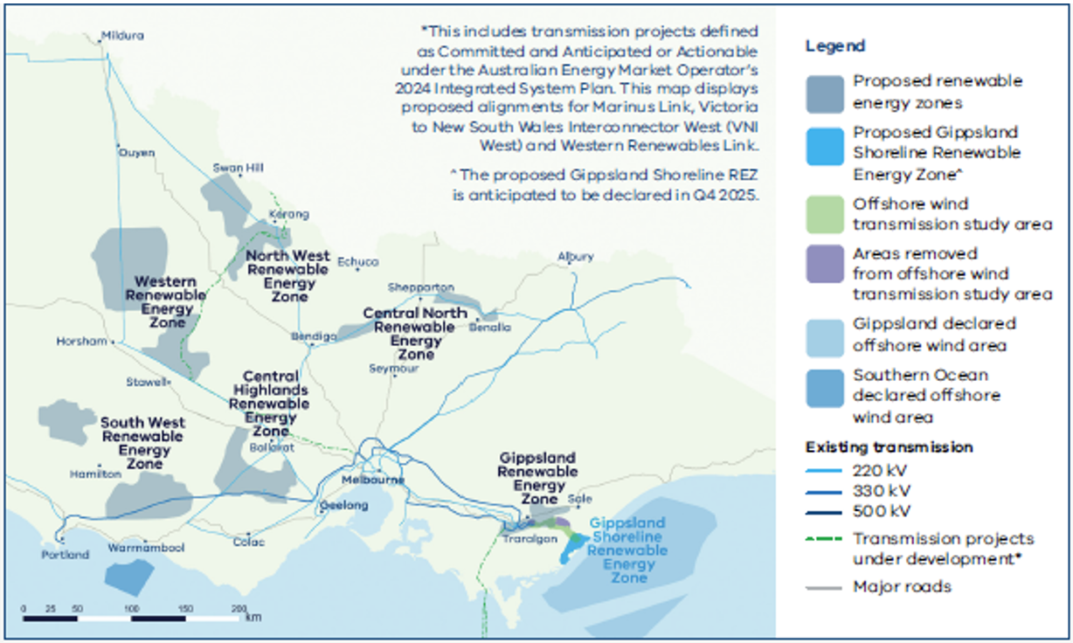

Figure 1 The 6 proposed renewable energy zones across Victoria for onshore renewable energy and a shoreline renewable energy zone

Note: The map shows transmission projects under development, including transmission projects defined as Committed and Anticipated or Actionable under the Australian Energy Market Operator’s 2024 Integrated System Plan.

Figure 2 overlays the proposed renewable energy zones with Registered Aboriginal Party (RAP) boundaries. This map supports engagement and better visibility of potential impacts to Country.

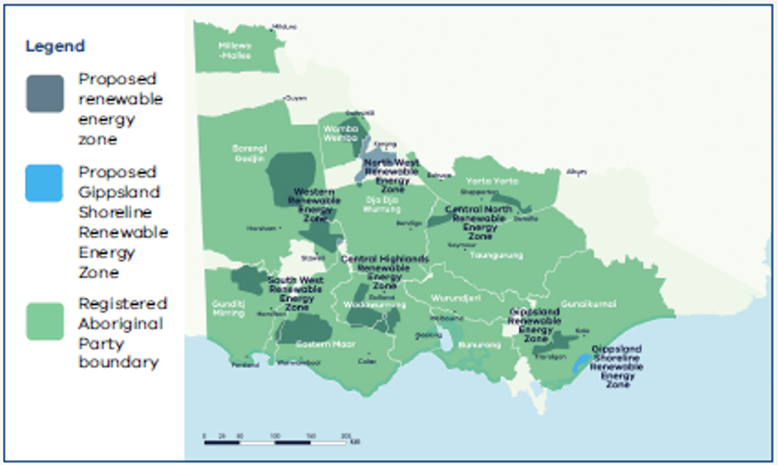

Figure 2 Proposed renewable energy zones and Registered Aboriginal Party boundaries

**Map disclaimer:** The Registered Aboriginal Party boundaries shown in Figure 2 are a computer representation. The boundaries show the general vicinity of land and waters subject to the *Native Title Act 1993* (Cth) and *Traditional Settlement Act 2010* (Vic) as at the time of publication and could conceivably change. For more details, please see the Disclaimer.

## The generation plan for the proposed renewable energy zones

The draft 2025 Victorian Transmission Plan set out the additional wind and solar generation capacity being planning for in each of the draft proposed renewable energy zones by 2040.

VicGrid received consistent feedback from communities that the modelled new generation did not reflect the full picture of generation because it didn’t include projects already in service. Table 1 below shows a breakdown of in-service generation and generation projects that are planned and already committed, as well as the additional generation that VicGrid is modelling to be required by 2040 under 3 different future scenarios. For more information about the scenarios, see Section 2.3 of the 2025 Victorian Transmission Plan.

The modelled generation is not a cap or limit. For more information on access limits and how VicGrid will allocate grid access to projects in renewable energy zones, see section ‘Increasing certainty with new access arrangements’.

VicGrid acknowledges the Victorian Transmission Plan also sets out a scenario where the demand for energy could grow at much higher levels, which would require new sections of zones created, or new zones in other areas of Victoria. The need for changes to zones, and the potential creation of new zones, will be considered when the next Victorian Transmission Plan is developed in 2027.

Table 1 The additional generation we are planning for in each proposed renewable energy zone by 2040

|  |  |  |  |  |  |
| --- | --- | --- | --- | --- | --- |
| Generation location | In-service wind and solar | Committed wind and solar | 2040 new wind and solar modelled for scenario 1 | 2040 new wind and solar modelled for scenario 2 | 2040 new wind and solar modelled for scenario 3 |
| Central Highlands Proposed Renewable Energy Zone | 0.5 GW | 1.4 GW | 0.6 GW | 2.2 GW | 0.6 GW |
| South West Proposed Renewable Energy Zone | 0.3 GW | 0.0 GW | 1.3 GW | 2.0 GW | 1.7 GW |
| Western Proposed Renewable Energy Zone | 0.4 GW | 0.0 GW | 0.8 GW | 4.5 GW | 0.8 GW |
| North West Proposed Renewable Energy Zone | 0.1 GW | 0.0 GW | 0.4 GW | 1.9 GW | 0.7 GW |
| Central North Proposed Renewable Energy Zone | 0.2 GW | 0.9 GW | 0.0 GW | 2.4 GW | 0.1 GW |
| Gippsland Proposed Renewable Energy Zone | 0.0 GW | 0.2 GW | 0.4 GW | 1.1 GW | 0.4 GW |
| **Renewable enegy zone total** | **1.5 GW** | **2.5 GW** | **3.5 GW** | **14.2 GW** | **4.4 GW** |
| Outside renewable energy zones (onshore) | 3.3 GW | 1.9 GW | 0.0 GW | 0.0 GW | 0.0 GW |
| Offshore | 0.0 GW | 0.0 GW | 9.0 GW | 9.0 GW | 8.0 GW |
| **Total** | **4.8 GW** | **4.4 GW** | **12.5 GW** | **23.2 GW** | **12.4 GW** |

Note: As a modelling simplification, no new generation has been modelled outside renewable energy zones, however it is expected that some projects will still proceed in these areas.

Note: Totals may not add due to rounding.

# How we identified the proposed renewable energy zones

To establish the proposed renewable energy zones, we identified a broader renewable energy zone study area based on a strategic land use assessment.

The assessment took feedback from the community into account alongside 60 statewide data sets covering agriculture, land use, biodiversity, cultural and social factors to identify an initial study area for further investigation.

We then investigated parts of the study area to narrow in on the most suitable places for renewable energy zones. The design process considered economic costs, land use, community preferences, regional development opportunities, generator interest, existing levels of development, access to wind and solar energy, cultural heritage information and community and industry feedback.

Table 2 Factors we considered in determining the location of proposed renewable energy zones

|  |  |
| --- | --- |
| Processes, program or project | Description |
| Agricultural land use | We considered agricultural land and types of farming. We sought to avoid farming types potentially less suitable for co-locating renewable energy infrastructure (noting that the circumstances of every farm should be considered individually). |
| Land use and landscape values | Where possible, we avoided areas such as national parks, world heritage sites, Ramsar wetlands, residential areas and other significant areas. We also sought to minimise impacts to areas of high biodiversity value. |
| Energy generation projects in planning | We sought to include energy projects in planning or development within the proposed renewable energy zones boundaries. We gave greater consideration to more developed and larger projects. |
| Modelled generation build | We used energy market modelling to identify the types of generation needed (including batteries), how much capacity to build, and when and where this capacity should be built. |
| Transmission network requirements | We prioritised areas close to the existing or planned transmission network to minimise the need for new transmission lines. |
| Engagement feedback | We considered feedback from communities, landholders, industry and local governments. |
| Partnering with Traditional Owners | Where possible, we sought to avoid known areas of high cultural significance or sensitivity based on publicly available Aboriginal cultural heritage information and prioritise areas with fewer known constraints. VicGrid is seeking to partner with Traditional Owners and First Peoples to supplement limited public datasets on Aboriginal cultural heritage and integrate a self-determined approach to protecting cultural heritage during renewable energy zone design and development. |
| Regional development considerations | We considered the readiness of different regional economies to host renewable energy zones, considering existing housing, social and transport infrastructure in each area, and local workforce profiles. We sought to prioritise areas where there was strong alignment with regional economic development strategies. |

We acknowledge that consideration of Aboriginal cultural values can only occur through engagement with the relevant Aboriginal cultural knowledge holders. While we have had some conversations with Traditional Owner representative bodies, we have not yet consulted with Traditional Owners in this process.

# How community, landholders, industry and local government helped shape the proposed renewable energy zones

VicGrid has been engaging with communities, landholders, First Peoples and industry over the past 2 years to understand important land use, social and environmental factors and take them into account in planning renewable energy zones.

Our community engagement to inform the planning process started with the Renewable Energy Planning Survey and online map from November 2023 to February 2024, giving communities opportunity to identify important landscapes, land uses and areas of significance in their regions. Feedback helped shape the renewable energy zone study area and draft Victorian Transmission Plan Guidelines, which were released for public consultation from July to September 2024. Feedback on the study area helped shape draft proposed renewable energy zones and the draft 2025 Victorian Transmission Plan, released for consultation from May to June 2025.

## Engagement opportunities

During consultation on the draft 2025 Victorian Transmission Plan from 16 May to 24 June 2025 we invited feedback through in-person community hubs in locations across regional Victoria, online feedback forms, formal submissions, industry and community briefings, webinars, the VicGrid email inbox and a dedicated phone contact centre.

In total we received the following engagement responses

* 261 feedback forms
* 70 project status survey responses
* 462 submissions
* 69 contact centre enquires
* 65 community and industry events
* Over 100 briefings with local councils, community groups and community members
* Over 20 briefings with energy industry peak bodies
* 50 meetings with renewable energy developers
* 18,187 unique visitors to the draft Victorian Transmission Plan Engage Victoria webpage

## Changes from the draft Victorian Transmission Plan

Feedback from communities, landholders, First Peoples and industry on the shape, size and locations of draft proposed renewable energy zones highlighted sensitive areas, potential impacts and also advocated for some areas to be considered for inclusion.

We heard from community, Traditional Owners and industry about areas where land use was not suitable for renewable energy projects. We have responded by removing some sections of zones or changing their footprint.

We also heard consistently from energy industry stakeholders that our modelling for future energy demand did not have sufficient contingency built in and that the zones needed to be expanded in size and be more flexible to allow for development of technically and commercially viable renewable projects.

After considering all feedback from community, landholders, Traditional Owners and industry, we have:

* changed the size and shape of some proposed renewable energy zones to remove sensitive areas and added new sections to the South West and Central North zones
* combined the draft proposed Wimmera Southern Mallee and Grampians Wimmera zones so they are now considered as 2 separate sections of a single Western Renewable Energy Zone
* increased the total combined area covered by proposed renewable energy zones to 7.9% of the state’s land area, up from 7% in the draft Victorian Transmission Plan
* refined the transmission projects needed to support the development of renewable energy zones.

The 6 proposed renewable energy zones cover about 1.8 million hectares, which is about 7.9% of Victoria’s total land area of 22.8 million hectares. Not all of this land is needed for development. It is estimated that only a very small fraction of the area will be needed to host physical infrastructure such as wind turbines, solar panels and access roads.

The zones will have significant areas that will be unaffected.

We will work with landholders, Traditional Owners, industry, community groups, local councils and other stakeholders to ensure that infrastructure is developed in areas with the least impacts.

In making changes to the draft proposed zones, we also considered current and planned energy generation and transmission projects across Victoria, with the dual aims of preventing any region from being overburdened by energy infrastructure and maintaining momentum in Victoria’s energy transition.

We will now engage with communities in the newly added areas who have not previously been consulted and listen to local views before the areas are formally declared as renewable energy zones.

# What renewable energy zones mean for communities, industry and Traditional Owners

## For landholders and communities

We recognise that landholders may have concerns about the impact of living in a renewable energy zone. The Victorian Transmission Plan does not change existing consent processes.You can choose whether or not to host new renewable energy such as wind turbines, solar farms or batteries on your property. It’s your decision and we encourage you to talk to your neighbours about it.

Existing planning and environment controls will still apply. All proposed projects will continue to be subject to the planning and environmental approval processes under the *Planning and Environment Act 1987* and *Environment Effects Act 1978*.

If you live in or near a renewable energy zone, over time, you will see more development of renewable energy generation and storage. However, only a small proportion of the land in a renewable energy zone will be needed for development. VicGrid will work with developers to coordinate new developments to minimise impacts on landscapes and the environment.

You will also see community and regional benefits delivered over time as part of the Victorian Government’s new Renewable Energy Zone Community Benefits Plan.

## Engaging with communities and landholders

Renewable energy development should empower communities, not inundate them.

VicGrid’s expectation is that project proponents and developers will be respectful of communities and shy away from prospecting activities that cause social upheaval and ultimately negatively impact social acceptance of the energy transition.

## For industry

For industry, renewable energy zones provide a signal on the locations most suitable for siting renewable generation projects. By coordinating and developing shared transmission lines to support renewable energy zones, VicGrid will make it easier for projects in these zones to connect to the network and provide more certainty they can get their energy to the grid.

VicGrid recognises industry’s crucial role in this process. We will continue to work closely with industry to inform future policy positions on access and connections in and out of renewable energy zones.

## For Traditional Owners and First Peoples

For Traditional Owners, establishing renewable energy zones will allow for better consultation, compensation, and a share in the economic benefits created.

It is important to note that the proposed renewable energy zones are primarily based on publicly available information regarding cultural heritage. We recognise that this information is limited and incomplete, which also affects the consideration of cultural heritage in the proposed renewable energy zones.

The development of renewable energy zones will require an ongoing dialogue with Traditional Owners and First Peoples to ensure we minimise impacts on Country. We will continue to work with Traditional Owners to create a Traditional Owner-led process for incorporating cultural heritage into renewable energy zone planning and to provide them with sustainable resourcing.

We acknowledge that Traditional Owners and First Peoples have not shared in the benefits of energy infrastructure in the past. That is why we are implementing a dedicated approach designed specifically for Traditional Owners and First Peoples to provide economic benefits from the energy transition.

# New benefits for communities that host renewable energy zones

The Victorian Government has heard clearly from regional communities that the benefits of the energy transition need to be shared fairly, especially with those communities hosting new infrastructure.

The government has listened and, after consultation with communities and stakeholders, has come up with a new approach to delivering community benefits.

This new approach, set out in our draft Renewable Energy Zone Community Benefits Plan, features:

* the introduction of new Renewable Energy Zone Community Energy Funds to benefit regional and rural communities
* payments for landholders who host new transmission
* guidance for payments for significantly impacted neighbours of new transmission
* a commitment to work with Traditional Owners on a new approach to economic benefits.

Renewable Energy Zone Community Energy Funds are an opportunity to invest directly in projects that improve local outcomes and create other benefits for communities in regions hosting energy infrastructure.

Local decision-making that responds to local needs and priorities will be a cornerstone of these funds, and decisions about investments will be made in consultation with regional community reference groups with broad community and industry representation.

The aim is to ensure communities benefit in a meaningful and lasting way based on their vision of the energy priorities for their region.

The Renewable Energy Zone Community Energy Funds and Traditional Owner benefits will be funded by access fees paid by generation developers who build projects within renewable energy zones, and by mandatory financial contributions from transmission companies.

Learn more about the Renewable Energy Zone Community Benefits plan at [our Engage Victoria web page](https://capirecg.sharepoint.com/sites/G-Drive/Shared%20Documents/3.%20Projects/A/AECOM/4368%20VicGrid%20Technical%20Advisor/4.%20Capire%20engagement/Final%202025%20VTP/engage.vic.gov.au/vtif-rez-community-benefits).

## Increasing certainty with new access arrangements

The Victorian Government is working to maximise the benefits for communities and industry of siting generation and storage projects within renewable energy zones. For project proponents, this means policy support and new network access arrangements that provide greater certainty about grid connection and reduce the risk of excessive curtailment. For communities, this means a transparent approach for how wind and solar projects will be allocated access to connect to the grid, and clear expectations about how developers must engage with and deliver benefits to landholders, Traditional Owners, neighbours and communities.

During 2023, we consulted with industry on a proposed new Victorian Access Regime to govern new connections to the grid. The new arrangements are designed to give generators and investors confidence that they can supply their energy to the market without facing excessive curtailment.

Once a renewable energy zone is declared, VicGrid will publish a draft renewable energy zone access scheme for consultation. The renewable energy zone access scheme will set out:

* Access limits that cap the maximum capacity of different types of renewable generation that can be connected within the renewable energy zone. Access limits give investors visibility of the renewable energy zone’s hosting capacity and assurance that a renewable energy zone’s capacity will not be oversubscribed.
* Access fees to be paid by generation operators. Access fees will cover the costs of administering the Victorian Access Regime and will also contribute towards Renewable Energy Zone Community Energy Funds and dedicated benefits for Traditional Owners.
* Access conditions, which could include requirements relating to a proponent’s community engagement performance, dates when the project must be operational, or other technical performance requirements.
* The access allocation process, which will describe the arrangements for allocating how much energy each generator within a renewable energy zone can connect to the network. For more information, see section, ‘How much generation will be allowed in each zone’ below.

The new access arrangements will offer clarity and fairness in network connections, meeting the need to support investor confidence, provide certainty for communities and deliver the secure, reliable and affordable operation of the energy system.

## How much generation will be allowed in each zone

Once renewable energy zones are declared, VicGrid proposes to run a competitive allocation process to decide which projects in each zone have the authority to connect the energy they produce to the grid.

We will consider:

* the amount of electricity Victoria needs to generate to meet expected demand as outlined in the Victorian Transmission Plan
* ensuring the level of development inside each zone can be supported by available transmission lines
* the density of projects within each zone
* how development can be coordinated to avoid the ‘spaghetti effect’ of many powerlines crossing the landscape
* whether developers are meeting expectations for landholder, community and Traditional Owner engagement and benefits.

This will ensure we ultimately produce enough energy to meet demand while also considering the impact on communities, Traditional Owners, agriculture and the environment.

We are proposing to set access limits at the maximum amount that can be managed by the planned build out of the transmission network.

This is not the level of development people should expect in each zone but is the maximum that the transmission network can support within the zone.

## Coordinating transmission connections

The 2025 Victorian Transmission Plan outlines 7 programs of transmission investments that will unlock critical capacity constraints along parts of the transmission network and support investment in renewable energy zones.

These transmission investments are part of the declared shared network. The declared shared network is the state’s interconnected high-voltage system of powerlines and shared terminal stations that transport large amounts of electricity from where it is generated to where it is needed across the state.

Individual project developers are responsible for establishing their own connections, such as powerlines, to the declared shared network.

We are exploring other ways we can work with developers to enable timely generation development and connection in renewable energy zones. This coordinated approach could include investigating new shared transmission or connection infrastructure to support generator and storage connections within renewable energy zones, limiting community and environmental impacts and keeping costs lower.

The need for additional shared transmission infrastructure to support generator and storage connections within renewable energy zones will depend on the renewable energy zone’s proximity to the existing network and the location of projects.

We want to ensure a coordinated approach that avoids multiple developers building individual transmission connections that could create a ‘spaghetti effect’ across the renewable energy zone landscape.

## Providing a pathway for projects outside of renewable energy zones

Renewable energy zones do not prevent projects outside of those zones from seeking network connections. However, generation and storage developers will need to demonstrate that their proposed project doesn’t impact renewable energy zone development. As part of the new Victorian Access Regime, we will be introducing a Grid Impact Assessment for proposed projects outside of renewable energy zones. The Grid Impact Assessment will require developers to demonstrate that their project satisfies the following criteria:

* The proposed connection is unlikely to result in excessive curtailment of existing and planned renewable energy zone generators.
* The access applicant meets government expectations for community and Traditional Owner engagement and provides meaningful benefits.

For more information on the Grid Impact Assessment visit [our Engage Victoria web page](https://engage.vic.gov.au/grid-impact-assessment).

## Next steps for confirming access and connections arrangements

We recognise there are developers that have generation and storage projects in various stages of planning and development in Victoria. We are developing an integrated renewable energy zone access and connection approach and transitional arrangements that take this into account and provide a clear process for all developers inside and outside the proposed renewable energy zones identified in the 2025 Victorian Transmission Plan.

We will engage with industry on the details of this approach, inviting feedback on an Access and Connections Consultation Paper and draft Grid Impact Assessment Guidelines. For more information and updates about consultation on access and connections, visit [our Engage Victoria web page](https://capirecg.sharepoint.com/sites/G-Drive/Shared%20Documents/3.%20Projects/A/AECOM/4368%20VicGrid%20Technical%20Advisor/4.%20Capire%20engagement/Final%202025%20VTP/engage.vic.gov.au/vicgrid).

## What do renewable energy zones mean for the Australian Government’s Capacity Investment Scheme?

The Australian Government’s Capacity Investment Scheme provides underwriting to encourage investment in renewable energy generation and storage to connect to the grid by 2030. The Australian Government is holding competitive tenders for Capacity Investment Scheme contracts every 6 months, with the first held in May 2024. As with other projects, Capacity Investment Scheme project proponents locating their projects within a Victorian renewable energy zone will benefit from special network access arrangements, while projects outside of renewable energy zones will, in future, be subject to a Grid Impact Assessment.

# The transmission projects needed to keep Victoria connected

We need new transmission projects to improve and modernise the power grid in the areas where sun and wind are abundant, so more renewable energy can flow to where it’s needed across Victoria.

The plan sets out the transmission infrastructure we need to build over the next 15 years to enable the development of new renewable energy sources.

## Changes to transmission projects

After considering all feedback received by community, Traditional Owners and industry, and carrying out further power system modelling, VicGrid has made some changes to the transmission projects in the 2025 Victorian Transmission Plan.

We have added a new project, removed a project, made changes to the scope of 3 projects and adjusted the timelines for 4 projects.

We have added a project to replace transformers at Keilor with 1000 megavolt ampere (MVA) units to support increased generation in Victoria’s west.

We’ve removed a project from the draft plan that would have boosted the capacity of the existing Hazelwood–Yallourn to Rowville powerline. Further analysis and feedback showed the upgrade wasn’t needed.

Based on feedback from industry and new information, VicGrid has adjusted the scope of proposed upgrades to the Moorabool to Geelong, Mount Beauty to Dederang, and Mount Beauty to Eildon powerlines.

VicGrid has also made minor adjustments to the timing of 4 projects after carrying out a deliverability analysis in collaboration with industry. The changes include:

* replacement of H1 and H2 South Morang transformers moves from 2028 to 2030
* rebuild of the Ballarat to Moorabool line moves from 2028 to 2030
* switching of existing Geelong to Keilor circuits at Deer Park moves from 2028 to 2029
* installation of a second transformer at Cranbourne and tie-in Hazelwood to Rowville circuit moves from 2028 to 2030.

## What is the optimal development pathway?

The optimal development pathway proposes 7 programs of transmission investments to be delivered over 2025-2040. The programs build on projects that are already under development or in construction. This includes Western Renewables Link (WRL), Victoria to New South Wales Interconnector West (VNI West), Marinus Link and Gippsland offshore wind transmission stage 1.

See Figure 3 for a map of the 7 programs and Table 3 for a description of each.See Figure 3 below for a map of the 7 programs and Table 3 below for a description of each.

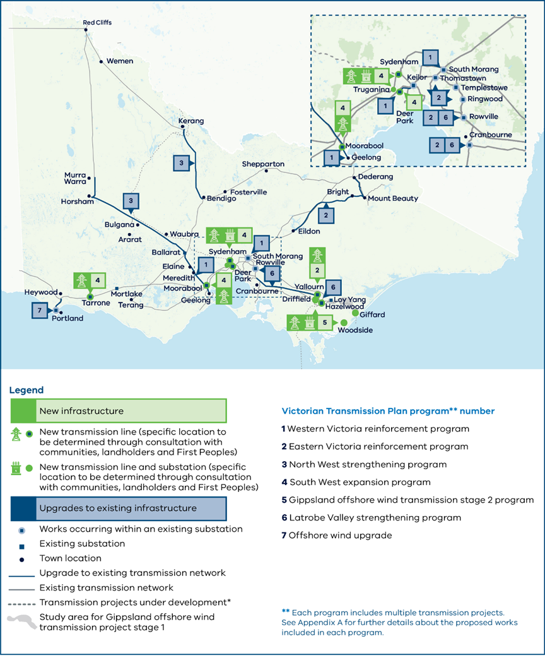**Map disclaimers:** This includes transmission projects defined as Committed and Anticipated or Actionable under the Australian Energy Market Operator’s 2024 Integrated System Plan. This map displays proposed alignments for Marinus Link, Victoria to New South Wales Interconnector West (VNI West), Western Renewables Link and the Gippsland offshore wind transmission stage 1. The Renewable Energy Zone Development Plan stage 1 project includes several network augmentations that are not included in this map.

Figure 3 Map of the 7 Victorian Transmission Plan priority transmission programs

Each program includes multiple transmission projects. See Appendix A for further details about the proposed works included in each program.

Table 3 The 7 new priority programs of transmission upgrades

|  |  |  |  |
| --- | --- | --- | --- |
| Program | Description | Why it is needed | Proposed year needed by |
| 1 Western Victoria reinforcement program | A collection of 4 network augmentations and upgrades of existing infrastructure. | To support connection of onshore wind and solar generation in the proposed Western, Central Highlands and South West renewable energy zones and reinforce the network supply to metropolitan Melbourne. | Between 2028 and 2030 |
| 2 Eastern Victoria reinforcement program | A suite of network augmentations and upgrades of existing infrastructure, as well as an additional line between Hazelwood and Yallourn. | To meet increased demand in eastern metropolitan Melbourne, respond to shifting supply from the east of Victoria to the west of Victoria and ensure connection and security of supply from the proposed Gippsland and Central North renewable energy zones and the Gippsland offshore wind area. | Between 2028 and 2030 |
| 3 North West strengthening program | Replacement of sections of the existing single circuit transmission with a new high capacity double circuit line | To support additional generation in the proposed Western and North West renewable energy zones and facilitate its transfer to areas of high energy demand. | 2035 |
| 4 South West expansion program | A new double circuit 500 kV line in South West Victoria. | To meet significant demand for high-quality wind generation in Victoria’s west, including additional generation in the proposed South West and Central Highlands renewable energy zones. | 2033 |
| 5 Gippsland offshore wind transmission stage 2 program | A new transmission loop to support offshore wind. | Building on the first Gippsland offshore wind transmission project, this new program is required to connect additional offshore wind generation in the Gippsland offshore wind area to meet Victoria’s 2035 and 2040 offshore wind targets. | Between 2033 and 2038 |
| 6 Latrobe Valley strengthening program | New power flow controllers and dynamic load rating devices in the Latrobe Valley. | To allow for easier integration of wind and solar into the grid, manage significant power flows and address network congestion. It supports connection and transfer of generation from the proposed Gippsland renewable energy zone and Gippsland offshore wind area. | Between 2034 and 2035 |
| 7 Offshore wind upgrade | Uprating of existing lines from Heywood to Portland. | To connect offshore generation from the Southern Ocean offshore wind area to Portland. | 2038, or earlier to align with the timing of offshore development in the Southern Ocean offshore wind area. |

# Where you can learn more about the transmission projects

You can learn more about the proposed transmission projects in the 2025 Victorian Transmission Plan and Appendix A.

While the 2025 Victorian Transmission Plan identifies the need for new transmission projects, the location where each transmission line will be built has not yet been identified.

The planning process for new transmission lines will begin with consultation with communities, landholders, First Peoples, Traditional Owners and industry, and technical investigations, to help determine a study area for the new transmission. Then, we will work to narrow the study area to a corridor, then a route, then an easement.

Throughout the process, consultation with landholders, community, industry, First Peoples and Traditional Owners will provide important feedback to help shape decisions.

All proposed projects will continue to be subject to current planning and environmental approvals in Victoria.

## Typical stages of identifying a new transmission line route

1. Study area: A broad geographic area that we will progressively narrow over time as we undertake detailed studies and consultation with landholders, First Peoples, Traditional Owners, community and stakeholders.
2. Corridor: One or more geographic areas narrowed down from the Study Area that are considered suitable for transmission infrastructure. There is flexibility within a corridor to undertake site-specific consultation with landholders to identify suitable routes.
3. Route: A route is narrower again and is the final stage before an easement is selected. This still allows flexibility for locating (or micro-siting) of towers to minimise impacts on landholders and landholder operations.
4. Easement: An easement is a legally secured right-of-way for the transmission infrastructure to be built and maintained.

# Coordinating offshore wind connections and unlocking benefits for coastal communities

The 2025 Victorian Transmission Plan is designed to help us meet Victoria’s targets for offshore wind.

In addition to the offshore wind transmission plans that are already under way, the 2025 Victorian Transmission Plan includes the following elements to support connecting Gippsland offshore wind energy to the grid:

* Proposed Gippsland Shoreline Renewable Energy Zone: An area along the Gippsland coast from Seaspray to Reeves Beach for Gippsland offshore wind developers to locate underground cables that connect to a connection hub near Giffard. VicGrid will identify the location of the connection hub, similar to a terminal station, within this zone.
* The Gippsland offshore wind transmission stage 2 program: A new 500 kV transmission line from the existing transmission network near Driffield to Woodside, and a new 500 kV line from Woodside to Giffard. New terminal stations will be needed at Driffield and Woodside. This project combined with the existing line and connection hub being planned for the first 2 GW of offshore wind will create a loop that can accommodate approximately 7 GW of offshore wind energy.

The proposed Gippsland Shoreline Renewable Energy Zone is designed to host onshore connection infrastructure to connect offshore wind generators to the transmission network. Onshore generation projects seeking to develop within the boundaries of the shoreline zone will not be eligible to participate in the access scheme for priority access to the network. These projects will be subject to the same Grid Impact Assessment process that will apply elsewhere in Victoria for projects located outside of renewable energy zones.

Communities impacted by the Gippsland Shoreline Renewable Energy Zone will receive new dedicated benefits, similar to our approach for onshore renewable energy zones. These benefits will be in addition to any discretionary benefits paid by offshore wind developers.

All proposed projects will continue to be subject to current planning and environmental approvals in Victoria.

Figure 4 Offshore wind infrastructure in Gippsland

# What’s next after the publication of the 2025 Victorian Transmission Plan

## Continued engagement with communities and industry

VicGrid will continue to engage with communities and industry as we implement the 2025 Victorian Transmission Plan. This will include inviting feedback and input on renewable energy zone declarations, detailed renewable energy zone design, implementation of Renewable Energy Zone Community Energy Funds and network access schemes. VicGrid will also carry out targeted engagement with directly impacted Traditional Owners, landholders, neighbours and communities throughout the planning process for transmission projects.

## Renewable energy zone declarations

The Minister for Energy and Resources can now consider whether to proceed with formal declaration of the proposed renewable energy zones. The declaration process requires that the Minister make a declaration in a formal order (Order) for each renewable energy zone, setting out key information including a map of the zone’s boundaries and the intended transmission hosting capacity within the zone.

A draft of the Order showing the proposed renewable energy zone will be placed on public notice for a minimum of 6 weeks, giving communities and industry opportunity to provide comments and submissions. The Minister must consider any submissions when determining whether the renewable energy zone should be declared under an Order.

## Access arrangements

We will consult on details of the new Victorian Access Regime, which will be set out in an Access and Connections Consultation Paper and draft Grid Impact Assessment (GIA) Guidelines. These consultation documents will include detailed information on how project developers can access and connect to the transmission network inside and outside of renewable energy zones, and information about proposed transitional arrangements.

We will also release for consultation a draft updated guide to community engagement and sharing economic and social benefits, setting out the government’s expectations for how developers engage with and create value for communities, Traditional Owners, landholders and neighbours. This will set the benchmark for our assessment of access applications by project developers. We will invite feedback from industry, landholders, Traditional Owners and communities.

Feedback will help shape an Access and Connections Handbook, final Grid Impact Assessment Guidelines and an updated community engagement and benefits sharing guide, anticipated to be released later in 2025. We expect the new access regime to commence across Victoria in late 2025, when VicGrid is established as the Victorian transmission planner.

## Transmission projects

As we start detailed planning for the priority transmission projects identified in the 2025 Victorian Transmission Plan, each project will be subject to a delivery case, which may identify a preferred solution or recommend a technology-neutral procurement process that is open to different types of solutions. Once developed, project solutions will proceed to a procurement process subject to independent oversight.

Figure 5 The process to refine and finalise renewable energy zones

# Infographic showing the five-step process of the Victorian Transmission Plan and renewable energy zone declaration. Steps include: 1) Study area, 2) Draft proposed renewable energy zones, 3) Proposed renewable energy zones, 4) Draft renewable energy zones (current stage marked with 'We are here'), and 5) Declared renewable energy zones. Consultation periods are indicated at steps 2, 3, and 4.

# Contact us

Phone: 1800 418 341

Email: [vicgrid@deeca.vic.gov.au](mailto:vicgrid@deeca.vic.gov.au)

Deaf, hearing or speech impaired? Please contact the National Relay Service on 133 677 or [communications.gov.au/accesshub/nrs](https://capirecg.sharepoint.com/sites/G-Drive/Shared%20Documents/3.%20Projects/A/AECOM/4368%20VicGrid%20Technical%20Advisor/4.%20Capire%20engagement/Final%202025%20VTP/communications.gov.au/accesshub/nrs)

Need an interpreter? Contact Translating and Interpreting Service (TIS) on 131 450 (within Australia) or visit [www.tisnational.gov.au](http://www.tisnational.gov.au)

ISBN 978-1-76176-138-6 (Print)

ISBN 978-1-76176-139-3 (pdf/online/MS word)

Disclaimer: The information in this document is current at the time of printing, may be subject to change and should not be relied upon. Please visit [vicgrid.vic.gov.au](https://www.energy.vic.gov.au/renewable-energy/vicgrid) for the latest updates.