# Neighbourhood Battery Training

Delivered by Yarra Energy Foundation - Case Study

[deeca.vic.gov.au](https://delwpvicgovau.sharepoint.com/Users/fionadurante/Downloads/deeca.vic.gov.au)

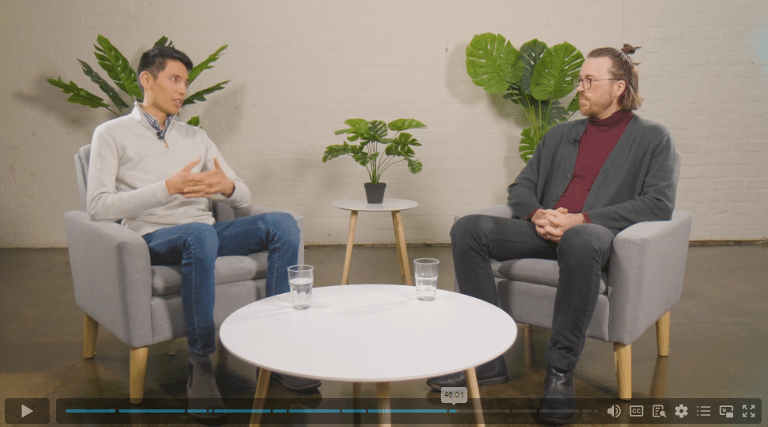

## Neighbourhood battery training gives a leg up to renewable energy and energy transition

Right now, under the stewardship of the Department of Energy, Environment and Climate Action (DEECA), Victorians are learning through accessible and comprehensive training how to set up and run neighbourhood batteries, making not just renewable energy but the energy transition a fast-approaching reality.

The genesis of this idea started in 2023 when DEECA contracted the Yarra Energy Foundation (YEF) to run 1-day, in-person training sessions whereby industry practitioners, community groups, local governments, and businesses could learn to plan and assess the feasibility of neighbourhood battery (NB) projects.

The training sessions were envisaged to be a step-by-step guide on not just how to establish neighbourhood scale batteries, but also how to run such a complex infrastructure asset successfully. Delivered in 2023 and 2024, the feasibility training covered topics such as business models and revenue opportunities for batteries, site selection, project management, and community engagement.

The training aimed to provide lasting value for participants beyond the classroom, giving participants the knowledge to become neighbourhood battery advocates.

To better support participation from across Victoria, the feasibility training was moved online and made free to access in 2024. New advanced, two day in-person training was introduced and delivered in 2024 and 2025. This advanced

*Photos: YEF Neighbourhood Battery, Fitzroy North visit during Neighbourhood Battery Training 2023 (left), online Neighbourhood Battery Training video (middle), August 2024 Neighbourhood Battery Training (right) on Wurundjeri Country*

training aimed to deepen the knowledge and skills of participants and improve outcomes of the Neighbourhood Battery Initiative and 100 Neighbourhood Batteries Program. 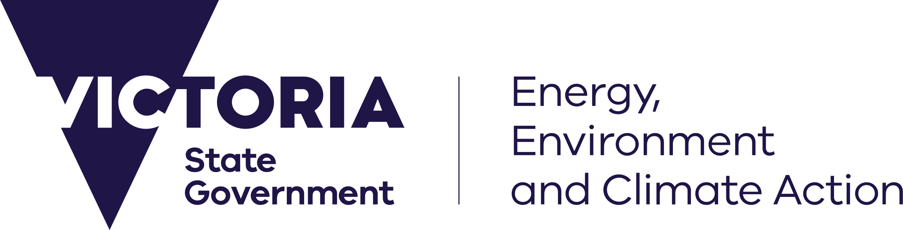

One measure of the value of the training was demonstrated by the number of organisations with staff and/or volunteers who completed this training and subsequently successfully applied for funding to install neighbourhood batteries through the 100 Neighbourhood Batteries Program.

#### Testimonials from those who completed the Neighbourhood Battery training

"The YEF neighbourhood battery training course was exceptional in every way. The team have the ability to convey complex information in a way that is highly engaging and memorable. I would recommend a YEF neighbourhood battery training course to anyone interesting in neighbourhood batteries."

"The [… Neighbourhood Batteries Advanced Training Course] provided an invaluable deep dive into the complexities of community battery projects. The course was well-structured, with expert-led sessions covering technical, regulatory, and financial aspects in a way that was both comprehensive and practical. The real-world case studies and interactive discussions were particularly beneficial, equipping us with the knowledge and confidence to progress community battery initiatives. A must for anyone with limited or advanced knowledge on delivering local energy solutions."

"As a member of the community group: Flinders Zero Carbon Community having partnered in the successful implementation of the Flinders Community Battery (Australian Government funded grant), I realise how much it would have helped to have taken part in a course like this one at the outset."

"The course exceeded my expectations. The knowledge sharing from YEF of their own experiences owning and operating a battery plus industry insights from completing a wide range of NB business cases is invaluable information that isn't otherwise accessible for many organisations. This course is a financially viable way to access a high level of expertise that is essential knowledge if planning to proceed with a NB project. Great job YEF, and a big thank you to YEF and DEECA."

"Coming into the Advanced Neighbourhood Battery training course I had a very limited knowledge on NB's. Now I feel equipped to confidently start our own NB's project and look forward to working with the community, scoping out possible sites and eventually entering into the electricity market."



We acknowledge Victorian Traditional Owners and their Elders past and present as the original custodians of Victoria’s land and waters and commit to genuinely partnering with them and Victoria’s Aboriginal community to progress their aspirations.

© The State of Victoria Department of Energy, Environment and Climate Action April 2025.

Creative Commons

This work is licensed under a Creative Commons Attribution 4.0 International licence, visit the [Creative Commons website](http://creativecommons.org/licenses/by/4.0/) (<http://creativecommons.org/licenses/by/4.0/>).

You are free to re-use the work under that licence, on the condition that you credit the State of Victoria as author. The licence does not apply to any images, photographs or branding, including the Victorian Coat of Arms, and the Victorian Government and Department logos.  
**ISBN** 978-1-76176-219-2 **(pdf/online/MS word)**

Disclaimer

This publication may be of assistance to you but the State of Victoria and its employees do not guarantee that the publication is without flaw of any kind or is wholly appropriate for your particular purposes and therefore disclaims all liability for any error, loss or other consequence which may arise from you relying on any information in this publication.

Accessibility

To receive this document in an alternative format, phone the Customer Service Centre on 136 186, email [customer.service@delwp.vic.gov.au](mailto:customer.service@delwp.vic.gov.au), or contact National Relay Service on 133 677. Available at [DEECA website](http://www.deeca.vic.gov.au/) (www.deeca.vic.gov.au).

#### Start the FREE Neighbourhood Battery training online today

Go to [www.energy.vic.gov.au/grants/neighbourhood-batteries/neighbourhood-battery-training](http://www.energy.vic.gov.au/grants/neighbourhood-batteries/neighbourhood-battery-training)

*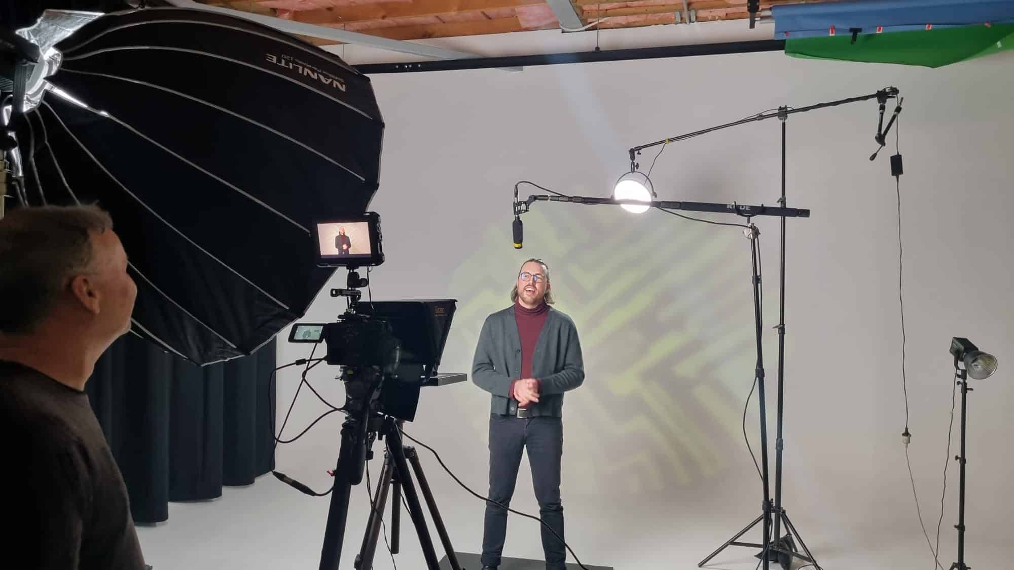Photo: Yarra Energy Foundation filming*

*the online Neighbourhood Battery Training on Wurundjeri Country*