To support more households to install solar, we need an emergency backstop
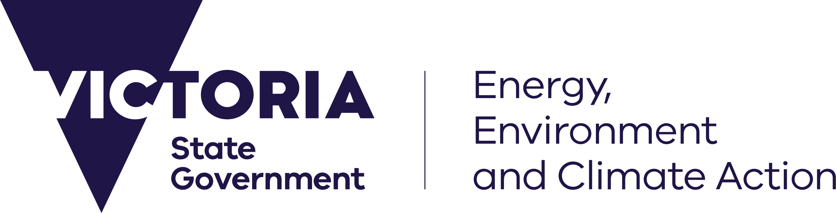

Victorians have embraced taking control of their energy bills and emissions with rooftop solar
Occasionally on mild, sunny days when there is low demand for electricity, more solar is exported to the grid than we can use.
This can lead to:
- unstable electricity supply
- local voltage issues
- possible outages
Keeping our grid secure means that more solar can be installed in Victoria, now and into the future.
The emergency backstop will make sure that solar exports can be safely managed. It will help to avoid blackouts by enabling rooftop solar systems to be turned down or switched off when there is too much power in the grid.
Using the emergency backstop is a last resort. It will not affect the supply of electricity to your home.

What this means for solar customers
From 1 July 2024, new and replacement solar systems will need:
- A compatible inverter
- A reliable internet connection*
*unless exceptions apply (see page 2 for details)

Our goal is for 1 in 3 Victorian households to have solar by 2025

Emergency backstop FAQs

What is an emergency backstop?
In rare circumstances when rooftop solar exports are high but our energy use is low, the grid can become unstable. With an emergency backstop, distribution businesses can remotely turn down or switch off rooftop solar systems during an energy supply emergency to avoid blackouts, as a last resort.

When will these changes happen?
The emergency backstop is being introduced in two stages for newly installed, upgraded and replacement rooftop solar systems.
- 25 October 2023: large systems (greater than 200 kW).
- 1 July 2024: small and medium systems (equal to and less than 200 kW).

What do I need to do?
If you are installing or upgrading your rooftop solar system after 1 July 2024, your installer must ensure it is emergency backstop enabled.
This requires:
- a compatible inverter: this means the export and generation from the inverter is capable of being remotely managed.
- a reliable internet connection: this will ensure the distribution business can communicate with the inverter.
If you do not have rooftop solar, or you have an existing rooftop solar system installed before 1 July 2024, then these changes will not impact you.

When will the emergency backstop be used?
The emergency backstop will only be used when required by the Australian Electricity Market Operator (AEMO) and only for as long as it is needed, in rare emergencies when solar exports are too high to be safely managed. It will help to avoid blackouts and make sure that Victorians can continue to use electricity.

How will the emergency backstop affect my ability to import and export electricity?
The emergency backstop will not impact power supply to your household. If activated in an emergency, distribution businesses will initially reduce only your solar exports so that you can continue to consume your own solar. If the grid is still not secure, they may turn off your solar generation, but only ever as a last resort for short emergencies.

What will the emergency backstop mean for my feed-in tariff?
If the emergency backstop is activated, your solar system will not be feeding excess energy into the grid. This means you will not receive income from your solar exports while it is activated. It is expected this will only cost householders between $4 and $7 in lost feed-in tariffs per year. You can minimise this loss by consuming as much of your own solar power as possible. By using more of your own solar power, you are avoiding using more expensive retail electricity from the grid.

What happens if my solar inverter loses internet connectivity?
If your solar inverter loses internet connectivity, the excess energy you export to the grid will automatically be reduced. This ensures it can be safely managed.
- If the internet outage is temporary, your exports will return to normal once the internet is reconnected.
- If your inverter is disconnected from the internet, potentially because of a change to your Wi-Fi password, then you will need to reconnect it to the internet to ensure you can continue to export your excess solar power to the grid. You can usually do this through your solar inverter smart phone application or the display. Your solar installer should show you how to reconnect your inverter if it disconnects from the internet.

What if I can’t connect to the internet, or prefer not to?
If it’s not possible to connect to the internet, you can still install a solar system. Because your system will not be emergency backstop enabled, a lower limit will be placed on how much excess energy you can export to the grid.
You will still need to install a compatible inverter. This ensures that if internet does become available, you can apply to have the lower export limit removed.

If a distribution business switches off or turns down my solar system’s generation, will I be notified?
Where possible, the distribution business will notify you about uses of the emergency backstop. Distribution businesses must also put notices on their websites as soon as possible in a backstop event, just like when there is a local power outage.

What else is being done to ensure that solar exports are safely managed?
The Victorian Government is working on a range of supporting measures to reduce the need to use the emergency backstop, including:
- supporting Victorian households and businesses to electrify so you consume more of your own solar power
- increasing the amount of storage in the energy grid, and
- developing flexible solar connections.

Is the emergency backstop the same as flexible exports?
Currently distribution businesses offer a static export limit of 5 kW or less to most solar customers. Successful trials have demonstrated that ‘flexible exports’ can allow customers to export more solar power more of the time. Using flexible exports, lower limits are applied only when there are limitations in the local grid. This uses the same technology as the emergency backstop.
Installing an emergency backstop enabled system now will ensure you can participate in flexible exports in the future. Contact your distribution business to understand more about their plans for flexible exports.

For more information on the emergency backstop, visit www.energy.vic.gov.au/emergency-backstop-solar

© The State of Victoria Department of Energy, Environment and Climate Action March 2024 Creative Commons
This work is licensed under a Creative Commons Attribution 4.0 International licence, visit the Creative Commons website (http://creativecommons.org/licenses/by/4.0/). You are free to re-use the work under that licence, on the condition that you credit the State of Victoria as author. The licence does not apply to any images, photographs or branding, including the Victorian Coat of Arms, and the Victorian Government and Department logos.
ISBN 978-1-76136-593-5
Disclaimer
This publication may be of assistance to you but the State of Victoria and its employees do not guarantee that the publication is without flaw of any kind or is wholly appropriate for your particular purposes and therefore disclaims all liability for any error, loss or other consequence which may arise from you relying on any information in this publication.
We acknowledge and respect Victorian Traditional Owners as the original custodians of Victoria’s land and waters, their unique ability to care for Country and deep spiritual connection to it. We honour Elders past and present whose knowledge and wisdom has ensured the continuation of culture and traditional practices.
DEECA is committed to genuinely partnering with Victorian Traditional Owners and Victoria’s Aboriginal community to progress their aspirations.

Accessibility
To receive this document in an alternative format, phone the Customer Service Centre on 136 186, email customer.service@delwp.vic.gov.au, or contact National Relay Service (www.accesshub.gov.au/) on 133 677. Available at DEECA website(www.deeca.vic.gov.au).

