VicGrid

Proposed Central North Renewable Energy Zone
  - August 2025
A renewable energy zone with 2 sections – a western section between Bendigo and Tatura and eastern section between Shepparton and Glenrowan – is proposed as part of the 2025 Victorian Transmission Plan (see map Figure 2). Before being officially declared by the Minister for Energy and Resources, there will be a further chance to provide your feedback. See section ‘Next steps’ below.

What is a renewable energy zone?
Renewable energy zones are areas identified as the best places to host wind and solar projects and batteries for storage. In designing these areas we’ve considered community and industry feedback as well as information about cultural heritage, existing uses of land, and quality of wind and solar energy in the region.

Why do we need renewable energy zones?
Victoria’s energy system is changing as coalfired power stations are becoming unreliable and closing down. VicGrid is working to put in place a long-term plan to deliver the safe, reliable and affordable power Victoria needs to keep the lights on. Renewable energy zones will:
- unlock new economic benefits for regional communities and Traditional Owners
- limit the need for additional transmission infrastructure
- help set clear expectations for how project developers engage and involve the community
- provide greater certainty about how and where renewables projects should be built.
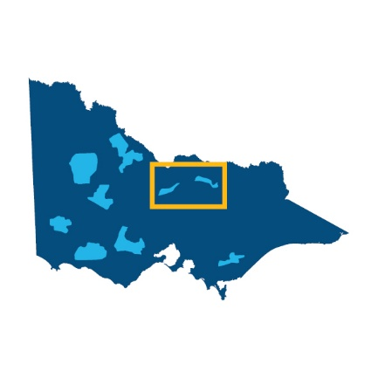
Six proposed zones have been identified in regional Victoria. Together, they cover 7.9% of the state’s land.
Figure 1 Central North Renewable Energy Zone Location

It’s your choice
Developers must talk to landholders to get permission to build renewable generation projects (such as wind turbines, large scale solar farms or batteries) on their land. Landholders can choose whether or not to host a project.
Landholders who do host renewable generation projects will receive financial payments and benefits that they negotiate with the developer. Dedicated community benefits will also apply to projects developed in renewable energy zones. This ensures the whole community benefits from development.

Have your say
The proposed Central North Renewable Energy Zone will soon be placed on public notice for 6 weeks to provide the opportunity for comments and submissions. The Minister for Energy and Resources must consider any submissions when determining whether the renewable energy zone should be officially declared. For more information, see ‘Next steps’ below.

The proposed Central North Renewable Energy Zone
The proposed Central North Renewable Energy Zone is in a location with diverse solar and wind resource that can provide flexibility in supporting Victoria’s overall energy mix. The zone covers parts of the Campaspe, Greater Shepparton, Benalla and City of Greater Bendigo local government areas.
The proposed zone has 2 sections – a western section between Bendigo and Tatura along the existing 220 kilovolt (kV) transmission line from Fosterville to Shepparton and an eastern section between Shepparton and Glenrowan. The western section sits within the boundaries of Yorta Yorta Nation Aboriginal Corporation and Taungurung Land and Waters Council. The eastern section sits within the boundaries of Yorta Yorta Nation Aboriginal Corporation.
The proposed Central North Renewable Energy Zone predominantly avoids the Goulburn Murray Irrigation District, overlapping a small part in the east. There are a number of sensitive wetlands, waterways and parks nearby or inside the zone that will require further consideration by individual project proponents.
It is important to note that this zone has been split into 2 sections in response to feedback on the draft proposed zone about potential impacts on biodiversity, cultural values and irrigated agriculture west of Shepparton and interest in solar energy opportunities east of Shepparton. While the sections are separate, they are both part of the proposed zone.

How much new energy are we planning for in the proposed Central North Renewable Energy Zone?
Once renewable energy zones are declared, VicGrid proposes to run a competitive allocation process to decide which projects in each zone have the authority to connect the energy they produce to the grid.
We wil consider
- the amount of electricity Victoria needs to generate to meet expected demand as outlined in the Victorian Transmission Plan
- ensuring the level of development inside each zone can be supported by available transmission lines
- the density of projects within each renewable energy zone
- how development can be coordinated to avoid the ‘spaghetti effect’ of many powerlines crossing the landscape
- whether developers are meeting expectations for landholder, community and Traditional Owner engagement and benefits.
This will ensure we ultimately produce enough energy to meet demand while also considering the impact on communities, Traditional Owners, agriculture and the environment.
We are proposing to set access limits for each zone at the maximum amount that can be managed by the planned build-out of the transmission network.
This is not the level of development people should expect in each zone but is the maximum that the transmission network could support within the zone.

How to read the map
This map shows the proposed Central North Renewable Energy Zone, including some of the significant land use and landscape values that influenced its location, size and shape. The labelled values are a sub-set only and are not exhaustive of values present. For detailed descriptions of the labelled land use and landscape values in the region, see section ‘key land use and landscape values’.

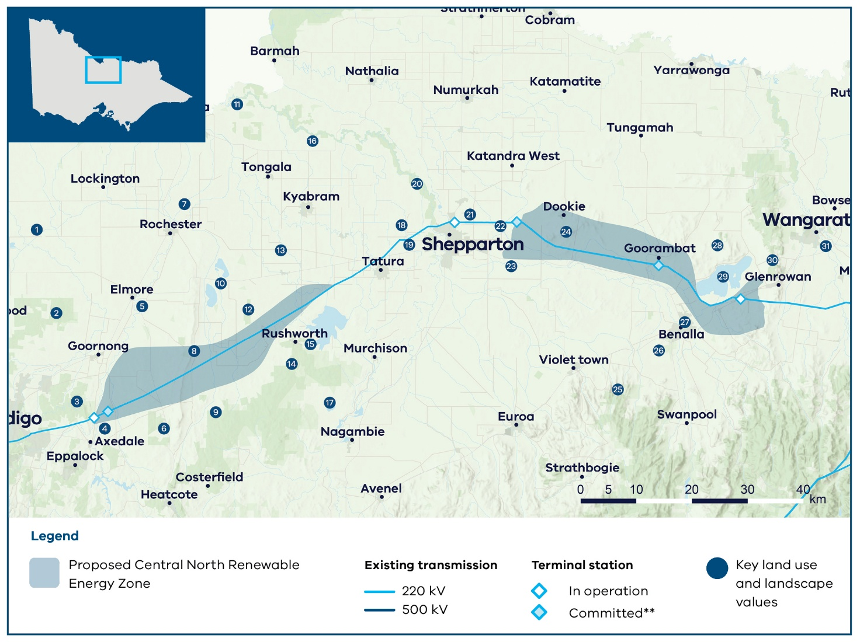
The proposed Central North Renewable Energy Zone
Figure 2 The proposed Central North Renewable Energy Zone
Note: The map shows committed terminal stations including new terminal stations on the Victorian Declared Shared Network that are proposed to be operational in the coming years, as identified by AEMO Victorian Planning in its Terminal Stations in Victoria report dated 2 September 2024.

Key land use and landscape values
- Flooding risk: Floodplain and land subject to inundation
- Biodiversity/cultural/ community: Greater Bendigo National Park and protected biodiversity areas
- Biodiversity: Mount Sugarloaf Nature Conservation Reserve and surrounding parks and reserves, home to native flora and fauna
- Mining: Active mine sites and Extractive Industry Interest Areas
- Biodiversity/cultural: Campaspe River and surrounding areas of sensitivity
- Biodiversity: Parks, reserves and state forests, home to native flora and fauna
- Flooding risk: Floodplain and land subject to inundation
- Biodiversity/cultural/ community: Corop Wetlands Cultural Waterscape, connecting significant waterways, wetlands and landscapes including the Corop wetlands complex in the north, extending south east to Reedy Lake and the forested hills around Rushworth and Whroo, and including the entire Mount Camel Range to the west
- Biodiversity/cultural/ community: Heathcote Graytown National Park and surrounding parks, reserves and state forests, including protected biodiversity areas for native flora and fauna
- Biodiversity/cultural: Corop wetlands complex including Lake Cooper, Greens Lake, Gaynor Swamp, Wallenjoe Swamp, Mansfield Swamp and surrounding parks and reserves
- Biodiversity/cultural: Murray River and surrounding sensitive landscapes
- Biodiversity: One Tree Swamp and Two Tree Swamp Nature Conservation Reserves, including biodiversity protected areas
- Agriculture: Agricultural productivity area within the Goulburn Murray Irrigation District, particularly irrigated dairy and cropping
- Biodiversity/cultural/ community: Corop Wetlands Cultural Waterscape, see value 8 for full description of this waterscape
- Biodiversity/cultural/ community: Corop Wetlands Cultural Waterscape, see value 8 for full description of this waterscape
- Biodiversity/cultural: Goulburn River and surrounding areas of sensitivity
- Biodiversity/cultural/ community: Reedy Lake Nagambie Wildlife Reserve
- Community: Area of higher aggregated dwelling density around Shepparton
- Agriculture: Agricultural productivity area within the Goulburn Murray Irrigation District, particularly irrigated dairy and cropping
- Biodiversity/cultural/ community: Lower Goulburn National Park and surrounding landscapes, including biodiversity protected areas
- Agriculture: Irrigated agriculture within the Goulburn Murray Irrigation District
- Flooding risk: Floodplain and land subject to inundation
- Biodiversity/cultural: Broken River and surrounding areas of sensitivity
- Biodiversity/cultural/ community: Mount Major
- Biodiversity/cultural: Strathbogie State Forest, home to native flora and fauna
- Biodiversity/cultural/ community: Reef Hills State Park including protected biodiversity area for native flora and fauna
- Community: Area of higher aggregated dwelling density around Benalla
- Biodiversity: Mount Meg Nature Conservation Reserve, home to native flora and fauna
- Biodiversity/Cultural: Winton Wetlands and surrounding areas of sensitivity, protected area and home to native flora and fauna
- Biodiversity/cultural/ community: Warby-Ovens National Park
- Biodiversity/cultural: Ovens River and King River, and surrounding areas of sensitivity

Acting on community feedback
Community and industry views have been crucial to the design of the 2025 Victorian Transmission Plan.
VicGrid’s role is to balance the need for new renewable projects that will deliver reliable and affordable power as coal closes with a range of other factors, including how we minimise impacts on landholders, communities, agriculture, the environment and power bills.
Not all community or industry requests have been adopted. The Victorian Transmission Plan reflects difficult choices, made by weighing up many factors to deliver a plan that best serves all Victorians. We have used the feedback received during engagement on the renewable energy zone study area and draft Victorian Transmission Plan Guidelines in 2024 and again during engagement on the draft Victorian Transmission Plan in 2025 to shape the size and location of the proposed renewable energy zone.

What we heard
- Minimise impacts on agriculture and land use, particularly irrigated land and dairy farming.
- Protect the natural environment and biodiversity, particularly around Lake Cooper, the Mount Camel Range, Gaynor Swamp and One and Two Tree Swamp as part of the Corop wetlands.
- Consider natural hazard vulnerability, particularly flooding and how new infrastructure may impact future flood events.
- Avoid areas of high rural dwelling density and project growth areas.
- Sections of the community were concerned about the reliability of power supply in the region without sufficient transmission upgrades.
- Avoid brolga flocking grounds, which restrict the planning of renewable energy infrastructure.
- Consider expanding or relocating the zone towards Benalla and Glenrowan, an area with multiple solar projects in development and access to the existing transmission network.

What we did
- We tried to avoid as much irrigated farmland as possible along the northern boundary in the Goulburn Murray Irrigation District and other agricultural land. For farmland that is located within the proposed zone, minimising the impacts will be an important consideration of any future projects as they are developed.
- We considered flood risks, particularly in the north of the draft proposed renewable energy zone. These will require further project-level assessments.
- We avoided areas near Shepparton that have a relatively high rural dwelling density.
- We removed a large portion of the draft proposed zone to the north-west, given the complex land use constraints.
- We added an eastern section to the zone, between Shepparton and Glenrowan, in response to high solar interest in the area.

Transmission network upgrades
The 2025 Victorian Transmission Plan also proposes 7 transmission infrastructure investment programs needed over 2025-2040, to enable development of renewable energy zones and offshore wind energy.
The programs include 4 new transmission projects: a Gippsland offshore wind transmission stage 2 project, a new line between Tarrone in South West Victoria and Sydenham in Melbourne’s north, a new line between Truganina and Deer Park in Melbourne, and an additional short line between Hazelwood and Yallourn in Gippsland. The other projects across the 7 programs range from augmentations within existing terminal stations to significant reconstruction of existing transmission lines.
Learn more about the transmission projects in the 2025 Victorian Transmission Plan on our website.

What will it be like living in a renewable energy zone?
If you live in or near a renewable energy zone, over time you will see more development of renewable energy generation and storage. You can choose whether or not to host new renewable energy such as wind turbines, solar farms or batteries on your property. It’s your decision and we encourage you to talk to your neighbours about it.
Existing planning and environment controls will still apply. All proposed projects will continue to be subject to the planning and environmental approval processes under the Planning and Environment Act 1987 and Environment Effects Act 1978.
VicGrid will work with developers to coordinate new development and associated transmission to minimise impacts on landscapes and the environment. Only a small proportion of land in a renewable energy zone will be needed for development.
You will also see new community and regional economic benefits delivered over time as part of the Victorian Government’s new Renewable Energy Zone Community Benefits Plan. This new approach will feature:
- the introduction of new Renewable Energy Zone Community Energy Funds to benefit regional and rural communities
- payments for landholders who host transmission
- guidance for payments for significantly impacted neighbours of new transmission
- a commitment to co-design a new approach to economic benefits for Traditional Owners.
Renewable Energy Zone Community Energy Funds are an opportunity to invest directly in projects that improve local outcomes and create other benefits for communities in regions hosting energy infrastructure. Local decision-making that responds to local needs and priorities will be a cornerstone of these funds and decisions about investments will be made in consultation with regional community reference groups with broad community and industry representation. In addition to government initiatives, developers of projects will be required to implement their own community benefits programs. The final Renewable Energy Zone Community Benefits Plan is set to be released in coming months. Learn more about community benefits.

Next steps
Communities within proposed renewable energy zones can continue to provide feedback and seek more information about renewable energy zones, including through face-to-face meetings with VicGrid.
We will invite formal feedback about the proposed Central North Renewable Energy Zone as part of the official declaration process. There will be 6 weeks of consultation, to begin in coming weeks, which will give landholders, communities and Traditional Owners another opportunity to provide feedback and shape decision-making.

Email updates
To stay up to date about the renewable energy zone declaration process and VicGrid’s work, subscribe for our email updates at vicgrid.vic.gov.au

Call or email us
Call us on 1800 418 341 or email vicgrid@deeca.vic.gov.au

Contact us
Phone: 1800 418 341
Email: vicgrid@deeca.vic.gov.au
Deaf, hearing or speech impaired? Please contact the National Relay Service on 133 677 or communications.gov.au/accesshub/nrs
Need an interpreter? Contact Translating and Interpreting Service (TIS) on 131 450 (within Australia) or visit www.tisnational.gov.au
ISBN 978-1-76176-467-7 (Print)
ISBN 978-1-76176-468-4 (pdf/online/MS word)
Disclaimer: The information in this document is current at the time of printing, may be subject to change and should not be relied upon. Please visit vicgrid.vic.gov.au for the latest updates.

