Offshore Wind Energy Transmission Gippsland Options Assessment
  - VicGrid Community Summary March 2024
Table of Contents
Transmission Study Area for further development 2
Study Area and indicative connection hub 2
Features of the Study Area and technology 2
Why overhead lines are preferred 3
Working with communities to refine the transmission option 3
Next steps for working with communities to refine the Study Area and confirm the transmission location 3
Contact us 4

  - This fact sheet describes the proposed new transmission infrastructure in Gippsland to connect offshore wind energy to the existing power grid. It sets out next steps to work with landholders, communities, stakeholders and First Peoples to inform the decision about the new transmission.

Offshore wind is a key pillar in the renewable energy transition and Victoria has some of the best offshore wind resources in the world. That is why the Victorian Government has set targets to generate at least 2 gigawatt (GW) of offshore wind energy by 2032, 4 GW by 2035, and 9 GW by 2040.

New transmission infrastructure is needed to extend the existing network from the Latrobe Valley to a connection hub near the Gippsland coast, which offshore wind generators will connect to.

VicGrid is the Victorian Government agency leading this transmission development to avoid multiple developers building individual transmission lines that could create a ‘spaghetti effect’ of powerlines criss-crossing the landscape.

Why Gippsland?
Offshore wind farms can only be built in areas approved by the Australian Government, which declared an area in Bass Strait as Australia’s first offshore wind zone in December 2022. This area spans approximately 15,000 square kilometres (km) in Commonwealth waters off the Gippsland coast.

Transmission Study Area for further development
VicGrid has identified a Study Area for the new transmission infrastructure through an assessment of a wide range of potential corridor and technical options. VicGrid used the Options Assessment Method which was developed in 2023 with community and stakeholder feedback to help assess and balance a range of competing factors.

The proposed new transmission in Gippsland is a new set of overhead alternating current (AC) 330 kilovolt (kV) or 500 kV transmission lines from a new connection hub near Giffard to a grid connection point near Loy Yang Power Station.

VicGrid has created a broad Study Area between 3 km and 12 km wide that provides opportunities to reduce impacts by exploring alignment with other infrastructure.
The Study Area will be refined through further engagement and detailed investigations to select a corridor, a route and ultimately an easement.

Assessment of environmental, visual, heritage, cost and technical factors found that new overhead transmission lines along an area away from major towns provided the best way of balancing the need to keep household energy bills down while minimising impacts for Gippsland communities.

Study Area – A broad geographic area that we will progressively narrow over time as we undertake detailed studies and consultation with landholders, First Peoples, community and stakeholders.
Corridor – One or more geographic areas narrowed down from the Study Area
that are considered suitable for transmission infrastructure. There is flexibility within
a corridor to undertake site-specific consultation with landholders to identify suitable routes.
Route – A route is narrower again and is the final stage before an easement is selected. This still allows flexibility for locating
(or micro-siting) of towers to minimise impacts on landholders and landholder operations.
Easement – An easement is a legally secured right-of-way for the transmission infrastructure to be built and maintained.

Study Area and indicative connection hub
A map of Gippsland shows the Study Area and indicative connection hub area. The Study Area starts approximately 6km from the coast near Giffard and travels northwest past Stradbroke West to Willung, across to Flynns Creek and then to the Loy Yang Power Station.
The map also shows a cross-hatched area along the coast, running approximately from Seaspray to Reeves beach. The legend for this area reads: Offshore wind energy connections to the VicGrid connection hub are subject to the outcome of the feasibility licence process which is pending.

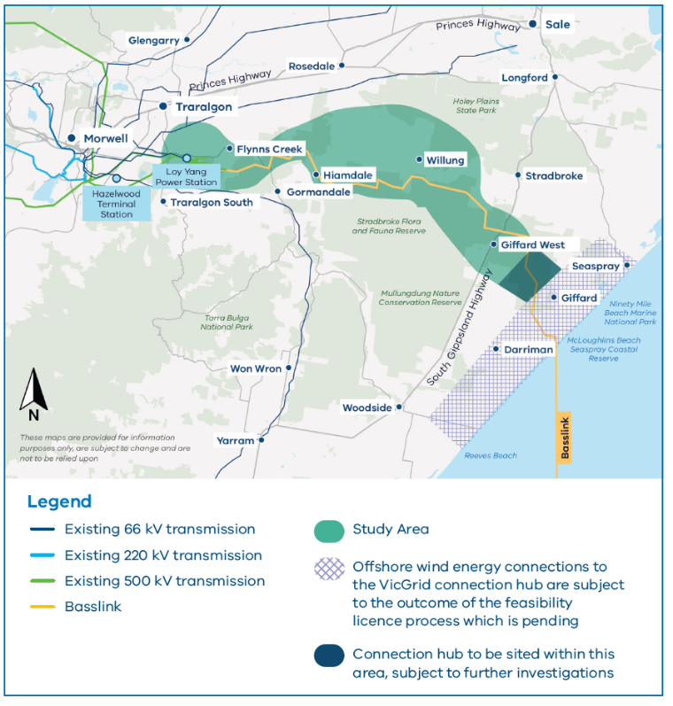

Features of the Study Area and technology

- Lower proportion of agricultural land than almost all other options
- Away from major residential areas
- Higher proportion of public and
- plantation land than other options
- Overhead technology proven to minimise energy costs paid by households and businesses
- Provide opportunities to explore alignment with other infrastructure such as roads and Basslink
- Allow for potential connection with existing assets at Loy Yang Power Station
- Shorter length than most other options
- Connect Victorian households and businesses to affordable renewable energy.

Why overhead lines are preferred
VicGrid’s assessment of technical options considered multiple overhead and underground technical options and balanced complex and competing technical, social, environmental and heritage factors.

The assessment showed that AC 330 kV and 500 kV overhead options scored the highest overall, due to lower cost impacts to energy consumers, lower engineering complexities and proven performance for long-distance large-scale energy transport.

For the first 2 GW offshore wind energy target, the preferred HVAC overhead options are estimated to cost between approximately $700 million and $1.5 billion, compared with between approximately $2 billion and $4.5 billion for the HVDC underground option.

Working with communities to refine the transmission option
Further engagement and in-depth investigations are now needed to inform the decision about where the new transmission should go.

VicGrid will talk with landholders, farmers and residents of nearby townships to better understand their needs, their properties and activities like agricultural practices with the aim of improving the project and minimising impacts as much as possible.

The Study Area needs further discussion with the Traditional Owner Corporation, Gunaikurnai Land and Waters Aboriginal Corporation (GLaWAC) on ways to avoid and minimise potential impacts to cultural heritage and values. VicGrid will continue working to build a partnership with GLaWAC.

Next steps for working with communities to refine
the Study Area and confirm the transmission location
2024 - 2027: In depth engagement and environment assessments and approvals.
2027 - 2030: Delivery and commissioning.
2024: Refine Study Area to identify preferred corridor.
2025: Refine corridor to identify preferred route.
2026 - 2027: Refine route to confirm transmission easement.
2027 - 2030: Construction of new transmission ready for at least 2 GW by 2032 offshore wind target.
2024 - 2027: Direct discussions with landholders. On-the-ground environment and heritage studies. Major planning and environment assessments and community submissions to independent panel.
2027 - 2030: Finalise delivery plan in accordance with planning and environment approvals.
2024 - 2027: Understanding land use, agriculture and business operations. Engagement with public land managers and businesses. Coordination with offshore wind developers. Design of transmission infrastructure and connection hubs.
2027 - 2030: Mobilise construction partner. Construction supported by ongoing engagement. Ready to connect offshore wind projects.
2024 - 2027: Community and landholder engagement. Traditional Owner/First Peoples engagement and partnership approach

Contact us
Phone: 1800 418 341
Email: vicgrid@deeca.vic.gov.au
Deaf, hearing or speech impaired? Please contact the National Relay Service on 133 677 or communications.gov.au/accesshub/nrs
Need an interpreter? Contact Translating and Interpreting Service (TIS) on 131 450 (within Australia) or visit www.tisnational.gov.au
ISBN 978-1-76136-626-0 (Print)
ISBN 978-1-76136-627-7 (pdf/online/MS word)
Disclaimer: It should be noted that this information
is current at the time of printing. However due to unforeseen circumstances changes may occur.
Please visit vicgrid.vic.gov.au for the latest updates.

