Victorian offshore wind auction
  - Australian-first Request for Proposal now open

Table of Contents
Minister’s message 2
Auction design 4
Opportunities for Traditional Owners 6
Opportunities for industry and workers 7
Opportunities for communities 10
Environmental Protections 11
Enabling infrastructure: Transmission 12
Enabling infrastructure: Ports 16
Victoria’s renewable energy future 21
Publication information 22

Minister’s message
Victoria is leading Australia’s development of offshore wind and the opening of our first offshore wind auction marks a significant milestone in delivering our vision for this industry.
Offshore wind energy will help strengthen Victoria's energy security, reduce emissions and support affordable, reliable electricity for generations to come. Achieving those aims requires more than ambition. It requires a clear pathway to bring projects from concept to construction.
This Request for Proposal is the next major step in that journey.
Through this auction, Victoria is seeking proposals to deliver the first 2 gigawatts (GW) of offshore wind capacity, laying the foundations for an industry that will support thousands of jobs, attract billions of dollars in investment and create lasting opportunities for regional communities.
The auction has been carefully designed to balance the Victorian Government's objectives of value for money, project deliverability and long-term industry development. It recognises that successful offshore wind projects must do more than generate electricity. They must build local supply chains, create opportunities for Victorian workers and businesses, partner meaningfully with Traditional Owners, and deliver genuine benefits for communities.
The support package available through the auction provides investment certainty while maintaining strong expectations around local content, workforce development, community engagement and social value outcomes. Together, these measures will help establish the strong foundations needed for a thriving Victorian offshore wind sector.
Victoria has some of the world's best offshore wind resources. Through this auction, we are taking the next step towards harnessing this opportunity to deliver a cleaner, more secure and more prosperous energy future for all Victorians.
Jaclyn Symes MP
Leader of the Government in the Legislative Council
Minister for Energy and Resources
Minister for Environment
Minister for Climate Action
Minister for the State Electricity Commission
Offshore wind energy presents a significant opportunity for Victoria to strengthen energy security, create thousands of jobs, drive economic growth, reduce emissions, help keep electricity costs down, and bring lasting benefit to Traditional Owners and regional communities.

Auction design
The opening of the Request for Proposal (RFP) marks the commencement of Victoria’s first formal auction process to deliver 2 GW of offshore wind capacity to the state’s energy grid.
The first projects will lay the foundation for the industry to thrive – and ensure our state is ready to receive the benefit.
The auction will award a support package to winning bidders. The package will consist of a contract for difference mechanism (CfD) with a term of 20 years to help mitigate market revenue variability risk, and an Availability Payment.
The Availability Payment is a fixed-sum periodic payment, conditional upon the infrastructure being available to generate electricity and only payable following achievement of commercial operation.
The auction timeline includes a 12-month RFP phase from August 2026 to August 2027. After auction close, an extensive evaluation of these bids will occur to select successful projects, with contracts for the first 2 GW expected to be awarded in 2028.
The state will evaluate bidder proposals based on value for money, deliverability and local content criteria. Project deliverability includes the assessment of feasibility licence holders’ partnerships with Traditional Owners as well as their broader community engagement and benefit-sharing plans.

Role of the Electricity Services Entry Mechanism (ESEM)
The Electricity Services Entry Mechanism (ESEM) is a proposed new national framework designed to support new energy generation across the National Electricity Market (NEM), including offshore wind.
Integrating Victorian offshore wind auctions into the ESEM will provide a strong, enduring pathway for delivery of 9 GW of offshore wind.
Subject to further work on detailed design and implementation, and Energy and Climate Change Ministerial Council decision, the ESEM scheme is expected to be in place by the end of 2027.

Victorian Government objectives
The auction process seeks to balance delivery of all Victorian Government objectives:
- Value for money for Victorians
- Developing foundations for long-term industry development
- Community engagement and benefit sharing
- Timely delivery of projects to meet Victoria’s energy needs
- Local content and investments for building local supply chain capability
- Partnerships with Traditional Owners

Opportunities for Traditional Owners
Traditional Owners are partners who have cultural and legal rights that must be upheld under the Traditional Owner Settlement Act 2010 (Vic), Aboriginal Heritage Act 2006 (Vic), the Victorian Charter of Human Rights, and Native Title Act 1993 (Cth).
The Victorian Government is committed to the self-determination of Traditional Owners and Aboriginal communities and to genuinely partnering with them to support the protection of Country and Sea Country, the maintenance of spiritual and cultural practices and their broader aspirations for the future.
The government reaffirms its commitment to supporting the Gunaikurnai Land and Waters Aboriginal Corporation to have mutually beneficial agreements with Gippsland feasibility licence holders, in line with international best practice.
The Victorian Government supports appropriate resourcing for Traditional Owners to allow meaningful engagement and genuine partnerships in the development of the offshore wind energy sector. An engagement agreement to provide resourcing to support ongoing engagement with Traditional Owners is part of Victoria’s first auction.

Opportunities for industry and workers
Today, around 45,000 people work in Victoria’s energy sector. As electrification accelerates and new infrastructure is developed, demand for skilled workers will continue to grow.
Between 2026 and 2040, Victoria’s energy workforce is expected to expand by more than 50 per cent, reaching approximately 68,000 workers right across the State. Around 37 per cent of this workforce demand is expected to be driven by activity in regional Victoria.
The Victorian Government is creating long-term opportunities for local workers and businesses through offshore wind development.
At its peak the offshore wind sector is estimated to require up to 2,300 – 4,000 jobs across Australia with the vast majority in Victoria.
As the industry matures and reaches its operational phase, an estimated 1,500 – 1,750 ongoing jobs will be needed over the 30-year life of the offshore wind assets, particularly in regions close to ports and offshore wind areas like Gippsland.
To participate in the first offshore wind auction, offshore wind feasibility licence holders must meet requirements for social procurement and local content and workforce commitments.

Local content requirements for the first 2 GW
The local content requirements, set via the Local Jobs First Act 2003, reflect that offshore wind, whilst a new industry in Australia, is well established internationally and that there is significant global competition for the technology. These requirements support a solid foundation for increased local participation in future projects.
The Local Jobs First policy aims to maximise local jobs, local supply chains and local economic value through procurement, by committing to minimum local content targets.
Following are the local content requirements that must be met throughout the lifecycle of an offshore wind farm:
- Maximise the use of local content during the construction phase
- Achieve 80 per cent minimum local content during the operations and maintenance phase, as averaged over a 30-year period
- Ensure 10% of labour hours come from apprentices, trainees, and cadets during onshore construction and operations
Maximise use of locally produced, milled and/or fabricated steel
Maximise the use of materials, products and services produced or manufactured by suppliers based in Victoria’s regions
Feasibility licence holders will need to provide a Local Industry Development Plan (LIDP) and a Supply Chain Action Plan and Engagement Strategy that sets out the plan for investing in and developing the local industry and workforce.

Social procurement requirements
The Social Procurement Framework enables opportunities for priority jobseekers, the promotion of women’s equality and safety, and increased opportunities for the First Peoples of Victoria.
Under the Social Procurement Framework, feasibility licence holders are required to develop and submit a social procurement commitment that sets targets and proposes initiatives for supporting these priority groups.

Timing for industry development
Developing an offshore wind project requires extensive planning, environmental assessments, supply chain development and regulatory approvals. Because of their scale and complexity, the development timeline for an offshore wind project is lengthy.
Subject to the tender process and favourable approval outcomes, construction for the first 2GW of offshore wind is expected to commence from 2032, with energy to start flowing into our grid in 2034.

Opportunities for communities
Establishing strong community engagement expectations and a framework for delivering social value and economic benefits is fundamental to the successful development of the offshore wind sector in Victoria.
The Victorian Government has used the auction to set expectations that feasibility licence holders will approach community engagement, social value, and economic benefit delivery with the same attention and diligence given to technical and economic feasibility.
In Victoria’s first offshore wind auction, feasibility licence holders will be evaluated on whether their engagement strategy and social value and economic benefits program will deliver positive and lasting outcomes for local communities. They will also be assessed on how communities and stakeholders have been meaningfully engaged to ensure the plans reflect community priorities.
The Victorian Government’s Community Engagement and Social Value Guidelines for renewable energy and transmission projects will apply to the auction.
They provide guidance for renewable energy and transmission project developers on engagement expectations and on creating social value and economic benefits for communities, Traditional Owners, landholders and neighbours in Victoria.

Environmental Protections
Offshore wind is operating safely around the world, coexisting alongside fishing, tourism and marine life and industries.
All offshore wind projects are assessed and approved under Victorian and Australian Government environmental regulations before, during and after operations begin. This includes the Commonwealth Environment Protection and Biodiversity Conservation Act 1999 (EPBC Act), the Victorian Environment Effects Act 1978, the Marine and Coastal Act 2018, and approvals relating to Aboriginal and European heritage. The Victorian and Commonwealth Governments continue to work together to ensure environmental assessments and regulatory approvals are managed well.
Before construction begins, rigorous environmental assessments enable understanding and mitigation of potential impacts. Projects are carefully designed to protect marine ecosystems, including whales, sea and shore birds, fish populations and critical habitats.
Offshore wind can support a healthy marine environment, with turbine foundations acting as artificial reefs that attract and sustain sea life.
International experience shows that with responsible development; offshore wind farms have minimal long-term environmental impacts.

Enabling infrastructure: Transmission
Victoria is moving from coal to renewable energy, and offshore wind energy will play a major role. The Gippsland coast has some of the best offshore wind resources in the world. VicGrid is planning and delivering the shared transmission infrastructure to connect this energy to the grid.
The 2025 Victorian Transmission Plan (VTP) provides a 15-year roadmap for transmission development. It identifies the Gippsland Shoreline Renewable Energy Zone (REZ) and the transmission infrastructure needed to support offshore wind energy in Gippsland. The Victorian Government has set targets to generate 9 GW of offshore wind energy, with 7.5 GW coming from Gippsland.

The transmission line
To enable the first 2 GW of offshore wind energy, VicGrid is building a new 500 kilovolt (kV) double circuit overhead transmission line from the proposed Giffard terminal station to the Loy Yang Power Station switchyard. Over the past two years, VicGrid has engaged with landholders, communities, Traditional Owners and industry to understand the land use, and social and environmental factors that shape the transmission route.
In October 2025, VicGrid released the corridor and draft preferred route.
An Environment Effects Statement is currently being prepared to assess potential environmental, social, cultural and economic impacts of the corridor and draft preferred route.
The final easement, around 70 metres wide, is expected to be confirmed in 2027.

Delivery partner
VicGrid has run a competitive invitation to tender to select a development partner to design, build, finance, operate, and maintain the project. A development partner is expected to be announced in late 2026.

Role of offshore wind energy developers
In June 2026, the Victorian Government declared Victoria’s Renewable Energy Zones, including the Gippsland Shoreline REZ. The zone includes four shoreline crossing areas where offshore wind feasibility licence holders can study the most suitable locations to bring their underground cables ashore. These areas were chosen to avoid the coast’s most environmentally and culturally sensitive locations, and to reduce technical challenges. From the shoreline, underground cables would run to the proposed Giffard terminal station – the shared point where multiple offshore wind energy projects will connect to the grid.

Local jobs
Industry has a crucial role to play in the energy transition, and it is important that it delivers real economic benefits for regional Victoria.
VicGrid will work to secure opportunities from the project for local businesses and workers.
During construction, the project is expected to support around 600 jobs a year.
Figure 1: Offshore wind and transmission in Gippsland
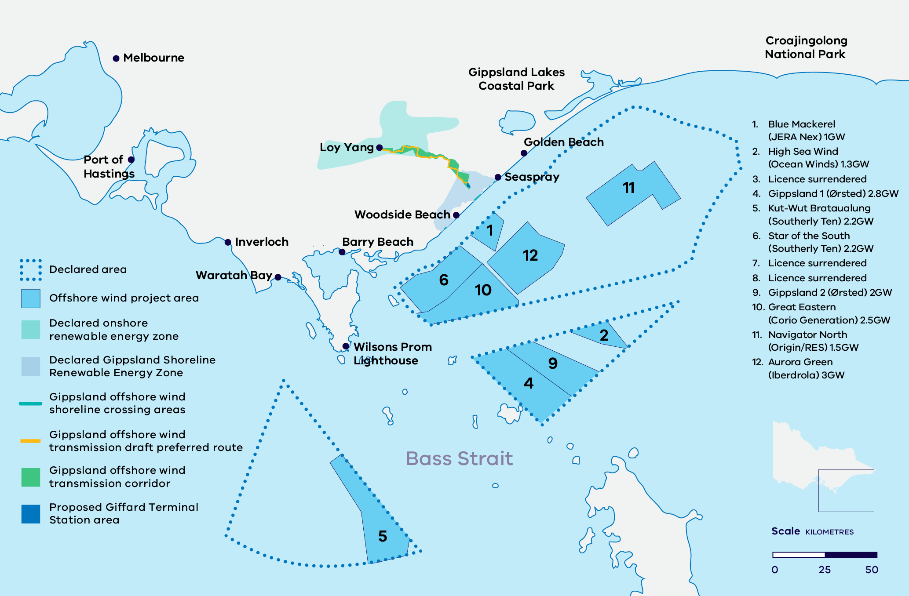

Figure 1 is a map of the Gippsland and Bass Strait coast showing the Commonwealth declared offshore wind areas, the numbered offshore wind project areas, the declared Gippsland Shoreline Renewable Energy Zone and its four shoreline crossing areas, and the offshore wind transmission corridor and draft preferred route running inland to the proposed Giffard terminal station and the Loy Yang Power Station switchyard. Coastal reference points include the Port of Hastings, Inverloch, Wilsons Promontory, Barry Beach, Seaspray and the Gippsland Lakes. The project areas, their proponents and capacities are listed in Table 1.
Table 1: Offshore wind project areas shown in Figure 1
Project area | Proponent | Capacity (GW)
Blue Mackerel | JERA Nex | 1
High Sea Wind | Ocean Winds | 1.3
Gippsland 1 | Ørsted | 2.8
Kut-Wut Brataualung | Southerly Ten | 2.2
Star of the South | Southerly Ten | 2.2
Gippsland 2 | Ørsted | 2
Great Eastern | Corio Generation | 2.5
Navigator North | Origin / RES | 1.5
Aurora Green | Iberdrola | 3

Enabling infrastructure: Ports
The Port of Hastings is set to play a key role in supporting Victoria’s transition to a clean energy future through the development of the proposed Victorian Renewable Energy Terminal (VRET).
The Victorian Government has selected the Port of Hastings as the preferred offshore wind construction and assembly terminal.
With the benefits of large areas of port-zoned land, a deep-water channel and proximity to the Gippsland and Southern Ocean offshore wind declared areas, its establishment would deliver critical port capacity to meet Victoria’s offshore wind ambitions.
The Victorian Government has identified the terminal as critical to supporting the state’s target of achieving net zero emissions by 2045 and providing long-term domestic energy security.
The proposed terminal site is in Western Port at the Old Tyabb Reclamation Area (OTRA) and the adjacent marine waters within the port precinct, between Woodside’s Long Island Point jetty and BlueScope’s wharves. Development of the terminal requires a comprehensive understanding of the facility’s impact on the surrounding environment and is subject to strict Commonwealth and State environmental assessment and approval before any development can proceed.
Figure 2: Proposed Victorian Renewable Energy Terminal in the Port of Hastings
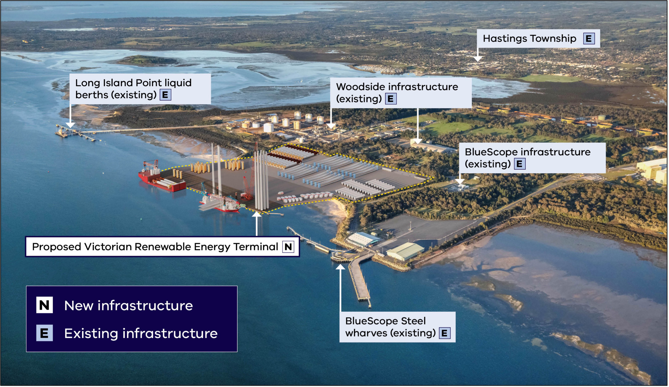
Figure 2 is an aerial photograph of the Port of Hastings in Western Port with an artist's impression of the proposed Victorian Renewable Energy Terminal overlaid on the shoreline. The new terminal is outlined in yellow and shows a wharf with an installation vessel and crane alongside, and laydown areas holding wind turbine towers, blades, nacelles and monopile foundations. Labels identify the proposed terminal as new infrastructure and the surrounding existing infrastructure: the Long Island Point liquid berths, Woodside infrastructure, BlueScope infrastructure, the BlueScope Steel wharves and the Hastings township.
Table 2: Assessment and approval timeline for the proposed Victorian Renewable Energy Terminal
Time | Event
June 2025 | Port of Hastings Corporation submits revised EPBC referral for the VRET.
August 2025 | Controlled action decision on revised EPBC referral.  Further assessment of the VRET via an EES process commences.
January 2026 | Final scoping requirements for the VRET EES published.
May 2026 | Victorian Government invests $124.5 million to progress EES and procurement activities for the VRET.
2027 | Expected exhibition and completion of EES. State and Commonwealth approvals sought thereafter.

Environmental assessment and approval
The Port of Hastings Corporation (PoHC) is preparing an Environment Effects Statement (EES) which involves undertaking extensive technical studies to understand the environment and impacts of the project.
The project is subject to a bilateral environmental assessment process with the Commonwealth, and requires both State and Commonwealth approvals before construction can commence.
In August 2025, the Commonwealth issued a controlled action decision under the Environment Protection and Biodiversity Conservation (EPBC) Act, following the PoHC submission of a new EPBC referral for the project. The new referral included a 70 per cent reduction to the dredging footprint and a significant reduction in the total size of the terminal’s reclaimed area – from 29ha to 18.0ha.
The controlled action decision has allowed PoHC to utilise the bilateral environmental assessment process and continue technical studies to support this work. This process includes design of the project components to minimise the environmental impacts.
The project design has continued to be refined to reduce impacts on the environment and the surrounding community. Some of these changes include:
- A reduction in the pile quantities required
- A reduction in the volume of imported fill material by approximately 400,000m³
A reduction in expected underwater noise from piling.
PoHC, as the proponent, is completing technical studies, including field surveys and investigations, to inform the engineering design and management of environmental impacts.
The Victorian Government has invested $124.5 million as part of the 2026/2027 budget to progress EES and procurement activities for the VRET.
Additional ports will also play a role in supporting offshore wind development. Ports such as Barry Beach Marine Terminal and Port Anthony are well-positioned to support operations and maintenance of offshore wind farms due to their proximity to the Gippsland offshore wind area.

Benefits of the Victorian Renewable Energy Terminal
The VRET would act as a key industrial hub, providing local employment and supply opportunities as well as significant economic benefits throughout its construction and operation.
As the terminal would be classified as a Strategic Project under the Local Jobs First Act 2003, the project will be required to source the majority of content locally, maximising local industry opportunities, as well as support local and First Nations jobs.
The Victorian Renewable Energy Terminal is expected to create local jobs on-site through the construction phase and ongoing jobs during the operational phase.
The growth of the renewable energy industry may also encourage future investment in the local area as well as opportunities to create jobs in a future high-demand industry as Victoria transitions to net zero emissions.

Victoria’s renewable energy future
Victoria is experiencing a once-in-a-generation transformation of its energy system.
The Victorian Government has legislated renewable energy generation targets to guide the decarbonisation of Victoria’s economy and transition of the energy system. Victoria’s legislated renewable generation targets are 65 per cent by 2030 and 95 per cent by 2035.
It is expected that Victoria will need to access additional onshore capacity between 2032 and 2035 to enable the state to meet the 95% by 2035 renewable energy target and continue the planned exit of coal-fired power from the grid.
The state will utilise the Electricity Services Entry Mechanism (ESEM) to support the first offshore wind auction and future onshore and offshore wind procurement. The 2027 Victorian Transmission Plan will identify Victoria’s energy needs over the coming 25 years.
The next VTP will consider the change to offshore wind timing and the generation mix and onshore capacity required to ensure Victoria’s energy supply remains clean, reliable and affordable.

More information
Find out more by visiting the Energy Victoria offshore-wind-energy website
Email: offshorewind@deeca.vic.gov.au

Publication information

Acknowledgement of Victorian Traditional Owners
We acknowledge and respect Victorian Traditional Owners as the original custodians of Victoria’s land and waters, their unique ability to care for Country and deep spiritual connection to it.
We honour Elders past and present whose knowledge and wisdom has ensured the continuation of culture and traditional practices.
DEECA is committed to genuinely partnering with Victorian Traditional Owners and Victoria’s Aboriginal community to progress their aspirations.

Copyright
© The State of Victoria Department of Energy, Environment and Climate Action, September 2026.

Creative Commons
This work is licensed under a Creative Commons Attribution 4.0 International licence, visit the Creative Commons website.
You are free to re-use the work under that licence, on the condition that you credit the State of Victoria as author. The licence does not apply to any images, photographs or branding, including the Victorian Coat of Arms, and the Victorian Government and Department logos.
ISBN 978-1-76176-957-3 (print)
ISBN 978-1-76176-958-0 (pdf)

Disclaimer
This publication may be of assistance to you but the State of Victoria and its employees do not guarantee that the publication is without flaw of any kind or is wholly appropriate for your particular purposes and therefore disclaims all liability for any error, loss or other consequence which may arise from you relying on any information in this publication.

Accessibility
To receive this document in an alternative format, phone the Customer Service Centre on 136 186, email customer.service@deeca.vic.gov.au, or contact National Relay Service on 133 677 or visit the National Relay Service website. This document is available on the DEECA website.
End of document.

